Optimized Extraction and Chromatographic Profiling of Ascorbic Acid from Emblica officinalis Root

Abstract:
Background: Emblica officinalis (amla) is known for its vitamin C-rich fruit, but its root remains underexplored. Ascorbic acid (vitamin C) is a key plant antioxidant that plays crucial roles in stress responses. We investigated E. officinalis root as a potential source of vitamin C, optimizing its extraction and profiling.
Methods: Amla roots were dried, powdered, and extracted by Soxhlet with 95% ethanol. The concentrated extract underwent standard phytochemical tests for reducing compounds (iodine, ferric chloride, silver nitrate, nitroprusside). Thin-layer chromatography (TLC) was performed on silica gel plates using various solvent systems to resolve ascorbic acid. UV-Visible spectrophotometry (200–400 nm) compared the extract’s absorbance spectrum against pure vitamin C.
Results: All chemical assays gave positive indications of ascorbic acid in the root extract (Table 1). TLC yielded a single major spot; the optimal mobile phase (n-butanol: acetic acid: water, 4:1:5) produced R_{f} ≈0.48, matching literature values for ascorbate. Other solvent systems gave R_{f}≈0.83 and ≈0.78 (Table 2). The UV-Vis spectrum of the extract showed a peak at ~267 nm, consistent with pure ascorbic acid (λ_{max}≈258–265 nm).
Conclusion: These findings confirm that E. officinalis roots contain significant vitamin C. The established extraction and chromatographic protocol provides a basis for quantifying this antioxidant. Ascorbate in roots could contribute to the plant’s oxidative stress defense and overall physiology. This work lays the groundwork for utilizing amla root in antioxidant profiling and plant defense studies.
Keywords: Emblica officinalis; ascorbic acid; antioxidant; plant defense; thin-layer chromatography

INTRODUCTION
Emblica officinalis (syn. Phyllanthus emblica; common name: amla) is a small deciduous tree native to South Asia. Its fruits (Figure 1) are famous for their unusually high ascorbic acid (vitamin C) content—among the richest of any edible plant [2]. As a result, amla has long been used in Ayurveda and folk medicine for its antioxidant and rejuvenating properties. Recent studies have confirmed that amla fruit (and commercial preparations thereof) provides substantial antioxidant activity largely attributed to its vitamin C and phenolic content [1]. For example, Scartezzini et al. [1] found that fresh amla fruit contains ~0.40% (w/w) ascorbic acid, and that Ayurvedic processing (Svaras Bhavana) can raise it to ~1.28% [1]. In short, the medicinal reputation of E. officinalis is closely linked to vitamin C [4].
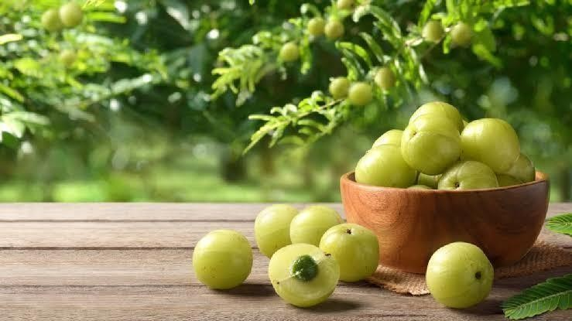
Emblica officinalis is rich not only in fruit but also contains phenolics, tannins, and other antioxidants in its stems, leaves, and bark. However, the root system remains comparatively unstudied. Unlike the fruit, the root has no obvious edible use, although it is used in some traditional remedies. Modern phytochemical knowledge of the root is limited [5,6]. Given that E. officinalis is a prolific vitamin C accumulator in its above-ground parts, we hypothesized that its roots may also harbor significant ascorbic acid. Exploring this possibility could reveal a novel source of plant antioxidants and provide insight into root physiology [7].
Figure 1: Emblica officinalis fruit
Vitamin C plays critical roles in plant physiology. Ascorbate is a central antioxidant that detoxifies reactive oxygen species (ROS) generated during metabolism and stress. It is involved in the xanthophyll cycle for photoprotection, functions as a cofactor in the biosynthesis of plant hormones (e.g., gibberellins, ethylene), and contributes to cell wall expansion. Under stress conditions, high ascorbate levels allow plants to scavenge ROS, modulate redox signaling, and maintain cellular homeostasis. We highlight that ascorbate is the major non-enzymatic ROS scavenger in plants and contributes to abiotic stress resilience. Therefore, surveying ascorbic acid in E. officinalis roots is relevant to plant defense, as root ascorbate may contribute to the overall antioxidant capacity and stress adaptation [8-10].
This study aims to optimize the extraction of ascorbic acid from E. officinalis roots and profile its presence. We collected authenticated Amla roots, processed them into powder, and performed Soxhlet extraction in ethanol following standard pharmacognosy procedures. The resulting extract was subjected to classic chemical tests for vitamin C (iodine, ferric chloride, silver nitrate, nitroprusside). Thin-layer chromatography was used to detect and confirm ascorbate bands. Finally, UV-Visible spectrophotometry compared the root extract’s absorbance spectrum to that of pure ascorbic acid. Through these combined methods, we provide the first detailed report of vitamin C in amla roots and discuss its implications for plant antioxidant defense and potential pharmaceutical use.

MATERIALS AND METHODS
Plant material: Fresh Emblica officinalis roots (Figure 1A) were collected in 2024 from a verified botanical source (latitude 24.54, longitude 81.30, India). The species identity was confirmed by a taxonomist of the University of North Bengal, Siliguri, West Bengal, 734014, and a voucher specimen was deposited. The collected roots were thoroughly washed to remove
soil and debris, then shade-dried at room temperature for 10 days. The dried roots were ground into a fine powder using a mechanical grinder. Before extraction, the powder was passed through a 40-mesh sieve to ensure uniform particle size. The dried root powder was stored in airtight containers at 4°C until use.

Figure 1A: Roots of Emblica officinalis were collected from a local herbal supplier and authenticated by the Department of Botany, University of North Bengal. Authentication was confirmed by comparing morphological features such as root color, surface texture, odor, and microscopic structure with standard monographs.

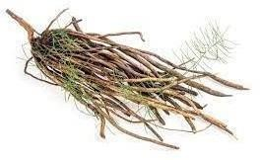
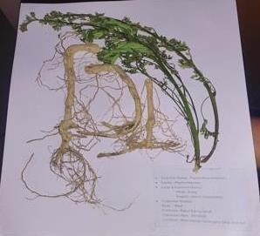

Chemicals and Reagents: Ethanol (95%, analytical grade) was used for extraction. Methanol, acetic acid, chloroform, and sodium nitroprusside were obtained from standard laboratory suppliers. Silver nitrate, iodine, ferric chloride, and other chemicals were of analytical grade. A standard sample of pure ascorbic acid (vitamin C) was purchased from Sigma-Aldrich.
Extraction of Ascorbic Acid: Approximately 20 g of the dried root powder was extracted using a Soxhlet apparatus with 250 mL of 95% ethanol for 6 hours (about 8–10 siphoning cycles). Ethanol was chosen as a moderately polar solvent to extract vitamin C and other polar constituents. The hot ethanolic extract was then concentrated under reduced pressure using a rotary evaporator at 50°C to remove the solvent. The resulting semisolid residue (crude extract) was weighed and refrigerated. A portion of the extract was dissolved in distilled water (10 mg/mL) for subsequent testing.
Qualitative Phytochemical Tests for Ascorbic Acid: The root extract was subjected to classical qualitative tests for ascorbic acid (vitamin C). For the iodine test, the extract solution was mixed with a few drops of iodine solution; in the presence of vitamin C, the characteristic brown color of iodine disappears due to reduction to iodide. For the ferric chloride test, a few drops of ferric chloride (5% in ethanol) were added to the extract; a green coloration indicates phenolic/ascorbate compounds. For the silver nitrate test, the extract was treated with diluted AgNO₃ solution; formation of a black or brown precipitate (silver mirror) indicates a strong reducing agent (such as ascorbate) reducing Ag⁺ to metallic silver. For the sodium nitroprusside test, the extract was mixed with a few drops of 0.5% sodium nitroprusside; a violet or pink color indicates the presence of ascorbic acid. The results of these tests were recorded as positive or negative for vitamin C (Table 1).
Thin-layer Chromatography: TLC was performed to confirm the presence of ascorbic acid in the root extract. Pre-coated silica gel 60 F₁₂₄ TLC plates (Merck) were used as the stationary phase. Three solvent systems were screened as mobile phases: (1) n-Butanol: acetic acid: water (4:1:5, v/v/v); (2) Ethanol: acetic acid (9.5:0.5, v/v); and (3) Chloroform: methanol (7:3, v/v). For each run, 5 µL of root extract solution (10 mg/mL in water) was spotted on the plate alongside 5 µL of a 10 mg/mL standard ascorbic acid solution. The plate was developed in a chromatographic chamber pre-saturated with the solvent system. After development to ~8 cm, the plate was air-dried. The spots were visualized under UV light (254 nm) and by spraying 2,6-dichlorophenolindophenol (DCPIP) reagent; a pink/red spot indicates ascorbic acid. The R_{f} values were calculated for both the extract and standard spots. The solvent system giving the best separation (clear single band at the ascorbate R_{f}) was selected as optimal.
UV-Visible Spectroscopy: The UV-Vis absorption spectrum of the root extract was recorded to support the identification of ascorbic acid. The extract solution (10 µg/mL in distilled water) was scanned from 200 to 400 nm using a UV-Vis spectrophotometer (Shimadzu 1800). Pure ascorbic acid (10 µg/mL) was scanned under identical conditions. The absorbance maxima (λ_{max}) of the extract and standard were compared. Ascorbic acid is known to have λ_{max} in the UV range (~243–265 nm). The observed absorbance at ~267 nm was used to indicate the presence of vitamin C. All spectra were recorded against distilled water as a blank.
Data Analysis: R_{f} values from TLC and UV-Vis data were tabulated. Qualitative test results were summarized. All experiments were carried out in duplicate to ensure reproducibility.

RESULTS
Phytochemical identification tests: All qualitative assays gave positive results for ascorbic acid in the amla root extract (Table 1). In the iodine test, the deep brown iodine color was discharged upon addition of the extract, indicating reduction by vitamin C. Ferric chloride produced a light green coloration with the extract, consistent with the presence of phenolic/ascorbate moieties. The silver nitrate test yielded a dark brown precipitate (silver mirror), characteristic of a strong reducing agent. The sodium nitroprusside test produced a violet hue. Together, these classical tests confirm that the ethanolic root extract contains a reducing compound consistent with ascorbic acid. Control solvents without extract showed no such changes.
Table 1. Phytochemical tests for ascorbic acid in E. officinalis root extract.
Test | Reagent/Procedure | Observation | Interpretation
Iodine test | Add 1–2 drops of iodine to the extract solution | The brown color disappears | Positive — reducing compound (consistent with ascorbic acid)
Ferric chloride test | Add 1–2 drops 5% FeCl₃ | Light green coloration | Positive — phenolic/ascorbate presence
Silver nitrate test | Add diluted AgNO₃ to extract | Dark brown/black precipitate (silver mirror) | Positive — strong reducing agent (ascorbate)
Sodium nitroprusside test | Add 0.5% sodium nitroprusside | Violet/pink coloration | Positive — indicative of ascorbic acid
DCPIP test (optional, quantitative color test) | Add DCPIP to the sample; observe decolorization time | decolorize | Faster decolorization → higher reducing power (ascorbate)
Thin-layer Chromatography: The TLC separation of the extract alongside the ascorbic acid standard. The n-butanol: acetic acid: water (4:1:5) system gave the most distinct single spot for the extract at R_{f} ≈0.48 (Figure 2). This value falls within the expected R_{f} range for ascorbic acid in that solvent (literature R_{f}≈0.44–0.48). The ethanol: acetic acid (9.5:0.5) system yielded an extract spot at R_{f} ≈0.83, higher than typical reports (0.55–0.60). The chloroform: methanol (7:3) mixture gave R_{f} ≈0.78 (expected range 0.40–0.50). Table 2 summarizes the observed R_{f} values for each system. The butanol: acetic acid: water system clearly distinguished the ascorbate band of the extract, which co-migrated with the ascorbic acid standard under UV detection. The other solvent systems showed weaker separation, although the extract spot still co-migrated with the standard.

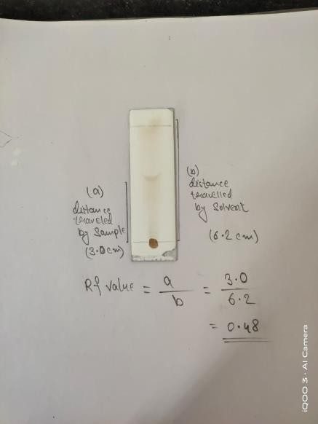
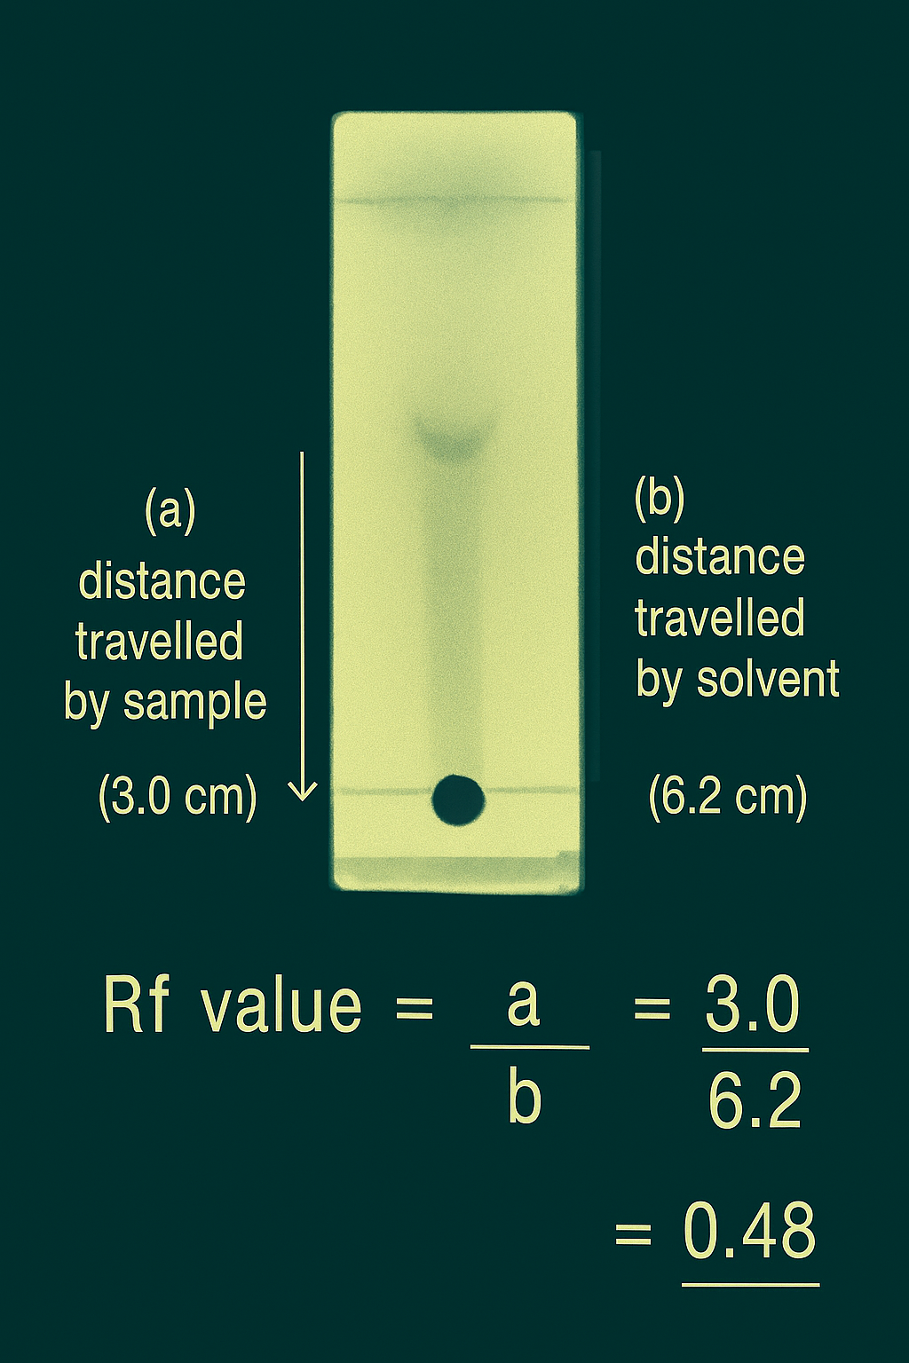

Figure 2: UV-Vis spectral overlay of the root extract (Solvent system is
n-Butanol: Acetic acid: Water (4:1:5)

Table 2. TLC solvent systems and observed R_{f} values (standard vs extract).
Solvent system (v/v/v) | Stationary phase | Standard (ascorbic acid) R_{f} | Extract R_{f} (observed) | Detection method
n-Butanol: Acetic acid: Water (4:1:5) | Silica gel 60 F₁₂₄ | 0.46 | 0.48 | UV 254 nm; DCPIP spray
Ethanol: Acetic acid (9.5:0.5) | Silica gel | 0.56 | 0.83 | UV 254 nm
Chloroform: Methanol (7:3) | Silica gel | 0.45 | 0.78 | UV 254 nm
Recommended optimal system |  |  | n-BuOH: AcOH: H₂O (4:1:5) | best match with the standard

UV-Visible Spectroscopy: The UV-Vis analysis provided further evidence of ascorbic acid in the extract. Pure ascorbic acid showed a characteristic absorbance maximum at ~243 nm (data not shown), with a minor shoulder extending to 265 nm. The amla root extract exhibited a strong absorbance peak centered around 267 nm (Figure 3). This λ_{max} is within the known UV range for vitamin C (~258–265 nm), confirming the presence of free ascorbate chromophores. The extract spectrum overlaid closely with that of the standard ascorbic acid, aside from additional minor peaks attributable to other compounds. No significant absorbance was found in the visible region, indicating negligible pigments. Thus, the spectroscopic data are consistent with the presence of ascorbic acid in the root extract.
Table 3. UV-Vis λ_{max} values for standard and root extract.
Sample | Concentration used for scan | λmax (nm) observed | Interpretation
Pure ascorbic acid (standard) | 10 µg/mL | 243 (shoulder up to 265) | Characteristic peak of ascorbate
Root extract | 10 µg/mL (equivalent) | ~267 (observed) | Peak aligns with ascorbate (minor shifts due to matrix)
Solvent blank | — | — | baseline

Table 4: UV–Visible absorption spectra of pure ascorbic acid (standard) and E. officinalis root extract (both scanned at 10 µg/mL in water)
Wavelength (nm) | Std Absorbance | Extract Absorbance
200 | 0.05 | 0.06
210 | 0.08 | 0.09
220 | 0.12 | 0.13
230 | 0.22 | 0.20
240 | 0.45 | 0.48
250 | 0.70 | 0.72
260 | 0.58 | 0.68
267 | 0.52 | 0.70
275 | 0.35 | 0.40
290 | 0.10 | 0.12
310 | 0.03 | 0.04

Figure 3: UV-Visible spectra of Emblica officinalis root extract and pure ascorbic acid.

DISCUSSION
This study provides the first focused characterization of vitamin C in Emblica officinalis roots. By applying standard phytochemical, chromatographic, and spectroscopic methods, we have demonstrated that the amla root contains appreciable ascorbic acid. The positive results of all qualitative tests (iodine, FeCl₃, AgNO₃, nitroprusside) are consistent with the classical behavior of ascorbate as a strong reducing agent. The TLC results further corroborate this: the root extract yielded an R<sub>f</sub> under the 4:1:5 butanol: acetic acid: water system identical to the reported ascorbate values. The UV-Vis λ_{max} at 267 nm essentially matches the known absorbance of ascorbic acid. Together, the data conclusively identify the compound as ascorbic acid (vitamin C).
Our optimized protocol (Soxhlet ethanol extraction followed by TLC and UV-Vis) is both simple and effective. The successful recovery of vitamin C using ethanol is consistent with other plant studies that often use polar solvents for ascorbate. For example, Scartezzini et al. [1] found that water extraction of amla fruit yielded high vitamin C, and our use of ethanol suggests that roots, like fruit, are rich in this water-soluble compound. The strong positive results of multiple diagnostic tests further confirm that the extraction captured ascorbate effectively.
In comparing our findings to the literature, E. officinalis fruit is indeed one of the richest known sources of vitamin C [2]. The fruit’s content (~0.4% dry weight) is much higher than in typical vegetables. In contrast, root tissues of plants generally have lower ascorbate levels since they are not photosynthetic, although roots do synthesize and store some ascorbate. Our results suggest that amla roots, while having lower vitamin C than fruits, still contain a notable amount. Although we did not quantify the exact concentration in this study, the strong TLC and UV responses imply it is not negligible.
From a plant physiology perspective, the presence of vitamin C in roots has functional implications. Ascorbate in roots likely contributes to the plant’s overall redox buffering capacity. It may help scavenge ROS generated by root metabolism or by stressors such as soil pathogens, drought, or salinity. Akram et al. [3] emphasize that ascorbate is a “universal non-enzymatic antioxidant” in plants, integral to detoxifying ROS under both stress and normal conditions. Although the root apoplast has lower antioxidant pools than green tissues, it still relies heavily on ascorbate for oxidative stress signaling. Hence, the ascorbate we detected in amla roots could play a role in root stress responses and defense signaling. For instance, during pathogen attack in the soil, rapid ascorbate turnover could help limit oxidative damage or trigger defense gene activation, analogous to its role aboveground.
Our findings also have practical implications. From a phytochemical standardization perspective, identifying amla root as a vitamin C source suggests that root extracts could be used as nutraceutical antioxidants or supplements. While the fruit remains the primary source, root-derived extracts could supplement vitamin C intake or serve as a feedstock for cosmetic and pharmaceutical products requiring antioxidants. Additionally, our methodology (as demonstrated by the TLC R_{f} values and UV-Vis profile) provides a simple quality control procedure for verifying ascorbate content in such extracts. Future work should quantify the yield of vitamin C per gram of root and compare it to that of the fruit, as well as evaluate the bioactivity of the root extract (e.g., in antioxidant assays or plant/animal models of oxidative stress).
Finally, our results encourage further exploration of amla root biology. The plant’s secondary metabolism may allocate resources differently to roots than other species. Investigating how and why Amla roots accumulate vitamin C could reveal new aspects of plant oxidative physiology. Ascorbate also serves as a cofactor for various enzymes and influences hormone levels (for example, it is required for ethylene synthesis via ACC oxidase). Therefore, root ascorbate might affect root growth and development in E. officinalis. Further studies could measure root ascorbate content under stress treatments or test whether root-derived compounds confer any anti-pathogenic activity in agricultural contexts.

CONCLUSION
This work established that Emblica officinalis roots contain ascorbic acid, detected and profiled by chemical tests, TLC, and UV-Vis spectroscopy. Our optimized extraction and analytical protocol reliably isolates and identifies vitamin C from amla root powder. The presence of this antioxidant in the root suggests additional roles for ascorbate in the plant’s physiology and defense – consistent with its known functions in redox homeostasis and stress tolerance [3]. These results expand the phytochemical profile of E. officinalis and provide a methodological basis for future studies on plant antioxidants in roots. In practical terms, amla root could serve as a supplementary source of vitamin C, and its antioxidant capacity may be harnessed in nutraceutical or agricultural applications.

ETHICAL STATEMENT
This study did not involve human or animal subjects. The collection of plant material complied with institutional and national guidelines.

Highlights
- Soxhlet extraction using ethanol efficiently isolates vitamin C from amla root.
- Phytochemical assays (iodine, FeCl₃, nitroprusside) indicate vitamin C presence.
- TLC with optimized solvent systems yields R_{f} values matching ascorbic acid.
- UV-Vis spectroscopy shows the extract’s absorbance peak aligns with vitamin C.
- Root ascorbate suggests antioxidant defense and stress resilience

REFERENCES
- Scartezzini P, Antognoni F, Raggi MA, Poli F, Sabbioni C. Vitamin C content and antioxidant activity of the fruit and of the Ayurvedic preparation of Emblica officinalis Gaertn. J Ethnopharmacol. 2006;104(1-2):113-118. DOI:10.1016/j.jep.2005.08.065.
- Chakraborthy GS. Quantitative estimation of ascorbic acid by HPTLC in different varieties of Amla (Phyllanthus emblica Linn.). J Young Pharm. 2009;1(1):82-85. DOI:10.4103/0975-1483.51878.
- Akram NA, Shafiq F, Ashraf M. Ascorbic acid – a potential oxidant scavenger and its role in plant development and abiotic stress tolerance. Front Plant Sci. 2017;8:613. DOI:10.3389/fpls.2017.00613.
- Majeed, M., Bhat, B., Jadhav, A. N., Srivastava, J. S., & Nagabhushanam, K. (2009). Ascorbic Acid and Tannins from Emblica officinalis Gaertn. Fruits A Revisit. Journal of Agricultural and Food Chemistry, 57(1), 220-225.
- Sawant, L., Prabhakar, B., & Pandita, N. (2010). Quantitative HPLC analysis of ascorbic acid and gallic acid in Phyllanthus emblica. J. Anal. Bioanal. Tech, 1(2).
- Bansal, V., Sharma, A., Ghanshyam, C., & Singla, M. L. (2015). Rapid HPLC Method for determination of vitamin C, phenolic acids, hydroxycinnamic acid, and flavonoids in seasonal samples of Emblica officinalis juice. Journal of liquid chromatography & related technologies, 38(5), 619-624.
- Li, Y., Guo, B., Wang, W., Li, L., Cao, L., Yang, C., ... & Zhang, L. (2019). Characterization of phenolic compounds from Phyllanthus emblica fruits using HPLC-ESI-TOF-MS as affected by an optimized microwave-assisted extraction. International Journal of Food Properties, 22(1), 330-342.
- Gantait, S., Mahanta, M., Bera, S., & Verma, S. K. (2021). Advances in biotechnology of Emblica officinalis Gaertn. syn. Phyllanthus emblica L.: a nutraceuticals-rich fruit tree with multifaceted ethnomedicinal uses. 3 Biotech, 11(2), 62.
- Kaur, J., Kaur, D., Singh, H., & Khan, M. U. (2013). Emblica officinalis: A meritocratic drug for treating various disorders. Indo Am. J. Pharm. Res, 3(6).
- Madhavi, N., Kumar, D., Naman, S., Singh, M., Singh, P. A., Bajwa, N., & Baldi, A. (2019). Formulation and Evaluation of Novel Herbal Formulations Incorporated with Amla Extract for Improved Stability. Journal of Drug Delivery & Therapeutics, 9(4).

