Enhanced New Donepezil Analogues: In Silico Design for Human Acetylcholinesterase Inhibition

.
ABSTRACT
Alzheimer's disease (AD) accounts for 60 to 70% of dementias worldwide. This condition is primarily associated with the decrease in acetylcholine (ACh) levels, due to the action of human acetylcholinesterase (AChE). The absence of a curative treatment for this pathology highlights the urgency to develop options that are more effective. This study aims to design new analogues of donepezil optimized for the effective inhibition of human AChE. Using a physics-based computer-aided molecular design (CAMD) approach, we developed a reliable quantitative structure-activity relationship (QSAR) model utilizing the crystallographic structure of AChE (PDB code: 7E3H) along with a series of 45 donepezil-derived molecules, comprising 32 for the training set and 13 for the validation set. The established QSAR model (${pIC}_{50}^{exp}=-0.1837×∆∆G_{com}+8.4845$) explains 95% of the variation in experimental biological activity (${pIC}_{50}^{exp}$) based on the variation in binding free energy (∆∆G_{com}). The variation in binding free energy in the biological environment is given by the equation: ${∆G}_{com}={∆G}_{binding}-T∆S+{∆G}_{solv}$. Analysis of the binding mode of inhibitors at the active site of human AChE, along with the individual contributions of active site residues to the interaction energy, allowed us to select relevant molecular substituents for the design of new analogues. Using an intuitive substitution method, a series of 59 new, more effective analogues of donepezil (DPZA) were designed, notably: DPZA46 (${IC}_{50}^{pre}=18 pM$), DPZA36 (${IC}_{50}^{pre}=31 pM$), DPZA20 (${IC}_{50}^{pre}=39 pM$). The best-designed DPZA analogues exhibit a favorable theoretical pharmacokinetic profile. The stability of the best-designed DPZA inhibitors and their complexes formed with AChE has been confirmed through molecular dynamics simulations, thereby validating the obtained active conformations.

Keywords: Alzheimer’s Disease; Quantitative Structure-Activity Relationships (QSAR); Human Acetylcholinesterase (AChE); Molecular docking; Free fixation energy; ADME

1. INTRODUCTION
Alzheimer's disease (AD) is a progressive and destructive neurodegenerative condition [1], representing the leading cause of dementia globally, accounting for 60 to 70% of cases [2]. In 2021, approximately 57 million people were affected by dementia, and this number could reach 139 million by 2050 [2, 3]. AD has a significant impact on healthcare systems [4, 5], with an estimated annual cost of $1.3 trillion in 2019, which is expected to more than double by 2030 to reach $2.8 trillion [3]. Alzheimer's disease is characterized by a progressive decline in cognitive function, manifested by memory impairments, speech difficulties, and spatial-temporal disorientation, leading to a loss of autonomy [4, 6].

The pathogenesis of AD is complex and influenced by several factors, including the accumulation of amyloid plaques, the formation of neurofibrillary tangles, and a significant decrease in acetylcholine (ACh) levels [4, 7, 8]. Acetylcholine (ACh) is a crucial neurotransmitter for perception and memory [9], whose degradation is catalyzed by the enzyme acetylcholinesterase (AChE). This enzyme acts rapidly, hydrolyzing ACh into acetate and choline, thereby interrupting neurotransmission at cholinergic synapses [10]. Consequently, research on AChE in the context of Alzheimer's disease has become a promising area of study [11]. Moreover, current research indicates that enhancing cholinergic neurotransmission in the brain, particularly through AChE inhibition, is the most effective treatment for Alzheimer's disease [11, 12]. Among therapeutic strategies, AChE inhibitors, such as donepezil derivatives, are essential for slowing the progression of symptoms [13, 14]. Given the increasing prevalence of Alzheimer's disease [2] and the limited efficacy of current treatments (Figure 1), often accompanied by side effects such as nausea, vomiting, and cardiovascular issues, the search for new therapeutic molecules is more critical than ever [15, 16]. Despite scientific advancements, no curative treatment currently exists, making the development of more effective treatments essential.

This study aims to design in silico new optimized analogues of donepezil to inhibit AChE with improved efficacy and ADME properties. In silico approaches, such as molecular modeling, docking, and quantitative structure-activity relationship (QSAR) analysis, provide powerful tools for designing and evaluating new AChE inhibitors [17]. These methods allow for the study of ligand-target interactions, optimization of binding affinity, and improvement of pharmacokinetic properties, while reducing costs and time associated with experimental trials [18, 19].

Recent studies have demonstrated their effectiveness in the discovery of anti-Alzheimer compounds, particularly through QSAR modeling and the analysis of ADMET (Absorption, Distribution, Metabolism, Excretion, and Toxicity) parameters [20]. Based on the crystallographic structure of human AChE in complex with donepezil (PDB code: 7E3H) crystallized by Deelip et al. [21] and a set of 45 donepezil-derived molecules (DPZ) synthesized by Azusada et al. [22], including 32 in the training set (TS) and 13 in the validation set (VS), we first developed a QSAR model for the binding of DPZ ligands to the active site of human AChE. We then evaluated the individual contributions of the active site residues of human AChE to the interaction energy. Subsequently, using the intuition-based substitution method, we identified a series of analogues derived from donepezil (DPZA) and evaluated their predicted inhibitory activities. Finally, the pharmacokinetic properties of these new DPZA were analyzed.
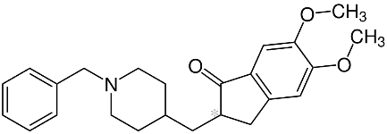 | 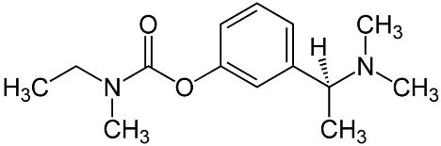 | 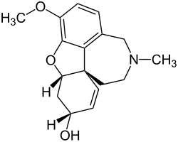
Donepezil | Rivastigmine | Galantamine
Figure 1 : Anti-AChE drugs available on the market

2. material and methods
In this study, we applied computer-aided molecular design (CAMD) techniques to optimize therapeutic molecules. These methods establish relationships between the structure and physicochemical properties of protein-ligand complexes and the biological activities (${IC}_{50}^{exp}$) of small-molecule inhibitors. This approach enables the identification of substituents or structural modifications that may enhance biological activity. Several previous studies have demonstrated the effectiveness of this methodology [23-28]. Pic 1 outlines the key steps in the design of improved DPZA inhibitors.

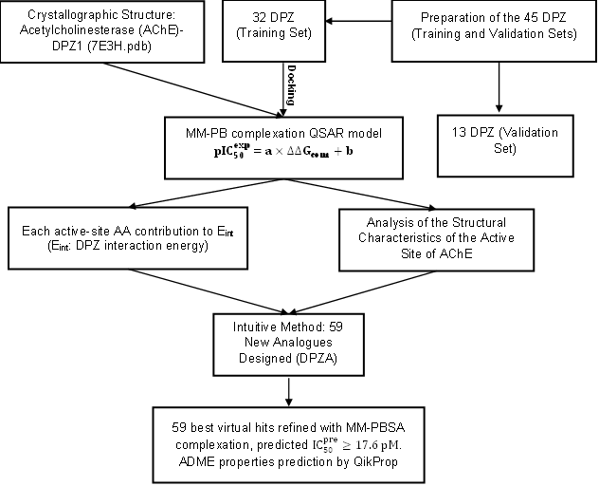
pic 1: Flow diagram of the computer-aided drug design approach that led to the design of improved DPZA analogues that effectively inhibit the human AChE.

- Training and Validation Sets
The experimental activities of the published DPZ inhibitors (${IC}_{50}^{exp}$) used in this work come from the study by Azusada et al. [22]. The half-maximal inhibitory concentrations (${IC}_{50}^{exp}$) values of the DPZ cover a relatively wide range of three orders of magnitude (2.9 nM ≤ ${IC}_{50}^{exp}$≤ 3632 nM) [22], allowing for the construction of a reliable QSAR model. To achieve this, the DPZ were divided into two sets (Table 1), with 32 DPZ assigned to the training set (TS) and 13 DPZ to the validation set (VS), following the OECD criteria [29].

- Model building
The molecular model of human AChE (PDB code: 7E3H) [21] used in this study is composed of two monomers: A and B. Following analysis with Discovery Studio software [30], monomer A was selected as the donepezil-bound complex [21]. The water molecules were removed from the crystal structure. After correction, a pre-minimization was performed using the Smart Minimizer algorithm [30] before docking to preserve the enzyme's secondary structure.

- Molecular Mechanics
The structures of DPZ ligands and AChE-DPZ complexes were modeled by molecular mechanics (MM) using the CHARMm force field [30], using previously reported [24-26].

- Solvation Gibbs free energies
To account for the effect of ionic strength in a biological environment, we calculated the electrostatic component of the solvation free energy (GFE) using the nonlinear Poisson-Boltzmann equation [31-33] with the DelPhi module of Discovery Studio [30], employing the CHARMm force field [30]. The solvent is modeled with a dielectric constant of 80, while the solute is confined within a molecular cavity characterized by a dielectric constant of 4. The details have been reported previously [23, 25, 26, 34, 35].
- Molecular Docking and QSAR Model
In this study, we employed molecular docking to simulate the binding of DPZ inhibitors to the active site of human AChE. This technique plays a central role in computer-aided drug design and discovery (CADDD) [36]. It allows for modeling the binding mode of ligands to the active site of the target protein, predicting protein-ligand interactions, and estimating binding affinity [37, 38]. The docking algorithm, CHARMm-based DOCKER (CDOCKER), implemented in DS [30], was used to dock the 32 DPZ inhibitors from TS to the active site of AChE. The choice of the CDOCKER algorithm is based on its ability to efficiently explore the conformational space of the ligand [39-41] and to generate multiple initial orientations of the ligand within the active site of the target protein [42]. This enhances the accuracy and efficiency of the docking process [43]. After the selection of poses following docking, each protein-ligand complex underwent a complete minimization, as described in sections 2.1-2.3. Subsequently, the binding energy (G_{binding}) was calculated using the "Calculate Binding Energies" protocol from DS [30]. Thereafter, the electrostatic component of the solvation energy was calculated according to the description in section 2.4. Finally, two QSAR models were developed: one correlating the relative change in binding energy (ΔΔG_{binding}) with the ${IC}_{50}^{exp}$ values of the 32 DPZ inhibitors from TS [${pIC}_{50}^{exp} = f({∆∆G}_{binding})$], and the other correlating the relative change in Gibbs free energy (GFE: ΔΔG_{com}) of complex formation with the ${IC}_{50}^{exp}$ values of the 32 DPZ inhibitors from TS [${pIC}_{50}^{exp} = f({∆∆G}_{com})$]. The binding energy (ΔΔG_{binding}) and the relative change in Gibbs free energy (ΔΔG_{com}) of complex formation are obtained according to the following relationships:
ΔG_{binding} = G_{complex} – G_{ligand} – G_{receptor} (1)
ΔΔG_{binding} (AChE-L_{x}) = ΔG_{binding}(AChE-L_{x})-ΔG_{binding}(AChE-L_{ref}) (2)
ΔG_{com} = ΔG_{binding} – TΔS + ΔG_{Solv} (3)
ΔΔG_{com} (AChE-L_{x}) = ΔG_{com}(AChE-L_{x}) - ΔG_{com}(AChE-L_{ref}) (4)
${pIC}_{50}^{exp} = -\log_{10}\left({IC}_{50}^{exp}\right)$ (5)
ΔG_{binding}: Binding energy of complex; G_{complex}: Energy of the protein-ligand complex; G_{Ligand}: Energy of the free ligand; G_{Receptor}: Energy of the protein.
ΔG_{com}: Gibbs free energy (GFE); TΔS: The entropic contribution to the GFE of complex formation (P:L); ΔG_{Solv}: The contribution of the solvation effect to the GFE of complex formation (P:L); L_{ref} : the reference ligand DPZ1.
The predictive power of the equation 6 was used as a target-specific scoring function for human AChE to estimate the predicted inhibitory activity (${pIC}_{50}^{pre}$) of the newly designed DPZA analogs [23, 26, 28, 44].

$${pIC}_{50}^{pre}=-\log_{10}{IC}_{50}^{pre}=a×∆∆G_{com}+b (6)$$
- Interaction Energy
The non-bonded interactions between the atoms of the AChE-DPZx complexes were evaluated using the "Calculate Interaction Energy" protocol in Discovery Studio [30], employing molecular mechanics (MM). These calculations were performed with the CHARMm force field [30] and a relative permittivity of 4. The analysis of the interaction energy (E_{int}) protein-ligand diagrams, broken down into individual contributions from active site residues, allows for the identification of residues influencing ligand binding, as well as structural modifications of the ligands that may enhance their biological activity [25, 26, 44].
- ADME properties
The absorption, distribution, metabolism, and excretion (ADME) properties of the new DPZA analogues were evaluated using QikProp from Schrödinger [45]. The details of the methodology employed have been reported previously [23, 25, 26, 28, 44].
- Molecular dynamics (MD) and MMGBSA binding free energy
To evaluate the structural stability of the most active inhibitor from the training set (DPZ1) as well as that of the three best-designed analogues (DPZA46, DPZA36, and DPZA20), molecular dynamics simulations were conducted on the complexes formed with AChE. These simulations provide crucial information regarding the structural and dynamic properties of the molecular systems. The Desmond module of Schrodinger 2018-4 [46] was utilized to perform these simulations over a duration of 200 ns, following the protocol described previously [44, 47, 48].
After these simulations, we calculated the variations in binding energy during complex formation using the Molecular Mechanics/Generalized Born Surface Area (MM-GBSA) method [49]. The Prime MM-GBSA tool from Schrodinger 2018-4 [46] was employed, utilizing the OPLS_2005 force field and the VSGB 2.0 implicit solvent model [50]. The average variation in binding energy (∆G_{BindMMGBSA}) was determined from the 500 frames of the simulation trajectory. Details of the MM-GBSA methodology have been reported previously [51].

Table 1. Training set (TS) and validation set (VS) of DPZ inhibitors [22] utilized in the development of the QSAR model for AChE inhibition. The molecular scaffold of DPZ and its building blocks (R-groups) are illustrated.
R
$$DPZx-{IC}_{50}^{exp}$$
Training Set
DPZ1 - 2.9 nM | DPZ2 - 4.4 nM |  | DPZ3 - 4.6 nM | DPZ4 - 5.4 nM |  | DPZ5 - 6.4 nM | DPZ6 - 9.4 nM
DPZ7 - 9.6 nM | DPZ8 - 9.7 nM |  | DPZ9 - 9.7 nM | DPZ10 - 10 nM |  | DPZ11 - 10.2 nM | DPZ12 - 10.6 nM
DPZ13 - 11 nM | DPZ14 - 11.3 nM |  | DPZ15 - 11.8 nM | DPZ16 - 12.3 nM |  | DPZ17 - 14.8 nM | DPZ18 - 21 nM
DPZ19 - 24.5 nM | DPZ20 - 37.9 nM |  | DPZ21 - 43.1 nM | DPZ22 - 49.4 nM |  | DPZ23 - 50.8 nM | DPZ24 - 57 nM
DPZ25 - 75.8 nM | DPZ26 - 102.5 nM |  | DPZ27 - 187 nM | DPZ28 - 215.4 nM |  | DPZ29 - 541.5 nM | DPZ30 - 548 nM
DPZ31 - 2377.8 nM |  |  |  | DPZ32 - 3632 nM
Validation Set
DPZ33 - 4.3 nM | DPZ34 - 39.5 nM | DPZ35 - 104.3 nM |  | DPZ36 - 131.3 nM | DPZ37 - 132.7 nM |  | DPZ38 - 181.3 nM
DPZ39 - 209.5 nM | DPZ40 - 237.7 nM | DPZ41 - 287.9 nM |  | DPZ42 - 376.8 nM | DPZ43 – 403.1 nM |  | DPZ44 - 523.6 nM
DPZ45 - 690.9 nM

3. results and discussion
- QSAR Model of AChE inhibition
In this study, we utilized acetylcholinesterase (AChE) inhibitors derived from donepezil (DPZ), based on the work of Azusada et al. [22]. A total of 45 DPZ, available with their experimental values (${IC}_{50}^{exp}$), were analyzed, divided into a training set of 32 DPZ and a validation set of 13 DPZ. The Gibbs free energy values (ΔG_{com}) for the AChE-DPZx complexes, along with their components (ΔGb_{inding}, TΔS, and ΔG_{Solv}), are presented in Table 2. Two quantitative structure-activity relationship (QSAR) models were developed: the first correlates the relative change in binding energy (ΔΔG_{binding}) with the inhibition potential (${pIC}_{50}^{exp}$) of the 32 ligands (Figure 2.A), while the second correlates the relative change in Gibbs free energy (ΔΔG_{com}) with ${pIC}_{50}^{exp}$ (Figure 2.B).
Table 2. Gibbs free energy (binding affinity, ∆∆G_{com}) and its components calculated for the training set of AChE inhibitors DPZ1-32 and validation set inhibitors DPZ33-45 [22]

Training Set | ΔG_{binding} [kcal.mol⁻¹] | TΔS [kcal.mol⁻¹] | ΔG_{Solv} [kcal.mol⁻¹] | ΔG_{com} [kcal.mol⁻¹] | ΔΔG_{com} [kcal.mol⁻¹] | $${pIC}_{50}^{exp}$$
DPZ1 | -47.4 | 20.4 | -700.0 | -767.8 | 0.0 | 8.54
DPZ2 | -46.4 | 20.3 | -699.6 | -766.3 | 1.5 | 8.36
DPZ3 | -45.6 | 20.4 | -699.4 | -765.4 | 2.4 | 8.34
DPZ4 | -46.8 | 20.4 | -699.6 | -766.7 | 1.0 | 8.27
DPZ5 | -47.1 | 20.5 | -697.2 | -764.8 | 3.0 | 8.19
DPZ6 | -45.4 | 20.5 | -699.2 | -765.1 | 2.7 | 8.03
DPZ7 | -43.8 | 20.5 | -699.0 | -763.3 | 4.5 | 8.02
DPZ8 | -45.6 | 20.5 | -699.0 | -765.1 | 2.6 | 8.01
DPZ9 | -44.1 | 20.4 | -701.5 | -766.0 | 1.8 | 8.01
DPZ10 | -43.5 | 20.8 | -700.5 | -764.8 | 3.0 | 8.00
DPZ11 | -46.2 | 20.2 | -700.2 | -766.6 | 1.2 | 7.99
DPZ12 | -44.7 | 20.5 | -700.0 | -765.2 | 2.6 | 7.97
DPZ13 | -45.7 | 20.5 | -698.7 | -764.9 | 2.9 | 7.96
DPZ14 | -44.3 | 20.7 | -698.3 | -763.3 | 4.5 | 7.95
DPZ15 | -44.7 | 20.4 | -699.5 | -764.6 | 3.2 | 7.93
DPZ16 | -44.8 | 20.6 | -699.0 | -764.5 | 3.3 | 7.91
DPZ17 | -44.8 | 20.5 | -699.7 | -765.0 | 2.7 | 7.83
DPZ18 | -44.5 | 20.5 | -698.1 | -763.1 | 4.6 | 7.68
DPZ19 | -44.9 | 20.6 | -698.8 | -764.3 | 3.5 | 7.61
DPZ20 | -42.7 | 20.5 | -698.8 | -762.1 | 5.7 | 7.42
DPZ21 | -43.7 | 20.5 | -698.8 | -763.0 | 4.8 | 7.37
DPZ22 | -43.3 | 20.7 | -698.2 | -762.2 | 5.6 | 7.31
DPZ23 | -42.8 | 20.7 | -697.3 | -760.8 | 7.0 | 7.29
DPZ24 | -41.2 | 20.7 | -699.5 | -761.4 | 6.4 | 7.24
DPZ25 | -42.9 | 20.4 | -699.1 | -762.3 | 5.5 | 7.12
DPZ26 | -40.7 | 20.2 | -699.6 | -760.5 | 7.3 | 6.99
DPZ27 | -37.9 | 20.8 | -700.1 | -758.8 | 9.0 | 6.73
DPZ28 | -38.3 | 20.7 | -697.5 | -756.5 | 11.3 | 6.67
DPZ29 | -37.3 | 20.7 | -697.9 | -755.9 | 11.9 | 6.27
DPZ30 | -35.4 | 20.8 | -698.5 | -754.7 | 13.1 | 6.26
DPZ31 | -36.8 | 20.9 | -694.8 | -752.5 | 15.3 | 5.62
DPZ32 | -32.1 | 21.0 | -698.6 | -751.7 | 16.1 | 5.44
Validation Set | ΔG_{binding} [kcal.mol⁻¹] | ΔG_{Solv} [kcal.mol⁻¹] | ΔG_{com} [kcal.mol⁻¹] | $${pIC}_{50}^{theo}$$ | $${pIC}_{50}^{pre}/{pIC}_{50}^{exp}$$
DPZ33 | -46.0 | -699.1 | -765.6 | 8.09 | 0.97
DPZ34 | -42.5 | -697.9 | -761.1 | 7.26 | 0.98
DPZ35 | -42.4 | -697.7 | -760.8 | 7.20 | 1.03
DPZ36 | -40.3 | -696.8 | -757.5 | 6.60 | 0.96
DPZ37 | -41.3 | -698.8 | -760.7 | 7.19 | 1.05
DPZ38 | -40.4 | -697.0 | -757.9 | 6.67 | 0.99
DPZ39 | -38.4 | -699.8 | -758.8 | 6.84 | 1.02
DPZ40 | -39.6 | -698.5 | -758.8 | 6.84 | 1.03
DPZ41 | -38.0 | -698.6 | -756.8 | 6.47 | 0.99
DPZ42 | -39.3 | -696.1 | -756.2 | 6.35 | 0.99
DPZ43 | -38.0 | -699.7 | -758.5 | 6.77 | 1.06
DPZ44 | -39.4 | -698.7 | -758.6 | 6.81 | 1.08
DPZ45 | -39.7 | -699.0 | -759.4 | 6.95 | 1.13

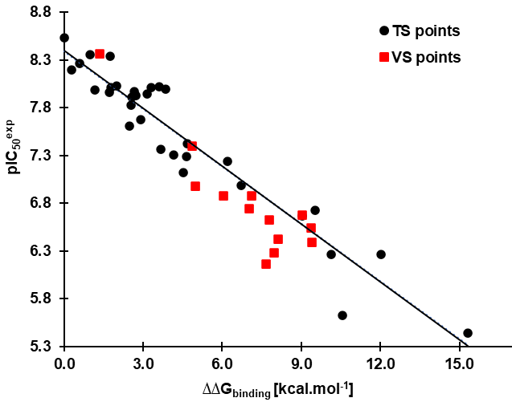 | 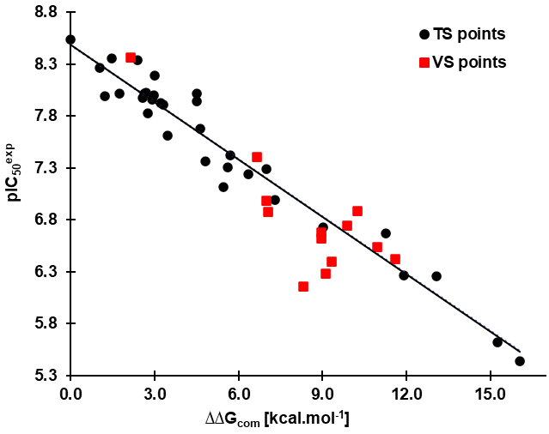
A B
Figure 2. A. Graph of the correlation between ${pIC}_{50}^{exp}$ and the binding energy component ΔΔG_{binding} of the GFE both in kcal⋅mol⁻¹. B. Similar correlation established for the GFE of P:L complex formation ∆∆G_{com} for the AChE-DPZx complexes [22]. The black points represent the data points from the training set (VS), while the red squares indicate the data points from the validation set (VS).
The equations derived from the linear regression lines and the values of the statistical parameters (reliability indicators) for the two QSAR models are presented in Table 3. These statistical parameters indicate strong correlations between the calculated quantities (∆∆G_{binding}, ∆∆G_{com}) and the experimental observations of ${pIC}_{50}^{exp}$. QSAR models based on single descriptors demonstrate that the molecular structures of AChE-DPZx complexes incorporate the most significant features crucial for the inhibitory activity of DPZ.
Table 3. Regression analysis of computed binding affinities ∆∆G_{com}, its binding energy component ∆∆G_{binding} *, and experimental half-maximal inhibitory concentrations ${pIC}_{50}^{exp}=-\log_{10}{{IC}_{50}^{exp}}$ of DPZ towards AChE.
Statistical data of linear regression | (A) | (B)
${pIC}_{50}^{exp}=-0.2016×∆∆G_{binding}+8.3995$ (A)
${pIC}_{50}^{exp}=-0.1837×∆∆G_{com}+8.4845$ (B)
Number of compounds n | 32 | 32
Squared correlation coefficient of regression $R^{2}$ | 0.92 | 0.95
Leave-one-out cross-validated squared correlation coefficient $R_{xv}^{2}$ | 0.91 | 0.95
Standard error of regression σ | 0.23 | 0.18
Statistical significance of regression, Fisher F-test | 324.21 | 577.57
Level of statistical significance α | > 95% | > 95%
Range of half-maximal inhibitory concentrations ${IC}_{50}^{exp}$ [nM] | 2.9 - 3632
* ∆∆G_{com} and ∆∆G_{binding} are in [kcal·mol⁻¹].
High correlation coefficients and the results of the Fisher test for equations (A) and (B) presented in Table 3 indicate that these binding models account for a substantial portion of the variation in the inhibitory activities of DPZ. The QSAR model [${pIC}_{50}^{exp} = f({∆∆G}_{com})$] considers, in addition to ligand-receptor interactions (∆∆G_{binding}), the solvent effect (∆∆G_{solv}) and the entropic term (T∆∆S) at a temperature of 298.15 K. The inclusion of entropy variation in QSAR models enhances their predictive capacity [52, 53] and contributes to the reliability of the predictions [54-56]. The validity of the developed binding model was confirmed by calculating the ratio between predicted and experimental values (${pIC}_{50}^{pre}/{pIC}_{50}^{exp}$) for the DPZ in the validation set, where ${pIC}_{50}^{pre}$ was determined using regression equation B presented in Table 3. This ratio approaches the theoretical value of 1 for all DPZ in the validation set (Table 2), supporting the considerable predictive power of the QSAR complexation model. Therefore, correlation equation B and the estimated values of ∆∆G_{com} can be used to predict the inhibitory activity of new DPZ analogs, provided they exhibit a similar binding mode at the active site of AChE as the DPZ molecules in the training set.
- Binding mode of DPZ
We analyzed the interactions between the AChE enzyme and two ligands from TS: the most active ligand, DPZ1(${IC}_{50}^{exp}=2.9 nM$), and the least active ligand, DPZ32(${IC}_{50}^{exp}=3632 nM$), based on the conformations obtained through molecular docking (Figure 3).
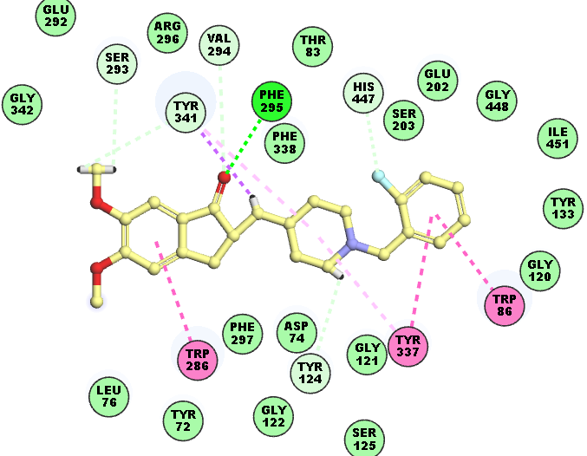 | 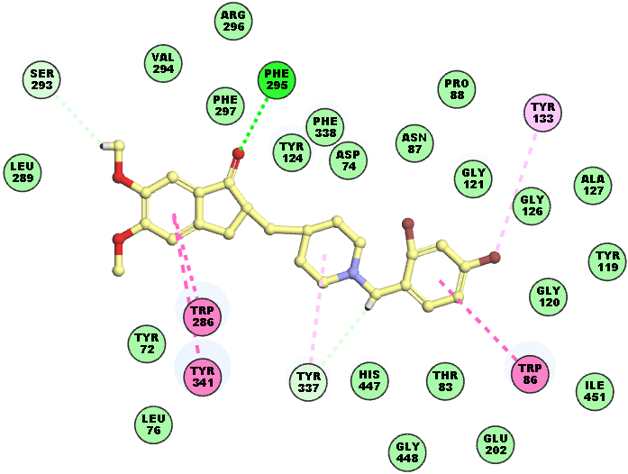
A | B
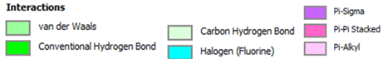
Figure 3. A. 2D interaction diagram of the most potent inhibitor DPZ1 at the active site of AChE. B. 2D interaction diagram of the inhibitor DPZ32 at the active site of AChE. Carbon atoms are coloured yellow for the ligands DPZ1, DPZ32.
Structural information derived from the AChE-DPZx complexes, formed following molecular docking and minimized using the MM method, allows for the identification of key interactions that may explain the inhibitory activity of DPZ against AChE. These interactions primarily consist of hydrogen bonds, van der Waals interactions, and hydrophobic contacts. In the AChE-DPZ1 and AChE-DPZ32 complexes, only the Phe295 residue of the acylation site establishes a hydrogen bond with the ligands DPZ1 and DPZ32 (Figure 3.A and 3.B). In Figure 3, the residues Trp86 and Tyr337 from the catalytic site (CAS), as well as the residue Trp286 from the peripheral aromatic site (PAS), establish "Pi-Pi Stacked" interactions with the ligand DPZ1 (Figure 3.A), similar to the interactions observed between the residues Trp86, Trp286, and Tyr341 with the ligand DPZ32 (Figure 3.B). Notably, the Tyr341 residue exhibits a Pi-Sigma interaction with the ligand DPZ1 (Figure 3.A), while this interaction is not observed with the ligand DPZ32. Pi-Alkyl interactions are noted between the ligand DPZ1 and the residues Tyr337 and Tyr341 (Figure 3.A), whereas the residues Tyr133 and Tyr337 establish such interactions with the ligand DPZ32 (Figure 3.B). Additionally, the residues Tyr124, Ser293, Val294, Tyr341, and the catalytic residue His447 engage in carbon-hydrogen bond interactions with the ligand DPZ1 (Figure 3.A), while only the residues Ser293 and Tyr337 form such interactions with the ligand DPZ32 (Figure 3.B). In Figure 3.A and 3.B, it is also observed that the majority of the active site residues of AChE exhibit van der Waals interactions with the ligands DPZ1 and DPZ32.
- Interaction Energy
The individual contributions of the active site residues of AChE to the interaction energy (∆E_{int}) were calculated for the ligands in the training set (TS), which were categorized into three classes based on their activity (high, moderate, and low), with four ligands per class (Figure 4). The decomposition of the interaction energy into individual contributions is crucial for the appropriate selection of R-groups in the design of new DPZ analogues, which could enhance their affinity for the active site of AChE and strengthen their inhibitory potential. Quantitative analysis of the contributions from the van der Waals component of the interaction energy (∆E_{int_vdW}) reveals a decrease in the energetic contributions from the residues Leu76, Gly120, Ser203, Ser293, Val294, Phe297, and His447 (Figure 4) when transitioning from the more active DPZx ligands to the less active ones. Furthermore, the majority of ΔE_{int_vdW} arises from the interactions of DPZx with the residues Asp74, Trp86, Tyr124, Trp286, Tyr337, Tyr338, and Tyr341 (Figure 4).

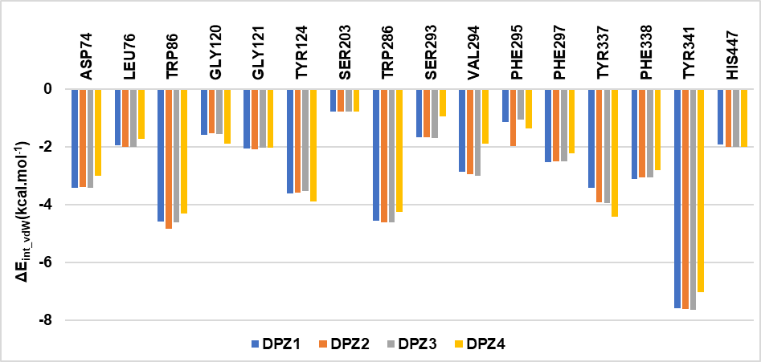
A
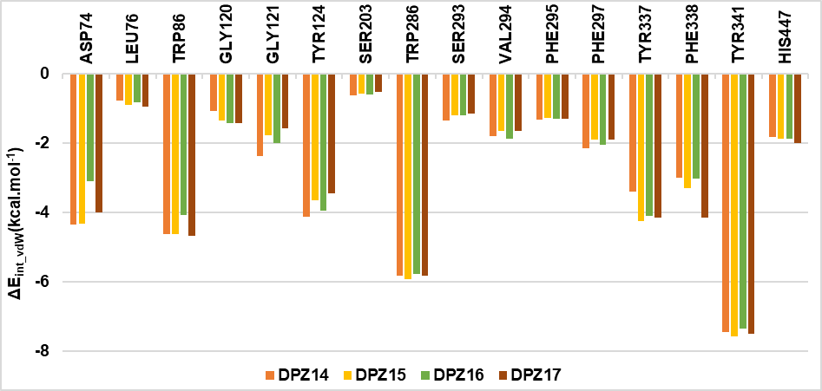
B
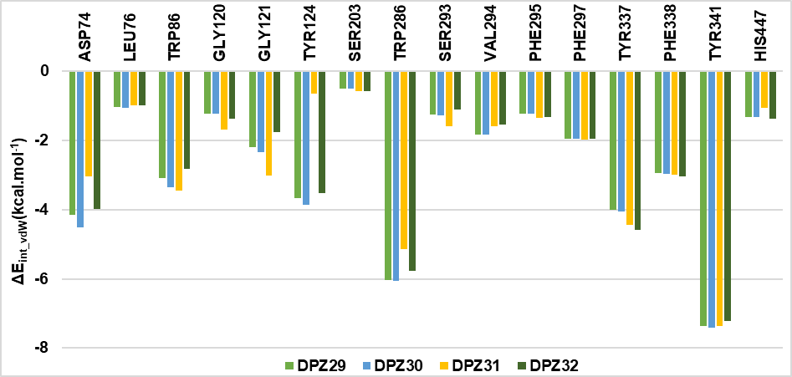
C
Figure 4. The van der Waals contributions to enzyme-inhibitor interaction energy (ΔE_{int_vdW}, in kcal·mol⁻¹) are shown for selected active site residue of AChE and selected training set DPZx analogues [22]. A. Most active DPZ inhibitors. B. Moderately active inhibitors. C. Fewer active inhibitors. The colour coding refers to the DPZ indicated in the legend.
- New DPZ analogues
We employed the intuitive substitution approach [25, 26] in the design of new analogues of donepezil derivatives (DPZA). This approach involves integrating molecular fragments that optimally occupy the target pockets, thereby increasing their affinity for the residues within those pockets and consequently enhancing the inhibitory potential of the newly designed analogues. The selection of appropriate substituents (R groups) was guided, on one hand, by information derived from qualitative and quantitative analyses of the binding mode of DPZx ligands to the active site of AChE, conducted in sections 3.2 and 3.3, respectively, and on the other hand, by the characteristics of the active site pocket of human AChE. The substituents (R groups) utilized during the design of the DPZAs are listed in Table 4. They were attached at the R position of the molecular scaffold to correspond to the substitution scheme of the DPZx ligands from the training and validation sets.
Table 4. Molecular substituents used in the design of new DPZA analogues
R
A1 | A2 | A3 | A4 | A5 | A6
A7 | A8 | A9 | A10 | A11 | A12
A13 | A14 | A15 | A16 | A17 | A18
A19 | A20 | A21 | A22 | A23 | A24
A25 | A26 | A27 | A28 | A29 | A30
A31 | A32 | A33 | A34 | A35 | A36
A37 | A38 | A39 | A40 | A41 | A42
A43 | A44 | A45 | A46 | A47 | A48
A49 | A50 | A51 | A52 | A53 | A54
A55 | A56 | A57 | A58 | A59
Thus, this approach enabled us to design a series of 59 new DPZAs, of which the best candidates exhibit a predicted inhibitory activity (${IC}_{50}^{pre}$) in the picomolar range. The predicted activity (${IC}_{50}^{pre}$) of each new analogue was determined using equation B from the RQSA complexation model. The Gibbs free energy (GFE) of complexation and its components for each new DPZA analogue were calculated under the same conditions as those for the DPZ in the training and validation sets. These results are detailed in Table 5.
Table 5. Gibbs Free Energy of complexation and its components, predicted inhibitory activity (${IC}_{50}^{pre}$) of the 59 newly designed DPZ Analogues (DPZA)
N° | New DPZ analogues | M_{w} ª  [g⋅mol⁻¹] | ΔG_{binding} [kcal.mol⁻¹] | TΔS [kcal.mol⁻¹] | ΔG_{Solv} [kcal.mol⁻¹] | ΔG_{com} [kcal.mol⁻¹] | ΔΔG_{com} [kcal.mol⁻¹] | ${IC}_{50}^{pre}$ ^{b}  [pM]
Ref. | DPZ1 | 397 | -47.4 | 20.4 | -700.0 | -767.8 | 0.0 | 2900*
1 | DPZA1 | 404 | -42.9 | 20.4 | -700.2 | -763.5 | 4.2 | 19715
2 | DPZA2 | 387 | -40.3 | 20.3 | -699.1 | -759.7 | 8.0 | 98334
3 | DPZA3 | 385 | -46.2 | 20.3 | -700.6 | -767.0 | 0.7 | 4453
4 | DPZA4 | 359 | -41.9 | 20.1 | -700.8 | -762.8 | 5.0 | 26848
5 | DPZA5 | 395 | -48.8 | 20.4 | -698.5 | -767.7 | 0.1 | 3373
6 | DPZA6 | 411 | -47.4 | 20.4 | -699.7 | -767.5 | 0.3 | 3716
7 | DPZA7 | 424 | -49.8 | 20.6 | -696.6 | -767.0 | 0.8 | 4562
8 | DPZA8 | 505 | -49.6 | 20.9 | -698.9 | -769.4 | -1.6 | 1659
9 | DPZA9 | 404 | -49.4 | 20.5 | -700.9 | -770.8 | -3.0 | 923
10 | DPZA10 | 606 | -50.5 | 21.3 | -700.9 | -772.8 | -5.0 | 397
11 | DPZA11 | 386 | -49.3 | 20.3 | -700.3 | -769.9 | -2.1 | 1335
12 | DPZA12 | 430 | -50.0 | 20.6 | -698.4 | -769.0 | -1.3 | 1918
13 | DPZA13 | 557 | -49.5 | 21.2 | -699.2 | -769.9 | -2.1 | 1328
14 | DPZA14 | 521 | -54.3 | 21.0 | -701.7 | -777.1 | -9.3 | 63
15 | DPZA15 | 410 | -53.2 | 20.4 | -698.4 | -772.0 | -4.3 | 539
16 | DPZA16 | 513 | -56.7 | 21.0 | -696.2 | -773.8 | -6.1 | 251
17 | DPZA17 | 503 | -52.2 | 20.9 | -697.3 | -770.4 | -2.7 | 1068
18 | DPZA18 | 636 | -55.5 | 21.3 | -699.5 | -776.3 | -8.5 | 89
19 | DPZA19 | 408 | -48.8 | 20.5 | -700.9 | -770.1 | -2.4 | 1211
20 | DPZA20 | 651 | -58.2 | 21.4 | -698.7 | -778.3 | -10.5 | 39
21 | DPZA21 | 525 | -49.3 | 21.0 | -696.1 | -766.4 | 1.3 | 5773
22 | DPZA22 | 622 | -53.8 | 21.5 | -695.8 | -771.1 | -3.3 | 811
23 | DPZA23 | 681 | -55.4 | 21.4 | -697.0 | -773.8 | -6.0 | 257
24 | DPZA24 | 387 | -45.9 | 20.3 | -700.5 | -766.7 | 1.1 | 5261
25 | DPZA25 | 404 | -48.0 | 20.4 | -700.7 | -769.2 | -1.4 | 1816
26 | DPZA26 | 411 | -47.2 | 20.5 | -699.6 | -767.4 | 0.4 | 3846
27 | DPZA27 | 463 | -51.4 | 20.8 | -697.4 | -769.5 | -1.7 | 1594
28 | DPZA28 | 463 | -50.3 | 20.8 | -696.8 | -767.9 | -0.1 | 3090
29 | DPZA29 | 547 | -57.2 | 21.1 | -697.9 | -776.2 | -8.5 | 91
30 | DPZA30 | 660 | -57.2 | 21.4 | -698.1 | -776.7 | -9.0 | 74
31 | DPZA31 | 646 | -52.4 | 21.3 | -697.5 | -771.3 | -3.5 | 735
32 | DPZA32 | 787 | -58.8 | 21.6 | -697.6 | -778.1 | -10.3 | 42
33 | DPZA33 | 519 | -54.2 | 21.0 | -701.7 | -776.9 | -9.2 | 68
34 | DPZA34 | 725 | -56.3 | 21.7 | -697.5 | -775.5 | -7.7 | 127
35 | DPZA35 | 696 | -55.6 | 21.6 | -697.8 | -775.0 | -7.2 | 154
36 | DPZA36 | 714 | -59.1 | 21.6 | -698.1 | -778.8 | -11.0 | 31
37 | DPZA37 | 481 | -50.9 | 20.9 | -697.5 | -769.2 | -1.5 | 1767
38 | DPZA38 | 453 | -49.5 | 20.8 | -699.8 | -770.1 | -2.3 | 1230
39 | DPZA39 | 503 | -53.7 | 21.0 | -701.1 | -775.7 | -7.9 | 115
40 | DPZA40 | 636 | -52.8 | 21.4 | -700.6 | -774.7 | -7.0 | 171
41 | DPZA41 | 715 | -53.4 | 21.6 | -700.2 | -775.2 | -7.4 | 141
42 | DPZA42 | 914 | -50.8 | 20.6 | -698.5 | -769.9 | -2.1 | 1345
43 | DPZA43 | 788 | -56.1 | 21.7 | -695.4 | -773.2 | -5.4 | 330
44 | DPZA44 | 536 | -49.6 | 21.0 | -697.0 | -767.6 | 0.2 | 3558
45 | DPZA45 | 428 | -45.3 | 20.6 | -695.8 | -761.7 | 6.0 | 42166
46 | DPZA46 | 445 | -49.6 | 20.7 | -709.8 | -780.1 | -12.4 | 18
47 | DPZA47 | 489 | -54.5 | 20.9 | -697.1 | -772.5 | -4.7 | 451
48 | DPZA48 | 648 | -58.9 | 21.5 | -697.4 | -777.8 | -10.1 | 47
49 | DPZA49 | 732 | -54.7 | 21.6 | -694.7 | -771.0 | -3.2 | 844
50 | DPZA50 | 734 | -50.9 | 21.7 | -695.1 | -767.6 | 0.1 | 3458
51 | DPZA51 | 512 | -54.1 | 21.0 | -696.8 | -771.9 | -4.2 | 566
52 | DPZA52 | 544 | -53.5 | 21.1 | -693.7 | -768.4 | -0.6 | 2539
53 | DPZA53 | 585 | -54.9 | 21.2 | -694.7 | -770.7 | -3.0 | 931
54 | DPZA54 | 593 | -53.3 | 21.2 | -698.7 | -773.2 | -5.5 | 324
55 | DPZA55 | 704 | -59.4 | 21.6 | -696.2 | -777.1 | -9.3 | 63
56 | DPZA56 | 513 | -50.8 | 21.1 | -695.6 | -767.5 | 0.3 | 3659
57 | DPZA57 | 402 | -47.8 | 20.8 | -696.7 | -765.3 | 2.5 | 9399
58 | DPZA58 | 402 | -45.9 | 20.4 | -699.7 | -766.0 | 1.8 | 6915
59 | DPZA59 | 527 | -53.3 | 20.9 | -699.3 | -773.5 | -5.8 | 287
ª M_{w} is molecular mass;
^{b} ${IC}_{50}^{exp}$ [22] is given for the reference inhibitor DPZ1 instead of the ${IC}_{50}^{pre}$.
We have identified promising substituents for the inhibition of human AChE, including A46, A36, A20, A32, A48, A55, A14, A33, A30, A18, and A29, through our computer-aided molecular design approach in the context of Alzheimer's disease treatment. The substitution of these molecular fragments at the R position of the DPZ scaffold significantly increases the predicted inhibitory activity (${IC}_{50}^{pre}$) of the resulting new DPZA analogues. The chemical structures of the 11 best new DPZA analogues, along with their ${IC}_{50}^{pre}$ values, are presented in Figure 5.
DPZA46 (${IC}_{50}^{pre}$ = 18 pM) | DPZA36 (${IC}_{50}^{pre}$ = 31 pM) | DPZA20 (${IC}_{50}^{pre}$ = 39 pM) | DPZA32 (${IC}_{50}^{pre}$ = 42 pM)
DPZA48 (${IC}_{50}^{pre}$ = 47 pM) | DPZA55 (${IC}_{50}^{pre}$ = 63 pM) | DPZA14 (${IC}_{50}^{pre}$ = 63 pM) | DPZA33 (${IC}_{50}^{pre}$ = 68 pM)
DPZA30 (${IC}_{50}^{pre}$ = 74 pM) | DPZA18 (${IC}_{50}^{pre}$ = 89 pM) | DPZA29 (${IC}_{50}^{pre}$ = 91 pM)
Figure 5. Chemical structures and predicted inhibitory activities of the 11 top designed DPZA analogues against Human AChE
The best-designed analogues presented in Figure 5 exhibit high predicted inhibitory potencies against human AChE. Figure 6 illustrates the binding mode of the three best-designed analogues. Stabilizing interactions, primarily hydrophobic, are observed between the analogues DPZA46 (Figure 6.A and B), DPZA36 (Figure 6.C), and DPZA20 (Figure 6.D) and the residues of the AChE active site. We evaluated the interaction energy of the three best DPZA analogues (DPZA46, DPZA36, and DPZA20) with the active site residues of AChE (Figure 7). The diagram of the van der Waals component of the interaction energy (ΔE_{int_vdW}) reveals an increased affinity between these analogues and several residues compared to the affinity of DPZ1, the best inhibitor in the training set, for the same residues.

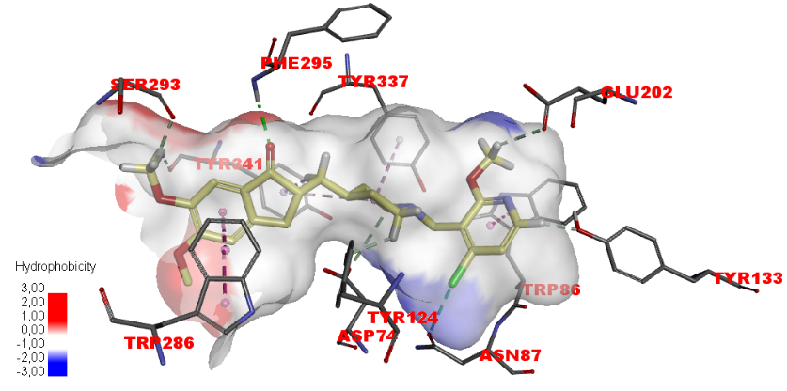 | 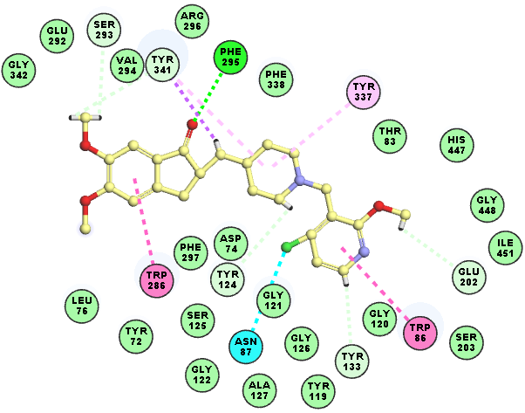
A | B
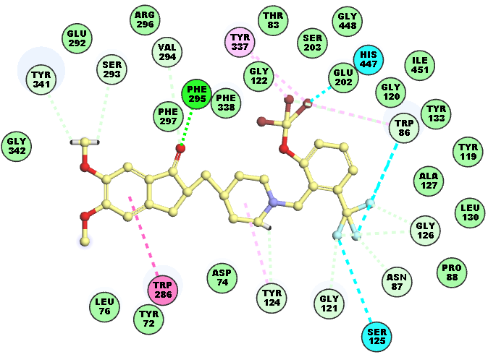 | 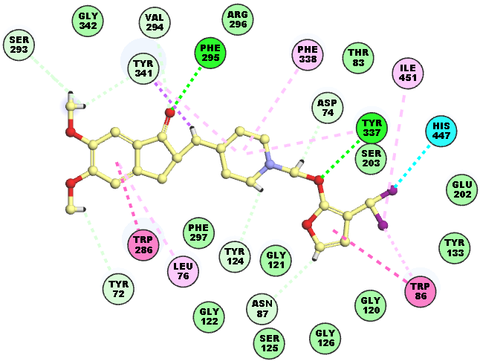
C | D

Figure 6. A. Solvent hydrophobicity surface of the AChE active site and interactions with DPZA46, the most active designed DPZ Analogue (${IC}_{50}^{pre}$ = 18 pM). The molecular surface of the binding site is coloured according to residue hydrophobicity: red - hydrophobic, blue – hydrophilic, and white - intermediate. B. 2D schematic interaction diagram of the DPZA46 at the active site of AChE. C. 2D schematic interaction diagram of the DPZA36 (${IC}_{50}^{pre}$ = 31 pM) at the active site of AChE. D. 2D schematic interaction diagram of the DPZA20 (${IC}_{50}^{pre}$ = 39 pM) at the active site of AChE. Carbon atoms are coloured yellow for the ligands.

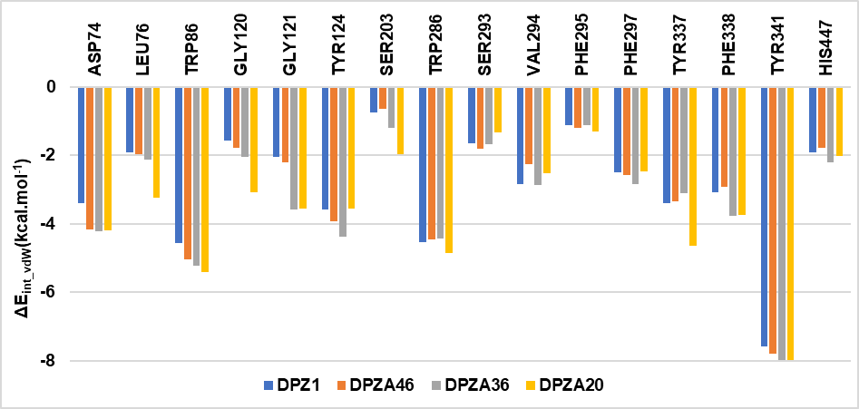
Figure 7. The van der Waals component of the intermolecular interaction energy ΔE_{int_vdW} [kcal.mol⁻¹] is provided for selected active site residue contributions. Results are presented for DPZ1 and three best newly designed DPZA (the colour coding refers to the inhibitors is indicated in the legend).
- Pharmacokinetic profile of new DPZ analogues
We calculated the ADME (Absorption, Distribution, Metabolism, and Excretion) properties of our DPZA analogues, as well as those of the marketed drugs used for the treatment of Alzheimer's disease, using the QikProp software [45], based on the method developed by Jorgensen [57]. This method has been described in detail previously [26]. Relevant descriptors of the ADME properties of our best-designed DPZA analogues and the drugs available on the market for the treatment of Alzheimer's disease are compared and presented in Table 6. The druglikeness value is 0 for most of the new DPZA analogues, indicating that no violations of the druglikeness descriptor are reported. Furthermore, these new analogues demonstrate good bioavailability, as well as a high percentage of human oral absorption (HOA) via the gastrointestinal system, allowing a greater quantity of molecules to reach the bloodstream and enhancing their therapeutic efficacy. Additionally, the blood-brain barrier descriptor for these analogues falls within an appropriate range, indicating that they possess a good capacity to penetrate the brain. Therefore, the designed DPZA analogues exhibit a favorable theoretical pharmacokinetic profile.
Table 6. Predicted ADME-related properties of newly designed top DPZA analogues and approved human AChE Inhibitors, calculated by QikProp [45].
DPZ_{x} ª | #stars ^{b} | M_{w} ^{c} [g.mol⁻¹] | S_{mol} ^{d}  [Å²] | S_{mol,hfo}^{e} [Å²] | V_{mol} ^{f} [Å³] | RotB ^{g} | HB_{don}^{h} | HB_{acc}^{i} | logP_{o/w} ^{j} | logS_{wat}^{k} | logK_{HS}^{l} | logB/B ^{m} | BIP_{caco}^{n} [nm.s⁻¹] | #meta º | $${\text{IC}}_{\text{50}}^{\text{pre}}$$[pM] | HOA^{q} | %HOA^{r}
DPZ1 | 0 | 397 | 709.4 | 45.7 | 1275 | 6 | 0 | 5.5 | 4.4 | -4.7 | 0.59 | 0.17 | 910.8 | 6 | 2900 | 3 | 100
DPZA14 | 0 | 521 | 792.0 | 45.4 | 1388 | 7 | 0 | 6.3 | 5.0 | -6.0 | 0.68 | 0.22 | 917.1 | 6 | 63 | 3 | 83
DPZA15 | 0 | 410 | 725.2 | 45.6 | 1324 | 7 | 0 | 6.3 | 4.3 | -4.3 | 0.49 | 0.07 | 912.5 | 7 | 539 | 3 | 100
DPZA16 | 0 | 513 | 747.7 | 45.7 | 1412 | 7 | 0 | 6.3 | 5.4 | -5.4 | 0.75 | 0.42 | 910.1 | 7 | 251 | 3 | 85
DPZA18 | 0 | 636 | 748.7 | 44.7 | 1400 | 8 | 0 | 6 | 5.5 | -5.4 | 0.74 | 0.42 | 930.7 | 7 | 89 | 3 | 86
DPZA20 | 0 | 651 | 726.7 | 44.6 | 1359 | 8 | 0 | 6 | 5.1 | -4.9 | 0.62 | 0.34 | 933.2 | 8 | 39 | 2 | 100
DPZA29 | 1 | 547 | 779.3 | 45.7 | 1461 | 7 | 0 | 6.3 | 5.9 | -6.2* | 0.89 | 0.54 | 911.7 | 7 | 91 | 3 | 88
DPZA30 | 0 | 660 | 794.0 | 45.5 | 1489 | 8 | 0 | 6.3 | 5.9 | -6.1* | 0.93 | 0.35 | 914.3 | 8 | 74 | 3 | 88
DPZA32 | 2 | 787 | 783.3 | 45.6 | 1465 | 8 | 0 | 6.3 | 5.8 | -6.0 | 0.86 | 0.39 | 913.5 | 7 | 42 | 3 | 88
DPZA33 | 0 | 519 | 751.7 | 435.3 | 1367 | 7 | 0 | 5.5 | 5.2 | -5.4 | 0.82 | 0.26 | 912.4 | 6 | 68 | 2 | 85
DPZA36 | 0 | 570 | 654 | 388.6 | 1237 | 6 | 0 | 5 .8 | 3.7 | 4.7 | 0.6 | 0.11 | 877,8 | 7 | 31 | 3 | 100
DPZA39 | 0 | 503 | 745.1 | 45.4 | 1376 | 7 | 0 | 6.8 | 4.9 | -5.2 | 0.51 | 0.47 | 917.8 | 8 | 115 | 3 | 96
DPZA46 | 0 | 445 | 760.3 | 55.7 | 1374 | 7 | 0 | 6.5 | 4.6 | -5.1 | 0.57 | 0.07 | 731.9 | 8 | 18 | 3 | 100
DPZA48 | 1 | 648 | 776.0 | 63.3 | 1399 | 7 | 0 | 10.5 | 3.1 | -3.8 | -0.43 | 0.24 | 620.2 | 7 | 47 | 2 | 82
Donépézil | 0 | 379 | 699.4 | 392.6 | 1267 | 6 | 0 | 5.5 | 4.3 | -4.4 | 0.57 | 0.12 | 887.2 | 6 |  | 3 | 100
Galantamine | 0 | 287 | 497.0 | 311.6 | 896 | 2 | 1 | 5.2 | 2.0 | -2.0 | 0.01 | 0.36 | 671.5 | 4 |  | 3 | 89
Rivastigmine | 0 | 250 | 562.8 | 395.7 | 953 | 4 | 0 | 5 | 2.4 | -2.4 | -0.12 | 0.27 | 887.3 | 3 |  | 3 | 94
ª designed DPZA analogues and approved human AChE Inhibitors, Table 5; ^{b} drug likeness, number of property descriptors (24 out of the full list of 49 descriptors of QikProp) that fall outside of the range of values for 95% of known drugs; ^{c} molecular weight in [g.mol⁻¹] (range for 95% of drugs: 130 - 725 g.mol⁻¹) [58]; ^{d} total solvent-accessible molecular surface, in [Å²] (probe radius 1.4 Å) (range for 95% of drugs: 300 - 1000 Å²); ^{e} hydrophobic portion of the solvent-accessible molecular surface, in [Å²] (probe radius 1.4 Å) (range for 95% of drugs: 0 - 750 Å²); ^{f} total volume of molecule enclosed by solvent-accessible molecular surface, in [Å³] (probe radius 1.4 Å) (range for 95% of drugs: 500 - 2000 Å³); ^{g} number of non-trivial (not CX3), non-hindered (not alkene, amide, small ring) rotatable bonds (range for 95% of drugs: 0 - 15); ^{h} estimated number of hydrogen bonds that would be donated by the solute to water molecules in an aqueous solution. Values are averages taken over several configurations, so they can assume non-integer values (range for 95% of drugs: 0.0 - 6.0); ^{I} estimated number of hydrogen bonds that would be accepted by the solute from water molecules in an aqueous solution. Values are averages taken over several configurations, so they can assume non-integer values (range for 95% of drugs: 2.0 - 20.0); ^{j} logarithm of partitioning coefficient between n-octanol and water phases (range for 95% of drugs: -2 - 6.5); ^{k} logarithm of predicted aqueous solubility, logS. S in [mol·dm^{–3}] is the concentration of the solute in a saturated solution that is in equilibrium with the crystalline solid (range for 95% of drugs: -6.0 - 0.5); ^{l} logarithm of predicted binding constant to human serum albumin (range for 95% of drugs: -1.5 - 1.5); ^{m} logarithm of predicted brain/blood partition coefficient (range for 95% of drugs: -3.0 - 1.2); ^{n} predicted apparent Caco-2 cell membrane permeability in Boehringer-Ingelheim scale in [nm s⁻¹] (range for 95% of drugs: < 25 poor, > 500 nm s⁻¹ great); º number of likely metabolic reactions (range for 95% of drugs: 1 - 8); ^{p} predicted inhibition constants ${IC}_{50}^{pre}$. The ${IC}_{50}^{pre}$ was predicted from computed ΔΔG_{com} using the regression equation B shown in Table 3; ^{q} human oral absorption (1 - low, 2 - medium, 3 - high); ^{r} percentage of human oral absorption in gastrointestinal tract (<25% - poor, >80% high); ^{(*)} star indicating that the property descriptor value falls outside the range of values for 95% of known drugs.
- Molecular Dynamics Simulations
DPZ1 | DPZA46
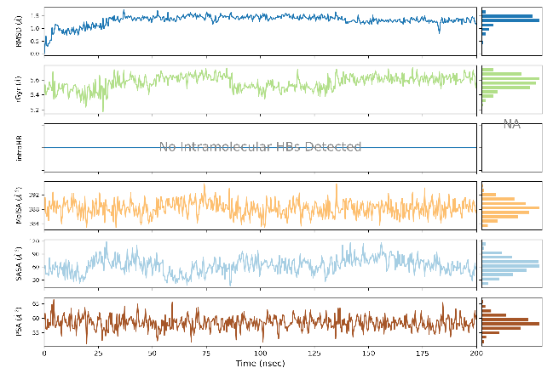 | 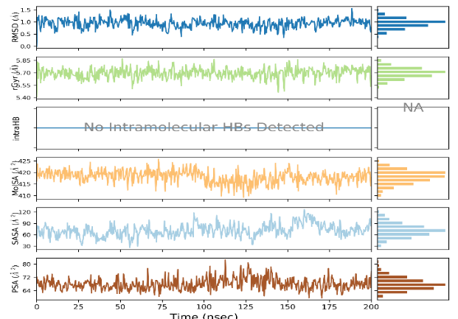
DPZA36 | DPZA20
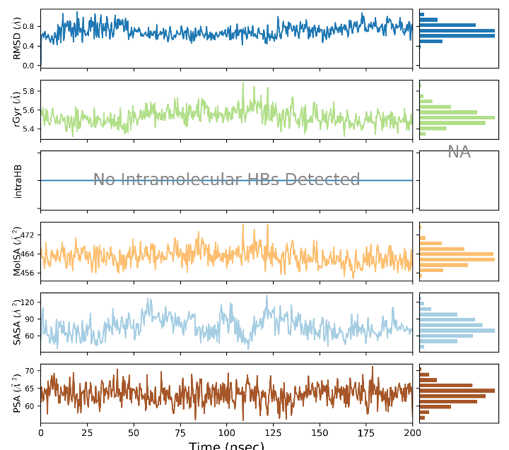 | 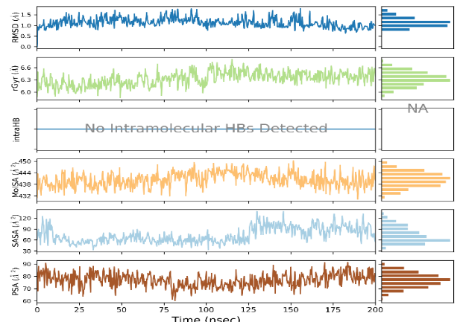
Figure 8. Molecular properties of DPZ1, DPZA46, DPZA36 and DPZA20 bound to human AChE were monitored over 200 ns of MD simulation time. For each inhibitor, root mean square deviation (RMSD) with respect to the initial conformation of the DPZA, radius of gyration (rGyr), number of intramolecular hydrogen bonds (intraHB), molecular surface area (molSA), solvent-accessible surface area (SASA), and polar surface area (PSA), were plotted (top to bottom in each diagram).
The dynamic behavior of the inhibitors DPZ1, DPZA46, DPZA36, and DPZA20 in complex with human AChE was studied over a period of 200 ns using Desmond [46]. These molecular dynamics simulations allowed for the exploration of the structural and dynamic properties of these complexes. Analysis of the results indicates excellent structural stability of the newly best-designed analogues interacting with AChE, with an RMSD lower than 1.5 Å (Figure 8).
Temporal analysis of the enzyme-inhibitor complexes revealed stabilizing interactions between the residues Trp86, Phe295, and Tyr337 and the inhibitors DPZ1, DPZA46, DPZA36, and DPZA20. These residues formed hydrogen bonds, hydrophobic contacts, and water bridges, highlighting the specificity of these inhibitors for human AChE (Figure 9 and Figure 10).

DPZ1 | DPZA46
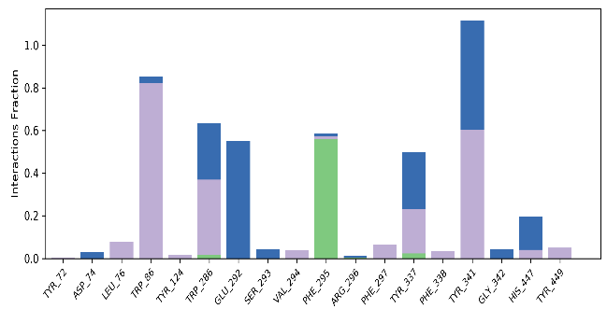 | 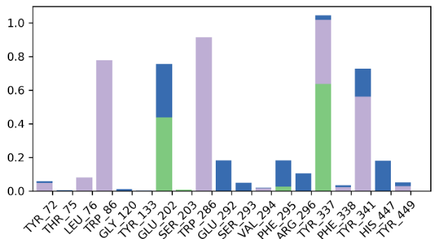
DPZA36 | DPZA20
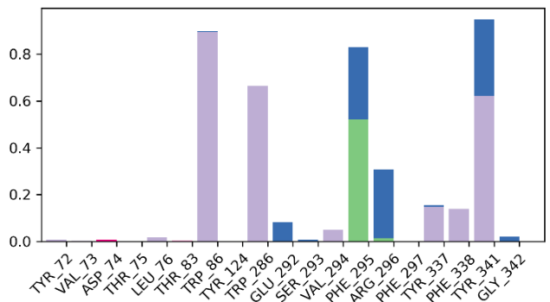 | 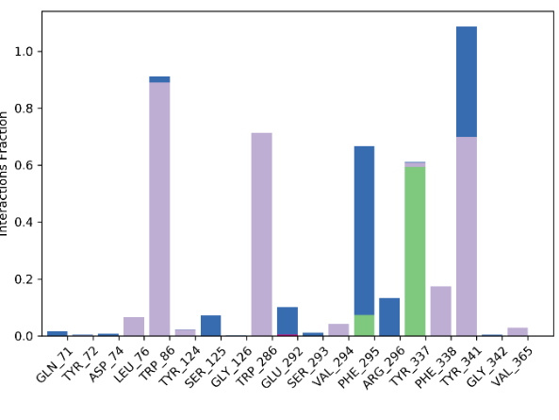

Figure 9 Contributions of individual active site residues to the AChE-DPZA_{x} binding energy present during at least during 20% of the MD simulation time.
DPZ1 | DPZA46
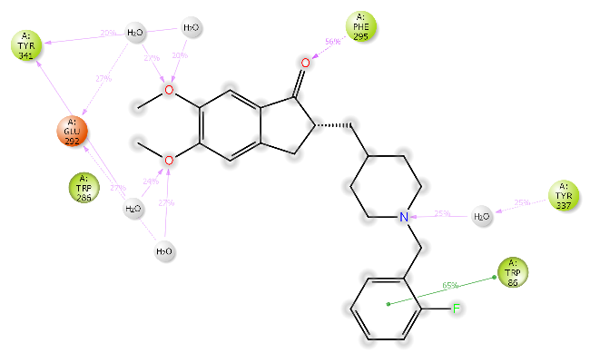 | 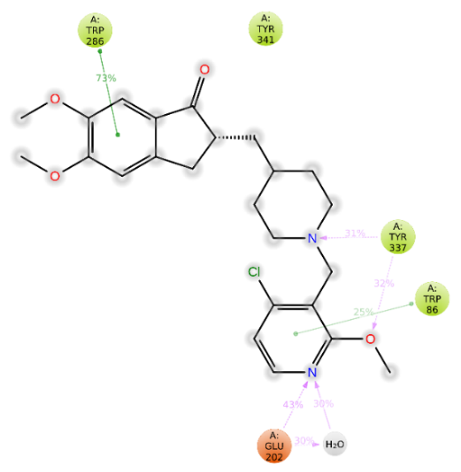
DPZA36 | DPZA20
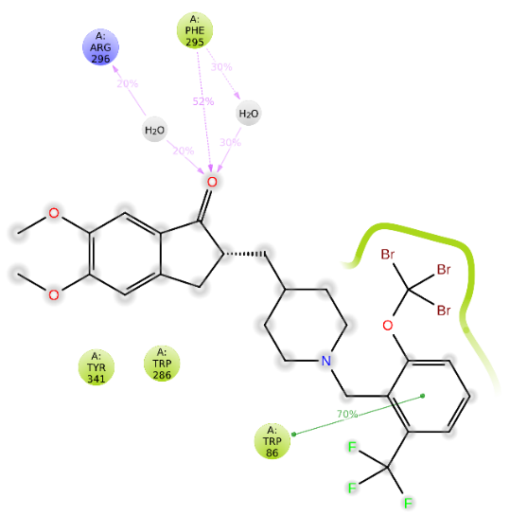 | 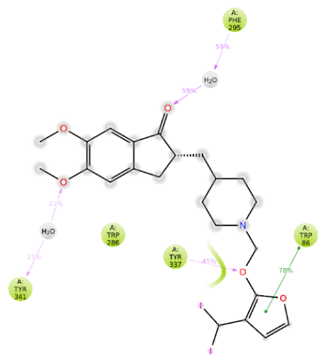
Figure 10. The 2D schemes present attractive interactions prevalent between the functional groups of the 3 inhibitor candidates and the individual residues of the active site of AChE. These interactions were observed in at least 20 % of the analysed 500 frames of the MD trajectory (i.e. in 40 ns).

The superposition of the average conformations of the inhibitors post-simulation (Figure 11) showed only minor structural deviations (RMSD < 2 Å), indicating the stability of the modeled complexes and the reliability of the ${IC}_{50}^{pre}$ predictions. These results emphasize the potential of DPZA as specific inhibitors of human AChE.
DPZ1 (RMSD = 1.61 Å) | DPZA46 (RMSD = 1.28 Å)
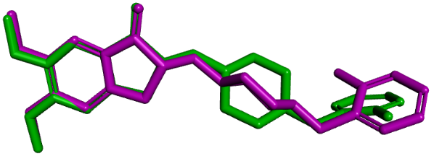 | 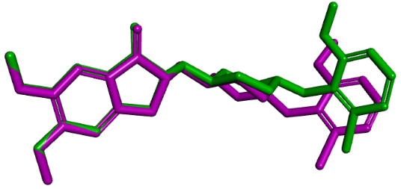
DPZA36 (RMSD = 1.45 Å) | DPZA20 (RMSD = 2.16 Å)
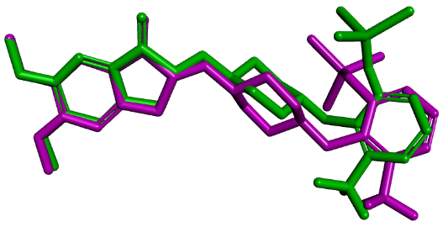 | 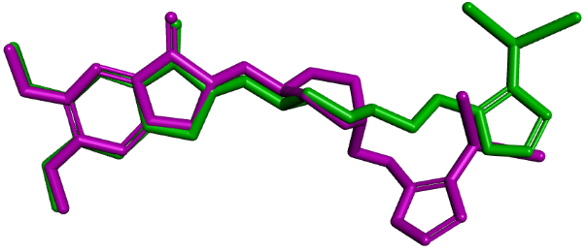
Figure 11. Overlay of the averaged bound conformation of selected new IPCLs from MD simulation (green colour) and those derived from the crystal structure of AChE-DPZA complex 7E3H (pink).

- Discussion
Understanding the binding mode of DPZ inhibitors at the active site of human AChE is essential for designing new, more effective DPZA analogues against Alzheimer's disease. The binding modes of DPZ1 and DPZ32, presented in Figure 3 and Figure 4, reveal that hydrophobic interactions play a key role in the inhibition of AChE, as previously reported [59]. Exploiting the data on the binding of DPZ has led to the design of new DPZA analogues with strong predicted inhibitory potencies (Table 5). The significant increase in the inhibition potential of the analogues DPZA46, DPZA36, and DPZA20 results from new stabilizing interactions with residues at the active site, particularly those at the catalytic site (Figure 6). Halogen contacts are observed between our best DPZA compounds and the catalytic residue His447 (Figure 6.C and D), as well as with residues Trp86 (Figure 6.C), Asn87 (Figure 6.B), and Ser125 (Figure 6.C). A hydrogen bond between DPZA20 and Tyr337 is also noted (Figure 6.D), along with several hydrophobic contacts with residues at the catalytic site of AChE (Figure 6). The binding mode of our best DPZA compounds is consistent with the data from previous studies on AChE inhibition [59, 60]. The strong predicted inhibitory activity of DPZA46, DPZA36, and DPZA20 is corroborated by the increased affinity observed between these compounds and the residues of the active site of human AChE (Figure 7). The individual contributions of the selected residues at the active site of AChE to the van der Waals interaction energy are ΔE_{int_vdW}(DPZ1) = -46.48 kcal/mol, ΔE_{int_vdW}(DPZA46)= -47.90 kcal/mol, ΔE_{int_vdW}(DPZA36) = -52.78 kcal/mol, and ΔE_{int_vdW}(DPZA20) = -55.94 kcal/mol, corresponding to a stabilization of approximately 1.42 kcal/mol for DPZA46, 6.30 kcal/mol for DPZA36, and 9.46 kcal/mol for DPZA20 compared to DPZ1, the best inhibitor from the training set. The high affinity between our best DPZA compounds and the residues of human AChE indicates their ability to form stable complexes with a reduced rate of dissociation [61]. This study confirms the importance of hydrophobic interactions in AChE inhibition, highlighting the key roles of the Trp86 residue, as well as the catalytic residues Ser203 and His447, as previously reported [21]. It also underscores the importance of halogenated hydrophobic molecular fragments in the inhibition of the enzymatic mechanism of human AChE.
Table 7. Average MMGBSA binding energies of complexes derived from molecular dynamics simulations
Analogues | ΔG_{BindMMGBSA} [kcal.mol⁻¹] | ΔΔG_{BindMMGBSA}[kcal.mol⁻¹] | ΔΔG_{com}[kcal.mol⁻¹] | ${IC}_{50}^{pre}$[pM]
DPZ1 | -70.0 | 0 | 0 | 2900*
DPZA46 | -76.5 | -6.5 | -12.4 | 18
DPZA36 | -72.3 | -2.3 | -11.0 | 31
DPZA20 | -85.0 | -15 | -10.5 | 39
* ${IC}_{50}^{exp}$ [22] is given for inhibitor DPZ1 instead of the ${IC}_{50}^{pre}$.
MMGBSA calculations revealed favorable binding energies for the DPZAs examined with AChE (Table 7). The average binding energy for DPZ1, the most active ligand in the training set, is -70.0 kcal/mol, while it reaches -76.5 kcal/mol for DPZA46, the best-designed analogue. For DPZA36, the binding energy is -72.3 kcal/mol, and for DPZA20, it rises to -85.0 kcal/mol. These results validate the order of predicted inhibitory activities (${IC}_{50}^{pre}$), with the exception of DPZA20. Furthermore, they indicate that the most effective analogues exhibit a strong affinity for AChE.

4. Conclusion
The absence of a curative treatment for Alzheimer’s disease highlights the urgent need to develop more effective therapeutic options. In this study, we developed a QSAR model for the inhibition of human AChE, correlating the variation in Gibbs free energy (GFE) of the AChE-DPZ_{x} complex with the experimental inhibitory activities (${IC}_{50}^{exp}$) of 32 DPZx compounds [22]. The evaluation of interaction energy, decomposed into individual contributions from residues at the active site of human AChE, allowed us to identify the structural determinants essential for improving affinity. Using a molecular design approach based on intuitive substitution, we designed new highly active DPZA analogues against human AChE, such as DPZA46 (${IC}_{50}^{pre}$ = 18 pM), DPZA36 (${IC}_{50}^{pre}$ = 31 pM), and DPZA20 (${IC}_{50}^{pre}$ = 39 pM). Although these results are theoretical, they suggest that these inhibitors may be more effective than those currently known. Additionally, our new DPZA analogues exhibit favorable ADME properties. Molecular dynamics simulations validated the stability of the AChE-DPZA complexes formed by the most effective new analogues, thereby demonstrating their efficacy in inhibiting human AChE. Therefore, we recommend their synthesis and inhibitory potency testing to evaluate their potential as new treatments for Alzheimer’s disease.

List of Abbreviations
2D Two-dimensional
3D Three-dimensional
Ach Acetylcholine
AChE Acetylcholinesterase
AD Alzheimer's disease
ADME Absorption, distribution, metabolism, and excretion
CAMD Computer-aided molecular design
CDOCKER CHARMm-based DOCKER
CHARMm CHARMm force field
MD Molecular dynamics
ΔE_{int} Interaction energy
ΔE_{int_vdW} van der Waals component of the interaction energy
GFE Gibbs free energy
ΔΔG_{binding} Binding energy component of the relative GFE
ΔΔG_{com} Relative GFE of formation of enzyme–inhibitor complex
ΔΔG_{Solv} Solvation component of the relative GFE
HBA Hydrogen bond acceptor
HBD Hydrogen bond donor
HOA Human oral absorption
${IC}_{50}^{exp}$ Observed half-maximal inhibitory concentration
${IC}_{50}^{pre}$ Predicted half-maximal inhibitory concentration
DPZx Inhibitors included in TS and in VS
MD Molecular dynamics
MM Molecular mechanics
MM-GBSA Molecular mechanics-generalized Born surface area
MM-PBSA Molecular mechanics–Poisson–Boltzmann surface area
PDB Protein Data Bank
QSAR Quantitative structure–activity relationships
TS Training set
∆∆TS Entropy contribution of the relative GFE
VS Validation Set

COMPETING INTERESTS DISCLAIMER:
Authors have declared that they have no known competing financial interests OR non-financial interests OR personal relationships that could have appeared to influence the work reported in this paper.

References

1. Li, M., Ma, C., Li, Y., Wang, H., Xiu, X., Zhao, X., Liu, P., Yang, H. & Cheng, M. (2025). Design, synthesis and biological evaluation of galantamine analogues for cognitive improvement in Alzheimer's disease. European Journal of Medicinal Chemistry. 284, 117198. https://doi.org/10.1016/j.ejmech.2024.117198.
2. Organization, W. H. (2025). Dementia. World Health Organization.
3. Aguzzoli, C., Anstey, K., Atri, A., Barbarino, P., Benoist, C., Brijnath, B., Bruno, M., Cose, L., Darge, D. & Dean, W. (2024). World Alzheimer Report 2024 Global Changes in Attitudes to Dementia Contributors: Survey Translators. Alzheimer’s Disease International: London, UK.
4. Peitzika, S.-C. & Pontiki, E. (2023). A review on recent approaches on molecular docking studies of novel compounds targeting acetylcholinesterase in Alzheimer disease. Molecules. 28, 1084. https://doi.org/10.3390/molecules28031084.
5. Hakeem, I. J. (2023). Molecular docking analysis of acetylcholinesterase inhibitors for Alzheimer's disease management. Bioinformation. 19, 565. https://doi.org/10.6026/97320630019565.
6. Jones, A., Ali, M. U., Mayhew, A., Aryal, K., Correia, R. H., Dash, D., Manis, D. R., Rehman, A., O'Connell, M. E. & Taler, V. (2025). Environmental risk factors for all-cause dementia, Alzheimer's disease dementia, vascular dementia, and mild cognitive impairment: An umbrella review and meta-analysis. Environmental research. 270, 121007. https://doi.org/10.1016/j.envres.2025.121007.
7. Xiao, W., Chen, L.-Z., Chang, J. & Xiao, Y.-W. (2025). Discovery of Novel Anti-Acetylcholinesterase Peptides Using a Machine Learning and Molecular Docking Approach. Drug Design, Development and Therapy. 5085-5098. https://doi.org/10.2147/DDDT.S523769.
8. Golde, T. E. (2003). Alzheimer disease therapy: can the amyloid cascade be halted? The Journal of clinical investigation. 111, 11-18. https://doi.org/10.1172/JCI17527.
9. Francis, P. T., Palmer, A. M., Snape, M. & Wilcock, G. K. (1999). The cholinergic hypothesis of Alzheimer’s disease: a review of progress. Journal of Neurology, Neurosurgery & Psychiatry. 66, 137-147. https://doi.org/10.1136/jnnp.66.2.137.
10. Dvir, H., Silman, I., Harel, M., Rosenberry, T. L. & Sussman, J. L. (2010). Acetylcholinesterase: from 3D structure to function. Chemico-biological interactions. 187, 10-22. https://doi.org/10.1016/j.cbi.2010.01.042.
11. Chennai, H. Y., Belaidi, S., Bourougaa, L., Ouassaf, M., Sinha, L., Samadi, A. & Chtita, S. (2024). Identification of potent acetylcholinesterase inhibitors as new candidates for Alzheimer disease via virtual Screening, Molecular Docking, Dynamic Simulation, and Molecular Mechanics–Poisson–boltzmann surface area calculations. Molecules. 29, 1232. https://doi.org/10.3390/molecules29061232.
12. Hampel, H., Mesulam, M.-M., Cuello, A. C., Farlow, M. R., Giacobini, E., Grossberg, G. T., Khachaturian, A. S., Vergallo, A., Cavedo, E. & Snyder, P. J. (2018). The cholinergic system in the pathophysiology and treatment of Alzheimer’s disease. Brain. 141, 1917-1933. https://doi.org/10.1093/brain/awy132.
13. Birks, J. (2006). Cholinesterase inhibitors for Alzheimer’s disease. Cochrane Database of Systematic Reviews. 1, CD001190. https://doi.org/10.1002/14651858.CD005593.
14. Birks, J. S., & Harvey, R. J (2018). Donepezil for dementia due to Alzheimer’s disease. Cochrane Database of Systematic Reviews. 6. https://doi.org/10.1002/14651858.CD001190.pub3.
15. Przedborski, S., Vila, M., & Jackson-Lewis, V (2003). Neurodegeneration : What is it and where are we ? J. Clin. Invest. 111, 3–10. https://doi.org/10.1172/JCI17522.
16. Hampel, H., Mesulam, M.-M., Cuello, A. C., Farlow, M. R., Giacobini, E., Grossberg, G. T., Khachaturian, A. S., Vergallo, A., Cavedo, E.,Snyder, P. J., Khachaturian, Z. S. (2018). The cholinergic system in the pathophysiology and treatment of Alzheimer’s disease. Nature Reviews Neurology. 14, 639–652. https://doi.org/10.1093/brain/awy132.
17. Sliwoski, G., Kothiwale, S., Meiler, J., Lowe, E. W. (2014). Computational methods in drug discovery. Pharmacological Reviews. 66, 334–395. https://doi.org/10.1124/pr.112.007336.
18. Jorgensen, W. L. (2009). Efficient drug lead discovery and optimization. Accounts of Chemical Research. 42, 724-733. https://doi.org/10.1021/ar800236t.
19. Galimberti, D. & Scarpini, E. (2016). Old and new acetylcholinesterase inhibitors for Alzheimer’s disease. Expert opinion on investigational drugs. 25, 1181-1187. https://doi.org/10.1080/13543784.2016.1216972.
20. Reynoso-García, M. F., Nicolás-Álvarez, D. E., Tenorio-Barajas, A. Y., Reyes-Chaparro, A. (2025). Structural Bioinformatics Applied to Acetylcholinesterase Enzyme Inhibition. International Journal of Molecular Sciences. 26, 3781. https://doi.org/10.3390/ijms26083781.
21. Dileep, K., Ihara, K., Mishima-Tsumagari, C., Kukimoto-Niino, M., Yonemochi, M., Hanada, K., Shirouzu, M. & Zhang, K. Y. (2022). Crystal structure of human acetylcholinesterase in complex with tacrine: Implications for drug discovery. International Journal of Biological Macromolecules. 210, 172-181. https://doi.org/10.1016/j.ijbiomac.2022.05.009.
22. Azusada, T., Baybay, E., Chi, J., Dole, P., Gonzalez, N., Jaramillo, E., Nguyen, T., Pivaral, A., Rodriguez, G. & Zavala, J. (2024). One-step microwave enhanced synthesis, biological evaluation, and molecular modeling investigations of donepezil analogs as acetylcholinesterase inhibitors. Results in Chemistry. 7, 101226. https://doi.org/10.1016/j.rechem.2023.101226.
23. Frecer, V., Burello, E. & Miertus, S. (2005). Combinatorial design of nonsymmetrical cyclic urea inhibitors of aspartic protease of HIV-1. Bioorganic & medicinal chemistry. 13, 5492-5501. https://doi.org/10.1016/j.bmc.2005.06.026.
24. Megnassan, E., Keita, M., Bieri, C., Esmel, A., Frecer, V. & Miertus, S. (2012). Design of novel dihydroxynaphthoic acid inhibitors of Plasmodium falciparum lactate dehydrogenase. Medicinal Chemistry. 8, 970-984. https://doi.org/10.2174/157340612802084324.
25. Keita, M., Kumar, A., Dali, B., Megnassan, E., Siddiqi, M., Frecer, V. & Miertus, S. (2014). Quantitative structure–activity relationships and design of thymine-like inhibitors of thymidine monophosphate kinase of mycobacterium tuberculosis with favourable pharmacokinetic profiles. RSC Advances. 4, 55853-55866. https://doi.org/10.1039/C4RA06917J.
26. Fofana, I., Dali, B., Mansilla-Koblavi, F., Megnassan, E., Frecer, V. & Miertus, S. (2021). Structure-Based Design of Tetrahydroisoquinoline-Based Hydroxamic Acid Derivatives Inhibiting Human Histone Deacetylase 8. https://doi.org/10.25177/JCCMM.5.1.RA.10708.
27. N’guessan, H., Soro, I., Keita, M. & Megnassan, E. (2022). Design and In silico Screening of Combinatorial Library of New Herbicidal Analogs of Cycloalka [d] quinazoline-2, 4dione− Benzoxazinones Inhibiting Protoporphyrinogen IX Oxidase. Journal of Pharmaceutical Research International. 34, 42-61. https://doi.org/10.9734/jpri/2022/v34i567251.
28. Konate, S., Allangba, K. N. G. P. G., Fofana, I., N’Guessan, R. K., Megnassan, E., Miertus, S. & Frecer, V. (2025). Improved Inhibitors Targeting the Thymidylate Kinase of Multidrug-Resistant Mycobacterium tuberculosis with Favorable Pharmacokinetics. Life. 15, 173. https://doi.org/10.3390/life15020173.
29. General, E. C. E. D. (2014). Guidance document on the validation of (quantitative) structure-activity relationship [(Q) SAR] models. OECD Paris, France.
30. Studio, D. (2009). Molecular modeling and simulation software, Release 2.5. Accelrys Inc., San Diego, CA, USA.
31. Rocchia, W., Sridharan, S., Nicholls, A., Alexov, E., Chiabrera, A. & Honig, B. (2002). Rocchia, W., Sridharan, S., Nicholls, A., Alexov, E., Chiabrera, A., & Honig, B. (2002). Rapid grid‐based construction of the molecular surface and the use of induced surface charge to calculate reaction field energies: Applications to the molecular systems and geometric objects. Journal of computational chemistry. 23, 128-137. https://doi.org/10.1002/jcc.1161.
32. Homeyer, N. & Gohlke, H. (2012). Free energy calculations by the molecular mechanics Poisson− Boltzmann surface area method. Molecular informatics. 31, 114-122. https://doi.org/10.1002/minf.201100135.
33. Gilson, M. K. & Honig, B. (1991). The inclusion of electrostatic hydration energies in molecular mechanics calculations. Journal of Computer-Aided Molecular Design. 5, 5-20. https://doi.org/10.1007/BF00173467.
34. Owono Owono, L. C., Keita, M., Megnassan, E., Frecer, V. & Miertus, S. (2013). Design of thymidine analogues targeting thymidilate kinase of Mycobacterium tuberculosis. Tuberculosis research and treatment. 2013, 670836. https://doi.org/10.1155/2013/670836.
35. Frecer, V., Seneci, P. & Miertus, S. (2011). Computer-assisted combinatorial design of bicyclic thymidine analogs as inhibitors of Mycobacterium tuberculosis thymidine monophosphate kinase. Journal of computer-aided molecular design. 25, 31-49. https://doi.org/10.1007/s10822-010-9399-4.
36. Jakhar, R., Dangi, M., Khichi, A. & Chhillar, A. K. (2020). Relevance of molecular docking studies in drug designing. Current Bioinformatics. 15, 270-278. https://doi.org/10.2174/1574893615666191219094216.
37. Shoichet, B. K., McGovern, S. L., Wei, B. & Irwin, J. J. (2002). Lead discovery using molecular docking. Current opinion in chemical biology. 6, 439-446. https://doi.org/10.1016/s1367-5931(02)00339-3.
38. Guedes, I. A., de Magalhães, C. S. & Dardenne, L. E. (2014). Receptor–ligand molecular docking. Biophysical reviews. 6, 75-87. https://doi.org/10.1007/s12551-013-0130-2.
39. Vieth, M., Hirst, J. D., Kolinski, A. & Brooks III, C. L. (1998). Assessing energy functions for flexible docking. Journal of Computational Chemistry. 19, 1612-1622. https://doi.org/10.1002/(SICI)1096-987X(19981115)19:14<1612::AID-JCC7>3.0.CO;2-M.
40. Shoichet, B. K. & Kuntz, I. D. (1991). Protein docking and complementarity. Journal of molecular biology. 221, 327-346. https://doi.org/10.1016/0022-2836(91)80222-g.
41. Walls, P. H. & Sternberg, M. J. (1992). New algorithm to model protein-protein recognition based on surface complementarity: Applications to antibody-antigen docking. Journal of molecular biology. 228, 277-297. https://doi.org/10.1016/0022-2836(92)90506-f.
42. Wu, G., Robertson, D. H., Brooks III, C. L. & Vieth, M. (2003). Detailed analysis of grid‐based molecular docking: A case study of CDOCKER—A CHARMm‐based MD docking algorithm. Journal of computational chemistry. 24, 1549-1562. https://doi.org/10.1002/jcc.10306.
43. Vieth, M., Hirst, J. D., Dominy, B. N., Daigler, H. & Brooks III, C. L. (1998). Assessing search strategies for flexible docking. Journal of computational chemistry. 19, 1623-1631. https://doi.org/10.1002/(SICI)1096-987X(19981115)19:14<1623::AID-JCC8>3.0.CO;2-L.
44. Bieri, C., Esmel, A., Keita, M., Owono, L. C. O., Dali, B., Megnassan, E., Miertus, S. & Frecer, V. (2023). Structure-based design and pharmacophore-based virtual screening of combinatorial library of triclosan analogues active against enoyl-acyl carrier protein reductase of Plasmodium falciparum with favourable ADME profiles. International Journal of Molecular Sciences. 24, 6916. https://doi.org/10.3390/ijms24086916.
45. Schrödinger (2018). Schrödinger Release 2018-4. QikProp. D. E. Shaw Research. Schrödinger LLC, New York, NY, USA.
46. Schrödinger (2018). Schrödinger Release 2018-4. Desmond molecular dynamics system. Maestro-Desmond interoperability tools. D. E. Shaw Research. Schrödinger LLC, New York, NY, USA.
47. Frecer, V. & Miertus, S. (2020). Antiviral agents against COVID-19: structure-based design of specific peptidomimetic inhibitors of SARS-CoV-2 main protease. RSC advances. 10, 40244-40263. https://doi.org/10.1039/d0ra08304f.
48. Frecer, V., Ho, B. & Ding, J. L. (2000). Molecular dynamics study on lipid A from Escherichia coli: insights into its mechanism of biological action. Biochimica et Biophysica Acta (BBA)-Biomembranes. 1466, 87-104. https://doi.org/10.1016/s0005-2736(00)00174-7.
49. Hou, T., Wang, J., Li, Y. & Wang, W. (2011). Assessing the performance of the MM/PBSA and MM/GBSA methods. 1. The accuracy of binding free energy calculations based on molecular dynamics simulations. Journal of chemical information and modeling. 51, 69-82. https://doi.org/10.1021/ci100275a.
50. Li, J., Abel, R., Zhu, K., Cao, Y., Zhao, S. & Friesner, R. A. (2011). The VSGB 2.0 model: a next generation energy model for high resolution protein structure modeling. Proteins: Structure, Function, and Bioinformatics. 79, 2794-2812. https://doi.org/10.1002/prot.23106.
51. Ntie-Kang, F., Kannan, S., Wichapong, K., Owono, L. C. O., Sippl, W. & Megnassan, E. (2014). Binding of pyrazole-based inhibitors to Mycobacterium tuberculosis pantothenate synthetase: docking and MM-GB (PB) SA analysis. Molecular BioSystems. 10, 223-239. https://doi.org/10.1039/C3MB70449A.
52. Garbett, N. C. & Chaires, J. B. (2012). Thermodynamic studies for drug design and screening. Expert opinion on drug discovery. 7, 299-314. https://doi.org/10.1517/17460441.2012.666235.
53. Wienen-Schmidt, B., Jonker, H. R., Wulsdorf, T., Gerber, H.-D., Saxena, K., Kudlinzki, D., Sreeramulu, S., Parigi, G., Luchinat, C. & Heine, A. (2018). Paradoxically, most flexible ligand binds most entropy-favored: intriguing impact of ligand flexibility and solvation on drug–kinase binding. Journal of Medicinal Chemistry. 61, 5922-5933. https://doi.org/10.1021/acs.jmedchem.8b00105.
54. Todeschini, R. & Consonni, V. (2009). Molecular descriptors for chemoinformatics: volume I: alphabetical listing/volume II: appendices, references. John Wiley & Sons.
55. Klebe, G. & Böhm, H.-J. (1997). Energetic and entropic factors determining binding affinity in protein-ligand complexes. Journal of Receptors and Signal Transduction. 17, 459-473. https://doi.org/10.3109/10799899709036621.
56. Freire, E. (2008). Do enthalpy and entropy distinguish first in class from best in class? Drug discovery today. 13, 869-874. https://doi.org/10.1016/j.drudis.2008.07.005.
57. Jorgensen, W. L. & Duffy, E. M. (2000). Prediction of drug solubility from Monte Carlo simulations. Bioorganic & medicinal chemistry letters. 10, 1155-1158. https://doi.org/10.1016/s0960-894x(00)00172-4.
58. Duffy, E. M. & Jorgensen, W. L. (2000). Prediction of properties from simulations: free energies of solvation in hexadecane, octanol, and water. Journal of the American Chemical Society. 122, 2878-2888. https://doi.org/10.1021/ja993663t.
59. Gerlits, O., Ho, K.-Y., Cheng, X., Blumenthal, D., Taylor, P., Kovalevsky, A. & Radić, Z. (2019). A new crystal form of human acetylcholinesterase for exploratory room-temperature crystallography studies. Chemico-Biological Interactions. 309, 108698. https://doi.org/10.1016/j.cbi.2019.06.011.
60. Zueva, I., Dias, J., Lushchekina, S., Semenov, V., Mukhamedyarov, M., Pashirova, T., Babaev, V., Nachon, F., Petrova, N. & Nurullin, L. (2019). New evidence for dual binding site inhibitors of acetylcholinesterase as improved drugs for treatment of Alzheimer's disease. Neuropharmacology. 155, 131-141. https://doi.org/10.1016/j.neuropharm.2019.05.025.
61. Copeland, R. A. (2011). Conformational adaptation in drug–target interactions and residence time. Future medicinal chemistry. 3, 1491-1501. https://doi.org/10.4155/fmc.11.112.

