Performance Analysis of Improved Natural Drift Sawdust Stove:-
Incorporated with Air-Varying Butterfly Valve

Abstract
Rocket Stove Technology on which the Sawdust Stove’s Design is based has been identified and used as one of the many biomass technologies suitable for use low in-come households mostly in third world countries because they offer cheaper alternative solutions to energy poverty and are more environmental friendly. However, there are notable design limitations in most sawdust stove designs, the inability for the stove to be ‘switched off’ once it get ignited enhance the stove has to deplete the loaded fuel-feed stock even when the cooking task was done. The study investigated the performance of an improved double chambered side-feed novel sawdust stove prototype with added design features such as the air-varying butterfly valve, for air regulation into the stove in order to mitigate this challenge, in addition good insulation materials pressed in between inner and out chambers to help reduce heat loss and improved user’s safety. In order to evaluate the prototype’s performance, Water Boiling Test (WBT) and Controlled Cooking Test (CCT) were implored in testing the stove’s water boiling ability, real-food cooking ability as well as usability. The study focused on thermal efficiency, fuel consumption and combustion chamber temperatures verses ambient temperature. These tests were also used to compare stove’s performance against Zambia’s common traditional cooking stoves such charcoal brazier and the rudimentary traditional three stone stove. The prototype showed better fuel economy, (20.6% stove efficiency achieved, 0.55 SFC) for sawdust stove compared to (19% stove efficiency, 0.62 SFC) for charcoal brazier and (10.3% efficiency, 0.77 SFC) for three stone fire stove.
Keywords: thermal efficiency, fuel consumption, air-varying valve, cheap-energy, sawdust stove.

- Introduction:
Heat energy in the form of ‘fire’ has been the cornerstone of human survival and development for millennia and continues to do so even now. This is because apart from heating, human beings need to cook their food for it to be edible, taste good as well as kill harmful pathogens. According to the World Energy Council, biomass or bioenergy accounts for 10% of global energy consumption. While on the other hand, though an important intervention, energy sources such as kerosene, liquid petroleum gas (LPG), and electric stoves offer much better efficiency, 40-55 and 66% fuel efficiency respectively, but these types of energy source are not easily accessible to majority Zambians because of the high cost associated with them. So, because of this, the practice now especially in third-world countries like Zambia, is to press great emphasis on research and investment in technologies that offer cheaper but environmentally friendly fuels such biomass, solar, and fireless cookers among many more interventions. One such identified technology is the use of rocket stoves under which comes the sawdust stove. These are improved cook stoves (ICS), Literature suggests they can offer up to 25-35% fuel efficiency, (Roth, 2014). Natural Drift Sawdust Stoves operate on the rocket theorem; the theory is that air is drawn into the stove by the partial vacuum created by the rising burnt gases in the combustion chamber. This allows fresh air (oxygen) supply to ‘rush’ in the stove as the fuel is burning creating a natural air draft into the cook stove. The challenge however with the existing designs is the inability to the stove to be ‘switch off’ or control the temperature once the stove is lit or ignited as already alluded to. This research study aimed at finding solutions to mitigate these limitations (challenges) by development novel sawdust stove prototype with added features that prioritizes prudent utilization of the fuel by way of controlling the fuel burning rate through a manual adjustable controlled mechanism, the air-varying butterfly valve, which acts as the ‘switch on and off’ mechanism for air and temperature regulation according to the user’s preference.
Sawdust Stoves are Biomass Stoves that operate on the principle of rocket theory, natural convection flow and heat transfer in these stoves are entirely due to natural convection (Natural Air Drift) with some instances where exceptions are made to the design and mechanical drift of air which is incorporated using fans and blowers to aid the air drift, but the addition of the external accessories raise the cost of stove construction. However, the biggest challenge with these stoves is the inability to be “switched off” or control the stove’s temperature as desired by the user once the stove is lit as already alluded to. The study Seeks to address these challenges. The main fuel used for combustion in these stoves was raw sawdust, sawdust pellets or briquettes, cow dung, and rice husks. So many studies have been done on the characterization of raw sawdust and one such was done by Borhan (2013).
1.1 Sawdust Waste: -
The Southern African region in recent memory and in particular Zambia had experienced severe droughts that has adversely impacted on the country’s energy needs and as are result, the majority of population are struggling to find cheaper and clean energy sources. So in the Zambian perspective, improved biomass stoves interventions offer a promising solution to these challenges and require further exploration and also assess their feasibility and suitability of practical sawdust use in the country.
Sawdust waste, these are waste products from timber mills and timber processing plants. It is a by-product of wood processing methods such as wood chipping and saw-milling. It comes with various applications in some regions of the world; it is used in weed control, charcoal briquette making, card boards, and as fertilizer in some instances (Khan.R.et al., 2023). In Zambia, a company called Zambia Forestry and Forest Industries Cooperation (ZAFFICO) supplies timber trees (pine and eucalyptus) to about 274 small-to-medium size timber processing enterprises country-wide (Ncube and Phiri, 2015). There are large amounts of sawdust waste produced by these timber processing firms daily which poses an environmental hazard because there is not much use for it, either just rots in these yards or is burnt (See figure 1). Up to 60% of every cubic meter of timber processed is waste, of which 0.12m³ is sawdust (Ncube and Phiri, 2015).This can be utilized for domestic heating and cooking using the improved Sawdust stove.
1.1.2 Characterisation of Sawdust.
The potential of this biomass to serve as a supplementary alternative energy source to those used in low-income households such as charcoal and firewood was exploited in this study. However, useful sawdust characterisation documented from Literature and experimental results has shown sawdust to have a moisture content range of 8 – 25% on dry basis and 40 – 60% on wet basis but the acceptable range of moisture content in sawdust fuel is 5 – 20% (wt. %), this applies to the High Heat Value (HHV) of sawdust, it is determined by this same method (wt. % dry, wet basis) (Asumadu.S.et al., 2023).
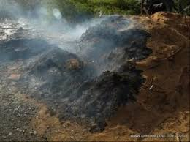
Figure 1: Uncontrolled burning of waste sawdust posed an environmental Challenge as well as human health risk. Smith et.al., (2023): Image Research Gate (2023)
In general however, good sun dried sawdust is assumed to be in acceptable range and does not require complicated drying methods. The researchers took advantage of the abundance of sawdust waste in the study area and used it in the study and since it was collected in the dry season, it did not require special drying before use.
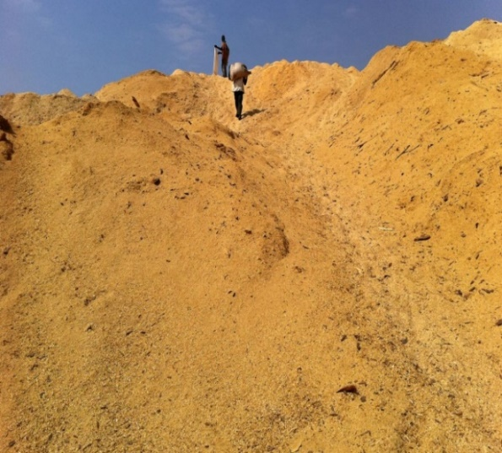

Figure: 2. Illustration of waste Sawdust pile which can be repurposed into useful waste as a source of cheap fuel. Image: courtesy of challenges worldwide (2017).

1.2. The Fire Triangle Concept:
The researchers in this study realised that to sustain a fire, three things need to be present namely:-
- Oxidizing agent- which is basically presence of oxygen in air and acts as an oxidant.
- Heat source- to ignite the fire, and
- Fuel- to sustain the heat energy.
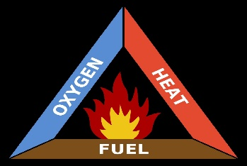
Figure: 3 Fire Triangle. Image: wikipedia.

Figure above presents a fire triangle illustrating the three elements a fire needed for ignition: heat, fuel, and an oxidizing agent which is usually oxygen. Reducing or removing any one of these elements in the triangle affects the other, in this case, the manipulation of the air (oxygen intake into the stove using the Air Varying Valve mechanism) by closing and opening affects the heat intensity in the combustion chamber and thereby allowing the stove user to control the cooking temperature of the stove.

Materials and Methods.

2.0. Stove Model Design.
2.1.
2.1.2. Material Selection:- At elevated temperatures, materials are subjected to static mechanical stresses, leading to the onset of creep. Rocket theory based stoves such as the sawdust stove operate at high elevated temperatures, it is, therefore, extremely important when selecting materials for the construction of the stove to put that into consideration. The selected materials must be able to withstand these temperatures. In this paper, carbon steel (2mm AISI l040, sheet metal) was chosen to be the main material for the construction of both the combustion chamber and the main outer body of the stove. To avoid deformation at such high temperatures, the selected materials should be resistant enough to creep. Thus, in metal selection for this design, it becomes important only for temperatures greater than 0.4Tm,
Where:
Tm = absolute melting temperature
According to the Engineering toolbox, for steel, the absolute melting temperature is: -
Tm =1510℃, Therefore,
0.4(1510) = 604℃.
Thus, for this design, temperatures around the combustion chamber made of steel must be kept below 604℃, on average, the maximum temperatures generated in this design ranged from 360℃ to 420℃ so, and the choice of steel as a construction metal was safe.
2.2 Stove Construction Method: -The stove body was constructed by using a 2mm thick carbon steel sheet (AISI1040), all joints in the stove were by arc welding, and fiberglass mixed with dry wood ash from hard wood was used as an insulating material between the outer main body and the combustion chamber to minimize conduction and conviction heat loss.
2.3. Natural Air Draft vs. Forced Air Draft:
2.3.1. Natural Air Draft: -The theory is that air is drawn into the stove by the partial vacuum created by the rising burnt gases in the combustion chamber. This allows fresh air (oxygen) supply to ‘rush’ in the stove as the fuel is burning creating a natural air draft into the cook stove.
2.3.2 Throttling:
The concept that was adopted in this design improvement project was similar to that used in natural aspired engines which use a throttle valve (throttle body) to regulate air supply into the combustion chamber and utilize natural air draft into the engine due to pressure difference between atmospheric pressure and the partial vacuum created inside the engine cylinders by piston movement. To create similar conditions in the prototype cook stove but without using blowers or fans, two heat risers with different diameters were considered, with a 60mm diameter welded at the base just before the 30 mm diameter combustion chamber air-intake in a vertical position forming the chimney of the cook stove flanked in between these two different diameter chambers was a 58 mm diameter mechanical air varying butterfly throttle valve located in the first 60 mm pipe adjacent to the opening of the 30mm opening leading into the combustion chamber.
2.3.3 Butterfly Throttle Valve:
The innovative feature for this design is an adjustable mechanical hand operated device which is basically is a spindle, on which a butterfly valve is welded at the centre, and is located just below the opening into the combustion chamber. The spindle then protrudes to the outside of the stove’s body and at the tail end of this spindle is a nob which the users could turn to close or open positions, to increase or reduce air-flow into the stove thereby, controlling the fuel burning rate. By utilizing the throttle valve, users can control air flow into the stove; this adjustability is key to optimizing heat transfer and ultimately leads to maximum fuel efficiency. Operating the throttle valve does not require special skills, the users simply ‘turns’ to and from positions to create opening and closing of the valve, the nob can be turned at different angles to vary the airflow into the stove, thereby controlling heat generation through (manipulating oxygen intake into the stove) to suit the cooking task (cold start, boiling, and simmering).
2.4. Geometric Parameters: - Under this parameter comes the combustion chamber design. To create ‘‘a thumb over the water hose effect’’, that lowers the pressure at the point of entry from the bigger diameter pipe to the smaller diameter pipe and increases air velocity, the 60mm bigger intake diameter was reduced into a smaller 30mm diameter outlet into the combustion chamber or reactor forming the inner chimney of the cook stove. Reducing or decreasing the cross-sectional area of the bigger pipe by a factor of two, increased the speed or velocity of the gases by a factor of two, hence creating the fanning effect for that natural air drafting into the cook stove.
2.5. Simplified Model Equations: - In this research study, the two simplified model equations that were used to predict air-flow behavior inside the combustion chamber of the stove were the Reynolds and Continuity equation.
i. Reynolds Number: - this is a ratio of the inertial forces to a viscous force (Uruba.V, 2019). It is dimensionless parameter.

Re$=\frac{ud}{v}$ (1)

Where: -
u = velocity of the fluid
d = pipe diameter
v = kinematic viscosity of fluid (air at 30℃ is 1.087x10⁻⁵).
The terms at the top of the equation give the inertial forces and the terms at the bottom gives us the viscous forces. When the inertial forces are dominant in the flow, the flow is laminar, and when the viscous forces are dominant, the flow is termed Turbulent. Therefore, when
Re ≤ 2000, the flow is Laminar, and when the
Re ≥ 4000, then the flow is Turbulent
ii. Continuity Equation: -
Q =AV (2)
Where: -
Q = mass flow rate of the fluid
A = cross-sectional area of the pipe
V = main velocity of the flow
But we know from fluid dynamics and behavior of fluids that are flowing through a pipe consisting of two different diameter sizes (the entry port 60mm diameter reduced to 30mm in the combustion chamber respectively) then the following conditions arise: -A↓
A↓ V↑ decreasing the cross-sectional Area (A) of the pipe increases the flow speed or velocity (V) of the fluid (air).

MacCarthy et al. (2016) using flows, and heat transfer modeling predicted a gas velocity of 1.7m/s through the combustion chamber of a typical rocket stove. Therefore,
Assuming that: -
Q₁= Q_{2:} A₁V₁= A₂ V₂ (3)

Where:-
$A=πr^{2},$ V₁=1.7m/s, and d₁= 60mm, r₁= 30mm,
d₂ =30mm, r₂=15mm, V₂=?

From eq: 2.
Q =AV
A₁V₁= A₂ V₂ (4)

V₂ = $\frac{A1V1}{A2}$ (5)
Then applying this velocity in equation (1) gives a Reynolds number of approximately greater than Re>4000, which indicates a turbulent flow pattern ideal for a good air-fuel mixture in the combustion chamber of the stove.
2.4. Stove Theoretical Design.
2.4.1. Chimney Diameter: - This determines the fuel burning rate, the general consideration in combustion chamber diameter design is to maintain a sufficient air supply through the stove reactor or combustion chamber, the ‘‘rule of thumb’’ is that both the cross-sectional area of the inner space and the heat riser (chimney) must be equal in diameter size this give rise to a stove with a laminar Flow in the stove (Baldwin,2022), however, according to Belonio (2022), stove diameter can also be determined by using the following formula:

D =$\left[\frac{1.27 x FCR}{SGR}\right]$^{0.} (6)

Where:
D = Diameter of the stove combustion Chamber (m)
FCR = Fuel Consumed per unit time (kg h⁻¹)
SCR = Specific Gasification Rate of the briquette (normally this is in the range between 100-210 or 5 -130kg m⁻² h⁻¹ (Bryden et al.,2022).
2.4.2 Stove Combustion Chamber Height: - for the construction of the combustion chamber,the following formula is used to determine the combustion chamber length. (Belonio, 2022).
H=$\frac{SGR x T}{ρ}$ (7)
Where:
H = Length of the combustion chamber (m)
SGR = Specific Gasification Rate of rice husk briquette (kg m⁻² h⁻¹).
T = Time required to consume the fuel (h)
ρ = Briquette density (kg m⁻³)
2.4.3 Stove’s Design Technical Drawings.
For possible replication of this stove design,the full detailed dimentioned drawing documents included a 2D and 3D represention of the prototype design concept as can be seen below.
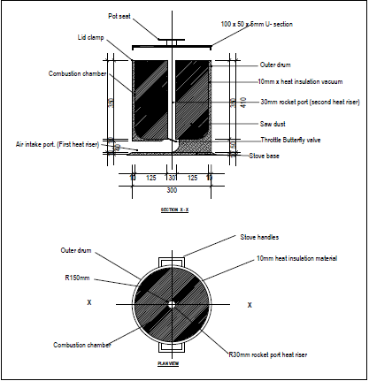
Figure 4: 2D drawing for Stove Combustion Chamber.
In order to concepturize the design features and dimetions, figure 4 above shows illustration of the prototpe design concepts in 2D before the design final assembly.
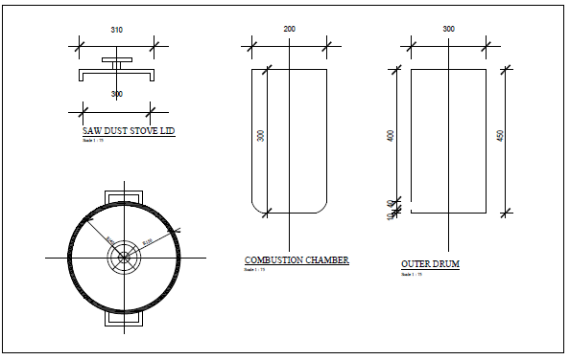
Fugure 5: Gives the dimisional details of the stove layout in 2D format.

2.4.3. The concept for the Sawdust Stove Throttle Valve Body.
Air-Varying Valve mechanism (Butterfly Valve).

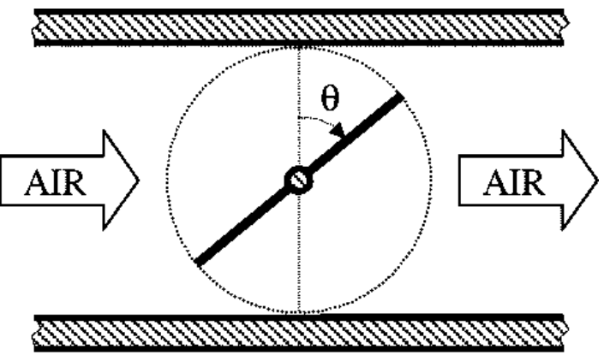
Figure 6: General Schematic Sectional drawing of the valve Throttle Body and its functionality. Image: Research Gate (2024).

2.4. Conceptual Design: - 3D Stove’s main components.

3D drawings for the prototype.
(a)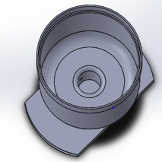 inner chamber.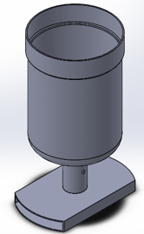 (b) ash tray.
(c)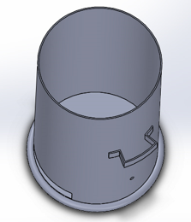outer main stove body. (d) 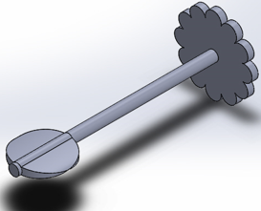 butterfly valve. (e)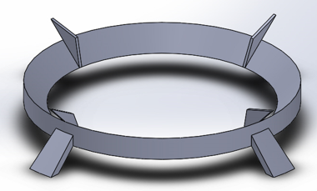pot seat.
Figure 7: Illustration of 3D design model parts of the stove’s concept.
The figure 7 above shows the main components of the stove design in 3D that consisted of the following parts: -
(a) inner chamber. (b) ash tray. (c) outter chamber. (d) butterfly valve. (e) pot seat.

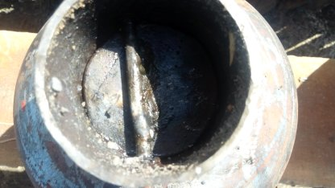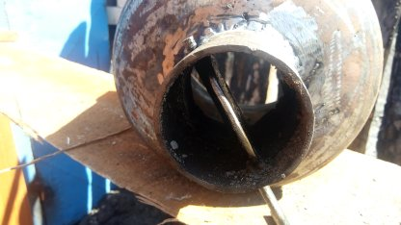
Figure 8: Closed & Opened Varying Throttle Valve Mechanism.

Fig. 8 above shows the fabricated Illustration of the conceptual stove’s throttle body in open and closed positions. The control nob of the butterfly valve mechanism is mechanical adjusted to the desired position by the stove user according to the preferred heat level of the dish being cooked.

Fabricated prototype and 3D representation of Stove.
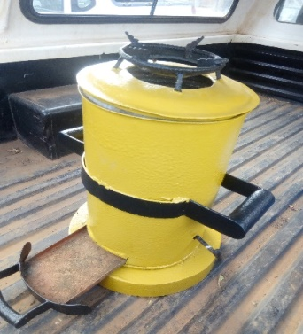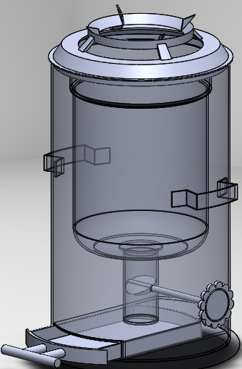
Figure 9: Actual representation of the stove prototype and in 3D model.
3.0: Stove Performance Analysis and Evaluation.
3.1. Stove’s Performance Test Methods.
Efficiency and Specific Fuel Consumption Comparisons between the improved sawdust stove prototype, the charcoal stove and the traditional three stone fire pit stove commonly used in Zambia were conducted.
To comprehend and compare the efficiencies and the specific fuel consumption of the these three types of stoves used in the study, two simple but effective recommended Stove Design Test methods (Water Boiling Test, WBT and Controlled Cooking Test CCT), were adopted and used to conduct the efficiency and specific fuel consumption tests on these three stoves (The improved sawdust stove, the charcoal brazier and the Traditional Three stone fire-pit stove commonly used in Zambia) and data collected is as tabulated below. Note: The strengths and weaknesses of both WBT and CCT methods of the stove tests have been documented and presented by Kashirsugar et al (2014), Kumar et al (2014) and Berkeley Air Monitoring Group (2012).
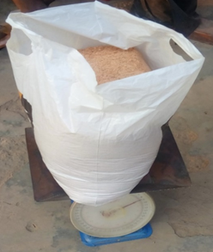
Figure 10: Weighing sawdust test materials before conducting the tests. Image by author.
Before tests were conducted, the test samples were sun dried to reduce the moisture content, then weighed in correct and consistent ratios to minimize the degree of error when conducting the tests.

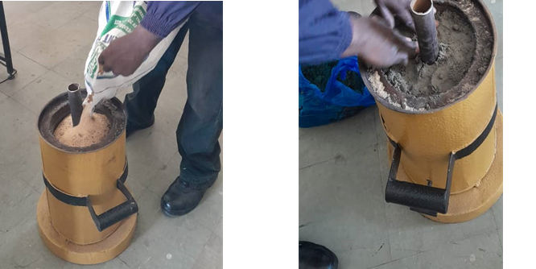
Figure 11: Loading, compacting of sawdust and sealing the top with clay sand to prevent localized burning at the top before conducting the Water Boiling Test:
Image courtesy of author
When operating the stove, specific steps are taken which involves the following stages:’
A centre pole or rod (wood or metal) is placed the middle of the combustion chamber
as a guide, then dry sawdust is carefully poured around the pole and then using a special designed ramming tool, the sawdust is heavily compacted around the centre pole to create a dense compacted fuel; this is to create or achieve a denser fuel-bed for smooth fuel burning (See Figure 11). Once this is done, then the wet soil (preferably clay) is placed on top of the compacted sawdust to prevent localized burning at the top once the stove is ignited (as shown in Figure 11). After doing that the centre pole is removed, this creates the important second heat riser (chimney) for hot gases rise up and contact the cooking pot at the top. The ignition of the stove is done at the base through the air intake port using an external source of fire. Among the three stoves used in the study, the sawdust stove took more time to ignite and had a smokey start but once the fire got set and temperatures reached optimum operating temperature, it became smooth and smokeless.
3.3. Process of Temperature reading and Collected Data for Sawdust Stove, Traditional Brazier and Three stone stoves during WBT and CCT.
To establish the Technical Performance baseline for the tests, the researchers adopted a modified WBT and CCT and conducted these controlled tests on all the three research items as mentioned before starting with:-
- The Water Boiling Test (WBT).
This test basically measured the following components of stoves test.
- Time required boiling a specific amount of water (2.2 liters).
- Run at least 3 replicated tests for Cold start, Hot start, and Simmer phases.
- Take readings at a 3 minute intervals
- The test protocol and setup included the following:-
- Scale: - for weighing pot, water and sawdust samples.
- Timer: - for recording time intervals during tests.
- Pot:- for boiling and cooking test food, and
- Fire starting device: - for igniting the fire in all the stoves.
- Fuel: - sawdust, charcoal and fire wood.
The procedure involved the following stages:-
- Weighing the initial weight of the pot (0.40kg) without water and fuel (4.78kg), (See Table 4).
- Taking and recording the initial, ambient and final temperatures.
- Ignition of the fire and placing of the pot on the stove seat.
- Observe and record the water temperature at 3 minutes interval, Tables 1,2 & 3 and finally,
- Record the total time each stove took to bring water to a boil.
This procedure was replicated on both the traditional charcoal stove as well as the traditional three stone stove for performance comparison.

Table 1: WBT Collected Data for Sawdust Stove.
No. of Tests. | Time in minutes | Temperature (℃)
1 | 0 | 21 (ambient)
2 | 3 | 31
3 | 6 | 40
4 | 9 | 55
5 | 12 | 68
6 | 15 | 78
7 | 18 | 86
8 | 21 | 91
9 | 24 | 95.8
10 | 27 | 96.2
11 | 30 | 96.2
12 | 33 | 96.2
Note. Table 1 shows data collected after conducting Water Boiling Test on the sawdust stove at three minutes interval.

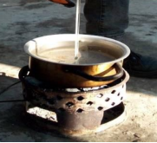
Figure 12: Illustration of conducting the WBT on the traditional cook stove.
(Mutembo, 2023).

Table 2: WBT Collected Data for Charcoal Brazier Stove.
No. of Tests. | Time in minutes | Temperature (℃)
1 | 0 | 21 (ambient)
2 | 3 | 33
3 | 6 | 42
4 | 9 | 51
5 | 12 | 61
6 | 15 | 70
7 | 18 | 81.5
8 | 21 | 90.5
9 | 24 | 94.5
10 | 27 | 94.8
11 | 30 | 95
12 | 33 | 95

Table 3: WBT Collected Data for Three Stone Stove TSS.
No. of Tests. | Time in minutes | Temperature (℃)
1 | 0 | 21 (ambient)
2 | 3 | 33
3 | 6 | 43
4 | 9 | 56
5 | 12 | 62
6 | 15 | 74
7 | 18 | 83.8
8 | 21 | 90.3
9 | 24 | 95.2
10 | 27 | 95.3
11 | 30 | 95.6
12 | 33 | 95.5

Table 4: Cumulative Test Results Data on all stoves (WBT).
Parameters | Units | Sawdust Stove | Charcoal Brazier | Three stone Stove
Ambient | (℃) | 21 | 26 | 22
Final temperature. | (℃) | 96.2 | 95 | 95.6
Initial mass of water (Mw) | (kg). | 2.2 | 2.2 | 2.2
Final mass of water | (kg). | 0.95 | 0.67 | 0.69
Mass of water evaporated(M_{w.E}) | (kg). | 1.24 | 1.80 | 1.51
Change in temperature. | (∆T) | 75.2 | 74 | 73.6
Initial mass of | (kg). | 4.78 | 1.63 | 2.0
Final mass of fuel | (kg). | 3.75 | .56 | 0.82
Mass of fuel consumed(M_{f} consumed) | (kg). | 1.03 | 1.07 | 1.18
Specific heat capacity of water(Cp) | kj/kg.k. | 4.186 | 4.186 | 4.186
Specific heat of vaporization water (L_{v}). | kj/kg | 2260 | 2260 | 2260
Low heating value (LHV). | Mj/kg | 16.54 | 43.10 | 17.65
Note. Adopted from Adjustable Sawdust Stove for Optimal Pot Placement and Improved Insulation Materials. (p.6), by K.E.Musonda and S. Mutembo, 2024, Ndola, Zambia: Wiley, Journal of Renewable Energy. Copyright © 2024 Kabaso E.Musonda and Steven Mutembo.
- Modified Controlled Cooking Test (CCT).
To determine how the Improved Sawdust stove could perform in a real-time cooking task, a modified CCT was used to determine the Stove’s Specific Fuel Capacity (SFC) on the Sawdust stove, the Traditional Charcoal brazier and the Three stone stoves. Paddy rice (1.22kg) was cooked and the data collected and tabulated were as follows.

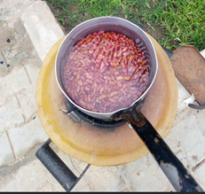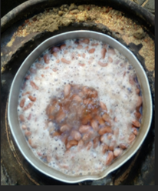

Figure 13: Illustration shows cooking of legumes such beans on the improved sawdust stove. Image courtesy of author.

Table 5: Data Collected for Controlled Cooking Test (CCT).
Parameters | Units | Sawdust Stove | Charcoal Brazier | Three Stone Stove
Mass of pot (Mp) | (kg) | 0.40 | 0.40 | 0.40
Initial mass of raw food (paddy rice) | (kg) | 1.22 | 1.22 | 1.22
Total mass of pot with cooked food (Mpf) | (kg) | 1.620 | 1.620 | 1.620
Initial mass of fuel at start of CCT (W) | (kg) | 4.620 | 4.620 | 4.620
Final mass of fuel at the end of CCT (X) | (kg) | 3.950 | 0.120 | 1.055
Cooking duration during CCT | (min) | 23.9 | 36.7 | 33.5

4.0. Results and Discussion.
The primary objective of this study was to construct a functional improved sawdust stove with added design features that facilities for air flow regulation into the stove for better fuel economy and improved fuel burning rate and improved overall efficiency of the stove with minimal refueling for long periods of cooking time. In order to assess the functionality and performance of the prototype, two controlled tests were conducted, namely the WBT and CCT respectively. Parameters that were considered during these controlled tests were the stove’s efficiency, this aspect was determined by carrying out the WBT whose primary objective was to ascertain the ability of the stove to function properly as intended and be able to bring water to a boil. The other parameter that was used in the study was CCT whose primary objective was ascertain the performance of the stove when cooking real foods. From the data collected, these two tests helped in the computation of Stove’s Thermal Efficiency and Specific Fuel Consumption and these parameters were also conducted on the other two locally used traditional methods of cooking practised in Zambia and the performance in terms of thermal efficiency and specific fuel consumption were compared to that of improved sawdust stove. Researchers in Nigeria in their study on stove’s thermal efficiency and SFC highlighted the importance of reducing SFC in stoves because of the benefits to users and environmental sustainability, lower fuel consumption means less resource use and potentially reduced ecological and environmental damage due to wood fuel collection (Afolabi, 2023).
4.1. Stove’s Thermal Efficiency Calculations.
The thermal efficiency of the stoves was calculated using the following formula
Thermal efficiency $(ɳ) =\frac{\left(Mw.Cp.ΔT\right)+(Mw.E.Lv)}{Mfconsumed.LHV}$ (8)

Where:
$ɳ$ = Thermal efficiency
$Mw=$ Mass flow rate ⁻ (kg/s)
$Cp$ = Specific heat capacity of fluid (kg/kg/k)
$ΔT$ = Change in temperature (℃) or (K)
E = mass fraction of the working fluid during evaporation
L_{v} = Latent heat of vaporization of the working fluid (kj/kg)
$Mf=$Mass flow rate of fuel consumed (kg/s)
LHV = Lower heat value or net calorific value (kj/kg)

The data collected from each stove during CCT was used in the computation of their efficiencies as shown below (See table 5 above).
- Sawdust Stove Efficiency Computation:-
Thermal efficienc$y (ɳ$)$=\frac{\left(Mw.Cp.ΔT\right)+(Mw.E.Lv)}{Mfconsumed.LHV}$
= $\frac{\left(2.2*4186*75.2\right)+\left(1.25*2260000\right) }{1.03*16540000}$
$= \frac{3517531.84}{15216800}$
$ɳ =$ $20.6\%$

2. Charcoal Brazier Efficiency:-
Thermal efficiency $=\frac{\left(Mw.Cp.ΔT\right)+(Mw.E.Lv)}{Mfconsumed.LHV}$
= $\frac{\left(2.2*4186*74\right)+\left(1.80*2260000\right) }{1.07*4310000}$
$$= \frac{474948.8}{4611700}$$
$ɳ$ = $10.3\%$

3. Open Pit Stove (Three Stone Stove)
Thermal efficiency $=\frac{\left(Mw.Cp.ΔT\right)+(Mw.E.Lv)}{Mfconsumed.LHV}$
= $\frac{\left(2.2*4186*73.6\right)+\left(1.51*2260000\right) }{1.18*17650000}$
$ɳ$ = $19\%$

Table 6: WBT & CCT Summary.
Type of Stove Design | Sawdust Stove | Charcoal Brazier | Three Stone Stove
Total Time Taken to boil water(min) | 24 | 27 | 27
Thermal Efficiency of the Stoves | 20.6 | 10.3 | 19.6
Average Combustion Time | 7 – 9 | 12 - 16 | 9 - 11
Note. Efficiency of 20.6% was achieved with the improved sawdust stove as compared to 10.3 and 19% for the local charcoal brazier and the three stone stoves respectively which suggested that an improved sawdust stove incorporated with a varying butterfly valve gave a better fuel economy than the other two traditional stoves.
It was also observed that the three stone stove fared better than the charcoal brazier averaging time ranging between (9 – 11 vs. 12 – 16 minutes) during WBT. The general assumption for this was perhaps not properly kilned charcoal or not much effect of wind condition. However, even an open fire system can achieve high efficiency if controlled properly but this system mainly rely on radiation for heat transfer as a results suffer severe significant energy loss ranging between 20 to 40% (Cengal et.al.,2017).

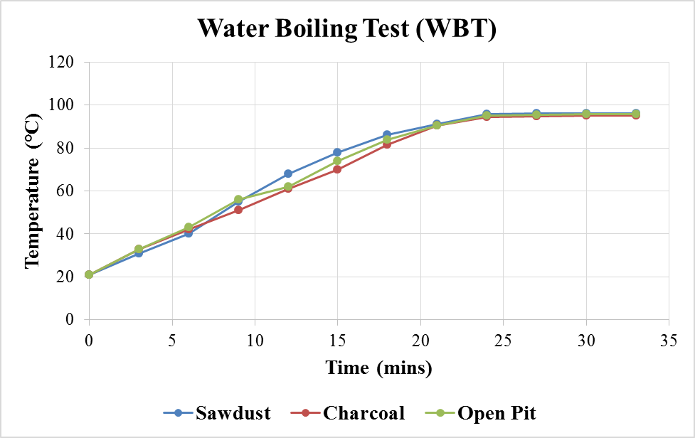

Figure 14. Graphical presentation of temperature variation with time during WBT test for Sawdust stove, Traditional charcoal and Three Stone Stove.

4.2 Modified Controlled Cooking Test (CCT)
In order to determine how the Improved Sawdust stove could perform in a real-time cooking task as compared to the other two widely used cooking devices in Zambia, namely charcoal brazier and the three stone open-pit system, a modified CCT was used to determine and evaluate the Stove’s Specific Fuel Consumption (SFC) of the Sawdust stove, the Charcoal Brazier and the Traditional Three Stone stove. Paddy rice (1.22kg) was chosen for this real-time cooking task because it does not require complicated ingredients to cook, just water and pot, the results obtain (see Table 5) were used in the calculation of the Specific Fuel Consumption (SFC). For this study, the following formula was chosen because of its simplicity to apply and wide use by most stove designers and researchers hence the preference.

SFC $=\frac{Mf.consumed}{Total mass of cooked food}=$ $\frac{w-x}{Mpf-mp}$ (9)
Where:
SFC = Specific Fuel Consumption of the stove (SFC)
$Mf=$Mass flow rate of fuel consumed (kg/s)
M_{pf} = Total mass of pot with cooked food (kg)
W = Initial mass of fuel at start of cooking task (kg)
X = Final mass of fuel at the end of cooking task (kg)

4.2.1 Specific Fuel Consumption Computations.
1.Sawdust Stove Specific Fuel Capacity:-
SFC $=\frac{Mf.consumed}{Total mass of cooked food}=$ $\frac{w-x}{Mpf-mp}$ $=$ $\frac{4.620-3.950}{1.62-0.40} =$ $\frac{0.67}{1.22}$ $=$ 0.55

2.Traditional Stove (brazier):-
SFC$=\frac{Mf.consumed}{Total mass of cooked food}=\frac{w-x}{Mpf-mp}$ $=$ $\frac{0.880-0.120}{1.620-0.400}$ $=$ $\frac{0.76}{1.22}$ $=$ 0.62

3. Open Pit (Three Stone Stove, TSS):-
SFC $=\frac{Mf.consumed}{Total mass of cooked food}=$ $\frac{w-x}{Mpf-mp}$ $=$ $\frac{ 2.0-1.055}{1.62-0.40}$ $=$ $\frac{0.95}{1.22}$ $=$ 0.77

Table 7: Specific Fuel Consumption Summery for the stove designs used in the study.
Parameters | Sawdust Stove | Charcoal Brazier | Three stone Stove
SFC | 0.55 | 0.62 | 0.77
Cooking time(min) | 24.8 | 31 | 30

Table 7 above indicate specific fuel consumption computation summerly of the three stoves designs used in the study and the times each stove took to copmplete the cooking task.
The SFC computations and cooking time taken to complete task suggested that design features incorporated in this design, such as the adjustable mechanical butterfly air varying throttle valve and better insulations between the inner and outer stove walls contributed greatly for the prototype to achieve better SFC and cooking time (0.55 & 24.8mins) in comparison to (0.62 & 31mins) for charcoal brazier and (0.77 & 30mins) for three stone stove respectively. Smith el.al., (2019) identified that airflow was a prominent attribute to good stove design because it plays a paramount role in ensuring complete combustion of the fuel stock and minimizing smoke generation.
4.3 Laboratory test analyses were conducted on the stove to ascertain its performance both in airflow into the stove, Flue gas, and temperatures generated.
4.3.1 Sampling: - the sampling was carried out over a period of 15 - 20 minutes on each
test run. The scope of work involved analysis of the effect that the air-varying valve flue gas under the Stove operating (Testing) conditions to determine the following;
4.4 Effect of the air regulating valve at various openings Furnace Shell temperature.

Figure 15: Outer Shell Temperature Correlation with Flue Gas Temperature.
Graphical presentation above shows the flue gas temperature, ambient temperature and outer shell temperature The illustration above demonstrated that good stove insulation was vital and played a crucial role in minimizing heat loss through heat transfer mechanisms such conduction, conviction and radiation thou the latter is almost impossible to control in real world.
Outer shell temperature correlation with flue gas temperature showed that at maximum flue gas (386.8℃) after 4.5 minutes when operating the stove at Hot Start High Power, the average stove outer shell temperature at this average maximum flue gas temperature was maintained at 34℃ which was close to the ambient temperature range of 29℃ due to good insulation material employed between the combustion chamber and the stove outer main body. This was crucial because this added feature provided extra safety for users from accidental burns by touching the outer because thou the inner temperatures were as high as 386.8℃; the outer walls of the stove were kept at lower temperatures.

4.5. Effects of the valve opening on flue gas flow.
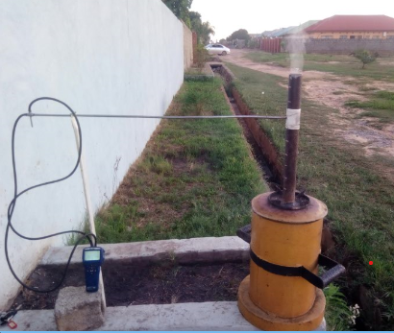
Figure 16: Flue gas and Velocity Testing- Image by author.

Figure 16 above shows the testing the flue gas velocity using a Pitot tube and flow meter, a modified chimney pipe was welded to the stove seat to accommodate the test equipment as shown.

In order to validate the effect of the valve opening at various stages, a small and simple modification was done on the stove to incorporate a chimney in the design to mount the Pitot tube that was connected to the flow meter to take and record Flue gas flow measurement in the combustion chamber. (See Fig.16)

Table 8: Average Velocity and Flow measurement results at respective Stove Valve opening.
Valve opening (%) | Av.Flue Velocity (m/s) | Temp. of Stove Furnace (℃) | Stove’s Volumetric flow (m³/hr.)
0 or (180⁰) | 3.69 | 112 | 26.39
50 or (45⁰) | 3.89 | 344.6 | 27.89
100 or (90⁰) | 4.01 | 386.8 | 28.10
.

Figure 17: Stove Valve (%) Opening vs. Air Volumetric Flow.

Illustration of the effect of the varying valve at various openings and how it affects the flue gas velocity.

5.0 Summary of Result and Analysis.
- The incorporation of varying air regulator valves between the lower chimney and the inner combustion chamber, improved the air draft into the stove, at 180⁰ or at 0%, opening, the average flue gas velocity was 3.69m/s and the stove volumetric flow was 26.39m³/hr. At 45⁰ or 50% valve opening, the average flue gas velocity was 3.89m/s and the stove volumetric flow was 27.49m³/hr, then at maximum valve opening (90⁰ or 100% valve opening), an average flue gas velocity of 4.01m/s was recorded and the stove volumetric flow was at 28.10m³/h.
- In order to validate the results, three important comparative cooking tests were done by using the Water Boiling Test (WBT) and a modified Controlled Cooking Test (CCT) on the sawdust stove, charcoal brazier and traditional three stone fire-pit stove
- The results showed the sawdust stove had a stead buildup of temperature because it was well insulated and lose lost little energy as compared to the other two traditional stoves (Graph 1 & 2). However, the sawdust stove took a longer time to set the fire compared to the other two stoves and had a Smokey start, but once the fire was set it became smokeless and had a steady temperature rise because the fire was insulated from the effects of the elements such as wind as compared to the other two which are open systems which makes them consume relatively much more fuel.
6. Conclusion:
The study draws the following conclusions:
- The study demonstrated that good air drift into the stove and temperature control can be achieved without the aid of auxiliary tools such as fans and blowers that increases the cost of the stove construction by incorporating into the design an air varying valve which acts as a throttle (body) valve and the heat riser which creates the ‘venturi’ effect into the combustion chamber for good air draft.
- The velocity (4.01m/s) recorded was higher than the documented velocity of 1.7m/s for a typical seed feed side rocket stove. MacCarthy et al. (2016).
- Average specific fuel consumption (SFC) rate of 0.55, 0.66 and 0.77 for sawdust stove, traditional charcoal stoves and three stove was achieved respectively giving the difference of 0.11primarily due to the added features in the design.
- The average stove efficiency of 20.6 % (which is within the range of a typical side drift sawdust stove), 19% and 10.3% for traditional charcoal stoves and the three stone stove were recorded respectively. Results showed that the sawdust stove fared well in terns its efficiency and a lower SFC which proved crucial for reduced fuel consumption even operated for longer hours (6 to 9 hours on just a 4.5kg load of sawdust), it was able to cook rice at a fairly reduced time rate as compared to the other two traditional Zambian stoves making it highly competitive in that regard.
The design improvements that were done on the stove showed that the stove can compete favourably with other stove designs in this category in terms of the ability to use little amount of fuel but cooking for longer times without the need to replenish the fuel feed stock, this is a possible feedback in that the stove can assist in improving cooking and heating practices in low-income households in Zambia at low cost since the raw sawdust is in abundance and is practically free fuel and easily accessible, especially in times of the current drought affecting hydro-power generation of the country resulting in long hours of load-shedding.

Recommendation for further future design improvements.
The study reviewed a number of design limitations among them the need to incorporate the fire ignition mechanism similar to those used in gas stoves because of the three stoves used in this study, the sawdust proved the most difficult to ignite in the initial stages (takes a longer time to start the fire).
Further research and dissemination of information about the stove needs to be encouraged for greater application of this resource.
Another area that needs more data sharing is on gas emission, since these stoves are designated for domestic cooking and heating, evaluation of indoor air pollution levels during stove use proves crucial to ensure user safety.

References
Bailis.R., Controlled Cooking Test, (CCT), Household Energy and Health Programme, Shell Foundation,( 2004).
Belonio, A.T., (2005), ‘‘Belone’s Rice Husk Stove Handbook’’. Appropriate Technology Centre, Department of Agricultural Engineering and Environment Management Centre, Philippine University, Iloilo City, Philippines.
Bengwanyan.M.A. (2010) ‘‘How to calculate Co₂ in Trees’’.,http://micheal bengwanyan.wordpress.com/2010/11/08/how-to-calculate-co₂-in-trees/Accessed on February 12, 2022.
Berkeley Air Monitoring Group (BAMG). (2012). Stove performance inventory report: prepare for the global alliance for clean cook stoves. United Nations Foundation. Berkeley;(Available on <http:/cleancookstoves.org/resource files/stove_performance-inventory.pdf > [viewed on 09.09.2023]
Bryden, M., D.Still, P.Scott, G.Hoffa, D, Ogle, R.Bailis& K.Goyer, (2005), Design principle for wood burning cook stoves. Aprovecho Research Centre, Shell Foundation. [Viewed on http://www.ewb-usa.org/files/2024/03/principlewoodburningcookstoves pdf].
Casillas CE, Kammen DM Biomass energy: Lessons from case studies in developing countries. Environment and Development, Policy Forum. Science (2010); 330(6008):1181-82.
Chaiyo, U.; Wilairat, D. (2011). Trace element and carbon content in particulate emission from tropical deciduous forest fire chiangmai. Journal of international Science and Technology 6(2):234.
Chikoko, M.G. (2003). A comparative analysis of household-owned woodlots and fuel wood sufficiency between females and male headed households: Pilot study in rural Malawi; Africa (PhD, Oregon State University)
Cuvilas C., Jirjij, R and Lucas, C.: ‘‘Energy Situation in Mozambique’’: A review, Renewable and Sustainable Energy Review (14) (2010), pp 2139-2146.
Darlami.H.B; Ale.B.B. And G.R.Pokharel, ‘‘Experimental analysis of thermal efficiency of mud improved cook stove with variation of different parameters and economic analysis’’, journal of the institute of engineering, Vol.15, no.3, pp.385-392, (2019).
David G Ullman, (2013.) ‘‘Design process (mechanical design process’’, 4th edition www.cigr journal.org
Dresen.Elisabeth, BenDevries, Martin Herold, Louis Verchot and Robert Muller, (2014). “Fuelwood Saving and Carbon Emission Reductions by the use of Improved Cooking Stoves in an Afromontane Forest, Ethiopia, land’’ Vol.3:1137-1157; doi: 10.3390/land 3031137.
Elaigwu, V; Adetogun, A.C and Tembe, E.T (2010): ‘‘Combustion properties of briquettes production from Groundnut shells and rice husk’’, Pp 4-20.
Environment and Energy Team, Development Research Group, Research Paper (2019), “Can Improved Biomass Cook Stoves Contribute to REDD+in low-Income Countries?” [Viewed on 04/20/2022].
K.R.Smith,G.Delgado,and A.Haines, 'Technologies for clean cooking:health,environment,and climate benefits’, lancet Global Health,vol.7,no.4.pp.e485 – e494,(2019).
Kashirsugar M.P, Kalamkar V.R. ‘‘A comprehensive review on biomass cook stoves and a systematic approach for modern cook stove designs’’. Review Sustain Energy Rev (2014); 30: 580 – 603.
Khan.A.R.,A.U.Khan.,M.T.Rahman,M.A.Ulah,and M.M.Rahman.‘‘Thermal Characterization of pine sawdust as energy source feedstock’’, fuel.vol.239, (2023).
M.J. Turinayo. ‘‘Performance Characterization of improved wood cooking stoves for monitoring household energy interventions in Uganda Kampala’’: National Forest Resources Institute (NaFORRI), (2011).Viewed at: Google Scholar.
Makame, O.M. (2007); ‘‘Adoption of improved stoves and deforestation in Zanzibar, Management of Environmental Quality,’’ 18(3), 353-366.
McCarthy.N.A and Bryden, K.M (2016).A generalized heat-transfer model for Shielded–Fire householdcookstoveEnergyforSustainable.Development,33,96107.http://doi:org/10.1016/j.esd.2016.03.03
Montalvo. Cleaner technology diffusion: Case Studies Modelling and Policy. J.Cleaner Production 2008b; 16(1) (suppl 1):51-56.
Musonda.E.K and Mutembo.S, (2024), Adjustable Sawdust Stove for Optimal Pot Placement and Improved Insulation Materials. Journal of Renewable Energy.
N. MacCarty, D. Still, and D. Ogle, “Fuel use and emission performance of fifty Cooking Stoves in the laboratory and related benchmarks of performances’’, Energy of Sustainable Development, Vol.13 no3, pp.161-171, (2010).
Ncube. E. and Phiri. B. (2015) ‘‘Concentration of heavy metals in Eucalyptus and Pinus wood sawdust and smoke Copperbelt province Zambia’’: Copperbelt University, School of Natural Resources, and Dept. Of Biomaterials Science and Technology, Kitwe Zambia.Maderas, Cienc.technol.vol. 17, no.3 Concepcion jul.2015) epub 30-june-(2015). Viewed October 2, 2022.
Nwakaire, J.N., Ugwauishiwu.B.O (2015) ‘‘Natural Cross Draft Gasifier Stove for Application in Rural Communities in Sub-Saharan Africa’’, Research Article.17 September, 2015.
Olawole A., Aina K.S and Egbewole Z.T. (2008): ‘‘Potential use of wood residue for briquette production; an alternative to energy generation. Production Agriculture and Technology Journal’’, Vol. 5 (1) ISS N 0794-5213 Pp 18-22.
Parmisiani, S.P., Vitali, F., Lezzi, A.M., Vaccari, M.: ‘‘Design and Performance assessment of a rice husk-fueled stove for household cooking in a typical sub-Saharan setting. Energy. Sustain, Dev’’. 23, 15-24 (2014).
Roth, C. (2014).micro gasification: Cooking with gas from dry biomass. Eschborn. Retrievedon09.09.2023fromhttps://energypedia.info/wiki/file:Micro_Gasification_2.0_Cooking_with_gas_from_dry_biomas Pdf.
Simfukwe, E. (2010). Programe for basic energy conservation-Impact Assessment Evaluation for Zambia. GTZ: Lusaka.
Smith, K.R., & Mehta, S, (2023). The burden of disease from indoor air pollution in developing countries: comparing of estimates.Int J Hyg Eviron Health 206:279-89.
Smith. K. Edwards. RD, et al., (2023). ‘‘Model to predict emissions of health-damaging pollutants and global warming contributions of residential fuel/stove combinations in China’’.Chemosphere50 (2), 201_215.
Sugar, A.D., & Kartha, S. (2007). ‘‘Bioenergy and Sustainable Development. Annual Review of Environment and Resources’’, 32,131-167.
Van Asperen S.A. Research Project: ‘‘Improvement of production and management processes of metal ceramic charcoal stoves in Dar-es-Salam, Tanzania’’ (2011).
Y.A. Cengel and A.J.Ghajar, ‘‘Heat and Mass Transfer fundamentals and Applications’’, McGraw – Hill Education, 5th edition, (2017).

