Enhancing downy mildew management in grapes through seaweed extracts, chitosan, and targeted fungicide Use

ABSTRACT
Objective: To manage downy mildew of grapes with targeted chemical fungicide applications combining the seaweed extracts and chitosan.
Study design: Present experiment evaluated by Department of Plant Pathology, University of Agricultural Sciences, Bengaluru at farmers' fields during 2019 and 2020.
Methodology:
Experiment was conducted at Harobande village of Chikkaballapur district and another experiment was laid out at Linganahalli village of Bangalore rural district during fruit pruning season which had four different schedules with four replications, for each schedule 20 vines were maintained along with untreated control.
Results:
Among these, Schedule 3, which incorporated LBD12 (a seaweed extract) alongside chemical fungicides, demonstrated the highest reduction in disease severity 86.26% at Linganahalli and 87% at Harobande while also enhancing yield and quality attributes. Additionally, Schedule 2 and Schedule 4, which included LBD3 (another seaweed extract) and chitosan, respectively, showed significant improvement over the control.
Conclusion:
This study highlights the potential of integrating seaweed extracts and chitosan with the need-based application of low-risk fungicides, offering an effective strategy for managing downy mildew while minimizing resistance development and fungicide residues in vineyards.
Key words: Seaweed, downy mildew, chitosan and management
- INTRODUCTION
Oomycete pathogens are highly destructive parasites that infect plants and animals across various ecosystems, causing severe economic losses (Thines 2014, Gascuel et al. 2015). Plasmopara viticola, an obligate biotroph, is a major concern in grape-growing regions of India and worldwide, as it leads to downy mildew in grapevines. The disease manifests as oil spots on the upper leaf surface and white downy fungal growth on the underside of leaves, canes, and bunches, particularly under humid conditions (Ash 2000). If infection occurs during early shoot growth to fruit set stages, yield losses can range from 30% to complete crop failure (Sawant et al. 2010). Even in the absence of rainfall, night time dew formation can trigger infections on grape clusters (Sawant et al. 2010). Additionally, spot infections on the rachis or pedicels of young bunches can lead to premature berry collapse, further impacting yield.
Most cultivated Vitis vinifera varieties in India and globally are highly susceptible to P. viticola. Only recently have sources of resistance been identified in Georgia (South Caucasus) (Toffolatti et al. 2018), the center of viticulture’s origin (This et al. 2006). Due to the high susceptibility of available cultivars, chemical fungicides remain the primary means of managing the disease. However, overuse or misuse of synthetic pesticides often causes residue problems that results in negative effects on humans, environment, and toxicity to non-target organisms (Sande et al. 2011) and also repeated use of fungicides has led to resistance development in pathogen populations, complicating disease control (Gisi and Sierotzki 2008). This challenge is exacerbated by P. viticola’s complex life cycle, which includes both sexual and asexual reproduction and multiple infection cycles within a single growing season.
To effectively manage downy mildew while reducing the risk of fungicide resistance, an integrated disease management strategy is essential. This involves combining chemical fungicides with low-risk compounds or eco-friendly alternatives. In recent years, seaweed extracts have gained prominence in pest and disease management due to their phytoelicitor properties attack (Fei et al. 2017). These extracts enhance plant defense responses by upregulating key defense-related genes, thereby conferring resistance to various pathogens and environmental stresses. Additionally, seaweed extracts influence phytohormonal activity, further strengthening plant immunity (Ali et al. 2016).
Chitosan, another eco-friendly compound, has also demonstrated success in disease management (Ghule et al. 2018). It is a naturally occurring linear polysaccharide composed of β-(1→4)-linked D-glucosamine and N-acetyl-D-glucosamine units. Chitosan has been reported to induce plant defense mechanisms, inhibiting fungal growth and development in various plant-pathogen interactions (Hadrami et al. 2010).
With these considerations in mind, a field experiment was conducted in two districts of southern Karnataka to evaluate four different disease management schedules. The objective was to develop an effective strategy that minimizes chemical fungicide applications while incorporating eco-friendly alternatives such as seaweed extracts and chitosan. This approach aims to achieve efficient downy mildew control while reducing fungicide resistance risks and minimizing chemical residues in vineyards.

- MATERIAL AND METHODS
2.1 Location, cultivar and date of pruning
The present experiment was implemented and carried out in farmers' fields located in two districts of Karnataka during 2019 and 2020. One experiment was laid out at Harobande village of Chikkaballapur district and another experiment was laid out at Linganahalli village of Bangalore rural district during fruit pruning season. Trail was conducted on six-year-old grape vine cultivar Dilkush which is cultivated in most of the areas of these two districts. The vines were planted at a spacing of 6′ x 3′ (row-to-row and plant-to-plant) with a pandal system of training of vines.
During both the year, pruning of vine was carried out on 15th November and 20th November at Linganahalli and Harobande, respectively. Spray schedule was initiated one week after pruning. Present experiment had four different schedules with four replications, for each schedule 20 vines were maintained along with untreated control. Details of each schedule is given in Table 1.
2.2 Seaweed extracts
Seaweed extracts used in this experiment viz., LBD3 and LBD12 were procured from the Sea6 energy private limited company located in National Centre for Biological Sciences, Bengaluru. Chitosan 70 per cent deacetylation was used at the rate of 2g/L of water.
2.3 Observation on downy mildew severity
Observations on downy mildew severity was done on randomly selected ten vines of each schedule. From each vine four shoots were selected and labelled, on each shoot 10 leaves were selected for disease scoring. 0-4 grade scale as described by Horsfall and Barratt (1986) was followed for disease observation, where 0 = No downy growth on the leaves, 1 =Trace to 25 % of leaf area diseased, 2 =26 – 50 % of leaf area diseased, 3 = 51 – 75 % of leaf area diseased, 4 = 76 – 100% of leaf area diseased. Later Per cent Disease Index was calculated using the formula given by McKinney (1923). The data was analysed by RBD using the R software.
Sum of numerical ratings × 100
PDI = –––––––––––––––––––––––––––––––––––––––––––
Number of leaves observed × Maximum disease rating scale

2.4 Observations on yield and quality parameters
At the time of harvest various yield and quality observations were made viz., Bunch length, Number of fruits per bunch, Diameter of the fruit, Total soluble solids (TSS) and Average weight of ten bunches.
2.5 Bunch length
From every schedule ten bunches were randomly selected in each vine and length of the bunch was taken with the help of scale. Later the average length of the bunch in each schedule was worked out and recorded.
2.6 Number of berries per bunch
In each vine, ten bunches were randomly selected and the number of berries in each bunch was counted and then the average number of berries per bunch was calculated and recorded.
2.7 Total soluble solids (TSS)
TSS was recorded with the help of a hand held refractometer (ARTAGO®). Ten berries from the selected bunches of each vine were taken and the berry was squeezed to place the juice on to the refractometer; later observations were recorded. Further average TSS of the berries was calculated.
2.8 Weight of the bunches
At the time of harvest ten bunches in each vine was selected randomly and average weight of ten bunches was rcorded with the help of weighing balance

 | Schedule 1 (Farmers practice) | Schedule 2 (Fungicides + LBD 3) | Schedule 3 (Fungicids + LBD 12) | Schedule 4 (Fungicides + Chitosan)
1st week | Bordeax mixture @ 1 % | Copper oxy chloride @ 3 g/L | Bordeax mixture @ 1 % | Bordeax mixture @ 1 %
2nd week | Captan 50 % WP @ 2.5 g/L | Metalaxyl-M 4 % + Mancozeb 64 % WP @2.5 g/L | Metalaxyl-M 4 % + Mancozeb 64 % WP @ 2.5 g/L | Metalaxyl-M 4 % + Mancozeb 64 % WP @ 2.5 g/l
3rd week | Mancozeb 75 % WP @ 2 g/L | Mancozeb 75 % WP @ 2 g/L | Propineb 70 % WP @ 3 g/L | Copper Sulphate 47.15 % + Mancozeb 30 % WDG @ 2 g/L
4th week | Mancozeb 75 % WP @ 2 g/L | Fosetyl AL 80 WP @ 2 g/L | Fosetyl Al 80 % WP @ 2 g/L | Fosetyl Al 80 WP @ 2 g/L
5th week | Metalaxyl-M 4 % + Mancozeb 64 % WP @ 2.5 g/L | Sea weed extract 1 (LBD-3) @ 2 mL/L | - | -
6th week | Metalaxyl-M 4 % + Mancozeb 64 % WP @ 2.5 g/L | Dimethomorph 50% WP @ 1 g/L | Sea weed extract 2 (LBD 12) @ 3 mL/L | Fosetyl Al 80 WP @ 2 g/L
7th week | Fosetyl AL 80 % WP @ 2 g/L | Sea weed extract 1 (LBD-3) @ 4 mL/L | Sea weed extract 2 (LBD 12) @ 3 mL/L | Chitosan @ 2 g/L
8th week | Fosetyl AL 80 % WP @ 2 g/L | Sea weed extract 1 (LBD-3) @ 4 mL/L | Sea weed extract 2 (LBD 12) @ 3 mL/L | Chitosan @ 2 g/L
9th week | Cymoxanil 8% + Mancozeb 64% WP  @ 1.5 g/L | Iprovalicarb 5.5 % + Propineb 61.25 % WP 66.75 WP @ 1.5 g/L | Famoxadone 16.6 % + Cymoxanil 22.1 % SC @ 1 mL/L | Ametoctradin 27 + Dimethomorph 20.27 SC @ 2 mL/L
10th week | Fluopyram 17.7%+ Tebuconazole17.7% w/w SC @ 1 mL/L | - | - | -
11th week | Tebuconazole 25.9% EC @ 1 mL/L | Sea weed extract 1 (LBD-3) @ 4 mL/L | Sea weed extract 2 (LBD 12) @ 3 mL/L | Chitosan @ 2g/L
12th week |  | Sea weed extract 1(LBD-3) @ 4 mL/L | Sea weed extract 2 (LBD 12) @ 3 mL/L | Chitosan @ 2g/L
Total applications | 11 applications of chemical fungicides | 6 applications chemical fungicides + 5 application of seaweed extract (LBD3) | 5 applications of chemical fungicides + 5 applications of seaweed extract (LBD12) | 6 applications chemical fungicides + 4 application of chitosan
Table 1: Details of the spray schedules implemented in farmers' fields for the management of downy mildew in grape
- Results and Discussion
Experiment was carried out at farmer’s field located in Harobande village of Chikkaballapur district and Linganahalli village of Bengaluru rural district to see the effect of seaweed extracts on downy mildew of grapes by combining with the other chemical fungicides and also with aim to reduce the number of fungicidal applications. Results obtained from the experiment are represented in Table 2 and Table 3.
The present experiment had four different schedules, wherein schedule1 was consisting of the practices that farmers are following for the management of downy mildew. Schedule2 and schedule3 had different chemical fungicides along with seaweed extracts, LBD3 and LBD12, respectively. All the schedule followed for the management of downy mildew were significantly differing from each when compared with the control
3.1 Effect of combining the seaweed extracts in reducing the severity of downy mildew
Among the four different schedules, schedule2 and schedule3 were included with seaweed extract at peak periods of downy mildew (At 5th,7th,8th, 11th and 12th week after pruning in schedule2, at 7th, 8th, 11th and 12th week after pruning in schedule 3). Both schedules along with farmer’s practices were able to reduce the downy mildew significantly when compared with untreated control (71.31 % and 74.21 % at Linganahalli and Haroaabnde, respectively. (Note: Data represented in the text was taken from the pooled data)). Among the four schedules, shedule3 which included with LBD12 has recorded the lowest downy mildew severity (9.79 % and 9.56 % at Linganahalli and Haroaabnde, respectively, Table 2 & 3) and highest reduction over control (86.26 per cent at Linganahalli and 87.08 at Harobande, Fig. 1a and 1b) at both the location and it was statistically differing from all the schedules, it was followed by the schedule 2 (12.06 % at both the location (Table 2 & 3)), 83.09 per cent reduction over control at Linganahalli and 82.86 per cent at Harobande (Fig. 1a and 1b)) but it was found to be on par with the schedule1 (Farmers practice (12.58 % and 12.98 % at Linganahalli and Harobande, respectively, Table 2 & 3)). Suthin et al. (2018) reported the application of Sargassum wightii (brown seaweed) at 10 percent, 30 and 50 days after pruning followed by challenge inoculation P. viticola, triggered plant mediated defense mechanism that in turn reduced the downy mildews incidences in grape. Thankaraj et al. (2019) reported the drastic reduction downy mildew upon spraying with Dictyota dichotoma (brown seaweed) at 10%. They observed the 51.13 and 81.27 per cent reduction in downy mildew. Romanazzi et al. (2016) found that laminarin extracted from the brown seaweed Laminaria digitate effectively controlled P. viticola when combined with low doses of copper salts or extracts from Saccharomyces spp. They noted downy mildew control rates of up to 95 percent and 37 percent, respectively.
3.2 Effect of combining the chitosan in reducing the downy mildew of grapes.
Among the different schedules, schedule4 was included with chitosan at 7th, 8th, 11th and 12th weeks after pruning. It had shown the significant reduction in the downy mildew incidence as compared to the control but show the little higher incidence level when compared with other schedules during both years (15.73 % and 16.77 % at Linganahalli and Haroaabnde, respectively (Table 2 and 3)). It had shown the 77.94 per cent reduction over control at Linganahalli and 77.40 per cent at Harobande (Fig. 1a and 1b). Ghule et al. (2018) reported that, foliar application of chitosan significantly reduced the PDI of downy mildew on both leaves and bunch at Maharashtra. They showed the 57 per cent control of downy mildew on leaves and 70 per cent control on bunch. Mian et al. (2023) reported that field testing of chitosan showed an average reduction in downy mildew disease severity by 30 per cent. Romanazzi et al. (2024) reported that, upon experiment with three consecutive seasons, chitosan treatments effectively reduced the grapes downy mildew on leaves and bunches under different environmental conditions. On bunches, chitosan alone was less effective than copper, when applied after copper had the same effectiveness, and combined with copper was more effective than copper standard.
3.3 Effect of seaweed extracts and chitosan on yield and quality attributes
Result obtained from the experiment shows that among the different schedules implemented, schedule3 which included with LBD12 showed the highest number of berries per bunch (89 berries/bunch both at Linganahalli and Harobande), highest bunch length (26.63 cm at Linganahalli and 27.06 cm at Harobande) total soluble solids (15.06 ⁰B at Linganahalli and 15.55 ⁰B at Harobande) and average weight of ten bunches (451.87g at Linganahalli and 454 at Harobande) when they are compare with all other schedules and also found significant (Table 2& 3). Schedule2 which included with LBD3 found to be the next best schedule and showed the significant differences with schedule1 and schedule 4 with respect to bunch length, no of fruits per bunch, total soluble solids and average weight of ten bunches (Table 2 and 3). With respect to the per cent increase over control schedule3 showed highest increase in bunch length (83.40 % at Linganahalli and 97.09 % at Harobande (Fig. 2 & 3)), number of berries per bunch (88.98 % at Linganahalli and 96.65 % Harobande), total soluble solids (71.53 % at Linganahalli and 72.59 % Harobande) and average weight of ten bunches (87.30 % at Linganahalli and 76.15 % at Harobande) (Fig. 2 & 3)). Thankaraj et al. (2019) reported that, upon spraying with Dictyota dichotoma (brown seaweed) @ 10% after 30 and 50 days after pruning, they observed the 69.93 per cent increase in bunch weight, 46.27 per cent increase in the number of berries and 54.87 per cent increase in berries weight over control. Petoumenou and Patris (2021) reported the preharvest canopy application of Ascophyllum nodosum (Brown seaweed) increased the weights of 50 berries by 8 percent, berry length by 8.9 per cent over the control. Application of brown seaweed extract also know to increase the yield numerous plants, such as apples of cv. Fuji (Spinelli et al. 2009), pear trees (Colavita et al. 2011) and strawberry plants (Weber et al. 2018). Chitosan included schedule also showed the significant increase in the the highest number of berries per bunch (74 berries/bunch both at Linganahalli and 73 at Harobande), total soluble solids (10.91 ⁰B at Linganahalli and 11.85 ⁰B at Harobande) and average weight of ten bunches (393.12 g at Linganahalli and 395.37 at Harobande) when compared with control but show less increase or on par with other schedules (Table 2 &3). Ghule et al. (2018) reported that, chitosan treated plants showed the highest number bunches per vine (37 bunches/vine), yield per vine (37.2 kg/vine), increase in berry size (17.4 cm) and total soluble solids (18.0º Brix) when compared with fungicides treatment alone.
- Conclusion
The present study demonstrates that integrating seaweed extracts and chitosan into disease management schedules effectively reduces downy mildew severity while enhancing grape yield and quality. Among the tested schedules, Schedule 3, which included the LBD12 seaweed extract, achieved the highest reduction in downy mildew severity, significantly outperforming other treatments. It also resulted in the improvements in bunch length, berry count, total soluble solids, and overall yield, proving to be a strong alternative. Chitosan application (Schedule 4) contributed to disease control and yield enhancement, though its effectiveness was slightly lower compared to seaweed-based treatments. However, when combined with traditional fungicides, chitosan improved disease resistance and fruit quality, reinforcing its potential as a sustainable disease management tool. Given the growing concerns over fungicide resistance and environmental impact, integrating seaweed extracts and chitosan into grapevine disease management presents a viable, eco-friendly approach. The findings support the adoption of these natural compounds in viticulture to enhance disease resistance, improve fruit quality, and reduce dependency on synthetic fungicides.

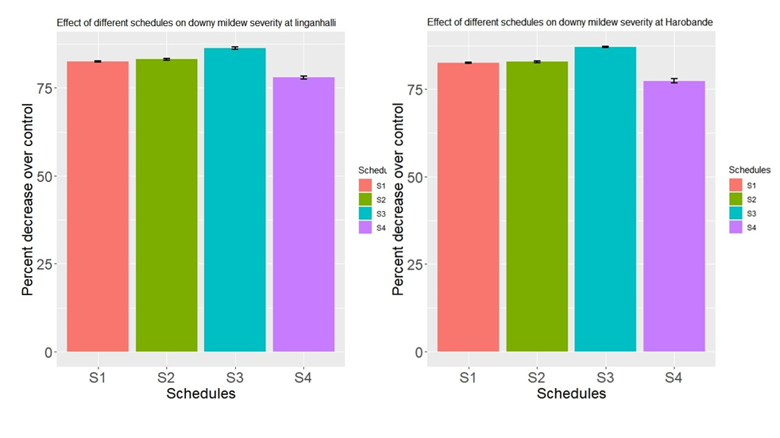
Figure1. Effect of different schedules on downy mildew of grapes, (a) Per cent decrease in severity over control implemented at Linaganahalli, (b) Per cent decrease in severity over control implemented at Harobande. Figure are obtained by taking the pooled data

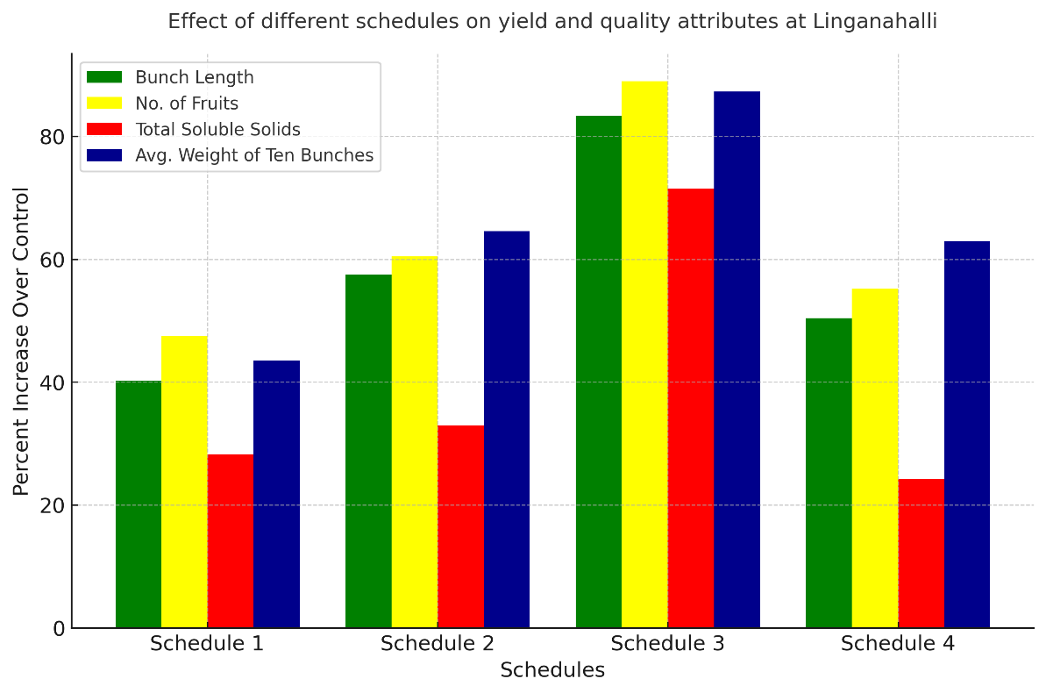

Figure 2. per cent increase in yield and quality attributes over control implemented Linganahalli
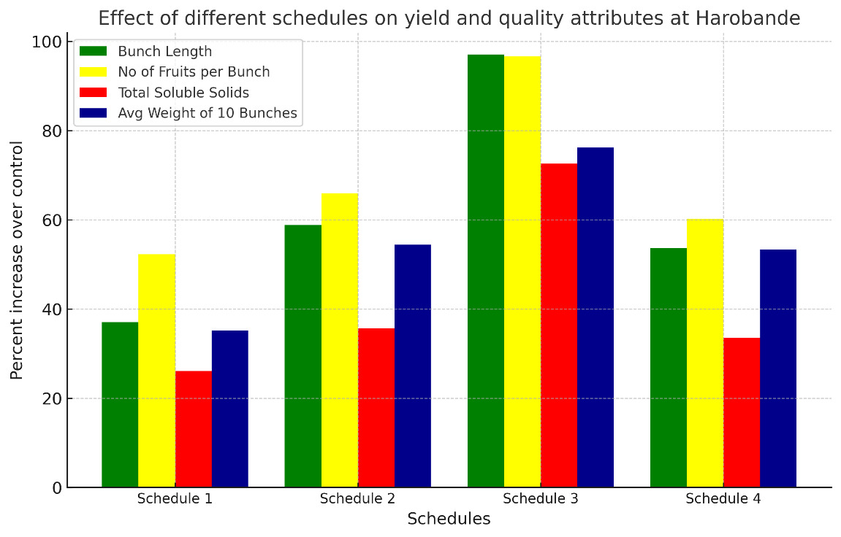

Figure 3. per cent increase in yield and quality attributes over control implemented Linganahalli

Table 2. Evaluation different spray schedules involving fungicides, seaweed extracts and chitosan on downy mildew of grapes implemented at Linganahalli (Pooled)
Schedules | PDI  (Percent disease index) | Bunch length  (cm) | No of fruits per bunch | Total soluble solids  ( ^{O}B) | Average weight of ten Bunches  (g)
Schedule 1 | 12.58^{c}  (20.77) | 20.36^{d} | 69.87^{d} | 11.26^{b} | 346.25^{d}
Schedule 2 | 12.06^{c}  (20.01) | 22.87^{b} | 76.00^{b} | 11.67^{b} | 397.00^{b}
Schedule 3 | 9.79^{d}  (9.85) | 26.63ª | 89.50ª | 15.06ª | 451.87ª
Schedule 4 | 15.73^{b}  (23.56) | 21.84^{c} | 73.50^{c} | 10.91^{b} | 393.12^{c}
Control | 71.31ª  (57.86) | 14.52e | 34.87e | 6.78^{c} | 241.25e
SE(m) | 0.34 | 0.43 | 1.49 | 0.27 | 6.34
CD | 1.07 | 1.36 | 4.65 | 0.84 | 19.77

Note: Mean values followed by different letters within the same column indicate significant differences according to Duncan’s multiple range test (p < 0.05). The data presented is a pooled data of 2019 and 2020.

Table 3. Evaluation different spray schedules involving fungicides, seaweed extracts and chitosan on downy mildew of grapes implemented at Harobande (Pooled)
Schedules | PDI  (Percent disease index) | Bunch length  (cm) | No of fruits per bunch | Total soluble solids ( ^{O}B) | Average weight of ten Bunches  (g)
Schedule 1 | 12.98^{c}  (21.11) | 18.82^{c} | 69.5^{d} | 11.36^{c} | 348.625^{c}
Schedule 2 | 12.68^{c}  (20.85) | 21.81^{b} | 75.75^{b} | 12.22^{b} | 398.25^{b}
Schedule 3 | 9.56^{d}  (18.00) | 27.06ª | 89.75ª | 15.55ª | 454.25ª
Schedule 4 | 16.77^{b}  (24.16) | 21.1^{b} | 73.12^{c} | 12.03^{bc} | 395.37^{b}
Control | 74.21ª  (59.46) | 13.73^{d} | 32.87e | 7.01^{d} | 257.87^{d}
SE(m) | 0.257 | 0.33 | 1.16 | 0.21 | 7.49
CD | 0.799 | 1.04 | 3.61 | 0.65 | 23.33

Note: Mean values followed by different letters within the same column indicate significant differences according to Duncan’s multiple range test (p < 0.05). The data presented is a pooled data of 2019 and 2020
References:

Ali N, Farrell A, Ramsubhag A, Jayaraman J (2016) The effect of Ascophyllum nodosum extract on the growth, yield and fruit quality of tomato grown under tropical conditions. J Appl Phycol 28:1353-1362.
Ash G (2005) Downy mildew of grape. The Plant Health Instructor, Charles Sturt University,
New South Wales, Australia.
Colavita GM, Spera N, Blackhall V, Sepulveda GM (2011) Effect of seaweed extract on pear fruit quality and yield. Acta Hortic 909: 601-607
Fei H, Crouse M, Papadopoulos Y, Vessey JK (2017) Enhancing the productivity of hybrid poplar (Populus× hybrid) and switchgrass (Panicum virgatum L.) by the application of beneficial soil microbes and a seaweed extract. Biomass and bioenergy 107:122-134.
Gascuel Q, Martinez Y, Boniface MC, Vear F, Pichon M, Godiard L (2015) The sunflower downy mildew pathogen Plasmopara halstedii. Mol Plant Pathol 16(2):109-22.
Ghule MR, Sawant IS, Sawant SD (2018) Eco-friendly methods for management of downy mildew of grapevines. J Eco-friendly Agric 13(1): 80-84.
Gisi UC, Sierotzki H (2008) Fungicide modes of action and resistance in downy mildews. In The Downy Mildews-Genetics, Molecular Biology and Control, Springer: Dordrecht, The Nederland, pp. 157–167.
Hadrami AE, Adam LR, Hadrami IE, Fouad D (2010) Chitosan in plant protection. Marine Drugs, 8: 968-987
Horsfall JG, Barratt RW (1986) An improved grading system for measuring plant disease. Phytopathology 35:655.
Mckinney HH (1923) A new system of grading plant diseases. J Agric Res 26:195-218.
Mian G, Musetti R, Belfiore N., Boscaro D, Lovat L, Tomasi D (2023) Chitosan application reduces downy mildew severity on grapevine leaves by positively affecting gene expression pattern. Physiol Mol Plant Pathol 125:102025.
Petoumenou DG, Patris VE (2021) Effects of several preharvest canopy applications on yield and quality of table grapes (Vitis vinifera L.) Cv. Crimson Seedless. Plants 10(5): 906.
Romanazzi G, Mancin V, Feliziani E, Servili A, Endeshaw S, Neri D (2016) Impact of alternative fungicides on grape downy mildew control and vine growth and development. Plant dis, 100(4):739-748.
Romanazzi G, Piancatelli S, Potentini R, D'Ignazi G, Moumni M (2024) Applications of chitosan alone, alternated or combined with copper for grapevine downy mildew management in large scale trials. J Clean Prod 451:142131.
Sawant IS, Sawant SD, Upadhyay A, Sharma J, Upadhyay AK, Shetty D, Bhirangi R (2010) Crop loss in grapes due to downy mildew infection on clusters at pre and post-bloom stages under non-epiphytotic conditions. Indian J Hortic 67:425-432.
Spinelli F, Fiori G, Noferini M, Sprocatti M, Costa G (2009) Perspectives on the use of a seaweed extract to moderate the negative effects of alternate bearing in apple trees. J Hortic Sci Biotech 84: 131-137
Sande D, Mullen J, Wetzstein M, Houston J (2011) Environmental impacts from pesticide use: a case study of soil fumigation in Florida tomato production. Int J Environ Res Public Health 8(12): 4649-4661.
Thankaraj SR, Sekar V, Kumaradhass HG, Perumal N, Hudson AS (2019) Exploring the antimicrobial properties of seaweeds against Plasmopara viticola (Berk. and MA Curtis) Berl. and De Toni and Uncinula necator (Schwein) Burrill causing downy mildew and powdery mildew of grapes. Indian Phytopath 73: 85-201.
Thines M (2014) Phylogeny and evolution of plant pathogenic oomycetes-a global overview. Eur J Plant Pathol 138(3): 431-447.
This P, Lacombe T, Thomas MR (2006). Historical origins and genetic diversity of wine grapes. TRENDS in Genetics 22(9): 511–519.
Toffolatti SL, De LG, Costa A, Maddalena G, Passera A, Bonza MC, Pindo M, Stefani E, Cestaro A, Casati P (2018) Unique resistance traits against downy mildew from the centre of origin of grapevine (Vitis vinifera). Sci Rep 8: 12523.
Weber N, Schmitzer V, Jakopic J, Stampar F (2018) First fruit in season: Seaweed extract and silicon advance organic strawberry (Fragaria_ananassa Duch.) fruit formation and yield. Sci Hortic 242: 103-109.

