Review Article
Integrating Biofertilizers in Nutrient Management of Millets: A Review of Advances and Prospects

ABSTRACT
Millets, often termed called “nutri-cereals,” are gaining renewed attention for their resilience, nutritional richness value, and adaptability to marginal environments. However, their productivity remains limited is still restricted by poor soil fertility and inefficient nutrient management. Integrating biofertilizers into millet cultivation offers an eco-friendly, cost-effective, and sustainable alternative to conventional fertilizer practices. This review synthesizes recent advances in biofertilizer application, nutrient dynamics, and their synergistic combined effects on millet growth, yield, and grain quality. Biofertilizers such as Rhizobium, Azospirillum, Azotobacter, and phosphate-solubilizing bacteria (PSB) enhance nutrient availability by fixing atmospheric nitrogen, solubilizing phosphorus, and mobilizing micronutrients, while mycorrhizal associations improve root absorption and stress tolerance. Evidence suggests that inoculation with appropriate microbial strains can increase millet yield by 20–30%, improve nutrient uptake efficiency, and maintain soil health. The review further highlights the influence of processing on millet millet's antioxidant potential, where techniques such as germination and malting significantly enhance enhanceing the bioavailability of phenolic compounds and antioxidant capacity. Policy recommendations for promoting to promote millet production include strengthening seed inoculation protocols, optimizing organic–inorganic fertilizer combinations, and integrating biofertilizers within national nutrient management frameworks. The convergence of biofertilizer technology with sustainable agronomic practices holds immense potential for revitalizing to revitalize millet cultivation, improving nutritional security, and reducing chemical fertilizer dependency in smallholder farming systems.
Keywords: Millets, biofertilizers, nutrient management, sustainable agriculture, soil health, antioxidant activity
- INTRODUCTION
The escalating demand for sustainable agricultural production in the face of climate change, soil degradation, and growing global food insecurity has revived interest in traditional, resilient, and nutrient-dense crops such as millets. Often referred to as “nutri-cereals,” millets are a diverse group of small-seeded grasses belonging to the family Poaceae, which includes species like pearl millet (Pennisetum glaucum), finger millet (Eleusine coracana), foxtail millet (Setaria italica), barnyard millet (Echinochloa frumentacea), and little millet (Panicum sumatrense). These crops thrive in semi-arid and marginal ecosystems where major cereals often fail, offering climate resilience, low input requirements, and rich nutritional profiles characterized by including high fiber, essential amino acids, minerals, and antioxidants (Samtiya et al., 2023). Despite these advantages, millet productivity remains suboptimal, largely due to poor soil fertility, limited adoption of improved agronomic practices, and imbalanced fertilizer use. Addressing these constraints through integrated nutrient management, particularly via biofertilizers, has emerged as a promising strategy to enhance both yield and soil sustainability.
Chemical fertilizers have undoubtedly contributed to yield enhancement and global food security; however, their excessive and unbalanced use has led to several ecological and agronomic challenges, including nutrient leaching, soil acidification, loss of beneficial microbes, and declining soil organic matter (Shah & Wu, 2019). The long-term dependence reliance on synthetic fertilizers has disrupted natural nutrient cycles and increased the cost of cultivation costs, posing economic and environmental concerns for resource-poor farmers. In this context, biofertilizers living formulations containing beneficial microorganisms capable of enhancing that enhance nutrient availability to plants offer an eco-friendly and cost-effective complement or alternative to conventional fertilizers (Basu et al., 2021). By improving nutrient mobilization, promoting root development, and fostering soil microbial diversity, biofertilizers play a vital role in restoring soil fertility and promoting sustainable crop production.
Biofertilizers encompass a wide range of microbial inoculants, including nitrogen-fixing bacteria (Rhizobium, Azotobacter, Azospirillum, Acetobacter), phosphate-solubilizing microorganisms (Bacillus, Pseudomonas, Aspergillus), and nutrient-mobilizing fungi such as vesicular-arbuscular mycorrhizae (VAM), which enhance phosphorus and micronutrient uptake (Mitra et al., 2023). These microorganisms colonize the rhizosphere and the interior of plant roots, facilitating improved nutrient acquisition through processes such as nitrogen fixation, phosphate solubilization, siderophore production, and the secretion of growth-promoting phytohormones like such as indole-3-acetic acid and gibberellins (Basu et al., 2021). In millet-based systems, microbial inoculation has been shown to significantly improve plant height, biomass accumulation, grain yield, and nutrient use efficiency. Studies by Gite et al. (2021) reported that inoculating pearl millet with Azospirillum lipoferum, Pseudomonas fluorescens, and phosphate-solubilizing bacteria improved nitrogen and phosphorus uptake, enhancing grain yield by up to 30% compared to untreated controls. Similarly, inoculations with Azotobacter and Rhizobium inoculations in finger millet and sorghum have been associated with increased germination, improved vigor, and enhanced yield attributes (Aamir et al., 2020).
Integrating biofertilizers into the nutrient management of millets not only improves productivity but also contributes to the long-term sustainability of soil ecosystems. The synergistic use of organic manures, biofertilizers, and judicious chemical inputs optimizes nutrient availability and enhances fertilizer use efficiency. The inclusion of organic sources such as compost or farmyard manure supports microbial proliferation, while biofertilizers improve nutrient mobilization and uptake. According to Gao et al. (2020), replacing 50–75% of nitrogen in chemical fertilizers with organic sources significantly improved millet yield and grain quality while maintaining soil microbial balance. Han et al. (2023) further demonstrated that integrating biogas slurry or biofertilizers into conventional nutrient regimes increased beneficial microbial populations such as Chloroflexi and Basidiomycota, enhancing soil structure and fertility. These findings underscore that partial substitution of synthetic fertilizers with bio-based inputs can sustain yield levels while improving soil health and biodiversity.
Beyond nutrient management, biofertilizers also play a critical role in enhancing plant resilience against abiotic and biotic stresses. Millets, though naturally hardy, often face constraints under extreme drought or poor soil conditions. The use of biofertilizers can mitigate such stresses by improving root microbe symbiosis, enhancing water retention, and stimulating antioxidant enzyme activity in plants (Mitra et al., 2023). Moreover, plant growth-promoting rhizobacteria (PGPR) act as bio-protectants and bio-stimulants by suppressing pathogenic microorganisms through competition, antibiosis, or the induction of systemic resistance (Basu et al., 2021). This multifaceted functionality positions biofertilizers as vital components in building climate-resilient millet production systems that can withstand adverse growing conditions.
An additional dimension to millet sustainability is their its health-promoting potential. Millets are rich in bioactive compounds such as inculding phenolic acids, flavonoids, and tannins, which possess antioxidant, anti-inflammatory, and antidiabetic properties (Majid & Priyadarshini, 2020). However, the nutritional value and antioxidant activity of millets can be influenced by processing methods like malting, germination, soaking, and roasting. Studies have shown that malting finger millet for 96 hours increased its free phenolic acid content twofold, enhancing antioxidant activity (Sunil et al., 2024). Similarly, germination of foxtail millet improved DPPH scavenging capacity and increased bioavailability of essential nutrients. Conversely, harsh heat treatments, such as boiling and roasting, can degrade thermolabile antioxidant compounds and reduce overall antioxidant activity (Singh et al., 2023). Hence, optimizing processing techniques is crucial not only for improving the functional properties of millets but also for maximizing their nutritional benefits in human diets. The integration of biofertilizers in millet cultivation can further enhance these qualities by improving micronutrient uptake and stimulating the biosynthesis of health-promoting phytochemicals.
India, the world’s largest producer of millets, plays a pivotal role in promoting these crops as part of national food and nutrition security programs. However, millet production and productivity have declined over the decades due to policy neglect, limited research investment, and the dominance of rice and wheat in public procurement and consumption patterns (Sajeev & Kundapura, 2023). To revive millet cultivation, a two-pronged approach addressing both production and consumption is essential. On the production side, integrating biofertilizers and improved nutrient management strategies can significantly increase yields, profitability, and resource-use efficiency. On the consumption side, awareness programs, product diversification, and inclusion of millets in institutional and public feeding schemes can boost demand. The government’s recent initiatives under the International Year of Millets (2023) mark a major step in toward repositioning millets as climate-smart, and nutrition-rich grains for the future.
Integrating biofertilizers into the nutrient management of millets represents a sustainable, and scientifically grounded pathway toward achieving to enhancing productivity enhancement, soil rejuvenation rejuvenation soils, and securing food–nutrient security. The adoption of microbial inoculants and organic-based fertilizers, coupled with optimized nutrient management, can help restore soil health while reducing the dependence reliance on costly, and environmentally damaging chemical fertilizers. The convergence of biotechnology, soil microbiology, and agronomy offers new opportunities to develop location-specific biofertilizer formulations and delivery systems. With coordinated efforts in research, policy, and farmer capacity building, biofertilizer-based millet cultivation can serve as a cornerstone of sustainable agricultural transformation in the decades ahead.

2. Millets: The Climate-Resilient Nutri-Cereals

2.1. Diversity and Classification of Millets
Millets encompass a broad group of small-grained cereals and pseudo-cereals, traditionally grown in semi-arid and arid regions of the world. According to the Food and Agriculture Organization of the United Nations (FAO), millets include major species such as pearl millet (Pennisetum glaucum) as well as a range of “minor” millets like finger millet (Eleusine coracana), foxtail millet (Setaria italica), proso millet (Panicum miliaceum), barnyard millet (Echinochloa frumentacea), kodo millet (Paspalum scrobiculatum), little millet (Panicum antidotale), and browntop millet (Brachiaria ramosa).
In terms of classification, millets are primarily grasses belonging to the family Poaceae (sub-families Panicoideae/Chloridoideae). The distinction between “major” and “minor” millets is largely agronomic and commercial: major millets are widely cultivated and have large acreage, whereas minor millets are grown on smaller, often marginal, lands. This diversity reflects both historical cultivation patterns and adaptation to marginal growing conditions. Many millet species were domesticated thousands of years ago and maintained under low-input farming systems, thereby conserving a wide genetic base.

2.2. Nutritional Composition and Health Benefits
Millets are increasingly recognised as “nutri-cereals” owing to their favourable nutrient profile relative to many staple cereals. Their macronutrient composition typically includes 60–70% carbohydrates, 6–12% proteins, 1.5–5% fats, and modest amounts of ash (minerals) and dietary fibre (Joshi and Sharma, 2023). For example, little millet has been reported with to contain ~83% carbohydrates, ~7.7% protein, 11.5% fibre, and ~1.5% fat. Micronutrient-wise, several millets stand out. They provide appreciable amounts of calcium, iron, zinc, magnesium, phosphorus, and B-vitamins. One review notes reports calcium levels ranging from 10–348 mg/100 g, iron levels from 2.2–17.7 mg/100 g, and zinc levels up to 60 mg/100 g in certain millet grains (Niraula, 2018).
Beyond basic nutrients, millets also harbour bioactive compounds such as phenolic acids, tannins, flavonoids, and resistant starches that confer health-promoting effects.
From a health-perspective, several benefits emerge:
- The gluten-free nature of most millets makes them suitable for individuals with celiac disease or gluten intolerance.
- The low glycaemic index of many millets supports blood-sugar regulation, which may be beneficial in diabetes management.
- Their high dietary-fibre and micronutrient content contribute to satiety, improved gut health, and may reduce risks of non-communicable diseases (cardiovascular ailments, certain cancers).
.2.3. Agronomic Advantages and Ecological Adaptability
One of the most compelling features of millets is their ability to thrive under harsh or marginal conditions, under low rainfall, high temperatures, poor soils, and low‐input regimes. As C4-photosynthesis photosynthetic plants, many millets exhibit high water-use efficiency and better tolerance to heat and drought compared to conventional cereals (Joshi et al., 2023). Their resilience extends to soil: they can tolerate acidic, saline, or nutrient-poor substrates, and are less susceptible to many pests and diseases. They also have relatively short growing seasons, enabling cropping in regions or windows not accessible to slower‐maturing cereals.
From a sustainability lens, millets are “climate-smart foods”; they require fewer inputs (fertilizers, irrigation), adapt to erratic weather, and often support the livelihoods of smallholder and marginal farmers. These agronomic features make millets particularly attractive in the context of climate change, land degradation, and resource constraints. Their capacity to cover and stabilise degraded lands and maintain production in suboptimal environments adds to ecosystem resilience.

2.4. Global and Indian Scenario of Millet Production
Globally, millets account for a modest share of cereal production, but their importance is steadily rising. The FAO, recognising this potential, designated 2023 as the International Year of Millets (IYM 2023) to bring attention to raise awareness of their role in sustainable food systems, nutrition, and climate resilience. In the Indian context, millets have long been cultivated under dryland farming systems. India is regarded as the world’s largest producer of millets, contributing around 38.4% of global production as of December 2023. According to recent data, in FY 24, India produced approximately 15.38 million tonnes of millets across 12.19 million hectares of area. States such as Rajasthan, Karnataka, Maharashtra, Uttar Pradesh, Haryana, Gujarat, and Madhya Pradesh carry major account for the bulk of ofmillet acreage. Policy interest is on the rise. The IYM 2023 declaration and associated national and international programmes aim to reposition millets within food systems, promote value-chains, and integrate them into nutrition and sustainable agriculture agendas.

Phosphate Solubilization and Micronutrient Mobilization
Many soils have contain phosphorus fixed in bound to Fe, Al, or Ca complexes. PSB and PSM secrete organic acids, phosphatases, and chelating compounds that lower soil pH and dissolve these complexes. The mobilized phosphorus becomes available in the form of H₂PO₄⁻ and HPO₄²⁻ ions.
Similarly, siderophore-producing microbes improve iron and zinc bioavailability by chelating Fe³⁺ ions and releasing micronutrients into soluble forms, thus enhancing the micronutrient profile of grains — a valuable trait for biofortified millet production (Gao et al., 2020).

Siderophore and Phytohormone Production
Many plant growth-promoting rhizobacteria (PGPR) release siderophores — low-molecular-weight compounds that bind ferric ions, making iron more accessible to plants while restricting pathogen access to iron. In addition, these microbes produce phytohormones such as indole-3-acetic acid (IAA), gibberellins, and cytokinins, which stimulate root elongation, lateral root formation, and improved nutrient absorption. Enhanced root surface area and root hair proliferation increase nutrient and water uptake, crucial for crops like millets grown in semi-arid regions (Aamir et al., 2020).

Stress Modulation and Plant Growth Promotion
Biofertilizers improve plant tolerance to abiotic stresses (drought, salinity, temperature extremes) through multiple pathways. They enhance osmolyte accumulation, antioxidant enzyme activity (superoxide dismutase, catalase, peroxidase), and modulate hormonal signaling (abscisic acid and ethylene balance). Microbial interactions with plant roots also induce systemic resistance, reducing the incidence of soil-borne pathogens. The combined effects result in improved improve vigor, chlorophyll synthesis, grain yield, and resilience under in low-input, and stress-prone environments characteristic of millet ecosystems (Mitra et al., 2023; Han et al., 2023).
Biofertilizers represent a cornerstone of sustainable nutrient management, acting as both nutrient providers and plant stimulants. Through their multifaceted roles in nitrogen fixation, nutrient solubilization, phytohormone synthesis, and stress mitigation, they contribute to enhanced productivity, soil health, and ecological stability. Integrating these microbial inoculants into millet-based systems is particularly strategic, as they offer a natural means of improving to improve nutrient-use efficiency and supporting support climate-resilient agriculture in resource-poor regions.
Table 1: Mechanisms of Biofertilizer Action in Millets
Mechanism / Process | Key Microbial Groups / Agents | Biochemical / Physiological Action | Effect on Millets / Outcome | References
Phosphate Solubilization and Micronutrient Mobilization | Bacillus, Pseudomonas, Aspergillus, Penicillium, other PSB/PSM strains | Secrete organic acids, phosphatases, and chelating compounds that dissolve Fe–Al–Ca phosphate complexes; mobilize P into H₂PO₄⁻ and HPO₄²⁻ forms | Increases available phosphorus and improves Fe and Zn bioavailability, enhancing micronutrient content in biofortified millet grains | Gao et al. (2020)
Siderophore Production | Pseudomonas fluorescens, Azospirillum, Bacillus spp. | Release low-molecular-weight siderophores that bind Fe³⁺, making iron accessible to plants and limiting pathogen access | Improves micronutrient uptake, reduces root pathogens, strengthens plant defense | Aamir et al. (2020)
Phytohormone Production | PGPR such as Azotobacter, Azospirillum, Bacillus spp. | Produce IAA, gibberellins, and cytokinins that promote cell division, elongation, and root development | Enhances root surface area and nutrient absorption; improves plant vigor and water-use efficiency | Aamir et al. (2020)
Stress Modulation and Plant Growth Promotion | Multifunctional microbial consortia (Azospirillum, Bacillus, Pseudomonas, AMF) | Enhance osmolyte accumulation and antioxidant enzymes (SOD, CAT, POD); regulate hormones (ABA, ethylene); induce systemic resistance | Increases drought, salinity, and temperature tolerance; improves chlorophyll synthesis, yield, and resilience under low-input conditions | Mitra et al. (2023); Han et al. (2023)
Integrated Multifunctional Role | Mixed microbial inoculants and consortia | Combine nitrogen fixation, nutrient solubilization, hormone synthesis, and stress alleviation | Boost overall nutrient-use efficiency, soil biological activity, and climate resilience of millet systems | Mitra et al. (2023); Gao et al. (2020)

3. Role of Biofertilizers in Millets

3.1. Impact on growth and yield attributes
Biofertilizers consistently improve early vigor, root architecture, and yield components in millet crops. Inoculation with plant-growth-promoting bacteria (PGPB) such as Azospirillum, Azotobacter, and Bacillus often leads to taller plants, more tillers, heavier panicles, and improved 1,000-seed weight, all translating into higher grain yields. Field and on-station studies report typical yield gains in the range of 15–35% over uninoculated controls when effective strains (or compatible consortia) are used under rainfed or low-input conditions. For example, dual inoculation of Azospirillum and phosphate-solubilizing bacteria (PSB) in foxtail and pearl millet produced statistically significant increases in panicle weight, root and shoot biomass, and final grain yield compared with single inoculants or control plots. These effects are attributed to enhanced root growth and improved nutrient capture during critical vegetative phases. Meta-analyses and syntheses corroborate these field results: country-level and cross-study reviews from India report average yield responses to biofertilizers that are agronomically meaningful (often measured in hundreds of kilograms to >1 t ha⁻¹ in high-response environments), although variability is large and depends on strain, soil status, crop, and management.

3.2. Effects on nutrient uptake and use efficiency
Beyond raw yield responses, biofertilizers improve nutrient-use efficiency (NUE) by enhancing the proportion of applied (or native) nutrients taken up by the crop. Studies report increases in plant N, P, and K concentration and in the total uptake of these macronutrients following inoculation with nitrogen-fixers and PSB. A recent meta-analysis of biofertilizer field trials found average increases in total soil available nitrogen and available phosphorus attributable to biofertilizer treatments (e.g., reported increases in total N of ~15–17% and available P of ~10% in pooled analyses), reflecting both microbial mobilization and improved plant recovery of soil nutrients. When paired with fertilizer microdosing, inoculated plots achieve yields similar yields to those with chemical fertilizers at reduced chemical fertilizer rates, demonstrating that biofertilizers can be a practical component of fertilizer-saving strategies for smallholders. Mechanistically, associative N-fixers (e.g., Azospirillum, Azotobacter) supply a portion of plant N directly or stimulate root growth to capture more soil N. PSB and mycorrhizal fungi mobilize phosphorus from sparingly soluble pools, while siderophore-producing bacteria increase micronutrient (Fe, Zn) availability. The net outcome is improved harvest index and nutrient-use efficiency under both low and moderate fertilizer regimes.

3.3. Improvement of soil health and microbial diversity
Longer-term applications of biofertilizers, especially when combined with organic amendments, can shift soil properties in favourable directions. Field reports and controlled trials indicate measurable increases in soil microbial biomass, and enzyme activities (dehydrogenase, phosphatase), and as well as modest rises in soil organic carbon following repeated inoculation combined with residue retention or manure. These biological improvements underpin better nutrient cycling and greater resilience to stress. At the community level, the introduction of beneficial strains can increase the abundance of functional groups (e.g., P-solubilizers, N-fixers, saprophytic fungi) and, when used as part of integrated practices, help restore microbial diversity that is often depleted under intensive mineral fertilizer regimes. However, the magnitude of change depends strongly on background soil organic matter and management: soils with higher organic inputs show the greatest, most persistent gains. Soil Fertility Constraints and Challenges in Millet-Based Cropping Systems are tabulated in Table 2.

3.4. Case studies and quantitative evidence

Pearl millet — Azospirillum and PSB
Multiple station and farmer-field trials on pearl millet report consistent positive effects of Azospirillum (often combined with PSB or Bacillus spp.) on tiller number, biomass and grain yield. Reported yield increases range from 15% to ~30%, with accompanying improvements in available soil P and root biomass (Fig. 1). Studies indicate that Azospirillum boosts root surface area and exerts hormonal effects (IAA production) that enhance early vigor and water uptake — valuable traits under semi-arid pearl millet environments (Shivhare et al., 2024).

Finger millet — Rhizobium and Azotobacter
Although Rhizobium is classically associated with legumes, Rhizobium and Azotobacter strains used as seed or soil inoculants have improved germination, seedling vigor and grain yield in finger millet trials. Reported effects include better test weight, higher panicle biomass, and yield increments commonly in the range of 10–25%, with larger gains where organic mulches or manures were also applied (Gupta et al., 2023) (Fig. 1). Some agronomic studies show near-doubling of marketable yield in mulched + inoculated plots relative to bare, uninoculated controls, illustrating the power of combining biofertilizers with improved residue/soil management.

Foxtail, barnyard and little millet examples
In foxtail and other small millets, inoculation with Azospirillum + PSB increased shoot and root dry weight, panicle attributes and 1,000-seed weight in replicated trials with yield gains frequently reported between 15–35% depending on season and treatment (Fig. 1). Foxtail millet experiments also show that multistrain consortia often outperform single strains under field variability (Kaur et al., 2023). For barnyard and little millet, fewer studies exist, but available still, available trials report similar directions of response: improved nutrient uptake, greater biomass, and higher grain yields with inoculation, especially where soils are P-deficient or organic carbon is low.

Table 2: Soil Fertility Constraints and Challenges in Millet-Based Cropping Systems
Aspect / Theme | Key Findings and Information | Supporting References
Nutrient depletion in low-input millet fields | Millets are mainly grown on marginal, rainfed soils with minimal fertilizer use. Continuous nutrient extraction without replenishment causes persistent negative N, P, and K balances and declining soil fertility. South Asian croplands have lost several million tonnes of N and tens of millions of tonnes of P and K over the last five decades. | Shah & Wu (2019); FAO & Global Soil Partnership (2022); Pathak et al. (2010)
Organic matter scarcity | Limited addition of manures and residues leads to poor soil organic carbon (<0.4 %) and weak aggregate stability in millet regions. Soil Health Card data show widespread N and organic C deficiency in dryland states. | ICAR–IIMR (2023); FAO & Global Soil Partnership (2022)
Imbalanced chemical fertilizer use | Over-reliance on urea and under-application of P and K reduce nutrient-use efficiency (NUE < 30 %), acidify soils, and accelerate leaching losses. Productivity gains become dependent on higher fertilizer doses—a “nutrient trap.” | Gao et al. (2020); Han et al. (2023); Shah & Wu (2019)
Soil biological degradation | Long-term NPK-only fertilization lowers microbial diversity and enzyme activities (urease, dehydrogenase, phosphatase) by 20–40 %, reducing natural nutrient cycling capacity. Beneficial fungi and PGPR populations decline sharply. | Basu et al. (2021); Aamir et al. (2020); Mitra et al. (2023); Han et al. (2023)
Soil physical deterioration | Continuous cultivation and low residue return cause crusting, compaction, and poor infiltration, further limiting root growth and moisture retention. | FAO & Global Soil Partnership (2022); ICAR–IIMR (2023)
Integrated nutrient management (INM) need | Combining organic amendments and biofertilizers with balanced mineral inputs can restore nutrient balance, enhance microbial activity, and improve soil structure and water use efficiency. | FAO (2023); ICAR–IIMR (2023); Basu et al. (2021)

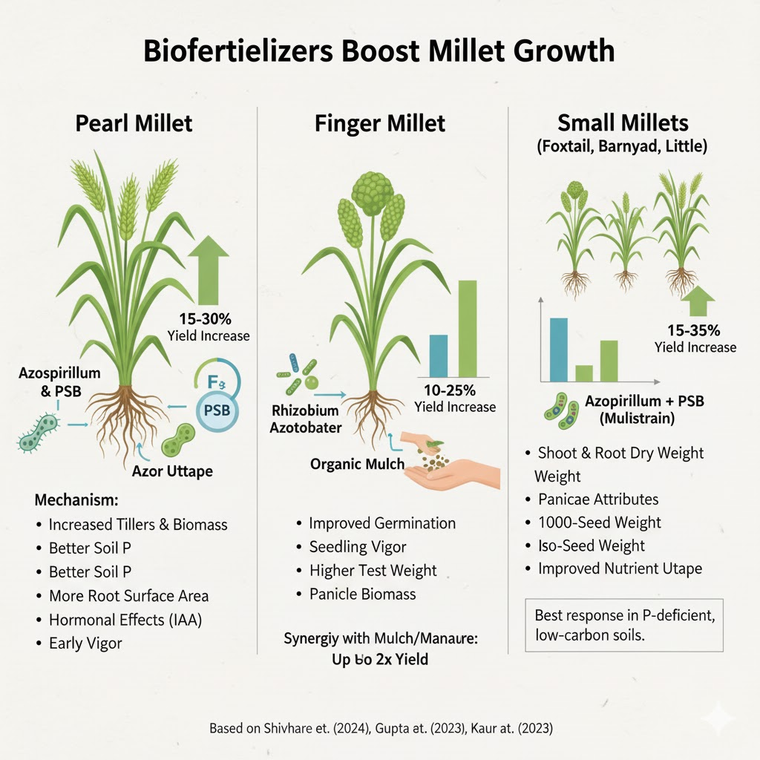
Fig. 1: Biofertilizers Boost Millet Growth: Species-Specific Benefits

4. Integrating Biofertilizers with Nutrient Management Systems

4.1. Combined Use with Organic Manures and Composts
Integrating biofertilizers with organic amendments such as farmyard manure (FYM), compost, green manures, or crop residues creates a synergistic system that enhances soil fertility and productivity in millet-based cropping systems. Organic manures provide the carbon and energy substrates essential for microbial proliferation, while biofertilizers supply specific functional microorganisms that accelerate nutrient transformation and mineralization processes. The decomposition of organic residues releases humic substances and low-molecular-weight organic acids that, in turn, improve the survival and efficiency of inoculated microbes. For instance, co-application of FYM with Azospirillum and phosphate-solubilizing bacteria (PSB) in pearl millet has been shown to increase plant height, leaf area, and dry matter accumulation by 20–30 % compared to with mineral fertilizers alone. Studies conducted in semi-arid regions of Rajasthan and Karnataka reported that applying 75 % of the recommended nitrogen dose through FYM combined with microbial inoculants produced yields statistically equivalent to full fertilizer doses, with the added benefits of improved soil structure and organic carbon content.
Similarly, finger millet inoculated with Azotobacter and Rhizobium, along with composted biomass, recorded higher root colonization, chlorophyll content, and nutrient uptake than either treatment alone. The organic–biofertilizer combination also enhances water retention capacity and buffering of soil pH buffering, which is particularly advantageous in the light-textured, nutrient-poor soils typical of millet-growing regions (Sham et al., 2024). Thus, organic matter acts as a medium that sustains the microbial population, moderates nutrient release, and provides a slow, and steady supply of nutrients, leading to improved nutrient use efficiency and sustained crop growth under rainfed conditions.

4.2. Interaction with Chemical Fertilizers: Optimization and Substitution Levels
The integration of biofertilizers with mineral fertilizers aims not to eliminate chemical inputs altogether but to optimize their use and minimize environmental losses. Numerous field experiments have shown that partial substitution of synthetic fertilizers with biofertilizers (and organics) can maintain or even enhance yield levels increase yields while reducing input costs. For instance, replacing 25–50 % of nitrogen and phosphorus fertilizers with biofertilizer inoculants such as Azospirillum, Azotobacter, and PSB in pearl millet and foxtail millet systems yielded results comparable to 100 % chemical fertilizer treatments. Gao et al. (2020) and Han et al. (2023) demonstrated that biofertilizer inclusion not only sustained yields but also improved fertilizer recovery efficiency and reduced nutrient leaching.
Long-term trials in sandy loam soils showed that millet plots treated with 75 % NPK + biofertilizers achieved up to 90–95 % of full-fertilizer yield levels, with an increase in soil organic carbon and microbial biomass by 10–20 % relative to chemical fertilizers alone. This substitution effect is critical in resource-poor regions, where fertilizer access is limited and cost constraints hinder full recommended dose application. Moreover, balanced nutrient management through calibrated fertilizer–biofertilizer ratios prevents nutrient antagonism and ensures that both immediate and long-term nutrient requirements are met. Integrating microbial inoculants with targeted chemical fertilization, therefore, supports sustainable intensification, achieving higher productivity with lower external input dependence dependence on external inputs.

4.3. Synergistic Effects in Integrated Nutrient Management (INM)
Integrated Nutrient Management (INM) combines organic, inorganic, and biological sources of nutrients to optimize productivity, nutrient cycling, and soil health. Biofertilizers serve as the biological catalyst in this triad, mediating key transformations that complement organic and mineral inputs.
When used together, the components of INM exhibit strong synergism (Fig. 2):
- Organic matter improves microbial survival, supplies carbon, and enhances soil structure.
- Chemical fertilizers provide an immediate supply of available nutrients for early growth.
- Biofertilizers sustain nutrient availability by mobilizing bound forms and maintaining microbial activity throughout the cropping season.
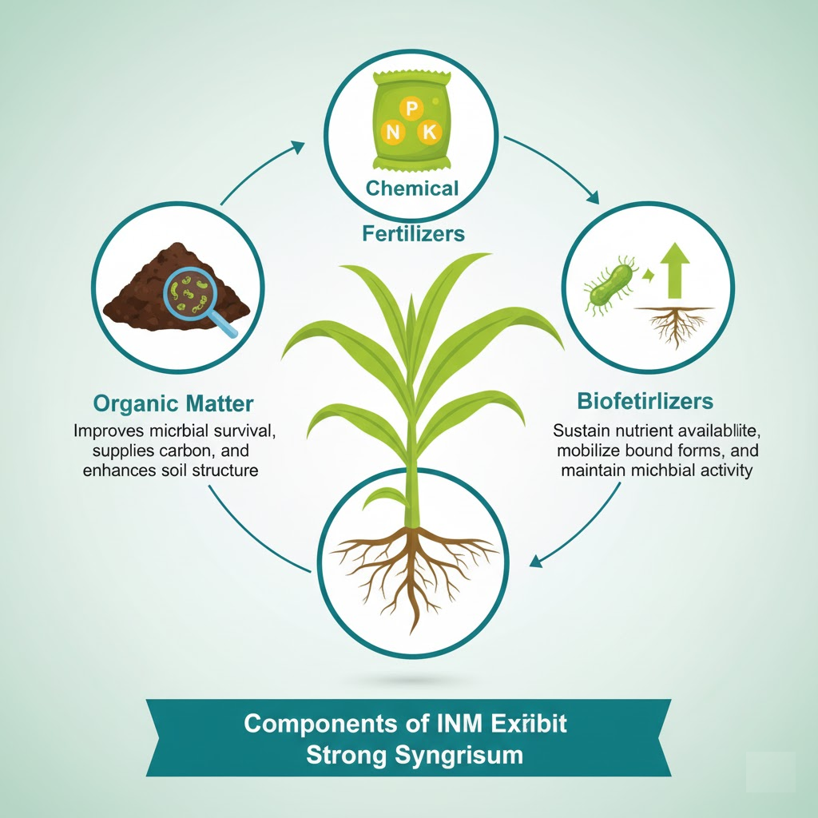
Fig. 2: Synergistic Components of Integrated Nutrient Management
Field data show that INM approaches in millets can increase yield by 20–40 %, improve nutrient use efficiency by 15–25 %, and enhance soil enzymatic activities (urease, phosphatase, dehydrogenase) compared to fertilizer-only management. Such systems also stabilize production under moisture stress, as microbial metabolites promote deeper rooting and higher antioxidant enzyme activity in plants. In pearl millet, an INM package of 50 % RDF + FYM @ 5 t ha⁻¹ + Azospirillum + PSB recorded higher grain and straw yields than 100 % RDF alone, highlighting the efficiency of partial substitution when biofertilizers are part of the nutrient chain. Similarly, in finger millet, INM systems using Azotobacter and Rhizobium combined with 50–75 % RDF improved nutrient uptake and protein content in grains, reflecting the comprehensive impact of biological integration. Overall, INM strategies that combine microbial inoculants with organic and inorganic sources ensure a sustained nutrient supply, improved soil quality, and reduced dependence on chemical fertilizers — aligning with climate-resilient, and low-carbon agriculture agricultural goals.

4.4. Influence on Nutrient Cycling
One of the most profound impacts of biofertilizer integration is on nutrient cycling dynamics. Microbial inoculants accelerate the transformation of nutrients from unavailable to plant-available forms through enzymatic and biochemical processes. Nitrogen-fixers replenish the soil N pool, while phosphate-solubilizing and mycorrhizal inoculants mobilize bound phosphorus and micronutrients. Long-term experiments have revealed that soils under biofertilizer–organic combinations exhibit higher soil enzyme activities (urease, dehydrogenase, phosphatase), indicators of active nutrient turnover and microbial respiration (Ali et al., 2024). Enhanced microbial biomass carbon and nitrogen pools indicate improved soil biological fertility. These processes reduce nutrient losses via leaching or volatilization and support a more balanced nutrient cycle within the soil–plant system.
Furthermore, biofertilizers improve carbon sequestration potential by enhancing root biomass and rhizodeposition, which feeds the microbial community and stabilizes soil organic matter. In the context of millet-based systems, typically characterized by low soil fertility and organic carbon, the improvement in nutrient cycling through microbial interventions is a pivotal step toward achieving both productivity and sustainability. Collectively, integrated nutrient management incorporating biofertilizers transforms the soil from a passive nutrient reservoir into an active biological engine, sustaining fertility and productivity under variable environmental conditions.
5. Future Prospects and Research Directions

5.1. Integration of Biofertilizers in Climate-Smart Agriculture
Climate-smart agriculture (CSA) aims to enhance agricultural productivity, improve resilience (adaptation), and reduce greenhouse gas emissions (mitigation). Biofertilizers are central to this framework because they simultaneously improve nutrient efficiency, reduce reliance on synthetic fertilizers, and strengthen crop tolerance to climatic stressors. In millet-based systems, typically cultivated in semi-arid and marginal environments, biofertilizers directly support CSA goals by:
- Enhancing resource-use efficiency: Microbial inoculants reduce nitrogen and phosphorus losses through fixation and solubilization, lowering the carbon footprint associated with chemical fertilizer manufacture and transport.
- Improving stress resilience: Certain strains of Azospirillum, Pseudomonas, and arbuscular mycorrhizal fungi (AMF) upregulate plant antioxidant enzymes and osmolyte accumulation, enabling crops to withstand drought and heat waves.
- Building soil carbon pools: Increased root biomass and microbial exudates promote organic carbon sequestration and improve aggregate stability, mitigating soil erosion under erratic rainfall.
According to FAO (2023), integrated biofertilizer management can reduce fertilizer-related nitrous oxide (N₂O) emissions by 10–25 %, while maintaining yield levels comparable to full mineral fertilization. Thus, microbial inoculants play a vital role in transitioning millet farming toward climate-resilient, low-emission systems that safeguard food and nutrition security.

5.2. Development of Millet-Specific Microbial Consortia
Most commercially available biofertilizers were originally designed for legumes or major cereals like rice and wheat. However, millets possess unique rhizospheric conditions, low fertility, high temperature, and drought-prone soils, which demand tailored microbial formulations. Recent research has moved toward developing millet-specific microbial consortia, combining complementary strains that function synergistically. For instance: Azospirillum and Bacillus species for nitrogen fixation and root stimulation, Pseudomonas fluorescens and Bacillus megaterium for phosphate solubilization, and Glomus intraradices for improved phosphorus uptake and drought tolerance.
Studies at ICAR–Indian Institute of Millets Research (IIMR) and SKUAST–Kashmir have shown that customized multi-strain inoculants can raise grain yield by 20–35 %, nutrient uptake by 15–25 %, and enhance microbial enzyme activity by 30–40 % compared to conventional single-strain inoculants. The next frontier is genomics-guided microbial selection, using metagenomic and transcriptomic tools to identify native endophytes and rhizobacteria that naturally associate with specific millet genotypes. Such tailored consortia will ensure greater colonization success and stability under diverse agro-ecological conditions.

5.3. Digital and Precision Tools for Biofertilizer Application
Advances in digital agriculture and precision nutrient management provide new opportunities to improve the accuracy, timing, and efficiency of biofertilizer application.
Smart farming tools, including remote sensing, soil sensors, and Internet of Things (IoT)-based monitoring, can be integrated to guide biofertilizer use more effectively:
- Geo-referenced soil mapping can identify microbial-deficient zones or nutrient-stressed fields where inoculation is most beneficial.
- Drones and variable-rate applicators enable precise biofertilizer spraying or seed coating, reducing wastage and ensuring even distribution across large fields.
- Artificial intelligence (AI) and data analytics can predict soil microbial health trends and recommend specific microbial strains suited to local climatic and edaphic conditions.
- Mobile-based advisory platforms, developed by ICAR and FAO’s e-Agriculture program, can assist farmers in choosing, applying, and storing biofertilizers safely.
Emerging innovations, such as nano-encapsulated microbial formulations and AI-driven soil microbiome diagnostics, promise better inoculant shelf-life, field stability, and performance predictability, critical factors for scaling biofertilizer adoption in millet systems.

5.4. Long-Term Soil Health Monitoring and Sustainability Indices
For biofertilizer-based nutrient management to gain institutional support, its benefits must be quantifiable and traceable through long-term soil health indicators.
Key measurable parameters include:
- Soil organic carbon (SOC) levels and microbial biomass carbon,
- Enzymatic activity indices (dehydrogenase, phosphatase, urease),
- Nutrient balance sheets tracking available N, P, K, and micronutrients,
- Microbial diversity indices derived from DNA-based metagenomic assays,
- Soil sustainability indices that integrate chemical, biological, and physical parameters.
Long-term monitoring programs by ICAR and FAO’s Global Soil Partnership emphasize that biological indicators respond faster to management changes than chemical ones. Thus, incorporating microbial activity metrics into national soil health schemes (like India’s Soil Health Card initiative) can provide real-time feedback on the ecological benefits of biofertilizer adoption. Developing Millet Soil Health Indices (MSHI) that reflect nutrient balance, microbial vitality, and carbon sequestration potential would be a powerful policy tool for evaluating the sustainability of millet-based farming systems. Such indices can guide policymakers and extension agencies to reward regenerative practices, thereby integrating biofertilizer adoption into broader sustainability frameworks and carbon credit programs.

6. CONCLUSION
The integration of biofertilizers into millet-based nutrient management represents a powerful step toward achieving sustainable, climate-resilient, and nutritionally secure agriculture. Millets, with their innate tolerance to drought, heat, and poor soils, are naturally suited to low-input production systems, and biofertilizers complement this resilience by enhancing nutrient acquisition, biological soil fertility, and crop productivity without ecological harm. The synergistic action of nitrogen-fixing, phosphate-solubilizing, and mycorrhizal inoculants not only supplements plant nutrition but also rejuvenates soil ecosystems depleted by years of chemical dependence. By stimulating soil enzymatic activity, enriching microbial diversity, and improving organic matter turnover, biofertilizers restore the living dynamics of soil, converting it from a passive substrate into a self-sustaining biological engine. Their integration with organic and mineral fertilizers optimizes nutrient-use efficiency, stabilizes yields, and reduces environmental losses. These outcomes directly contribute to food–nutrient security, as enhanced micronutrient uptake and bioactive compound synthesis in millets translate into improved human nutrition and health outcomes. Looking ahead, the path forward lies in research and innovation. Millet-specific microbial consortia need to be developed using molecular and metagenomic tools to ensure compatibility across genotypes and agro-ecologies. Field validation under diverse climatic zones, along with standardization of formulations, quality control, and shelf-life testing, remains critical for large-scale farmer adoption. Policy support through national soil health programs, climate-smart agriculture missions, and incentive schemes will be essential to mainstream biofertilizer use and ensure its inclusion in official nutrient management recommendations. In essence, the widespread and scientifically informed adoption of biofertilizers can transform millet farming into a model of ecological intensification, producing more grain and nutrition with fewer external inputs, healthier soils, and a smaller environmental footprint. As agriculture faces the twin challenges of climate stress and nutritional insecurity, biofertilizer-based millet cultivation stands out as a sustainable pathway toward resilient livelihoods and regenerative food systems.
REFERENCES
Aamir, M., Rai, K. K., Zehra, A., Dubey, M. K., Kumar, S., Shukla, V., & Upadhyay, R. S. (2020). Microbial bioformulation-based plant biostimulants: A plausible approach toward next generation of sustainable agriculture. In Microbial Endophytes (pp. 195–225). Woodhead Publishing. https://doi.org/10.1016/B978-0-12-819692-6.00009-7
Ali, A., Liu, X., Yang, W., Li, W., Chen, J., Qiao, Y., ... & Yang, Z. (2024). Impact of bio-organic fertilizer incorporation on soil nutrients, enzymatic activity, and microbial community in wheat–maize rotation system. Agronomy, 14(9), 1942.
Basu, A., Prasad, P., Das, S. N., Kalam, S., Sayyed, R. Z., Reddy, M. S., & El Enshasy, H. (2021). Plant growth-promoting rhizobacteria (PGPR) as green bioinoculants: Recent developments, constraints, and prospects. Sustainability, 13(3), 1140. https://doi.org/10.3390/su13031140
Chapke, R. R., Shyamprasad, G., Das, I. K., & Tonapi, V. A. (2018). Improved millets production technologies and their impact. Indian Journal of Agricultural Sciences, 88(12), 1909–1914.
FAO. (2023). International Year of Millets 2023: Harnessing the potential of millets for food security, nutrition, and climate resilience. Food and Agriculture Organization of the United Nations. https://www.fao.org/millets-2023
Gao, C., El-Sawah, A. M., Ali, D. F. I., Alhaj Hamoud, Y., Shaghaleh, H., & Sheteiwy, M. S. (2020). The integration of bio and organic fertilizers improves plant growth, grain yield, quality and metabolism of hybrid maize (Zea mays L.). Agronomy, 10(3), 319. https://doi.org/10.3390/agronomy10030319
Gite, D. P., Gite, P. A., & Darvhankar, M. S. (2021). The response of bio-fertilizers to the production potential of cereal crops. Plant Archives, 21(1), 2401–2407.
Gupta, S., Abbas, M., & Singh, P. (2023). Optimizing Maize Harvests: Unraveling the Impact of Organic Mulching on Yield Parameters. Indus Journal of Animal and Plant Sciences, 1(02), 48-53.
Han, C., Zhang, Z., Gao, Y., Wang, W., Chen, J., & Wang, Y. (2023). Microbiome reveals the effects of biogas fertilizer on soil microbial community structure and diversity in perennial apple orchards. Horticulturae, 9(9), 1023. https://doi.org/10.3390/horticulturae9091023
ICAR–Indian Institute of Millets Research (IIMR). (2023). Millet Research and Development in India: Annual Report 2023. Indian Council of Agricultural Research. https://millets.res.in
Joshi, R. K., Ghimire, K. H., KC, H., & GC, A. (2023). Millets–Resilient Crops in the Changing Climate: a review. NAGRC, CCDABC and FAO; Kathmandu, 478-486.
Joshi, S., & Sharma, R. (2023). Nutri-Cereals: Niche to Mainstream. In Nutri-Cereals (pp. 1-25). CRC Press.
Kaur, T., Devi, R., Kumar, S., Kour, D., & Yadav, A. N. (2023). Plant growth promotion of pearl millet (Pennisetum glaucum L.) by novel bacterial consortium with multifunctional attributes. Biologia, 78(2), 621-631.
Majid, A., & Priyadarshini, C. G. P. (2020). Millet-derived bioactive peptides: A review on their functional properties and health benefits. Critical Reviews in Food Science and Nutrition, 60(19), 3342–3351. https://doi.org/10.1080/10408398.2019.1702503
Mitra, P. K., Adhikary, R., & Mandal, V. (2023). Current status of mycorrhizal biofertilizer in crop improvement and its future prospects. In Microbial Symbionts and Plant Health: Trends and Applications for Changing Climate (pp. 465–485). Springer Nature Singapore. https://doi.org/10.1007/978-981-19-8772-2_19
Niraula, P. (2018). Preparation of Ready to Use Supplementary Food (RUSF) for treating moderately acute malnutrition in children aged 6-24 months (Doctoral dissertation).
Pathak, H., Mohanty, S., Jain, N., Bhatia, A., & Kumar, M. (2010). Global warming mitigation potential of biogas plants in India. Environmental Monitoring and Assessment, 166, 401–409. https://doi.org/10.1007/s10661-009-1013-5
Sajeev, A., & Kundapura, S. (2023). Temporal assessment of meteorological drought events using stationary and nonstationary drought indices for two climate regions in India. Journal of Hydrologic Engineering, 28(11), 05023018. https://doi.org/10.1061/(ASCE)HE.1943-5584.0002297
Samtiya, M., Aluko, R. E., Dhaka, N., Dhewa, T., & Puniya, A. K. (2023). Nutritional and health-promoting attributes of millet: Current and future perspectives. Nutrition Reviews, 81(6), 684–704. https://doi.org/10.1093/nutrit/nuac106
Shah, F., & Wu, W. (2019). Soil and crop management strategies to ensure higher crop productivity within sustainable environments. Sustainability, 11(5), 1485. https://doi.org/10.3390/su11051485
Sham, I. N., Yap, C. K., Nulit, R., Peng, S. H. T., & Chai, E. W. (2024). Nutrient Leaching in Oil Palm Plantation: A Review on Special Reference to Fertilization Application. Pakistan Journal of Life & Social Sciences, 22(2).
Shivhare, R., Semwal, P., Mishra, S. K., & Chauhan, P. S. (2024). Pseudomonas putida Facilitates Pearl Millet Growth in Cold Environments and Alleviates Drought Stress by Modulating Phytohormone, Antioxidant, and Secondary Metabolite Pathways. Journal of Plant Growth Regulation, 43(11), 4199-4218.
Singh, P., Singh, R., Bhadauria, V., & Singh, H. (2023). The functionality and extraction of protein from sorghum, finger millet, and kodo millet: A review. International Journal of Food Science & Technology, 58(3), 1201–1215. https://doi.org/10.1111/ijfs.16165
Snehal, G., & Neena, J. (2018). Effect of hydrothermal treatments on mineral composition, bioaccessibility and total polyphenols of pearl millet (Pennisetum glaucum). Journal of Pharmacognosy and Phytochemistry, 7(6), 442–448.
Sunil, C. K., Gowda, N. N., Nayak, N., & Rawson, A. (2024). Unveiling the effect of processing on bioactive compounds in millets: Implications for health benefits and risks. Process Biochemistry, 133, 63–75. https://doi.org/10.1016/j.procbio.2023.10.004

