Original Research Article

Growth, Physiological and Biochemical Effects of Atrazine on Foxtail Millet Genotypes

Abstract
Weeds are a major constraint in foxtail millet (Setaria italica) cultivation, where manual weeding remains the most common but increasingly uneconomical practice due to rising labor costs. The present study was undertaken to evaluate the agronomic, physiological, and biochemical responses of three foxtail millet entries (SiA-1, SiA-2, and SiA-3) to varying concentrations of atrazine herbicide under field conditions during 2022–2025. The experiment was conducted in a split-plot design with three replications, assigning millet entries to main plots and atrazine treatments to sub-plots. Atrazine was applied at five concentrations: 0 (control, CK), 2.5 (T1), 12.5 (T2), 22.5 (T3), and 32.5 (T4) mg kg⁻¹. Growth traits, photosynthetic pigments, oxidative stress markers, and antioxidant enzyme activities were assessed following treatment. Atrazine exposure led to a marked decline in plant height (up to 41%) and leaf area (up to 28%), accompanied by a reduction in superoxide dismutase (SOD) activity and a concomitant increase in malondialdehyde (MDA) content by 65–74%, indicating oxidative damage. Among the tested entries, SiA-2 exhibited greater tolerance to atrazine, maintaining higher photosynthetic efficiency and antioxidant capacity across all concentrations. The results highlight differential genotypic responses to atrazine and underscore the potential of SiA-2 as a candidate for developing herbicide-tolerant foxtail millet cultivars. These findings contribute valuable insights toward establishing safe and effective chemical weed management strategies in foxtail millet production systems.

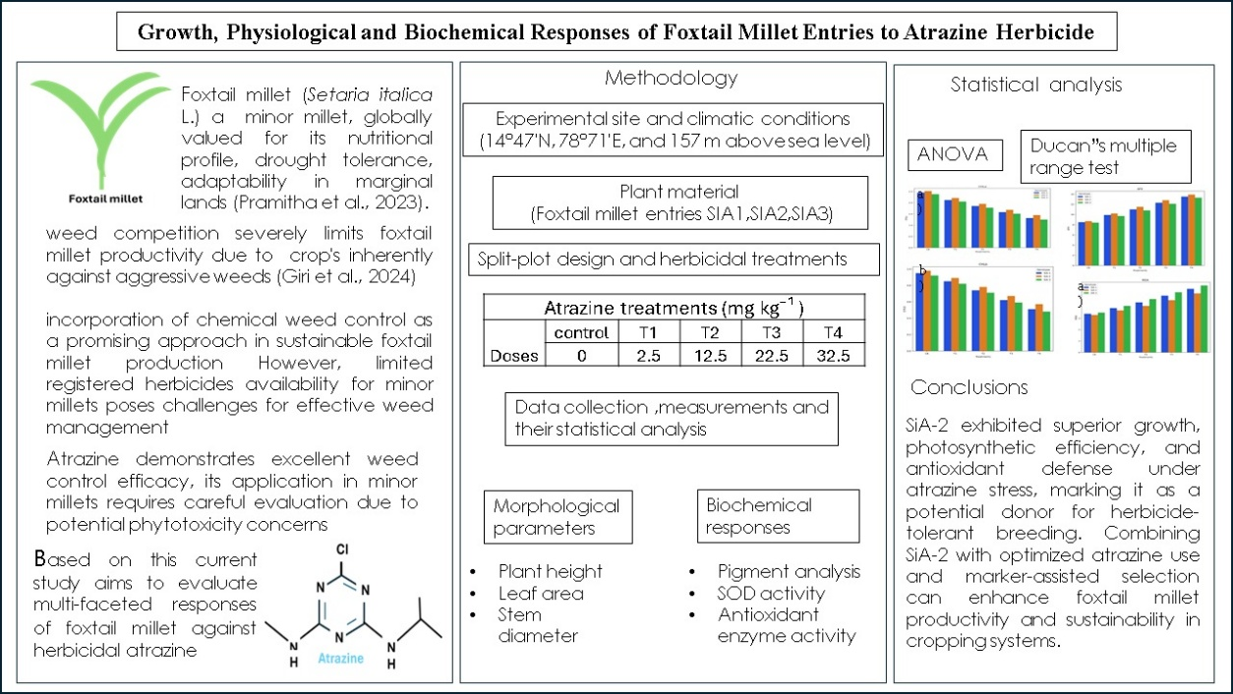
Graphical abstract

Keywords: foxtail millet, atrazine, herbicide tolerance, photosystem II inhibition, oxidative stress, antioxidant enzymes

1. INTRODUCTION
Foxtail millet (Setaria italica L.) is one of the most important minor millets globally, valued for its exceptional nutritional profile, drought tolerance, and adaptability to marginal lands (Pramitha et al., 2023). Despite these advantages, weed competition remains a major constraint in foxtail millet cultivation. The crop’s inherently slow early growth makes it a poor competitor against aggressive weeds during the critical establishment stages, resulting in substantial yield losses (Giri et al., 2024).
Traditional weed management in foxtail millet relies mainly on manual weeding and mechanical cultivation, which are increasingly unsustainable due to rising labor costs and declining availability of agricultural laborers. Integrating chemical weed control measures offers a promising approach to enhance the sustainability and productivity of foxtail millet cultivation. However, the limited availability of registered herbicides for minor millets poses a significant challenge for effective weed management. At present, integrated weed management (IWM) practices typically involve 2–3 intercultivations and 1–2 hand weedings during the first 25 days after sowing, supplemented with selective herbicide applications. Among the chemical measures, pre-emergence applications of isoproturon and post-emergence treatments with 2,4-D sodium salt constitute the mainstay of weed control in millets (Shafna & Menon, 2024).
Atrazine (6-chloro-N-ethyl-N′-(1-methylethyl)-1,3,5-triazine-2,4-diamine) is a photosystem II (PSII)–inhibiting herbicide widely used in cereal crop production. As a triazine herbicide, atrazine disrupts photosynthetic electron transport by binding to the D1 protein of the thylakoid membrane, thereby blocking plastoquinone binding and interrupting ATP and NADPH synthesis. This disruption leads to chlorophyll degradation, accumulation of reactive oxygen species (ROS), and ultimately plant death in susceptible species (Shimabukuro & Swanson, 1969).
Although atrazine provides excellent broad-spectrum weed control, its application in minor millets demands careful evaluation due to potential phytotoxicity concerns. Previous studies have reported variable responses among cereal crops to atrazine exposure, with tolerance mechanisms involving enhanced detoxification pathways, particularly glutathione conjugation systems (Chowdhury et al., 2020). Recent transcriptomic and metabolomic studies in foxtail millet have revealed complex molecular responses to herbicide stress, including the upregulation of glutathione metabolism, amino acid biosynthesis, and phenylpropanoid pathways (Sun et al., 2022).
The development of herbicide-tolerant cultivars is a critical component of sustainable weed management. Genetic variability in herbicide tolerance among foxtail millet genotypes has been documented, with resistance mechanisms encompassing both target-site modifications and enhanced non-target-site resistance (NTSR) pathways (Jugulam & Shyam, 2019). Elevated glutathione S-transferase (GST) activity, improved antioxidant enzyme defense systems, and altered secondary metabolite profiles contribute to differential herbicide tolerance among cultivars (Nianiou-Obeidat et al., 2017).
Understanding the physiological and biochemical basis of atrazine tolerance in foxtail millet is therefore essential for developing effective weed management protocols and breeding programs. The foxtail millet SiA entries developed by Acharya N. G. Ranga Agricultural University (ANGRAU) represent promising germplasm adapted to dryland farming systems in semi-arid regions, with potential for enhanced herbicide tolerance. The present study aims to evaluate the growth, physiological, and biochemical responses of three foxtail millet SiA entries to atrazine herbicide under field conditions, thereby providing insights into their tolerance mechanisms and implications for sustainable weed management.

2. material and methods
2.1 Experimental site and climatic conditions
The field experiment was conducted near farmer fields at the Yogi Vemana University, Andhra Pradesh, India (14°47'N, 78°71'E, and 157 m above sea level) during three consecutive growing seasons from 2022 to 2025. The experimental site is characterized by a semi-arid tropical climate with distinct wet (June-September) and dry (October-May) seasons. The experimental soil is classified as black cotton clay loam (Vertisol) with pH 7.6, electrical conductivity 0.32 dS m⁻¹, and organic carbon content of 0.78%. Soil fertility status showed available nitrogen (240 kg ha⁻¹), phosphorus (28 kg ha⁻¹), and potassium (380 kg ha⁻¹). Pre-experimental soil analysis confirmed the absence of atrazine residues and other herbicide contamination.
2.2 Plant material and experimental design
Three foxtail millet entries from the SiA series (SiA-1, SiA-2, and SiA-3) developed by ANGRAU's millet breeding program were selected based on their adaptation to dryland conditions and contrasting morphological characteristics. The experiment was laid out in a split-plot design with three replications. Main plots were assigned to foxtail millet entries, while sub-plots received atrazine treatments. Individual plot size was 4.0 × 3.0 m with 0.5 m border strips to prevent cross-contamination. Sowing carried out at 25 cm row spacing with a seeding rate of 8 kg ha⁻¹. Following emergence, seedlings were thinned to maintain uniform plant population of 160,000 plants ha⁻¹.
2.3 Herbicide treatments and application
With Atrazine as active ingredient, treatments comprised five doses with concentration: 0 (control, CK), 2.5 (T1), 12.5 (T2), 22.5 (T3), and 32.5 (T4) mg kg⁻¹. According to literature recommendations for cereal crops and preliminary screening trials, these concentrations were determined (Cao et al., 2017; Bibi et al., 2019; Sher et al., 2021). Commercial atrazine formulation (Atrazine 50% WP, PI Industries Ltd., India) was utilised with appropriate dilutions to attain target concentrations.
Herbicide application performed at the three-leaf stage (approximately 15 days after sowing) using hand operated battery sprayers fitted with flat-fan nozzles. Spray volume was standardized at 450 L ha⁻¹ with uniform coverage ensured through overlapping spray patterns. Applications were conducted during early morning hours (06.00-08.00 h) under calm weather conditions.
To isolate herbicide effects from weed competition, all plots were maintained weed-free through manual weeding throughout the experimental period. Standard agronomic practices including fertilizer application (40:20:0 kg NPK ha⁻¹) and uniform pest management measures were implemented applied across all treatments.
2.4 Data collection and measurements
2.4.1 Morphological parameters
Morphological observations were recorded at 10 and 20 days after treatment (DAT) from five randomly selected plants per plot. Plant height was measured from ground level to the tip of the main culm using a graduated scale. Leaf area was determined using a leaf area meter. Stem diameter was measured at the basal internode using digital vernier calipers (±0.01 mm precision).
2.4.2 Photosynthetic pigments and gas exchange
For photosynthetic pigment analysis, 0.5 grams of Fresh leaf samples (fully expanded 3rd leaf from apical region) was collected and used for estimation of Chlorophyll a, Chlorophyll b following the protocols devised by Lichtenthaler and Buschmann (2001).
Photosynthetic rate (Pn) was measured using a portable photosynthesis system (PPS). Measurements were conducted on clear days between 0900-1100 h under standardized conditions (photosynthetic photon flux density: 1200 μmol m⁻² s⁻¹, leaf temperature: 30°C, CO₂ concentration: 400 ppm).
2.4.3 Oxidative stress markers and antioxidant enzymes
Fresh leaf tissue (200 mg) was collected at 15 DAT for biochemical analysis. Malonaldehyde (MDA) content, an indicator of lipid peroxidation, was determined using the thiobarbituric acid reactive substances (TBARS) method (Hodges et al., 1999). Additionally, Superoxide dismutase (SOD) activity was measured for Superoxide detection, quantification through inhibition of photochemical reduction of nitro blue tetrazolium (Bournonville & Díaz-Ricci, 2011) One unit of SOD activity was defined as the amount of enzyme required to inhibit 50% of NBT reduction. Followed by antioxidant enzyme assay (Elavarthi & Martin, 2010).
2.5 Statistical analysis
Data was subjected to analysis of variance (ANOVA) using R statistical software (version 4.2.0). The split-plot design was analyzed with genotypes as main plots and herbicide treatments as sub-plots. Treatment means were compared using Duncan's Multiple Range Test at 5% probability level. Data were checked for normality and homogeneity of variance before analysis, with appropriate transformations applied wherever necessary. All the statistical analyses were carried out using the software R 4.5.0 (R Core Team, 2025)

3. results
3.1 Effects of atrazine on morphological parameters
Atrazine application significantly affected all morphological parameters in a dose-dependent manner across all three foxtail millet entries (Table 1). Plant height showed progressive reduction with increasing herbicide concentration, with maximum suppression observed at T4 treatment. At 20 DAT, SiA-1 exhibited the most severe height reduction (41.0%) under T4 compared to control, while SiA-2 showed relatively better tolerance with 38.1% reduction. SiA-3 displayed intermediate response with 43.0% height reduction at the highest dose.
Leaf area demonstrated similar patterns of dose-dependent reduction, with significant decreases observed from T2 treatment onwards. At 20 DAT, leaf area reductions ranged from 12.5-15.0% at T1 to 26.5-28.8% at T4 across genotypes. SiA-2 consistently maintained higher leaf area values compared to other entries under herbicide stress.
Stem diameter measurements revealed significant treatment effects, with reductions becoming apparent from T2 treatment. At 20 DAT, stem diameter decreased by 15.1-25.5% across treatments, with SiA-2 showing better maintenance of stem thickness under atrazine stress.
Table 1: Effect of atrazine treatments on morphological parameters of foxtail millet entries at 10 and 20 days after treatment (DAT)
Variety | Treatment | Plant Height (cm) |  | Leaf Area (cm²) |  | Stem Diameter (mm)
 |  | 10 DAT | 20 DAT | 10 DAT | 20 DAT | 10 DAT | 20 DAT
SiA-1 | CK | 78.2 ± 2.1a | 88.0 ± 2.3a | 112.5 ± 3.2a | 130.2 ± 3.8a | 9.2 ± 0.3a | 10.6 ± 0.3a
 | T1 | 60.7 ± 1.8b | 70.0 ± 1.9b | 85.3 ± 2.5b | 113.6 ± 3.1b | 7.4 ± 0.2b | 9.0 ± 0.3b
 | T2 | 55.9 ± 1.7bc | 65.0 ± 1.8bc | 79.0 ± 2.2c | 107.4 ± 2.9c | 7.0 ± 0.2bc | 8.7 ± 0.3bc
 | T3 | 50.5 ± 1.5cd | 58.0 ± 1.6cd | 72.5 ± 2.1d | 100.1 ± 2.7d | 6.6 ± 0.2cd | 8.2 ± 0.2cd
 | T4 | 46.2 ± 1.3d | 52.0 ± 1.5d | 68.0 ± 1.9d | 94.0 ± 2.5e | 6.3 ± 0.2d | 7.9 ± 0.2d
SiA-2 | CK | 80.5 ± 2.2a | 90.5 ± 2.5a | 115.0 ± 3.3a | 133.5 ± 3.9a | 9.4 ± 0.3a | 10.8 ± 0.3a
 | T1 | 63.0 ± 1.8b | 73.0 ± 2.0b | 88.0 ± 2.6b | 117.0 ± 3.2b | 7.6 ± 0.2b | 9.2 ± 0.3b
 | T2 | 58.0 ± 1.6bc | 68.0 ± 1.9bc | 82.0 ± 2.3c | 111.5 ± 3.1c | 7.3 ± 0.2bc | 8.9 ± 0.3bc
 | T3 | 52.7 ± 1.5cd | 61.0 ± 1.7cd | 75.2 ± 2.1d | 103.8 ± 2.8d | 6.8 ± 0.2cd | 8.4 ± 0.2cd
 | T4 | 48.3 ± 1.4d | 56.0 ± 1.6d | 70.0 ± 2.0d | 98.0 ± 2.6e | 6.6 ± 0.2d | 8.1 ± 0.2d
SiA-3 | CK | 77.5 ± 2.1a | 86.0 ± 2.3a | 110.0 ± 3.1a | 128.6 ± 3.7a | 9.1 ± 0.3a | 10.4 ± 0.3a
 | T1 | 59.5 ± 1.7b | 68.0 ± 1.9b | 84.0 ± 2.4b | 112.5 ± 3.1b | 7.3 ± 0.2b | 8.9 ± 0.3b
 | T2 | 53.8 ± 1.6bc | 63.0 ± 1.8bc | 77.0 ± 2.2c | 105.4 ± 2.9c | 7.0 ± 0.2bc | 8.6 ± 0.3bc
 | T3 | 48.4 ± 1.4cd | 56.0 ± 1.6cd | 71.0 ± 2.0d | 98.7 ± 2.7d | 6.5 ± 0.2cd | 8.1 ± 0.2cd
 | T4 | 44.1 ± 1.2d | 49.0 ± 1.4d | 66.5 ± 1.9d | 92.0 ± 2.5e | 6.2 ± 0.2d | 7.7 ± 0.2d
Values followed by different letters within columns indicate significant differences (P ≤ 0.05)
3.2 Photosynthetic pigments and gas exchange responses
Atrazine significantly affected photosynthetic pigment concentrations (Table 2, Figure 1a – 1c). Chlorophyll a content decreased progressively with increasing herbicide doses, showing 15-25% reduction at T2 and 35-45% reduction at T4 across genotypes. Chlorophyll b demonstrated similar patterns but with relatively smaller magnitude of reduction (12-20% at T2, 30-40% at T4). Gas exchange measurements revealed significant impairment of photosynthetic processes. Net photosynthetic rate (Pn) decreased by 20-30% at T2 and 45-60% at T4 treatments.
Table 2: Effect of atrazine treatments on photosynthetic pigment parameters of foxtail millet genotypes
Variety | Treatment | Chl a (mg g⁻¹ FW) | Chl b (mg g⁻¹ FW) | Pn (μmol m⁻² s⁻¹)
SiA-1 | CK | 2.45 ± 0.08a | 0.95 ± 0.04a | 18.5 ± 0.8a
 | T1 | 2.12 ± 0.07b | 0.85 ± 0.03b | 15.2 ± 0.7b
 | T2 | 1.85 ± 0.06c | 0.74 ± 0.03c | 12.8 ± 0.6c
 | T3 | 1.58 ± 0.05d | 0.62 ± 0.02d | 9.5 ± 0.5d
 | T4 | 1.32 ± 0.04e | 0.51 ± 0.02e | 7.2 ± 0.4e
SiA-2 | CK | 2.52 ± 0.09a | 0.98 ± 0.04a | 19.2 ± 0.9a
 | T1 | 2.21 ± 0.08b | 0.89 ± 0.03b | 16.1 ± 0.8b
 | T2 | 1.95 ± 0.07c | 0.78 ± 0.03c | 13.8 ± 0.7c
 | T3 | 1.68 ± 0.06d | 0.67 ± 0.02d | 10.8 ± 0.6d
 | T4 | 1.45 ± 0.05e | 0.57 ± 0.02e | 8.5 ± 0.5e
SiA-3 | CK | 2.38 ± 0.08a | 0.92 ± 0.04a | 17.8 ± 0.8a
 | T1 | 2.05 ± 0.07b | 0.82 ± 0.03b | 14.5 ± 0.7b
 | T2 | 1.78 ± 0.06c | 0.71 ± 0.03c | 11.9 ± 0.6c
 | T3 | 1.51 ± 0.05d | 0.59 ± 0.02d | 8.8 ± 0.5d
 | T4 | 1.25 ± 0.04e | 0.48 ± 0.02e | 6.5 ± 0.4e
Values followed by different letters within rows indicate significant differences (P ≤ 0.05)
3.3 Oxidative stress responses and antioxidant enzyme activities
Atrazine exposure induced significant oxidative stress as evidenced by increased malonaldehyde (MDA) content and altered antioxidant enzyme activities (Table 3, Figure 2). MDA levels, indicative of lipid peroxidation, increased progressively with herbicide dose across all genotypes. At T4 treatment, MDA content increased by 65%, 57%, and 74% in SiA-1, SiA-2, and SiA-3, respectively, compared to control values.
Ascorbate peroxidase (APX) activity showed significant upregulation in response to atrazine stress, with maximum increases observed at T3 and T4 treatments. APX activity increased by 35-60% at T4 across genotypes, indicating active ROS scavenging mechanisms. Superoxide dismutase (SOD) activity showed consistent decreases with increasing atrazine dose, indicating impaired superoxide radical scavenging capacity.
SiA-2 demonstrated superior antioxidant enzyme responses, maintaining higher APX and SOD activities while showing lower MDA accumulation compared to other entries.
Table 3: Effect of atrazine treatments on oxidative stress markers and antioxidant enzyme activities in foxtail millet genotypes
Variety | Treatment | MDA  (μmol g⁻¹.FW) | APX  (μmol min⁻¹mg⁻¹.FW) | SOD  (U.min⁻¹ mg⁻¹.FW)
SiA-1 | CK | 3.4 ± 0.15e | 8.5 ± 0.28e | 23.0 ± 0.85a
 | T1 | 3.9 ± 0.18d | 9.9 ± 0.35d | 22.0 ± 0.82b
 | T2 | 4.4 ± 0.21c | 11.0 ± 0.42c | 20.0 ± 0.78c
 | T3 | 5.0 ± 0.23b | 12.3 ± 0.48b | 18.0 ± 0.75d
 | T4 | 5.6 ± 0.26a | 13.5 ± 0.52a | 16.0 ± 0.72e
SiA-2 | CK | 3.3 ± 0.14e | 8.7 ± 0.31e | 23.5 ± 0.89a
 | T1 | 3.7 ± 0.17d | 10.2 ± 0.38d | 22.5 ± 0.86b
 | T2 | 4.1 ± 0.19c | 11.5 ± 0.45c | 21.0 ± 0.83c
 | T3 | 4.6 ± 0.21b | 12.8 ± 0.51b | 19.0 ± 0.80d
 | T4 | 5.2 ± 0.24a | 13.9 ± 0.55a | 17.5 ± 0.77e
SiA-3 | CK | 3.5 ± 0.16e | 8.4 ± 0.29e | 22.8 ± 0.84a
 | T1 | 4.1 ± 0.19d | 9.7 ± 0.36d | 21.5 ± 0.81b
 | T2 | 4.7 ± 0.22c | 10.8 ± 0.41c | 19.8 ± 0.78c
 | T3 | 5.3 ± 0.25b | 12.1 ± 0.47b | 17.8 ± 0.74d
 | T4 | 5.9 ± 0.28a | 13.3 ± 0.51a | 16.3 ± 0.71e
Values followed by different letters within rows indicate significant differences (P ≤ 0.05)
3.4 Genotypic variation in herbicide tolerance
Comprehensive analysis of all measured parameters revealed significant genotypic variation in atrazine tolerance among the three SiA entries. SiA-2 consistently demonstrated superior performance across morphological, physiological, and biochemical parameters under herbicide stress. This entry maintained higher plant height, leaf area, photosynthetic efficiency, and antioxidant enzyme activities while showing lower oxidative stress markers.
SiA-1 exhibited intermediate tolerance responses, while SiA-3 showed the highest sensitivity to atrazine exposure. These differential responses suggest genetic variation in herbicide tolerance mechanisms, potentially involving enhanced detoxification pathways, improved ROS scavenging systems, and better maintenance of photosynthetic apparatus under stress conditions.

4. DISCUSSION
4.1 Mechanisms of atrazine phytotoxicity in foxtail millet
The results of this comprehensive study demonstrate that atrazine induces complex physiological and biochemical responses in foxtail millet, with effects manifesting across multiple organizational levels from molecular to whole-plant. The observed dose-dependent reductions in plant height, leaf area, and stem diameter align with previous reports documenting atrazine's inhibitory effects on plant growth and development (Bibi et al., 2019; Sher et al., 2021; Santos et al., 2024). These morphological changes represent integrated responses to the herbicide's primary mode of action which is through inhibition of photosystem II (PSII) electron transport (Wilkinson et al., 2015).
Atrazine's mechanism of action involves binding to the D1 protein in the thylakoid membrane, effectively blocking plastoquinone binding and disrupting electron flow from PSII to photosystem I (Battaglino et al., 2021). This disruption leads to the accumulation of reactive oxygen species (ROS) along with subsequent oxidative damage to cellular components. The progressive decline in chlorophyll content with increasing atrazine dose reflects both direct herbicide effects on chlorophyll synthesis and indirect effects through ROS-mediated degradation (Matejczyk et al., 2023). Chlorophyll a showed greater sensitivity compared to chlorophyll b, consistent with its direct involvement in photosystem reaction centers (Sher et al., 2021).
4.2 Oxidative stress responses and antioxidant defense mechanisms
The significant increase in malonaldehyde (MDA) content across all treatments confirms that atrazine exposure induces oxidative stress through enhanced lipid peroxidation (Erinle et al., 2016). MDA accumulation indicates membrane damage resulting from ROS attack on polyunsaturated fatty acids in cellular membranes (Bai et al., 2015). The magnitude of MDA increase (57-74% at T4) demonstrates substantial oxidative damage, highlighting the importance of antioxidant defense systems in herbicide tolerance.
The upregulation of ascorbate peroxidase (APX) activity represents adaptive responses to combat herbicide-induced oxidative stress (Caverzan et al., 2012). APX, which utilizes ascorbate as an electron donor to reduce hydrogen peroxide, showed consistent increases across treatments, indicating its crucial role in ROS detoxification (Alla & Hassan, 2006).
The contrasting response of superoxide dismutase (SOD), which showed consistent decreases with herbicide dose, suggests that SOD may be particularly vulnerable to atrazine-induced damage or that its synthesis is inhibited under herbicide stress (Bibi et al., 2019). SOD catalyzes the dismutation of superoxide radicals to hydrogen peroxide and oxygen, representing their first line of defense against ROS (de Sousa et al., 2025). With the impaired SOD activity observations, this study may contribute to increased oxidative damage by allowing superoxide radical accumulation.
4.3 Genotypic variation in herbicide tolerance mechanisms
The differential responses among SiA entries reveal significant genetic variation in atrazine tolerance mechanisms. SiA-2's superior performance across all measured parameters suggests this entry possesses enhanced tolerance mechanisms that warrant further investigation for breeding applications. The consistently higher photosynthetic efficiency, better maintenance of growth parameters, and superior antioxidant enzyme responses in SiA-2 indicate multiple tolerance mechanisms operating simultaneously.
Recent transcriptomic and metabolomic studies in foxtail millet have identified several pathways involved in herbicide tolerance, including glutathione metabolism, amino acid biosynthesis, and phenylpropanoid pathways (Sun et al., 2022; Wang et al., 2023). Enhanced glutathione S-transferase (GST) activity represents a key mechanism for herbicide detoxification through conjugation reactions that facilitate herbicide metabolism and excretion (Cummins et al., 2011; Nakka et al., 2017). The superior performance of SiA-2 may be associated with enhanced GST activity, although direct enzyme measurements would be required to confirm this hypothesis.
4.4 Implications for integrated weed management
The findings of this study have important implications for developing sustainable weed management strategies in foxtail millet production systems. The identification of SiA-2 as a tolerant entry provides valuable germplasm for breeding programs aimed at developing herbicide-tolerant cultivars. However, the substantial phytotoxic effects observed even in the most tolerant entry at higher concentrations emphasizes the need for meticulous dose optimization in field applications.
The dose-response relationships established in current study suggest that atrazine applications should be limited to concentrations below 12.5 mg kg⁻¹ to minimize crop injury while maintaining acceptable weed control efficacy. This recommendation requires validation through field trials evaluating both crop safety and weed control effectiveness under diverse environmental conditions.
Integration of herbicide applications with other weed management practices remains essential for sustainable crop production systems. The combination of reduced herbicide rates with mechanical cultivation, improved crop competitiveness through optimal plant population including fertilizer management, and targeted application timing can enhance overall weed management effectiveness while minimizing herbicide dependence.

5. Conclusion

Genotypic variation in foxtail millet revealed promising candidates for breeding herbicide-tolerant cultivars, with entry SiA-2 demonstrating superior resilience through maintained growth metrics, photosynthetic efficiency, and robust antioxidant responses under atrazine stress, Incorporating SiA-2 as a donor parent in breeding programs—supported by marker-assisted selection for key detoxification and antioxidant defense genes can accelerate the development of high-yielding, atrazine-tolerant cultivars. These genotypic insights, coupled with optimized atrazine application rates below 12.5 mg kg⁻¹ and integrated weed management practices, offer a strategic framework to enhance foxtail millet productivity, reduce environmental herbicide loads, and improve sustainability in cropping systems.

Consent (where ever applicable)

Not Applicable

Ethical approval (where ever applicable)

Not Applicable

References

Alla, M. N., & Hassan, N. (2006). Changes of antioxidants levels in two maize lines following atrazine treatments. Plant physiology and biochemistry, 44(4), 202-210.
Bai, X., Sun, C., Xie, J., Song, H., Zhu, Q., Su, Y., Qian, H., & Fu, Z. (2015). Effects of atrazine on photosynthesis and defense response and the underlying mechanisms in Phaeodactylum tricornutum. Environmental Science and Pollution Research, 22(22), 17499-17507.
Battaglino, B., Grinzato, A., & Pagliano, C. (2021). Binding Properties of Photosynthetic Herbicides with the Q(B) Site of the D1 Protein in Plant Photosystem II: A Combined Functional and Molecular Docking Study. Plants (Basel), 10(8). https://doi.org/10.3390/plants10081501
Bibi, S., Khan, S., Taimur, N., Daud, M. K., & Azizullah, A. (2019). Responses of morphological, physiological, and biochemical characteristics of maize (Zea mays L.) seedlings to atrazine stress. Environmental monitoring and assessment, 191(12), 717.
Bournonville, G. C. F., & Díaz-Ricci, J. C. (2011). Quantitative determination of superoxide in plant leaves using a modified NBT staining method. Phytochemical Analysis, 22(3), 268-271. https://doi.org/https://doi.org/10.1002/pca.1275
Caverzan, A., Passaia, G., Rosa, S. B., Ribeiro, C. W., Lazzarotto, F., & Margis-Pinheiro, M. (2012). Plant responses to stresses: role of ascorbate peroxidase in the antioxidant protection. Genetics and Molecular Biology, 35.
Chowdhury, I. F., Doran, G. S., Stodart, B. J., Chen, C., & Wu, H. (2020). Trifluralin and atrazine sensitivity to selected cereal and legume crops. Agronomy, 10(4), 587.
Cummins, I., Dixon, D. P., Freitag-Pohl, S., Skipsey, M., & Edwards, R. (2011). Multiple roles for plant glutathione transferases in xenobiotic detoxification. Drug metabolism reviews, 43(2), 266-280.
de Sousa, B. T., Bortotto da Silva, B. H., Inêz, E. A., Espírito Santo Pereira, A. D., Oliveira, J. L., Fraceto, L. F., Dalazen, G., & Oliveira, H. C. (2025). Leveraging Nanotechnology for Safer Herbicide Use: Insights from Maize Tolerance to Nanoencapsulated Atrazine. ACS Omega, 10(34), 38943-38954. https://doi.org/10.1021/acsomega.5c04949
Elavarthi, S., & Martin, B. (2010). Spectrophotometric assays for antioxidant enzymes in plants. In Plant stress tolerance: methods and protocols (pp. 273-280). Springer.
Erinle, K. O., Jiang, Z., Li, M., Su, G., Ma, B., Ma, Y., & Zhang, Y. (2016). Oxidative stress response induced in an atrazine phytoremediating plant: Physiological responses of Pennisetum glaucum to high atrazine concentrations. International Journal of Phytoremediation, 18(12), 1187-1194.
Giri, S., Das, N. K., & Kundu, A. K. (2024). Weed management in millets. Millets: the Miracle Grains of 21st Century. 1st edition. Pp, 62-72.
Hodges, D. M., DeLong, J. M., Forney, C. F., & Prange, R. K. (1999). Improving the thiobarbituric acid-reactive-substances assay for estimating lipid peroxidation in plant tissues containing anthocyanin and other interfering compounds. Planta, 207(4), 604-611.
Jugulam, M., & Shyam, C. (2019). Non-target-site resistance to herbicides: recent developments. Plants, 8(10), 417.
Lichtenthaler, H. K., & Buschmann, C. (2001). Extraction of phtosynthetic tissues: chlorophylls and carotenoids. Current protocols in food analytical chemistry, 1(1), F4. 2.1-F4. 2.6.
Matejczyk, M., Kondzior, P., Ofman, P., Juszczuk-Kubiak, E., Świsłocka, R., Łaska, G., Wiater, J., & Lewandowski, W. (2023). Atrazine toxicity in marine algae Chlorella vulgaris and in E. coli lux and gfp biosensor tests. Archives of Environmental Protection, 87-99-87-99.
Nakka, S., Godar, A. S., Thompson, C. R., Peterson, D. E., & Jugulam, M. (2017). Rapid detoxification via glutathione S‐transferase (GST) conjugation confers a high level of atrazine resistance in Palmer amaranth (Amaranthus palmeri). Pest management science, 73(11), 2236-2243.
Nianiou-Obeidat, I., Madesis, P., Kissoudis, C., Voulgari, G., Chronopoulou, E., Tsaftaris, A., & Labrou, N. E. (2017). Plant glutathione transferase-mediated stress tolerance: functions and biotechnological applications. Plant cell reports, 36(6), 791-805.
Pramitha, L., Choudhary, P., Rana, S., Singh, R. K., Das, P., Sharma, S., Rajasekaran, R., Prasad, M., & Muthamilarasan, M. (2023). Foxtail millet (Setaria italica L.): a model for small millets. In Neglected and Underutilized Crops (pp. 305-324). Elsevier.
R Core Team. (2025). R: A Language and Environment for Statistical Computing. https://www.R-project.org/
Santos, W. F., Caldas, J. V. d. S., Silva, A. G. d., Procópio, S. d. O., Braz, G. B. P., & Jakelaitis, A. (2024). Selectivity of tembotrione + atrazine herbicides for grain sorghum. Revista Ceres, 71.
Shafna, P. H., & Menon, S. S. (2024). Sustainable weed management in foxtail millet. International Journal of Research in Agronomy, 7(12), 233-236. https://doi.org/10.33545/2618060X.2024.v7.i12c.2141
Sher, A., Maqbool, M. M., Iqbal, J., Nadeem, M., Faiz, S., Noor, H., Hamid, Y., & Yuan, X. (2021). The growth, physiological and biochemical response of foxtail millet to atrazine herbicide. Saudi Journal of Biological Sciences, 28(11), 6471-6479.
Shimabukuro, R. H., & Swanson, H. R. (1969). Atrazine metabolism, selectivity, and mode of action. Journal of Agricultural and Food Chemistry, 17(2), 199-205.
Sun, L., Liu, L., Wang, Y., Feng, Y., Yang, W., Wang, D., Gao, S., Miao, X., & Sun, W. (2022). Integration of metabolomics and transcriptomics for investigating the tolerance of foxtail millet (Setaria italica) to atrazine stress. Frontiers in Plant Science, 13, 890550.
Wang, J., Sun, Z., Wang, X., Tang, Y., Li, X., Ren, C., Ren, J., Wang, X., Jiang, C., Zhong, C., Zhao, S., Zhang, H., Liu, X., Kang, S., Zhao, X., & Yu, H. (2023). Transcriptome-based analysis of key pathways relating to yield formation stage of foxtail millet under different drought stress conditions [Original Research]. Frontiers in Plant Science, Volume 13 - 2022. https://doi.org/10.3389/fpls.2022.1110910
Wilkinson, A. D., Collier, C. J., Flores, F., & Negri, A. P. (2015). Acute and additive toxicity of ten photosystem-II herbicides to seagrass. Scientific Reports, 5(1), 17443. https://doi.org/10.1038/srep17443

Figures
Figure 1: Effect of atrazine treatments on photosynthetic pigment parameters in different genotypes a) Chlorophyll a, b) Chlorophyll b, c) Photosynthetic Rate

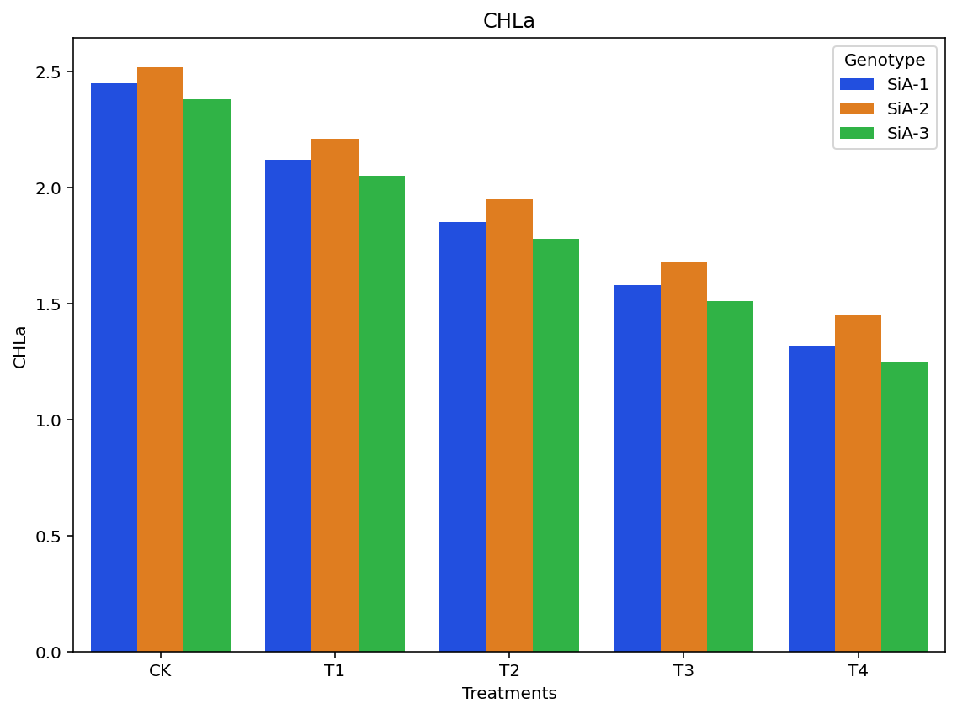
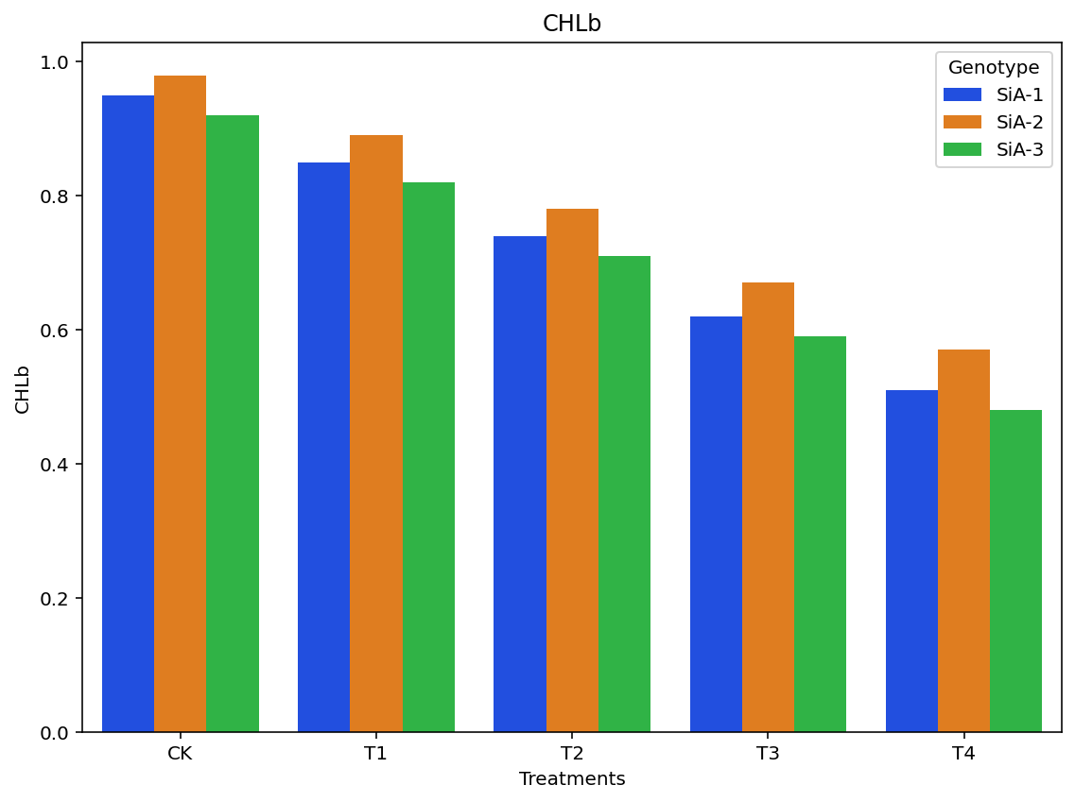
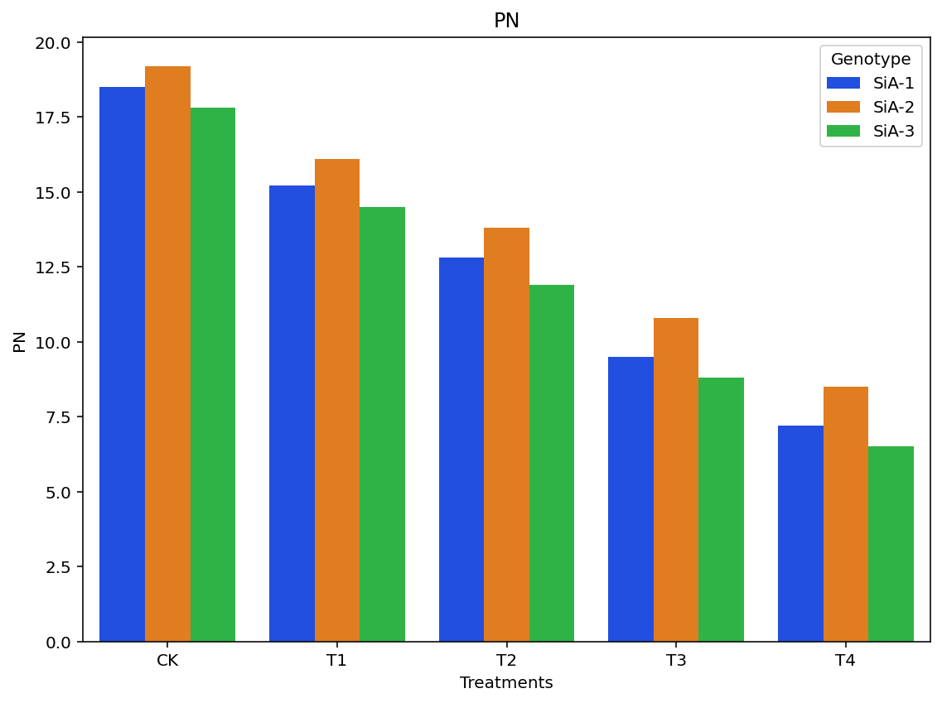
b)
c)

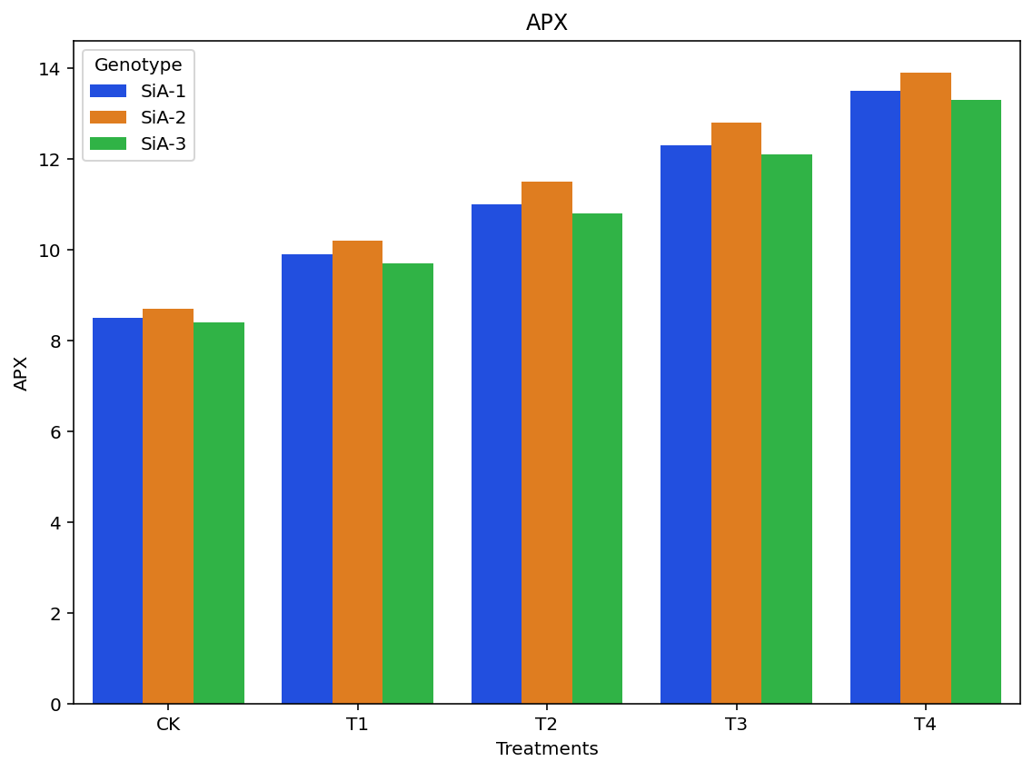
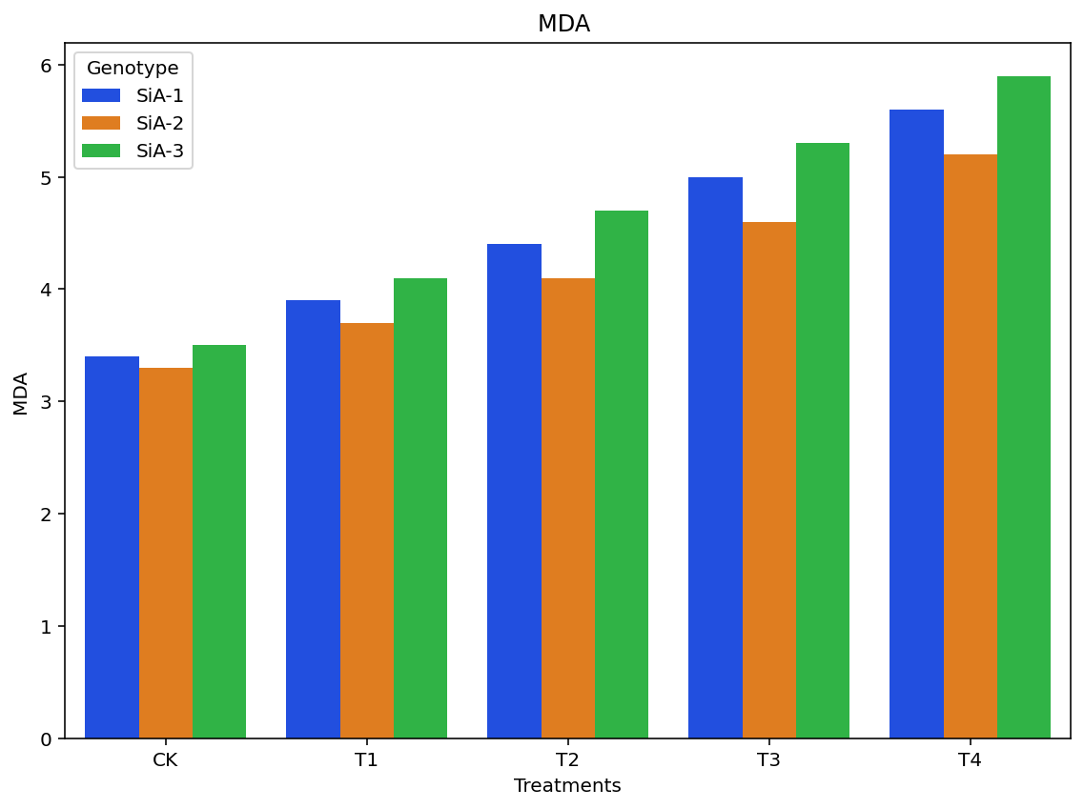
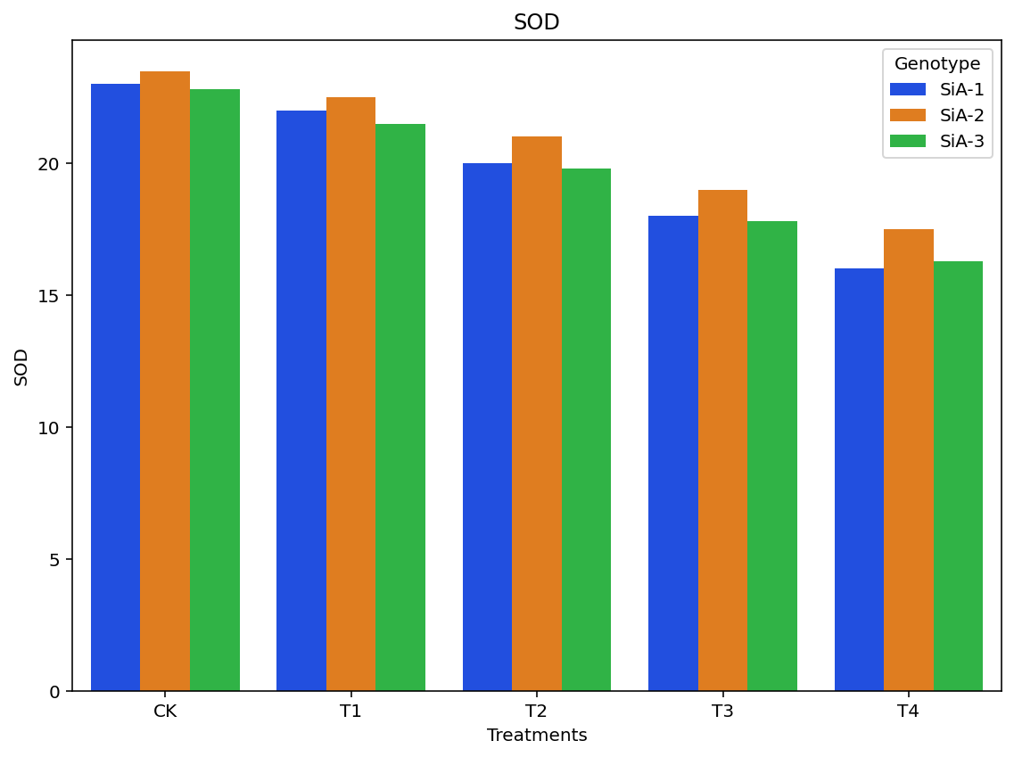
Figure 2: Effect of atrazine treatments on Oxidative stress markers and antioxidant enzyme activities in different genotypes a) Malonaldehyde, b) Ascorbate peroxidase, c) Superoxide dismutase
a)a)
c)

b)

