Studies on seed dormancy pattern and mitigation strategies for overcoming dormancy in kodo millet varieties

ABSTRACT
Seed dormancy in kodo millet (Paspalum scrobiculatum L.) poses a significant challenge to timely germination and uniform crop establishment, especially under rainfed farming systems. This hampers crop productivity and limits the adoption of improved varieties by farmers. The present study was undertaken to investigate the dormancy patterns in kodo millet from post-flowering stages to six months after harvest, and to identify effective mitigation strategies for breaking seed dormancy.
A systematic analysis revealed that dormancy initiates approximately four days before physiological maturity across all genotypes. Significant genotypic differences were observed in the dormancy-to-germination transition: varieties such as CKMV 3, ATL-2, ATL 1, and TNAU 86 exhibited earlier dormancy release, while JK 155 showed prolonged dormancy. Among them, ATL 2 recorded the highest germination percentage, followed by ATL 1 and TNAU 86. To identify effective dormancy-breaking methods, eight seed treatments were evaluated on ATL 2 (low dormancy) and JK 91 (high dormancy). Soaking seeds in 1% potassium nitrate (KNO₃) solution for 4 hours significantly improved germination, reducing dormancy by 31% compared to the untreated control.These findings suggest that seed soaking in 1% KNO₃ for 4 hours is an effective, low-cost, and farmer-friendly method for breaking dormancy in kodo millet, which can enhance seedling establishment and crop productivity.
INTRODUCTION
Kodo millet (Paspalum scrobiculatum L.) is well known by other names like rice grass, creeping paspalum, ditch millet, indian paspalum, cow grass etc. Kodo millet is a short-day and C4 plant. It is a lesser-known crop with valuable nutritional benefits and climate resilience, positioning kodo millet as a promising candidate for future crop development with potential nutraceutical advantages. Kodo millet stands out among cereals due to its gluten-free nature, high phosphorus levels, and notable antioxidant properties, which may help lower the risk of cardiovascular diseases. Typically grown in rainfed regions by small-scale farmers, kodo millet is prized for both its grain and fodder. This hardy crop can withstand various environmental stresses, thriving in low-organic-matter soils with minimal resources, making it an ideal dual-purpose option for rainfed farming areas (Jeeva et al., 2024). It is a self-pollinating cereal with a tetraploid structure (2n = 4x = 40) that is part of the Poaceae family. It was domesticated in India approximately 3000 years ago and is one of the oldest varieties of small millets grown in India, the Philippines, Indonesia, Thailand, and parts of West Africa. (de Wetet al., 1983).The area dedicated to kodo millet production has significantly decreased over the past twenty years, as farmers have shifted towards cultivating paddy and maize, leaving kodo millet primarily in arid regions. Key states where kodo millet is cultivated include Madhya Pradesh, Chhattisgarh, Tamil Nadu, Gujarat, and Karnataka. Kodo millet grains are rich in high-value proteins (8.9%), contain carbohydrates (66.2%), have low fat content (2.55%), and are also a good source of iron (23.4 ppm) and calcium (15.3 mg/100 g) (Longvah et al., 2017) .The appropriate timing for crop harvesting is a crucial element that influences the quality of seed production and ultimately impacts the performance of the subsequent crop. Understanding the seed development patterns and maturation duration is essential for seed production, especially since information on small millets is limited. When seeds reach physiological maturity, they achieve their highest dry matter content while significantly reducing moisture levels; at this stage, if the seeds exhibit their maximum germination capacity and vigor, it is optimal to proceed with harvesting. (Patrick and Offler, 2001).
Dormancy poses challenges in cereal production, whether it is characterized by a brief duration or prolonged persistence. In fact, cereal varieties that do not exhibit sufficient dormancy at the time of harvest may suffer from damage due to pre-harvest sprouting, while excessive dormancy can hinder activities that depend on rapid germination, like malting or achieving uniform crop emergence (Rodriguez et al., 2015). The post-harvest dormancy in kodo millet was observed through our preliminary studies. But systematic and organized experimental studies on the dormancy pattern of kodo millet is lacking. This necessitates the research to take on breaking dormancy in kodo millet seeds. Therefore, a research experiment has been undertaken on studying the dormancy pattern in kodo millet from post flowering stages till six months after harvesting. Burton (1969) stated that the seeds of many pearl millet varieties, Pennisetum typholdes (Burm.) Stapf and C.E. Hubb., exhibit partial dormancy for a few weeks following harvest. Investigations into kodo millet by Kothai and Roobavathi (2021) revealed that seed germination was significantly inhibited by seed priming with gibberellic acid (GA3) as compared to control but notably promoted significant seedling elongation across all tested concentrations. Broadening the scope, Collectively, these studies underscore the critical importance of understanding physiological maturity for optimizing harvest practices to ensure superior seed quality and highlight diverse and effective strategies, encompassing chemical treatments and hormonal applications, to overcome post-harvest dormancy and enhance germination and vigor across different millet species and related crops.
MATERIAL AND METHODS
Seed dormancy pattern and dormancy breaking studies on 10 kodo millet varieties (JK9-1, CKMV-3, JK137, RK390-25, JK 155, ATL-1, ATL-2, TNAU-86, JK65 and JK364)were carried out at Seed Technology Research Unit, Department of Plant Breeding and Genetics, College of Agriculture, Jawaharlal Nehru Krishi Vishwa Vidyalaya, Jabalpur, Madhya Pradesh during 2024-2025. In order to study the dormancy pattern, genotypes must be observed right before the onset of physiological maturity to understand dormancy behaviour, which can be assessed by cultivar-specific germination cues and maximum dry matter accumulation. At an interval of 4 to 5 days from 2 weeks before physiological maturity until a period of maximum germination percentage of the lot is achieved, observations was recorded (where the onset of germination/dormancy switch inter alia can be noticed). These observations will tentatively proceed for two months (or the time till it starts germinating, whichever is earlier), during which time the dormancy level, and type of delineated cultivar seed lot can be known. Later, monthly observations of cultivar lots was taken.Seed fresh and dry weight right from 2 weeks before physiological maturity till harvest maturity (on 25 seeds oven dried at 103 ºC for 17 h expressed in g) at an interval of 3 to 4 days, where seeds are to be collected from tagged ears was obd=served In order to design dormancy breaking strategies, following following dormancy breaking methods viz., T1(Control), T2(water soaking for 24hrs), T3(water soaking for 48hrs),T4(stratification at 5ºC for 24hrs), T5(stratification at 5ºC for 48h), T6(GA3@ 500 ppm), T7(Thiourea @ 0.5 %), T8(KNO3 @ 1 %) was studied.
Estimation of Germination Percentage
Germination percentage was recorded by using Paper towel method. From each varieties and treatment, 50 seeds were placed in three replications on moist towel paper, rolled properly and kept in seed germination at constant temperature (25°C) and relative humidity (90 %) first count of germination was taken on 5th day. Whereas, final germination recorded on 10th day (ISTA, 1999).
Germination percentage (%)= seeds germinated/total seeds x 100
Estimation of Seed Fresh and Dry Weight
Seed fresh and dry weight right from 2 weeks before physiological maturity till harvest maturity (on 25 seeds oven dried at 103 ⁰C for 17 h expressed in g) at an interval of 3 to 4 days, where seeds are to be collected from tagged ears was observed.

RESULT AN DISCUSSION
A. Effect on Seed Germination Percentage 14 days before maturity until physiological maturity
Seed germination studies revealed that seed germination increased from 14 days before physiological maturity to 8 days before physiological maturity, and start decreasing from eight days before physiological maturity to physiological maturity. This shifts the onset of primary dormancy from eight days before physiological maturity to just four days before maturity, in all the varieties (Table 1 & fig.1 ).
Table 1: Depiction of Germination percentage 14 days before maturity until physiological maturity in all the kodo millet varieties
Germination Percentage (%)
VARIETIES | 14 days before physiological maturity | 11 days before physiological maturity | 8 days before Physiological maturity | 4 days before physiological maturity | Physiological maturity
JK9-1 | 0 | 1 | 1 | 0 | 0
CKMV-3 | 0 | 0 | 0 | 0 | 0
JK137 | 0 | 0 | 0 | 0 | 0
RK390-25 | 0 | 0 | 1 | 0 | 0
JK155 | 0 | 1 | 2 | 0 | 0
ATL-1 | 1 | 1 | 0 | 0 | 0
ATL-2 | 0 | 1 | 2 | 0 | 0
TNAU-86 | 0 | 0 | 0 | 0 | 0
JK 65 | 0 | 0 | 0 | 0 | 0
JK 364 | 0 | 1 | 1 | 0 | 0
CD (0.01%) | 1.45 | 1.94 | 1.45 | 1.70 | 0.00
SEm | 0.32 | 0.42 | 0.32 | 0.37 | 0.00
After first month of storage period after harvesting dormancy / germination switch inter-alia starts in CKMV-3, ATL-1 & TNAU-86 variety and in other variety dormancy continue. After second month of storage period after harvesting, dormancy ends in all the variety except JK 155. After third month of storage period after harvesting, dormancy ends in all the variety with ATL-2 exhibiting maximum germination followed by ATL-1 & TNAU-86, in contrast minimum dormancy was observed for JK-364. After fourth month and fifth month of storage period after harvesting, variety with ATL-2 exhibiting maximum germination followed by ATL-1 & TNAU-86, in contrast minimum dormancy was observed for JK-364.After sixth month of storage period after harvesting, variety with ATL-1 exhibiting maximum germination followed by ATL-2 & JK 65, in contrast minimum dormancy was observed for JK 364 (Table 2 & fig.2).
Table 2.: Germination percentage from first month till sixth month of storage period after harvesting
VARIETIES | 1ST month of Storage period after harvesting | 2nd month of Storage period after harvesting | 3rd month of Storage period after harvesting | 4th month of Storage period after harvesting | 5th month of Storage period after harvesting | 6th month of Storage period after harvesting
JK9-1 | 0 | 8 | 9 | 47 | 64 | 82
CKMV-3 | 2 | 3 | 9 | 16 | 52 | 85.33
JK137 | 0 | 2 | 15 | 15 | 61 | 89
RK390-25 | 0 | 1 | 12 | 9 | 50 | 83.33
JK155 | 0 | 0 | 3 | 7 | 47 | 54.33
ATL-1 | 2 | 6 | 20 | 44 | 72 | 94
ATL-2 | 0 | 13 | 39 | 69 | 77 | 93.33
TNAU-86 | 1 | 8 | 20 | 30 | 61 | 87.33
JK 65 | 0 | 3 | 4 | 23 | 29 | 91.33
JK 364 | 0 | 1 | 1 | 2 | 39 | 90.66
CD (0.01%) | 3.91 | 8.79 | 20.67 | 17.36 | 29.47 | 8.77
SEm | 0.85 | 1.91 | 4.50 | 3.78 | 6.41 | 2.15

2. Effect on Seed Fresh Weight (gms) from 14 days before maturity until physiological maturity
Seed Fresh weight studies revealed that seed fresh weight increased from 14 days before physiological maturity to physiological maturity. At 14 days before physiological maturity, kodo millet variety RK 390-25 and ATL-1 exhibited maximum seed fresh weight. At physiological maturity, RK 390-25 exhibited maximum seed fresh weight followed by TNAU-86, JK 65 & JK 364 (Table 3).
Table 3: Depiction of seed fresh weight from 14 days before maturity upto physiological maturity
Variety | Days  to  flowering | 14 days before physiological maturity | 11 days before physiological maturity | 8 days before Physiological maturity | 4 days before physiological maturity | Physiological maturity
JK9-1 | 71 | 0.0708 | 0.0826 | 0.0826 | 0.0826 | 0.0944
CKMV-3 | 71 | 0.0826 | 0.0944 | 0.0944 | 0.0944 | 0.0944
JK137 | 71 | 0.0708 | 0.0708 | 0.0708 | 0.0708 | 0.0826
RK390-25 | 71 | 0.0944 | 0.1062 | 0.1062 | 0.1062 | 0.118
JK155 | 71 | 0.0826 | 0.0826 | 0.0826 | 0.0826 | 0.0944
ATL-1 | 81 | 0.0944 | 0.0944 | 0.0944 | 0.0944 | 0.1062
ATL-2 | 75 | 0.0708 | 0.0826 | 0.0826 | 0.0826 | 0.0826
TNAU-86 | 73 | 0.0708 | 0.0826 | 0.0826 | 0.0826 | 0.1062
JK 65 | 81 | 0.0826 | 0.1062 | 0.1062 | 0.1062 | 0.1062
JK 364 | 78 | 0.059 | 0.0944 | 0.0944 | 0.0944 | 0.1062
CD (0.01%) | 1.72 | 0.0118531 | 0.0206964 | 0.0249486 | 0.0278535 | 0.0257793
SEm | 0.42322 | 0.00291 | 0.00508 | 0.00613 | 0.00684 | 0.00633

FIG 1. Seed fresh weight from 14 days before maturity upto physiological maturity
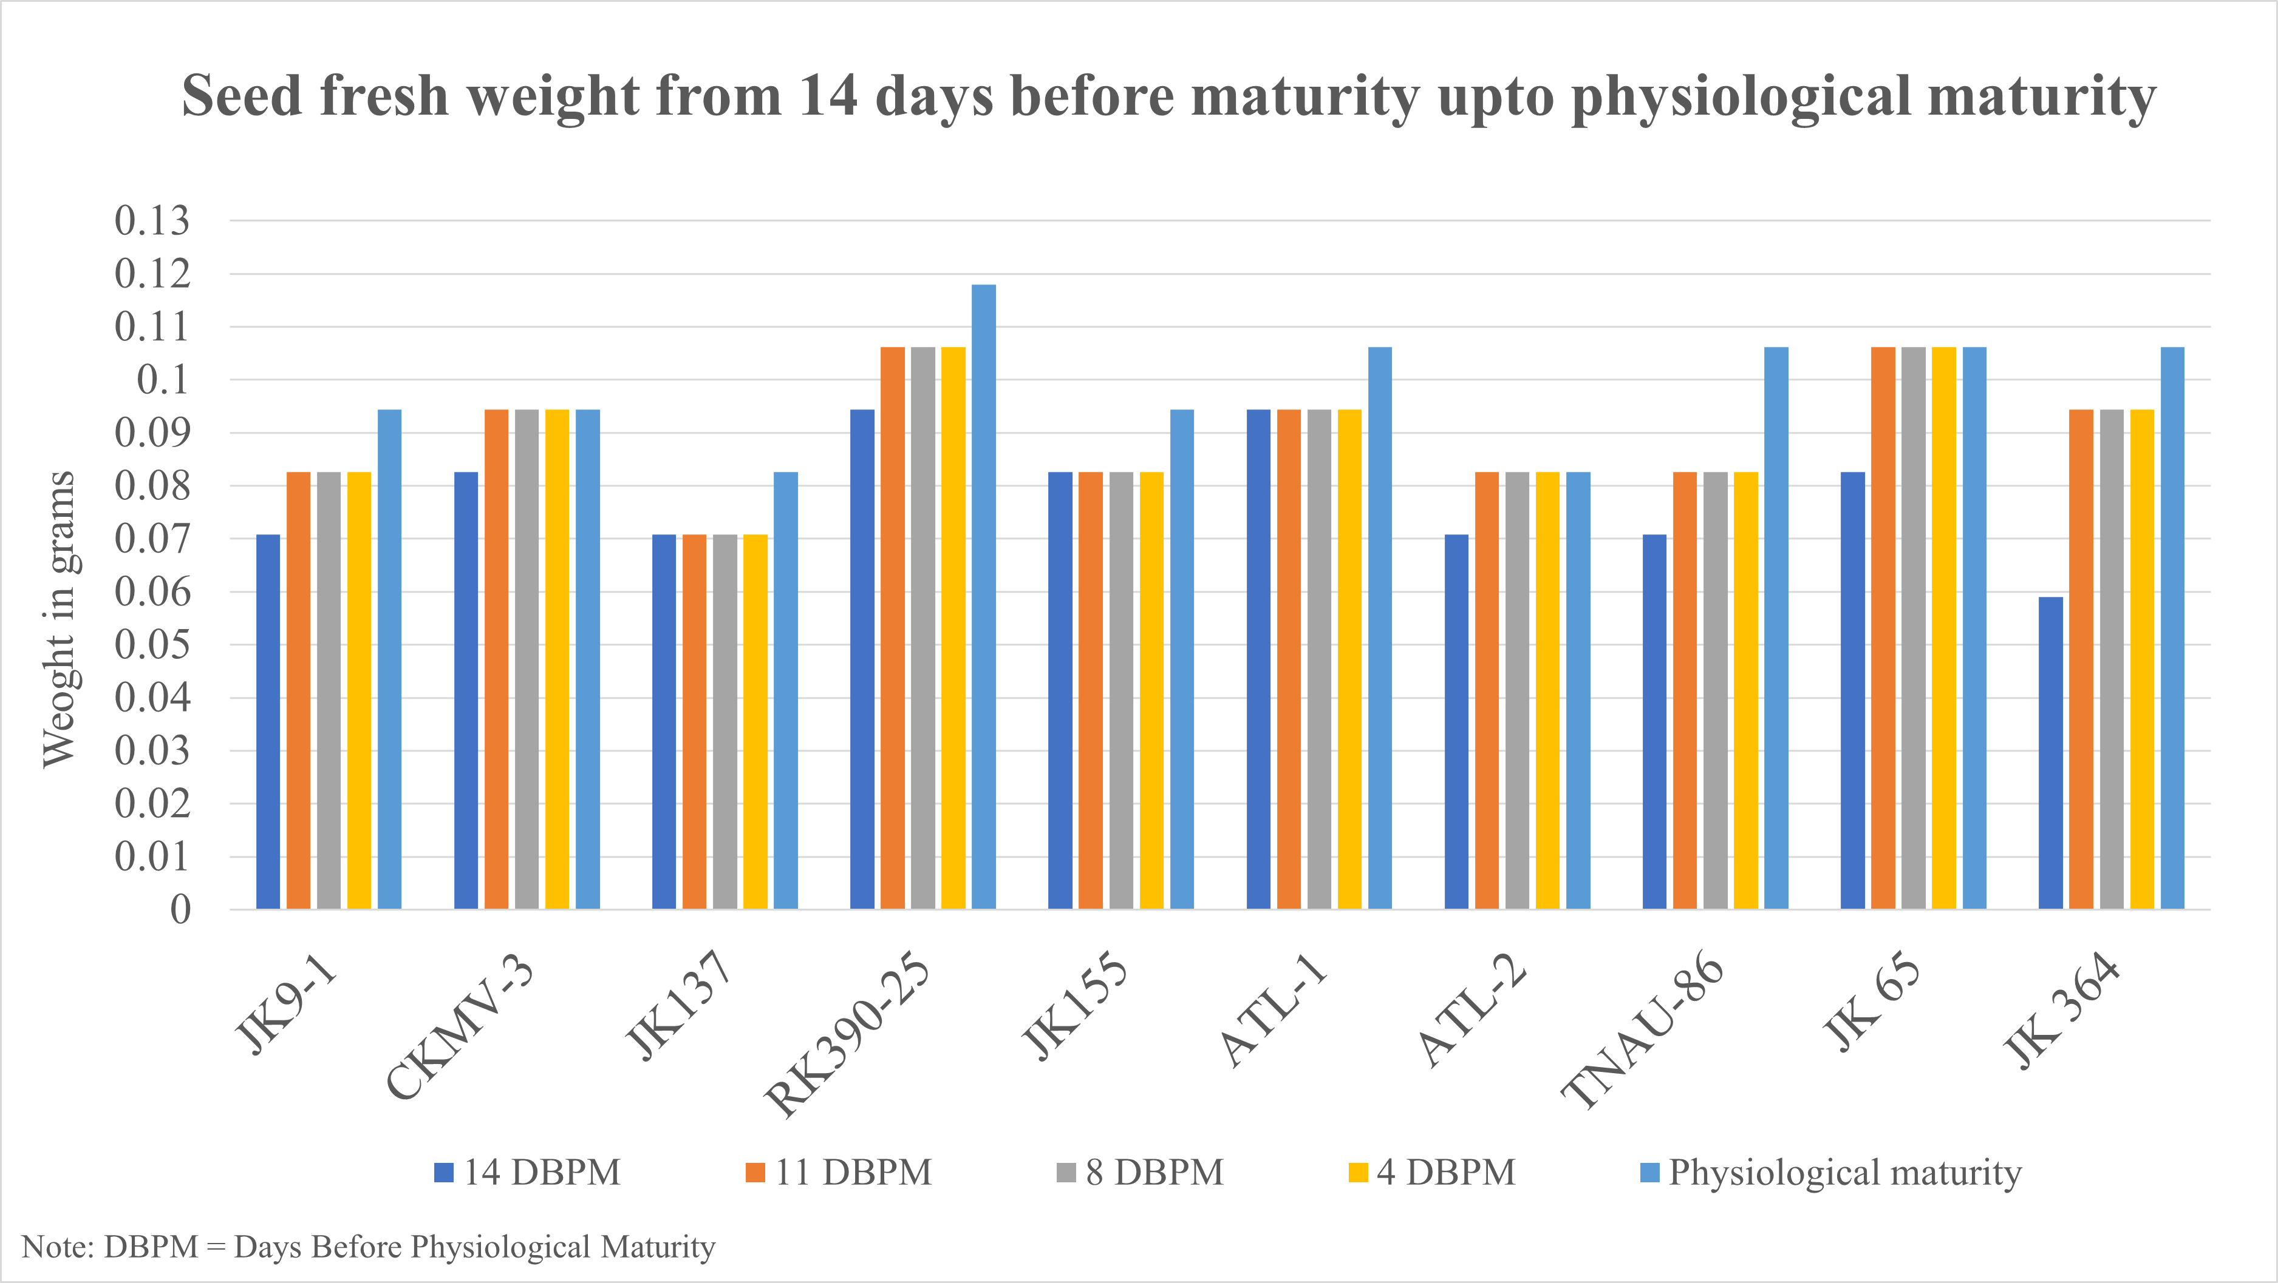
C. Effect on Seed dry weight from 14 days before maturity upto physiological maturity
Seed dry weight studies revealed that seed dry weight increased from 14 days before physiological maturity to physiological maturity. At 14 days before physiological maturity, Kodo millet variety RK 390-25 and ATL-1 exhibited maximum seed dry weight. At physiological maturity, RK 390-25 exhibited maximum seed dry weight followed by ATL-1, TNAU-86, JK-65 & JK364 (Table 4).

Table 4: Seed Dry weight 14 days before maturity until physiological maturity
Seed Dry weight (g)
Variety | Days to flowering | 14 days before physiological maturity | 11 days before physiological maturity | 8 days before Physiological maturity | 4 days before physiological maturity | Physiological maturity
JK9-1 | 71 | 0.06 | 0.07 | 0.07 | 0.07 | 0.08
CKMV-3 | 71 | 0.07 | 0.08 | 0.08 | 0.08 | 0.08
JK137 | 71 | 0.06 | 0.06 | 0.06 | 0.06 | 0.07
RK390-25 | 71 | 0.08 | 0.09 | 0.09 | 0.09 | 0.1
JK155 | 71 | 0.07 | 0.07 | 0.07 | 0.07 | 0.08
ATL-1 | 81 | 0.08 | 0.08 | 0.08 | 0.08 | 0.09
ATL-2 | 75 | 0.06 | 0.07 | 0.07 | 0.07 | 0.07
TNAU-86 | 73 | 0.06 | 0.07 | 0.07 | 0.07 | 0.09
JK 65 | 81 | 0.07 | 0.09 | 0.09 | 0.09 | 0.09
JK 364 | 78 | 0.05 | 0.08 | 0.08 | 0.08 | 0.09
CD (0.01%) | 1.6324 | 0.007851 | 0.006099 | 0.007426 | 0.007248 | 0.007164
SEm | 0.40102 | 0.00193 | 0.00150 | 0.00182 | 0.00178 | 0.00176
FIG 2. Seed Dry Weight 14 days before maturity until Physiological maturity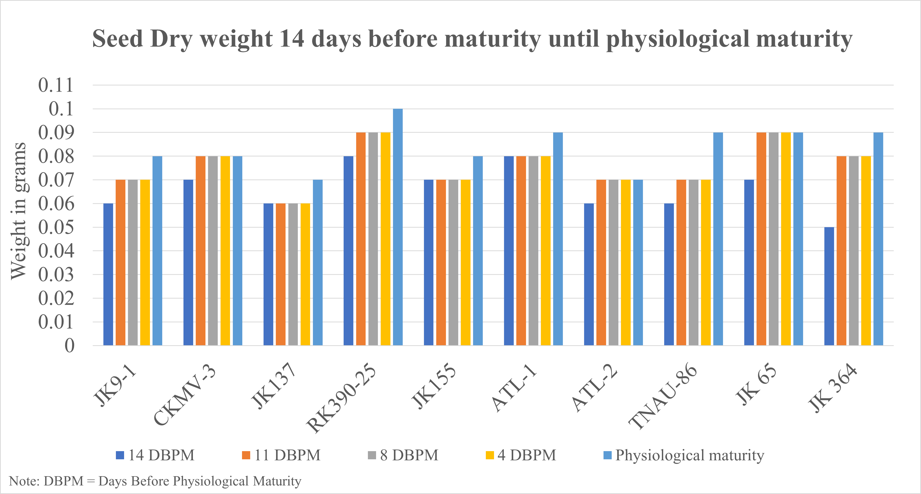
PLATE 1. 14,11 and 4 days before physiological maturity of CKMV-3 seeds respectively
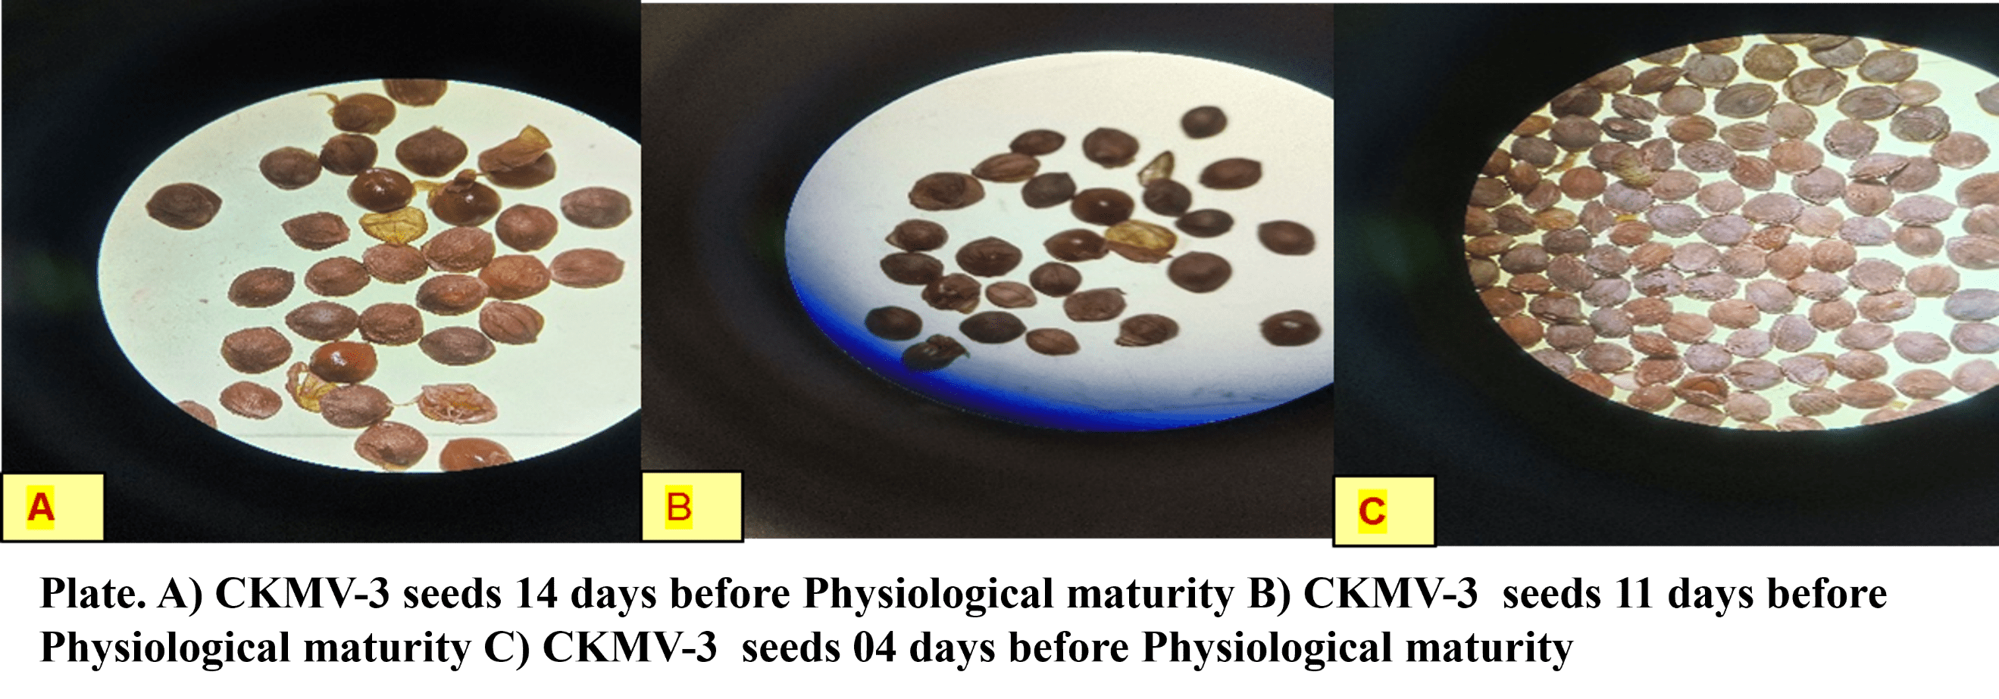
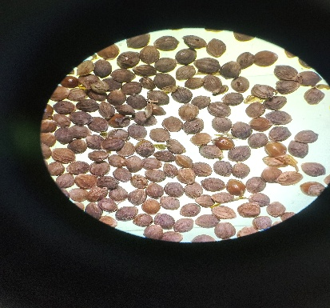
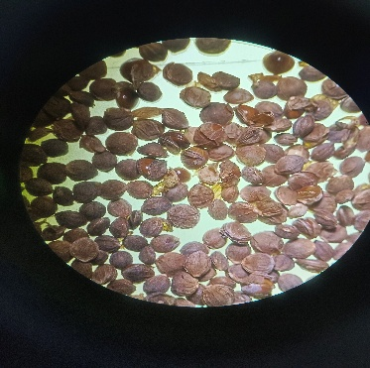
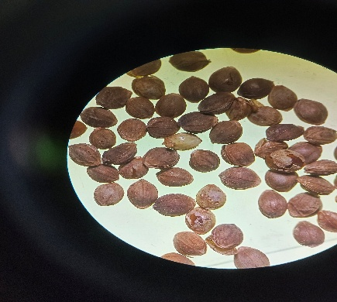
PLATE 2. JK 9-1 Seeds before 14,11,04 days before physiological maturity
B
C
A
Plate. A) JK 9-1 seeds 14 days before Physiological maturity B) JK 9-1 seeds 11 days before Physiological maturity C) JK 9-1 seeds 04 days before Physiological maturity

PLATE 3. RK 390-25 seeds 14, 11, 04 days before physiological maturity

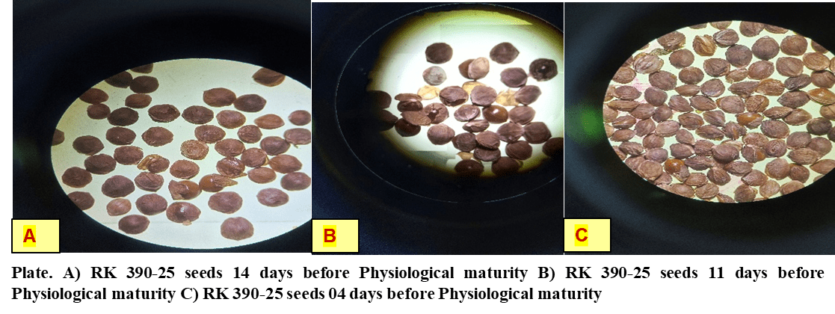

PLATE 4. JK 155 14, 11 and 04 days before Physiological maturity
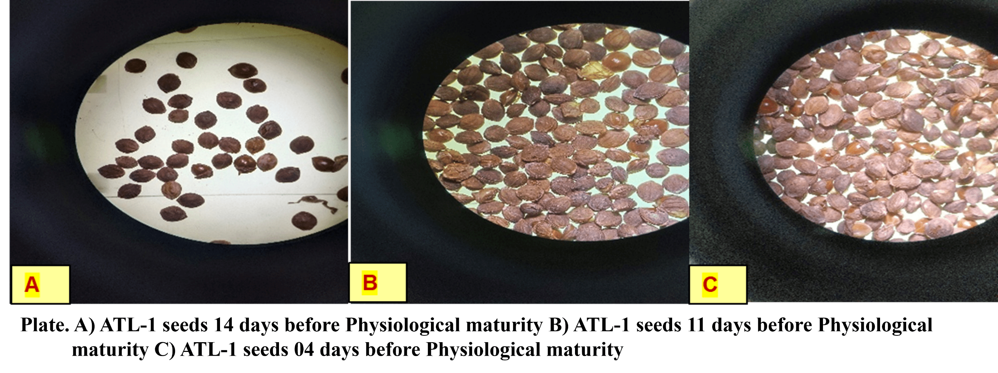
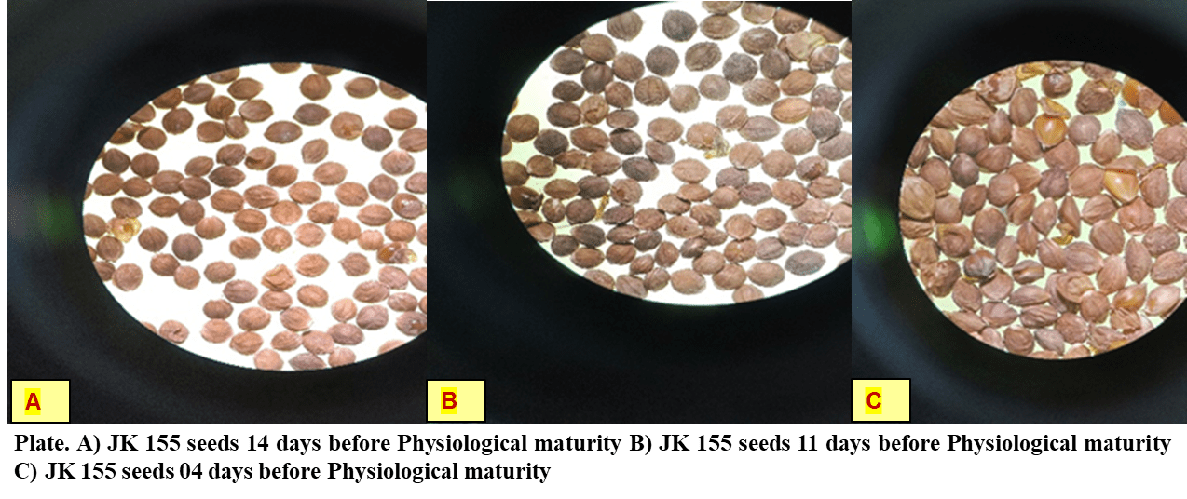
PLATE 5. ATL-1 Seeds 14,11,04 days before Physiological maturity
PLATE 6. TNAU-86 seeds 14,11,04 days before Physiological maturity
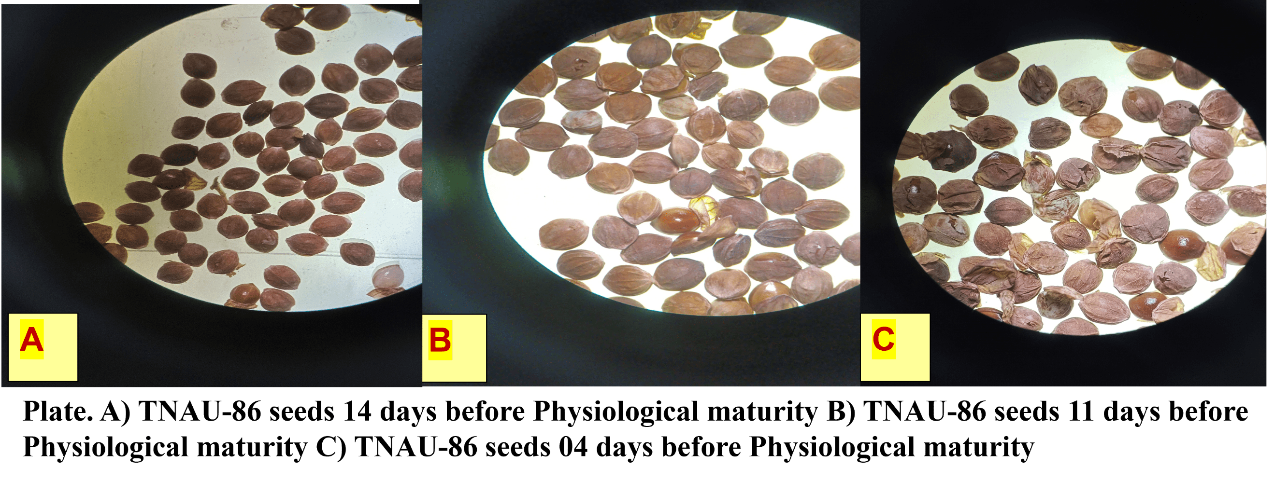
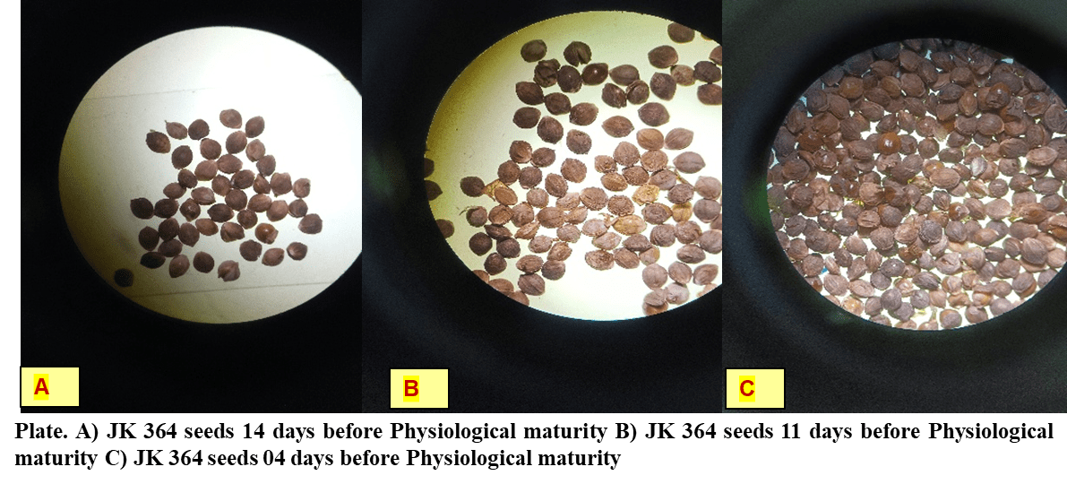
PLATE 7.JK 364 seeds 14,11,04 days before Physiological maturity
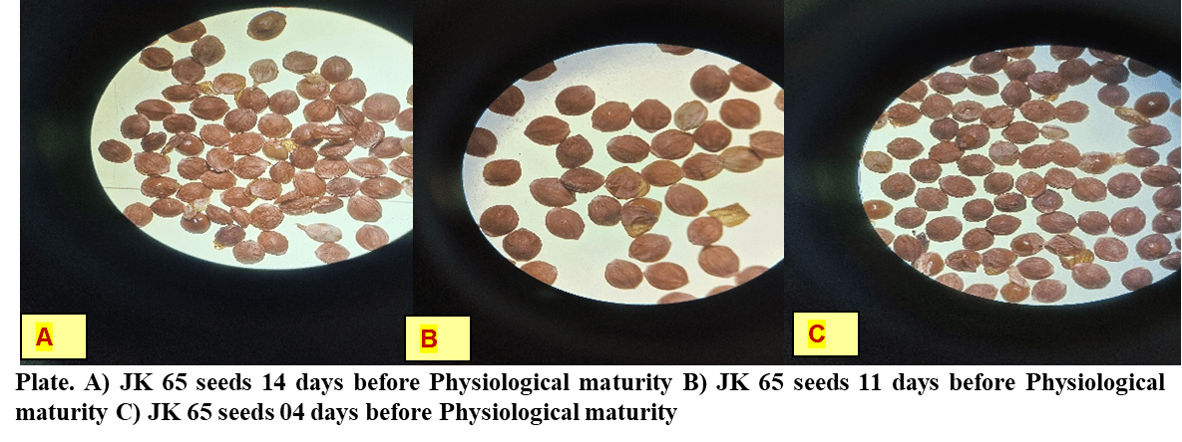
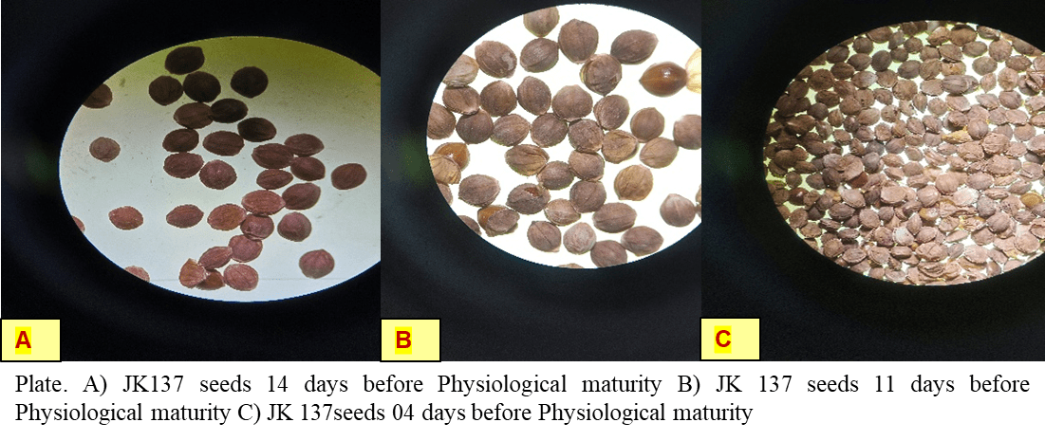
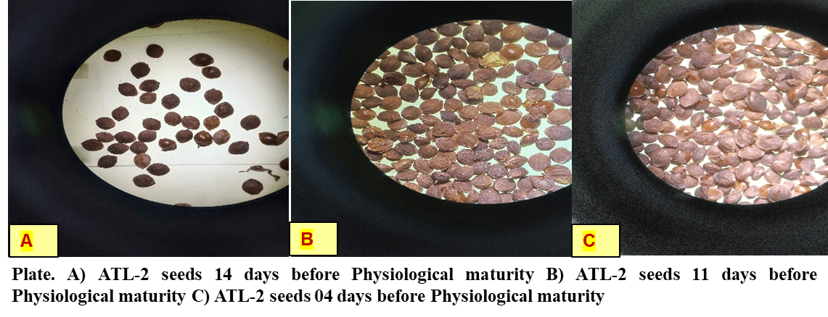

PLATE 8. JK 65 seeds 14,11,04 days before Physiological maturity

PLATE 9. ATL-2 14,11,04 days before Physiological maturity

PLATE 10.JK 137 14,11,04 days before Physiological maturity

D. Studying the efficacy of different seed dormancy breaking treatments in two kodo millet varieties
While evaluating the germination percentage, significant dormancy was observed and in order to break seed dormancy, eight seed dormancy breaking treatments were undertaken which were as follows. 1. Scarification (water soaking for 24-48h or Hot water treatment), 2. stratification (50ºC for 24h to 48h) hormonal and chemical treatments 2. (GA3@ 500 ppm / Thiourea @ 0.5 % / KNO3 @ 1 %) was undertaken. The result observed that out of eight dormancy mitigation treatments viz., scarification, stratification, hormonal and chemical treatments, KNO3 @ 1% for 4 hrs exhibited maximum dormancy mitigation efficiency (62% seed germination) with 31% higher seed germination as compared to control (no treatment) (Table 5).
Table 5: Depiction of the efficacy of scarification, stratification and hormonal and chemical treatment in breaking seed dormancy as observed from Germination percentage

Treatment (T) | Varieties (V) |  | Mean (T)
Treatment (T) | ATL-2 | JK 9-1 | Mean (T)
T1-Control | 58.00 | 36.00 | 47^{b}
T2-Soaking in water for 24 hrs | 0.00 | 0.00 | 0^{c}
T3-Soaking in water for 48 hrs | 0.00 | 0.00 | 0^{c}
T4- Stratification at 5⁰C for 24 hrs | 7.00 | 0.00 | 3.5^{c}
T5-Stratification at 5ºC only for 48 hrs | 6.00 | 1.00 | 3.5^{c}
T6-GA₃ @ 500 ppm for 4 hrs | 81.00 | 34.00 | 57.5ª
T7-Thiourea @ 0.5% for 4 hrs | 85.00 | 38.00 | 61.5ª
T8-KNO₃ @ 1% for 4 hrs | 84.00 | 40.00 | 62ª
Mean (V) | 40.12ª | 18.62^{b}
CD (P≤5%) | CD (V)=3.30 | CD (T)=6.61 | CD(VxT)=9.36
S.Em (±) | SEm(V)=1.10 | SEm(T)=2.20 | SEm(VxT)=3.12

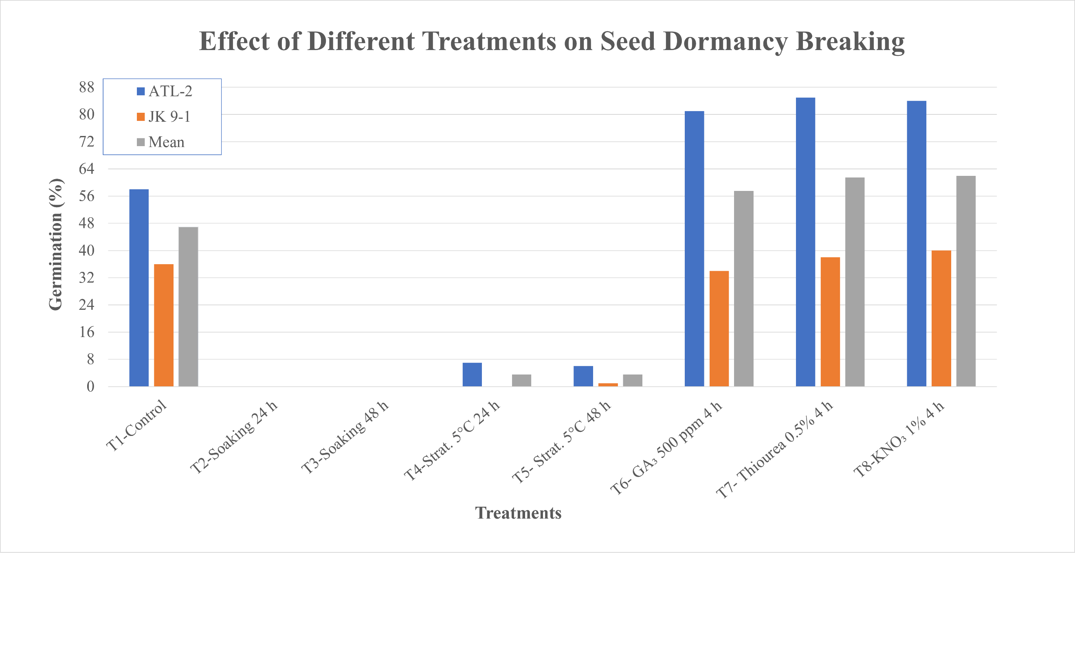

FIG 3. Effect of Different Treatments on Seed Dormancy BreakingSs

-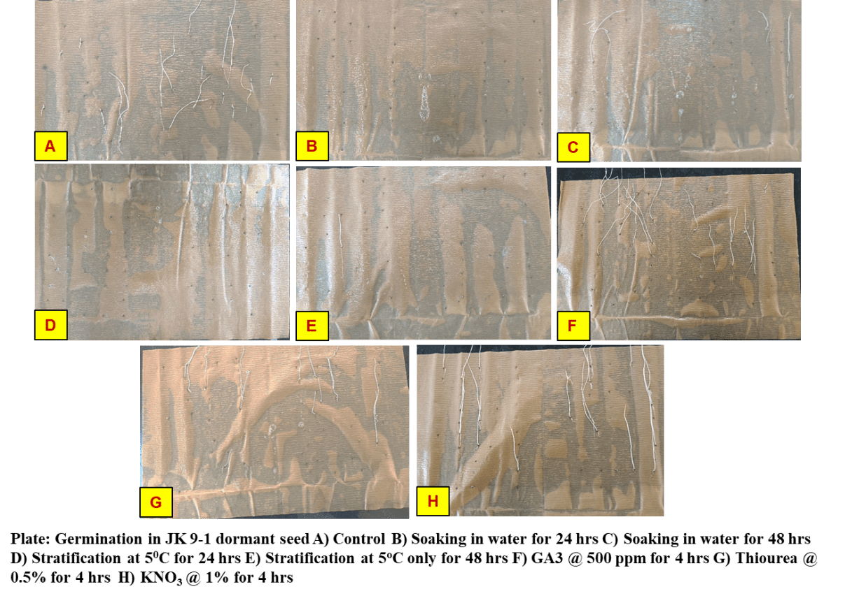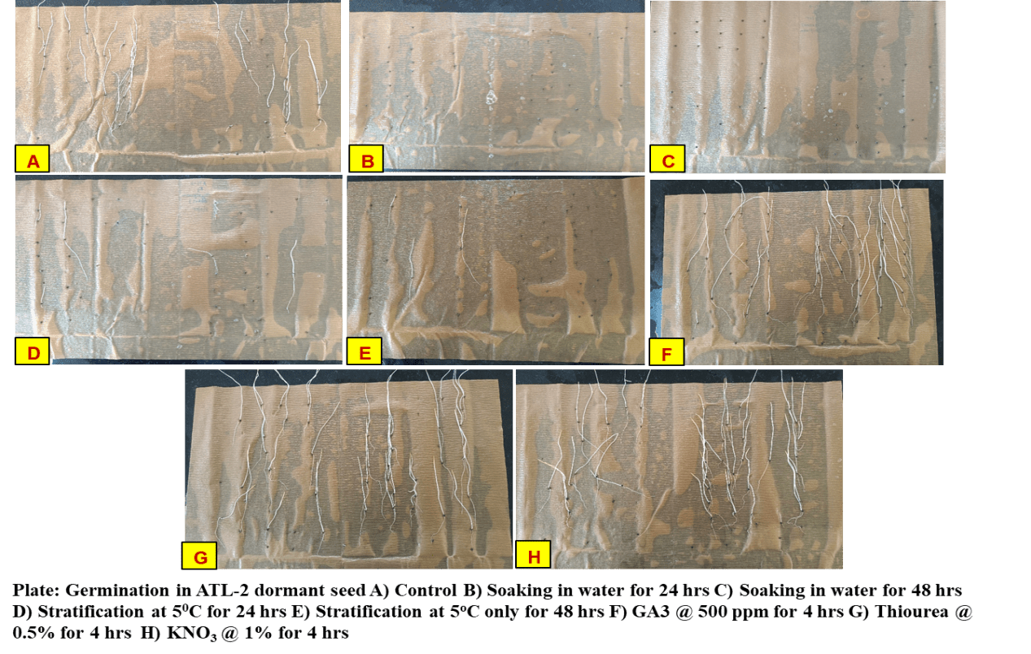

PLATE 11. Germination in JK 9-1 dormant seed
PLATE 12.Germination of ATL-2 dormant seeds

DISCUSSION
The present investigation into the mechanism and duration of seed dormancy in kodo millet cultivars revealed a dynamic interplay between physiological maturity, seed development, and post-harvest dormancy expression. Germination studies indicated a progressive increase in seed germination from 8 to 14 days before physiological maturity, followed by a decline from 8 days before physiological maturity to the point of physiological maturity. This trend suggests the onset of primary dormancy beginning approximately four days prior to physiological maturity across all evaluated varieties. Such early dormancy induction aligns with findings in proso millet by Sridevi and Manonmani (2019), who reported dormancy initiation at physiological maturity despite peak seed development indicators.
Post-harvest dormancy behaviour varied significantly among the kodo millet genotypes. Dormancy release began within the first month of storage in CKMV-3, ATL-1, and TNAU-86, while other varieties retained dormancy. By the second month, dormancy had ended in all varieties except JK 155, and by the third month, complete dormancy release was observed across all genotypes, with ATL-2 exhibiting the highest germination rate, followed by ATL-1 and TNAU-86. These findings are consistent with the dormancy release patterns reported in pearl millet by Burton (1969), where dormancy persisted for several weeks post-harvest and was alleviated through chemical treatments.
Seed fresh and dry weight studies further corroborated the physiological maturity timeline. Both parameters increased steadily from 14 days before physiological maturity to the point of maturity, with RK 390-25 consistently exhibiting the highest values. This suggests that RK 390-25 may possess superior seed filling capacity, potentially contributing to enhanced seed vigor. Similar developmental trajectories were observed in little millet by Senthil Raj et al. (2021), where peak seed weights and germination rates coincided with physiological maturity, reinforcing the importance of precise harvest timing.
Among the eight dormancy mitigation treatments evaluated, seed soaking with potassium nitrate (KNO₃) at 1% for 4 hours emerged as the most effective, achieving a 62% germination rate—31% higher than the untreated control. This result aligns with the findings of Mutetwa et al. (2023), who demonstrated the efficacy of KNO₃ in enhancing germination and early seedling growth in horned melon. The dormancy-breaking potential of KNO₃ may be attributed to its role in stimulating nitrate-sensitive signalingpathways that promote germination.
Collectively, the results of this study emphasize the critical importance of understanding the timing of physiological maturity and post-harvest dormancy dynamics for optimizing seed quality in kodo millet. The differential dormancy release patterns among genotypes and the efficacy of chemical treatments like seed soking with 1% KNO₃ for 4 hrs provide valuable insights for breeders and seed technologists aiming to enhance germination and vigor.
CONCLUSION
This study highlighted the critical importance of observing Kodo millet genotypes and cultivars just before physiological maturity to accurately assess seed dormancy behaviour and while evaluating the germination percentage, if significant dormancy is observed, based on the class of dormancy, eight seed dormancy breaking treatments was undertaken viz.,scarification (water soaking for 24-48h or Hot water treatment) / stratification (50ºC for 24h to 48h) / physical (50⁰C dry heat 2 to 7 days) / hormonal and chemical treatments (GA₃@ 500 ppm / Thiourea @ 0.5 % / KNO3 @ 1 %).
Regular, frequent observations, beginning two weeks before physiological maturity and continuing every 4-5 days until peak germination, are vital for determining the dormancy class, level, and type of each seed lot. Germination studies revealed an increase in seed germination from 14 to 8 days before physiological maturity, followed by a decline, indicating the onset of primary dormancy approximately four days before physiological maturity across all varieties. Dormancy release varied among varieties; for instance, CKMV-3, ATL-1, and TNAU-86 began to switch from dormancy to germination after one month of storage, while others remained dormant. By the second month, most varieties, except JK 155, had broken dormancy, with ATL-2 showing the highest germination after three months, followed by ATL-1 and TNAU-86.
Furthermore, seed fresh and dry weights consistently increased from 14 days before physiological maturity until maturity. At 14 days before physiological maturity, RK 390-25 and ATL-1 exhibited the highest fresh and dry weights. At physiological maturity, RK 390-25 maintained the maximum fresh and dry weights, followed by TNAU-86, JK-65, and JK364 for fresh weight, and ATL-1, TNAU-86, JK-65, and JK364 for dry weight. These findings provide a comprehensive understanding of Kodo millet seed development and its intricate relationship with dormancy.
While evaluating the germination percentage, significant dormancy was observed, so we have worked out the mitigation strategies for breaking the dormancy. Out of eight dormancy mitigation treatments viz., scarification, stratification, hormonal and chemical treatments, seed soaking with KNO3 @ 1% for 4 hrs exhibited maximum dormancy mitigation efficiency (62% seed germination) and 31% higher seed germination as compared to control (no treatment).
REFERENCES
Burton, GW. (1969). Breaking Dormancy in Seeds of Pearl Millet, Pennisetum typhoides 1. Crop Science, 9(5), 659-664.
de Wet JMJ, Brink DE, Rao KP and Mengesha MH. (1983). Diversity in kodo millet, Paspalum scrobiculatum. Economic Botany, 37, 159–163.
Jeeva G, Suhasini B, Pramitha L, Jency JP, Joshi P, Ravikesavan R and Elango D. 2024. Unlocking the potential of Kodo millet: reviving an indigenous super grain for tomorrow's nutrition. Planta 259(6), 140.
Kothai N and Roobavathi MR. (2021). Understanding the response of water and hormonal stress on seed germination and early seedling growth in Kodo Millet (Paspalum scrobiculatum L.). Journal of Stress Physiology & Biochemistry, 17(4), 46-59.

Longvah T, Ananthan R, Bhaskarachary K and Venkaiah K. (2017). Indian food composition tables. National Institute of Nutrition.

Mutetwa, M., Mafukidze, B. P., Makaure, B. T., Mubaiwa, T. C., Dendera, O., Tovigepi, E., ... &Chaibva, P. (2023). Priming seeds with potassium nitrate is associated with modulation of seed germination and seedling growth ecology of cucumismetuliferus. EUREKA: Life Sciences, (4), 23-35.
Patrick JW and Offler CE. (2001). Compartmentation of transport and transfer events in developing seeds. Journal of Experimental Botany, 52, 551–564.
Rodriguez MV, Barrero JM, Corbineau F, Gubler F and Benech-Arnold RL. (2015). Dormancy in cereals (not too much, not so little): about the mechanisms behind this trait. Seed Science Research, 25(2), 99-119.
Senthil Raj R, Ahamed AS, Sujatha K and Ragupathi KP. (2021). Seed development and maturation studies in Little Millet (Panicum sumatrense Roth ex Roem. and Schult.) cv. Co (Samai) 4. IJCS, 9(1), 870-875.
Sridevi R and Manonmani V. (2019). Predicting the optimal stage of maximum seed quality during seed development and maturation in proso millet (Panicum miliaceum L). International Journal of Farm Sciences, 9(4), 89-93.
Yadav R, Chauhan JS and Nautiyal PC. (2025). Seed development and induction of germination or dormancy, and storage potential in proso millet. Plant Archives, 25(1), 377-385.

