Case report

Silent Obstruction: A rare case of nasolabial
schwannoma

.
ABSTRACT

Schwannomas are benign peripheral nerve sheath tumors that commonly affect the head and neck regions, though their occurrence in the nasolabial area is rare. This report details a case of a 27-year-old male with a history of progressive swelling and nasal obstruction localized to the right nostril. Clinical examination revealed a firm, non-tender mass on the anterior right nasal floor without significant accompanying symptoms. The mass was excised via sub-labial approach, and histopathological analysis confirmed it as a schwannoma. Schwannomas in this region require differentiation from other nasal masses. This case highlights the importance of considering schwannoma in the differential diagnosis of nasal masses and supports sub-labial excision as a safe and effective treatment approach.

Keywords: schwannoma, nasolabial, nasolabial schwannoma, nasal mass

1. INTRODUCTION

Schwannomas are tumors that arise from the peripheral nervous system and are composed of various cell types such as tumorigenic Schwann cells, axons, macrophages, T cells, fibroblasts, blood vessels, and an extracellular matrix [1]. Schwannomas are one of the most common types of peripheral nerve sheath tumors. These tumors can develop spontaneously or in association with familial tumor syndromes such as neurofibromatosis type 2 [2]. Typically, schwannomas are solitary growths that most often affect small peripheral nerves, especially in the head, neck, and the flexor surfaces of extremities [2]. Diagnosing extracranial schwannomas preoperatively presents a challenge, as indicated in most literature.

2. CASE PRESENTATION

A 27-year-old male with no history of neurofibromatosis presented with a swelling over his right nostril for two years, which gradually increased in size. He also experienced progressive nasal blockage in the right nostril over the past year, as the swelling enlarged, and obstructed the nasal cavity. There were no accompanying nasal symptoms such as rhinorrhea, sneezing, or episodes of epistaxis. On clinical examination, a 1x1 cm firm, non-tender swelling with a smooth surface and regular margins was noted on the anterior right nasal floor. The nasal mucosa was normal, and no punctum was seen. Sub-labial palpation revealed the swelling with no fistula. A direct nasoendoscopy showed normal findings. The mass was excised via a sub-labial approach [Figure 1 and Figure 2], and histopathological examination of the mass confirmed a well-circumscribed tumor, measuring 10x9x6 mm, composed of spindle cells arranged in compact hypercellular Antoni A areas and myxoid hypocellular Antoni B areas [Image 1]. Verocay bodies were also observed [Image 2]. The final diagnosis was right nasolabial schwannoma. The patient had an uneventful postoperative course with no signs of recurrence.

3. discussion

Schwannomas are benign, slow-growing tumors originating from Schwann cells. Though rare, 25-45% of schwannomas occur in the head and neck, with only 4% arising from the nasal cavity and paranasal sinuses [4]. These tumors affect both genders equally, and the vestibulocochlear nerve is their most common site of origin [5]. In this case, it develop at nasolabialarea which is second reported case in Malaysia.

Schwannomas in the facial region, especially the upper lip, are considered uncommon [6]. They typically present as solitary, movable, elastic-soft subcutaneous masses. Differential diagnoses, such as nasolabial cysts, should be considered, as the clinical presentation and MRI findings of schwannomas beneath the alar base may appear similar [7]. In this case, an initial diagnosis of nasolabial cyst was made due to the similar presentation with schwanoma until histophathological result proven it as schwannoma.

Histologically, schwannomas can be categorized into different subtypes, including common, plexiform, cellular, epithelioid, and ancient [2]. In this case, the histopathological findings were consistent with schwannoma showing spindle cells arranged in compact hypercellular Antoni A areas and myxoid hypocellular Antoni B areas with observed verocay bodies, distinguishing it from neurofibroma. Differentiating schwannoma from neurofibroma is critical since solitary neurofibromas may be linked to neurofibromatosis, with malignant transformation occurring in 5-16% of cases [8].

Surgical excision is the treatment of choice for schwannomas, and it can be done endoscopically or via external approaches [9]. In this instance, the tumor size allowed for excision through a sub-labial approach under general anesthesia. The mass was carefully dissected and removed along with its capsule. Recurrence is rare, and the patient remained well during follow-up.

4. Conclusion

Schwannomas of the nasolabial region are rare benign tumors that can clinically mimic other nasal or sublabial masses such as nasolabial cysts. Complete surgical excision remains the treatment of choice, providing both definitive diagnosis and curative outcome. The sub-labial approach is one of the technique that can offers excellent exposureand satisfactory cosmetic results. This case emphasizes the importance of including schwannoma in the differential diagnosis of nasal and nasolabial swellings and demonstrates that early recognition and complete excision lead to favorable prognosis with low recurrence risk.

Consent (where ever applicable)

All authors declare that written informed consent was obtained from the patient and patient agreed for publication of this case report and accompanying images. A copy of the written consent is available for review by the Editorial office/Chief Editor/Editorial Board members of this journal whenever needed.

References
- Helbing, D. L., Schulz, A., & Morrison, H. (2020). Pathomechanisms in schwannoma development and progression. Oncogene, 39(32), 5421-5429.
- Hilton, D. A., & Hanemann, C. O. (2014). Schwannomas and their pathogenesis. Brain pathology, 24(3), 205-220.
- Kumar, S. R. U., Tarmizi, N. E. A., Singh, A. S. M., & Chua, H. H. Traversing the Nasolabial Terrain: Unveiling a Unique Extracranial Schwannoma Case Report.
- Suh, J. D., Ramakrishnan, V. R., Zhang, P. J., Wu, A. W., Wang, M. B., Palmer, J. N., & Chiu, A. G. (2011). Diagnosis and endoscopic management of sinonasal schwannomas. Orl, 73(6), 308-312.
- Khodaei, I., & Davies, E. (2008). Schwannoma of the inferior turbinate: case report and review of literature. RadiologiaBrasileira, 41, 205-206.
- Yang, S. W., & Lin, C. Y. (2003). Schwannoma of the upper lip: case report and literature review. American journal of otolaryngology, 24(5), 351-354.
- Iida, S., Aikawa, T., Kishino, M., Sakai, T., Nakano, Y., Okura, M., & Kogo, M. (2006). Spheric mass beneath the alar base: MR images of nasolabial cyst and schwannoma. American journal of neuroradiology, 27(9), 1826-1829.
- Wright, B. A., & Jackson, D. (1980). Neural tumors of the oral cavity: a review of the spectrum of benign and malignant oral tumors of the oral cavity and jaws. Oral Surgery, Oral Medicine, Oral Pathology, 49(6), 509-522.
- Agarwal, A., Kumar, P., Gupta, N., & Sharma, N. (2023). A rare case of schwannoma of the nasal vestibule. The Egyptian Journal of Otolaryngology, 39(1), 9.

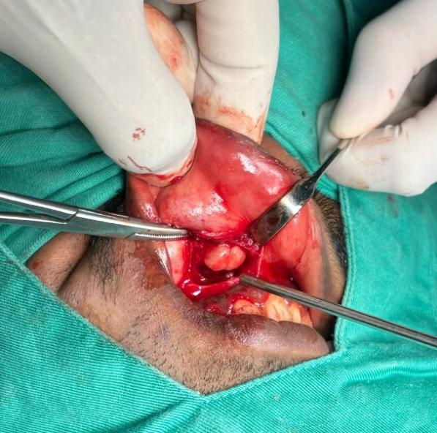  Figure 1 : Intraoperative right nasolabial mass | 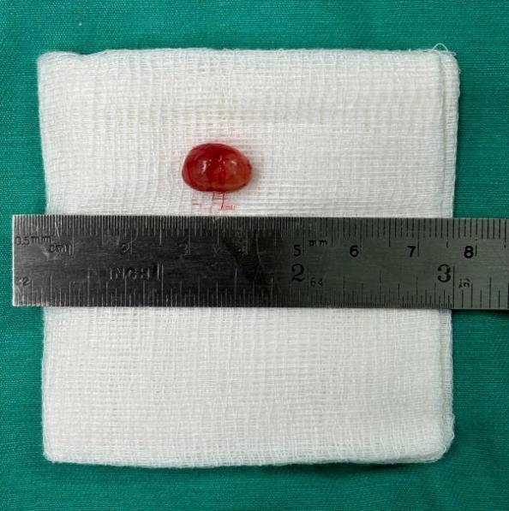  Figure 2: Right Nasolabial Mass

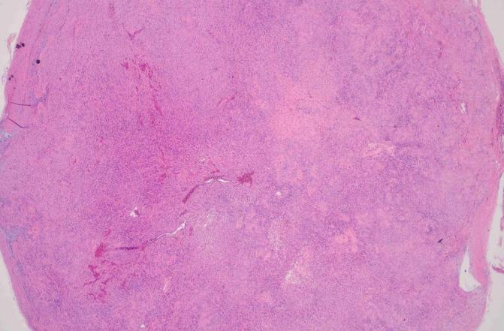  Image 1: Low power image showing a well circumscribed tumor with hypercellular (Antoni A) and hypercellular (Antoni B) areas. | 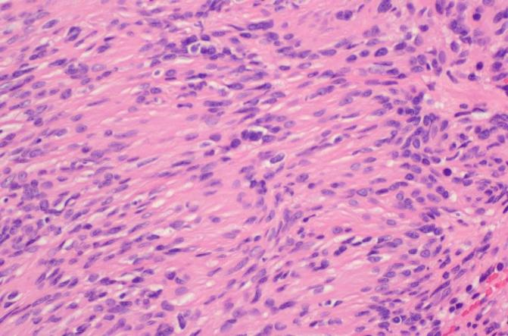  Image 2: hypercellular areas with presence of nuclear pallisading around fibrillary process (Verocay bodies)

