Original Research Article

Plant growth-promoting potentials of mycoendophytes associated with medicinal herb Argemone mexicana L.

ABSTRACT
Aims: Argemone mexicana L., a ubiquitous, medicinally important herb that possesses therapeutic properties used in traditional medicine. It hosts a diverse species of mycoendophytes, but their application pertaining to plant growth promotion is yet to be explored. Hence, this study aimed to investigate the potentials of the mycoendophytes of A. mexicana as plant growth promoters.
Study design: The experimental design included the analysis of plant growth-promoting properties of selected endophytic fungi from the plant Argemone mexicana through different qualitative and quantitative assays..
Place and Duration of Study: Department of Microbiology, Davangere University, Davangere, Karnataka, from November 2023 to January 2025.
Methodology: Different mycoendophytes isolated from healthy tissues of Argemone mexicana, the Aspergillus luchuensis (DUMB 210 and DUMB 222), Penicillium dierckxii (DUMB 208), and Penicillium restrictum (DUMB 211) were selected based on their antimicrobial properties. They were examined for their abilities to solubilize the nutrients through plate assays. The Indole-3-acetic acid (IAA) and siderophore production were detected using Salkowski’s reagent method and on Chrome Azurol S (CAS) agar medium respectively. Ammonia secretion was analyzed using the Nessler’s reagent, and the nitrogen fixation was determined in nitrogen-free media. The effects of fungal seed treatment on seed germination and seedling vigour of sorghum and green gram were evaluated by rolled paper-towel method..
Results: Phosphate, potassium, and zinc solubilization potentials were exhibited by all the four mycoendophytes. The isolates of Aspergillus luchuensis (DUMB 210 and DUMB 222) displayed greater potassium and zinc solubilization. Further, they were also highly potential producers of IAA and siderophores. The Penicillium spp. were not producing siderophores. All the isolates showed maximum ammonia production, and also capable of nitrogen fixation. The P. restrictum (DUMB 211) was the potential fungal isolate to promote the sorghum and green gram seedling vigour and biomass.
Conclusion: The potential of mycoendophytes from A. mexicana was established in plant growth promotion. These fungi may be used for seed biopriming in sustainable agriculture.
Keywords: Aspergillus, Indole-3-acetic acid, mycoendophytes, Penicillium, siderophores.
- INTRODUCTION
Mycoendophytes inhabit plant tissues by forming symbiotic relationships without causing any noticeable harm. They generate a range of bioactive substances both in the plant system and in laboratory cultures having potential applications in agriculture, medicine, and biotechnology. Such chemical substances play significant role in the host plant’s survival and fitness (Baron and Rigobelo, 2022). The advancement of research on mycoendophytes has gained attention due to their enormous abilities to produce important metabolites. The applications of such endophytes as efficient biofertilizers in agriculture have been demonstrated by recent research. The ability of certain mycoendophytes to synthesize compounds beneficial in plant development has been studied (Fouda et al., 2015; Syamsia et al., 2021; Airin et al., 2023; Hatamzadeh et al., 2023). Hence, it may be essential to explore mycoendophytes for their potential applications..
The plant growth-promoting endophytes (PGPE) have shown direct and indirect means of growth promotion. The several ways of growth promotion by these mycoendophytes include the acquisition of macro and micronutrients, production of phytohormones, siderophores, and other secondary metabolites (Garcia-Latorre et al., 2023; Gateta et al., 2023; Shen et al., 2023; Kharkwal et al., 2024). The investigation of mycoendophytes from medicinal flora would provide ample opportunities to discover new metabolites with potential bioactivities. The herb Argemone mexicana L. (Mexican poppy) is generally grown in tropical and sub-tropical areas and extensively used in herbal remedies (Jaiswal et al., 2023; Patocka et al., 2024). It seems no attempt has been made to investigate mycoendophytes of A. mexicana for plant growth promotion. With this context, the mycoendophytes of A. mexicana were evaluated for mineral-solubilizing activity and for the production of beneficial compounds. Also, the abilities of different mycoendophytes to promote plant growth in sorghum and green gram were assessed.
- MATERIALS AND METHODS
  - Mycoendophytes from Argemone mexicana
The mycoendophytes from healthy tissues of A. mexicana were isolated on Potato Dextrose Agar (PDA) medium according to surface disinfection protocols (Schulz et al., 1993). The antimicrobial properties of the endophytic fungi were assessed (Bhat and Shishupala, 2025). The fungal isolates that demonstrated antimicrobial activity were selected for the present study. These mycoendophytes were evaluated for their capability to promote plant growth by considering various parameters.
  - Mineral solubilization by mycoendophytes
The selected mycoendophytes from A. mexicana were assessed for their proficiency to solubilize phosphate in plate assay by inoculating on Pikovskaya’s agar (PKA) medium containing calcium phosphate as substrate (Adnan et al., 2018; Khalil et al., 2021). The potassium solubilization was assessed by growing them on Aleksandrow agar medium containing potassium alumino-silicate as a sole source of potassium (Setiawati and Mutmainnah, 2016; Sonsiam et al., 2024). The zinc solubilization potential was evaluated on a modified zinc-solubilization agar medium consisting zinc oxide (ZnO) as a sole source of zinc (Nutaratat et al., 2014; Kharkwal et al., 2024). The incubation of all the plates was carried out at an ambient temperature (30±5°C). The plates were observed at an interval of 24 h., for the presence of clear zone surrounding the colony for up to 72 h. The diameter of the colony and the clear zone were measured in millimeters using a graduated scale, and the Solubilization Index (SI) was determined using a standard formula (Singh et al., 2014)..
$$Solubilization Index \left(SI\right)=\frac{Colony Diameter \left(mm\right)+Zone of Clearance Diameter \left(mm\right)}{Colony Diameter \left(mm\right)}$$

  - Production of beneficial compounds by mycoendophytes
    - Indole-3-acetic acid (IAA)
The fungal endophytes were cultured in Czapek-Dox Broth (CZB) supplemented with 0.5% L-Tryptophan. After seven days of incubation (30±5°C), the culture filtrates were collected by filtration. The fungal culture supernatants were obtained by centrifugation (5000 rpm for 20 min) and collected in separate tubes. The fungal biomass soaked overnight in methanol was also collected and the methanol-soluble compounds were used as cellular extracts. The freshly prepared Salkowski’s reagent was added to the fungal culture filtrates and to the methanol-soluble cellular extracts in the ratio of 1:2 (v/v). The reaction mixtures were incubated for 30 minutes at room temperature in dark condition. The observations were made for the appearance of pink colour and the absorbance was read at 540 nm in a colorimeter (ELICO CL-157) (Garcia-Latorre et al., 2023; Hatamzadeh et al., 2023). The sterile CZB with Salkowski’s reagent was used as a blank. The concentration of IAA produced was determined by plotting standard IAA curve (Y=0.006852*X+0.001061) using GraphPad Prism 10.4.2.
    - Siderophore
The ability of mycoendophytes to synthesize siderophores was tested on Chrome Azurol S (CAS) agar medium. The composition and preparation of the CAS agar medium was done according to the protocols of Louden et al. (2011) with the modifications suggested by Chowdappa et al. (2020). The selected mycoendophytes were cultured on CAS agar medium, at room temperature in the dark condition (30±5°C) for up to seven days. The siderophore production was evaluated by the formation of pinkish-range/pink/yellow colour in the culture plates around the fungal colony. The colony diameter and coloured zone diameter were measured, and the Siderophore production Index (SI) was calculated using the formula as mentioned in mineral solubilization..
    - Hydrogen cyanide (HCN)
The HCN producing abilities of the mycoendophytes were tested through picric acid detection method. A modified PDA medium supplemented with Glycine (4.4 g/L) was used. The sterile filter paper strips (10x1 cm) were soaked in a solution mixture of 0.5% Picric acid and 1.5% Sodium carbonate, and dried aseptically. The dried filter paper strips were inserted into the PDA slants inoculated with mycoendophytes and closed tightly. Incubation was carried out at room temperature (30±5°C) for up to seven days. The observation was made for the colour change of the strips from yellow to orange, red, or brown (Nutaratat et al., 2014; Potshangbam et al., 2017)..
    - Ammonia production and nitrogen fixation
The mycoendophytes were cultured in Peptone water medium to test their capacity to synthesize ammonia. After five days of growth at 30±5°C, the fungal culture filtrates were collected and centrifuged at 5000 rpm for 20 minutes. For two milliliters of culture filtrate supernatant equal volume of Nessler’s reagent was added and mixed properly. The appearance of colour change from yellow to reddish-brown/brown/dark brown colour or precipitation indicates the secretion of ammonia in the culture broth (Fouda et al., 2015; Garcia-Latorre et al., 2023). The sterile Peptone water medium was used as a negative control, and the ammonia solution (25%) was used as a positive control.
The mycoendophytes were inoculated onto nitrogen-free Burk’s agar and Jensen’s agar medium supplemented with Bromothymol blue for the detection of nitrogen-fixing abilities of mycoendophytes. The incubation was done up to seven days at room temperature (30±5°C). The growth of fungal colonies on the nitrogen-free media indicates their nitrogen-fixing capabilities. The transformation of green colour medium to blue or yellow is an indication of nitrogen fixation (Cordova-Rodriguez et al., 2022; Roy et al., 2023)..
  - Influence of mycoendophytes on seed germination and seedling vigour
To examine mycoendophyte seed treatment on sorghum (Sorghum bicolor L.) and green gram (Vigna radiata L.) seed germination and seedling vigour, the rolled paper-towel method was used (Anon., 1985). The seed biopriming was done using two different methods. The seeds soaked in gum arabic (2%) for 30 min. were directly treated with seven-day-old fungal biomass by rolling the seeds over the culture. In another setup, seeds were soaked in mycoendophyte culture filtrates overnight (12 h.). The seeds treated with only gum arabic and soaked in sterile Potato Dextrose Broth (PDB) were used as controls. A total of four replicates containing 100 seeds each were kept separately for each fungal treatment in germination paper rolls. The Seed Germination (SG%), Average Root Length (ARL), and Average Shoot Length (ASL) were determined for the seedlings, and seedling vigour was calculated as Vigour Index (VI) using the formula.
$$Vigor Index \left(VI\right)=\left(Average Root Length+Average Shoot Length\right) X Seed germination \%$$

The dry biomass of seedlings was determined and represented as milligrams/seedling.

  - Statistical analyses:
Each experiment was performed in triplicate and repeated twice. The Standard Error (SE) was calculated for mean values. One-way ANOVA (p=0.05) along with Duncan Multiple Range Test (DMRT) was performed using an online statistical tool GRAPES 1.1.0. (https://www.kaugrapes.com/) (Gopinath et al., 2021)....
- RESULTS AND DISCUSSION
  - Mycoendophytes from Argemone mexicana
The Aspergillus luchuensis (DUMB 210), Penicillium dierckxii (DUMB 208), and P. restrictum (DUMB 211) were obtained from the root segments of the plant. The A. luchuensis (DUMB 222) was isolated from the stem sample. These fungi have shown antimicrobial properties in earlier experiments (Bhat and Shishupala, 2025)..
  - Mineral solubilization by mycoendophytes
All the mycoendophytes demonstrated the ability to solubilize phosphate, potassium, and zinc (Fig. 1). The SI was varying among isolates and according to the incubation periods (Table 1). All the mycoendophytes displayed phosphate solubilization with no significant differences among the isolates at 72 h. of growth. With respect to potassium solubilization both the isolates of Aspergillus luchuensis (DUMB 210 and DUMB 222) displayed significantly higher capacity. Further, significantly higher zinc solubilization was displayed by both the isolates of A. luchuensis than the Penicillium spp. During the initial growth, both Penicillium spp. were unable to solubilize potassium and zinc.
One of the primary mechanisms through which mycoendophytes promote plant growth is by enhancing nutrient uptake. The selected mycoendophytes in our study clearly demonstrated their potential for mineral solubilization highlighting their role in nutrient mobilization. Endophytic fungi from different hosts were known to solubilize phosphates, potassium, and zinc (Adnan et al., 2018; Kharkwal et al., 2024; Sonsiam et al., 2024; Wang et al., 2024). The selected mycoendophytes from A. mexicana possess significant mineral-solubilizing potential which is a critical criterion in plant growth promotion. Such mycoendophytes may be employed in agriculture facilitating soil mineral nutrition for plants (Wei et al., 2024). Many of the endophytes can grow as saprophytes. Soil amendment with such organisms would enrich soil fertility..
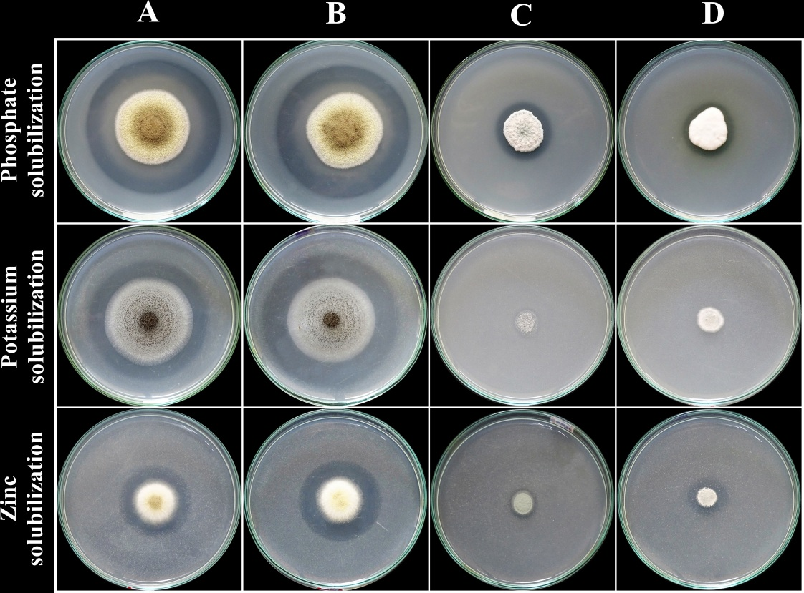

Fig. 1. Mineral solubilization by different mycoendophytes of Argemone mexicana at 72 h. of growth period.
- Aspergillus luchuensis (DUMB 210) B- Aspergillus luchuensis (DUMB 222)
- Penicillium dierckxii (DUMB 208) D- Penicillium restrictum (DUMB 211)

  - Production of beneficial compounds by mycoendophytes
    - Indole-3-acetic acid (IAA)
The different concentrations of IAA production were exhibited by the three mycoendophytes in culture broth (Table 2). The amount of IAA produced by both isolates of Aspergillus luchuensis was significantly high. This was evidenced by the appearance of intense deep pink colour in the reaction mixture of both isolates. Among them, the significantly higher IAA production was noticed in A. luchuensis isolate DUMB 210 with139.47±3.4 µg/ml of culture filtrate. The Penicillium restrictum (DUMB 211) was not shown to secrete detectable IAA in the culture medium. The methanol-soluble cellular extracts of these mycoendophytes also did not show the presence of IAA.
.

Table 1. Mineral solubilization by mycoendophytes from Argemone mexicana.

Sl.  No. | Endophytic fungi | Solubilization Index (SI) ± SE
Sl.  No. | Endophytic fungi | Phosphate |  |  | Potassium |  |  | Zinc
Sl.  No. | Endophytic fungi | Incubation periods (h)
Sl.  No. | Endophytic fungi | 24 | 48 | 72* | 24 | 48 | 72 | 24 | 48* | 72
01. | Aspergillus luchuensis (DUMB 210) | 1.05±0.02^{b} | 1.16±0.06^{b} | 1.74±0.08 | 1.10±0.00ª | 1.49±0.08ª | 1.36±0.02^{b} | 2.59±0.18ª | 1.85±0.17 | 2.58±0.11ª
02. | Aspergillus luchuensis (DUMB 222) | 1.15±0.03^{b} | 1.31±0.04^{b} | 1.72±0.00 | 1.11±0.00ª | 1.52±0.00ª | 1.61±0.01ª | 2.45±0.22ª | 1.69±0.08 | 2.39±0.03ª
03. | Penicillium dierckxii  (DUMB 208) | 1.13±0.03^{b} | 1.53±0.03ª | 1.68±0.12 | 0.00±0.00^{b} | 1.20±0.00^{b} | 1.00±0.00^{c} | 0.00±0.00^{c} | 1.36±0.07 | 1.45±0.02^{c}
04. | Penicillium restrictum  (DUMB 211) | 1.31±0.06ª | 1.54±0.10ª | 1.73±0.07 | 0.00±0.00^{b} | 0.89±0.01^{c} | 1.00±0.00^{c} | 0.00±0.00^{c} | 1.48±0.09 | 1.74±0.01^{b}
$$Solubilization Index (SI)=\frac{Colony Diameter \left(mm\right)+Zone of Clearance Diameter (mm)}{Colony Diameter (mm)}$$
Note: In the column, the values are the Mean ± Standard Error (SE) (n=3), followed by different letter are significantly different (p=0.05) by Duncan Multiple Range Test.
*The mean values are not significantly different (p=0.05) according to ANOVA.

Many fungi are known to produce plant hormones. Fungal endophytes have coevolved with their host plants and probably acquired the capacity to produce plant growth hormones (Mesny et al., 2023). Our study detects IAA production by mycoendophytes of Aregemone mexicana. The production of IAA by mycoendophytes is widely regarded as a direct mechanism of inducing plant growth promotion, as it regulates root initiation, responses to tropism, cell division and elongation, lateral root proliferation, and shoot elongation (Baron and Rigobelo, 2022; Garcia-Latorre et al., 2023; Kharkwal et al., 2024). Specifically, the Aspergillus awamori from Withania somnifera and Penicillium sp. from cucumber plant have been previously reported as IAA-producing endophytes (Waqas et al., 2012; Mehmood et al., 2019), which correlates with the high IAA productivity of Aspergillus isolates recorded in the present study. Significant difference in the IAA secretion among A. luchuensis isolates was noticed. The Penicillium dierckxii (DUMB 208) showed IAA synthesis whereas another isolate P. restrictum (DUMB 211) was not secreting IAA in the culture broth. This variation in IAA production among the species of the same genus may be attributed to strain/species level differences in IAA biosynthetic capacity..
Mycoendophytes of Argemone mexicana producing IAA may directly influence plant growth when used. Plant hormone treatments are now common means of growth stimulation in plant nurseries and fields (Wolf et al., 2019). The culture filtrates of mycoendophytes showed copious amount of IAA released. These fungi are not plant pathogenic. Hence, culture filtrates may be used to improve plant growth in agriculture nurseries..
    - Siderophore
Both the isolates of Aspergillus luchuensis (DUMB 210 and DUMB 222) exhibited siderophore production, which formed a distinct pink halo on CAS agar plates (Fig. 2). The A. luchuensis isolate DUMB 210 showed the significantly better activity (SI=1.5±0.02), whereas both the Penicillium isolates failed to produce siderophores during seven days of incubation (Table 2). Use of CAS agar medium for detection of siderophore is beneficial for screening fungi (Schwyn and Neilands, 1987). The higher siderophore-producing capacity of A. luchuensis (DUMB 210) suggests an enhanced ability to mobilize iron thereby strengthening host nutrient acquisition and contributing to plant growth promotion as an indirect mechanism. Such characteristics of endophytic fungi promoting plant growth was reported in Aspergillus wetwitschiae from Oryza coarctata and A. tamari from Mangifera indica (Airin et al., 2023; Sonsiam et al., 2024). The isolate A. luchuensis DUMB 210 was obtained from root segment of A. mexicana. This root-associated isolate is beneficial for host plant iron uptake in rhizosphere. Therefore, the association of such mycoendophytes with plant roots could enhance iron uptake, indicating their potential for plant growth promotion (Ibiang et al., 2020; Turbat et al., 2020).
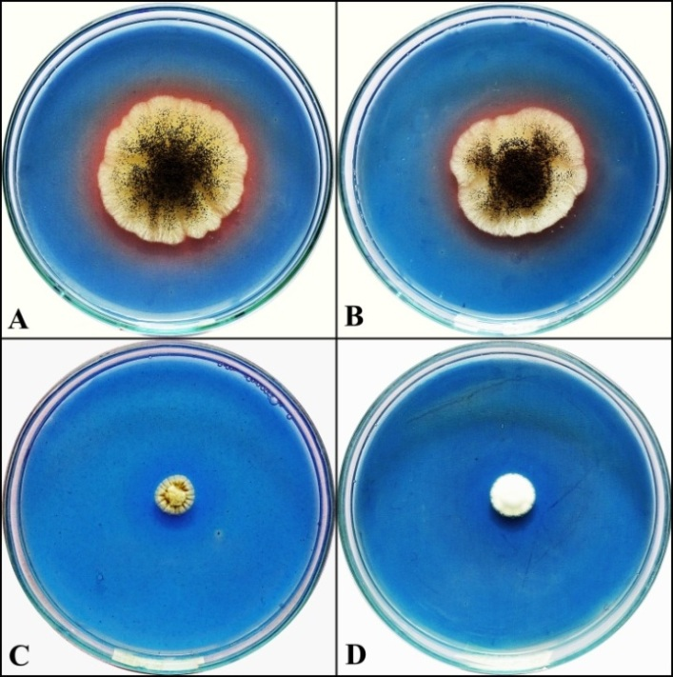

Fig. 2. Siderophore production by mycoendophytes from Argemone mexicana on Chrome Azurol S Agar.

A- Aspergillus luchuensis (DUMB 210) (Positive) B- Aspergillus luchuensis (DUMB 222) (Positive)
C- Penicillium dierckxii (DUMB 208) (Negative) D- Penicillium restrictum (DUMB 211) (Negative)

    - Hydrogen Cyanide (HCN)
None of the tested fungal isolates produced hydrogen cyanide (HCN) even after 10 days of incubation. Although HCN production is recognized as an indirect mechanism of plant growth promotion by suppressing phytopathogens, its occurrence among fungal endophytes appears to be species- and strain-specific. The endophytic Xylaria regalis isolated from Thuja plicata has been reported to produce HCN (Adnan et al., 2018), whereas none of the endophytic yeasts from rice and sugarcane leaves exhibited this property (Nutaratat et al., 2014). The absence of HCN production in this study indicated that the growth-promoting potential of the tested isolates is likely mediated through other mechanisms such as mineral solubilization, IAA, and siderophore production rather than cyanogenesis.

    - Ammonia production and nitrogen fixation
All the mycoendophytes produced ammonia, as evidenced by the brick-red to reddish-brown colour development after reaction with Nessler’s reagent (Fig. 3). Ammonia is a readily available nitrogen source, enhances root and shoot elongation, lateral root outgrowth and branching, and thereby strengthening the plants (Otvos et al., 2021). Ammonia production is one of the properties of plant growth promotion among mycoendophytes. The Aspergillus and Penicillium species may have direct contribution to improved nutrient availability and biomass accumulation in host plants (Fouda et al., 2015; Ripa et al., 2019; Garcia-Latorre et al., 2023). The ability mycoendophytes from Argemone mexicana to produce ammonia suggests their functional role in the enhancement of plant growth. This potential ability highlights importance of mycoendophytes to be used in organic farming. .
All four mycoendophytes exhibited nitrogen fixing ability. They formed a yellow colouration on the green medium. All the isolates were capable of growing in both the nitrogen-free agar medium tested and confirmed their ability to fix nitrogen. The A. luchuensis isolates showed potential nitrogen fixing capacities than the other Penicillium spp. (Fig. 4.). This colour change in the medium accounts for ammonia production and hence the nitrogen fixation (Cordova-Rodriguez et al., 2022).
The differential nitrogen fixation potential observed among isolates indicated species-specific variations in nitrogen metabolism. The higher activity in A. luchuensis could also be associated with its robust metabolic system and adaptability to nutrient-deficient conditions. Though free-living fungi fixing nitrogen is rare the mycoendophytes of Argemone mexicana were found to grow in nitrogen free media indicating their nitrogen assimilating abilities. This provides additional advantages to use these mycoendophytes for plant growth promotion. Some endophytic fungi from different host plants were found to be involved in nitrogen fixation (Xie et al., 2019; Roy et al., 2023). Such potential of mycoendophytes permits agricultural applications.

Table 2. Indole-3-acetic acid (IAA) and siderophore production by mycoendophytes from Argemone mexicana.

Sl. No. | Endophytic fungi | Amount of IAA produced in the culture filtrate (µg/ml) ± SE | Siderophore production Index (SI) ± SE
01. | Aspergillus luchuensis (DUMB 210) | 139.47±3.40ª | 1.50±0.02ª
02. | Aspergillus luchuensis (DUMB 222) | 112.22±3.86^{b} | 1.41±0.03^{b}
03. | Penicillium dierckxii (DUMB 208) | 23.20±0.85^{c} | 0.00±0.00^{c}
04. | Penicillium restrictum (DUMB 211) | 0.00±0.00^{d} | 0.00±0.00^{c}
$$Siderophore production Index (SI)=\frac{Colony Diameter \left(mm\right)+Zone of Siderophore production (mm)}{Colony Diameter (mm)}$$
Note: In the column, the values are the Mean ± Standard Error (SE) (n=3), followed by different letter are significantly different (p=0.05) by Duncan Multiple Range Test.

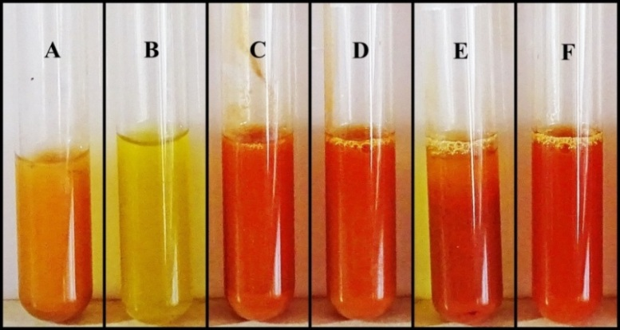

Fig. 3. Ammonia production by mycoendophytes from Argemone mexicana in Peptone water medium.

A-Positive control (Ammonium solution) B-Negative control (sterile Peptone water)
C- Aspergillus luchuensis (DUMB 210) D- Aspergillus luchuensis (DUMB 222)
E- Penicillium dierckxii (DUMB 208) F- Penicillium restrictum (DUMB 211)
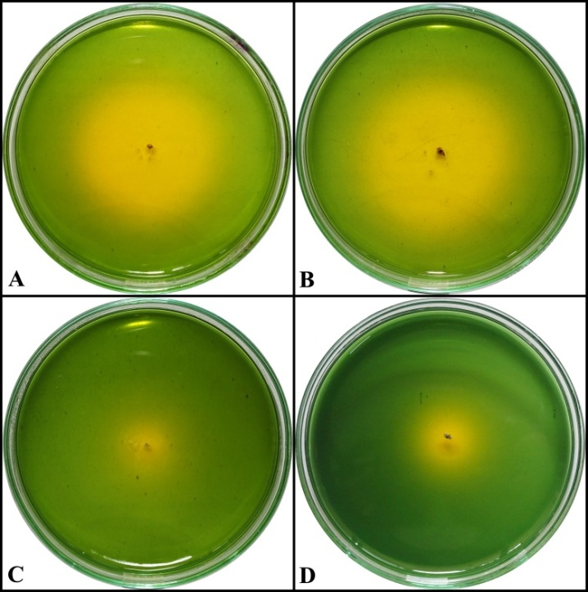

Fig. 4. Nitrogen fixation by mycoendophytes from Argemone mexicana on Jensen’s agar medium.
A- Aspergillus luchuensis (DUMB 210) B- Aspergillus luchuensis (DUMB 222)
C- Penicillium dierckxii (DUMB 208) D- Penicillium restrictum (DUMB 211)

  - Influence of mycoendophytes on seed germination and seedling vigour
Seed biopriming with mycoendophytes resulted in varying effects on sorghum and green gram. In sorghum, the mycoendophyte Penicillium restrictum (DUMB 211) significantly improved average shoot length (ASL), Vigour Index (VI) and seedling biomass without affecting seed germination (Table 3). The culture filtrate of the same isolate was involved in significant root and shoot lengths promotion contributing to significant increase in VI and biomass of the seedlings. The culture filtrates of Aspergillus luchuensis (DUMB 210) significantly enhanced ASL but resulted in reduced seedling vigour due to significant reduction in seed germination. The fungal biomass treatment of P. dierckxii (DUMB 208) significantly involved in root elongation thereby equally contributing to the enhanced seedling vigour. The culture filtrate of the same fungus significantly reduced the seed germination resulting in lower VI. Hence, the P. restrictum (DUMB 211) was promising plant growth promoter in sorghum.
In contrast, green gram seeds showed comparatively weaker responses to fungal biopriming. The culture filtrate of P. restrictum (DUMB 211) markedly increased the green gram seed germination, seedling shoot lengths and vigour (Table 4). The significant improvement in seedling biomass was found in both fungal biomass and culture filtrate treatments of P. restrictum (DUMB 211). The culture filtrates of remaining three fungi negatively affected the germination, resulting in reduced seedling vigour. The compounds secreted by those fungi in the culture broth may have inhibitory effects on green gram seed germination..
Seed biopriming is gaining importance in agriculture. The endophytic fungi enhancing plant growth after seed treatment have been identified in various crops (Li et al., 2017; Garcia-Latorre et al., 2023; Pradhan et al., 2023). However, direct use of fungi or their extracts may influence plant growth promotion differently. In the present study, P. restrictum (DUMB 211) influenced both sorghum and green gram seedlings growth. Obviously, the compounds released from fungi directly absorbed by the seeds or secreted into the medium enhanced seedling vigour. Such fungi may be potential PGPE and therefore require further exploitation as promising bioinoculants. These mycoendophytes are originated from Argemone mexicana but greatly influencing sorghum and green gram suggesting no host-specificity. Potential of these mycoendophytes as plant growth promoters was realized. .

Table 3. Efficacy of mycoendophytes from Argemone mexicana on sorghum seed germination and seedling growth.
Sl.  No. | Endophytic fungi | Seed Germination (G%) ± SE |  | Average Root Length (ARL±SE) (cm) |  | Average Shoot length (ASL±SE) (cm) |  | Vigour Index  (VI±SE) |  | Average dry biomass weight/seedling (mg)
Sl.  No. | Endophytic fungi | Seed treatment with
Sl.  No. | Endophytic fungi | Fungal biomass | Culture filtrate | Fungal biomass | Culture filtrate | Fungal biomass | Culture filtrate | Fungal biomass | Culture filtrate | Fungal biomass | Culture filtrate
01. | Control* | 93±1.03ª | 97±0.29ª | 8.9±0.20ª | 9.9±0.29^{b} | 9.7±0.22^{b} | 10.2±0.23^{bc} | 1725±51.3^{bc} | 1935±37.7^{b} | 31±0.76^{b} | 28±0.60^{d}
02. | Aspergillus luchuensis  (DUMB 210) | 87±0.40^{b} | 90±0.48^{b} | 7.3±0.33^{c} | 8.3±0.34^{c} | 9.8±0.29^{b} | 11.3±0.34ª | 1487±50.5^{d} | 1762±56.3^{c} | 31±0.88^{b} | 30±0.65^{c}
03. | Aspergillus luchuensis  (DUMB 222) | 89±0.10^{b} | 91±0.41^{b} | 7.3±0.13^{c} | 10.3±0.30^{ab} | 11.2±0.16ª | 10.7±0.19^{ab} | 1650±34.6^{c} | 1908±52^{b} | 32±0.64^{b} | 30±0.76^{c}
04. | Penicillium dierckxii  (DUMB 208) | 93±0.85ª | 85±1.47^{c} | 9.2±0.15ª | 7.6±0.27^{c} | 10.1±0.31^{b} | 9.7±0.12^{c} | 1793±37.2^{ab} | 1468±5.8^{d} | 31±0.52^{b} | 33±0.47^{b}
05. | Penicillium restrictum  (DUMB 211) | 94±0.63ª | 97±0.25ª | 8.1±0.03^{b} | 11.1±0.21ª | 11.8±0.28ª | 11.0±0.21ª | 1867±27.9ª | 2144±34.7ª | 37±0.44ª | 38±0.48ª
$$Vigour Index \left(VI\right)=\left(Average Root Length+Average Shoot Length\right) X Seed germination \%$$
*Control- only 2% Gum Arabic treatment without fungal biomass; Sterile Potato Dextrose Broth treatment for culture filtrate
Note: In the column, the values are the Mean ± Standard Error (SE) (n=4), followed by different letter(s) are significantly different (p=0.05) by Duncan Multiple Range Test.

Table 4. Efficacy of mycoendophytes from Argemone mexicana on green gram seed germination and seedling growth.
Sl.  No. | Endophytic fungi | Seed Germination (G%) ± SE |  | Average Root Length (ARL±SE) (cm) |  | Average Shoot length (ASL±SE) (cm) |  | Vigour Index  (VI±SE) |  | Average dry biomass weight/seedling (mg)
Sl.  No. | Endophytic fungi | Seed treatment with
Sl.  No. | Endophytic fungi | Fungal biomass | Culture filtrate | Fungal biomass* | Culture filtrate | Fungal biomass* | Culture filtrate | Fungal biomass | Culture filtrate | Fungal biomass | Culture filtrate
01. | Control* | 92±0.91ª | 95±0.48^{b} | 8.2±0.21 | 9.8±0.16ª | 7.4±0.33 | 7.0±0.24^{b} | 1440±50.7ª | 1595±26.5^{b} | 51±0.46^{b} | 54±0.73^{b}
02. | Aspergillus luchuensis  (DUMB 210) | 85±0.63^{b} | 04±0.41^{d} | 8.1±0.25 | 6.3±0.62^{c} | 7.7±0.26 | 5.2±0.83^{c} | 1342±28ª | 047±10.5^{d} | 41±0.63^{d} | 25±0.78^{d}
03. | Aspergillus luchuensis  (DUMB 222) | 92±0.25ª | 22±0.58^{b} | 7.5±0.40 | 5.7±0.63^{c} | 8.1±0.40 | 5.1±0.45^{c} | 1432±65.4ª | 239±23.6^{c} | 45±0.58^{c} | 30±0.76^{c}
04. | Penicillium dierckxii  (DUMB 208) | 80±0.71^{c} | 04±0.50^{d} | 6.9±0.83 | 7.6±0.86^{bc} | 7.4±0.12 | 4.0±0.69^{c} | 1148±8.6^{b} | 043±10.1^{d} | 44±0.41^{c} | 21±0.91e
05. | Penicillium restrictum  (DUMB 211) | 90±1.44ª | 98±0.75ª | 8.1±0.18 | 8.9±0.25^{ab} | 7.7±0.13 | 9.1±0.33ª | 1412±19.3ª | 1765±49.5ª | 62±0.64ª | 77±0.93ª
$$Vigour Index \left(VI\right)=\left(Average Root Length+Average Shoot Length\right) X Seed germination \%$$
*Control- only 2% Gum Arabic treatment without fungal biomass; Sterile Potato Dextrose Broth treatment for culture filtrate
Note: In the column, the values are the Mean ± Standard Error (SE) (n=4), followed by different letter(s) are significantly different (p=0.05) by Duncan Multiple Range Test.
*The mean values were not significantly different (p=0.05) in ANOVA.
CONCLUSION
The present findings suggested that mycoendophytes exhibited variable growth-promoting effects such as minerals solubilization, ammonia production and nitrogen fixation, indicating a functional diversity among them. The Aspergillus luchuensis have demonstrated significant potential by enhancing acquisition of nutrients, production of phytohormone and other beneficial compounds, whereas the Penicillium restrictum significantly improved the seedling health. These mycoendophytes have both direct and indirect mechanisms of plant growth promotion. The innovative strategies for crop improvement and soil health management by employing such mycoendophytes need to be focused..
DISCLAIMER (ARTIFICIAL INTELLIGENCE)
Author(s) hereby declare that NO generative AI technologies such as Large Language Models (ChatGPT, COPILOT, etc.) and text-to-image generators have been used during the writing or editing of this manuscript.
Abbreviations:
ANOVA- Analysis of Variance ASL- Average Shoot Length
ARL- Average Root Length CAS- Chrome Azurol S
HCN- Hydrogen cyanide IAA- Indole-3-acetic acid
SG%- Seed Germination % VI- Vigour Index
DUMB- Davangere University Microbial culture collection DMRT- Duncan Multiple Range Test
ISTA- International Seed Testing Association PGPE- Plant growth-promoting endophytes

REFERENCES
Adnan, M., Alshammari, E., Ashraf, S. A., Patel, K., Lad, K., & Patel, M. (2018). Physiological and molecular characterization of biosurfactant producing endophytic fungi Xylaria regalis from the cones of Thuja plicata as a potent plant growth promoter with its potential application. BioMed Research International, 2018(1), 7362148-7362158. https://doi.org/10.1155/2018/7362148
Airin, A. A., Arafat, M. I., Begum, R. A., Islam, M. R., & Seraj, Z. I. (2023). Plant growth-promoting endophytic fungi of the wild halophytic rice Oryza coarctata. Annals of Microbiology, 73(1), 36-56. https://doi.org/10.1186/s13213-023-01738-3
Anonymous, (1985). International Seed Testing Association. International rules for seed testing. Seed Science and Technology, 13, 307–520.
Baron, N. C., & Rigobelo, E. C. (2022). Endophytic fungi: a tool for plant growth promotion and sustainable agriculture. Mycology, 13(1), 39-55. https://doi.org/10.1080/21501203.2021.1945699
Bhat, M. T., & Shishupala, S. (2025). Diversity and antimicrobial attributes of fungal endophytes from Argemone mexicana L. Microbiology Research Journal International, 35(11), 101-117. https://doi.org/10.9734/mrji/2025/v35i111657
Chowdappa, S., Jagannath, S., Konappa, N., Udayashankar, A. C., & Jogaiah, S. (2020). Detection and characterization of antibacterial siderophores secreted by endophytic fungi from Cymbidium aloifolium. Biomolecules, 10(10), 1412-1429. https://doi.org/10.3390/biom10101412
Cordova-Rodriguez, A., Rentería-Martínez, M. E., Lopez-Miranda, C. A., Guzman-Ortíz, J. M. & Moreno-Salazar, S. F. (2022). Simple and sensitive spectrophotometric method for estimating the nitrogen-fixing capacity of bacterial cultures. MethodsX, 9, 101917-101921. https://doi.org/10.1016/j.mex.2022.101917
Fouda, A. H., Hassan, S. E. D., Eid, A. M., & Ewais, E. E. D. (2015). Biotechnological applications of fungal endophytes associated with medicinal plant Asclepias sinaica (Bioss.). Annals of Agricultural Sciences, 60(1), 95-104. https://doi.org/10.1016/j.aoas.2015.04.001
Garcia-Latorre, C., Rodrigo, S., Marin-Felix, Y., Stadler, M., & Santamaria, O. (2023). Plant-growth promoting activity of three fungal endophytes isolated from plants living in dehesas and their effect on Lolium multiflorum. Scientific Reports, 13(1), 7354-7368. https://doi.org/10.1038/s41598-023-34036-8
Gateta, T., Nacoon, S., Seemakram, W., Ekprasert, J., Theerakulpisut, P., Sanitchon, J., et al., (2023). The potential of endophytic fungi for enhancing the growth and accumulation of phenolic compounds and anthocyanin in maled phai rice (Oryza sativa L.). Journal of Fungi, 9(9), 937-955. https://doi.org/10.3390/jof9090937
Gopinath, P. P., Parsad, R., Joseph, B. & Adarsh V. S. (2021). grapesAgri1: collection of shiny apps for data analysis in agriculture. Journal of Open Source Software, 6(63), 3437-3440. https://doi.org/10.21105/joss.03437
Hatamzadeh, S., Rahnama, K., White, J. F., Oghaz, N. A., Nasrollahnejad, S., & Hemmati, K. (2023). Investigation of some endophytic fungi from five medicinal plants with growth promoting ability on maize (Zea mays L.). Journal of Applied Microbiology, 134(1), 1-5. https://doi.org/10.1093/jambio/lxac015
Ibiang, S. R., Sakamoto, K. & Kuwahara, N. (2020). Performance of tomato and lettuce to arbuscular mycorrhizal fungi and Penicillium pinophilum EU0013 inoculation varies with soil, culture media of inoculum, and fungal consortium composition. Rhizosphere, 16, 100246-100255. https://doi.org/10.1016/j.rhisph.2020.100246
Jaiswal, J., Siddiqi, N. J., Fatima, S., Abudawood, M., AlDaihan, S. K., Alharbi, M. G., et al. (2023). Analysis of biochemical and antimicrobial properties of bioactive molecules of Argemone mexicana. Molecules, 28(11), 4428-4443. https://doi.org/10.3390/molecules28114428
Khalil, A. M. A., Hassan, S. E. D., Alsharif, S. M., Eid, A. M., Ewais, E. E. D., Azab, E., et al. (2021). Isolation and characterization of fungal endophytes isolated from medicinal plant Ephedra pachyclada as plant growth-promoting. Biomolecules, 11(2), 140-158. https://doi.org/10.3390/biom11020140
Kharkwal, A. C., Joshi, H., Shandilya, C., Dabral, S., Kumar, N., & Varma, A. (2024). Isolation and characterization of a newly discovered plant growth-promoting endophytic fungal strain from the genus Talaromyces. Scientific Reports, 14(1), 6022-6040. https://doi.org/10.1038/s41598-024-54687-5
Li, X. Z., Song, M. L., Yao, X., Chai, Q., Simpson, W. R., Li, C. J., et al. (2017). The effect of seed-borne fungi and Epichloë endophyte on seed germination and biomass of Elymus sibiricus. Frontiers in Microbiology, 8, 2488-2495. https://doi.org/10.3389/fmicb.2017.02488
Louden, B. C., Haarmann, D., & Lynne, A. M. (2011). Use of blue agar CAS assay for siderophore detection. Journal of Microbiology & Biology Education, 12(1), 51-53. https://doi.org/10.1128/jmbe.v12i1.249
Mehmood, A., Hussain, A., Irshad, M., Hamayun, M., Iqbal, A. & Khan, N. (2019) In vitro production of IAA by endophytic fungus Aspergillus awamori and its growth promoting activities in Zea mays. Symbiosis, 77(3), 225-235. https://doi.org/10.1007/s13199-018-0583-y
Mesny, F., Hacquard, S., & Thomma, B. P. (2023). Co‐evolution within the plant holobiont drives host performance. EMBO Reports, 24(9), e57455-e57472. https://doi.org/10.15252/embr.202357455
Nutaratat, P., Srisuk, N., Arunrattiyakorn, P., & Limtong, S. (2014). Plant growth-promoting traits of epiphytic and endophytic yeasts isolated from rice and sugar cane leaves in Thailand. Fungal Biology, 118(8), 683-694. https://doi.org/10.1016/j.funbio.2014.04.010
Otvos, K., Marconi, M., Vega, A., O’Brien, J., Johnson, A., Abualia, R., et al. (2021). Modulation of plant root growth by nitrogen source‐defined regulation of polar auxin transport. The EMBO Journal, 40(3), e106862-e106882. https://doi.org/10.15252/embj.2020106862
Patocka, J., Ovando-Martinez, M., Navratilova, Z., Oleksak, P., Ogwu, M. C., Nepovimova, E., et al. (2024). Argemone mexicana L. (Papaveraceae): Chemistry, pharmacology, and toxicology. Phytochemistry Reviews, 23(4), 1167–1182. https://doi.org/10.1007/s11101-024-09918-y
Potshangbam, M., Devi, S. I., Sahoo, D., & Strobel, G. A. (2017). Functional characterization of endophytic fungal community associated with Oryza sativa L. and Zea mays L. Frontiers in Microbiology, 8, 325-339. https://doi.org/10.3389/fmicb.2017.00325
Pradhan, J., Sarma, A., Kalita, S., Talukdar, R., & Tayung, K. (2023). Plant growth-promoting effect of seed-borne endophytic fungi isolated from Senna alata (L.) Roxb. Proceedings of the National Academy of Sciences, India Section B: Biological Sciences, 93(4), 901-908. https://doi.org/10.1007/s40011-023-01483-2
Ripa, F. A., Cao, W. D., Tong, S., & Sun, J. G. (2019). Assessment of plant growth promoting and abiotic stress tolerance properties of wheat endophytic fungi. BioMed Research International, 2019(1), 6105865-6105876. https://doi.org/10.1155/2019/6105865
Roy, S., Sarma, A., Paul, S., Jha, D. K., & Tayung, K. (2023). Plant growth-promoting traits and activation of defense enzymes in traditional rice variety by fungal endophytes isolated from seeds of indigenous rice cultivars of Northeast India. South African Journal of Botany, 160, 483-492. https://doi.org/10.1016/j.sajb.2023.07.041
Schulz, B., Wanke, U., Draeger, S., & Aust, H. J. (1993). Endophytes from herbaceous plants: effectiveness of surface sterilization methods. Mycological Research, 97(12), 1447-1450.
Schwyn, B., & Neilands, J. (1987). Universal chemical assay for the detection and determination of siderophores. Analytical Biochemistry, 160(1), 47-56. https://doi.org/10.1016/0003-2697(87)90612-9
Setiawati, T. C., & Mutmainnah, L. (2016). Solubilization of potassium containing mineral by microorganisms from sugarcane rhizosphere. Agriculture and Agricultural Science Procedia 9, 108–117. https://doi.org/10.1016/j.aaspro.2016.02.134
Shen, N., Chen, Z., Cheng, G., Lin, W., Qin, Y., Xiao, Y., et al. (2023). Diversity, chemical constituents and biological activities of endophytic fungi from Alisma orientale (Sam.) Juzep. Frontiers in Microbiology, 14, 1190624-1190639. https://doi.org/10.3389/fmicb.2023.1190624
Singh, P., Kumar, V., & Agrawal, S. (2014). Evaluation of phytase producing bacteria for their plant growth promoting activities. International Journal of Microbiology, 2014(1), 426483-426489. https://doi.org/10.1155/2014/426483
Sonsiam, K., Sonesouphap, O., Sangkaew, A., Chulaka, P., Sihanonth, P., & Yompakdee, C. (2024). Roles of endophytic fungi isolated from Mangifera indica L. in promoting plant growth. Journal of Microbiology and Biotechnology, 34(9), 1857-1866. https://doi.org/10.4014/jmb.2401.01034
Syamsia, S., Idhan, A., Firmansyah, A. P., Noerfitryani, N., Rahim, I., Kesaulya, H., et al. (2021). Combination on endophytic fungal as the plant growth-promoting fungi (PGPF) on cucumber (Cucumis sativus). Biodiversitas Journal of Biological Diversity, 22(3), 1194-1202. https://doi.org/10.13057/biodiv/d220315
Turbat, A., Rakk, D., Vigneshwari, A., Kocsube, S., Thu, H., Szepesi, A., et al. (2020). Characterization of the plant growth-promoting activities of endophytic fungi isolated from Sophora flavescens. Microorganisms, 8(5), 683-697.
https://doi.org/10.3390/microorganisms8050683
Wang, Q., Zhang, X., Xie, Q., Tao, J., Jia, Y., Xiao, Y., et al., (2024). Exploring plant growth-promoting traits of endophytic fungi isolated from Ligusticum chuanxiong hort and their interaction in plant growth and development. Journal of Fungi, 10(10), 713-733. https://doi.org/10.3390/jof10100713
Waqas, M., Khan, A. L., Kamran, M., Hamayun, M., Kang, S. M., Kim, Y. H., et al. (2012). Endophytic fungi produce gibberellins and indoleacetic acid and promotes host-plant growth during stress. Molecules, 17(9),10754-10773. https://doi.org/10.3390/molecules170910754
Wei, X., Xie, B., Wan, C., Song, R., Zhong, W., Xin, S., & Song, K. (2024). Enhancing soil health and plant growth through microbial fertilizers: Mechanisms, benefits, and sustainable agricultural practices. Agronomy, 14(3), 609-624. https://doi.org/10.3390/agronomy14030609
Wolf, J., Kiss, T., Venuta, R., & Necas, T. (2019). The use of phytohormones in production of fruit tree rootstocks in nursery without irrigation. Acta Universitatis Agriculturae et Silviculturae Mendelianae Brunensis, 67(2), 463-470. https://doi.org/10.11118/actaun201967020463
Xie, X. G., Zhang, F. M., Yang, T., Chen, Y., Li, X. G., & Dai, C. C. (2019). Endophytic fungus drives nodulation and N₂ fixation attributable to specific root exudates. MBio, 10(4), 1-20. https://doi.org/10.1128/mbio.00728-19

