Original Research Article
Foliar Nitrogen Fixers on Knol Khol: Differential Isolation, Characterization, and Biofertilizer Potential of Azotobacter and Azospirillum

Abstract
The rising need for sustainable agricultural practices, especially in non-leguminous vegetable production, necessitates the exploration of alternative nitrogen sources like plant-associated nitrogen-fixing bacteria. This study aimed to isolate, characterize, and evaluate native foliar nitrogen-fixing bacteria, Azotobacter and Azospirillum, from knol khol (Brassica oleracea var. gongylodes) leaves collected across diverse farming regions of Chhattisgarh, India, to assess their potential as foliar biofertilizers. Twelve leaf samples were collected from fields representing varied cultivation practices, including chemical application. Foliar Azotobacter was isolated from 10 samples but could not be recovered from fields associated with heavy pesticide use, whereas Azospirillum was successfully isolated from all 12 samples, suggesting its potential endophytic nature and greater resilience to chemical stress. All isolates were confirmed as Gram-negative with variable biochemical profiles. Nitrogen-fixing efficiency varied widely, with the most efficient Azotobacter isolate (Kk-Azot-6) fixing 10.58 mg N g⁻¹ sucrose and the top Azospirillum isolate (Kk-Azos-10) exhibiting a higher efficiency of 15.56 mg N g⁻¹ malate. The superior nitrogen-fixing potential and differential stress tolerance observed, particularly in Azospirillum, emphasize the significant ecological role of these bacteria on aerial plant surfaces and their strong candidacy for developing effective foliar biofertilizers for sustainable and eco-friendly crop production.
Keywords: Foliar Nitrogen Fixation, Biofertilizer, Azotobacter, Azospirillum, Knol khol, Pesticide Stress.

Introduction
Agricultural sustainability is becoming increasingly critical in the face of growing global population, soil degradation and environmental pollution. The pressure on agricultural systems to increase food production has increased due to the ongoing population growth. Farmers have largely relied on chemical fertilizers, especially nitrogenous ones, to increase productivity (Craswell, 2021; Bisht and Chauhan, 2020). Chemical fertilizers greatly boost crop yields in the short term, but their long-term and careless use has led to serious ecological and soil-related issues, such as nutrient imbalance, soil acidification, groundwater contamination and loss of beneficial microflora (Pahalvi et al., 2021; Agegnehu et al., 2014). As a result, contemporary agriculture is progressively turning its attention to sustainable and environmentally friendly substitutes that can preserve output without endangering the environment (Fahrurrozi et al., 2019). In agricultural soils, nitrogen (N) is the most limiting element among the vital nutrients needed for plant growth. It is essential for photosynthesis and plant metabolism since it is a component of chlorophyll, nucleic acids, amino acids, enzymes and coenzymes (Ohyama, 2010; Kumari et al., 2022). Despite making up almost 78% of the atmosphere, plants cannot access molecular nitrogen (N₂) in its elemental form. Through the process of biological nitrogen fixation (BNF), which is mediated by specialized groups of microorganisms that possess the nitrogenase enzyme complex, atmospheric nitrogen is naturally converted into forms that plants can use, such as ammonia (Pahari et al., 2021; Soumare et al., 2020). These nitrogen-fixing microorganisms play an essential role in maintaining soil fertility and reducing the dependency on synthetic nitrogen fertilizers (Boraste et al., 2009; Panda, 2011). Among the free-living and associative nitrogen-fixing bacteria, Azotobacter and Azospirillum are recognized as the most efficient and agriculturally beneficial genera (Kachari and Korla., 2009). These bacteria are known for their ability to fix atmospheric nitrogen and promote plant growth through multiple mechanisms. Azotobacter species are obligate aerobes, motile, and cyst-forming bacteria that fix nitrogen under aerobic conditions, whereas Azospirillum species are microaerophilic, gram-negative, motile, and spiral-shaped, exhibiting associative nitrogen fixation (Nongthombam et al., 2021; Patil et al., 2020; Cassán et al., 2020; Pedraza et al., 2020). Both genera are commonly found in the rhizosphere and phyllosphere of various crops. Apart from fixing nitrogen, they also generate a number of compounds that promote plant growth, including gibberellic acid (GA₃), indole-3-acetic acid (IAA), and cytokinins, which improve vegetative growth, root elongation, and seed germination (Pandey and Kumar, 1989; Chen., 2006; Dilfuza, 2011). These bacteria also improve nutrient uptake, induce stress tolerance, and secrete antifungal compounds that protect plants from pathogens. Due to their multifunctional properties and ecological adaptability, it is commonly acknowledged that Azotobacter and Azospirillum are promising biofertilizers for environmentally friendly farming practices (Sun et al., 2025; Ansabayeva et al., 2025). Most conventional studies on Azotobacter and Azospirillum have focused on their isolation from soil and rhizosphere regions. However, recent research has highlighted that these microorganisms are also present on the phyllosphere, which is one of the largest microbial habitats on Earth and consists of the aerial portions of plants like leaves and stems (Ruinen, 1965; Abadi et al., 2021). Foliar bacteria play a crucial role in enhancing nutrient uptake through the leaves, improving photosynthetic activity and providing protection against environmental stress. The concept of foliar (phyllospheric) nitrogen fixation is less explored, but holds potential for directly supplying nitrogen via leaves, especially under foliar inoculation techniques (Azmat et al., 2020; Latkovic et al., 2020). Knol khol (Brassica oleracea var. gongylodes), commonly known as kohlrabi, is a cole crop valued for its swollen stem ("knob") and is a good source of nutritional fibre, enzymes, antioxidants like vitamins A, C, E, and carotene (Talukder et al., 2013; Banotra et al., 2017). In temperate and subtropical climates, it is extensively grown. Despite its economic and dietary importance, the microbial ecology of its leaf surfaces and especially nitrogen-fixing bacteria colonizing them-has received little attention. Foliar diazotrophs may be particularly useful in enhancing plant nitrogen nutrition in low-input or organic systems because their leaf surfaces are directly exposed to sunlight and atmospheric N₂. The exploration of foliar Azotobacter and Azospirillum associated with knol khol is thus scientifically and practically valuable. Isolating such bacteria, characterizing their morphological, physiological, and biochemical traits and testing their nitrogen-fixing ability in vitro can help identify effective strains for foliar biofertilizer development. These isolates might complement soil-applied biofertilizers or reduce the need for nitrogen inputs in vegetable cultivation.
Materials and Methods
Collection of leaf samples of knol-khol from different locations
Twelve leaf samples of knol khol were collected from the different locations of Raipur and Durg district of Chhattisgarh. Fully expanded, young and healthy leaf were selected from the middle section of each plant. Avoiding old and damaged leaf ensured uniformity among the samples. The collected leaf samples were immediately placed in a locked polythene bag and are properly labelled with the location. After proper washing of collected leaf samples the isolation work started on the same day of the sample collection.
Surface washing
Collected healthy leaf samples of knol khol were selected for isolation of foliar Azotobacter and Azospirillum. For surface washing of leaf, rinse the leaf samples gently with double distilled water for at least five times to remove especially dirt and dust. After washing with double distilled water, leaf samples were placed in sterile paper with the help of sterile forceps and allow them to dry.
Isolation of foliar Azotobacter and Azospirillum from leaf samples of knol-khol
After washing and drying of leaf samples, they were directly placed in Jensen’s broth and nitrogen free bromothymol blue (Okon’s) broth medium for isolation of foliar Azotobacter and Azospirillum, respectively (Bashan et al., 2014). Broth with the knol-khol leaf samples were incubated at 30 ºC for 96 hours in the shaking incubator for optimal growth of the desired bacteria. After incubation, bacteria growing in a liquid medium appears turbid which indicates the presence and growth of bacteria in the liquid medium. Then after bacterial broth culture was streaked on petri plates containing Jensen’s and nitrogen free bromothymol blue (Okon’s) media for the isolation of Azotobacter and Azospirillum, respectively. After growth, pure distinct colony was picked and streaked on respective agar slants and kept in an incubator to obtain pure culture. After desired growth, agar slant were stored in a refrigerator for further use. Sub culturing was done at the regular interval period.
Colony morphological characteristics of foliar Azotobacter and Azospirillum of knol khol
The colony characters viz. shape, margin, elevation, colour, opacity and texture were observed on their respective agar media and confirmed their identity in consultation of Bergey’s Manual of Systematic Bacteriology (2001). The morphological features of the bacterial isolates were examined after their optimum growth. In this connection, 0.1 mL of appropriate dilution of the foliar Azotobacter and Azospirillum was transferred into the Petri plates containing Jensen’s agar medium and nitrogen free bromothymol blue agar (Okon’s) medium. The plates were incubated for characterization study. The phenotype and growth pattern of the isolates were observed (Rashid et al., 2012; Li et al., 2020).
Gram staining
Fresh culture of Azotobacter and Azospirillum were smeared on clean glass slides and were heat fixed. Then smears were stained in the following steps: 1) Firstly, crystal violet was applied on each slide and kept for 1 min., 2) Washed with distilled water, 3) Then applied iodine on the slides as mordant for 1 min and 95% alcohol was used for washing for 30 sec. then washed with distilled water, 4) Safranin was applied on the slides then washed with distilled water and 5) air-dried the slides. The slides were observed under compound microscope using immersion oil (Beveridge, 2001).
Biochemical characterization of foliar Azotobacter and Azospirillum of knol-khol
Foliar Azotobacter and Azospirillum isolates were characterized using standard biochemical methods as given in the Bergey’s manual of systematic bacteriology (2001). Biochemical characterization was done based on different biochemical tests viz., Starch hydrolysis test, Catalase test, Urease hydrolysis test, Citrate utilization test, Methyl red test and Triple sugar iron (TSI) test.
Starch hydrolysis test
The starch hydrolysis test was conducted to determine the ability of foliar Azotobacter and Azospirillum isolates to hydrolyze starch by producing the enzyme amylase. Starch Agar Medium was prepared and streaked with the Azotobacter and Azospirillum isolates using a sterile loop, streaked plates were incubated at 28°C for 48 hours to allow bacterial growth. After the incubation period, the surface of the plates was flooded with iodine solution, clear halo zone around the bacterial growth indicated positive starch hydrolysis. No clear zone indicated a lack of starch degrading activity (Mahon and Lehman, 2022).
Catalase test
The catalase test was performed to detect the presence of the enzyme catalase in foliar Azotobacter and Azospirillum isolates, which helps in breaking down hydrogen peroxide (H₂O₂) into water and oxygen. Firstly, fresh bacterial cultures were taken and placed on a clean glass slides. A few drops of 3% H₂O₂ solution were added directly to the bacterial smear and allowed to react for 30-45 seconds. Rapid production of gas bubbles indicates a positive results while absence of bubble indicates a lack of catalase activity (Cappuccino and Sherman, 2013).
Urease test
The urease test was conducted to know ability of the foliar isolates (Azotobacter and Azospirillum) to produce enzyme urease, which hydrolyzes urea into ammonia and carbon dioxide. Urea agar medium was prepared and poured into sterile test tubes at a slanted position. After solidification of the medium the bacterial isolates were streaked on the surface of urea agar slants. Streaked tubes were incubated at 28°C for 24-48 hours. After incubation period urea agar slants were observed for a color change. A bright pink color indicates the production of urease while no color change indicates a lack of urease production (Brink, 2013).

Citrate utilization test
The citrate utilization test was performed to determine the ability of foliar Azotobacter and Azospirillum isolates to use citrate as their sole carbon source. Simmons citrate agar slants was prepared and the bacterial isolates were streaked onto the surface of the Simmons citrate agar slants. Inoculated tubes were incubated at 28°C for 24-48 hours. After incubation, slants were observed for a color change. Changes color from green to blue indicates that the bacteria can utilize citrate as their sole carbon source, no color change (remains green) indicates negative results (Atlas, 2004).
Methyl red test
The methyl red (MR) test was used to differentiate bacterial isolates based on their ability to ferment glucose. MR broth, which contains glucose and phosphate buffer was prepared in tube. The bacterial isolates were inoculated and incubated at 28°C for 48 hours. After incubation, 5 drops of methyl red indicator were added to the tubes, development of red color indicated a positive MR test, showing the production of mixed acids from glucose fermentation. A yellow or orange color indicated a negative result (Forbes et al., 2007).
Triple sugar iron agar test
Triple sugar iron (TSI) test is used to differentiate the foliar Azotobacter and Azospirillum isolates based on their ability to ferment three sugars (glucose, lactose and sucrose), produce gas, and generate hydrogen sulfide (H₂S). Triple sugar iron agar contains glucose, lactose and sucrose with phenol red as a pH indicator and iron compounds to detect hydrogen sulfide production (Cappuccino and Sherman, 2008). TSI agar slants was prepared and autoclaved. Using a sterile inoculation loop, the bacterial isolates were first stabbed into the butt of the slant and streaked along the surface of the slant. The inoculated tubes were incubated at 28°C for 24 hours.
Nitrogen fixing ability of foliar Azotobacter and Azospirillum of knol-khol
Nitrogen fixing ability was determine to evaluate the capacity of the foliar Azotobacter and Azospirillum isolates to fix atmospheric nitrogen. Nitrogenase enzyme effectiveness of the foliar isolates was assessed by quantifying the nitrogen fixed by the Azotobacter and Azospirillum isolates by using micro Kjeldahl method as given by Jackson (1967). Jensen’s broth medium for Azotobacter and semi solid N free malate medium for Azospirillum was prepared and autoclaved. Fresh cultures of foliar Azotobacter and Azospirillum isolates were inoculated in their respective nitrogen-free medium. The inoculated flasks were incubated at 30°C for 7 days under shaking condition (150 rpm) to promote nitrogen fixing activity. After seven days of incubation, the culture broth was homogenized. Five mL of homogenized culture broth was withdrawn and digested with 5 mL concentrated H₂SO₄ and 5 gram of catalyst mixture (K₂SO₄ and CuSO₄) until the sample solution became clear and colorless. After cooling, 5 mL of sample aliquot was transferred to micro Kjeldahl distillation unit. During distillation the final product ammonium borate produced. Then after it was titrated against 0.005N H₂SO₄ (Bremner, 1965). In vitro nitrogen fixation was determined by formula of 1 mL of 0.005N H₂SO₄ = 0.00007g of N and represented as mg of N/g of sucrose and mg of N/g of malate in case of Azotobacter and Azospirillum, respectively.
Results and Discussion
4.1 Collection of knol-khol leaf samples from different locations for isolation of foliar Azotobacter and Azospirillum
A survey was conducted during the year 2022-23 to collect leaf samples from knol khol crop grown in different locations of Raipur and Durg districts of Chhattisgarh. Twelve leaf samples of knol khol were collected from different villages of Raipur and Durg districts (Table 1). The selected fields represented diverse farming practices, including areas with high pesticide application as communicated by the farmers during the survey. The collected leaf samples were subjected for the isolation of native nitrogen-fixing bacteria. Several studies, including those by Beattie and Lindow (1995), Gupta et al., (2000), Kuklinsky‐Sobral et al., (2004), Beattie (2011), Kim (2012) and Costa et al., (2012), they have consistently demonstrated that native microbial isolates are superior for the formulation of effective and location-specific bio-inoculants over exotic isolates. Properly screened native isolates are inherently better adapted to local environmental conditions, never face adaptability problem being native to the place, hence ensuring their better efficacy and reducing the risk of compatibility issues when applied in the field.
4.2 Isolation of foliar Azotobacter and Azospirillum from leaf samples of knol-khol
Nitrogen-free Jensen’s medium and bromothymol blue (Okon’s) medium were used for the isolation of Azotobacter and Azospirillum, respectively. Out of the 12 leaf samples of knol khol, Azotobacter isolates were obtained from 10 samples, while Azospirillum was successfully isolated from all 12 leaf samples (Figure 1 and Table 1). Data presented in Table 1 revealed that those leaf samples which were collected from the Kharun river belt (beside Bhatagaon of Raipur district and Nandanvan area of Durg district) clearly indicated the absence of foliar Azotobacter isolates in 2 leaf samples of knol khol (sample numbers 11 and 12). This may be due to the heavy use of pesticides at these collection sites. This finding aligns with earlier studies that indicate pesticides can negatively affect free-living nitrogen-fixing bacteria by altering microbial diversity and soil microbiota (Khudhur and Askar 2013; Khudhur and Sarmamy 2016; Shahid et al., 2019). However, Azospirillum isolates were successfully isolated from all the leaf samples of knol khol including those collected from areas with heavy pesticide application (sample numbers 11 and 12 in Table 1). This is may be because of endophytic nature of Azospirillum (Yasuda et al., 2009; Sivagamasundari and Gandhi 2021), which allows them to colonize internal plant tissues and protect themselves (Verma et al., 2016; Gureev et al., 2024). These results indicate the adaptability and ecological significance of Azospirillum as an important nitrogen-fixing bacterium, capable of growth and multiplication even in pesticide-affected areas. Earlier studies conducted in the Department of Agricultural Microbiology IGKV, Raipur under a CGCOST-funded project have also demonstrated the natural survival of atmospheric nitrogen-fixing bacteria on the leaf surface of various forest crops (Anonymous, 2009). These findings support the observations of the present investigation, indicating that foliar colonization by nitrogen-fixing bacteria is not only possible but potentially widespread among different plant species. Similar study was also reported by Agarwala et al., (1991), Lindow and Leveau (2002), Gupta et al., (2002), Schreiber et al., (2005) and Whipps et al., (2008), who documented the presence and persistence of nitrogen-fixing bacteria on leaf surfaces. These researchers highlighted the phyllosphere as a favorable habitat for microbial colonization, particularly by plant growth-promoting bacteria including atmospheric N fixing bacteria.
Table 1. Collection sites of knol khol leaf samples and isolation of foliar Azotobacter and Azospirillum
S/N | Name of village | Block | District | Isolates no. of Azotobacter | Isolates no. of Azospirillum
1 | Mandirhasaud | Arang | Raipur | Kk-Azot-1 | Kk-Azos-1
2 | Banjari | Arang | Raipur | Kk-Azot-2 | Kk-Azos-2
3 | Kachna | Dharsiwa | Raipur | Kk-Azot-3 | Kk-Azos-3
4 | Mungi | Arang | Raipur | Kk-Azot-4 | Kk-Azos-4
5 | Riko | Arang | Raipur | Kk-Azot-5 | Kk-Azos-5
6 | Mana | Arang | Raipur | Kk-Azot-6 | Kk-Azos-6
7 | Serikhedi | Dharsiwa | Raipur | Kk-Azot-7 | Kk-Azos-7
8 | Jora | Dharsiwa | Raipur | Kk-Azot-8 | Kk-Azos-8
9 | Badgaon | Arang | Raipur | Kk-Azot-9 | Kk-Azos-9
10 | Pirda | Dharsiwa | Raipur | Kk-Azot-10 | Kk-Azos-10
11 | Bhatagaon | Abhanpur | Raipur | - | Kk-Azos-11
12 | Nandanvan area | Kumhari | Durg | - | Kk-Azos-12
Kk = Knol-khol, Azot = Azotobacter, Azos = Azospirillum, (-) = No isolate of Azotobacter was obtained

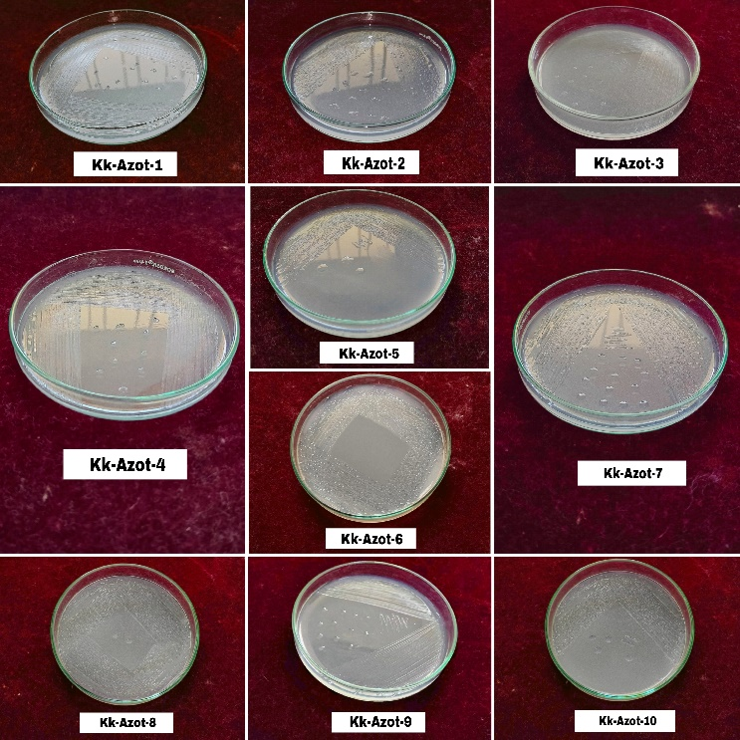
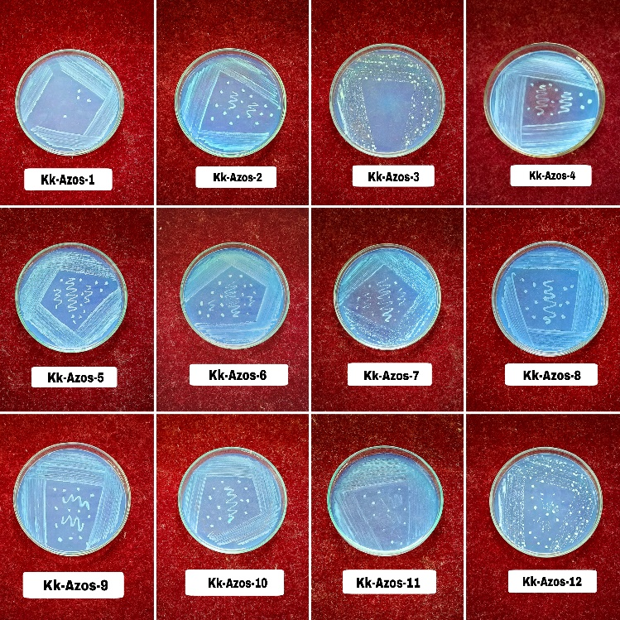

Figure 1. Isolated colonies of foliar Azotobacter (Left) and Azospirillum (Right) from knol khol leaf samples

4.3.1 Colony morphological and staining characteristics of foliar Azotobacter and Azospirillum of knol khol
The foliar isolates of Azotobacter and Azospirillum obtained from knol khol leaf samples exhibited distinct and consistent colony morphological characteristics on their respective selective media (Table 2). Azotobacter isolates (Kk-Azot-1 to Kk-Azot-10) produced uniform white, circular colonies with convex elevation and entire margins, appearing translucent on Jensen’s agar, indicative of active growth. In contrast, Azospirillum isolates (Kk-Azos-1 to Kk-Azos-12) formed blue to light blue circular colonies with raised elevation and entire margins, showing opaque appearance, which reflected high cell density and vigorous growth. These observations are in line with descriptions in Bergey’s Manual of Systematic Bacteriology (2001) and corroborated by earlier reports of Dobernier et al., (1976), Kandler et al., (1986), Holt et al., (1994), Okon and Labandera-Gonzalez (1994), Hashidoko et al., (2002), Akhter et al., (2012), Jadhav et al., (2015) and Rasool et al., (2015). Gram staining confirmed that all isolates of Azotobacter and Azospirillum were Gram-negative, consistent with their reported cell wall composition. Similar Gram-negative nature of both genera has also been well-documented by Tarrand et al., (1978), Jiménez et al., (2011), Reis et al., (2015) and Cassán et al., (2015).
Table 2. Colony morphological and staining characteristics of foliar Azotobacter and Azospirillum of knol khol
S/N | Name of isolates | Gram staining | Colour | Shape | margin | elevation | opacity
1 | Kk-Azot-1 | -ve | White | Circular | Entire | Convex | Translucent
2 | Kk-Azot-2 | -ve | White | Circular | Entire | Convex | Translucent
3 | Kk-Azot-3 | -ve | White | Circular | Entire | Convex | Translucent
4 | Kk-Azot-4 | -ve | White | Circular | Entire | Convex | Translucent
5 | Kk-Azot-5 | -ve | White | Circular | Entire | Convex | Translucent
6 | Kk-Azot-6 | -ve | White | Circular | Entire | Convex | Translucent
7 | Kk-Azot-7 | -ve | White | Circular | Entire | Convex | Translucent
8 | Kk-Azot-8 | -ve | White | Circular | Entire | Convex | Translucent
9 | Kk-Azot-9 | -ve | White | Circular | Entire | Convex | Translucent
10 | Kk-Azot-10 | -ve | White | Circular | Entire | Convex | Translucent
11 | Kk-Azos-1 | -ve | blue | Circular | Entire | Raised | Opaque
12 | Kk-Azos-2 | -ve | light blue | Circular | Entire | Raised | Opaque
13 | Kk-Azos-3 | -ve | light blue | Circular | Entire | Raised | Opaque
14 | Kk-Azos-4 | -ve | blue | Circular | Entire | Raised | Opaque
15 | Kk-Azos-5 | -ve | light blue | Circular | Entire | Raised | Opaque
16 | Kk-Azos-6 | -ve | blue | Circular | Entire | Raised | Opaque
17 | Kk-Azos-7 | -ve | light blue | Circular | Entire | Raised | Opaque
18 | Kk-Azos-8 | -ve | light blue | Circular | Entire | Raised | Opaque
19 | Kk-Azos-9 | -ve | light blue | Circular | Entire | Raised | Opaque
20 | Kk-Azos-10 | -ve | blue | Circular | Entire | Raised | Opaque
21 | Kk-Azos-11 | -ve | light blue | Circular | Entire | Raised | Opaque
22 | Kk-Azos-12 | -ve | light blue | Circular | Entire | Raised | Opaque
Kk = Knol-khol, Azot = Azotobacter, Azos = Azospirillum

4.4 Biochemical characterization of foliar Azotobacter and Azospirillum isolates
4.4.1 Starch hydrolysis test
Among the Azotobacter isolates from knol-khol, six isolates tested positive, as evidenced by clear zones around the colonies. The remaining four Azotobacter isolates were negative. Similarly, among the Azospirillum isolates of knol-khol, eight isolates exhibited positive results, while four isolates tested negative (Table 3 and Figure 2). These results align with earlier studies by Tejera et al., (2005), Upadhyay et al., (2015) and Sulaiman et al., (2019), who reported amylase production as a characteristic feature of many Azotobacter and Azospirillum isolates.
4.4.2 Catalase test
The catalase test was conducted to identify the ability of the foliar Azotobacter and Azospirillum isolates to produce the enzyme catalase, which breaks down hydrogen peroxide into water and oxygen. All foliar Azotobacter isolates (Kk-Azot-1 to Kk-Azot-10) and Azospirillum isolates (Kk-Azos-1 to Kk-Azos-12) were found positive for catalase test (Table 3 and Figure 3). Catalase activity showed by the foliar isolates of Azotobacter and Azospirillum, indicating their effective adaptation to oxygen-rich environments and their ability to mitigate oxidative stress. These findings are close to findings of earlier studies by Akhter et al., (2012), Ahmad et al., (2013), Nag et al., (2018) and Yadav et al., (2024), who reported catalase activity as a common characteristics of nitrogen-fixing bacteria.
4.4.3 Urease test
Among all the Azotobacter isolates of knol-khol, 8 isolates tested positive while 2 Azotobacter isolates found negative for urease test. Similarly among all Azospirillum isolates, 11 isolates were gave positive test. The remaining 1 isolate (Kk-Azos-3) was negative (Table 3 and Figure 4). The presence of urease activity in majority of the foliar isolates, indicating their potential contribution to nitrogen cycling. Positive isolates can effectively convert urea into ammonia, enhancing nitrogen availability for plants. These results are consistent with earlier findings by Romero-Perdomo et al., (2017), Sulaiman et al., (2019), Kyaw et al., (2019) and Rabara et al., (2023), who demonstrated that both Azotobacter and Azospirillum produce the urease enzyme, a characteristic feature of many strains of these genera.
4.4.4 Citrate utilization test
Among all the Azotobacter isolate, 8 isolates tested positive for citrate utilization. The remaining 2 isolates were gave negative result. Out of all the Azospirillum isolates of knol-khol, 8 isolates also tested positive while the remaining 4 isolates were found negative (Table 3 and Figure 5). The positive results observed in the foliar Azotobacter and Azospirillum isolates were close to the previous findings by Ahmad et al., (2013), Kyaw et al., (2019) and Muthukumar et al., (2021).
4.4.5 Methyl red test
Among all the Azotobacter isolates from knol-khol, 6 isolates showed positive results for the methyl red test. The remaining 4 isolates found negative. Regarding the Azospirillum isolates, 9 isolates were found positive while 3 Azospirillum isolates were found negative for this test (Table 3 and Figure 6). The positive reactions observed in the foliar isolates indicate their ability to ferment glucose and produce acidic end products. This metabolic activity indicate that the isolates can effectively utilize glucose as a carbon source under anaerobic or microaerophilic conditions. These findings are in agreement with studies by Hala and Ali (2019), Rabara et al., (2023) and Yadav et al., (2024), who also reported glucose fermentation in many Azotobacter and Azospirillum strains.

Table 3. Biochemical characterization of foliar Azotobacter and Azospirillum of knol khol
S/N | Name of isolates | Starch hydrolysis | Catalase test | Urease test | Citrate utilization | Methyl red test
1 | Kk-Azot-1 | + | + | + | + | -
2 | Kk-Azot-2 | + | + | + | + | +
3 | Kk-Azot-3 | - | + | - | - | -
4 | Kk-Azot-4 | - | + | + | - | +
5 | Kk-Azot-5 | + | + | + | + | +
6 | Kk-Azot-6 | + | + | + | + | +
7 | Kk-Azot-7 | - | + | - | + | -
8 | Kk-Azot-8 | + | + | + | + | +
9 | Kk-Azot-9 | - | + | + | + | -
10 | Kk-Azot-10 | + | + | + | + | +
11 | Kk-Azos-1 | + | + | + | + | -
12 | Kk-Azos-2 | - | + | + | - | +
13 | Kk-Azos-3 | + | + | - | + | -
14 | Kk-Azos-4 | - | + | + | - | -
15 | Kk-Azos-5 | + | + | + | + | +
16 | Kk-Azos-6 | + | + | + | + | +
17 | Kk-Azos-7 | - | + | + | - | +
18 | Kk-Azos-8 | + | + | + | + | +
19 | Kk-Azos-9 | + | + | + | + | +
20 | Kk-Azos-10 | + | + | + | + | +
21 | Kk-Azos-11 | + | + | + | + | +
22 | Kk-Azos-12 | - | + | + | - | +
Kk = Knol-khol, Azot = Azotobacter, Azos = Azospirillum, (-) = Negative, (+) = Positive

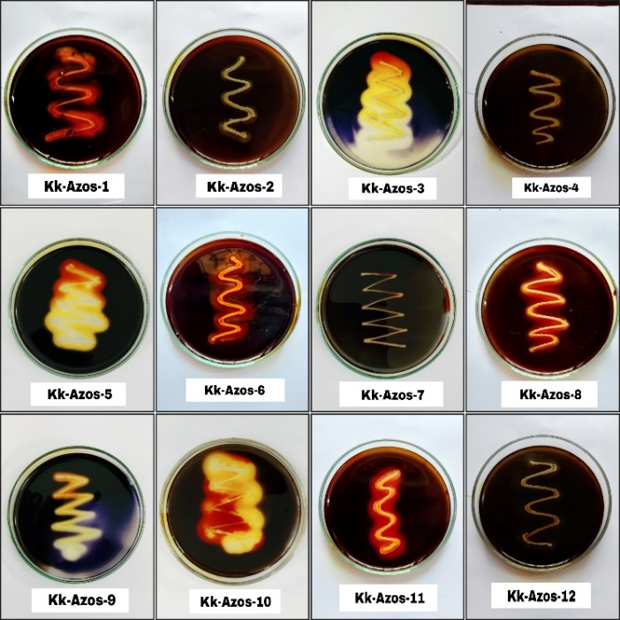
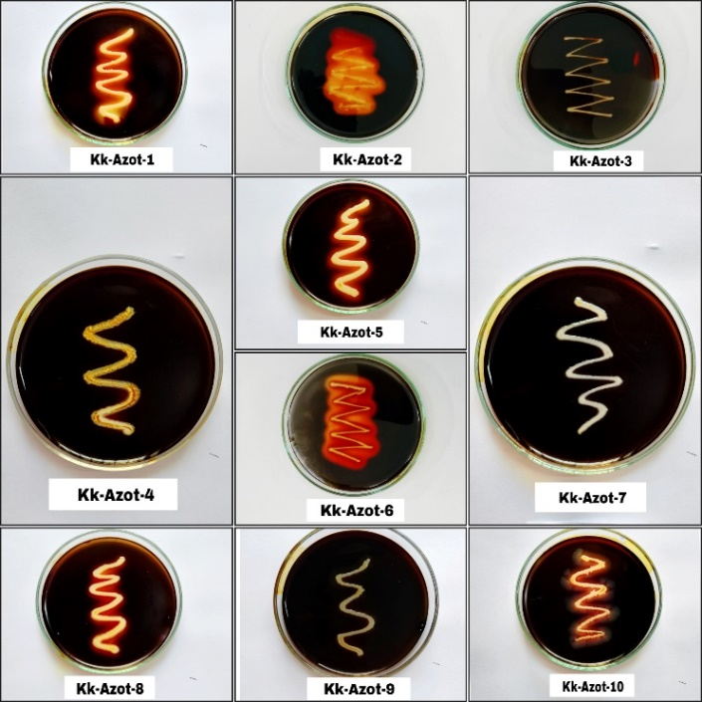

Figure 2. Starch hydrolysis test of foliar Azotobacter (Left) and Azospirillum (Right) isolated from knol khol

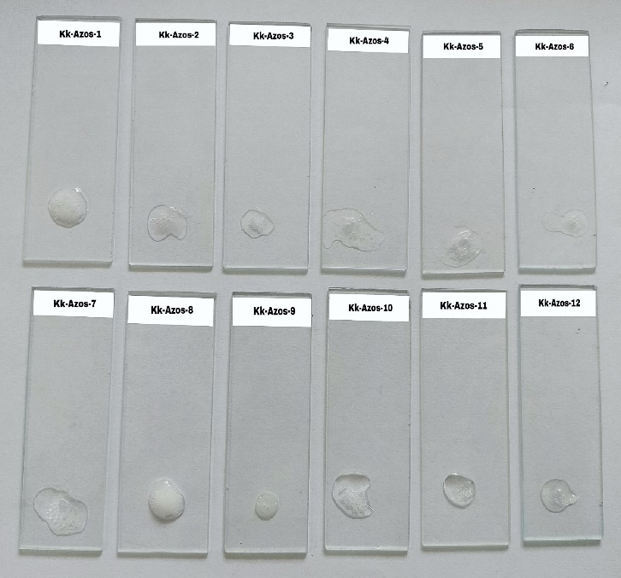
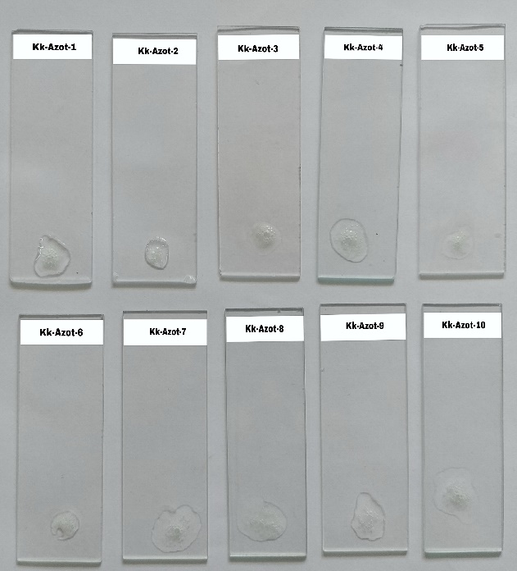

Figure 3. Catalase test of foliar Azotobacter (Left) and Azospirillum (Right)

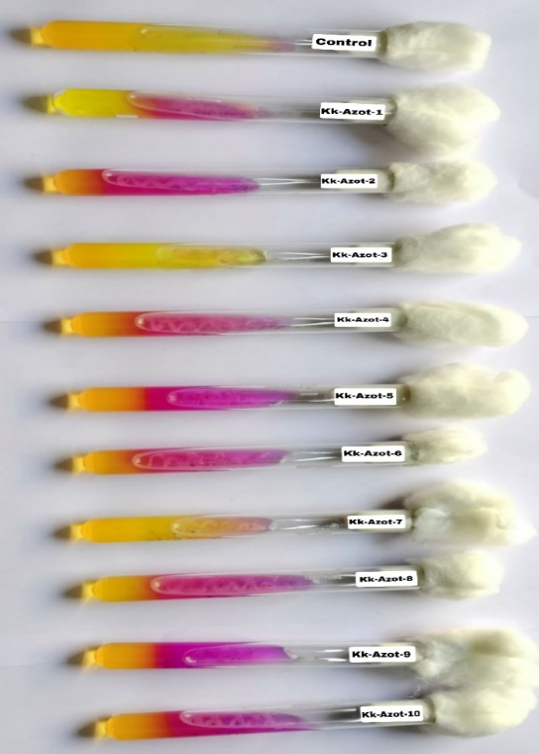
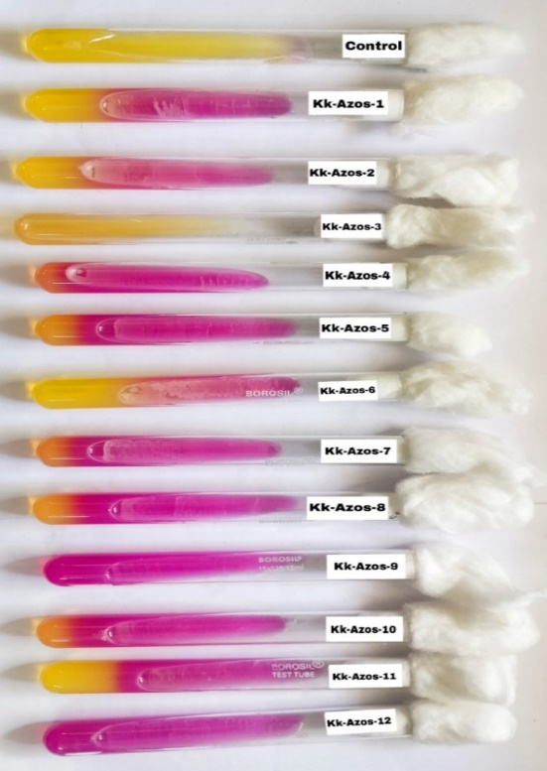

Figure 4. Urease test of foliar Azotobacter (Left) and Azospirillum (Right)

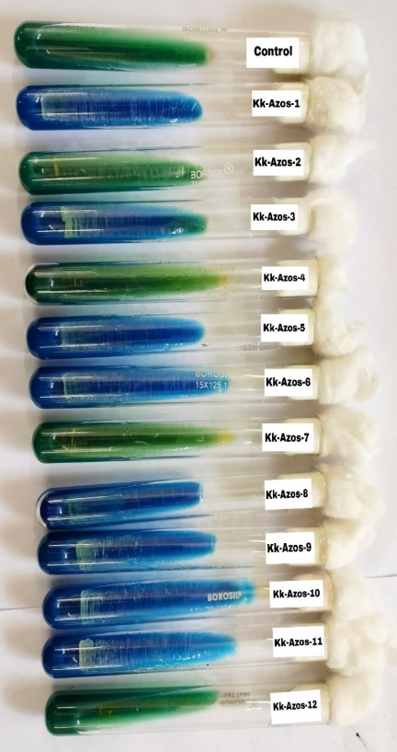
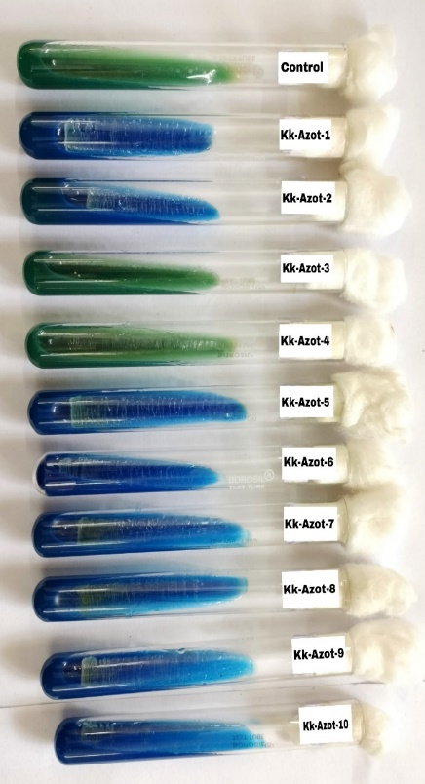

Figure 5. Citrate utilization test of foliar Azotobacter (Left) and Azospirillum (Right)

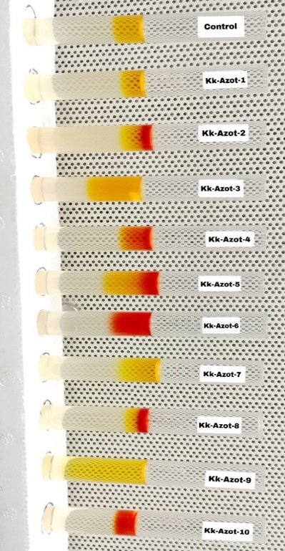
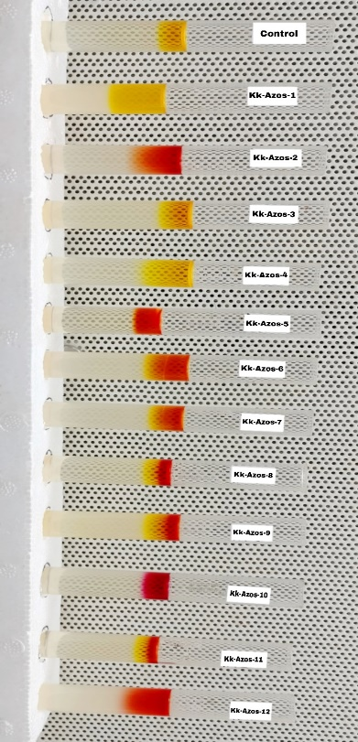

Figure 6. Methyl red test of foliar Azotobacter (Left) and Azospirillum (Right)

4.4.6 Triple Sugar iron (TSI) test
Among the Azotobacter isolates of knol-khol, glucose utilization was observed in 6 isolates. Lactose and sucrose utilization was positive in 1 isolate. Gas production was observed in 7 isolates and none of the isolates exhibited H₂S production. In case of Azospirillum isolates, glucose utilization was observed in 9 isolates. Lactose and sucrose utilization were positive in 4 isolates. Gas production was recorded in 10 isolates and no H₂S production was observed in any of the isolates (Table 4 and Figure 7). Positive results for gas production indicate active fermentation which can promote soil aeration and nutrient cycling. The absence of H₂S production in all the foliar isolates indicate a non-toxic metabolic profile which suitable for soil and plant health. These findings are close to findings of Nag et al., (2018), Kujur et al., (2018), Paul et al., (2020) and Rabara et al., (2023), they reported similar type of sugar metabolism patterns in Azotobacter and Azospirillum isolates.

Table 4. Tripal sugar iron test of foliar Azotobacter and Azospirillum of knol khol
S/N | Name of isolates | Glucose | Lactose | Sucrose | H₂S | Gas
1 | Kk-Azot-1 | - | - | - | - | +
2 | Kk-Azot-2 | + | - | - | - | +
3 | Kk-Azot-3 | - | - | - | - | +
4 | Kk-Azot-4 | + | - | - | - | +
5 | Kk-Azot-5 | + | - | - | - | +
6 | Kk-Azot-6 | + | + | + | - | +
7 | Kk-Azot-7 | - | - | - | - | -
8 | Kk-Azot-8 | + | - | - | - | -
9 | Kk-Azot-9 | - | - | - | - | -
10 | Kk-Azot-10 | + | - | - | - | +
11 | Kk-Azos-1 | - | - | - | - | -
12 | Kk-Azos-2 | + | - | - | - | +
13 | Kk-Azos-3 | - | - | - | - | +
14 | Kk-Azos-4 | - | - | - | - | +
15 | Kk-Azos-5 | + | - | - | - | +
16 | Kk-Azos-6 | + | + | + | - | +
17 | Kk-Azos-7 | + | - | - | - | +
18 | Kk-Azos-8 | + | - | - | - | +
19 | Kk-Azos-9 | + | + | + | - | +
20 | Kk-Azos-10 | + | + | + | - | +
21 | Kk-Azos-11 | + | - | - | - | -
22 | Kk-Azos-12 | + | + | + | - | +
Kk = Knol-khol, Azot = Azotobacter, Azos = Azospirillum, (-) = Negative, (+) = Positive

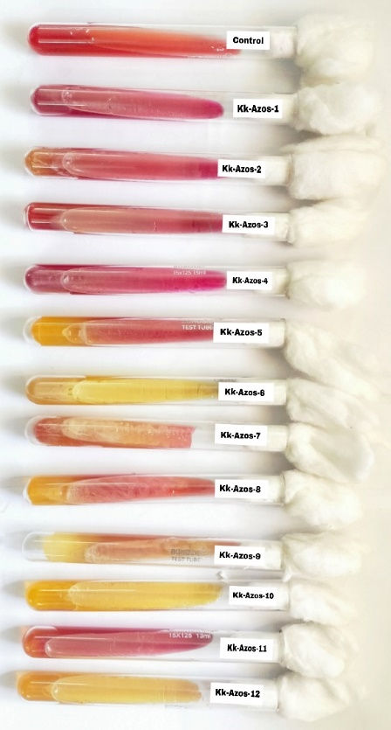
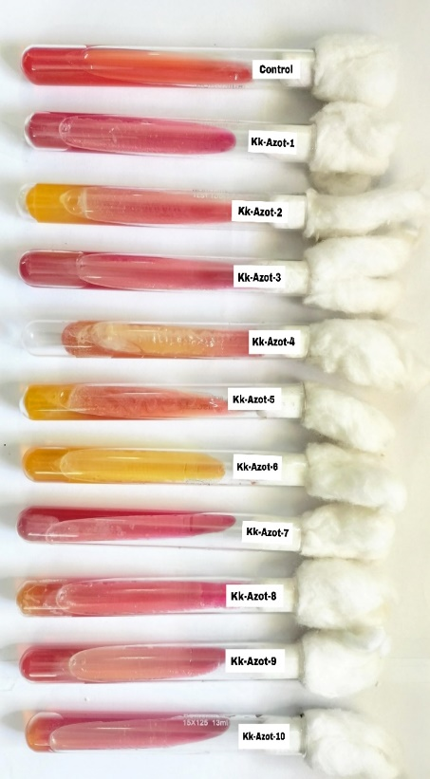

Figure 7. Triple sugar iron test of foliar Azotobacter (Left) and Azospirillum (Right)

Nitrogen-fixing ability of the foliar Azotobacter and Azospirillum isolates
The nitrogen-fixing ability of Azotobacter isolates of knol-khol varied from 4.85 to 10.58 mg N/g of sucrose (Figure 8). The highest nitrogen fixation was associated with the isolate Kk-Azot-6 (10.58) followed by Kk-Azot-9 (9.23) and Kk-Azot-10 (8.48). The lowest nitrogen fixation was recorded for Kk-Azot-3 (4.85) and Kk-Azot-1 (5.54). Regarding Azospirillum isolates, the biologically fixed amount of nitrogen ranged from 6.53 to 15.56 mg N/g of malate (Figure 9). Kk-Azos-10 showed the highest nitrogen fixation (15.56) followed by Kk-Azos-3 (13.25) and Kk-Azos-2 (13.18). The lowest nitrogen fixation was recorded with Kk-Azos-4 (6.53). The variation in nitrogen-fixing abilities across different foliar isolates may be due to environmental factors, specific growth conditions and genetic differences among the isolates. It is clear that Azotobacter and Azospirillum can fix atmospheric nitrogen wherever basic nutrients and suitable environmental conditions are available. The data present in Table 5 clearly showed that Azotobacter and Azospirillum isolates can use leaf organic metabolites to survive, multiply and fix atmospheric nitrogen directly on the plant's foliar surface. Hence, in regions like Chhattisgarh, which faces extremely dry and hot climate during summers, foliar biofertilizers can be more effective than biofertilizers are being used as soil, seed and root inoculant. Similar studies were also conducted by Day and Dobriener (1976), Nelson and Knowles (1978), Rao and Venkateswarlu (1982), Okon et al., (1983), Savalgi et al., (2009) and Sahoo et al., (2014). The contribution of the higher plant –Rhizobium symbiosis for nitrogen nutrition in legumes is well established. However, increasing research attention is now being directed toward improving nitrogen nutrition in non-leguminous crops including vegetables. Such studies hold significant importance as they offer the potential to reduce the reliance on mineral nitrogen and support the advancement of eco-friendly sustainable agriculture. As reported earlier by Dobereiner and Day (1976), it is crucial to focus on soil microorganisms involved in nitrogen dynamics, especially those capable of fixing atmospheric nitrogen. Nature holds a vast diversity of microbes, it is our responsibility to explore and identify helpful microbes through scientific screening in the interest of soil and plant health.

Figure 8. Variation in Nitrogen-fixing ability among foliar Azotobacter isolates from knol khol

Figure 9. Variation in Nitrogen-fixing ability among foliar Azospirillum isolates from knol khol
Conclusion
The present study successfully isolated, characterized and evaluated foliar Azotobacter and Azospirillum from knol khol (Brassica oleracea var. gongylodes) cultivated under diverse agro-climatic conditions of Raipur and Durg districts in Chhattisgarh. The findings conclusively demonstrated that the phyllosphere of knol khol serves as a favorable ecological niche for nitrogen-fixing bacteria such as Azotobacter and Azospirillum. Out of twelve leaf samples, ten Azotobacter and twelve Azospirillum isolates were obtained, exhibiting distinct morphological and biochemical characteristics typical of their respective genera. All isolates were Gram-negative and catalase-positive, confirming their aerobic and nitrogen-fixing nature. The nitrogen-fixing ability varied considerably among isolates, with Azotobacter isolate Kk-Azot-6 and Azospirillum isolate Kk-Azos-10 recording the highest nitrogen fixation values of 10.58 mg N/g sucrose and 15.56 mg N/g malate, respectively. The findings clearly demonstrate that foliar surfaces of knol khol harbor potential nitrogen-fixing bacteria capable of surviving and multiplying under aerial conditions. The high nitrogen-fixing efficiency of selected isolates indicates their strong adaptability and potential application as foliar biofertilizers. Utilization of such native foliar isolates can reduce dependence on synthetic nitrogen fertilizers, enhance nutrient use efficiency and promote sustainable vegetable production under organic and eco-friendly farming systems.
Conflict of Interests
All authors declare that they do not have any conflict of interest related to this research.

COMPETING INTERESTS DISCLAIMER:
Authors have declared that they have no known competing financial interests OR non-financial interests OR personal relationships that could have appeared to influence the work reported in this paper.

References
Abadi, V.A.J.M., Sepehri, M., Rahmani, H.A., Dolatabad, H.K., Shamshiripour, M. and Khatabi, B., 2021. Diversity and abundance of culturable nitrogen‐fixing bacteria in the phyllosphere of maize. Journal of Applied Microbiology, 131(2), pp.898-912.
Agarwala-Dutt, R.E.N.D., Tilak, K.V.B.R. and Rana, J.P.S. 1991. Isolation of Azospirillum from the interior of various parts of some graminaceous plants. Zentralblatt für Mikrobiologie, 146(3): 217-219.
Agegnehu, G., Vanbeek, C. and Bird, M.I., 2014. Influence of integrated soil fertility management in wheat and tea productivity and soil chemical properties in the highland tropical environment. Journal of soil science and plant nutrition, 14(3), pp.532-545.
Ahmad, B., Nigar, S., Malik, N.A., Bashir, S., Ali, J., Yousaf, S., Bangash, J.A. and Jan, I. 2013. Isolation and characterization of cellulolytic nitrogen fixing Azotobacter species from wheat rhizosphere of Khyber Pakhtunkhwa. World Applied Sciences Journal, 27(1): 51-60.
Akhter, M.S., Hossain, S.J., Hossain, S.A. and Datta, R.K. 2012. Isolation and characterization of salinity tolerant Azotobacter sp. Greener J Biol Sci., 2(3): 43-51.
Anonymous, 2009. Final report of CGCOST funded project on Development of foliar bio-inoculants for increasing mulberry biomass production in order to enhance silk yield in Mahasamund area of Chhattisgarh.
Ansabayeva, A., Makhambetov, M., Rebouh, N.Y., Abdelkader, M., Saudy, H.S., Hassan, K.M., Nasser, M.A., Ali, M.A. and Ebrahim, M., 2025. Plant growth-promoting microbes for resilient farming systems: mitigating environmental stressors and boosting crops productivity—A review. Horticulturae, 11(3), p.260.
Atlas, R.M. 2004. Handbook of Microbiological Media, 3rd edn. CRC Press.
Azmat, A., Yasmin, H., Hassan, M.N., Nosheen, A., Naz, R., Sajjad, M., Ilyas, N. and Akhtar, M.N., 2020. Co-application of bio-fertilizer and salicylic acid improves growth, photosynthetic pigments and stress tolerance in wheat under drought stress. PeerJ, 8, p.e9960.
Banotra, M., Sharma, B.C., Kumar, A., Samanta, A., Nandan, B., Shah, I.A., Verma, A., Kumar, R. and Namgial, T., 2017. Critical Review-Impact of Differential Substitution of Organics for in Organics on Growth, Yield, Quality, Economics and Soil Properties of Cole Crop (Brassica oleracea var gonylodes L.). Int. J. Curr. Microbiol. App. Sci, 6(11), pp.3180-3194.
Bashan, Y., de-Bashan, L.E., Prabhu, S.R. and Hernandez, J.P. 2014. Advances in plant growth-promoting bacterial inoculant technology: formulations and practical perspectives (1998–2013). Plant Soil, 378: 1–33.
Beattie, G.A. 2011. Water relations in the interaction of foliar bacterial pathogens with plants. Annual review of phytopathology, 49(1): 533-555.
Beattie, G.A. and Lindow, S.E. 1995. The secret life of foliar bacterial pathogens on leaves. Annual review of phytopathology, 33(1): 145-172.
Bergey’s Manual of Systematic Bacteriology. 2001. Springer.
Beveridge, T.J. 2001. Use of the Gram stain in microbiology. Biotechnic and Histochemistry, 76(3): 111-118.
Bisht, N. and Chauhan, P.S., 2020. Excessive and disproportionate use of chemicals cause soil contamination and nutritional stress. Soil Contamination-Threats and Sustainable Solutions, pp.1-10.
Boraste, A., Vamsi, K.K., Jhadav, A., Khairnar, Y., Gupta, N., Trivedi, S., Patil, P., Gupta, G., Gupta, M., Mujapara, A.K. and Joshi, B., 2009. Biofertilizers: A novel tool for agriculture. International Journal of Microbiology Research, 1(2), p.23.
Bremner, J.M. 1965. Nitrogen availability indexes. Methods of Soil Analysis: Part 2 Chemical and Microbiological Properties, 9: 1324-1345.
Brink, B. 2013. Urease Test Protocol. American Society for Microbiology.
Cappuccino, J.G. and Sherman, N. 2008. Microbiology: A Laboratory Manual (9th ed.). San Francisco: Pearson/Benjamin Cummings.
Cappuccino, J.G. and Sherman, N., 2013. Microbiology: A Laboratory Manual. 10th Edition. Pearson Education Limited, London.
Cassán, F., Coniglio, A., López, G., Molina, R., Nievas, S., de Carlan, C.L.N., Donadio, F., Torres, D., Rosas, S., Pedrosa, F.O. and de Souza, E., 2020. Everything you must know about Azospirillum and its impact on agriculture and beyond. Biology and Fertility of Soils, 56(4), pp.461-479.
Cassán, F.D., Penna, C., Creus, C.M., Radovancich, D., Monteleone, E., de Salamone, I.G., Di Salvo, L., Mentel, I., García, J., Pasarello Mayans, M.C. and Lett, L.A.C. 2015. Protocol for the quality control of Azospirillum spp. inoculants. In: Cassán, F.D., Okon, Y., and Creus, C.M. (Eds.), Handbook for Azospirillum: Technical Issues and Protocols, 487–499. Springer, Cham.
Chen, J.H., 2006, October. The combined use of chemical and organic fertilizers and/or biofertilizer for crop growth and soil fertility. In International workshop on sustained management of the soil-rhizosphere system for efficient crop production and fertilizer use (Vol. 16, No. 20, pp. 1-11). Land Development Department Bangkok Thailand.
Costa, L.E.D.O., Queiroz, M.V.D., Borges, A.C., Moraes, C.A.D. and Araújo, E.F.D. 2012. Isolation and characterization of endophytic bacteria isolated from the leaves of the common bean (Phaseolus vulgaris). Brazilian Journal of Microbiology, 43: 1562-1575.
Craswell, E., 2021. Fertilizers and nitrate pollution of surface and ground water: an increasingly pervasive global problem. SN Applied Sciences, 3(4), p.518.
Day, J.M. and Döbereiner, J. 1976. Physiological aspects of N2-fixation by a Spirillum from Digitaria roots. Soil Biology and Biochemistry, 8(1): 45-50.
Dilfuza, E., 2011. Indole-acetic acid production by root associated bacteria and its role in plant growth and development. Auxins: Structure, biosynthesis and functions, pp.1-13.
Dobereiner, J. and Day, J.M. 1976. First international symposium on nitrogen fixation. In recent advances in Biological nitrogen fixation. Eds. Newton, W.E. and Nyman, C.J., Washington state university press, Washington, 518-538.
Fahrurrozi, F., Muktamar, Z., Setyowati, N., Sudjatmiko, S. and Chozin, M., 2019. Comparative effects of soil and foliar applications of tithonia-enriched liquid organic fertilizer on yields of sweet corn in closed agriculture production system. AGRIVITA, Journal of Agricultural Science, 41(2), pp.238-245.
Forbes, B.A., Sahm, D.F. and Weissfeld, A.S. 2007. Bailey and Scott's Diagnostic Microbiology. 12th ed. St. Louis, MO: Mosby Elsevier, 288-302.
Gupta, S.B., Katre, R.K., Chhonkar, P.K., Gupta, M.K. and Adil, M.L. 2000. Significant research and development with reference to biofertilizers in Chhattisgarh. Fert. News. 45(11): 35-40.
Gupta, S.B., Tedia, K., Singh, A., Anurag, Lakpale, N., Pal, A. and Chhonkar, P.K. 2002. Isolation and identification of stress tolerant bio-inoculants for rainfed cropping system. Soil and Crops. 12(1): 11-16.
Gureev, A.P., Kryukova, V.A., Eremina, A.A., Alimova, A.A., Kirillova, M.S., Filatova, O.A., Moskvitina, M.I., Kozin, S.V., Lyasota, O.M. and Gureeva, M.V. 2024. Plant-growth promoting rhizobacteria Azospirillum partially alleviate pesticide-induced growth retardation and oxidative stress in wheat (Triticum aestivum L.). Plant Growth Regulation, 1-19.
Hala, Y. and Ali, A. 2019. Isolation and characterization of Azotobacter from neem rhizosphere. Journal of Physics: Conference Series, 1244(1), p.012019.
Hashidoko, Y., Itoh, E., Yokota, K., Yoshida, T. and Tahara, S. 2002. Characterization of five phyllosphere bacteria isolated from Rosa rugosa leaves and their phenotypic and metabolic properties. Bioscience, biotechnology and biochemistry, 66(11): 2474-2478.
Holt, J.G., Krieg, N.R., Sneath, P.H.A., Staley, J.T. and Williams, S.T. 1994. Bergey's Manual of Determinative Bacteriology. 9th ed. Baltimore: Williams and Wilkins.
Jackson, M.L. 1967. Soil Chemical Analysis. Prentice Hall of India Pvt. Ltd., New Delhi, p. 498.
Jadhav S.W., Dilpak S.A and Dhapate S.S. 2015. Isolation and Screening of Drought Tolerent Azotobacter and PSB from Sorghum rhizosphere (Sorghum bicolor L. Moench) International Journal of Tropical Agriculture, 33(4): 3451-3454.
Jiménez, D.J., Montaña, J.S. and Martínez, M.M. 2011. Characterization of free nitrogen fixing bacteria of the genus Azotobacter in organic vegetable-grown Colombian soils. Brazilian Journal of Microbiology, 42: 846-858.
Kachari, M. and Korla, B.N., 2009. Effect of biofertilizers on growth and yield of cauliflower cv. PSB K-1. Indian Journal of Horticulture, 66(4), pp.496-501.
Kandler, O., Weiss, N., Sneath, P.H.A., Mair, N.S., Sharpe, M.E. and Holt, J.G. 1986. Bergey's manual of systematic bacteriology. Bergey’s manual of systematic bacteriology, 2: 1208–1234.
Khudhur, A.M. and Askar, K.A. 2013. Effect of some pesticides on growth, nitrogen fixation and nif genes in Azotobacter chroococcum and Azotobacter vinelandii isolated from soil. Journal of Toxicology and Environmental Health Sciences, 5(9): 166–171.
Khudhur, N.S. and Sarmamy, A.G.O.I. 2016. Impact of some pesticides on total counts of soil non-symbiotic nitrogen-fixing bacteria, particularly Azotobacter sp. Journal of Zankoy Sulaimani – Part A (Pure and Applied Sciences), 18(1): 99–126.
Kim, M. 2012. Distinctive phyllosphere bacterial communities in tropical trees. Microb. Ecol., 63: 674–681.
Kujur, E., Dash, D. and Deole, S. 2018. Effect of Azotobacter and Pseudomonas inoculation on microbiology of rhizosphere soils of Okra. IJCS, 6(5): 2132-2136.
Kuklinsky‐Sobral, J., Araújo, W.L., Mendes, R., Geraldi, I.O., Pizzirani‐Kleiner, A.A. and Azevedo, J.L. 2004. Isolation and characterization of soybean‐associated bacteria and their potential for plant growth promotion. Environmental microbiology, 6(12): 1244-1251.
Kumari, R., Bhatnagar, S. and Kalra, C., 2022. Nitrogen assimilation in plants. In advances in plant nitrogen metabolism (pp. 38-54). CRC Press.
Kyaw, E.P., Soe, M.M., San San Yu, Z.K.L. and Lynn, T.M. 2019. Study on plant growth promoting activities of Azotobacter isolates for sustainable agriculture in Myanmar. J. Biotech. Biores., 1(5): 1-6.
Latkovic, D., Maksimovic, J., Dinic, Z., Pivic, R., Stanojkovic, A. and Stanojkovic-Sebic, A., 2020. Case study upon foliar application of biofertilizers affecting microbial biomass and enzyme activity in soil and yield related properties of maize and wheat grains. Biology, 9(12), p.452.
Li, Y., Peng, X., Zhou, X., Ren, B., Xiao, L., Li, Y. and Guo, Q. 2020. Basic biology of oral microbes. Atlas of Oral Microbiology: From Healthy Microflora to Disease. Springer, Singapore, 1–24.
Lindow, S.E. and Leveau, J.H. 2002. Phyllosphere microbiology. Current Opinion in Biotechnology, 13(3): 238-243.
Mahon, C. R. and Lehman, D. C. 2022. Textbook of Diagnostic Microbiology – E-Book. Elsevier Health Sciences.
Muthukumar, A., Sandhya, G.M. and Dakshayini, G. 2021. Morphological and biochemical characterization–A comparative analysis of non-commercial and commercial plant growth promoting microorganisms. International Journal of Current Microbiology and Applied Sciences, 10(2): 867-874.
Nag, N. K., Dash, B., Gupta, S. B., Khokher, D. and Soni, R. 2018. Evaluation of stress tolerance of Azotobacter isolates. Biologija, 64(1): 82–93.
Nelson, L.M. and Knowles, R. 1978. Effect of oxygen and nitrate on nitrogen fixation and denitrification by Azospirillum brasilense grown in continuous culture. Canadian journal of microbiology, 24(11): 1395-1403.
Nongthombam, J., Kumar, A., Sharma, S. and Ahmed, S., 2021. Azotobacter: A complete review. Bull. Env. Pharmacol. Life Sci, 10(6), pp.72-79.
Ohyama, T., 2010. Nitrogen as a major essential element of plants. Nitrogen Assim. Plants, 37, pp.1-17.
Okon, Y. and Labandera-Gonzalez, C.A. 1994. Agronomic applications of Azospirillum: an evaluation of 20 years worldwide field inoculation. Soil Biology and Biochemistry, 26(12): 1591-1601.
Okon, Y., Heytler, P.G. and hardy, R.W.F. 1983. Nitrogen fixation by Azospirillum brasilense and its incorporation in to its host Setaria italic. Applied and Environmental Microbiology, 49: 694-698.
Pahalvi, H.N., Rafiya, L., Rashid, S., Nisar, B. and Kamili, A.N., 2021. Chemical fertilizers and their impact on soil health. In Microbiota and biofertilizers, Vol 2: Ecofriendly tools for reclamation of degraded soil environs (pp. 1-20). Cham: Springer International Publishing.
Pahari, A., Nayak, S.K., Banik, A., Lakra, P.B. and Mishra, B.B., 2021. Biological nitrogen fixation mechanism and applications. In Agriculturally Important Microorganisms (pp. 137-151). CRC Press.
Panda, H. (2011). Manufacture of biofertilizer and organic farming. Asia Pacific Business Press Inc.
Pandey, A. and Kumar, S., 1989. Potential of Azotobacters and Azospirilla as biofertilizers for upland agriculture: a review.
Patil, S.V., Mohite, B.V., Patil, C.D., Koli, S.H., Borase, H.P. and Patil, V.S., 2020. Azotobacter. In Beneficial microbes in agro-ecology (pp. 397-426). Academic Press.
Paul, G.K., Mahmud, S., Naher, K., Jabin, T., Mahmud, M.L., Haque, M.N., Uddin, M.S., Zaman, S. and Saleh, M.A. 2020. Isolation and characterization of bacteria from two soil samples and their effect on wheat (Triticum aestivum l.) growth promotion. J. Adv. Biotechnol. Exp. Ther, 3(3): 254-262.
Pedraza, R.O., Filippone, M.P., Fontana, C., Salazar, S.M., Ramírez-Mata, A., Sierra-Cacho, D. and Baca, B.E., 2020. Azospirillum. In Beneficial microbes in agro-ecology (pp. 73-105). Academic Press.
Rabara, S., Vishwakarma, N.P. and Patel, S. 2023. Isolation and biochemical identification of N₂ Fixing Bacteria (Azospirillium Sp.) from Saurashtra Region. Current Agriculture Research Journal, 11(1): 277-286.
Rao, A. V. and Venkateswarlu, B. 1982. Occurrence of Azotobacter and nitrogen fixation in desertic soils. Indian Journal of Microbiology, 22(4): 255–257.
Rashid, S., Charles, T.C. and Glick, B.R. 2012. Isolation and characterization of new plant growth-promoting bacterial endophytes. Applied soil ecology, 61: 217-224.
Rasool, L., Asghar, M., Jamil,A. and. Rehman S.U. 2015. Identification of Azospirillum species from wheat rhizosphere. The Journal of Animal and Plant Sciences. 25(4): 1081-1086.
Reis, V.M., Baldani, V.L.D. and Baldani, J.I. 2015. Isolation, identification and biochemical characterization of Azospirillum spp. and other nitrogen-fixing bacteria. Handbook for Azospirillum: Technical Issues and Protocols, 3–26.
Romero-Perdomo, F., Abril, J., Camelo, M., Moreno-Galván, A., Pastrana, I., Rojas-Tapias, D. and Bonilla, R. 2017. Azotobacter chroococcum as a potentially useful bacterial biofertilizer for cotton (Gossypium hirsutum): Effect in reducing N fertilization. Revista Argentina de microbiologia, 49(4): 377-383.
Ruinen, J. (1965). The phyllosphere: III. Nitrogen fixation in the phyllosphere. Plant and Soil, 22(3), 375-394.
Sahoo, R.K., Ansari, M.W., Dangar, T.K., Mohanty, S. and Tuteja, N. 2014. Phenotypic and molecular characterisation of efficient nitrogen-fixing Azotobacter strains from rice fields for crop improvement. Protoplasma, 251: 511-523.
Savalgi, V.P., Onkarappa, R., Veena Savalgi, V.S. and Gurumurthy, S.B. 2009. Screening of plant growth promotional activities and diazotrophic activities of Azospirillum strains from vertisols of northern Karnataka. Karnataka Journal of Agricultural Sciences, 22(5): 1032–1034.
Schreiber, L., Krimm, U., Knoll, D., Sayed, M., Auling, G. and Kroppenstedt, R.M. 2005. Plant–microbe interactions: identification of epiphytic bacteria and their ability to alter leaf surface permeability. New Phytologist, 166(2): 589-594.
Shahid, M., Zaidi, A., Ehtram, A. and Khan, M.S. 2019. In vitro investigation to explore the toxicity of different groups of pesticides for an agronomically important rhizosphere isolate Azotobacter vinelandii. Pesticide biochemistry and physiology, 157: 33-44.
Sivagamasundari, U. and Gandhi, A. 2021. Effect of bacterial endophytes-Azospirillum brasilense and Pseudomonas fluorescens on growth and yield of Brinjal var. Annamalai in field trial. Current Trends in Biotechnology and Pharmacy, 15(5): 489-495.
Soumare, A., Diedhiou, A.G., Thuita, M., Hafidi, M., Ouhdouch, Y., Gopalakrishnan, S. and Kouisni, L., 2020. Exploiting biological nitrogen fixation: a route towards a sustainable agriculture. Plants, 9(8), p.1011.
Sulaiman, K.H., Al-Barakah, F.N., Assaeed, A.M. and Dar, B.A.M. 2019. Isolation and identification of Azospirillum and Azotobacter species from Acacia spp. at Riyadh, Saudi Arabia. Bangladesh Journal of Botany, 48(2): 239-251.
Sun, W., Shahrajabian, M.H. and Wang, N., 2025. A study of the different strains of the genus Azospirillum spp. on increasing productivity and stress resilience in plants. Plants, 14(2), p.267.
Talukder, M.R., Banu, M.B., Hoque, A.K.M.S. and Hoque, M.A., 2013. Response of knolkhol to different levels of nutrients. Eco-friendly Agricultural Journal, 6(2), pp.29-33.
Tarrand, J.J., Krieg, N.R. and Döbereiner, J. 1978. A taxonomic study of the Spirillum lipoferum group, with descriptions of a new genus, Azospirillum gen. nov. and two species, Azospirillum lipoferum (Beijerinck) comb. nov. and Azospirillum brasilense sp. nov. Canadian Journal of Microbiology, 24: 967–980.
Tejera, N.L.C.M.M.G.J., Lluch, C., Martínez-Toledo, M.V. and González-López, J. 2005. Isolation and characterization of Azotobacter and Azospirillum strains from the sugarcane rhizosphere. Plant and Soil, 270(1): 223–232.
Upadhyay, S., Kumar, N., Singh, V.K. and Singh, A. 2015. Isolation, characterization and morphological study of Azotobacter isolates. Journal of Applied and Natural Science, 7(2): 984-990.
Verma, J.P., Jaiswal, D.K. and Maurya, P.K. 2016. Screening of bacterial strains for developing effective pesticide-tolerant plant growth-promoting microbial consortia from rhizosphere soils of vegetable fields of eastern Uttar Pradesh, India. Energy, Ecology and Environment, 1: 408-418.
Whipps, J., Hand, P., Pink, D. and Bending, G.D. 2008. Phyllosphere microbiology with special reference to diversity and plant genotype. Journal of applied microbiology, 105(6): 1744-1755.
Yadav, N.S., Sakshi, I. and Gaur, R.K. 2024. Biochemical characterization of bacteria isolated from rhizosphere soils of sugarcane grown in Uttar Pradesh. Research Journal of Biotechnology, 19(3): 70–75.
Yasuda, M., Isawa, T., Shinozaki, S., Minamisawa, K. and Nakashita, H. 2009. Effects of colonization of a bacterial endophyte, Azospirillum sp. B510, on disease resistance in rice. Bioscience, biotechnology and biochemistry, 73(12): 2595-2599.

