Original Research Article

Isolation and evaluation of the antibiotic sensitivity profile of Coagulase-positive Staphylococcus aureus from slaughterhouse workers

.
ABSTRACT

Aims: This study was undertaken to isolate and evaluate the antimicrobial resistance pattern of coagulase-positive Staphylococcus aureus from the Slaughterhouse workers.
Study design: Cross-sectional study.
Place and Duration of Study: Samples were collected from various slaughterhouses of the Thoothukudi district of Tamil Nadu between December 2024- July 2025.
Methodology: 50 nasal swabs were randomly collected from the slaughterhouse workers of various places and processed for isolation of S. aureus using the standard (ISO 6888-1, 1999) procedure by enrichment in Tryptic Soy Broth (TSB), followed by streaking in Mannitol salt agar (MSA). Then the presumptive isolates were stained and confirmed molecularly by species-specific PCR targeting the nuc gene. Then the PCR confirmed isolates were evaluated for their coagulase production, by specific PCR targeting the Coa gene. Finally, the characterized isolates were tested for their antibiotic sensitivity profile by following CLSI guidelines in the standard disc diffusion method.
Results: Among the 50 nasal swabs processed for isolation, 6 samples (12% prevalence rate) showed typical presumptive colony morphology in selective media, and all those were confirmed as S. aureus by species-specific PCR targeting the nuc gene. Further, all six isolates were confirmed to be positive for coagulase production by specific PCR targeting the Coa gene. Finally, all six characterized isolates were resistant to multiple groups of antibiotics, viz. Ampicillin, Penicillin, Chloramphenicol, Clindamycin, Gentamicin, and Ofloxacin in in vitro antibiotic sensitivity analysis.
Conclusion: This alarming threat of increasing antimicrobial resistance pattern of coagulase-positive S. aureus pathogen warrants in-depth research and education to overcome the problems in the future to save the lives of patients.

Keywords: Staphylococcus, Slaughterhouse, Coagulase, Antimicrobial resistance

1. INTRODUCTION

Staphylococcus aureus is a highly prevalent Gram-positive bacterium responsible for various types of infections in both animals and humans (Pal et al., 2020). Globally, it is considered to be one of the most common virulent opportunistic pathogens. In humans, S. aureus causes a wide range of skin and soft tissue infections, such as furuncles, carbuncles, folliculitis, impetigo, mastitis, and wound infections (Linz et al., 2023; Peacock and Paterson, 2015; Lindsay and Holden, 2004). Along with that, via the production of exo and enterotoxins, S. aureus infection leads to toxin-mediated conditions, such as toxic shock syndrome, scalded skin syndrome, and staphylococcal food poisoning (Pal et al., 2023; Papadopoulos et al., 2018). In addition, serious complications such as bone and joint infections, endocarditis, bacteremia, and pneumonia are also associated with this pathogen (Rasquel-Oliveira et al., 2025; Argaw and Addis, 2015; Peacock and Paterson, 2015). In animals, the pathogen affects a wide host range, which includes cattle, goat, sheep, pigs, cats, dogs, horses, rabbits, poultry, and wild animals (Verma et al., 2024; Grema et al., 2015). Various types of infections have been reported in these species; however, the most significant are mastitis in dairy cattle, lethal systemic infections in farmed rabbits, and bumblefoot (ulcerative pododermatitis) in poultry (Kumar et al., 2024; Peacock and Paterson, 2015).
Globally, Staphylococcal food poisoning is one of the most common but rarely reported types of food poisoning (Freitas et al., 2024; Pillsbury et al., 2013; Singh et al., 2013). Although S. aureus is recognized as a major cause of food poisoning in many countries, there are only a few reports available in our country to explain its prevalence and incidence. Nasal carriage of S. aureus is identified as a key risk factor for food poisoning in most epidemiological studies.
Food poisoning occurs from consuming foods contaminated with various types of preformed enterotoxins produced by S. aureus (Abdallah and Sulieman, 2024; Argudín et al., 2013). These organisms primarily adhere to and colonize the mucosa of the upper respiratory tract, skin, and other internal sites in both humans and animals, either temporarily or permanently (Abdallah and Sulieman, 2024). Early reports indicated that about 20% of healthy individuals may be colonized with this organism at any given time. The presence of abundant S. aureus in food suggests improper handling or hygiene and possible temperature abuse, which promotes bacterial growth within the food matrix (Phan et al., 2024; Rall et al., 2010). These organisms can be transferred to food through contaminated hands, sneezing, coughing, or nasal secretions. The external nares of food handlers may harbor multiple strains of S. aureus, any of which could be involved in food poisoning cases; therefore, it’s important to screen for multiple strains during investigations rather than just a single colony (Argaw and Addis, 2015). Contamination can also occur due to poor hygiene practices during animal slaughter and food processing in slaughterhouses. Consuming contaminated food can cause nausea, abdominal cramps, and vomiting within 1-6 hours, with symptoms lasting 24-48 hours and leading to full recovery (Nema et al., 2007). This disease is usually mild, self-limiting, with low mortality but a high rate of morbidity (Chan and Shelat, 2024). Consequently, S. aureus food poisoning presents a significant social burden, including hospitalizations, lost workdays, and disposal of contaminated food products (Vinu et al., 2025; Normanno et al., 2007). S. aureus is characterized by its ability to produce coagulase enzyme, although some other Staphylococcus species, such as S. delphini, S. hyicus, and S. intermedius, may also exhibit coagulase activity (Ben Chehida et al., 2024; Normanno et al., 2005). A high correlation has been noted between coagulase activity and enterotoxin production. However, this should not be the only method used for identifying enterotoxigenic Staphylococcus spp., as certain coagulase-negative species like S. Xylosus and S. epidermidis have also produced low levels of enterotoxins (Ali et al., 2025).
Recently, the emergence of drug resistance to most of the newly identified antibiotic classes has become a common threat among pathogenic bacterial isolates worldwide (Alara and Alara, 2024). The death rate due to S. aureus bacteremia exceeded 80% in the pre-antibiotic era (Zhang et al., 2024; Skinner and Keefer, 1941). However, after the introduction of the first antibiotic, penicillin G, in the early 1940s, patient prognosis improved significantly, but resistant pathogens were identified shortly thereafter in 1942 (Reverter et al., 2024; Rammelkamp and Maxon, 1942). A few years later, in 1959, a penicillinase-resistant semi-synthetic β-lactam antibiotic called methicillin was developed and introduced into clinical practice; however, by 1960, the first case of methicillin-resistant S. aureus (MRSA) was reported from the United Kingdom (Beaumont et al., 2024; Jevons, 1961). Since then, MRSA has become an endemic threat in hospitals, nursing homes, and clinical settings worldwide (Alam et al., 2014; Brown et al., 2005). In light of these facts, this study was conducted to isolate and analyze the antibiotic sensitivity profile of coagulase-positive S. aureus from slaughterhouse workers in the Thoothukudi district of Tamil Nadu.
2. material and methods
.
2.1 Sample Collection
Thoothukudi is one of the southern coastal districts of Tamil Nadu with a large number of slaughterhouses. The present study is designed to isolate and evaluate the antibiotic sensitivity profile of coagulase-positive Staphylococcus aureus from the nasal swabs collected from slaughterhouse workers of various local meat shops in the Thoothukudi district. By following simple random sampling, 50 nasal swabs (n=50) were collected using standard procedures in clean, sterile screw capped plastic containers and labeled as S1 to S50.
2.2 Isolation of S. aureus using the cultural method
Isolation of S. aureus from the collected nasal swabs was performed as per the ISO 6888-1 (ISO 6888-1, 1999) with slight modifications. Briefly, performed with a two-step enrichment and selective plating. The collected samples were placed in 9 ml of Tryptic Soy Broth (TSB) (Himedia, Mumbai, India) containing 6.5% w/v of sodium chloride, and incubated at 37 °C for 24 h. After incubation, a loopful of enriched cultures from the broth was streaked onto Mannitol salt agar (MSA) (Himedia, Mumbai, India). The plates were then incubated for 24-48 h at 37ºC. On MSA, the presumptive S. aureus appeared as small yellow colored colonies surrounded by yellow medium. Further, the presumptive S. aureus isolates were subjected to morphological confirmation using Gram staining and molecular confirmation using PCR.

2.3 Isolation of S. aureus using the cultural method
Smears were made from the presumptive colonies on a grease-free glass slide and stained using the standard Gram staining procedure described earlier (Parasuraman et al., 2024). The stained smears were examined under the 100x oil immersion objective; those samples that exhibited a Gram-positive coccus in bunches were considered as Staphylococcus Spp. The morphologically confirmed isolates were further subjected to molecular confirmation.
2.4 Molecular Confirmation of S. aureus by PCR
The Isolates were further confirmed using the standardized PCR by targeting the species-specific nuc gene as described earlier (Brakstad et al., 1992). Briefly, the PCR was performed using the standardized PCR cycling conditions with the 25 µl reaction mixture comprised of 2.5 µl of 10x PCR Buffer (100 mM Tris-HCl buffer pH-8.3 with 15 mM MgCl₂, 500 mM KCl, and 0.01% gelatin), 1 µl of 25 mM MgCl_{2,} 1 µl of Taq Polymerase (1U/ µl), 1 µl of 10mM dNTPs, 1 µl of 10 pM specific forward and reverse primers (Table 1), 5 µl of DNA Template and 12.5 µl of NFW (Nuclease Free water) in the PCR thermal cycler- C 1000 TouchTM (Bio-Rad, USA). The standardized cycling conditions used for the amplification of the nuc gene are described in Table 2. After the amplification, the PCR products were separated in a 1.5% agarose gel with Ethidium bromide in Tris-Acetate-EDTA (TAE) buffer using standard horizontal gel electrophoresis at 100 volts for 30 min. The DNA ladder of 100 bp was used as a marker for comparing the size of amplified PCR products. The amplified nuc gene fragments were visualized using an ultraviolet gel documentation system. All the contaminants with the Ethidium bromide were disposed of by following the institutional biosafety guidelines for disposing of biohazardous materials.

Table 1. Nucleotide Sequence of S. aureus specific nuc gene primer

Primers | Sequences (5’-3’) | Amplicon size (bp) | Reference
nuc | F: CGATTGATGGTGATACGGTT  R: ACGCAAGCCTTGACGAACTAAAGC | 279 | (Brakstad et al., 1992)

Table 2. Standard cycling conditions of the PCR targeting the nuc gene

Initial Denaturation | Denaturation | Annealing | Extension | Final extension
95°C | 95°C | 56°C | 72°C | 72°C
2 min | 30 sec | 1 min | 1:30 min | 10 min
2 min | 35x |  |  | 10 min

2.5 Molecular Confirmation of Coagulase Production by PCR
The PCR confirmed S. aureus isolates were further confirmed for their Coagulase production using the standardized PCR by targeting the specific Coa gene as described earlier (Hookey et al., 1998). Briefly, the PCR was performed using the standardized PCR cycling conditions with the 25 µl reaction mixture comprised of 2.5 µl of 10x PCR Buffer (100 mM Tris-HCl buffer pH-8.3 with 15 mM MgCl₂, 500 mM KCl, and 0.01% gelatin), 1 µl of 25 mM MgCl_{2,} 1 µl of Taq Polymerase (1U/ µl), 1 µl of 10mM dNTPs, 1 µl of 10 pM specific forward and reverse primers (Table 3), 5 µl of DNA Template and 12.5 µl of NFW (Nuclease Free water) in the PCR thermal cycler- C 1000 TouchTM (Bio-Rad, USA). The standardized cycling conditions used for the amplification of the nuc gene are described in Table 4. Finally, the amplified samples were separated and visualized under UV illumination as described earlier.
Table 3. Nucleotide Sequence of S. aureus specific nuc gene primer

Primers | Sequences (5’-3’) | Amplicon size (bp) | Reference
Coa | F: ATAGAGATGCTGGTACAGG  R: GCTTCCGATTGTTCGATGC | Variable (600-800) | (Hookey et al., 1998)

Table 4. Standard cycling conditions of the PCR targeting the Coa gene

Initial Denaturation | Denaturation | Annealing | Extension | Final extension
95°C | 95°C | 56°C | 72°C | 72°C
2 min | 30 sec | 1 min | 1:30 min | 10 min
2 min | 35x |  |  | 10 min

2.6 Antibiotic sensitivity test
All molecularly confirmed S. aureus isolates were tested for antibiotic susceptibility using the disc diffusion method according to CLSI guidelines (CLSI, 2018), as described by Bauer et al. (1966). The antibiotic discs used included Penicillin (P, 10U), Co-trimoxazole (SXT, 25 µg), Ciprofloxacin (CIP, 10 µg), Ampicillin (AMP, 10 µg), Tetracycline (TE, 10 µg), Chloramphenicol (C, 30 µg), Clindamycin (CD, µg), Gentamicin (GM, 30 µg), Linezolid (LZD, 15 µg), Norfloxacin (NX, 10 µg), Doxycycline (DO, 30 µg), Ofloxacin (OX, 5 µg), Erythromycin (E, 30 µg), and Nitrofurantoin (NIT, 300 µg). Briefly, a single colony of each isolate was inoculated into 2 ml of nutrient broth and incubated at 37°C overnight. From the incubated broth, 1 ml was centrifuged at 5000 rpm for 5 minutes to obtain a culture pellet. The pellets were resuspended in sterile normal saline solution (NSS) to achieve a 0.5 McFarland standard turbidity (approximately 1.50 × 10^8 CFU/ml). These diluted cultures were lawned on Mueller-Hinton (MH) agar plates using a sterile cotton swab. After the plates dried for 5 minutes, sterile forceps were used to place five antibiotic discs on each plate. The plates were then incubated at 37°C for 18–24 hours. Post-incubation, inhibition zone diameters were measured with a standard ABST ruler. The zones of inhibition were compared to the interpretative chart (CLSI, 2018) to determine whether each isolate was susceptible, intermediate, or resistant to the respective antibiotics.

3. results and discussion

Coagulase-positive S. aureus is one of the most common pathogens causing diseases in animals and humans. It causes a wide variety of skin infections, toxin-mediated acute food poisoning in humans, and various systemic pyogenic infections in animals (Kumar et al., 2024; Pal et al., 2023). The human nasal cavity and upper respiratory tract harbours this pathogen regularly as a commensal, and its contamination of food via improper handling leads to the spread of infection.
In this study, 50 nasal swabs were collected from the slaughterhouse workers randomly from the Thoothukudi district of Tamil Nadu, and processed for isolation, identification, and evaluation of antibiotic sensitivity profiling of coagulase-positive S. aureus. Typical yellow colonies surrounded by a yellow zone in Manitol salt agar (Fig. 1) were observed with 6 samples out of 50 samples tested, and all these 6 presumptive isolates were found to be Gram-positive cocci in bunches (grape-like) under 100x magnification. Further, all the isolates were confirmed using S. auresus species-specific PCR; it was observed that all six isolates could amplify the nuc gene (product size 279 bp) (Fig. 2). The results observed revealed, out of 50 samples screened, 6 were positive for S. aureus (12% prevalence). In an earlier study, similar findings were observed: 13.2% of S. aureus was isolated from workers involved in dairy farm practices (Mekuria et al., 2013). Similar findings have been reported by Jakee and his colleagues, who reported a 20% S. aureus prevalence rate from nasal swabs collected from hospital settings (El-Jakee et al., 2008). Our finding is slightly lower than that of Kluytmans and Struelens (2009), who stated approximately 20% of healthy humans are persistent S. aureus carriers, about 30% are intermittent carriers, and around 50% are never colonized with S. aureus (Kluytmans and Struelens, 2009). The nasal carriage rates vary according to the different populations studied, for example, higher in children than in adults (Armstrong-Esther and Smith, 1976).

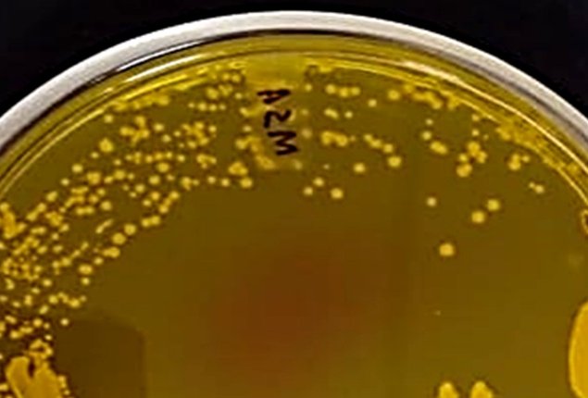

Fig. 1. Presumptive S. aureus Colonies in Mannitol Salt agar

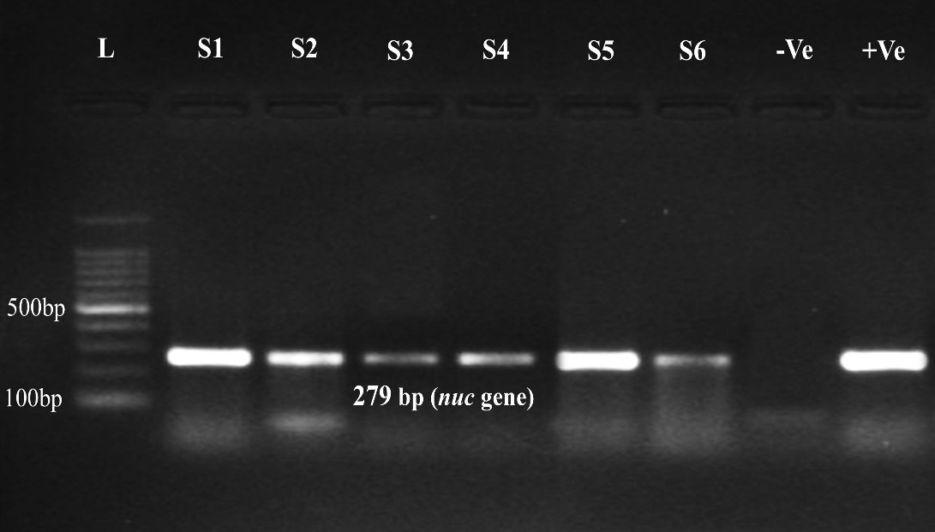

Fig. 2. Results of S. aureus species-specific PCR (nuc gene)
L- 100 bp Ladder; S1-S6 – Samples (279 bp); -Ve – Negative Control; +Ve – Positive Control

Coagulase production is one of the important characteristics of S. auresus, as it is highly correlated with the production of enterotoxins, which in turn confirms the food poisoning ability of the pathogen in humans (Ben Chehida et al., 2024). All six isolates were evaluated for their ability to produce coagulase using specific PCR targeting the Coa gene, which is responsible for coagulase production; it was observed that all six isolates could amplify the Coa gene (product size 600 bp) (Fig. 3).

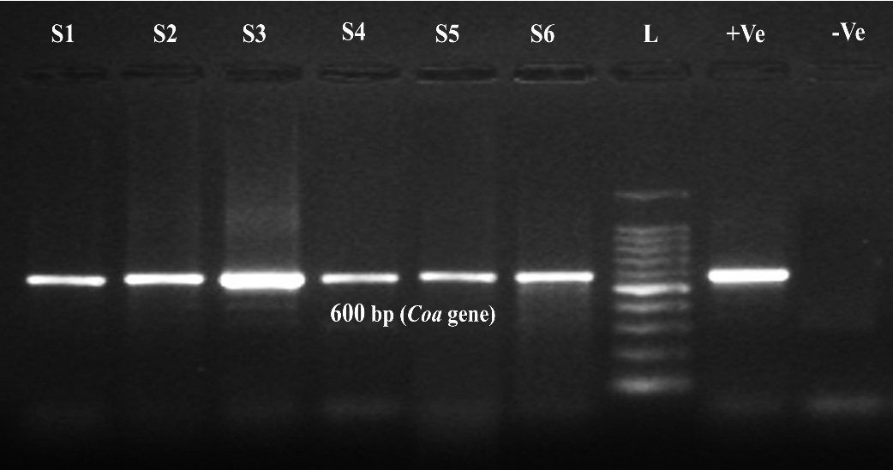

Fig. 3. Results of S. aureus Coa gene PCR
L- 100 bp Ladder; S1-S6 – Samples (600 bp); -Ve – Negative Control; +Ve – Positive Control

The emergence of drug resistance against the commonly used antibiotics in common pathogens warranted elaborate work on AMR. In this study, the antibiotic sensitivity profile of the isolates was evaluated using the standard disc diffusion method. It revealed that all six isolates tested were completely resistant to Ampicillin and Penicillin. Some were resistant to Chloramphenicol, Clindamycin, Gentamicin, and Ofloxacin. However, other antibiotics such as Co-trimoxazole, Ciprofloxacin, Tetracycline, Linezolid, Doxycyclin, and Nitrofurentoin were found to be effective. The ABST results obtained were depicted in Table 5. To support our findings, similar ABST results were obtained in an earlier study; A complete resistant pattern to Penicillin groups and a variable resistant pattern to other groups were observed against S. aureus isolated from the dairy sector (Berhilevych et al., 2017).

Table 5. Antibiotic sensitivity Profile of S. auresus isolates

Antibiotics | S1 | S2 | S3 | S4 | S5 | S6
Penicillin  (P-10U) | R | R | R | R | R | R
Co-trimoxazole  (SXT-25 µg) | S | S | S | S | S | S
Ciprofloxacin  (CIP-10 µg) | S | S | S | S | S | S
Ampicillin  (AMP-10µg) | R | R | R | R | R | R
Tetracycline  (TE-10 µg) | S | S | S | S | S | S
Chloramphenicol  (C-30 µg) | S | R | R | S | S | S
Clindamycin  (CD-µg) | S | S | S | R | R | S
Gentamicin  (GM-30 µg) | I | R | R | R | S | S
Linezolid  (LZD-15 µg) | S | S | S | S | S | S
Norfloxacin  (NX-10 µg) | S | I | I | I | S | S
Doxycyclin  (DO-30 µg) | S | S | S | S | S | S
Ofloxacin  (OX-5 µg) | R | R | I | R | R | S
Erythromycin  (E-30 µg) | S | S | S | I | I | S
Nitrofurentoin  (NIT-300 µg) | S | S | S | S | S | S

S1-S6 – Isolates

To overcome the spread of S. aureus through meat and food, intensive education of the public, slaughterhouse workers, and food handlers to follow strict hygienic measures in the working environment and at home. Also, further research in the field of development of alternative therapeutics, such as herbs, antimicrobial peptides, lysins, bacteriophages, and nanoparticles, is warranted to overcome the AMR issues.

4. Conclusion

To conclude, Staphylococcus aureus is a common commensal bacterium on the skin, as well as an important pathogen in foreign-body infections. In addition, it is also an economically important pathogen of animals and is responsible for causing mastitis in dairy animals, which often leads to early culling of animals and thereby incurring heavy economic loss to the owner. On the Other hand emergence of antimicrobial resistance is a serious public health threat, and therefore, to overcome this emerging crisis, an alternative approach, such effective vaccine, phage therapy, herbal/homeopathy therapy, antimicrobial peptides, etc., should be in place. In the present study, isolation and identification of Coagulase-positive S. aureus was attempted from the nasal swabs of slaughterhouse workers (n=50) by cultural, Gram staining, and molecular assays (amplification of nuc and Coa gene by PCR). 6 isolates were obtained and evaluated for their antibiotic sensitivity profile, which shows resistance to multiple groups of antibiotics, viz. Ampicillin, Penicillin, Chloramphenicol, Clindamycin, Gentamicin, and Ofloxacin in in vitro antibiotic sensitivity analysis. This alarming increase in AMR among S. aureus needs exhaustive research and community education for the public, slaughterhouse workers, and food handlers to overcome the problems in the future. In research, emphasis should be given to the One Health approach to prevent the spread of pathogens between animals, humans, and the environment.
DISCLAIMER (ARTIFICIAL INTELLIGENCE)
Author(s) hereby declare that NO generative AI technologies such as Large Language Models (ChatGPT, COPILOT, etc) and text-to-image generators have been used during the writing or editing of this manuscript.

COMPETING INTERESTS DISCLAIMER:
Authors have declared that they have no known competing financial interests OR non-financial interests OR personal relationships that could have appeared to influence the work reported in this paper.

References

Abdallah, E. M., & Sulieman, A. M. E. (2024). Staphylococcus aureus. Microbial Toxins in Food Systems: Causes, Mechanisms, Complications, and Metabolism, 235.

Alam, M. T., Petit III, R. A., Crispell, E. K., Thornton, T. A., Conneely, K. N., Jiang, Y., ... & Read, T. D. (2014). Dissecting vancomycin-intermediate resistance in Staphylococcus aureus using genome-wide association. Genome biology and evolution, 6(5), 1174-1185.

Alara, J. A., & Alara, O. R. (2024). An overview of the global alarming increase of multiple drug resistant: a major challenge in clinical diagnosis. Infectious Disorders-Drug TargetsDisorders), 24(3), 26-42.

Ali, S., Nazir, F., Ahmad, M. U., Sarfraz, H., Sarwar, A., Aziz, T., ... & Al-Joufi, F. A. (2025). Isolation, Identification, biochemical and molecular characterization of potential source of enterotoxigenic strains of Staphylococcus aureus from the bovine raw and mastitis milk. International Dairy Journal, 106306.

Argaw, S., & Addis, M. (2015). A review on staphylococcal food poisoning. Food Science and Quality Management, 40(2015), 59-72.

Argudín, M. A., Cariou, N., Salandre, O., Le Guennec, J., Nemeghaire, S., & Butaye, P. (2013). Genotyping and antimicrobial resistance of Staphylococcus aureus isolates from diseased turkeys. Avian pathology, 42(6), 572-580.

Beaumont, M., Subramanian, B., Agwuh, K., Ryan, Y., & Pichon, B. (2024). Clinical impact and public health challenges of a PVL-MRSA bacteraemia outbreak amongst people who inject drugs in South Yorkshire, UK. Access Microbiology, 6(2), 000642-v3.

Ben Chehida, F., Tombari, W., Gharsa, H., Rabia, Y., Ferhi, S., Jrad, M., & Messadi, L. (2024). New Insights into Molecular Characterization, Antimicrobial Resistance and Virulence Factors of Methicillin-Sensitive Coagulase-Positive Staphylococcus spp. from Dogs with Pyoderma and Otitis Externa. Microbiology Research, 15(3).

Berhilevych, O. М., Kasianchuk, V. V., Lotskin, I. М., Garkavenko, T. O., & Shubin, P. A. (2017). Characteristics of antibiotic sensitivity of Staphylococcus aureus isolated from dairy farms in Ukraine. Regulatory Mechanisms in Biosystems, 4(8), 559-563.

Brakstad, O. G., Aasbakk, K., & Maeland, J. A. (1992). Detection of Staphylococcus aureus by polymerase chain reaction amplification of the nuc gene. Journal of clinical microbiology, 30(7), 1654-1660.

Brown, D. F., Edwards, D. I., Hawkey, P. M., Morrison, D., Ridgway, G. L., Towner, K. J., & Wren, M. W. (2005). Guidelines for the laboratory diagnosis and susceptibility testing of methicillin-resistant Staphylococcus aureus (MRSA). Journal of antimicrobial chemotherapy, 56(6), 1000-1018.

Chan, K. S., & Shelat, V. G. (2024). The Ongoing Debate on the Use of Prophylactic Antibiotics in Acute Pancreatitis—Is There a Conclusion? A Comprehensive Narrative Review. Antibiotics, 13(5), 411.

Clinical and Laboratory Standards Institute, Methods for dilution antimicrobial susceptibility tests for bacteria that grow aerobically. M07 standard, 12th ed. Clinical and Laboratory Standards Institute, Wayne, PA, (2018)

El-Jakee, J., Nagwa, A. S., Bakry, M., Zouelfakar, S. A., Elgabry, E., & El-Said, W. G. (2008). Characteristics of Staphylococcus aureus strains isolated from human and animal sources. American-Eurasian Journal of Agricultural & Environmental Sciences, 4(2), 221-229.

Freitas, J. K. G. R., de Assis, C. F., de Oliveira, T. R. M., de Sousa, B. J., de Medeiros Maia, C. M., Pereira, A. S., ... & Damasceno, K. S. F. D. S. C. (2024). Global prevalence of staphylococcal enterotoxins in food contaminated by Staphylococcus spp.—Systematic review and meta‐analysis. Journal of Food Safety, 44(4), e13154.

Grema, H. A., Geidam, Y. A., Gadzama, G. B., Ameh, J. A., & Suleiman, A. (2015). Methicillin resistant Staphylococcus aureus (MRSA): a review.

Hookey, J. V., Richardson, J. F., & Cookson, B. D. (1998). Molecular typing of Staphylococcus aureus based on PCR restriction fragment length polymorphism and DNA sequence analysis of the coagulase gene. Journal of clinical microbiology, 36(4), 1083-1089.

Jevons, M. P. (1961). “Celbenin”-resistant staphylococci. British medical journal, 1(5219), 124.

Kluytmans, J., & Struelens, M. (2009). Meticillin resistant Staphylococcus aureus in the hospital. Bmj, 338.

Kumar, R., Bhoker, A., Priya, B., & Kumar, A. (2024). Ulcerative Mammillitis. Periparturient Diseases of Cattle, 321-330.

Lindsay, J. A., & Holden, M. T. (2004). Staphylococcus aureus: superbug, super genome?. Trends in microbiology, 12(8), 378-385.

Linz, M. S., Mattappallil, A., Finkel, D., & Parker, D. (2023). Clinical impact of Staphylococcus aureus skin and soft tissue infections. Antibiotics, 12(3), 557.

Mekuria, A., Asrat, D., Woldeamanuel, Y., & Tefera, G. (2013). Identification and antimicrobial susceptibility of Staphylococcus aureus isolated from milk samples of dairy cows and nasal swabs of farm workers in selected dairy farms around Addis Ababa, Ethiopia. Afr J Microbiol Res, 7(27), 3501-3510.

Nema, V., Agrawal, R., Kamboj, D. V., Goel, A. K., & Singh, L. (2007). Isolation and characterization of heat resistant enterotoxigenic Staphylococcus aureus from a food poisoning outbreak in Indian subcontinent. International Journal of Food Microbiology, 117(1), 29-35.

Nema, V., Agrawal, R., Kamboj, D. V., Goel, A. K., & Singh, L. (2007). Isolation and characterization of heat resistant enterotoxigenic Staphylococcus aureus from a food poisoning outbreak in Indian subcontinent. International Journal of Food Microbiology, 117(1), 29-35.

Normanno, G., Corrente, M., La Salandra, G., Dambrosio, A. N. G. E. L. A., Quaglia, N. C., Parisi, A., ... & Celano, G. V. (2007). Methicillin-resistant Staphylococcus aureus (MRSA) in foods of animal origin product in Italy. International journal of food microbiology, 117(2), 219-222.

Normanno, G., Firinu, A., Virgilio, S., Mula, G., Dambrosio, A., Poggiu, A., ... & Celano, G. V. (2005). Coagulase-positive Staphylococci and Staphylococcus aureus in food products marketed in Italy. International journal of food microbiology, 98(1), 73-79.

Pal, M., Kerorsa, G. B., Marami, L. M., & Kandi, V. (2020). Epidemiology, pathogenicity, animal infections, antibiotic resistance, public health significance, and economic impact of staphylococcus aureus: a comprehensive review. American Journal of Public Health Research, 8(1), 14-21.

Pal, M., Shuramo, M. Y., Tewari, A., Srivastava, J. P., & Steinmetz, C. H. (2023). Staphylococcus aureus from a commensal to zoonotic pathogen: a critical appraisal. International Journal of Clinical and Experimental Medicine Research, 7(2).

Papadopoulos, P., Papadopoulos, T., Angelidis, A. S., Boukouvala, E., Zdragas, A., Papa, A., ... & Sergelidis, D. (2018). Prevalence of Staphylococcus aureus and of methicillin-resistant S. aureus (MRSA) along the production chain of dairy products in north-western Greece. Food microbiology, 69, 43-50.

Parasuraman, P., Busi, S., & Lee, J. K. (2024). Standard microbiological techniques (staining, morphological and cultural characteristics, biochemical properties, and serotyping) in the detection of ESKAPE pathogens. In ESKAPE Pathogens: Detection, Mechanisms and Treatment Strategies (pp. 119-155). Singapore: Springer Nature Singapore.

Peacock, S. J., & Paterson, G. K. (2015). Mechanisms of methicillin resistance in Staphylococcus aureus. Annual review of biochemistry, 84(1), 577-601.

Phan, A., Mijar, S., Harvey, C., & Biswas, D. (2025). Staphylococcus aureus in Foodborne Diseases and Alternative Intervention Strategies to Overcome Antibiotic Resistance by Using Natural Antimicrobials. Microorganisms, 13(8), 1732.

Pillsbury, A., Chiew, M., Bates, J., & Sheppeard, V. (2013). An outbreak of staphylococcal food poisoning in a commercially catered buffet. Communicable Diseases Intelligence, 37, 144-148.

Rall, V. L. M., Sforcin, J. M., Augustini, V. C. M., Watanabe, M. T., Fernandes Jr, A., Rall, R., ... & Araújo Jr, J. P. (2010). Detection of enterotoxin genes of Staphylococcus sp isolated from nasal cavities and hands of food handlers. Brazilian Journal of Microbiology, 41, 59-65.

Rammelkamp, C. H., & Maxon, T. (1942). Resistance of Staphylococcus aureus to the action of penicillin. Proceedings of the Society for Experimental Biology and Medicine, 51(3), 386-389.
Rasquel-Oliveira, F. S., Ribeiro, J. M., Martelossi-Cebinelli, G., Costa, F. B., Nakazato, G., Casagrande, R., & Verri, W. A. (2025). Staphylococcus aureus in inflammation and pain: update on pathologic mechanisms. Pathogens, 14(2), 185.

Reverter, M., Vega-Heredia, S., & Warburton, P. J. (2025). Historical Perspective and Contribution of Aquaculture to the AMR Global Pandemic. In Antimicrobial Resistance in Aquaculture and Aquatic Environments (pp. 17-38). Singapore: Springer Nature Singapore.

Singh, A., Walker, M., Rousseau, J., & Weese, J. S. (2013). Characterization of the biofilm forming ability of S taphylococcus pseudintermedius from dogs. BMC veterinary research, 9(1), 93.

Skinner, D., & Keefer, C. S. (1941). Significance of bacteremia caused by Staphylococcus aureus: a study of one hundred and twenty-two cases and a review of the literature concerned with experimental infection in animals. Archives of internal medicine, 68(5), 851-875.

Todd, J. K. (2005). Staphylococcal infections. Pediatrics in review, 26(12), 444-450.

Verma, S., Malik, Y. S., Singh, G., Dhar, P., & Singla, A. K. (2024). Comprehensive Knowledge About Major Infectious Diseases of Livestock, Poultry, Pets, and Wildlife Species. In Core Competencies of a Veterinary Graduate (pp. 77-99). Singapore: Springer Nature Singapore.

Vinu, W., Kabeer, D. A., Khan, R. T., Ashif Ali, N. K., Ajmal, P. M., Fuad Sharaf, V. C., & Reddy, B. S. (2025). Introduction to Physiological Aspects of Food Safety. In Physiological Perspectives on Food Safety: Exploring the Intersection of Health and Nutrition (pp. 1-63). Cham: Springer Nature Switzerland.

Zhang, Y., Li, R., Zou, G., Guo, Y., Wu, R., Zhou, Y., ... & Li, J. (2024). Discovery of antimicrobial lysins from the “dark matter” of uncharacterized phages using artificial intelligence. Advanced Science, 11(32), 2404049.

