Detection and Antibiogram of Staphylococcus spp. & Vibrio spp. Isolated from Fresh Fruit Juices and Sauces Collected from Cafes and Restaurants in Dhaka City, Bangladesh

ABSTRACT

Aims: This study aims to assess the microbial status of fruit juices and sauces from cafes and restaurants in Dhaka city, Bangladesh.
Study design: The sample was cultivated on nutrient agar to get isolated colonies. The colony was inoculated on selective media. Then the isolated colonies were identified by biochemical tests, and their drug susceptibility was investigated.
Place and Duration of Study: The study was carried out in Dhaka city in Bangladesh between -----------to ---------. .
Methodology: Fruit juice and sauce samples were collected by aseptic technique. The samples were transported to the laboratory within one hour. Several diluted samples were inoculated on a nutrient agar plate to get an isolated colony. The isolated colonies were cultivated on selective media. The colony morphology was investigated. Gram staining and biochemical tests were conducted to identify the specific organisms. Finally, the antibiotic susceptibility tests were done by the Kirby-Bauer disc diffusion method.
Results: Selective media were used to identify Staphylococcus spp. and Vibrio spp. Gram staining and biochemical tests indicate the presence of Staphylococcus spp. and Vibrio spp.
Out of 42 samples, 21 samples were Staphylococcus spp., and 3 samples were Vibrio spp. Two strains of Staphylococcus spp were amoxicillin and amikacin-resistant. One strain of Vibrio spp. was ceftriaxone-resistant.
Conclusion: The result revealed that about 57% of samples were contaminated by Staphylococcus spp. (50%) and Vibrio spp. (7%). Some of the organisms were drug-resistant.

Keywords: Staphylococcus spp.; Vibrio spp.; Selective media; Pathogens; Contamination; antibiotic susceptibility; antibiotic resistance.

1. INTRODUCTION
Fruit juice is a popular soft drink made from the pulp of various fresh fruits. It contains several beneficial components, such as flavonoid glycosides, dietary fiber, calcium, carotenoids, amino acids, vitamins, and others that help enhance the immune system and prevent diseases like heart disease, certain cancers, asthma, etc. Fruit juices and sauces are widely consumed beverages in Bangladesh due to their refreshing taste and nutritional benefits. However, the safety and microbiological quality of these products have become a major public health concern, especially in urban areas like Dhaka city, where street vendors and local shops often operate under unhygienic conditions. The consumption of street foods and drinks has increased remarkably in most low- and medium-income countries (LMIC), because of the low startup cost for the vendors and the affordable price for the people with low socio-economic status (Sharma et al., 2020). Contaminated fruit and vegetable juices have been reported to be associated with infectious disease outbreaks, producing high morbidity and mortality across the world (Lima et al., 2016; Aneja, K. R., 2016; Callejón et al., 2015; Salomão, B. D. C. M., 2018; and Kechero et al., 2019). In India, millions of street food vendors are found in the metropolitan areas, representing about 2% of the total population (Rane S., 2011; Sundaram S. S., 2008; and Choudhury et al., 2011). The World Health Organization (WHO) has reported more than 600 million cases of food-related diseases in the world, resulting in 420,000 deaths and 27,000,000 years of life lost (YLL) (Havelaar et al., 2015). Major microorganisms commonly found in street juice include Escherichia coli, Salmonella typhi, Pseudomonas spp, Staphylococcus aureus, and Vibrio cholerae (Sharma et al., 2020). These pathogens are linked to typhoid fever, food poisoning, gastroenteritis, enteric fever, and diarrhea, which, in many cases, become life-threatening across the globe (Callejón et al., 2015; Aneja et al., 2014; Verma and Gaur, 2017; and Aruna and Rajan, 2017). Escherichia coli and Vibrio cholera have been commonly found in Bangladesh and Japan (Ubong et al., 2011 and Uddin et al., 2017). Staphylococcus aureus is one of the most infamous and widespread bacterial pathogens, causing a hard-to-estimate number of uncomplicated skin infections and probably hundreds of thousands to millions of more severe, invasive infections globally per year (Klevens et al., 2007 and Rasigade et al., 2014). It is a leading causative agent in pneumonia and other respiratory tract infections, surgical site, prosthetic joint, and cardiovascular infections, as well as nosocomial bacteremia (Tong et al., 2015). Treatment of S. aureus infections is complicated by antibiotic resistance, and a working vaccine is not available (Cheung and Otto, 2021). On the other hand, in Vibrios, motility is the primary physiology involved in biofilm formation (Arun et al., 2020). The antibiotics are not efficient to treat bacterial infections in biofilm formation (Arun et al., 2020). The antibiotics cannot penetrate the biofilm. The eradication of biofilm is very complicated with the use of commercial antibiotics (Khatoon et al., 2018). Antibiotic resistance has evolved from the frequent use of antibiotics and the transfer of mobile genetic elements through the system of horizontal gene transfer, which often occurred in the bacterial biofilms (I. Sultan, 2018).

In this study, we focus on Staphylococcus spp. and Vibrio spp. based on their virulence properties. It specifically focuses on the detection and antibiotic susceptibility of Staphylococcus spp. and Vibrio spp., which are encountered pathogens in such food products.

2. material and methods

2.1 Study Area
The study was conducted in Dhaka, the capital city of Bangladesh. A total of 42 samples of various fruit juices and sauces were collected over four months. The red circle in the figure indicates the sampling sites (Fig. 1).



Fig. 1. Research and Study Area of the Project (Marked in red circle).

2.2 Types of samples and locations in Dhaka City
The samples were fruit juices and sauces, including orange, lemon, pineapple, sugarcane, papaya, and apple juices, as well as tomato sauce, mustard sauce, and tamarind sauce. These samples were specifically collected from various public locations, including Mohammadpur, Badda, Mirpur, Banani, Khilkhet, Mohakhali, Gulisthan, and Abdullahpur, across Dhaka city. Samples were collected using sterile containers under aseptic conditions to prevent contamination.

2.3 Sample Processing
A total of 42 samples, comprising 6 different fruit juices and 3 types of sauces, were collected in sterile conical flasks from various locations in Dhaka City. All the collected samples were placed on a 4°C ice box to inhibit the growth of microorganisms and were immediately transported to the laboratory for analysis. Serial dilution was performed on the samples to reduce the microbial load. The original and the diluted samples were spread onto nutrient agar media to observe primary microbial growth.

2.4 Experiment Design
A good experiment design is essential to conclude a study. The summary of the complete experimental activities of these specific bacterial isolates is shown in Figure 2.

Sample collection from different fruit juices and sauces

Serial dilution & spread on bacteriological media (MSA) for isolation of Staphylococcus spp.

Serial dilution & spread on bacteriological media (TCBS) for isolation of Vibrio spp.

Subcultural on MSA for isolation of pure Staphylococcus spp.
Subcultural on TCBS for isolation of pure Vibrio spp.

Biochemical test (Gram staining, catalase, oxidase, SIM agar, TSI & urease test.)

Detection of Staphylococcus spp. & Vibrio spp.

Antibiotics susceptibility test

Fig. 2. Schematic workflow

2.5 Isolation and Identification of Microorganisms

Diluted samples were spread over Mannitol Salt Agar (MSA) agar and Thiosulfate Citrate Bile Salts Sucrose (TCBS) agar media and incubated for 24 hours at 37ºC for the isolation of Staphylococcus spp. and Vibrio spp. respectively. Isolated colonies were selected from the plates, and the pure cultures were subjected to Gram staining and biochemical tests. Based on different biochemical and morphological characteristics, the isolates were identified.

2.5.1 Gram Staining
Gram staining is a laboratory technique that differentiates bacteria into two major groups, Gram-positive (Purple color) and Gram-negative (Pink/Red color), based on their cell wall structure. Gram stains yield results much more quickly than culturing, and are especially important when infection would make an important difference in the patient's treatment and prognosis; examples are cerebrospinal fluid for meningitis and synovial fluid for septic arthritis ( Ryan K. J., 2018 and Søgaard et al., 2007). Gram staining is the initial step in identifying a bacterial group.

    - Biochemical Tests
An isolated colony was streaked on the respective media to obtain a pure culture. All the plates were incubated at 37 ̊C for 24 hours. Pure bacterial isolates were preserved at 4 ̊C. The bacterial isolates were recognized based on morphological and biochemical characteristics such as Catalase, Oxidase, SIM agar, Urease, and TSI. The identification was based on its microscopic, physiological, and biochemical characteristics (Bergey D. H., 1994).

      - Triple Sugar Iron Agar Test (TSI)
The TSI test differentiates among members of the Enterobacteriaceae and also distinguishes between the Enterobacteriaceae and other groups of intestinal bacilli. It is not the routine test for identifying Staphylococcus spp. But this test is used for Vibrio spp.

2.5.2.2 Indole Production Test
Some bacteria can use tryptophan as a sole carbon source. Tryptophan is an essential amino acid that can undergo oxidation by way of the enzymatic degradation of some bacteria. The enzyme tryptophanase mediates the conversion of tryptophan into metabolic products. This test determines the ability of microorganisms to degrade the aromatic amino acid tryptophan.

      - Methyl Red (MR) Test
Some bacteria can utilize glucose and convert it to a stable acid like lactic acid, acetic acid, succinic acid, or formic acid as the end product. The MR test determines the ability of microorganisms to oxidize glucose with the production and stabilization of high concentrations of acid end products. This acidity is identified by methyl red, a pH indicator.
      - Voges-Proskauer (VP) Test
Some MR-negative organisms further metabolize the acid end product, which decreases acidity in the medium, raising the pH towards neutrality (pH 6.0 or above). The VP test is used to determine if an organism produces acetylmethyl carbinol, a neutral end product of glucose fermentation by certain bacteria.
      - Citrate Utilization Test
In the absence of fermentable sugar, some microorganisms are capable of using citrate as a sole carbon source for cellular metabolism. The ability depends on the presence of a citrate permease enzyme that facilitates the transport of citrate into the cell. Citrate is the first major intermediate in the Tricarboxylic Acid cycle and is produced by the condensation of acetyl-CoA with oxaloacetate. A green medium, Simmons citrate agar slant containing sodium citrate and bromothymol blue as a pH indicator. If the organism utilizes citrate, it produces alkaline byproducts, causing the agar slant to turn blue.
      - Catalase Test
Catalase is a common enzyme found in nearly all living organisms exposed to oxygen (such as bacteria, plants, and animals) which catalyzes the decomposition of hydrogen peroxide to water and oxygen (Chelikani et al., 2004). Catalase has one of the highest turnover numbers of all enzymes; one catalase molecule can convert millions of hydrogen peroxide molecules to water and oxygen each second (Goodsell D. S., 2004). In the catalase test, a drop of hydrogen peroxide is placed on a microscope slide and smeared with a live colony. If the mixture produces bubbles, the organism is considered to be catalase-positive.
      - Oxidase Test
Cytochrome oxidase is a key component of the electron transport chain during aerobic respiration. Aerobic bacteria, some facultative anaerobes, and microaerophiles exhibit oxidase activity. This test is used to assist in the identification of Pseudomonas spp., Neisseria spp., Alcaligens spp., Aeromonas spp., Campylobacter spp., Vibrio spp., Brucella spp., and Pasteurella spp.
2.5.2.8 Coagulase Test
Coagulase enzyme causes plasma to clot by converting fibrinogen to fibrin. The coagulase test is used to differentiate Staphylococcus aureus (positive), which produces the enzyme coagulase, from S. epidermis and S. saprophyticus (negative), which do not produce coagulase.
2.6 Antimicrobial Susceptibility Testing
Antimicrobial susceptibility testing is the measure of the susceptibility of organisms against antibiotics. Sensitivity testing results can allow a clinician to change the choice of antibiotics from empiric therapy, which is when an antibiotic is selected based on clinical suspicion about the site of an infection and common causative bacteria, to directed therapy, in which the choice of antibiotic is based on knowledge of the organism and its sensitivities (Leekha et al., 2011). A standardized filter-paper disc-agar diffusion procedure, known as the Kirby-Bauer method, is frequently used to determine the drug susceptibility of isolated microorganisms (Hudzicki, 2009). The disc diffusion method involves selecting a strain of bacteria, placing it on an agar plate, and observing bacterial growth near antibiotic-impregnated discs (Syal et al., 2017). In the disk diffusion method, Muller-Hinton agar is used as a growth medium. The organism was diluted in saline water, and then a sterile cotton swab was immersed in the inoculum and swabbed on the medium. Then the antibiotic discs were evenly dispensed and lightly pressed onto the agar surface. The plates were then incubated at 35°C to 37°C for 18-24 hours, and then the zone of inhibition was measured. The bacteria are classified as sensitive, intermediate, or resistant to an antibiotic by comparing the diameter of the zone of inhibition to defined thresholds which correlate with MICs (Minimum Inhibitory Concentrations) (Jorgensen and Turnidge, 2015). The Clinical and Laboratory Standards Institute (CLSI) and European Committee on Antimicrobial Susceptibility Testing (EUCAST) provide standards for the type and depth of agar, temperature of incubation, and method of analysing results (Hombach et al., 2015). Disc diffusion is considered the cheapest and most simple of the methods used to test for susceptibility, and is easily adapted to testing newly available antibiotics or formulations (Reller et al., 2009).

Statistical analysis
All experiments were performed in triplicate. The results were reported as mean±standard deviation. The standard deviation was less than 5%.

3. results and discussion

All the collected samples were diluted from 10⁻¹ to 10⁻⁷ to get discrete colonies. Two selective media were used to identify Staphylococcus spp. and Vibrio spp. (Table 1).

Experiments | Staphylococcus spp. | Vibrio spp.
Nutrient Agar | White/golden/, round, opaque, glistening colony | Small/moderate size, white/translucent, smooth, opaque, creamy colony
Mannitol Salt Agar | White/golden/red, large, opaque and convex colony | Not applied
Thiosulfate Citrate Bile Salts Sucrose Agar | Not applied | Yellow/blue-green colony
Gram Staining | +ve | -ve
Microscopy | Cocci, grape-like cluster, diameter: 0.5-1µm | Rod, comma shaped, often with a polar flagellum, 1.5-3.0 µm in length
Table 1. Colonial Characteristics and Gram staining of the organisms

3.1 Cultivation On Mannitol Salt Agar (MSA) Plate
The diluted samples were spread on an MSA plate. After the overnight incubation, a yellow or white pinpoint colony was observed (Fig. 3).

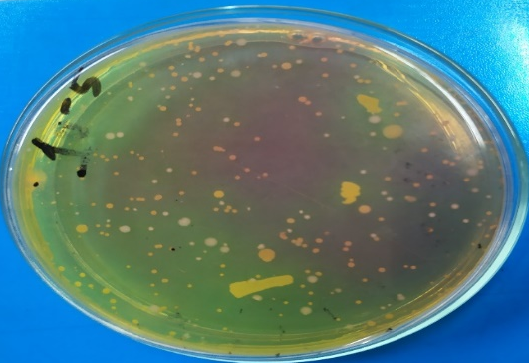

Fig. 3. The yellow colonies on the MSA plate

3.2 Cultivation on Thiosulfate Citrate Bile Salts Sucrose (TCBS) plate
The diluted samples were inoculated on a TCBS plate. The medium is selective and differential for Vibrio spp. Flat yellow colonies were observed on TCBS media (Fig. 4).
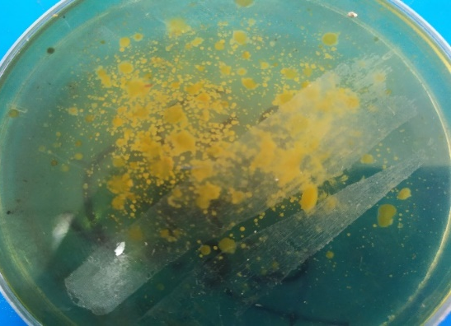

Fig. 4. Flat yellow colonies on TCBS media

3.3 Microscopic Examination of Staphylococcus spp.
In Gram staining, the organisms were found Gram-positive, cocci-shaped, arranged in grape-like clusters, which are the standard staining characteristics of Staphylococcus spp. (Fig. 5).
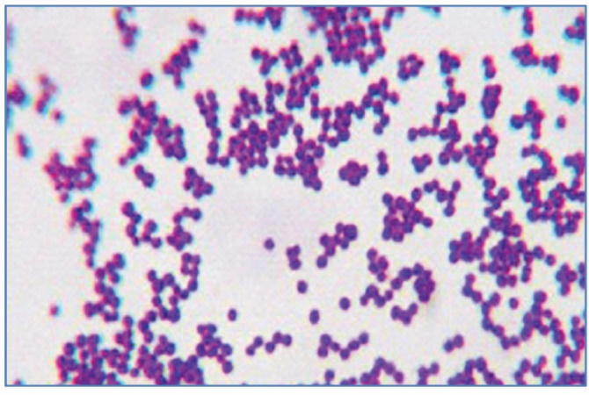
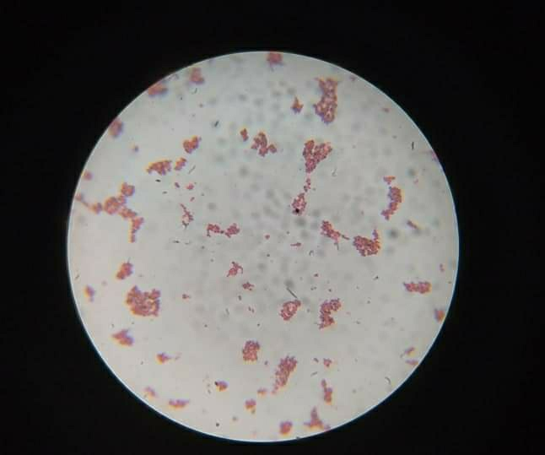

Fig. 5. The microscopic view of Staphylococcus spp. from MSA plate

3.4 Microscopic examination of Vibrio spp.
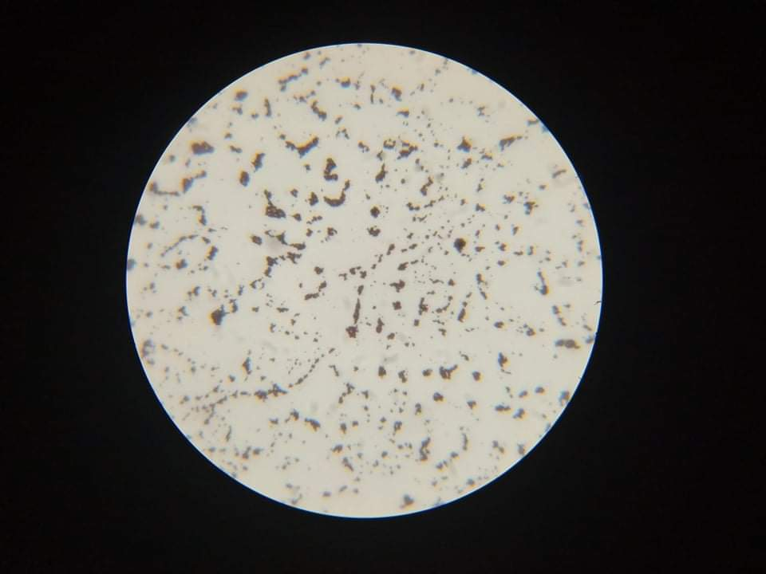
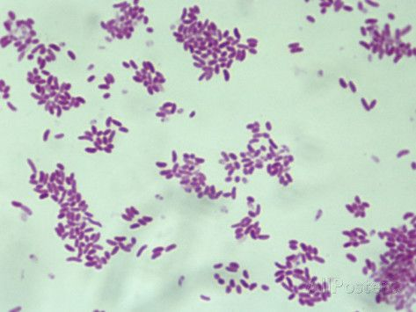
Gram staining of Vibrio spp. showed Gram-negative rod or comma-shaped Organisms arranged in clusters under the light microscope (Fig. 6).

Fig. 6. The microscopic view of Vibrio spp. from TCBS plate

3.5 Identification of organisms
Several biochemical tests revealed the presence of Staphylococcus spp. and Vibrio spp. (Table 2). Isolates identified as Staphylococcus spp. were MR-VP, citrate, coagulase, and catalase positive; on the other hand, Indole and oxidase were negative. Vibrio spp. was indole, citrate, oxidase, and catalase positive and MR, coagulase negative.

Table 2. Biochemical test for the isolates
Number of Isolates | Gram’s Staining |  | TSI |  |  |  |  |  |  | Indole | MR | VP | Citrate | Oxidase | Catalase | Coagulase | Suspected  Microorganism
Number of Isolates | Type | Shape | Slant | Butt | Glucose | Lactose | Sucrose | H₂S | Gas
21 | +ve | Cocci | n/a | n/a | n/a | n/a | n/a | n/a | n/a | - | + | + | + | - | + | + | Staphylococcus spp.
3 | -ve | Rod | Yellow  ( Acidic) | Yellow  (Acidic) | + | - | + | - | - | + | - | +/- | + | + | + | - | Vibrio spp.

3.6 Organisms found in juice and sauce
A total of 42 samples, consisting of 6 different fruit juices and 3 sauces, were collected in sterile conical flasks from various locations in Dhaka city. The colony morphology, Gram staining, and biochemical tests reveal the presence of Staphylococcus spp. and Vibrio spp. Among them, 21 samples were Staphylococcus spp., and 3 samples were Vibrio spp. positive (Table 3).

Table 3. The identified organisms found in fresh juices and sauces
Types of samples | Number of samples | Staphylococcus spp. | Vibrio spp.
Papaya juice | 7 | 3 | _
Orange juice | 7 | 4 | _
Lemon juice | 5 | 3 | _
Pineapple juice | 7 | 4 | 1
Sugar-cane juice | 8 | 5 | 1
Apple juice | 3 | 2 | _
Tomato sauce | 1 | _ | _
Mustard sauce | 2 | _ | _
Tamarind sauce | 2 | _ | 1
Total | 42 | 21 | 3

3.7 Antibiotic Sensitivity Profile of Staphylococcus spp.
Most of the organisms were susceptible to prescribed drugs. Two isolates were amoxicillin-resistant, and the other two isolates were amikacin-resistant (Fig. 7). The papaya juice and sugarcane juice contained the antibiotic-resistant Staphylococcus spp.

Fig. 7. Antibiotic susceptibility patterns of Staphylococcus spp.

3.8 Antibiotic Sensitivity Profile of Vibrio spp.

Of the three isolates, one was Ceftriaxone-resistant. The isolate was found in sugarcane juice. During the rainy season, the sugarcane field floods. The sugarcane may contain Vibrio spp. from the floodwater.

Fig. 8. Antibiotic susceptibility patterns of Vibrio spp.

4. Conclusion
This study was conducted on various fruit juices and sauces collected from the streets of Dhaka city, Bangladesh. The study aimed to isolate and identify Staphylococcus spp. and Vibrio spp. from different types of fruit juices and sauces, and to assess the antibiotic sensitivity patterns of these isolated strains. A total of 42 samples, consisting of 6 different fruit juices and 3 sauces, were collected in sterile conical flasks from various locations. The samples were subjected to serial dilution to reduce the microbial load. After dilution, they were spread on the nutrient agar media to observe the primary microbial growth. Then the isolated colonies were inoculated on selective media. The colony morphology on selective media, Gram staining, and biochemical tests indicate the presence of Staphylococcus spp. and Vibrio spp. Some of the organisms were antibiotic-resistant, and these organisms were spread through juice and sauce consumption. The findings of this study are significant for public health as well as highlighting the potential risks associated with foodborne pathogens and emphasizing the need for increased awareness of food safety. To mitigate these risks, it is essential to practice proper food hygiene, such as thoroughly washing fruits before juice preparation and ensuring safe handling procedures during all stages of the food supply chain.

Ethical approval

Not needed ethical approval for this work

References
Sharma, N., Singh, K., Toor, D., Pai, S. S., Chakraborty, R., & Khan, K. M. (2020). Antibiotic resistance in microbes from street fruit drinks and hygiene behavior of the vendors in Delhi, India. International Journal of Environmental Research and Public Health, 17(13), 4829.)

Lima Tribst, A. A., de Souza Sant’Ana, A., & de Massaguer, P. R. (2009). Microbiological quality and safety of fruit juices—past, present and future perspectives. Critical reviews in microbiology, 35(4), 310-339.

Aneja, K. R. (2016). Microbes associated with fruit juices sold in the retail market and their inactivation with plant antimicrobials.

Callejón, R. M., Rodríguez-Naranjo, M. I., Ubeda, C., Hornedo-Ortega, R., Garcia-Parrilla, M. C., & Troncoso, A. M. (2015). Reported foodborne outbreaks due to fresh produce in the United States and European Union: trends and causes. Foodborne pathogens and disease, 12(1), 32-38.

Salomão, B. D. C. M. (2018). Pathogens and spoilage microorganisms in fruit juice: an overview. Fruit juices, 291-308.

Kechero, F. K., Baye, K., Tefera, A. T., & Tessema, T. S. (2019). Bacteriological quality of commonly consumed fruit juices and vegetable salads sold in some fruit juice houses in Addis Ababa, Ethiopia. Journal of Food Safety, 39(1), e12563.

Rane, S. (2011). Street vended food in developing world: hazard analyses. Indian journal of microbiology, 51(1), 100-106.

Sundaram, S. S. (2008). National policy for urban street vendors and its impact. Economic and Political Weekly, 22-25.

Choudhury, M., Mahanta, L., Goswami, J., Mazumder, M., & Pegoo, B. (2011). Socio-economic profile and food safety knowledge and practice of street food vendors in the city of Guwahati, Assam, India. Food control, 22(2), 196-203

Havelaar, A. H., Kirk, M. D., Torgerson, P. R., Gibb, H. J., Hald, T., Lake, R. J., ... & World Health Organization Foodborne Disease Burden Epidemiology Reference Group. (2015). World Health Organization global estimates and regional comparisons of the burden of foodborne disease in 2010. PLoS medicine, 12(12), e1001923.

Aneja, K. R., Dhiman, R., Aggarwal, N. K., Kumar, V., & Kaur, M. (2014). Microbes associated with freshly prepared juices of citrus and carrots. International journal of food science, 2014(1), 408085.

Verma, A. N. U. K. R. I. T. I., & Gaur, S. M. R. I. T. I. (2017). Microbiological analysis of street vended sugarcane juice in Noida city, India. Int J Pharma Bio Sci, 8, 496-499.

Aruna, N., & Rajan, V. (2017). Microbial analysis of street foods of different locations at Chennai city, India. Innovat Int. J. Med. Pharma. Sci, 2, 21-23.

Ubong, A., Tunung, R., Noorlis, A., Elexson, N., Tuan Zainazor, T. C., Ghazali, F. M., ... & Son, R. (2011). Prevalence and detection of Vibrio spp. and Vibrio cholerae in fruit juices and flavored drinks. International food research journal, 18(3).

Uddin, M.E.; Akter, T.; Parvez, M.A.K.; Nahar, S.; Pervin, S.; Debnath, B.; Datta, S. Microbial safety of street vended fruit juices in Dhaka City of Bangladesh. J. Adv. Microbiol. 2017, 3, 1–7.

Klevens, R. M., Morrison, M. A., Nadle, J., Petit, S., Gershman, K., Ray, S., ... & Active Bacterial Core surveillance (ABCs) MRSA Investigators. (2007). Invasive methicillin-resistant Staphylococcus aureus infections in the United States. Jama, 298(15), 1763-1771.

Rasigade, J. P., Dumitrescu, O., & Lina, G. (2014). New epidemiology of Staphylococcus aureus infections. Clinical Microbiology and Infection, 20(7), 587-588.

Tong, S. Y., Davis, J. S., Eichenberger, E., Holland, T. L., & Fowler Jr, V. G. (2015). Staphylococcus aureus infections: epidemiology, pathophysiology, clinical manifestations, and management. Clinical microbiology reviews, 28(3), 603-661.

Cheung, G. Y., Bae, J. S., & Otto, M. (2021). Pathogenicity and virulence of Staphylococcus aureus. Virulence, 12(1), 547-569.

Arunkumar, M., LewisOscar, F., Thajuddin, N., Pugazhendhi, A., & Nithya, C. (2020). In vitro and in vivo biofilm forming Vibrio spp: A significant threat in aquaculture. Process Biochemistry, 94, 213-223.

Khatoon, Z., McTiernan, C. D., Suuronen, E. J., & Mah, T. F. (2018). EI Alarcon Bacterial biofilm formation on implantable devices and approaches to its treatment and prevention., 2018, 4, p. e01067. DOI: https://doi. org/10.1016/j. heliyon, e01067.

I. Sultan, S. Rahman, A.T. Jan, M.T. Siddiqui, A.H. Mondal, Q.M.R. Haq,
Antibiotics, resistome and resistance mechanisms: a bacterial perspective, Front.
Microbiol. (2018), https://doi.org/10.3389/fmicb.2018.02066

Ryan, K. J. (2018). Sherris medical microbiology. McGraw-Hill Education.

Søgaard, M., Nørgaard, M., & Schønheyder, H. C. (2007). First notification of positive blood cultures and the high accuracy of the Gram stain report. Journal of Clinical Microbiology, 45(4), 1113-1117.

Bergey, D. H. (1994). Bergey's manual of determinative bacteriology. Lippincott Williams & Wilkins.

Chelikani, P., Fita, I., & Loewen, P. C. (2004). Diversity of structures and properties among catalases. Cellular and Molecular Life Sciences CMLS, 61(2), 192-208.).

Goodsell, D. S. (2004). Catalase. RCSB Protein Data Bank.

Leekha, S., Terrell, C. L., & Edson, R. S. (2011, February). General principles of antimicrobial therapy. In Mayo clinic proceedings (Vol. 86, No. 2, pp. 156-167). Elsevier.

Hudzicki, J. (2009). Kirby-Bauer disk diffusion susceptibility test protocol. American society for microbiology, 15(1), 1-23.

Syal, K., Mo, M., Yu, H., Iriya, R., Jing, W., Guodong, S., ... & Tao, N. (2017). Current and emerging techniques for antibiotic susceptibility tests. Theranostics, 7(7), 1795.

Jorgensen, J. H., & Turnidge, J. D. (2015). Susceptibility test methods: dilution and disk diffusion methods. Manual of clinical microbiology, 1253-1273.

Hombach, M., Maurer, F. P., Pfiffner, T., Böttger, E. C., & Furrer, R. (2015). Standardization of operator-dependent variables affecting precision and accuracy of the disk diffusion method for antibiotic susceptibility testing. Journal of clinical microbiology, 53(12), 3864-3869.

Reller, L. B., Weinstein, M., Jorgensen, J. H., & Ferraro, M. J. (2009). Antimicrobial susceptibility testing: a review of general principles and contemporary practices. Clinical infectious diseases, 49(11), 1749-1755.

