Original Research Article

Antifungal Activities of Fleshy Fungi Against Phytopathogenic Fungi

.
ABSTRACT

The inhibitory effect of forty species of fleshy fungi species (Auricularia sp., Clitocybe sp., Fistulina sp., Fomes sp., Laccaria sp., Lycoperdon sp., Schizophyllum commune , Phellinus sp. Tricholoma sp., Collybia sp., Coriolus versicolor, Flammulina sp., Inocybe sp., Laetiporus sp., Lentinula sp., Lepiota sp., Mycena sp., Scleroderma sp., Thelephora sp., Trametes versicolor, Amanita sp., Coprinus sp., Pycnoporus sp., Cortinarius sp., Daldinia concentrica, Ganoderma lucidum , Hydnum sp., Hypholoma sp., Lactarius sp., Lentinus sp., Panaeolus sp., Polyporus sp., Qudemansiella sp., Stereum sp., Amanita sp. Xylaria sp., Cordyceps sp., Marasmius sp., Stropharia sp. and Russula sp.) were tested in vitro against nine phytopathogenic fungi (Rhizoctonia solani, Sclerotium rolfsii, Sclerotinia sclerotiorum, Alternaria brassicae, Fusarium oxysporum f.sp. pisi, Fusarium solani f.sp. pisi, Phoma medicaginis, Colletotrichum capsici and Phytophthora nicotianae) causing fruit rot, leaf spot, root rot and wilt disease of various crops. The antagonistic interaction was found out on the basis of antagonism index value. The maximum antagonism index was found in Stropharia sp., Cordyceps sp., Pycnoporus sp. and Marasmius sp. which were showed very strong inhibition in dual culture. The inhibition includes deadlock at distance, complete or partial replacement of phytopathogenic fungi. During interaction 1080 pairing were carried out of which 82.50 % of pairing showed antagonistic effect against plant pathogen and 17.50 % pairing indicate adverse inhibitory effect over fleshy fungi. During mycelial interaction Phytophthora nicotianae, Sclerotium rolfsii, Rhizoctonia solani and Sclerotinia sclerotiorum exhibit strong competition against fleshy fungi. Thus, it was proved that fleshy fungi have potential inhibitory effect over plant pathogens.

Keywords: Antagonistic; biological control; evaluation; micro fungi; mycelium growth inhibition; wild mushrooms.
1. INTRODUCTION

Fungi play very important role in our ecological system. They act as decomposer, parasitic, pathogenic and antagonistic. Many micro fungi like Trichoderma sp., and Fusarium sp. act as antagonists and used as potential biocontrol agents against so many plant pathogenic fungi. Similarly, wild mushrooms are widely distributed in nature. They have the ability to grow under diverse ecological condition. These macro fungi need so many antimicrobial molecules for their survival in the existing environment. These wild mushrooms synthesize and produces a series of toxic metabolite which include polysaccharide, phenolics, terpenoids and triterpenoids which have antimicrobial properties (Steglich, 1981; Anke et al., 1983; Hautzel et al., 1990; Toyota and Hostettmann, 1990; Becker et al., 1994; Steinmetz et al., 1995; Badalyan, 1998; Badalyan et al., 1998). Badylan et al. (2002) described the antagonistic activity of 17 species of fleshy fungi against Bipolaris sorokiniana, Fusarium culmorum, Gaeumannomyces graminis var. tritici and Rhizoctonia cerealis causing foot and root diseases of winter cereals. In vitro antifungal effect of Boletus, Collybia, Cortinarius, Hebeloma and Lactarius against Cytospora sp., Fusarium oxysporum, Graphium ulmi, Rhizoctonia solani and Stereum purpureum were reported by Chaumont et al. (1982) and Borhani et al. (2011) showed the antagonistic activity of Flammulina velutipes against Bipolaris sorokiniana, Ophiostoma ulmi, Pestalotiopsis funerea, Fusarium culmurum, and Fusarium oxysporum. Thus, the interaction between fleshy fungi and phytopathogenic fungi play key role in identification of new biocontrol agents. The main aim of these studies was to investigate the potentiality of fleshy fungi as antagonistic agent against different combination of fungi which include soil borne, seed borne and foliar fungi.

2. material and methods
All the test wild mushrooms viz., Auricularia sp., Clitocybe sp., Fistulina sp., Fomes sp., Laccaria sp., Lycoperdon sp., Schizophyllum commune, Phellinus sp., Tricholoma sp., Collybia sp., Coriolus versicolor, Flammulina sp., Inocybe sp., Laetiporus sp., Lentinula sp., Lepiota sp., Mycena sp., Scleroderma sp., Thelephora sp., Trametes versicolor, Amanita sp., Coprinus sp., Pycnoporus sp., Cortinarius sp., Daldinia concentrica, Ganoderma lucidum, Hydnum sp., Hypholoma sp., Lactarius sp., Lentinus sp., Panaeolus sp., Polyporus sp., Qudemansiella sp., Stereum sp., Amanita sp., Xylaria sp., Cordyceps sp., Marasmius sp., Stropharia sp. and Russula sp. were collected during the rainy season in the forest area of Himachal Pradesh viz., Kangra, Mandi and Kullu districts. The Isolation from the fresh specimens was done following standard tissue culture technique. Each specimen after washing with the jet of sterile water was cut across the pileal region with the help of sterilized sharp blade to obtain bits (1-2 mm) of tissue, which were dipped in 0.1 per cent mercuric chloride solution using sterile forceps for 10 to 20 seconds. These were repeatedly washed with sterile water (5 washings) and placed on sterilized filter paper to remove excess moisture, the bits were then transferred on PDA slants (Sud 1995) aseptically with the help of sterilized inoculating needle and incubated at 20±1⁰C. Stock cultures were maintained in the refrigerator at 4⁰C. Cultures were revived after a period of 7-10 days on fresh slants.

2.1 Isolation of Plant Pathogens

Ten plant pathogenic fungi viz., Rhizoctonia solani, Sclerotium rolfsii, Sclerotinia sclerotiorum, Alternaria brassicae, Fusarium oxysporum f.sp. pisi, Fusarium solani f.sp. pisi, Phoma medicaginis, Colletotrichum capsici, Phytophthora nicotianae, and Rhynchosporium oryzae were isolated from their hosts viz., maize, cabbage, pea, capsicum, rice, showing characteristic disease symptoms. The infected specimens were collected from research farm/ farmers’ fields around Palampur. The collected diseased samples were washed thoroughly in running tap water for 30 minutes to remove soil particles, air-dried, and cut into 5 mm pieces. Root stems and leaves were surface sterilized in 0.1% HgCl₂ for 15 seconds (Mohmad, 1962) and rinsed three times in sterilized distilled water and were on sterilized dry blotting sheet. The surface sterilized segment will be placed on petri dishes (three to four segments per plate) containing potato dextrose agar medium. The plates were incubated for 2 to 3 days at 25 +1⁰C in the incubator. Pure cultures of the pathogenic fungi were obtained by hyphal tip method (Hyamumachi et al., 2005).

2.2 Evaluation of Anti Plant Pathogenic Activity of Wild Mushrooms
The antagonistic activity of fleshy fungi was carried out by competitive interaction between fleshy fungi and plant pathogenic fungi (soil borne as well as foliar pathogen) in vitro. During evaluation, fresh culture of mushroom and plant pathogenic fungi were grown in 90 mm Petri dishes containing Potato Dextrose Agar (PDA) medium. After complete growth of the fungus, 2 mm diameter of mycelial disks were taken with the help of cork borer. In dual culture experiment, mycelial discs of both fleshy fungi and plant pathogenic fungi were placed in 90 mm diameter petri dishes containing PDA medium. After inoculation, the plates were placed in incubator at 24⁰C for 15-30 days for appropriate growth and interaction. Colony growth and type of interaction were examined regularly. The presence of dense zones of mycelium, aggregated structures such as mycelial cords, pigmented hyphae, exudate droplets, dark pseudosclerotial lines, and fruiting body primordia in the interaction zones were also noted. The antagonistic activity of the various mushroom cultures was tested by the method described by Huang and Hoes (1976). The antagonistic ability of each mushroom was determined by using antagonistic rating scale given by Badalyan et al. (2002) with modifications in Table 1.

Table 1. Antagonistic rating scale

Type of interaction | Interaction category | Score
Over growth of pathogen over mushroom | A₀ | 0.5
Mutual inhibition, in which neither organism was able to over grow the other at mycelial contact | B | 1
Colour and boundary of fungal mycelium change at mycelium contact | B₁ | 1.5
Presence of pseudosclerotial line at mycelial contact | B₂ | 2
Mutual inhibition, in which neither organism was able to over grow the other at mycelial distance | C | 2.5
Presence of pseudosclerotial line at mycelial distance | C₁ | 3
Partial over growth of mushroom without initial deadlock | D | 3.5
Partial replacement after initial deadlock with mycelial contact | E | 4
Complete replacement after initial deadlock with mycelial contact | E₁ | 4.5
Partial replacement after initial deadlock at distance | E₂ | 5
Complete replacement after initial deadlock at distance | E₃ | 5.5

$$AI={0.5nA}_{0}+1nB+1.5nB_{1}+2nB_{2}+2.5nC+3nC_{1}+3.5nD+4nE+4.5nE_{1}+5nE_{2}+5.5nE_{3}$$
where n= frequency of each type or sub type of reaction.

3. results

The interaction between wild mushroom and plant pathogenic fungi in dual cultures on PDA has been presented in Table 2 to 5. Five types of main and six sub type of competitive interaction were observed., Over growth of pathogen over mushroom, inhibition at mycelial contact, inhibition at mycelia distance, overgrowthand partial or complete replacement of plant pathogenic fungi. In this study, different types of interactions between mushroom cultures and plant pathogenic fungi and differences in strength of interaction were observed.

During interaction, the maximum antagonism index was observed in Stropharia sp. (37) followed by Cordyceps sp. (37 .0), Pycnoporus sp. (32) and Marasmius sp. (31.5). On the basis of the antagonism index (AI) values, mushrooms were divided into five groups: I- Strongly active (AI >30): Stropharia sp., Cordyceps sp., Pycnoporus sp. and Marasmius sp.; II- very active (AI 25-30), III- active (AI 20-24), IV moderately active (AI 11-20) and weakly active (AI 1-10) which has been presented in Table 3. Strongly active group mostly showed deadlock which include partial replacement or complete replacement after initial deadlock with mycelial contact or mycelia distance. While over growth of mycelium and presence of pseudosclerotial line at mycelia contact were also observed against few pathogens. Stropharia sp. showed two type of combative activity first one is very competent interplay against very fast growing pathogenic fungi such as Rhizoctonia solani, Sclerotium rolfsii, Sclerotinia sclerotiorum etc., which mainly include partial replacement after initial deadlock with mycelial contact or at distance (E type group interaction) and other hand it showed weak interaction against Phytophthora nicotianae in which neither organism was able to over grow the other at mycelial contact whereas Cordyceps sp., Marasmius sp. and Lentinus sp. have diverse interaction activities ranged from weak to moderate against tested pathogens. Among very active group Oudemansiella sp. and Stereum sp. showed deadlock against fast growing fungi such as Rhizoctonia solani, Sclerotinia sclerotiorum and Fusarium sp. while other mushroom of this group showed dead lock against Fusarium solani, Alternaria brassicae and Colletotrichum capsica.

Among soil borne and foliar pathogens, only Sclerotium rolfsii, Rhizoctonia solani, Sclerotinia sclerotiorum and Phytophthora nicotianae had been found more aggressive and competitive against most of the fleshy fungi of group II, III. IV and V.

The percent frequency interaction between the mycelium of fleshy fungi against phytopathogenic fungi was shown in Table 4. The maximum frequency 56.44 percent was recorded in replacement of mycelium at mycelia contact and at distance followed by 26.10 percent deadlock. Among the whole competitive interaction 25.80 % of fleshy fungi exhibit mutual inhibition, in which neither organism was able to over grow at mycelia contact. In 17.50 % interaction plant pathogen supersede the fleshy fungi. In overall interaction 82.54 % of pairings point out the inhibitory effect over phytopathogenic fungi. During mycelia interaction presence of pseudosclerotial line, discolorations of mycelium, presence of pigmentation, mycelia cord, putrefying of mycelium and exudate droplets were also observed in deadlock competition.

The patterns of percent interaction category of pathogens over various type of interaction against fleshy fungi were presented in Table 5. The interaction category is very much variable. Sclerotium rolfsii showed strong interaction in which over growth of Sclerotium rolfsii was most common (72.5%) followed by inhibition and replacement (15.0%) by Collybia sp., Cordyceps sp., Cortinarius sp., Lepiota sp., Stropharia sp. and Polyporus sp. The moderate interaction was observed in Phytophthora nicotianae (52.5%) followed by Fusarium oxysporum (50%) and Sclerotinia sclerotiorum (40%) & Rhizoctonia solani (40%) where no mutual inhibition observed at mycelial contact. Among all pathogens, Alternaria brassicae showed (50%) very weak interaction which exhibits colonization and deadlock by fleshy fungi. During the study, it was found out that the nature of interaction was depending on type of pathogen (soil inhabitants & foliar) and its growth (Fast and slow). Soil inhabitant fungi have strong competitive capacity toward fleshy fungi while foliar pathogens were easily colonized by fleshy fungi.

Table 2. Antagonism index of fleshy fungi against plant pathogenic fungi

S. No | Scientific name of mushroom | Antagonism  Index  *[AI] | **RS | SR | SS | FS | FO | AB | CC | PM | PN
1 | Amanita sp. | 25.5 | B | A₀ | E | E₁ | E₁ | E₁ | E₁ | B | B
2 | Auricularia sp. | 8 | B | A₀ | A₀ | B | B | B | B | B | B
3 | Clitocybe sp. | 10.5 | B₂ | A₀ | B₁ | B | B | B | B | B₁ | B
4 | Collybia sp. | 17.5 | B₂ | E₃ | B | B | B | B | E | B | B
5 | Coprinus sp. | 28.5 | B | A₀ | E | D | D | E | E | E | E
6 | Pycnoporus sp. | 32 | E₃ | A₀ | E | D | D | E₁ | D | D | D
7 | Cordyceps sp. | 37 | E₂ | E | E | D | D | E₁ | E₁ | E₁ | D
8 | Coriolus versicolor | 13 | A₀ | A₀ | A₀ | B | B₁ | E | B₂ | B₂ | B
9 | Cortinarius sp. | 28.5 | D | E₂ | D | D | B | E | E | D | A₀
10 | Daldinia concentrica | 26.5 | A₀ | A₀ | B | E₂ | E | E₂ | D | D | D
11 | Fistulina sp. | 7.5 | A₀ | A₀ | A₀ | B | B | B | B | B | B
12 | Flammulina sp. | 18 | B | A₀ | B₁ | B | B | E | E | E | B
13 | Fomes sp. | 8.5 | B | A₀ | B | B | B | B | B | B | B
14 | Ganoderma lucidum | 24.5 | B₂ | A₀ | B₂ | D | B₂ | D | D | D | E
15 | Hydnum sp. | 21.5 | E | B | B | E | E | E₁ | B | B | B
16 | Hypholoma sp. | 24.5 | A₀ | A₀ | C₁ | D | E | E₁ | D | D | B₁
17 | Inocybe sp. | 12.5 | A₀ | B | A₀ | B | B | B₁ | B₂ | B₁ | D
18 | Laccaria sp. | 7 | A₀ | A₀ | A₀ | B | B | A₀ | B | B | B
19 | Lactarius sp. | 27 | D | B₂ | D | D | A₀ | D | D | D | D
20 | Laetiporus sp. | 17.5 | B | A₀ | B₂ | E | E | B₁ | B₁ | B₂ | B
21 | Lentinula sp. | 15 | B | A₀ | B₁ | B | B | D | B₁ | B₁ | D
22 | Lentinus sp. | 20.5 | A₀ | A₀ | A₀ | C₁ | E₃ | B | C | D | D
23 | Lepiota sp. | 23 | B | E₁ | C₁ | B | B | B₂ | D | D | D
24 | Lycoperdon sp. | 10 | A₀ | A₀ | C₁ | A₀ | B | B | B | B | B₁
25 | Marasmius sp. | 31.5 | B₂ | B₂ | B₂ | E | E | E₁ | E | E₂ | E
26 | Mycena sp. | 18 | B | A₀ | B₂ | B₁ | B₁ | E | E | C | B
27 | Stropharia sp. | 37 | E₁ | E₂ | E₁ | E | E | E | E₂ | E₂ | B
28 | Panaeolus sp. | 23 | B | A₀ | B | E | B | E | E | E | D
29 | Phellinus sp. | 9 | A₀ | A₀ | A₀ | B₁ | C | A₀ | B | B | B
30 | Polyporus sp. | 28 | E₁ | E₂ | B₂ | A₀ | B₂ | B | E₁ | E | E₁
31 | Oudemansiella sp. | 29 | E | B | E | E | E₁ | E₂ | A₀ | E₂ | B
32 | Russula sp. | 24 | C | A₀ | E₃ | C₁ | C₁ | C₁ | C₁ | C₁ | C₁
33 | Schizophyllum commune | 20 | A₀ | A₀ | A₀ | E | E | E | B₁ | D | B₁
34 | Scleroderma sp. | 17 | A₀ | A₀ | B₁ | B | B₁ | B₁ | D | D | D
35 | Stereum sp. | 29.5 | E₂ | A₀ | E | E₂ | E | E | B | E₂ | B
36 | Amanita sp. | 21 | B₂ | A₀ | A₀ | E | D | E | C₁ | C | B
37 | Thelephora sp. | 18 | B | A₀ | B₂ | E | B | B₂ | E | B | C
38 | Trametes versicolor | 17.5 | A₀ | A₀ | A₀ | B | B | E | E₁ | E₁ | B
39 | Tricholoma sp. | 11.5 | A₀ | A₀ | A₀ | A₀ | E | B | D | A₀ | A₀
40 | Xylaria sp. | 29 | E | A₀ | B₂ | D | E | E₁ | D | D | D
$$AI*={0.5nA}_{0}+1nB+1.5nB_{1}+2nB_{2}+2.5nC+3nC_{1}+3.5nD+4nE+4.5nE_{1}+5nE_{2}+5.5nE_{3}$$
where n= frequency of each type or sub type of reaction.
**RS: Rhizoctonia solani, SR: Sclerotium rolfsii, SS: Sclerotinia sclerotiorum, FS: Fusarium solani, FO: Fusarium oxysporum, AB: Alternaria brassicae, PM: Phoma medicaginis, CC: Colletotrichum capsici, PN: Phytophthora nicotianae

Table 3. Antagonistic activity groups of wild mushrooms

Group | Antagonism index | Number of wild mushrooms | Mushrooms
Weakly active | 1-10 | 7 | Auricularia sp., Clitocybe sp., Fistulina sp., Fomes sp., Laccaria sp., Lycoperdon sp. and Phellinus sp.
Moderately active | 11-20 | 11 | Collybia sp., Coriolus versicolor, Flammulina sp., Inocybe sp., Laetiporus sp., Lentinula sp., Mycena sp., Scleroderma sp., Thelephora sp., and Trametes versicolor, Tricholoma sp.
Active | 20-24 | 09 | Ganoderma lucidum, Hydnum sp., Hypholoma sp., Lentinus sp., Panaeolus sp., Amanita sp., Lepiota sp., Russula sp. and Schizophyllum commune
Very  Active | 25-30 | 09 | Amanita sp., Coprinus sp., Cortinarius sp., Daldinia concentrica, Lactarius sp., Polyporus sp., Qudemansiella sp., Stereum sp. and Xylaria sp.
Strongly active | >30 | 4 | Cordyceps sp., Marasmius sp., Stropharia sp. and Pycnoporus sp.

Table 4. In Vitro percent frequency of interaction between mycelium of fleshy fungi and phytopathogenic fungi of the total number (1080) of pairings tested

Replacement of mushroom by phytopathogenic fungi |  | Replacement of phytopathogenic fungi by mushroom |  | Deadlock
Interaction Type | Frequency  (%) | Interaction Type and sub type | Frequency (%) | Interaction Type and sub type | Frequency (%)
A₀ | 17.50 | B | 25.80 | E | 15.30
 |  | B₁ | 5.80 | E₁ | 5.80
 |  | B2 | 6.10 | E₂ | 3.90
 |  | C | 1.70 | E₃ | 1.10
 |  | C₁ | 3.10
 |  | D | 13.90
Total | 17.50 | Total | 56.40 | Total | 26.10
For legend see Table 2.

Table 5. Percent interaction frequency of phytopathogenic fungi against main interaction category

Interaction category/Plant Pathogen | **RS | SR | SS | FS | FO | AB | CC | PM | PN
A₀ | *35.0 | 72.5 | 27.51 | 7.5 | 2.5 | 5.0 | 2.5 | 2.5 | 5.0
B | 40.0 | 12.5 | 40.0 | 37.5 | 50.0 | 35.0 | 35.0 | 37.5 | 52.5
C | 2.5 | 0.0 | 7.5 | 5.0 | 5.0 | 2.5 | 7.5 | 7.5 | 5.0
D | 5.0 | 0.0 | 5.0 | 20.0 | 10.0 | 7.5 | 22.5 | 27.5 | 27.5
E | 17.5 | 15.0 | 20.0 | 30.0 | 32.5 | 50.0 | 15.5 | 25.0 | 10.0

*Percent interaction among forty mushrooms (For legend see Table 2).

3. discussion

According to other studies in vitro inhibition of micro fungi, mostly at a distance by ectomycorrhizal fungi have reported and proved to have antagonistic properties in higher fungi (Baar and Stanton, 2000). Santoro and Casida (1962) evaluated the antagonistic activity of wild mushrooms and proved their inhibitory effect against micro fungi. Johansson et al. (2004) noted the strong interaction of wild mushroom against root pathogenic fungi and saprophytic fungi in vitro. Stark and Kytoviita (2005) provided evidence of antagonistic interactions between rhizosphere microorganisms and macro fungi associated with birch (Betula pubescens). Natarajan and Govindaswamy (1990) reported the inhibition of six root pathogen by Amanita muscaria, Laccaria laccata, L. fraterna, and Suillus brevipes. In another study Morin et al. (1999) found that Tricholoma sp., Paxillus involutus and Hebeloma cylindrosporum inhibited the growth of Cylindrocladium floridanum in Petri dishes, while Laccaria bicolor was inhibited and completely covered by C. Floridanum. Werner and Zadworny (2003) observed suppression of Mucor hiemalis by Laccaria. laccata. In vitro antifungal and antibacterial action of ectomycorrhizal fungi Pisolithus sp. and Scleroderma sp. tested against 8 fungi and 6 bacteria and showed higher activity against all fungi except three Aspergillus spp. (Vaidya et al., 2005). Werner et al. (2002) studied the interactions between the Laccaria laccata and soil fungus Trichoderma virens in co-culture and in the rhizosphere of P. sylvestris seedlings growing in vitro, where growth of T. virens was inhibited in co-culture. Rayner and Webber (1984) reported that during interaction of wild mushroom against plant pathogenic fungi substitution phenomenon was more common by wild mushroom. They also found dense zone of mycelium in deadlock interaction. Li (1981, 1983) observed that during deadlock interaction over grown fungus produces certain toxic metabolites which are responsible for pigmentation and exudation at interaction zone in vitro. The investigations of Borhani et al. (2011) showed that in vitro interaction between F. velutipes and plant pathogenic fungi had different antagonistic effects. The mushroom had strong antagonistic effect on Ophiostoma ulmi. During interaction complete replacement of plant-pathogenic fungi by F. velutipes was recorded after initial deadlock, however it had the less effect on Bipolaris sorokiniana. Badalyan et al. (2002) reported the inhibition of 4 cereals pathogenic fungi by the 17 species of xylotrophic bacidiomycetes in vitro. They also observed various type of interaction such as complete replacement, replacement at distance, deadlock & overgrowth against pathogenic fungi. In overall interaction 92.5% of pairings led to prevention and limitation of fungal growth.

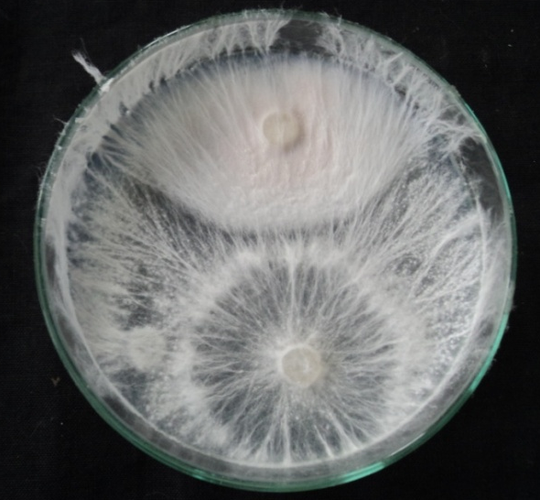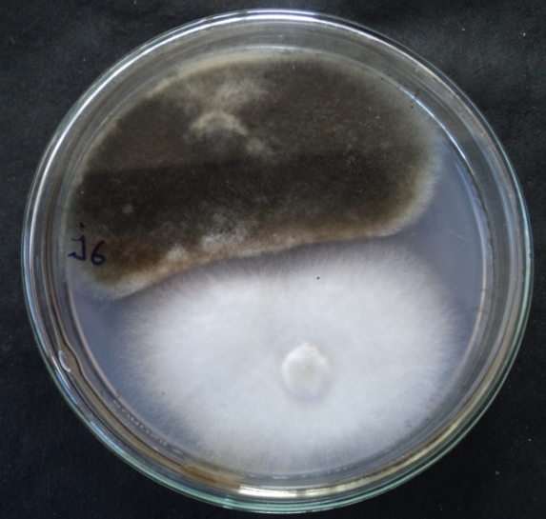
AO B
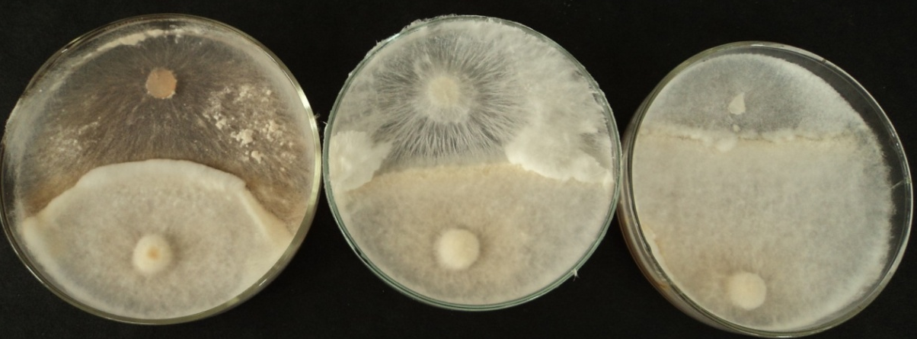
B1
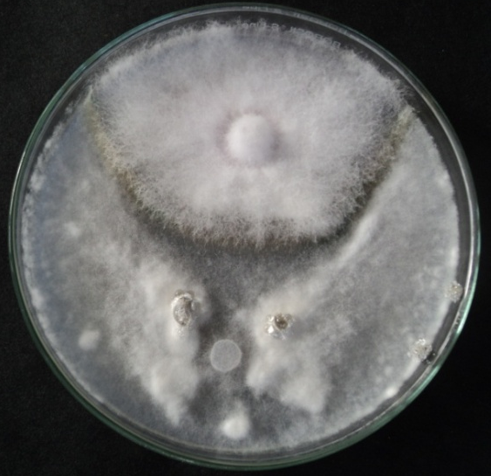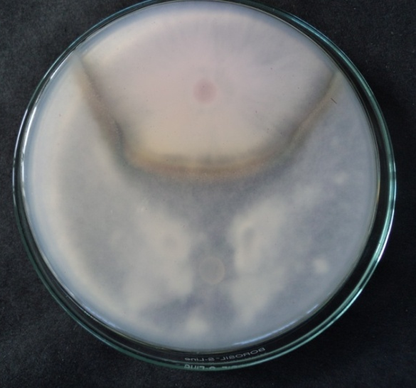
B1 B2
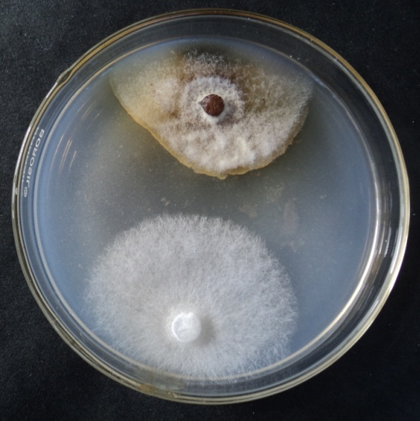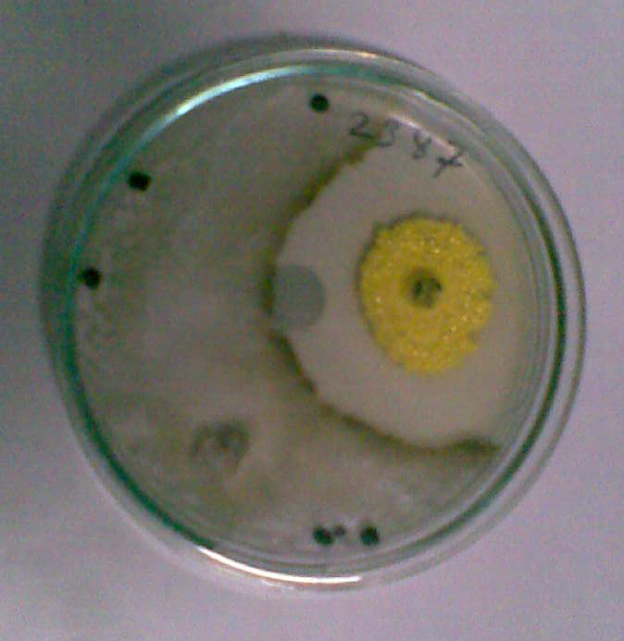
C C₁
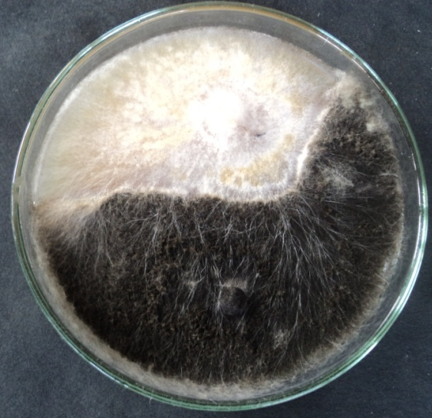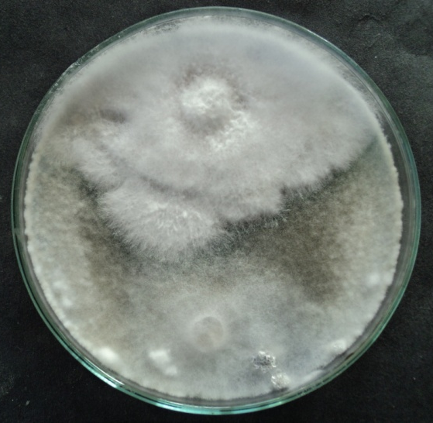
D E
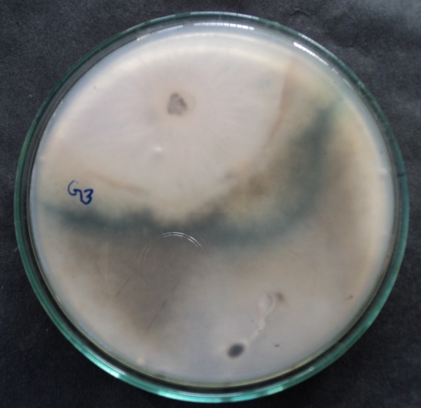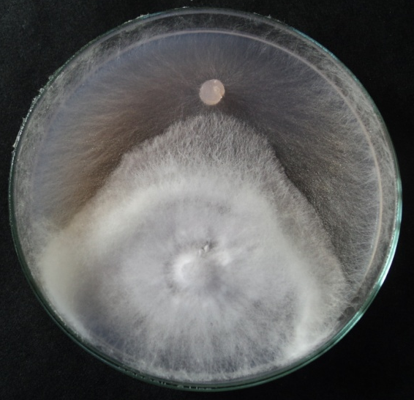
E E₁
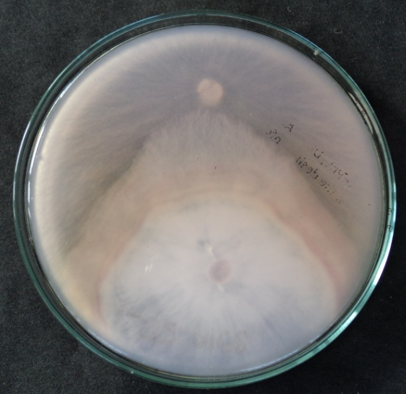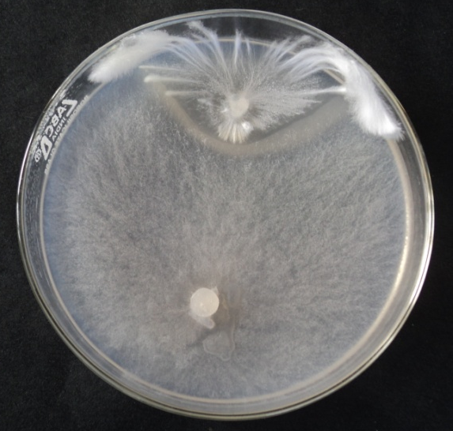
E₁ E₂
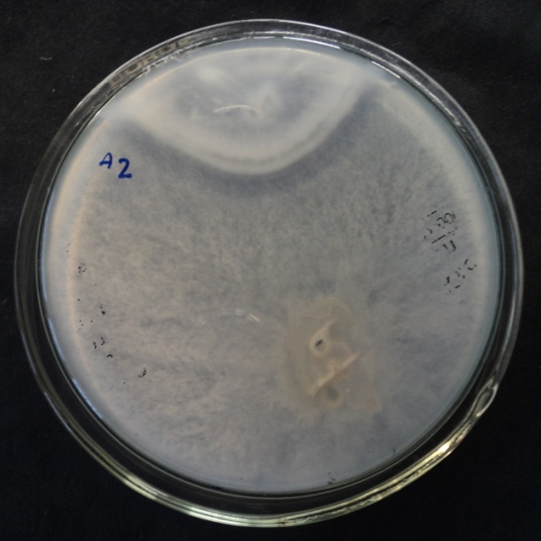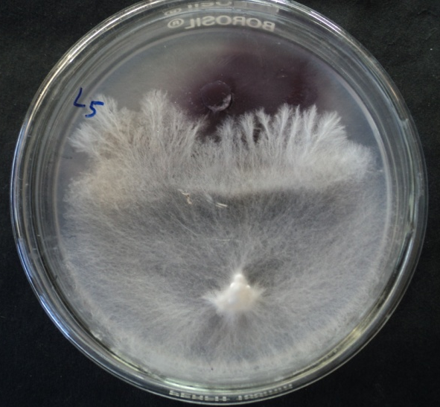
E₂ E₃
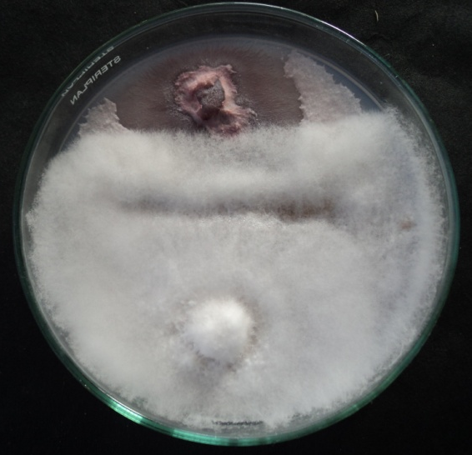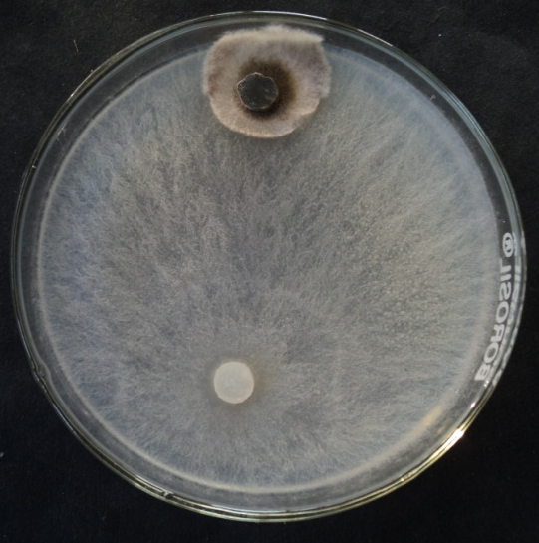
E_{3.1} E_{3.2}

Fig. 1. Inhibitory interactions between fleshy fungi and phytopathogenic fungi in dual cultures on potato dextrose agar. (A₀) Over growth of pathogen over mushroom between Stereum sp. and Sclerotium rolfsii (B) Mutual inhibition in which neither organism was able to over grow the other at mycelial contact between Mycena sp. and Alternaria brassicae (B₁) Colour and boundary of fungal mycelium change at mycelium contact between Marasmius sp. and Rhizoctonia solani, Sclerotium rolfsii & Sclerotinia sclerotiorum. (B₂) Presence of pseudosclerotial line at mycelial contact between Xylaria sp. and Sclerotinia sclerotiorum (C) Mutual inhibition at mycelial distance between Lactarius sp. and Colletotrichum capsici (C₁) Presence of pseudosclerotial line at mycelial distance between Russula sp. and Rhizoctonia solani (D) Partial over growth of mushroom without initial dead lock between Cortinarius sp. and Alternaria brassicae. (E) Partial replacement after initial deadlock with mycelial contact between Collybia sp. and Sclerotinia sclerotiorum. (E₁) Complete replacement after initial deadlock with mycelial contact between Pycnoporus sp. and Rhizoctonia solani. (E2) Partial replacement after initial deadlock at distance between Amanita sp. and Sclerotium rolfsii (E₃) Complete replacement after initial dead block at distance between Stropharia sp. and Fusarium oxysporum (E_{3.1}) Between Oudemansiella sp. and Fusarium solani. (E_{3.2}) Between Amanita sp. and Alternaria brassicae.

4. Conclusion

Antagonistic interaction studies in dual culture indicated five main types of interaction viz., overgrowth of pathogen over mycelium, inhibition at mycelial contact, inhibition at mycelial distance, overgrowth and partial or complete replacement of plant pathogenic fungi. Replacement interaction frequency was recorded to be 56.40% followed by deadlock 26.10% compared to 17.50% replacement of mushroom by phytopathogenic fungi. Mutual inhibition, in which neither organism was able to over grow the other at mycelial contact, colour and boundary of fungal mycelium change at mycelium contact, presence of pseudosclerotial line at mycelial contact, mutual inhibition, in which neither organism was able to over grow the other at mycelial distance, presence of pseudosclerotial line at mycelial distance and partial over growth of mushroom without initial deadlock of the pathogens were recorded to the tune of 25.80, 5.80, 6.10, 1.70, 3.10 and 13.90% respectively. Overall, 82.50% of pairing results led to prevention and limitation of pathogen growth. On the basis of the antagonism index (AI) values, mushrooms were divided into five groups: I- Strongly active (AI >30), II- very active (AI 25-30), III- active (AI 20-24), iv- moderately active (AI 11-20) and v weakly active (AI 1-10). Cordyceps sp., Marasmius sp., Stropharia sp. and Russula sp. were placed under strongly active group.

References

Anke, T.H., Besl, U., Mocek, W., & Steglich. (1983) Antibiotics from basidiomycetes. XVIII. Strobilurin C and Oudemansin B, two new antifungal metabolites from Xerula species (Agaricales). Journal of Antibiotics, 36, 661–666.
Baar, J., & Stanton, N.L. (2000) Ectomycorrhizal fungi challenged by saprotrophic basidiomycetes and soil micro fungi under different ammonium regimes in vitro. Mycological Research, 104, 691-697.
Badalyan, S.M. (1998) Biological Properties of Certain Macroscopic Basidiomycetes (Doctoral dissertation). Yerevan University, Armenia, 480 pp.
Badalyan, S.M., Rapior, S., Andary, C., & Serrano, J.J. (1998) Biological active compounds of higher fungi. In: Proceedings of the 4th International Colloquium on Natural Products from Plants, 25–29 May, 1998, Ottawa, Canada, 93–98.
Badalyan, S.M., Innocenti, G., & Garibyan, N.G. (2002) Antagonistic activity of xylotrophic mushrooms against pathogenic fungi of cereals in dual culture. Phytopathologia mediterranea, 41(3), 220-225.
Becker, U., Anke, T., & Sterner, O. (1994) A novel bioactive illudalane sesquiterpene from the fungus Pholiota destruens. Natural Products Letters, 5, 171–174.
Borhani, A., Badalyan, S.M., Garibyan, N.N., & Mosazadeh, S.A. (2011) Flammulina Velutipes (Curt. Fr.) Singer: An Edible Mushroom in Northern Forest of Iran and its Antagonistic Activity against Selected Plant Pathogenic Fungi. International Journal of Biology, 3(2), 162-167.
Chaumont, J.P., Symeray, J., & Maréchal, G. (1982) Les propriétés antifongiques des 225 Basidiomycètes et Ascomycètes vis-à-vis de 7 champignons pathogens cultivés in vitro. Cryptogamie Mycologie, 3, 249–259.
Hautzel, R., Anke, H., & Sheldrick, W. (1990) Mycenon, a new metabolite from a Mycena species TA 87202 (Basidiomycetes) as an inhibitor of isocitrate lyase. Journal of Antibiotics, 43, 1240–1244.
Huang, H.C., & Hoes, J.A. (1976) Penetration and infection of Sclerotinia sclerotiorum by Coniothyrium minitans. Canadian Journal of Botany, 54, 406-410.
Hyamumachi, M., Priyatomojo, A., Kubota, M., & Fukui, H. (2005) New anartomosis, AG-T and AG-U, of Bi-nucleate Rhizoctonia spp. causing root and stem rot of cut flower and minature roses. American Phytopathological Society, 95(7), 790-793.
Johansson, J., Paul, L., & Finlay, R.D. (2004) Microbial interactions in mycorrhizosphere and their significance for sustainable agriculture. FEMS Microbiology Ecology, 48 (1),28-33.
Li, C.Y. (1981) Phenoloxidase and peroxidise activities in zone line of Phellinus weirii. Mycologia, 73, 811-821.
Li, C.Y. (1983) Melanin like pigment in zone line of Phellinus weirii-colonized wood. Mycologia , 75, 562-566.
Mohmad, H.A. (1962) Effect of date of planting on fungi and other micro-organic isolates from cotton seedling. Plant Disease Report, 46, 801-803.
Morin, C., Samson, J., & Dessureault, M. (1999) Protection of black spruce seedlings against Cylindrocladium root rot with ectomycorrhizal fungi. Canadian Journal of Botany, 77, 169–174.
Natarajan, K., & Govindaswamy, V. (1990) Antagonism of ectomycorrhizal fungi to some common root pathogens. In: Current trends in mycorrhizal research- The proceedings of the national conference on mycorrhiza (eds. Mukerji, K.G., Chamola, B. P., & Singh, J.). Harayana Agricultural University, Hissar, India, 98-99.
Rayner, A.D.M., & Webber, J.F. (1984) Interspecific mycelia interactions: an overview, In: The ecology and physiology of the fungal mycelium (Jennings, D.H., and Rayner, A.D.M. ed), Cambridge University Press, Cambridge, UK, 383-418.
Santoro, T., & Casida, L.E. (1962) Elaboration of antibiotics by Boletus luteus and certain other mycorrhizal fungi. Canadian Journal of Microbiol, 8, 43-48.
Stark, S., & Kytoviita, M.M. (2005) Evidence of antagonistic interactions between rhizosphere microorganisms and mycorrhizal fungi associated with birch (Betula pubescens). Acta Oecologica, 28, 149-155.
Steglich, W. (1981) Biologically active compounds from higher fungi. Pure Applied Chemistry, 53, 1233–1240.
Steinmetz, M.D., Rascol, J.P., Regli, P., Gargadennec, A., & Andary, C. (1995) In vitro antifungal activity of Polyporaceae against yeasts and dermatophytes. Mycoses, 38, 305–309.
Sud, D. (1995) Investigation on morel mushrooms (Master dissertation). H.P. Krshi Vishvavidyalaya, Palampur, India, 47.
Toyota, M., & Hostettmann, K. (1990) Antifungal diterpenic esters from the mushroom Boletinus cavipes. Phytochemistry, 29, 1485–1489.
Vaidya, G.S., Shrestha, K., & Wallander, H. (2005) Antagonistic study of ectomycorrhizal fungi isolated from Baluwa forest (Central Nepal) against with pathogenic fungi and bacteria. Scientific World, 3, 49-52.
Werner, A., & Zadworny, M. (2003) In vitro evidence of mycoparasitism of the ectomycorrhizal fungus Laccaria laccata against Mucor hiemalis in the rhizosphere of Pinus sylvestris. Mycorrhiza, 13, 41-47.
Werner, A., Zadworny, M., & Idzikowska, K. (2002) Interaction between Laccaria laccata and Trichoderma virens in co-culture and in the rhizosphere of Pinus sylvestris grown in vitro. Mycorrhiza, 12, 139-145.

