Detection and Molecular Characterization of Chilli Veinal Mottle Virus (ChiVMV) in Chili from Karnataka, India

ABSTRACT
The study aimed to characterize viral infections affecting chili plants in Karnataka, India. Transmission electron microscopy revealed the presence of flexuous rod-shaped particles, indicative of potyviruses, in symptomatic leaf dip preparations. DAC-ELISA further confirmed the presence of potyvirus across all tested chili samples, with varying absorbance values among locations, highest in Masanige (1.66) and lowest in Dharwad (0.89). Positive reactions were consistent across all infected samples, contrasting with healthy and buffer controls. PCR using specific primers amplified a ~1.2 kb fragment from all diseased samples, confirming the presence of Chilli veinal mottle virus (ChiVMV). This comprehensive analysis underscores the prevalence and distribution of potyviruses, particularly ChiVMV, in chili crops in Karnataka, highlighting the importance of continued surveillance and management strategies to mitigate viral impact on agricultural productivity.
KEY WORDS: Chilli Veinal Mottle Virus, Potyvirus, PCR, ELISA, Chilli

Introduction
The popularity of chilli peppers has grown dramatically in recent decades, with hotter varieties leading the surge. An estimated 25% of the world's population now incorporates chillies into their daily meals (Halikowski-Smith, 2015). Roughly two-thirds of global chilli production comes from Asia (FAOSTAT, 2022). Chilli cultivation offers significant economic advantages for small-scale farmers, boosting their income and improving their social and economic standing (Weinberger and Lumpkin, 2007; Kahane et al., 2013).
Among the various viruses that plague chilli plants, Chilli Veinal Mottle Virus (ChiVMV) stands out as the most damaging and widespread, particularly in East Asia and certain African nations. The presence of ChiVMV infection has been documented in numerous countries, including Korea (Ha et al., 2013), Indonesia (Taufik et al., 2005), Papua New Guinea (Davis et al., 2002), China (Wang et al., 2006) and parts of West and East Africa (Womdim et al., 2001). Classified as a positive-sense single-stranded RNA (+ssRNA) virus, ChiVMV belongs to the Potyvirus genus within the Potyviridae family (King et al., 2011). Beyond Capsicum annuum, ChiVMV is known to infect a range of other plants in the Solanaceae family, including tobacco, tomato, eggplant and Jimson weed (Tsai et al., 2008; Ding et al., 2011; Yang et al., 2013; Zhao et al., 2014; Kaur et al., 2015). The characteristic signs of ChiVMV infection include mottled leaves with a mosaic pattern, distorted or drooping leaves, visible bands along the veins, and stunted fruit development (Tsai et al., 2008; Gao et al., 2016). The genetic makeup of ChiVMV is comprised of a single-stranded RNA molecule, about 9.7 kilobases in length excluding the poly(A) tail. This RNA encodes a polyprotein, which is subsequently cleaved by viral proteases into ten functional mature proteins (Yang et al., 2013; Gao et al., 2016). The aphid Aphis gossypii has been identified as a non-persistent transmitter of the virus among solanaceous crops (Shah et al., 2008).
Material and Methods
Symptomatic chilli plants showing typical symptoms viz., mottled leaves with a mosaic pattern, distorted or drooping leaves, visible bands along the veins (Fig 1) were collected from major chilli growing districts like Belgaum, Dharwad, Haveri and Gadag of Northern Karnataka, India and used for detection of ChiVMV using DAC-ELISA and PCR.
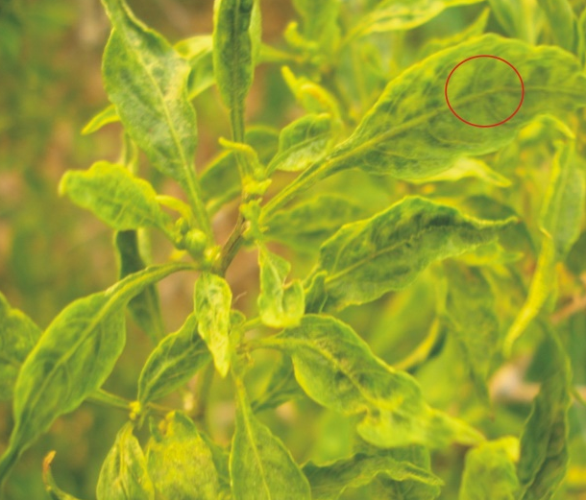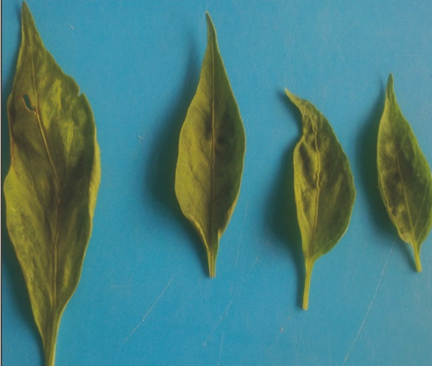
Fig 1: Chilli leaves showing vein banding, veinal necrosis and green mottling
Detection of potyvirus through Electron microscopy and DAC-ELISA
Leaf dip preparations were prepared by grinding small pieces of diseased leaves for detection of potyvirusthrough Electron microscopic studies (Transmission Electron Microscope facility, Indian Institute of Horticulltural Research, Benguluru).
A direct antibody coating enzyme linked immuno sorbent assay (DAC-ELISA) technique (Hobbs et al., 1987) was employed for serological detection of the potyvirus associated with diseases field samples of chilli using commercially purchased polyclonal antibodies raised against Tobacco etch virus (TEV). The assay was carried out in 96-well polysterene microtitre plate. Positive controls (Poty virus Y supplied by manufacturer (Agida) and papaya sample infected with Papaya ring spot virus) healthy controls as well as buffer controls were maintained. The mean absorbance values were measured at 405 nm wavelengths. The absorbance values (optical density, OD) are directly proportional to the virus concentrations.
Detection of Chilli veinal mottle virus through PCR
Total RNA isolation
Qiagen, Germany Kit (ID No.:74534) was used for the isolation of total RNA from the diseased leaf tissue. Virus infected leaf sample was taken and ground to powder in a pestle and mortar using liquid nitrogen. About 50 mg of powder was taken into 450 μl of buffer RLT was added and procedure mentioned in kit was followed for extraction of total RNA. Finally, RNA was eluted by transferring the Rneasy column into a new 1.5 ml eppendorf tube and eluted out using 30-50 μl of Rnase free water by centrifugation for 1 minute at 10000 rpm. The RNA was stored at – 20⁰C.
Reverse transcription
Potyviral cDNA was synthesized using Oligo (dT) (5’ GCGGGATCC TTTTTTTTTTTTTTTTTT-3’) as downstream primer (Hiskias et al., 1998). Three microlitres of extracted RNA was used for viral cDNA synthesis following a modified protocol for Moloney Murine Leukemia Virus reverse transcriptase (M-MLVRT, Pomega), using 0.375 mM dNTP, 20 U RNase inhibitor, 100 U M-MLV-RT, and incubation at 42⁰C for 120 min.
PCR amplification using Degenerate primers for potyvirus (ChiVMV):
PCR amplification was performed using CVMV1037Pol (the ChiVMV polymerase primer, 5’-AGCATGGAGAGAGCGACATTAGTC-3’) for the coat protein of pepper and tomato potyviruses, as upstream primer and Oligo (dT) (5’-GCGGGATCCTTTTTTTTTTTTTTTTTT-3’) as the downstream primer. The primer pair CVMV1037 Pol/Oligo (dT) was designed to amplify the 3’-end of ChiVMV genomic c DNA including 3’ terminus of the polymerase (Nlb) gene, the CP gene and the 3’-UTR (Tsai et al., 2008). The components in PCR reaction were standardized and followed as given below in order to amplify a single sharp amplicon. Corbett Palm Cycler (JH Bio) was used to run the PCR programme for amplification. The optimised amplified conditions with 35 cycles of denaturation at 94⁰C, primer annealing at 58⁰C and extension at 72⁰C
Components | Concentrations | Volume (μl)
Components | Concentrations | Potyvirus
Template cDNA | - | 1
Taq assay buffer Awith 15mM MgCl2 | 10x | 2
dNTPs | 2.5 mM each | 2.5
Forward primer | 10 pM | 1
Reverse primer | 10 pM | 1
Taq DNA polymerase | 1 U/ μl | 1
Nuclease free water to final volume |  | 20
Results
Particle morphology of virus
Leaf dip preparations infected symptomatic samples were stained with uranyl acetate and observed under transmission electron microscope. No geminate (icosahedral) particles were observed in partially purified preparations indicating that the absence of begomoviruses. Similarly, quasi-spherical enveloped particles characteristic of tospoviruses were not noticed in dip preparations. Whereas, typical flexuous rod shaped particles measuring about 700 nm were observed in leaf dip preparations which reveals that the presence of potyvirus (Fig 2).

Fig 2: Electron micrograph showing flexous particles of potyvirus (18000x)
DAC-ELISA
The absorbance values revealed that all the infected chilli samples that were brought from field showed positive reaction for TEV antisera. Highest absorbance for potyvirus was recorded in chilli sample brought from Masanige (1.66) of Haveri district followed by Hebbali (1.44) and Shalavaddi (1.34) and least absorbance value was found in sample brought from Dharwad (0.89) (Table 1).
Table 1: DAC-ELISA absorbance values of chilli murda samples for potyvirus (ChiVMV)
Sl. No. | Samples | Location | OD value (405 nm) | Reaction + / -
1 | Chilli | Hebbali farm  (Dharwad district) | 1.44 | +
2 | Chilli | Masanige  (Haveri district) | 1.66 | +
3 | Chilli | Shalavaddi  (Gadag district) | 1.34 | +
4 | Chilli | UAS Campus  (Dharwad district) | 0.89 | +
5 | Positive control (Potyvirus, Agida) | - | 1.21 | +
6 | Positive control, Papaya ( PRSV) | UAS Campus  (Dharwad district) | 1.45 | +
7 | Healthy control, Chilli | UAS Campus  (Dharwad district) | 0.31 | -
8 | Buffer control (PBS-T) | -- | 0.23 | -
Note : “+”= Positive reaction, “_” = Negative reaction
PCR detection of Chilli veinal mottle virus
A set of primers CVMV1037Pol/Oligo (dT) designed to amplify the 3’-end of ChiVMV genomic cDNA including the 3’ terminus of polymerase (NIb) gene, the CP gene and the 3’-UTR were used at optimized 0.5 pM of final concentration and 58⁰C annealing temperature keeping all other components of PCR reaction constant. The predicted ~1.2 kb DNA fragment was amplified in all diseased samples (Fig 3). The resulted sequences may ranges from 1237 to 1257 nucleotides in length. No PCR product was obtained in uninfected control samples.


Fig 3: RT-PCR analysis of chilli samples for potyvirus (ChiVMV)
Discussion
Hussain et al. (2009) reported Chilli veinal mottle virus (ChiVMV) as one of the prevalent chilli-infecting viruses found throughout chilli growing areas of Pakistan and observed 44.7 per cent relative occurrence of the virus in the country during 2003 and 2004. Individual plants occurring sporadically showing chlorotic, necrotic spots symptoms on leaves with typical apical necrosis were also made by Krishnareddy et al. (2008).
Typical flexuous rod shaped particles measuring about 700 nm were detected in all samples through electron microscopy. These observations are in conformity with Ravi et al. (1997) who reported for PVBV as flexuous rods with an average length of 900 nm in pepper with mosaic symptoms and Gundannavar (2006) and Raju (2010) who also stated electron microscopy examination of chilli leaf curl samples revealed flexuous rods (Poty virus).
Potyvirus was detected by DAC-ELISA in all samples with TEV antiserum utilizing crude sap of the samples. However, the value of absorbance was varied from sample to sample. This may be due to variation in the concentration of the virus in the infected samples. This variation in concentration may be due to varietal difference and also due to age of the crop. Previously, Siriwong et al. (1995) also observed chilli vein-banding mottle virus serologically related to Chilli veinal mottle potyvirus from Malaysia and had a distinct serological relationship with Tobacco etch virus.
Ravi et al. (1997) and Green and Kim (1991) detected PVBV and ChiVMV utilizing PAbs produced against them. Variability within the pepper-infecting potyviruses Pepper veinal mottle virus (PVMV) and Chili veinal mottle virus (ChiVMV) in Africa and Asia could not be unambiguously identified with polyclonal antisera (Moury et al., 2005). These findings reveal that PVBV and ChiVMV are closely related and not distinguishable serologically. Thus, the potyvirus detected in the present investigation could be either one or both of the above two viruses. But, viruses having more than 85 percent nucleotide identity of full length viral RNA, or more than 80 per cent amino acid identity of the CP gene should be considered as the same potyvirus species (Faquet et al., 2005). Based on these criteria, CVbMV, CVbMV-CM1 and PVBV isolates have recently been classified as strains of ChiVMV by the International Committee on Taxonomy of Viruses (ICTV) (Faquet et al., 2005).
As per the present classification, PVBV of Indian isolate was identified as ChiVMV by Tsai et al. (2008).
In electron microscopic studies, leaf dip preparations from infected chilli samples revealed typical flexuous rod shaped particles measuring about 700 nm and no quasi spherical virus particles characteristic of tospoviruses was observed. Partially purified preparations from infected samples for begomovirus also did not show geminate particles.
The diseased chilli samples were diagnosed through direct antigen coated enzyme linked immunosorbent assay (DAC-ELISA) against polyclonal antibodies raised against TEV, ToLCV and PBNV to detect chilli veinal mottle virus, Begomovirus and Capsicum chlorosis virus respectively. Simultaneously, positive controls were maintained in each case to be familiar with the sensitivity of antisera. ChiVMV was serologically detected by TEV antiserum in all diseased samples as well as in positive controls.
The most sensitive diagnostic tool polymerase chain reaction (PCR) was performed for detection of the above three referred viruses at genus level. A set of primers CVMV1037Pol/Oligo (dT) designed to amplify the CP gene of Chilli veinal mottle virus were used in RT-PCR against all diseased isolates. The predicted ~1.2 kb DNA fragment was amplified in all murda infected samples with no amplification in healthy control.
In conclusion, the combined evidence from transmission electron microscopy (TEM), Double Antibody Sandwich - Enzyme Linked Immunosorbent Assay (DAC-ELISA), and PCR analysis strongly suggests that chilli veinal mottle virus which comes under Potyvirus genus was the only virus associated with the particular symptomatic chilli plants.
References:
Ding, M., Yang, C., Zhang, L., Jiang, Z. L., Fang, Q., Qin, X. Y., et al. (2011). Occurrence of Chilli veinal mottle virus in Nicotiana tabacum in Yunnan, China. Plant Disease, 95, 357–357. doi: 10.1094/pdis-09-10-0686
FAOSTAT. (2022). Food and agriculture organization of the United Nations. Retrieved from http://www.fao.org/faostat/en/
Fauquet, C. M., Mayo, M. A., Maniloff, J., Desselberger, U., & Ball, L. A. (Eds.). (2005). Virus taxonomy: Eighth report of the International Committee on Taxonomy of Viruses. San Diego, CA, USA: Elsevier Academic Press.
Gao, F., Jin, J., Zou, W., Liao, F., & Shen, J. (2016). Geographically driven adaptation of Chilli veinal mottle virus revealed by genetic diversity analysis of the coat protein gene. Archives of Virology, 161, 1329–1333. doi: 10.1007/s00705-016-2761-7
Ha, C., Coombs, S., Revill, P., Harding, R., Vu, M., & Dale, J. (2008). Molecular characterization of begomoviruses and DNA satellites from Vietnam: Additional evidence that the New World geminiviruses were present in the Old World prior to continental separation. Journal of General Virology, 89(Pt 1), 312–326. doi: 10.1099/vir.0.83236-0
Halikowski-Smith, S. (2015). In the shadow of a pepper-centric historiography: Understanding the global diffusion of Capsicums in the sixteenth and seventeenth centuries. Journal of Ethnopharmacology, 167, 64–77. doi: 10.1016/j.jep.2014.10.048
Hiskias, Y. (1998). Characterization of potyvirus isolates from hot pepper and tomato in Ethiopia. Ph.D. Thesis, Institute of Plant Pathology and Plant Protection, Georg-August University, Göttingen, Germany.
Kaur, C., Kumar, S., & Krishna Raj, S. (2015). Association of a distinct strain of Chilli veinal mottle virus with mottling and distortion disease of Datura inoxia in India. Archives of Phytopathology and Plant Protection, 48, 545–554. doi: 10.1080/03235408.2015.1052260
King, A. M. Q., Lefkowitz, E., Adams, M. J., & Carstens, E. B. (Eds.). (2011). Virus taxonomy: 9th report of the International Committee on Taxonomy of Viruses. Elsevier.
Krishnareddy, M., Usha Rani, R., Anil Kumar, K. S., Madhavi Reddy, K., & Pappu, H. R. (2008). Capsicum chlorosis virus (Genus Tospovirus) infecting chili pepper (Capsicum annuum) in India. Plant Disease, 92, 1469.
Moury, B., Palloix, A., Caranta, C., Gognalons, P., Souche, S., Gebre Selassie, K., & Marchoux, G. (2005). Serological, molecular, and pathotype diversity of Pepper veinal mottle virus and Chili veinal mottle virus. Phytopathology, 95, 227-232.
Nono-Womdim, R., Swai, I. S., Chadha, M. L., Gebre-Selassie, K., & Marchoux, G. (2001). Occurrence of Chilli veinal mottle virus in Solanum aethiopicum in Tanzania. Plant Disease, 85(7), 801-801.
Shah, H., Yasmin, T., Fahim, M., Hameed, S., & Haque, M. I. (2008). Transmission and host range studies of Pakistani isolate of Chilli veinal mottle virus. Pakistan Journal of Botany, 40, 2669–2681.
Taufik, M., Astuti, A. P., & Hidayat, S. H. (2005). Survey of Cucumber mosaic virus and Chilli veinal mottle virus on chilli pepper and screening of resistance of chilli pepper genotypes (in Bahasa Indonesia, English abstract). J Agrik, 16, 146-152.
Tsai, W. S., Huang, Y. C., Zhang, D. Y., Reddy, K., Hidayat, S. H., Srithongchai, W., et al. (2008). Molecular characterization of the CP gene and 3’ UTR of Chilli veinal mottle virus from South and Southeast Asia. Plant Pathology, 57, 408–416. doi: 10.1111/j.1365-3059.2007.01780.x
Wang, J., Liu, Z., Niu, S., Peng, M., Wang, D., Weng, Z., et al. (2006). Natural occurrence of Chilli veinal mottle virus on *Capsicum chinense* in China. *Plant Disease*, 90(3), 377-377.
Weinberger, L., & Lumpkin, T. A. (2007). Diversification into horticulture and poverty reduction: A research agenda. *World Development*, 35(8), 1464–1480. doi: 10.1016/j.worlddev.2007.05.002
Yang, J., Dong, J., Zhang, T. J., Wang, R., Luo, Z. P., Luo, H. Y., et al. (2013). A new isolate of Chilli veinal mottle virus that infects tobacco in China. *Journal of Plant Pathology*.
Zhao, F. F., Xi, D. H., Liu, J., Deng, X. G., & Lin, H. H. (2014). First report of Chilli veinal mottle virus infecting tomato (Solanum lycopersicum) in China. Plant Disease, 98, 1589. doi: 10.1094/pdis-11-13-1188-pdn

