Employing Genetic Variability for Salt Tolerance in Rice: A Field Study of F₅ Recombinant Inbred Lines mapping population

.
ABSTRACT

Rice productivity in coastal areas is limited by salinity stress. The problem is aggravated by sea water intrusion, over exploitation of ground water and excessive use of fertilizers. The present investigation focused on genetic variability for salt tolerance to know the salt tolerant lines. The analysis of variance (ANOVA) for 12 characters attributed that there was significant differences among 150 RILs studied under salinity. The mean performance of RILs indicated the presence of transgressive segregants for salt tolerance and yield traits i.e., 24.6% of RILs yielded higher than MCM 109 (female) and 13.3% higher than BRR 0119 (male). Phenotypic coefficient of variation and genotypic coefficient of variation for the traits ear bearing tillers hill-1, salinity scoring at reproductive stage, shoot Na+/K+ ratio at harvesting stage and grain yield per plant (g) exhibited high estimates of GCV (>20%), PCV (>20%), heritability (>60%) and Genetic Advance (>20%) suggesting substantial genetic variability and potential for effective selection. While the traits plant survival (%), plant height (cm), panicle length (cm), number of filled grains per panicle, spikelet fertility % and 100 grain weight (g) exhibited moderate PCV and GCV (10-20%) values with high heritability and genetic advance indicating additive gene action. Therefore, selection based on these traits could be influential in developing high yielding salt tolerant varieties.

Key words: RILs, GCV, PCV, heritability, genetic advance.
1. INTRODUCTION
Rice (Oryza sativa L.), a self-pollinating crop with chromosome number 2n=24 belonging to Gramineae family is an important staple crop that feeds more than half of the world population. Eventhough it is one of the main sources to relieve hunger, it also harbors many biotic and abiotic stresses. Salinity and drought are the two major abiotic stresses that affect rice production (Hussain et al., 2018). Excessive concentrations of salt in the plant cells leads to reduced cell membrane stability, cell wall damage, increase in proline content, which in turn lowers the grain yield (Alshiekheid et al., 2023). According to the global estimates, on an average 683 million hectares of land is categorized as saline area. Around 6.73 million hectares of irrigated land was affected from salt degradation only in India (Samy et al., 2024). The total saline soils occupy 12.94 lakh ha in coastal India. In terms of their distribution, coastal Gujarat has the highest area (5.28 lakh ha), followed by West Bengal (5.08 lakh ha) and Andhra Pradesh (1.06 ha). In Andhra Pradesh, around 105,725 ha of saline soils are distributed within the coastal region, in which 71% of the area spread within five districts, viz., Konaseema (17.9%), Prakasam (15.8%), Bapatla (13.4%), Krishna (12.4%) and Eluru (11.2%) (Mandal et al., 2023). About 10% of yield loss occurs due to salt stress at 3.5 dSm⁻¹ of EC and even up to 50% of yield losses were reported at EC 7.2 dSm⁻¹ (Pranaya et al., 2024). Soil salinity is complex trait influenced by soil salinity parameters, weather parameters like rain fall and temperature. Cultivation of salt tolerant rice varieties is one of the effective strategies to enhance rice productivity in salt affected areas. To know which varieties are showing better performance even in salinity, selection should be followed in field conditions. Genetic variability is such a parameter to identify the traits with higher heritability and selection potential (Indrajeet et al., 2024). As there are only few studies to assess genetic variability for salt tolerance in both seedling and reproductive stages under field conditions the present research focused on “phenotyping of F₅ RILs for genetic variability in natural coastal saline soils”. Many of the researchers have manifested genetic variability and heritability is the key parameters to identify salt tolerant genotypes and yield traits that contributed to salt tolerance in field conditions (Nounjan et al., 2018). Hence, in the present study these parameters not only identify the variation but also signify the tolerant RILs for future breeding purpose.

2. methodology

The present investigation was carried to estimate genetic variability using F₅ RIL population derived from MCM 109 as female parent and BRR 0119 as male parent along with five checks including susceptible check - BPT 5204 (Samba Mahsuri), resistant checks - MCM 103, MTU 1293, FL 478 and MCM 125 during Kharif, 2025 at natural coastal saline soil of Agricultural research station, Machilipatnam. This center was located at 81.7⁰ E longitude and 16.10⁰ N latitude in Krishna district of Andhra Pradesh. Nursery was raised in normal soil and 35 days old seedlings were transplanted in saline soil with pH 8.4 and EC 7.2 dSm⁻¹. Alpha-lattice design was adopted with two rows of 10 plants each following spacing of 20 х 15 cm. Phenotypic screening of 150 RILs was conducted in saline soils from September 2024 to December 2024. All recommended agronomic management practices were followed during the conduct of the experiment. Data was recorded on 5 plants per RIL for 12 traits, including plant survival %, days to 50 percent flowering, salt tolerance at seedling and reproductive stage as per SES (IRRI, 2014), plant height (cm), ear bearing tillers hill⁻¹, panicle length (cm), number of filled grains panicle⁻¹, spikelet fertility %, 100 grain weight (g), grain yield per plant (g) and shoot Na/K ratio at harvesting stage. Additionally, observations were taken for pH and EC at different crop growth stages (Table 1) and weather parameters prevailed during crop growth (Table 2). The mean values for all traits were calculated and the data of GCV, PCV, heritability and genetic advance was analyzed using R software version 4.4.3 as suggested by Singh and Chaudhary (1985).

3. results and discussion

The analysis of variance (ANOVA) for the 12 characters in saline field conditions viz. plant survival %, days to 50 per cent flowering, seedling and reproductive stage salinity score, plant height (cm), ear bearing tillers per hill, panicle length (cm), number of filled grains/panicle, spikelet fertility %, 100 grain weight (g), grain yield per plant (g) and shoot Na⁺/K⁺ ratio at harvesting stage attributed that there is significant differences among 150 RILs for 12 traits studied under salinity (Table 3). Similar trend of results was reported by Sitaresmi et al. (2022). Summary of mean performance of RILs (Table 4) with frequency distribution (figure 1) for all the traits unveiled the presence of transgressive segregants for salt tolerance and yield traits i.e., 24.6% of RILs yielded higher than MCM 109 (female) and 13.3% higher than BRR 0119 (male). 110 RILs exhibited better performance over the checks in all respective traits and 4 RILs F₅ 106, F₅ 112, F₅ 198 and F₅ 200 showed better performance with both parents and checks for all the traits studied (Table 5) and variation in length of panicles with salinity scoring at better and poor survival conditions was given in the figure 2. Some of the RILs showed early duration while some showed medium and late duration. Those which escape stress by showing early duration in comparing with tolerant and best checks FL 478 and MCM 125 are used in breeding programmes for salt tolerance to locate salinity genes and also to improve the existing lines through MAS, back cross breeding. The RILs exposed medium and late duration might be used in multi-location trials, or hybrid breeding. High estimates of PCV, GCV and heritability was recorded for ear bearing tillers per hill (27.69, 27.44), salt tolerance at reproductive stage (33.13, 30.11), shoot Na/K ratio at harvesting stage (66.34, 65.88) and grain yield per plant (g) (72.67, 72.67) among all traits indicating magnitude of variation present in the population and the traits are governed by genetic factors like additive gene action with minimum amount of environmental influence on them as reported by Kumar et al. (2018), Tam et al. (2019) and Prashanth et al. (2020). Hence, selection may be rewarding for RILs with fine grain, early or medium duration, and more number of filled grains per panicle with including salinity score (≤3) at both seedling and reproductive stages followed by low Na⁺/K⁺ ratio (0-0.5). Similar trend of results were followed by Manohara et al. (2020), Selvam et al. (2024), Patel et al. (2025), Senguttuvel et al. (2016), Bharali et al. (2024), Kulsum et al. (2022) and Prashanth et al. (2020). All those traits that showed better performance over tolerant check FL 478, best check MCM 125 and parents are given in the table 6.

Table 1. Salinity parameters at different crop growth stages

Stage of the crop | pH | E.C. (dS/m)
Tillering | 8.5 | 7.1
Flowering | 8.2 | 7.0
Harvesting | 8.7 | 7.2

Table 2. Month wise weather parameters prevailed during crop growth

Name of the month | Temperature (ºC) | Rainfall (mm) | No. of rainy days
July | 28.86 | 370.72 | 15
August | 30.05 | 216.20 | 5
September | 29.66 | 205.60 | 9
October | 28.8 | 31.7 | 3
November | 28.21 | 19.8 | 3
December | 26.00 | 15.4 | 3

 | Mean Sum of Squares
Source | df | PS (%) | SS | DFF | RS | PH (cm) | EBT/ hill | PL (cm) | FG/Panicle | SF (%) | Na⁺/K⁺ | 100 GW (g) | GY (g)
Genotype | 156 | 149.1** | 2.0** | 157.4** | 6.7** | 218.8** | 8.6** | 9.3** | 862.7** | 258.5** | 10.4** | 0.1** | 16.0**
Error | 149 | 6.0 | 0.52 | 5.3 | 0.7 | 3.1 | 0.04 | 0.5 | 3.8 | 9.3 | 0.01 | 0.007 | 0.002
Table 3. Analysis of Variance (ANOVA) for salinity and yield related traits

**Significance at 5% level

Table 4. Summary of RILs studied in natural coastal saline soils of ARS, Machilipatnam

 |  | Range
Traits | Mean | Maximum | Minimum | S. E. | C.D. (5%) | C.V
PS (%) | 94.67 | 100 | 54 | 0.69 | 4.84 | 9.06
DFF | 94.54 | 118.5 | 82 | 0.73 | 4.57 | 9.63
SS | 2.21 | 7 | 1 | 0.08 | 1.43 | 27.27
PH (cm) | 53.9 | 98.09 | 42 | 0.85 | 3.7 | 19.77
EBT/ hill | 3.9 | 10.25 | 1 | 0.16 | 0.4 | 27.36
PL (cm) | 16.08 | 22.42 | 6.95 | 0.17 | 1.46 | 13.43
FG/ Panicle | 59.91 | 165.3 | 14 | 1.67 | 3.93 | 9.02
RS | 2.79 | 7 | 1 | 0.13 | 1.71 | 27.97
SF (%) | 88.31 | 100 | 51.87 | 0.91 | 6.09 | 12.85
Na/K | 0.67 | 4.25 | 0.11 | 0.05 | 0.89 | 11.88
100 GW (g) | 1.57 | 2.85 | 1.1 | 0.02 | 0.16 | 15.82
GY (g) | 4.72 | 26.74 | 1.14 | 0.27 | 0.09 | 25.32

PS (%) = plant survival percentage, DFF= days to fifty per cent flowering, SS= salinity scoring at seedling stage, PH= plant height (cm), EBT/hill= ear bearing tillers per hill, PL= panicle length (cm), FG/panicle= number of filled grains per panicle, RS= salinity scoring at reproductive stage, SF %= spikelet fertility percentage, Na/K= shoot sodium to potassium ratio at harvesting stage, 100 GW= hundred grain weight (g), GY= grain yield per plant (g).
Fig.1. Frequency curves of mean performance of RILs under salinity in natural coastal saline soil of ARS, Machilipatnam

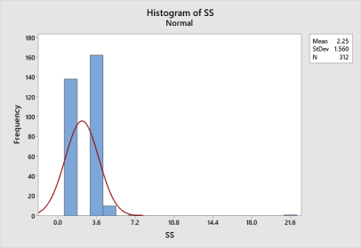
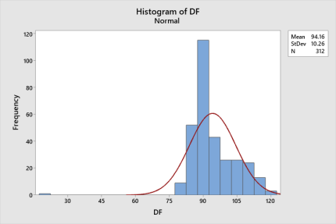
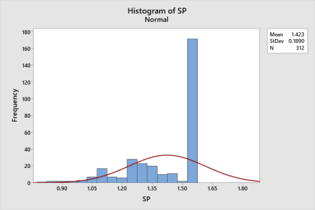
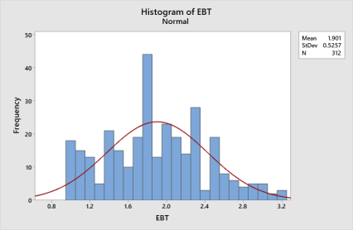
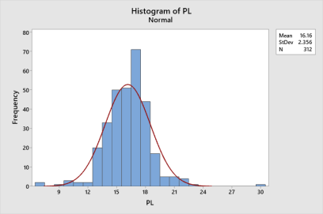
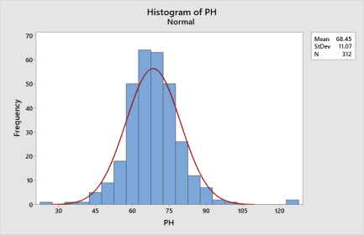

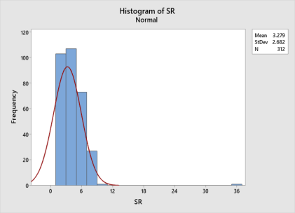
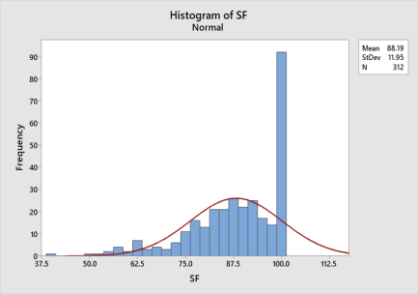
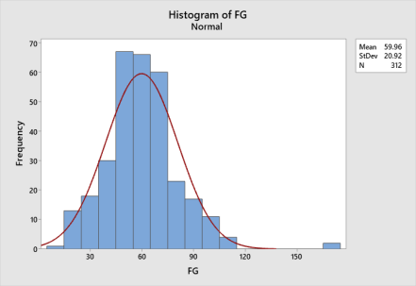

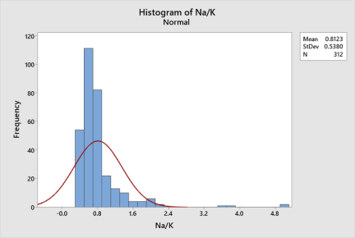
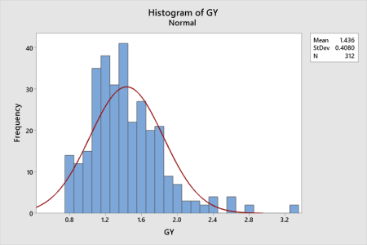
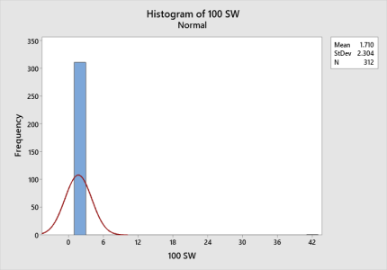
Standard peaks of histograms revealed traits for positively skewness and normal distribution (bell – shaped curves).
Table 5. List of RILs showing significant better performance over the checks and parents

No. of traits | BPT 5204  (Susceptible) | MCM 103 | MTU 1293 | FL 478 | MCM 125 | Both checks and parents
12 | F₅ 90, F₅ 112, F₅ 117, F₅ 119, F₅ 122, F₅ 145, F₅ 153, F₅ 169, F₅ 179, F₅ 182, F₅ 185, F₅ 198, F₅ 199, F₅ 201, F₅ 203 and F₅ 204, | F₅ 69, F₅ 74, F₅ 93, F₅ 160, F₅ 169, F₅ 198, F₅ 200, F₅ 231 and F₅ 240 | F₅ 112, F₅ 114, F₅ 115, F₅ 116, F₅ 129, F₅ 139, F₅ 142, F₅ 149, F₅ 150, F₅ 162, F₅ 169, F₅ 176, F₅ 185, F₅ 193, F₅ 198, F₅ 211, F₅ 214, F₅ 217, F₅ 225, F₅ 231, F₅ 236, F₅ 240 and F₅ 246. | F₅ 67, F₅ 69, F₅ 74, F₅ 76, F₅ 85, F₅ 88, F₅ 90, F₅ 93, F₅ 95, F₅ 96, F₅ 97, F₅ 100, F₅ 101, F₅ 102, F₅ 105, F₅ 106, F₅ 107, F₅ 110, F₅ 111, F₅ 112, F₅ 117, F₅ 119, F₅ 124, F₅ 129, F₅ 130, F₅ 136, F₅ 139, F₅ 142, F₅ 145, F₅ 148, F₅ 149, F₅ 156, F₅ 158, F₅ 159, F₅ 160, F₅ 161, F₅ 162, F₅ 165, F₅ 169, F₅ 179, F₅ 180, F₅ 185, F₅ 191, F₅ 192, F₅ 193, F₅ 218, F₅ 220, F₅ 225, F₅ 230 and F₅ 238. | F₅ 67, F₅ 68, F₅ 69, F₅ 80, F₅ 90, F₅ 91, F₅ 133, F₅ 149, F₅ 190, F₅ 200, F₅ 202 and F₅ 238. | F₅ 106, F₅ 112, F₅ 198 and F₅ 200

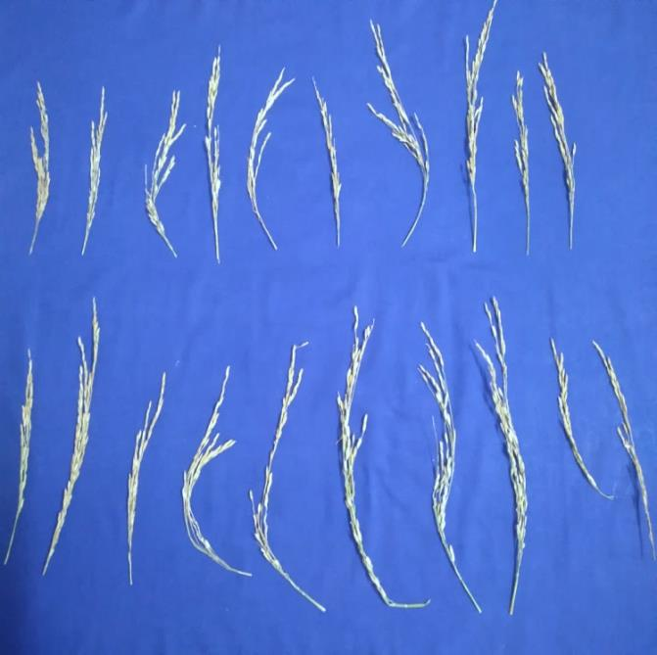
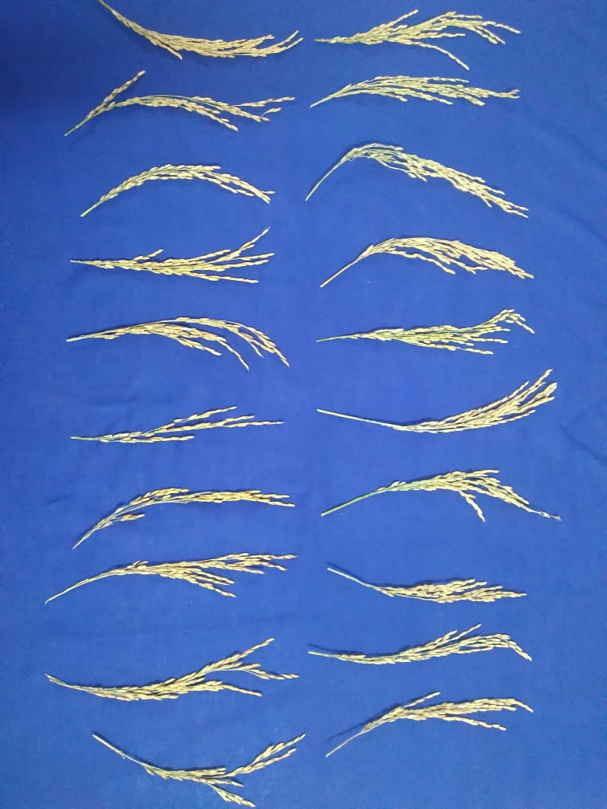
Fig.2. Variation in panicle lengths at better and poor survived field conditions

4. Conclusion

The evaluation of F₅ RILs under field conditions expressed a remarkable genotypic variability indicating that RIL population has considerable variation for salinity and yield traits in stress conditions. Higher values were observed for no. of ear bearing tillers per hill, shoot Na/K ratio at harvesting stage, salt tolerance at seedling and reproductive stages meanwhile heritability coupled with genetic advance exhibited higher range of values for plant survival%, plant height (cm), ear bearing tillers per hill, panicle length (cm), number of filled grains per panicle, salt tolerance at reproductive stage, spikelet fertility %, shoot Na/k ratio at harvesting stage and 100 Grain weight (g). Results obtained through histograms and highest values of PCV, GCV, heritability and genetic advance as mean among 150 RILs with parents and checks showed preponderance of additive gene action indicating the traits can be used as selection criteria in evolving salt tolerant varieties based on breeding objective of developing fine grain and bold grain test weight as selection criteria enhancing their importance especially in the coastal areas.

COMPETING INTERESTS DISCLAIMER:
Authors have declared that they have no known competing financial interests OR non-financial interests OR personal relationships that could have appeared to influence the work reported in this paper.

References

- Alshiekheid, M.A., Dwiningsih, Y., & Alkahtani, J. (2023). Analysis of morphological, physiological, and biochemical traits of salt stress tolerance in asian rice cultivars at different stages. Preprints org, 1-19.
- Bharali, V., Yadla, S., Fiyaz, R.A., Rao, V.S., & Jukanti, A.K. (2024). Genetic inheritance studies in rice (Oryza sativa L.) for grain protein, quality and yield. Electronic Journal of Plant Breeding, 15(3), 604-611.
- Hussain, M., Ahmad, S., Hussain, S., Lal, R., Ul-Allah, S., & Nawaz, A. (2018). Rice in saline soils: physiology, biochemistry, genetics and management. Advances in Agronomy, 148, 231-287.
- Indrajeet, S.K., Kanwar, R.R., & Singh D.P. (2024). Large scale evaluation, genetic variability and correlation analysis in rice accessions. Journal of Genetics, Genomics and Plant Breeding, 7(3), 83-91.
- IRRI. Standard Evaluation System for rice (SES). (2014). International Rice Research Institute, Los Baños, Philippines.
- Kulsum, U., Sarker, U., & Rasul, M.G. (2022). Genetic variability, heritability and interrelationship in salt-tolerant lines of T. Aman rice. Genetika, 54(2), 761-776.
- Kumar, S., Chauhan, M.P., Tomar, A., & Kasana, R.K. (2018). Coefficient of variation (GCV & PCV), heritability and genetic advance analysis for yield contributing characters in rice (Oryza sativa L.). Journal of Pharmacognosy and Phytochemistry, 7(3), 2161-2164.
- Mandal, U.K., Nayak, D.B., Ghosh, A., Bhardwaj, A.K., Lama, T.D., Mahajan, G.R., et al. (2023). Delineation of saline soils in coastal India using satellite remote sensing. Current Science, 125(12), 1339.
- Manohara, K.K., Morajkar, S., & Shanbagh, Y., (2020). Genetic analysis of grain yield and its associated traits in diverse salt-tolerant rice genotypes under coastal salinity condition. Journal of Cereal Research, 12(3), 290-296.
- Nounjan, N., Chansongkrow, P., Charoensawan, V., Siangliw, J.L., Toojinda, T., Chadchawan, S., et al. (2018). High performance of photosynthesis and osmotic adjustment are associated with salt tolerance ability in rice carrying drought tolerance QTL: physiological and co-expression network analysis. Frontiers in Plant Science, 9, 1135.
- Patel, D. P., Patel, V. P., Patel, V. B., Patel, R. K., Modha, K. G., Shrivastava, A., et al. (2025). Development and evaluation of F₅ breeding lines for yield and yield attributes in rice (Oryza sativa L.). Plant Archives, 25(1), 107-117.
- Pranaya, J., Roja, V., Rao, P., Rani, M. G., & Ramesh D. (2024). Evaluation of germplasm for seedling stage salinity tolerance in rice (Oryza sativa L.). International Journal of Plant and Soil Science, 36(5), 73-81.
- Prashanth, C., Mahantashivayogayya, K., Diwan, J.R., Kuchanur, P.H., & Vishwanath, J. (2020). Genetic variability and association studies on bpt-5204 based rice mutants under saline stress soil. International Journal of Current Microbiology and Applied Sciences, 9(2), 2441-2450.
- Samy, P. M. A., Singh R. K., Gregorio, G. B., Gautam, R.K., Krishnamurthy, S. L., & Thirumeni S. (2024). Genetic improvement of rice for salt tolerance. In Genetic Improvement of Rice for Salt Tolerance, 1-8.
- Senguttuvel, P., Sravan raju, N., Padmavathi, G., Sundaram, R. M., Madhav, S., Hariprasad, A. S., et al. (2016). Identification and quantification of salinity tolerance through salt stress indices and variability studies in rice (Oryza sativa L.). Sabrao journal of breeding and genetics, 48(2), 172-179.
- Selvam, Y.A. 2024. Assessment of genetic variability and association in morphometric traits of rice (Oryza sativa. L) genotypes under saline condition. Indian Journal of Natural Sciences. 15(84), 73880-73887.
- Singh, R. K., & Chaudhary, B. D. (1985). Biometrical Methods in Quantitative Genetic Analysis. Kalyani Publishers, New Delhi, 85-89.
- Sitaresmi, T., Gunarsih, C., & Hairmansis, A. (2022). Grain yield and yield component trait association and salinity tolerance of rice lines under mild saline stress condition. In IOP Conference Series: Earth and Environmental Science, 978(1), 12-17.
- Tam, B.P., Tu, P.T.B., Van, P., Dung, P.T., Hai, P.N., Trieu, N.L.V., et al. (2019). Genetic analysis of salinity tolerance in a rice backcross population at seedling stage. Journal of Bioscience and Agriculture Research, 19(01), 1576-1588.

