Foliar feeding of micro-nutrient influencing physical attributes of winter season guava (Psidium guajava L.) cv. L-49

Abstract
Foliar application of micronutrients significantly enhanced the physical and yield attributes of winter season guava (Psidium guajava L.) cv. L-49, with calcium chloride and borax combinations showing the most pronounced effects. The experiment, conducted on 21-year-old guava trees, evaluated nine treatments sprayed during the first week of August and the second week of September. Results indicated that calcium chloride 0.2% + borax 0.1% (T₇) recorded the highest fruit set (67.54%), fruit retention (57.84%), fruit length (8.89 cm), fruit width (8.85 cm), fruit weight (136.67 g), fruit volume (121.63 cc), specific gravity (1.18), yield per tree (62.17 kg), and yield per hectare (168.61 q/ha), compared to control. The improvement in these parameters was attributed to boron’s role in carbohydrate translocation, pollen viability, and fertilization, and calcium’s contribution to growth regulation and metabolic processes. The study concludes that foliar feeding of calcium chloride and borax, particularly at 0.2% and 0.1% respectively, is an effective strategy to enhance fruit size, quality, and productivity in winter guava cultivation.
KEYWORDS: Borax, Calcium chloride, Foliar application, Micronutrients, Psidium guajava
INTRODUCTION
Guava (Psidium guajava L.) is an economically and nutritionally significant fruit crop cultivated extensively in tropical and subtropical regions across the world. It belongs to the family Myrtaceae and is classified under the Psidium genus, which encompasses approximately 150 species. However, among these, Psidium guajava L. stands out as the only species commercially exploited on a large scale for its fruit production and economic value. The crop is believed to have originated in the tropical regions of America, ranging geographically from Mexico to Peru, and has now spread widely to several parts of Asia, Africa, and other tropical areas. The increasing commercial importance of guava can be attributed to its multiple desirable features, including its adaptability to varied climatic conditions, the ability to provide shade, prolific bearing capacity, richness in vitamin C, pleasing aroma, and delectable flavor, making it an attractive fruit both for consumption and trade.
The growth, productivity, and fruit quality of guava are directly affected by the adequate availability of essential macro- and micronutrients. Deficiencies of these nutrients are often manifested through symptoms such as stunted growth, chlorosis, poor flowering, reduced fruit yield, dieback, and in severe cases, plant mortality. Correcting these nutrient deficiencies, therefore, becomes crucial to ensure healthy plant growth and optimal yield. Among various nutrient management strategies, the foliar application of fertilizers has gained prominence due to its efficiency and rapid response. Unlike soil application, foliar nutrition involves spraying nutrients directly onto the leaves, allowing for effective and immediate absorption through the stomata and cuticle. This method facilitates quick correction of nutrient imbalances, particularly in situations where soil nutrient availability is restricted due to pH, moisture, or other environmental factors.
Foliar fertilization offers several notable advantages, including reduced fertilizer requirement, uniform nutrient distribution across the canopy, enhanced absorption efficiency, and minimization of nutrient losses through leaching or fixation in the soil. It has been reported that foliar application can be 10 to 20 times more efficient than soil-based nutrient application methods (Zaman and Schumann, 2006). Such efficiency makes foliar feeding an essential component of modern horticultural practices aimed at improving both yield and fruit quality, especially in high-value fruit crops like guava. Enhancement of the nutritional and physical quality of guava, particularly during the winter season, requires precise timing, concentration, and combination of nutrient applications. Seasonal variations significantly influence the physiological processes of the guava plant, including flowering, fruit development, and ripening. Therefore, optimizing the foliar application of micronutrients such as zinc, boron, calcium, and potassium can substantially improve these physiological functions. These trace elements play pivotal roles in critical plant metabolic activities, including nitrogen metabolism, hormonal regulation, enzymatic activation, cell division, and elongation.
Zinc and boron, in particular, have been widely documented for their positive effects on fruit set, reduction in pre-harvest fruit drop, and improvement in fruit size and overall quality across numerous fruit crops. Helper (2005) demonstrated that the foliar application of calcium and boron resulted in a marked increase in guava fruit dimensions, attributed primarily to their involvement in promoting cell division and elongation processes. Enhanced cell wall stability and improved structural integrity brought about by calcium also contribute to better fruit firmness and post-harvest shelf life. Similarly, boron’s role in carbohydrate translocation and reproductive development underpins its significance in improving fruit retention and set.
Supporting findings by Singh et al. (2004) and Pal et al. (2008) revealed that the foliar application of borax significantly influenced the physical parameters of guava fruits, resulting in increased fruit weight, size, and volume. Additionally, borax application was noted to minimize fruit drop and maximize fruit retention in aonla cv. NA-7 (Triptahi et al., 2018), indicating broad applicability of micronutrient foliar feeding across different horticultural crops. Moreover, the combined application of borax and calcium chloride demonstrated synergistic effects by improving not only the physical quality but also the yield-related characteristics of guava (Poojan et al., 2020). The integration of these micronutrients in foliar feeding regimes enhances nutrient synergy and supports balanced plant nutrition, resulting in superior fruit development and marketable yield.
Considering the above evidence and documented benefits of micronutrient foliar applications, the present study has been designed to evaluate the effect of various micronutrients on the physical characteristics and yield-related traits of winter season guava (Psidium guajava L.) cv. L-49. This cultivar, widely cultivated due to its adaptability and high productivity, serves as an ideal subject for assessing the influence of micronutrient management strategies aimed at enhancing productivity and fruit quality during cooler growing periods. The study’s outcomes are expected to contribute valuable insights into the optimized use of foliar nutrition in guava production systems, leading to improved yield performance and fruit quality under winter cultivation conditions.
MATERIAL AND METHODS
The experiment was conducted at Horticultural Research Farm Department of Horticulture, Babasaheb Bhimrao Ambedkar University, Lucknow on Twenty-one (21) years old guava cv. L-49. The experiment was consisting of 9 treatments and three replications such as T₀- Control (Water spray), T₁ - Calcium chloride 0.1%, T₂ ₋ Calcium chloride 0.2%, T₃- Borax 0.1%, T₄- Borax 0.2%, T₅- Calcium chloride 0.1% + Borax 0.1%, T₆- Calcium chloride 0.1% + Borax 0.2%, T₇- Calcium chloride 0.2% + Borax 0.1%, T₈- Calcium chloride 0.2% + Borax 0.2% and three replications. Fruit set and fruit retention was calculated as per the standard formula and expressed in percentage (Darshan et al., 2023). Fruit length and fruit width was measured with the help of digital Vernier calipers and expressed in centimeter. Weight of fruits was measured with electronic weighing balance and expressed in gram, while fruit volume was assessed by water displacement methods and represent in cubic centimeters. Specific gravity of fruits was determined by dividing fruit weight and fruit volume.
STATISTICAL ANALYSIS
The experiment was conducted following a randomized block design, and data analysis was performed using SAS version 9.4. The interaction means were evaluated through analysis of variance (ANOVA), and significant differences were determined using the least significant difference (LSD) test at the 5% probability level (p≤0.05).
RESULT AND DISCUSSION
FLOWERING PARAMETERS
The data presented in (Fig. 1A and Fig. 1B) clearly indicate that the foliar application of micronutrients exerted a significant influence on the percentage of fruit set and fruit retention in guava. The highest fruit set and fruit retention (67.54% and 57.84%, respectively) were observed in plants treated with a combination of calcium chloride (0.2%) and borax (0.1%). This treatment was followed by pre-harvest application of calcium chloride (0.2%) in combination with borax (0.2%), whereas the control plants recorded the lowest fruit set and fruit retention (47.12% and 38.49%, respectively). The pronounced positive response to borax application can be attributed to the role of boron in enhancing the translocation of carbohydrates and auxin synthesis toward the sink, thereby improving pollen viability and fertilization. Consequently, the combined application of borax and calcium chloride effectively improved fruit retention and reduced fruit drop in guava. Moreover, calcium chloride contributes to the development of plant growth components and activation of enzyme systems, which are essential for promoting various metabolic processes. Similar findings were also reported by Yadav et al. (2012) in ber and Awasthi and Lal (2009) in guava.
PHYSICAL PARAMETERS
Foliar spraying with various treatments proved effective in enhancing fruit length, breadth, weight, volume, and specific gravity compared to the control (Table 1). The maximum fruit measurements 7.89 cm in length, 7.84 cm in breadth, 135.67 g in weight, 120.63 ml in volume, and 1.18 specific gravity were recorded with the application of calcium chloride at 0.2% combined with borax at 0.1%. This was closely followed by calcium chloride at 0.2% combined with borax at 0.2%, where the effects were slightly lower. In contrast, the minimum fruit dimensions, namely 6.53 cm in length, 5.72 cm in breadth, 103.89 g in weight, 92.33 cc in volume, and 0.95 specific gravity, were observed in the control treatment (water spray). The observed improvement in fruit physical attributes under micronutrient application may be attributed to their catalytic role in metabolic processes, which enhances the physical quality parameters of guava. Foliar application of micronutrients alleviates nutritional deficiencies by facilitating improved nutrient absorption and translocation into the plant tissues and organs, thereby supporting overall plant development and fruit quality enhancement. These results are consistent with the findings reported by Dutta (2004) in mango cultivar ‘Himsagar’ and Bhatt et al. (2012) in ‘Dashehari’, where similar trends in fruit quality improvement were observed following foliar micronutrient application.
YIELD PARAMETERS
The data presented in Table 1 reveal a significant influence of foliar application of micronutrients on the physical and yield-attributing characteristics of guava cv. L-49, particularly concerning fruit yield per tree and per hectare. The fruit yield per tree ranged from 44.33 kg to 62.17 kg, while the corresponding yield per hectare varied from 124.71 q/ha to 168.61 q/ha, indicating a notable enhancement in productivity due to micronutrient application. The maximum fruit yield (62.17 kg per tree and 168.61 q/ha) was observed under the treatment receiving the most effective combination of micronutrients, followed by yields of 59.66 kg per tree and 163.07 q/ha, respectively. Conversely, the minimum yield (44.33 kg per tree and 124.71 q/ha) was recorded in the untreated control. The observed improvement in yield may be attributed to the physiological roles of boron and calcium supplied through borax and calcium chloride sprays. Although the exact role of boron in hormone synthesis and regulation remains not fully understood, it has been suggested that boron may contribute to the inactivation of surplus growth hormones through the formation of complex compounds. This in turn optimizes hormonal balance and enhances various physiological processes within the plant. Similarly, calcium chloride application supports these processes by promoting growth hormone activity, starch synthesis, and seed development, ultimately contributing to improvements in fruit size (length and width), fruit weight, and overall yield. These findings are consistent with the observations of Bhatt et al. (2012) in mango cv. Dashehari, who reported similar effects of micronutrient sprays on fruit development and productivity.
CORRELATION ANALYSIS
The correlation heatmap reveals a highly coordinated relationship among eight fruit-related traits, with uniformly positive and generally strong Pearson coefficients indicating minimal antagonistic interactions (Fig. 2). Fruit yield per tree demonstrates exceptionally strong positive associations with fruit weight (0.96), fruit retention (0.93), fruit volume (0.91), and fruit set (0.90), signifying that improvements in these component traits are directly linked to enhanced individual-tree productivity. Similarly, fruit yield per hectare mirrors this trend, exhibiting high correlations with per-tree yield (0.96), fruit volume (0.92), weight (0.91), retention (0.90), and set (0.85), which confirms a consistent scaling of component effects from tree level to population level.
The analysis of component traits highlights that size and mass variables form a tightly integrated complex, where fruit weight correlates strongly with fruit width (0.91), fruit volume (0.84), and fruit set or retention (0.87–0.88), emphasizing the structural coherence between physical dimensions and mass accumulation in determining yield potential. Fruit width shows closer association with both yield and weight (0.84–0.91) compared to fruit length, whose moderate correlations with yield (0.70–0.72) and lower linkage with volume (0.57) suggest that width is a more influential determinant of fruit size expansion and biomass accumulation.
Reproductive efficiency traits-fruit set and retention-are tightly interlinked (r = 0.91) and display strong correlations with both yield measures (0.85–0.93), reinforcing their pivotal role in determining fruit number and overall productivity. Their robust associations with fruit weight and volume (0.81–0.89) indicate that higher fruit set and retention favor not only greater fruit numbers but also larger individual fruit size, revealing a beneficial alignment between sink number and sink strength rather than a compensatory trade-off.
Overall, the correlation matrix suggests a harmonious pattern of trait interaction where most variables contribute positively to yield formation. The absence of negative correlations indicates that simultaneous selection or management aimed at improving multiple yield-contributing attributes is feasible without penalty. From an applied perspective, the results clearly point to fruit retention, fruit set, and fruit weight as the most influential determinants of yield at both tree and hectare scales. Strategic emphasis on enhancing these attributes through breeding or horticultural management is therefore expected to deliver the largest and most stable gains in productivity, while improvements focused solely on fruit length may offer comparatively limited yield benefits relative to interventions targeting width and mass-related characteristics.
CONCLUSION
The present investigation demonstrated that foliar application of micronutrients, particularly calcium chloride at 0.2% combined with borax at 0.1%, significantly improved the physical attributes and yield of winter season guava (Psidium guajava L.) cv. L-49. This treatment recorded the highest fruit set, fruit retention, and superior fruit dimensions, weight, volume, and specific gravity, along with maximum yield per tree and per hectare. The positive response may be attributed to calcium’s role in growth regulation, cell wall stability, and enzyme activation, and boron’s role in carbohydrate translocation, pollen viability, and hormonal balance. The synergistic effect of combined micronutrient application proved more effective than individual applications, highlighting the importance of integrating calcium and boron in foliar feeding regimes. This study affirms that targeted micronutrient foliar applications during critical fruit development stages can substantially enhance productivity and quality in winter guava cultivation.

COMPETING INTERESTS DISCLAIMER:
Authors have declared that they have no known competing financial interests OR non-financial interests OR personal relationships that could have appeared to influence the work reported in this paper.

REFERENCES
Awasthi, Priya and Lal, S. (2009). Effect of calcium, boron and zinc foliar sprays on the yield and quality of guava (Psidium guajava) Pantnagar J. Res. 7 (2): 223- 225.
Bhatt Arvind, Mishra N K, Mishra D S and Singh C P (2012). Foliar application of potassium, calcium, zinc and boron enhanced yield, quality and shelf life of mango cv. Dashehari. Hort Flora Res Spectrum1 (4):300-305.
Darshan, D., Shukla, A. K., Hota, D., Singh, V., & Kumar, V. (2023). Foliar application of growth regulators and nutrients for enhanced yield attributes of guava cv Lalit. Emergent Life Sciences Research, 9, 72-76.
Dutta P (2004). Effect of foliar application on panicle growth, fruit retention and physico-chemical characters of mango cv. Himsagar. Indian J Hort 61 (30): 265-266.
Hepler, P. K. (2005). Calcium: a central regulator of plant growth and development. The Plant Cell, 17(8), 2142-2155.
Kumar, S., Singh, A.K. and Singh, A. (2011). Effect of foliar application of various growth regulators nutrients on shelf life and chemical attributes of guava cv. Lucknow-49. Plant Archives 11: 107-111.
Kumar, S., Yadav, P., Jain, V. And Malhotra, S.P. (2011). Oxidative Stress and Antioxidative System in Z. mauritiana. Food Technology and Biotechnology 49: 453–459.
Pal, Anju; Pathak, R.K.; Pal, Krishna and Tejbir, S. (2008). Effect of foliar application of nutrients on yield and quality of guava (Psidium guajava L.) fruits cv. Sardar. Prog. Res. 3 (1): 89- 90.
Panse, V.G. and Sukhatme, P.V. (1985). Statistical method for agricultural workers, ICAR, New Delhi.
Poojan, S., Pandey, D., Trivedi, A. K., Pandey, A. K., & Pandey, M. (2020). Efficacy of foliar application of nutrients on yield and quality of guava. Journal of Environmental Biology, 41(5), 1061-1067.
Sharma, L. K., Sood, P., & Yadav, D. S. (2020). Effect of foliar application of nutrients on growth, yield and quality of mango under rain-fed conditions of Himachal Pradesh. Journal of Krishi Vigyan, 9(1), 84-87.
Singh, R., Chaturvedi, O. P., & Singh, R. (2004). Effect of pre harvest spray of zinc, boron and calcium on the physico chemical quality of guava fruits (Psidium guajava L.) International seminar onrecent Trend on Hi-tech Hort. and PHT Kanpur. Horticulture and Post-Harvest Technology Kanpur, 204.
Tripathi, V. K., Pandey, S. S., Kumar, A., Dubey, V., & Tiwari, P. (2018). Influence of foliar application of gibberellic acid, calcium and boron on fruit drop, yield and quality attributes of aonla (Emblica officinalis) cv. NA 7. Indian Journal of Agricultural Sciences, 88(11), 1784-88.
Yadav, P., Kumar, S., Jain, V. and Malhotra, S.P. (2012). Cell wall metabolism of two varieties of ber (Ziziphusmauritiana Lam.) fruit during ripening. Food Technology and Biotechnology 50: 467–472.
Zaman Q U and Schumann A W. 2006. Nutrient management zones for citrus based on variation in soil properties and tree performance. Precision Agriculture 7: 45–63.

Fig. 1: Effect of foliar application of micronutrients on Fruit set and Fruit retention of guava cv. L-49.

Treatment | Fruit length  (cm) | Fruit width  (cm) | Fruit weight (g) | Fruit volume  (cc) | Fruit yield (kg/tree) | Fruit yield (q/ha) | Fruit specific gravity
T₀ | 6.53 | 5.72 | 103.89 | 92.33 | 44.33 | 124.71 | 0.95
T₁ | 7.29 | 6.59 | 111.58 | 105.63 | 50.07 | 138.65 | 1.06
T₂ | 6.86 | 6.36 | 119.95 | 108.78 | 55.42 | 153.57 | 1.05
T₃ | 7.48 | 6.15 | 108.48 | 103.57 | 48.63 | 134.82 | 1.13
T₄ | 6.01 | 6.76 | 113.86 | 114.42 | 52.38 | 144.93 | 1.05
T₅ | 7.73 | 6.21 | 111.29 | 110.76 | 53.61 | 149.67 | 1.15
T₆ | 7.60 | 6.40 | 121.98 | 108.70 | 56.26 | 142.65 | 1.14
T₇ | 8.89 | 8.85 | 136.67 | 121.63 | 62.17 | 168.61 | 1.18
T₈ | 8.79 | 8.20 | 130.76 | 116.40 | 59.66 | 163.07 | 1.16
SEm ± | 0.20 | 0.17 | 0.56 | 0.64 | 0.741 | 0.57 | 0.02
CD at 5 % | 0.56 | 0.43 | 1.66 | 1.91 | 2.23 | 1.57 | 0.03
Table 1: Effect of foliar application of micronutrients on physical and yield attributing characteristics of guava cv. L-49.

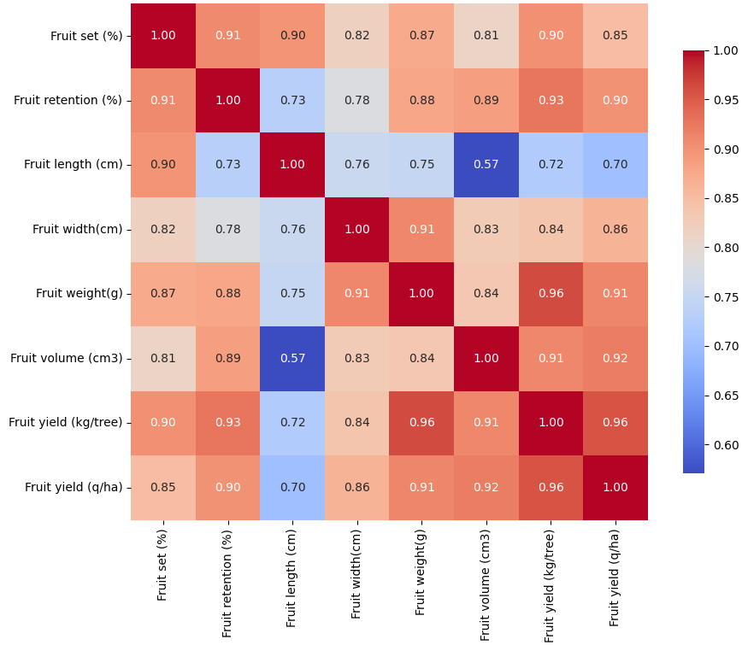
Fig. 2: Pearson Correlation Matrix of Fruit traits and Yields

