Statistical Characterization and Trait Association Studies for Selection of Elite Mutant Lines of Mustard (Brassica juncea L.)

Abstract
The​‍​‌‍​‍‌​‍​‌‍​‍‌ study presented was an attempt to assess the scope of genetic variability and the interrelationships among different traits of the mutant lines of mustard (Brassica juncea L.) after treatment of the variety PM 21 with sodium azide mutagenesis. Seventy-one M₄ generation mutant lines were evaluated in the field for nine agronomic and yield-related traits. The genotypes differed significantly for all the traits, indicating vast genetic diversity. The range of days to 50% flowering was 44.00 to 58.50 days (mean = 50.22 ± 3.07, CV = 6.1%), and days to maturity ranged from 88.00 to 107.00 days (mean = 100.37 ± 5.92, CV = 5.9%), indicating moderate variability. Plant height varied greatly from 124.90 to 223.77 cm (mean = 172.44 ± 16.66, CV = 9.7%), while the number of seeds per plant showed the highest variability (74.27 to 381.50; mean = 194.92 ± 65.11, CV = 33.4%), thus revealing a wide genetic base. The seed yield per plant ranged from 3.96 to 16.64 g (mean = 9.25 ± 2.76, CV = 29.8%), thus indicating high genetic variability for yield potential. Correlation analysis showed that days to 50% flowering had a positive correlation with days to maturity (r = 0.157*) and a negative correlation with the number of seeds per plant (r = –0.163*). Also, plant height was strongly positively correlated with the number of siliqua per plant (r = 0.44***) and seed yield per plant (r = 0.181*). The number of siliquae per plant showed the strongest positive correlation with seed yield (r = 0.34***), identifying it as a main yield-determining factor. The findings of this study emphasize the presence of considerable genetic variability and the importance of choosing genotypes with a high number of siliqua and moderate plant height to enhance mustard yield ​‍​‌‍​‍‌​‍​‌‍​‍‌potential.
Keywords: Correlation analysis, Descriptive statistics, Mutation, Mutant lines, Sodium azide, Variability

Introduction
Brassica​‍​‌‍​‍‌​‍​‌‍​‍‌ juncea L. (Indian mustard) is an amphidiploid species that resulted from the natural hybridization between B. rapa (AA, 2n = 2x = 20) and B. nigra (BB, 2n = 2x = 16). Thus, it has inherited genetic diversity from both parents and is, therefore, a vital genetic source for the development of new cultivars (Jat et al., 2019). This crop is one of the major sources of edible oil in India and a few other Asian countries, covering around 23.5% of the area cultivated with oilseed crops while contributing close to 24.2% of the national oilseed production (Jat et al., 2019). However, the polyploid nature of B. juncea, selective domestication, and modern breeding have resulted in a genetically limited polyploid B. juncea (Li et al., 2013; Zhang et al., 2022). In addition, it is believed that the genetic diversity of the parental species has not been well exploited, hence a narrow gene pool and small possibility for developing cultivars with desirable agronomic traits (Gepts & Papa, 2003; Hu et al., 2021; Singh et al., 2021).
The global population is forecasted to be about 10 billion by 2050, which will require food production to rise by 60–70% to maintain food and nutritional security (Hickey et al., 2019; van Dijk et al., 2021). The Brassica crops, being nutrient-rich, industrially valuable, and good for feed, can be the primary source to meet the said demand. However, Brassicas are afflicted by heat and cold sensitivity, drought, shattering, pest and disease pressure, and delayed maturity in some species like B. napus (Augustine et al., 2014; Raman et al., 2014; Zhu et al., 2016; Wrucke et al., 2019; Kourani et al., 2022). In spite of the fact that B. juncea is relatively early maturing and is tolerant of extreme conditions, its high erucic acid and glucosinolate content are still the factors making it less edible and attractive as an export commodity (Nour-Eldin et al., 2017). Consequently, the need for superior genotypes combining high yield potential, stress resilience, and good seed quality is imperative.
The limited genetic base of B. juncea has a negative effect on breeding progress for yield and adaptability (Gupta et al., 2025; Tiwari et al., 2025). The method of induced mutagenesis serves as a powerful tool to attain new allelic variations and expand the genetic base of a population, particularly in self-pollinated crops where the variability arising from recombination is scarce, and is therefore a viable option to solve this problem (Devi et al., 2025). The mutation program has been effectively implemented to create genetic variation for yield and quality traits in the Brassica species. In the meantime, besides mutation breeding, utilization of quantitative genetic instruments like estimates of statistical characterization, along with multivariate analyses of trait interrelationships (correlation analysis), is still indispensable in scouting for top-ranking genotypes in the early generations of mutant lines.
Therefore, the study presented here is designed to achieve the objective of assessing correlations among yield and yield-contributing traits; and thirdly, the study is meant to pinpoint those elite mutant lines that exhibit the most advantageous combinations of traits for the targeted breeding pipelines. The incorporation of mutation-induced genetic variation with comprehensive trait-association analyses enables the study to provide breeders with dependable, data-driven selection criteria of superior mutant lines in Indian ​‍​‌‍​‍‌​‍​‌‍​‍‌mustard.
Materials and Methods
The​‍​‌‍​‍‌​‍​‌‍​‍‌ research involved mustard variety PM 21, known for its low erucic acid content and adaptability to the Vidarbha region of Maharashtra. Dry, healthy, and genetically pure seeds of Brassica juncea cv. PM 21 were divided equally into four groups of 300 seeds each. One group served as the control, whereas the other three groups were treated with aqueous solutions of sodium azide (NaN₃) at concentrations of 0.03%, 0.06%, and 0.09% for 18 hours. All seeds were rinsed with sterilized distilled water to ensure the complete removal of any residual traces of the mutagen and were sown one hour later, along with the control seeds, under field conditions. The M₁ generation was grown during the rabi season of 2015–16, and plants of each treatment were harvested individually to maintain genetic purity. Seeds harvested from the M₁ plants were used to raise the M₂ generation, in which a total of 71 distinct mutants were identified during the rabi season of 2016-17. In the next rabi season of 2017–18, seeds obtained from each of the 71 mutants of the M₃ generation were sown to raise the M₄ generation in a randomized block design (RBD) with proper replications to ensure experimental precision. Data was gathered on essential agronomic and yield-related traits. These included days to 50% flowering, days to maturity, plant height (cm), number of primary branches per plant, number of siliquae per plant, silique length (cm), number of seeds per silique, seed yield per plant (g), and 1000-seed weight (g). The data recorded in the M₃ generation were analysed statistically to yield means, standard deviation, maximum, minimum, median, coefficient of variation, skewness, kurtosis, histogram and correlation. Standard biometrical procedures and suitable statistical software were used for all the statistical calculations. This was done to evaluate the extent of variability and associations among the studied traits for the identification and selection of elite mutant lines of mustard (Brassica juncea L.) suitable for yield ​‍​‌‍​‍‌​‍​‌‍​‍‌improvement.
Results and discussion
The​‍​‌‍​‍‌​‍​‌‍​‍‌ traits that were used for the descriptive statistics of the genotypes in the investigation revealed significant differences among genotypes for all the traits measured, referring to the presence of genetic diversity in the population (table 1 and Fig. 1). The average value of days to 50% flowering was 50.22, having a standard deviation (SD) of 3.07, the lowest value was 44.00, the highest value was 58.50, and the median was 49.50, reflecting moderate variability (CV = 6.1%) and positive skewness (0.88). Days to maturity were characterized by an average of 100.37 (SD = 5.92), with the values lying within 88.00 and 107.00, and a median of 102.50, indicating relatively low variation (CV = 5.9%) and negative skewness (-0.68), meaning that most of the genotypes matured earlier than the average. The number of seeds per pod had an average of 13.72 with a standard deviation of 1.27, the minimum value was 10.83, and the maximum value was 17.33, respectively, and the CV of 9.2%, thus showing slight positive skewness (0.58) and indicating a tendency for higher seed production in some genotypes. Plant height was on average 172.44 cm (SD = 16.66), the lowest value was 124.90 cm, the highest value was 223.77 cm, the median was 169.70, and the CV was 9.7%, thus indicating considerable genetic variability, whereas the slight positive skewness (0.32) and moderate kurtosis (1.38) pointed to a near-normal distribution. The number of primary branches per plant was characterized by relatively small changes in the mean of 3.76, SD of 0.35, and CV of 9.3%. The distribution was a little bit skewed (0.19) toward higher values, thus indicating that genotypes were quite uniform for this trait. The number of seeds per plant was distinguished by the highest variation to the mean and had a mean of 194.92, standard deviation of 65.11, and CV of 33.4%, with a range of 74.27-381.50, suggesting a broad genetic base for this trait. The positive skewness (0.89) showed that the majority of genotypes had a lower seed number per plant than the average, while the kurtosis value (0.93) indicated a leptokurtic distribution. Length of the stem recorded a mean value of 6.36, with almost no variation (SD = 0.27; CV = 4.2%) and negative skewness (-0.52), indicating that the distribution slightly shifted toward longer stem lengths. Seed yield per plant varied greatly, with a mean of 9.25 g and SD of 2.76, ranging from 3.96 to 16.64 g, and a very high CV of 29.8% were recorded, thus indicating strong genetic variability for yield potential among genotypes. The moderate positive skewness (0.47) also revealed that the majority of genotypes were below-average producers. Thousand-seed weight had an average value of 5.00 g (SD = 0.82), with the values lying within 3.24 and 6.36 g, the CV being 16.3%, and the slight negative skewness (-0.22), thus reflecting an almost symmetrical distribution with slight kurtosis (-0.83). Our results are supported by previous findings (Rashid et al., 2009; Gangapur et al., 2010; Jahan et al., 2013; Pankaj et al., 2017; and Khushboo et al., 2018). High-performance genotypes identified in this study represent a very important resource to advance yield and other key characteristics in Brassica crops (Kaur and Banga, 2015; Gadi et al.,2020; and Nandi et al., 2021).
The correlation analysis among the evaluated traits of mustard mutant lines revealed complex interrelationships, providing valuable insights into the direct and indirect associations governing yield and its contributing characters (Table 2 and Fig. 2). Days to 50% flowering showed a positive and significant correlation with days to maturity (r = 0.16*) but a significant negative association with the number of seeds per plant (r = - 0.16*). Days to maturity exhibited a strong and positive correlation with the number of branches per plant (r = 0.32***). However, days to maturity showed a significant negative relationship with the number of siliqua per plant (r = -0.19*). The number of seeds per pod exhibited a significant negative correlation with plant height (r = - 0.24**). Plant height demonstrated a strong positive association with the number of siliqua per plant (r = 0.44***). Furthermore, plant height (cm) was positively and significantly correlated with seed yield per plant (r = 0.18*). The number of branches per plant was significantly correlated with days to maturity (r = 0.32***). Number of siliqua per plant emerged as one of the most influential traits for yield, exhibiting a strong and positive correlation with seed yield per plant (r = 0.34***). Length of siliqua showed weak, non-significant associations with most traits, implying that it had a limited influence on yield variability within this mutant population. Seed yield per plant exhibited significant and positive correlations with plant height (cm) and number of siliqua per plant, but a negative association with days to 50 % flowering and days to maturity. Thousand-seed weight was not significantly correlated with any trait, highlighting its relative independence from phenological and morphological parameters. Similar findings have been reported, indicating that increased yield is linked to a greater number of seeds, longer siliques, and larger leaf area (Singh et al., 2014 and Naznin et al., 2015).

Conclusion
The​‍​‌‍​‍‌​‍​‌‍​‍‌ current study has shown significant genetic differences among mustard genotypes for traits that were measured, which points to a broad genetic base and substantial scope for genetic improvement through selection. The significant variation in the traits of seed yield per plant, plant height, and number of seeds per plant that has been revealed is a testimony to the potential of the high-genotype performance breeding programs. The traits of days to 50% flowering and days to maturity were only moderately variable, which indirectly indicates their role in the adaptability and management of crop duration. Correlation analysis has gone a step further to reveal even more relationships among yield-contributing traits. For example, seed yield per plant was the trait that had the strongest and most positive correlation with the number of siliqua per plant and plant height, which means that these traits are the main factors leading to productivity. On the other hand, the negative correlations of yield with days to flowering and maturity suggest that early-maturing genotypes may yield better under certain conditions. The weak or non-significant correlations of length of siliqua and thousand-seed weight with other traits imply that these traits have a limited impact on total yield in this population. These findings underscore the importance of genotype selection with the best combination of traits, plant height, siliqua number, and early flowering, in the yield of mustard improvement ​‍​‌‍​‍‌​‍​‌‍​‍‌potential.
Table 1: Descriptive statistical summary of yield and yield-attributes in mutant lines of Indian mustard (Brassica juncea L.)
Traits | Means | Standard deviation | Maximum | Minimum | Median | Coefficient variation | Skewness | Kurtosis | Histogram
DTF | 50.22 | 3.07 | 58.50 | 44.00 | 49.50 | 6.11 | 0.88 | 0.50 | ▂▇▅▂▂
DTM | 100.37 | 5.92 | 107.00 | 88.00 | 102.50 | 5.90 | -0.68 | -1.00 | ▂▂▂▃▇
SPS | 13.72 | 1.27 | 17.33 | 10.83 | 13.50 | 9.23 | 0.58 | 0.59 | ▂▇▇▃▂
PH | 172.44 | 16.66 | 223.77 | 124.90 | 169.70 | 9.66 | 0.32 | 1.38 | ▁▅▇▂▁
NBPP | 3.76 | 0.35 | 4.70 | 3.03 | 3.70 | 9.33 | 0.19 | -0.39 | ▂▇▆▅▁
NSPP | 194.92 | 65.11 | 381.50 | 74.27 | 176.23 | 33.40 | 0.89 | 0.93 | ▂▇▅▂▁
LOS | 6.36 | 0.27 | 6.74 | 5.84 | 6.34 | 4.20 | -0.52 | -0.73 | ▃▅▆▇▅
SYPP | 9.25 | 2.76 | 16.64 | 3.96 | 9.09 | 29.81 | 0.47 | -0.36 | ▃▇▇▃▂
TSW | 5.00 | 0.82 | 6.36 | 3.24 | 5.20 | 16.32 | -0.22 | -0.83 | ▂▅▅▇▃
DTF- Days to 50% flowering, DTM- Days to maturity, PH- Plant height (cm), NPBP- Number of primary branches plant⁻¹, NSPP- Number of siliqua plant⁻¹, SL LOS- Length of silique (cm), NSPS- Number of seed siliqua⁻¹, SYPP- Seed yield plant⁻¹ (g) and TSW- 1000 seed weight (g)
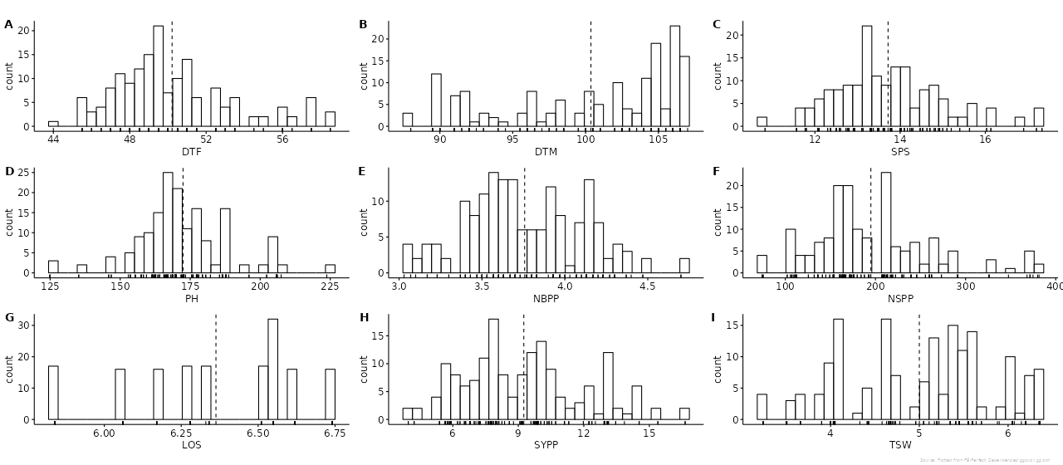
Fig. 1: Frequency distribution of yield and yield-attributes in mutant lines of Indian mustard (Brassica juncea L.)

Table 2: Correlation matrix of yield and yield-attributes in mutant lines of Indian mustard (Brassica juncea L.)
 | DTF | DTM | SPS | PH | NBPP | NSPP | LOS | SYPP | TSW
DTF | 1
DTM | 0.157* | 1
SPS | 0.014 | 0.101 | 1
PH | -0.043 | 0.003 | -0.241** | 1
NBPP | 0.005 | 0.321*** | 0.081 | -0.069 | 1
NSPP | -0.163* | -0.191* | -0.013 | 0.44*** | -0.131 | 1
LOS | 0.08 | -0.049 | 0.067 | -0.094 | 0.01 | -0.134 | 1
SYPP | -0.118 | -0.117 | 0.093 | 0.181* | -0.142 | 0.34*** | 0.024 | 1
TSW | 0.07 | 0.069 | -0.054 | -0.015 | 0.007 | -0.09 | -0.102 | -0.102 | 1

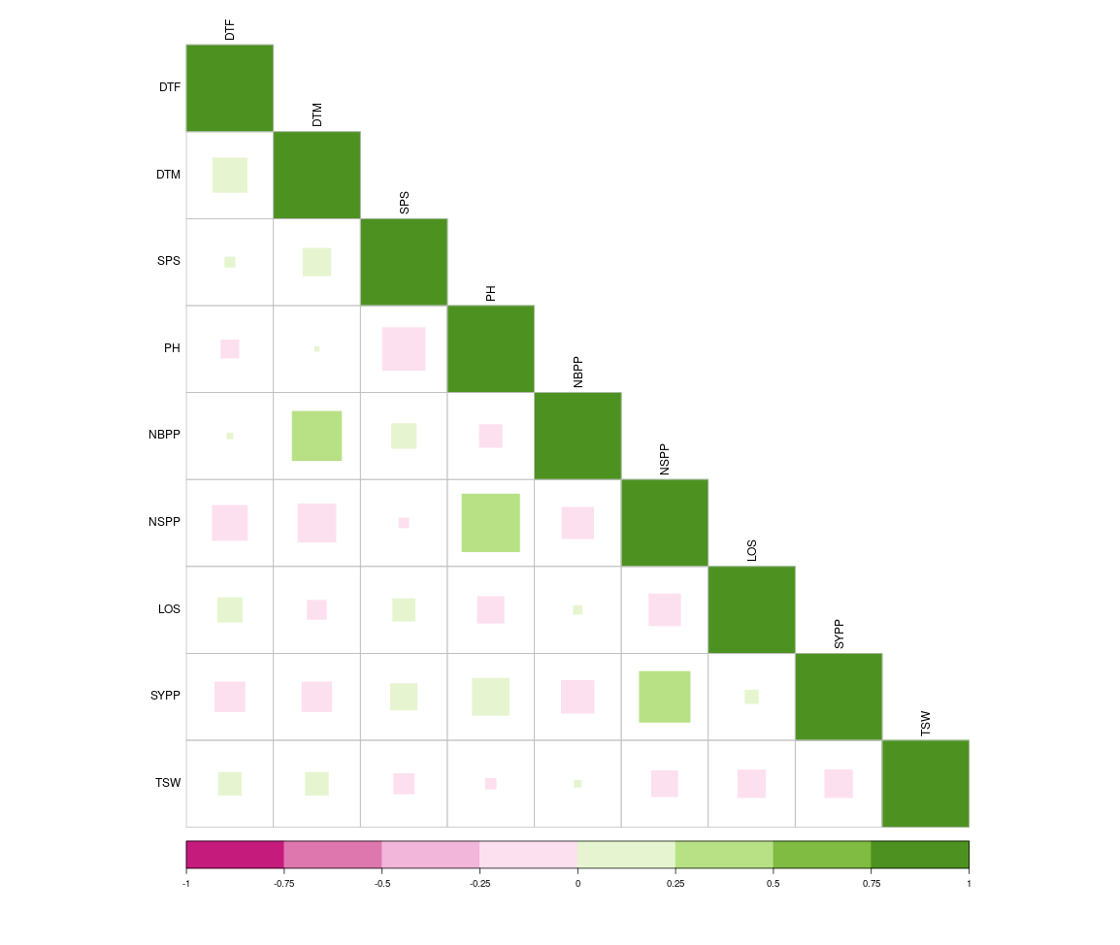
Fig. 2: Correlation matrix of yield and yield-attributes in mutant lines of Indian mustard (Brassica juncea L.)

COMPETING INTERESTS DISCLAIMER:
Authors have declared that they have no known competing financial interests OR non-financial interests OR personal relationships that could have appeared to influence the work reported in this paper.

References
Augustine, R., Arya, G. C., Nambiar, D. M., Kumar, R., & Bisht, N. C. (2013). Translational genomics in Brassica crops: challenges, progress, and future prospects. Plant Biotechnology Reports, 8(2), 65-81. https://doi.org/10.1007/s11816-013-0298-8
Devi, S. A., Barua, P. K., & Phukan, A. (2025). Correlation and Path Analysis of Yield-attributing Traits in Indian Mustard (Brassica juncea L. Czern & Coss.) Mutants and Non-mutants. Journal of Scientific Research and Reports, 31(2), 1-8. https://doi.org/10.9734/jsrr/2025/v31i22820
Gadi, J., Chakraborty, N. R., Imam, Z. (2020). Genetic diversity analysis in Indian mustard (Brassica juncea). Journal of Pharmacognosy and Phytochemistry, 9: 952-955.
Gangapur, D. R., Prakash, B., Hiremath, C. P. (2010). Genetic diversity analysis of Indian mustard (Brassica juncea L.). Electronic Journal of Plant Breeding, 1: 407-413.
Gepts, P., & Papa, R. (2003). Possible effects of (trans)gene flow from crops on the genetic diversity from landraces and wild relatives. Environmental Biosafety Research, 2(2), 89-103. https://doi.org/10.1051/ebr:2003009
Gupta, K. K., Singh, M. K., Singh, S. M., & Raghuvanshi, A. K. (2025). Genetic Variability, Heritability, Correlation and Path Analysis of Quantitative Traits in Indian Mustard (Brassica juncea L.). Journal of Experimental Agriculture International, 47(6), 27-33. https://doi.org/10.9734/jeai/2025/v47i63467
Hickey, L. T., Hafeez, A. N., Robinson, H., Jackson, S. A., Leal-Bertioli, S. C. M., Tester, M., Gao, C., Godwin, I. D., Hayes, B. J., & Wulff, B. B. H. (2019). Breeding crops to feed 10 billion. Nature Biotechnology, 37(7), 744-754. https://doi.org/10.1038/s41587-019-0152-9
Hu, D., Jing, J., Snowdon, R. J., Mason, A. S., Shen, J., Meng, J., & Zou, J. (2021). Exploring the gene pool of Brassica napus by genomics‐based approaches. Plant Biotechnology Journal, 19(9), 1693-1712. https://doi.org/10.1111/pbi.13636
Jahan, N., Bhuiyan, S., Talukder, M., Alam, M., Parvin, M. (2013). Genetic diversity analysis in Brassica rapa using morphological characters. Bangladesh Journal of Agricultural Research, 38: 11-18.
Jat, R., Singh, V., Sharma, P., & Rai, P. (2019). Oilseed brassica in India: Demand, supply, policy perspective and future potential. Oilseeds fats Crops Lipids, 26, 8. https://doi.org/10.1051/ocl/2019005
Kaur, H., Banga, S. (2015). Genetic divergence in novel determinate variants of resynthesized Indian mustard (Brassica juncea (L.) Czern and Coss). Indian Journal of Genetics and plant breeding, 75: 260-263.
Khushboo, C., Anil, P., Mishra, S. (2018). Principal component analysis of Indian mustard genotypes for morpho-physiological traits under rainfed condition. Green Farming, 9: 404-408.
Kourani, M., Mohareb, F., Rezwan, F. I., Anastasiadi, M., & Hammond, J. P. (2022). Genetic and Physiological Responses to Heat Stress in Brassica napus. Frontiers in Plant Science, 13. https://doi.org/10.3389/fpls.2022.832147
Li, Q., Mei, J., Zhang, Y., Li, J., Ge, X., Li, Z., & Qian, W. (2013). A large-scale introgression of genomic components of Brassica rapa into B. napus by the bridge of hexaploid derived from hybridization between B. napus and B. oleracea. Theoretical and Applied Genetics, 126(8), 2073–2080. https://doi.org/10.1007/s00122-013-2119-4
Nandi, S., Rout, S., Sur, B., Chakraborty, M., Hijam, L., Roy, S. K., Gupta, A. (2021). Assessment of genetic parameters, trait association and diversity analysis in Indian mustard [Brassica juncea (L.) Czern and Coss]. Biological Forum - An International Journal, 13: 96-109.
Naznin, S., Kawochar, M., Sultana, S., Bhuiyan, M. (2015). Genetic variability, character association and path analysis in Brassica rapa L. Genotypes. Bangladesh Journal of Agricultural Research, 40: 305-323.
Nour-Eldin, H. H., Madsen, S. R., Engelen, S., Jørgensen, M. E., Olsen, C. E., Andersen, J. S., Seynnaeve, D., Verhoye, T., Fulawka, R., Denolf, P., & Halkier, B. A. (2017). Reduction of antinutritional glucosinolates in Brassica oilseeds by mutation of genes encoding transporters. Nature Biotechnology, 35(4), 377-382. https://doi.org/10.1038/nbt.3823
Pankaj, R., Avtar, R., Kumari, N., Jattan, M., Rani, B. (2017). Multivariate analysis in Indian mustard genotypes for morphological and quality traits. Electronic Journal of Plant Breeding, 8: 450-458.
Raman, H., Raman, R., Kilian, A., Detering, F., Carling, J., Coombes, N., Diffey, S., Kadkol, G., Edwards, D., McCully, M., Ruperao, P., Parkin, I. a. P., Batley, J., Luckett, D. J., & Wratten, N. (2014). Genome-Wide Delineation of Natural Variation for Pod Shatter Resistance in Brassica napus. PLoS ONE, 9(7), e101673. https://doi.org/10.1371/journal.pone.0101673
Rashid, M., Bhuiyan, M., Akbar, M., Parveen, S. (2009). Diversity analysis of the germplasm oleiferous Brassica species. Journal of Sher-e-Bangla Agricultural University, 3: 30-34.
Singh, K. P., Kumari, P., & Rai, P. K. (2021). Current Status of the Disease-Resistant Gene(s)/QTLs, and Strategies for Improvement in Brassica juncea. Frontiers in Plant Science, 12. https://doi.org/10.3389/fpls.2021.617405
Singh, N., Sharma, P., Kumar, V., Kumar, V., Malik, V. (2014). Genetic divergence analysis in Indian mustard [Brassica juncea (L.) Czern & Coss.]. Annals of Biology, 30: 296-298.
Singh, S., Singh, M., Dubey, A., Syed, M., & Sahu, E. (2025). Genotypic and Phenotypic Correlation Analysis of Morphological and Yield-contributing Traits in Mustard (Brassica juncea L.) Genotypes Under Organic Conditions. Asian Plant Research Journal, 13(4), 46-52. https://doi.org/10.9734/aprj/2025/v13i4316
Van Dijk, M., Morley, T., Rau, M. L., & Saghai, Y. (2021). A meta-analysis of projected global food demand and population at risk of hunger for the period 2010-2050. Nature Food, 2(7), 494-501. https://doi.org/10.1038/s43016-021-00322-9
Wrucke, D. F., Mamidi, S., & Rahman, M. (2018). Genome-wide association study for frost tolerance in canola (Brassica napus L.) under field conditions. Journal of Plant Biochemistry and Biotechnology, 28(2), 211-222. https://doi.org/10.1007/s13562-018-0472-8
Zhang, L., Li, X., Chang, L., Wang, T., Liang, J., Lin, R., Wu, J., & Wang, X. (2022). Expanding the genetic variation of Brassica juncea by introgression of the Brassica rapa genome. Horticulture Research, 9. https://doi.org/10.1093/hr/uhab054
Zhu, M., Monroe, J. G., Suhail, Y., Villiers, F., Mullen, J., Pater, D., Hauser, F., Jeon, B. W., Bader, J. S., Kwak, J. M., Schroeder, J. I., McKay, J. K., & Assmann, S. M. (2016). Molecular and systems approaches towards drought‐tolerant canola crops. New Phytologist, 210(4), 1169-1189. https://doi.org/10.1111/nph.13866

