Review Article

Integrated Artificial Intelligence in Weather Forecasting for Agriculture: Opportunities, Challenges, and the Road Ahead

ABSTRACT
Farming is very vulnerable to weather change, variable rainfalls, temperatures, humidity, and prevalence of extreme climatic conditions, which directly affect growth and yields, as well as livelihoods of farmers. Microclimate Small scale details about microclimate are generally missing in classical forecast systems - statistical models, numerical weather prediction (NWP) and expert forecasts due to the coarse resolution in space and time. In recent times, AI, and in particular, machine learning (ML) and deep learning (DL) is transforming agricultural weather forecasting, including processing massive volumes of data gathered by satellites, on-ground sensors, etc. This review evaluates the use of AI in prediction of rainfall, temperature, humidity, wind, and extreme events in which case studies within and beyond India show an increase in prediction accuracy, reduction in prediction error and lead time. The major progress is the hybrid AI-NWP models, the multimodal data fusion and the IoT-based sensor network, which allow utilizing real-life benefits in the area of irrigation scheduling, pest and disease management and disaster early-warning systems. Hyperlocal advisory platforms and edge computing are also capable of supporting real-time field level decision making precision farming. Nevertheless, there are still challenges (e.g. low data quality, high computational needs, poor rural-infrastructure, socio-economic restrictions) that hinder uptake. Researchers, policy-makers and technologists should be included to resolve these issues, to direct the design of technologies to user-friendliness and trust among farmers. The emerging pathways - adaptive AI, block-chain secured edge systems, and customized advisories, hold significant opportunities of creating resilience, resource-use efficiency, and food security in the context of increased climate variability.

Keywords: Artificial Intelligence, Weather Forecasting, Remote Sensing, Microclimates, Sustainable Farming

INTRODUCTION
Traditionally, agriculture is based on the diversity of weather conditions, which has its own disequilibrium in precipitation (rain, hail, snow and drizzle), temperatures, a relative humidity and other weather extremes which has an aftermath on the growth and development of the crops, its qualitative value, and the socio-economic balance of the farmers. As the world population grows and the variable attributes of climatic conditions increase, timely and clear forecasting is emerging as the clincher to provide security in food and sustainable agricultural practices. Traditionally weather-forecasting in agriculture is relying on statistic techniques, numerical weather prediction possible modes, scientific experience, physical data perceived by the use of various instruments of the meteorological laboratory. These procedures or techniques despite the informative meaning have their drawbacks in that the spacio-temporal resolution of the procedures fails to capture the convolution and diverseness of the microclimates that co-relates with the modern agriculture.
The new technological systems, in particular, AI-related advanced technologies comprising of ML methodologies are transforming the process of weather forecasting by providing data-driven adaptive and hyper-local forecasts. Learning of non-linear and spatial-temporal patterns using big data provided by remote sensing satellites, ground stations, sensors and historical records has assisted AI systems to identify complex relationships that conventional systems cannot learn. Furthermore, AI-based solutions are gaining more and more applications in giving advice to growers about what to plant, how to utilize resources, and how to manage risks - bringing together weather intelligence and agronomic decision support.(Sham et al., 2025)
in the meantime AI that is applied in agricultural weather forecasting is not flawless, but promising..(Das & Nayak, 2024) Its most significant impediments to its broad acceptance remain data quality and availability, the complexity of computations of the models and the high level of digital skills of the end-users. I aim at synthesizing recent findings, methodological underpinnings and evidence originating from case studies, and to pinpoint research gaps as well as to outline prospects. It is intended to be a critical, evidence-based review targeted at agricultural scientists, policy-makers, technology developers, and practitioners.

WEATHER FORCASTING IN AGRICULTURE
“Yet real-time weather variability affects every aspect of agriculture — from what seed is put in the ground, to how quickly it matures, to when it is harvested and how it will perform after harvest.” Traditional forms of weather forecasting, for example NWP, give generalised predictions, but these are of little use for current precision farming practices, which require spatial resolutions well under a kilometre and temporal resolutions approaching operational windows, for sowing, irrigation and harvesting.(Agyekum et al., 2022)
Accurate forecasts enable:
- Lower production expenditures under optimized irrigation, fertilisation and pesticide schedules
- Timely protection against extreme weather
- Maximized productivity and quality of crops through adaptive management
The pressing need has been to narrow the distance between forecasts and decision-making, but nevertheless, at the level of the field. This has required both technical development of and deployment through decision support systems. For further application or uses of weather forecasting in agriculture see table 1.

Table 1: Leading Uses of Weather Forecasting in Agriculture (Agyekum et al., 2022).
APPLICATION | IMPACTS
Sowing or harvest | Increase yield, avoids loss
Irrigation management | Conserves water, prevent waterlog
Pest and disease warnings | Preventive measures, reduces crop yield loss
Fertilizer dosage which is planned to be applied | Enhances overall efficiency which furthermore helps in preventing runoff
Disaster awareness | Diminish damage from weather extremes

AI PERCEPTION AND TOOLS
Artificial intelligence involves computational methods for performing tasks that require intelligence such as learning, reasoning, and adaptation.
Artificial intelligence tools that are being widely used in agriculture, particularly in the field of weather forecasting are as follows:
- Machine learning (ML): regressions, support vector machine, decision trees, random forests.
- Deep learning (DL): Neural networks – particularly recurrent neural networks (RNNs) and convolutional neural networks (CNNs) for spatial - temporal patterns interpretation
- Hybrid Models: Combining ML/DL with statistical models (i.e., ARIMA, exponential smoothing) to combine linear and non-linear pattern recognition.
- Natural Language Processing (NLP): Unstructured parsing of weather bulletins and combining qualitative reports.(Bastiatul Fawait et al., 2024)

APPLICATION OF ARTIFICIAL INTELLIGENCE IN WEATHER FORECASTING
AI has the most transformative power when it comes to processing large amounts of multi-source, high-resolution data for this refer to table 1:
- Rainfall Forecasting: We use neural networks (LSTMs) because they are better at forecasting rainfall than traditional models, particularly in the case of anomalous or extreme rainfall events. Hybrid construction Some models are run with hybrid architectures, where physical NWP output is combined with AI-based correction of biases.(Sham et al., 2025)
- Temperature and Humidity Prediction: Fine-grained foresight using sensor networks and adaptable ML models enhances irrigation scheduling and disease outbreak prediction.
- Wind speed and direction: Real-time wind prediction to support spraying, pollination, and harvesting logistics; SVM, ensemble.
- Early Warning for Drought and Floods: Anomaly detection combined with multi-sensor fusion for earlier warning lead times for risk reduction, insurance, and emergency response planning.(Sivakumar & Motha, 2007)
- Hyperlocal Forecast Dissemination: Utilize integration of IoT( Internet of Things) , satellite (MODIS, Sentinel) and farm weather stations for Field or Block level advisories PIC.(Dhanve et al., 2025)
Performance Metrics: Reduces the possibility in mean absolute error (MAE) for precipitation: 15–40% compared to traditional NWP. Lead-time improvement: 10-16 hours more lead-time for weather warnings in several pilot implementations. Greater use by farmers, with adoption rates increasing when with market forecasting is clearly depending upon the monetary terms.

DATA SOURCES AND AI IN WEATHER FORECASTING
Introduction: Success of artificial intelligence (AI) in agricultural weather prediction is directly dependent on quality, variety, and harmonization of input datasets. The power of combining diverse data sources—such as satellite images, makers of in-situ sensors, archived reanalysis data, agronomic data and crowd sensed data—requires sound data integration and rigorous quality control. This chapter explores the main flows of data, their fusion and current practices of assurance, as well as challenges and future directions (supporting readings).(Kikuchi, 2025)

Data taxonomies

Satellite Remote Sensed Data:
Low-earth orbit satellite platforms that deliver more consistent and precise in the wide-area coverage which is very critical for agricultural applications. The first data source for the remote sensed data is MODIS (Moderate Resolution Imaging Spectroradiometer), which provides daily global observations of vegetation indices, land surface temperature, and atmospheric moisture content at a resolution of 250m-1km (Awais et al., 2023) . The availability of SAR data from Sentinel-1 and optical multispectral data from the Sentinel-2 satellites provides possibilities for precise observations on crop conditions and surface moisture, that cannot be conducted when relying solely on the radar or optical sensors. Landsat: The Landsat series provide historical continuity with a long-term record for climate analysis and model training while geostationary satellites.(He et al., 2024)

In-Situ and IoT networks:
Low altitude, or above-ground measurements of temperature, humidity, wind speed, precipitation and solar radiation are normally provided by automatic weather station deployed with the IoT sensor array. The company's products provide the accuracy needed for precision agriculture applications (Zenkner & Navarro-Martinez, 2023) . Edge-computing architectures at the farm-level enable processing data in real time and removing any latency that is not conducive to making decisions quickly as required, without disrupting operations during connectivity outages (Oh & Seo, 2022).

Historical and Revised datasets:
National Weather Services records: Long-term meteorological records from major national weather services (IMD, NOAA, ECMWF) serve as the vital data for training machine learning models. The ERA5 reanalysis provides sub-daily records of meteorological variables on a global grid since 1979 (Chen et al., 2021). These datasets inform the creation of climatological baselines and create a benchmark for identifying the exceptional weather systems that could affect agriculture-related processes. 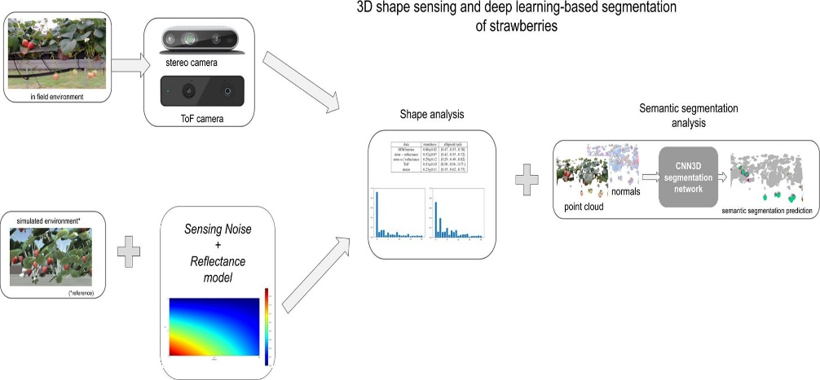
Figure 1: Process of analysis of shape through stereo camera and reflective mode.
Source: https://www.sciencedirect.com/science/article/abs/pii/S0168169921003914?via%3Dihub

Multi-source Data Integration :
Recent events underline how using multimodal data fusion methods including ground measurements, meteorological reanalysis, and satellite data helps to increase prediction accuracy (Hachimi et al., 2023). Showed that for irrigation management, soil-water content predictions are significantly improved when several data sources are combined utilizing sophisticated preprocessing and feature engineering techniques. In a similar vein, multisource techniques have proven their worth in treating missing data by means of sophisticated imputation techniques (Awais et al., 2023) .

Data Integration and Methodologies

Spatiotemporal Harmonization
Operative blending requires trutination of the data across different spatial as well as temporal scales. Grid-based insertion techniques such as kriging and co-kriging are employed to orient the satellite, ground station, and model data to common spatial configuration (Verrier, 2020) . Temporal synchronization: resampled high-frequency sensor data at model timesteps (left) while maintaining the relevant meteorological parameters (right) (Zenkner & Navarro-Martinez, 2023).

Feature Engineering and Data Preprocessing
The Operational fusion is required for digital processing of the data, across several spatial-temporal levels. Grid-based inoculating techniques such as kriging and co-kriging orient the satellite, ground station and model data into a common spatial configuration or arrangement (Hachimi et al., 2023). Agriculturally relevant indices such as growing degree days, vapor pressure deficit, drought indices are usually driven from such unfiltered meteorology variables by feature engineering procedures.

Edge Computing and Real-time Processing
The contemporary agricultural applications increasingly rely on edge computing architectures that enables real-time data processing at the unit farm level. These systems comprise of the local sensor networks with lightweight artificial intelligence (AI) models that are capable of generating instant forecasts without dependence on cloud connectivity (Oh & Seo, 2022). Edge deployment helps in reducing the latency while also ensuring data specific privacy and operational continuity during network interferences.

CASE STUDIES: PRACTICAL USE OF AI IN WEATHER FORCASTING

Maharashtra, India: use of machine learning in smart weather data system
Kadu and Reddy (2025) created a Smart Weather Data Management (SWDM) system designed and developed to serve the agriculture needs in Wardha, a district in Maharashtra. Real-time meteorological data procurements using APIs was integrated with weather forecasting and agricultural data analytics using machine learning(ML) procedures.

Technical Implementation:
Data Architecture: Pride of Lions Pattern (Acquisition, Storage, Processing and Application),
ML Models | Mix of regression models, decision trees, neural networks
Data Sources: Weather feeds API, Land-based reanalysis datasets. (both in real-time)
Monitored Variables: Temp-min, Temp-max, RH

Performance Outcomes:
Projection Period: 5-day temp-min, temp-max, relative humidity, wind and clouds predictions
Metrics used: Root Mean Square Error (RMSE), Mean Square Error (MSE), R² score.
Integrations: Weather visualisation, time series analysis, and ML monitoring & evaluation with Py Caret integration..(Kadu & Reddy, 2025)
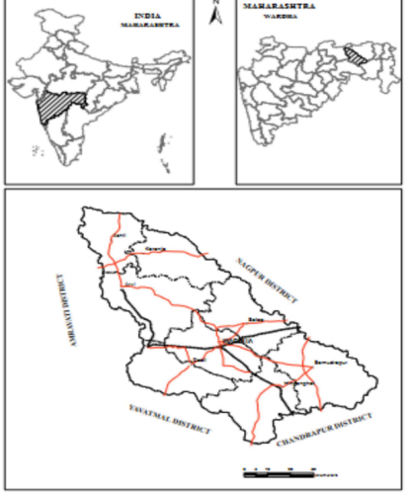
Figure 2: Wardha district location map (Kadu & Reddy, 2025)

Telangana, India: Machine Learning-Based Optimal Crop Selection with Weather Integration
Rani et al. (2023) developed an exhaustive Machine learning (ML) -based system which combines the weather prediction with crop selection for Telangana state. The survey utilized Long Short-Term Memory Recurrent Neural Networks (LSTM-RNN) for weather forecasting consolidated with Random Forest Classification for superlative crop suggestion.

Technical Methodology:
Weather Prediction Phase: LSTM-RNN models for minimum temperature, maximum temperature, and rainfall prediction trained over the historical data (2015–2020) of Temperature, Wind speed, Humidity & Sun hours provided by National Remote Sensing Agency (NRSA), Hyderabad Dataset contains 1,993 records in total Crop Selection Phase: Random Forest Classifier using weather predictions along with soil descriptors

Performance Metrics:
Metrics for Temperature Prediction: RMSE of 5.023% for minimum temperature, 7.28% for maximum temperature, Rainfall Prediction: RMSE of 8.24%,
Metrics for Crop Selection Accuracy: 97.235% accuracy for crop selection, 96.437% for resource dependency prediction, 97.647% for optimal sowing time prediction Model
Toal Construction Time: 5.34 seconds using Random Forest Classifier.

Agricultural Applications:
The system provided integrated suggestions for crop selection, resource required , and optimum sowing period and time for ten major crops including soybean, cotton, maize, rice, and chili across Telangana's three agro-climatic zones.(Rani et al., 2023)
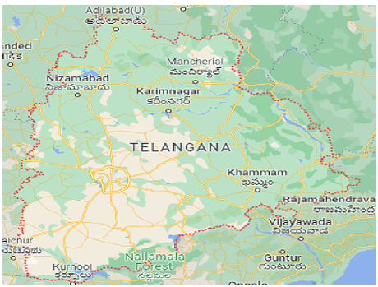
Figure 3: Telangana state of India: Area considered for this study. (Source Google Maps https://www.google.co.in/maps) .

India: AI-Enabled Precision Agriculture Weather Prediction Using Ensemble Methods
Lavanya & Swapna (2025) devised an ingenious machine learning (ML) structure for precision agronomics, encompassing steady weather parameters monitored by utilizing Internet of Things (IoT) integration. This analysis was then used to compared between the standard Adaboost and improved Adaboost algorithms for accurate weather prediction.

Technical specifications:
Parameters monitored including maximum temperature, minimum temperature, air or atmospheric pressure, relative humidity (RH) and wind velocity. Integration of IoT which involves smart weather nodes which is helpful for real-time data collection.
Machine learning (ML) which comprises of Adaboost and modified Adaboost ensemble procedures. And at last it encompasses of Data interpretation which ensures the real time environmental factors for the irrigation and fertilizers application recommendations.
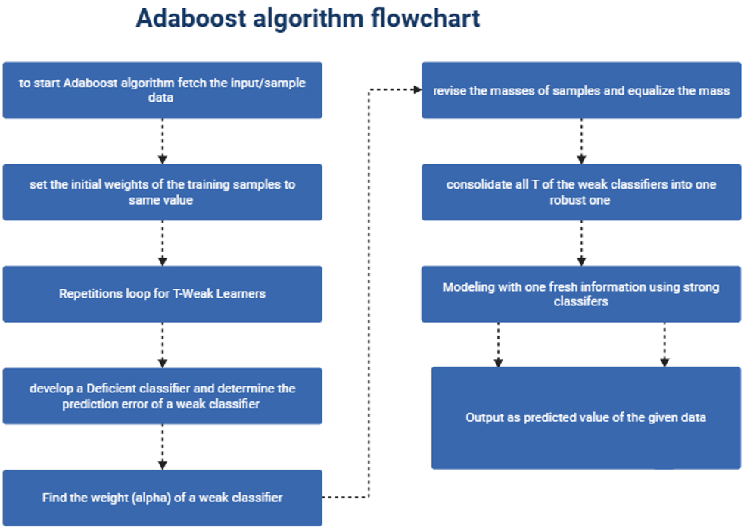
Figure 4: Flow-chart Adaboost algorithm (Lavanya & Swapna, 2025).

Performance outcomes:
Accuracy: modified Adaboost accuracy was observed which was up to 90% in weather prediction
Comparative analysis: a comparative analysis was successfully observed between Adaboost and modified Adaboost in which modified Adaboost outperformed Adaboost in prediction accuracy.
Evaluation metrics: Root mean square error (RMSE) and mean absolute error (MAE) were evaluated
Integration of systems: Irrigation systems incorporated with moisture sensors driven by AI integrated systematics.

IMPLEMENTATION IN AGRICULTURE:
The structural framework provided useful and dynamic recommendations for pest management, irrigation scheduling, nutrient management, by utilising augmented reality dashboard which helps our farmers to make decision directly in field conditions using data driven decisions(Lavanya & Swapna, 2025).

National/Regional Application: Integration of AI for Personalized Weather and Crop Advisory – The Meghdoot App
The Meghdoot app, developed by the India Meteorological Department (IMD) and the Indian Council of Agricultural Research (ICAR), is considered a pioneering initiative to digitize agricultural advisories in the sprawling and varied farming landscape in the country. Using AI, massive meteorological data and participatory feedback, the Meghdoot provides actionable triggers for location specific actionable information to millions of farmers across India to make an informed decision on climate variation and agricultural risks The Meghdoot App: A Comprehensive Review of a Flagship Digital Initiative in India jointly announced by the Prime Ministers of the two countries We do an extensive study of the Meghdoot app to analyse the relative impact it may have created. Released by the India Meteorological Department (IMD) and the Indian Council of Agricultural Research (ICAR). Based on artificial intelligence (AI), the app will convert complex meteorological data into real-time advisory alerts that are unique to thousands of farmers in India. The paper cautiously charts the technical architecture and the user implication of using AI to integrate into a scalable and farmer centric AMAAS. (Singha et al., 2024)

Technical Methodology
AI fused analytics: Meghdoot data engine applies machine learning on massive amounts of district and sub-district level meteorological data to train. They include temperature, rainfall, wind, humidity among other pertinent factors communicated to the IMD data models and are also produced by remote sensors and the Sensor Network of IMD.
Agronomic and User Data: Crop management histories, soil inferences and challenges reported, are sorted and accessed to localize the advice. The two ways of in-app interaction control enable the flow of the data that makes the offers more personal and more trustworthy.
Multilingual, Hyperlocal Delivery Aware of the linguistic and cultural diversity of India, the advisory platform was built on the idea of the delivery of content such as food in regional languages. This implies that the weather notification, operational warning, and crop suggestions can be contextually applicable and widely accessible- even to digital illiterates.
Model Training: The sound training of the AI models is on historical reports of multiannual weather reports and crop outcome under the IMD. Such historical richness makes it available to differentiate short-term anomalies and climatological trends and deliver advice that is relevant to the season.
Platform Functionality: The app helps in combining various forecast visualization tools, real-time notifications, and archived advisory recovery , ensuring continuous support through planting, cultivation, and harvest cycles (Singha et al., 2024) .

Performance and Impact
Higher Advisory Accuracy: AI-enabled personalization was shown to significantly increase the accuracy and local specificity of weather and crop advisories as compared to classical, district-level advisories. It contributed to more accurate hazard forecasting (heavy rain and drought, pest and disease outbreak forecasting) and improved timing of input application.
Improved Farmer Early-Warning: The in-app early warning and response advice helped to build farmers’ resilience, they were better able to respond to unexpected weather and accommodate changes in irrigation/fertilizer applications and crop protection activities, directly translating meteorological foresight into reduced agricultural losses.
User Engagement/Trust: Personalising advisory content, recognising local crop-stage needs and building upon user opinion on the effectiveness of previous advisories helped to establish ownership and trust in the application. The report shows that user uptake reached over 3.7 million and there are anecdotal stories which strongly suggest an increase in farmer confidence in planning options.
Aid for Climate Adaptation -The Meghdoot App, by regular advisory updates and personalised historic climate analysis, contributed significantly towards enhancing adaptive agriculture practices. Farmers became more aware of seasonal and inter-annual climate anomalies, supporting longer-term resilience and the adoption of climate-smart strategies.
Bridging Digital Exclusion: Special features for low literacy populations, such as audio advisories and icon-based navigation, increased inclusion and minimized digital disparities (Singha et al., 2024) for more brief explanation refer to table 2.

CASE STUDY | TECHNICAL APPROACHES | DATA SOURCES & FLUCTUATIONS | OUTCOMES & PERFORMANCE METRICS | APPLICATION & IMPACT ON AGRICULTURE | REFERENCES
Maharashtra- SWDM | Used pride of lions patterns for regression, decision trees, neural networks | Weather feeds, reanalysis of datasets, temperature (max and min) & RH | RMSE, MSE, five days forecasts for temp- min/max, RH, wind, clouds | Realtime data is provided for data analytics for agricultural requirements in Wardha | (Kadu & Reddy, 2025)
Telangana-ML-Based crop selection | LSTM-RNN (for predicting weather), Random Forest (for crop selection) | NRSA datasets, temperature, speed of wind, RH, sunshine hours, soil descriptors | RMSE: 5.02% (min temperature), 7.28% (max temperature), 8.24%(rainfall), crop selection accuracy 97.2% | Provide rapid suggestions for crop/resource use/ sowing period, prediction time (5.34 seconds) | (Rani et al., 2023)
India-precision agriculture with IoT | Adaboost and modified Adaboost ensemble, IoT integrated | IoT nodes: max/min temperature, pressure, RH, wind velocity | 90% accuracy (of modified Adaboost), RMSE, MAE comparison analysis | Provide real-time pest/irrigation/nutrient management through Augmented reality dashboard. AI driven moisture sensors for field analysis | (Lavanya & Swapna, 2025)
National-Meghdoot App | AI prediction engine, historical multiannual weather/crop results | IMD sensors are used, remote sensing, temperature, rainfall, wind, RH, data of users | Provides enhanced accuracy, early warning system, 3.7+ users, efficient climate adaptation | Personalization can be done, multiple-language support in crop and weather advisories, adaptive | (Singha et al., 2024)
Table 2: case studies on AI integrated in weather forecasting in more brief manner.

Challenges and problems
Data and Sensor Challenges: An important limitation to successful AI‐based weather forecasting in agriculture is the quality, availability, and fusion of data from multiple sources. Weather prediction is based on a huge a historical climate dataset and real‐time data of ground sensors, satellite images and IoT devices; however, collecting this well‐condition data is a cumbersome task to deal with. For example, many smallholder and resource‐constrained farms do not have the required sensor networks and IoT infrastructure to support reliable and consistent data.(Dhal & Kar, 2024). In most databases, the information has blank or noisy or erroneous values, which may compromise AI model performance. (Delfani et al., 2024). It is also worsened by the reality that agricultural data tend to be seasonal and spatially non-homogenous, such that the trend and extreme events on the long-term scale can be hardly reflected by the AI algorithms.
Modelling and Computational Complexity: The creation of effective AI models tailored-made to weather forecasting in agriculture is full of complexities, in addition to the data hurdles. The character of climate is one of the obstacles and is dynamic, non-linear and relies on a mass of variables characterizing a myriad of interacting elements. Traditional time series forecasting such as ARIMA only allows the model to predict when the data is stationary and cannot readily accommodate any form of exogenous variables like sudden weather conditions that occur to your tomatoes or market changes. (Dhal & Kar, 2024)
Integration, Deployment, and Infrastructure Limitations: The implementation of the full-fledged AI systems in the weather forecasting of agricultural sector suffers further setbacks by system integration, system infrastructure and real time data processing. On the hardware and communication front, in many agriculture regions, rural and under-developed areas in particular, the digital infrastructure is not strong enough for continuous data collection & real time analysis. The digital divide Internet of Things sensors can only reach full potential when there are no restrictions and limitations for their deployment and usage across different parts of the globe, but the current IoT world thus far is not there, as not everyone under the dome of sensorial coverage has access to the same Web network capabilities, or can afford such access (Das & Nayak, 2024) .
Socio-economic, Ethical, and Operational Challenges: Even if technical and infrastructure challenges are lifted, achievement of integrated AI in weather prediction for agriculture depends on solving social-economic, ethical and operational issues. One of the key challenges in the dissemination of such technologies is lack of digital knowledge and technical knowhow among farmers, especially in remote areas and in developing nations. Farmers might have a reluctance to adopt new technology because of a lack of training, unclear benefits, or lack of trust in “black-box” AI models (Das & Nayak, 2024).
Economic constraints: the expense of outlay of money necessary to more sophisticated sensors, computer hardware as well as maintenance for small-scale farmers, can be against. In most scenarios, the expense of implementing integrated AI solutions has not justified the claims they make – especially when the predictions fail to consistently convert to actionable steps to improve crop yields or resource usage (Olabimpe Banke Akintuyi, 2024).

Future prospects
Whilst conventional methods of weather forecasting are solid the precision agriculture at the granular level and adaptable real-time is beyond their ability. AI-paired systems, in their turn, can examine a range of data (past weather information or real time sensor readings) and, in addition, give forecasts based on microclimatic features. This can give farmers far better decision support systems leading to improved utilization of resource and crop performance. It is also the need of such sophisticated prediction systems that is encouraged by an increasing amount of evidence that climate extremes (e.g., precipitation, temperature) can play a significant role in long term variability and change in climate.
Better prediction accuracy Deep learning and time series analysis innovations are enabling AI systems to predict the weather more precisely as they absorb and study data on past weather and real time sensor data in large amounts. The promise of better accuracy in predictions, achieved by the inclusion of state-of-the-art algorithms, such as LSTM and ARIMA models enables microscale predictions that could be used to optimize irrigation schedules, planting choices, and eventually crop use. Such precision is important to compensate for unstable weather patterns.
INTense IoT Adaptation Small-scale, cost-effective IoT sensor networks with low power density across farmlands to monitor environment variables including temperature, rainfall, land soil moisture and humidity in real time.. These sensors form the foundation for the accumulation of localized data used to train AI models, which can provide a hyperlocal perspective of microclimates in agricultural fields. The integration of such sensors improves the robustness and responsiveness of weather prediction systems to changing field conditions (Adli et al., 2023) .
Integration of Multi‐modal Data The integration of meteorological data and other information sources (e.g., drones, satellite remote sensing, and soil sensors) can facilitate a more complete understanding of the farm environment. With these multi-modal datasets combined, AI systems can generate predictions that are sufficiently sensitive to the actual heterogeneity of local weather on a field scale, allowing case-specific advice to be offered by crops and area.
Adaptive AI, Real-time Decision Support Systems Designing adaptive AI systems to continually learn on the data and dynamically update forecasting models in real time. This enables the provision of dynamic response to the changing weather systems and environmental conditions at ground level. They are able to provide significant improvements to irrigation practices, fertilization and pest management practices by providing decision support in a timely and situation specific context. (Olabimpe Banke Akintuyi, 2024)
Blockchain and edge computing to ensure secure and real time processing: New safety systems in accordance with incorporation of blockchain in edge computation would secure sensitive agricultural information and at the same time enable the speedy decentralized processing of the weather condition data. This two-pronged approach enhances the security and integrity of the data and reduces the latency introduced through cloud-based processing and therefore enables local real time forecasting that is requisite to timely decision making.
Predict and Prevent Catastrophic Events: with Predictive Modelling and AI With advanced AI models, PA system In India is now able to predict catastrophic events such as floods, drought, hurricane, and extreme storms with higher accuracy. These predictive capabilities serve as early warning systems that enable farmers to prepare for a possible natural disaster, ultimately minimizing the expected crop losses and financial risks through proactive risk management and insurance strategies.
Improved Crop and Disease Management: AI‐integrated weather forecasting is also paramount for disease forecasting and pest management. Weather variables can be compared to past disease outbreaks and pest generations, allowing AI models to issue early alerts and warnings enabling regional authorities and advisors to take necessary control steps, improving the crop protection and minimising crop losses due to pastoral infestations.
Scenario analysis and adaptive forecasting: The use of model simulations that integrate different climate change scenarios enable farmers and agricultural planners to evaluate potential effects on crop yields and resources. These models, combined with scenario analysis and weather forecast in real time, allow the design of adaptive strategies aimed to accommodate optimal crop performance under uncertain future climatic scenarios (Das & Nayak, 2024) .

Conclusion
The impact of artificial intelligence on the land(planetary) weather climate prediction is changing the way weather forecasting in agriculture is performed far from the classical statistical models and the numerical ones. Leveraging multi-source datasets, state-of-the-art ML techniques and IoT-enabled sensor networks, AI can generate hyperlocal, adaptive, actionable predictions which ultimately empower precision agriculture. The Indian use-cases, i.e.: district level smart weather systems in Maharashtra and Telangana, development of Meghdoot App etc are a testimonial to the potential that AI must transform decision-making processes to serve the purpose of sowing, irrigation, input management, and risk management.
Although artificial intelligence has shown great potential in realizing the agricultural weather forecast, there are still many obstacles to be overcome in applying it on a massive scale. The limitations of data, inconsistency, and noise, along with computational heavy nature of sophisticated models are all still a challenge. Also, digitization infrastructure in rural settings, and socio-economic limitations of digital technology to farmers in terms of cost and skill complicate their full implementation. Such barriers will require a joint approach by researchers, policy-makers, technology developers, and extension systems to ensure that their personal roles are inclusive and reachable to small farmers who are the mainstay of agriculture in developing nations.
Forward view the future evolution of deep learning algorithms, the multi-source information fusion technology, block chain-based edge computing solutions, and the adaptable real-time decision-assisting frameworks will introduce immense possibilities to increase the accuracy, reliability, and the availability of the weather forecasting services to the users. When properly developed, such AI-based forecasting will be able to positively influence climate resilience, offer superior resource management, minimize crop failures, and maintain food security against the rising climate change.

References
Adli, H. K., Remli, M. A., Wan Salihin Wong, K. N. S., Ismail, N. A., González-Briones, A., Corchado, J. M., & Mohamad, M. S. (2023). Recent Advancements and Challenges of AIoT Application in Smart Agriculture: A Review. Sensors, 23(7), 1–22. https://doi.org/10.3390/s23073752
Agyekum, T. P., Antwi-Agyei, P., & Dougill, A. J. (2022). The contribution of weather forecast information to agriculture, water, and energy sectors in East and West Africa: A systematic review. Frontiers in Environmental Science, 10(August), 1–14. https://doi.org/10.3389/fenvs.2022.935696
Awais, M., Naqvi, S. M. Z. A., Zhang, H., Li, L., Zhang, W., Awwad, F. A., Ismail, E. A. A., Khan, M. I., Raghavan, V., & Hu, J. (2023). AI and machine learning for soil analysis: an assessment of sustainable agricultural practices. Bioresources and Bioprocessing, 10(1). https://doi.org/10.1186/s40643-023-00710-y
Bastiatul Fawait, A., Aprilani, P., Sok, V., & Author, C. (2024). Applications of Artificial Intelligence in Weather Prediction and Agricultural Risk Management in India. 1(3), 15–27. https://doi.org/10.70177/agriculturae.v1i3.1591
Das, S. K., & Nayak, P. (2024). Integration of IoT-AI powered local weather forecasting: A Game-Changer for Agriculture.
Delfani, P., Thuraga, V., Banerjee, B., & Chawade, A. (2024). Integrative approaches in modern agriculture: IoT, ML and AI for disease forecasting amidst climate change. Precision Agriculture, 25(5), 2589–2613. https://doi.org/10.1007/s11119-024-10164-7
Dhal, S. B., & Kar, D. (2024). Transforming Agricultural Productivity with AI-Driven Forecasting: Innovations in Food Security and Supply Chain Optimization. Forecasting, 6(4), 925–951. https://doi.org/10.3390/forecast6040046
Dhanve, S., Kale, M., Phadatare, T., & Dherange, S. (2025). AI Enabled Weather Forecasting for Rural Farmers : A Case Study Approach. 1–6.
Hachimi, C. El, Belaqziz, S., Khabba, S., Sebbar, B., Dhiba, D., & Chehbouni, A. (2023). Smart Weather Data Management Based on Artificial Intelligence and Big Data Analytics for Precision Agriculture. Agriculture (Switzerland), 13(1), 1–22. https://doi.org/10.3390/agriculture13010095
He, Q., Zhao, H., Feng, Y., Wang, Z., Ning, Z., & Luo, T. (2024). Edge computing-oriented smart agricultural supply chain mechanism with auction and fuzzy neural networks. Journal of Cloud Computing, 13(1). https://doi.org/10.1186/s13677-024-00626-8
Kadu, A. V, & Reddy, K. T. V. (2025). Smart Weather Data Management System for Sustainable Agriculture in Maharashtra Using Machine Learning. Ml. https://doi.org/10.3844/jcssp.2025.1526.1538
Kikuchi, T. (2025). Weather-Aware AI Systems versus Route-Optimization AI: A Comprehensive Analysis of AI Applications in Transportation Productivity. 1–41. http://arxiv.org/abs/2507.17099
Lavanya, A., & Swapna, B. (2025). Precision Agriculture: Machine Learning based Weather Prediction – A Comparative Study of Adaboost and Modified Adaboost Algorithm. SSRG International Journal of Electronics and Communication Engineering, 12(7), 459–471. https://doi.org/10.14445/23488549/IJECE-V12I7P136
Oh, J., & Seo, M. (2022). Evaluation of Citizen–Student Cooperative Urban Planning and Design Experience in Higher Education. Sustainability (Switzerland), 14(4), 1–18. https://doi.org/10.3390/su14042072
Olabimpe Banke Akintuyi. (2024). Adaptive AI in precision agriculture: A review: Investigating the use of self-learning algorithms in optimizing farm operations based on real-time data. Open Access Research Journal of Multidisciplinary Studies, 7(2), 016–030. https://doi.org/10.53022/oarjms.2024.7.2.0023
Rani, S., Mishra, A. K., Kataria, A., Mallik, S., & Qin, H. (2023). Machine learning-based optimal crop selection system in smart agriculture. Scientific Reports, 13(1), 1–11. https://doi.org/10.1038/s41598-023-42356-y
Sham, F. A. F., El-Shafie, A., Jaafar, W. Z. W., S, A., Sherif, M., & Ahmed, A. N. (2025). Advances in AI-based rainfall forecasting: a comprehensive review of past, present, and future directions with intelligent data fusion and climate change models. Results in Engineering, 27(December 2024), 105774. https://doi.org/10.1016/j.rineng.2025.105774
Singha, K., Dhulipalaa, R., Billub, N., & Chawalab, K. (2024). Integration of Artificial Intelligence (AI) to generate personalized weather and crop advisories: A case study of Meghdoot app in India. 1–6. https://cgspace.cgiar.org/items/b3056650-1acd-427a-9c15-d26a026c922a%0Ahttps://cgspace.cgiar.org/bitstreams/c4c6bea3-0198-464e-8f73-8d413acd299b/download
Sivakumar, M. V. K., & Motha, R. P. (2007). Managing weather and climate risks in agriculture. Managing Weather and Climate Risks in Agriculture, January 2007, 1–503. https://doi.org/10.1007/978-3-540-72746-0
Verrier, S. (2020). Multifractal and multiscale entropy scaling of in-situ soil moisture time series: Study of SMOSMANIA network data, southwestern France. Journal of Hydrology, 585, 124821. https://doi.org/https://doi.org/10.1016/j.jhydrol.2020.124821
Zenkner, G., & Navarro-Martinez, S. (2023). A flexible and lightweight deep learning weather forecasting model. Applied Intelligence, 53(21), 24991–25002. https://doi.org/10.1007/s10489-023-04824-w

