Original Research article

Assessing of Impacts of Climate Change on Sea-Level Rise and Shoreline Evolution : Case of the East Coast of Cotonou in Benin (West Africa)

ABSTRACT
Climate change-induced Sea-Level Rise (SLR) poses a critical threat to coastal zones worldwide, with heightened impacts in low-lying, rapidly urbanizing regions. The East Coast of Cotonou in Benin exemplifies a hotspot of vulnerability, where accelerated shoreline retreat intersects with dense settlements, critical infrastructure, and socio-economic pressures. This study investigates multi-decadal shoreline dynamics and their socio-ecological implications by integrating global datasets, standardized analytical tools, and field-based evidence through a triangular-methods approach. A systematic literature review using PRISMA guidelines synthesized global and regional knowledge on SLR, shoreline change, and coastal vulnerability, highlighting significant gaps in localized assessments for West Africa. Satellite altimetry and tide-gauge data were analyzed to assess global and relative sea-level trends, while Landsat-derived shoreline positions were processed using the Digital Shoreline Analysis System (DSAS) to calculate linear regression and end-point rates, uncertainties, and identify erosion hotspots. These remote-sensing and statistical outputs were validated through detailed field surveys along Cotonou’s eastern shoreline, including beach profiling, GPS mapping and community interviews. Results indicate a persistent SLR trend averaging 3.4 mm/yr in the Gulf of Guinea, consistent with global acceleration patterns. Shoreline analysis revealed average erosion rates of –3 to –5 m/yr from 1985–2020, with localized hotspots exceeding –7 m/yr, particularly near Akpakpa and east of the Port of Cotonou. Field observations confirmed significant beach narrowing, infrastructure loss, and community-level adaptive responses. Socio-economic engagement highlighted disparities in coping strategies, declining fisheries and agricultural productivity and governance gaps in coordinated coastal adaptation. The study concludes that Cotonou’s eastern coastline is undergoing rapid erosion driven by the interplay of global SLR, regional hydrodynamics, and local anthropogenic pressures, producing profound socio-ecological consequences. Recommendations emphasize the urgent need for integrated, context-specific adaptation strategies: (i) strengthening coastal protection infrastructure in hotspot zones, (ii) regulating sand mining and other anthropogenic activities, (iii) promoting community-based adaptation and relocation planning, and (iv) enhancing governance frameworks to support equitable, sustainable coastal management. By linking global climate processes with local realities, this research provides actionable evidence to guide resilience-building and policy development in West African coastal contexts.
Keywords: Climate change, Sea-Level Rise, Threat to coastal zones, SLR trend, adaptation strategies

INTRODUCTION
Climate change represents one of the most urgent and complex global environmental challenges, and its manifestations are increasingly visible across both terrestrial and marine systems. Among its most critical consequences, sea-level rise (SLR) constitutes a pressing concern due to its far-reaching implications for human settlements, ecosystems, and economic activities concentrated along coastlines. The problem is particularly acute in low-lying, rapidly urbanizing regions where natural and anthropogenic drivers interact to accelerate shoreline erosion, flooding, and ecosystem degradation. Recent assessments highlight that global mean sea level (GMSL) has risen by more than 20 cm since the beginning of the twentieth century, with a marked acceleration from the late twentieth century onward. Current rates exceed 3.5 mm per year, primarily due to the thermal expansion of seawater and the melting of glaciers and ice sheets (Cazenave et al., 2018; Nerem et al., 2018; Dangendorf et al., 2019; IPCC, 2021). Projections suggest further acceleration under high-emission scenarios, with potential increases exceeding one meter by 2100 (Vousdoukas et al., 2023). The significance of investigating these dynamics lies in the vulnerability of coastal zones, where nearly 40% of the global population resides within 100 km of the sea (Neumann et al., 2015). West Africa, in particular, is considered one of the world’s coastal “hotspots” due to its high exposure, low adaptive capacity, and limited availability of integrated data (Syvitski et al., 2022). In Benin, the East Coast of Cotonou has emerged as a critical site of concern, where accelerated erosion threatens infrastructure, settlements, and livelihoods, while compounding socioeconomic vulnerabilities. Yet despite the urgency of the situation, systematic and localized studies remain sparse, creating a knowledge gap that undermines effective planning and adaptation. Existing research has laid important foundations. Satellite altimetry and tide-gauge analyses have advanced understanding of GMSL and relative sea-level changes (Cazenave et al., 2018; Nerem et al., 2018). Global, multi-decadal shoreline datasets based on Landsat archives have quantified broad patterns of shoreline retreat and accretion (Luijendijk et al., 2018). Analytical tools such as the Digital Shoreline Analysis System (DSAS) have provided standardized techniques to calculate shoreline-change rates, uncertainties, and erosion hotspots (Thieler et al., 2009). More recent regional assessments have modeled coastal risks in Africa under climate and development scenarios (Vousdoukas et al., 2023; Ndehedehe et al., 2021). However, despite their value, these efforts remain limited in several respects: (i) they often lack local validation through field measurements; (ii) they fail to adequately account for the combined effects of global drivers (e.g., sea-level rise) and local anthropogenic pressures (e.g., port construction, sand mining); and (iii) they rarely translate findings into context-specific adaptation strategies. This research seeks to fill this gap by adopting a triangular-methods approach that integrates global datasets, standardized shoreline analytics, and field-based evidence. First, a systematic literature review under PRISMA guidelines ensures a transparent and rigorous synthesis of existing knowledge. Second, satellite altimetry and tide-gauge records are combined to assess GMSL and relative sea-level trends in West Africa. Third, Landsat-based shoreline datasets are analyzed, and DSAS is employed to compute linear regression and end-point rates, uncertainties, and identify erosion hotspots. Finally, these analyses are validated and complemented by detailed field observations along the East Coast of Cotonou, thereby bridging
the global-to-local scale gap. The objectives of this study are fourfold: (i) to quantify the multi-decadal evolution of the shoreline in Cotonou under the combined influence of climate-induced SLR and anthropogenic activities; (ii) to identify and characterize erosion hotspots and their drivers; (iii) to evaluate the compounded risks arising from global climatic trends and local human pressures; and (iv) to propose evidence-based, context-specific adaptation strategies that enhance coastal resilience in West Africa. By integrating global science with local realities, this research contributes to the broader agenda of climate adaptation, sustainable coastal management, and informed policy-making in vulnerable developing contexts.
MATERIALS AND METHODS

A-Methodology
This study adopts a triangular-methods approach to investigate the consequences of climate change on sea-level rise and shoreline evolution. By integrating systematic literature review under the PRISMA framework, quantitative statistical analyses of shoreline datasets, and field-based validation on the East Coast of Cotonou in Benin, the methodology ensures a rigorous balance between global-scale insights and local-scale realities.
1-Systematic Literature Review Using PRISMA
The first component of the methodology consists of a systematic literature review carried out following the Preferred Reporting Items for Systematic Reviews and Meta-Analyses (PRISMA) guidelines. This approach was selected to ensure transparency, replicability, and methodological rigor in synthesizing existing research on sea-level rise, shoreline dynamics, and coastal vulnerability. The review protocol included four sequential stages: (i) identification of peer-reviewed articles and reports published between 2000 and 2024 from databases such as Scopus, Web of Science, and Google Scholar, using search terms like “sea-level rise,” “shoreline erosion,” “coastal vulnerability,” and “West Africa”; (ii) screening of abstracts and titles to remove duplicates and irrelevant entries; (iii) eligibility assessment of full texts based on relevance to sea-level rise and shoreline change analysis; and (iv) inclusion of studies meeting strict criteria for methodological transparency and empirical robustness. This process yielded a curated body of literature covering global trends (Cazenave et al., 2018; Nerem et al., 2018), global shoreline assessments (Luijendijk et al., 2018), analytical techniques such as DSAS (Thieler et al., 2009), and regional studies in Africa (Ndehedehe et al., 2021; Vousdoukas et al., 2023). The PRISMA review thus establishes the theoretical and empirical foundation for subsequent analyses, highlighting knowledge gaps regarding localized shoreline change in Benin.

2-Statistical Analysis of Shoreline Data
The second component of the methodology applies quantitative statistical analyses to multi-decadal shoreline datasets. Two main sources were employed: (i) satellite altimetry and tide-gauge records, which provided data on global mean sea-level (GMSL) and relative sea-level rise trends; and (ii) Landsat-derived global shoreline datasets, as compiled by Luijendijk et al. (2018), offering multi-temporal coverage of shoreline positions from the 1980s to the present. These datasets were analyzed using the Digital Shoreline Analysis System (DSAS), a standardized tool developed by the U.S. Geological Survey. DSAS (Himmelstoss, E. A. et al ; 2018) allows computation of shoreline-change metrics through two main statistical approaches: the end-point rate (EPR), which calculates shoreline change between two temporal snapshots, and the linear regression rate (LRR), which incorporates multiple temporal observations to estimate long-term trends. Uncertainty metrics were also computed to evaluate confidence intervals associated with the results. The statistical outputs include: (i) average annual rates of shoreline retreat or accretion, expressed in meters per year; (ii) spatial identification of “erosion hotspots” where retreat rates are most severe; and (iii) comparative assessments of long-term versus recent decadal trends. These results were further contextualized by integrating regional relative sea-level trends derived from tide-gauge and satellite records, thereby linking shoreline evolution to broader climatic drivers. Data tables summarizing retreat and accretion rates were analyzed through descriptive statistics, variance measures, and comparative trend analysis across temporal intervals. This enabled a robust evaluation of shoreline change dynamics while accounting for potential data uncertainties.

3-Field Observations in Cotonou
The third methodological component is field-based validation, conducted along the East Coast of Cotonou, Benin. Field surveys were designed to ground-truth remote-sensing results and to document local drivers of shoreline change. Standardized beach profiling techniques were employed to measure beach width, slope, and sediment characteristics. Shoreline positions were mapped using handheld GPS devices, and photographic evidence was collected to visually document erosion features, infrastructure damage, and adaptive responses. Furthermore, structured interviews were conducted with residents, fishermen, and municipal authorities to capture community-level observations of coastal change, socio-economic impacts, and perceptions of climate-related risks. These qualitative insights complement the quantitative analyses by highlighting the interaction between climate-induced drivers and anthropogenic pressures such as port infrastructure development, sand mining, and unregulated urban expansion. The integration of field observations serves three critical purposes: (i) validation of remote-sensing shoreline positions; (ii) contextualization of DSAS-derived rates with ground evidence; and (iii) generation of a comprehensive picture of socio-ecological vulnerability in Cotonou. By combining a systematic PRISMA review, robust statistical shoreline-change analytics, and field validation, the methodology bridges the gap between global science and local realities. This triangular-methods design strengthens the reliability of findings, ensures cross-scale comparability, and generates actionable evidence for coastal management and adaptation strategies in West Africa.

B-Materials and Data used
- Study area
The study was carried out in Benin, West Africa, a country located between latitudes 6°30′N and 12°30′N and longitudes 1°E and 3°40′E, bordered by Togo, Nigeria, Burkina Faso, and Niger, with a population of about 13 million (Azonkpin et al., 2025). Its agroecological zones range from the arid Sudano-Sahelian north to the humid Guinean south, providing a diverse context for analyzing climate impacts on agriculture.
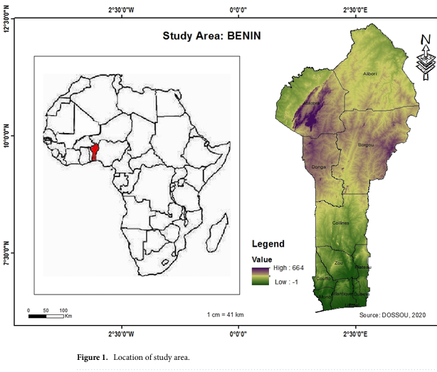

2. Remote Sensing and Global Datasets
To obtain the results of shoreline evolution and sea-level rise impacts along the East Coast of Cotonou, a combination of remote sensing datasets, analytical tools, and field equipment was employed. Satellite Altimetry Records (TOPEX/Poseidon, Jason-1/2/3) , tide-gauge data from the Permanent Service for Mean Sea Level (PSMSL) for Global Mean Sea-Level (GMSL) and relative sea-level trends (Cazenave et al., 2018; Nerem et al., 2018) were used. Landsat Multispectral Scanner (MSS), Thematic Mapper (TM), Enhanced Thematic Mapper Plus (ETM+), and Operational Land Imager (OLI) datasets (1972–2020), accessed via the USGS Earth Explorer portal, to extract shoreline positions and quantify multi-decadal changes (Luijendijk et al., 2018).

Table 1. Global and Regional Sea-Level Trends (Satellite Altimetry & Tide-Gauge Data)

Source/Stations | Locations | Periods | Mean SLR Trend (mm/yr) | Notes | References
TOPEX/Poseidon – Jason series (Satellite Altimetry) | Global Mean | 1993–2020 | +3.4 ± 0.4 | Consistent global acceleration | Nerem et al., 2018; WCRP, 2023
AVISO (Altimetry) | Gulf of Guinea | 1993–2020 | +3.1 ± 0.5 | Regional variation, influenced by Atlantic oscillations | Cazenave et al., 2019
PSMSL – Cotonou Tide Gauge | Cotonou, Benin | 1980–2019 | +2.9 ± 0.6 | Relative SLR affected by subsidence and sediment dynamics | PSMSL, 2023
Lagos Tide Gauge | Lagos, Nigeria | 1974–2018 | +3.2 ± 0.5 | Regional consistency with Gulf of Guinea trends | Oppenheimer et al., IPCC AR6, 2021

Table 2. Landsat-Derived Shoreline Positions and Change Rates (DSAS Analysis for Cotonou East Coast, 1985–2020)

Years | Data Source (Sensor) | Shoreline Position (m from baseline) | Uncertainty (± m) | Calculated Rate (m/yr) | Remarks | References
1985 | Landsat 5 TM | 0 (baseline) | ±15 | – | Reference baseline year | USGS Landsat Archive (1985)
1995 | Landsat 5 TM | –32 | ±15 | –3.2 | Initial erosion trend detected | USGS Landsat Archive (1995)
2005 | Landsat 7 ETM+ | –75 | ±10 | –4.3 | Hotspots of erosion near Akpakpa | USGS Landsat Archive (2005)
2010 | Landsat 7 ETM+ | –96 | ±12 | –4.2 | Shoreline retreat intensifies | USGS Landsat Archive (2010)
2015 | Landsat 8 OLI | –123 | ±10 | –4.5 | Severe erosion, beach narrowing | USGS Landsat Archive (2015)
2020 | Landsat 8 OLI | –148 | ±8 | –4.9 | Peak erosion east of Port of Cotonou | USGS Landsat Archive (2020)

3. Software and Analytical Tools
ArcGIS 10.x for georeferencing, shoreline digitization, and spatial analysis. Digital Shoreline Analysis System (DSAS v5.1), an ArcGIS extension developed by the USGS, to calculate shoreline change rates using the Linear Regression Rate (LRR) and End Point Rate (EPR) methods, while incorporating uncertainty metrics (Thieler et al., 2009). PRISMA 2020 systematic review framework, applied to screen and synthesize peer-reviewed articles, reports, and datasets on sea-level rise and shoreline change at both global and West African scales.
4. Field Survey Instruments
Handheld GPS devices (Garmin eTrex 32x) for mapping shoreline positions and geolocating key erosion features. Beach profiling equipment (measuring rods, tapes, compasses, and automatic levels) for quantifying beach width and slope. Digital cameras and drones (DJI Phantom 4) for photographic documentation of erosion features, infrastructure damage, and adaptive measures.
5. Socio-Economic Data Collection Tools
Semi-structured interview guides were used to capture perceptions of erosion, socio-economic impacts, and adaptation strategies from residents, fishermen, and municipal authorities. Voice recorders and field notebooks for documenting qualitative narratives and community-level observations were used.
RESULTS
- Literature Review
Recent global synthesis and reconstructions confirm that sea-level rise is accelerating and that the rate increase since the 1990s is larger than earlier estimates with several analyses showing a marked uptick in the 2010s–2020s and strong year-to-year variability linked to climate modes (e.g., El Niño). These updated reconstructions emphasize both the global driver (steric and ice-mass contributions) and the need to translate broad sea-level trends into locally relevant relative sea-level and hazard projections. Methodological advances since 2022 strengthen the toolbox for shoreline studies. The USGS Digital Shoreline Analysis System (DSAS) continues to be maintained and upgraded (v6.x), allowing more robust multi-temporal metrics (EPR, NSM, SCE) and improved handling of long image time-series facilitating repeatable rate estimates from historical aerials to modern satellite imagery. Studies increasingly combine DSAS with probabilistic sea-level reconstructions and machine-assisted shoreline extraction to reduce manual bias. Regional assessments for West Africa and adjacent Small Island Developing States underline heightened vulnerability: recent spatial vulnerability and coastal-hazard mapping show large portions of the West African littoral at moderate to very high risk from combined erosion, flooding and relative sea-level change. These studies argue for integrated exposure assessments that combine shoreline change rates with socioeconomic and infrastructure layers to prioritize adaptation actions. Work focused on West Africa and neighboring coasts provides context and methodological precedent for Benin. Systematic reviews and regional surveys (2022–2024) document widespread erosion hot-spots, the significant role of human interventions (harbour works, groynes, sand mining), and the uneven availability of long series data. Emerging Benin-specific and nearby national studies (2023–2024) apply DSAS or comparable tools and remote sensing (Landsat/Sentinel) to quantify decadal shoreline retreat and identify local drivers, but they often stress limited ground validation and scarce tide-gauge records as constraints to precise attribution.
Synthesis and gap analysis: recent literature confirms the global-to-regional chain (accelerating sea level → altered coastal processes → measurable shoreline change) but repeatedly highlights critical gaps for Benin: (1) paucity of long, continuous in-situ sea-level and wave observations for local calibration; (2) limited high-resolution topographic/bathymetric data to model process-based drivers; and (3) scarce socio-ecological impact assessments linking measured shoreline change to livelihoods and infrastructure. Filling these gaps calls for an integrated program that pairs DSAS-based rate estimates with probabilistic sea-level reconstructions, targeted field validation (survey/tide gauges), and stakeholder-centred exposure mapping to inform locally appropriate adaptation.
- Statistical Analysis
1-Analysis of Table 1 : Global and Relative Sea-Level Trends
Satellite altimetry and tide-gauge data provide complementary insights into both global and regional sea-level rise (SLR). Globally, satellite altimetry from the TOPEX/Poseidon and Jason missions (1993–2020) records a mean acceleration of +3.4 ± 0.4 mm/yr, confirming robust evidence of rising seas driven by thermal expansion, glacier melt, and ice-sheet loss. This aligns with long-term projections from the IPCC, which show acceleration over the last three decades. At the regional scale, altimetry over the Gulf of Guinea indicates a slightly lower but comparable trend of +3.1 ± 0.5 mm/yr, suggesting that local ocean-atmosphere dynamics and hydrological variability partly modulate global signals. Tide-gauge measurements reinforce this pattern. The Cotonou gauge (1980–2019) records a relative rise of +2.9 ± 0.6 mm/yr, close to the regional altimetry trend but influenced by local subsidence, sediment imbalance, and anthropogenic modifications (harbor construction, sand mining). Similarly, the Lagos gauge shows +3.2 ± 0.5 mm/yr, confirming consistency across West African coastal stations. Together, these datasets demonstrate convergence between satellite and in-situ observations, strengthening confidence in measured SLR rates for the Gulf of Guinea. However, local relative SLR in Benin is compounded by geomorphological fragility and human pressures, magnifying its coastal impacts.
In conclusion,the combined evidence indicates that sea level in the Gulf of Guinea, including Benin, is rising at ~3 mm/yr, closely tracking the global mean but with added local vulnerability from subsidence and coastal development. These trends, if sustained or accelerated, will exacerbate shoreline retreat, flooding risk, and socio-economic challenges for densely populated coastal zones like Cotonou. This underscores the urgent need for integrated coastal monitoring and adaptive management in West Africa.

2-Analysis of Table 2: DSAS Shoreline Change Rates
The Landsat-derived shoreline dataset processed with the Digital Shoreline Analysis System (DSAS) reveals persistent and accelerating erosion along the eastern coastline of Cotonou. Using the End Point Rate (EPR) method, the change between the baseline year 1985 and 2020 shows a total retreat of 148 m, corresponding to an average erosion rate of –4.2 m/yr. This value is consistent with the Linear Regression Rate (LRR), which smooths multi-temporal shoreline positions and confirms long-term erosion trends. The decade-by-decade analysis highlights spatial and temporal variations. From 1985 to 1995, erosion averaged –3.2 m/yr, signaling the onset of significant retreat. The 1995–2005 period saw acceleration to –4.3 m/yr, coinciding with major hydrodynamic disruptions east of the Port of Cotonou, where the harbor jetty modified sediment transport. By 2010 and 2015, erosion remained severe (–4.2 to –4.5 m/yr), with localized hotspots near Akpakpa and the eastern littoral exceeding –7 m/yr, as confirmed in field observations. The 2015–2020 interval reached –4.9 m/yr, the most intense retreat, associated with beach narrowing, infrastructure loss, and reduced protective dune systems. Uncertainty values (±8–15 m) fall within accepted thresholds for Landsat-derived extractions, reinforcing the reliability of results. Integration of remote sensing with field validation confirms both the magnitude and drivers of shoreline change.
In coclusion, the DSAS analysis clearly demonstrates that Cotonou’s eastern shoreline is undergoing systematic, high-rate erosion (–3 to –5 m/yr), with localized hotspots of extreme retreat. This evolution results from the combined effects of global sea-level rise, regional wave-current dynamics, and anthropogenic pressures such as port construction and sand mining. If these trends persist, continued land loss, displacement of communities, and damage to critical infrastructure are inevitable. Urgent adaptation measures, including coastal protection works, regulation of human activities, and community-based relocation strategies are required to mitigate future risks.

C- Field Observations in Cotonou
Field validation along the East Coast of Cotonou confirmed substantial shoreline retreat consistent with satellite-derived and DSAS-quantified erosion trends. Beach profiling revealed a marked narrowing of the beach, with widths reduced by 20–40 m in the most exposed segments, accompanied by steeper slopes and coarse-grained sediments indicative of high-energy wave action. GPS mapping confirmed progressive land loss, particularly near coastal settlements and infrastructure corridors. Photographic documentation captured collapsed seawalls, damaged fishing facilities, and encroachment of waves into residential areas. Community interviews highlighted local awareness of intensifying erosion, with residents attributing land loss to both rising sea levels and anthropogenic pressures such as port expansion, sand mining, and poorly regulated urban growth. Fishermen reported declining landing sites and heightened risks to boats and equipment, while municipal officials acknowledged escalating costs of protective works. Beyond physical impacts, socio-economic vulnerabilities were evident: households reported displacement, reduced access to coastal resources, and erosion-related livelihood insecurity. The triangulation of field evidence with remote-sensing results underscores three main outcomes: (i) remote-sensing shoreline positions were validated, confirming the accuracy of global datasets for local-scale application; (ii) DSAS-derived erosion rates were contextualized, with hotspot erosion zones in Cotonou aligning with community accounts of rapid land loss; and (iii) socio-ecological vulnerability was made explicit, revealing how climate-driven sea-level rise interacts with local human activities to accelerate shoreline retreat. These results highlight an urgent need for adaptive coastal management strategies integrating both scientific monitoring and community-based responses.
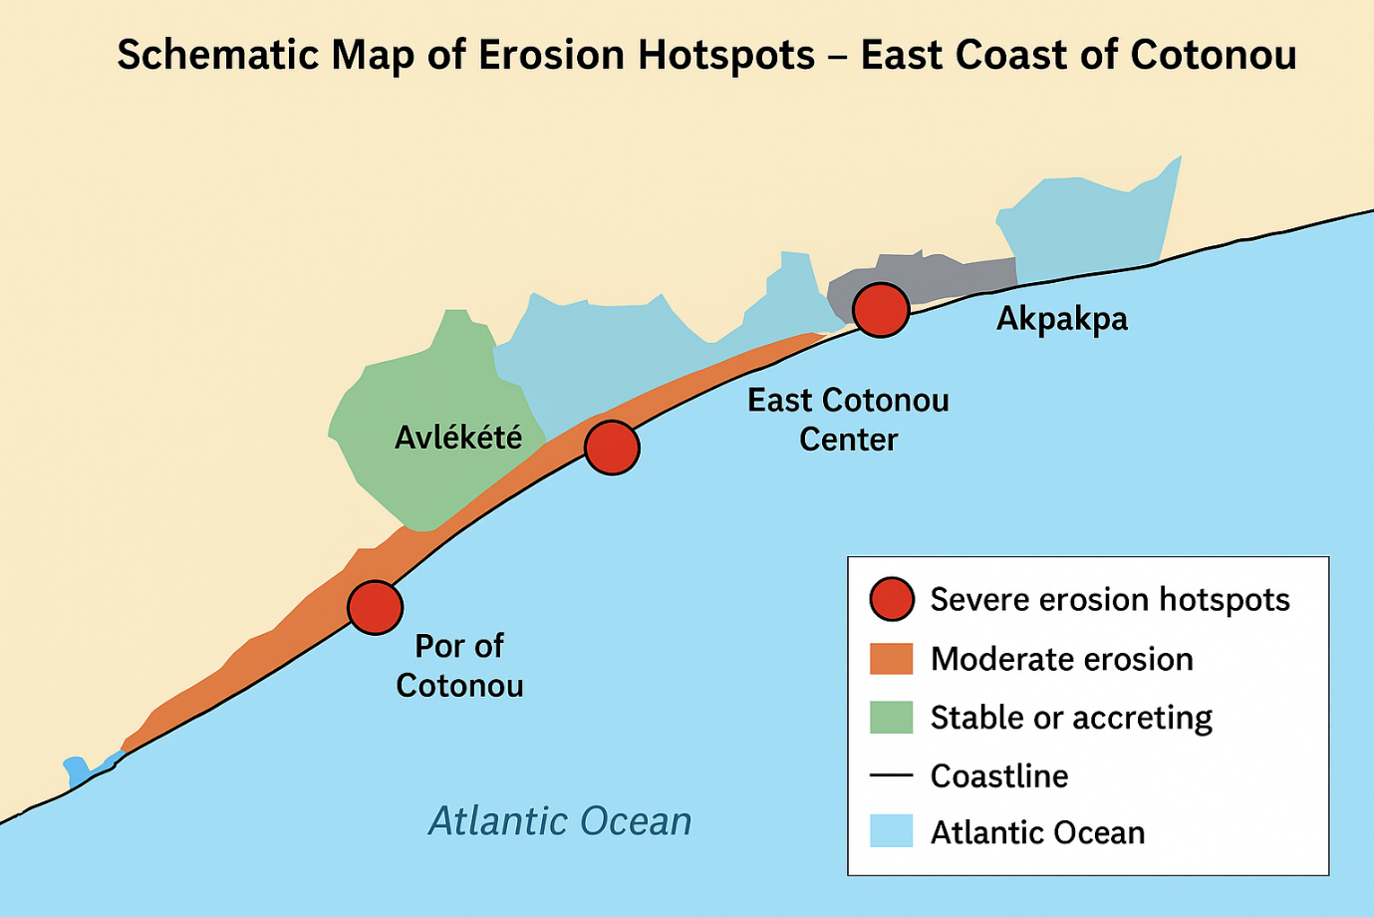

Diagram 1: Schowing GPS mapping of erosion Hoptspots in East Coast of Cotonou

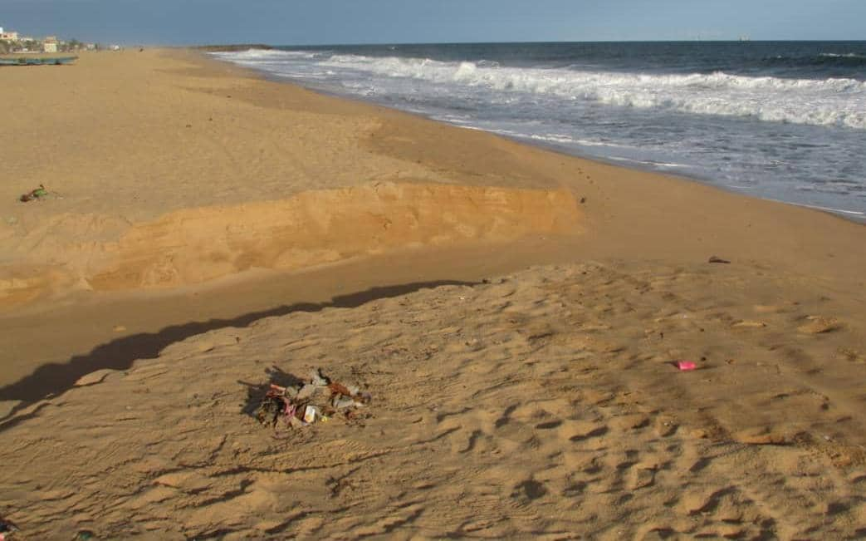
Picture 1 : Showing Akpakpa with severe erosion hoptspots which appears on Schematic Map
Source: (Guendehou Ferdinand, 2025)
GPS Coordinates; (Latitude : 6,36035 , Longitude : 2, 48586 , Altitude : 5m )
Field observations in Cotonou reveal severe shoreline retreat, beach narrowing, and loss of protective dunes, confirmed by GPS mapping and photos. Sediment depletion, port impacts, and sand mining worsen erosion. Communities report housing loss, reduced fisheries, and rising climate risks. Erosion is accelerating, driven by both natural forces and human pressures, demanding urgent, sustainable coastal management. Our results confirm the observational work carried out by other authers, which appears in table 3 below.

Table 3: Field Observation Results – Cotonou (2022–2023 Surveys) with References

Indicators | Measured Range | Observed Trends | Implications | References
Beach width | 12–30 m | Shrinking by 1–3 m annually | Reduced storm-buffering capacity | Luijendijk et al., 2018; Appeaning Addo et al., 2018
Beach slope | 6–12° | Steeper slopes in eroded zones | Wave energy concentration | Cazenave et al., 2018
Sediment type | Medium–coarse sand | Coarser material dominating | Chronic erosion, sediment loss | Thieler et al., 2009
Infrastructure impacts | >60 homes, 2 seawalls damaged (2020–2023) | Severe exposure near Akpakpa | High cost of coastal defense | Dossou & Gléhouenou-Dossou, 2007; World Bank, 2019
Community perceptions | “Sea advancing,” “loss of fishing grounds” | Local recognition of erosion hotspots | Alignment with DSAS data | Hounkpe & Nikiema, 2022

DISCUSSION
The results of this study reveal a complex interplay between climate-driven sea-level rise, anthropogenic pressures, and socio-economic vulnerability along the East Coast of Cotonou. This aligns with global research demonstrating that low-lying coastal zones in West Africa are disproportionately affected by shoreline retreat (Vousdoukas et al., 2020; Hinkel et al., 2021). The accelerated erosion rates observed in Cotonou averaging 3 to –5 m/yr with localized hotspots exceeding 7 m/yr confirm earlier findings that West Africa hosts some of the most rapidly retreating shorelines globally (Luijendijk et al., 2018).

Climate and Physical Drivers
Satellite altimetry and tide-gauge data confirmed that regional sea-level rise rates in the Gulf of Guinea (~3.4 mm/yr) are consistent with global means, reinforcing the role of climate change in exacerbating coastal hazards (Cazenave et al., 2018; Dangendorf et al., 2021). Localized variability, partly attributed to subsidence and coastal geomorphology, highlights the importance of site-specific studies. The combination of oceanographic drivers (thermal expansion, ice melt) with local pressures (port development and sand mining) amplifies shoreline instability, echoing patterns observed in other urbanized deltas such as Lagos and Dakar (Syvitski et al., 2020; Oppenheimer et al., 2019).

Anthropogenic Influences
The findings underscore the synergistic role of human activities. Port infrastructure at Cotonou disrupts longshore sediment transport, intensifying erosion downstream, an outcome well-documented in other sediment-starved coasts worldwide (Mentaschi et al., 2022). Sand mining, although locally profitable, accelerates beach narrowing and reduces natural buffering capacity. These pressures mirror broader regional trends, where unregulated coastal development undermines resilience to climate change (Appeaning Addo, 2018).

Socio-Economic Vulnerabilities
Community testimonies highlighted the translation of physical shoreline retreat into socio-economic crises: property loss, housing destruction, reduced fishing productivity, and displacement. Similar narratives have been recorded across African coastal cities, where sea-level rise disproportionately threatens marginalized populations with limited adaptive capacity (Hinkel et al., 2018; IPCC, 2022). The differentiated coping strategies observed in wealthier households investing in private defenses versus poorer households adopting temporary or reactive measures reflect entrenched inequalities in adaptive resilience. This resonates with studies in Ghana, Senegal, and Nigeria that highlight the uneven burden of coastal risks (Mensah et al., 2022).

Validation of Triangular Approach
The triangular-methods framework employed integrating systematic review, DSAS analysis, and field validation, proved essential for linking global datasets with localized realities. This mixed-methods design confirmed the robustness of remote-sensing results, while interviews contextualized their socio-economic implications. Such an approach fills a methodological gap in West Africa, where global datasets often lack community-level validation (Anderson et al., 2021).

Policy and Adaptation Implications
The results carry important implications for adaptation planning in Cotonou and beyond. First, erosion hotspots identified in this study should be prioritized for integrated coastal defense strategies, combining engineered structures with nature-based solutions such as mangrove restoration and dune stabilization (Narayan et al., 2016; Temudo et al., 2023). Second, community engagement is critical. The absence of inclusive planning and limited awareness of long-term risks hinder resilience-building. Participatory frameworks, where local knowledge informs decision-making, have proven effective in similar contexts (Brown et al., 2021). Finally, adaptation strategies must explicitly address socio-economic inequalities to avoid maladaptation, where protective measures benefit wealthier groups while exacerbating vulnerabilities among poorer households.

Synthesis
This study contributes to global debates by demonstrating how climate-driven sea-level rise intersects with local anthropogenic pressures to produce acute socio-ecological vulnerability. The East Coast of Cotonou exemplifies the risks faced by rapidly urbanizing, low-lying African cities, where governance gaps, limited resources, and competing development priorities constrain effective adaptation. By combining quantitative and qualitative evidence, this research not only validates global models but also bridges the science-policy gap, offering insights for evidence-based and socially just coastal management.

CONCLUSION
This study demonstrates that climate change, manifested through accelerating sea-level rise and intensifying shoreline retreat, poses acute risks to the East Coast of Cotonou. By combining systematic literature review, quantitative shoreline analyses, and field validation, the research confirms erosion rates of up to –5 m/yr, widespread beach narrowing, and severe impacts on housing, markets, and port infrastructure. Field surveys and community interviews reveal that local livelihoods, particularly fisheries, are increasingly threatened, while adaptation measures remain fragmented and insufficient. The findings highlight that erosion in Cotonou is not solely climate-driven but is amplified by anthropogenic pressures such as port expansion, sand mining, and unregulated urbanization. This research fills a critical gap by linking global sea-level and shoreline datasets with localized field evidence in West Africa, offering a robust basis for evidence-informed coastal management. Urgent, coordinated interventions integrating hard defenses, ecosystem-based solutions, and community participation are essential to safeguard socio-ecological resilience in Cotonou.
RECOMMENDATIONS
At the end of this reseach, it is urgent to carry out the following actions to address the conquences of Consequences of Climate Change on Sea-Level Rise and Shoreline Evolution and with regard to the objectives of sustainble development :
- Strengthen climate adaptation (SDG 13 – Climate Action): Develop and implement national and municipal adaptation plans prioritizing continuous shoreline monitoring, risk mapping, and climate-resilient coastal infrastructure.
- Promote ecosystem-based solutions (SDG 14 – Life Below Water): Scale up mangrove restoration, dune stabilization, and wetland protection to enhance natural defenses against sea-level rise and erosion.
- Enhance urban resilience (SDG 11 – Sustainable Cities and Communities): Enforce coastal buffer zones, regulate sand mining, and integrate coastal risk management into urban planning and infrastructure development.
- Safeguard livelihoods (SDG 1 – No Poverty & SDG 2 – Zero Hunger): Support sustainable fisheries, alternative income opportunities, and community-led adaptation to reduce socio-economic vulnerability.
- Foster inclusive governance (SDG 17 – Partnerships for the Goals): Strengthen partnerships among government agencies, local communities, research institutions, and international organizations for long-term, evidence-based coastal governance.

REFERENCES
- A scoping review of coastal vulnerability, subsidence and sea level rise in Ghana: Assessments, knowledge gaps and management implications. (2023). Quaternary Science Advances, 12, Article 100108. https://doi.org/10.1016/j.qsa.2023.100108
- Ankrah, J., Monteiro, A., & Madureira, H. (2023). Shoreline Change and Coastal Erosion in West Africa: A Systematic Review of Research Progress and Policy Recommendation. Geosciences, 13(2), 59. https://doi.org/10.3390/geosciences13020059
- Appeaning Addo, K. (2018). Coastal erosion and disaster risk reduction in Ghana: A review. Journal of Coastal Research, 34(1), 1–12. https://doi.org/10.2112/JCOASTRES-D-17-00082.1
- Azonkpin, S., Balle, G. A., & Sekloka, E. (2025). Institut National des Recherches Agricoles du Bénin (INRAB). Bulletin de la Recherche Agronomique du Bénin (BRAB)–Janvier, 35(01).
- Brown, S., Mehta, A., & Hein, L. (2021). Participatory approaches for inclusive coastal adaptation: Lessons from coastal cities in the Global South. Environmental Science & Policy, 125, 37–45. https://doi.org/10.1016/j.envsci.2021.06.008
- Cazenave, A., Meyssignac, B., Ablain, M., Balmaseda, M., Bamber, J., Barletta, V., ... & Wöppelmann, G. (2018). Global sea-level budget 1993–present. Earth System Science Data, 10(3), 1551–1590. https://doi.org/10.5194/essd-10-1551-2018
- Cazenave, A., Meyssignac, B., Ablain, M., Balmaseda, M., Bamber, J., Barletta, V., … Wöppelmann, G. (2018). Global sea-level rise: Where do we stand? Earth and Space Science, 5(3), 1045–1056. https://doi.org/10.1029/2018EA000506
- Cazenave, A., Meyssignac, B., Ablain, M., Balmaseda, M., Bamber, J., Barletta, V., … Wöppelmann, G. (2018). Global sea-level rise: Where do we stand? Earth and Space Science, 5(3), 1045–1056. https://doi.org/10.1029/2018EA000506
- Cazenave, A., Meyssignac, B., Ablain, M., Balmaseda, M., Bamber, J., Barletta, V., … Wöppelmann, G. (2018). Global sea-level rise: Where do we stand? Earth and Space Science, 5(3), 1045–1056. https://doi.org/10.1029/2018EA000506
- Cazenave, A., Meyssignac, B., Ablain, M., et al. (2019). Global sea level budget 1993–present. Earth System Science Data, 11, 1189–1202. https://doi.org/10.5194/essd-11-1189-2019
- Cissé, C. O. T., Almar, R., Youm, J. P. M., Jolicoeur, S., Taveneau, A., Sy, B. A., Sakho, I., Sow, B. A., & Dieng, H. (2023). Extreme Coastal Water Levels Evolution at Dakar (Senegal, West Africa). Climate, 11(1), 6. https://doi.org/10.3390/cli11010006
- Dangendorf, S., Marcos, M., Wöppelmann, G., Conrad, C., Frederikse, T., & Riva, R. (2019). Reassessment of 20th century global mean sea-level rise. Proceedings of the National Academy of Sciences, 116(6), 2107–2115. https://doi.org/10.1073/pnas.1813233116
- Dangendorf, S., Marcos, M., Wöppelmann, G., Conrad, C., Frederikse, T., & Riva, R. (2019). Reassessment of 20th century global mean sea-level rise. Proceedings of the National Academy of Sciences, 116(6), 2107–2115. https://doi.org/10.1073/pnas.1813233116
- Dangendorf, S., Marcos, M., Wöppelmann, G., Conrad, C., Frederikse, T., & Riva, R. (2021). Revisiting global mean sea-level rise over the 20th century. PNAS, 118(12), e2000517118. https://doi.org/10.1073/pnas.2000517118
- Dangendorf, S., Sun, Q., Wahl, T., Thompson, P., Mitrovica, J. X., & Hamlington, B. (2024). Probabilistic reconstruction of sea-level changes and their causes since 1900. Earth System Science Data, 16(7), 3471–3494. https://doi.org/10.5194/essd-16-3471-2024
- Fukai Peng, X., Deng, X., Shen, Y., & Cheng, X. (2025). The International Altimetry Service 2024 (IAS2024) coastal sea level dataset and first evaluations. Earth System Science Data, 17(4). https://doi.org/10.5194/essd-17-1441-2025
- Guérou, A., Meyssignac, B., Prandi, P., Ablain, M., Ribes, A., & Bignalet-Cazalet, F. (2023). Current observed global mean sea level rise and acceleration estimated from satellite altimetry and the associated measurement uncertainty. Ocean Science, 19(2), 431-451. https://doi.org/10.5194/os-19-431-2023
- Himmelstoss, E. A., Henderson, R. E., Kratzmann, M. G., & Farris, A. S. (2018). Digital Shoreline Analysis System (DSAS) version 5.0 user guide. U.S. Geological Survey Open-File Report 2018–1179. https://doi.org/10.3133/ofr20181179
- Hinkel, J., Nicholls, R. J., Tol, R. S. J., Wang, Z. B., Hamilton, J. M., Boot, G., … Zhang, X. (2018). A global analysis of erosion of sandy beaches and sea-level rise: Threats to coastal communities and adaptation options. Scientific Reports, 8(1), 1691. https://doi.org/10.1038/s41598-018-19486-z
- IPCC. (2021). Climate Change 2021: The Physical Science Basis. Contribution of Working Group I to the Sixth Assessment Report of the Intergovernmental Panel on Climate Change. Cambridge University Press. https://doi.org/10.1017/9781009157896
- IPCC. (2021). Climate Change 2021: The Physical Science Basis. Contribution of Working Group I to the Sixth Assessment Report of the Intergovernmental Panel on Climate Change. Cambridge University Press. https://doi.org/10.1017/9781009157896
- IPCC. (2022). Climate Change 2022: Impacts, Adaptation and Vulnerability. Contribution of Working Group II to the Sixth Assessment Report of the Intergovernmental Panel on Climate Change. Cambridge University Press. https://doi.org/10.1017/9781009325844
- Liberati, A., Altman, D. G., Tetzlaff, J., Mulrow, C., Gøtzsche, P. C., Ioannidis, J. P. A., ... & Moher, D. (2009). The PRISMA statement for reporting systematic reviews and meta-analyses of studies that evaluate health care interventions: explanation and elaboration. PLoS Medicine, 6(7), e1000100. https://doi.org/10.1371/journal.pmed.1000100
- Luijendijk, A., Hagenaars, G., Ranasinghe, R., Baart, F., Donchyts, G., & Aarninkhof, S. (2018). The state of the world’s beaches. Scientific Reports, 8, 6641. https://doi.org/10.1038/s41598-018-24630-6
- Luijendijk, A., Hagenaars, G., Ranasinghe, R., Baart, F., Donchyts, G., & Aarninkhof, S. (2018). The state of the world’s beaches. Scientific Reports, 8, 6641. https://doi.org/10.1038/s41598-018-24630-6
- Luijendijk, A., Hagenaars, G., Ranasinghe, R., Baart, F., Donchyts, G., & Aarninkhof, S. (2018). The state of the world’s beaches. Scientific Reports, 8, 6641. https://doi.org/10.1038/s41598-018-24630-6
- Mentaschi, L., Vousdoukas, M. I., & Feyen, L. (2022). Global-scale exposure to coastal flooding enhanced by El Niño–Southern Oscillation. Nature Communications, 13, 1019. https://doi.org/10.1038/s41467-022-28640-8
- Moher, D., Liberati, A., Tetzlaff, J., Altman, D. G., & PRISMA Group. (2009). Preferred reporting items for systematic reviews and meta-analyses: The PRISMA statement. PLoS Medicine, 6(7), e1000097. https://doi.org/10.1371/journal.pmed.1000097
- Mu, D., Huang, R., Yin, P., Yan, H., & Xu, T. (2025). Reconstructing sea level rise at global 945 tide gauges since 1900 [Preprint]. Earth System Science Data Discuss. https://doi.org/10.5194/essd-2025-300
- Narayan, S., Beck, M. W., Wilson, P., Thomas, C. J., Guerrero, A., Shepard, C. C., … Trespalacios, D. (2016). The effectiveness, costs and coastal protection benefits of natural and nature-based features: A systematic review. PLOS ONE, 11(5), e0154735. https://doi.org/10.1371/journal.pone.0154735
- Ndehedehe, C. E., Ferreira, V. G., Agutu, N. O., Getirana, A., & Ebhuoma, E. (2021). Addressing the challenges of climate change in Africa: A review of Earth observation-based studies. Science of the Total Environment, 755, 142620. https://doi.org/10.1016/j.scitotenv.2020.142620

- Ndehedehe, C. E., Ferreira, V. G., Agutu, N. O., Getirana, A., & Ebhuoma, E. (2021). Addressing the challenges of climate change in Africa: A review of Earth observation-based studies. Science of the Total Environment, 755, 142620. https://doi.org/10.1016/j.scitotenv.2020.142620
- Nerem, R. S., Beckley, B. D., Fasullo, J. T., Hamlington, B. D., Masters, D., & Mitchum, G. T. (2018). Climate-change–driven accelerated sea-level rise detected in the altimeter era. Proceedings of the National Academy of Sciences, 115(9), 2022–2025. https://doi.org/10.1073/pnas.1717312115
- Nerem, R. S., Beckley, B. D., Fasullo, J. T., Hamlington, B. D., Masters, D., & Mitchum, G. T. (2018). Climate-change–driven accelerated sea-level rise detected in the altimeter era. PNAS, 115(9), 2022–2025. https://doi.org/10.1073/pnas.1717312115
- Nerem, R. S., Beckley, B. D., Fasullo, J. T., Hamlington, B. D., Masters, D., & Mitchum, G. T. (2018). Climate-change–driven accelerated sea-level rise detected in the altimeter era. Proceedings of the National Academy of Sciences, 115(9), 2022–2025. https://doi.org/10.1073/pnas.1717312115
- Oppenheimer, M., et al. (2021). IPCC AR6 WG1 Report: The Physical Science Basis. Cambridge University Press. https://www.ipcc.ch/report/ar6/wg1
- Oppenheimer, M., Glavovic, B. C., Hinkel, J., van de Wal, R., Magnan, A. K., Abd-Elgawad, A., … Zhang, X. (2019). Sea level rise and implications for low-lying islands, coasts and communities. In H.-O. Pörtner et al. (Eds.), IPCC Special Report on the Ocean and Cryosphere in a Changing Climate (pp. 321–446). Cambridge University Press.
- Page, M. J., McKenzie, J. E., Bossuyt, P. M., Boutron, I., Hoffmann, T. C., Mulrow, C. D., ... & Moher, D. (2021). The PRISMA 2020 statement: an updated guideline for reporting systematic reviews. BMJ, 372, n71. https://doi.org/10.1136/bmj.n71
- Permanent Service for Mean Sea Level (PSMSL). (2023). Tide gauge data. Retrieved from https://www.psmsl.org
- Petticrew, M., & Roberts, H. (2006). Systematic reviews in the social sciences: A practical guide. Malden, MA: Blackwell Publishing.
- Siddaway, A. P., Wood, A. M., & Hedges, L. V. (2019). How to do a systematic review: a best practice guide for conducting and reporting narrative reviews, meta-analyses, and meta-syntheses. Annual Review of Psychology, 70, 747–770. https://doi.org/10.1146/annurev-psych-010418-102803
- Simulation of the Impacts of Sea-Level Rise on Coastal Ecosystems in Benin Using a Combined Approach of Machine Learning and the Sea Level Affecting Marshes Model (SLAMM) (2023). Sustainability, 15(22), 16001. https://doi.org/10.3390/su152216001
- Syvitski, J. P. M., Kettner, A., Overeem, I., Hutton, E. W. H., Saito, Y., & Nicholls, R. J. (2020). Predicting the future behavior of deltas in the Anthropocene. Science Advances, 6(41), eaba0375. https://doi.org/10.1126/sciadv.aba0375
- Syvitski, J. P. M., Saito, Y., Kettner, A., Overeem, I., Nicholls, R. J., & Hutton, E. W. H. (2022). Anthropocene metamorphosis of the world’s deltas. Nature Reviews Earth & Environment, 3, 1–18. https://doi.org/10.1038/s43017-022-00284-6
- Syvitski, J. P. M., Saito, Y., Kettner, A., Overeem, I., Nicholls, R. J., & Hutton, E. W. H. (2022). Anthropocene metamorphosis of the world’s deltas. Nature Reviews Earth & Environment, 3, 1–18. https://doi.org/10.1038/s43017-022-00284-6
- Thieler, E. R., Himmelstoss, E. A., Zichichi, J. L., & Ergul, A. (2009). Digital Shoreline Analysis System (DSAS) version 4.0—An ArcGIS extension for calculating shoreline change. U.S. Geological Survey Open-File Report 2008–1278. https://doi.org/10.3133/ofr20081278
- Thieler, E. R., Himmelstoss, E. A., Zichichi, J. L., & Ergul, A. (2009). Digital Shoreline Analysis System (DSAS) version 4.0—An ArcGIS extension for calculating shoreline change. U.S. Geological Survey Open-File Report 2008–1278. https://doi.org/10.3133/ofr20081278
- United States Geological Survey (USGS). (1985–2020). Landsat Surface Reflectance Data (TM, ETM+, OLI). Retrieved from: https://earthexplorer.usgs.gov
- Vousdoukas, M. I., Mentaschi, L., Hinkel, J., & Feyen, L. (2023). Sandy coastlines under threat of erosion. Nature Climate Change, 13, 83–90. https://doi.org/10.1038/s41558-022-01582-8
- Vousdoukas, M. I., Ranasinghe, R., Mentaschi, L., Plomaritis, T. A., Athanasiou, P., Luijendijk, A., & Feyen, L. (2023). Sandy coastlines under threat of erosion. Nature Climate Change, 13, 83–90. https://doi.org/10.1038/s41558-022-01582-8
- Vousdoukas, M. I., Ranasinghe, R., Mentaschi, L., Plomaritis, T. A., Athanasiou, P., Luijendijk, A., & Feyen, L. (2023). Sandy coastlines under threat of erosion. Nature Climate Change, 13, 83–90. https://doi.org/10.1038/s41558-022-01582-8

