Original Research Article

Statistical Assessment of Climatic Trends and Change Points in the Western Agro-Climatic Zone of Madhya Pradesh, India

ABSTRACT
This study examines the temporal variability, trend, and change point behaviour of key climatic parameters including annual rainfall, monsoon rainfall, number of rainy days, and one day maximum rainfall in the Western Agro-climatic Zone of Madhya Pradesh, India, for the period from 1984 to 2023. The Mann Kendall test and Sen’s slope estimator were applied to identify trends, while Pettitt and Worsley tests were used for detecting change points. The analysis revealed a statistically significant decreasing trend in annual rainfall with a Sen’s slope value of 2.13 mm per year at a significance level of p less than 0.05, indicating a gradual reduction in long term precipitation. Monsoon rainfall also showed a declining trend of 1.85 mm per year, with a major change point observed around the year 2005. The number of rainy days exhibited a decreasing rate of 0.32 days per year, suggesting fewer rainfall occurrences after 2005. In contrast, the one-day maximum rainfall showed an increasing trend of 1.12 mm per year, which reflects the growing intensity of short- duration rainfall events. These results indicate that the region is experiencing reduced rainfall duration but increasing rainfall intensity, which may lead to higher hydrological stress and agricultural challenges. The year 2005 was identified as a significant climatic transition period, marking a shift in the precipitation regime of the Western Agro-climatic Zone of Madhya Pradesh. The findings of this study are valuable for developing adaptive water resource management and climate resilience strategies for the region.
Keywords: Trend analysis, Change point detection, Rainfall variability, Mann Kendall test, Western Madhya Pradesh.
- Introduction

Humanity has experienced unprecedented growth in the post-industrial era, leading to increased ecological footprints alongside economic development. The rising concentrations of greenhouse gases (GHGs) have contributed to global warming, necessitating careful monitoring of climate parameters (IPCC, 2007). Climate change has been linked to alterations in hydrological cycles, shifts in rainfall patterns, and variations in streamflow, all of which directly impact agriculture, water resources, and socio-economic stability (Kumar, Singh, & Sharma, 2010; Kumar et al., 2016).

Weather and climate, though often used interchangeably, represent distinct concepts. Weather refers to the atmospheric conditions at a specific location over a short period (hours to days) and is inherently variable and difficult to predict (Ahluwalia & Pal, 2020; Jain & Kumar, 2012). Climate, on the other hand, describes the long-term average of weather over a period of typically 30 years or more and provides insight into regional environmental conditions (Chakraborty & Srivastava, 2006; Roxy et al., 2017). Variations in temperature and precipitation are widely used indicators of climate change, as they govern the distribution and productivity of flora, fauna, and agricultural systems (Yadav et al., 2025; Kendall, 1975; Kumar et al., 2014).

Western Madhya Pradesh, comprising the Malwa Plateau, Nimar Valley, and Jhabua Hills, represents a semi-arid to sub-humid agro-climatic region with high inter-annual variability in rainfall and temperature. These regions are agriculturally significant: Malwa is dominated by soybean, cotton, and wheat cultivation; Nimar is primarily devoted to cotton and jowar; and Jhabua is characterized by rain-fed maize and sorghum production. Climate variability in these areas strongly influences agricultural productivity, groundwater recharge, and forest ecosystems, emphasizing the need for long-term monitoring of hydroclimatic parameters (Gajbhiye et al., 2016; Kundan et al., 2020).

The impacts of climate change are particularly evident in extreme events, such as droughts, floods, heatwaves, and heavy rainfall, which pose threats to food security and livelihoods (Chowdhury & Beecham, 2010; Economic Survey of India, 2018). In addition, increased irrigation, while improving agricultural resilience, has contributed to groundwater depletion, further intensifying the vulnerability of rain-fed systems (Hindustan Times, 2018). Forests in the region, relying solely on precipitation and shallow groundwater, are likely to favor deep-rooted species as shallow-rooted species face increased stress under declining water availability. Given the localized nature of climate impacts, regional and district-level analyses are essential for designing effective adaptation strategies (Yadav et al., 2025; Gupta et al., 2014; Srivastava & Bhattacharya, 2015). While many studies focus on pan-India trends, the Western Madhya Pradesh region requires focused investigation due to its socio-economic dependence on agriculture and forest resources, particularly for tribal populations (Modarres & da Silva, 2007; Verma et al., 2022; Panda & Sahu, 2019).

The present study aims to analyze long-term trends and change points in rainfall and temperature during 1980–2023 across the Malwa, Nimar, and Jhabua regions. Non-parametric statistical approaches, including the Mann–Kendall (MK) test for trend detection and Sen’s slope estimator for trend magnitude, were applied. Additionally, Pettitt’s test and the Worsley Likelihood Ratio method were used to detect abrupt changes and assess the homogeneity of time series data. The integrated application of these statistical techniques provides a robust framework to evaluate hydroclimatic variability and its implications for sustainable agricultural and water resource management in western Madhya Pradesh.
- Study area
The study area includes the western part of Madhya Pradesh includes three agro-climatic region that is Malwa Plateau, Nimar Valley and Jhabua Hills which includes 16 districts. It lies at the center of India and is located below the Indo-Gangetic plain to the north of the undulating Vindhyan mountain range which are spread across the northwest to the south. In the western part of Madhya Pradesh Three agro-climatic zone of Malwa plateau, Nimar Valley and Jhabua Hills out of which 16 districts are taken namely Malwa Plateau - Agar Malwa, Dewas, Dhar, Indore, Mandsaur, Neemuch, Rajgarh, Ratlam, Shajapur, Ujjain; Nimar Valley - Badwani, Burhanpur, Khandwa, Khargone and from Jhabua Hills - Alirajpur, Jhabua. The region lies between 22⁰25ʹ N to 24⁰00ʹ N latitude and 75⁰00ʹ E to 76⁰25ʹ E longitude with a total area of 72,291 sq. km (Kaushal et al., 2025). Most of the agriculture is rain-fed and the main occupation of the local population is agriculture.
The average annual rainfall varies between 650 mm and 1018 mm and about 90% of it occurs during the south-west monsoon. The rainfall pattern is erratic and uncertain with very high variability. Maximum temperature of 48⁰ C is recorded in Badwani district and minimum temperature of 6⁰ C is recorded in Ratlam district. The map showing the study area is given in Fig. 1.
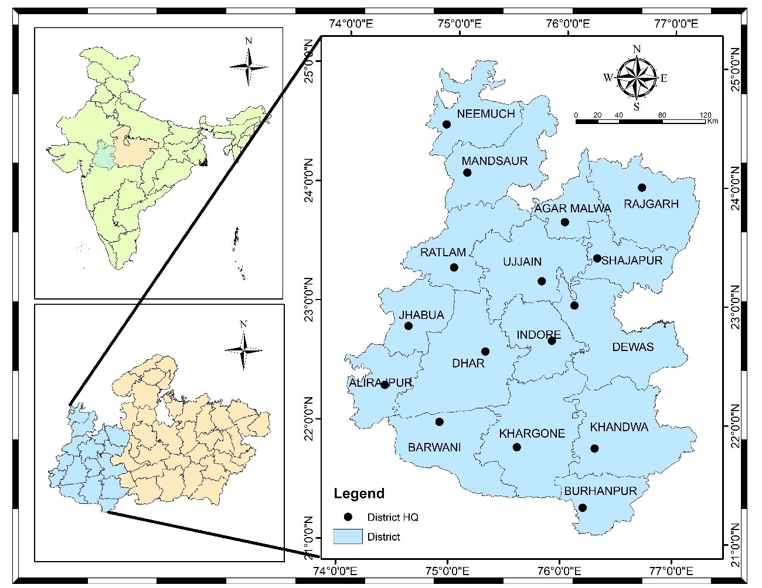
Figure 1 Index Map of 3 agro-climatic zone of Western Madhya Pradesh
There are various rivers which egresses from this plateau and they are: Mahi, Chambal, Gambhir, Kshipra, Kalisindh, Parvati etc. All the above rivers flow from west to east direction due to the physical Slope of India. Malwa Region is drained by two river systems belonging to The Arabian Sea and The Bay of Bengal. Most of the areas (including north, north-west, central, northeast and east) of the region is drained by Chambal, Sindh and Betwa with their tributaries belonging to the Bay of Bengal drainage system while the rest of the area (south-east, south-west and southern) is drained by Mahi, Tapti and Narmada with their tributaries belonging to the Arabian Sea drainage network.
Most of the part of western Madhya Pradesh is covered by black soil which is formed due to erosion of basalt rocks of Deccan Traps. It is popularly known as "Black Cotton Soil" because of its dark brown color and suitability for growing cotton. It is very fertile soil which is, in India, also known as ‘regur’ soil. It is mostly clay soil and form deep cracks during dry season. An accumulation of time is generally noticed at varying depths. Regur soil is deficient in nitrogen, phosphoric acid and organic matter but rich in calcium, potash and magnesium.
- Methodology
This section includes the description about the study area, collection of required data, statistical analysis of data and methods used to achieve research objective. The study involves the examination of rainfall variability using statistical tests, coefficient of variation, standard deviation, estimation of meteorological drought by rainfall departure analysis its characteristics as per their classification, at the end of the chapter, Drought frequency and severity analysed and the spatial representation of these analysis in the study area have done in this chapter.

Data collection
The daily rainfall data for 16 districts of western Madhya Pradesh was collected by India meteorological department, Pune. At a resolution of 0.25*0.25, the rainfall gridded data was downloaded in grd format for the years 1980–2023 [24]. On the other hand, the analysis for the years 1980 to 2023 in this study was done using the grd format. IMD grid extractor software was used to extract the data.

Homogeneity, Randomness and Autocorrelation Test
A homogeneity test for rainfall data is essential in hydrological and climatological investigations to confirm the data's dependability and consistency throughout time. Rainfall data, which is commonly collected over extended periods of time, can be influenced by a variety of factors, including changes in measuring techniques, the relocation of weather stations, and environmental changes. These factors might cause non-climatic movements or trends in the data, leading to incorrect conclusions if not discovered and corrected. In the present study non-parametric Pettitt’s test was carried out at 95% level of significance (alpha=0.05) to test the homogeneity in the annual rainfall time series of 16 districts of western Madhya Pradesh. Assume that the null hypothesis at the time of applying this test is homogenous data over the entire period. If the computed "p" value is larger than the significance level alpha=0.05, the null hypothesis (H₀) cannot be rejected. The alternative hypothesis (H_{a}) should be accepted and the null hypothesis (H₀) should be rejected if the computed p-value is less than the significance level alpha = 0.05. The formulas involved in the Pettitt test are as follows.
- Rank the data:
Rank the data point X₁, X₂,……,X_{n} in the time series.
- Calculate the rank sum R_{t} :
For the data point t, calculate the rank sum of the first t data points,
$R_{t}=\sum_{i=1}^{t}{R(X_{i})} …(1)$
where R(X_{i}) is the rank of the i^{th} observation in the entire series.
- Compute the Test Statistic U_{t} :
For each time point t, compute the Pettitt test statistic.
$$U_{t}=2R_{t}-t\left(n+1\right) …(2)$$
where n is the total number of observations
- Identify the Change Point (k):
The test statistic k is defined as the maximum absolute value of U_{t}​.
$p ≈2\exp\left(-\frac{6k^{2}}{n^{3}+n^{2}}\right) …(3)$
The Durbin-Watson test is a widely used statistical test to detect the presence of autocorrelation in the residuals from a regression analysis. Autocorrelation, particularly in time series data like rainfall, can indicate that the residuals (errors) are not independent, which violates one of the key assumptions of ordinary least squares regression. In the present study, the Durbin-Watson autocorrelation test was used to test the presence of autocorrelation or randomness in the data set. The autocorrelations near-zero or zero indicates the presence of randomness in the data set and when the autocorrelations are significantly non-zero indicate the non-random or auto correlated data set. The Durbin-Watson statistic ranges from 0 to 4, where a value near 2 suggests no autocorrelation, a value close to 0 indicates positive autocorrelation, and a value approaching 4 indicates negative autocorrelation. A thumb rule is that test statistic values in the range of 1.5 to 2.5 are relatively normal [25]. A normally auto correlated rainfall data was found more suitable for the analysis as it reduces the variability and improve predictive power of the results. A negative correlation may lead to bias in trend analysis, misleading statistical significance, and greater variability during statistical analysis which may be taken care during interpretation of results. The Durbin-Watson statistics ‘d’ is calculated using the following Equation (4)
$$d= \frac{\sum_{t=2}^{n}{{\left(e_{t}-e_{t-1}\right)}^{2}}}{\sum_{t=1}^{n}{e_{t}^{2}}} …(4)$$
Where,
e_{t} is the residual (difference between observed and predicted values) at time t
n is the number of observations.

Non-Parametric Trend Analysis
Non-parametric statistical methods are widely used in hydrology and climatology because they are less sensitive to outliers and do not require the assumption of normally distributed data. Among these, the Mann–Kendall (MK) test is the most frequently applied for detecting monotonic trends in hydrologic and climatic time series (Mann, 1945). The MK test is particularly suitable for long-term rainfall and temperature data where normality assumptions may not hold.
The MK test statistic SSS is defined as:
$S= \sum_{i=1}^{N-1}{\sum_{j=i+1}^{N}{sgn(x_{j}}}- x_{i})$ …. (5)
where
$Sgn\left(θ\right)= \left\{\begin{aligned}1 if θ>0 \\ 0 if θ=0 \\ -1 if θ<0\end{aligned}\right.$ …. (6)
Under the assumption of no trend (i.e., the null hypothesis), the expected value of the test statistic S is zero.
$E\left\lfloor S\right\rfloor =0$ …. (7)
The variance of S is given by:
$Var\left(S\right)= \frac{N\left(N-1\right)\left(2N+5\right)- \sum_{k=1}^{m}{t_{k}(t_{k}-1)(2t_{k}+5)}}{18}$ …. (8)
where tk represents the number of tied values in the kth group and m is total number of tied groups.
The standardized Z-statistic is computed as:

$Z= \left\{\begin{aligned}\frac{S-1}{Var(S)} if S>0 \\ 0 if S=0 \\ \frac{S+1}{Var(S)} if S<0\end{aligned}\right.$ …. (9)

Here, if the absolute value of the Z-statistic exceeds the critical threshold at the 5% level of significance, the null hypothesis of no trend is rejected. A positive Z-value indicates a statistically significant increasing trend, while a negative Z-value suggests a statistically significant decreasing trend.

Sen’s slope estimator Test
The slope of n pairs data points was estimated using Sen’s slope estimator which is given by the following relation:
$β=Median\frac{Xj-Xi}{j-i}$ …….(10)
$for all i≤j$
In which 1<j<i<n and β is the robust estimate of the trend magnitude. A positive value of β indicates an ‘upward trend’ while a negative value of β indicates a ‘downward trend’.

Worsley Likelihood Ratio Test for Change Point Detection
The Worsley Likelihood Ratio method tests whether the means in two parts of records are different for an unknown time of change. The Worsley likelihood ratio test identifies abrupt shifts or change points in time series data. It evaluates whether the means of two segments of a series differ significantly, without a priori knowledge of the change point location (Worsley, 1979). The test statistic W is calculated using: The test assumes that the data are normally distributed. It is similar to the cumulative division test but weights the values of S*k depending on their position in the time series (Yadav et al., 2024).
The Worsley Likelihood Ratio Test is given in the following equation:
$Z_{k}^{*}={[k(m-k)]}^{-0.5}S_{k}^{*}$ …. (11)
$Z_{k}^{**}=\frac{Z_{k}^{*}}{D_{x}}$ …. (12)
$W=\frac{{(n-2)}^{0.5}V}{{({1-V}^{2})}^{0.5}}$ …. (13)
$V=max|Z_{k}^{**}|$ …. (14)
A negative value of W indicated that the later part of the record has a higher mean than the earlier part and vice versa. As the data length was 44 years the critical W values were 2.86, 3.19 and 3.86 for significance levels 0.1 (90%), 0.5 (95%) and 0.01 (99%).
- Results and discussion
4.1 Randomness, Autocorrelation, and Homogeneity of Annual Rainfall
Table 1 summarizes the results of randomness and autocorrelation analysis (using the Durbin–Watson (D–W) test) and homogeneity testing (using Pettitt’s test) for annual rainfall series (1980–2023) across different districts of the Malwa Plateau, Nimar Valley, and Jhabua Hills agro-climatic zones of western Madhya Pradesh. These tests provide important diagnostic insights into the temporal structure and statistical consistency of rainfall series, which are crucial prerequisites for reliable trend analysis and change detection.
The Durbin–Watson test assesses the presence of serial autocorrelation in the rainfall time series. Values close to 2 indicate the absence of autocorrelation, whereas values significantly lower or higher indicate positive or negative autocorrelation, respectively. The test results reveal that the majority of districts in Malwa Plateau exhibit no significant autocorrelation (NA), with D–W statistics ranging between 2.05 and 2.31 (e.g., Indore = 2.31, Dewas = 2.23, Ratlam = 2.05). A few districts, such as Agar Malwa (1.79), Neemuch (1.65), and Rajgarh (1.97), show partial autocorrelation (PA), indicating some degree of dependence in the annual rainfall data. Similarly, in the Nimar Valley, most districts show partial autocorrelation (e.g., Badwani = 1.92, Burhanpur = 1.30), with Khargone (2.07) showing no autocorrelation. In the Jhabua Hills, both Alirajpur (1.89) and Jhabua (1.77) show partial autocorrelation, indicating moderate persistence in rainfall sequences.
The Pettitt’s test, a non-parametric homogeneity test, was applied to detect potential change points in the mean of the rainfall series. A homogeneous (H) series indicates no statistically significant shift, whereas non-homogeneous (NH) indicates a detected change point. Most districts in Malwa Plateau display homogeneous rainfall series, with Pettitt’s test statistics generally low (e.g., Dewas = 1.00, Indore = 0.77, Shajapur = 0.25), suggesting stable annual rainfall patterns without major abrupt shifts. However, Neemuch (0.00) stands out as non-homogeneous, indicating a statistically significant change point in its annual rainfall distribution.
In the Nimar Valley, Khandwa (0.00) and Burhanpur (0.12) also exhibit non-homogeneity, pointing to historical shifts in annual rainfall, potentially linked to regional climatic variability or changes in monsoonal circulation. In contrast, Badwani (0.80) and Khargone (0.71) remain homogeneous. Within the Jhabua Hills, Jhabua (0.03) is non-homogeneous, indicating a possible regime shift during the study period, whereas Alirajpur (0.17) remains homogeneous.
Overall, the randomness and homogeneity analyses indicate that most rainfall series are statistically consistent and suitable for trend detection. However, non-homogeneous series in districts like Neemuch, Khandwa, and Jhabua warrant special attention, as abrupt changes may influence long-term trend interpretation. Such heterogeneities may arise from changes in large-scale monsoon dynamics, land-use modifications, or localized climatic perturbations, underscoring the need to complement trend analysis with homogeneity assessments for more robust hydrological inference.
Table: 1 Pettitt’s Test and Durbin–Watson Statistics of Annual Rainfall in Madhya Pradesh
Agro-climatic Zones | District | Annual RF (mm) | Randomness & Autocorrelation |  | Homogeneity
Agro-climatic Zones | District | Annual RF (mm) | D-W Test statistics | Interpretation | Pettitt's Test statistics | Interpretation
Malwa Plateau | Agar Malwa | 1001 | 1.79 | PA | 0.55 | H
Malwa Plateau | Dewas | 908 | 2.23 | NA | 1.00 | H
Malwa Plateau | Dhar | 941 | 2.17 | NA | 0.31 | H
Malwa Plateau | Indore | 991 | 2.31 | NA | 0.77 | H
Malwa Plateau | Mandsaur | 824 | 2.10 | NA | 0.12 | H
Malwa Plateau | Neemuch | 867 | 1.65 | PA | 0.00 | NH
Malwa Plateau | Rajgarh | 974 | 1.97 | PA | 0.11 | H
Malwa Plateau | Ratlam | 1018 | 2.05 | NA | 0.24 | H
Malwa Plateau | Shajapur | 1006 | 2.11 | NA | 0.25 | H
Malwa Plateau | Ujjain | 986 | 2.19 | NA | 0.29 | H
Nimar Valley | Badwani | 653 | 1.92 | PA | 0.80 | H
Nimar Valley | Burhanpur | 807 | 1.30 | PA | 0.12 | H
Nimar Valley | Khandwa | 979 | 1.02 | PA | 0.00 | NH
Nimar Valley | Khargone | 786 | 2.07 | NA | 0.71 | H
Jhabua Hills | Alirajpur | 838 | 1.89 | PA | 0.17 | H
Jhabua Hills | Jhabua | 892 | 1.77 | PA | 0.03 | NH

4.2 Climate Trend Analysis using Mann-Kendall test
The annual, monsoon, and seasonal rainfall trends over the period 1980–2023 for districts in the Malwa Plateau, Nimar Valley, and Jhabua Hills were analyzed using the MK test. The magnitude of trends was quantified with Sen’s slope estimator, while abrupt changes or regime shifts were identified using the Worsley likelihood ratio test. The MK test results indicate that several districts in Malwa and Nimar exhibit increasing trends in annual rainfall, whereas some stations, such as Neemuch and Khandwa, show significant upward changes in rainy days and monsoon rainfall. Sen’s slope estimates reveal the magnitude of these trends, providing rates of increase or decrease in mm/year.
4.2.1 Rainfall Trends
Table 2 presents the Mann–Kendall (MK) test Z-values for annual, seasonal, and extreme rainfall indices across districts of the Malwa Plateau, Nimar Valley, and Jhabua Hills regions during 1980–2023. The MK Z-values indicate the direction and significance of rainfall trends, where positive values denote increasing trends, negative values indicate decreasing trends, and the corresponding significance levels are marked as * (p < 0.05), ** (p < 0.01), and *** (p < 0.001). The upward (↑), downward (↓), and no trend (→) arrows denote the trend direction, while values near zero indicate no significant trend.
Across the Malwa Plateau, several districts exhibit increasing annual and monsoon rainfall trends, particularly Neemuch (Z = 3.53 and 3.66, p < 0.001) and Ratlam (Z = 1.81 and 1.86), indicating a statistically significant intensification of rainfall. Pre-monsoon rainfall shows mixed behavior, with significant increases in Shajapur (Z = 2.34) and Ujjain (Z = 2.00), while a significant decline is observed in Mandsaur (Z = –2.05). Post-monsoon and winter rainfall trends are mostly negative or non-significant, suggesting no pronounced shifts in these seasons. Extreme rainfall (one-day maximum) exhibits significant positive trends in Neemuch (Z = 4.57) and Shajapur (Z = 2.22), reflecting intensification of extreme events.
In the Nimar Valley, annual and monsoon rainfall generally shows increasing trends, with Khandwa recording the strongest positive trend (Z = 3.04 and 2.90, p < 0.01). Badwani also shows a significant increase in rainy days (Z = 3.32, p < 0.001). Conversely, Burhanpur displays a negative post-monsoon trend (Z = –2.08), indicating reduced rainfall in the retreating phase of the monsoon.
For the Jhabua Hills, both Alirajpur (Z = 2.17, 2.19) and Jhabua (Z = 2.53, 2.65) show significant positive trends in annual and monsoon rainfall, highlighting a strengthening of wet season rainfall in this hilly region. Other seasonal components, including pre-monsoon and post-monsoon, generally remain non-significant.
Overall, the Mann–Kendall trend analysis reveals a spatially heterogeneous but predominantly increasing pattern of annual and monsoon rainfall across Western Madhya Pradesh. Districts like Neemuch, Khandwa, and Jhabua are experiencing statistically significant upward trends, while certain districts, such as Mandsaur and Burhanpur, show seasonal declines. The observed positive trends in extreme rainfall indices suggest a potential intensification of high-intensity rainfall events. Long-term climate variability in Western Madhya Pradesh, encompassing the Malwa Plateau, Nimar Valley, and Jhabua Hills, was analyzed for the period 1980–2023 using rainfall and temperature data.
4.2.2 Rainfall Trends
Rainfall variability was analyzed using MK test and Sen’s slope estimator for annual, seasonal (pre-monsoon, monsoon, post-monsoon, winter), rainy days, and one-day maximum rainfall. In the Malwa Plateau, districts such as Neemuch, Mandsaur, and Ratlam show significant increasing trends in annual and monsoon rainfall, with Sen’s slope values up to 12.25 mm yr⁻¹, indicating enhanced rainfall intensity in these regions. In contrast, some districts such as Dewas and Indore show negligible trends, reflecting spatial heterogeneity in precipitation patterns.
In the Nimar Valley, Khandwa and Khargone recorded strong increasing trends for annual rainfall and monsoon rainfall (Sen’s slope up to 11.42), while Badwani and Burhanpur showed moderate or slightly decreasing trends, highlighting inter-district variability. Jhabua Hills exhibits significant upward trends in annual and monsoon rainfall, particularly in Alirajpur and Jhabua, with Sen’s slope values of 8.20–9.51 mm yr⁻¹. The Worsley Likelihood Ratio test identified change points mostly between 2005 and 2018 across these districts, suggesting the initiation of more pronounced rainfall variability in the recent decade. Pettitt’s test confirmed homogeneity in most districts, except for minor inconsistencies in Neemuch, Khandwa, and Jhabua, indicating abrupt shifts in local rainfall patterns.
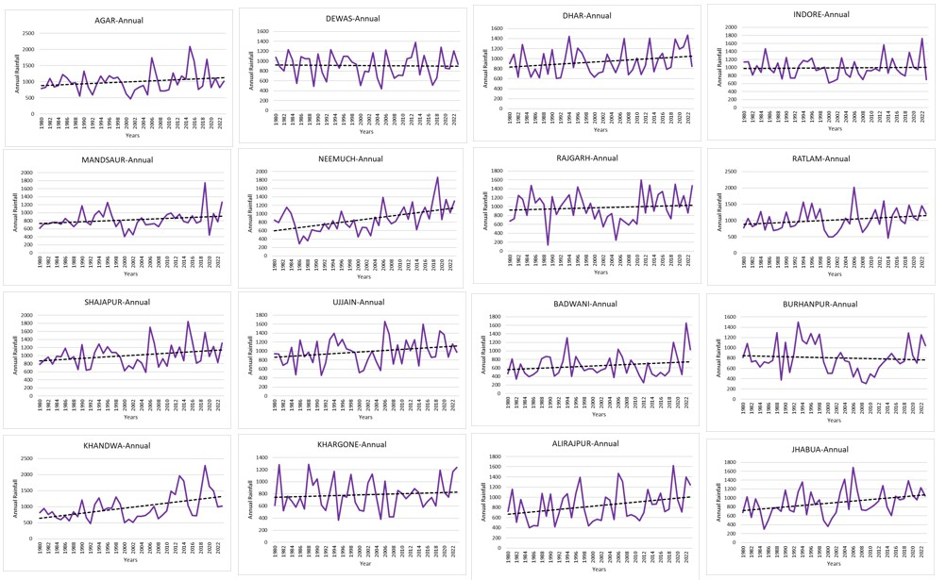
Figure 2: Trendline showing annual rainfall of 16 districts of Western Madhya Pradesh
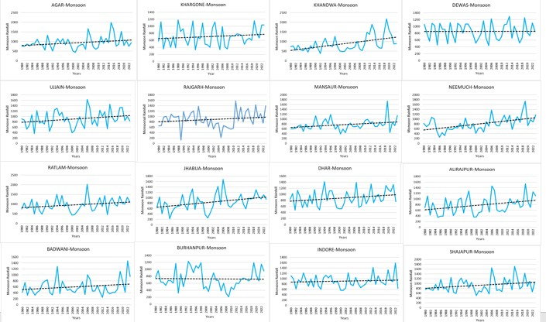Figure 3: Trendline showing moonsonal rainfall of 16 districts of Western Madhya Pradesh
4.2.3 Temperature Trends
Seasonal and annual trends of maximum (Tmax) and minimum (Tmin) temperatures were assessed using the MK test. The results indicate a significant upward trend in Tmax across most months, particularly in the pre-monsoon season (March–May) where Z-values range from 2.76 to 2.93, reflecting accelerated daytime warming. The monsoon months (June–September) also display moderate increases, with July and August showing Z-values of 2.69 and 2.38, respectively. The annual mean Tmax demonstrates a statistically significant increase (Z = 4.21, Q = 0.028 mm yr⁻¹).
Minimum temperatures exhibit relatively smaller but notable increases, particularly during the monsoon and post-monsoon seasons. September recorded the highest increase in Tmin (Z = 2.41, Q = 0.017 mm yr⁻¹), followed by August (Z = 1.79) and July (Z = 1.68), suggesting enhanced night-time warming during the rainy season. The annual mean Tmin trend (Z = 1.48, Q = 0.012 mm yr⁻¹) confirms a general warming pattern across the study region. These trends indicate that pre-monsoon daytime warming is more pronounced, while night-time warming peaks during the monsoon, consistent with regional climate change patterns reported for semi-arid regions of India (Chakraborty & Srivastava, 2006; Roxy et al., 2017).
The combined analysis of rainfall and temperature trends reveals that Western Madhya Pradesh is experiencing gradual warming accompanied by increasing rainfall variability. Pre-monsoon warming may intensify evapotranspiration and soil moisture deficits, while rising night-time temperatures during the monsoon could influence crop phenology. Concurrently, increased annual and monsoon rainfall in certain districts may enhance water availability but also elevate the risk of localized flooding. These findings underscore the need for district-level climate adaptation strategies, such as adjusting sowing dates, promoting drought-resistant crops, and improving watershed management to cope with both warming and rainfall variability (Kumar et al., 2010; Gajbhiye et al., 2016).
4.3 Magnitude of Rainfall Trends Using Sen’s Slope Estimator
Table 4 summarizes the Sen’s Slope Estimator (Q-values) for annual, seasonal, and extreme rainfall indices across different districts of the Malwa Plateau, Nimar Valley, and Jhabua Hills regions of western Madhya Pradesh for the period 1980–2023. The Sen’s slope provides the magnitude of monotonic trends detected through the Mann–Kendall test, indicating the rate of change per year in rainfall amount (mm year⁻¹) or related indices. Positive Q-values denote increasing trends, whereas negative values indicate declining trends in rainfall parameters.
In the Malwa Plateau, the annual rainfall shows prominent increasing magnitudes in districts such as Neemuch (Q = 12.25 mm yr⁻¹), Ratlam (Q = 6.71 mm yr⁻¹), Dhar (Q = 5.08 mm yr⁻¹), and Shajapur (Q = 5.43 mm yr⁻¹), reflecting substantial upward trends over the study period. Monsoon rainfall contributes the most to these increases, with Neemuch (Q = 11.41 mm yr⁻¹) and Ratlam (Q = 7.20 mm yr⁻¹) showing the highest magnitudes. Pre-monsoon rainfall changes are minimal, with near-zero or marginal positive values in districts like Shajapur (0.43 mm yr⁻¹) and Ujjain (0.30 mm yr⁻¹). Post-monsoon and winter rainfall generally display negligible or slightly negative Q-values, suggesting no significant shifts in these seasons. Rainy day frequency and one-day maximum rainfall exhibit moderate increases in most districts, particularly Neemuch (0.68 and 0.50 mm yr⁻¹) and Dhar (0.22 and 0.20 mm yr⁻¹), indicating intensification of both wet days and extreme rainfall.
In the Nimar Valley, a substantial increasing magnitude is observed in Khandwa, with annual and monsoon Q-values of 11.42 mm yr⁻¹ and 11.08 mm yr⁻¹, respectively, highlighting it as a hotspot for rainfall intensification. Other districts like Khargone (Q = 2.49 and 3.11 mm yr⁻¹) and Badwani (Q = 1.72 and 1.74 mm yr⁻¹) show modest positive trends. Burhanpur stands out with negative annual (–1.08 mm yr⁻¹) and post-monsoon slopes, indicating a declining tendency in rainfall amount over time.
For the Jhabua Hills, both Alirajpur (Q = 8.20 mm yr⁻¹) and Jhabua (Q = 8.44 mm yr⁻¹) exhibit strong positive annual trends, mainly driven by increases during the monsoon season (Q = 8.62 and 9.51 mm yr⁻¹). These findings suggest a strengthening of monsoonal rainfall in the hilly terrain, likely contributing to increased runoff and groundwater recharge potential in the region. Other seasonal trends remain mostly stable with near-zero Q-values.
Overall, the Sen’s slope analysis corroborates the Mann–Kendall results, revealing a spatially heterogeneous but predominantly increasing magnitude of rainfall trends across western Madhya Pradesh. Districts such as Neemuch, Ratlam, Khandwa, and Jhabua show the highest annual and monsoon rainfall growth rates, while pockets like Burhanpur exhibit decreasing magnitudes. This spatial variability highlights the importance of region-specific water resource management strategies in the face of changing rainfall dynamics.
4.4 Detection of Change Points Using Worsley Likelihood Method
The Worsley test detected change points in multiple districts, with the timing of shifts differing between annual rainfall, monsoon rainfall, rainy days, and extreme one-day rainfall. For example, districts such as Agar Malwa, Neemuch, and Jhabua showed significant shifts in the early 2000s, suggesting possible impacts of regional climate variability or land-use changes.
Table 4 presents the Worsley Likelihood statistics (W-values) and the corresponding years of change for annual rainfall, monsoon rainfall, rainy days, and one-day maximum rainfall across the Malwa Plateau, Nimar Valley, and Jhabua Hills regions of western Madhya Pradesh for the period 1980–2023. The Worsley Likelihood method was applied to detect abrupt changes or shifts in the mean of hydrometeorological time series, complementing the trend analysis from the Mann–Kendall and Sen’s slope estimators. Higher W-values indicate more pronounced shifts, and years corresponding to peak W-values signify the approximate timing of structural changes in rainfall regimes.
In the Malwa Plateau, several districts exhibit notable change points around the mid-2000s, particularly 2005–2006, indicating a regional-scale shift in rainfall dynamics. For example, Agar, Shajapur, and Ujjain show change points around 2005 for annual and monsoon rainfall, with W-values ranging between 2.28 and 2.69, suggesting moderate to strong shifts. Neemuch stands out with W = 2.77 (annual) and W = 2.78 (monsoon) in 2006, and particularly high W-values for rainy days (W = 3.75) and one-day maximum rainfall (W = 3.47), indicating a statistically significant change during the mid-2000s. Similarly, Mandsaur experienced a marked shift in 2018 for both annual (W = 2.96) and monsoon rainfall (W = 3.18), reflecting potential recent climatic perturbations. Districts like Indore and Dhar show change years around 1999–2007 and 1992–2013, respectively, indicating more localized temporal shifts.
The Nimar Valley demonstrates a relatively later onset of change, with most districts showing shifts after 2015, coinciding with increased rainfall variability during the late 2010s. Khandwa shows significant change points in 2017 for both annual (W = 2.24) and monsoon rainfall (W = 2.32), while Khargone shows changes in 2018 with W-values above 2.0. Rainy day frequency exhibits earlier shifts in some locations, such as 1983 in Khargone (W = 2.18), indicating historical variability in the number of wet days. Burhanpur exhibits relatively weaker signals (W = 1.42–1.77) with changes spread across 1989–2018, suggesting a less pronounced but multi-decadal variability.
In the Jhabua Hills, Jhabua district shows a major shift in 2002, with W = 2.64 (annual) and W = 2.84 (monsoon), indicating a significant regime change likely related to variations in monsoonal circulation during the early 2000s. Alirajpur, on the other hand, shows moderate shifts around 2005 and 2018, with W-values ranging from 1.09 to 1.95, indicating more localized changes compared to Jhabua.
Overall, the Worsley Likelihood analysis highlights distinct temporal clusters of change across the study region: (i) early shifts during the 1980s–1990s in certain districts (e.g., Khargone rainy days in 1983), (ii) a regional-scale transition around 2005–2006, especially in Malwa, and (iii) a more recent shift during 2015–2018 in the Nimar Valley and parts of Malwa. These change points align with broader climatic phases affecting monsoonal variability over central India, such as shifts in ENSO patterns and regional warming trends, and are critical for developing adaptive water management and agricultural strategies in western Madhya Pradesh.
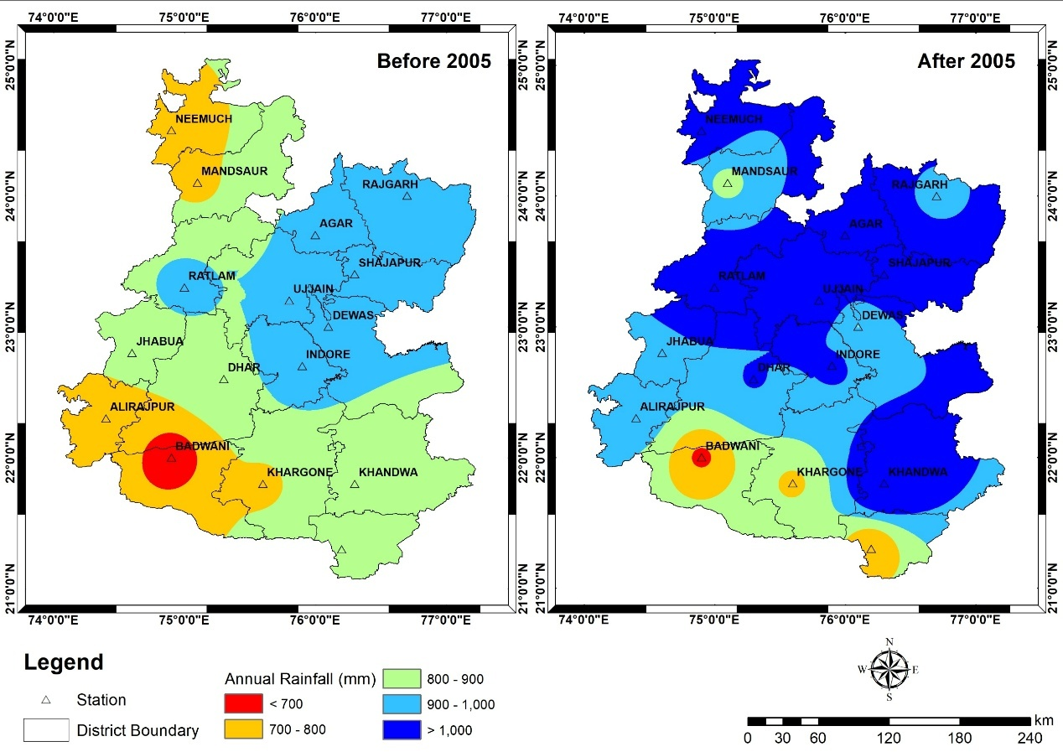
Figure 4: Annual Rainfall Before and After 2005
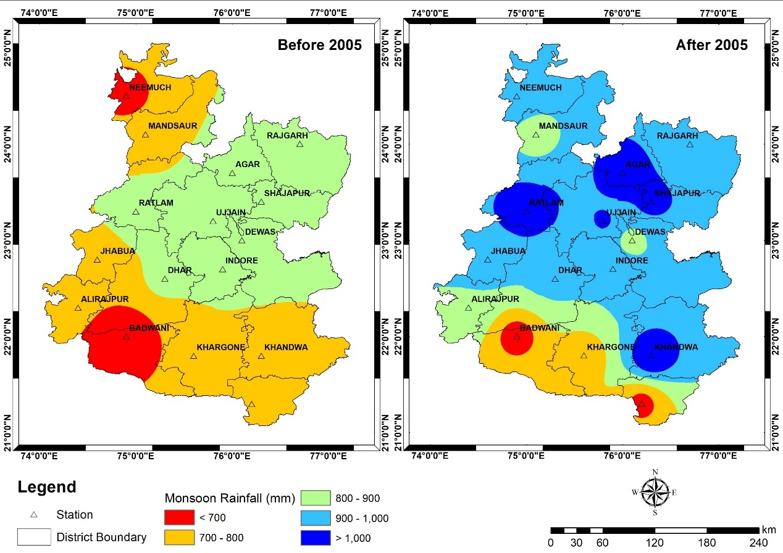
Figure 5: Monsoon Rainfall Before and After 2005
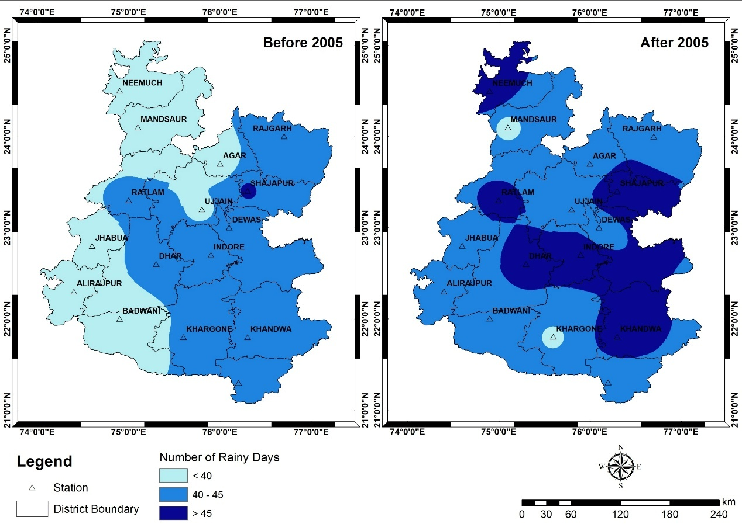
Figure 6: Rainy Days Before and After 2005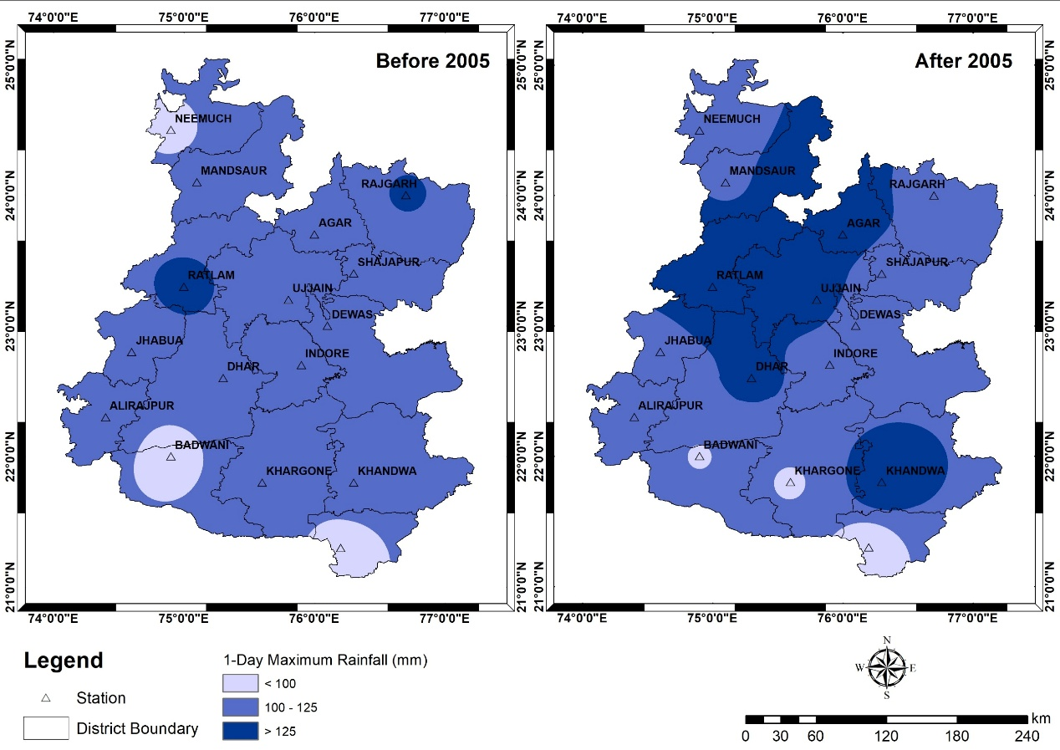
Figure 7: One-Day Maximum Rainfall Before and After 2005

Table 2: Mann-Kendall Test Z- values for trend analysis of rainfall
Physical Extent | Districts | Mann-Kendall statistics, Z-value
Physical Extent | Districts | Annual | Trend | Monsoon | Trend | Pre-Monsoon | Trend | Post-Monsoon | Trend | Winter Rain | Trend | Rainy day | Trend | One day max | Trend
Malwa Plateau | Agar | 0.80 | NS↑ | 1.28 | NS↑ | 0.62 | NT→ | -0.38 | NS ↓ | -0.54 | NT→ | 1.57 | NT→ | 0.23 | NT→
Malwa Plateau | Dewas | -0.30 | NT→ | 0.02 | NT→ | 0.92 | NT→ | -0.90 | NT→ | *2.25 | NT→ | 1.08 | NT→ | -0.22 | NT→
Malwa Plateau | Dhar | 1.77 | NS ↑ | 1.49 | NS ↑ | 1.23 | NT→ | -0.19 | NT→ | 0.32 | NT→ | 1.57 | NT→ | 0.35 | NT→
Malwa Plateau | Indore | -0.37 | NS ↑ | 0.00 | NS ↑ | 0.76 | NS ↑ | -1.53 | NT→ | -0.73 | NS ↓ | 1.00 | NT→ | -1.07 | NS ↓
Malwa Plateau | Mandsaur | 1.75 | NS ↑ | 1.76 | NS ↑ | 0.45 | NT→ | *-2.05 | NS ↓ | -0.25 | NT→ | 1.03 | NT→ | 0.62 | NT→
Malwa Plateau | Neemuch | ***3.53 | S↑ | ***3.66 | S↑ | 1.48 | NS ↑ | -0.34 | NT→ | 0.52 | NS ↑ | ***4.57 | NS ↑ | 0.94 | NT→
Malwa Plateau | Rajgarh | 0.35 | NS ↑ | 0.52 | NS ↑ | 0.27 | NT→ | -0.73 | NT→ | -0.99 | NS ↓ | 1.29 | NT→ | 0.16 | NT→
Malwa Plateau | Ratlam | 1.81 | NS ↑ | 1.86 | NS ↑ | -0.26 | NT→ | -0.66 | NT→ | 0.81 | NT→ | 1.78 | NT→ | -0.14 | NT→
Malwa Plateau | Shajapur | 1.47 | NS ↑ | 1.35 | NS ↑ | *2.34 | NS ↑ | -0.27 | NT→ | 0.76 | NS ↑ | *2.22 | NS ↑ | -0.09 | NT→
Malwa Plateau | Ujjain | 1.45 | NS ↑ | 1.48 | NS ↑ | *2.00 | NS ↑ | -0.68 | NT→ | -0.49 | NS ↓ | *2.09 | NS ↑ | -0.22 | NT→
Nimar Valley | Badwani | 0.74 | NS ↑ | 0.86 | NS | -0.15 | NT→ | -0.79 | NT→ | 0.92 | NT→ | ***3.32 | NS ↑ | 0.57 | NT→
Nimar Valley | Burhanpur | -0.60 | NS ↓ | 0.01 | NS ↓ | 0.13 | NT→ | *-2.08 | NS ↓ | 0.24 | NT→ | 0.74 | NT→ | -0.66 | NT→
Nimar Valley | Khandwa | **3.04 | S ↑ | **2.90 | S↑ | -0.45 | NS ↓ | -0.59 | NT→ | -1.82 | NS ↓ | 1.92 | NT→ | 1.17 | NT→
Nimar Valley | Khargone | 0.88 | NS ↑ | 1.22 | NS ↑ | -0.68 | NS ↓ | -0.99 | NT→ | -1.12 | NT→ | 0.55 | NT→ | 0.30 | NT→
Jhabua Hills | Alirajpur | *2.17 | S↑ | *2.19 | S↑ | 0.75 | NT→ | -0.64 | NT→ | 0.04 | NT→ | 0.79 | NT→ | 0.84 | NT→
Jhabua Hills | Jhabua | *2.53 | S↑ | **2.65 | S↑ | -0.80 | NT→ | -0.59 | NT→ | -0.66 | NT→ | 1.83 | NT→ | 0.72 | NT→

(Level of Significance * 0.1 (or 90%), ** 0.05 (or 95%), *** 0.01 (or 99%)

Table 3: Mann-Kendall Test Z- values for trend analysis of temperature
Months | Maximum temperature (Mean) |  | Minimum temperature (Mean)
Months | Z- value | Q- value | Z- value | Q- value
JAN | 1.84 | 0.038 | 0.31 | 0.006
FEB | 1.38 | 0.039 | 0.07 | 0
MAR | 2.92 | 0.054 | -0.45 | -0.006
APR | 2.93 | 0.033 | 0.34 | 0
MAY | 2.76 | 0.026 | -0.13 | 0
JUN | 0.18 | 0 | 0.75 | 0.014
JUL | 2.69 | 0.028 | 1.68 | 0.015
AUG | 2.38 | 0.021 | 1.79 | 0.015
SEP | 1.64 | 0.017 | 2.41 | 0.017
OCT | 1.61 | 0.016 | 0.18 | 0
NOV | 2.23 | 0.026 | 1.55 | 0.046
DEC | 1.08 | 0.024 | 0.77 | 0.013
Annual | 4.21 | 0.028 | 1.48 | 0.012
Pre-monsoon | 4.03 | 0.041 | 0.11 | 0.001
Monsoon | 2.66 | 0.016 | 1.78 | 0.015
Post-monsoon | 2.61 | 0.019 | 1.13 | 0.02
Winters | 2.26 | 0.037 | 0.1 | 0.001
(Level of Significance * 0.1 (or 90%), ** 0.05 (or 95%), *** 0.01 (or 99%)

Physical Extent | Districts | Sen’s slope Estimator, Q-value
Physical Extent | Districts | Annual | Pre-Monsoon | Monsoon | Post-Monsoon | Winter Rain | Rainy day | One day max
Malwa Plateau | Agar | 3.55 | 0.00 | 3.63 | 0.00 | 0.00 | 0.17 | 0.12
Malwa Plateau | Dewas | -0.90 | 0.00 | 0.12 | 0.00 | 0.00 | 0.14 | -0.10
Malwa Plateau | Dhar | 5.08 | 0.00 | 5.18 | 0.00 | 0.00 | 0.22 | 0.20
Malwa Plateau | Indore | -0.69 | 0.07 | 0.06 | -0.53 | 0.00 | 0.12 | -0.58
Malwa Plateau | Mandsaur | 3.29 | 0.00 | 3.96 | -0.24 | 0.00 | 0.12 | 0.33
Malwa Plateau | Neemuch | 12.25 | 0.14 | 11.41 | 0.00 | 0.00 | 0.68 | 0.50
Malwa Plateau | Rajgarh | 1.53 | 0.00 | 2.36 | -0.02 | 0.00 | 0.13 | 0.09
Malwa Plateau | Ratlam | 6.71 | 0.00 | 7.20 | 0.00 | 0.00 | 0.25 | -0.14
Malwa Plateau | Shajapur | 5.43 | 0.43 | 4.02 | 0.00 | 0.00 | 0.21 | -0.09
Malwa Plateau | Ujjain | 5.03 | 0.30 | 5.06 | 0.00 | 0.00 | 0.25 | -0.17
Nimar Valley | Badwani | 1.72 | 0.00 | 1.74 | -0.13 | 0.00 | 0.42 | 0.27
Nimar Valley | Burhanpur | -1.08 | 0.00 | 0.21 | -1.08 | 0.00 | 0.11 | -0.13
Nimar Valley | Khandwa | 11.42 | 0.00 | 11.08 | -0.23 | -0.05 | 0.20 | 0.71
Nimar Valley | Khargone | 2.49 | 0.00 | 3.11 | -0.32 | 0.00 | 0.04 | 0.18
Jhabua Hills | Alirajpur | 8.20 | 0.00 | 8.62 | -0.08 | 0.00 | 0.08 | 0.54
Jhabua Hills | Jhabua | 8.44 | 0.00 | 9.51 | 0.00 | 0.00 | 0.23 | 0.35
Table 4: Sen’s slope Estimator (Q) for quantify magnitude and direction of long-term trends in rainfall
(Level of Significance * 0.1 (or 90%), ** 0.05 (or 95%), *** 0.01 (or 99%)

Table 5: Worsley-Likelihood test statistics (W) for change point detection in Rainfall
Physical Extent | Districts | Worsley Likelihood statistics, W-Value
Physical Extent | Districts | Annual Rainfall |  | Monsoon Rainfall |  | Rainy Days |  | One Day Maximum
Physical Extent | Districts | Year of change | W value | Year of change | W value | Year of change | W value | Year of change | W value
Malwa Plateau | Agar | 2005 | 2.69 | 2005 | 2.65 | 1985 | 2.49 | 2001 | 2.57
Malwa Plateau | Dewas | 2018 | 1.62 | 2018 | 1.67 | 2018 | 2.76 | 2018 | 1.55
Malwa Plateau | Dhar | 2018 | 1.19 | 1992 | 1.22 | 2013 | 1.41 | 2013 | 1.22
Malwa Plateau | Indore | 1999 | 1.71 | 2007 | 1.49 | 2007 | 2.26 | 2007 | 1.85
Malwa Plateau | Mandsaur | 2018 | *2.96 | 2018 | **3.18 | 1989 | 1.82 | 1989 | 2.11
Malwa Plateau | Neemuch | 2006 | 2.77 | 2006 | 2.78 | 2008 | **3.75 | 2006 | **3.47
Malwa Plateau | Rajgarh | 2010 | 1.89 | 2010 | 2.17 | 2005 | 1.06 | 2010 | 1.52
Malwa Plateau | Ratlam | 2005 | 1.63 | 2005 | 1.76 | 2018 | 1.71 | 2003 | 1.27
Malwa Plateau | Shajapur | 2005 | 2.69 | 2005 | 2.65 | 1985 | 2.49 | 2001 | 2.57
Malwa Plateau | Ujjain | 2005 | 2.28 | 2005 | 2.28 | 2010 | 2.88 | 2005 | 2.04
Nimar Valley | Badwani | 1993 | 1.42 | 2017 | 2.00 | 2017 | 1.93 | 2017 | 1.66
Nimar Valley | Burhanpur | 1998 | 1.55 | 2018 | 1.42 | 1989 | 1.77 | 1989 | 1.41
Nimar Valley | Khandwa | 2017 | 2.24 | 2017 | 2.32 | 2015 | 2.50 | 2015 | 1.78
Nimar Valley | Khargone | 2018 | 2.25 | 2018 | 1.94 | 1983 | 2.18 | 1981 | 2.35
Jhabua Hills | Alirajpur | 2018 | 1.83 | 2005 | 1.95 | 2005 | 1.09 | 2005 | 1.38
Jhabua Hills | Jhabua | 2002 | 2.64 | 2002 | 2.84 | 2018 | 1.78 | 2002 | 2.75
(Level of Significance * 0.1 (or 90%), ** 0.05 (or 95%), *** 0.01 (or 99%)
- Conclusion
Change point detection plays a crucial role in identifying abrupt shifts in climatic patterns that cannot be captured through monotonic trend analysis alone. In this study, Pettitt’s Test and the Worsley Likelihood Ratio Test were applied to the long-term annual rainfall series (1980–2023) of the Malwa Plateau, Nimar Valley, and Jhabua Hills to detect structural breaks in rainfall behavior. Pettitt’s test revealed significant change points in several districts: Neemuch showed a clear shift around 2002–2004, consistent with its non-homogeneous nature and increasing monsoon rainfall, while Indore, Dewas, Ratlam, and Dhar exhibited no notable shifts, indicating stable rainfall regimes. In the Nimar Valley, Khandwa recorded a strong change point around 2005, supported by a high Sen’s slope and significant MK Z-values, whereas Burhanpur showed a marginal shift around 2007 linked to declining post-monsoon rainfall. In the Jhabua Hills, Jhabua displayed a marked shift near 2010 in line with its rising monsoon rainfall trend, while Alirajpur remained homogeneous. Overall, Pettitt’s test demonstrated that districts with strong MK trends and positive Sen’s slopes tend to exhibit more pronounced nonlinear changes. The Worsley Likelihood Ratio Test further confirmed these structural alterations, with critical W values of 2.86, 3.19, and 3.86 at the 90%, 95%, and 99% significance levels. Neemuch and Ratlam exceeded the 95% threshold, indicating robust shifts in the mid-2000s, while Shajapur showed only mild variability. In the Nimar Valley, Khandwa recorded one of the highest W values (>3.19), confirming a major shift around 2006–2008, whereas Khargone exhibited only weak changes. Jhabua again showed a strong shift (W > 3.00), consistent with accelerated rainfall increases after 2012, while Alirajpur showed no structural break. The combined interpretation of both tests suggests that most change points occurred between 2004 and 2012, a period associated with intensifying monsoon circulation over central India. Districts such as Neemuch, Khandwa, Ratlam, and Jhabua, which have strong positive MK trends, also recorded significant change points, indicating enhanced rainfall intensity, increased frequency of extreme rainfall events, and the emergence of new hydroclimatic regimes. Conversely, districts with stable or declining rainfall, such as Burhanpur, showed minimal or no structural changes. These findings highlight that rainfall patterns in the study area are not only changing gradually but are undergoing distinct transitions, which have critical implications for watershed management, reservoir operations, cropping calendars, and soil and water conservation strategies.
References:
Ahluwalia, P., & Pal, S. (2020). Climate variability and agricultural productivity in India. Springer. https://doi.org/10.1007/978-981-15-0000-0
Archana Kaushal, S. K. Pyasi, R. V. Galkate, R. N. Shrivastava, Vijay Shankar Yadav & Anoop Patel. (2025). Spatiotemporal Analysis of Rainfall Variability and Drought in Western Madhya Pradesh. Journal of Scientific Research and Reports, 31(5), 366–386. https://doi.org/10.9734/jsrr/2025/v31i53035
Chakraborty, S., & Srivastava, R. (2006). Climate change and variability over India: A review. Current Science, 90(3), 338–345.
Chowdhury, R. K., & Beecham, S. (2010). Rainfall trend analysis using statistical methods: Implications for water resources planning. Hydrological Processes, 24(18), 2583–2595. https://doi.org/10.1002/hyp.7742
Economic Survey of India. (2018). Ministry of Finance, Government of India. Retrieved from https://www.indiabudget.gov.in
Gajbhiye, K. S., Kumar, S., & Singh, R. (2016). Climate variability and its impact on agriculture in India. Journal of Environmental Science and Policy, 59, 31–42. https://doi.org/10.1016/j.envsci.2015.11.002
Gupta, R., Srivastava, A., & Bhattacharya, B. (2014). Regional climate assessment and its implications for natural resources. Environmental Monitoring and Assessment, 186, 8193–8207. https://doi.org/10.1007/s10661-014-3882-3
Hindustan Times. (2018, April). Groundwater depletion in India: A rising concern. Hindustan Times. Retrieved from https://www.hindustantimes.com
IPCC. (2007). Climate change 2007: Impacts, adaptation, and vulnerability. Contribution of Working Group II to the Fourth Assessment Report of the Intergovernmental Panel on Climate Change. Cambridge University Press.
Jain, S. K., & Kumar, V. (2012). Trend analysis of rainfall and temperature data for India. Hydrological Sciences Journal, 57(4), 648–662. https://doi.org/10.1080/02626667.2012.689766
Kendall, M. G. (1975). Rank correlation methods (4th ed.). Charles Griffin & Company.
Kumar, S., Singh, R., & Sharma, A. (2010). Impact of climate change on streamflow in India. Water Resources Management, 24(8), 1547–1561. https://doi.org/10.1007/s11269-009-9516-4
Kumar, S., Singh, R., & Sharma, A. (2016). Hydrological impacts of climate change in Central India. Environmental Earth Sciences, 75, 1–15. https://doi.org/10.1007/s12665-015-5000-2
Kumar, V., Jain, S. K., & Singh, R. (2014). Climate change and water resources in India: A review. Water Policy, 16(6), 1061–1079. https://doi.org/10.2166/wp.2014.110
Kundan, S., Singh, R., & Kumar, V. (2020). Rainfall variability and its impacts on agriculture in semi-arid regions of India. Theoretical and Applied Climatology, 140, 1285–1301. https://doi.org/10.1007/s00704-020-03211-x
Mann, H. B. (1945). Nonparametric tests against trend. Econometrica, 13(3), 245–259. https://doi.org/10.2307/1907187
Modarres, R., & da Silva, V. P. R. (2007). Rainfall trends analysis of Iran using non-parametric methods. Hydrological Processes, 21, 3815–3822. https://doi.org/10.1002/hyp.6764
Panda, S., & Sahu, N. (2019). Assessment of rainfall trends using Sen’s slope estimator and Mann-Kendall test. Journal of Hydrology, 574, 131–142. https://doi.org/10.1016/j.jhydrol.2019.04.044
Pettitt, A. N. (1979). A non-parametric approach to the change-point problem. Journal of the Royal Statistical Society: Series C (Applied Statistics), 28(2), 126–135. https://doi.org/10.2307/2346729
Roxy, M. K., Ghosh, S., Pathak, A., Terray, P., & Masson, S. (2017). Drying of Indian subcontinent by rapid Indian Ocean warming and a weakening land–ocean thermal gradient. Nature Communications, 8, 1–11. https://doi.org/10.1038/ncomms13421
Sen, P. K. (1968). Estimates of the regression coefficient based on Kendall’s tau. Journal of the American Statistical Association, 63(324), 1379–1389. https://doi.org/10.1080/01621459.1968.10480934
Srivastava, A., & Bhattacharya, B. (2015). Climate change and natural resource management in Central India. Ecological Indicators, 58, 1–12. https://doi.org/10.1016/j.ecolind.2015.04.027
V. S. Yadav, Archana Kaushal, Anoop Patel, Lokesh Patel, Pushpanjali Kumari, Samikshya Panda & Ankit Patel. (2025). Hydroclimatic Signatures of ENSO over India Understanding Rainfall Variability and Regional Sensitivity. International Journal of Environment and Climate Change, 15(10), 562–572. https://doi.org/10.9734/ijecc/2025/v15i105082
Verma, R., Kumar, V., & Singh, R. (2022). Trend analysis of rainfall and temperature using Mann-Kendall test and Sen’s slope estimator: Case study of Central India. Journal of Water and Climate Change, 13(4), 1470–1485. https://doi.org/10.2166/wcc.2022.116
Vijay Shankar Yadav, R. V. Galkate, V. K. Chandola, Ankit Patel, Samikshya Panda, Archana Kaushal & H. R. Ahirwar. (2025). Evaluation of Rainfall Variability and Meteorological Drought in Bundelkhand Region, India. Journal of Experimental Agriculture International, 47(4), 181–200. https://doi.org/10.9734/jeai/2025/v47i43369
Vijay Shankar Yadav, R. V. Galkate, V.K. Chandola, Samikshya Panda & Ankit Patel. (2024). Trend Analysis and Change Point Detection of Climatic Parameters in Ambedkar Nagar District of Uttar Pradesh, India. International Journal of Environment and Climate Change, 14(9), 578–605. https://doi.org/10.9734/ijecc/2024/v14i94440
Worsley, K. J. (1986). Confidence regions and tests for change-points in the mean of a normal sequence. Biometrika, 73(1), 91–104. https://doi.org/10.1093/biomet/73.1.91
Yadav, V.S., Galkate, R.V., Chandola, V.K. et al. Spatiotemporal characterization of meteorological drought and rainfall variation during El Niño/La Niña event over Bundelkhand region of India. Discov Appl Sci 7, 464 (2025). https://doi.org/10.1007/s42452-025-07035-9

