Assessing the Impact of Climate Change on Black Pepper (Piper nigrum L.) Distribution in Kerala through MaxEnt Modelling

Abstract
Black pepper (Piper nigrum L.) is an important spice crop of Kerala, whose productivity depends on climatic variation. The present study assesses the current and future climatic suitability of black pepper in Kerala using the MaxEnt model. Nineteen bioclimatic variables from the CHELSA database and topographic variables were used to predict the distribution of the species, and seven uncorrelated bioclimatic variables and four topographic variables were selected to run the model under current and future climate scenarios, SSP1-2.6, SSP 3-7.0, and SSP5-8.5 for the mid-century (2041-2070) and end-century (2071-2100) time periods. Model output was reclassified with a 0.38 threshold to demarcate suitable and unsuitable areas. Spatial suitability distribution was analyzed across twenty-three Agro-Ecological Units of Kerala to quantify area gain, loss, and no-change regions. The results showed a significant shift in suitable areas under high-emission scenarios, especially in lowland AEUs, indicating the potential contraction of suitable zones due to climate change. The study points to the vulnerability of traditional pepper-growing areas and emphasizes the need to adopt adaptive management strategies along with climate-resilient varietal selection for sustainable black pepper cultivation in Kerala.
- Introduction
Black pepper, Piper nigrum L., known as the ‘King of Spices’ is one of the important export-oriented crops of India and has historical and economic importance in Kerala State. As the center of origin, Kerala contributes a major share to the national production of the crop. In Kerala, cultivation of pepper is concentrated in the humid midland and highland zones (Ravindran, 2000). Black pepper is highly sensitive to climate conditions and grows well in warm, humid tropical climates with annual rainfall ranging from 1250 to 2000 mm at an average temperature of about 28 °C (Spices Board India, 2009). However, due to its perennial nature and a poor root system, it is very sensitive to temperature and rainfall variations. In Kerala, studies have reported that for every 1 °C rise in maximum/minimum temperature, there was about a 2.5% decline in yield (Nair et al., 2021). Such risks are projected to increase under climate change. According to the Intergovernmental Panel on Climate Change, IPCC, 2022, along with the intensification of warming trends, changing monsoon rainfall will probably result in a decline in climatic suitability for sensitive crops, especially in South Asia. Over Kerala, a shift in monsoon patterns and rising temperatures is projected to affect traditional pepper-growing areas. Sen et al., 2016 using MaxEnt modeling showed that climate change would contract the suitable habitat of P. nigrum in the Western Ghats. This further underlined the need to identify future refugia and vulnerable zones.
Species Distribution Models (SDMs)are now widely used to assess current and future habitat suitability based on environmental parameters. Of these, the MaxEnt model has become one of the preferred tools for modeling potential distributions using presence-only occurrence data (Phillips et al., 2006). MaxEnt works well with limited data, handles complex variable interactions, and has been applied in ecological and agricultural contexts such as modeling crop suitability under climate change scenarios.
But added to this is the spatial complexity brought in by Kerala's agro-ecological diversity. The state is divided into five Agro-Ecological Zones and 23 Agro-Ecological Units, distinct in soil, climate, elevation, and land use combinations, according to the Kerala Agricultural University, 2019. These classes provide a good input in regional agricultural planning, besides providing a good framework for suitability analysis at a localized scale. Thus, the present study aims to assess the current climatic suitability of black pepper in Kerala by using MaxEnt and the CHELSA-derived 19 bioclimatic variables, project future suitability under three Shared Socioeconomic Pathways viz., SSP1–2.6, SSP3–7.0, SSP5–8.5 for mid-century (2041–2070) and end-century (2071–2100), and detect zones of stability, loss, or gain in suitability, with implications for climate adaptation in pepper-growing regions. These findings will support regional policy, crop planning, and adaptive management strategies for sustaining black pepper cultivation in a changing climate.
2. Materials and Methodology
2.1. Study area
The study area, Kerala, lies between 8°17′–12°47′ N latitude and 74°52′–77°24′ E longitude along the southwestern coast of India, representing a total geographical area of 38,863 km². This state falls under a humid tropical monsoon climate with an average annual rainfall of about 2891 mm, distributed mainly during the southwest (June–September) and northeast (October–December) monsoons (IMD, 2025). Its terrain exhibits a steep west–east gradient from coastal lowlands to high-altitude regions of the Western Ghats.
For agroclimatic planning, Kerala was delineated into five Agro-Ecological Zones (AEZ) and twenty-three Agro-Ecological Units (AEUs) based on soil type, topography, and climatic features (Kerala State Planning Board). These range from coastal plains to midlands and highlands, representing diverse climatic regimes that significantly affect crop suitability and management.
2.2. Occurrence Data
Presence data of black pepper cultivation locations were collected from various field locations of Idukki, Kannur, Wayanad, and Thrissur along with open-source databases like Global Biodiversity Information Facility database (GBIF, 2025) and inaturalist. Duplicate records and points falling outside Kerala were removed. To reduce spatial sampling bias and spatial autocorrelation, occurrence points were subjected to spatial thinning at 1 km resolution using the spThin package in R, Aiello-Lammens et al. (2015). The final dataset consisted of 184 thinned occurrence points used for model calibration and validation.
2.3. Environmental Variables
Nineteen bioclimatic variables, bio1 to bio19, which were temperature and precipitation-related, from CHELSA v2.1 for the period 1981-2010 at 30 arc-second (~1 km²) resolution (Karger et al., 2017) were downloaded. Topographic variables such as elevation, slope, and aspect were derived from Digital Elevation Model (DEM) using the Shuttle Radar Topography Mission (SRTM) dataset, while aspect was further transformed into eastness and northness layers to capture directional effects on plant growth. Pearson's correlation analysis was carried out using the terra package in R to avoid multicollinearity among variables. When |r| ≥ 0.75, only one biologically meaningful variable was retained among pairs of variables. The final predictor set consisted of 11 bioclimatic variables: Bio1(annual mean temperature), Bio5(maximum temperature of warmest month), Bio7 (temperature annual range), Bio13(precipitation of wettest month), Bio15 (precipitation seasonality), Bio17(precipitation of driest quarter), Bio18(precipitation of warmest quarter), elevation, slope, northness, and eastness.
Mid-century (2041–2070) and end-century (2071–2100) future climate projections were extracted for two Shared Socioeconomic Pathways — SSP1-2.6 (low emission) and SSP5-8.5 (high emission) for the state from five CMIP6 Global Climate Models: GFDL-ESM4, IPSL-CM6A-LR, MPI-ESM1-2-HR, MRI-ESM2-0, and UKESM1-0-LL. To ensure that all spatial data are in a consistent format before modeling, all raster layers were clipped to the Kerala boundary and projected to a common spatial resolution and extent in WGS 84/ UTM zone 42S using ESRI ArcGIS 10.8.
2.4 Maxent modelling
The Maximum Entropy (MaxEnt) algorithm (version 3.4.4) was employed to model the potential distribution of black pepper using presence-only data (Phillips et al., 2006). MaxEnt estimates the probability distribution of species occurrence by maximizing entropy subject to environmental constraints derived from the input data.
Model calibration was carried out with 75% of occurrence data for training and 25% for testing. Default regularization settings and cloglog output were used, along with 10 replicates (cross-validation). The maximum number of background points was set to 10,000. 5,000 iterations were done with the convergence threshold set to 1 × 10⁻⁶. A Jackknife test was performed to evaluate the variable importance. Model performance was evaluated using the AUC, which stands for Area under the curve. AUC is a threshold-independent metric used to measure the models' ability to distinguish between random and background points. It is the area under the curve of the receiver operating characteristic plot. The ROC plot has the false-positive error rate on the x-axis, that is, 1 - specificity, versus the true positive rate on the y-axis, that is sensitivity, based on each possible value of threshold probability. It ranges from 0.5 to 1.0, where a value of 0.5 can be interpreted as random predictions and values above 0.5 indicate a performance better than random. Projections for the future climate change scenarios were done for the best performing model present in the scenario.
Resulting continuous logistic outputs were reclassified into binary maps of suitable/unsuitable using a threshold value of 0.38, which corresponds to the maximum training sensitivity plus specificity criterion as identified by Liu et al. (2005). These binary suitability maps were then used for further applications of spatial overlay and area computation.
2.5. Zonal and Area Analysis
The current and future binary suitability maps were overlaid with AEU shapefiles in ArcGIS 10.8. Raster-to-polygon conversion was carried out to delineate suitable regions, and the Calculate Geometry tool was used to compute area (km²) within each AEU. Thereafter, areas were categorized into gain, loss, and no-change classes by comparing current and future suitability layers using raster calculator and reclassification tools.
Area change statistics were summarized in Microsoft Excel, and spatial patterns were visualized through map layouts prepared in ArcGIS. The workflow ensured quantification of climate-induced changes in black pepper suitability across distinct agroecological domains, providing a fine-scale assessment of regional vulnerability and adaptation potential.
- Results and Discussion
  - Maxent model performance and environmental variable analysis
The MaxEnt species distribution model exhibited high predictive accuracy for Piper nigrum's current climatic suitability in Kerala. Calibration with a 10-fold cross-validation across 10 replicates resulted in an average test AUC of 0.910 (±0.026) (Fig. 1). The high value of AUC indicates that the model has strong discriminatory ability; that is, 91% of the time, it will correctly identify suitable conditions over unsuitable ones. The low standard deviation suggests that variations across folds were minimal and overfitting was limited, thus providing confidence in projections under future climate scenarios.
For converting the continuous MaxEnt output into a binary classification of suitable versus unsuitable, a threshold of 0.38 was chosen based on the MTSS criterion and the current suitability map of Kerala was prepared (Fig.2). This threshold was selected because it offered a more critical balance between omission and commission errors for agricultural decision-making and spatial planning. The binary conversion allows for zonal analysis and the quantification of area changes under climate scenarios in a more interpretable way.
Based on the contribution analysis, environmental variables related to precipitation were dominant factors in determining black pepper suitability and collectively contributed 73.2% towards the model predictive power. Of those, Bio13 (Precipitation of Wettest Month) was the most influential single predictor accounting for 42.0% of total contribution (Table 2).
Bio17 (Precipitation of Driest Quarter) contributed 19.8% to model performance and was identified via jackknife analysis as containing the most unique information: its omission resulted in the largest drop in training gain. This indicates that dry-season moisture availability is a critical limiting factor for pepper distribution, likely due to its influence on flowering and berry development. Bio18 (Precipitation of Warmest Quarter) also provided significant explanatory power (11.4%), likely reflecting the monsoonal rainfall regime during the peak growing season.
The temperature-related variables, although important in a secondary but complementary role, contributed to 22.1%. Bio1 corresponded to Annual Mean Temperature, which is representative of the general thermal suitability of the landscape at 11.0%. However, its permutation importance was considerably higher (33.5%), indicating a latent effect exerted by it that is masked by variable collinearity. Bio7 corresponded to the Temperature Annual Range with a meagre percent contribution of 3.4% yet with very high permutation importance of 36.4%, thus indicating it plays a critical role in capturing inter-seasonal thermal variability, which influences physiological thresholds. Bio5 pertains to Maximum Temperature of the Warmest Month, contributing 7.7%, and likely reflects thermal extremes relevant to pepper's phenological stress thresholds during summer months.
Topographic predictors contributed marginally to the model but added important nuance, accounting for less than 3.5%. Digital Elevation Model accounted for 1.1%, reflecting indirect climatic influences such as lapse-rate-driven temperature gradients. Slope accounted for 1.4%, and was likely capturing microclimatic and soil moisture retention variations linked to terrain-driven drainage patterns.
These patterns were further corroborated by the results of the jackknife test (Fig. 3). Of all factors taken in isolation, Bio13 provided the highest training gain, confirming it as the single most informative variable. On the other hand, removing Bio17 decreased the gain more than any other variable, further emphasizing its uniqueness and irreplaceability in the context of black pepper suitability modelling.
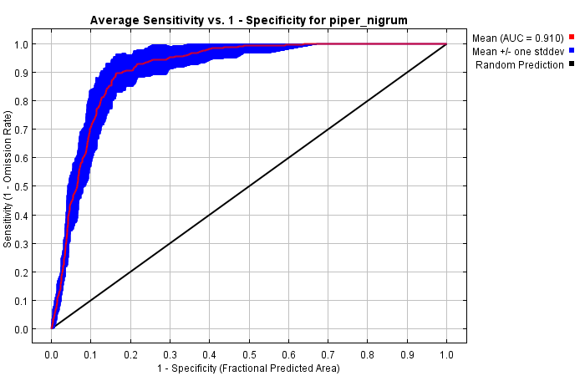
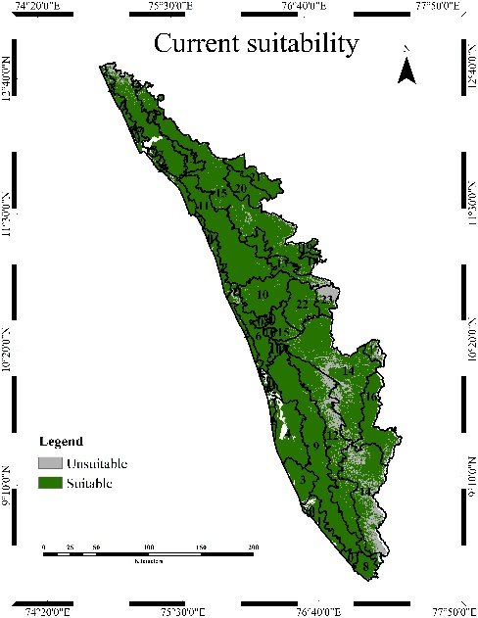

Figure 1. Receiver operating characteristic (ROC ) curve and AUC value averaged over 10 replicate runs for period 1981 to 2010
Figure 2. Black pepper current suitable and unsuitable areas

Agroecological units (AEUs)
AEU 1 Southern Coastal Plain | AEU 13 Northern Foothills
AEU 2 Northern Coastal Plain | AEU 14 Southern High Hills
AEU 3 Onattukara Sandy Plain | AEU 15 Northern High Hills
AEU 4 Kuttanad | AEU 16 Kumily Hills
AEU 5 Pokkali Lands | AEU 17 Marayur Hills
AEU 6 Kole Lands | AEU 18 Attappady Hills
AEU 7 Kaipad Lands | AEU 19 Attappady Dry Hills
AEU 8 Southern Laterites | AEU 20 Wayanad Central Hills
AEU 9 Southern Coastal Laterites | AEU 21 Wayanad Eastern Hills
AEU 10 Northern Coastal Laterites | AEU 22 Palakkad Central Plains
AEU 11 Northern Laterite | AEU 23 Palakkad Eastern Plains
AEU 12 Southern and Central Foothills
Table 1: List of Agroecological units of Kerala

Table 2: Relative contributions of the environmental variables
Variable | Percent contribution | Permutation importance
bio13 | 42 | 10
bio17 | 19.8 | 10.3
bio18 | 11.4 | 0.1
bio1 | 11 | 33.5
bio5 | 7.7 | 0.7
bio7 | 3.4 | 36.4
bio15 | 1.6 | 6.7
Slope | 1.4 | 1.3
Elevation (DEM) | 1.1 | 0.6
Eastness | 0.5 | 0.2
Northness | 0.1 | 0.3
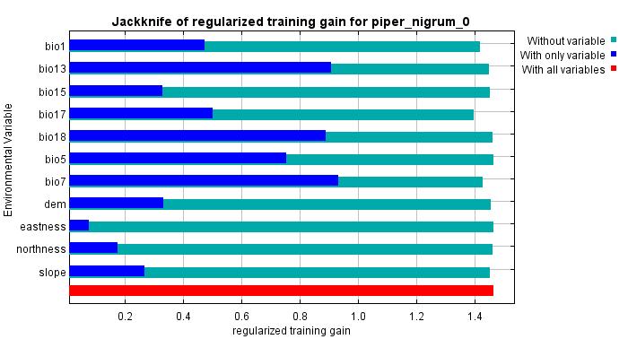
Figure 3. Results of jackknife test of variable importance

  - Projected Impacts of Climate Change on Black Pepper Distribution
    - Baseline suitability (1981-2010)
Presently, most of Kerala is suitable for black pepper cultivation, with highest suitable areas falling under Southern High Hills (AEU 14, 5257.9 km²), Northern High Hills (AEU 15, 5041.2 km²), Northern Laterite (AEU 11, 4600.0 km²), Southern Coastal Laterites (AEU 9, 3749.4 km²), Southern and Central Foothills (AEU 12, 2655.5 km²), Kumily hills (AEU16, 1320.91km²). These AEUs have a high proportion of their total area classified as suitable. In contrast, the smaller hills and valleys like Marayur Hill, occupying areas in the rain shadow regions, represent low or very low areas, such as AEU 17, 158.5 km² out of 298.4 km², having a much larger fraction of unsuitable area, 46.89%. Waterlogged basins, such as Pokkali and Kaipad lands, also exhibit reduced suitability, with larger percentages of unsuitable area, such as Pokkali Lands at 36.5% unsuitable. These AEUs are likely beset by problems such as waterlogging, salinity, or extreme variations in hydrology that make cultivation of black pepper difficult despite suitable temperature regimes. This reflects the reasons why flat, water-prone areas today are relatively less suitable, despite favorable climatic variables.
    - Future scenarios
In this mid-century scenario of the SSP1-2.6 (2041–2070), black pepper is highly suitable in a wide area in Kerala because it has favorable bioclimatic factors, including moderate annual mean temperature (bio1 ~ 26.5–27°C), maximal warm month temperature (bio5 ~30–33°C), substantial precipitation during the wettest month (bio13 > 660 mm), moderate rainfall seasonality (bio15 ~790–950), and adequate rainfall during the driest quarter (bio17 > 440 mm). These areas consist of AEUs such as the Northern and Southern High Hills (AEUs 14, 15), Northern Laterite (AEU 11), and Southern & Central Foothills (AEU 12), which collectively have the largest current and projected suitable cultivation zones.
Suitability declines markedly in lowland AEUs, such as Kuttanad (AEU 4), and coastal plains, where climatic factors increase temperature bio1 and bio5 beyond 30°C and rainfall seasonality is higher (bio15), pushing the conditions outside optimal ranges for black pepper. These areas have recorded a considerable loss of suitability area, thus corroborating the shifts that are driven by climatic factors. However, there are some scattered gains in mid-elevation zones where borderline current conditions are slightly improved by warming trends.
Topographical factors of moderate elevation and gentle slopes in favoured AEUs offer beneficial microclimate buffering, which allows for the retention of soil moisture and avoidance of waterlogging, further supporting suitable conditions.
In SSP370, for the mid-century climate scenario, black pepper suitability contracts drastically in Kerala compared to the present-day distribution. Major traditional pepper growing AEUs along the coast and lowlands, like Southern Coastal Plain (AEU 1), Northern Coastal Plain (AEU 2), and Kuttanad (AEU 4), become nearly unsuitable, with negligible future suitable area between 0 to 0.85 km². Losses are quite heavy in these regions: over 542 km² in AEU 1 and 1251 km² in AEU 2.
In contrast, few AEUs record small gains or persistence of suitability; it is most interior hill AEUs that show limited but nonzero area gains. In coastal AEUs, maximum temperatures are rising (bio5), and rainfall seasonality is increasing (bio15) with declines in dry-quarter precipitation (bio17), undermining black pepper's growth. On the other hand, limited gains in certain interior or higher altitude AEUs (High hills) are associated with warming temperatures that are bringing bio1 and bio5 into a more favourable range for pepper physiology.
Mid-century (2041–2070) projections indicate the drastically contracted suitability of black pepper across Kerala in the event of a high emission SSP585 scenario. The coastal and lowland AEUs are projected to experience complete loss of suitability. Zero future suitability can be seen in the southern Coastal Plain (AEU 1), Northern Coastal Plain (AEU 2), Onattukara Sandy Plain (AEU 3), and Kuttanad (AEU 4) with totals ranging from 536 to 1,313 km². These losses in suitability are driven by elevated annual mean temperatures that lie above the optimum for black pepper. Maximum temperatures of the warmest month reach 32.1–34.8°C, while rainfall seasonality remains high with precipitation in the driest quarter reaching as low as 267–450 mm. Laterite and foothill zones are also projected to experience severe losses in suitability. Northern and southern Foothills lose 3,733.147 km², Southern coastal Laterites lose 3,749.423 km², and the northern laterites lose 4,534.94 km². Suitability retention or gain among hills and high-elevation AEUs under SSP585 can be seen. Southern high hills (AEU 14) have maintained the largest suitable area at 3,231.17 km² with gains of 101.94 km². Bio1 ranges from 24.56 to 26.28°C and bio5 ranges from 32 to 34°C. The Northern high hills maintain 2,498.76 km² with 66.82 km² of gains. Kumily hills (AEU 19) show 1,260.94 km² of suitable area with minimal gains of 5.996 km². Wayanad Central Hills (AEU 20) and the Wayanad eastern hills (AEU 21) are resilient with 739.26 and 627 km², respectively.
Under the low-emission SSP126 scenario for late-century, black pepper suitability in Kerala presents relatively better outcomes compared to higher emission scenarios. The primary suitable regions concentrate in Kerala's high-altitude and midland zones which includes Southern High Hills (AEU 14): Maintains the largest suitable area at 3,913.04 km² with substantial gains of 376.91 km², driven by favourable thermal conditions (bio1: 24.67°C, bio5: 32.69°C) and excellent moisture availability (bio17: 1,511.82 mm). Northern High Hills (AEU 15): Retains 3,863.35 km² suitable area with gains of 108.79 km², supported by moderate temperatures (bio1: 26.69°C) and adequate dry season precipitation (bio17: 474.19 mm). Northern Laterite (AEU 11): Shows 1,890.56 km² suitable area, representing significant potential despite losses of 2,704.35 km². Kumily Hills (AEU 16): Demonstrates strong suitability with 1,294.35 km² and modest gains (36.83 km²), reflecting cooler microclimates (bio1: 22.52°C, bio5: 30.61°C). The projection indicates a pronounced elevation-dependent redistribution, with high-altitude zones (>1,000 m elevation) becoming the sole viable cultivation zones. Southern and Northern High Hills together account for 7,776 km² (53.5% of total suitable area), establishing them as critical resilience zones. This elevation-driven pattern reflects topographic modulation of temperature and precipitation, providing climatic buffering unavailable in lowlands.
In the late century, under the intermediate-emission SSP370 scenario, black pepper suitability in Kerala experiences severe contraction. In all, the total suitable area is projected to be 8,058.2 km², with modest gains of 364.06 km²; only 5 AEUs (14, 15, 16, 20, 21) retain any meaningful suitability. While temperature effects are rather broad on suitability, moisture limitations show extreme spatial variability. Coastal Plains and Palakkad present bio17 values <450 mm, unviable, while Highland zones maintain >1,100 mm, viable. This geographic specificity underlines that future adaptation needs to focus on high-elevation, high-precipitation zones, with limited alternatives in lowland cultivation without large investments in irrigation infrastructure.
Under the high-emission SSP585 scenario for late-century (2071–2100), black pepper suitability in Kerala experiences catastrophic collapse. The projected total suitable area is 5,126.01 km² with minimal gains of 209.02 km². Only Southern High Hills (1,662 km²) and Northern High Hills (1,446 km²) retain meaningful suitability, jointly accounting for 60.6% of the remaining viable area. This extreme geographic concentration means that black pepper cultivation becomes economically unviable across 95% of current growing regions. Farmers who cannot access high-elevation zones face existential economic collapse. Whereas in previous analyses, suitability was codetermined by both temperature and moisture, under SSP585 reveals moisture as the primary constraint in coastal zones (bio17= 262 - 445 mm = severe drought), while even temperature-resilient highland zones become moisture-limited (bio17 declines to 413–425 mm in some zones). Remaining zones maintain viability only because of exceptional moisture concentrations (bio17 > 1,200 mm in Southern High Hills).
- Conclusion
In this study, the MaxEnt modelling framework was used to evaluate current and future (under multiple climate change scenarios) climatic suitability maps for black pepper Piper nigrum L across Kerala's 23 Argo-Ecological Units. The results clearly indicate that though a considerable part of the state is suitable for raising pepper, especially in areas falling in mid- and high-elevation regions, the projected climate change would alter the spatial pattern of suitability significantly.
Results under mid-century and end-century projections, especially the high-emission SSP3–7.0 and SSP5–8.5 scenarios, indicate that Kerala will face a significant contraction of suitable areas. Temperature rise and increased seasonality in rainfall are expected to drive the loss of suitability in the lowland and coastal AEUs. Contrasting this, high-elevation AEUs, especially the Southern and Northern High Hills (AEUs 14 and 15), consistently appear as climatic refugia with favourable thermal and moisture conditions.
Analysis reveals that bio17, the precipitation of the driest quarter, and bio1, bio5, and bio7, representing annual thermal stability, are among the most important environmental predictors of pepper suitability. Increased dry-season moisture deficits, even in previously wet areas, may become the dominant constraint to pepper under future climate regimes.
From a policy and planning perspective, these findings underline the need for proactive adaptation strategies, including the promotion of climate-resilient cultivars, elevation-specific planting guidelines, microclimate management through agroforestry, and region-specific agroecological zoning approaches. High-resolution spatial modelling, as used in this study, provides a key decision-support tool for securing the long-term sustainability of black pepper cultivation under a changing climate.
Disclaimer (Artificial intelligence)
Author(s) hereby declare that no generative AI technologies such as large language models (ChatGPT, COPILOT, etc) and text to image generators have been used during the writing or editing of manuscript.
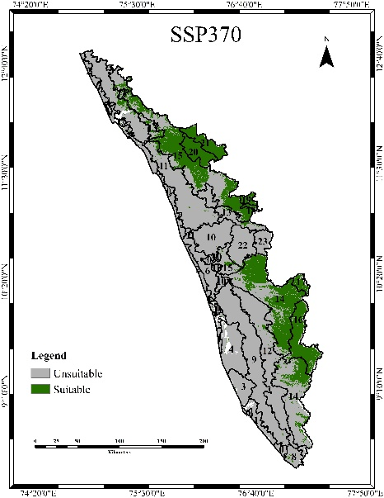
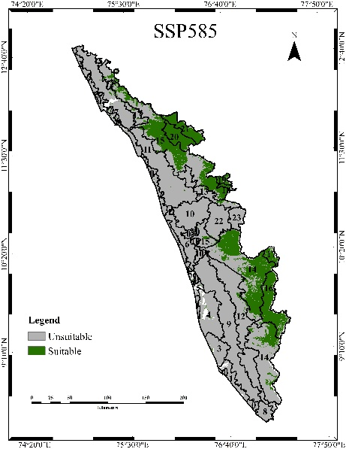
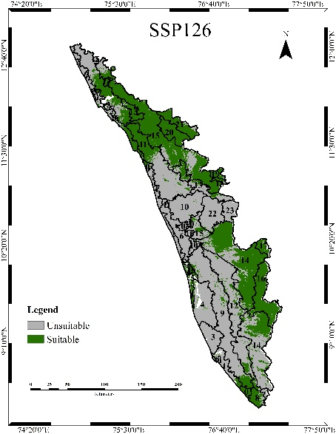
Mid-century (2041-2070) suitability maps

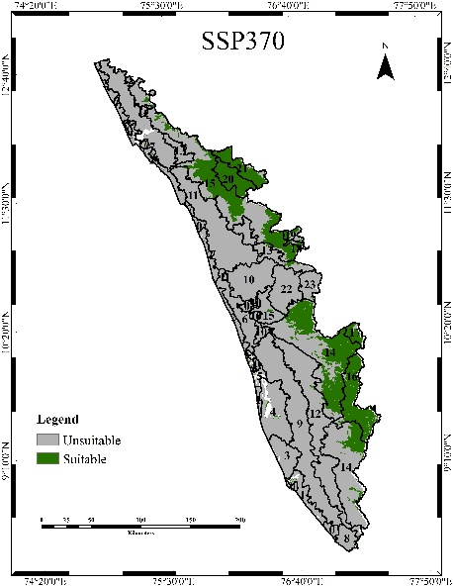
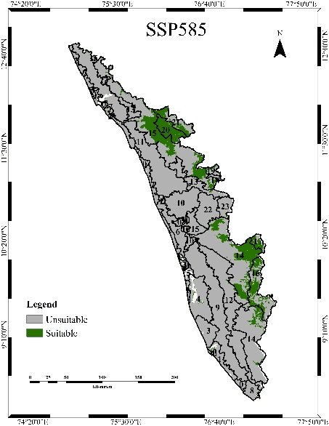
End-century (2070-2100) suitability maps
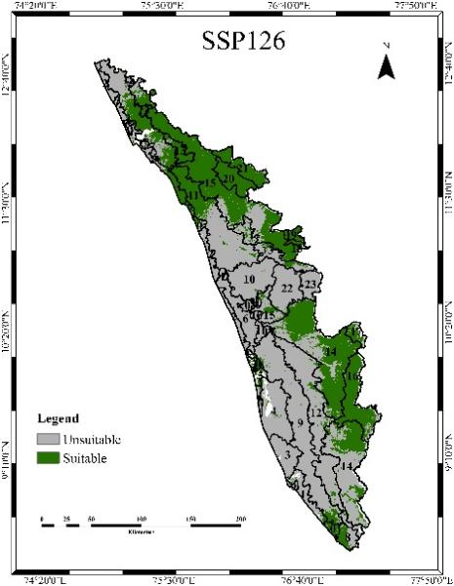
Figure 4. Black pepper future suitability under climate change scenarios

References
Aiello-Lammens, M. E., Boria, R. A., Radosavljevic, A., Vilela, B., & Anderson, R. P. (2015). spThin: An R package for spatial thinning of species occurrence records for use in ecological niche models. Ecography, 38(5), 541–545.
GBIF. 2025. Available at: https://doi.org/10.15468/dl.k3yzgj . [Date accessed: 13 July 2025].
India Meteorological Department. (2025). Annual Climate Summary 2024.Ministry of Earth Sciences, Government of India. https://internal.imd.gov.in/press_release/20250115_pr_3554.pdf
Intergovernmental Panel on Climate Change (IPCC). (2022). Climate Change 2022: Impacts, Adaptation and Vulnerability. Contribution of Working Group II to the Sixth Assessment Report. Cambridge University Press.
Karger, D. N., Conrad, O., Böhner, J., Kawohl, T., Kreft, H., Soria-Auza, R. W., Zimmermann, N. E., Linder, H. P., & Kessler, M. (2017). Climatologies at high resolution for the Earth’s land surface areas (CHELSA V1.2): Bioclimatic variables for ecological and biogeographical modelling. Scientific Data, 4, 170122.
Kerala State Planning Board. (n.d.). Agriculture. In Kerala State Planning Board Annual Report. Available at: https://spb.kerala.gov.in/sites/default/files/inline-files/1.1Agriculture.pdf (Accessed: September 7, 2025).
Liu, C., Berry, P. M., Dawson, T. P., & Pearson, R. G. (2005). Selecting thresholds of occurrence in the prediction of species distributions. Ecography, 28(3), 385–393.
Nair, N. S., Thilagavathi, M., Prahadeeswaran, M., & Duraisamy, M. R. (2021). Role of major weather parameters in the production of black pepper in Kerala. Asian Journal of Agricultural Extension, Economics & Sociology, 39(11), 259–267
Phillips, S. J., Anderson, R. P., & Schapire, R. E. (2006). Maximum entropy modeling of species geographic distributions. Ecological Modelling, 190(3–4), 231–259.
Ravindran P N. 2000. Black pepper: Piper nigrum. Harwood academic publishers, New Jersey. pp. 1-10.
Sen, S., Gode, A., Ramanujam, S., Ravikanth, G., & Aravind, N. A. (2016). Modeling the impact of climate change on wild Piper nigrum (Black Pepper) in Western Ghats, India using ecological niche models. Journal of Plant Research, 129(6), 1033–1040. https://doi.org/10.1007/s10265-016-0859-3
Spices Board India. (2019). Cultivation practices for pepper. Ministry of Commerce and Industry, Government of India. https://www.indianspices.com/sites/default/files/cultivation_practices-pepper_1.pdf

