Effect of weather on physiological aspect and quality of kinnow mandarin under sub-tropics foothill Himalayas

ABSTRACT
Field experiment was carried out to study the effect of weather parameter on physiological aspect and quality of Kinnow mandarin, which were drip-irrigated from initial year of planting. Results showed positive correlation of the chlorophyll content and relative leaf water concentration of kinnow mandarin with Tmax, Tmin and RH at K₁ stage; Tmax, Tmin and evaporation at K₃ stage and evaporation at K₂. Leaf water content of kinnow mandarin were influenced positively by Tmin and evaporation at K₃ stage and evaporation at K₂ stage.
However the quality parameter viz., total sugar, reducing sugar, non-reducing sugar and ascorbic acid content in fruits of kinnow mandarin were influenced positively byTmax and Tmin at K₃ stage, Tmax and RH at K₄ stage whereas, acidity, total phenol and total flavonoid of kinnow mandarin fruit were influenced positively with rainfall at K₃ with Tmin and rainfall at K₄ stage.
Keywords: Weather, Physiological, Quality, Citrus, Kinnow mandarin
Citrus is the imperative and leading fruit crops of the world. Among the different commercially grown citrus fruits, cultivation of kinnow mandarin, a first generated hybrid of King Orange (♂) and Willow Leaf (♀) developed by Dr. H. B. Frost in 1915 in California (USA) has assumed most prized status among citrus fruit grower of North-Western regions of the India. It is the second most important commercial fruit crop in India, occupying an area1078 thousand hectare and production 11147 thousand metric tons, respectively with a productivity of 10.3 metric tons per hectare (Anonymous, 2014). Considering the nutritional value, the magnitude of fruit production and array of commercial product made the citrus may be consider as a number one fruit of the world. It has a great variety of beverage, industrial, and medicinal uses and has assumed special economics importance and export demand being acknowledged for its high juice contents, special flavor, and delicious taste and being a rich source of Vitamin C, it is widely used for juices, squashes, jams, jellies and marmalade. It also provides some micronutrients such as calcium, phosphorous and iron. In spite of such qualities and scope, the Kinnow production throughout the world suffers from a multitude of environmental challenges.
Climate is interrelated with citrus quality and quantity. In sub-tropical regions, the fruit growth rate is rapid, but the fruit quality of oranges and mandarin is poor, with typical green peel colour and a pale light yellow juice colour (Makinde et al., 2011). Moreover, the sugar and acids tend to be low due to high average temperatures throughout the year which cause respiratory metabolism of sugar and acids (Davies and Albrigo, 1994; Davies, 1997). Climate variability to be, the principal source of fluctuations in global food production in developing countries. The high temperature increases the capacity of air to absorb water vapour and constantly generate a higher demand of water (Moretti et al., 2010).The temperature increase affected the photosynthesis, causes alternation in sugar, organic acid, firmness as well as post harvest quality of the fruit (Moretti et al., 2010) and higher temperature also resulted in physiological problems in flower and fruit development. Current and forecast global warming is expected to change climate in the classic regions of fruit tree cultivation. Hence, the recent investigation was carried out to find out the impact of weather parameters on physiological aspect at different phenological stages and quality during fruit developmental stages of kinnow mandarin under sub-tropical foot-hill Himalayas conditions.

MATERIALS AND METHODS
Experimental site
The field experiment was conducted for two consecutive year 2014 and 2015 at Research Farm Chatha, Division of Fruit Science, Faculty of Agriculture, Sher-e-Kashmir University of Agricultural Sciences and Technology-Jammu, India. The experimental orchard at Chatha is situated in the sub-tropical zone at latitude 32º 43' North, longitude of 74º 54' East and altitude 332 meters above mean sea level. Annual rainfall is about 1110 mm, out of which most of the rains are received during July to October. The mean annual maximum and minimum temperatures are 29.7 and 16.3 ºC, respectively. Summer months are hot with temperature and humidity ranging from 23.5 to 35.5 ºC and 53.0 to 73.5%, respectively. The winter months experience mild to severe cold conditions with an average temperature ranging from 6.5 to 21.7 ºC. December is the coldest month, when minimum temperature touches to 4 ºC. The highest temperature is recorded in the month of June (45 ºC). Daily maximum and minimum values of temperature, evaporation rate rises from February onwards up to June drop during July to September with a slight peak in October and then drop progressively up to December.
Experimental design and treatments
The experiment was conducted on 08 year-old plants, uniformly growing and bearing habit trees of ‘Kinnow’ mandarin, which were drip-irrigated from initial year of planting. The experiment was laid out according to randomized block design, plant to plant spacing in a row and within the row was 5 m and 5 m, respectively. Three plants from each replication were selected randomly for periodic identification of phenological events. The stages were taken into consideration for purposes of identifying some critical stages required for this study. These stages were identified on the basis of external morphological characteristics of Kinnow mandarin which included (i) Pre-flowering stage (K1), (ii) Flowering to first fruit set (K2), (iii) First fruit set to maximum fruit set (K3) and (iv) Maximum fruit set to fruit harvest (K4).
Plant sampling and analysis
In the experiment, the phenophase wise correlation studies of growth, yield and quality with various parameters were carried out separately with the help of methodology described by Gomez and Gomez (1984) for the crop on first, second, third and four stages. The meteorological parameters included were maximum temperature (Tmax), minimum temperature(Tmin), maximum relative humidity(RHmax) and minimum relative humidity (RHmin), rainfall (Rf) and Evapotranspiration (Ev) whereas physiological aspect and quality parameters, viz. chlorophyll content, relative leaf water content, leaf water concent, total sugar, reducing sugar, non-reducing sugar, sugar: acid ratio, total phenol, total flavonoid. Chlorophyll content in leaves of kinnow mandarin crop was determined by the use of chlorophyll meter SPAD-502 and the data expressed as per cent. For determining relative leaf water content (RLWC) and leaf water concentration (LWC), For determining relative leaf water content (RLWC), two leaves per plant from near the trunk or a main scaffold branch were detached once in a fortnight at mid-day in early fruit growth period. The leaves were cut into small pieces (approximately 1 cm² area) and weight of the leaflets was measured known as fresh weight (FW). Afterwards, the leaflets were placed in distilled water (for 3-4 hours) until they gained a constant weight known as turgid weight (TW). The dry weight (DW) was determined by placing the leaflets in an oven at 60 ^{ο}C (for 1-2 days) till a constant weight had been achieved.
RLWC and LWC were estimated following the procedures suggested by Bowman (1989) using the formula:
RLWC (%) = | {(FW − DW)/(TW − DW)}x 100
LWC (%) = | {(FW − DW)/(FW)}x100
Sugar (total sugar, reducing sugar, non-reducing sugar) were calculated by the procedure described in A. O. A. C. (1995).
Total sugars (%) = | Factor x Dilution | x 100
Total sugars (%) = | Aliquot used x Sample weight | x 100

Reducing sugars (%) = | Factor x Dilution | x 100
Reducing sugars (%) = | Aliquot used x Sample weight | x 100

Non-reducing sugars (%) = | (Total sugars-Reducing sugars) x factor
Ascorbic acid content was determined by the procedure described by Sadasivam and Manicham (1996).
Ascorbic acid (mg/100 g) = | Titre x dye factor x volume made up (ml) | x 100
Ascorbic acid (mg/100 g) = | Aliquot of extract taken (ml) х Weight of sample (g) | x 100

The total phenolics were determined by the Singleton et al. (1999) method. The content of total flavonoids was measured according to Dewanto et al. (2002), with the modifications of Tounsi et al. (2011).
Data analysis
The statistical correlation analysis of data was done using SPSS 16.0 software. The test of significance was done at p<0.01, 0.05 and 0.005 level.
RESULTS AND DISCUSSION
Climate of crop cultivated region influence the physiological aspects of the crops and quality of the fruits, but its impact on crop is complex and is combined with other factors and hence, it become very difficult to single out any particular meteorological parameters for describing its influence. However, the emphasis was given on main climatic factors that influenced either individually or jointly the growth and quality of kinnow mandarin. These factors include maximum temperature, minimum temperature, maximum relative humidity and minimum relative humidity, rainfall, evaporation during both the crop growing seasons 2014 and 2015, which are depicted in Fig 1 and 2.
Effect of climatic factors on physiological aspect of kinnow mandarin fruit
Chlorophyll content of kinnow mandarin had positive correlation with both maximum and minimum temperature and relative humidity at K₁ stage (r = 0.69*, 0.72* and 0.71*, 0.73*, respectively) with maximum and minimum temperature at K₃ stage (r = 0.71* and 0.77*, respectively) and evaporation at K₂ and K₃ stage (r = 0.87** and 0.82**, respectively). Chlorophyll content had negative correlation with minimum temperature and evaporation at K₄ stage (r = –0.80** and –0.73*). This result are in line with the finding of Begum and Nessa (2014), who reported that among all climatic factors chlorophyll content of wheat crop is more influenced by temperature and decreased with increase in temperature. Further, rainfall at K₃ and K₄ stage (r = –0.76* and r = –0.79*) also exerted negative correlation on the leaf chlorophyll content of kinnow mandarin fruit plants.
The relative leaf water content of kinnow mandarin had positive correlation with both maximum and minimum temperature at K₁ and K₃ stage (r = 0.71*, 0.73* and 0.75*, 0.80**, respectively), with maximum relative humidity at K₁ and K₄ stage (r = 0.73* and 0.70*) and with minimum relative humidity at K₁ stage (r = 0.74*) and with evaporation at K₂ and K₃ stage (r = 0.83** and 0.85**). However, relative leaf water content was negatively influenced by minimum temperature and evaporation at K₄ stage (r = –0.76*, and – 0.71*), and rainfall at K₃ and K₄ stage (r = –0.77* and –0.81**) with evaporation at K₂ stage (r = 0.84**) and with minimum temperature and evaporation at K₃ stage (r = 0.70* and 0.77*, respectively). Whereas, at K₄ stage, climatic factor like minimum temperature, evaporation and rainfall (r = –0.85**, –0.79* and –0.73*, respectively) and at K₃ stage rainfall (r = –0.84**) expressed negative impact on leaf water content of kinnow mandarin.
Effect of climatic factors on quality of kinnow mandarin fruit
The data pertaining to the effect of different climatic factors on quality of kinnow mandarin fruit at fruit growth stage are presented in Table 2. The sugar content (total sugar, reducing sugar, non-reducing sugar) of kinnow mandarin fruit crops were positively associated by maximum and minimum temperature at K₃ stage (r = 0.77*, 0.71* 0.75* and 0.81**, 0.76*, 0.77*, respectively). Salvador et al. (1998) reported that Elegant Lady peach and Fantasia nectarine fruits from Santiago (with higher maximum and minimum temperature) had higher content of sucrose percentage as compared to the fruits obtained from Mendoza. Lizana et al. (2007) reported higher sugar in Thompson Seedless from temperature treated berries. Zheng et al. (2009) reported that fructose, glucose and citric acid in Mortti and Ola cultivars of black currants was correlated positively with the average temperature from the start of the growth season until the day of harvest. Further, maximum relative humidity at K₄ stage (r = 0.86**, 0.85** and 0.74*, respectively) exerted positive impact on sugar content (total sugar, reducing sugar, non-reducing sugar). These findings are supported by Jianfu et al. (2002) who stated that high relative humidity reduced peroxidase enzyme activity and increased super oxide dismutase activity, pollen vigour and fertility as well as sugar and starch accumulation, which resulted in increased yield and quality in macadamia plants, while rainfall at K₄ stage (r = –0.84**, = –0.81** and = –0.74*, respectively) negatively influenced the sugar content of kinnow mandarin fruit. Peng et al. (2000) reported that among climatic factors, the rainfall in the month of September and October affects the soluble solid content of Naval orange whereas less rainfall in this period will increased the soluble solids. However, evaporation at K₃ stage (r = 0.83**, 0.78* and 0.76*, respectively) were positively correlated with total sugar, reducing sugar, non-reducing sugar, respectively.
The acidity content in fruit was positively affected by minimum temperature at K₄ stage (r = 0.819**). Malic acid synthesis was more sensitive to high temperature exposure during growth (Kliewer and Lider, (1970); Lakso and Kliewer, (1975), as malate is respired during ripening and that respiration rate is increased by temperature (Coombe, 1987). Redalen et al. (1993) observed that titratable acids contents were highest in ‘Katja’ apple fruits from normal Stockholm climate (at about 60°N), and lowest in fruits from Frankfurt climate (at 50°N). The acidity content was negatively affected by maximum relative humidity at K₄ stage (r = –0.69*), whereas rainfall at K₃ and K₄ stage (r = 0.78* and 0.73*) were positively associated with the acidity content of kinnow fruit crop. High precipitation near harvest increased titratable acidity in plum (Vangdal et al., 2007). Acidity content of kinnow mandarin fruit was positively influence by evaporation at K₄ stage (r = 0.76*) but negatively influence at K₃ stage (r = –0.76*).
Ascorbic acid content in fruits of kinnow mandarin was negatively affected by minimum temperature at K₄ stage (r = –0.79*) but positively affected by maximum and minimum temperature at K₃ stage (r = 0.69* and 0.75*). Temperature governs the enzymatic systems involved in biogenesis and catabolism of ascorbic acid (Rathore, 1979), which might be related to these differential response. Chen et al. (1999) reported that vitamin C content was lower in pear fruit collected from the low temperature region of China as compared to high temperature. Singh and Dhaliwal (2004) found higher vitamin C content in narrowly spaced trees and in the lower part of tree canopy in Sardar guava under warm and dry weather. Njoku et al. (2011) observed that lower the temperature better the concentration of Vitamin C in fruit juice of kinnow mandarin fruit crops. Further, maximum relative humidity at K₄ stage (r = 0.73*) was positively correlated with ascorbic acid content in fruits of kinnow mandarin. The higher ascorbic acid in fruit may be ascribed to better uptake of potassium, which might increase the synthesis of this acid. However, evaporation and rainfall at K₄ stage and rainfall at K₃ stage (r = –0.78*, –0.73*, –0.77*, respectively) exerted negative impact on ascorbic acid content of kinnow mandarin fruit crops, while evaporation at K₃ stage showed positive correlation.
Among all the climatic factors, minimum temperature and rainfall at K₄ stage and rainfall at K₃ stage (r= 0.70*, 0.85** and 0.70*, respectively) were the only climatic factors that correlated positively with the total phenol content of kinnow mandarin fruit crops whereas, maximum and minimum temperature at K₃ stage (r = –0.73* and –0.79*), maximum relative humidity at K₄ stage (r = –0.77*) and evaporation at K₃ stage (r = –0.83**) were negatively correlated with the total phenol content of kinnow mandarin.
The total flavonoid content of kinnow mandarin were negatively influenced by minimum temperature (r = –0.73*) and evaporation (r = 0.83**) at K3 stage and maximum relative humidity at K₄ stage (r = –0.76*). However minimum temperature at K4 stage associated positively with the total flavonoid content in fruits of kinnow mandarin. Similarly rainfall at K3 and K4 stage showed positive correlation with the total flavonoid content of kinnow mandarin.
CONCLUSION On the basis of above study, it can be concluded that there was a strong relationship between weather parameters and quality of kinnow mandarin fruit crops. Further, the climate of a particular region is a decisive factor to have quality fruit with marketable size. Based on this study we can provide the optimum crop environment at different phenological stage of kinnow mandarin fruit crops by doing proper crop management based on weather conditions for producing good quality fruits having high market demand with more price
REFERENCES
A.O.A.C. 1995. Official methods of analysis of 16th edition. Association of Analytical Chemists, Washington, D.C.
Anonymous. (2014). Indian Horticulture Database. NHB, Ministry of Agriculture, Govt. of India, pp 85 Institutional area, Sec-18, Gurgoan, New Delhi.
Begum, F. and Nesa, A. 2014. Effects of temperature on some physiological traits of wheat. J Bangladesh Acadamy Sci, 38(2): 103-110.
Bowman, W. D. 1989. The relationship between leaf water status, gas exchange, and spectral reflectance in cotton leaves. Remote Sens Environ, 30: 249-255.
Chen, Z., Zhao, S., Xia, H. and Ding, H. 1999. Effect of ecological factors and cultural systems on pear fruit quality. South China Fruit, 28(3): 41-42.
Coombe, B.G.1987. Influence of temperature on composition and quality of grapes. Acta Hort, 206: 23-35.
Davies, F. S. and Albrigo, L.G. 1994. Citrus. pp 254. Cab International, Wallingford, U.K.
Davies, F.S. 1997. An overview of climatic effects on citrus flowering and fruit quality in various parts of the world. In: Stephen, H. F. and Walter, J. K. (eds.). Citrus Flowering and Fruiting Short Course. University of Florida Press. Gainesville. Florida, USA.
Dewanto, V., Wu, X., Adom, K. and Liu, R. H. 2002. Thermal processing enhances the nutritional value of tomatoes by increasing total antioxidant activity. J Agric Food Chem, 50: 3010–3014.
Gomez, K. A. and Gomez, A. A. 1984. (eds.). Statistical procedures for agricultural research, pp 717. An International Rice Research Institute, John Willey and Sons, New York.
Jianfu, L., Shubang, N. I., Jianguo, J., Daogao, L., Xiyong, H. and Yingyi, D. 2002. Effect of relative humidity on macadamia′s pollen vigor, fertility and physiological character. Chin J Trop Crops, 2: 48-53.
Kliewer, W. M. and Lider, L. A.1970. Effects of day temperatures and light intensity on growth and composition of Vitis vinifera L. fruits. J. Am. Soc. Hortic. Sci., 95: 766-769.
Lakso, A. N. and Kliewer, W. M. 1975. The influences of temperature on malic acid metabolism in grapes berries I. enzyme responses. Plant Physiol., 56: 370-372.
Lizana, L. A., Miranda, J., Pinto, M. and Garcia-de-cortazar, V. 2007. Effect of night temperatures on Thompson seedless soluble solids and acidity evolution and berry growth. Acta Hort., 754: 191-195.
Makinde, A. A., Afolayan, S. O., Olaniyan, A. A., Odeleye, O. M. O and Okafor, B. N. 2011. Effect of climate on citrus yield in rainforest-Savanna Transitional Zone of Nigeria. J. Agric. Bio. Sci., 2(1): 10-13.
Moretti, C. L., Mattos, L. M., Calbo, A. G. and Sargent, S. A. 2010. Climate changes and potential impacts on post harvest quality of fruit and vegetable crops: A review. Food Res. Int., 43: 1824-1832.
Njoku, P. C., Ayuk, A. A. and Okoye, C. V. 2011. Temperature effects on vitamin C content in citrus fruits. Pak J Nutri, 10(2): 1168-1169.
Peng, L., Wang, C., He, S., Guo, C. and Yan, C. 2000. Effects of elevation and climatic factors on the fruit quality of Navel orange. South-Chin-Fruits, 29(4): 3-4.
Rathore, D. S. 1979. A possibility of inverse relationship between the ascorbic acid content of guava fruits and ripening temperature. Indian J Hortic., 36: 128-129.
Redalen, G., Lindhagen, M. and Huntrieser, I. 1993. Fruit and shoot development in apple as affected by temperature, light, humidity and a possible greenhouse effect in simulated latitudes. Acta Hort., 326: 65-72.
Sadasivam, S. and Manicham, A. (eds.). 1996. Biochemical method. Pp.136. New Age International (P) Ltd., New Delhi.
Salvador, M. E., Lizana, L. A., Luchsinger, L. E., Alonso, E. and Loyola, E. 1998. Locality effect on some fruit quality parameters in peaches and nectarines. Acta Hort., 465: 447-454.
Singh, A. and Dhaliwal, G. S. 2004. Influence of radiation interception and canopy temperature on fruit quality of Sardar guava at different planting distances. Indian J. Hortic., 61(2): 118-121.
Singleton, V. L., Orthofer, R. and Lamuela-Raventos, R. M. 1999. Analysis of total phenols and other oxidation substrates and antioxidants by means of Folin–Ciocalteu reagent. Meth. Enzymol., 299: 152-178.
Tounsi, M. S., Wannes, W. A., Ouerghemmi, I., Jegham, S., Njima, Y. B. and Hamdaoui, G. 2011. Juice components and antioxidant capacity of four Tunisian Citrus varieties. J Sci Food Agric, 91: 142-151.
Vangdal, E., Daving, A. and Mage, F. 2007. The fruit quality of plums (Prunus domestica L.) as related to yield and climatic conditions. Acta Hort., 734: 425-429.
Zheng, J., Yang, B., Tuomasjukka, S., Ou, S. and Kallio, H. 2009. Effects of latitude and weather conditions on contents of sugars, fruit acids, and ascorbic acid in black currant (Ribes nigrumL.) juice. J. Agric. Food Chem, 57(7): 2977-87.

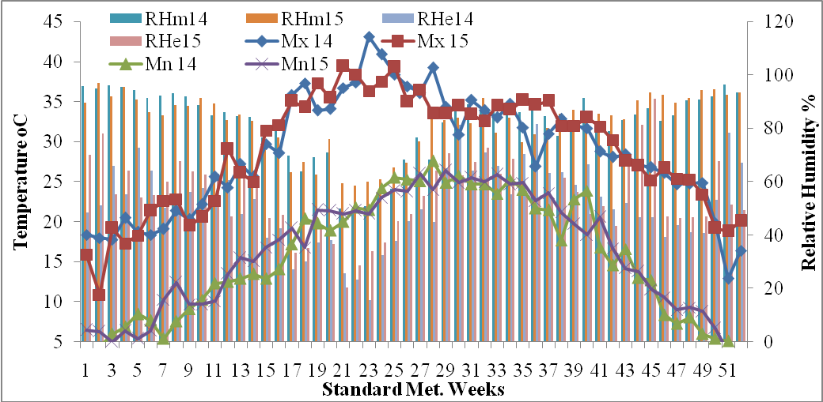
Fig. 1: Temperature and relative humidity recorded during crop growing period (2014 & 2015)

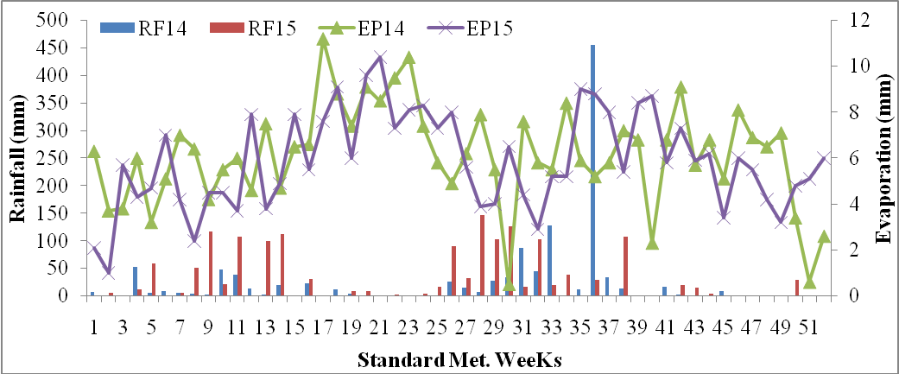
Fig. 2: Rainfall and evaporation recorded during crop growing period (2014 & 2015)

Table1: Correlation between weather parameter and physiological aspect of kinnow mandarin at phenological stage during crop growing period 2013-14 and 2014-15
Climatic factors | Pre-flowering stage (K₁) |  |  | Flowering to first fruit set (K₂) |  |  | First fruit set to maximum fruit set (K₃) |  |  | Maximum fruit set to fruit harvest (K₄)
Climatic factors | Chlorophyll | RL  WC | LWC | Chlorophyll | RLWC | LWC | Chlorophyll | RL  WC | LWC | Chlorophyll | RLWC | LWC
Tmax | 0.69* | 0.71* | 0.61 | 0.23 | 0.19 | 0.28 | 0.71* | 0.75* | 0.64 | -0.22 | -0.18 | -0.33
Tmin | 0.72* | 0.73* | 0.65 | 0.56 | 0.52 | 0.57 | 0.77* | 0.80** | 0.70* | -0.80** | -0.76* | -0.85**
RH 1 | 0.72* | 0.73* | 0.64 | -0.16 | -0.19 | -0.07 | -0.11 | -0.10 | -0.07 | 0.68* | 0.70* | 0.56
RH 2 | 0.73* | 0.74* | 0.67 | -0.12 | -0.15 | -0.04 | 0.07 | 0.12 | -0.02 | 0.31 | 0.35 | 0.16
RF | 0.56 | 0.58 | 0.58 | -0.33 | -0.34 | -0.32 | -0.76* | -0.77* | - 0.84** | -0.79* | -0.81** | -0.73*
EV | 0.60 | 0.60 | 0.47 | 0.87** | 0.83** | 0.84** | 0.82** | 0.85** | 0.77* | -0.73* | -0.71* | -0.79*
*Significant at p<0.05
** Significant at p<0.001

Table2: Correlation between weather parameter and quality of kinnow mandarin at fruit growth stage during crop growing period 2013-14 and 2014-15

Climatic factors |  | First fruit set to maximum fruit set (K₃) |  |  |  |  |  |  |  | Maximum fruit set to fruit harvest (K₄)
Climatic factors | Total sugar |  | Reducing Sugar | NonReducing Sugar | Acidity | Vitamin C | Total Phenol | Total Flavonoid | Total sugar |  | Reducing Sugar | Non-Reducing Sugar | Acidity | Vitamin C | Total Phenol | Total Flavonoid
Tmax | 0.77* |  | 0.71* | 0.75* | -0.63 | 0.69* | -0.73* | -0.67 | 0.09 |  | 0.05 | 0.26 | 0.23 | -0.17 | 0.07 | 0.06
Tmin | 0.81** |  | 0.76* | 0.77* | -0.70* | 0.75* | -0.79* | -0.73* | -0.56 |  | -0.61 | -0.24 | 0.82** | -0.79* | 0.70* | 0.69*
RH 1 | -0.03 |  | 0.01 | -0.15 | 0.14 | -0.10 | 0.11 | 0.14 | 0.86** |  | 0.85** | 0.74* | -0.69* | 0.73* | -0.77* | -0.76*
RH 2 | 0.25 |  | 0.15 | 0.47 | 0.04 | 0.04 | -0.13 | -0.06 | 0.63 |  | 0.59 | 0.66 | -0.31 | 0.38 | -0.44 | -0.43
RF | -0.57 |  | -0.62 | -0.20 | 0.78* | -0.77* | 0.70* | 0.68* | -0.84** |  | -0.81** | -0.74* | 0.73* | -0.78* | 0.85** | 0.82**
EV | 0.83** |  | 0.78* | 0.76* | -0.76* | 0.80* | -0.83** | -0.77* | -0.52 |  | -0.57 | -0.21 | 0.76* | -0.73* | 0.63 | 0.62
*Significant at p<0.05
** Significant at p<0.001

