Bioconversion of banana pseudostem into value added bio manure
Abstract:
Banana pseudostem, an abundant by-product of banana cultivation, is nutrient-rich yet often discarded, leading to environmental challenges. This study investigated the bioconversion of banana pseudostem into value-added bio-manure through aerobic heap composting over 60 days, using seven treatment combinations with cow dung, vegetable waste, paddy straw, and a biomineralizer. Physicochemical parameters (pH, EC, organic carbon, nitrogen, phosphorus, potassium, sodium, and C:N ratio) and microbial populations (bacteria, fungi, actinomycetes) were monitored at 15-day intervals. Results revealed that enriched treatments—particularly banana pseudostem with vegetable waste, cow dung, and biomineralizer (T5), and banana pseudostem with paddy straw, cow dung, and biomineralizer (T7)—achieved optimal compost maturity, with final C:N ratios of 16:1 and 15:1, high nutrient concentrations (up to 0.90% N, 0.34% P, 2.41% K), and significantly elevated microbial counts. Organic carbon declined markedly, while pH and EC rose to levels favorable for soil application. ). Evaluation of compost maturity and stability through phytotoxicity bioassay and humification analysis confirmed that the enriched composts were agriculturally safe. Germination index values exceeded 80% in co-composted treatments, whereas the control (banana pseudostem alone) recorded only 55%, indicating incomplete stabilization. The findings demonstrate that strategic co-composting of banana pseudostem with complementary substrates and microbial inoculants produces stable, nutrient-rich compost, offering an eco-friendly alternative to synthetic fertilizers, reducing waste, and promoting sustainable agriculture.
Keywords: Banana pseudostem; Composting; Bio-manure; Agricultural waste; Organic fertilizer

I.INTRODUCTION
Banana (Musa spp.) is one of the most widely cultivated fruit crops in the world, especially in tropical and subtropical regions. The cultivation of banana generates a substantial amount of biomass waste, particularly in the form of pseudostems, which are the non-woody, fleshy stalks that support the plant. Typically, after the harvest of the banana bunch, the pseudostem is discarded as agricultural waste, contributing to environmental concerns and resource underutilization. Banana pseudostem is rich in organic matter, moisture, and essential plant nutrients such as nitrogen (N), phosphorus (P), potassium (K), and micronutrients, making it an excellent raw material for composting.
Composting is a sustainable, eco-friendly method of converting such biodegradable waste into a valuable soil amendment that enhances soil fertility, improves microbial activity, and supports plant growth. The transformation of banana pseudostem into compost not only reduces organic waste but also contributes to circular agriculture by recycling nutrients back into the soil. The process of composting banana pseudostem involves controlled biological decomposition, often enhanced by adding cow dung, paddy straw, or bio-mineralizers to accelerate the breakdown. Over time, the fibrous material transforms into a dark, crumbly compost rich in humus and beneficial microbes. This compost not only improves soil health by enhancing its structure and aeration but also supports the growth of crops by slowly releasing nutrients in a plant-available form. Research has demonstrated its potential to improve soil structure, water retention, and crop yield while reducing the ecological footprint of banana cultivation and waste management.
The present study, conducted at the Tamil Nadu Agricultural University (TNAU), Coimbatore, focuses on the bioconversion of banana pseudostem into value-added bio-manure through different composting combinations. Seven treatments were formulated, varying in co-substrates (vegetable waste, paddy straw) and additives (cow dung, biomineralizer), and composting was carried out using the heap method. Over a 60-day period, changes in physiochemical parameters (pH, EC, organic carbon, N, P, K, Na, C:N ratio) and microbial populations (bacteria, fungi, actinomycetes) were monitored to evaluate decomposition progress and compost maturity.
II MATERIALS AND METHODS

2.1 Composting Experiment
The experiment was conducted at Tamil Nadu Agricultural University, Coimbatore. Seven treatments were set up using combinations of banana pseudostem, cow dung, vegetable waste, paddy straw, and a biomineralizer (Table 1). The Composting was carried out using the Heap method which allows effective microbial degradation of organic matter. The materials were sun dried and chopped into 3 to 5cm pieces in the shredder to facilitate faster decomposition. The heap composting method used in this study is supported by earlier work by Kalemelawa et al. (2012) and Islam et al. (2021), who highlighted its effectiveness in retaining microbial activity and facilitating nutrient mineralization during decomposition. Compost heaps were maintained at 60–65% moisture, turned periodically, and allowed to decompose for 60 days.

Table 1 Treatment details

Treatments | Composition
T₁ | Banana pseudostem (Control)
T₂ | Banana pseudostem + Cow dung
T₃ | Banana pseudostem + Cow dung + Biomineralizer
T₄ | Banana pseudostem + Vegetable waste + Cow dung
T₅ | Banana pseudostem + Vegetable waste + Cow dung + Biomineralizer
T₆ | Banana pseudostem + Paddy straw + Cow dung
T₇ | Banana pseudostem + Paddy straw + Cow dung + Biomineralizer

2.2 Sampling and analysis
Samples were collected at regular intervals: 15th, 30th, 45th and 60th days for analysis (Fig 3.3) from each treatment.
    - Physicochemical Analysis
pH, electrical conductivity (EC), organic carbon (Walkley and Black), total nitrogen (Kjeldahl), total phosphorus (colorimetric), potassium and sodium (flame photometry).
2.2.2 Microbial Enumeration
Colony counts for bacteria, fungi, and actinomycetes using selective media.
2.3 Compost Maturity
Assessed via C:N ratio, germination index (using Lepidium sativum), and humification index (humic/fulvic acid)

III RESULTS AND DISCUSIION

3.1 Initial Characteristics of Raw Materials
The raw materials used for composting banana pseudostem, cow dung, paddy straw, and vegetable waste—exhibited distinct physiochemical profiles relevant to the composting process (Table 2). Banana pseudostem and paddy straw were characterized by high moisture content and C:N ratios (68:1 and 69:1, respectively), while cow dung and vegetable waste offered lower C:N ratios (30:1 and 26:1) and higher nitrogen content, essential for balancing the compost substrate. The pH ranged from mildly acidic in vegetable waste (5.8) to near neutral in cow dung (7.2). Notably, banana pseudostem was a substantial source of potassium (2.05%) but relatively poor in nitrogen (0.62%) and phosphorus (0.18%).

3.2 Physiochemical changes in the banana pseudostem compost during composting
3.2.1. pH
Across all treatments, the pH increased over time, a trend attributed to the decomposition of organic acids and generation of ammonia from protein breakdown. Initial values ranged from 6.80 to 7.10 (day 15), reaching 7.10-7.72 by day 60. The highest pH was observed in T7 (banana pseudostem + paddy straw + cow dung + biomineralizer, 7.72). Biomineralizer-amended treatments (T3, T5, T7) consistently showed higher pH compared to their non-biomineralizer counterparts, underlining enhanced microbial activity and organic matter stabilization with microbial addition (Table 3.).

3.2.2. Electrical Conductivity (EC)
The EC values increased in all treatments as the compost matured, with most pronounced increases in treatments containing both co-substrates and biomineralizer. The control (T1) showed only a marginal EC increase (1.20 to 1.26dS/m), reflecting slow nutrient mineralization. In contrast, T7 recorded the highest EC (2.52 dS/m at day 60), denoting greater release of soluble mineral nutrients. Biomineralizer intensified this effect, confirming its role in accelerating organic matter transformation and making nutrients more plant-available (Table 4).

3.2.3. Organic Carbon

Organic carbon serves as the primary energy source for microorganisms during composting, and its reduction reflects the progress of decomposition and stabilization. In this study, a sharp decline in OC was recorded across all treatments over the 60-day period. The control (T1: pseudostem alone) retained a relatively high final carbon content of 29.6%, suggesting slow decomposition due to lack of readily available nitrogen sources. In contrast, co-composted treatments showed significantly lower OC levels, ranging between 16–17% in T5 (pseudostem + vegetable waste + cow dung + biomineralizer) and T7 (pseudostem + paddy straw + cow dung + biomineralizer).The marked reduction in OC in enriched treatments is attributable to the synergistic action of cow dung, vegetable waste, and biomineralizer, which enhanced microbial activity and accelerated degradation of lignocellulosic material. This observation aligns with Islam et al. (2021), who reported that co-substrate addition provides balanced nutrients, stimulating microbial metabolism and efficient carbon mineralization. Thus, a lower OC percentage in the enriched composts indicates advanced stabilization and a shift from labile to recalcitrant organic matter (Table 5).

3.2.4. Macronutrients – N,P,K,Na
      - Total Nitrogen
Nitrogen dynamics during composting are influenced by microbial assimilation and mineralization processes. In the present study, the nitrogen content of composts increased substantially in treatments with organic additives. The control maintained a low nitrogen value of 0.45%, indicative of minimal enrichment. In contrast, T5 and T7 recorded nitrogen contents of approximately 0.90%, nearly double the control. The higher N levels in these treatments can be attributed to the addition of cow dung and vegetable/paddy residues, which provided both microbial inocula and readily available nitrogen sources. Moreover, the biomineralizer further facilitated ammonification and nitrification processes, improving nitrogen availability. These results are comparable to those of Parmar et al. (2019), who reported higher nitrogen enrichment in banana pseudostem composts inoculated with microbial consortia (Table 6).
3.2.4.2 Total Phosphorus
Phosphorus availability improved significantly in co-composted treatments compared to the control. Final phosphorus content in enriched treatments (T5 and T7) was 0.33–0.34%, while the control had only 0.18%. This increase is due to solubilization of insoluble phosphorus compounds by microbial activity, particularly phosphobacteria present in the biomineralizer. The role of microbial inoculation in enhancing phosphorus solubilization has been highlighted by Verma et al. (2024), who reported similar improvements in composts inoculated with Pseudomonas and Saccharomyces strains. Enhanced phosphorus content in the enriched composts of this study indicates improved potential for supporting root growth and energy transfer in plants when applied to soils (Table 7).
3.2.4.3 Total Potassium
Potassium was the most abundant macronutrient observed, as banana pseudostem inherently contains high K levels. Final potassium content was 1.56% in the control, while enriched treatments T5 and T7 reached 2.40–2.41%. This enrichment is beneficial for crops, particularly those requiring high potassium for flowering and fruiting. The higher potassium levels in enriched treatments are attributed to accelerated breakdown of pseudostem tissues facilitated by microbial activity and co-substrate addition, which released bound potassium into plant-available forms. These findings are consistent with those of Khatua et al. (2018), who observed higher potassium concentrations in banana stem vermicompost blended with cow dung (Table 8).
3.2.4.4 Total Sodium
Sodium content remained stable or decreased slightly in most amended treatments, reaching a minimum (0.10%) in T4, T5, T6, and T7 by day 60. Lower sodium is beneficial for compost quality, reducing the risk of soil salinization upon field application (Table 9).

3.2.5. C:N ratio
The C:N ratio is a critical index of compost maturity. At the start of the process, all treatments exhibited wide ratios due to the high initial carbon content of banana pseudostem. Over time, the ratio narrowed as organic carbon decreased and nitrogen mineralized. The control (T1) recorded a final C:N ratio of 38.6, reflecting poor compost maturity and limited microbial decomposition. On the other hand, enriched treatments demonstrated remarkable narrowing of the ratio, with final values around 18–20 in T5 and T7. Such values fall within the recommended range for mature compost, signifying stable organic matter and readiness for agricultural application. The improvement in C:N ratio in enriched treatments is consistent with findings by Virk et al. (2021), who observed that co-composting banana residues with nutrient-rich inputs accelerates nitrogen retention and humification. Hence, the narrow C:N ratio achieved in this study highlights the efficiency of co-substrates and biomineralizer in producing agronomically safe compost (Table 10).

  - Microbial population
3.3.1 Bacterial Population
Bacteria were the most dominant microbial group throughout composting. Their population increased rapidly in the early stages, driven by the availability of easily degradable organic matter, and stabilized toward the end of the process. Enriched treatments (particularly T5 and T7) consistently recorded the highest bacterial counts, indicating the synergistic effect of cow dung, vegetable/paddy residues, and biomineralizer in stimulating microbial proliferation. The control (T1), in contrast, showed lower bacterial density due to limited nutrient diversity in banana pseudostem alone. This supports earlier findings by Parmar et al. (2019), who observed that microbial consortia combined with organic amendments significantly enhanced bacterial activity and accelerated compost maturity. The strong bacterial activity in enriched treatments also correlates with the rapid reduction in organic carbon and narrowing of the C:N ratio observed in this study (Table 11.).
3.3.2 Fungal Population (Table 12)
Fungal populations exhibited a progressive increase in enriched treatments, reflecting their critical role in degrading complex lignocellulosic materials such as cellulose and hemicellulose present in banana pseudostem. Treatments with biomineralizer (T3, T5, T7) displayed the highest fungal densities, suggesting that inoculation encouraged the proliferation of lignolytic and cellulolytic fungi. The control maintained relatively low fungal populations, indicating that pseudostem alone provided limited support for fungal activity. Similar results were reported by Khatua et al. (2018), where vermicomposting of banana stem with cow dung promoted fungal dominance and effective breakdown of fibrous residues. The enhanced fungal activity in this study contributed to improved humification and compost maturity.
3.3.3 Actinomycetes population
Actinomycetes play a vital role in the later stages of composting, decomposing resistant organic compounds and contributing to the earthy smell characteristic of mature compost. Their population gradually increased as composting progressed, peaking in enriched treatments (T5 and T7) toward the end of the 60-day period. This reflects their preference for stabilized substrates and higher pH levels achieved during maturation.The control treatment showed poor actinomycete growth, again highlighting limited substrate availability. The results are in line with observations by Islam et al. (2021), who demonstrated that co-composting with organic amendments enhances actinomycete abundance, leading to higher compost stability. Their activity in enriched treatments of the present study corresponds with favorable HA/FA ratios (>1.5), confirming their role in humification (Table 13).
  - Final characteristics of banana pseudostem compost with various treatments
At the end of 60 days, clear differences emerged between the control and enriched treatments. The control compost (T1) was immature, with high organic carbon (29.6%), low nitrogen (0.45%), phosphorus (0.18%), potassium (1.56%), wide C:N ratio (38.6), and slightly alkaline pH (7.8). In contrast, enriched treatments, especially T5 and T7, produced stable and nutrient-rich compost with desirable physicochemical properties: balanced pH (7.1–7.3), low OC (16–17%), high nitrogen (~0.90%), phosphorus (~0.34%), potassium (~2.40%), and narrow C:N ratio (~18). These values conform to internationally accepted standards for mature compost (Rukmana et al., 2024), establishing the efficacy of co-substrates and biomineralizer in producing high-quality bio-manure from banana pseudostem (Table 14).

3.5. Compost maturity test

3.5.1 Phytotoxicity assessment
Non-amended control (T1) had poor GI (55%), indicating phytotoxicity and immaturity. All enriched treatments achieved GI >80%, confirming seedling safety and compost maturity (Table 15).
    - Humification parameters
Both Humic acid and fulvic acid increased significantly in biomineralizer-amended treatments, HA/FA ratios exceeded 1.5 (up to 1.77 in T5), demonstrating the formation of stable humic substances and high-qualitycompost (Table 16).
Table 2 Initial characteristics of different waste
Property | Banana pseudostem | Cow dung | Paddy straw | Vegetable waste
pH | 6.5 | 7.2 | 6.1 | 5.8
EC (dS/m) | 1.0 | 1.3 | 0.6 | 1.4
Organic carbon(%) | 23.2 | 22.2 | 38.6 | 29.8
Total N (%) | 0.62 | 2.5 | 0.41 | 0.87
C:N ratio | 68:1 | 30:1 | 69:1 | 26:1
Total P (%) | 0.18 | 1.8 | 0.09 | 0.22
Total k (%) | 2.05 | 0.85 | 1.15 | 1.45
Sodium (%) | 0.16 | 0.10 | 0.07 | 0.19
Bacteria (×10⁶ CFU/g) | 17 | 29 | 12 | 32
Fungi ( ×10⁴ CFU/g) | 8 | 10 | 6 | 12
Actinomycetes (×10³ CFU/g) | 1 | 2 | 1 | 1

Table 3. Effect of treatments on pH at different periods of composting
Treatments | pH |  |  |  | Mean
Treatments | Sampling period (days) |  |  |  | Mean
Treatments | 15 | 30 | 45 | 60 | Mean
T₁ | 6.80 | 7.00 | 7.10 | 7.10 | 7.10
T₂ | 6.85 | 7.18 | 7.25 | 7.36 | 7.16
T₃ | 6.92 | 7.10 | 7.34 | 7.45 | 7.20
T₄ | 6.95 | 7.18 | 7.35 | 7.50 | 7.25
T₅ | 7.02 | 7.20 | 7.44 | 7.57 | 7.31
T₆ | 7.05 | 7.28 | 7.50 | 7.65 | 7.37
T₇ | 7.10 | 7.35 | 7.54 | 7.72 | 7.43
Mean | 6.95 | 7.00 | 7.32 | 7.47 | 7.18
SEd | 0.0767 | 0.1059 | 0.1519 | 0.1456 | -
CD (0.05) | 0.1710 | 0.2361 | 0.3387 | 0.3248 | -

Table 4 Effect of treatments on EC at different periods of composting
Treatments | EC (dS/m) |  |  |  | Mean
Treatments | Sampling period (days) |  |  |  | Mean
Treatments | 15 | 30 | 45 | 60 | Mean
T₁ | 1.20 | 1.22 | 1.23 | 1.26 | 1.23
T₂ | 1.30 | 1.53 | 1.75 | 2.00 | 1.65
T₃ | 1.33 | 1.65 | 1.87 | 2.01 | 1.72
T₄ | 1.50 | 1.68 | 1.91 | 2.20 | 1.82
T₅ | 1.62 | 1.83 | 2.07 | 2.33 | 1.96
T₆ | 1.70 | 1.95 | 2.17 | 2.40 | 2.05
T₇ | 1.82 | 2.03 | 2.27 | 2.52 | 2.16
Mean | 1.50 | 1.69 | 1.90 | 2.10 | 1.80
SEd | 0.1622 | 0.1938 | 0.2434 | 0.2962 | -
CD (0.05) | 0.3616 | 0.4321 | 0.5428 | 0.6606 | -

Table 5 Effect of treatments on Organic Carbon at different periods of composting
Treatments | Organic Carbon (%) |  |  |  | Mean
Treatments | Sampling period (days) |  |  |  | Mean
Treatments | 15 | 30 | 45 | 60 | Mean
T₁ | 25.1 | 23.9 | 22.4 | 22.4 | 23.45
T₂ | 28.8 | 26.4 | 21.1 | 17.0 | 23.32
T₃ | 27.6 | 25.1 | 21.7 | 16.5 | 22.72
T₄ | 28.2 | 25.7 | 22.3 | 16.0 | 23.05
T₅ | 27.0 | 24.4 | 21.0 | 16.2 | 22.15
T₆ | 27.0 | 23.6 | 20.2 | 17.1 | 21.97
T₇ | 28.7 | 24.3 | 21.9 | 16.7 | 22.90
Mean | 27.48 | 24.77 | 21.51 | 17.41 | 22.79
SEd | 0.9077 | 0.7138 | 0.5589 | 1.5797 | -
CD (0.05) | 2.0243 | 1.5917 | 1.2467 | 3.5229 | -

Table 6 Effect of treatments on Total Nitrogen content at different periods of composting
Treatments | Total Nitrogen (%) |  |  |  | Mean
Treatments | Sampling period (days) |  |  |  | Mean
Treatments | 15 | 30 | 45 | 60 | Mean
T₁ | 0.54 | 0.55 | 0.56 | 0.58 | 0.56
T₂ | 0.60 | 0.62 | 0.69 | 0.88 | 0.67
T₃ | 0.62 | 0.65 | 0.68 | 0.85 | 0.68
T₄ | 0.61 | 0.63 | 0.72 | 0.83 | 0.70
T₅ | 0.63 | 0.66 | 0.76 | 0.90 | 0.73
T₆ | 0.58 | 0.60 | 0.70 | 0.88 | 0.66
T₇ | 0.60 | 0.63 | 0.68 | 0.90 | 0.70
Mean | 0.60 | 0.62 | 0.68 | 0.83 | 0.68
SEd | 0.0211 | 0.0258 | 0.0435 | 0.08046 | -
CD (0.05) | 0.0471 | 0.0576 | 0.0971 | 0.179426 | -

Table 7. Effect of treatments on Total Phosphorous content at different periods of composting
Treatments | Total Phosphorous (%) |  |  |  | Mean
Treatments | Sampling period (days) |  |  |  | Mean
Treatments | 15 | 30 | 45 | 60 | Mean
T₁ | 0.18 | 0.20 | 0.20 | 0.21 | 0.19
T₂ | 0.20 | 0.22 | 0.24 | 0.25 | 0.22
T₃ | 0.21 | 0.23 | 0.26 | 0.28 | 0.24
T₄ | 0.23 | 0.26 | 0.30 | 0.32 | 0.28
T₅ | 0.25 | 0.28 | 0.31 | 0.33 | 0.29
T₆ | 0.23 | 0.27 | 0.30 | 0.32 | 0.28
T₇ | 0.24 | 0.27 | 0.31 | 0.34 | 0.29
Mean | 0.22 | 0.25 | 0.27 | 0.26 | 0.26
SEd | 0.0173 | 0.0215 | 0.0300 | 0.0341 | -
CD (0.05) | 0.0386 | 0.0479 | 0.0668 | 0.0760 | -

Table 8 Effect of treatments on Total Potassium content at different periods of composting
Treatments | Total Potassium (%) |  |  |  | Mean
Treatments | Sampling period (days) |  |  |  | Mean
Treatments | 15 | 30 | 45 | 60 | Mean
T₁ | 2.04 | 2.07 | 2.07 | 2.10 | 2.07
T₂ | 2.10 | 2.15 | 2.18 | 2.18 | 2.15
T₃ | 2.13 | 2.18 | 2.20 | 2.22 | 2.18
T₄ | 2.14 | 2.22 | 2.28 | 2.38 | 2.25
T₅ | 2.16 | 2.26 | 2.35 | 2.40 | 2.29
T₆ | 2.15 | 2.24 | 2.33 | 2.37 | 2.27
T₇ | 2.15 | 2.25 | 2.34 | 2.41 | 2.28
Mean | 2.12 | 2.19 | 2.25 | 2.29 | 2.21
SEd | 0.0296 | 0.0548 | 0.0809 | 0.1002 | -
CD (0.05) | 0.0661 | 0.1223 | 0.1803 | 0.2233 | -

Table 9 Effect of treatments on Total Sodium content at different periods of composting
Treatments | Na (%) |  |  |  | Mean
Treatments | Sampling period (days) |  |  |  | Mean
Treatments | 15 | 30 | 45 | 60 | Mean
T₁ | 0.16 | 0.16 | 0.16 | 0.16 | 0.16
T₂ | 0.15 | 0.14 | 0.13 | 0.13 | 0.14
T₃ | 0.14 | 0.13 | 0.12 | 0.12 | 0.13
T₄ | 0.13 | 0.12 | 0.11 | 0.10 | 0.12
T₅ | 0.12 | 0.11 | 0.10 | 0.10 | 0.11
T₆ | 0.13 | 0.12 | 0.11 | 0.10 | 0.12
T₇ | 0.13 | 0.12 | 0.11 | 0.10 | 0.12
Mean | 0.14 | 0.13 | 0.12 | 0.12 | 0.13
SEd | 0.0098 | 0.0119 | 0.0141 | 0.0163 | -
CD (0.05) | 0.0218 | 0.0264 | 0.0315 | 0.0363 | -

Table 10 Effect of treatments on Organic Carbon at different periods of composting
Treatments | Organic Carbon (%) |  |  |  | Mean
Treatments | Sampling period (days) |  |  |  | Mean
Treatments | 15 | 30 | 45 | 60 | Mean
T₁ | 25.1 | 23.9 | 22.4 | 22.4 | 23.45
T₂ | 28.8 | 26.4 | 21.1 | 17.0 | 23.32
T₃ | 27.6 | 25.1 | 21.7 | 16.5 | 22.72
T₄ | 28.2 | 25.7 | 22.3 | 16.0 | 23.05
T₅ | 27.0 | 24.4 | 21.0 | 16.2 | 22.15
T₆ | 27.0 | 23.6 | 20.2 | 17.1 | 21.97
T₇ | 28.7 | 24.3 | 21.9 | 16.7 | 22.90
Mean | 27.48 | 24.77 | 21.51 | 17.41 | 22.79
SEd | 0.9077 | 0.7138 | 0.5589 | 1.5797 | -
CD (0.05) | 2.0243 | 1.5917 | 1.2467 | 3.5229 | -

Table 11. Effect of treatments on Bacterial population at different periods of composting
Treatments | Bacterial population (×10⁶ CFU/g) |  |  |  | Mean
Treatments | Sampling period (days) |  |  |  | Mean
Treatments | 15 | 30 | 45 | 60 | Mean
T₁ | 18 | 19 | 17 | 17 | 17.75
T₂ | 24 | 28 | 26 | 22 | 25.00
T₃ | 26 | 30 | 28 | 23 | 26.75
T₄ | 28 | 34 | 29 | 24 | 28.75
T₅ | 30 | 36 | 31 | 23 | 30.00
T₆ | 28 | 34 | 29 | 25 | 29.00
T₇ | 29 | 35 | 28 | 21 | 28.25
Mean | 26.14 | 30.71 | 35.57 | 38.85 | 32.81
SEd | 2.8991 | 4.4481 | 6.0099 | 6.9626 | -
CD (0.05) | 6.4650 | 9.9193 | 4.1147 | 6.4649 | -

Table 12 Effect of treatments on Fungal population at different periods of composting
Treatments | Fungal population (×10⁴ CFU/g) |  |  |  | Mean
Treatments | Sampling period (days) |  |  |  | Mean
Treatments | 15 | 30 | 45 | 60 | Mean
T₁ | 8 | 9 | 8 | 7 | 8.00
T₂ | 12 | 16 | 13 | 11 | 13.00
T₃ | 13 | 18 | 14 | 12 | 14.25
T₄ | 14 | 22 | 18 | 13 | 16.75
T₅ | 15 | 24 | 16 | 10 | 16.25
T₆ | 14 | 21 | 15 | 12 | 15.50
T₇ | 15 | 23 | 17 | 11 | 16.50
Mean | 13 | 19 | 14.42 | 10.85 | 14.31
SEd | 1.7320 | 3.6968 | 2.3401 | 1.3801 | -
CD (0.05) | 3.8624 | 8.2439 | 5.2184 | 3.0776 | -

Table 13 Effect of treatments on Actinomycertes population at different periods of composting
Treatments | Actinomycetes population (×10³ CFU/g) |  |  |  | Mean
Treatments | Sampling period (days) |  |  |  | Mean
Treatments | 15 | 30 | 45 | 60 | Mean
T₁ | 2 | 3 | 4 | 3 | 3.0
T₂ | 2 | 8 | 5 | 3 | 4.5
T₃ | 2 | 8 | 6 | 2 | 4.5
T₄ | 2 | 9 | 6 | 4 | 5.2
T₅ | 3 | 9 | 7 | 2 | 5.2
T₆ | 2 | 8 | 6 | 2 | 4.5
T₇ | 3 | 9 | 5 | 3 | 5.0
Mean | 3.0 | 7.7 | 6 | 3.2 | 5.0
SEd | 1.5811 | 1.5118 | 0.9128 | 1.2724 | -
CD (0.05) | 3.5259 | 3.3714 | 2.0357 | 2.8374 | -

Table 14 Final characteristics of banana pseudostem compost with various treatments
Parameters | Treatments
Parameters | T₁ | T₂ | T₃ | T₄ | T₅ | T₆ | T₇
pH | 6.92 | 7.36 | 7.45 | 7.50 | 7.57 | 7.65 | 7.72
EC (dS/m) | 1.26 | 2.00 | 2.01 | 2.20 | 2.33 | 2.40 | 2.52
Organic carbon(%) | 22.4 | 17.0 | 16.5 | 16.0 | 16.2 | 17.1 | 16.7
Total N (%) | 0.58 | 0.88 | 0.85 | 0.83 | 0.90 | 0.88 | 0.90
C:N ratio | 38.62 | 19.32 | 19.41 | 19.28 | 18.00 | 19.43 | 18.56
Total P (%) | 0.21 | 0.25 | 0.28 | 0.32 | 0.33 | 0.32 | 0.34
Total k (%) | 2.10 | 2.18 | 2.22 | 2.38 | 2.40 | 2.37 | 2.41
Sodium (%) | 0.16 | 0.13 | 0.12 | 0.10 | 0.10 | 0.10 | 0.10
Bacteria (×10⁶ CFU/g) | 17 | 22 | 23 | 24 | 23 | 25 | 21
Fungi ( ×10⁴ CFU/g) | 7 | 11 | 12 | 13 | 10 | 12 | 11
Actinomycetes (×10³ CFU/g) | 3 | 3 | 2 | 4 | 2 | 2 | 3

Table 15 Germination percentage and germination index (GI %) of banana pseudostem compost under different treatments
Treatments | Germination percentage(%) | Germination index (%)
T₁ | 42 | 55
T₂ | 91 | 82
T₃ | 92 | 81
T₄ | 93 | 83
T₅ | 95 | 84
T₆ | 93 | 83
T₇ | 94 | 84
Mean | 85.71 | 78.85
SEd | 3.8483 | 1.3972
CD (0.05) | 8.5817 | 3.1159

Table 16. Humification parameters of banana pseudostem compost under different treatments
Treatments | Humic acid (HA) (%) | Fulvic acid (FA)  (%) | HA/FA ratio
T₁ | 8 | 9 | 0.89
T₂ | 17 | 10 | 1.70
T₃ | 20 | 12 | 1.67
T₄ | 18 | 11 | 1.64
T₅ | 23 | 13 | 1.77
T₆ | 19 | 12 | 1.58
T₇ | 25 | 15 | 1.67
Mean | 18.57 | 11.71 | 1.56
SEd | 3.8483 | 1.3972 | 0.2128
CD (0.05) | 8.5817 | 3.1159 | 0.4746

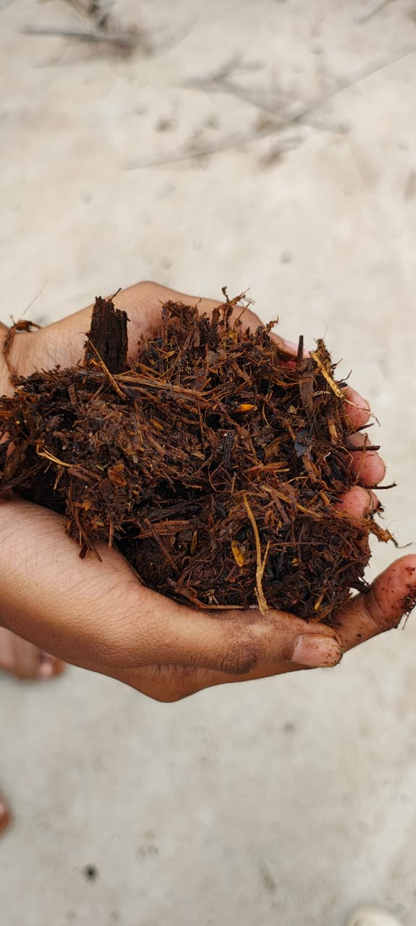

Fig 1. Observation of Treatment-1 (Control) at 60th day

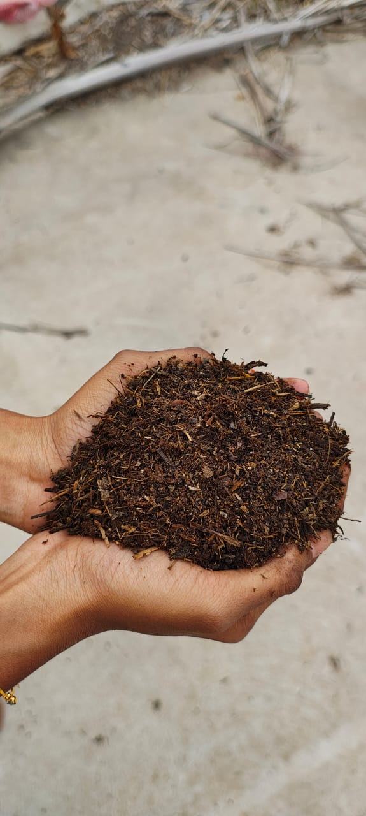

Fig 2. Observation of Treatment-2(Banana pseudostem + Cow dung) at 60th day

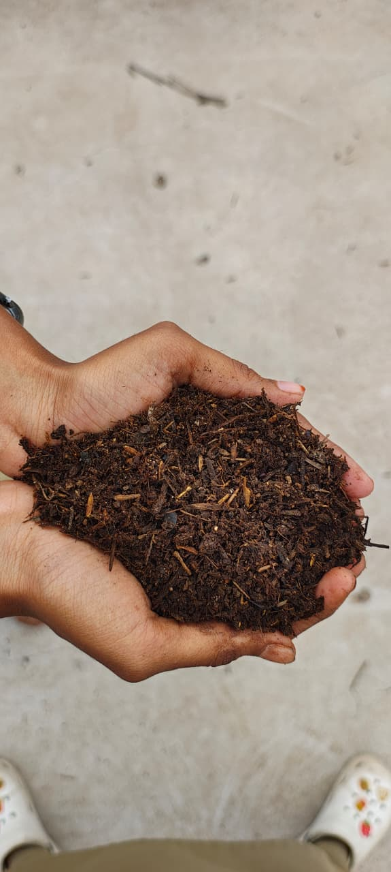

Fig 3. Observation of Treatment-3(Banana pseudostem + Cowdung + Biomineralizer) at 60th day

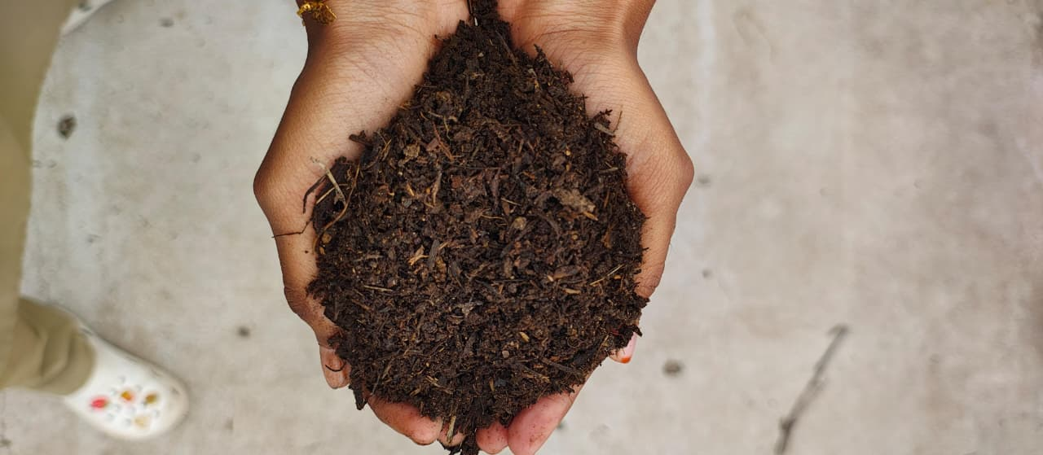

Figure 4. Observation of Treatment-4(Banana pseudostem +Vegettable waste + Cowdung) at 60th day

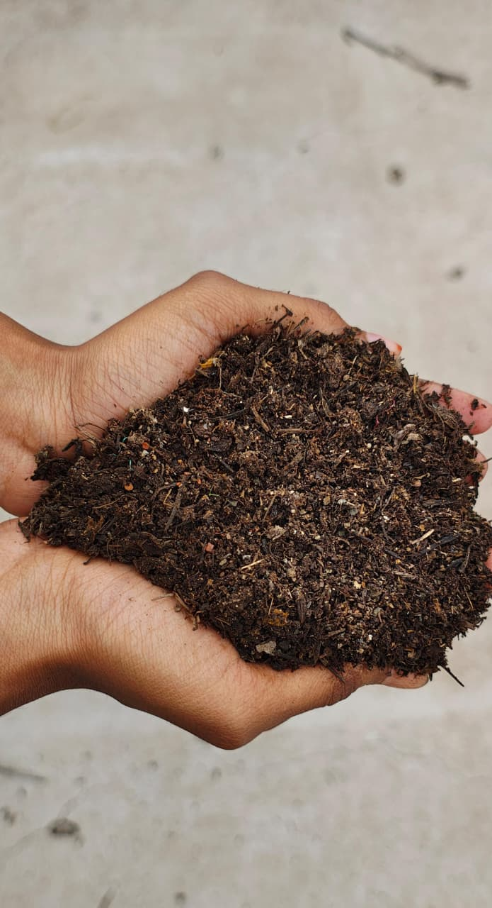

Figure 5. Observation of Treatment-5(Banana pseudostem +Vegetable waste + Cowdung + Biomineralizer) at 60th day

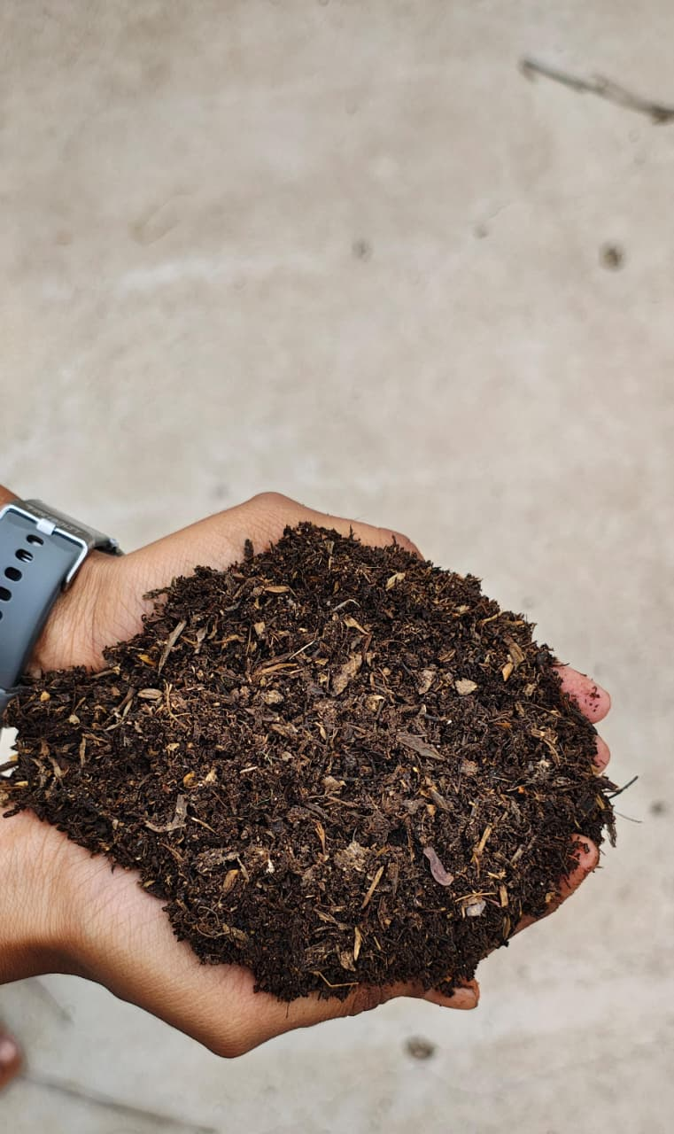

Fig 6- Observation of Treatment-6(Banana pseudostem + Paddy straw + Cowdung + ) at 60th day

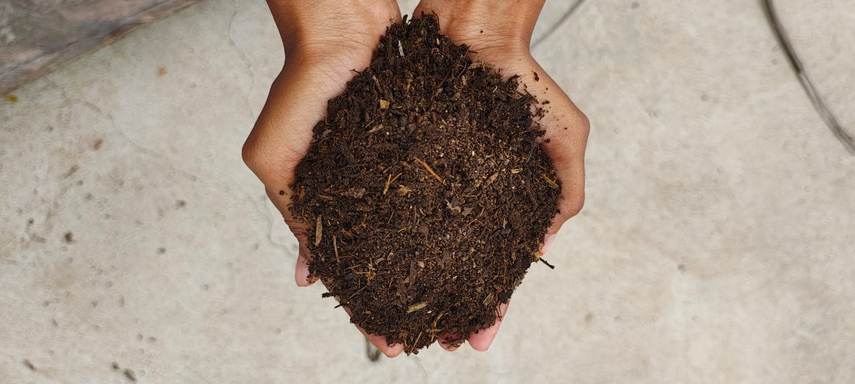

Fig 7. Observation of Treatment-6(Banana pseudostem + Paddy straw + Cowdung + Biomineralizer) at 60th day

IV CONCLUSION
The present study on the bioconversion of banana pseudostem into value-added bio-manure through composting revealed that banana pseudostem, though underutilized as waste, possesses high potential as an organic fertilizer when co-composted with other biodegradable materials and microbial inoculants.
Among the seven treatments evaluated, Treatment 1 (Control: Banana pseudostem alone) showed negligible changes in all physical, chemical, and microbial parameters, indicating very slow decomposition and minimal composting activity. This highlights that banana pseudostem alone is not sufficient to achieve effective composting within 60 days.
Conversely, Treatments supplemented with cow dung, vegetable waste, paddy straw, and biomineralizers (T2 to T7) exhibited progressively better decomposition, nutrient enrichment, and microbial proliferation. Notably: Treatment 5 (Banana pseudostem + Vegetable waste + Cow dung + Biomineralizer) and Treatment 7 (Banana pseudostem + Paddy straw + Cow dung + Biomineralizer)
were the most effective treatments, demonstrating:
- Significant reduction in organic carbon
- Optimal C:N ratios (18:1 and 17:1 respectively), indicating mature and stable compost
- Higher concentrations of nutrients, especially nitrogen (up to 0.85%), phosphorus (up to 0.34%), and potassium (up to 2.41%)
- Enhanced microbial populations across bacteria, fungi, and actinomycetes, essential for nutrient cycling and soil health
- Improved pH and EC values, favorable for plant growth and soil application
The presence of biomineralizers played a pivotal role in accelerating decomposition, enhancing nutrient mineralization, and boosting microbial activity. Treatment 5 (Banana pseudostem + Vegetable waste + Cow dung + Biomineralizer) and Treatment 7(Banana pseudostem + Paddy straw + Cow dung + Biomineralizer) emerged as the best-performing treatment, producing a well-balanced, nutrient-rich compost suitable for use in sustainable and organic agriculture. It achieved near-ideal compost characteristics in just 60 days, making it a practical and eco-friendly solution for managing banana pseudostem waste. The incorporation of maturity indicators (phytotoxicity test and humification index) validated that the composts were non-toxic, stable, and agriculturally safe for soil application within 60 days.
The study clearly demonstrates that banana pseudostem, though a recalcitrant biomass, can be efficiently composted through strategic enhancement using microbial consortia and nutrient-rich additives. The optimized treatments not only accelerated decomposition but also resulted in nutrient-enriched compost suitable for agricultural application. Therefore, adopting such composting strategies offers a sustainable solution for managing banana waste while promoting organic agriculture.

DISCLAIMER (ARTIFICIAL INTELLIGENCE): Author(s) hereby declare that NO generative AI technologies such as Large Language Models (ChatGPT, COPILOT, etc) and text-to-image generators have been used during writing or editing of this manuscript.

REFERENCES
Abro, S.A., Pathan, S.A., Tunio, S.D., et al. (2019). Enrichment of compost from banana leaves with sugarcane press mud, goat manure and poultry manure for improved fertility. Journal of Basic and Applied Sciences, 15, 59–67.
Emaga, T.H., Andrianaivo, R.H., Wathelet, B., Tchango, J.T., & Paquot, M. (2007). Effects of the stage of maturation and varieties on the chemical composition of banana and plantain peels. Food Chemistry, 103(2), 590–600.
ElNour, I.A., Ibrahim, I.S., & Elamin, A.W.M. (2015). Effect of banana plant waste compost on the growth and yield of sorghum (Sorghum bicolor L. Moench). International Journal of Agriculture Innovations and Research, 4(1), 83–88.
Falcon, M.A., Valero, F., Esteban, E., & Gadea, E. (1987). Study of the microbial population of a soil treated with olive mill wastewater. International Biodeterioration, 23(4), 283–294.
Formowitz, B., Elango, F., Okumoto, S., Müller, T., & Buerkert, A. (2007). The role of “Effective Microorganisms” in the composting of banana residues. Journal of Plant Nutrition and Soil Science, 170(5), 649–656.
Gajendra Kumar Rana, P., & Sharma, S. (2018). Value addition of banana pseudostem and peel for bioethanol, biodegradable plastics, and bioremediation. International Journal of Recycling of Organic Waste in Agriculture, 7(4), 319–329.
Ghutke, T.D., Bhalerao, V.P., Mendhe, A.R., & Kadam, R.G. (2024). Composting of banana pseudostem with organic wastes and microbial inoculants for nutrient enrichment. International Journal of Environmental Sciences, 15(2), 112–120.
Islam, M.S., Rahman, M.M., & Uddin, M.E. (2021). Co-composting of banana pseudostem, mushroom media waste and chicken manure for nutrient-rich organic fertilizer. Journal of Environmental Management, 286, 112212.
Jackson, M.L. (1973). Soil Chemical Analysis. Prentice Hall of India Pvt. Ltd., New Delhi.
Jabbour, R., Nasreddine, S., & Hajj, H. (2024). Valorization of banana peels for compost and biodegradable plastic production: Environmental and economic perspectives. Waste and Biomass Valorization, 15, 987–999.
Kalemelawa, F., Nishihara, E., Endo, T., et al. (2012). Evaluation of compost maturity, stability and phytotoxicity during the composting of banana peels, poultry manure and wood shavings. African Journal of Biotechnology, 11(94), 16071–16078.
Khatua, C., Ghosh, S., & Chattopadhyay, G.N. (2018). Vermicomposting of banana stem waste blended with cow dung: Quality assessment by chemical and spectroscopic analysis. Bioresource Technology Reports, 3, 87–94.
Kumar, R., & Rajkumar, D. (2019). Banana pseudostem compost: A potential organic manure for sustainable agriculture. International Journal of Chemical Studies, 7(3), 504–508.
Li, X., Tock, R.W., & Mohapatra, D. (2010). Banana pseudostem as a source of cellulose for papermaking and composites. Industrial Crops and Products, 31(2), 233–238.
Mawahib, M.E., ElNour, I.A., & Ibrahim, I.S. (2015). Impact of banana residues compost on sorghum productivity in greenhouse conditions. Sudan Journal of Agricultural Research, 25, 39–46.
Mohapatra, D., Mishra, S., & Sutar, N. (2010). Banana and its by-product utilization: An overview. Journal of Scientific and Industrial Research, 69, 323–329.
Munishamanna, M., & Raghavendra, B. (2020). Banana pseudostem utilization for fiber, juice, and compost production. Agricultural Reviews, 41(4), 345–352.
Nurhayati Abdullah, N., Sulaiman, F., & Abdullah, N. (2014). Characterization of banana pseudostem and fruit-bunch-stem as a potential renewable energy source. BioResources, 9(1), 7–23.
Padam, B.S., Tin, H.S., Chye, F.Y., & Abdullah, M.I. (2012). Banana by-products: An under-utilized renewable food biomass with great potential. Journal of Food Science and Technology, 51(12), 3527–3545.
Parmar, D.K., Thakur, R.K., & Singh, J. (2019). Effect of microbial consortia on vermicomposting of banana pseudostem blended with cow dung. International Journal of Recycling of Organic Waste in Agriculture, 8(1), 117–126.
Phirke, N.V., Patil, A.S., & Deotale, R.D. (2001). Solid state fermentation of banana pseudostem for use as organic manure in banana cultivation. PKV Research Journal, 25(1), 49–51.
Piper, C.S. (1966). Soil and Plant Analysis. Hans Publishers, Bombay.
Rukmana, H., Sutanto, R., & Wibowo, H. (2024). Nutrient content and compliance of banana stem compost with Indonesian organic fertilizer standards. International Journal of Agronomy, 2024, 1–8.
Someya, S., Yoshiki, Y., & Okubo, K. (2002). Antioxidant compounds from banana (Musa cavendish) fruit peel. Food Chemistry, 79(3), 351–354.
Suganthi, S., & Kavitha, M. (2022). Utilization of banana spathe compost and extracts for enhancing rice growth and yield. Journal of Pharmacognosy and Phytochemistry, 11(3), 278–284.
Teshome, T. (2022). Effect of banana peel compost on growth and yield of Swiss chard (Beta vulgaris L.). International Journal of Horticulture and Agriculture, 7(3), 77–84.
Ultra, V.U., Nakagawa-Izumi, A., & Ohsumi, T. (2005). Utilization of banana pseudostem in manure and animal feed production. Japan Agricultural Research Quarterly, 39(4), 269–274.
Verma, R., Singh, P., & Meena, R.K. (2024). Effect of microbial inoculants on nutrient content of banana waste compost and spinach growth. Environmental Technology & Innovation, 33, 103024

