Review Article
Unearthing rice germplasm, enlightening a new path towards abiotic stress-resilient crop

Abstract
Oryza sativa, the commonly cultivated rice, is one of the most important crops for human consumption, but its production is increasingly threatened by abiotic stresses. Drought challenge is the major abiotic stress to rice grain production under unpredictable, changing environmental conditions. Traits supporting drought resistance are limited in cultivars, while wild rice species represent an important reservoir of useful genes for rice improvement. Although many efforts have resulted in breeding rice varieties that are relatively tolerant of their local environments, climate change and population growth are expected to soon require a new, rapid generation of stress-tolerant rice germplasm, and the current diversity within rice varieties may be not sufficient to meet this need. To achieve rice self-sufficiency by 2050, the development of high-yielding rice varieties with a high degree of tolerance and resistance to drought, salt stress, and other abiotic factors is a prerequisite. This high level of tolerance or resistance can only be achieved through the use of wild rice relatives. In this article, we provide an overview of the wild ancestors, the ecological and genomic diversity of the genus Oryza, and the stress tolerance variation observed in wild Oryza species.

Keywords: - Rice, Abiotic stress, Drought, Wild species

Introduction: -
Rice is an important crop that feeds more than half of the world's population. (Zhang et al., 2006).It is the main source of calories and staple food for more than three billion people worldwide. With the world's population expected to grow to 9.7 billion by 2050 (United Nations, 2019), there is a need to ensure that food production can keep pace with demand. The cause of wide fluctuations in agricultural output is principally climate-related climate-related and diverse abiotic stresses. Stresses can be due to biotic factors such as pest, insect, and disease incidence or abiotic such as flooding, salinity, drought, high temperature, air pollution, mineral deficiency, adverse pH, and heavy metal toxicity, among others (Bhatt and Sharma, 2018).
Abiotic stress in rice is a major concern and an increasing threat to its production when we talk about climate change, population increase, and land degradation. According to recent studies, the chances of Drought, flood, and extreme heat are going to be more frequent in the near future. About 700 million people live in extreme poverty in Asia, of them 30% live in areas prone to abiotic stresses like drought, flooding, and excess soil salinity (Bhowmick et al., 2014). Salinity, Drought, and Heat are major abiotic stresses restricting the efficiency of yield plants.
Now a day’s availability of Irrigation water is very limited and is one of the factors which regulates the yield potential in Rice. (Menguer, Sperotto and Ricachenevsky, 2017). In recent years, drought stress has been witnessed in many parts of the world; breeding drought-tolerant rice has become a priority research project, although numerous efforts to produce drought-tolerant rice have been made around the world. Among the abiotic factors, drought is one of the most devastating and it has been estimated that more than 50% of the world’s arable land will be affected by drought in the year 2050 (Wani and Sah, 2014). Drought a major abiotic stress is one of the most devastating environmental stress factors for rice. Rice plants are highly sensitive to drought stress because it is acclimated to either rain-fed or fully irrigated conditions. The vegetative phase is the most sensitive phase to drought resulting in reduced height, tiller number, and leaf area. (Menguer, Sperotto and Ricachenevsky, 2017). It is already predicted that for every 1º c rise in daily temperature, the rice yields would get reduced by 10% (Peng et al., 2004). Feeding such a large population is a very difficult task, given there is a constant change in the environment leading to many abiotic stresses.
Rice is the cereal that is most susceptible to salt stress out of all the plants. Saltiness reduces development rate, including cell and leaf extension, number of tillers, and photosynthesis, and can prompt untimely senescence of older leaves. Osmotic stress, which is caused by salt in the soil, or ionic stress, which is the harmful effect of Na+ accumulation in plant tissues, can have negative effects on plants. (Prodjinoto, Gandonou and Lutts, 2018). When Na+ levels reach toxic levels and plant leaf cells compartmentalize salt to reduce damage, tissue tolerance or Na+ exclusion from xylem vessels is used to deal with ionic stress tolerance.
One important approach to meet these challenges is to use Crop Wild relatives (CWRs) as a source of useful new traits through breeding and biotechnology. CWR are reservoirs for many new genes that are not present in cultivated species but are lost during selection and domestication. At the moment, only the gene pool of crop progenitor species contains these valuable genes. As there are about 24 known species within the Oryza genus, a large source of genetic material remains virtually untapped. It is relatively difficult to harness desirable genes through genetic recombination, and many undesirable genes are introduced from the wild parents, resulting in inferior yields, undesirable plant architecture, and/or poor grain quality. (Tanksley and McCouch, 1997). As a result, wild species are frequently not included as parental lines in cultivar development. However, research has demonstrated that wild species possess genomic components that may result in genetic enhancements of agronomic performance.
As a result of rapid advancements in molecular technologies, accessions can be studied in depth faster, and a larger number of accessions can be used to enhance introgression's efficiency and accuracy. The identification of molecular markers associated with desirable traits in wild species and the transfer of these traits into elite lines and/or cultivars are two new possibilities made possible by these advancements. In this article, we are going to illustrate the feasibility of using rice wild relatives as a source for abiotic stress tolerance in O. sativa.

Phylogeny of Genus Oryza
Genus Oryza consists of 24 species (22 wild + 2 cultivated). Based on their genome they characterized 10 groups of the following combination AA, BB, CC, BBCC, CCDD, EE, FF, GG, HHJJ, and KKLL. Out of 22 wild four are tetraploid, remaining 18 and the two cultivated are diploid. Of the two cultivated species, O. sativa (2n = 24, AA), more commonly referred to as "Asian rice," produces high yields and is grown all over the world, whereas O. glaberrima (2n = 24, AA), more commonly referred to as "African rice," produces low yields and is grown in a small portion of West Africa (Mondal and Henry, 2018). Further, the O. sativa is partitioned into three significant geological races: javanica, indica, and japonica (Balu) The plant's ability to adapt to a variety of climatic and environmental conditions is made possible by the genus's extensive genetic diversity. However, habitat destruction, climate change, and the use of genetically homogeneous, high-yielding modern varieties are destroying this genus's genetic diversity. Notably, gene banks contain a significant amount of conserved diversity that is extremely rich and impressive.
There are more than 132,000 available accessions maintained at the International Rice Gene bank, as of December 2019 (CGIAR genebanks, 2012-2021). This includes rice cultivars, wild relatives, and genera-related species. The gene bank contains the world's largest collection of rice genetic diversity. Nations from everywhere the world send their rice to IRRI for safety's sake, and for sharing with the normal public great. Similarly National gene bank of India situated at NBPGR has 1,17,550 accessions to cultivated rice and 367 accessions of O. rufipogon and 792 accessions of O. nivara (Base collection in NGB, ICAR-NBPGR, 2023).
The wild species are grass-like plants that are shattering in nature. They are weedy and have inferior morphological characteristics such as growth habit, height, flowering, leaf size, a poor plant type, poor grain characteristics, and low grain yield. Despite their weedy nature, these wild species are important genetic resources of useful genes/QTLs for tolerance to major biotic (diseases, insects), abiotic (drought, salinity, heat), yield-related traits like weed-competitive ability, new source of cytoplasmic male sterility (CMS), and other traits related to rice improvement.
Oryza probably started as a wild grass in Gondwanaland, the supercontinent that split up and became Asia, Africa, the Americas, Australia, and Antarctica at least 130 million years ago. Four species complexes have been identified within the genus Oryza: 1) the sativa complex; 2) the officinalis complex; 3) the meyeriana complex; and 4) the ridleyi complex. O. schlechteri and O. coarctata are placed in an unclassified group.

- O. sativa Complex-A total of 8 diploid species (2n = 24) belonging to AA genome are placed under this complex, of which two are cultivated (O. sativa and O. glaberrima) and six are wild species (O. nivara, O. rufipogon, O. breviligulata, O. longistaminata, O. meridionalis, and O.glumaepatula). The primary gene pool is made up of these species, which can easily cross with rice, which is commonly used to transfer genes into rice cultivars.

- O. officinalis Complex- There are 12 species under this complex: 6 diploid and 6 allotetraploid species (O. schweinfurthiana, O. minuta, O. malampuzhaensis, O. latifolia, O. alta, and O. grandiglumis). In Asia, the most widely recognized species is O. officinalis, generally circulated in South and Southeast Asia and South and Southwest China. O. officinalis does best in full sun or partial shade. It is also called bird rice.

- O. ridleyi Complex- Two tetraploid species, (O. ridleyi and O. longiglumis 2n = 48, HHJJ) usually grow in shaded habitats beside rivers, streams, or pools are placed in this complex. The O.ridleyi complex is primarily found in Southeast Asia (Cambodia, Malaysia, Myanmar) and New Guinea. Recently, a new diploid species, O. neocaledonica, has been included in this complex.

- O. meyeriana Complex- Small, unbranched panicles with small spikelets distinguish O. meyeriana complex species from the other three complexes (O. sativa, O. officinalis, and O. ridleyi). There are two species in this complex O. meyeriana and O. granulata, 2n = 24, GG. While O. meyeriana can be found in Southeast Asia, O. granulata can be found in South Asia, Southeast Asia, and Southwest China.

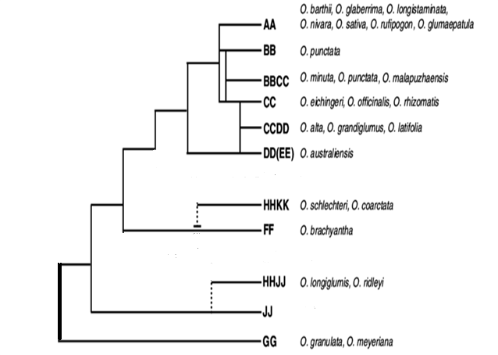

Fig 1: - Phylogenetic tree of the Genus (Ge et al., 1999)

Unclassified Complex-
- O. schlechteri: A tetraploid species (2n = 48, HHKK) which is widely distributed in Indonesia (Irian Jaya) and Papua New Guinea. A species that can grow either under full or partial shade.
- O. coarctata: It is also a tetraploid species commonly found in coastal areas of South Asia having 2n = 48 and a genome of KKLL. Due to having genes for salt tolerance, changes in the morphology have occurred, developing rough, erect leaves, and glands to secrete salts. So, it can survive in brackish waters (Mondal and Henry, 2018).

Table-1: Genetic Composition, chromosome number, Distribution, and useful traits along with QTLs – an extended version of the table resented by (Mondal and Henry, 2018)

Species | 2n | Genome | Distribution | Useful traits for abiotic stress | Genes/  QTLs | References
O. sativa complex
O. glaberrima Steud. | 24 | A^{g}A^{g} | West Africa | tolerance to drought, acidity, iron toxicity; salinity | OsHKT1;5  (salinity) | (Platten, Egdane and Ismail, 2013)
O. rufipogon Griff. | 24 | AA | Tropical and sub-tropical Asia | tolerance to aluminum and soil acidity | qSDT12-2  (drought) | (Luo et al., 2019)
O. breviligulata (O.barthii) | 24 | A^{g}A^{g} | Africa | drought avoidance
O. meridionalis | 24 | A^{I}A^{I} | Africa | drought avoidance
O. longistaminata | 24 | A^{m}A^{m} | Tropical Australia | drought avoidance | qDWR8.1  (drought) | (Huang et al., 2022)
O. officinalis complex
O. rhizomatis | 24 | CC | Sri Lanka | drought avoidance
O. australiensis Domin. | 24 | EE | Tropical Australia | salinity tolerance
O. brachyantha | 24 | FF | Australia | Tolerance to laterite soils
O. meyeriana complex
O. granulata | 24 | GG | South and South East Asia | Shade Tolerance, Adaptation to aerobic soil
O. meyeriana | 24 | GG | South East Asia | Shade Tolerance, Adaptation to aerobic soil
Unclassified
O. coarctata | 48 | KKLL | South Asia | Salt tolerance | NHX1 | (Bansal et al., 2021)
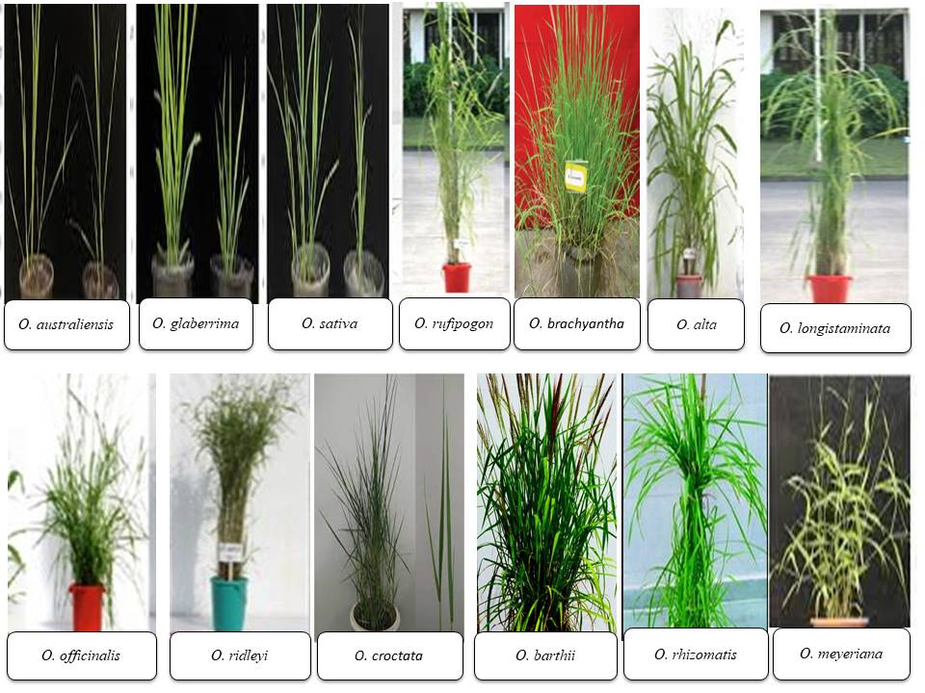
Fig 2: - Collection of Accessions that can be used as a source for various stresses

Donors for Drought Resistance
Drought is the greatest threat to agricultural food production, particularly to the cultivation of rice, a semiaquatic crop. Different stages of plant development are affected by drought tolerance, which is a complicated quantitative trait with a complicated phenotype. Rice is considered one of the most drought-sensitive plants due to its small root system, thin cuticular wax, and rapid stomata closure. In a rain-fed ecosystem, drought is one of the most devastating abiotic stresses for rice, reducing crop yield by up to 50%. Nearly every year, 34 million hectares (Mha) of lowland rice and 8 Mha of upland rice in Asia are affected by varying degrees of drought stress, including 13.6 Mha in India alone. (Neelam et al., 2018).
Four major ecosystems are generally recognized: irrigated (55%), rain-fed lowland (25%), upland (12%), and flood-prone (8%) (Thanh et al., 2006). The largest stretches of upland rice are grown in Brazil and West Africa. Significant upland areas can still be found in India, Indonesia, and Laos. In the upland rice areas of South and Southeast Asia that are either highly drought-prone or drought-prone, more than 8.5 million ha of rice are currently grown (Herdt, 1991). The solution can be pictured as beginning with adjustments to agronomic management and farm-level water management. Ideally, the task of creating new rice varieties adapted to limited water-limited conditions would proceed with drought stress. Genetic variability of resistance to drought stress is limited in the cultivated germplasm while wild species offer useful sources of genes for drought avoidance such as O. australiensis, O. breviligulata, O. glaberrima, O. longistaminata, O. meridionalis, O. nivara and O. rhizomatis (Thanh et al., 2006).
Leaf rolling and leaf drying are two essential characteristics that can be used to intuitively determine a plant's drought tolerance. (Sahebi et al., 2018). Leaf rolling is one of the dry season aversion systems to forestall water deficiencies during dry spell pressure. Leaf rolling during stress reduces the leaf surface exposure to sunlight energy and decreases transpiration leading to the closure of stomata so that gaseous exchange and CO₂ entry into cells are reduced and photosynthesis is decreased. Stomatal closure, gas exchange, transpiration, and photosynthesis are affected by this abiotic stress, which also affects plant water balance by reducing total water content, turgor, and water content. Drought tolerance in plants is a complex trait that is influenced by numerous physiological and biochemical traits. Genotypes with cuticular resistance, early stomatal closure, leaf roll elasticity, deep, coarse roots with high branching and penetration ability, and a higher root-to-shoot ratio are cited as components of drought avoidance.
There are several mechanisms of adaptation to drought in rice
(a) Drought escape - ability to complete the life cycle
(b) Drought avoidance - ability to maintain high water potential
(c) Drought tolerance - the ability to survive, grow, and produce seed.
Of these three adaptive mechanisms, only drought tolerance allows the plant to grow and produce seeds efficiently. Drought tolerance is defined as the plant's tolerance to minimum moisture content in the cytoplasm at a water content of ~23% or ~0.3 g of fresh or dry tissue. Mechanisms of drought tolerance include cellular adaptations, physiological acclimation, and morphological adaptations controlled at various stages by genetic factors. (Sahebi et al., 2018). Cellular adaptations for drought tolerance include increased chlorophyll content, lower osmotic potential, and higher harvest index. Our wild varieties are a very rich source of these genes that give current varieties their drought tolerance. Of these wild varieties, O. glaberrima is the most widely used.
In the effort to achieve rice self-sufficiency by 2050, the development of high-yielding rice varieties with a high degree of tolerance and resistance to drought is a prerequisite. (Oladosu et al., 2019). This high level of tolerance or resistance can only be achieved by using wild relatives of rice.

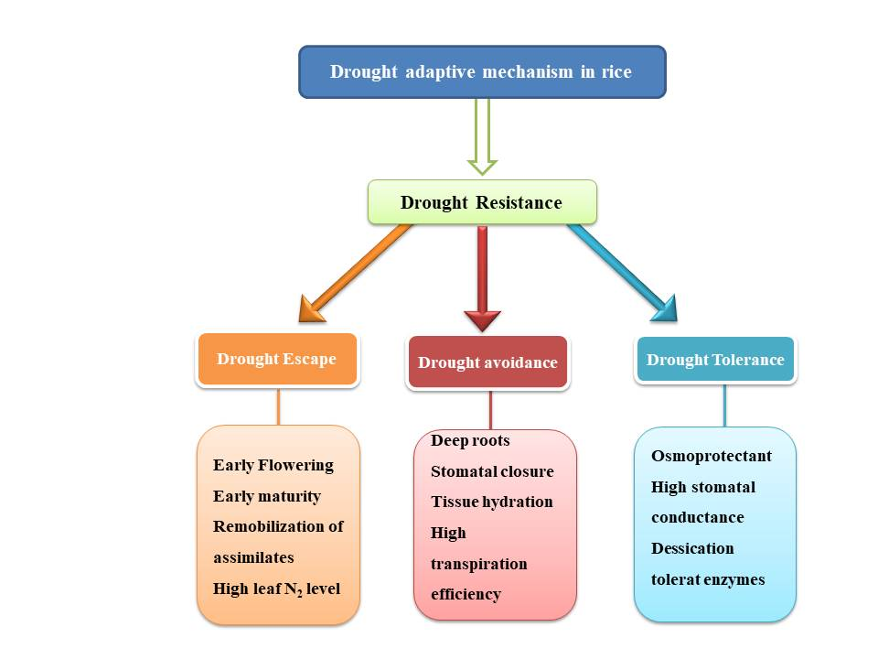

Fig 3: -Drought adaptive mechanism in rice

Effects of Drought stress on rice
- The primary effects of drought stress are stunted germination and decreased growth. Due to a lack of water, severe stunting of seedling germination and growth is observed.
- Drought stress can affect water balance, metabolic processes at the cell level, membrane transport impairment, and decreased ATP production and respiration.
- Under water stress, root growth characteristics exhibit a wide range of responses. An increase in the concentration of abscisic acid in the roots caused an increase in the length of rice roots under drought stress (Jaleel et al., 2009).
- Osmoregulation is a significant cycle in plants, and the diminishing in turgor leads to the amassing of Osmo-protectants. Under water deficiency, various osmolytes like proline, soluble sugar, phenolic, and total free amino acids accumulate, which is important for plants' drought tolerance (Nguyen, Babu and Blum, 1997).
- Under drought conditions the proline accumulation increases as against well-watered conditions in rice cultivars.
- Reactive oxygen species (ROS) are a natural byproduct of aerobic metabolism. However, a wide range of biotic and abiotic stresses frequently lead to an excessive production of ROS, which causes cell damage and plant death. ROS are produced in various parts of the cytosol during respiration and photosynthesis (Sahebi et al., 2018). ROS production rises to an excessive level when unfavorable conditions are present because mitochondrial and chloroplast electron transport chains undergo an excessive reduction.

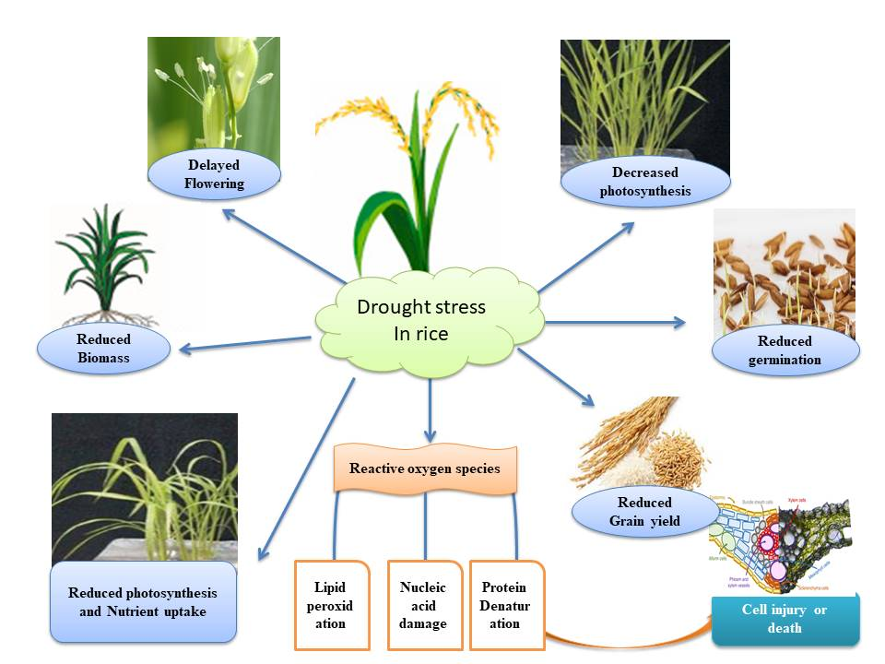
Fig 4: - Various physiological and morphological effects of Drought stress in rice

Oryza glaberrima, which is part of the primary gene pool of cultivated rice, is a source of readily available diversity for rice improvement. It thrives very well in a variety of harsh environments, such as rain-fed hills, floating conditions in deep waters, drought, and other environments, and has many useful traits, such as competitive ability against weeds, drought tolerance, and the ability to respond to low inputs (Sarla and Swamy, 2005). O.glaberrima has several mechanisms to escape drought, such as the ability to mature early and synchronize maturity at the end of the rainy season. In addition to these characteristics, it also has the ability to recover quickly from moisture due to its thinner leaves and roots. The thin leaves curl up quickly to retain water, and the thin roots penetrate effectively to extract water and nutrients. These characteristics can be successfully transferred to cultivated rice. Of the O. glaberrima accessions tested for drought tolerance, 217 were moderately resistant and 32 were highly resistant to drought(Sarla and Swamy, 2005).
Drought stress did not significantly reduce soil and plant analysis values of O. glaberrima genotypes, but there was a large reduction in cultivars of O. sativa (Awala et al., 2010). Among different genotypes One of the genotypes of O. glaberrima, RAM12, was able to increase the SPAD value under water stress conditions (Feng et al., 2012).
Some O. glaberrima cultivars, namely TOG 5691, TOG 6679, and TOG 5591, were found more resistant to drought and gave higher yields than the resistant control cultivars (Ndjiondjop et al., 2012). Many research studies also show that specific leaf area and specific leaf weight were maintained in O.glaberrima genotypes under water stress conditions, while lower specific leaf area was observed in sativa genotypes. These O.glaberrima genotypes can be used in interspecific crosses with cultivated rice. All these genes or QTLs need to be identified and used as a source of drought-resistance genes for cultivated rice.

Oryza long staminate, a distant wild relative found only in Africa, is agronomically inferior but has several useful traits that can be transferred to cultivated varieties. These traits include strong rhizomes, vigorous biomass, drought avoidance mechanism, good weed suppression ability, and also efficient nitrogen utilization. Oryza long staminatelong staminate has already made a significant contribution to rice improvement programs in Asia and Africa. Oryza long staminatelong staminate appears to be a potential source of new alleles that can be used to provide drought relief to cultivated rice varieties. Of 126 accessions of O. long staminatelong staminate examined, 4 show tolerance to water stress. Greater membrane stability, stomatal conductance, and leaf elongation, as well as higher root mass in deeper soil layers, were also observed in O. rufipogon and O. long staminate accessions compared to O. sativa under water deficit. (Neelam et al., 2018).
QTL mapping through BIL lines of O.langistaminata has found stronger drought tolerance than O.sativa in the respective specific traits. ChromosomesChromosomes 1, 7, 8, and 9 have been found to harbor multiple QTLs Related to drought stress. They also identified qDWR8.1 as the drought resistance locus of O.longistaminata that contributes most to drought resistance. Upon further analysis, the qDWR8.1 locus has six ORFs, including three functional and three hypothetical genes. A unique allele MH08g0242800, annotated as an ATP-dependent proteolytic subunit of Clp protease, was finally selected as a candidate gene for drought. In addition, six BIL lines (BIL 1702, 1704, 1728, 1732, 1742, 1776) were identified that showed stronger resistance in the two experiments performed. (Huang et al., 2022).
To improve the utilization of O. long staminate genetic resources for rice improvement, concerted efforts need to be made worldwide to systematically characterize and evaluate O. long staminate collections held in various national gene banks. This will help identify accessions with new traits and thus increase their value to rice breeders.
One of the most studied wild species; Oryza rufipogon is naturally perennial and frequently occurs in aquatic environments in East and South Asia. It is a photoperiodic plant, usually flowering from September to November. It is also known as O.balunga or O.perennis and is a true diploid. Although the underlying mechanisms of Dongxiang wild rice's drought resistance remain a mystery, the cultivar exhibits a high degree of drought resistance.
A large number of DEGs (differentially expressed gene) were identified; and several key pathways, including those for RNA transport, mRNA surveillance, secondary metabolite biosynthesis, and plant hormone signal transduction, and different cycles, including endopeptidase inhibitor action, serine-type endopeptidase inhibitor action, iron particle restricting, and electron transporter movement were distinguished as engaged with drought resistance(J. Zhang et al., 2017).
To date, only 12 quantitative trait loci (QTLs) associated with drought stress have been discovered in O. rufipogon. Of these QTLs, qSDT12-2 on chromosome 12 proved to be the most important quantitative trait locus associated with drought stress in O. rufipogon. Several populations such as BILs, NILs, RILs, and CSSLs have already been developed from crosses between O. rufipogon and O. sativa as a pre-breeding resource (Luo et al., 2019). Leaf extension was particularly sensitive to stress in the O. rufipogon accession Nagesa18, dropping by 30% relative to the control after only 4 days without water, and by 60% after 10 d. Accessions of O. Longis Aminata (SL313-13, WOL2-2) one accession of O. rufipogon (Ulanpur18) and some upland-rice varieties maintained extension rates of 60– 70% of the control up to 6 days of water exclusion (Liu, Lafitte and Guan, 2004). Scientists at Punjab Agriculture University have already initiated the. The transfer of drought tolerance from the identified O.rufipogon (IRGC 89006, IRGC 106433) and O. long staminate (IRGC92619A) accessions to elite rice cultivars PR121 and PR122 (Neelam et al., 2018).

Oryza meridionalis is an AA genome species cultivated in Northern Australia. By Phylogenetic analysis, we can conclude that this is the most distant of the AA genome species from cultivated rice (Oryza sativa). This makes this wild species a crucible heritable resource for rice improvement. Research studies claimed that after 4 hours of heat, the Leaf Expansion Rate (LER) of O.sativa was halved but leaf growth wasn't at all affected in O.meridionalis (Thanh et al., 2006).. Heat continued for 24 hours at 45ºC causing a 91% drop in the LER of O. sativa but only a 47% decline in O.meridionalis. Numerous papers claim that the proteins associated with the dark reaction of photosynthesis increase during the case of heat stress. The large isoform of Rubisco actives (RCAI) increased in relative abundance more than any other protein, while the small isoform of Rubisco actives (RCAII) was found in multiple spots that both increased.
If appropriate screening methods can be found to identify such alleles, rice breeders may be able to access the genetic variability for useful traits in perennial wild relatives of rice, and incorporate valuable traits into cultivated varieties.

Donors for salinity
Over 100 countries of the world cultivate rice which occupies an area of more than 150 million hectares; However, a significant number of these agricultural areas are already or are at risk of becoming salinized in some way (Solis et al., 2020). This includes a huge number of hectares in South Asia and Southeast Asia that are climatically appropriate for rice production but are left fallow or have low yields because of saline soils. One of the most destructive abiotic stresses on rice is salinity, and salt-affected soils make up about 20% of the paddy rice planting area at the moment. For agriculture, soil salinization is a worldwide issue. As a result of natural accumulation over long periods, it affects 6% of all land on Earth. Agriculture, on the other hand, contributes to secondary salinization: 2% of all dry land is becoming salinized, and over 20% of irrigated soils are impacted, for the most part on account of water system water containing modest quantities of sodium chloride.
Rice is the most salinity-sensitive species among the cereal, where 3 dSm⁻¹ of saltiness is adequate to cause huge yield loss in most developed accessions. Over 127,000 accessions of cultivated rice and wild relatives have been reported, indicating the widespread availability of numerous rice varieties worldwide (Solis et al., 2020). However, only a small number of these naturally occurring accessions have been examined for traits in saline environments.
Osmotic stress, which is caused by salt in the soil, or ionic stress, which is the harmful effect of Na+ accumulation in plant tissues is the major cause of salinity stress. Compared to osmotic stress, the genetics of ionic stress tolerance are much better understood. The high-affinity potassium transporter (HKT), salt overly sensitive (SOS), and Na+/H+ exchanger (NHX) gene families, among others, were described as being involved in subcellular compartmentalization and reducing Na+ accumulation in shoots. HKT individuals are significant determinants of tissue convergence of Na+. The most important quantitative trait locus (QTL) for salt accumulation in O. sativa genotypes, is OsHKT1;5 (Menguer, Sperotto and Ricachenevsky, 2017).

Although O. sativa's salt tolerance has been extensively studied, little is known about O. glaberrima's salt tolerance levels. Platten et al. measured the Na+ accumulation in several salt-exposed O. glaberrima lines and discovered a particular gene (OgHKT1;5) that plays a role in regulating Na+ absorption and translocation. Several O. sativa cultivars, landraces, and O. glaberrima (AA genome) genotypes were used in a large screening effort to demonstrate a correlation between salinity sensitivity and leaf blade Na+ concentration. The OsHKT1;5 genotype was found to be a significant factor in tolerance: Na+ is less translocated to leave the more active the efflux transporter, which directs the Na+ exclusion from the transpiration stream. These results indicate that O. glaberrima genotypes could exclude Na+ from shoots using a mechanism independent of OsHKT1;5 (Platten, Egdane and Ismail, 2013). Salt resilience is for the most part characterized as the small portion of development under saline circumstances as contrasted and development under non-saline conditions. Breeding salt tolerance cultivars using wild species can help in reducing these stresses. When an accession of O. glaberrima CG14 which is sensitive to salt, but crossing with the O. sativa line WAB56-104 cultivar resulted in hybrids that were highly salt-resistant (Awala et al., 2010). Evaluating for salinity tolerance in O. glaberrima still needs to be explored as the most promising wild cultivar for interspecific crosses with O. sativa.

Oryza rufipogon is ancestral wild rice found in South and Southeast Asia and Northern Australia. Salinity tolerance trait has been reported in this wild rice species. It has been identified 13 QTLs associated with salt tolerance located on chromosomes 1, 2, 3, 6, 7, and 9 in wild rice O. rufipogon (Tian et al., 2011).

Oryza coarctata is a halophytic wild rice species that thrives in the coastal regions of South Asian nations. It can withstand conditions of high saline as well as submergence for a considerable amount of time to the point where any tolerant rice genotype will die. It grows vegetatively and is triploid. O. coarctata is an allotetraploid (KKLL; 2n = 4x = 48) with an expected genome size of 665 Mb. Numerous taxonomists actually place it in the monospecific genus Porteresia because it is morphologically and naturally particular from different species, regardless of biosystematic and phylogenetic examinations showing that its nearest family members are other Oryza species (Bansal et al., 2021).
It has been found that under various salinity stresses, O. coarctata tissue did not differ in its sodium, potassium, calcium, or chloride content, which is probably due to their salt excretion mechanism (Bal and Dutt, 1986). According to the findings of his study, O. coarctata probably does not experience any stress, even at higher salinity levels, due to the distinctive salt hairs that enable them to effectively eliminate toxic elements. Their experiment demonstrates that anatomical research led to the discovery of unique unicellular salt hairs (trichomes) on the adaxial surface of O. coarctata leaves. These distinctive unicellular structures can be found in the creases and are connected to the epidermal cells. It has been seen that ABC carriers are connected with the transport of optional metabolites and Na+/K+ homeostasis that get the reaction against salt pressure (Bansal et al., 2021). DnaK has been linked to cellular morphogenesis and differentiation, whereas CML proteins are thought to be significant Ca2+ sensors and mediate plant stress tolerance in significant ways.
The finding depicting that the water content of O. coarctata was retained at 90% under both normal and salinity stress (Mondal et al., 2018). They have found that there is a positive correlation between leaf sodium and water content because of the presence of efficient membrane channels. They have also found that after 24 hours of salt treatment, the vacuolar Na+/H+ antiporters decreased, indicating that they were regulated diurnally in leaves subjected to salinity stress in the morning. Although Na+/H+ (NHX) antiporters of cultivated rice and O.coarctata are highly similar they perform best in O.coarctata.
Some of the research thesis revealed that to improve salt tolerance, some wild rice genes have been introduced into elite rice varieties. For instance, the novel quality gene PcINO1 encoding L-myoinositol 1-phosphate synthase in wild rice species O. coarctata was introgressed into developed rice O. sativa indica transgenic lines showed developed salt tolerance (Nguyen, 2022).
Compared to other Oryza spp., O.croactata has also the highest development of mechanical tissue that is much stronger. Reduced root-to-shoot translocation, increased compartmentalization in the vacuole, and increased salt hair secretion are some of the ways O. coarctata is able to adapt to environments with high salinity. So, this O. coarctata may serve as a parent plant for the development of superior, salt-resistant rice varieties. The International Rice Research Institute is currently developing salt-tolerant rice cultivars with introgressed O. coarctata traits for salt tolerance.

Australia's wild rice Oryza australiensis is a one-of-a-unique example of the E genome from the genus Oryza. It has rhizomes that allow the crop to well thrive in saline and dry conditions. This makes it an important potential source of novel genes for cultivated rice. The genome of O. australiensis which is assessed to be 965 Mbp is the biggest among the diploid genomes in the genus Oryza. O. australiensis was found to be genetically related to O. coarctata when genetic analysis was done using RAPD and AFLP markers.
According to Thi Thuy Ha Nguyen's research thesis, stressed O. australiensis plants maintained a higher relative water content (RWC) and less cell membrane damage than cultivated rice during salinity stress(Nguyen, 2022). When exposed to 150 mM NaCl, O. australiensis plants maintained a low Na+ concentration in their shoots and roots, as well as a low Na+/K+ ratio in their shoots, in contrast to cultivated rice plants, according to the ion content analysis. Proline which is one of the most common osmolytes that play an important role in osmotic adjustment in rice during osmotic stress was found higher in O. australiensis wild rice within hours after exposure to salt stress, whereas cultivated rice did not show significant proline accumulation. When gene expression analysis is done using qRT-PCR Wild rice O.australiensis showed downregulation of proline degrading gene OsProDH just after 1 hr of exposure to salt stress. It Also revealed that the genes of Proline synthesis i.e. OsP5CS1, OsP5CS2, and OsP5CR also gets activated, while there is an upregulation in the proline degradation gene OsProDH at the early stage of salt exposure in the Salt-sensitive cultivated rice Nipponbare (Nguyen, 2022).
Yoav Yichie et al. in their studies gave proof of the morphological and physiological premise of salt resistance in wild rice O. australiensis and proposed an expected procedure for working on salt resistance in developed rice. Both salt-tolerant Pokkali and an O. australiensis accession (Oa-VR) experienced the least reduction in biomass accumulation, SES score, and chlorophyll content in response to salinity in their experiment. Even in higher salt treatments, the putatively salt-tolerant Oa-VR only suffered minor leaf damage, with a relative senescence increase of less than 40% at 100 mM NaCl (Yichie et al., 2018). The genome of O. australiensis has not yet been mapped. There will be more evidence to support O. australiensis as a potential source for cultivated rice improvement as more data on its genomes and characteristics become available.

Donors for heat tolerance
Heat stress brought about by high-temperature weather conditions truly undermines global food security. To be sure, as a significant food crop on the planet, the yield and quality of rice are regularly impacted by heat stress (Liu et al., 2023). According to the Intergovernmental Panel on Climate Change (IPCC), heat waves are likely to be more intense, more frequent, and last for longer periods. Even though rice is a pantropical grass, it is better suited to high temperatures than other cereals like wheat (Triticum aestivum L.). However, peak temperatures will rise over the next century, posing an abiotic stress to which cultivated rice may not be suited (Scafaro, Haynes and Atwell, 2010). Therefore, it is urgent to determine the molecular basis of heat tolerance and cultivate heat-tolerant rice varieties.
Oryza meridionalis is a wild relative of Oryza sativa L. and can be found in northern Australia, where monsoon temperatures frequently exceed 35 degrees Celsius. By comparing O. meridionalis plants maintained at 27 degrees Celsius to those grown at 45 degrees Celsius, heat tolerance was determined. In contrast to O. sativa ssp. japonica cv. O. meridionalis, Amaroo, could withstand heat. At 27 degrees Celsius, O. sativa's third leaves grew longer than those of O. meridionalis; however, at 45 degrees Celsius, O. meridionalis grew longer than O. sativa. Additionally, they have also found that the Leaf Equivalent Ration (LER) of O. sativa decreased by 91% after 24 hours at 45°C, whereas the LER of O. meridionalis decreased by only 47%. Heat waves can be prevented by the protective proteins chaperone 60 (Cpn60), heat shock protein 70 (HSP70), and heat shock protein 90 (HSP90). In O. meridonalis, heat treatment results in increased gene expression and levels of these proteins (Scafaro, Haynes and Atwell, 2010). Cpn60 is a type of chaperone found in mitochondria and chloroplasts of plants and accepted to promote protein folding. HSP70 and HSP90 have been related with a variety of defensive capabilities including protein refolding, transportation, including protein signaling pathways.
Oryza australiensis, the wild rice of Australia, can also withstand extremely hot days. Analysis of leaf tissues from heat-tolerant wild rice (Oryza australiensis) and compared with with mild adjusted O. sativa supported openness to warm, as well as diurnal heat shock. Even though CO₂ assimilation was faster at 30 °C, O. australiensis leaves had 50% less Rubisco activase per unit Rubisco at 45 °C (Phillips, Scafaro and Atwell, 2022). By contrast, Rubisco activase per unit Rubisco multiplied in O. sativa at 45 °C while CO₂ absorption was slower, mirroring its inferior Rubisco activase thermostability. O. australiensis, in contrast to O. sativa, responded to CO₂ enrichment at 45 °C, indicating the wild rice relative's more robust carboxylation capacity and thermal tolerance. O. australiensis produced more biomass than O. sativa when grown at a high temperature (45 °C) and ambient CO2 (400 ppm) (Phillips, Scafaro and Atwell, 2022). However, while O. sativa experienced severe growth penalties when grown at high temperatures, O. australiensis was more susceptible to low temperatures (25 °C). report no huge decrease in the LER of O. australiensis after 4 h at 45 °C, which was connected to its photosynthetic thermotolerance (Scafaro et al., 2018).
The fact that O. australiensis has consistently outperformed O. sativa when subjected to high temperatures suggests that it has access to the resources necessary to support such growth. These resources include carbon resources that are either generated through photosynthesis or mobilized from stored carbohydrates. The mechanism behind this tolerance to high day temperatures in this heat tolerant species remains unknown. Further ivestigation is needed to transfer these heat stress tolerance qualities to Cultivated rice varieties to manage this heat stress.
. In O. rufipogon Griff, they discovered a stable quantitative trait locus (QTL) for heat tolerance at the heading stage on chromosome 5 (qHTH5). The corresponding gene, HTH5, is a member of the pyridoxal phosphate-binding protein PLPBP (previously known as PROSC) family. It is anticipated that this gene will encode the mitochondrion-localized pyridoxal phosphate homeostasis protein (PLPHP). Rice plants under heat stress at the heading stage with overexpression of HTH5 had a higher rate of seed-setting, whereas plants with suppression of HTH5 were more susceptible to heat stress. (Cao et al., 2022). Further research revealed that by increasing the amount of heat-induced pyridoxal 5'-phosphate (PLP), HTH5 reduces the accumulation of reactive oxygen species at high temperatures. Besides, two SNPs situated in the HTH5 promoter regiont are associated with its expression level and connected with heat resistance diversity. Based on these findings, the novel gene HTH5 may increase rice's tolerance to heat stress and the ongoing threat posed by global warming.

Conclusion and Prospects
A major constraint that restricts global rice productivity is abiotic stress. Due to the effects of climate change and human activity, this stress is rapidly expanding globally over the past few decades. Nevertheless, rice production worldwide significantly decreased as a result of these stresses. In this way, the advancement of developed rice with abiotic stress resistance is expected to settle the production level of rice. The genus's wild rice species are regarded as a useful resource for cultivating rice's stress tolerance. Accessions of wild rice demonstrated a variety of abilities for coping with and recovering from the lack of water, salinity stress as well as heat tolerance. Accessions of wild rice from tropical islands, where the dry season brings high temperatures and little precipitation, appeared to be more resistant to drought than accessions from subtropical regions. The ability of QTLs derived from wild species to effectively improve rice's tolerance to drought and salinity stress points to their great potential for use in the breeding of elite rice varieties. These QTLs either need to be identified or if identified can be used to develop introgression lines in cultivated rice. Even though research on abiotic stress resistance has been happening for quite a long time, not many screenings have been done. A great deal of work actually should be finished by screening various wild genotypes in rice with the goal that in the future yield and quality are kept up for the upcoming generations. It will take more research to create lines that use these wild varieties to produce higher-yielding, higher-quality rice.

Reference
Atwell, B.J., Wang, H. and Scafaro, A.P. (2014) ‘Could abiotic stress tolerance in wild relatives of rice be used to improve Oryza sativa?’, Plant Science, 215, pp. 48–58.
Awala, S.K. et al. (2010) ‘Differential salinity tolerance among Oryza glaberrima, Oryza sativa and their interspecies including NERICA’, Plant Production Science, 13(1), pp. 3–10.
Bal, A.R. and Dutt, S.K. (1986) ‘Mechanism of salt tolerance in wild rice (Oryza coarctata Roxb)’, Plant and soil, 92, pp. 399–404.
Bansal, J. et al. (2021) ‘Draft genome and transcriptome analyses of halophyte rice Oryza coarctata provide resources for salinity and submergence stress response factors’, Physiologia Plantarum, 173(4), pp. 1309–1322.
Base collection in NGB, ICAR-NBPGR (2023). Available at: http://www.nbpgr.ernet.in/Research_Projects/Base_Collection_in_NGB.aspx (Accessed: 31 March 2023).
Bhatt, D. and Sharma, G. (2018) ‘Role of silicon in counteracting abiotic and biotic plant stresses’, IJCS, 6(2), pp. 1434–1442.
Bhowmick, M.K. et al. (2014) ‘Improved management options for submergence-tolerant (Sub1) rice genotype in flood-prone rainfed lowlands of West Bengal’, American Journal of Plant Sciences, 2014.
Cao, Z. et al. (2022) ‘Natural variation of HTH5 from wild rice, Oryza rufipogon Griff., is involved in conferring high‐temperature tolerance at the heading stage’, Plant biotechnology journal, 20(8), p. 1591.
CGIAR genebanks, 2012-2021 (no date). Available at: https://www.genebanks.org/genebanks/irri/ (Accessed: 13 May 2023).
Feng, F. et al. (2012) ‘Assessment of drought resistance among wild rice accessions using a protocol based on single-tiller propagation and PVC-tube cultivation’, Australian Journal of Crop Science, 6(7), pp. 1204–1211.
Ge, S. et al. (1999) ‘Phylogeny of rice genomes with emphasis on origins of allotetraploid species’, Proceedings of the National Academy of Sciences, 96(25), pp. 14400–14405.
Hamzelou, S. et al. (2020) ‘Wild and Cultivated Species of Rice Have Distinctive Proteomic Responses to Drought.’, International journal of molecular sciences, 21(17). Available at: https://doi.org/10.3390/ijms21175980.
Herdt, R.W. (1991) ‘Research priorities for rice biotechnology’, Rice biotechnology, 6, pp. 19–54.
Huang, S. et al. (2022) ‘Favorable QTLs from Oryza longistaminata improve rice drought resistance’, BMC Plant Biology, 22(1), p. 136. Available at: https://doi.org/10.1186/s12870-022-03516-w.
Jaleel, C.A. et al. (2009) ‘Drought stress in plants: a review on morphological characteristics and pigments composition’, Int. J. Agric. Biol, 11(1), pp. 100–105.
Kadam, N.N. et al. (2017) ‘Genetic control of plasticity in root morphology and anatomy of rice in response to water deficit’, Plant physiology, 174(4), pp. 2302–2315.
Liu, H. et al. (2023) ‘Genetic Research Progress: Heat Tolerance in Rice’, International Journal of Molecular Sciences, 24(8), p. 7140.
Liu, L., Lafitte, R. and Guan, D. (2004) ‘Wild Oryza species as potential sources of drought-adaptive traits’, Euphytica, 138, pp. 149–161.
Lu, B. and Ge, S. (2003) ‘Oryza coarctata: the name that best reflects the relationships of Porteresia coarctata (Poaceae: Oryzeae)’, Nordic Journal of Botany, 23(5), pp. 555–558.
Luo, Y. et al. (2019) ‘Development of a drought stress-resistant rice restorer line through Oryza sativa–rufipogon hybridization’, Journal of genetics, 98, pp. 1–5.
Menguer, P.K., Sperotto, R.A. and Ricachenevsky, F.K. (2017) ‘A walk on the wild side: Oryza species as source for rice abiotic stress tolerance’, Genetics and molecular biology, 40, pp. 238–252.
Mondal, T.K. et al. (2018) ‘Draft genome sequence of first monocot-halophytic species Oryza coarctata reveals stress-specific genes’, Scientific reports, 8(1), p. 13698.
Mondal, T.K. and Henry, R.J. (2018) The wild Oryza genomes. Springer.
Nahar, S. et al. (2016) ‘Morphophysiological and molecular effects of drought stress in rice’, Ann Plant Sci, 5(9), pp. 1409–1416.
Ndjiondjop, M.-N. et al. (2012) ‘Effect of drought on Oryza glaberrima rice accessions and Oryza glaberrima derived-lines.’, Asian Journal of Agricultural Research, 6(4), pp. 144–157.
Neelam, K. et al. (2018) ‘Identification of drought stress tolerance in wild species germplasm of rice based on leaf and root morphology’, Plant Genetic Resources, 16(4), pp. 289–295.
Nguyen, H.T., Babu, R.C. and Blum, A. (1997) ‘Breeding for drought resistance in rice: physiology and molecular genetics considerations’, Crop Science, 37(5), pp. 1426–1434.
Nguyen, T.T.H. (2022) ‘INVESTIGATING AUSTRALIAN WILD RICE FOR IMPROVEMENT OF SALINITY STRESS TOLERANCE IN CULTIVATED RICE ORYZA SATIVA L.’ Queensland University of Technology.
Oladosu, Y. et al. (2019) ‘Drought resistance in rice from conventional to molecular breeding: a review’, International journal of molecular sciences, 20(14), p. 3519.
Peng, S. et al. (2004) ‘Rice yields decline with higher night temperature from global warming’, Proceedings of the National Academy of Sciences, 101(27), pp. 9971–9975.
Phillips, A.L., Scafaro, A.P. and Atwell, B.J. (2022) ‘Photosynthetic traits of Australian wild rice (Oryza australiensis) confer tolerance to extreme daytime temperatures’, Plant Molecular Biology, 110(4–5), pp. 347–363.
Platten, J.D., Egdane, J.A. and Ismail, A.M. (2013) ‘Salinity tolerance, Na+ exclusion and allele mining of HKT1; 5 in Oryza sativa and O. glaberrima: many sources, many genes, one mechanism?’, BMC plant biology, 13, pp. 1–16.
Prodjinoto, H., Gandonou, C. and Lutts, S. (2018) ‘Screening for salinity tolerance of Oryza glaberrima Steud. seedlings’, African Journal of Agricultural Research, 13(12), pp. 561–573.
Sahebi, M. et al. (2018) ‘Improvement of drought tolerance in rice (Oryza sativa L.): genetics, genomic tools, and the WRKY gene family’, BioMed research international, 2018.
Sarla, N. and Swamy, B.P.M. (2005) ‘Oryza glaberrima: a source for the improvement of Oryza sativa’, Current science, pp. 955–963.
Scafaro, A.P. et al. (2018) ‘A thermotolerant variant of Rubisco activase from a wild relative improves growth and seed yield in rice under heat stress’, Frontiers in Plant Science, 9, p. 1663.
Scafaro, A.P., Haynes, P.A. and Atwell, B.J. (2010) ‘Physiological and molecular changes in Oryza meridionalis Ng., a heat-tolerant species of wild rice’, Journal of Experimental Botany, 61(1), pp. 191–202.
Selamat, N. and Nadarajah, K.K. (2021) ‘Meta-analysis of quantitative traits loci (QTL) identified in drought response in rice (Oryza sativa L.)’, Plants, 10(4), p. 716.
Sikirou, M. et al. (2018) ‘Screening African rice (Oryza glaberrima) for tolerance to abiotic stresses: I. Fe toxicity’, Field crops research, 220, pp. 3–9.
Solis, C.A. et al. (2020) ‘Back to the wild: on a quest for donors toward salinity tolerant rice’, Frontiers in Plant Science, 11, p. 323.
Tanksley, S.D. and McCouch, S.R. (1997) ‘Seed banks and molecular maps: unlocking genetic potential from the wild’, science, 277(5329), pp. 1063–1066.
Thanh, P.T. et al. (2006) ‘Transfer of drought resistant character from wild rice (Oryza meridionalis and Oryza nivara) to cultivated rice (Oryza sativa L.) by backcrossing and immature embryo culture’, Agriculture and Natural Resources, 40(3), pp. 582–594.
Tian, L. et al. (2011) ‘Identification of quantitative trait loci associated with salt tolerance at seedling stage from Oryza rufipogon’, Journal of Genetics and Genomics, 38(12), pp. 593–601.
Wang, W. et al. (2004) ‘Role of plant heat-shock proteins and molecular chaperones in the abiotic stress response’, Trends in plant science, 9(5), pp. 244–252.
Wani, S.H. and Sah, S.K. (2014) ‘Biotechnology and abiotic stress tolerance in rice. J Rice Res 2: e105’.
Yichie, Y. et al. (2018) ‘Salinity tolerance in Australian wild Oryza species varies widely and matches that observed in O. sativa’, Rice, 11, pp. 1–14.
Zhang, F. et al. (2017) ‘Effects of drought stress on global gene expression profile in leaf and root samples of Dongxiang wild rice (Oryza rufipogon)’, Bioscience Reports, 37(3).
Zhang, J. et al. (2017) ‘Dexmedetomidine preconditioning may attenuate myocardial ischemia/reperfusion injury by down-regulating the HMGB1-TLR4-MyD88-NF-кB signaling pathway’, PLoS One, 12(2), p. e0172006.
Zhang, K. et al. (2006) ‘GOLD HULL AND INTERNODE2 encodes a primarily multifunctional cinnamyl-alcohol dehydrogenase in rice’, Plant Physiology, 140(3), pp. 972–983.

