Original Research Article

Nanostructural Chitin Variations in Zooplankton Under Salinity Stress: A SAXS-Based Biochemical Analysis

.
ABSTRACT

Objective: This study aims to investigate the effects of salinity and seasonal variation on the nanoscale morphology of zooplankton species (copepods and rotifers) inhabiting five Turkish lagoons: Uzun Lake, Hersek, Dalyan, Çakalburnu, and Paradeniz. The research focuses on chitin-based nanoglobules as biochemical indicators of organismal development and environmental stress.
Methodology: Small Angle X-ray Scattering (SAXS), a high-resolution biophysical technique, was employed to analyze adult zooplankton specimens collected across different seasons. SAXS profiles were used to determine radii of gyration (RG), pair distance distributions (PDDs), and spatial organization of chitin nanoglobules in copepod carapaces and rotifer mastax structures.
Results: RG values of chitin nanoglobules ranged from 21–23 nm, with Dalyan samples showing the most compact and uniform structures. Inter-nanoglobule distances varied by site: 67 ± 1 nm (Uzun Lake), 72 ± 1 nm (Paradeniz), and 76 ± 1 nm (Dalyan). Elevated salinity correlated with disrupted nanoglobule homogeneity and impaired carapace development. SAXS imaging also revealed chitin aggregations linked to developmental stage and ecological stress.
Conclusion: This study demonstrates the utility of SAXS as a non-invasive tool for ecological nanostructural analysis. The findings establish a strong link between salinity gradients and chitin nanostructure organization, offering novel biochemical insights into zooplankton development and environmental adaptation in lagoon ecosystems.

Keywords: Zooplankton, Copepoda, Rotifera, Chitin nanoglobules, SAXS, Salinity, Environmental stress, Lagoon ecosystems

1. INTRODUCTION

The Lagoons are quite complex natural systems that serve a wide range of local people and ecologically and economically important wetlands which are formed different way of set in front of the gulf with the various substances carried by the sea, (Akyol and Ceyhan, 2010).

The study of zooplankton communities in lagoons serves as a sensitive tool for monitoring environmental changes, highlighting the importance of ongoing monitoring and conservation efforts to protect zooplankton in these ecosystems. (Etile at al.,2009)

Zooplankton communities are influenced by many environmental factors such as nutrient levels, salinity, temperature (Etile 2009; Alprol et al.,2021) dissolved oxygen, pollution, and hydrological changes. These parameters play significant roles in shaping zooplankton populations in the lagoons. (Emir &Tavşanoğlu 2018; Kıllı 2020).
Amoung the environmental parameters Salinity levels play a crucial role and significantly affects the abundance of zooplankton. Higher salinity levels generally lead to a decrease in zooplankton abundance. (Paturej & Gutkowska 2015; Yuan et al., 2020). For instance, in the Vistula Lagoon, a negative correlation was found between salinity and zooplankton abundance and low salinity allowed the presence of freshwater organisms, altering the zooplankton composition (Araújo,2015).Seasonal temperature changes also influence zooplankton dynamics, with higher abundances typically observed during warmer months (Etile 2009). In addition to salinity and temperature, there are significant environmental parameters that affect zooplankton population density and diversity. Studies have observed positive correlation between increased dissolved oxygen and zooplankton population density (Subinoy et al., 2015). Nutrient levels, particularly nitrogen and phosphorus, play a critical role in zooplankton dynamics. High nutrient concentrations can lead to increased phytoplankton, providing more food for zooplankton (Lopes et al., 2010). Stable pH conditions are generally favorable for maintaining diverse zooplankton communities (De Souza et al.,2013). By integrating macro- and micro-scale perspectives, the referenced study highlights long-term salinity-driven shifts in zooplankton community structure, while our research reveals how these environmental changes manifest at the nanoscale level in individual organisms. Although the studies of zooplankton carried out in lagoon systems in our country are quite limited, Ustaoğlu et al. 2012, examined the zooplanktonic organisms found in 35 different lagoons in Turkey between 1996-1997 and were identified a total of 125 taxa which of them 64 Rotifera, 24 Cladocera, 32 Copepoda and 5 Ostracoda. Akbulut and Tavsanoglu 2018 were investigated the effects of environmental factors especially salinity and temperature on zooplankton in the Dalyan and Kocaçay lagoons of Susurluk river basin and increased salinity have reduced the population density of rotifers while predominance of copepods in the system (Bayramıalemdarı and Akbulut 2016).
The expected nanoaggregations which will be determined and characterized by SAXS analyses may be defined as chitin based nanoglobules. Because these globules exhibit recordable electron density differences respect to the other anatomical regions of the organisms (Sugier et.al., 2018) making them ideal targets for SAXS-based structural analysis. Given the high electron density contrast and the structural rigidity of chitin, the most prominent and detectable nanoscopic features in zooplankton exoskeletons are likely to be chitin-based aggregations. Chitin, a β-(1→4)-linked polymer of N-acetylglucosamine, is a critical structural component in the exoskeletons of copepods and rotifers. Its hierarchical organization from nanofibrils to crystalline lamellae plays a pivotal role in maintaining mechanical integrity and environmental resilience. Environmental stressors such as salinity fluctuations can disrupt this hierarchical organization, leading to observable changes in nanoglobule size, shape, and spatial distribution. These changes are not merely morphological but reflect underlying biochemical remodeling processes, such as altered chitin synthesis, cross-linking, or degradation pathways. The mentioned nanoscopic analyses have not yet been realized globally or in Türkiye, despite the presence of ecological and taxonomical studies on zooplanktonic organisms inhabiting Turkish lagoons. The pioneering efforts in this context began with a national project (Code: H.Ü. BABK-FHD-2017-14064), which identified copepods as the most suitable model organisms for systematic nanostructural research. A follow-up project (Code: H.Ü. BABK-FHD-2018-17181) expanded this scope by targeting copepods from multiple lagoons, enabling comparative analyses of nanoscale chitin architecture under varying environmental conditions. So, the structural changes were determined according to the different salinity ratios and the sampling months. The first nanoscopic findings were obtained at NSRRC (Taiwan National Synchrotron Radiation and Research Center) by using SAXS beamline. In these findings, derivatives of three different genera of rotifers (Flinia, Keratella, and Brachionus) and one genus of algae (Chlorella) were studied using adult samples collected in November from various lagoons suitable for the life cycle of the mentioned derivatives. In the next level of the research, Laboratory type HECUS system was used to measure the SAXS profiles of the samples. Because the number of the collected copepods were sufficient to reach nano scale structural information, even though the usage of X-ray source with low flux. The important contribution of copepods in the biological carbon pump has also been known any more (Jonasdottir et al., 2015; Valdés et al., 2017).
So, with this study, the size, shape (morphology), and distributions of the mentioned nano aggregations were obtained by first case using of SAXS method on zooplanktonic organisms. The new insights for the nanoscale anatomic contents were also carried out to characterize the some zooplankton specimens.
Recent studies emphasize that Türkiye, as a biodiversity hotspot, harbors over 662 zooplankton taxa across its freshwater and coastal systems, yet faces mounting pressures from climate change, eutrophication, and habitat degradation (Akyıldız et al., 2025). The findings of Akyıldız et al. (2025) align with the present study in highlighting Türkiye’s rich zooplankton diversity and the ecological sensitivity of these communities to environmental stressors.
Moreover, advances in chitin nanofiber research highlight their potential for ecological sensing and structural analysis, reinforcing the relevance of SAXS-based approaches in marine biology (Islam et al., 2025). These findings align with recent advances in chitin nanofiber research, which underscore the sensitivity of chitinous structures to environmental cues and their potential as bioindicators of ecological stress (Islam et al., 2025). The ability of SAXS to non-invasively detect such nanoscale alterations positions it as a powerful tool for monitoring organismal health and environmental quality in aquatic ecosystems.
Previous studies have demonstrated copepod sensitivity to oxidative stress, particularly in water treatment applications using ozone (Lin et al., 2012). Similar to oxidative stress induced by ozone treatment, elevated salinity disrupts cellular integrity in copepods by altering chitin nanostructure organization, suggesting a convergent impact of chemical and osmotic stressors on zooplankton morphology. This study addresses key challenges in understanding the environmental effects on zooplankton development, introduces a non-invasive method for assessing organism maturity, advances nanostructural analysis in marine biology, and links microscopic chitin architectures to broader ecological functions.

2. material and methods

2.1 Zooplankton Studies

The Zooplankton samples have been collected seasonally using by 44 µm mesh size plankton net horizontally from Uzungöl lagoon located in Black Sea; Dalyan and Hersek Lagoon located in Marmara Sea; Çakalburnu lagons located in Aegean Sea and Paradeniz lagoon located in Mediterranean region in May, September and November 2015- 2017 (see in Table 1) and one more sample was collected from Bafra lakes in 2018. The samples were fixed in formaldehyde and lugol solution (4%) and identified, counted and isolated under a binocular microscope (Leica DM5000 B).
Dominant zooplankton species found in different lagoons were identified for SAXS analyses. At least 20-25 individuals of these species were isolated. However, as not every species was present in the desired numbers in every lagoon, sufficient numbers could not be obtained for some species in this study. Therefore, the species observed as dominant were used, and the analyses were performed on these species. To this end, 31 different measurement samples were prepared, each containing 20-25 individuals, for nanoscopic analyses, and the results were evaluated.

Table 1. Sampling Localities
Area | Sampling Stations | Coordinate
Samsun | Uzun Göl-1 | 41.56710N 036.09714E
Samsun | Uzun Göl-2 | 41.56339N 036.09665E
Enez | Dalyan-1 | 40.72028N 026.08052E
Enez | Dalyan-2 | 40.71136N 026.08791E
Yalova | Hersek-1 | 40.71127N 029.52613E
Yalova | Hersek-2 | 40.71608N 029.50973E
İzmir | Çakalburnu-1 | 38.40919N 027.04907E
İzmir | Çakalburnu-2 | 38.40649N 027.04943E
Silifke | Paradeniz-1 | 36.28259N 033.98993E
Silifke | Paradeniz-2 | 36.28330N 033.99256E

Moreover, lake water temperature (°C), conductivity (mScm^{–1}), salinity (%), dissolved oxygen (mg L^{–1}), and pH were measured in situ using the YSI Pro Plus multiprobe system. The focused zooplankton species according to the Lagoons were indicated with Table 2.

Table 2. Isolated and studied zooplankton species according to the lagoons
Lagoons | Zooplankton | May 17 | September 2017 | November 2017
Samsun Uzun Lake | Rotifera | 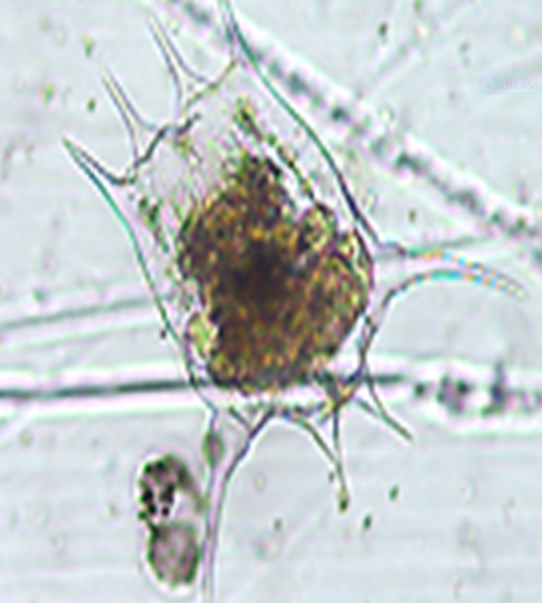 Brachionus calyciflorus  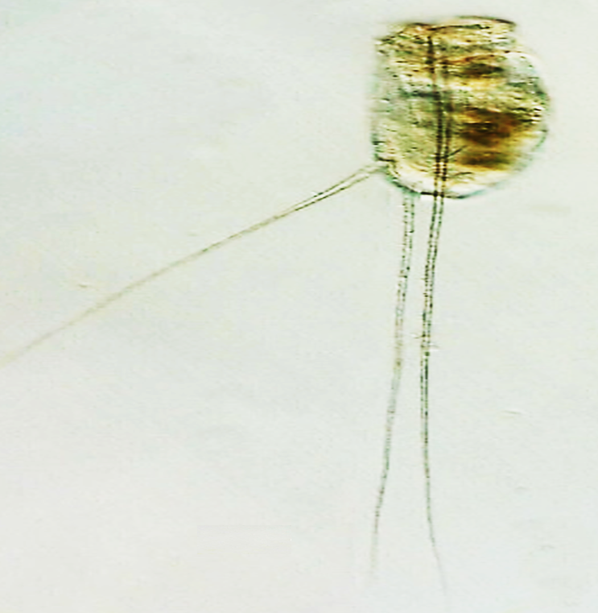  Filinia longiseta | Brachionus calyciflorus  Brachionus urceolaris  Brachionus quadridentatus  Filinia longiseta  Hexarthra fennica  Keratella cochlearis  Polyarthra vulgaris | Brachionus calyciflorus  Filinia longiseta  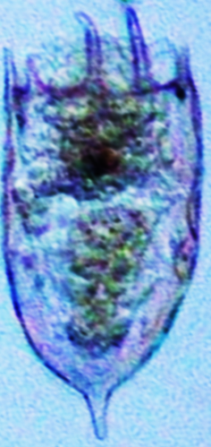  Keratella cochlearis
Samsun Uzun Lake | Copepoda | Acartia clausi | 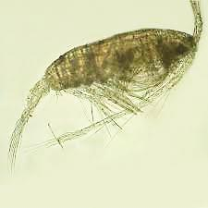Acartia clausi
Dalyan | Rotifera |  | Brachionus urceolaris
Dalyan | Copepoda | Acartia clausi
Hersek | Rotifera |  | Brachionus quadridentatus
Çakalburnu | Copepoda |  | Acartia clausi
Paradeniz | Rotifera | Synchaeta pectinata | Synchaeta pectinata  Keratella cochlearis  Filinia longiseta
 | Copepoda |  | Acartia clausi

2.2 SAXS Method
The most important advantage of the method is related to the possible usages on the different nanostructured bio samples in the forms of liquid/gels. The realized analyses supply optimized knowledge concerning all nano scale formations contained in sample holder with macroscale.
On the other hand, the usage of high-flux X-rays and the short-term experiments give the opportunity to measure the SR based X-Ray scattering data without harmful biological damages in the samples. The number (7-10) of the zooplanktons in each capillary tube was limited in the SR measurements but the sampling was increased (20-25) for laboratory type system of HECUS used SAXS data measurements. So, the usage of X-rays with low flux and Kratky optic was also effective to determine the nanoscale structural results. Details of the mentioned experimental conditions were given in Table-3 and Table-4; and Experimental scheme of the SAXS measurements was illustrated in Fig. 1.

Table 3. Measurement parameters (HECUS X-ray Systems, Graz, Austria)

Wave length | 1.54 Å
X-Ray Power | 2 kW (V=50 kV and I= 40 mA)
Detector | Position sensitive Linear gas detector  with 1024 channels
Distance of sample- detector | 27.9 cm
Range of q | 0.030-0.550 Å⁻¹
Measurement temperature | 22 ⁰C

Table 4. Experimental parameters (Taiwan NSRRC-23 A ,SAXS Beamline)

Photon Energy and resolution | 15.0000 keV, 2x10⁻⁴
Monochromator | DCM, Si(100)
Detector | 2D-CCD
Flux (0.5x0.6 mm²) | 10⁹ photons/s
Scale factor | 994.32
Data collection mode | Multi
The range of transmission for empty and filled sample cells | 0.64046-0.64769, 0.64535-0.64682
The range of Thickness of the samples (inside of the cell) | 2.784-2.906 mm
Distance between sample and detector | 2599.217 mm
Pinhole Size | 0.50x0.50 mm
Number of the measured data | 1024

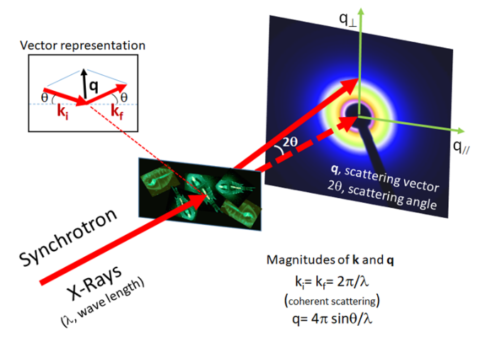
Fig. 1. Fundamental of SAXS profile measurement (the scattering data includes scattered intensity of I(q) from the sample as a function of q: magnitude of the scattering vector).

Since SAXS measurement (scattering data profile of I (q) – q) contains reciprocal space information, Fourier Transforms of the scattered intensities and the amplitudes must be performed for passing mathematically to real space.
IGOR Pro 6 (Kline, 2006) and DAMMIN (Svergun,1999) programs were used in the SAXS analyses for the fitting- refinement processes and 3D ab-initio modelling of the nanoglobules. So, the gyration radii and maximum dimensions of the nanoglobules (which are present in the bodies of the zooplankton) were determined. It was also previewed that the obtained nanoglobules are indicating more electron densed regions in the body such as chitin rich nanoaggregations appeared in mastax and carapax.

3. RESULTS AND DISCUSSION

3.1 Samples

During the study determined minimum and maximum salinity (%) was changed between 0.4-1.21 in Uzunlake; 13.8-23.53 in Dalyan; 9.1-30.3 in Hersek; 6.7-32.2 in Paradeniz and 24.9-38.4 %o in Çakalburnu, respectively. When the salinity values were examined by months it was determined that the salinity was the least in November, and there was an obvious increase in May and September.
In total, 43 zooplancton taxa were observed in both lagoons and 12 of these species were common. Among the species, Keratella cochlearis, Brachionus plicatilis, Brachionus quadridentatus, Brachionus calyciflorus, Synchaeta pectinata and Hexarthra fennica were the most common species. Although the tolerance of these species to salinity changes is known, some species have been found more intensely in some lagoons. For example, species belonging to the Synchaeta genus were more intense in Çakalburnu, Paradeniz and Hersek Lagoons, respectively.
We also observed the highest number of zooplankton species were recorded in May, November and September, respectively.

  - SAXS Results
The firstly obtained shapes of the chitin nanoglobules of the rotifers were given in Fig. 2.
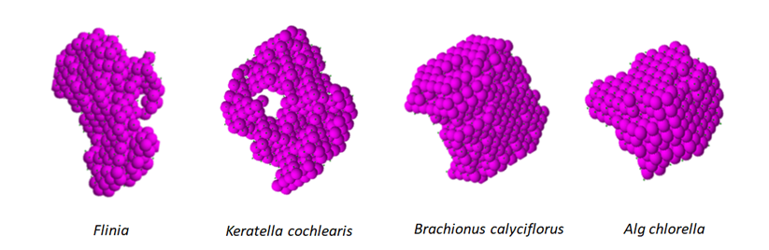
Fig. 2. The obtained 3D morphologies of the Chitin nano globules for four different adult zooplanktons collected in November

It was obtained that Chitin based nanoglobules reaches the biggest sizes and the most densed structural forms on may and in Paradeniz and Dalyan lagoons in November which have the low salinity. The Radius of gyration values (R_{G}) of the mentioned samples were determined as 209 ±9 Å (21 nm) and 220±11Å (22 nm). In other words, the SAXS-based findings revealed that copepods from low-salinity lagoons (e.g., Dalyan and Paradeniz) exhibited more compact, uniformly distributed chitin nanoglobules with radii of gyration (R_{G}) between 21–22 nm. In contrast, copepods from high-salinity environments (e.g., Çakalburnu) showed irregular, loosely packed nanoglobules, suggesting impaired chitin assembly or degradation. These observations imply that salinity acts as a modulator of chitin biosynthesis and structural maturation, potentially through osmotic stress pathways that affect enzymatic activity or gene expression related to chitin metabolism.
Beside of the obtained nanoglobular morphologies and the sizes, the distance distributions (PDDs) are also informative structural knowledge for the anatomic details. Table 5 summarises the nanoscopic findings including pair distance distributions of the nanoglobules in the adult bodies living in different lagoons on may.
It may be said that, according to the Table 5 (3D nanoscale morphologies), the developments of the carapax structure of the studied samples are improving in spring from top to bottom. The most densed and compact nanoglobular morphology was observed in Dalyan’s copepods, possibly because of low salt density. The non-developed carapax formation (morphology) and their non-ordered structural distribution in the samples of Çakalburnu Lagoon (where the salt density is high) is also supporting this result.
The measured nano sizes (R_{G} values) of the chitin formation (present in carapax) are Uzunlake lagoon 230±6 Å (23 nm), Paradeniz 209 ±9 Å (21 nm) and Dalyan 220±11Å (22 nm).
In other words, Dalyan Lagoon’s copepods are the examples which have the best uniformly distributed and developmentally completed nano aggregations. The evidence of the uniform distribution related to the nanoglobules are PDDs which has bell (hump) like smooth curves indicating homogenous distribution.
Furthermore, the pair distance distribution functions (PDDs) derived from SAXS profiles provide additional insight into the spatial organization of chitin nanostructures. Bell-shaped PDD curves, as observed in Dalyan samples, indicate a high degree of homogeneity and regularity in nanoglobule spacing—hallmarks of well-developed carapace architecture. Conversely, broader or multi-peaked PDDs in Çakalburnu samples reflect disordered or incomplete chitin layering, which may compromise mechanical protection and ecological fitness.
So the maximum distances between two (pair) nano formations were also measured as 67±1, 72±1 and 76±1 nm for Samsun Uzunlake , Paradeniz and Dalyan copepods. respectively.
3D morphology in the most developed carapax of an adult copepod has ellipsoidal morphology. During the development phase, the linear arrangements (small humps in the main broad PDDs of uzunlake) of crystalline nano aggregations, firstly come together and develop, and then the linear fractal structures form stratified heaps as they pass into the volumetric form (as in the example of Uzunlake).

Lagoons | Fitting curves and the SAXS profiles | 3D nanoscale structural morphologies | PDDs  (Pair Distance Distributions)
Çakalburnu | 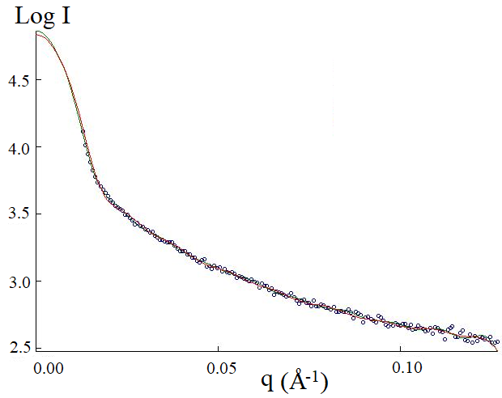 | 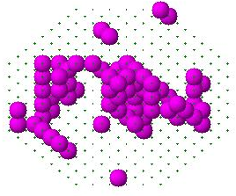 | The ordered and well distributed structure is absent
Uzun lake | 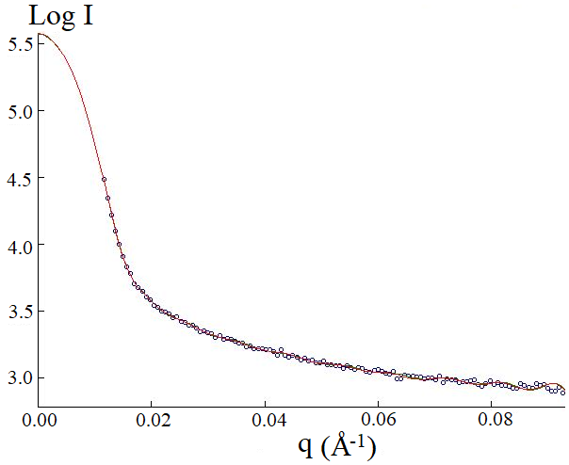 | 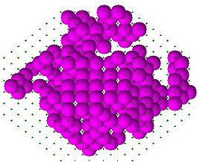 | 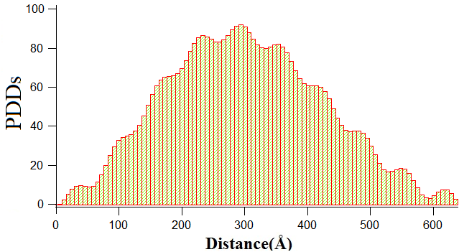
Paradeniz | 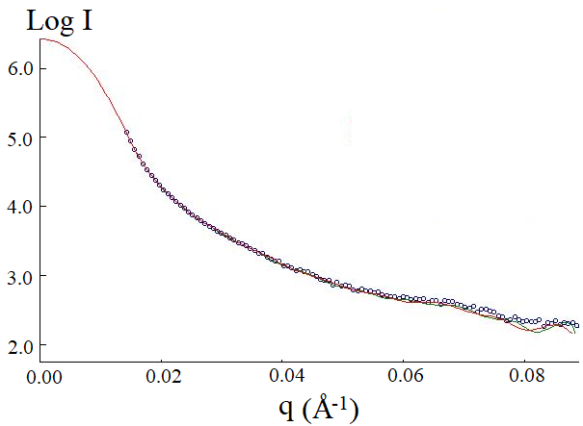 | 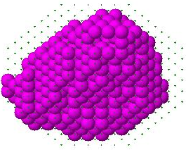 | 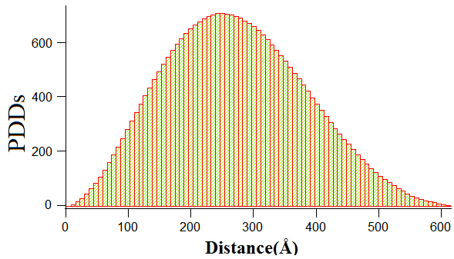
Dalyan | 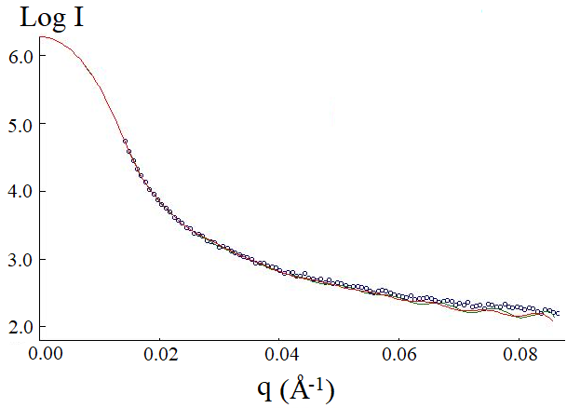 | 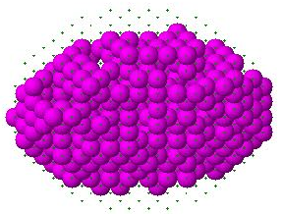 | 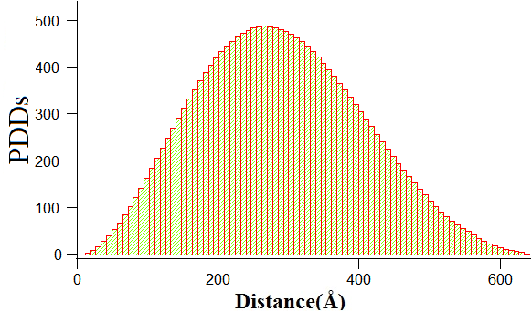

Table 5. The nano scale comparison of the studied samples which is including the fitted SAXS profiles (related to ab-inito models), 3D nano-morphologies (pink colour) and PDDs (Pair Distance Distributions).

The generalized result (on chitin structures) of adult copepods in may be given with the range of 21-23 nm.
With this study,,the above mentioned nanoscopic measurements were first case realised by using SAXS method. At the same time, the usage of high-flux X-rays and the short-term measurements were also recorded without destructive effects in biological samples.
Table 6 shows different month effects on chitin aggregation in copepods living in the same lagoon, while Table 7 shows similarities on the nanoglobular morphologies according to the different lagoons and different months.

Lagoons,  Month | Fitting curves and the SAXS profiles | 3D nanoscale structural morphologies | PDDs  (Pair Distance Distributions)
Paradeniz  September | 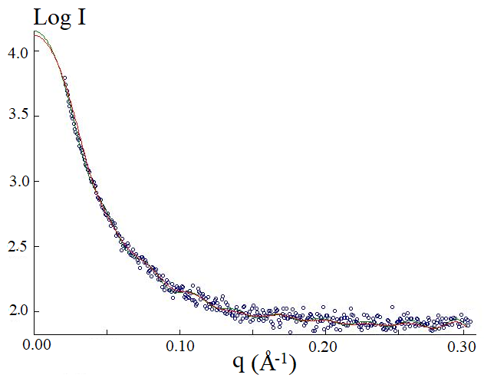 | 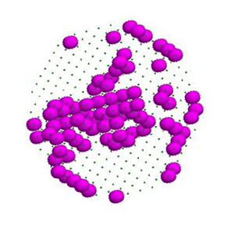 | The ordered and well distributed structure is absent
Paradeniz
May

Table 6 . Comparison of the nanostructural developments according to the months.

Lagoons,  Month | Fitting curves and the SAXS profiles | 3D nanoscale structural morphologies | PDDs  (Pair Distance Distributions)
Uzunlake  May | 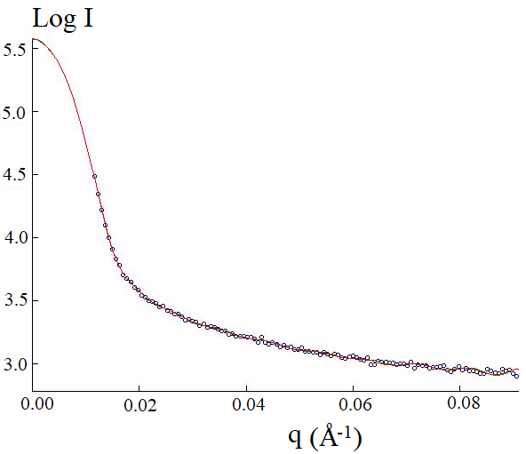 | 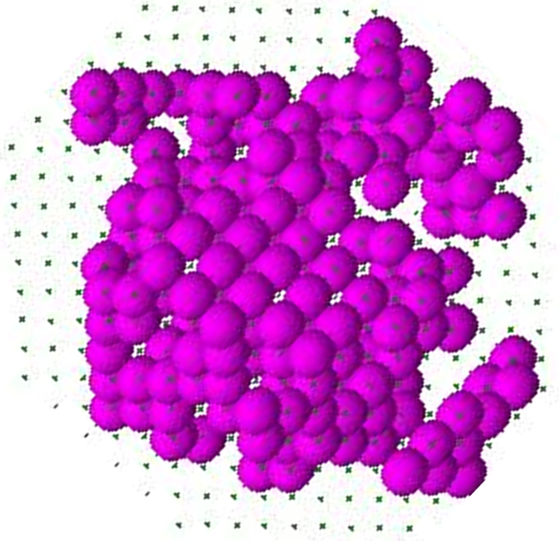
Çakalburnu  September | 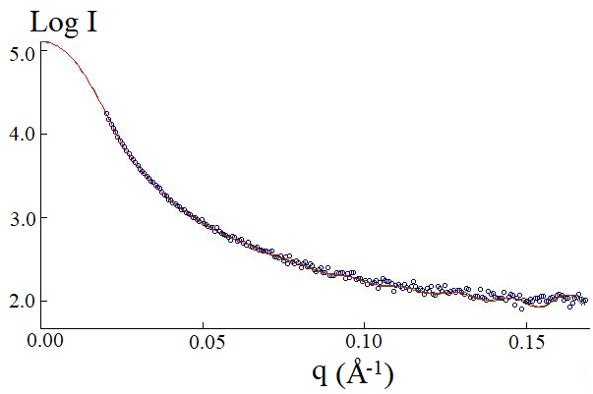 |  | 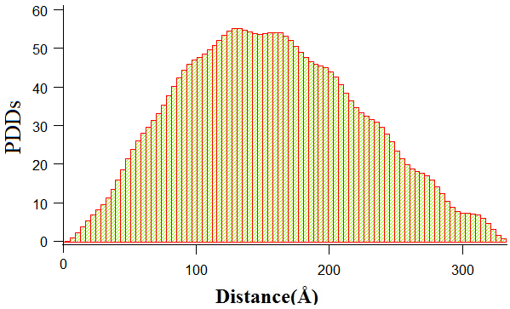

Table 7. Nanostructural similarities (similar aging) for two different lagoons and seasons’ months

It may be said that, according to the Table 5 (3D nanoscale morphologies), the developments of the carapax structure of the studied samples are improving in spring from top to bottom. The most densed and compact nanoglobular morphology was observed in Dalyan’s copepods, possibly because of low salt density. The non-developed carapax formation (morphology) and their non-ordered structural distribution in the samples of Çakalburnu Lagoon (where the salt density is high) is also supporting this result.
The measured nano sizes (RG values) of the chitin fromation (present in carapax) are Uzunlake lagoon 230±6 Å (23 nm), Paradeniz 209 ±9 Å (21 nm) and Dalyan 220±11Å (22 nm).
In other words, Dalyan Lagoon’s copepods are the examples which have the best uniformly distributed and developmentally completed nano aggregations. The evidence of the uniform distribution related to the nanoglobules are PDDs which has bell (hump) like smooth curves indicating homogenous distribution.
The maximum distance value measured from the PDD histogram is also giving another structural knowledge defined as the maximum dimension or maximum possible distance of nano chitin formations. So the maximum distances between two (pair) nano formations were also measured as 67±1, 72±1 and 76±1 nm for Samsun Uzunlake , Paradeniz and Dalyan copepods. respectively.
May is the best month to study on the adult copepods living in Paradeniz. Lamellar aggregations appeared with crystalline stacking of the chitin globules may be investigated in Samsun Uzunlake lagoon in the month of May while in Çakalburnu lagoon in September. It means that similar aged copepods may be followed according to the convenient time tables which may be prepared by using nanoscale analyses.
This study demonstrates a strong correlation between lagoon salinity levels and the nanostructural development of zooplankton, particularly in the carapace of copepods. In high-salinity environments such as the Çakalburnu Lagoon, copepod samples exhibited underdeveloped carapace structures with irregular and disordered distributions of chitin nanoglobules. In contrast, Dalyan Lagoon, characterized by lower salinity, showed the most compact and uniformly distributed nanostructures, indicating more advanced developmental stages. This result may be explained by a result of a previous study (Gürel, 2000). As a result of the mentioned study which focused hydrodynamic evaluations on Nutrient Dynamics in Coastal Lagoons: Dalyan Lagoon Case Study, it was obtained that hydrodynamic analyses revealed a two-layer flow in the system, with salinity varying with seasons and locations. In spring, significant mixing occurs in the water column, increasing freshwater inputs. So, the copepods samples were collected in spring (in May) and at the expected low salinity case. SAXS-based measurements supported these observations, revealing radius of gyration (R_{G}) values between 21–23 nm and site-specific variations in maximum inter-nanoglobule distances 67±1 nm (Uzunlake), 72±1 nm (Paradeniz), and 76±1 nm (Dalyan). The smooth, bell-shaped pair-distance distribution (PDD) curves observed in Dalyan samples further confirmed the presence of well-organized chitin aggregations. Overall, the findings suggest that elevated salinity disrupts nanostructural integrity and inhibits the physiological maturation of zooplankton, highlighting salinity as a key environmental factor shaping nanoscale biological architecture in aquatic ecosystems.
As a general result of SAXS analyses, it was demonstrated that increased salinity disrupts nanoglobule uniformity and impairs chitin-based structural development in copepods and rotifers, offering a novel biophysical lens to assess ecological stress and organismal maturity in lagoon ecosystems.

These organisms are very diverse, and there are more than 11,500 species worldwide (Humes, 1994). The detailed structural knowledge on the internal anatomy of the copepods are valuable to deeply understand their ecological success. The present work may allow a new insight into the nanoscale anatomic investigations and highlighted the role of chitin in the digestion and reproduction. Nanostructural comparison for the Copepods which have developed carapax sections, could be made regarding the samples living in different lagoons in May.
According to the SAXS analyses (in the nanoscopic comparison), it can be said that Crusalis organs (which have big numbers and the expected morphologies are globular in the bodies of copepods), have more electron density than the other body components, and most importantly, have the closest dimensions in nanometer scale. These organs form similar nanoscopic morphologies on the swimming legs (Johnson et.al. 2014).
SAXS method could be applied to a wide range copepods in order to perform comparative nano scale anatomic analyses. On the other hand, SAXS may be useful to characterise new copepod species, separate cryptic species within a species complex, and elucidate restricted distribution patterns.
Salinity, pH, Electrical conductivity and temperature are among the important environmental parameters affect the distribution and population densities of zooplanktonic organisms especially rotifers. The water temperature varies depending on the air temperature, the amount of dissolved substance, depth and the geographical location of the area as well.
In some studies conducted in estuarine areas have shown that salinity is specified the most important parameter affecting zooplankton density and diversity (Gao et al., 2008; Tavşanoğlu &Akbulut 2019).
Gao et al., 2008, were observed, that salinity affects zooplankton density positively in August and November, and no significant relationship was observed during September and May while there is a negative relationship with temperature and zooplankton density in Changjiang lagoon. Pardo & Armengol (2012) were studied the effect of salinity on zooplankton, that the rotifers increased significantly when the salt concentration increased but there was a significant decrease in the Cladocera group. Paturej et al., 2017, In their study conducted in Vistula Lagoon between August 2006 and 2009, it was reported that there was an important relationship between zooplankton distribution and physicochemical variables too.
According to the study results, zooplankton density and diversity were high in Bafra lake, Dalyan, Paradeniz and Çakalburnu Lagoons respectively. In our study, nanoscopic structural arrangement showed that linear results like zooplankton. However, since it was the first study on this subject, it could not be compared with other study findings and the results could not be fully interpreted.

4. Conclusion
This study presents a pioneering nanoscopic analysis of zooplanktonic organisms from Turkish lagoons, addressing key gaps in aquatic ecological research. By employing Small Angle X-ray Scattering (SAXS) for the first time in this context, the research reveals how lagoon salinity and seasonal temperature fluctuations influence zooplankton development at the nanoscale level. The identification of chitin nanoglobules as non-invasive indicators of organismal maturity offers a significant methodological advancement over conventional destructive techniques.
Moreover, the acquisition of high-resolution 3D morphological data on chitin-based structures provides new insights into their spatial organization and electron density variations, which are closely linked to physiological resilience and ecological function. These microscopic features are further connected to broader ecosystem processes such as oxygen production and trophic dynamics, enhancing the precision of ecological modelling and informing conservation strategies.
Importantly, the findings demonstrate that both chemical stressors like ozone and osmotic challenges such as elevated salinity can induce similar structural disruptions in copepod exoskeletons. This highlights a shared vulnerability of zooplankton to diverse environmental pressures and underscores the utility of SAXS as a powerful tool for assessing ecological stress responses in aquatic systems.
In summary, this study not only pioneers the application of SAXS in zooplankton nanostructural analysis but also establishes a mechanistic link between salinity-driven environmental stress and chitin remodeling in copepods. The observed nanoscale variations in chitin architecture serve as both a marker of developmental progression and a proxy for ecological stress, offering new avenues for integrative marine biomonitoring.

DISCLAIMER (ARTIFICIAL INTELLIGENCE)

Authors hereby declare that NO generative AI technologies such as Large Language Models (ChatGPT, COPILOT, etc.) and text-to-image generators have been used during the writing or editing of this manuscript.

Ethical Statement

The present study on zooplankton was carried out in accordance with the legal permissions obtained under the scope of the referenced project in the Acknowledgements. No conflict of interest or dispute exists among the contributing authors or with other researchers working in related fields.

References

Ahmed M. M. Heneash; Ahmed E. Alprol and D.E. Abd-El-khalek 2022. Short-Term Scale Observations on Zooplankton Community and Water Quality in the Eastern Harbor of Alexandria, Egypt. Egyptian Journal of Aquatic Biology & Fisheries, 26 (2): 197-216. DOI:10.21608/ejabf.2022.226358.

Akbulut N. E. and Tavşanoğlu Ü.N., 2018. Impacts of environmental factors on zooplankton taxonomic diversity in coastal lagoons in Turkey. Turkish Journal of Zoology. 42: 68-78. DOI:10.3906/zoo-1707-12.

Akyıldız G.K., Altındağ A., Tavşanoğlu Ü.N., 2025. Recent advances in freshwater zooplankton in a conservation hotspot: Türkiye case, Hydrobiologia 852:2581–2594.
DOI: 10.1007/s10750-025-05822-4.

Akyol O., Ceyhan T., 2010. Enez Dalyanı (Edirne, Kuzey Ege) Balıkçılığı. E.Ü. Su Ürünleri Dergisi, E.U. Journal of Fisheries & Aquatic Sciences, Vol. 27, Issue 1: 31-34.
https://www.academia.edu/84450081/Enez_Dalyanı_Edirne_Kuzey_Ege_Balıkçılığı.

Alprol A.E., Heneash, A.M.M., Soliman A.M., Ashour M., Alsanie W.F., Gaber A., Mansour A.T., 2021. Assessment of water quality, Eutrophication and Zooplankton Community in Lake Burullus. Egypt. Diversty., 13: 1-23.
DOI: 10.3390/d13060268.

Araújo, L.R. , Santangelo, J.M. Bozelli, R.L. (2015). Long-term dynamics of the zooplankton community during large salinity fluctuations in a coastal lagoon. Marine and Freshwater Research. 66(4) 352-359. DOI :10.1071/MF14083.

Bayramıalemdarı, V., Akbulut N. (2016). Zooplankton Diversity and Density Through The Turkish Lagoons. 3 rd International Conference of Water Resources and Wetlands 8-10 September 2016 Tulcea Romania (Poster).
https://avesis.hacettepe.edu.tr/yayin/35738708-9c26-4bb6-9f23-f13a529653a2/

De Souza Jr. A. N., Magalhães, A., Pereira, L.C.C., Rauquírio, M.D.C. (2013). Zooplankton dynamics in a tropical Amazon estuary. Journal of Coastal Research, 65 (sp2) 1230-1235, DOI: 10.2112/SI65-208.

Etile N.R., Kovassi A.M., Aka, M.N., Kouassi, N.J. (2009). Spatio-temporal variations of the zooplankton abundance and composition in a West African tropical coastal lagoon (Grand-Lahou, Côte d'Ivoire) Hydrobiologia 624, 171-189.

DOI: 10.1007/s10750-008-9691-7.

Gao Q., Xu Z., Zhuang P. (2008). The relation between distribution of zooplankton and salinity in the Changjiang Estuary, Chinese Journal of Oceanology and Limnology. Volume 26, Issue 2, pp 178–185. DOI: 10.1007/s00343-008-0178-1.

Gürel M. (2000). Nutrient Dynamics in Coastal Lagoons: Dalyan Lagoon Case Study, İstanbul Technical University, Institute of Science and Technology, Environmental Engineering Graduate Program – PhD Thesis.

Humes A. G. (1994). How many copepods?, Hydrobiology, 292/293, 1-7.
DOI: 10.1007/BF00229916

Islam, M. A., Hasan, M. N., Evan, M. S. H., Uddin, M. J., Tulin, W. S., Islama, M. S., Khandaker, M. U., Rahman, I. M. M., Chowdhury, F. I. (2025). Chitin nanofibers: recent advances in preparation and applications in biomedical and beyond, (Review Article) RSC Adv., 15, 14655-14690, DOI: 10.1039/D4RA06937D.

Johnson, K.E., Perreau, L., Charmantier, G., Charmantier-Daures, M., Lee, C. E. (2014). Without Gills: Localization of Osmoregulatory Function in the Copepod Eurytemora affinis, Physiological and Biochemical Zoology 87(2):310–324. DOI: 10.1086/674319

Jónasdóttir, S.H., Visser, A.W., Richardson, K., Heath, M. R. (2015). Seasonal copepod lipid pump promotes carbon sequestration in the deep North Atlantic. PNAS September 29, 112 (39) 12122-12126. DOI: 10.1073/pnas.1512110112.

Kıllı, N. (2020). Spatio-temporal variation in the distribution and abundance of marine cladocerans in relation to environmental factors in a productive lagoon (Güllük Bay, SW Aegean Sea, Turkey). Oceanological and Hydrobiological Studies 49,4.374-382.

DOI: 10.1515/ohs-2020-0032

Kline, S.R. (2006). Reduction and analysis of SANS and USANS data using IGOR Pro, J. Appl. Crystallogr. 39, 895–900. DOI: 10.1107/S0021889806035059

Lin, T., Chen, W., Zhang, J. (2012). Optimization and mechanism of copepod zooplankton inactivation using ozone oxidation in drinking water treatment. Journal of Water Supply: Research and Technology – AQUA, 61(6), 342–348. DOI: 10.2166/aqua.2012.099

Lopes, J.F.,Almeida, M.A.,Cunha, M.A. (2010). Modelling the ecological patterns of a temperate lagoon in a very wet spring season. Ecological Modelling, Volume 221, Issue 19, 24, 2302-2322. DOI: 10.1016/j.ecolmodel.2010.06.009

Pardo, M.A., Armengol, X. (2012). Effects of salinity and water temporality on zooplankton community in coastal Mediterranean ponds. Estuarine, Coastal and Shelf Science. Volume 114, 1 December 93-99. DOI: 10.1016/j.ecss.2011.08.018

Paturej, E., Gutkowska, A., Koszałka, J., Bowszys, M. (2017). Effect of physicochemical parameters on zooplankton in the brackish, coastal Vistula Lagoon. Oceanologia, Vol 59, Issue 1, 49-56. DOI: 10.1016/j.oceano.2016.08.001

Paturej, E. , Gutkowska, A. (2015). The effect of salinity levels on the structure of zooplankton communities. Archives of Biological Sciences Volume 67, Issue 2, Pages: 483-492.

DOI: 10.2298/ABS140910012P

Ruzafa, P., Molina-Cuberos G. J., García-Oliva, M., Umgiesser, G., Marcos, C. (2024). Why coastal lagoons are so productive? Physical bases of fishing productivity in coastal lagoons. Science of the Total Environment Vol. 922, 20, 171264 (41 pages).
DOI: 10.1016/j.scitotenv.2024.171264

Subinoy, M., Debajyoti, K.,Smaranya, H.,Tarakeshwar , S., Ghosh, A. R. (2015). Seasonal variation of zooplankton distribution in sewage-fed east Kolkata Wetland, West Bengal, India, Pollution Research 34(2):477-787.
https://www.envirobiotechjournals.com/issues/article_abstract.php?aid=6114&iid=193&jid=4

Sugier, K., Vacherie, B., Cornils, A., Jamet, J., Wincker, P., Madoui, M. (2018). Chitin distribution in the Oithona digestive and reproductive systems revealed by fluorescence microscopy. Peer J Preprints 6:e3447. DOI: 10.7287/peerj.preprints.3447v1

Svergun, D. I. (1999). Restoring low resolution structure of biological macromolecules from solution scattering using simulated annealing. Biophysical Journal, 76(6),2879–2886. DOI: 10.1016/S0006-3495(99)77443-6

Tavşanoğlu, Ü.N., Akbulut, N.E. (2019). Seasonal Dynamics of Riverine Zooplankton Functional Groups in Turkey: Kocaçay Delta as a case study. TRIFAJ Fisheries and Aquatic Science Turk. J. Fish.& Aquat. Sci. 20(1), 69-77. DOI: 10.4194/1303-2712-v20_1_07

Ustaoğlu, M.R., Mis, D. Ö., Aygen, C. (2012). Observations on zooplankton in some lagoons in Turkey, Mediterranean Environment, 18, 2, 208-222. https://dergipark.org.tr/tr/pub/jbme/issue/9836/121815

Valdés, V.P., Fernandez, C., Molina, V., Escribano, R., Joux, F. (2017). Dissolved compounds excreted by copepods reshape the active marine bacterioplankton community composition. Front. Mar. Sci. 4:343. DOI: 10.3389/fmars.2017.00343

Yuan, D. ,Chen, L.,Luan, L., Yang, Y. (2020). Effect of Salinity on the Zooplankton Community in the Pearl River Estuary Journal of Ocean University of China 19, 1389-1398.DOI: 10.1007/s11802-020-4449-6

