Original Research Article

Can Lemongrass essential oil (Cymbopogon citratus) improve on the social interactions of weaned piglets?

.
ABSTRACT

Aims: This study investigated a sustainable and innovative alternative to improve animal welfare in swine production through the topical application of Cymbopogon citratus essential oil (CCEO) in newly weaned piglets.
Study design: Completely randomized design.
Place and Duration of Study: The experiment was conducted at the Swine Teaching and Learning Unit of the Federal Institute of Education, Science and Technology of Santa Catarina (IFC), Araquari Campus, Brazil, between February 2019 and April 2020.
Methodology: A total of 124 newly weaned piglets were randomly assigned to four groups: a control group and three treatments with CCEO applied at concentrations of 1.25%, 2.50%, and 5.00%. At each weaning, piglets received 1 mL of the solution on the dorsal region and were observed for 3 hours for behavioral recording through photos and videos, without observer interaction. Skin lesions were mapped 24 h after weaning and classified by anatomical region. The study was structured in three stages: (I) an initial observational survey of the behavioral repertoire, (II) development of an ethogram with zootechnical parameters, and (III) validation of the ethogram with detailed behavioral analysis. Zootechnical performance (body weight, average daily gain, and mortality rate) was assessed in stages II and III.
Results: Chemical analysis showed that CCEO was predominantly composed of citral (geranial + neral, 87.53%) and β-myrcene (7.78%). Topical application significantly influenced the frequency of some social and exploratory behaviors (P < 0.05), although no effect was observed on aggressions or inactivity. While lesion numbers did not differ statistically among treatments (P > 0.05), all CCEO-treated groups showed numerically fewer lesions than the control, with ears being the most affected region. Zootechnical indexes were not significantly influenced by treatment (P > 0.05), but piglets treated with 2.50% and 5.00% CCEO showed a trend toward improved performance.
Conclusion: However, topical application of Cymbopogon citratus essential oil, particularly at 2.5% and 5.0%, favored positive social interactions and contributed to piglet welfare without impairing productive performance, while also reducing the severity of agonistic behaviors and lesions.

Keywords: Agonistic interactions, animal welfare, stress, weaned piglets, zootechnical performance

1. INTRODUCTION

In Brazil, swine farming plays a significant role in the national economy (ABPA, 2025). The country ranks fourth worldwide in both pork production and exports (USDA, 2025), with steadily increasing indices. In 2024, Brazilian production reached 5.305 million tons (ABPA, 2025). This strong performance reflects the rise in domestic pork consumption, which increased from 14.7 kg per capita in 2014 to 18.6 kg in 2024, with approximately 75% of production destined for the domestic market (ABPA, 2025).

Parallel to production growth, there has been a shift in public perception, with greater concern about food production practices, driving debates in the field of animal welfare (OIE, 2017). Consumers are now interested not only in animal welfare, but also in ethical aspects and their sociological, economic, and environmental implications (Cornish et al., 2019). This change in attitude has been accompanied by increased demand for information and regulations regarding production systems, as well as a growing willingness to pay more for products from systems certified for animal welfare (Miranda-de la Lama et al., 2017). In this context, the food industry has exerted additional pressure and placed greater value on products from companies adopting practices aligned with these principles (Amos & Sullivan, 2017).

Considering that the scientific community recognizes pigs as sentient beings and that many current production systems do not fully meet the five freedoms (sanitary, behavioral, nutritional, environmental, and psychological), it becomes essential to develop research aimed at improving animal welfare. Such studies are crucial, as they have direct impacts on biological functioning and, consequently, on animal health and productivity (Broom, 1988, 1991a,b, 1998).

In this sense, it is worth noting that, weaning represents a critical stage in piglets’ lives, mainly due to the early age at which it occurs, generally at 21 days. This period coincides with the transition from passive to active immunity, characterized by a state of relative immunosuppression that increases susceptibility to infections (Morés & Amaral, 2001). Furthermore, weaning marks the beginning of a new phase, in which piglets live without maternal presence and share space and resources (such as feed and water), often with individuals from different litters. This practice, combined with group mixing, is associated with higher stress levels, injuries, inflammatory processes, immunosuppression, and reduced productive performance (Ji et al., 2021).

Pigs are highly gregarious animals (Ji et al., 2021) and exhibit a strong social dominance structure. When regrouped, the social hierarchy is disrupted, triggering aggression until a new hierarchy is established, which negatively impacts welfare (Peden et al., 2018). Moreover, the greater the heterogeneity of the group, the more intense the agonistic interactions required to reorganize this hierarchy (Andersen et al., 2000).

Research has sought to develop methods and strategies capable of minimizing stress and improving welfare in animal production, considering that small changes can yield significant impacts (Morgan et al., 2014; Poletto et al., 2014; Peden et al., 2018; Ji et al., 2021; Chaaban et al., 2022). In this context, the use of medicinal plants with calming properties emerges as a sustainable alternative to mitigate agonistic behaviors. Among these possibilities, essential oils (EOs)—secondary metabolites of aromatic plants (Blanco et al., 2009)—stand out for their diverse therapeutic properties. In addition to their potential to improve animal welfare, the use of EOs in swine production can represent significant cost reductions, up to six times lower per piglet compared to conventional programs (Suzuki et al., 2008).

The botanical species Cymbopogon citratus (C. citratus), popularly known as lemongrass, is a perennial aromatic plant of the Poaceae family, characterized by thin, long green leaves (Tarkang et al., 2012). Widely used in herbal medicine, it presents various therapeutic applications, including antibacterial, antifungal, antiprotozoal, anticarcinogenic, anti-inflammatory, antioxidant, and especially sedative activities (Blanco et al., 2009). The essential oil of C. citratus (CCEO) is rich in bioactive substances such as saponins, tannins, anthraquinones, flavonoids, phenols, alkaloids, alcohols, esters, and terpenes, the latter representing about 96% of its composition. Among them, geranial, β-myrcene, neral, and citral (a mixture of geranial and neral) stand out as compounds with relevant biological properties in animal therapeutics, due to their psychoactive and medicinal effects, including sedative and anxiolytic actions (Negrelle & Gomes, 2007; Blanco et al., 2009; Akhila, 2009). Evidence suggests that this phytochemical diversity is responsible for the broad spectrum of biological and therapeutic activities of lemongrass (Ekpenyong et al., 2015).

Despite the numerous studies on the therapeutic effects of C. citratus, no research has evaluated the topical administration of its essential oil on social interactions in newly weaned piglets. In this context, the present study aimed to investigate a sustainable and innovative alternative to improve animal welfare in swine production through the topical application of lemongrass essential oil in newly weaned piglets.

2. material and methods

2.1 Location of the experimental stage

The study was carried out at the Swine Teaching and Learning Unit (UEA) of the Federal Institute of Education, Science and Technology of Santa Catarina (IFC), Araquari Campus – Santa Catarina, Brazil. The herd was composed of 16 Topigs Norvins F1 hybrid TN70 (Landrace x Large White) sows, housed in a full-cycle intensive confinement system. The project was approved by the Animal Use Ethics Committee under protocol number 291/2019. After weaning, marking the beginning of the experimental phase, piglets were moved to the nursery room, which was equipped with elevated slatted plastic flooring, natural air renewal, curtains for temperature control, and ad libitum supply of water and starter feed.

2.2 Cultivation site of the botanical species

Leaves of C. citratus were collected from a population of approximately 15 individuals cultivated under an agroecological system at the UEA garden of IFC-Araquari, located on the northern coast of Santa Catarina, under the geographical coordinates 26° 23' 33.6691" S, 48° 44' 18.3336" W, at an altitude of 10.60 m. The species was photographed, and a voucher specimen was deposited in the HFIE Herbarium in Curitiba under number HFIE 8.558.

2.3 Extraction and chemical characterization of Cymbopogon citratus essential oil

The collected botanical material was subjected to fresh hydro distillation using a Clevenger-type apparatus. After extraction, the essential oils were stored in amber glass containers at 4 °C until biological testing. Qualitative and quantitative analyses of their components were performed using GC/MS, following the methodology described by Chaaban et al. (2019).

2.4 Behavioral assessment in newly weaned piglets – General information

A total of 124 weaned piglets aged between 24 and 28 days were evaluated, randomly allocated into four groups at each weaning. The groups were defined by treatment type: one control group (CG) and three groups treated with different concentrations of C. citratus essential oil: 1.25%, 2.50%, and 5.00%, designated T1.25%, T2.50%, and T5.00%, respectively. The EO was diluted in a solution of 50% ethanol (92%) and 50% distilled water. The control group received only the diluent to ensure consistency in handling and application procedures across all animals.

At weaning, as per UEA standard procedures, piglets were individually weighed, and the average litter weight was recorded. After group allocation, 1.00 mL of the solution containing 1.25%, 2.50%, or 5.00% C. citratus essential oil (CCEO), or diluent (control), was applied topically to the dorsal region using a syringe. Piglets were then placed in nursery pens at a density until than 0.75 m² per piglet. From this point, visual observations and behavioral repertoire recordings were performed by an observer over a 3-hour period. During this time photos and videos were taken alongside written notes. The observer remained in the corridor and did not interact with the animals.

Twenty-four hours after weaning, piglet skin lesions were mapped and classified into four regions: (1) ear lesions (right and left), (2) anterior region (head, excluding ears, forelimbs, and thoracic region), (3) posterior region (abdominal area and hindlimbs), and (4) tail lesions. The number of animals with bites or scratches in each area was recorded according to treatment group. Lesion mapping followed the same procedure across all experiments.

2.5 Behavioral assessment in newly weaned piglets – Experiment I – Observational

Experiment I began in 2019 and included two weaning’s (twice to year). The first occurred in April with 28 piglets (i.e, coming from 3 different matrices), seven per treatment (N=7 and the useful area allocated to each animal was 0.85 m²/piglet), randomly chosen. The second occurred in May with 32 piglets (i.e, coming from 3 different matrices), eight per treatment (N=8 and the useful area allocated to each animal was 0.75 m²/piglet), randomly chosen. All piglets were managed identically to generate a behavioral repertoire after application and acclimatization. In this experiment, behaviors were noted but not quantified, as the purpose was to survey the most common behaviors. Zootechnical indexes were not evaluated in this stage.

2.6 Behavioral assessment in newly weaned piglets – Experiment II – Ethogram development

Behavior | Description
Inactive | Physical immobility with no activity
Aggression | Piglets involved in actions that cause the recipient to react negatively (e.g., fighting, biting, aggressive shoulder-to-shoulder posture, mounting). If the recipient moved away, the event was classified as one pig behaving aggressively; if the recipient later retaliated, it was classified as two aggressive pigs. If the recipient did not react negatively, the initiator was described as investigating.
Investigating | Activities of chewing, sniffing, and exploring the pen or pen-mates
Drinking | Drinking water
Feeding | Eating
Sitting | Hindquarters on the floor, front legs supporting the body
Lying down | Entire body length on the floor or on other pigs, i.e., not supported by the legs
Excreting | Urinating or defecating
The third weaning took place in October 2019 with 32 piglets (i.e, coming from 3 different matrices), divided into eight per group (N=8 and the useful area allocated to each animal was 0.75 m²/piglet), randomly chosen. In this experiment, zootechnical performance were collected, and the number of interactions was quantified to support the creation of the ethogram used in Experiment III (Table 1).

Table 1. Ethogram used for evaluating behaviors and postures observed in newly weaned piglets.

Adapted from Poletto et al. (2014) and Morgan et al. (2014)

2.7 Behavioral assessment in newly weaned piglets – Experiment III – Behavioral recording

The fourth weaning occurred in February 2020 using 32 piglets (i.e, coming from 3 different matrices), divided into eight per group (N=8 and the useful area allocated to each animal was 0.75 m²/piglet), randomly chosen. This experiment employed the ethogram (Table 1) developed from behavioral observations in Experiments I and II. In all evaluations, all animals were chosen randomly, in order to mix different litters in each group.

2.8 Zootechnical performance assessment

Zootechnical performance was evaluated from weaning until the end of the nursery phase (63 days of age) in Experiments II and III. Data collected included body weight, average daily gain (ADG), and mortality rate. Weighing was conducted on the day of weaning (initial weight) and on the day of nursery exit (final weight), with average litter weight recorded. Mortality rate was also determined, with cause of death recorded when identified. Routine management procedures followed UEA standards and were documented as supplementary information.

2.9 Statistical analysis

Data were tested for normality using the Shapiro-Wilk test and for variance homogeneity using Bartlett’s test. Lesion data were analyzed using the Kruskal-Wallis test followed by the Wilcoxon test for mean comparisons. Zootechnical indexes were analyzed using the F test. Behavioral variables were individually assessed using the Proportions test followed by the χ² Goodness-of-Fit test. All tests were conducted at a 5% significance level. Statistical analyses were performed using R Core Team (2020) and The Jamovi Project (2021).

3. results and discussion

3.1 Results

3.1.1 Chemical composition of Cymbopogon citratus essential oil

The CCEO is predominantly composed (95.31%) of three components: Geranial, Neral, and β-Myrcene (Table 2). Within this high percentage, Citral (Neral + Geranial) accounts for 87.53%.

Table 2. Chemical composition of Cymbopogon citratus essential oil.

Components | RIc | RIi | Cymbopogon citratus (%)
6-Methyl-5-heptene-2-one | 984 | 986 | 0.90
β-Myrcene | 989 | 989 | 7.78
Linalool | 1100 | 1100 | 0.58
Neral | 1239 | 1240 | 35.57
D-Carvone | 1246 | 1246 | 0.65
Geraniol | 1251 | 1249 | 1.79
Geranial | 1268 | 1271 | 51.96
2-Undecanone | 1293 | 1292 | 0.77
Total identified |  |  | 100.00
RIc: Retention index of calculated, RIi: Retention index of literature, %: percentage of the component in the essential oil.

3.1.2 Behavior

The frequencies of piglets running around the pen, biting the gate, lying down, sitting, investigating the environment, vocalizing, feeding, and drinking were significantly influenced by treatment (P < 0.05) (Figure 1; Video 1). However, aggression/fighting, urination/defecation, lethargy, and inactivity were not significantly affected by treatments (P > 0.05) (Figure 1).

Fig. 1. Frequency of behaviors in newly weaned piglets treated with Cymbopogon citratus essential oil during two hours of observation.
*: Statistical difference (P < 0.05).

Video 1. Behavior of recently weaned piglets after treatment with Cymbopogon citratus essential oil (CCEO).
A) Control group – Animals treated only with the diluent (50% 92% alcohol and 50% distilled water). Observe agonistic interactions, intense fights, and aggressive behavior; B) Animals treated with 1.25% CCEO solution. Note more lethargic and lying animals; C) Animals treated with 2.50% CCEO solution. Observe playful behavior and running in the pen; D) Animals treated with 5.0% CCEO solution. Note food-seeking behavior.

3.1.3 Lesions

The average number of piglets with general lesions, ear lesions, tail lesions, anterior region lesions, and posterior region lesions did not differ statistically (P > 0.05) among treatments (Table 3). However, all CCEO concentrations numerically reduced the number of piglets with any evaluated lesion compared to the control group. Ear lesions (Figure 2) were the most frequently observed. However, lesions were present in all evaluated areas (Table 3; Figure 3).

Table 3. Number of recently weaned piglets after treatment with different concentrations of Cymbopogon citratus essential oil. Values are presented as mean ± standard deviation, referring to animals that presented lesions 24 h after group formation. Mean refers to n of 7 or 8 animals per treatment in 4 repetitions (total n = 124).

Variables | Control | T1.25% | T2.50% | T5.00%
General Lesions | 4.06 ± 2.54 | 3.00 ± 2.45 | 2.25 ± 1.98 | 2.94 ± 3.04
Ear Lesions | 6.00 ± 1.41 | 5.00 ± 2.16 | 4.25 ± 1.89 | 5.75 ± 3.30
Tail Lesions | 1.00 ± 1.15 | 0.50 ± 0.58 | 0.00 ± 0.00 | 0.00 ± 0.00
Anterior Lesions | 5.50 ± 2.08 | 4.25 ± 2.63 | 3.25 ± 0.96 | 4.25 ± 2.50
Posterior Lesions | 3.75 ± 2.06 | 2.25 ± 1.26 | 1.50 ± 1.00 | 1.75 ± 1.71
General Lesions: Average number of piglets presenting any lesion; Ear Lesions: Average number of piglets presenting at least one lesion in at least one ear; Tail Lesions: Average number of piglets presenting at least one lesion on the tail; Anterior Lesions: Average number of piglets presenting at least one lesion in the anterior part of the body; Posterior Lesions: Average number of piglets presenting at least one lesion in the posterior part of the body; Significance level: 95%.

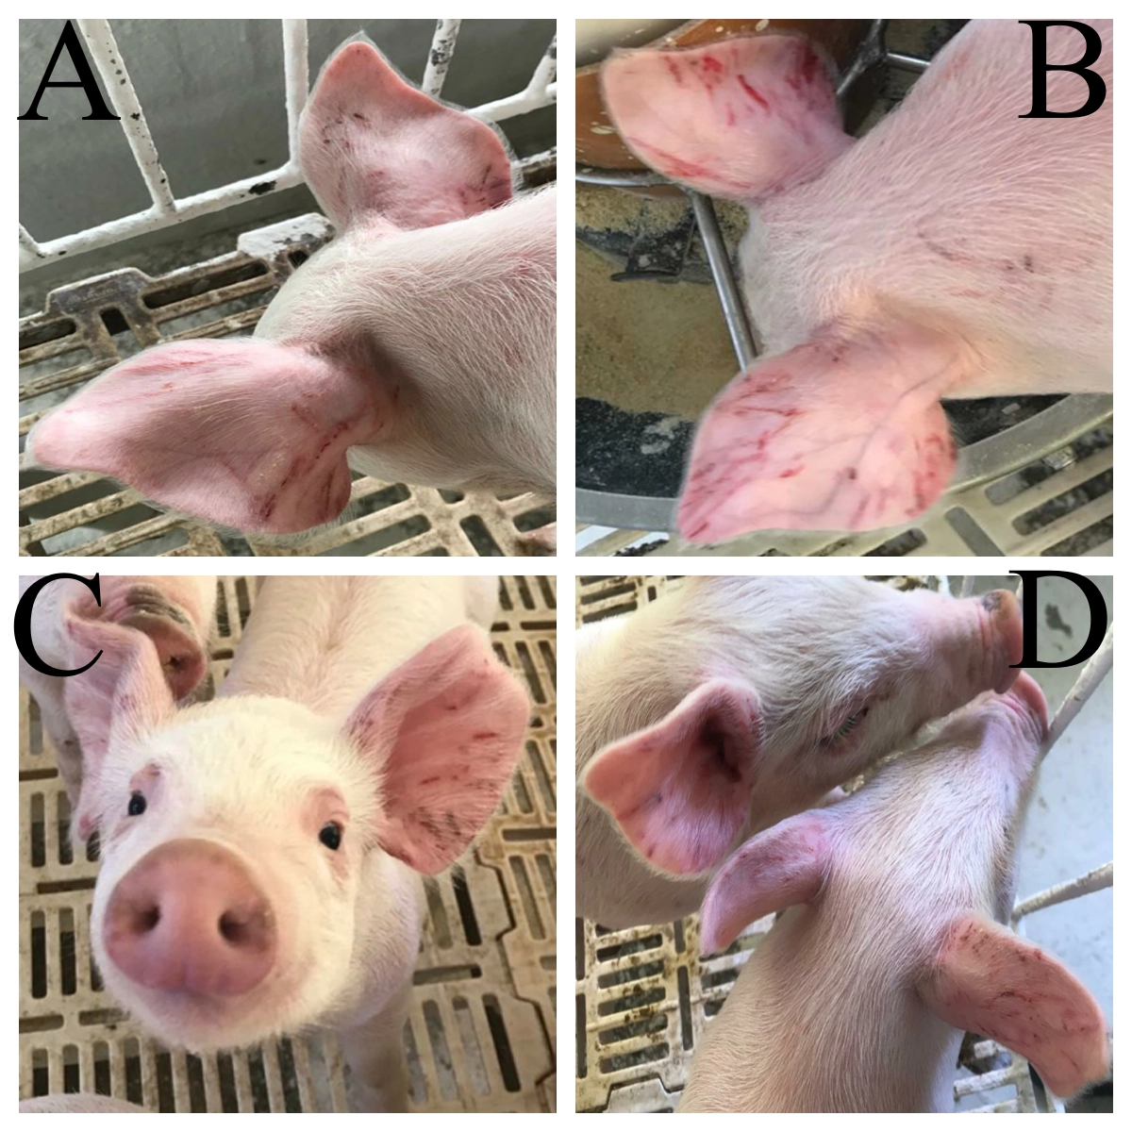
Fig. 2. Ear lesions in newly weaned piglets after treatment with Cymbopogon citratus essential oil (CCEO). A) Control group – Animals treated only with the diluent (50% 92% alcohol and 50% distilled water). Note the severe bite lesions. B) Animals treated with 1.25% CCEO solution. Note that there are still lesions resulting from agonistic behaviors. C and D) Animals treated with 2.50% and 5.00% CCEO solution, respectively. Observe the few superficial lesions.

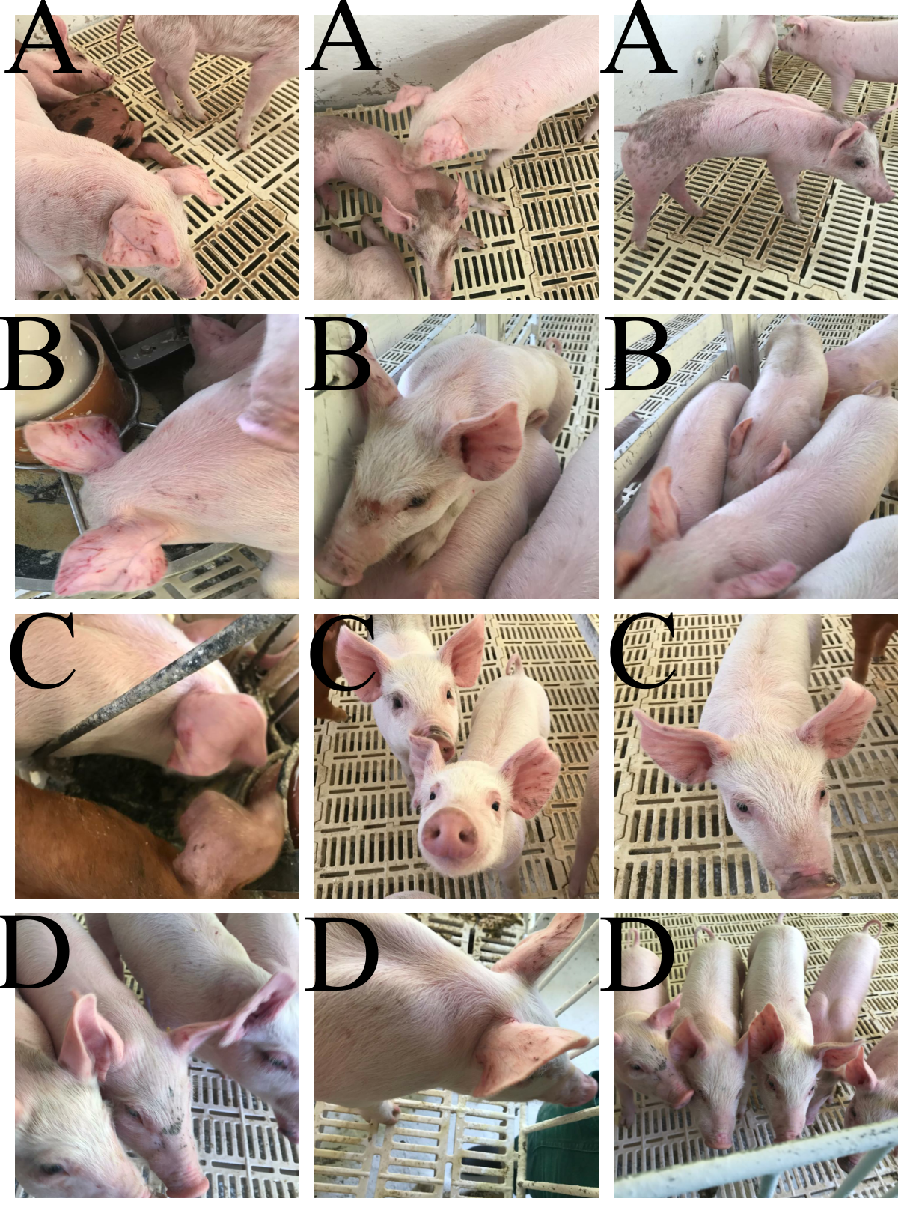
Fig. 3. Overall lesions in newly weaned piglets after treatment with Cymbopogon citratus essential oil (CCEO). A) Control group – Animals treated only with the diluent (50% 92% alcohol and 50% distilled water). Note the severe bite lesions across all body regions. B) Animals treated with 1.25% CCEO solution. Note that there are still lesions resulting from agonistic behaviors. C and D) Animals treated with 2.50% and 5.00% CCEO solution, respectively. Observe few superficial lesions, with animals showing more intact and uniform skin.

3.1.4 Zootechnical indexes

Average litter weight at nursery exit (ABW) was not significantly affected by CCEO application (P > 0.05) (Table 4). Average daily gain (ADG) also did not differ significantly (P > 0.05) among groups (Table 4). However, piglets treated with 2.50% and 5.00% CCEO showed numerically higher ABW and ADG.

Table 4. Zootechnical indices of piglets at weaning off at 63 days of age, after being treated at weaning with different concentrations of Cymbopogon citratus essential oil. Values are presented as mean ± standard deviation.

Parameter | Control | T1.25% | T2.50% | T5.00%
ADG (Kg day⁻¹) | 0.41 ± 0.00 | 0.34 ± 0.12 | 0.42 ± 0.01 | 0.48 ± 0.07
AW (Kg) | 22.69 ± 0.27 | 19.83 ± 2.93 | 22.16 ± 0.63 | 23.81 ± 1.50
ADG: Average daily gain; AW: Average weight at weaning off at 63 days; Significance level: 95%

3.2 Discussion

3.2.1 Chemical composition of Cymbopogon citratus essential oil

Neral and Geranial have frequently been reported as the major compounds in CCEO, ranging from 26.03 to 37.42% and 31.43 to 48.10%, respectively (Blanco et al., 2009; Katsukawa et al., 2010; Silva et al., 2010; Bassole et al., 2011; Ajayi et al., 2016). These components, when combined, form Citral (Iijima et al., 2006; Katsukawa et al., 2010; Ajayi et al., 2016). Citral has been associated with sedative and anxiolytic properties (Negrelle & Gomes, 2007; Blanco et al., 2009; Akhila, 2009; Hacke et al., 2020) and, in fish, with anesthetic effects (de Freitas Souza et al., 2018). According to Hacke et al. (2020), Citral is responsible for the anxiolytic effects of CCEO through gamma-aminobutyric acid type A (GABA_{A}) receptors.

3.2.2 Behavior

In swine production, weaning is considered one of the most stressful management practices in a piglet’s life, as they must assume nutritional independence through solid feed, face social challenges due to maternal and littermate separation, and cope with forced contact with piglets from other litters (Gardner et al., 2001; da Silva et al., 2014). Commercial weaning has multiple impacts because it occurs abruptly and earlier than the natural period (Gardner et al., 2001). Unlike semi-natural systems, this weaning does not occur playfully or with environmental enrichment, resulting in skin lesions due to agonistic interactions, as well as diarrhea and respiratory problems caused by stress-induced immunosuppression (Wattanakul et al., 1997). The duration and severity of agonistic interactions vary between litters, being most intense in the first 48 hours but can extend up to 10 days (Souza et al., 2006).
In our experiment, piglets treated with CCEO, especially the T2.50% group, showed a higher frequency of sitting and lying behaviors and, along with the T5.00% group, exhibited more frequent feeding and drinking. Additionally, these groups numerically showed the highest ABW and ADG. This increased frequency of calm behaviors may be related to the sedative and anxiolytic properties of Citral (Negrelle & Gomes, 2007; Blanco et al., 2009; Akhila, 2009). These results are similar to those reported by Morgan et al. (2014), who observed that piglets socialized during lactation were more relaxed than the control group.
On the other hand, non-agonistic interactions were more frequent in CCEO-treated groups, such as investigation, which increased in the T1.25% and T5.00% groups. Previous pre-weaning socialization, as reported by Morgan et al. (2014), showed similar outcomes, particularly in females, who predominated in investigative behaviors. However, the highest CCEO concentrations (T2.50% and T5.00%) were associated with increased vocalization. Nevertheless, vocalizations alone are not fully sufficient to assess welfare, as not all stressful situations provoke vocalization, and not all vocalizations indicate poor welfare (Manteuffel et al., 2004).
In this study, no significant reduction in aggression/fighting was observed between treatments (P > 0.05). Morgan et al. (2014) also reported no reduction in agonistic interactions in piglets socialized during lactation compared to controls, despite positive behavioral effects, as observed in our study. This aligns with Arey & Edwards (1998) and Marchant-Forde (2009), who state that this is a critical period due to the formation of social hierarchy.
The increase in non-agonistic interactions observed in our experiment reinforces the anxiolytic effects of Citral, the major compound of CCEO, observed in other studies (Negrelle & Gomes, 2007; Blanco et al., 2009; Akhila, 2009; Hacke et al., 2020; Chaaban et al., 2022). This effect may be related to high affinity for the benzodiazepine binding sites of GABA_{A} receptors (Fedotova et al., 2017). Hacke et al. (2020), when testing the anxiolytic effects of CCEO in zebrafish, observed that anxiolytic activity was attributed to its compounds: Citral (18.57%), Geraniol (22.02%), and Linalool (20.59%). The observed behaviors suggested involvement of GABA_{A} receptors in the anxiolytic effects, which may underlie the behavioral outcomes in our experiment (Video 1).

3.2.3 Lesions

Biting lesions generally result from redirected stress due to unmet welfare needs and typically occur on tails and ears but can extend to other body parts (Nannoni et al., 2014). The results of our study (Table 3, Figures 2 and 3) align with literature reporting various lesions caused by agonistic interactions during the establishment of new social hierarchies (Campos et al., 2010). However, piglets treated with CCEO showed numerically fewer lesions. This may be related to the observed behaviors, resulting from the sedative, hypnotic, and anxiolytic effects of CCEO (Blanco et al., 2009). According to Sriraksa et al. (2018), individuals under the influence of CCEO are alert yet calm, corroborating our findings (Video 1).
According to Smulders et al. (2008), ear-biting lesions are common in swine production and negatively affect welfare and economic returns. These lesions have multifactorial origins, with temperature and the number of feeding points per pig in the nursery being important risk factors (Smulders et al., 2008).

3.2.4 Zootechnical indexes

ADG is an important indicator of swine growth and has been evaluated in various experiments, including those related to animal welfare (Brumm et al., 2001; Gomes et al., 2018; Ji et al., 2021). Strategies such as lower stocking density and pre-weaning socialization can increase ADG (Brumm et al., 2001; Ji et al., 2021). However, differences between tested groups are sometimes not observed in controlled environments (Gomes et al., 2018). In our experiment, all groups were housed at a low density (until 0.75 m²/piglet), which, according to Brumm et al. (2001), offers fewer challenges to the animals.
In Brazil, it is worth noting that Normative Instruction 113/2020, which establishes good management practices for commercial pig farms, recommends that stocking density on the farm should be adjusted according to environmental conditions, management, and animal behavior, with maximum densities being permitted. For nursery piglets weighing up to thirty kilograms, for example, the usable area allocated to each animal must be equal to or greater than 0.27 (zero point twenty-seven) square meters (Brazil, 2020). However, under these conditions, agonistic interactions between unfamiliar piglets are frequent and intense. In our experiments, although we worked with lower densities and greater animal comfort and welfare, several negative behaviors were still observed.

4. Conclusion

The topical application of C. citratus essential oil (CCEO), particularly at concentrations of 2.50% and 5.00%, in weaned piglets increased non-agonistic interactions and promoted animal welfare. The procedure for applying the product is simple and does not negatively affect zootechnical performance. Both agonistic behaviors and lesions were apparently milder in the groups treated with 2.50% and 5.00% CCEO. Further studies with larger numbers of animals and under commercial production conditions are needed to better assess zootechnical gains. Additionally, it is necessary to investigate the underlying physiology and validate the mechanisms of action involved.

Ethical approval (where ever applicable)

All authors hereby declare that "Principles of laboratory animal care" (NIH publication No. 85-23, revised 1985) were followed, as well as specific national laws where applicable. All experiments have been examined and approved by the appropriate ethics committee. O projeto foi aprovado pelo Comitê de Ética de Uso Animal, sob protocolo de número 291/2019.

References

Ajayi, E. O., Sadimenko, A. P., & Afolayan, A. J. (2016). GC–MS evaluation of Cymbopogon citratus (DC) Stapf oil obtained using modified hydrodistillation and microwave extraction methods. Food chemistry, 209, 262-266.

Akhila, A. (2009). Essential oil-bearing grasses: the genus Cymbopogon. CRC press.

Amos, N., & Sullivan, R. (2017). The business benchmark on farm animal welfare 2016 report. Available at SSRN 2933184.

Andersen, I. L., Andenæs, H., Bøe, K. E., Jensen, P., & Bakken, M. (2000). The effects of weight asymmetry and resource distribution on aggression in groups of unacquainted pigs. Applied Animal Behaviour Science, 68(2), 107-120.

Arey, D. S., & Edwards, S. A. (1998). Factors influencing aggression between sows after mixing and the consequences for welfare and production. Livestock Production Science, 56(1), 61-70.

ABPA - Associação Brasileira de Proteína Animal. Relatório Anual 2025. (2025). São Paulo: ABPA - Associação Brasileira de Proteína Animal; 2018. Disponível em: <http://abpa-br.org/mercados/#relatorios>. Acesso em 17 aug 2025.

Bassolé, I. H. N., Lamien-Meda, A., Bayala, B. O. L. C., Obame, L. C., Ilboudo, A. J., Franz, C., Novak, J., Nebié, R. C., & Dicko, M. H. (2011). Chemical composition and antimicrobial activity of Cymbopogon citratus and Cymbopogon giganteus essential oils alone and in combination. Phytomedicine, 18(12), 1070-1074.

Blanco, M. M., Costa, C. A. R. A., Freire, A. O., Santos Jr, J. G., & Costa, M. (2009). Neurobehavioral effect of essential oil of Cymbopogon citratus in mice. Phytomedicine, 16(2-3), 265-270.

BRASIL. (2020). Ministério da Agricultura, Pecuária e Abastecimento. Instrução Normatíva n° 113 de 16 de dezembro de 2020. Estabelece as boas práticas de manejo e bem-estar animal nas granjas de suínos de criação comercial. Diário Oficial da União, publicado em: 18/12/2020 Edição:242,Seção:1,Página:5

Broom, D. M. (1988). The scientific assessment of animal welfare. Applied Animal Behaviour Science, 20(1-2), 5-19.

Broom, D. M. (1991a). Animal welfare: concepts and measurement. Journal of animal science, 69(10), 4167-4175.

Broom, D. M. (1991b). Assessing welfare and suffering. Behavioural processes, 25(2-3), 117-123.

Broom, D. M. (1998). Welfare, stress, and the evolution of feelings. In Advances in the Study of Behavior (Vol. 27, pp. 371-403). Academic Press.

Brumm, M. C., Ellis, M., Johnston, L. J., Rozeboom, D. W., Zimmerman, D. R., & NCR-89 Committee on Swine Management. (2001). Interaction of swine nursery and grow-finish space allocations on performance. Journal of animal science, 79(8), 1967-1972.

Campos, J. A., de FF Tinôco, I., Fabyano, F., Pupa, J. M., & da Silva, I. J. (2010). Enriquecimento ambiental para leitões na fase de creche advindos de desmame aos 21 e 28 dias. Revista Brasileira de Ciências Agrárias, 5(2), 272-278.

Chaaban, A., Santos, V. M. C. S., Martins, C. E. N., Brum, J. S., Bertoldi, F. C., & Molento, M. B. (2019). Tissue damage and cytotoxic effects of Tagetes minuta essential oil against Lucilia cuprina. Experimental parasitology, 198, 46-52.

Chaaban, A; Bertoldi, F.C.; Martins, C.E.N.; Bako, E.P.M; da Silva, E.; Martins, P.R.P.; Gazaniga, D. V. (2022). Uso do óleo essencial de Cymbopogon citratus (capim limão) para minimizar interações agonísticas de leitões recém-desmamados e método de uso. BR 10 2022 005672 2, Março 24, 2022.

Cornish, A. R., Ashton, B., Raubenheimer, D., & McGreevy, P. D., (2019). Australian consumers’ knowledge and concern for animal welfare in food production: Influences on purchasing intentions. Soc. Anim., 30(1), 23-50. 10.1163/15685306-12341601
da Silva, G. A., Rorig, A., Schmidt, J. M., & do Prado Guirro, E. C. B. (2014). Impacto do desmame no comportamento e bem-estar de leitões: revisão de literatura. Revista Veterinária Em Foco, 12(1).

de Freitas Souza, C., Baldissera, MD, Bianchini, AE, da Silva, EG, Mourão, RHV, da Silva, LVF, Schmidt, D., Heinzmann, B. M., & Baldisserotto, B. (2018). Citral and linalool chemotypes of Lippia alba essential oil as anesthetics for fish: a detailed physiological analysis of side effects during anesthetic recovery in silver catfish (Rhamdia quelen). Fish Physiology and Biochemistry, 44 (1), 21-34.

Ekpenyong, C. E., Akpan, E., & Nyoh, A. (2015). Ethnopharmacology, phytochemistry, and biological activities of Cymbopogon citratus (DC.) Stapf extracts. Chinese journal of natural medicines, 13(5), 321-337.

Fedotova, J., Kubatka, P., Büsselberg, D., Shleikin, A. G., Caprnda, M., Dragasek, J., Rodrigo, L., Pohanka, M., Gasparova, I., Nosal, V., Opatrilova, R., Qaradakhi, T., Zulli, A., & Kruzliak, P. (2017). Therapeutical strategies for anxiety and anxiety-like disorders using plant-derived natural compounds and plant extracts. Biomed. Pharmacother., 95, pp. 437-446, 10.1016/j.biopha.2017.08.107.

Gardner, J. M., Duncan, I. J. H., & Widowski, T. M. (2001). Effects of social “stressors” on belly-nosing behaviour in early-weaned piglets: is belly-nosing an indicator of stress?. Applied Animal Behaviour Science, 74(2), 135-152.

Gomes, L. M., de Mello Miassi, G., dos Santos, L. S., Saleh, M. A. D., Sartori, J. R., Tse, M. L. P., & Berto, D. A. (2018). Impact of two light programs and two levels of dietary tryptophan for weanling piglets. Livestock Science, 216, 191-196.

Hacke, A. C. M., Miyoshi, E., Marques, J. A., & Pereira, R. P. (2020). Anxiolytic properties of Cymbopogon citratus (DC.) stapf extract, essential oil and its constituents in zebrafish (Danio rerio). Journal of Ethnopharmacology, 260, 113036.

Iijima, Y., Wang, G., Fridman, E., & Pichersky, E. (2006). Analysis of the enzymatic formation of citral in the glands of sweet basil. Archives of Biochemistry and Biophysics, 448(1-2), 141-149.

Ji, W., Bi, Y., Cheng, Z., Liu, R., Zhang, X., Shu, Y., Li, X., Bao, J., & Liu, H. (2021). Impact of early socialization environment on social behavior, physiology and growth performance of weaned piglets. Applied Animal Behavior Science, 238, 105314.

Katsukawa, M., Nakata, R., Takizawa, Y., Hori, K., Takahashi, S., & Inoue, H. (2010). Citral, a component of lemongrass oil, activates PPARα and γ and suppresses COX-2 expression. Biochimica et Biophysica Acta (BBA)-Molecular and Cell Biology of Lipids, 1801(11), 1214-1220.

Manteuffel, G., Puppe, B., & Schön, P. C. (2004). Vocalization of farm animals as a measure of welfare. Applied Animal Behaviour Science, 88(1-2), 163-182.

Marchant-Forde, J. N. (2009). Welfare of dry sows. In The welfare of pigs (pp. 95-139). Springer, Dordrecht.

Miranda-de la Lama, G. C., Estévez-Moreno, L. X., Sepulveda, W. S., Estrada-Chavero, M. C., Rayas-Amor, A. A., Villarroel, M., & María, G. A. (2017). Mexican consumers' perceptions and attitudes towards farm animal welfare and willingness to pay for welfare friendly meat products. Meat science, 125, 106-113.

Morés, N., & Amaral, A. D. (2001). Patologias associadas ao desmame. In CONGRESSO DA ABRAVES (Vol. 10, pp. 215-224).

Morgan, T., Pluske, J., Miller, D., Collins, T., Barnes, A.L., Wemelsfelder, F., & Fleming, P. A. (2014). Socialising piglets in lactation positively affects their post-weaning behaviour. Appl. Anim. Behav. Sci., 158, 23-33. https://doi.org/10.1016/j.applanim.2014.06.001

Nannoni, E., Valsami, T., Sardi, L., & Martelli, G. (2014). Tail docking in pigs: a review on its short-and long-term consequences and effectiveness in preventing tail biting. Italian Journal of Animal Science, 13(1), 3095.

Negrelle, R. R. B., & Gomes, E. C. (2007). Cymbopogon citratus (DC.) Stapf: chemical composition and biological activities. Revista Brasileira de Plantas Medicinais, 9(1), 80-92.

OIE - Organização Mundial de Saúde Animal - OIE. Código Sanitario para los Animales Terrestres. 2017. Disponível em: https://tinyurl.com/y8vu84lt. Acesso em 04 dez 2018.

Peden, R. S., Turner, S. P., Boyle, L. A., & Camerlink, I. (2018). The translation of animal welfare research into practice: The case of mixing aggression between pigs. Appl. Anim. Behav. Sci., 204, 1-9. https://doi.org/10.1016/j.applanim.2018.03.003

Poletto, R., Kretzer, F. C., & Hötzel, M. J., (2014). Minimizing aggression during mixing of gestating sows with supplementation of a tryptophan-enriched diet. Physiol. Behav., 132, 36-43. https://doi.org/10.1016/j.physbeh.2014.04.043

R Core Team (2020). R: A Language and environment for statistical computing. (Version 4.0) [Computer software]. Retrieved from https://cran.r-project.org.

Silva, M. R., Ximenes, R. M., da Costa, J. G. M., Leal, L. K. A., de Lopes, A. A., & de Barros Viana, G. S. (2010). Comparative anticonvulsant activities of the essential oils (EOs) from Cymbopogon winterianus Jowitt and Cymbopogon citratus (DC) Stapf. in mice. Naunyn-Schmiedeberg's archives of pharmacology, 381(5), 415-426.

Smulders, D., Hautekiet, V., Verbeke, G., Geers, R., 2008. Tail and ear biting lesions in pigs: an epidemiological study. Anim. Welf., 17(1), 61-69. https://doi.org/10.1017/S0962728600031997

Souza, A. S., Jansen, J., Tempelman, R. J., Mendl, M., & Zanella, A. J. (2006). A novel method for testing social recognition in young pigs and the modulating effects of relocation. Applied Animal Behaviour Science, 99(1-2), 77-87.

Sriraksa, N., Kaewwongse, M., Phachonpai, W., & Hawiset, T. (2018). Effects of Lemongrass (Cymbopogon citratus) essential oil inhalation on cognitive performance and mood in healthy women. Thai Pharmaceutical and Health Science Journal, 13(2), 80-88.

Suzuki, O. H., Flemming, J. S., & Silva, M. E. T. (2008). USO DE ÓLEOS ESSENCIAIS® 1 NA ALIMENTAÇÃO DE LEITÕES. Revista Acadêmica Ciência Animal, 6(4), 519-526.

Tarkang, P. A. et al. 2012. Effect of long-term oral administration of the aqueous and ethanol leaf extracts of Cymbopogon citratus (DC. ex Nees) stapf. Annals of Biological Research, v. 3, n. 12, p. 5561-55570.

The Jamovi Project (2021). jamovi. (Version 1.6) [Computer Software]. Retrieved from https://www.jamovi.org.

USDA – UNITED STATES DEPARTMENT OF AGRICULTURE. (2021). Disponível em: <http://www.usda.gov>. Acesso em: 17 aug 2025.

Wattanakul, W., Sinclair, A. G., Stewart, A. H., Edwards, S. A., & English, P. R. (1997). Performance and behaviour of lactating sows and piglets in crate and multisuckling systems: a study involving European White and Manor Meishan genotypes. Animal Science, 64(2), 339-349.

