Original Research Article
Ethnobotanical Survey and Phytochemical Screening of Aqueous Extracts of Flueggea virosa Collected in Mali

.
ABSTRACT
Aims: Flueggea virosa is a medicinal plant widely used in Malian traditional medicine for the treatment of various affections. This study aims to document the ethnobotanical uses of Flueggea virosa in four localities of Mali and to carry out a phytochemical screening of its extracts in order to identify its main secondary metabolites, thereby establishing a link between characterized constituents and traditional practices
Place and Duration of Study: The plant material consisted of leaves, bark, and whole roots of Flueggea virosa. These organs were collected between October and November 2018 in Tabarako (Sikasso region) and Bougoula, Sanankoroba (Koulikoro region). Methodology: A questionnaire was used to collect information from local populations regarding knowledge of the plant and recommended preparation methods. Ethnobotanical data collected from In total 45 individuals (25 women and 20 men) aged 30 to 70 were interviewed during this ethnobotanical survey. The extracts were prepared by aqueous decoction using reflux heating. The aqueous extracts were subjected to qualitative tests for alkaloids, tannins, flavonoids, etc. Results: During this ethnobotanical survey, several informations were collected, namely the treatments for 15 ailments. The main indications were infections and fever. The phytochemical analysis of Flueggea virosa indicated the presence of tannins, flavonoids, alkaloids, sterols and triterpenes, etc.
Conclusion: These compounds are indicative elements that justify its use in traditional medicine in Mali

Keywords: Flueggea virosa, ethnobotanical survey, Phytochemical Screening aqueous extracts, Mali

1. INTRODUCTION

Medicinal plants play an important role in traditional healthcare worldwide, particularly in regions where access to modern medicines is limited (Ouoba et al., 2022).
Flueggea virosa a shrub belonging to phyllanthaceae family, is commonly used in traditional medicine across multiple African cultures (Kpabi et al. 2020; Bailly, 2024). Recognized for its therapeutic properties, this shrub has increasingly attracted scientific interest. This plant is widely distributed in the wild throughout tropical Africa, ranging from Mauritania to Somalia and extending southwards to South Africa. F. virosa is also present in Madagascar and Reunion Island. Beyond Africa, its distribution extends from Egypt and the Arabian Peninsula to tropical Asia, including Japan, Australia and Polynesia. Its popularity in traditional medicine stems from a wide range of uses, from treating infectious diseases to managing chronic disorders (PROTA, 2010).
F. virosa is an important medicinal plant in tropical Africa, used either alone or in combination with other plants for a variety of purposes, including liver, kidney, urinary and veneral diseases, bile deficiency, testicular inflammation, frigidity, sterilitu, heavy menstruation, rheumatism and arthritis (Noudamadjo et al., 2025). The plant has also been used to treat pain, fever, diabetes, snakebites, sexual dysfunction and more (Kaou et al., 2008). In Mali and other African regions, F.virosa is commonly employed in traditional medicine to manage ailments such as diarrhea, rheumatism, malaria, liver, diseases, inflammation and pain.
Phytochemical studies reveal that F.virosa is particularly rich in bioactive compounds such as alkaloids, triterpenoids, tannins, flavonoids, resins, steroids, cardiac glycosides and anthraquinones (Dénou et al., 2021). This chemical diversity confers to F. virosa a large spectrum of pharmacological activities, including analgesic, anti-inflammatory, aphrodisiac, sedative, antiarrhythmic, antidiabetic, antimalarial, anti-HIV, anti-hepatitis C, antidiarrheal, cytotoxic, antimicrobial, antifungal, antioxidant, abdominal pain relief and laxative effects (Dénou et al., 2021; Pullaiah, 2023).
The ethnobotanical study of F.virosa helps shed light on the traditional knowledge associated with its use, while also identifying its variuous medicinal applications among different ethnic groups in Mali. At the same time, a detailed phytochemical analysis of the aqueous extracts of F. virosa seeks to characterize the bioactive compounds responsible for its therapeutic effectiveness.
Despite previous studies on F. virosa, no comparative phytochemical study of plant organs collected from different sites has been conducted in view to establish correlations between characterized constituents and traditional practices. Such investigations are essential for identifying new potential therapeutic agents and for enhancing cultural heritage that links plants to health.
This work is based on documenting the traditional uses of F.virosa through a detailed ethnobotanical survey, while also presenting a phytochemical study of its aqueous extracts. It aims to bridge traditional knowledge and modern scientific research, thereby opening new perspectives for development of phytotherapeutic treatments.
The exploration of traditional uses of plants and their chemical composition represents a fundamental step in the valorization of local biological resources. The purpose of this study is to describe the local uses of the plant in traditional practices in Mali and to carry out a phytochemical screening of the aqueous extracts. Our research focused on the different organs of F.virosa collected at two different sites in Mali, namely Tabarako (Sikasso) and Sanankoroba (Koulikoro).

2. material and methods

2.1 Ethnobotanical Survey
This study was based on a series of ethnobotanical surveys conducted to document the traditional uses of F. virosa (vernacular Bambara name: suruku gnegne) of the Phyllanthaceae family.
Selection of Survey and Harvest Locations
The localities selected for the ethnobotanical survey (Figure 1) were chosen for their strong tradition in traditional medicine practices. Harvest sites were selected based on the diversity of their climatic conditions, their abundant vegetation cover favorable to the presence of F. virosa, and their low levels of pollution.
2.2 Species identification
The plant material was authenticated at the Department of Traditional Medicine (DMT) of Mali under herbarium voucher number 1356/DMT.
Study area
The survey was conducted in the District of Bamako, in the regions of Ségou and Sikasso, and in the commune of Sanankoroba (Koulikoro region).
- Sikasso: Located in the extreme south of Mali, Sikasso has a population of 2,977,595. The region features diverse landscapes, including hills and mountains in the south, valleys, and plains in the center and north. It has a Sudanian tropical climate, making it the wettest region of Mali. Vegetation ranges from wooded savanna to gallery forests. The economy is mainly based on agriculture (cereals, fruits, cotton, and tea cultivation) and mining, thanks to a mineral-rich subsoil. It is Mali’s second-largest industrial region after Bamako. Geographic coordinates: 11° 11′ 59″ N, 7° 05′ 49″ W.
- Sanankoroba: A commune in the Koulikoro region, south of Bamako, characterized by a tropical climate. Its landscape consists of vast plains along the Niger River, with lateritic plateaus to the east and south. The commune has a diverse population of approximately 37,294 inhabitants. Agriculture is the primary economic activity, supplemented by livestock farming, fishing, gathering, and market gardening (Dembele et al., 2022). Geographic coordinates: 12° 23′ 51″ N, 7° 56′ 22″ W.
- Bamako: Located on the banks of the Niger River, the city lies in a basin surrounded by hills. It extends 22 km from west to east and 12 km from north to south, with a total area of 267 km². The District of Bamako contains one classified forest, Koulouba, which covers an area of 2,010 ha. Bamako belongs to the western Sudanian savanna zone Republic of Mali, Ministry of Environment, National Directorate of Nature Conservation, 2008). The city has a humid tropical climate. Geographic coordinates: 12° 38′ 00″ N, 7° 59′ 00″ W.
- Ségou: Located in central Mali, the 4 th administrative region of Mali covers an area of 62 000 km². From a climatic point of view, it is divided into two zones: the North with a Sahelian type climate, and the South with a Sudanian type climate. It experiences different annual rainfall regimes: from 200 to 400 mm in the far North, 400 to 600 mm in the area north of the Niger River, and 600 to 800 mm in the South (SOURISSEAU et al., 2016).
- Geographic coordinates: 13° 22′ 05″ N, 5° 16′ 24″ W.
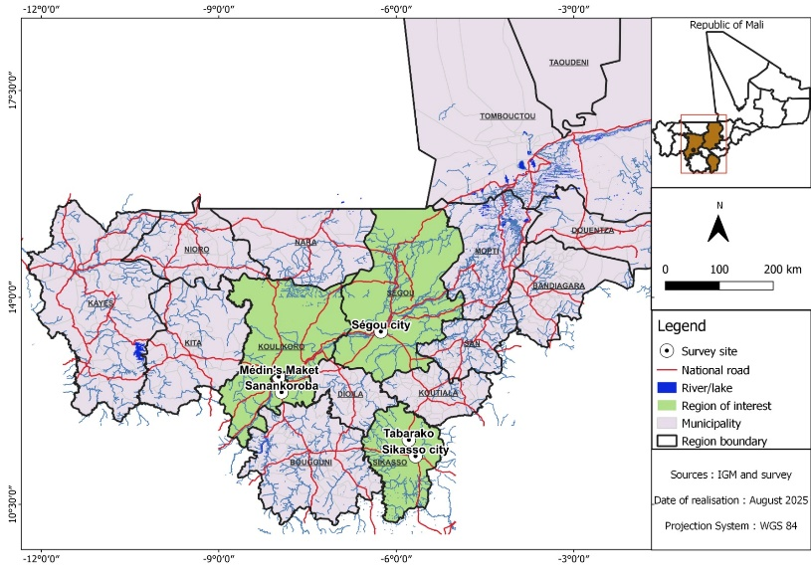
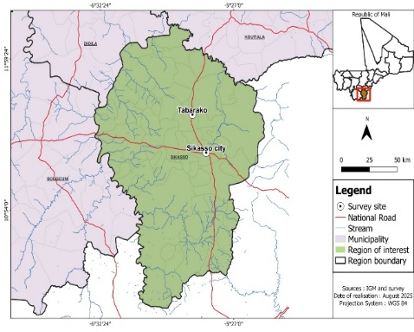
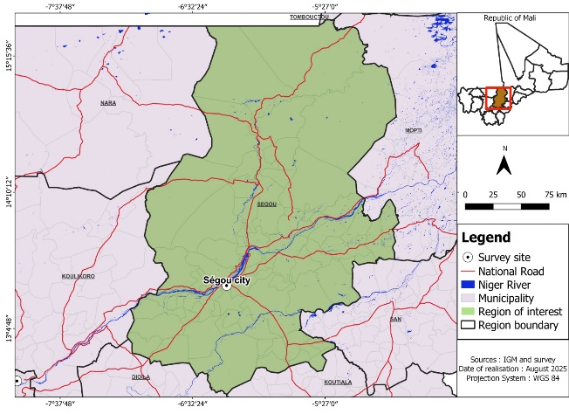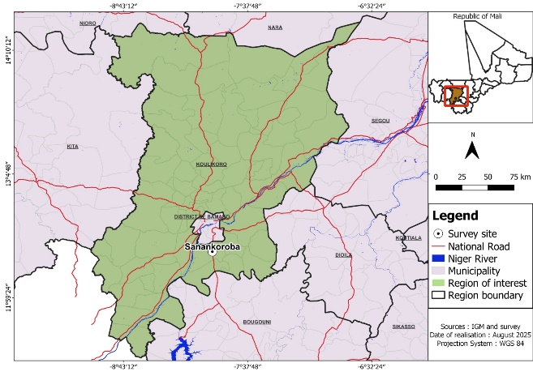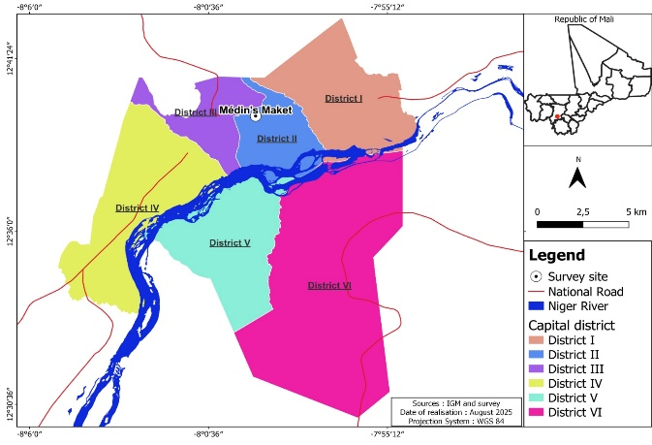
Fig. 1. Maps of ethnobotanical survey and harvested zones (Institute of Geography of Mali, 2025)

2.3 Questionnaire
The survey method relied on an ethnobotanical questionnaire administered during individual interviews. The questionnaire comprised five sections: identification (informant, interviewer, plant), plant part used, preparation of the remedy, mode of application, and other uses. It gathered both informant profiles and ethnopharmacological data for each plant.
2.4 Data Collection
The ethnobotanical survey was carried out from September to December 2018. Data were collected through oral interviews conducted randomly at 38 selected sites, in the local language Bamanankan. Informants were interviewed individually using a structured questionnaire completed through oral responses. The first section of the questionnaire concerned the informant (age, sex, education level, residence, housing), and the second focused on information about F. virosa (vernacular name, plant parts used, methods of preparation, and modes of administration).
2.5 Plant Collection
The plant organs (leaves, bark, and roots of F. virosa) were collected at the two harvest sites and sampled. Collections were made from October to November 2018, during the post-rainy season. The plants were harvested in Sikasso (Tabarako village, Gongassa commune, 45 km from Sikasso city) and Koulikoro (Korè village, Bougoula commune, Sanankoroba sub-prefecture).
2.6 Preparation of Plant Material
Freshly harvested leaves, bark, and roots were dried at room temperature in the laboratory. The organs were then ground into powder. The leaf powder was fine and green, while the root powder was ochre-yellow. These powders were used for phytochemical screening.
Preparation of Aqueous Extracts
Twenty grams of powdered plant material were ground and placed in 200 mL of distilled water, then boiled under reflux with stirring for 15 minutes. The resulting solution was filtered under vacuum after cooling. The filtrate was evaporated to dryness in an oven for 24 h. The solid product obtained was ground and stored at 4 °C.
Phytochemical Screening
This rapid characterization aimed to detect the qualitative presence of different chemical constituents. The study was based on:
- formation of insoluble complexes;
- formation of colored complexes.
We performed a screening of aqueous extracts to highlight the presence or absence of specific secondary metabolites in the different organs of F. virosa using standard reagents. The compounds tested included alkaloids, flavonoids, saponins, tannins, etc. These tests allowed for a rapid assessment of the chemical composition of the aqueous extracts.
Tests performed
- Alkaloids: 2 mL of each extract were mixed with 5 mL of 10% HCl, incubated in a water bath, then divided into two portions. Mayer’s reagent was added to the first, Wagner’s reagent to the second. Formation of a white or brown precipitate confirmed alkaloid presence (Mojab et al., 2003).
- Flavonoids: 1 mL of extract was treated with concentrated HCl and a few milligrams of magnesium turnings. A red-orange or pink color indicated a positive test (N’Guessan et al., 2009).
- Tannins: 1 mL of extract was mixed with 2–3 drops of 1% FeCl₃ solution. After a few minutes of incubation, the appearance of a blue or dark green color indicated a positive reaction (Belfekih et al., 2017).
- Sterols and triterpenes (Liebermann–Burchard reaction): 1 mL of extract was mixed with 1 mL of acetic anhydride and a few drops of concentrated H₂SO₄. Steroids yielded a violet to green color, while a brown interfacial layer indicated triterpenic saponins (Edeoga et al., 2005).
- Free quinones: 1 mL of extract mixed with a few drops of 1% NaOH. The appearance of yellow, red, or violet color confirmed the presence of free quinones (Kasouni et al., 2021).
- Terpenoids: 1 mL of extract was treated with 0.4 mL chloroform and 0.6 mL concentrated H₂SO₄. A positive reaction was indicated by two layers with a brown interphase (Khan et al., 2011).
- Anthraquinones: 1 mL of extract was mixed with 0.5 mL of 10% NH₄OH and shaken. A violet color confirmed a positive result (Oloyede, 2005).
- Reducing sugars: 5 mL of extract were mixed with 1 mL of Fehling’s solution (A + B) and heated in a water bath for 5 minutes. Formation of a brick-red precipitate confirmed reducing sugars (Cai et al., 2011).
- Amines: One drop of extract was applied to filter paper, dried at 80 °C, then treated with one drop of ninhydrin. The paper was dried at 110 °C for 5 minutes. A violet spot indicated the presence of amines (Kasouni et al., 2021).
- Saponins: 1 mL of extract was mixed with 2 mL of hot distilled water, shaken for 15 seconds, then left to stand for 15 minutes. A persistent foam layer greater than 1 cm indicated the presence of saponins (Bammou et al., 2015).

3. results and discussion

3.1 Ethnobotanical Survey
The results obtained during this ethnobotanical survey are summarized in the tables below:
Table 1. Traditional medicinal uses of the leaves of F. virosa (Roxb. ex Willd.)

Diseases treated | Dosage | Sites
Schistosomiasis | Decoction of 4 bundles for women and 3 bundles for men + a few roots. One coffee cup (200–300 mL) to drink 3 times per day, until recovery. Oral route and sitz bath | Ségou
Infant teething | Decoction of 4 bundles for girls and 3 bundles for boys. A few sips 2 times per day for 7 days. Oral route and bath | Ségou, Sikasso
Tiredness | Decoction of a few bundles. One cup (~500 mL) 3 times per day for 3 days. Oral route and bath | Ségou
Fibroids | Infusion of powder. One spoonful in a glass to drink 3 times per day for 1 month. Oral route | Bamako
Typhoid fever | Decoction of 4 bundles for women and 3 bundles for men. One glass to drink 3 times per day for 2 weeks. Oral route and bath | Ségou
Urinary infections | Decoction of 4 bundles of leaves + a few roots. One glass to drink 3 times per day, until recovery. Oral route and sitz bath | Ségou
Stomach aches | Decoction of a few bundles. One coffee cup 3 times per day for 1 week. Oral route | Bamako, Ségou, Sikasso
Irregular menstruation | Decoction of 4 bundles. One cup 3 times per day for 1 month. Oral route | Bamako
Malaria | Decoction of 4 bundles for women and 3 bundles for men. One glass to drink 3 times per day for 2 weeks. Oral route and bath | Ségou, Sikasso, Sanankoroba
Loss of appetite | Decoction of a few bundles. One glass 3 times per day before meals for 1 week. Oral route | Bamako, Sikasso
Cervical softening (before childbirth) | Decoction of 4 bundles. One cup 3 times per day, renewed until delivery. Oral route and bath | Sanankoroba, Ségou

Table 2. Traditional medicine uses of the root of F. virosa (Roxb. ex Willd.)
Diseases treated | Dosages |  | Sites
Sexual weakness | Maceration  1/8 glass taken before bedtime, duration not specified.  Oral route. |  | Sikasso, Ségou
Hepatitis | Maceration  1 cup, 3 times per day for 1 month. Oral route and bath. | Sanankoroba
Irregular menstruation | Decoction of root + leaves  1 cup, 3 times per day for 1 month. Oral route. | Bamako
Intestinal worms | Decoction of root + bark  1 cup, 3 times per day for two weeks.  Oral route. |  | Ségou, Bamako

Table 3. Traditional medicinal uses of the bark of F. virosa (Roxb. ex Willd.)
Diseases treated | Dosages | Sites
Intestinal worms | Decoction of roots + bark.  One glass 3 times per day.  Oral route | Ségou
Approximate mass of a bundle of dried leaves of F. virosa: 56.82 ± 5.51 g

Based on the collected data, 15 ailments were recorded as being treated with F. virosa. The most frequently cited diseases include stomach aches, infections and schistosomiasis.
A decoction of F.virosa leaves is taken orally for stomach aches in Bamako, Ségou and Sikasso, for loss of appetite in Bamako and Sikasso. A decoction of leaves is also used for the treatment of schistosomiasis in Ségou. However, a decoction combining leaves and roots is used for the samed treatment in Bamako (oral route and sitz bath). A decoction of leaves is used to soften yhe cervix before delivery in Sanankoroba and Ségou. A decoction of roots and bark is taken orally to treat intestinal worms in Ségou.
All parts of F. virosa are used but in different proportions. The leaves the most commonly used, accounting for 57%, followed by the combination of leaves and roots (21%), roots alone (14%) and the least used being the combination of roots and bark (7%). The most frequently employed methods of preparation are decoction (79%), maceration (14%) and infusion (7%).
3.2 Aqueous extract
The results of the decoction of F.virosa different organs are presented in Table 4
Table 4. Yields of aqueous extracts from different organs of F. virosa
Yield (%)
 | Leaves | Bark | Root
Sanankoroba | 39,8 | 22,85 | 21,45
Sikasso | 38,1 | 27,95 | 11,8

3.3 Phytochemical Screening
The results of the phytochemical analysis are presented in Table 5 classified by chemical families. Eleven chemical groups were characterized: alkaloids, quinones, tannins, flavonoids, steroids and terpenes, anthraquinones, free quinones, reducing sugars, saponosides and amines.

Table 5. Results of phytochemical screening of different organs of F. virosa

F. virosa
Phytochemical constituents | Sikasso |  |  | Sanankoroba
Phytochemical constituents | Leaves | Bark | Roots | Leaves | Bark | Roots
Tannins | + | + | + | + | + | +
Flavonoids | + | + | + | + | + | +
Alkaloids | + | + | + | + | + | +
Sterols & triterpenes | + | + | + | + | + | +
Free quinones | + | + | + | + | + | +
Terpenoids | + | + | + | + | + | +
Anthraquinones | + | + | + | + | + | +
Reducing sugars | + | + | + | + | + | +
Amines | + | + | + | + | + | +
Saponosides | – | – | – | – | – | –
+ : Positive reaction; – : Negative reaction.

The analyses revealed the presence of all the characterized secondary metabolites with the exception of saponins.

The results of the ethnobotanical survey reveal a therapeutic use diversified of F.virosa in Ségou, Sikasso, Bamako and Sanankoroba, addressing pathologies affecting children, adults and pregnant women. This result show the endogenous knowledge richness and the trust placed in this plant in traditional medicine.
Several ailments were cited: infectious diseases (malaria, urinary tract infections, typhoid fever), digestive disorders (loss of appetite, stomach aches), gynecological and obstetric disorders (irregular menstruation, fibroids, preparation for childbirth), childhood ailments (teething) as well as general conditions (fatigue). These findings demonstrate the large therapeutic spectrum of F.virosa, valued for its antimicrobial and febribuge properties and for its effect on the reproductive health.
In accordance with other populations, decoctions of the leaves and roots of F.virosa are taken orally as an aphrodisiac and the roots are used in the treatment of malaria in Uganda (Kamatenesi-Mugisha & Oryem-Origa H, 2005; Tabuti, 2008). F. virosa is used to treat malaria in the comoros (Kaou et al., 2008) and has been cited in Togo for its antiparasitic activity (Kpabi et al., 2020). F. virosa is traditionally employed in the treatment of various ailments such as pain, fever, malaria, diabetes, snake bites, sexual dysfunctions, etc.(Zengin et al., 2022). The plant has been recognized for its biological activity against schistosomiasis in Senegal. In Kenya, F. virosa is also part of malaria treatment (Gathirwa et al., 2011).
Among the different preparation methods, decoction and maceration were more frequently preferred by traditional health practitioners and herbalists than infusion. Decoction is the most commonly used method of preparation by traditional healers (Salifou, 2023). For some researchers, decoction enables the extraction of the maximum amount of active principles while reducing or eliminating the toxic effects of certain remerdies (Adou et al., 2018).
We observed that oral administration and body baths are the main routes of administration, compared to local application. Our results are consistent with those found by Ouattara, (2006), Ouro-Djeri et al., (2022) and M. Khan et al., (2011) which also reported oral administration as the most frequently used route. According to our results, despite the differences between study sites, there is a certain consistency in the information provided by herbalists and traditional healers.
The dosage is based on empirical measures, notably the number of “bundles” of the plant, which has a link with gender ( 4 bundles for women and 3 bundles for men). The frequency of administration is relatively constant with variable durations depending on the pathology.
The phytochemical screening carried out on aqueous extracts of all organs of F. virosa from both sites revealed the presence of alkaloids, tannins, flavonoids, sterols, and triterpenes, among others. Only saponins were absent in our aqueous extracts. The phytochemical profiles of the samples from Sikasso and Sanankoroba are similar, with no qualitative differences observed between the two harvesting areas. This homogeneity suggests a relatively stable chemical composition despite different environmental conditions.
Our results corroborate those reported by other authors, according to which crude aqueous extracts of F.virosa exhibit a chemical richness. All group of compounds identified: alkaloids, sterols ans triterpenes, saponins, flavonoids, free quinones, tannins, anthocyanins, reducing sugars and aromatic amino acids have been detected in F. virosa extracts (Souleymane et al., 2023). The presence of tannins, flavonoids, saponins and triterpenes has also been demonstrated in F.virosa leaf extracts (Traoré et al., 2019). The absence of saponins in our extracts, while reported in previous studies, could be due to the geographical area of collection (climatic factors, soil type, harvest period) (Koudoro et al., 2018). It is well established that gene expression, particularly the content of enzymes catalyzing the biosynthetic pathways of secondary metabolites in plants, is regulated by abiotic factors such as climate, geological environment of the harvesting site and harvest season. Thus, assuming that plants can adapt to environmental conditions at the collection site by modulating their metabolic pathways, the differences observed may be explained (Dembele, 2023).
In this study, we attempted to justify the presence of chemical substances in aqueous extracts of F. virosa that may explain its uses in traditional medicine. The therapeutic properties of secondary metabolites have been widely reported in the literature (Samaké et al., 2020). The use of F.virosa in traditional medicine can be explained by the richness in bioactive secondary metabolites identified through phytochemical screening.
Flavonoids possess anti-inflammatory and antispasmodic properties and have a significant bactericidal effect (Akré et al., 2022; Nnanga et al., 2019). This class of phytochemical compounds are also known for their antioxidant, antimicrobial, anticancer and anti-inflammatory activities, as well as for their ability to reduce blood pressure. Alkaloids has demonstrated important pharmacological effects, such as antimalarial, antibacterial, antihypertensive, anti-inflammatory, antifungal, anticonvulsant, analgesic, and cardiotonic activities. Terpenoids also exhibit antimicrobial, antifungal, antiparasitic, antiviral, antispasmodic, antihyperglycemic, anti-inflammatory, and immunomodulatory properties (Rabi & Bishayee, 2009; Shah et al., 2021). Tannins are polyphenols compounds that exhibit antimicrobial, antiviral and antiparasitic effects (Huang et al., 2018). They are also known for their antioxidant, anti-inflammatory and cardioprotective properties (Cosme et al., 2025).
Sterols and triterpenes present potential antiviral properties (anti-hepatite B and C virus activities, anti HIV1 and 2, anti herpes simplex virus) (Hisham Shady et al., 2020).
Indeed, the therapeutic action of plants results from the combination of these phytochemical elements or secondary metabolites synthesized by plants (Houmènou et al., 2018). The secondary metabolites identified in the aqueous extracts of F. virosa are known for their antimicrobial, antiparasitic, anti-inflammatory, and antioxidant properties, which corroborates the documented ethnobotanical uses (malaria, schistosomiasis, urinary tract infections, fever, digestive disorders, etc.). The anti-infectious activity of F. virosa could be attributed to the presence of alkaloids and flavonoids. Its use in malaria treatment may be explained by the presence of alkaloids and anti-hepatitis by steroids and triterpenes.
The present study highlights the ethnobotanical relevance and phytochemical potential of F. virosa, a species widely used in traditional medicine for the treatment of various ailments. While the qualitative screening confirmed the presence of several classes of secondary metabolites likely responsible for the observed biological properties, further studies are needed to identify the specific compounds underlying these effects.
Future investigations should adopt a bioactivity-guided fractionation strategy to isolate and charaterize the bioactive constituents responsible for the pharmacological actions attributed to F. virosa. For this purpose, simple and reliable bioassays should be developed to assess key traditional indications including antimicrobial, antiparasitic, or antischistosomal activities, can be evaluated using accessible in vitro or mortality assays on revelant pathogens.
Identifying the compounds responsible for these activities would also pave the way for quality control and standardization of F.virosa based preparations, thus contributing to the rational development of Improved Traditional Medicine. Such an integrative approach, combining ethnobotanical knowledge, phytochemical analysis and bioassay-guided isolation, represents a promising avenue to bridge traditional medicine and modern pharmacological validation
4. Conclusion
At the end of this study, which contributes to ethnobotanical and phytochemical research on F.virosa collected from two different sites in Mali we were able to gather valuable information on the traditional uses of this plant in the treatment of various diseases. All plants organs were cited in the management of the fifteen ailment recorded. The phytochemical screening revealed the presence of several secondary metabolites with well-documented therapeutic effects. This richness in bioactive compounds may justify its use in traditional medicine.
Despite F. virosa numerous applications in traditional healing practices, no recent scientific study has reported the uses of this plant in relation to its geographical origin nor correlated these applications with the chemical composition of the different organs from plants collected across distinct sites.

References

Adou, L.M.D., Gonezieti, B.B.H.J., & Zirihi, G.N. (2018). “Ethnobotanical Survey and Uses of Pteridophytes of Banco National Park, Abidjan District (Côte d’Ivoire).” Journal of Animal & Plant Sciences 38 (2): 6206-16.

Akré, D., Sosthène, T., Kan, B.K., Obou, C.O., Diakité, D., Auguste J. B.A., Ackah J.A.B.A., & Djaman A J. (2022). “Phytochemical Screening and Antimicrobial Activities of Hydroacetonic Extracts of Baphia Nitida (Fabaceae) on Shigella spp. and E. coli, Two Enterobacteria Involved in Infantile Diarrhea in Daloa, Côte d’Ivoire.” European Scientific Journal ESJ 11 (November). https://doi.org/10.19044/esipreprint.11.2022.p711.

Bailly, C. (2024). “Traditional Uses, Pharmacology, and Phytochemistry of the Medicinal Plant Flueggea Virosa (Roxb. Ex Willd.) Royle.” Future Pharmacology 4 (1): 77-102. https://doi.org/10.3390/futurepharmacol4010007.
Bammou, M., Daoudi, A., Slimani, I., Bammou, M., Najem, M., Bouiamrine, E., Ibijbijen H., & Nassiri, J. L., (2015). “Valorization of Mastic Tree (Pistacia lentiscus L.): Ethnobotanical Study, Phytochemical Screening, and Antibacterial Activity.” Journal of Applied Biosciences 86 (1): 7966. https://doi.org/10.4314/jab.v86i1.4.

Belfekih, F., El Yahyaoui O., Mariam, E. A., Chleh M., Ould Abdellahi L., Amal S. L, Lrhorfi A., & Bengueddour R. (2017). “Phytochemical Screening of Arbutus unedo L.” American Journal of Innovative Research and Applied Sciences.
Cai, L.Y., Feng, X. S., & Xia G. (2011). “Preliminary Phytochemical Analysis of Acanthopanax trifoliatus (L.) Merr.” Journal of Medicinal Plants Research.

Cosme, F., Aires, A., Pinto, T., Oliveira, I., Vilela, A., & Gonçalves B. (2025). “A Comprehensive Review of Bioactive Tannins in Foods and Beverages: Functional Properties, Health Benefits, and Sensory Qualities.” Molecules 30 (4): 800. https://doi.org/10.3390/molecules30040800.

Dembele, N. (2023). “Ethnobotanical, Phytochemical, and Biological Studies of Detarium microcarpum Guill & Perr (Fabaceae) and Flueggea virosa (Roxb. ex Willd.) Voigt (Euphorbiaceae), Two Medicinal Plants Collected in Mali.” Université des Sciences, des Techniques et des Technologies de Bamako.

Dembele, N., Somboro, A., Badiaga, M., Cissé, S., Cissé, Mody., Nick, P., & Traore, N. (2022). “Ethnobotanical Survey and Phytochemical Screening of Aqueous Extracts from Detarium microcarpum Guill. Perr in Mali.” Journal of Medicinal Plants Research 16 (10): 280-87. https://doi.org/10.5897/JMPR2022.7256.

Dénou, A., Haïdara, M., Diakité, F., Doumbia F., Dembélé, D. L., & Sanogo R., (2021). “Phytochemicals and Biological Activities of Flueggea virosa (Phyllanthaceae) Used in the Traditional Treatment of Benign Prostatic Hyperplasia in Mali.” Journal of Diseases and Medicinal Plants 7 (4): 119. https://doi.org/10.11648/j.jdmp.20210704.14.

Edeoga, H.O., Okwu, D.E., & Mbaebie, B.O. (2005). “Phytochemical Constituents of Some Nigerian Medicinal Plants.” African Journal of Biotechnology 4 (7): 685-88. https://doi.org/10.5897/AJB2005.000-3127.
Gathirwa, J.W., Rukunga, G.M., Mwitari, P.G., Mwikwabe, N. M., Kimani, C .W., Muthaura, C. N., Kiboi, D. M., Nyangacha, R.M., & Omar, S. A.(2011). “Traditional Herbal Antimalarial Therapy in Kilifi District, Kenya.” Journal of Ethnopharmacology 134 (2): 434-42. https://doi.org/10.1016/j.jep.2010.12.043.
Hisham Shady, N., Youssif, K. A., Sayed, A. M., Belbahri, L., Oszako, T., Hassan, H. M., & Abdelmohsen, U. R. (2020). Sterols and Triterpenes : Antiviral Potential Supported by In-Silico Analysis. Plants, 10(1), 41. https://doi.org/10.3390/plants10010041
Houmènou, V., Adjatin, A., Assogba, F., Gbénou, J., & Akoègninou, A. (2018). “Phytochemical and Cytotoxicity Study of Some Plants Used in the Treatment of Female Infertility in Southern Benin.” European Scientific Journal, ESJ 14 (6): 156. https://doi.org/10.19044/esj.2018.v14n6p156.

Huang, Q., Liu, X., Zhao, G., Hu, T., & Wang, Y. (2018). “Potential and Challenges of Tannins as an Alternative to In-Feed Antibiotics for Farm Animal Production.” Animal Nutrition 4 (2): 137-50. https://doi.org/10.1016/j.aninu.2017.09.004.

Kamatenesi-Mugisha, M., & Oryem-Origa, H. (2005). “Traditional Herbal Remedies Used in the Management of Sexual Impotence and Erectile Dysfunction in Western Uganda.” African Health Sciences 5 (1): 40-49.

Kaou, A. M., Mahiou-Leddet, V., Hutter, S., Aïnouddine, S., Hassani, S., Ibrahim, Y., & Ollivier, E. (2008). “Antimalarial Activity of Crude Extracts from Nine African Medicinal Plants.” Journal of Ethnopharmacology 116 (1): 74-83. https://doi.org/10.1016/j.jep.2007.11.001.

Kasouni, A., Theodoros I., Chatzimitakos, G., Stalikas, C. D., Trangas, Theoni., Papoudou-Bai, A., & Anastassios, N. T. (2021). “The Unexplored Wound Healing Activity of Urtica dioica L. Extract: An In Vitro and In Vivo Study.” Molecules 26 (20), 6248. https://doi.org/10.3390/molecules26206248.

Khan, M.A., Qureshi, R. J., Ullah,F., Gilani,S., Nosheen, A., Sahreen,S., Leghari, M., Laghari, I., & Hussain, M. Y. (2011). “Phytochemical Analysis of Selected Medicinal Plants of Margalla Hills and Surroundings.” Journal of Medicinal Plants Research. http://www.academicjournals.org/JMPR.

Khan, S., Gupta, G. K., Agrawal, D., Nawaz Zaidi, S. H., Batra, J., Syed, S., Sharma, L., Khambira, M., Haile, D. A., Sethy, G., & Singh, S. K. (2024). The Big Catch-up: Addressing Zero-Dose Children as a Surrogate of Vaccination Disruptions During Public Health Emergencies: A review of literature. European Scientific Journal, ESJ, 20(36), 19. https://doi.org/10.19044/esj.2024.v20n36p19
Koudoro, Y. A., Pascal, D. Cokou, A., & Diane, B. (2018). “Secondary Metabolites and Biological Activities of the Trunk Bark Extracts of Khaya senegalensis, a Veterinary Plant Harvested in Benin.” International Journal of Innovation and Applied Studies 23: 441-50.

Kpabi, I., Amégninou A., Yao H., Passimna P., Tchadjobo T., & Komlan B. (2020). “Ethnobotanical Study of Plants with Antiparasitic Activities Used in Traditional Medicine in the Prefecture of Doufelgou, Northern Togo.” Journal of Applied Biosciences 148 (April), 15176-89. https://doi.org/10.35759/JABs.148.2.

Mojab, F., Kamalinejad, M., Ghaderi, N., & Vahidipour, H.R. (2003). “Phytochemical Screening of Some Species of Iranian Plants.” Iranian Journal of Pharmaceutical Research 2 (2). https://doi.org/10.22037/ijpr.2010.16.

N’Guessan, K., Kadja, B., Zirihi, G., Traoré, D., & Aké-Assi, L. (2009). “Phytochemical Screening of Some Ivorian Medicinal Plants Used in Krobou Country (Agboville, Côte d’Ivoire).” Sciences & Nature 6 (1). https://doi.org/10.4314/scinat.v6i1.48575.

Nnanga, N., Soppo, L.V., Nokam, A.B.E., & Nyangono, N.M. (2019). “Identification of Families of Bioactive Compounds and Secondary Metabolites Justifying the Use of Trichoscypha odonii De Wild in Traditional Medicine.” Health Sci. Dis 20 (6): November-December 2019.

Noudamadjo, A., Glinma, B., Kpadonou, B., Goueti B., Assogba, F., Medegan, S., Kpoviessi, S., Gbaguidi, F.(2025). “Study of the Medicinal Plant Flueggea virosa: Review on Its Uses and Some Phytochemical and Biological Properties for the Last Decade.” American Journal of Plant Sciences 16 (03): 378-97. https://doi.org/10.4236/ajps.2025.163030.

Oloyede, O.I. (2005). “Chemical Profile of Unripe Pulp of Carica papaya.” Pakistan Journal of Nutrition 4 (6): 379-81.

Ouattara, D. (2006). “Contribution to the Inventory of Significant Medicinal Plants Used in the Divo Region (Southern Forest Area of Côte d’Ivoire) and to the Diagnosis of Guinea Pepper: Xylopia aethiopica (Dunal) A. Rich. (Annonaceae).” Université de Cocody-Abidjan (Côte d’Ivoire).

Ouoba, K., Lehmann, H., Semde, R. & Pabst, J.-Y. (2022). “Literature Review on Pharmacovigilance of Medicines Derived from Traditional Pharmacopeias. Part I: Identification of Risks.” Annales Pharmaceutiques Françaises 80 (5): 646-58. https://doi.org/10.1016/j.pharma.2021.11.008.

Ouro-Djeri, H., Koudouvo K., & Tchacondo, C. (2022). “Ethnopharmacological Study of Plants Used in Traditional Medicine in the Canton of Sédomé, on the Edge of Togodo-Sud National Park, Yoto District, Togo.” 38 (2): 286-304. International Journal of Innovation and Applied Studies.
PROTA. (2010). “Plant Resources of Tropical Africa.” http://database.prota.org/PROTAhtml/Corchorus%20olitorius_En.html

Pullaiah, T. (2023). Bioactives and Pharmacology of Medicinal Plants: Volume 1. Apple Academic Press, Incorporated.

Rabi, T., & Bishayee, G.(2009). “Terpenoids and Breast Cancer Chemoprevention.” Breast Cancer Research and Treatment 115 (2): 223-39. https://doi.org/10.1007/s10549-008-0118-y.
République du Mali, Ministère de l’Environnement, Direction nationale de la conservation de la nature. (2008). “Annual Activity Report 2007.”

Salifou, Z. S. (2023). “Ethnobotanical Study of Medicinal Plants Used in Traditional Treatment of Snake Bites in Rural Areas of Benin.” Journal of Applied Biosciences 189 (September): 19885. https://doi.org/10.35759/JABs.189.1.

Samake, S., Togola, I, Diarra N., Samake, M., & Sanogo R. (2020). “Ethnobotanical Study and Phytochemical Screening of Ornamental Plants with Therapeutic Uses in the District of Bamako, Mali.” International Journal of Advanced Research 8 (8): 251-62. https://doi.org/10.21474/IJAR01/11487.

Shah, Mohibullah, Sidra Bashir, Samavia Jaan, et al. 2021. “Computational Analysis of Plant-Derived Terpenes as α-Glucosidase Inhibitors for the Discovery of Therapeutic Agents against Type 2 Diabetes Mellitus.” South African Journal of Botany 143 (December): 462-73. https://doi.org/10.1016/j.sajb.2021.09.030.

Souleymane, H. D., Djibo, A. K., Seyni S. H. (2023). “Phytochemical Characterization and In Vitro Evaluation of the Anti-Sickle Cell Activity of Aqueous and Ethanolic Extracts of Two Medicinal Plants from Niger: Flueggea Virosa (Roxb. Ex Willd.) Royle and Kigelia Africana (Lam.) Benth.” Plants 12 (20): 3522. https://doi.org/10.3390/plants12203522.

Sourisseau, J. M., Soumaré, M., Beliers, J. F., Guengant, J. P. (2016). “Territorial Prospective on Demographic Dynamics and Rural Development in Sub-Saharan Africa and Madagascar: Territorial Diagnostic of the Ségou Region in Mali.” https://gfair.network/sites/default/files/Rapport%20diagnostic%20prospective%20Segou%20final.pdf.

Tabuti, J. R.S. (2008). “Herbal Medicines Used in the Treatment of Malaria in Budiope County, Uganda.” Journal of Ethnopharmacology 116 (1): 33-42. https://doi.org/10.1016/j.jep.2007.10.036.

Traoré, K., Haidara, M., Denou, A., Kanadjigui, F., Sogoba, M. N., Diarra, D., Maiga, S., & Sanogo, R. (2019). “Phytochemical Screening and Biological Activities of Four Plants Used in Mali for the Treatment of Malaria in Children.” European Scientific Journal ESJ 15 (6). https://doi.org/10.19044/esj.2019.v15n6p210.

Zengin, G., Dall’Acqua, S., & Kouadio I. S., (2022). “Gathering Scientific Evidence for a New Bioactive Natural Ingredient: The Combination between Chemical Profiles and Biological Activities of Flueggea Virosa Extracts.” Food Bioscience 49 (October): 101967. https://doi.org/10.1016/j.fbio.2022.101967

