Review Article

Review of gallium extraction methods: from state-of-the-art to sustainable approaches

.
ABSTRACT

This paper provides a detailed overview of the various techniques used to extract gallium from strategic sources. Conventional processes, such as acid leaching and solvent extraction, are commonly used to recover gallium from industrial residues such as coal fly ash, aluminum industry waste, bauxite residues, and Bayer liquor. Under optimized conditions, these methods can achieve extraction rates of over 90%. Alternative and more sustainable approaches are emerging, such as the use of supported liquid membranes and green solvents such as ionic liquids, which improve selectivity, reduce reagent consumption, and limit secondary pollution. Optimizing process parameters (pH, temperature, choice of extractants, sorption conditions) and developing new organic extractants or ion exchange resins can increase the efficiency of gallium recovery, even at very low concentrations. The article addresses the technological challenges associated with gallium recovery, highlighting the need for innovation to make these processes more viable and environmentally friendly in the long term, in a context of growing demand for electronic and energy applications.

Keywords: Gallium; Selective extraction; Industrial residues; Strategic sources

1. INTRODUCTION
Global demand for gallium (Ga) is growing exponentially, driven by the rise of cutting-edge technologies and strategic sectors. Projections estimate that gallium consumption could increase fivefold by 2030, far exceeding the annual production of 275 tons recorded in 2012 (Gladyshev et al., 2015). Gallium is a post-transition metal notable for its malleability, silvery color, and unique physical and chemical properties (Truong et al., 2023). In its solid state, it exhibits diamagnetic behavior, high electrical conductivity (7.1 × 10⁶ S/m), and notable thermal conductivity (29W/(m·K), while maintaining exceptionally low vapor pressure even at high temperatures, which distinguishes it from other metals (Truong et al., 2023; Jamwal et Kiani, 2022; Green et al., 2022).
Discovered experimentally in 1875 by Paul-Émile Lecoq de Boisbaudran, after being predicted by Mendeleev, gallium was first isolated in very small quantities from zinc ores using advanced spectroscopic techniques. Its amphoteric nature, which allows it to react with both acids and bases, gives it a wide range of chemical applications (Yu et Liao, 2011).
Gallium is now classified as a strategic and critical metal due to its central role in sectors such as electronics, aerospace, defense, and renewable energy (Jamwal et Kiani, 2022; Truong et al., 2023). Gallium is a strategic element that is essential for the production of next-generation semiconductors, particularly GaN and Ga₂O₃, which are revolutionizing power electronics technologies. These materials are at the heart of high-performance applications such as high-intensity lasers, high-efficiency LEDs, advanced photovoltaic cells, precision optoelectronic sensors, and ultra-fast optical communication networks (Han et al., 2008; Truong et al., 2023).
The high electronic mobility and thermal stability properties of gallium and its oxides make them materials of choice for next-generation devices, sometimes surpassing silicon and silicon carbide in terms of performance and energy efficiency (Geng and Bleischwitz, 2023; Ganguly et al., 2025). In addition, liquid gallium and its alloys, such as gallium-indium eutectic, are attracting growing interest for their applications in flexible electronics, biotechnology, energy catalysis, and medicine, particularly for their antimicrobial properties and biocompatibility (Zhao et al., 2023; Zika et al., 2024; Goss et al., 2018).
This wide range of applications highlights the strategic importance of gallium in many modern industries (Han, Liu, Xin, and al., 2024). This overview highlights the strategic importance of gallium in the modern economy and the need for technological innovations to meet growing demand while conserving resources and protecting the environment. Figure 1 shows the main uses of gallium based on volumes consumed for the manufacture of semi-finished and finished products in 2001 and 2021.
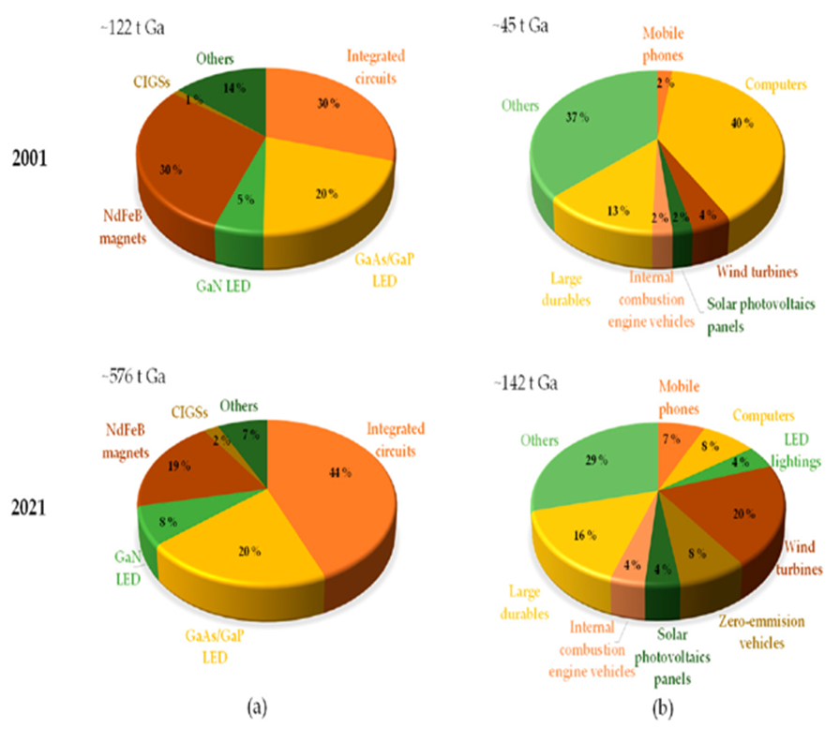
Figure 1. Distribution of gallium consumption: (a) semi-finished products; (b) finished products, based on global gallium flows in 2001 and 2021, according to data from (Han et al., 2024).
2. Sources and availability of gallium
Gallium (Ga) does not exist naturally in the form of distinct minerals; it is mainly recovered as a by-product during metallurgical processes, particularly during the extraction of alumina from bauxite (Larichkin et al., 2017; Han et al., 2024). Present in bauxite at concentrations generally ranging from 0.01% to 0.1% by weight, gallium is largely carried away in red mud, a solid residue from the Bayer process, which makes its recovery considerably more difficult due to the technical constraints and environmental challenges associated with managing this waste (Løvik, Restrepo et Müller, 2015; Han et al., 2024).
Zinc, via sphalerite, is another primary source, but gallium recovery remains complex and inefficient, requiring advanced industrial processes (Larichkin et al., 2017). In addition, fly ash generated by coal combustion is a promising secondary source of gallium, with recovery rates exceeding 90% under optimal conditions. However, the low metal content and the presence of complex impurities necessitate the use of advanced separation methods, such as ion exchange or adsorption (Chand et al., 2022).
However, the recovery of gallium from this waste remains limited due to low collection rates, technically complex treatment processes, and significant losses throughout the production chain (M. Ueberschaar, Otto et Rotter, 2017). For example, it is estimated that 40 to 60% of primary gallium production ends up in industrial waste or is stored without being recovered, and that the majority of gallium contained in end-of-life products is not recovered due to a lack of suitable industrial channels (Løvik, Restrepo et Müller, 2015; M. Ueberschaar, Otto et Rotter, 2017; Han, Liu, Xin, et al., 2024).
From an economic perspective, global demand for gallium quadrupled between 2000 and 2021, mainly driven by low-carbon technologies and advanced electronics, while China became the world's leading producer thanks to its alumina industry (Han, Liu, Xin, et al., 2024). Despite the possibility of increasing primary production with current technologies, the overall efficiency of the system remains low, and dependence on a few producing countries exposes the market to supply risks (Løvik, Restrepo et Müller, 2015).
3. Main Gallium-producing countries and their economic potential
The adoption of a circular economy model, combined with significant technological advances in extraction and recycling processes, as well as enhanced international collaboration, are essential levers for ensuring the sustainability of gallium supplies and supporting the sustainable development of strategic industrial sectors (Han, Liu, Xin, et al., 2024 ; Gao et al., 2024). Public policies, particularly in Europe, the United States, and Japan, encourage the development of recycling channels and the diversification of supply sources to reduce the risks associated with the geographical concentration of production (Løvik, Restrepo et Müller, 2015;Song et al., 2022). Given the rapid growth in demand, securing the supply of gallium is a major industrial and geopolitical challenge for the coming decades.
China dominates global gallium production, accounting for approximately 97-98% of primary production in 2020-2023, thanks to its integrated alumina industry and favorable industrial policies (Han, Liu, Xin, et al., 2024 ; Gao et al., 2024). Cette prédominance résulte d’une intégration verticale efficace reliant l’exploitation des gisements de bauxite à la production d’aluminium, d’une compétitivité accrue des coûts industriels, ainsi que d’un cadre politique favorable, marqué notamment par des restrictions à l’exportation et des subventions ciblées en faveur de la recherche sur les semi-conducteurs GaAs et GaN (Song et al., 2022 ; Gao et al., 2024).
Since August 2023, China has introduced a licensing system for gallium exports, causing a significant increase in prices on the global market and exacerbating tensions within Western countries' supply chains (Zhang, 2024 ; Cui et Jiang, 2025). Other countries, such as Japan, Russia, and the United States, play an important role in refining high-purity gallium and manufacturing advanced electronic components (Larichkin et al., 2017 ; Gao et al., 2024).
In 2022, gallium production in Russia amounted to approximately five tons, while countries such as Japan, South Korea, and Canada produced only a few tons or less, reflecting these players' limited contribution to the global market (Naumov, 2013). Between 2013 and 2019, several countries, including Hungary, Kazakhstan, and Ukraine, ended their primary gallium production, largely due to competitive pressure from China and the insufficient profitability of this activity on international markets (Naumov, 2013).
Although primary production has ceased in several countries, the refining of high-purity gallium for electronic applications remains active in Germany, the United States, Japan, Slovakia, Canada, and China. These nations occupy a strategic position in the global gallium value chain, particularly in the manufacture of advanced semiconductor materials, which are essential to cutting-edge technologies (Løvik, Restrepo et Müller, 2015 ; Frenzel et al., 2017).
Japan and the United States stand out as key players in the refining of high-purity gallium, which is essential for the production of advanced electronic devices, while Germany retains a central role in recycling and refining activities, thereby consolidating its position within the technology value chain (Frenzel et al., 2017).
Strengthening recovery technologies and establishing structured recycling channels appear to be essential levers for securing the supply of gallium and limiting dependence on Chinese primary production (Gao et al., 2024). Figure 2 illustrates global gallium consumption by application sector, providing valuable insight into contemporary global supply and demand dynamics.
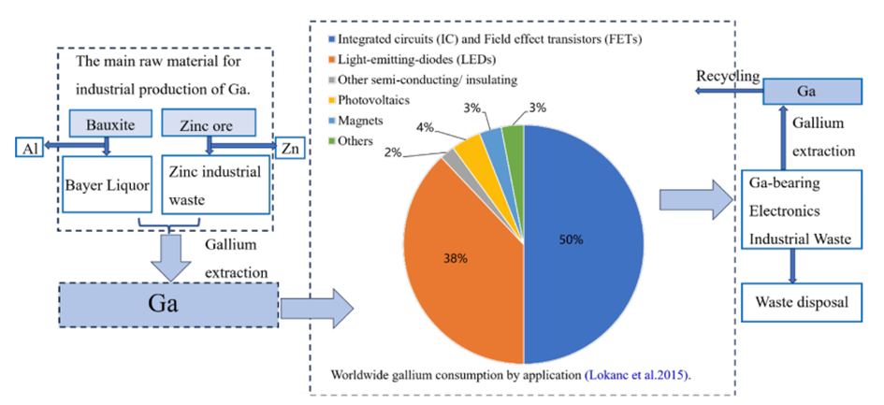
Figure 2. Gallium production and global consumption by application sector (Yuxin et al., 2025).
4. Recent processes for extracting gallium from primary sources and waste
- Recovery of gallium as a by-product of Bayer's liquor
The Bayer process, the main industrial process for extracting alumina from bauxite, involves heating bauxite with a concentrated solution of caustic soda (NaOH) at temperatures between 150 and 250°C. Under these conditions, the alumina (Al₂O₃) dissolves in the form of [Al(OH)₄]⁻ ions. Gallium, present in trace amounts in bauxite, is mainly found in the form of Ga³⁺. Due to its amphoteric nature, it mainly forms a tetrahedral complex with hydroxide ions, [Ga(OH)₄]⁻, which makes it theoretically soluble in the caustic liquor of the Bayer process, although its solubility is not completely complete (Vind et al., 2018 ; (Qu et al., 2024 ; Sipos, Megyes et Berkesi, 2008 ; Hoang et al., 2015). Several industrial and academic studies show that a significant proportion of gallium remains trapped in solid residues known as “red mud.” According to trace element distribution analyses, approximately 30% of the gallium initially present in bauxite is not recovered in the solution but ends up in red mud, which limits the overall gallium recovery yield (Vind et al., 2017). This distribution depends on many factors, including the mineralogy of the bauxite, operating conditions (temperature, NaOH concentration, contact time), and the presence of other trace elements or mineral phases that may trap gallium (Vind et al., 2018). For example, in 2021, 79% of gallium co-extracted from bauxite was lost in tailings, highlighting considerable recycling potential (Gao et al., 2024).
The extraction of gallium from solutions produced by the Bayer process is based mainly on four approaches: fractional precipitation, electrodeposition, solvent extraction, and ion exchange. Of these methods, fractional precipitation is one of the oldest and most historically used. It involves inducing the co-precipitation of gallium and aluminum by adding lime (Ca(OH)₂) or carbon dioxide (CO₂). Although it has the advantage of being low cost, this technique remains difficult to master operationally due to its complexity, which severely limits its large-scale industrial application (Hoang et al., 2015). Equations (1) and (2) illustrate the chemical reactions that occur during precipitation (Hoang et al., 2015). Equations (1) and (2) illustrate the chemical reactions occurring during precipitation:
2NaAlO₂ + 3H₂O + CO₂→2Al(OH)₃↓ + Na₂CO₃ Eq (1)
2NaGaO₂ + 3H₂O + CO₂→2Ga(OH)₃↓ + Na₂CO₃ Eq (2)
In equations (1 and 2), gallium and aluminum are both amphoteric, meaning they can form precipitates in both acidic and basic environments. However, the pH ranges required for their precipitation are not identical. It is therefore possible to separate them by precisely controlling the pH of the solution. Nevertheless, due to the complex composition of the solutions resulting from leaching, other ions may also precipitate, making the separation of gallium less effective. This process, in addition to being complex and unprofitable, has therefore been abandoned in current practices (Moskalyk, 2003). Mercury electrolysis is now banned due to its toxicity (Zhang et al., 2021). Electrodeposition includes cementation, based on redox reactions with metals such as aluminum.
Solvent extraction of gallium from Bayer leachate is an essential method for recovering this strategic metal, which is present in low concentrations in solutions produced during alumina production. This technique relies on the use of specific organic extractants capable of selectively separating gallium from major elements such as aluminum and sodium. This method is generally carried out using Kelex 100 (7-alkyl-substituted-8-hydroxyquinoline), dissolved in kerosene, often modified by the addition of alcohols such as isodecanol or ethanol to improve the solubility of the extractant and accelerate the extraction kinetics. This system allows between 80% and 98% of the gallium contained in the Bayer leachate to be recovered. However, in the absence of additives, the kinetics may remain slow, requiring several hours to reach equilibrium (Puvvada, Chandrasekhar et Ramachandrarao, 1996 ;Puvvada, 1999 ; Zhao et al., 2012).
The introduction of surfactants, such as petroleum sulfonate or Versatic 10, significantly improves extraction kinetics, reducing the time required to reach equilibrium to just a few minutes, while maintaining high recovery rates of up to 98% (Puvvada, 1999). In addition, parameters such as pH, extractant concentration, and stirring intensity play a key role in optimizing the selectivity and efficiency of the process (Kekesi, 2007). However, selectivity with regard to aluminum, which is very abundant in the leachate, is a major challenge. It can be improved by washing and stripping steps using hydrochloric acid, which effectively separate gallium from co-extracted aluminum (Borges and Masson, 1994). The use of alternative solvents such as ionic liquids is also being explored to improve the selectivity and environmental performance of the process.
(Raiguel, Dehaen and Binnemans, 2020) studied the use of two diluents based on triazolium 1,2,3 ionic liquids to optimize gallium extraction from spent liquids from the Bayer process, in combination with the Kelex® 100 extractant. The first, a hydrophobic triazolium ionic liquid, allows direct extraction of gallium. The second, a hydrophilic triazolium ionic liquid, forms a two-phase aqueous system in the presence of concentrated saline solutions, facilitating extraction after a cooling phase. Experimental results show that these systems significantly improve the kinetics and selectivity of extraction, paving the way for more efficient and sustainable alternatives to conventional organic diluents. (Sato and Oishi, 1986) determined the overall mechanism by analyzing the parameters influencing equilibrium (see equation 3).
Ga${(OH)}_{4 }^{-}$ + 3HK100 $↔$ Ga(K100)₃ + O$H^{-}$ + 3H₂O Eq (3)
In equation 3, the species in the organic phase are (3HK100 and Ga(K100)3).HK100 corresponds to the neutral acid form of Kelex® 100. (Sato and Oishi, 1986) confirmed previous hypotheses on the gallium extraction mechanism, while suggesting a similar extraction for aluminum and sodium extraction by neutralization (see equation 4).
Na⁺ + O$H^{-}$+ HK100 $↔$ NaHK100 + H₂O Eq (4)
Solvent extraction, although effective, faces competition from ion exchange, which dominates the industry due to its simplicity and efficiency, although the optimization of solvent extraction systems remains a promising area (Zhao et al., 2012). Among the techniques for extracting gallium from Bayer liquid, ion exchange is preferred on an industrial scale, particularly thanks to specific resins such as Duolite ES-346 and DHG586, which combine chemical stability and high efficiency. This process is notable for its simplicity of implementation, facilitating the selective separation and recovery of the metal. However, it has structural and operational limitations, such as the non-selective extraction of competing metals (such as vanadium) and the gradual degradation of the functional groups of the resins, reducing their lifespan and efficiency over cycles (Zhao et al., 2012) ; (Lu et al., 2017). The process involves capturing metal ions present in the aqueous phase using an ion exchange resin, then releasing them by elution, which facilitates their separation and purification (Adel et al., 2010 ; Zhang et al., 2021).
Exchange resins containing specific functional groups, such as amidoxime (Puromet MTS9701), have demonstrated a high capacity to extract gallium from Bayer's liquor, reaching up to 80% after 24 hours (Giannopoulou, Konstantakopoulou et Panias, 2023) ; (Qu et al., 2024). The amidoxime group consists of an oxime function (=N–OH) associated with an amine function (–NH₂), both attached to the same carbon atom. This molecular configuration promotes the formation of coordination bonds with the target metal ions, enabling their selective binding and facilitating the separation and purification steps (Adel et al., 2010).
The performance of the amidoxime group is based on rapid kinetics (75% in 5 hours at 50g/L), high selectivity towards gallium, probably due to interaction with the nitrogen atom of the amidoxime group, and good stability after several regeneration cycles (Giannopoulou, Konstantakopoulou et Panias, 2023). Adsorption follows the Freundlich isothermal model, while kinetics follow the pseudo-second-order model. Although alternatives, such as organic solvents or ionic liquids, are also used to extract gallium, they still have limitations in terms of selectivity and phase separation, particularly at low concentrations (Giannopoulou, Konstantakopoulou et Panias, 2023).
Extensive research conducted by (Z. Wang et al., 2024) focused on the co-adsorption of vanadium and gallium from the Bayer process using a hydroxylated anion resin (LSC-600S). Under optimal conditions, adsorption rates of 72% for vanadium and 74% for gallium were achieved. The process, which is spontaneous and endothermic, involves chemisorption, demonstrating the potential of this method for the selective recovery of critical metals.
In a similar approach, (Selvi et al., 2004) developed a chelating resin with hydroxamic groups, synthesized from an acrylonitrile-divinylbenzene copolymer. The addition of acrylic acid improved its stability, and gallium adsorption was optimized on particles ranging from 0.3 to 0.5 mm. Infrared analyses confirmed gallium complexation, while batch and column tests demonstrated good adsorption capacity and stability over 30 cycles. Figure 3 illustrates the schematic diagram of the synthesis sequence of polyhydroxamic resin.
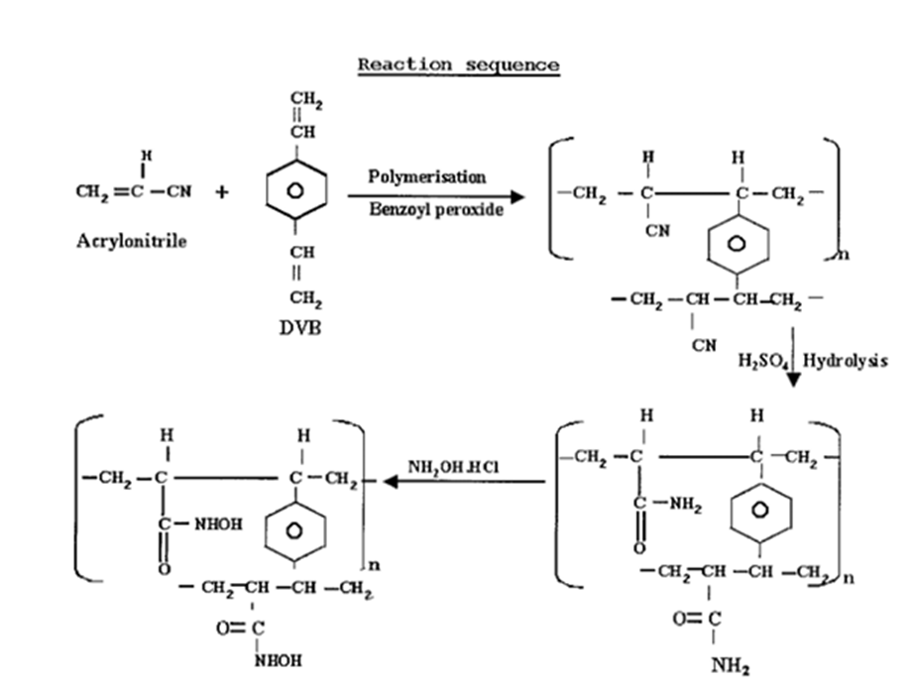
Figure 3. Diagram of the polyhydroxamic resin synthesis sequence (Selvi et al., 2004)
With the aim of optimizing gallium extraction in a basic environment, (Lu et al., 2019) designed an innovative adsorbent, poly(acrylamidoxime) supported on silica (PAO/SiO₂). This material, rich in chelating sites, is obtained in three steps: copolymerization of styrene and divinylbenzene with silica, grafting of acrylonitrile, then conversion to amidoxime. PAO/SiO₂ reaches gallium adsorption equilibrium in 60 minutes, with a maximum capacity of 1.34 to 2.6 mmol·g⁻¹ depending on the temperature and gallium salt. Desorption is complete in 45 minutes with 1.5 M HCl, and the material remains stable over five cycles. It shows excellent selectivity for Ga (III), surpassing the commercial resin LSC-600, particularly in the strongly basic environment typical of Bayer solutions. Figure 4 illustrates the detailed structure of this high-performance gallium adsorbent.
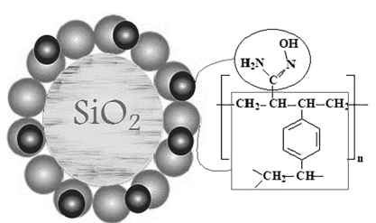
Figure 4. Proposed structure of the PAO/SiO₂ adsorbent material (Lu et al., 2019).
Figure 5 shows the FT-IR spectra of the PAN/SiO₂, PAO/SiO₂ materials, the adsorbent after gallium (III) fixation, and after desorption. The conversion of nitrile groups to amidoxime is confirmed by the disappearance of the peak at 2240 cm⁻¹ (C≡N) and the appearance of new bands at 3422, 1669, 1382, and 939 cm⁻¹, corresponding respectively to OH/NH, C=N, OH, and N–O vibrations. These spectral changes confirm the successful grafting of amidoxime groups onto the supported matrix. Furthermore, bands typical of Si–O–Si bonds, originating from the silicate structure of the support, are observed around 1110, 800, and 460 cm⁻¹ in all samples, attesting to the stability of the silica skeleton throughout the process (Lu et al., 2019).
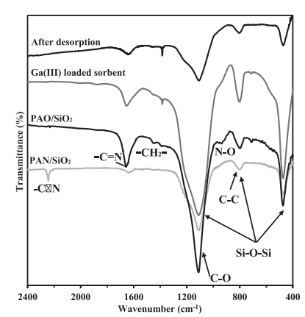
Figure 5. Spectres FT-IR des matériaux (PAN/SiO₂ et PAO/SiO₂) montrant les modifications chimiques du support et de l’adsorbant amidoxime après adsorption et désorption du Ga (III) (400–2400 cm⁻¹) (Lu et al., 2019).
A promising alternative for recovering gallium from Bayer liquor involves the use of electrochemical processes. Electrolysis, using solid or liquid cathodes, has been studied as a replacement for traditional mercury-based processes. However, despite their potential, these technologies still have limitations in terms of yield and efficiency (Urmosi et al., 2010 ; Qu et al., 2024). Similarly, selective precipitation of gallium from Bayer liquor, although economically attractive, has relatively low recovery rates and relies on complex operating protocols, thus limiting its industrial deployment (Qu et al., 2024).
(ABDOLLAHI and Naderi, 2007) studied the extraction of gallium contained in a concentrated Bayer liquor from the Jajarm plant (164.90 g/L Na₂O, 86.70 g/L Al₂O₃, 106.02 ppm Ga). The extractant system consisted of 10% Kelex® 100, 10% ethanol, and kerosene. At room temperature, with an organic/aqueous volume ratio of 1:1, an extraction yield of 93.39% was achieved in 60 minutes. The gallium was then desorbed using HCl (1.5 M), after selective leaching of the aluminum with HCl (5.0 M). The final solution contained 490 ppm gallium and 141.73 ppm aluminum, confirming efficient and partially selective recovery.
Other innovative adsorbents, such as amidoxime-functionalized crosslinked polyacrylonitrile (PAN) monoliths, have been developed to improve gallium extraction (Zhang et al., 2021). These materials, with a controlled porous structure and good mechanical strength, exhibit an adsorption capacity of up to 15.8 mg/g in 140 minutes, thanks to the synergy between physical and chemical adsorption.
Parallel work has focused on innovative materials for the selective adsorption of gallium, in particular resins and fibers based on polyacrylonitrile (PAN) functionalized with amidoxime groups. These materials offer high adsorption capacity (up to 26.9 mg/g) and good selectivity, even in the presence of competing ions, while maintaining their mechanical stability in highly alkaline environments (Zhang et al., 2019).
Nanofibrous membranes based on MIL-53(Al) functionalized with amidoxime groups (PAN/MIL-53-AO) also exhibit exceptional adsorption capacity (231mg/g) and high selectivity for gallium, with good regenerability over several cycles. The tetradentate amidoxime structure and the specific pore size of the MOF promote selectivity (Shi et al., 2024) . Furthermore, certain porous hierarchical membranes and amidoxime-treated nanofibers, obtained by phase separation or electrospinning, also exhibit rapid and high adsorption capacities (up to 88 mg/g for certain membranes and 39.8 mg/g for nanofibers), as well as good selectivity and satisfactory reusability (Qin et al., 2023).
It is also possible to use polyacrylonitrile nanofibers loaded with organophosphorus extractants, enabling high adsorption capacities (up to 33 mg/g) and good stability over several cycles (Segala et al., 2023 ; Segala, Bertuol et Tanabe, 2022). It should also be mentioned that materials based on zeolites or mesoporous carbons also offer promising alternatives for the selective and efficient recovery of gallium under various conditions (Díez et al., 2021). Table 1 compares the main materials, their performance, and their gallium adsorption capacity.
Table 1. Comparison of key materials and performance characteristics
Material / Process | Adsorption capacity (mg/g) | Selectivity / Key Benefits | References
Crosslinked amidoximated PAN (C-PAO) | 26,9 (simulé), 17,6 (Bayer) | Selective Ga, stable in alkaline environment. | (Zhang et al., 2019)
PAN/MIL-53(Al)-AO (MOF nanofiber) | 231 | Exceptional selectivity and regenerability | (Shi et al., 2024)
Amidoximated AN-DVB resin | ~46 –57% d’adsorption | Optimisation par réticulation/diluant | (Su, Liu et Zhang, 2010)
Hierarchical poly(vinyl amidoxime) membrane | 88,3 | Rapid adsorption, wide temperature range | (Chen et al., 2021)
Amidoximated PAN nanofiber (AOPAN NFs) | 39,8 | Rapid adsorption, Ga selectivity | (Qin et al., 2023)
Commercial resin LSC-700 | 29,2 | Langmuir model, good reusability | (Zhao et al., 2016)
  - Gallium recovery from red mud
Red mud, rich in unrecovered gallium, represents a potential secondary resource. Recent research is exploring the extraction of gallium and other valuable metals (iron, titanium, rare earths) from these bauxite residues using hydrometallurgical, pyrometallurgical, or bioleaching processes (Rai et al., 2025). However, the chemical complexity of red mud and its high alkalinity pose significant technical and environmental challenges (Vind, Vassiliadou and Panias, 2017 ; Rai et al., 2025). A thorough understanding of gallium distribution and trapping mechanisms within the various stages of the Bayer process remains essential to maximize recovery yields and minimize losses (Giannopoulou, Konstantakopoulou et Panias, 2023 ;Rai et al., 2025).
(Ujaczki et al., 2017) studied the recovery of gallium contained in red mud, a residue from the alumina industry, using microwave-assisted aqua regia digestion. Selective extraction of gallium was tested with several acids (HCl, HNO₃, H₂SO₄, and oxalic acid), with oxalic acid proving to be selectively effective. The optimal parameters determined by a Box-Behnken design of experiments are: 2.5 M oxalic acid, 21.7 hours of contact, 80°C, and 10 g/L pulp, achieving an extraction yield of 80%. This method highlights red mud as a promising secondary source of gallium, contributing to the security of supply of strategic metals.
(Lu et al., 2018) developed a three-step process to efficiently extract gallium from red mud. It combines hydrochloric acid leaching (94.77% Ga extracted), selective iron removal using ion exchange resin, and gallium concentration via a second ion exchange, achieving 59.84% adsorption and 95.32% desorption. This process offers a promising solution for the recovery of gallium-rich industrial residues. In their work, (Xue et al., 2019) developed a hydrothermal alkaline leaching process to selectively extract gallium from red mud, converting iron into less reactive α-Fe₂O₃. Under optimized conditions (20% NaOH, 120°C, 12hours), they achieved an extraction yield of 91.4% without iron contamination, demonstrating the efficiency and selectivity of this method.
The use of phosphoric acid (H₃PO₄) instead of sulfuric acid (H₂SO₄) allows for selective and more efficient extraction of gallium from red mud, achieving a yield of 95.9% under optimized conditions (100°C, 10 mol/L, 6h, liquid/solid ratio 9:1, agitation 400 rpm). This yield is 5% higher than that obtained with H₂SO₄, thanks to the reduction of unfavorable interactions between Ga³⁺ and silicate species, which keeps gallium in solution and improves its recovery (Zhu et al., 2024). Figure 6 illustrates the recovery of gallium by leaching using sulfuric acid and phosphoric acid, respectively.
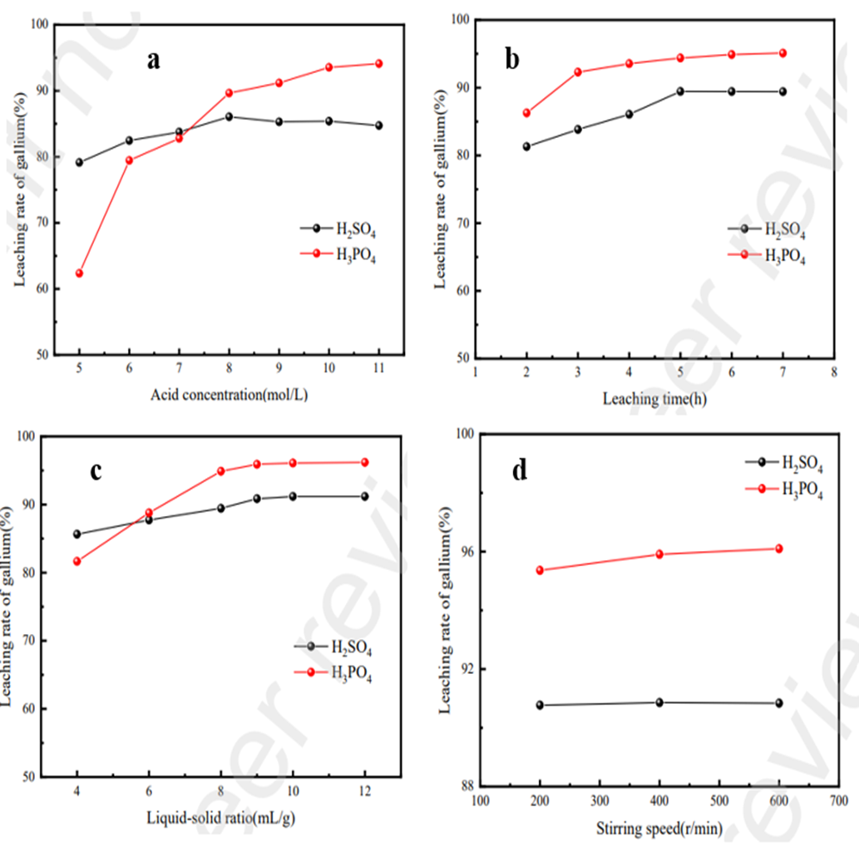
Figure 6. Recovery of gallium by leaching using sulfuric and phosphoric acid. (a) Effect of concentration; (b) effect of time; (c) effect of liquid/solid ratio; (d) effect of stirring speed on gallium leaching rate (Zhu et al., 2024).
  - Recovery of gallium from aluminum slag
The extraction of gallium from aluminum industry residues, particularly smelting slag and reduction cell dust, is a promising way to recover value from these by-products. Recent studies show that residues from the Hall-Héroult process, such as carbon dust and smelting slag, are promising secondary sources for gallium recovery, with concentrations of up to 4kg per ton in post-combustion ash (Shimanskii et al., 2021).
In the field of recovery, acid leaching using acids such as sulfuric, hydrochloric, or nitric acid is widely used to extract gallium from aluminum industry slag. However, the selectivity of these processes remains limited, mainly due to the chemical similarity between gallium and aluminum, which complicates their effective separation (Ettler et al., 2022 ; Rudnick, 2024).
The extraction of gallium from these residues involves a calcination step to concentrate the gallium, followed by acid leaching, enabling recovery rates of up to 98% (Losev et al., 2024). After leaching, gallium can be separated from other metals using ion exchange resins and then recovered by desorption with distilled water, which allows for effective separation of gallium from metal impurities (Losev et al., 2024 ; Yang et al., 2024 ; Zhu, Guo et Zheng, 2024). At the same time, bioleaching, which uses microorganisms that produce acidic metabolites, shows promise for selectively solubilizing gallium while reducing the environmental impact of processing (Potysz, van Hullebusch et Kierczak, 2018).
Approaches combining bioleaching and chemical precipitation show interesting potential, but the co-precipitation of gallium with aluminum, due to their similar chemical properties, remains a major obstacle to selective and efficient separation (Ettler et al., 2022 ; Potysz, van Hullebusch et Kierczak, 2018).
Recent advances include the use of modified mesoporous silica or functionalized graphene, which offer improved selectivity for gallium in complex solutions derived from residue leaching (Yang et al., 2024) ; (Rudnik, 2024). Optimization of operating parameters and the development of integrated processes combining leaching, selective adsorption, and controlled precipitation are essential to maximize gallium recovery while limiting the generation of secondary waste (G. Wang et al., 2024 ; Ettler et al., 2022) ; Potysz, van Hullebusch et Kierczak, 2018 ; Rudnik, 2024).
The recovery of industrial by-products addresses both economic challenges, due to the growing demand for gallium in advanced technologies, and environmental concerns related to waste management in the aluminum industry (Losev et al., 2024 ; Shimanskii et al., 2021).
It is in this context that, (Losev et al., 2024) developed an effective process for extracting gallium from carbon concentrate, a waste product of the aluminum industry. The process involves incinerating the concentrate at 600°C to remove carbon, followed by acid leaching with 6 mol/L HCl, achieving a yield of 98%. The gallium is then recovered by sorption on Purolite resins, with a maximum capacity of 2.7 mmol/g, and then almost completely desorbed (99%) with distilled water. Finally, the addition of soda ash allows the gallium to be cemented onto aluminum, yielding pure metallic gallium.
In an innovative approach to recovering value from aluminum smelting slag, (Wang et al., 2018) combined bioleaching and milk of lime treatment to selectively recover gallium. Biolixiviation achieved a dissolved gallium concentration of up to 505mg/L with an efficiency of nearly 100%. However, conventional separation methods (ion exchange resins, coprecipitation) proved to be less selective. The addition of milk of lime resulted in a recovery rate of 60.6%, which was much higher than other techniques, making this approach a promising, effective, and sustainable solution for the recovery of gallium-rich industrial residues. In Figure 7, microbial growth and pH changes vary depending on the type and concentration of substrate, directly influencing the activity of microorganisms involved in bioleaching.

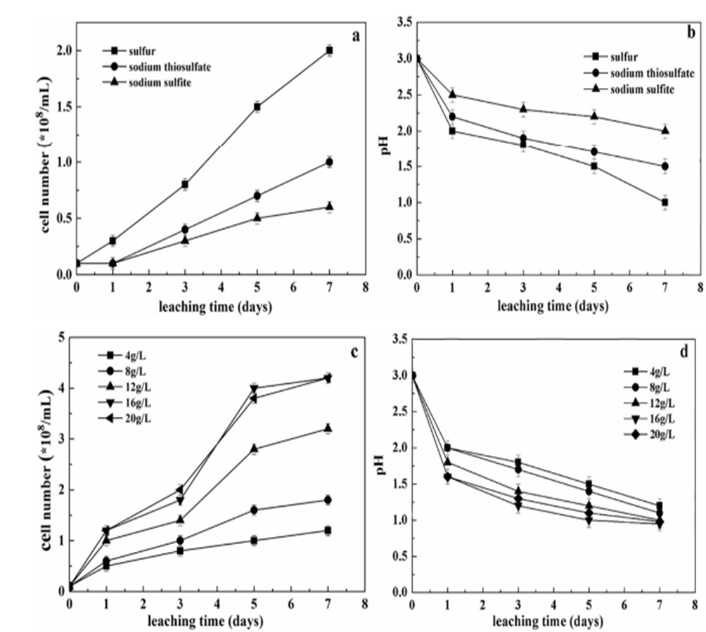

Figure 7. Changes in strain growth and pH over time, depending on different types of energy substrates or various sulfur concentrations. Panels (a) and (b) illustrate the variation in cell number and pH under the effect of different types of energy substrates, respectively. Panels (c) and (d) show the evolution of cell number and pH as a function of different sulfur concentrations, respectively (Wang et al., 2018).
  - Recovery of gallium from coal processing waste
    - Occurrence of gallium in coal and ash
Gallium is indeed found at significant concentrations in some coals and, especially, in their by-products such as fly ash, gasification slag, and coal gangue, making these materials a strategic secondary resource for this critical metal (Rudnik, 2024). Fly ash and bottom ash from coal combustion, as well as boiler slag, are mainly composed of silicate and aluminosilicate glass, along with various minerals and carbon fragments. The proportions of these components vary depending on the type of coal and combustion conditions (Feng et al., 2024 ; Rudnik, 2024). The main minerals present include quartz, mullite, lime, hematite, magnetite, and gypsum (Feng et al., 2024). Gallium is enriched in ash after combustion, mainly as inclusions in quartz, aluminosilicate phases (such as mullite and glass), and certain sulfides (Feng et al., 2024).
At low temperatures (around 600°C), gallium is primarily associated with the glassy phase. As the temperature increases, gallium migrates and becomes predominantly incorporated into mullite and quartz (Wu, Zhou and Zhou, 2024). In combustion products from coal and oil shale, more than 90% of gallium is found in the residual fraction, bound to organic matter, sulfides, or metal oxides (Wu, Zhou and Zhou, 2024). Recent studies using laser ablation mass spectrometry (LA-ICP-MS) have shown that gallium is mainly hosted in clay minerals such as kaolinite and boehmite, but it can also be associated with organic matter (notably vitrinite) in certain aluminum-rich coals (Jiu et al., 2023 ; Jiu et al., 2024).
The distribution and occurrence form of gallium therefore depend heavily on the mineralogical nature of the original coal and the mineral transformations induced by combustion (Feng et al., 2024 ; Wu, Zhou et Zhou, 2024). Figure 8 presents a detailed comparison of the chemical composition between raw coal and the solid residues resulting from its combustion, namely fly ash and bottom ash. These samples come from both real industrial facilities and laboratory experiments. This comparative analysis provides a better understanding of the physicochemical transformations that occur during coal combustion, as well as the distribution of trace elements and potentially recoverable metals in the different types of residues. It thus provides an essential basis for assessing the potential for recovering certain elements, such as gallium, from these by-products.
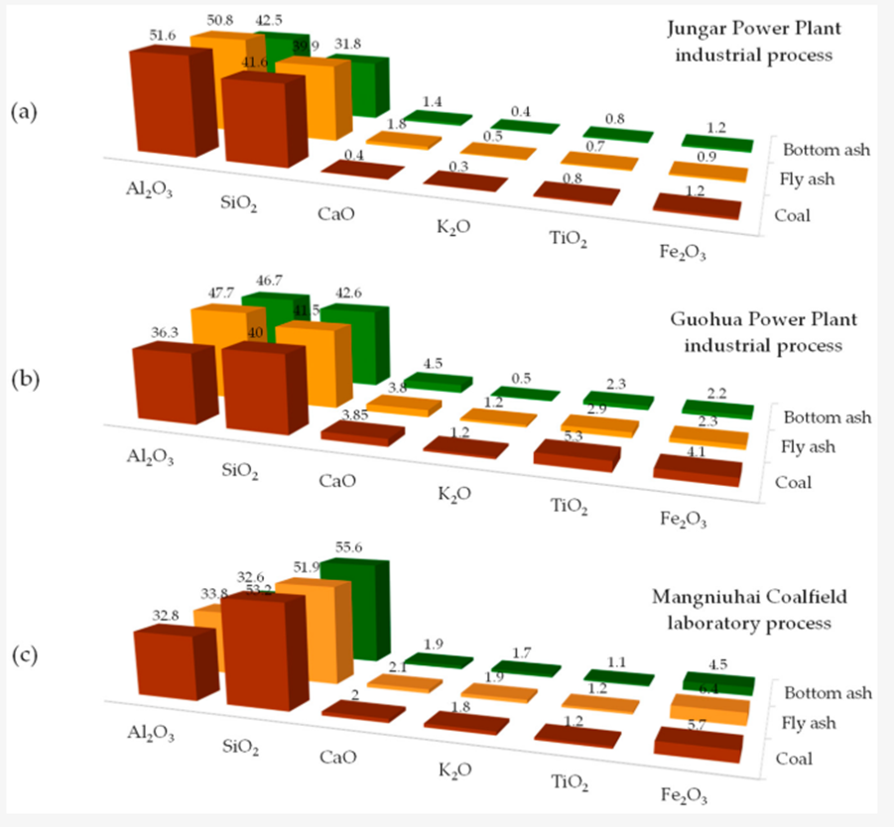

Figure 8. Percentage distribution of gallium in raw coal and ash produced under industrial conditions (a) (Dai et al., 2010), (b) (Feng et al., 2024) and in the laboratory (c) (Zhou et al., 2021), according to a sequential leaching procedure, reproduced from (Rudnik, 2024).

    - Process for recovering gallium from coal and its by-products, in particular fly ash
Extracting gallium from these solid residues offers economic and environmental benefits, particularly by recycling industrial waste and reducing pollution associated with its storage (Yang et al., 2024). Fly ash from coal is particularly promising, with gallium recovery rates of 90% thanks to optimized hydrometallurgical processes, such as reagent-assisted roasting followed by acid leaching or the use of innovative adsorbent materials (Huang et al., 2019 ; (Yang et al., 2024).
Selective separation techniques, such as solvent extraction (P507, Cyanex 272) or adsorption on mesoporous silica derived from slag, enable gallium to be effectively isolated from other metals present in leachates (Zhao et al., 2020). However, the low concentration of gallium and the presence of impurities require advanced and selective separation methods (Zhao et al., 2020 ; Yang et al., 2024).
The prior enrichment of gallium in Matrox coal through targeted orientation toward carrier minerals such as mica and clay also improves the profitability and sustainability of the process (Dai et al., 2023). Despite these advances, there is little information in the scientific literature on the recovery of gallium from certain coal by-products such as bottom ash and coarse slag, which may, however, have higher concentrations than raw coal (Yang et al., 2024).
This is the case of (Zhao et al., 2020) who explored a multi-step process to selectively extract gallium (Ga) from the sulfuric acid leaching solution of coal fly ash, using suitable acid extractants and precise pH control. At pH ≤ 0.8, titanium (Ti) and iron (Fe) are removed by cross-extraction with 1 mol/L P507. Next, Ga (III) is separated from aluminum (Al) at pH 2.4-2.6 with 0.5mol/L Cyanex 272, achieving high selectivity factors (Fe/Ga: 145; Ga/Al: 40). The extraction of Ga(III) follows an ion exchange mechanism, involving the formation of specific complexes with Cyanex 272. This process optimizes selectivity by exploiting differences in solubility and reactivity of the elements depending on pH and environmental conditions. Figure 9 illustrates the mechanism of selective gallium recovery from sulfuric acid leachate of coal fly ash (CFA) through a multi-stage acid separation process.
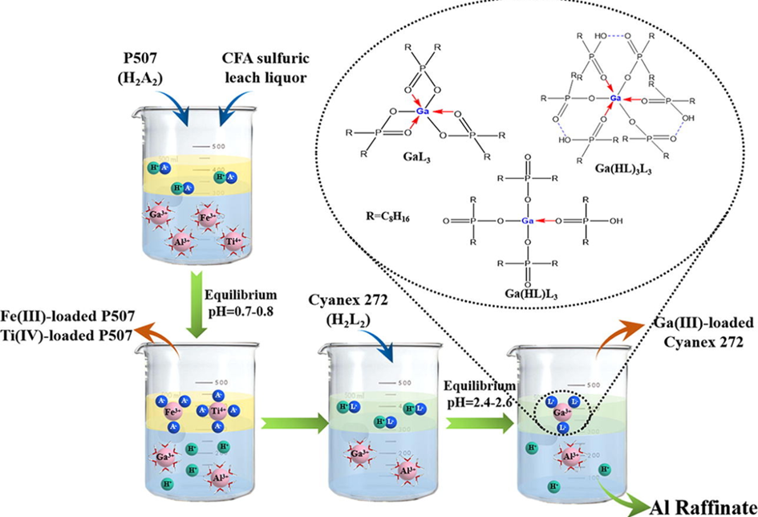
Figure 9. illustrates the mechanism of selective gallium recovery from sulfuric acid leachate of coal fly ash (CFA) through a multi-stage acid separation process (Zhao et al., 2020).
More recently (Zou, Tian and Wang, 2017) developed an innovative process for recovering gallium from coal-bearing strata at the Zhongliangshan mine in southwestern China. Their method, called ASWIAL (Alkaline Sintering–Water Immersion–Acid Leaching), combines alkaline sintering, hot water immersion, and acid leaching. After calcination at 860°C for 30 minutes (sample/sintering agent ratio of 1 :1.5), the sample is immersed at 90°C for 2 hours, then leached with 4 mol/L HCl at 40°C for 2hours (liquid/solid ratio of 20:1). This process achieves high recovery rates: 93.4% for gallium and 85.8% for rare earths. However, niobium remains mainly in the solid residue, with a leaching yield of less than 1%, indicating the need for complementary methods for its extraction, as it is mainly retained in the post-leaching residue. This low solubility of Nb indicates the need to develop complementary strategies to enable its efficient extraction from solid residues. Figure 10 illustrates the alkaline sintering-water immersion-acid leaching (ASWIAL) process.
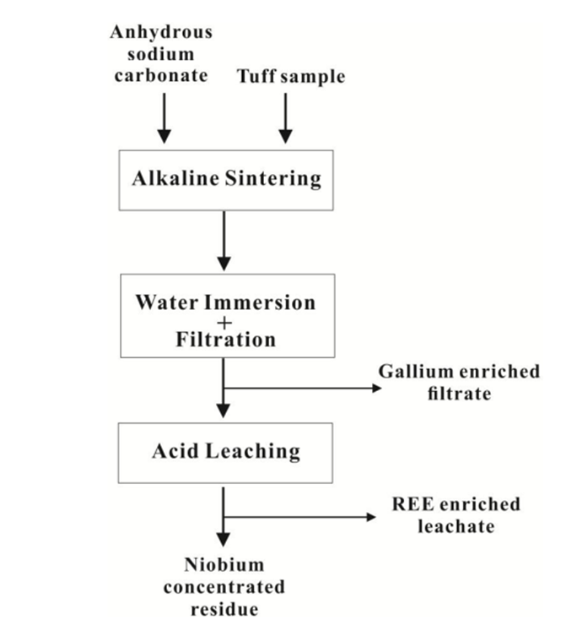
Figure 10. Schéma du procédé de frittage alcalin-immersion dans l'eau-lixiviation acide (ASWIAL) (Zou, Tian et Wang, 2017).
For their part (Huang et al., 2019) developed an innovative process combining sodium fluoride (NaF) roasting and nitric acid leaching to extract gallium from coal fly ash. Under optimal conditions (roasting at 800°C for 10 min, leaching with 2 mol/L HNO₃ for 1h, NaF/CVC ratio of 0.75:1), the gallium extraction yield reaches 94%. This process is notable for its speed, efficiency, and use of low acid concentrations, thereby limiting its environmental impact. Figure 11 shows the results of gallium (Ga) extraction from coal fly ash, carried out either by direct acid leaching or after prior roasting followed by leaching.
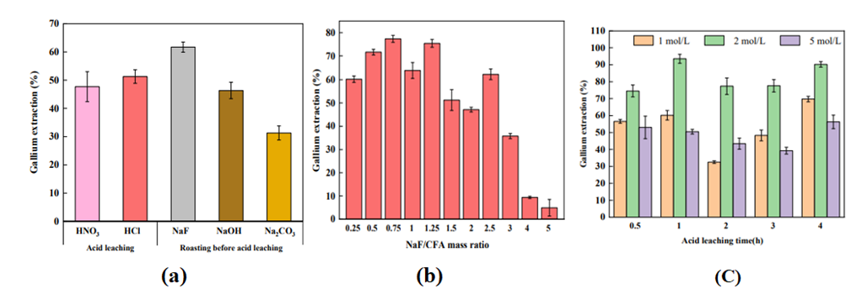
Figure 11: (a) Extraction of gallium (Ga) from coal fly ash by direct acid leaching or after prior roasting followed by acid leaching. The experimental conditions are: reagent/CVC mass ratio of 1:1, roasting at 800°C for 20min, then acid leaching at 120°C for 1h with a 2mol/L HNO₃ solution. (b) Effect of the NaF/CVC mass ratio on Ga extraction (roasting at 800°C for 10min; leaching at 120°C for 2h; HNO₃ 2mol/L). (c) Influence of acid leaching time and acid concentration on gallium extraction (NaF/CVC mass ratio of 0.75:1, roasting at 800°C) (Huang et al., 2019).
(Fang and Gesser, 1996) also proposed a four-step process for extracting gallium from coal fly ash: acid leaching (HCl 2 mol/L), removal of impurities, extraction of gallium by froth flotation, and purification. This process also allows aluminum and iron to be recovered. Calcination at 500°C concentrates the gallium without loss, but slightly reduces the extraction efficiency. A two-stage leaching process (HCl 2M) achieves a yield of over 95%, which varies depending on the type of ash. An optimal liquid/solid ratio (L/S = 6) maximizes efficiency, with extraction being rapid (<1hour) and effective at room temperature. In light of the above, it appears that gallium extraction from coal fly ash is a promising avenue, enabling recovery rates of over 90% thanks to hydrometallurgical processes combining acid leaching, selective extraction, and purification. However, the low gallium content and the presence of impurities require advanced techniques such as solvent extraction or adsorption on mesoporous materials. Optimizing parameters and integrating innovative processes improves efficiency, but scaling up to industrial levels remains a challenge.
  - Extraction of gallium from zinc sulfide waste
The recovery of gallium from zinc sulfides, mainly present in the form of sphalerite, generally involves a high-temperature roasting step to convert ZnS to ZnO, followed by acid leaching to dissolve metals of interest such as gallium, aluminum, and zinc (Chegrouche, Bensmaili and Kadri, 2001 ; Tianxiang Nan et al., 2024). The efficiency of leaching depends on several parameters, including temperature, sulfuric acid concentration, and contact time, allowing gallium extraction yields of over 80% to be achieved under optimized conditions (Chegrouche, Bensmaili and Kadri, 2001 ; X.-L. Wu et al., 2013). After leaching, the solution is often purified by selective precipitation, in particular by adding ZnO to remove iron in the form of hydroxide, followed by treatment with caustic soda to separate gallium and aluminum from residual iron (X.-L. Wu et al., 2013).
Innovative processes, such as oxygen pressure leaching or the use of ultrasound, can significantly improve gallium extraction yields by facilitating the breakdown of mineral matrices and allowing acid to access encapsulated metals (Tian-xiang Nan et al., 2024 ; Ding et al., 2024 ;X. Wu et al., 2013). However, certain obstacles remain, notably the presence of mineral phases that are resistant to acid leaching and the formation of passivating layers that limit gallium recovery (Geng et al., 2024). Optimization of leaching parameters, including fine grinding of zinc sulfide concentrates, adjusting the temperature, oxygen pressure, and sulfuric acid concentration, makes it possible to achieve gallium recovery rates of over 90%, or even 96% under optimized conditions, while promoting the co-recovery of germanium and other strategic metals (Wang et al., 2020 ;Zhang and Shuai, 2024).
Reducing particle size through fine grinding is essential, as it increases the contact surface area and facilitates the dissolution of precious metals, whereas coarser particles limit extraction (Zhang et al., 2024). Increasing the sulfuric acid concentration and optimizing the temperature and oxygen pressure during pressure leaching significantly improve gallium recovery (Ding et al., 2023). Innovative methods, such as ultrasound-assisted or magnetic field-assisted leaching, have proven effective in significantly improving extraction yields while meeting environmental sustainability requirements, with gallium recovery rates exceeding 95% (Flerus and Friedrich, 2020 ;Liang et al., 2024). These processes also promote the sustainable recovery of residues, limiting emissions and facilitating waste management (Liang et al., 2024). Life cycle analysis shows that these methods, if optimized for energy consumption and chemical input management, are a more sustainable alternative to traditional processes (Fang et al., 2019).
Similarly, (Liu et al., 2017) also demonstrated that the efficiency of gallium leaching depends heavily on particle size, acid concentration, oxygen pressure, and reaction time, with gallium generally being more difficult to extract than zinc or germanium due to its tendency to co-precipitate with certain residues such as PbSO₄ or CaSO₄. In addition, advanced purification techniques, such as solvent extraction with specific agents such as OPAP, can achieve high gallium purities from leaching solutions (Judd and Harbuck, 1990). These advances contribute to more efficient recovery of zinc residues and better management of secondary resources, while minimizing the environmental impact of metallurgical processes (Tian-xiang Nan et al., 2024).
Recently, (Hartzell and Moats, 2023) developed a process for extracting gallium from industrial residue produced during zinc leaching. Agitated atmospheric leaching tests using sulfuric acid and hydrochloric acid were conducted to study the extraction of gallium, indium, and germanium as a function of concentration, temperature, and time. Gallium extraction proved to be similar to iron extraction in all experiments. Maximum extraction rates in solution reached 82% for gallium, approximately 100% for germanium, and 89% for indium.
In the same vein, (Guo et al., 2024) tested BGYW, a new low-toxicity hydroxamic acid, for the selective extraction of Ga³⁺ and Ge⁴⁺ from zinc metallurgy solutions also containing Zn²⁺, As³⁺, Cu²⁺, and Al³⁺. This multi-step process (extraction, washing, re-extraction) achieves high yields: after 15 cycles, 98.7% of gallium and 100% of germanium are extracted, while the commercial extractant YW100 drops to 20% efficiency by the fifth cycle. In addition, the loss of BGYW through dissolution is ten times less than that of YW100, making it a more stable and sustainable solution. Figure 12 illustrates the proposed conceptual diagram for the recovery of gallium and germanium from the leaching solution of zinc metallurgical residues.
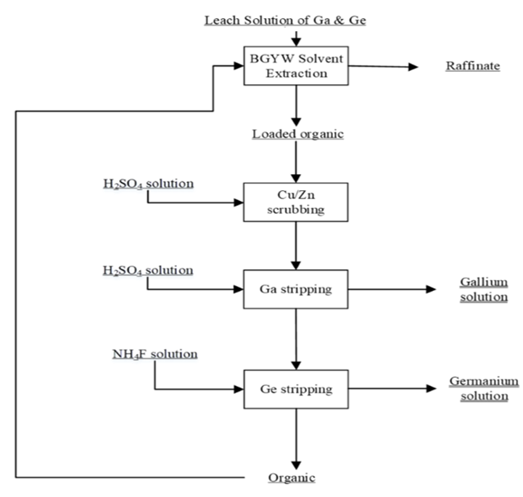
Figure 12. Proposed conceptual diagram for the recovery of gallium and germanium from the leaching solution of zinc metallurgical residues (Guo et al., 2024)
With a view to promoting the circular economy, (Jiang et al., 2006) explored an integrated strategy for recovering by-products from hydrometallurgical zinc production processes. In this study, processing residues containing 512g/t of silver were first subjected to a flotation stage, yielding a concentrate rich in 4321.6 g/t of silver, with a recovery rate of 80.96%. The flotation tailings were then agglomerated and thermally reduced in a rotary kiln at 1100°C for 2hours, resulting in the recovery of zinc, lead, and indium in the form of condensable fumes. The residual calcined pellets were crushed and then treated by magnetic separation, yielding iron concentrates enriched in gallium and germanium. The concentrations achieved in these concentrates were 1.805 g/t for gallium and 1.536g/t for germanium, with high recovery rates of 94.67% for gallium and 93.20% for germanium.
(Liu, et al., 2017) also implemented a two-step hydrometallurgical method to separate and recover gallium and germanium from zinc refinery residues. An initial sulfuric acid leaching dissolves 92% of the zinc and 94% of the copper, thereby concentrating the gallium and germanium by a factor of three. Next, leaching with oxalic acid (70 g/L, L/S = 10, 90°C, 2 hours) extracts more than 96% of the gallium and 99% of the germanium. The iron is then selectively removed by ultrasound-assisted precipitation, with over 96% efficiency and minimal losses of gallium and germanium (1.4% and 1.3%). Figure 13 illustrates several parameters affecting the leaching of zinc refinery residues.

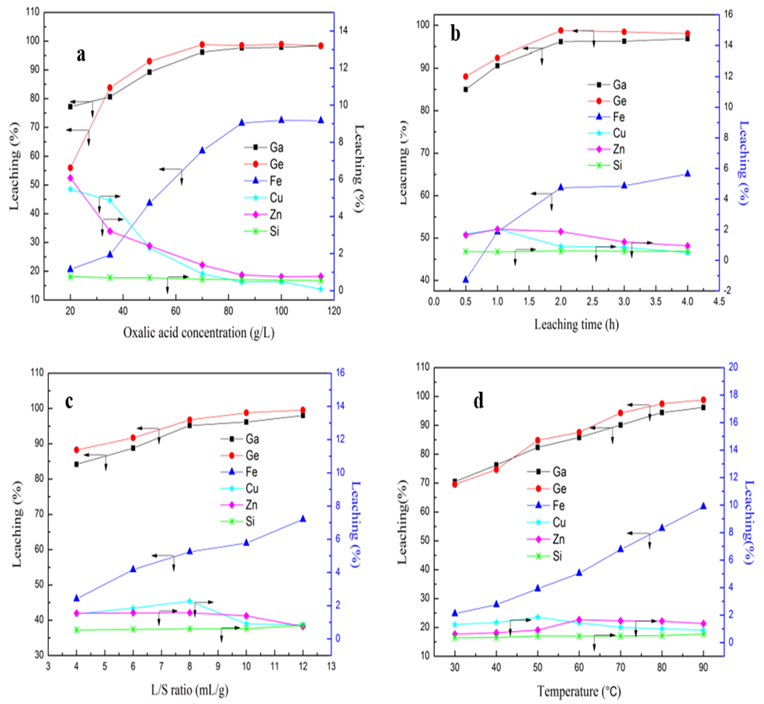
Figure 13. (a) Effect of oxalic acid concentration on the dissolution of Ga, Ge, Fe, Cu, Zn, (b) effect of time, effect of liquid/solid ratio, (c) effect of temperature on the leaching of zinc refinery residues (T = 90°C ; L/S ratio = 10; duration = 2 hours (Liu, et al., 2017).
  - Recovery of gallium from electronic waste
Recovering gallium from electronic waste is essential due to its scarcity and its role in Advanced technologies. The most effective processes are hydrometallurgical (solvent extraction, precipitation, nanofiltration) or thermal, achieving yields of over 90% from LEDs or integrated circuits (Jiang et al., 2006). Innovative techniques, such as vacuum pyrolysis or oxidation followed by leaching, also offer good results while limiting pollution (Zhan et al., 2018). However, recovery remains complex due to the low concentration of gallium in waste and significant losses during production and recycling (Maximilian Ueberschaar, Otto et Rotter, 2017 ; Kluczka, 2024).
Several recent studies have explored the recovery of gallium from electronic waste, particularly through thermal oxidation followed by leaching. (Maarefvand, Sheibani et Rashchi, 2020) showed that by heating LED chips (GaN) to 1100°C to form gallium oxide, then leaching with 4 M HCl at 93°C for 120 min, it is possible to achieve a recovery yield of 91.4%. The leaching temperature is the most decisive parameter for the efficiency of the process.
For their part, (Zhan et al., 2018) developed a method combining pyrolysis and vacuum metallurgy to efficiently recycle gallium and arsenic from electronic waste containing GaAs. At 1273 K, under 20 Pa for 60 minutes, the overall recovery rate reaches 95%. Gallium and arsenic are condensed and collected separately, thus limiting contamination and material loss.
In the study conducted by (Zhang et Xu, 2016), pyrolysis under nitrogen, followed by vacuum decomposition, was applied to used photovoltaic modules. Gallium was effectively recovered at 1123K, under a pressure of 1Pa, for 40 min. Extraction using solvents such as Cyanex 272, TBP, TOPO, and ionic liquids allows gallium to be recovered from electronic waste with very high yields and purity levels. For example, extraction with Cyanex 272 achieves 77.4% in one step and 99.5% after four steps, with a final purity of 99.95% (Chen et al., 2020). Other processes, using TBP and D2EHPA, enable up to 96.2% of gallium to be extracted with a purity of 99.6% from used semiconductor materials (Gu et al., 2018).
As part of an integrated strategy for recycling NdFeB magnet waste, (Qin, Chen and Bai, 2024), developed an effective process for extracting gallium from NdFeB magnet waste, producing gallium oxide (Ga₂O₃) with a purity of 98.6%. The process combines acid leaching, iron reduction, TBP extraction (with 10% isodecanol to avoid the third phase), selective precipitation, and calcination. A three-step countercurrent extraction achieves 99% gallium extraction efficiency, which is then recovered as pure oxide. Phosphonium and ammonium ionic liquids also show promise for the selective extraction of gallium from DEE (Thombre et Kundu, 2024).
In addition to conventional methods (vacuum pyrolysis, oxidation, leaching, solvent extraction), more sustainable approaches such as biohydrometallurgy have been developed to reduce the environmental footprint of gallium recovery from electronic waste. Bioleaching uses microorganisms capable of solubilizing metals through acid production, redox reactions, or chelation mechanisms (Priya and Hait, 2017 ; Jaiswal and Srivastava, 2024). Strains such as Acidithiobacillus ferrooxidans, which are specially adapted to the toxicity of LED waste, have demonstrated increased efficiency in gallium extraction, achieving up to 60% recovery after acclimatization (Pourhossein et Mousavi, 2018). Other bacteria, such as Rhodanobacter sp. and Sphingomonas sp., have also shown good performance, particularly for gallium extraction from compounds such as GaAs (Chung et al., 2022).
The effectiveness of bioleaching depends on many parameters: pH, pulp density, temperature, type of microorganism, and adaptation to waste toxicity (Pourhossein and Mousavi, 2018; Priya and Hait, 2017). Adaptation of bacterial strains improves heavy metal tolerance and optimizes gallium recovery (Pourhossein and Mousavi, 2018). Gallium recovery yields from bioleaching are generally lower than those from chemical processes (typically 60-70% versus >90% for strong acids), but bioleaching remains more environmentally friendly (Zheng, Benedetti, and van Hullebusch, 2023; Erkmen et al., 2025). However, it is limited by longer processing times (Tezyapar Kara et al., 2023). Recent research has focused on optimizing bacterial strains (e.g., Acidithiobacillus ferrooxidans, Rhodanobacter sp., Sphingomonas sp.) and understanding the genomic and metabolic mechanisms involved in gallium tolerance and leaching efficiency.
The effectiveness of bioleaching depends on many parameters: pH, pulp density, temperature, type of microorganism, and adaptation to waste toxicity (Pourhossein and Mousavi, 2018 ; Priya and Hait, 2017). Adaptation of bacterial strains improves heavy metal tolerance and optimizes gallium recovery (Pourhossein and Mousavi, 2018). Gallium recovery yields from bioleaching are generally lower than those from chemical processes (typically 60-70% versus >90% for strong acids), but bioleaching remains more environmentally friendly (Zheng, Benedetti and van Hullebusch, 2023; Erkmen et al., 2025). However, it is limited by longer processing times (Tezyapar Kara et al., 2023).
- Conclusion
Gallium extraction techniques have undergone significant changes, evolving from conventional hydrometallurgical processes (acid or base leaching, solvent extraction, ion exchange) to more innovative and environmentally friendly approaches. Although traditional methods offer good yields, they have limitations in terms of selectivity, operational complexity, and environmental impact, particularly due to the production of secondary waste and the use of aggressive reagents.
In response to these challenges, more sustainable alternatives have emerged, such as the use of mesoporous sorbents, ion-liquid-assisted extraction, electrosorption on bio-based materials, and bioleaching. These approaches improve selectivity, reduce reagent consumption, and limit pollutant emissions, while maintaining high recovery rates, sometimes exceeding 90%. The optimization of operating parameters and the development of new extraction materials are paving the way for increased recovery from secondary sources such as industrial waste, fly ash, zinc refining residues, and electronic waste.
However, despite these advances, several challenges remain for the large-scale implementation of truly circular and environmentally sustainable processes: controlling selectivity in the face of competing elements, reducing costs, industrial integration, and treating complex flows from multi-metal waste. In the future, the solution will lie in an intelligent combination of optimized conventional processes and technological innovations to ensure a sustainable supply of gallium, a strategic metal for advanced technologies and the energy transition. An integrated approach, combining performance, selectivity, circular economy, and respect for the environment, will be essential to make this transition a reality.

COMPETING INTERESTS DISCLAIMER:
Authors have declared that they have no known competing financial interests OR non-financial interests OR personal relationships that could have appeared to influence the work reported in this paper.

- REFERENCES

ABDOLLAHI, M. et Naderi, H. (2007) « Liquid-liquid extraction of gallium from Jajarm Bayer process liquor using Kelex 100 ». Disponible sur : https://www.sid.ir/EN/VEWSSID/J_pdf/84320070414.pdf.
Adel, A.-H.A.-R. et al. (2010) « Studies on the Uptake of Rare Earth Elements on Polyacrylamidoxime Resins from Natural Concentrate Leachate Solutions », Journal of Dispersion Science and Technology, 31(8), p. 1128‑1135. Disponible sur: https://doi.org/10.1080/01932690903224821.
Borges, P.P. et Masson, I.O.C. (1994) « Solvent extraction of gallium with kelex 100 from Brazilian weak sodium aluminate solution », Minerals Engineering, 7(7), p. 933‑941. Disponible sur : https://doi.org/10.1016/0892-6875(94)90135-X.
Chand, M. et al. (2022) « Analysis of coal ash samples from thermal power plants of India for their gallium content using NAA and EDXRF techniques. », Applied radiation and isotopes: including data, instrumentation and methods for use in agriculture, industry and medicine, 187. Disponible sur: https://doi.org/10.1016/j.apradiso.2022.110336.
Chegrouche, S., Bensmaili, A. et Kadri, B. (2001a) « Recovery of gallium, germanium and indium from Algerian zinc residues », Entropie (Paris), 37(233), p. 58‑61.
Chen, W.S. et al. (2020) « Recovery gallium from GaAs waste etching solutions by solvent extraction », in 15th International Symposium on East Asian Resources Recycling Technology, EARTH 2019. Disponible sur : https://researchoutput.ncku.edu.tw/en/publications/recovery-gallium-from-gaas-waste-etching-solutions-by-solvent-ext.
Chen, Z. et al. (2021) « Facile preparation of hierarchical porous poly(vinyl amidoxime) membranes as efficient gallium adsorbents », Polymer Bulletin, 78(10), p. 5977‑5995. Disponible sur : https://doi.org/10.1007/s00289-020-03414-x.
Chung, A.P. et al. (2022) « Genome mining to unravel potential metabolic pathways linked to gallium bioleaching ability of bacterial mine isolates », Frontiers in Microbiology, 13, p. 970147.
Cui, L. et Jiang, Y. (2025) « Quantitative analysis of the US chip embargo and China’s export controls on GaGe and graphite », Computers & Industrial Engineering, 200, p. 110860.
Dai, S. et al. (2023) « A new method for pre-enrichment of gallium and lithium based on mode of occurrence in coal gangue from Antaibao surface mine, Shanxi Province, China », Journal of Cleaner Production, 425, p. 138968.
Díez, E. et al. (2021) « Recovery of Gallium from Aqueous Solution through Preconcentration by Adsorption/Desorption on Disordered Mesoporous Carbon », Journal of Sustainable Metallurgy, 7(1), p. 227‑242. Disponible sur: https://doi.org/10.1007/s40831-021-00336-4.
Ding, W. et al. (2023) « Innovative Recovery of Gallium and Zinc from Corundum Flue Dust by Ultrasound-Assisted H2SO4 Leaching », Mineral Processing and Extractive Metallurgy Review, 45, p. 495‑508. Disponible sur: https://doi.org/10.1080/08827508.2023.2196073.
Erkmen, A.N. et al. (2025) « Towards sustainable recycling of critical metals from e-waste: Bioleaching and phytomining », Resources, Conservation and Recycling, 215, p. 108057.
Ettler, V. et al. (2022) « Gallium and germanium extraction and potential recovery from metallurgical slags », Journal of Cleaner Production, 379, p. 134677.
Fang, S. et al. (2019) « Selective Recovery of Gallium (Indium) from Metal Organic Chemical Vapor Deposition Dust—A Sustainable Process », ACS Sustainable Chemistry & Engineering [Preprint]. Disponible sur: https://doi.org/10.1021/ACSSUSCHEMENG.9B01228.
Fang, Z. et Gesser, H.D. (1996) « Recovery of gallium from coal fly ash », Hydrometallurgy, 41(2‑3), p. 187‑200.
Feng, L. et al. (2024) « Modes of Occurrence, Migration, and Evolution Pathways of Lithium and Gallium during Combustion of an Al-Rich Coal, Inner Mongolia, China », Minerals, 14(8), p. 771.
Flerus, B. et Friedrich, B. (2020) « Recovery of Gallium from Smartphones—Part II: Oxidative Alkaline Pressure Leaching of Gallium from Pyrolysis Residue », Metals [Preprint]. Disponible sur: https://doi.org/10.3390/met10121565.
Frenzel, M. et al. (2017) « Quantifying the relative availability of high-tech by-product metals – The cases of gallium, germanium and indium », Resources Policy, 52, p. 327‑335. Disponible sur: https://doi.org/10.1016/J.RESOURPOL.2017.04.008.
Ganguly, S., Nama Manjunatha, K. et Paul, S. (2025) « Advances in Gallium Oxide: Properties, Applications, and Future Prospects », Advanced Electronic Materials, 11(7). Disponible sur: https://doi.org/10.1002/aelm.202400690.
Gao, Z. et al. (2024) « Tracking the global anthropogenic gallium cycle during 2000–2020: A trade-linked multiregional material flow analysis », Global Environmental Change, 87, p. 102859.
Geng, X. et al. (2024) « Major obstacles hindering gallium and germanium leaching in the zinc refining process », Chemical Engineering Science [Preprint]. Disponible sur: https://doi.org/10.1016/j.ces.2024.120793.
Geng, Y., Sarkis, J. et Bleischwitz, R. (2023) « How to build a circular economy for rare-earth elements », Nature, 619(7969), p. 248‑251.
Giannopoulou, I., Konstantakopoulou, E. et Panias, D. (2023) « Gallium Recovery from Bayer Liquor Using a Chelating Resin », in World Congress on Mechanical, Chemical, and Material Engineering. The 9th World Congress on Mechanical, Chemical, and Material Engineering, Avestia Publishing. Disponible sur: https://doi.org/10.11159/mmme23.131.
Gladyshev, S.V. et al. (2015) « Recovery of vanadium and gallium from solid waste by-products of Bayer process », Minerals Engineering, 74, p. 91‑98.
Goss, C.H. et al. (2018) « Gallium disrupts bacterial iron metabolism and has therapeutic effects in mice and humans with lung infections », Science Translational Medicine, 10(460). Disponible sur: https://doi.org/10.1126/scitranslmed.aat7520.
Green, A.J. et al. (2022) « β-Gallium oxide power electronics », Apl Materials, 10(2). Disponible sur: https://pubs.aip.org/aip/apm/article/10/2/029201/2834895 (Consulté le: 17 juillet 2025).
Gu, S. et al. (2018) « Recovery of indium and gallium from spent IGZO targets by leaching and solvent extraction », Journal of Chemical Engineering of Japan, 51(8), p. 675‑682.
Guo, Z. et al. (2024) « Solvent Extraction of Gallium and Germanium Using a Novel Hydroxamic Acid Extractant », Minerals, 14(11), p. 1147. Disponible sur: https://doi.org/10.3390/min14111147.
Han, I. et al. (2008) « Characterization of threading dislocations in GaN using low-temperature aqueous KOH etching and atomic force microscopy », Scripta Materialia, 59(11), p. 1171‑1173.
Han, Z., Liu, Q., Xin, O., et al. (2024a) « Tracking two decades of global gallium stocks and flows: A dynamic material flow analysis », Resources, Conservation and Recycling [Preprint]. Disponible sur: https://doi.org/10.1016/j.resconrec.2023.107391.
Han, Z., Liu, Q., Xin, O., et al. (2024b) « Tracking two decades of global gallium stocks and flows: A dynamic material flow analysis », Resources, Conservation and Recycling [Preprint]. Disponible sur: https://doi.org/10.1016/j.resconrec.2023.107391.
Hartzell, W. et Moats, M. (2023) « Extraction of Critical Electronic Materials from Steelmaking Wastes », Mining, Metallurgy & Exploration, 40, p. 1445‑1453. Disponible sur: https://doi.org/10.1007/s42461-023-00819-w.
Hoang, A.S. et al. (2015) « Extraction of gallium from Bayer liquor using extractant produced from cashew nutshell liquid », Minerals Engineering, 79, p. 88‑93. Disponible sur: https://doi.org/10.1016/j.mineng.2015.05.012.
Huang, J. et al. (2019a) « Investigation on the effect of roasting and leaching parameters on recovery of gallium from solid waste coal fly ash », Metals, 9(12), p. 1251.
Jaiswal, M. et Srivastava, S. (2024) « A review on sustainable approach of bioleaching of precious metals from electronic wastes », Journal of Hazardous Materials Advances, 14, p. 100435.
Jamwal, N.S. et Kiani, A. (2022) « Gallium oxide nanostructures: A review of synthesis, properties and applications », Nanomaterials, 12(12), p. 2061.
Jiang, T. et al. (2006) « Novel process to recover valuable metals from hydrometallurgical zinc residues », Mining, Metallurgy & Exploration, 23(4), p. 214‑218. Disponible sur: https://doi.org/10.1007/BF03403349.
Jiu, B. et al. (2023) « Distribution of Li, Ga, Nb, and REEs in coal as determined by LA-ICP-MS imaging: A case study from Jungar coalfield, Ordos Basin, China », International Journal of Coal Geology, 267, p. 104184.
Jiu, B. et al. (2024) « Modes of occurrence of gallium in Al-Ga-rich coals in the Jungar Coalfield, Ordos Basin, China: Insights from LA-ICP-MS data », International Journal of Coal Geology, 282, p. 104436.
Judd, J.C. et Harbuck, D. (1990) « Gallium Solvent Extraction from Sulfuric Acid Solutions Using OPAP », Separation Science and Technology, 25, p. 1641‑1653. Disponible sur: https://doi.org/10.1080/01496399008050414.
Kekesi, T. (2007) « Gallium extraction from synthetic Bayer liquors using Kelex 100-kerosene, the effect of loading and stripping conditions on selectivity », Hydrometallurgy, 88(1), p. 170‑179. Disponible sur: https://doi.org/10.1016/j.hydromet.2007.04.006.
Kluczka, J. (2024) « A review on the recovery and separation of gallium and indium from waste », Resources, 13(3), p. 35.
Larichkin, F. et al. (2017) « State and prospects of Russian and world gallium market », p. 108‑114. Disponible sur: https://doi.org/10.21440/2307-2091-2017-4-108-114.
Liang, Y. et al. (2024) « Strong magnetic and ultrasonic fields enhanced the leaching of Ga and Ge from zinc powder replacement residue », Separation and Purification Technology [Preprint]. Disponible sur: https://doi.org/10.1016/j.seppur.2023.125572.
Liu, F., Liu, Z., Yuhu, L., et al. (2017) « Behavior of gallium and germanium associated with zinc sulfide concentrate in oxygen pressure leaching », Physicochemical Problems of Mineral Processing, 53, p. 1047‑1060. Disponible sur: https://doi.org/10.5277/PPMP170229.
Liu, F., Liu, Z., Li, Y., et al. (2017) « Recovery and separation of gallium(III) and germanium(IV) from zinc refinery residues: Part I: Leaching and iron(III) removal », Hydrometallurgy, 169, p. 564‑570. Disponible sur: https://doi.org/10.1016/j.hydromet.2017.03.006.
Losev, V. et al. (2024) « Extraction of gallium from carbon concentrate - Aluminum industry waste », Hydrometallurgy [Preprint]. Disponible sur: https://doi.org/10.1016/j.hydromet.2024.106289.
Løvik, A.N., Restrepo, E. et Müller, D. (2015) « The global anthropogenic gallium system: determinants of demand, supply and efficiency improvements. », Environmental science & technology, 49 9, p. 5704‑12. Disponible sur: https://doi.org/10.1021/acs.est.5b00320.
Lu, F. et al. (2017) « Resources and extraction of gallium: A review », Hydrometallurgy, 174, p. 105‑115. Disponible sur: https://doi.org/10.1016/j.hydromet.2017.10.010.
Lu, F. et al. (2018) « Recovery of gallium from Bayer red mud through acidic-leaching-ion-exchange process under normal atmospheric pressure », Hydrometallurgy, 175, p. 124‑132. Disponible sur: https://doi.org/10.1016/j.hydromet.2017.10.032.
Lu, S. et al. (2019) « Amidoxime functionalization of a poly(acrylonitrile)/silica composite for the sorption of Ga(III) – Application to the treatment of Bayer liquor », Chemical Engineering Journal, 368, p. 459‑473. Disponible sur: https://doi.org/10.1016/j.cej.2019.02.094.
Maarefvand, M., Sheibani, S. et Rashchi, F. (2020) « Recovery of gallium from waste LEDs by oxidation and subsequent leaching », Hydrometallurgy, 191, p. 105230. Disponible sur: https://doi.org/10.1016/j.hydromet.2019.105230.
Moskalyk, R.R. (2003) « Gallium: the backbone of the electronics industry », Minerals Engineering, 16(10), p. 921‑929. Disponible sur: https://doi.org/10.1016/j.mineng.2003.08.003.
Nan, Tianxiang et al. (2024) « Extracting valuable metals from zinc sulfide concentrate: A comprehensive simulation-based life cycle assessment study of oxidative pressure leaching », Minerals Engineering, 216, p. 108888.
Naumov, A. (2013) « Status and prospects of world gallium production and the gallium market », Metallurgist, 57, p. 367‑371. Disponible sur: https://doi.org/10.1007/s11015-013-9740-y.
Potysz, A., van Hullebusch, E.D. et Kierczak, J. (2018) « Perspectives regarding the use of metallurgical slags as secondary metal resources–A review of bioleaching approaches », Journal of environmental management, 219, p. 138‑152.
Pourhossein, F. et Mousavi, S.M. (2018) « Enhancement of copper, nickel, and gallium recovery from LED waste by adaptation of Acidithiobacillus ferrooxidans », Waste management, 79, p. 98‑108.
Priya, A. et Hait, S. (2017) « Comparative assessment of metallurgical recovery of metals from electronic waste with special emphasis on bioleaching », Environmental Science and Pollution Research, 24(8), p. 6989‑7008. Disponible sur: https://doi.org/10.1007/s11356-016-8313-6.
Puvvada, G.V.K. (1999) « Liquid–liquid extraction of gallium from Bayer process liquor using Kelex 100 in the presence of surfactants », Hydrometallurgy, 52(1), p. 9‑19. Disponible sur: https://doi.org/10.1016/S0304-386X(98)00086-3.
Puvvada, G.V.K., Chandrasekhar, K. et Ramachandrarao, P. (1996) « Solvent extraction of gallium from an Indian Bayer process liquor using Kelex-100 », Minerals Engineering, 9(10), p. 1049‑1058. Disponible sur: https://doi.org/10.1016/0892-6875(96)00097-0.
Qin, R., Chen, J. et Bai, Y. (2024) « High-efficiency stepwise recovery of gallium and rare earths from NdFeB waste by a hydrometallurgical process », Separation and Purification Technology, 350, p. 127914.
Qin, Z. et al. (2023) « Innovative Amidoxime Nanofiber Membranes for Highly Effective Adsorption of Ga(III) from Waste Bayer Solution », Industrial & Engineering Chemistry Research, 62(28), p. 11140‑11150. Disponible sur: https://doi.org/10.1021/acs.iecr.3c01410.
Qu, L. et al. (2024) « A Review of the Current State of Research on Gallium Recovery from Bayer Liquor », JOM, 76(10), p. 6084‑6098. Disponible sur: https://doi.org/10.1007/s11837-024-06578-3.
Rai, S. et al. (2025) « Recovery of Metal Values from Bauxite Residue/Red Mud: A Review », Research Journal of Engineering and Technology, 16(1), p. 31‑43. Disponible sur: https://doi.org/10.52711/2321-581X.2025.00004.
Raiguel, S., Dehaen, W. et Binnemans, K. (2020) « Extraction of gallium from simulated Bayer process liquor by Kelex 100 dissolved in ionic liquids », Dalton Transactions, 49(11), p. 3532‑3544. Disponible sur: https://doi.org/10.1039/C9DT04623B.
Rudnik, E. (2024) « Review on Gallium in Coal and Coal Waste Materials: Exploring Strategies for Hydrometallurgical Metal Recovery », Molecules, 29(24), p. 5919. Disponible sur: https://doi.org/10.3390/molecules29245919.
Sato, T. et Oishi, H. (1986) « Solvent extraction of gallium(III) from sodium hydroxide solution by alkylated hydroxyquinoline », Hydrometallurgy, 16(3), p. 315‑324. Disponible sur: https://doi.org/10.1016/0304-386X(86)90006-X.
Segala, B.N. et al. (2023) « Efficient gallium recovery from aqueous solutions using polyacrylonitrile nanofibers loaded with D2EHPA », Metals, 13(9), p. 1545.
Segala, B.N., Bertuol, D.A. et Tanabe, E.H. (2022) « Production of polyacrylonitrile nanofibres modified with Cyanex 272 for recovery of gallium from solution », Environmental Technology, 43(5), p. 737‑750. Disponible sur: https://doi.org/10.1080/09593330.2020.1803991.
Selvi, P. et al. (2004) « Gallium recovery from Bayer’s liquor using hydroxamic acid resin », Journal of Applied Polymer Science, 92(2), p. 847‑855. Disponible sur: https://doi.org/10.1002/app.20047.
Shi, C. et al. (2024) « Highly selective capture of gallium from aqueous solutions using tetradentate amidoxime functionalized MIL-53(Al) nanofiber membranes », Separation and Purification Technology, 330, p. 125303. Disponible sur: https://doi.org/10.1016/j.seppur.2023.125303.
Shimanskii, A. et al. (2021) « Aluminum Smelting Carbon Dust as a Potential Raw Material for Gallium and Germanium Extraction », JOM, 73, p. 1103‑1109. Disponible sur: https://doi.org/10.1007/s11837-021-04563-8.
Sipos, P., Megyes, T. et Berkesi, O. (2008) « The Structure of Gallium in Strongly Alkaline, Highly Concentrated Gallate Solutions—a Raman and 71Ga-NMR Spectroscopic Study », Journal of Solution Chemistry, 37(10), p. 1411‑1418. Disponible sur: https://doi.org/10.1007/s10953-008-9314-y.
Song, H. et al. (2022) « China Factor: Exploring the Byproduct and Host Metal Dynamics for Gallium–Aluminum in a Global Green Transition », Environmental Science & Technology, 56(4), p. 2699‑2708. Disponible sur: https://doi.org/10.1021/acs.est.1c04784.
Su, Y.Q., Liu, X.L. et Zhang, Z.G. (2010) « Synthesis and adsorption behavior of macroporous amidoxime resin for separate of gallium », Chin. J. Process Eng, 10(5), p. 893.
Thombre, A.V. et Kundu, D. (2024) « UNIQUAC-ext-PDH* Framework for the Ionic Liquid Assisted Extraction of Gallium (III) », Journal of Solution Chemistry, 53(9), p. 1149‑1170. Disponible sur: https://doi.org/10.1007/s10953-024-01365-9.
Truong, V.K. et al. (2023) « Gallium Liquid Metal: Nanotoolbox for Antimicrobial Applications », ACS Nano, 17(15), p. 14406‑14423. Disponible sur: https://doi.org/10.1021/acsnano.3c06486.
Ueberschaar, M., Otto, S.J. et Rotter, V.S. (2017) « Challenges for critical raw material recovery from WEEE - The case study of gallium. », Waste management, 60, p. 534‑545. Disponible sur: https://doi.org/10.1016/j.wasman.2016.12.035.
Ujaczki, É. et al. (sans date) « Bauxite Residue as a Source of Gallium – An Extraction Study ».
Urmosi, Z. et al. (sans date) « ELECTROCHEMICAL REACTOR FOR GALLIUM RECOVERY FROM THE BAUXITE TREATING BAYER PROCESS ».
Vind, J. et al. (2018) « Distribution of Selected Trace Elements in the Bayer Process », Metals, 8(5), p. 327. Disponible sur: https://doi.org/10.3390/met8050327.
Vind, J., Vassiliadou, V. et Panias, D. (sans date) « Distribution of Trace Elements Through the Bayer Process and its By-Products ».
Wang, G. et al. (2024) « A zero-emission collaborative treatment method for brown corundum fly ash and carbide slag: producing silicon fertilizer while recovering gallium and potassium », Separation and Purification Technology, 332, p. 125739.
Wang, J. et al. (2018) « Gallium recovery from aluminum smelting slag via a novel combined process of bioleaching and chemical methods », Hydrometallurgy, 177, p. 140‑145.
Wang, Y. et al. (2020) « Study on the improvement of the zinc pressure leaching process », Hydrometallurgy, 195, p. 105400.
Wang, Z. et al. (2024) « Basic Study on the Synergistic Extraction of V and Ga from Bayer Mother Liquor of Alumina Production », Journal of Sustainable Metallurgy, 10(3), p. 1225‑1236. Disponible sur: https://doi.org/10.1007/s40831-024-00806-5.
Wu, F., Zhou, B. et Zhou, C. (2024) « Experimental investigation on gallium and germanium migration in coal gangue combustion », Minerals, 14(5), p. 476.
Wu, X. et al. (2013) « Recovery of gallium from zinc concentrate by pressure oxygen leaching », Rare Metals, 32, p. 622‑626. Disponible sur: https://doi.org/10.1007/s12598-013-0175-1.
Xue, B. et al. (2019) « The influencing factor study on the extraction of gallium from red mud », Hydrometallurgy, 186, p. 91‑97. Disponible sur: https://doi.org/10.1016/j.hydromet.2019.04.005.
Yang, S. et al. (2024) « Enhanced Gallium Extraction Using Silane-Modified Mesoporous Silica Synthesized from Coal Gasification Slag », Molecules, 29(22), p. 5232.
Yu, H.-S. et Liao, W.-T. (2011) « Gallium: environmental pollution and health effects ».
Yuxin, L. et al. (2025) « A critical review of gallium production: Resources and extraction technologies », Minerals Engineering, 228, p. 109320. Disponible sur: https://doi.org/10.1016/j.mineng.2025.109320.
Zhan, L. et al. (2018) « Recycle Gallium and Arsenic from GaAs-Based E-Wastes via Pyrolysis–Vacuum Metallurgy Separation: Theory and Feasibility », ACS Sustainable Chemistry & Engineering, 6(1), p. 1336‑1342. Disponible sur: https://doi.org/10.1021/acssuschemeng.7b03689.
Zhang, C. (2024) « Do Export Controls Pay Off in the Long Term? A Study of Trade Bans in Great Power Crises », China Quarterly of International Strategic Studies, 10(01), p. 83‑104. Disponible sur: https://doi.org/10.1142/s2377740024500040.
Zhang, H. et al. (2021) « Uniform macroporous amidoximated polyacrylonitrile monoliths for gallium recovery from Bayer liquor », Journal of Applied Polymer Science, 138(5), p. 49764. Disponible sur: https://doi.org/10.1002/app.49764.
Zhang, L. et Xu, Z. (2016) « Separating and Recycling Plastic, Glass, and Gallium from Waste Solar Cell Modules by Nitrogen Pyrolysis and Vacuum Decomposition », Environmental Science & Technology, 50(17), p. 9242‑9250. Disponible sur: https://doi.org/10.1021/acs.est.6b01253.
Zhang, W. et al. (2024) « Dissolution behavior and improvement approach for gallium extraction from zinc refinery residues », Transactions of Nonferrous Metals Society of China [Preprint]. Disponible sur: https://doi.org/10.1016/s1003-6326(23)66450-7.
Zhang, W. et Shuai, R.A.O. (2024) « Dissolution behavior and improvement approach for gallium extraction from zinc refinery residues », Transactions of Nonferrous Metals Society of China, 34(3), p. 1016‑1026.
Zhang, X. et al. (2019) « Amidoximation of cross-linked polyacrylonitrile fiber and its highly selective gallium recovery from Bayer liquor », Polymer Bulletin, 76(8), p. 4189‑4204. Disponible sur: https://doi.org/10.1007/s00289-018-2551-3.
Zhao, Z. et al. (2012) « Recovery of gallium from Bayer liquor: A review », Hydrometallurgy, 125‑126, p. 115‑124. Disponible sur : https://doi.org/10.1016/j.hydromet.2012.06.002.
Zhao, Z. et al. (2016) « Adsorption Performances and Mechanisms of Amidoxime Resin toward Gallium (III) and Vanadium(V) from Bayer Liquor », ACS Sustainable Chemistry & Engineering, 4(1), p. 53‑59. Disponible sur: https://doi.org/10.1021/acssuschemeng.5b00307.
Zhao, Z. et al. (2020) « Recovery of gallium from sulfuric acid leach liquor of coal fly ash by stepwise separation using P507 and Cyanex 272 », Chemical Engineering Journal, 381, p. 122699.
Zhao, Z. et al. (2023) « Smart Eutectic Gallium–Indium: From Properties to Applications », Advanced Materials, 35(1). Disponible sur: https://doi.org/10.1002/adma.202203391.
Zheng, K., Benedetti, M.F. et van Hullebusch, E.D. (2023) « Recovery technologies for indium, gallium, and germanium from end-of-life products (electronic waste)–a review », Journal of environmental management, 347, p. 119043.
Zhu, X., Guo, Y. et Zheng, B. (2024) « Preparation of 4-amino-3-hydrazino-1, 2, 4-triazol-5-thiol-modified graphene oxide and its greatly enhanced selective adsorption of gallium in aqueous solution », Molecules, 29(12), p. 2778.
Zhu, Y. et al. (2024) « Gallium extraction from red mud via leaching with a weak acid », Process Safety and Environmental Protection, 182, p. 740‑751.
Zika, F. et al. (2024) « Gallium oxide and its applications in electronics: An overview », WSEAS Transactions on Electronics, 15, p. 118‑127.
Zou, J., Tian, H. et Wang, Z. (2017) « Leaching process of rare earth elements, gallium and niobium in a coal-bearing strata-hosted rare metal deposit—A case study from the Late Permian tuff in the Zhongliangshan mine, Chongqing », Metals, 7(5), p. 174.

