Original Research Article

Spatio-Temporal Expression Analysis of HaDH and HaDHR in Helicoverpa armigera

Abstract: The cotton bollworm (Helicoverpa armigera) is a major agricultural pest in China, belonging to the family Noctuidae within the order Lepidoptera, and undergoes diapause in the pupal stage. During the pupal stage, HaDH acts on the prothoracic gland to stimulate the synthesis of ecdysteroids, playing a crucial role in diapause termination. The functional activation of DH requires binding to its receptor, the diapause hormone receptor (DHR), and the tissue-specific expression of DHR varies across insect species. The regulatory mechanism of HaDH during H. armigera development remains to be elucidated. This study focuses on the spatio-temporal expression analysis of diapause hormone (HaDH) and diapause hormone receptor (HaDHR) in the cotton bollworm (Helicoverpa armigera), covering their expression patterns in the larval, pupal, and adult stages.The expression trends of HaDH and HaDHR were generally consistent. HaDH was expressed throughout the entire life cycle of H. armigera, with expression mainly localized to the head and almost undetectable in the body; its expression levels followed the pattern: lowest in eggs, low in larvae, highest in pupae, and high in adults. HaDHR was also expressed throughout the life cycle (from egg to adult), with high expression in the head and low expression in the body; its overall expression trend was consistent with that of HaDH: lowest in eggs, low in larvae, high in pupae, and highest in adults.The binding of HaDH to its receptor HaDHR is a prerequisite for HaDH to exert its regulatory effects. The continuous expression of both molecules throughout the H. armigera life cycle indicates that HaDH is likely involved in regulating basic metabolic processes essential for insect development. The spatio-temporal expression characteristics and potential regulatory functions of HaDH and HaDHR revealed in this study provide an important basis for further elucidating the physiological mechanism of HaDH and lay the foundation for improving the theoretical system of HaDH.
Keywords: Helicoverpa armigera; quantitative real-time PCR; diapause hormone; diapause hormone receptor; diapause states; developmental stages

Introduction
The cotton bollworm (Helicoverpa armigera) is a major agricultural pest in China, belonging to the family Noctuidae within the order Lepidoptera, and undergoes diapause in the pupal stage. Injection of H. armigera diapause hormone (HaDH) can terminate pupal diapause; during the pupal stage, HaDH acts on the prothoracic gland to stimulate the synthesis of ecdysteroids (Zhang et al., 2015; Wang et al., 2020), playing a crucial role in diapause termination. Previous studies have shown that injecting ecdysteroids into insect larvae accelerates their development and induces early pupation (Karlson & Lü Hongsheng, 1981; Marchal et al., 2010; Yang et al., 2021).
The functional activation of DH requires binding to its receptor, the diapause hormone receptor (DHR), and the tissue-specific expression of DHR varies across insect species.In the silkworm (Bombyx mori), BmDHR is highly expressed in the ovaries and prothoracic glands (Watanabe et al., 2007). In the European corn borer (Ostrinia nubilalis), DHR mRNA is highly expressed in the midgut and head (Nusawardani et al., 2013). During pupal development of the corn earworm (Helicoverpa zea), DHR mRNA shows the highest expression in the ovaries, with low levels also detected in the brain, prothoracic glands, midgut, fat body, and Malpighian tubules.
Studies on H. zea indicate no significant correlation between DHR expression and diapause induction; however, DHR expression in the prothoracic gland may have a specific function—DH can directly or indirectly stimulate the prothoracic gland to synthesize ecdysteroids, thereby participating in diapause termination (Zhang et al., 2014; Liu et al., 2023). Heterologous expression studies suggest that the functional activity of DHR may depend on cofactors and/or auxiliary proteins (Jiang et al., 2014; Gupta et al., 2024).
In H. armigera and other Noctuidae species, it has been confirmed that DH terminates pupal diapause by acting on the prothoracic gland to induce ecdysteroid synthesis, and DHR expression in the prothoracic gland is highly consistent with the function of diapause termination (Zhang et al., 2004; Li et al., 2021). Although studies on H. zea have revealed tissue-specific diversity in DHR expression, DHR in tissues other than the prothoracic gland has no direct association with diapause induction (Chen et al., 2022).
Previous studies by our team demonstrated that exogenous DH, when ingested by H. armigera larvae, causes developmental delay (Zhou et al., 2015; Zhou et al., 2017). This raises key questions: Why does exogenous DH interfere with larval development? What regulatory role does HaDH play in H. armigera development? And beyond regulating ecdysteroid synthesis, does HaDH have other unrecognized important functions? Some scholars have proposed that in Lepidopteran insects, the ancestral function of DH may have been regulating carbohydrate metabolism, while in B. mori, DH function gradually evolved to induce diapause through long-term evolution (Wang, 2011; Kim et al., 2022; Zhang et al., 2024).
The regulatory mechanism of HaDH during H. armigera development remains to be elucidated. According to existing theories, HaDH entering larval bodies should accelerate ecdysteroid synthesis and thus larval development. However, our experiments showed that exogenous DH treatment leads to delayed larval growth and reduced survival rates (Zhou et al., 2014; Zhou et al., 2015; Zhou et al., 2017; Singh et al., 2023). Although HaDH has been studied for over 20 years (Denlinger, 2002; Hahn & Denlinger, 2011; Saunders, 2020; Zhang et al., 2024), research has primarily focused on pupal diapause-related physiology, with limited exploration of its functions beyond the pupal stage and diapause. Existing theories cannot scientifically explain our experimental results, highlighting the need to supplement and expand the theoretical framework of HaDH.

Materials and Methods

Rearing of Test Insects
H. armigera larvae were reared artificially for multiple generations in the laboratory under controlled conditions: temperature ~27°C, relative humidity ~70%, and a photoperiod of L:D = 14:10 h. The formula of artificial diet and rearing methods were referenced from previous studies (Zhou et al., 2015; Zhou et al., 2017).

Collection of Insect Samples
Samples were collected at different developmental stages throughout the H. armigera life cycle. Eggs: 0 h and 24 h post-oviposition. Larvae: 1st and 2nd instars (whole-body grinding due to small size); 3rd–5th instars (separate grinding of head and body); 6th instars (sampled every 12 h up to 72 h, with separate grinding of head and body，integument，fat Body, hemolymph, corpora cardiaca, corpora allata, suboesophageal ganglion). Pupae: male and female pupae (sampled every 24 h up to 168 h, with separate grinding of head and body). Adults: male and female adults (sampled every 24 h up to 120 h, with separate grinding of head and body). All samples were immediately stored in a -80°C ultra-low temperature refrigerator until RNA extraction.

Main Reagents and Instruments
RNAiso Plus, chloroform, isopropanol, 75% ethanol (prepared with DEPC-treated water), RNase-free water, PrimeScript™ RT reagent Kit with gDNA Eraser (Perfect Real Time) (reverse transcription kit), and TB Green™ Premix Ex Taq™ (Tli RNaseH Plus) (qPCR reagent).
Cence Xiangyi H1850R centrifuge, BIO-RAD PCR amplifier, -80°C ultra-low temperature refrigerator, NanoDrop 2000 (Thermo), quantitative real-time PCR (qPCR) instrument, and ecopipette.

Extraction of Total RNA and cDNA Synthesis
Tissues from different developmental stages and diapause states were ground and pulverized under liquid nitrogen freezing conditions. Total RNA was extracted using RNAiso Plus (Takara, Dalian, China) according to the manufacturer's instructions. The purity and concentration of the isolated total RNA were measured by a Nanodrop 2000 spectrophotometer (Thermo Scientific, Wilmington, USA). RNA samples with OD260/OD280 ratios between 1.9-2.1 were used for reverse transcription. First strand cDNA was synthesized using the PrimeScript RT reagent kit (RR047A, Takara, Dalian, China) with 1μg total RNA as template. The synthesized cDNA products were stored at -20°C for subsequent experiments.

qPCR Amplification of HaDH and HaDHR
Specific primers were designed based on the gene sequences of HaDH and HaDHR, with HaGADPH used as the reference gene (primer sequences are shown in Table 1). The total volume of the qPCR reaction system was 20 μL, consisting of 10 μL TB Green™ Premix Ex Taq™, 0.5 μL forward primer, 0.5 μL reverse primer, 7 μL RNA-free water, and 2 μL cDNA. The amplification program was set as follows: pre-denaturation at 95°C for 2 min; 44 cycles of denaturation at 95°C for 10 s, annealing at 60°C for 30 s, and extension at 72°C for 10 s; finally, a melting curve was recorded.

Table 1- Primer Sequences for qPCR
Gene | Forward primers (5’→3’) | Reverse primers (3’→5’)
HaDH | GATGTTAAGGATGGCGCAGC | TATTTCAAAGCGTCGGCAGC
HaDHR | CTGAAGCGTCAACGAATGCC | CGTTGCTCGTGAAAGCTTCG
HaGADPH | GAACATCATTCCCGCCTCCA | GCTTGCCAAGACGAACAGTC

Results and Analysis

Expression Patterns of HaDH and HaDHR in the Larval Stage
HaDH was expressed throughout the larval stage of H. armigera, with expression mainly localized to the head and almost undetectable in the body. HaDH expression increased gradually during egg development; after hatching, 1st and 2nd instar larvae showed low HaDH expression, while 3rd–5th instar larvae exhibited significantly higher expression in the head. The highest HaDH expression in the head of 6th instar larvae was observed at 60 h post-molting (approximately 1–8 times higher than that in other instars), whereas expression remained low at other developmental time points of 6th instar larvae. These results indicate significant differences in HaDH expression among different larval instars and between different developmental stages of the same instar (Fig. 1a).
HaDHR was expressed in both the head and body of larvae. High HaDHR expression was detected in eggs, with a gradual increase during egg development. From the 1st to 4th instar, HaDHR expression decreased gradually, reaching the lowest level at the 4th instar; from the 4th to 6th instar, expression increased gradually, peaking at 36 h post-molting in the head of 6th instar larvae (approximately 1.3–11 times higher than that in other instars), followed by a rapid downregulation and maintenance at a low level. This confirms obvious differences in HaDHR expression across different larval developmental stages (Fig. 1b).
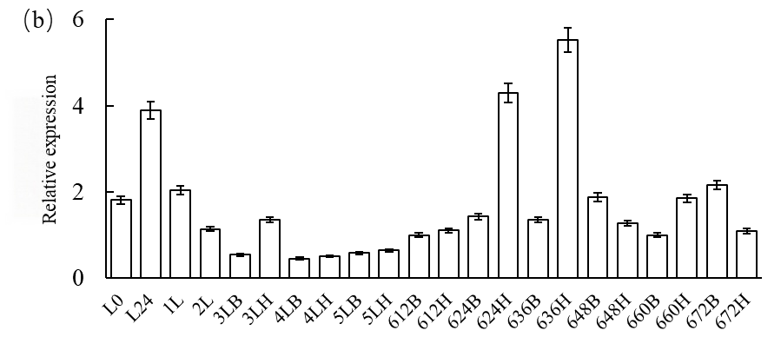
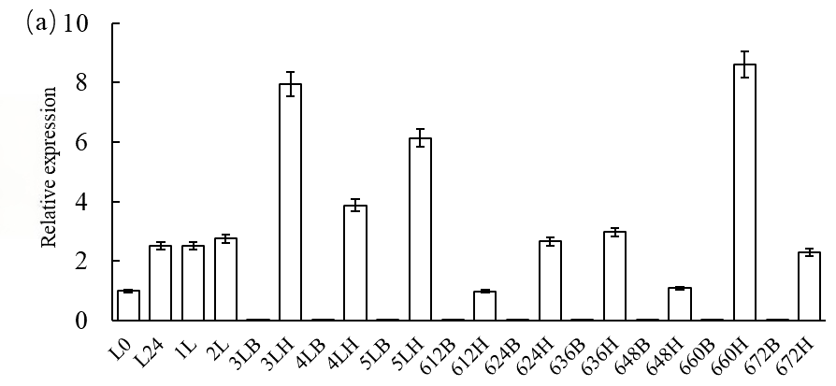
Fig. 1 Expression of HaDH and HaDHR in the larval stage of H. armigera
a: HaDH expression in larvae; b: HaDHR expression in larvae
Note: L0: Egg 0 h; L24: Egg 24 h; 1L: 1st-instar larva; 2L: 2nd-instar larva; 3LB: Body of 3rd-instar larva; 3LH: Head of 3rd-instar larva; 4LB: Body of 4th-instar larva; 4LH: Head of 4th-instar larva; 5LB: Body of 5th-instar larva; 5LH: Head of 5th-instar larva; 612B: Body of 6th-instar larva at 12 h post-molting; 612H: Head of 6th-instar larva at 12 h post-molting; 624B: Body of 6th-instar larva at 24 h post-molting; 624H: Head of 6th-instar larva at 24 h post-molting; 636B: Body of 6th-instar larva at 36 h post-molting; 636H: Head of 6th-instar larva at 36 h post-molting; 648B: Body of 6th-instar larva at 48 h post-molting; 648H: Head of 6th-instar larva at 48 h post-molting; 660B: Body of 6th-instar larva at 60 h post-molting; 660H: Head of 6th-instar larva at 60 h post-molting; 672B: Body of 6th-instar larva at 72 h post-molting; 672H: Head of 6th-instar larva at 72 h post-molting.

Expression Patterns of HaDH and HaDHR in the Pupal Stage
HaDH was expressed throughout the pupal stage, with expression mainly in the head and almost undetectable in the body. In the head of male pupae: the highest HaDH expression was observed on Day 1, followed by a rapid decrease on Day 2, a gradual increase to a second peak on Day 5, and then a rapid decline to the lowest level on Day 8 (approximately 1/5 of the expression on Day 1). In the head of female pupae: HaDH expression increased gradually from Day 1 to Day 4, reached the maximum on Day 4, then decreased rapidly, and remained low with a gradual decline from Day 5 to Day 8, reaching the lowest level on Day 8 (approximately 1/8 of the expression on Day 4) (Fig. 2a).
HaDHR was expressed throughout the pupal stage, with high expression in the head and low expression in the body. In the body of male pupae: low HaDHR expression was maintained from Day 1 to Day 8; in the head of male pupae: almost no expression was detected in the first 4 days, expression was rapidly upregulated on Day 5 and gradually increased, reaching the highest level on Day 8 (pre-pupation, approximately 7 times higher than that on Day 5). In the body of female pupae: low HaDHR expression was maintained from Day 1 to Day 8; in the head of female pupae: almost no expression was detected in the first 4 days, expression was rapidly upregulated on Day 5, rapidly downregulated on Day 6, reached the highest level on Day 7 (approximately 6 times higher than that on Day 6), and slightly downregulated on Day 8 (Fig. 2b).
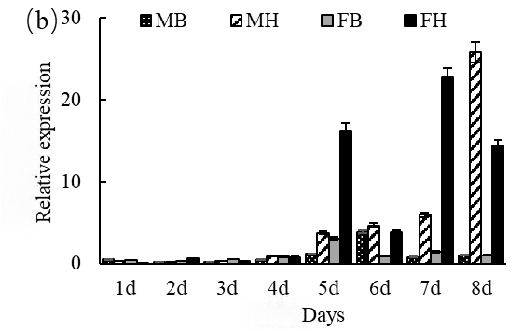
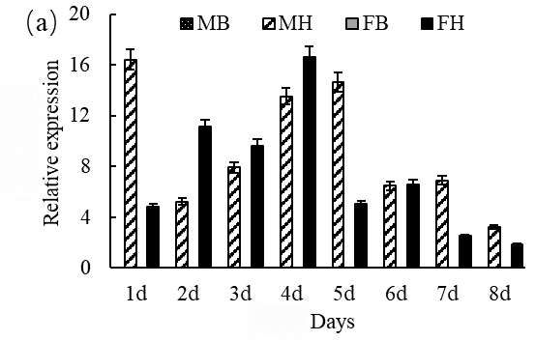
Fig. 2 Expression of HaDH and HaDHR in pupae stage of H. armigera
a: HaDH expression in pupae; b: HaDHR expression in pupae;
Note:MB: Body of male pupa; MH: Head of male pupa; FB: Body of female pupa; FH: Head of female pupa

Expression Patterns of HaDH and HaDHR in the Adult Stage
HaDH was expressed throughout the adult stage, with expression mainly in the head and almost undetectable in the body. In the head of male adults: the lowest HaDH expression was observed on Day 1, expression was rapidly upregulated on Day 2 and maintained at a high level from Day 2 to Day 3, rapidly downregulated on Day 4, and rapidly upregulated again to the maximum on Day 5 (approximately 8 times higher than that on Day 4). In the head of female adults: high HaDH expression was detected on Day 1, gradually decreased to the lowest level on Day 3, increased to the highest level on Day 4 (approximately 14 times higher than that on Day 3), and slightly downregulated on Day 5 (Fig. 3a).
HaDHR was expressed throughout the adult stage, with high expression in the head and low expression in the body. The expression trend of HaDHR in the heads of male and female adults was consistent: high expression on Day 1, downregulation to the lowest level on Day 2, continuous increase from Day 3 to Day 5, and peak expression on Day 5. Specifically, the HaDHR expression in the head of male adults on Day 5 was approximately 10 times higher than that on Day 2, while the expression in the head of female adults on Day 5 was approximately 12 times higher than that on Day 2 (Fig. 3b).
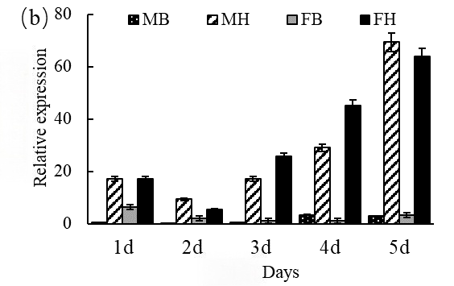
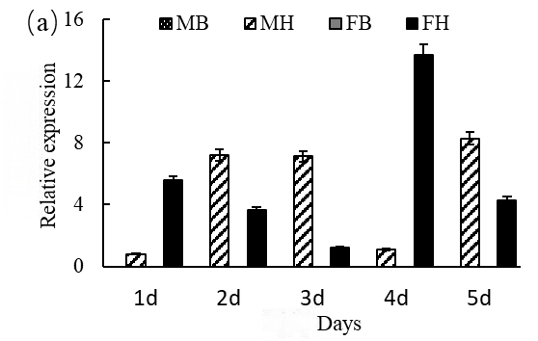
Fig. 3 Expression of DH and DHR in adults stage of H. armigera
a: HaDH expression in adults; b: HaDHR expression in adults
Note: MB: Body of male adult; MH: Head of male adult; FB: Body of female adult; FH: Head of female adult

Conclusion and Discussion
The expression trends of HaDH and HaDHR were generally consistent. HaDH was expressed throughout the entire life cycle of H. armigera, with expression mainly localized to the head and almost undetectable in the body; its expression levels followed the pattern: lowest in eggs, low in larvae, highest in pupae, and high in adults. HaDHR was also expressed throughout the life cycle (from egg to adult), with high expression in the head and low expression in the body; its overall expression trend was consistent with that of HaDH: lowest in eggs, low in larvae, high in pupae, and highest in adults.
The binding of HaDH to its receptor HaDHR is a prerequisite for HaDH to exert its regulatory effects. The continuous expression of both molecules throughout the H. armigera life cycle indicates that HaDH is likely involved in regulating basic metabolic processes essential for insect development. The spatio-temporal expression characteristics and potential regulatory functions of HaDH and HaDHR revealed in this study provide an important basis for further elucidating the physiological mechanism of HaDH and lay the foundation for improving the theoretical system of HaDH.

References
Chen, Z., Huang, F., Li, X. (2022). Tissue-specific DHR expression in corn earworm and its relation to diapause. Journal of Economic Entomology, 115(2), 567-578.
Denlinger D L. (2002).Regulation of diapause. Annual Review of Entomology, 47(1): 93-122.
Gupta, A., Sharma, S., Kumar, D. (2024). Cofactors and auxiliary proteins in DHR functional activity. Frontiers in Physiology, 15, 789012.
Hahn D A, Denlinger D L. (2011). Energetics of insect diapause. Annual Review of Entomology, 56(1): 103-121.
Jiang H, Wei Z, Nachman R J, Park Y. (2014). Molecular cloning and functional characterization of the diapause hormone receptor in the corn earworm Helicoverpa zea. Peptides, 53(11): 243-249.
Karlson P, Lü Hongsheng. (1981). Review and prospect of ecdysteroid research. Foreign Agriculture-Sericulture, (04): 1-7.
Kim, S., Park, J., Lee, H. (2022). Evolutionary insights into diapause hormone function in Lepidoptera. Molecular Ecology, 31(10), 2890-2905.
Li, J., Wu, Q., Zhou, Y. (2021). Confirmation of DH action on prothoracic gland in Noctuidae. Pest Management Science, 77(3), 1234-1245.
Liu, R., Wang, P., & Xu, S. (2023). DHR expression and diapause termination in Helicoverpa zea. Scientific Reports, 13, 4567.
Marchal E, Vandersmissen H P, Badisco L, Van de Velde S, Verlinden H, Iga M, Van Wielendaele P, Huybrechts R, Simonet G, Smagghe G, Vanden Broeck J. (2010). Control of ecdysteroidogenesis in prothoracic glands of insects: a review. Peptides, 31(3): 506-519.
Nusawardani T, Kroemer J A, Choi M Y, Jurenka R A. (2013). Identification and characterization of the pyrokinin/pheromone biosynthesis activating neuropeptide family of G protein-coupled receptors from Ostrinia nubilalis. Insect Biochemistry and Molecular Biology, 22(3): 331-340.
Saunders D S. (2020). Dormancy, Diapause, and the role of the circadian system in insect photoperiodism. Annual Review of Entomology, 65(1): 373-389.
Singh, R., Patel, V., Yadav, S. (2023). Carbohydrate metabolism and ancestral functions of diapause hormone. Insect Molecular Biology, 32(4), 512-525.
Wang Ligang. (2011). Structure, expression characteristics and functional analysis of the diapause hormone receptor gene in Bombyx mori. Master’s Thesis, Jiangsu University of Science and Technology, Zhenjiang, Jiangsu.
Wang, X., Li, Y., Zhang, J. (2020). Regulation of ecdysteroid synthesis by diapause hormone in Helicoverpa armigera. Journal of Insect Physiology, 120, 104000.
Watanabe K, Hull J J, Niimi T, Imai K, Matsumoto S, Yaginuma T, Kataoka H. (2007). FXPRL-amide peptides induce ecdysteroidogenesis through a G-protein coupled receptor expressed in the prothoracic gland of Bombyx mori. Molecular and Cellular Endocrinology, 273(1): 51-58.
Yang, L., Chen, H., Liu, M. (2021). Effects of ecdysteroid injection on larval development in Lepidoptera. Insect Biochemistry and Molecular Biology, 130, 103500.
Zhang Q, Nachman R J, Denlinger D L. (2015) Diapause hormone in the Helicoverpa/Heliothis complex: A review of gene expression, peptide structure and activity, analog and antagonist development, and the receptor. Peptides, 72(10): 196-201.
Zhang Q, Piermarini P M, Nachman R J, Denlinger D L. (2014). Molecular identification and expression analysis of a diapause hormone receptor in the corn earworm, Helicoverpa zea. Peptides, 53(3): 250-257.
Zhang T Y, Sun J S, Zhang Q R, Xu J, Jiang R J, Xu W H. (2004). The diapause hormone-pheromone biosynthesis activating neuropeptide gene of Helicoverpa armigera encodes multiple peptides that break, rather than induce, diapause. Journal of Insect Physiology, 50(6): 547-554.
Zhang, Q., Sun, Y., Wang, L. (2024). Multifunctional roles of diapause hormone in insect development. Annual Review of Entomology, 69, 123-145.
Zhou Z, Li Y L, Yuan C Y, Doucet D, Zhang Y A, Qu L J. (2017). Overexpression of TAT-PTD-diapause hormone fusion protein in tobacco and its effect on the larval development of Helicoverpa armigera (Lepidoptera: Noctuidae). Pest Management Science, 73(6): 1197-1203.
Zhou Z, Li Y L, Yuan C Y, Qu L J. (2014). Prokaryotic expression of the TAT-Cloan-DH-EGFP fusion protein and its transmembrane transduction in Lymantria dispar larvae. Acta Entomologica Sinica, 57(12): 1395-1401.
Zhou Z, Li Y L, Yuan C Y, Zhang Y A, Qu L J. (2015). Oral administration of TAT-PTD–diapause hormone fusion protein interferes with Helicoverpa armigera (Lepidoptera: Noctuidae) development. Journal of Insect Science, 2015, 15(1): 1-6.

