Case study

A STUDY ON ENDOMETRITIS IN CATTLE

.
ABSTRACT
Aim: To study the incidence of endometritis in cattle and compare different treatment protocols.
Study design:Case study.
Place and Duration of Study:Veterinary Clinical Complex, Krantisinh Nana Patil College of Veterinary Science, Shirwal, Satara. September 4th, 2024 to February 26th, 2025.
Methodology:The cattle (n=20), positive for endometritis, diagnosed from trans-rectal ultrasonography and proper anamnesis were divided into 2 treatment groups, one group (n=10) receiving 60 ml Intrauterine Moxifloxacin+ Ornidazole + Urea combination and other (n=10) intrauterine administration of 30 ml Lugol’s Iodine (1:40).
Results:The estrual symptoms improved in the subsequent estrus. Improvement rate was compared based on the conception in next heat. In the first group, the improvement rate was 40% and in second, it was 60%.
Conclusion:From the present study, it was concluded that intrauterine Lugol’s Iodine (1:40 dilution) is an effective treatment for cattle with endometritis.

Keywords: Endometritis, Lugol's Iodine, Moxifloxacin, Trans-rectal ultrasonography

1. INTRODUCTION

The economic viability of dairy herd is dependent on normal reproduction. Reproduction may be affected by various factors, but the pathological changes in the reproductive tract caused by microorganisms appear to be the key factor for infertility (Patel et al., 2009). Infertility in cattle is of paramount importance causing great loss to the farmer and dairy industry. It may be resulted from infections affecting various parts of genital tract. Generally, non-specific infection of genitalia was considered to be the main cause of repeat breeding (Murthy et al., l974). Uterine infection is a major cause of reproductive failure leading to infertility in cattle as well as buffalo (Knutti et al., 2000; Moghaddam and Mamoei, 2004; Sheldon et al., 2008). The major affections of the uterine infection include endometritis (subclinical as well as clinical), metritis, puerperal metritis, septic metritis and pyometra, of which most commonly encountered condition is endometritis.
Incidence of repeat breeding in cows varies between 10-18% among various countries (Kimura et al., 1987). Bhosrekar (1973) reported 42.7% incidence of repeat breeding in cows and observed that the causative factors were endometritis (37.5%), cervicitis (19.4%), cystic ovary (16.6%), kinky cervix (9%), tubal factors (1.4%) and ovarian factors (5.6%). Furthermore, it is bacterial endometritis which constitutes major cause of repeat breeding in crossbred cattle (Saini, 1993; Couto et al., 2013).

Endometritis can occur by ascending route following abnormal parturition such as abortions, retained placenta, premature births, twin births, dystocia as well as uterine affections like septic metritis, post-partum metritis, pyometra and traumatic lesions of genital tract. It is the inflammation of endometrium with no systemic signs and usually caused by pathogenic bacteria (Bondurant, 1999), and has been divided into subclinical and clinical endometritis (Sheldon et al., 2006). Clinical endometritis is characterized by the presence of purulent or mucopurulent uterine discharge in the vagina with no systemic signs of illness; whereas subclinical endometritis is defined as inflammation of the uterus without any clinical signs but characterised by an increased number of polymorphonuclear neutrophil (PMN)-2- infiltration in the endometrium with a threshold level of 5% on cytobrush cytology (LeBlanc et al., 2002; Gilbert et al., 2005; Sheldon et al., 2006). Non-specific opportunist pathogens that contaminate the uterus especially during the peri-parturient period or post service are responsible for endometritis. Both aerobic and anaerobic, gram-positive and gram-negative bacteria have been isolated from endometritic cow and buffalo (Olson et al., 1984; Sheldon et al., 2006; Azawi, 2006).

Diagnosis of endometritis by rectal palpation and visual observation of a vaginal discharge, if present in adequate amount is probably the basis for its treatment in the field (Lewis, 1997). Rectal examination (LeBlanc et al., 2002), vaginoscopic examination (Barlund et al., 2008), endometrial cytobrush cytology (Barlund et al., 2008; Dubuc et al., 2010; Fischer et al., 2010; Ghasemi, 2011), endometritis clinical score (Williams et al., 2005), white side test (Sarkar et al., 2006), ultrasonography (Mateus et al., 2002; Barlund et al., 2008) and uterine biopsy (Gonzalez et al., 1985) have been used for efficient detection of endometritis.
The therapeutic approach towards endometritic cow involves either antibiotics and antiseptics or hormonal therapy (Vijayarajan et al., 2007). Various types of antibiotics are used in treatment regimens for uterine infection through intrauterine route. An appropriate treatment protocols need to be initiated for the treatment of uterine infection in cows. In practice, veterinarian has a large number of treatment protocols. However, providing safe and effective treatment is the main task of the doctor.
Therefore, the present study was planned to compare the treatment protocols for treating endometritic cows.
2. material and methods

2.1 Selection of Animals:
A total of twenty cattle diagnosed with endometritis with the help of proper history, clinical examination and trans-rectal ultrasonography in the Department of Animal Reproduction, Gynaecology and Obstetrics, Krantisinh Nana Patil College of Veterinary Science, Shirwal at Teaching Veterinary Clinical Complex (TVCC) during the period from September 4th, 2024 to February 26th, 2025 were selected for this research work. Please include ethical issue statement.
2.2 Anamnesis:
History was taken from the owners and date of last calving, difficulties during/after parturition, any abnormal discharge recorded by owners, failure to conceive, last estrual symptoms shown, etc. were noted down.
2.3 Ultrasonographic Examination:

A real-time B-mode portable ultrasonography machine (Hitachi F31 Aloka) with a 5-7.5 MHz multi-frequency trans-rectal transducer was used to scan the uterus. A protective transparent plastic sheath was used to cover the transducer and jelly was applied over the probe, before insertion. After back-recking, the transducer was inserted per-rectally and the uterus was visualized by moving transducer from left to right and vice-versa. The transducer was positioned dorsally above the uterus and the sound beams were directed dorso-ventrally. These beams were cutting the tissue beneath, in a longitudinal plane to get a relevant view of the uterus. Endometrial wall thickness and any fluid if present was noted down. Echotexture and echogenicity were also taken into consideration.
2.4 Treatment:
Operators hand was passed per-rectally and cervix was fixed. AI-gun covered with sheath was inserted per-vaginally till it reaches the uterine body. The gun was removed and the injections were infused by a syringe into the body of uterus. 60 ml Intrauterine Moxifloxacin + Ornidazole + Urea combination was given to the endometritic cattle (n=10). In remaining half (n=10), intrauterine administration of Lugols’s Iodine was carried out. Lugols’s iodine was prepared beforehand with 1:40 dilution in distilled water. 30 ml of this was infiltrated.
3. results and discussion
There were 200 case records of cattle with the history of physio-pathological reproductive problems presented in TVCC during the period from 4thSeptember, 2024 to 26thFebruary, 2025. Out of 200 case records, physiological conditions contributed 39.62%, out of which pregnancy diagnosis contributed 22.28% and estrus detection 17.34%. Among pathological conditions, the incidence was repeat breeder (16.37%), anestrus (18.04%), endometritis (10.02%), cystic ovary (5.46%), torsion (3.08%), retention of foetal membranes (0.57%), cervicitis (0.36%) and utero-vaginal prolapse (0.19%).
In the given period, 20 cattle were diagnosed for endometritis. The infection was more common after parturition in the post-parturient period and was associated with repeat breeding syndrome. Endometritis may be clinical or sub-clinical. The clinical form is often manifested by systemic symptoms and discharge. Sub-clinical form may go unnoticed. Ultrasonography and other diagnostic tests such as white side test, endometrial cytology, pH of cervical mucus help in diagnosing the endometritic cases.
The incidence of endometritis varies. Bedewy and Rahaway, 2019 reported an incidence of 16.66% for sub-clinical endometritis in the repeated breeding cows. Clinical endometritis is recognized as the most common condition occurring around the time of calving, representing approximately 15% of all periparturient disorders. In dairy cows, the incidence of subclinical endometritis after parturition varies widely, with reported rates ranging from 5% to 68% across different herds (Cheong et al., 2011; Pascottini et al., 2017) and in beef cattle, the prevalence has been observed in the range of 2% to 31% (Ricci et al., 2015; Pfeifer et al., 2018).
In the present study, cattle with uterine infection were diagnosed by proper history, ultrasonographic findings and were treated by intrauterine administration of moxifloxacin + ornidazole + urea combination and Lugol’s iodine. Both the treatment groups were compared.
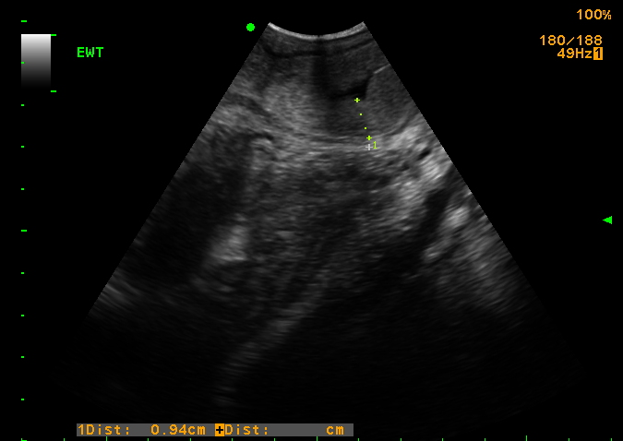
Fig.1.Thickened endometrium wall with anechoic fluid accumulation in the uterus of HF Crossbred cattle during trans-rectal ultrasonography

As reported by Kasimanickamet al. (2004) and Lenz et al. (2007), uterine lumen diameter above 0.2 cm and presence of echogenic content in the uterus of dairy cows may be used as indicator of sub-clinical endometritis which negatively affect conception rate as well as the proportion of cows becoming pregnant. In the present study, endometrial wall thickness of the affected cattle was found to be 0.54 ± 0.12 cm. The wall was hyperechoic in echogenicity as diagnosed from trans-rectal ultrasound. Some amount of anechoic fluid was also observed in the endometrium. Estrual endometrial thickening and that of endometritis was differentiated by abnormal discharge, presence of more amount of anechoic fluid or absence of estrual symptoms.
Half of the cases (n=10) were administered moxifloxacin + ornidazole + urea combination intra-uterine. The estrual symptoms improved in the subsequent estrus. The cattle were inseminated in the next estrus, and 4 out of 10 were conceived after confirmation by trans-rectal ultrasonography after 28 days of insemination. The improvement rate was 40%.
As per Azawi (2008), intrauterine infusion of Lugol's iodine solution is the most widely practiced treatment for endometritis. In this study also, half of the cases (n=10) were administered 30 ml of lugol’s iodine (1:40 dilution) intra-uterine. A better estrual response was observed in the upcoming estrus. The subsequent heat was skipped, and animals were inseminated in next heat. 6 out of 10 animals conceived after confirmation by trans-rectal ultrasonography after 28 days of insemination. The improvement rate was 60%. This is in accordance to the study done by Thombare (2017).
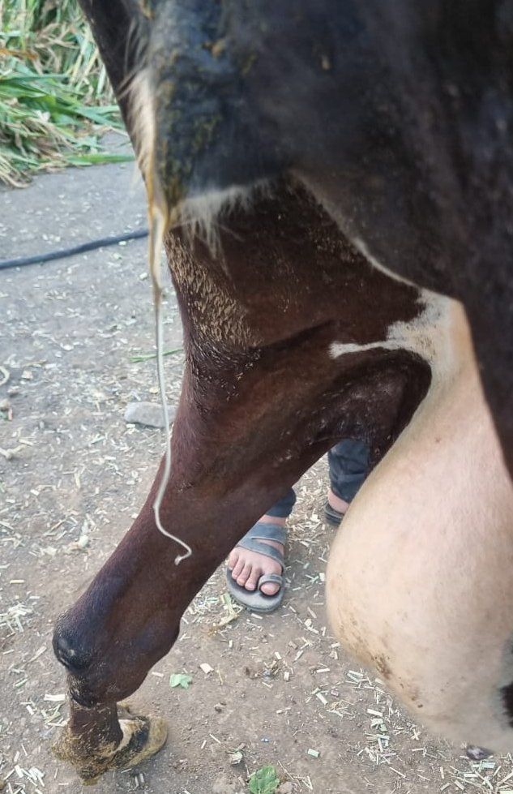
Fig.2.Clear vaginal discharge in the subsequent estrous.

4. Conclusion

The present trial was carried out in clinical cases of endometritic cattle and total 20 cases were attended. The infertility cases reported to clinics were thoroughly evaluated and selected critically for present clinical investigation during a period of six months. The cases were initially investigated on the basis of history and ultrasonographic findings to diagnose and confirm endometritis. Cases were also recorded as either of fresh type having minimum seven repeats and chronic type having more than seven repeats of oestrus cyclicity on the basis of reproductive record available with the owner. They were also correlated with last calving date.
Trans-rectal ultrasonographic findings showed increased echogenicity, i.e. hyperechoic nature of the endometrial wall. The thickness was also found to be increased. Average thickness of the endometrial wall was 0.54 ± 0.12 cm. Fluid accumulation was seen as anechoic areas in endometrium of the affected cattle.
The cases were divided into two treatment groups- first receiving intrauterine 60 ml combination of Moxifloxacin + Ornidazole + Urea and second group receiving 30 ml of Lugol’s Iodine (1:40 dilution). On treatment, the results for conception rate were 40% in first group and 60% in second.
The combination cures the infection by reducing the bacterial load in the endometrium. Lugol’s Iodine, being mild irritant increases the inflammatory response and cures the infection. From the present study, it was concluded that intrauterine Lugol’s Iodine (1:40 dilution) is an effective treatment for cattle with endometritis.
YOUR RESULTS SHOULD BE JUSTIFIED BY USING ANY STATICTICAL TEST LIKE INDEPENDENT SAMPLE T TEST

References

Adnane, M., Kaidi, R., Hanzen, C. and England, G.C.W. 2017. Risk factors of clinical and subclinical endometritis in cattle: a review. Turk. J. Vet. Anim. Sci.41: 1-11.
Ahmad, W.M., El-Jakee, J.A., El-Seedy, F.R., El-Ekhnawy, K.I., and Abd El-Moez. 2007.Vaginal bacterial profile of buffao-cows in relation to ovarian activity. Global Veterinaria., 1(1): 1-8.
Ahmed, K. and Bhattacharyya, D. K. 2005. Isolation, identification and antibiogram of aerobic bacteria from repeat breeding buffaloes. Indian Vet. J., 82: 898-899
Azawi O.I. (2008) Postpartum Uterine Infection in Cattle. Animal Reproduction Science, 105: 187-208.
Azawi, O. I. 2010. Uterine infection in buffalo cows: a review. Buffalo Bulletin. 29(3): 154-171.
Azawi, O. I., 2006. Clinical, bacteriological and pathological studies of uterine infections in Iraqi buffaloes. PhD Thesis, College of Veterinary Medicine, University of Baghdad, Iraq, pp. 122–170.
Azawi, O. I., Omran, S. N. and Hadad, J. J. 2008c. A study of Endometritis Causing Repeat Breeding of Cycling Iraqi Buffalo Cows. Reprod Dom Anim. 43: 735-743
Barlund C S, Carruthers T D, Waldner C L and Palmer C W. 2008. A comparison of diagnostic techniques for postpartum endometritis in dairy cattle. Theriogenology69: 714-723.
Bedewy, R. B., & Rahaway, M. A. (2019). Comparative study for detection of subclinical endometritis in local cows. Adv. Anim. Vet. Sci, 7(4), 289-294.

Bhosrekar, M. 1973. Investigation into the incidence and causes of repeat breeding in dairy cattle at National Dairy Research Institute, Karnal (Haryana). Indian Vet. J. 50: 418-429.
Bondurant, R. H. 1999. Inflammation in the bovine female reproductive tract. J. Anim. Sci.77:101–110.
Cheong, S. H., Nydam, D. V., Galvão, K. N., Crosier, B. M., & Gilbert, R. O. (2011). Cow-level and herd-level risk factors for subclinical endometritis in lactating Holstein cows. Journal of dairy science, 94(2), 762-770.

Couto, G.B, Vaillancourt, D.H. and Lefebvre, R.C.2013. Comparison of leukocyte esterase test with endometrial cytology for diagnosis of subclinical endometritis in postpartum dairy cows. Theriogenology. 79: 103-107.
Donofrio, G., Herath, S., Sartori, C., Cavirani, S., Flammini, C. F. and Sheldon, I. M. 2007.Bovine herpesvirus 4 (BoHV-4) is tropic for bovine endometrial cells and modulates endocrine function. Reproduction. 134: 183–197.
Dubuc, J., Duffield, T.F., Leslie, K.E., Walton, J.S. and LeBlanc, S.J. 2010. Definition and diagnosis of postpartum endometritis in dairy cows. Journal of Dairy Science. 93:5225-5233.
Fischer, C., Drillich, M., Odau, S., Heuwieser, W., Einspanier, R. and Gabler, C. 2010. Selected pro-inflammatory factor transcripts in bovine endometrial epithelial cells are regulated during the oestrous cycle and elevated in case of sub-clinical or clinical endometritis. Reproduction Fertility and Development. 22:818-829.
Gautam, G., Nakao, T., Yusuf, M. and Koike, K. 2009. Prevalence of endometritis during the postpartum period and its impact on subsequent reproductive performance in two Japanese dairy herds. Anim. Reprod. Sci. 116: 175-187.
Ghasemi, F. 2011. Characterization of endometritis in postpartum dairy cows. Thesis, M.Sc. Western College of Veterinary Science, University of Saskatchewan.
Gilbert, R. O., Shin, S.T., Guard, C. L., Erb, H. N. and Frajblat, N. 2005. Prevalence of endometritis and its effect on reproductive performance of dairy cows. Theriogenology. 64: 1879-1888.
Gonzalez, H. E., Crowell, W. A., Caudle, A. B. and Thompson, F. N. 1985. Morphometric studies of the bovine uterus: Microscopic lesions and retrospective reproductive history. American Journal Veterinary Research. 46:2588.
Kasimanickam, R., Duffield, T. F., Foster, R. A., Gartley, C. J., Leslie, K. E., Walton, J. S., & Johnson, W. H. (2004). Endometrial cytology and ultrasonography for the detection of subclinical endometritis in postpartum dairy cows. Theriogenology, 62(1-2), 9-23.
Kimura, M., Nakao, T., Moriyoshi, M. and Kawata, K. 1987. Luteal phase deficiency as a possible cause of repeat breeding in dairy cows. Br. Vet. J. 143: 560-566.
Knutti, B., Kupfer, U., and Busato, A. 2000. Reproductive efficiency of cows with endometritis after treatment with intrauterine infusions or prostaglandin injections, or no treatment. J. Vet. Med. A. Physiol. Pathol. Clin. Med. 47: 609–615
LeBlanc, S. J., Duffield, T. F., Leslie, K. E., Bateman, K. G., Keefe, G. P., Walton, J. S., and Johnson, W. H. 2002. Defining and diagnosing postpartum clinical endometritis and its impact on reproductive performance in dairy cows. J. Dairy Sci.85: 2223–2236.
Lenz, M., Drillich, M., & Heuwieser, W. (2007). Evaluation of the diagnosis of subclinical endometritis in dairy cattle using ultrasound. Berliner und Munchener Tierarztliche Wochenschrift, 120(5-6), 237-244.
Lewis, G. S. 1997. Uterine health and disorders. Journal of Dairy Science. 80:984-994.
Mateus, L., Lopes da Costa, L., Bernardo, F. and Robalo Silva, J. 2002. Influence of puerperal uterine infection on uterine involution and postpartum ovarian activity in dairy cows. Reproduction in Domestic Animal. 37:31-35.
Moghaddam, A. A. I. and Mamoei. M. 2004. A Survey on some of the reproductive and productive traits of the buffalo in Iran. In 23rd World Buiatries Congress. Qu and Evacute, Canada. p. 1910
Murthy, G. N. R., & Murthy, B. S. K. (1974). Bacterial flora of cervical mucus in repeat breeding bovines.
Noakes, D. A., Till, D. and Smith, G. R. 1989. Bovine uterine ûora postpartum: a comparison of swabbing and biopsy. Vet. Rec. 124: 563–564.
Olson, J. D., Mortimer, R. G., Farin, P. W., Adney, W. S. and Huffman, E. M. 1984. Aspects of bacteriology and endocrinology of cows with pyometra and retained fetal membranes. Am. J. Vet. Res. 45: 2251–2255
Pascottini, O. B., Hostens, M., Sys, P., Vercauteren, P., & Opsomer, G. (2017). Cytological endometritis at artificial insemination in dairy cows: Prevalence and effect on pregnancy outcome. Journal of dairy science, 100(1), 588-597.

PATEL, P.P., PANCHAL, M.T., KALYANI, I.H. and KAVANI, F.S., 2009. Antibiotic sensitivity spectrum of bacterial isolates from cervico vaginal mucus of postpartum rural buffaloes. Intas Polivet., 10(1): 29-31
Pfeifer LFM, de Souza Andrade J, Moreira EM, da Silva RR, Neves PMA, da Silva GM. Uterine inflammation and fertility of beef cows subjected to timed AI at different days postpartum. 2018;197:268-277.

Prajapati, S. B., Ghodasara, D. J., Prajapati, K. S., Purohit, J. H. and Jani, V. R. 2006.Microbial study of endometritis and its antibiotic spectra in repeat breeder buffaloes. Indian J. Anim. Reprod. 27(1): 69-71
Raghavan, R., Nilakantan, P.R. and Uppal, P.K. 1971. Studies on the bacteriology of bovine genital tract. Indian Vet. J. 48(8): 779-783.
Ricci A, Bonizzi G, Sarasso G, Gallo S, Dondo A, Zoppi S, et al. Subclinical endometritis in beef cattle in early and late postpartum: cytology, bacteriology, haptoglobin and test strip efficiency to evaluate the evolution of the disease. Theriogenology 2017;94:86-93.

Saini, P.S. 1993. Studies on etiopathology and modified therapy of bovine endometritis. Thesis, M.V.Sc. Punjab Agricultural University, Ludhiana.
Sarkar, P., Kumar, H., Rawat, M., Varshney, V. P., Goswami, T. K., Yadav, M. C. and Srivastava, S. K. 2006. Effect of administration of garlic extract and PGF2α on hormonal changes and recovery in endometritis cows. Asian-Australasian Journal of Animal Science. 19(7):964-969.
Sayyari, M., Farahangnia, M., Ghaemmaghami, S. H. and Sharma, R. H. 2012. A comparative study on bacteriology and pathology in uteri of cattle and buffalo in Ahwaz region, Iran. Iranian Journal of Veterinary Medicine. 6(1): 33-39
Sheldon, I. M, Lewis, G. S., LeBlanc, S. and Gilbert, R. O. 2006. Defining postpartum uterine disease in cattle. Theriogenology. 65: 1516–1530.
Sheldon, I. M., Cronin, J., Goetze, L., Donofrio, G. and Schuberth, H. J. 2009. Defining Postpartum Uterine Disease and the Mechanism of infection and Immunity in the Female Reproductive Tract in Cattle. Biol. Reprod. 81(6): 1025-32
Sheldon, I. M., Williams, E. J., Miller, A. N. A., Nash, D. M and Herath, S. 2008.Uterinediseases in cattle after partutation. Vet. J.176: 115-121.
Thombare, G.A., 2017. Efficacy of neem extract,Lugol’s iodine and E. coli LPS for the treatment of endometritis in cows and buffaloes. M.V.Sc thesis submitted to the College of Veterinary and animal sciences, Parbhani, MAFSU.
Vijayarajan A., C. Chandrhasan and R. Ezakial Nepolian (2007) Effect of pre-and post-insemination substitution of GnRH in repeat breeding buffalos. Indian Veterinary Journal,84: 940-943.
Williams, E.J., Fischer, D.P., Pfeiffer, D.U., England, G.C.W., Noakes, D.E., Dobson, H. and Sheldon, I.M. 2005. Clinical evaluation of postpartum vaginal mucus reflects uterine bacterial infection and the immune response in cattle. Theriogenology. 63: 102-117.
Zemjanis, R. 1980. Repeat breeding or conception failure in cattle. In: Morrow, D.A. (ed.). Current Therapy in Theriogenology. W.B. Saunders Co., Philadelphia. pp. 209.
Include recent articles for references

