Molecular detection and identification of Tomato leaf curl New Delhi virus associated with mosaic disease of Luffa aegyptiaca and Coccinia grandis from Central India

ABSTRACT
Luffa aegyptica and Coccinia grandis are significant crops of the Cucurbitaceae family, these crops are highly susceptible to the begomovirus which is transmitted by Bemisia tabaci (whiteflies) through a persistent and circulative manner. The ToLCNDV has emerged as a major constraint on vegetable production in numerous countries. Symptomatic and asymptomatic leaf samples of sponge gourd and ivy gourd were collected in the Bhopal district and confirmed for begomovirus disease by PCR using a begomovirus-specific primer. The full-length viral DNA-A genome was amplified using total DNA and begomovirus-specific primers through a polymerase chain reaction. The amplified PCR amplicons were sequenced and the consensus sequence data of three identical sequences were assembled into a DNA-A genome and data deposited in the NCBI GenBank database (accession numbers PP530350, PP530351 on sponge gourd, and PP505781 on ivy gourd). The sequence analysis of the complete DNA-A (PP530350 and PP505781) genome sequence of the virus isolate under this study, showed the highest 95-98% sequence identities and close phylogenetic relationships with Tomato leaf curl New Delhi virus. This information has also contributed to the development of effective control strategies and the conservation of begomoviruses within cucurbits plant. The insights provided here are crucial for understanding the biology and epidemiology of ToLCNDV and will aid in future disease management efforts.
Keywords: Begomovirus; Cucurbits; ivy gourd; severe mosaic; leaf curling; ToLCNDV
1. INTRODUCTION
Cucurbits are important vegetable crops, rich in minerals and nutrients, and are cultivated worldwide. However, they are susceptible to virus infections (Nagendran et al., 2016). Luffa cylindrica is a subtropical vegetable that is extensively grown in tropical and subtropical regions of Asia, India, Brazil, and the USA. The Cucurbitaceae family includes a group of gourds known by various names such as vegetable sponges, dishcloth gourds, running okra, strainer vine, Chinese okra, California okra, and loofah. Loofah sponges are a suitable natural matrix for immobilizing microorganisms and have proven effective in absorbing heavy metals from wastewater. As an emerging cash crop, loofahs hold significant potential to boost the economies of many nations in the near future (Mariod et al., 2017).
Ivy gourd (Coccinia grandis L.), native to tropical Africa and Asia, belongs to the Cucurbitaceae family and is a perennial vegetable crop grown worldwide. The fruit yields of ivy gourd are low due to viral disease infections, with begomoviruses being the primary culprits (Nagendran et al., 2016).
The Begomovirus, belonging to the Geminiviridae family, includes over 450 species and is responsible for diseases affecting a diverse array of economically significant crops and weeds in both the "Old World" and "New World" regions (Brown et al., 2015; Kumar et al., 2019). Begomoviruses are transmitted by Bemisia tabaci (whiteflies) through a persistent and circulative process. They are further classified into two groups: bipartite, which consists of two similarly sized genomic components, DNA-A and DNA-B, or monopartite, which contains a single DNA-A-like genomic component (Vignesh et al., 2023). The Tomato leaf curl New Delhi virus (ToLCNDV), transmitted by whiteflies, and is a major constraint on cucurbit production in Asian and European countries (Srivastava et al., 1995; Hussain et al., 2004; Maruthi et al., 2005; Chang et al., 2010; Sangeetha et al., 2018). ToLCNDV infection in cucurbits manifests with distinctive symptoms such as severe leaf curling, yellow mosaic patterns, vein swelling, shortened internodal length, and rough skin etc. (Vignesh et al., 2023; Moriones et al., 2017; Zaidi et al., 2017).
In this study, we have detected and identified begomovirus species associated with mosaic disease of Luffa and ivy gourd. Based on the nucleotide identity of the DNA-A component, it has been identified as a Tomato leaf curl New Delhi virus. We have also established the phylogenetic relationship of DNA-A and partial DNA-A (Coat protein gene) of the Tomato leaf curl New Delhi virus with different begomoviruses infecting cucurbitaceous and other hosts.
2. METHODOLOGY
2.1 Sample collection
The survey was carried out at various sites within the Bhopal district, where both symptomatic and healthy plant leaves were collected at each location (please provide collection details).
2.2 Total DNA extraction and detection of Begomovirus using PCR
Total DNA was extracted from leaf samples of both symptomatic and healthy plants using the method described by Dellaporta (Dellaporta et al., 1983). To identify causal agents of the disease, PCR was performed using total DNA extracted from symptomatic plant samples with begomovirus-specific primers (Singh 2005; Rojas et al., 1993). Additionally, DNA-B specific primers (Padidam et al., 1995; Reddy et al., 2005) and DNA-β specific primer (Briddon et al., 2003) were used in the PCR. The PCR was carried out in a 245 μl volume containing 100 ng of template DNA, 10X Taq buffer with 25 mM MgCl2, 10 mM dNTPs, 25 pmol of each primer, and 250 U of Taq DNA polymerase (DSS Takara Bio India Pvt. Ltd., New Delhi). The reactions were conducted in a BIO-RAD T-100 Thermal Cycler with initial denaturation at 94°C for 5 minutes, followed by 35 cycles of 94°C for 1 minute, 47°C for 1 minute, and 72°C for 1.5 minutes. A final extension was performed at 72°C for 5 minutes. The resulting PCR products were analyzed by 1% agarose gel electrophoresis, and the expected bands were eluted using the Wizard SV Gel and PCR Clean-Up System (Promega, USA).
2.3 Sequence Analysis using bioinformatics tool
The eluted product was sequenced commercially by Barcode Biosciences Pvt. Ltd., Bengaluru (India) using both forward and reverse primers. The nucleotide sequences of the virus isolates were analyzed using BLAST with Blastn against sequences available in the GenBank database (https://blast.ncbi.nlm.nih.gov/Blast.cgi?PROGRAM=blastn&PAGE). The Genomatix alignment tool and the Sequence Demarcation Tool (SDTv1.2) were used for pairwise identity comparison of the virus isolates under study with selected begomovirus sequences obtained from the GenBank database (Morgenstern 1999; Muhire et al., 2004). The sequences under study were aligned using the ClustalW algorithm and MEGAv11. Phylogenetic trees were generated using bootstrapping with 1000 replicates (Thompson et al., 1994; Tamura et al., 2007). Dendrograms were visualized using the NJ plot program.
3. RESULT AND DISCUSSION
3.1 Disease symptoms
During the year 2023, in virus-like symptoms were observed in Sponge gourd and Ivy gourd. In each field visited infected leaf samples showing severe mosaic, leaf curling on sponge gourd (Fig. 1) and mosaic on ivy gourd (Fig. 2) were collected.
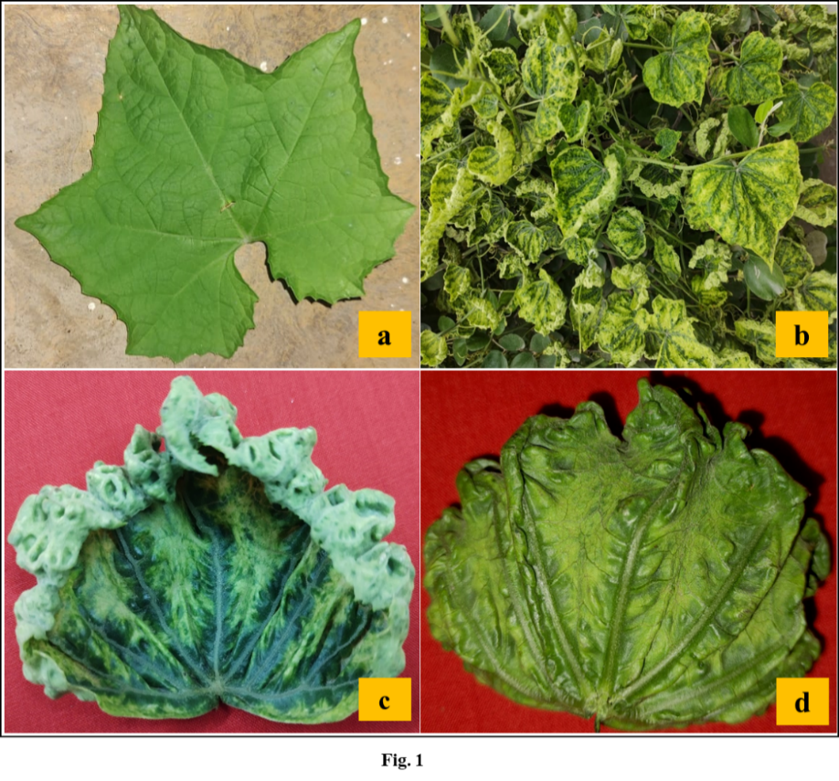
Fig. 1 Symptoms of begomovirus infection on Luffa aegyptiaca (a) Asymptomatic leaf, (b) Severe mosaic with leaf curl, (c) cupping of leaf, (d) vein clearing and vein swelling.

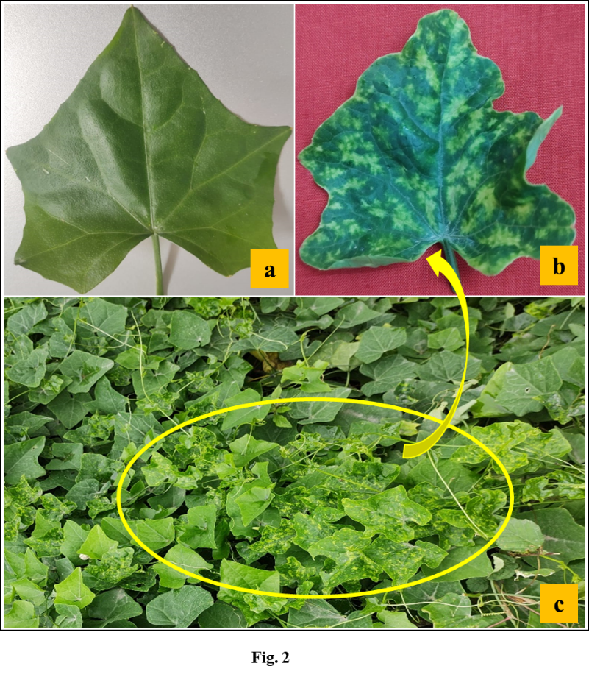
Fig. 2 Symptoms of begomovirus infection on Coccinia grandis (a) Asymptomatic leaf, (b) mosaic with yellowing, (c) Field view of infected Coccinia grandis crop.
Begomoviruses transmitted by whitefly (Bemisia tabaci) are becoming major constraints on the production of many crops belonging to different taxonomic groups. Diseases caused by ToLCNDV, a member of the begomoviruses, are emerging as a major challenge to the cultivation of numerous agricultural crops in India, Pakistan, Bangladesh, Sri Lanka, Iran, Malaysia, Thailand, Taiwan, Indonesia, Spain, Tunisia, and Italy (Zaidi et al., 2017; Venkataravanappa et al., 2018). ToLCNDV was first time reported on tomato (Padidam et al., 1995) and subsequently in other solanaceous vegetables (Arguello-Astorga & Ruiz-Medrano 2001; Hanley-Bowdoin et al., 1999). The virus has a very broad host range and is known to infect many cucurbitaceous vegetables, including sponge gourd, bottle gourd, bitter gourd, ivy gourd, pumpkin, cucumber, ash gourd, long melon, ridge gourd, and watermelon in northern and north-western India (Venkataravanappa et al., 2015; Nagendran et al., 2016; Venkataravanappa et al., 2018; Kumar et al., 2019; Vignesh et al., 2023; Naganur et al., 2023).
3.2 Genomic extraction and detection of Begomovirus using PCR
Total genomic DNA was isolated by the Dellaporta method from symptomatic and asymptomatic leaf samples to confirm the association of begomovirus with severe leaf curling, vein banding, vein swelling and mosaic disease of sponge gourd and ivy gourd. This method yielded a good quality & quantity of DNA preparation as checked by taking its best O.D. at 260/280 is 1.8 and concentration also checked by the 1% agarose gel electrophoresis. DNA samples were subjected to PCR using the begomovirus gene-specific primers for DNA-A: CPIT-I/CPIT-T, PALIv1978/PARIc496 and PARIv722/PALIc1960 with PCR reactions and conditions. As expected, bands of ~0.8 kb, ~1.2 and ~1.2 kb were consistently amplified from all symptomatic (5) samples, but not from asymptomatic (2) samples. The PCR was also performed for DNA-B using BC1F/BC1R, and BF518/BR1641 primers, whether the virus isolate is monopartite or bipartite. The PCR carried out with DNA-B-specific primers did not show a positive result of amplification in any of the plant samples. So it may be a monopartite nature. During PCR with β01/β02 primers, DNA-β was not amplified from symptomatic and asymptomatic samples. The PCR products were analyzed by electrophoresis in 1% agarose gel. As expected, bands of ~0.8 kb, ~1.2 kb and 1.2 kb. The PCR amplicons were gel eluted through Wizard SV Gel and PCR Clean-Up System (Promega Pvt. Ltd. USA), and eluted products sequenced from Barcode Biosciences Pvt. Ltd, India. The obtained sequence data of the complete DNA-A genome and partial DNA-A were deposited in the NCBI GenBank database under accession numbers PP530350, PP530351 on Luffa, and PP505781 on ivy gourd.
3.3 Sequencing and Sequence Analysis
BLASTn analysis of the understudy Luffa aegyptiaca virus isolates complete DNA-A (Acc. No. PP530350) showed 95-98% nucleotide identities with isolates of Tomato leaf curl New Delhi virus (MW426776, KC545812, PP505781, PP230701, MH577015 and MW538661) in Solanum lycopersicum, Cucumis sativus, Coccinia grandis, Glycine max, ridge gourd from Pakistan, India and 95% sequence identity with Tomato leaf curl virus (JX232220) in Lycopersicon esculentum from Raebareli. The BLASTn analysis of the complete coat protein gene of Luffa aegyptiaca virus isolate under study (PP530351) showed 97-98% sequence identities with Tomato leaf curl New Delhi virus isolate from chilli (KU196750), cucumber (OR678736), tomato (KF551576), Coccinia grandis (PP505781), Luffa aegyptiaca (PP530350), Glycine max (PP230701) and tomato (MH577015) isolated from India, and 96-97% with Tomato leaf curl virus isolated from Ipomoea cairica (OM777194), whitefly (AY691902 and AY691899), and Lycopersicon esculentum (JX232220) from India. However, 96% sequence identity with Pumpkin yellow vein mosaic virus isolate of pumpkin (AY686500) from New Delhi.
BLASTn analysis of complete DNA-A genome of virus isolate Coccinia grandis (PP505781) under study showed highest 95-98% sequence identities with Tomato leaf curl New Delhi virus (OQ921390, KM383736, OR678735, OR921108, HM007113 and KU196750) on Chilli, Solanum lycopersicum, Cucumis sativus isolated from Andhra Pradesh, Bangladesh, Tamil Nadu, IARI New Delhi. The identity was 96% with Tomato leaf curl virus isolated from Ipomoea carica (OM777194) isolated from India.
3.4 SDT Analysis
The complete DNA-A genome (PP530350: Luffa aegyptiaca) of begomovirus isolate was compared with other begomoviruses available in the GenBank database, and pairwise identity scores were calculated using the SDTv1.2. The SDT analysis showed that isolate PP530350 had maximum nucleotide similarities (98%) with ToLCNDV isolate (OM777194) on ridge gourd from India. 95-97 nt similarities with other ToLCNDV isolates; 93-96% nt similarities with ToLCV; 89% nt similarities with BGYVV and ChaEYMV; 87-89% nt similarities with SLCCNV and 88% nucleotide similarities with ToLCPalV.
The complete DNA-A genome (PP505781: Coccinia grandis) of begomovirus isolate was compared with begomovirus. The analysis showed that isolate PP505781 had maximum nucleotide similarities 96-98% with ToLCNDV; 93-96% nt similarities with ToLCV and 86-89% nt similarities with other begomovirus isolate. This isolates species was also supported by a two-dimensional color-coded matrix of pairwise identity scores of the complete DNA-A genome of ToLCNDV generated by SDTv1.2 (Fig. 3).

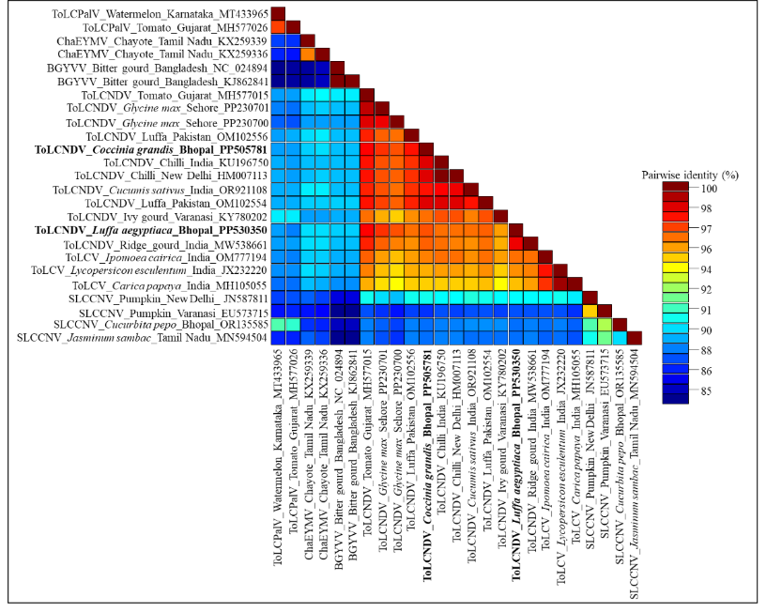
Fig. 3 Using the Sequence Demarcation Tool, a two-dimensional color-coded matrix of pairwise identity scores of begomovirus isolates (PP530350 and PP505781) were constructed.

3.5 Phylogenetic analysis
To determine the evolutionary relationship of the understudy begomovirus isolates (PP530350, PP530351 and PP505781), the phylogenetic trees were constructed using the MEGAv11 using the neighbor-joining method with 1000 bootstraps replicates with selected begomoviruses that were found to be closely related by BLASTn (Fig. 4). The understudy begomovirus isolates (PP530350, PP530351 and PP505781) showed the close relationship with the ToLCNDV on ridge gourd, ivy gourd, Glycine max, tomato, Luffa, Cucumis sativus, and chilli plant from India, and Pakistan. Under study begomovirus isolates shared distinct relationships with ToLCV, ToLCPalV, SLCCNV, BGYVV and ChaEYMV begomovirus species reported from India and abroad.
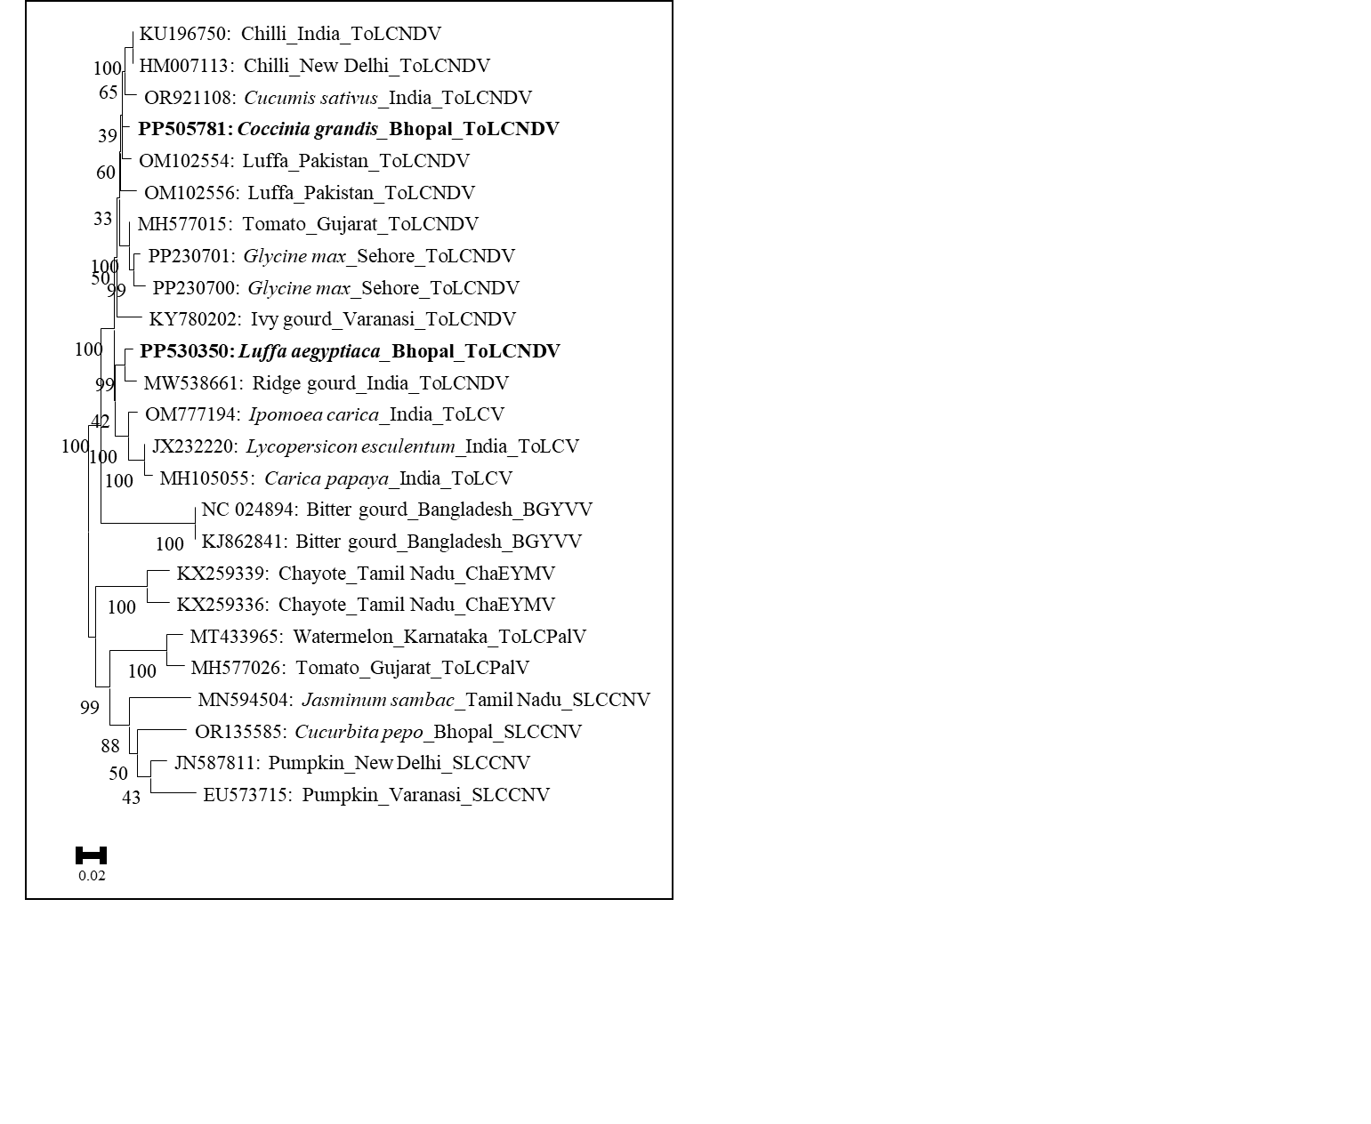
Fig. 4 Phylogenetic analysis of the complete DNA-A genome (PP530350 and PP505781) associated with severe mosaic with leaf curl disease of Luffa aegyptiaca and mosaic disease of Coccinia grandis showing relationships with isolates of ToLCNDV and other begomoviruses. The phylogenetic trees were generated using MEGA v11, and the evolutionary history was inferred using the neighbour-joining method with 1000 replicate bootstraps.
However, understudy begomovirus isolate (PP530351) showed the close relationship with the ToLCNDV on Glycine max, Luffa cylindrica, Luffa aegyptiaca, Coccinia grandis, Hibiscus sp., from India; and shared distinct relationships with PYVMV, ToLCV, ToLCPalV, SLCCNV and ToLCKV begomovirus species reported from India (Fig. 5).
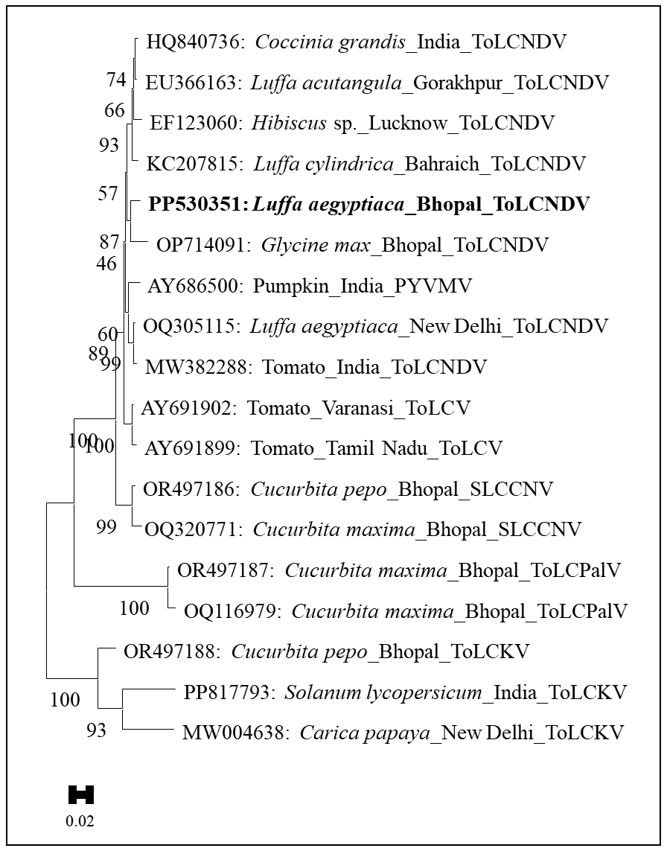
Fig. 5 Phylogenetic analysis of the complete coat protein gene of virus isolate (PP530351) associated with severe mosaic with leaf curl disease of Luffa aegyptiaca showing relationships with isolates of ToLCNDV and other begomoviruses. The tree was constructed using neighbour-joining method implemented by MEGA v11 and bootstrap values (1000 replicates) are given at the branch nodes.
In this study identify and characterize ToLCNDV on sponge gourd (L. aegyptiaca) and ivy gourd (C. grandis) for the first time in Central India. The leaf samples of sponge gourd and ivy gourd that had severe mosaic and mild mosaic were collected from the field and examined by PCR for the presence of begomoviruses using begomovirus specific primer. Further begomovirus-positive sponge gourd and ivy gourd samples were sequenced and submitted in GenBank database. The complete DNA-A genome and complete coat protein gene sequences of understudy virus isolates showed the highest identities with isolates of ToLCNDV.
On the basis of the highest sequence identities, pairwise similarities, and closest phylogenetic relationship understudy virus isolate was identified as an isolate of Tomato leaf curl New Delhi virus on the sponge gourd and ivy gourd. To our knowledge, this was the first recode of Tomato leaf curl New Delhi virus associated with mosaic disuse of sponge gourd and ivy gourd from Central India.
The first natural infection of Tomato leaf curl New Delhi virus with Yellow Mosaic Disease of Luffa cylindrica from New Delhi (Sohrab et al., 2003). These infections were reported in association with the yellowing symptom of luffa crops in Indonesia (Wilisiani et al., 2019). ToLCNDV associated with mosaic disease of ivy gourd in North India.
The under-study virus isolate of sponge gourd (PP530350, PP530351) and ivy gourd (PP505781) identified as begomovirus isolate of Tomato leaf curl New Delhi virus. However, this is the first record of Tomato leaf curl New Delhi virus associated with mosaic disease of Luffa aegyptiaca and Coccinia grandis from Bhopal, Madhya Pradesh, India.
CONCLUSION
Begomoviruses pose a significant threat to a wide range of crops in India due to the country's favorable environmental conditions that support their proliferation and the widespread presence of their vector, the Bemisia tabaci. The warm climate and conducive agricultural practices provide an ideal environment for both the virus and the vector, leading to severe crop losses across various regions. The Luffa aegyptica and Coccinia grandis are the two main crops cultivated in India and infected by begomoviruses. On investigation, we conclude that the full-length viral DNA-A genome was amplified using total DNA and begomovirus-specific primers through a polymerase chain reaction. The amplified PCR amplicons were sequenced and the consensus sequence data of three identical sequences were assembled into a DNA-A genome and data deposited in the NCBI GenBank database under accession numbers (PP530350, PP530351 on sponge gourd, and PP505781 on ivy gourd). DNA- B and DNA-β were not amplified from symptomatic and asymptomatic samples, hence we can predict that the begomovirus that infected both crops is monopartite. Sequence analysis of the complete DNA-A (PP530350 and PP505781) genome sequence of the virus isolate under this study, showed the highest 95-98% sequence identities and close phylogenetic relationships with the Tomato leaf curl New Delhi virus.

REFERENCE
Argüello-Astorga, G. R., & Ruiz-Medrano, R. (2001). An iteron-related domain is associated to Motif 1 in the replication proteins of geminiviruses: identification of potential interacting amino acid-base pairs by a comparative approach. Archives of virology, 146, 1465-1485.
Briddon, R. W., Bull, S. E., Amin, I., Idris, A. M., Mansoor, S., Bedford, I. D., Dhawan, P. & Markham, P. G. (2003). Diversity of DNA β, a satellite molecule associated with some monopartite begomoviruses. Virology, 312(1), 106-121.
Brown, J. K., Zerbini, F. M., Navas-Castillo, J., Moriones, E., Ramos-Sobrinho, R., Silva, J. C., Fiallo-Olivé, E., Briddon, R.W., Hernández-Zepeda, C., Idris, A., Malathi, V.G. & Varsani, A. (2015). Revision of Begomovirus taxonomy based on pairwise sequence comparisons. Archives of Virology, 160, 1593-19. https://doi.org/10.1007/s00705-015-2398-y
Chang, H. H., Ku, H. M., Tsai, W. S., Chien, R. C., & Jan, F. J. (2010). Identification and characterization of a mechanical transmissible begomovirus causing leaf curl on oriental melon. European journal of plant pathology, 127, 219-228. https://doi.org/10.1007/s10658-010-9586-0
Dellaporta, S.L., Wood, J., & Hicks, J.B. (1983). A plant DNA minipreparation: version II. Plant Molecular Biology Reporter, 1: 19-21. https://doi.org/10.1093/molbev/msm092
Hanley-Bowdoin, L., Settlage, S. B., Orozco, B. M., Nagar, S., & Robertson, D. (1999). Geminiviruses: models for plant DNA replication, transcription, and cell cycle regulation. Critical Reviews in Plant Sciences, 18(1), 71-106.
Hussain, M., Mansoor, S., Iram, S., Zafar, Y., & Briddon, R. W. (2004). First report ofTomato leaf curl New Delhi virusaffecting chilli pepper in Pakistan. Plant pathology, 53(6) 794. https://doi.org/10.1111/j.1365-3059.2004.01073.x
Kumar, R., Esakky, R., & Acharya, S. (2019). Molecular evidence of occurrence of Tomato Leaf Curl New Delhi Virus infecting cucurbits in several states in India. Archives of Phytopathology and Plant Protection, 52(9-10), 895-905. https://doi.org/10.1080/03235408.2019.1668108
Mariod, A. A., Mirghani, M. E. S., & Hussein, I. H. (2017). Unconventional oilseeds and oil sources. Academic Press.
Maruthi, M. N., Rekha, A. R., Cork, A., Colvin, J., Alam, S. N., & Kader, K. A. (2005). First report of Tomato leaf curl New Delhi virus infecting tomato in Bangladesh. Plant Disease, 89(9), 1011-1011. https://doi.org/10.1094/PD-89-1011C
Morgenstern, B. (1999). DIALIGN 2: improvement of the segment-to-segment approach to multiple sequence alignment. Bioinformatics (Oxford, England), 15(3), 211-218.
Moriones, E., Praveen, S., & Chakraborty, S. (2017). Tomato leaf curl New Delhi virus: an emerging virus complex threatening vegetable and fiber crops. Viruses, 9(10), 264. https://doi.org/10.3390/v9100264
Muhire, B. M., Varsani, A., & Martin, D. P. (2014). SDT: a virus classification tool based on pairwise sequence alignment and identity calculation. PloS one, 9(9), e108277.
Naganur, P., Shankarappa, K. S., Mesta, R. K., Rao, C. D., Venkataravanappa, V., Maruthi, M. N., & Reddy, L. R. C. N. (2023). Detecting Tomato Leaf Curl New Delhi Virus Causing Ridge Gourd Yellow Mosaic Disease, and Other Begomoviruses by Antibody-Based Methods. Plants, 12(3), 490.
Nagendran, K., Satya, V. K., Mohankumar, S., & Karthikeyan, G. (2016). Molecular characterization of a distinct bipartite Begomovirus species infecting ivy gourd (Coccinia grandis L.) in Tamil Nadu, India. Virus Genes, 52, 146-151.doi: https://doi.org/10.1007/s11262-015-1278-6
Padidam, M., Beachy, R. N., & Fauquet, C. M. (1995). Tomato leaf curl geminivirus from India has a bipartite genome and coat protein is not essential for infectivity. Journal of General Virology, 76(1), 25-35.
Reddy, C. R. V., Colvin, J., Muniyappa, V., & Seal, S. (2005). Diversity and distribution of begomoviruses infecting tomato in India. Archives of virology, 150, 845-867.
Rojas, M. R., Gilbertson, R. L., Russell, D. R., & Maxwell, D. P. (1993). Use of degenerate primers in the polymerase chain reaction to detect whitefly-transmitted geminiviruses. Plant disease, 77, 340-347.
Sangeetha, B., Malathi, V. G., Alice, D., Suganthy, M., & Renukadevi, P. (2018). A distinct seed-transmissible strain of tomato leaf curl New Delhi virus infecting Chayote in India. Virus research, 258, 81-91. https://doi.org/10.1016/j.virusres.2018.10.009
Singh, R. (2005). Molecular characterization of a virus yellow mosaic disease in Cucurbita maxima and development of diagnostics for detection of virus. (thesis), Lucknow University, Lucknow, India.
Sohrab, S. S., Mandal, B., Pant, R. P., & Varma, A. (2003). First report of association of Tomato leaf curl virus-New Delhi with yellow mosaic disease of Luffa cylindrica in India. Plant disease, 87(9), 1148-1148.
Srivastava, K. M., Hallan, V., Raizada, R. K., Chandra, G., Singh, B. P., & Sane, P. V. (1995). Molecular cloning of Indian tomato leaf curl vims genome following a simple method of concentrating the supercoiled replicative form of viral DNA. Journal of Virological Methods, 51(2-3), 297-304. https://doi.org/10.1016/0166-0934(94)00122-W
Tamura, K., Dudley, J., Nei, M., & Kumar, S. (2007). MEGA4: molecular evolutionary genetics analysis (MEGA) software version 4.0. Molecular biology and evolution, 24(8), 1596-1599.
Thompson, J. D., Higgins, D. G., & Gibson, T. J. (1994). CLUSTAL W: improving the sensitivity of progressive multiple sequence alignment through sequence weighting, position-specific gap penalties and weight matrix choice. Nucleic acids research, 22(22), 4673-4680. https://doi.org/10.1093/nar/22.22.4673
Venkataravanappa, V., Prasanna, H. C., Lakshminarayana Reddy, C. N., & Krishna Reddy, M. (2015). Evidence for two predominant viral lineages, recombination and subpopulation structure in begomoviruses associated with yellow vein mosaic disease of okra in India. Plant pathology, 64(3), 508-518.
Venkataravanappa, V., Reddy, L. R. C. N., Saha, S., Subbanna, S. K., & Manem, K. R. (2018). Detection and characterization of tomato leaf curl New Delhi virus association with mosaic disease of ivy gourd (Coccinia grandis (L.) Voigt) in North India. Archives of Biological Sciences, 70(2), 339-347.
Vignesh, S., Renukadevi, P., Nagendran, K., Senthil, N., Kumar, R. V., SwarnaPriya, R., T.K. Behera, & Karthikeyan, G. (2023). A distinct strain of tomato leaf curl New Delhi virus that causes mosaic disease in ash gourd and other cucurbitaceous crops. Frontiers in Microbiology, 14, 1268333.
Wilisiani, F., Neriya, Y., Tagami, M., Kaneko, M., Hartono, S., Nishigawa, H., & Natsuaki, T. (2019). Complete genome sequence of tomato leaf curl New Delhi virus from Luffa in Indonesia. Microbiology Resource Announcements, 8(15), 10-1128.
Zaidi, S. S. E. A., Martin, D. P., Amin, I., Farooq, M., & Mansoor, S. (2017). Tomato leaf curl New Delhi virus: a widespread bipartite begomovirus in the territory of monopartite begomoviruses. Molecular Plant Pathology, 18(7), 901-911.

