Original Research Article
Land use specific soil site suitability evaluation for cereal and oilseed crops in Bada micro watershed (4D4F2j05) of Haveri District, Karnataka

ABSTRACT:
This study aimed to evaluate the soil site suitability of forest, barren, agricultural and horticultural land use systems within the Bada microwatershed of Haveri district, located in the Northern Transition Zone (Zone 8) of Karnataka. A base map at a scale of 1:7,920, combined with satellite imagery, facilitated the identification and excavation of eight soil profiles, with two profiles representing each land use system. Morphological characteristics of the soil profiles were documented and horizon wise soil samples were analyzed for their physical and chemical properties by following standard methodologies. Subsequently, the potential of these land use systems for cultivating major cereal crops namely paddy, maize and sorghum; oilseed crops namely groundnut, soybean and sunflower were assessed using the limitation method. This assessment considered factors such as oxygen availability to roots, nutrient availability, rooting conditions, soil toxicity and erosion as primary criteria. Crop suitability maps were generated using ArcGIS software.The findings revealed that across forest, agricultural and horticultural land use systems, crop suitability ranged from highly suitable (S1) to marginally suitable (S3). Specifically, 33.17% of the total area was classified as highly suitable (S1) for the cultivation of sorghum crop. In contrast, 52.25% of the area was classified as marginally suitable (S3) for paddy cultivation, while 1.36% of the area was determined to be marginally suitable (S3) for the production of maize, sorghum, soybean and sunflower. These findings establish a fundamental comprehension of soil constraints, delivering critical insights that inform the development and application of sustainable crop management practices specifically adapted to the study region.
KEYWORDS: Soil site suitability, Land use system, Cereals, Oilseeds
- INTRODUCTION:
The nation’s most vital natural resources, namely land and water are presently experiencing considerable stress due to increasing biotic pressures (Wani and Sidhu, 2009). Effectively managing these resources while minimizing adverse environmental impacts is essential not only for attaining the sustainable development, but also for promoting the sustenance of human life. A watershed represents an ideal unit for resource management, necessitating a multidisciplinary approach to ensure the continuous provision of sustainable benefits. Integrated watershed management is crucial for the conservation and protection of land, water resources and degraded areas, thereby ensuring the preservation of biodiversity and genetic resources for future generations.The mapping of land resources constitutes a fundamental component in the effective management of its resources. This process facilitates strategic planning for future land use, particularly within the agricultural sector, by assessing the available land resources and their potential to support sustainable agricultural productivity over the long term.Crop productivity is predominantly determined by the quality of land resources and the prevailing climatic conditions within a given region. To enhance yield and overall productivity, it is essential to accurately identify the specific requirements of crops and address them utilizing the resources that are readily available. This approach is especially critical in light of the increasing global demand for food (Sehgal, 1996).
To enhance or maintain the existing level of productivity, the management of land resources must comply with established principles. A fundamental component of this process is the execution of a comprehensive soil resource inventory, which provides critical data concerning the capabilities and constraints of these resources. Such information is indispensable for the effective utilization of land resources, achieved through their systematic characterization and assessment (Prabhavati et al., 2017). The assessment of land suitability constitutes a critical component of land use planning, as it entails evaluating the potential of land to accommodate diverse existing and prospective applications (Sehgal, 1995).The integration of soil properties with climatic conditions and land use patterns is evident. Soil and site characteristics are fundamental in assessing land suitability and contribute significantly to the strategic planning of expanding cultivation areas for particular crops.
Singh et al. (1981) emphasize that analyzing the inter relationship between soil properties, site characteristics and crop requirements constitutes the fundamental basis for evaluating soil suitability and formulating effective land use planning strategies.Each crop requires specific soil and site conditions to achieve optimal growth. To maximize utilization, it is essential to evaluate the suitability of soil and site characteristics for different crops. Accordingly, a comprehensive land resource inventory was undertaken across four land use systems in the Bada microwatershed (4D4F2j05), situated within the Shiggaontaluk of Haveri district.
2. MATERIALS AND METHODS
2.1 Study area
The Bada micro watershed (4D4F2j05), is situated within the Shiggaon taluk of Haveri district of Karnataka state (Fig. 1). This microwatershed encompasses a total area of 592.62 hectares and is geographically positioned between 14˚55'30" - 14˚58'0" North latitudesand 75˚11'45" and 75˚14'0" Eastlongitudes.The study area is situated at an elevation of 450 to 900 meters above mean sea level (MSL).The study region is classified within the Northern Transition Zone (Agroclimatic Zone 8), experiencing an annual precipitation range of 620 to 1025 mm.The natural vegetation in this area predominantly comprises species such as Neem (Azadiractaindica), Jali (Prosopis juliflora), Mango (Mangiferaindica), Eucalyptus (Eucalyptus spp.), along with various thorny plants and creepers, accompanied by grass cover.
Figure-1. Location of the research area
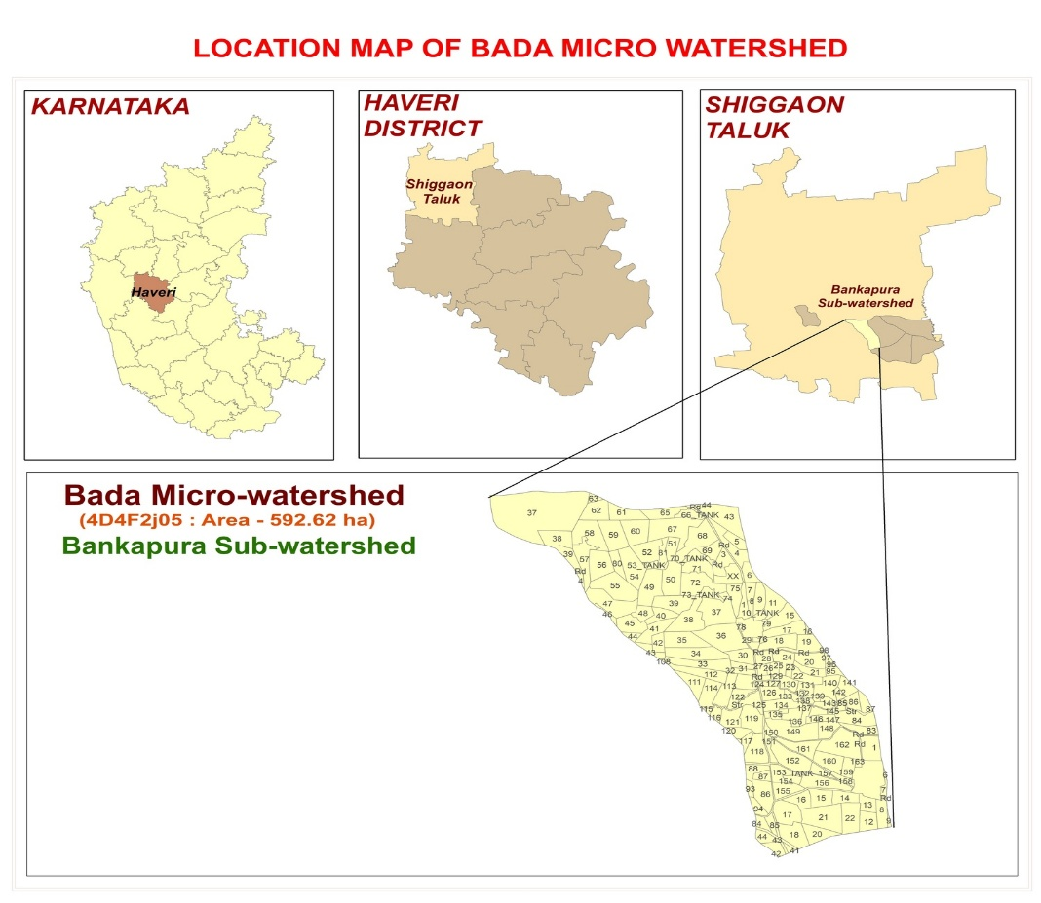
2.2 Base map
A comprehensive soil survey was carried out within the Bada micro watershed, employing the IRS P6 LISS-IV satellite imagery in conjunction with the topographic map of Haveri district. The image and the scanned topographic map were georeferenced and a subset was generated utilizing ArcGIS 10.8.2 at a scale of 1:7,920. The cadastral map illustrates the boundary lines of parcels along with their respective survey numbers, in addition to the exact positions of tanks, streams and other permanent features within the area. Remote sensing data products derived from LISS IV were integrated with satellite imagery to identify land use systems and various surface features. The imagery enabled the detection and delineation of boundaries between hills, water bodies, forests, vegetated areas, roads, settlements and other cultural attributes within the region.
2.3 Field investigations
An initial survey of the microwatershed was performed utilizing a cadastral map delineating the boundaries of individual fields. During the initial traverse, the drainage patterns, surface features, slope attributes, landforms and land use configurations associated with the region's geological formations were systematically identified and documented.
A detailed soil survey was performed at a scale of 1:7,920, enabling a high resolution of spatial information. Four land use systems were systematically selected to investigate soil profiles (Fig. 2). Two soil profiles from each land use system were excavated at designated sites to a depth until excavation was impeded by the presence of bedrock or a compacted substrate.All profiles were meticulously analyzed to assess their morphological and physical characteristics by employing standard procedures by following Keys to soil taxonomy (Anon., 2022). A comprehensive evaluation of a watershed area entails the examination of multiple factors, including oxygen availability to roots, nutrient availability, rooting conditions, soil toxicity and erosion as detailed in Table-1.
Figure-2. Map representing land use systems of the Bada micro watershed
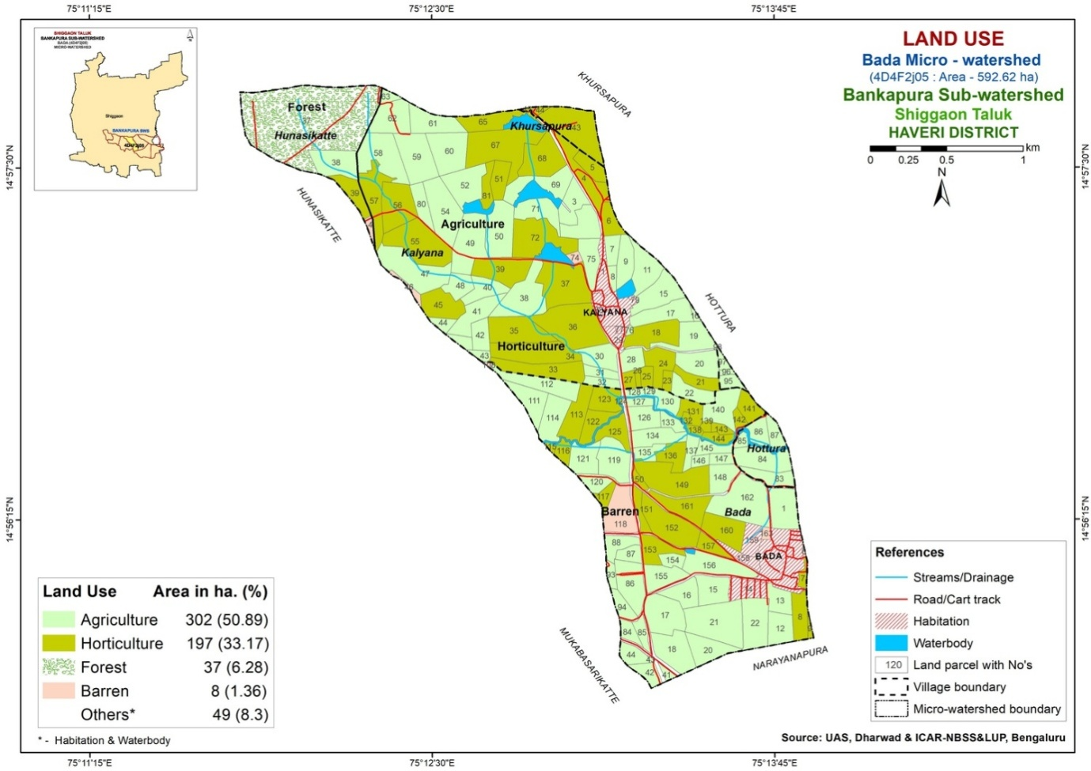

Table-1. Soil site characteristics of pedons under different land use systems for soil site suitability evaluation

Soil properties | Land use
Soil properties | Forest | Barren land | Agriculture | Horticulture
Oxygen availability to roots
Soil drainage | Moderately well | Moderately well | Moderately well | Moderately well
Nutrient availability
Surface texture | Clay | Clay | Clay | Clay
pH* | 6.43 | 8.39 | 7.68 | 7.31
CEC [cmol (p⁺) kg⁻¹)* | 56.97 | 16.34 | 46.95 | 48.21
BS (%)* | 53.16 | 77.20 | 86.07 | 81.80
Free CaCO₃(g kg⁻¹)* | 1.29 | 4.33 | 3.56 | 2.64
OC (g kg⁻¹)* | 7.79 | 1.88 | 4.38 | 5.53
Rooting conditions
Soil Depth (cm)* | 103 | 85 | 135 | 105
Coarse fragments (%) | 15-35 | 35-60 | <15 | <15
Soil toxicity
Salinity - EC (1:2.5) (dS m⁻¹)* | 0.15 | 0.40 | 0.24 | 0.28
Sodicity - ESP (%)* | 3.14 | 2.89 | 4.28 | 5.25
Erosion
Slope (%) | 1-3 | 3-5 | 0-1 | 1-3
*Weighted average value of two profiles in respective land use

The evaluation of soil site suitability for the principal existing crops was performed by considering soil and its site characteristics, following the methodology outlined by Naidu et al. (2006). In accordance with FAO framework (Anon., 1976), soil site suitability was categorized into four classes - Highly Suitable (S1): denoting land that is conducive to plant growth with minimal or easily remediable limitations, Moderately Suitable (S2): representing conditions that are near optimal but may exhibit minor restrictions or up to three moderate constraints that do not substantially affect crop yield, Marginally Suitable (S3): indicating land with significant limitations that adversely influence production, yet remain marginally viable and Not suitable (N): referring to land units with constraints that preclude sustained use for the intended purpose.All classes were further classified with specific subclasses denoting particular limitations. The assessment of soilsite suitability for cereal crops – including paddy, maize and sorghum; oilseed crops – groundnut, soybean and sunflower was conducted in accordance with the criteria established by Sehgal (1996) and Naidu et al. (2006). Soil site suitability maps for each crop were generated by utilizing ArcGIS version 10.8.2 software.
3. RESULTS AND DISCUSSION
The soil characteristics of the study area were evaluated in relation to theestablished soilsite suitability criteria for few cereal and oilseed crops grown in Northern Karnataka. Table-2 presents the assessment of soilsite suitability for six agricultural crops.
Table-2. Soilsite suitability classification for cereal and oilseed crops in Bada micro watershed
Crop |  | Land use
 |  | Forest | Barren land | Agriculture | Horticulture
Cereals | Paddy | S2l | S3ln | S3n | S2ln
Cereals | Maize | S2gt | S3gn | S2nt | S2nt
Cereals | Sorghum | S2g | S3gn | S2n | S1
Oilseeds | Groundnut | S2t | S2glnt | S2t | S2nt
Oilseeds | Soybean | S2gnt | S3gn | S2nt | S2nt
Oilseeds | Sunflower | S2gnt | S3g | S2t | S2t
Note: S1 – Suitable, S2 – Moderately suitable, S3 – Marginally suitable, N – Not suitable;
g – Gravelliness, l – Topography, n – Nutrient availability, r – Rooting condition, t – Texture.
3.1 Paddy
The cultivation of paddy (Oryza sativa L.) requires specific environmental and soil conditions to achieve maximum yield and grain quality. Optimal growth occurs within a temperature range of 21˚C to 37˚C.However, key early developmental phases such as seedling establishment, tillering, panicle initiation and anthesis are most effectively supported at cooler temperatures between 13˚C and 21˚C. Paddy is ideally grown in soils with clay to clay loam textures, which are capable of retaining water for extended periods. The preferred soil pH for rice cultivation lies between 5.5 and 6.5, although the crop can tolerate a broader pH range from 4.5 to 8.0. Sufficient water availability is essential, with a minimum annual rainfall of approximately 700 mm requirement. Additionally, soils exhibiting moderate to poor drainage are beneficial, as they help maintain the standing water necessary throughout the paddy growth cycle.
An assessment of pedons for the suitability of paddy cultivation across different land use systems was undertaken, resulting in the classification of the study area as moderately suitable (S2) to marginally suitable (S3) (Fig. 3). The findings revealed that forest and horticulture land uses were categorized under suitability class S2, with subclasses S2l and S2ln, respectively. Notably, soil slope emerged as a significant limiting factor in forest areas, whereas both soil pH and slope were identified as primary constraints in horticultural lands. In contrast, agricultural and barren lands were classified within suitability class S3, corresponding to subclasses S3n and S3ln, respectively. The suitability of agricultural lands was predominantly restricted by soil pH, while barren lands were constrained by both soil pH and slope.A study by Verma et al. (1999) identified soils in the Hoogly district of West Bengal as highly suitable for rice cultivation. Comparable results have been documented in subsequent research by Mini et al. (2007) and Ravikumar et al. (2009).
3.2Maize
Maize (Zea mays), commonly known as corn, is most widely cultivated cereal crops across world due to its versatility, high yield potential and adaptability to a range of climatic conditions. This crop prospers in warm climates, with optimal growth occurring at temperatures between 18˚C and 27˚C. Furthermore, maize development is supported by welldistributed rainfall ranging between 500 and 800 mm during the growing season. However, maize is sensitive to waterlogging, which necessitates its cultivation in welldrained soils. Ideally, the soils should be loamy, rich in organic matter and maintain a pH level between 5.5 and 7.5 to optimize nutrient availability.
The suitability of pedons across various land use systems within the study area for maize cultivation was assessed and classified as moderately suitable (S2) to marginally suitable (S3) (Fig. 4). The results indicated that both agricultural and horticultural lands were classified under the suitability class S2nt, denoting significant limitations associated with soil texture and organic carbon content. Additionally, horticultural lands were constrained by soil pH levels. Forest land use was categorized as suitability class S2, specifically subclass S2gt, indicating that the primary limitations were related to soil texture and gravelliness. Suitability class S3 with subclass S3gn was assigned to barren land use, reflecting major constraints due to low organic carbon and the presence of gravelliness.The assessment of soil suitability for maize cultivation within the 48A Distributary of the Malaprabha Right Bank Command classified the soils as highly suitable (S1) (Ravikumar et al., 2009). In contrast, evaluations conducted in the Hosakere micro watershed of Davanagere district revealed that the land was moderately suitable (S2) for maize cultivation, a limitation attributed primarily to soil gravelliness and shallow soil depth (Gowda et al., 2018). Comparable findings have been documented by Dsouza and Patil (2021) and Patil et al. (2023).
3.3Sorghum
Sorghum (Sorghum bicolor) cultivation requires warm climatic conditions, with optimal growth occurring at temperatures between 25˚C and 30˚C, although it can tolerate a broader temperature range of 20˚C to 35˚C. As a heattolerant and droughtresistant crop, sorghum is well adapted to semi-arid regions receiving annual rainfall between 400 and 600 mm. Its ability to withstand lower precipitation levels is largely attributed to its extensive root system and efficient water use. The crop favours welldrained, fertile loamy or sandy loam soils with pH values ranging from 5.5 to 8.0, demonstrating adaptability to a variety of soil types, including those with moderate salinity.
A scientific evaluation of soil pedon characteristics across various land use systems was conducted to determine their appropriateness for sorghum cultivation. The suitability classifications ranged from highly suitable (S1) to marginally suitable (S3) (Fig. 5). Notably, horticultural land was designated as highly suitable (S1) with no significant limitations identified. In contrast, forest land was classified as S2, with a subclass of S2g, indicating gravelliness as a primary limiting factor. Agricultural land was categorized within suitability
Figure-3. Soilsite suitability map for paddy crop in Bada micro watershed
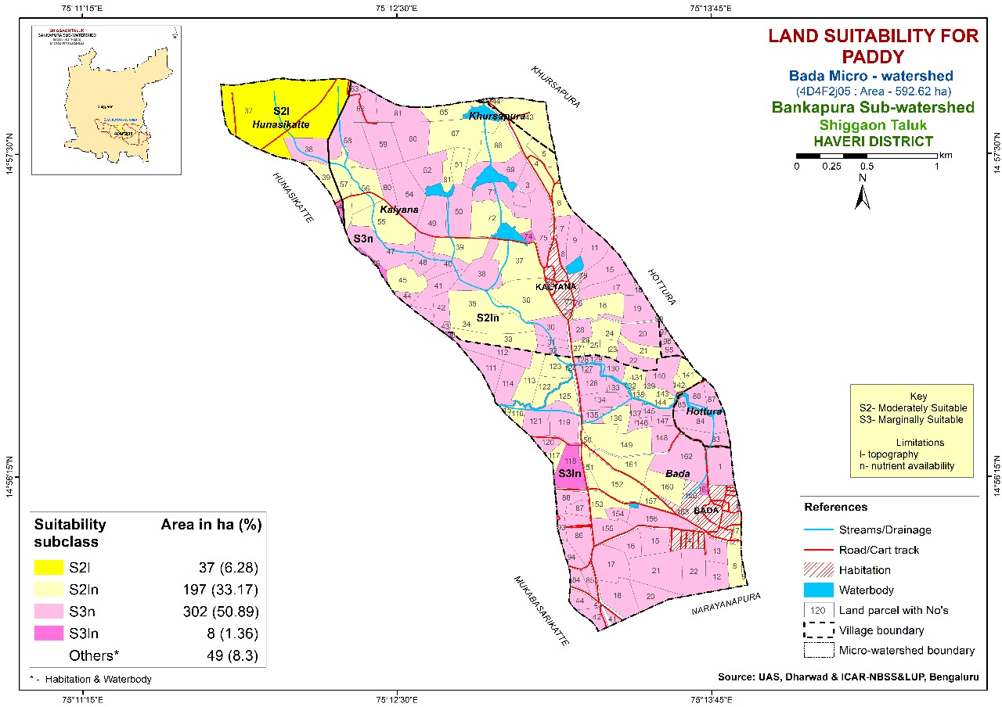

Figure-4. Soilsite suitability map for maize crop in Bada micro watershed
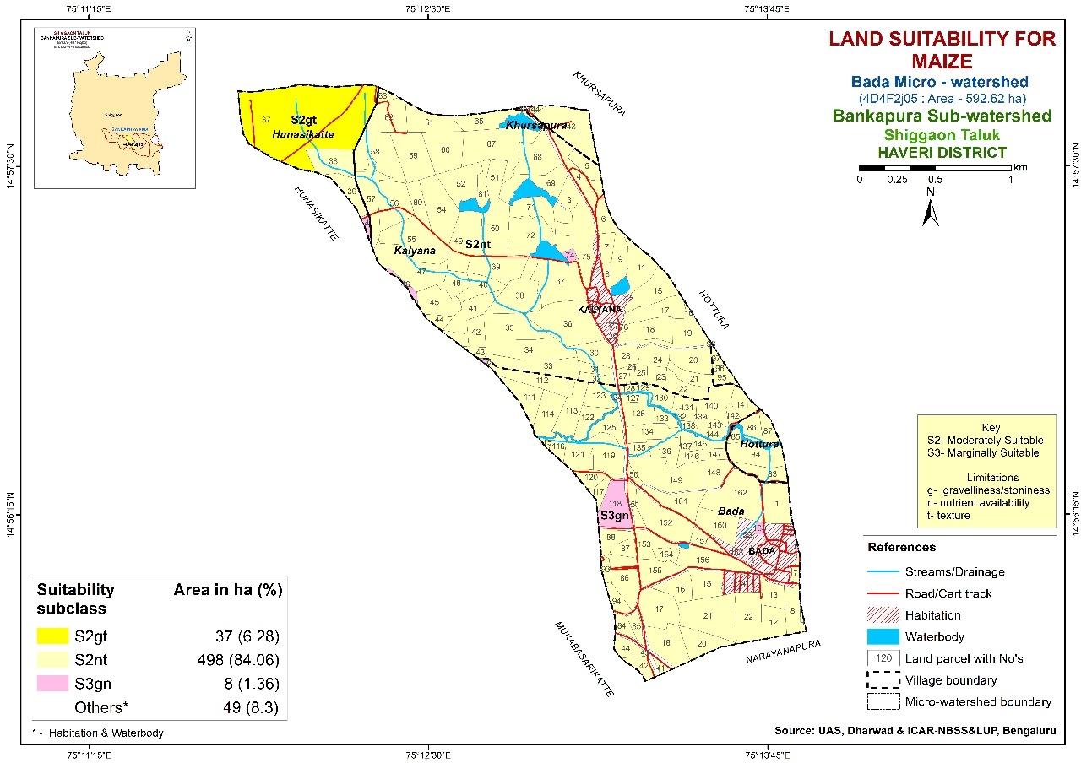
class S2, subclass S2n, primarily constrained by low organic carbon content. Barren land was classified under class S3, subclass S3gn, reflecting organic carbon deficiency and gravelliness as major constraints for sorghum production.Hegde et al. (2019) identified the soil site suitability for sorghum cultivation in the Chincholi Khurd-1 micro watershed of Gulbarga district as highly suitable (S1). In contrast, Sashikalaet al. (2021) found the suitability for sorghum in Tatrakallu village, Anantapuramu district, Andhra Pradesh, to be marginally suitable (S3), attributing this limitation to factors such as soil wetness and fertility parameters, including organic carbon content and pH levels. Similar observations were documented by Venkatesan and Dhanasekararan (2019) and Dsouza and Patil (2021).
3.4Groundnut
The groundnut (Arachis hypogaea), also known as the peanut or monkey nut, is a leguminous crop valued for its high protein content, substantial oil production and versatile applications in culinary practices. This crop thrives in warm climatic conditions, with optimal development observed at temperatures between 20˚C and 30˚C. Cultivation of groundnuts generally necessitates an annual rainfall ranging from 500 to 1,000 mm during the growing period, although these requirements may vary depending on the specific cultivar and environmental factors. Furthermore, groundnuts can be effectively cultivated under irrigated agricultural systems. The crop exhibits a preference for welldrained sandy loam or loamy soils, with an ideal soil pH level between 5.5 and 7.0.
The assessment of soil pedon suitability for groundnut cultivation across various land use systems revealed a moderately suitable (S2) class in all land use systems (Fig. 6). Agricultural and forest lands were categorized under the S2t subclass, where soil texture was the primary factor influencing suitability. In contrast, horticultural lands were designated as S2nt, with limitations related to both soil texture and exchangeable sodium percentage. The barren land was classified as S2glnt, reflecting multiple constraintsincluding gravelliness, slope, texture and soil pHthat collectively reduced its suitability for groundnut cultivation.According to the findings by Anilkumar et al. (2017) and Chikkaramappaet al. (2020), the soils of the Bantanahalli micro-watershed in Davanagere and the Bidanagere micro-watershed in Tumkur have been classified as moderately suitable (S2) for groundnut cultivation. Similar observations have been reported in the studies of Rajeswari et al. (2021).

Figure-5. Soilsite suitability map for sorghum crop in Bada micro watershed
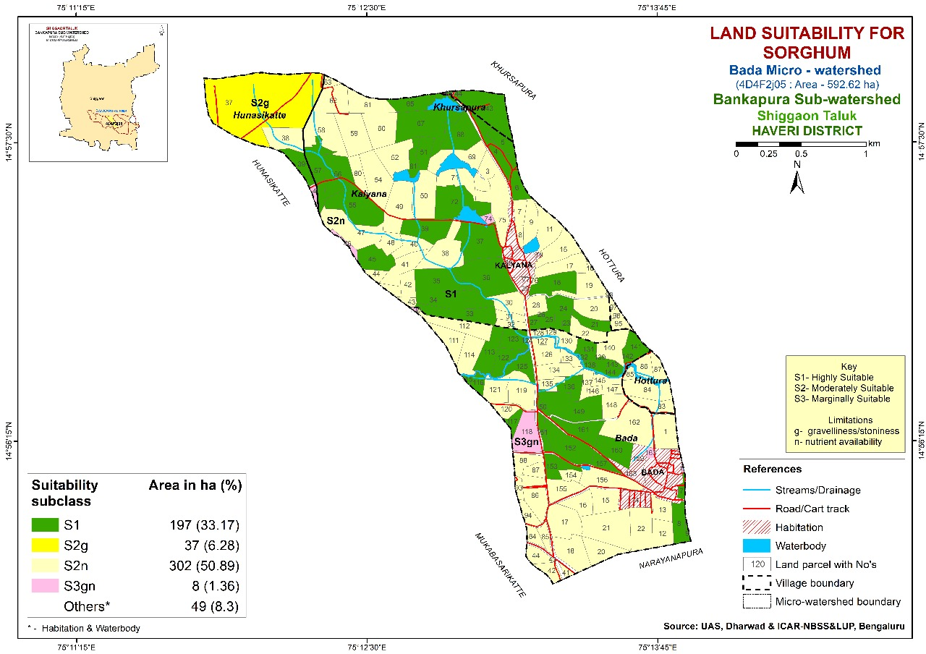

Figure-6. Soilsite suitability map for groundnut crop in Bada micro watershed
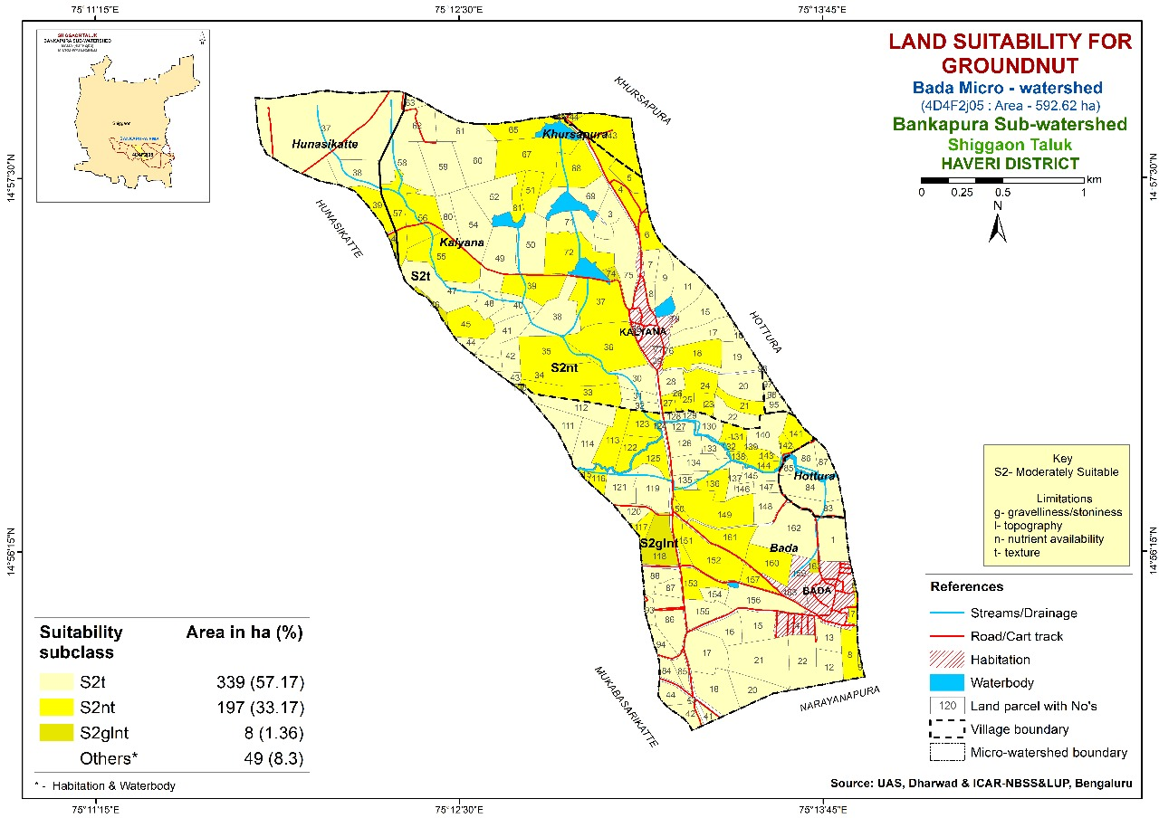
3.5Soybean
Soybean (Glycine max) is a leguminous crop with considerable economic significance, primarily due to its high protein and oil content, which makes it vital for food, feed and industrial uses. The species is adaptable to a wide range of climatic conditions, with optimal germination and growth occurring at temperatures between 20˚C and 30˚C. Cultivation typically requires an annual rainfall of approximately 500 to 800 mm during the growing season.However, successful production is also achievable under irrigated conditions. Soybean shows a preference for welldrained, fertile soils, especially those with loamy or silty textures and a pH ranging from 6.0 to 7.5.
A comprehensive evaluation of soil pedons across diverse land use categories was conducted to assess their suitability for soybean cultivation. The suitability ratings within the study area ranged from moderately suitable (S2) to marginally suitable (S3) (Fig. 7). Agricultural and horticultural soils were classified as S2, subclass S2nt, with principal limitations attributed to soil texture, pH and exchangeable sodium percentage. Forest soils were also designated as class S2, subclass S2gnt, with significant constraints including soil texture, pH, organic carbon content and gravelliness. Pedons from barren lands were categorized as class S3, subclass S3gn, primarily restricted by low organic carbon levels and gravelliness.Yadav (2023) reported that the Ganjigatti sub-watershed in Karnataka is characterized by moderate to severe limitations concerning soil drainage, texture, depth, gravel content and slope, all of which adversely impact soybean cultivation. Similar observations have been documented by Bhaskar et al. (2017), Kumar et al. (2018) and Ravikumar (2019).
3.6Sunflower
Sunflower (Helianthus annuus L.) is a widely cultivated oilseed crop valued for its high linoleic acid content and a wellbalanced amino acid composition, making it important for both edible oil production and animal feed purposes. The crop demonstrates optimal development in warm temperate regions, with a preferred temperature range of 20˚C to 25˚C. Successful sunflower cultivation requires moderate rainfall, ideally between 500 mm and 700 mm during the growing season. The species performs best in deep, welldrainedand fertile soils, particularly those characterized as loamy or sandy loam, with an optimal soil pH between 6.5 and 8.0.
The study evaluated the suitability of pedons across various land use systems for sunflower cultivation, resulting in a classification ranging from moderately suitable (S2) to
Figure-7. Soilsite suitability map for soybean crop in Bada micro watershed
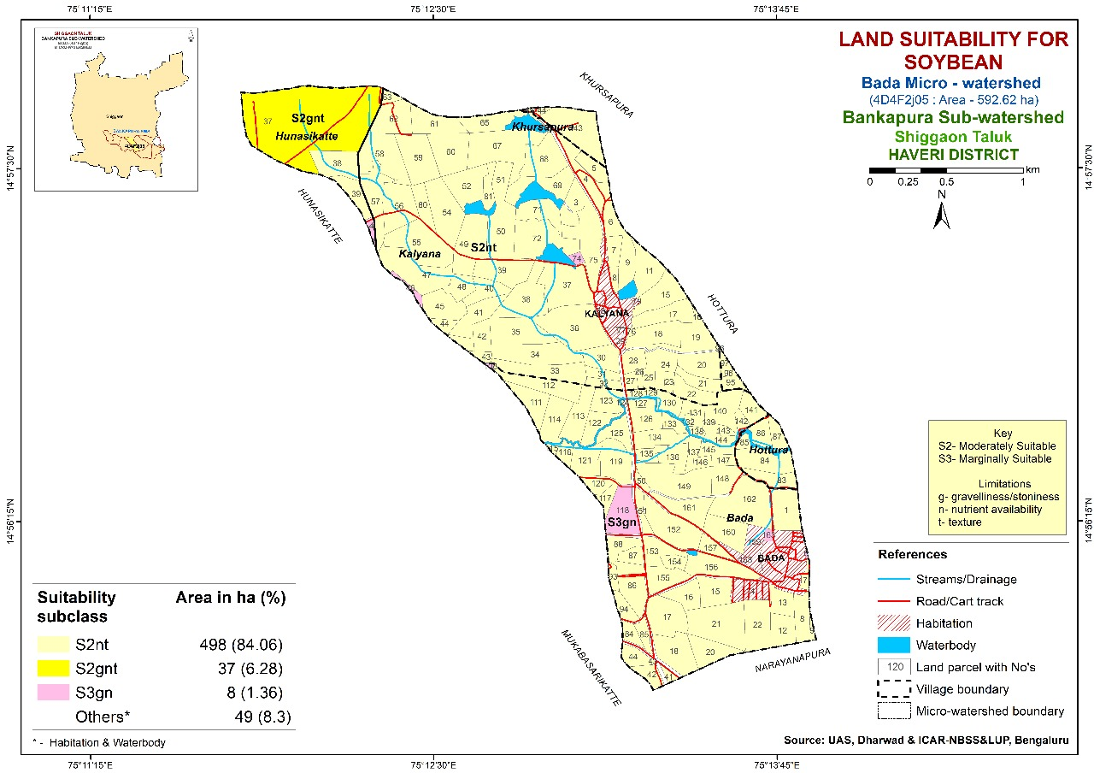

Figure-8. Soilsite suitability map for sunflower crop in Bada micro watershed
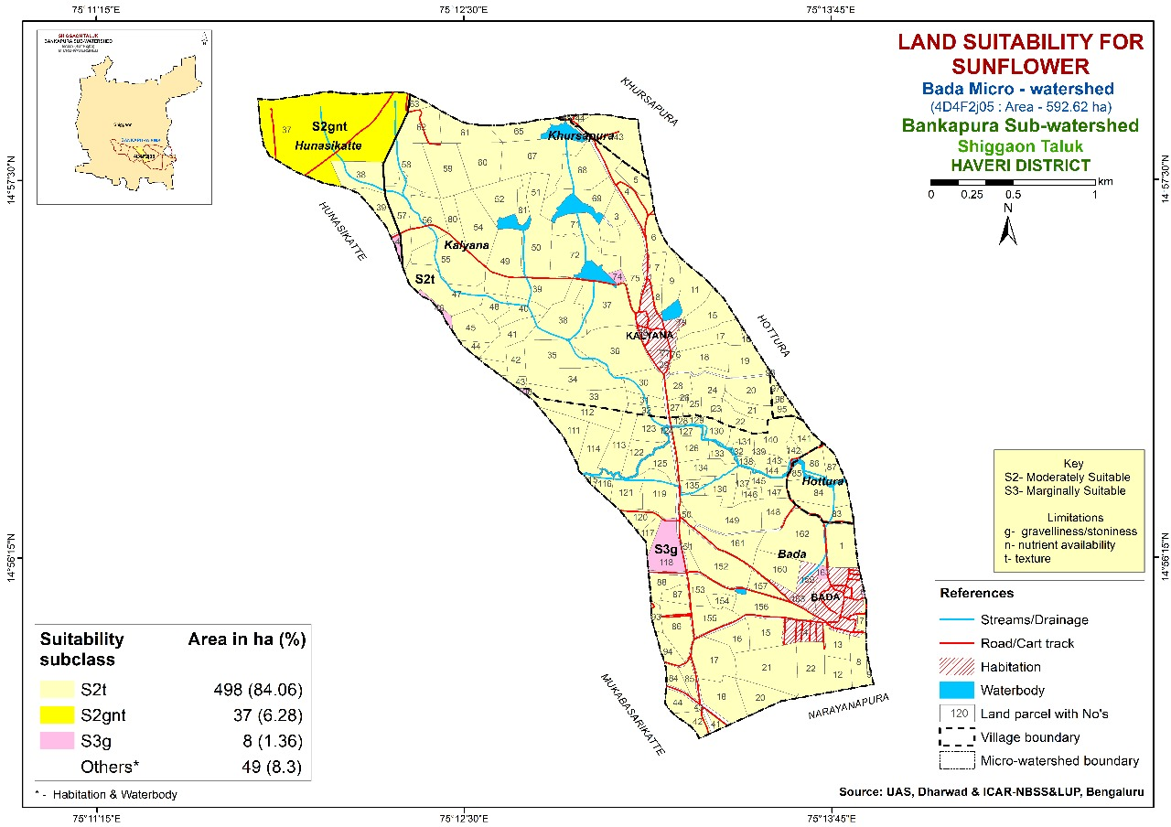
marginally suitable (S3) (Fig. 8). It was found that agricultural and horticultural land use systems were classified as S2, specifically subclass S2t, primarily limited by soil texture and drainage characteristics. Forest land use was also assigned to class S2, subclass S2gnt, exhibiting notable constraints related to soil drainage, texture, pH and gravelliness. In contrast, barren land was categorized under class S3, subclass S3g, where elevated levels of gravelliness significantly restricted crop productivity.Overall, the land use patterns within the study area exhibited a range of suitability for sunflower cultivation, spanning from marginal to moderate. These results are consistent with the findings of Manojkumar (2011), who classified the soils as moderately suitable (S2) for sunflower cultivation, primarily due to constraints associated with drainage, soil depth, texture and other soil properties. Additionally, these observations are further supported by the work of Patil et al. (2011).
4. CONCLUSION
Based on the findings, the investigation concluded that soils within the Bada micro watershed, under different land use systems, exhibit diverse levels of suitability for the cultivation of cereal and oilseed crops, including paddy, maize, sorghum, groundnut, soybean and sunflower.Horticultural land was classified as highly suitable (S1) for sorghum cultivation, exhibiting no limiting factors. In contrast, barren lands were generally deemed marginally suitable (S3) for all assessed crops, with the exception of groundnut, for which barren land was categorized as moderately suitable (S2). The majority of the study area was characterized as moderately suitable (S2) for most crops. The principal constraints affecting soil suitability across all land use types were gravelliness and nutrient deficiencies, with the severity of these limitations varying from mild to very severe depending on the specific land use category. To enhance crop productivity and ensure longterm soil sustainability, the integrated application of organic manures and inorganic fertilizers is strongly recommended. This nutrient management approach not only supports sustainable crop yields but also maintains soil health, mitigates degradation and improves the livelihoods of farmers in the region.

REFERENCES
Anilkumar, S., Dhumgond, P., Satish, A., & Parama, V. R. (2017). Soil resource inventory, land capability and crop suitability assessment of Bantanahalli micro-watershed under semi-arid regions of Karnataka. Journal of Soil and Water Conservation, 16(3), 201-211.
Anonymous. (1976). A Framework for Land Evaluation. Food and Agriculture Organization of the United Nations, Rome, Italy, p.72.
Anonymous. (2022). Keys to Soil Taxonomy. Soil Survey Staff, United States Department of Agriculture, Washington DC, USA.
Bhaskar, B. P., Chaturvedi, A., Bhattacharyya, T., & Gaikwad, S. S. (2017).Sustainable management of land resources.Florida, USA: Apple Academic Press.
Chikkaramappa, T., Kadalli, G. G., Prakash, S. S., Dhumgond, P., Shruti, Y., Chaithra, M. C., & Patel, G. V. (2020). Land suitability classification for agricultural crops in Bidanagere micro-watershed, Tumkur district, Karnataka using geospatial techniques. Journal of the Indian Society of Soil Science, 68(2), 128-137.
Gowda, J. V., Anilkumar, S. N., Sathish, A., & Parama, V. R. (2018). Soil fertility mapping, land suitability assessment for suggesting maize and pomegranate crops in Hosakere micro-watershed of Davanagere district, Karnataka. Journal of Soil and Water Conservation, 17(1), 75-82.
Hegde, R., Bardhan, G., Niranjana, K. V., Bhaskar, B. P., & Singh, S. K. (2019). Land evaluation for site-specific crop planning-A case study of Chincholi khurd-1 microwatershed, Aland taluk, Gulbarga district, Karnataka, India. Journal of the Indian Society of Soil Science, 67(3), 291-300.
Kumar, S. R., Bhaskar, B. P., Chandrakala, M., Niranjana, K. V., Hegde, R., & Singh, S. K. (2018). Land Capability and Land Irrigability Classification in Garakahalli Micro-watershed of Karnataka. Agropedology, 28(1), 60-69.
Manojkumar, D. (2011).Characterization and classification of soils of a micro-watershed on basalt parent rock in Northern transition zone of Karnataka(Master’s thesis, University of Agricultural Sciences, Dharwad, Karnataka, India).
Mini, V., Patil, P. L., &Dasog, G. S. (2007). Characterisation and classification of soils of a pilot site in coastal agro-eco system of North Karnataka. Agropedology, 17(1),59-67.
Naidu, L. G. K., Ramamurthy, V., Challa, O., Hegde, R., & Krishnan, P. (2006). Manual soil-site suitability criteria for major crops. NBSS Publication No 129, NBSS and LUP, Nagpur, India, pp. 118.
Patil, P. L., Kalappanavar, D., Geetha, G. P., Patil, R., Adarsh, G. S., &Dasog, G. S. (2023). Characterization and classification of soil resources of hittinahalli sub-watershed derived from basalt in Northern dry zone of Karnataka. Journal of Agriculture, Science and Technology, 22(4), 16-40.
Patil, P. L., Vinay, L., &Dasog, G. S. (2011). Land evaluation of Bhanapur micro-watershed in northern dry zone of Karnataka. Agropedology, 21(2), 10-16.
Prabhavati, K., Dasog, G. S., Sahrawat, K. L., Patil, P. L., & Wani, S. P. (2017). Characterization and classification of soils from three agro-climatic zones of Belgavi District, Karnataka. Journal of the Indian Society of Soil Science, 65(1), 1-9.
Rajeswari, B., Reddy, P. V. R. M., Nagamadhuri, K. V., &Reddiramu, Y. (2021). Generation of soil site suitability maps for major crops grown in Nethakuppam watershed of Ramachandrapuram mandal in Chittor district using RS and GIS. InternationalJournal of Economic Plants, 8(2), 50-56.
Ravikumar, D. (2019). Assessment of land suitability potentials for agriculture in Koranahallisubwatershed using remote sensing & GIS. Journal of Pharmacognosy andPhytochemistry, 8(2), 2128-2137.
Ravikumar, M. A., Patil, P. L., &Dasog, G. S. (2009). Characterization, classification and mapping of soil resources of 48A distributary of Malaprabha right bank command, Karnataka for land use planning. Karnataka Journal of Agricultural Sciences, 22(1), 81-88.
Sashikala, G., Naidu, M. V. S., Ramana, K. V., Nagamadhuri, K. V., Reddy, A. P. K., Sudhakar, P., & Krishna, T. G. (2021). Mapping of nutrients status in Tatrakallu village of Anantapuramu district of Andhra Pradesh using geographic information system. Journal of the Indian Society of Soil Science, 69(2), 133-141.
Sehgal, J. L. (1995). Land resources appraisal for land use planning to meet the challenges of 21st century. Journal of the Indian Society of Soil Science, 43(4), 504-528.
Sehgal, J. L. (1996).A textbook of pedology: Concepts and applications.New Delhi, India: Kalyani Publishers.
Singh, G., Chandra, S., & Babu, R. (1981). Soil loss and prediction research in India, Central Soil and Water Conservation Research Training Institute. Bulletin No T-12 D, 9(1981).
Souza, A. D., & Patil, P. L. (2021). Soil suitability assessment for sustainable production of Cereals in Kanamadi South Subwatershed. International Journal of Chemical Studies, 9(1), 291-296.
Venkatesan, S., &Dhanasekararan, K. (2019). Soil suitability evaluation of Sollapura sub watershed of Karnataka. Plant Archives, 19(1), 231-237.
Verma, T. P., Rao, R. V. S., & Mahapatra, S. K. (1999). Evaluation of soil site suitability for rice in humid sub-tropical areas of Hooghly district of West Bengal. Annals ofAgricultural Research, 20(2), 183-185.
Wani, S. P., & Sidhu, G. S. (2009). Land use planning in integrated watershed development program for improving livelihoods. Indian Society of Soil Science - Platinum Jubilee Symposium, 154-164.
Yadav, M. B. N. (2023).Studies on soil resources of Ganjigattisubwatershed (5B1A4F) of Dharwad district for watershed development planning(Doctoral dissertation, University of Agricultural Sciences, Dharwad, Karnataka, India).

