Case report

Idiopathic Choroidal Neovascularization in Young Patients: Report of Two Cases

Abstract
Idiopathic choroidal neovascularization (ICNV) in young patients represents a rare but visually threatening condition characterized by the presence of subfoveal or juxtafoveal neovascular membranes in the absence of identifiable predisposing factors such as high myopia, inflammatory disorders, trauma, or hereditary retinal disease. The advent of anti-VEGF therapy has dramatically changed the visual prognosis of these patients. We report two cases of ICNV managed at the Department of Ophthalmology, Hôpital Militaire d’Instruction Mohamed V, Rabat, Morocco, emphasizing the role of multimodal imaging and the efficacy of intravitreal anti-VEGF therapy.
Keywords: Idiopathic choroidal neovascularization, young patients, anti-VEGF therapy, OCT, fluorescein angiography.

Introduction
Choroidal neovascularization (CNV) refers to the growth of abnormal blood vessels originating from the choroid and extending into the subretinal pigment epithelium or subretinal space. In individuals under 50 years of age, idiopathic CNV (ICNV) represents the second most common etiology after pathological myopia. Its pathogenesis remains poorly understood but is believed to involve localized alterations in Bruch’s membrane and the retinal pigment epithelium (RPE). ICNV is typically unilateral and may lead to rapid and irreversible visual loss if untreated. Multimodal imaging, including fluorescein angiography (FA) and optical coherence tomography (OCT), is essential for diagnosis and follow-up. The introduction of intravitreal anti–vascular endothelial growth factor (anti-VEGF) therapy has revolutionized management, providing significant anatomical and functional recovery in most cases.
Case presentation

Case 1
An 18-year-old female presented with a sudden decrease in visual acuity in her left eye (OS). Best-corrected visual acuity (BCVA) was 2/10 OS and 10/10 OD. Anterior segment examination was unremarkable bilaterally. Fundus examination revealed a macular subretinal membrane associated with serous retinal detachment. The vitreous was clear and the retinal periphery normal. Fluorescein angiography demonstrated early hyperfluorescence with late leakage corresponding to the choroidal neovascular membrane. OCT revealed the loss of the foveal contour, disruption of the RPE, and a central macular thickness of 461 µm, consistent with active ICNV.

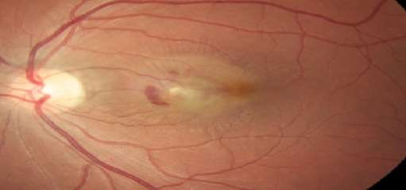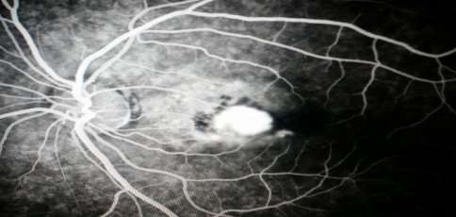
B
A

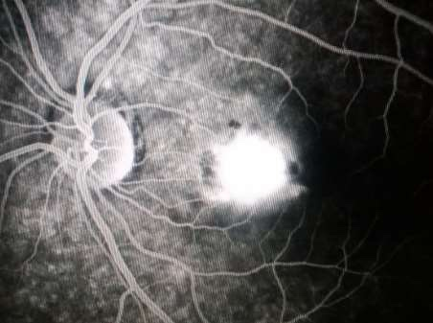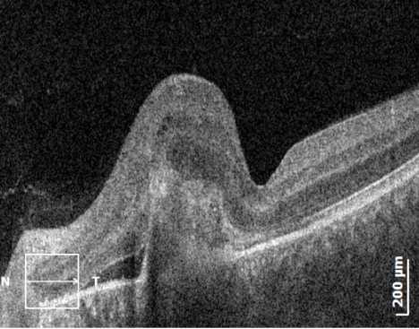
D
C

Figure 1A-D: Fundus photograph, fluorescein angiography, and OCT images showing active subfoveal ICNV in the left eye.

Case 2
A 39-year-old male consulted for progressive visual decline in his right eye (OD). BCVA was 4/10 OD and 8/10 OS. Anterior segment examination was normal in both eyes. Fundus examination revealed a macular neovascular membrane. FA showed early and intense hyperfluorescence with late dye leakage. OCT confirmed a macular choroidal neovascular membrane with subretinal fluid. Etiological work-up for inflammatory, infectious, and hereditary causes was negative. The diagnosis of idiopathic CNV was retained.

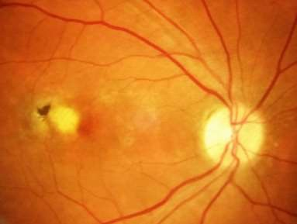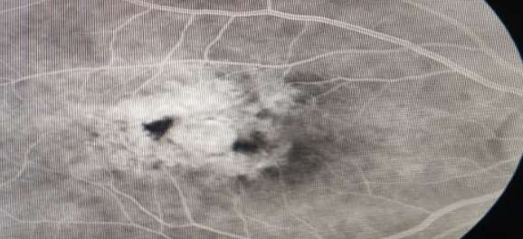
B
A
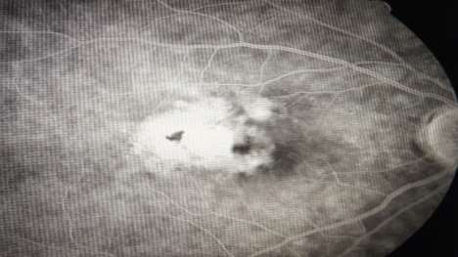 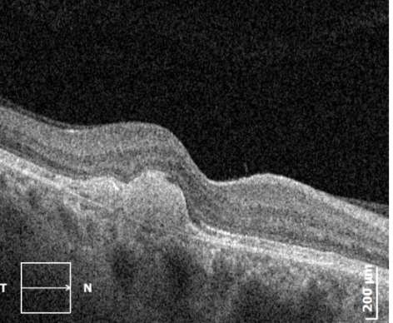Figure 2A-D: Fundus photograph, FA, and OCT images showing idiopathic macular CNV in the right eye.
D
C

Treatment and Follow-up
Both patients received intravitreal injections of bevacizumab (1.25 mg/0.05 mL) as first-line therapy. A pro re nata (PRN) regimen was adopted with monthly follow-up. Retreatment was performed in cases of persistent or recurrent subretinal fluid on OCT. Both patients showed significant anatomical and functional improvement after initial injections, with stabilization of visual acuity and regression of exudative signs. No adverse events were reported during follow-up.

Discussion
Idiopathic choroidal neovascularization (ICNV) represents a distinct clinical entity occurring in younger, otherwise healthy individuals in whom no predisposing ocular or systemic condition can be identified (1,2). Although relatively uncommon, accounting for approximately 17% of CNV cases in patients under 50 years (1), it poses a major diagnostic and therapeutic challenge. The pathophysiology remains uncertain but likely involves multifactorial disruption of Bruch’s membrane and dysfunction of the retinal pigment epithelium (RPE), leading to upregulation of angiogenic factors such as VEGF (6,9). Localized inflammation, oxidative stress, and mechanical stress at the RPE–Bruch’s membrane interface are proposed contributors (6). The resulting subretinal neovascular network produces exudation and hemorrhage that threaten central vision.
The diagnosis of ICNV relies on multimodal imaging. Fluorescein angiography typically demonstrates early hyperfluorescence with late leakage (1,3), while OCT reveals a hyperreflective subretinal lesion with intraretinal or subretinal fluid (9,10). OCT angiography (OCTA) now provides a non-invasive method to visualize and quantify choroidal neovascular flow, monitor treatment response, and detect early recurrences (15). Differentiating ICNV from secondary CNV—such as that due to myopia, angioid streaks, trauma, or inflammatory diseases—is essential (6,11), since the prognosis and recurrence rate differ substantially. In contrast to secondary forms, ICNV usually shows a limited course and better response to anti-VEGF therapy (4–7).
Prior to the introduction of anti-VEGF agents, available treatments such as thermal laser photocoagulation and photodynamic therapy (PDT) were associated with significant scarring and frequent recurrences (3). Anti-VEGF therapy has revolutionized the prognosis, offering rapid resolution of exudation and significant visual recovery in most patients (4,5). Recent studies have confirmed comparable outcomes among bevacizumab, ranibizumab, and aflibercept (7,13,14), although bevacizumab remains widely used for its affordability (4,7). Different treatment regimens have been proposed, including fixed monthly dosing, pro re nata (PRN), and Treat-and-Extend (T&E) (6,7). While PRN reduces treatment burden, it requires strict follow-up, whereas T&E offers longer-term stability with fewer recurrences (14). In the present cases, a PRN approach led to anatomical improvement and stabilization of vision without adverse events.
The long-term prognosis of ICNV is generally favorable, especially when therapy is initiated early (5,8,16). However, recurrences can occur in up to 30% of cases, often within the first year of treatment cessation (16). Fibrotic remodeling, macular atrophy, and rare bilaterality have been reported, emphasizing the need for continued surveillance even after clinical quiescence (4,6,11). Prognostic factors include baseline visual acuity, lesion size and location, and time to treatment initiation (5,7). Early therapeutic intervention before the development of subfoveal fibrosis remains the most important predictor of visual preservation (8,11,13).
In resource-limited settings such as ours, where access to OCTA and branded anti-VEGF agents may be constrained, bevacizumab remains a cost-effective and effective alternative (4,7,13). Our findings are consistent with multiple reports demonstrating that timely diagnosis and tailored intravitreal anti-VEGF therapy can maintain favorable functional and anatomical outcomes in young patients with ICNV (5,7,8,13,16). Future research should focus on biomarkers of recurrence, imaging-based predictors of treatment response, and standardized protocols to optimize retreatment intervals (15,16).

Conclusion
Idiopathic choroidal neovascularization in young adults represents a rare but vision-threatening condition with a potentially favorable prognosis when recognized early and managed appropriately (1,4,6). The combination of multimodal imaging—particularly OCT and OCTA—and timely anti-VEGF therapy is fundamental for precise diagnosis, disease monitoring, and preservation of central vision (9,10,15). Bevacizumab offers an affordable and efficient therapeutic option with outcomes comparable to other anti-VEGF agents (4,7,13). Long-term follow-up is recommended to detect recurrences and prevent fibrotic sequelae (5,8,16).
Beyond individual management, there remains a need for prospective multicenter studies to establish evidence-based treatment protocols specific to ICNV, identify predictive biomarkers of recurrence, and refine imaging-based monitoring strategies (15,16). Early detection, patient education, and continued vigilance remain the cornerstones of successful visual outcomes in this young population.

Patient Consent and Conflict of Interest
Written informed consent was obtained from all patients for publication of their clinical data and accompanying images. The authors declare no conflicts of interest related to this publication.

References
1. Cohen SY, Laroche A, Leguen Y, Soubrane G. Idiopathic choroidal neovascularization in young patients. Retina. 1996;16(6):438‑444.
2. Lim JI, Bressler NM, Marsh MJ. Idiopathic subfoveal choroidal neovascularization in patients under 50 years. Ophthalmology. 1995;102(9):1351‑1356.
3. Chan WM, Lam DS, Lai TY, et al. Photodynamic therapy versus observation in idiopathic CNV: a randomized clinical trial. Ophthalmology. 2003;110(5):911‑918.
4. Carneiro AM, Costa R, Falcão MS, Barthelmes D. Long‑term results of anti‑VEGF treatment for idiopathic CNV. Eye (Lond). 2013;27(10):1171‑1176.
5. Inoue M, Arakawa A, Yamane S, Kadonosono K. Long‑term outcomes of intravitreal anti‑VEGF therapy for ICNV. Br J Ophthalmol. 2015;99(7):915‑920.
6. Cicinelli MV, Carnevali A, Rabiolo A, Querques L, Bandello F, Querques G. Idiopathic CNV: diagnosis and management. Prog Retin Eye Res. 2018;67:107‑125.
7. Liu B, Xu D, Zhao L, et al. Bevacizumab versus ranibizumab for idiopathic CNV: comparative outcomes. BMC Ophthalmol. 2020;20(1):164.
8. Otsuji T, Nagai Y, Saito M, et al. Clinical features and long‑term outcomes of ICNV in Japanese patients. Retina. 2017;37(3):512‑518.
9. de Carlo TE, Bonini Filho MA, Chin AT, et al. Spectral‑domain OCT and OCT angiography in neovascular AMD and CNV. Ophthalmology. 2015;122(12):2435‑2447.
10. Spaide RF, Jaffe GJ, Sarraf D, et al. Consensus nomenclature for reporting neovascular activity on OCT. Ophthalmology. 2020;127(5):616‑636.
11. Yannuzzi LA, Freund KB, Takahashi BS. Review of neovascular maculopathies in young patients. Dev Ophthalmol. 2014;54:135‑156.
12. Peiretti E, Wessel MM, Yannuzzi LA. Idiopathic CNV in young adults. Dev Ophthalmol. 2014;54:140‑146.
13. Parodi MB, Iacono P, Papayannis A, et al. Intravitreal bevacizumab for idiopathic CNV: long‑term results. Eur J Ophthalmol. 2013;23(1):104‑110.
14. Ho M, Liu DT, Lam DS. Anti‑VEGF therapy in myopic and idiopathic CNV: current evidence. Eye (Lond). 2015;29(3):312‑318.
15. Călugăru D, Călugăru M. OCT angiography in ICNV: diagnostic and prognostic applications. Graefes Arch Clin Exp Ophthalmol. 2021;259(4):995‑1004.
16. Arrigo A, Bandello F, Parodi MB. Long‑term recurrence rate after anti‑VEGF therapy in idiopathic CNV. Retina. 2022;42(5):943‑951.

