INVESTIGATION OF DISEASES IN RABI CROPS IN AGRA & ETMADPUR TEHSIL USING GEOSPATIAL TECHNIQUES

ABSTRACT
The increasing population in the country requires an ample amount of food, which has to fulfill through increasing crop production but on the other hand, loss in crop production is one of the most important things that limit the amount of crop production. Plant diseases, insect pests, and weeds cause damage in production. In Agra and Etmadpur Tehsil, the major Rabi crops: wheat, mustard, potato, etc., are affected by disease and pests. Geospatial technique is effective in providing precise and up-to-date information on productivity and in mapping disease-affected areas.
KEYWORDS: Plant Disease, Geospatial Technique, Rabi Crops, and Geo-database.

- INTRODUCTION

In India the main primary activity is Agriculture; it is the strength of rural Indian economy. Agriculture plays a major role in economic development of India. Since, the country’s Independence, agriculture has been the main economic sector in India, employing over 60 % of the workforce and supporting over 115.5 million farming families (Kekane 2013). In India the main cropping season are Kharif and Rabi crops, the growing period for Kharif crop is from July to October. The Kharif crops are also known as summer crops. Rice, Maize, Cotton, Sugarcane, Jute Groundnut, Soyabean, Bajra etc are major Kharif crops.Rabi crops also known are winter crops; the growing season for rabi is during the period from October to April (Nageswararao et al., 2016).Wheat, Duram wheat, Barley, Oats, Toria, Rye/Mustard, Yellow Mustard, Alsi, Kusum, Rabi Maize, Babycorn, Grams, Peas, Masoor, Rajma, Cumin, Linseed Coriander and Barseem are major Rabi crops grown in India. Vegetables are also grown in Rabi season for example: Brocolli, Cauliflower, Cabbage, Capsicum, Spinach, Carrots, Onion, Beetroot, Green Peas, Brinjal, Chilli and Radish.
Rabi crops are grown in Northwest India (NWI) and it is an important region for the cultivation of rabi crops, the lower temperature over NWI supports in the periodic events in biological life cycles of rabi crops. The North West India mainly consists of 8 States of India viz. Jammu & Kashmir, Himachal Pradesh, Uttarakhand, Punjab, Chandigarh-Haryana-Delhi, Uttar Pradesh and Rajasthan. All over India, the amount of precipitation falls between December and February contrasts greatly both in terms of time and location. The Himalayan region receives the most rainfall, which is significant for the regions Agriculture and Water resources as well as the National Economy (Nageshwarao et al., 2015).
Uttar Pradesh is well known as agrarian state and it is one of the leading producers of goods and services. The fertile Indo-Gangetic plains in UP, given the size of the state’s geographical area; it is an important contributor to the food security of the nation. Here, 47 % population is engaged in agricultural activity, the small and marginal farmers are dominated in agriculture sector with 93% of agriculture households operating 65 % of land and plays the major role for India’s economy. About 28% of India’s wheat and 12% of rice is produced by the state. Sugarcane is also produced in large quantities, accounting for 44% of the country’s total production. U.P is also the largest producer of Potatoes in the country (Aloka Kumar Goyal and Sandeep Kumar2013 ; Gulati et al., 2021). UP is divided in nine agro-climate zones—Terai, Western Plains, Central-Western, South-Western, Central Plain, Bundelkhand, North Eastern plains, Eastern plain and Vindhyachal. The South-Western zone comprises Agra, Firozabad, Manpuri, Etawah, Aligarh, and Mathura District.
Agra district is situated in South-West semi-arid zone of UP. The main cropping seasons in Agra are Kharif, Rabi and Zaid. The major kharif crops of the district are Bajra with the productivity of 16.68q/ha, Rice with the productivity of 21.59 q/ha, Sorghum with the productivity of 7.55q/ha, Arhar with the productivity of 6.95q/ha, Urd with the productivity of 6.37 q/ha, Til with the productivity of 1.98 q/ha. In Rabi, major crops are grown wheat with the productivity of 37.03 q/ha, Mustard with the productivity of 17.41q/ha, Potato with the productivity of 263.77 q/ha, Barley with the productivity of 32.98q/ha, Gram with the productivity of 18.57q/ha and other vegetables such as Cabbage (Brassica oleracea var. capitata), Cauliflower (Brassica oleracea var. botrytis), Raddish (Raphanus sativus), Tomato (Lycopersicon esculentum), Spinach (Spinacia oleracea), Pea (Pisum sativum), Carrot (Daucus carota subsp. Sativus), Onion (Allium cepa), Fenugreek (Trigonellafoenum-graecum) and Ladyfinger (Abelmoschus esculentus).
Disease in Rabi Crops
Numerous pests and diseases can harm Rabi crops such as the following; Wheat crops are impacted by the pathogens that cause rust (Puccinia tritici), loose smut (Ustilago tritici), and leaf curl (wheat curl mite). Mustard crops are affected by Alternaria Blight, which is caused by Alternaria brassicae, and Powdery mildew, which is caused by Erysiphe cruciferum. Phytophhthora infestans is the causative agent of late blight, while Alternaria solani are responsible for early blight, and leaf insects impacts potato crops. Stem rust, a leaf blight disease, and root rot, harm barley and gramme crops (Krishi Vigyan Kendra, Agra). Pod borer affect Gram and Arhar, White gerui and Alternaria blight of Mustard, Powdery mildew of peas and feloris minor of wheat. Chilli thrips caused leaf curls in chilli plant.
In present-day world, when we talk about pest and disease control, we can be use Geospatial Techniques to control the spread of pest and disease in place of pesticides and insecticides and this method is less costly rather than using pesticides, insecticides and nematicides etc. Geospatial technology is used to collects and analyzes the geospatial data (data includes information related to locations on earth’s surface). Geospatial techniques have been used in collecting, mapping, and analyzing the dispersal and forecasting the scenario of insect pests, diseases and crop yield.
Global Positioning System (GPS) is a satellite and ground-based radio navigation and locational system that determine the exact places on the earth’s surface. It was developed by the US Department of Defense (DoD) and used for many civilian purposes. We can also use GPS in precision agriculture. Geographic Information System (GIS) is used for analysis, simulation, and model building purposes. The software provides a structure for presenting data in the form of maps for visual analysis as points, lines and areas, but the power of GIS goes far beyond the maps. In fact, mapping is a minor part of the use of GIS (Khatri et al., 2022).Remote sensing refers to the noncontact measurement of radiation reflected from crops, which is determined by the interaction between the electromagnetic spectrum and the soil or plant. Remote sensing is a technique that has been widely used in precision agriculture since the past 25 years. Airborne type of remote sensing has been a likely and convenient tool for insect pest management and weed detection. Furthermore, remote sensing using satellite information proved to be a promising tool for forecasting and monitoring the distribution of many species. It will help farmers in the early detection of insect pests and diseases like mite infestation in cotton fields using multi-spectral systems, which depend on color changes in canopy resemblance over time. In agriculture, integrated RS and GIS technology offers enormous prospects for costeffective treatment of crop stress sources. (S. Walker & Jai Kumar 2021).

- STUDY AREA

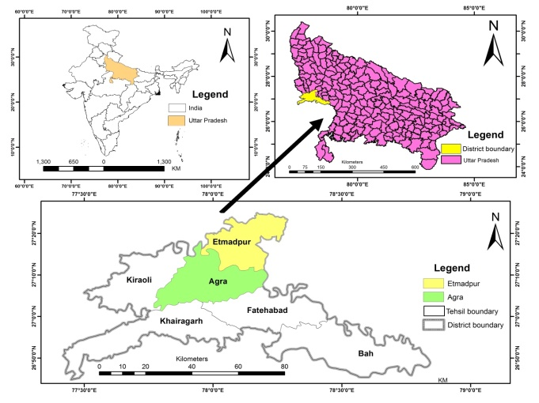
Fig 1 Study Area Map

The Agra district is situated in western U.P., between 27.11′ degree Latitude North and 78.0′ degree to 78.2′ degree Longitude East. On the North it is bounded by Mathura District, On the South it is bounded by Dhaulpur District, On the East it is bounded by Firozabad District and On the West it is bounded by Bharatpur. It is situated on the bank of Yamuna River (Prasad et al., 2019). Agra district comprise 6 Tehsils viz: Agra, Bah, Fatehabad, Kheragarh, Kiraoli and Etmadpur. There are 127villages in Agra Tehsil viz: Abhaypura, Akbarpur, Akola, BabarpurMustkil etc.The Elevation of Agra Tehsil is 169 meters above sea level.
Soil
The soils of the Agra District area show great difference, On the basis of composition, physical & chemical properties and texture, the soils of the district may be divided. The soil found in Agra Tehsil is coarse sandy texture and grey to ash-grey in colour. It is found in adjacent the banks of Yamuna in the Agra; it isalso found in Fatehabad, Etmadpur and Bah tehsils (Ajay Vir Singh 2013).
Geomorphology
The entire study area can be geomorphologically separated into four units: structural hills, ravines, alluvial plains, and valleys. The majority of the district is covered by the alluvial plain. The sloping land area, primarily situated in the Yamuna Chambal Doab, constitutes the second geomorphological unit.
The third geomorphological unit in the region is the structural valleys, which are mostly exposed in the blocks of Fatehpur Sikri, Achhnera, and Jagner. The structural hills, which are mostly exposed in the Kiraoli, Jagner, Fatehabad, and Fatehpur Sikri blocks, make up the fourth geomorphological unit(Ajay Vir Singh 2013).

- MATERIAL AND METHODS
The methods to investigate rabi crop diseases are mentioned below:

3.1 Field data collection
The data on diseases in Rabi crops has been collected after Field survey. With the help of GPS, find the locations and mark the precise coordinates of that location. Also, take photographs of disease that affected the crop plants.Similarly take affected crop plants samples for testing in lab.

3.2 Crop Disease Analysis in Botany Lab
The disease in plant sample may be examined with a Lensand Review of Literature was also used to study the field data in the botany laboratory.
3.3
GPS coordinate converted into degree decimal
The Raw digital No. in the image had converted into radiance or reflectance.NDVI indices in image processing in QGIS 3.4 .Different types of color indicates the health of crops, such as Dark green color which represent crop greenness or good health of crops, Whereas dark brown color is an indicator of none vegetation or water and Brown to green color is in between situation.
NDVI also show man-mad and natural climate effect on crop phonology and crop growth evenly influence by management practices such as sowing date, irrigation and fertilization application.

3.3.1 Creation of Geo-database
GPS point converted into the Geo-data base. For Geo-Data rectified to WGS84 datum and projected on UTM- 43 north zone based on WGS84

3.3.2 NDVI Map
- Present study is based on spatial-temporal satellite data as well as Non- Spatial data available from different sources.
- For Rabi crops Sentinel data were used from Oct 2023 to April 2024.
- Data were obtained from USGS online source.
- QGIS software has been used for the image processing, analyzing and Monitoring the disease purpose in the study area.
- NDVI indices have been used to calculate the NDVI values, Normalized Difference Vegetation Index is simple numerical indicator used to analyze the disease monitoring. It is used to distinguish between healthy and unhealthy vegetation using Red and NIR reflectance value and this technique used in vegetation condition as well as crop disease analysis.

This was derived from following equation:
No | Index name | Formula | Reference
1 | Normalized Difference Vegetation Index  (NDVI) | (NIR-RED)  / (NIR+ RED) | Khan et al., (2005)

- Creation of Thematic Map
QGIS software has been used to create maps and it may be used for crop Disease analysis.

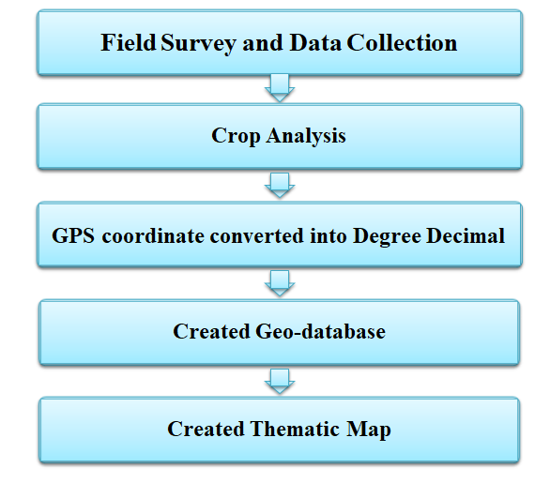
Fig:2 Flowchart of Investigation of Rabi crop Disease

- RESULT &DISCUSSION
The findings of the study indicated that major rabi crops are affected from disease and pest and it may does severe damage to crops.
  - Disease-Pests of Potato Crop

- Late Blight of Potato (Causal organism): This is a dangerous disease caused by fungus in potato. The menace of this disease is found on all parts of potato such as leaves, stem and bulbs. The possibility of this disease is increased when the season becomes cloudy, the temperature ranges from 10-20 degree celsius and relative humidity is 80%.
- Potato Beetle: The Colorado potato beetle (Leptinotarsa decemlineata) is a significant pest of potato, eggplant and pepper. When not controlled, Colorado potato beetle (CPB) can completely defoliate plants resulting in serious yield losses or even plant death. Beetles prefer to feed on potato, but will also use eggplant and other solanaceous crops. Both larval and adult life stages commonly cause damage to plants throughout the growing season. CPB is a persistent pest annually, once an infestation occurs beetle populations tend to increase annually. When potato is unavailable in the environment CPB can utilize alternate solanaceous host plants.

  - Disease of Mustard Crop :

Alternaria blight (Causal Organism): in this disease, dark brown colored spot are formed on leaves and pods which clearly appear as ring shaped on the leaves. In case of intense menace, the spots are jointed. This burns the whole leaf.

  - Disease of Barley Crop :

Yellow Strip Rust: Is is also known as Leaf Stripe Disease, yellow stripes is formed in the ribs of the leaves which later turns into dark grey color on which large number of spores of fungus are formed.

  - Insect Pests of Brinjal

Insect: Hadda Beetle: Hadda beetle, Henosepilachna vigintioctopunctata (Fabricius), also known as spotted/epilachna beetle. It is a polyphagous pest of various cultivated and wild vegetable crops in India. Among the various pests it is highly destructive and considered as a key pest damaging brinjal crop from seedling stage to maturity throughout country. It is a most serious pest of solanaceous and cucurbit crops, especially, Brinjal, Potato, Tomato, bitter gourd and melons. In the Asian countries, hadda/spotted beetle is the most harmful and the first ranked pest causing up to 60 per cent fruit yield loss and leaf damage up to 80 per cent in brinjal. A number of chemicals and botanicals have been found effective against insect-pests of brinjal.

  - Chili Plant Pest

Chilli Thrips: Thrips are common pests that can cause significant damage to chilli crops. Managing these pests is important to protect the yield and quality of the crop. They infest the chilli crop from the seedling stage to the reproductive stage. Both the adult and nymph stage of thrips causes damage to the chilli crop by sucking the sap from leaves, shoots, buds and fruits. They cause ‘leaf curl’ symptoms in the affected plants.
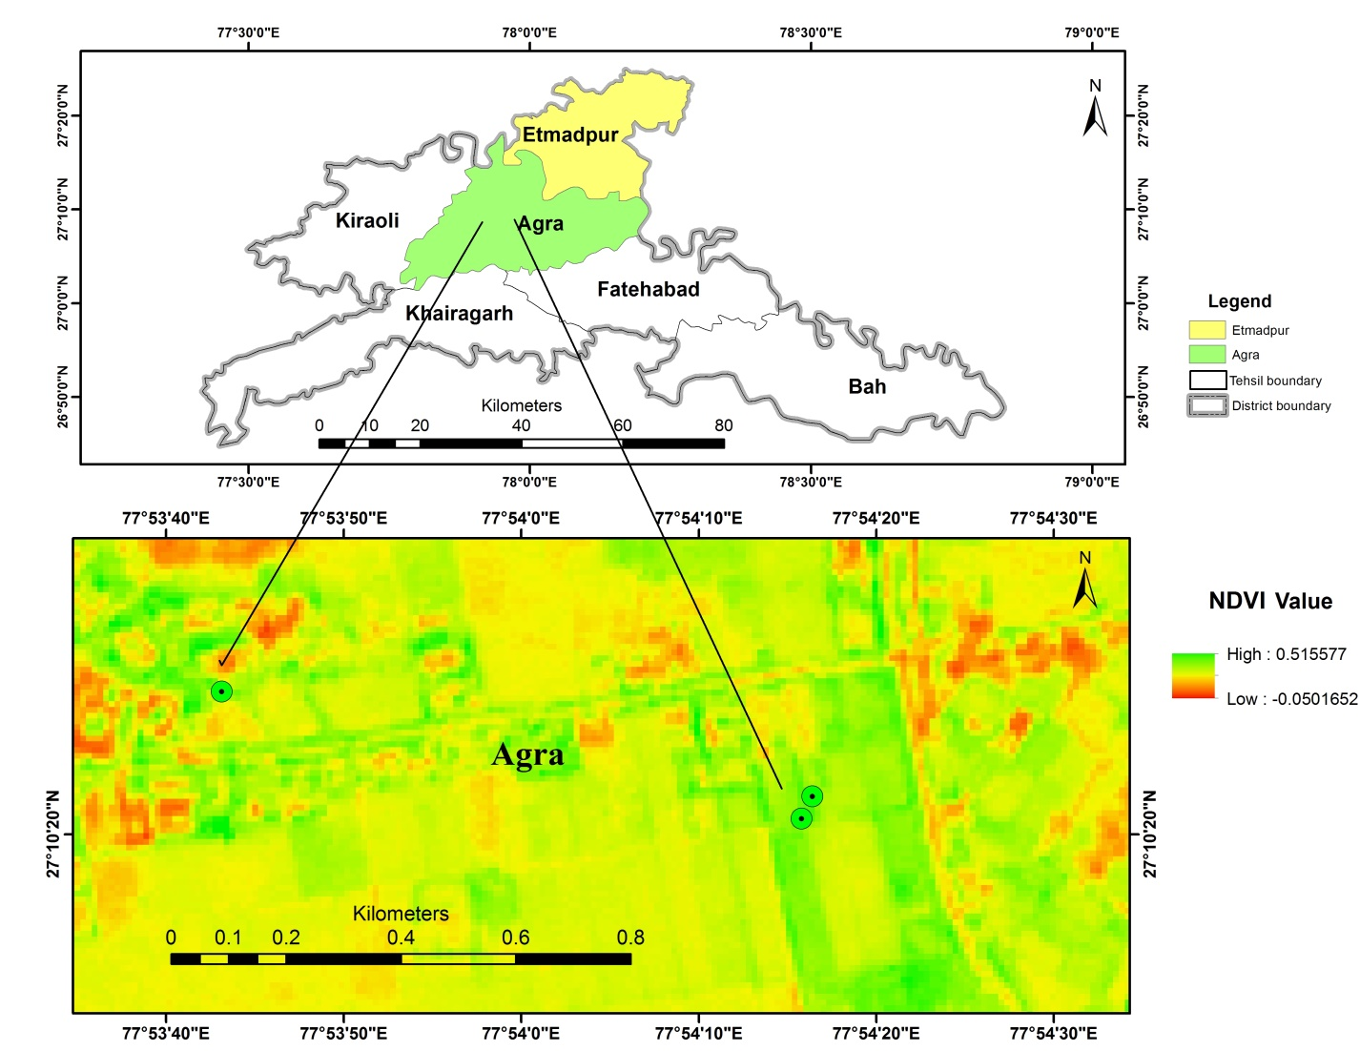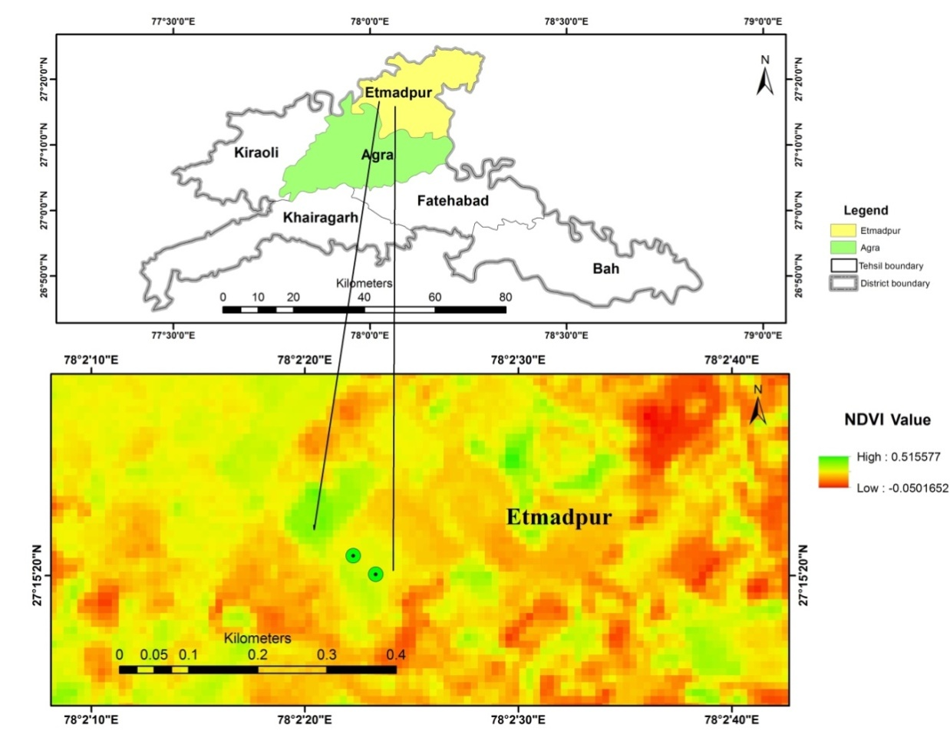
Fig 3:Spatial distribution diseased crops in crop in Agra Tehsil
Fig 4 Spatial distribution of diseased crops in Etmadpur Tehsil

4.6 NDVI Analysis
The Normalized Difference Vegetation Index is one of the remote sensing indices which use to find out the difference between healthy and unhealthy plants or crops, based on chlorophyll content which tends to disease in disease condition. It is influenced by the fractional cover of the ground by vegetation, the vegetation density and greenness, and it indicates the photosynthetic capacity of the land surface cover. Its value is always between -1 and +1. With, higher values associated with greater density and greenness of the plant canopy. NDVI decreases as leaves come under water stress, and diseased etc. The calculation of NDVI for an expected pixel always results in a number that ranges from minus one (-1) to plus one (+1); nevertheless, no green leaves provide a value near to zero; it means that if there is no vegetation the NDVI is shown at zero and if the area holds the maximum likely density of green leaves it is close to +1 (0.8 - 0.9).
The formula for NDVI is: NDVI = (NIR — RED)/(NIR + RED)
In this study, the analysis of Reflectance image with the help of NDVI Index values that indicate the significant difference between healthy and diseased crops. The NDVI values categorized into different classes:
- Less than 0.0--- No Agriculture
- 0.0-0.2--- Low Agriculture
- 0.2-0.4--- Medium Agriculture
- 0.4-0.6--- High Agriculture
- Greater 0.6--- Very high Agriculture
Less than 0.0 on the NDVI scale indicates no agriculture or vegetation, whereas values between 0.0 and 0.2 denote low agriculture and may also indicate the presence of illness or stress. 0.4-0.6 denotes high agricultural, 0.6 denotes very high agriculture, while 0.2-0.4 denotes medium agriculture. Classes 2 and 3 show a decrease in the NDVI value, indicating a possibility of stress or illness of any kind.

Graph 1: NDVI values of Diseased Crops

In this study, the bar graph is prepared to examine the comparison between NDVI values of diseased and healthy crops. The potato crop was affected by Late Blight of potato and potato beetle infestation, Barley was affected by yellow strip rust later the NDVI value were calculated i.e., 0.34 and 0.31 respectively and this indicates that potato and barley were not severely damaged by pest and disease; medium yield of both the crops were found.
Alternaria blight damaged the mustard crop, the Hadda Beetle bug caused leaf eating in the brinjal plant, and the Chilli plant was impacted by Chilli Thrips, which caused leaf curls. The NDVI values that follow show 0.20, 0.22, and 0.21, respectively. The NDVI values indicate that crops were near to severe damage. According to the NDVI values, all three crops were in danger of suffering significant damage and require appropriate care.

Table 1: The list of Rabi Crop Diseases with location.

S.No. | GPS Coordinates | Scientific Name | Local Name | Disease | Causal Agent | Disease Source | Location | Landmark
1 | 27.17247 N  77.90439 E | Solanum tuberosum | Potato | 1.Late Blight 2. Potato Beetle | 1. Fungus: Phytophthora infestans 2. Insect: Leptinotarsadecemlineata | Soil | Bichpuri, Agra Tehsil. | Near Krishi Vigyan Kendra, Agra
2 | 27.17446 N  77.89531 E | Brassica nigra | Mustard | Alternaria blight | Fungus: Alternaria brassicae | soil, wind , water and infected seeds | Bichpuri, Agra Tehsil. | Near Krishi Vigyan Kendra, Agra
3 | 27.17282 N  77.90456 E | Hordeum vulgare | Barley | Yellow Strip Rust | Fungus: Puccinia striiformis | Soil Born, Infected seeds and seedlings | Bichpuri, Agra Tehsil. | Near Krishi Vigyan Kendra, Agra
4 | 27.255572 N  78.039811 E | Solanum Melongena | Brinjal | leaf feeding | Insect: Hadda Beetle | infected leaves | Poiya, Etmadpur | Near Hathras Road
5 | 27.255812 N  78.03952E | Capsicum frustescens | Chilli | leaf curls | Insect: Chilli Thrips | seed, soil | Poiya, Etmadpur | Near Hathras Road

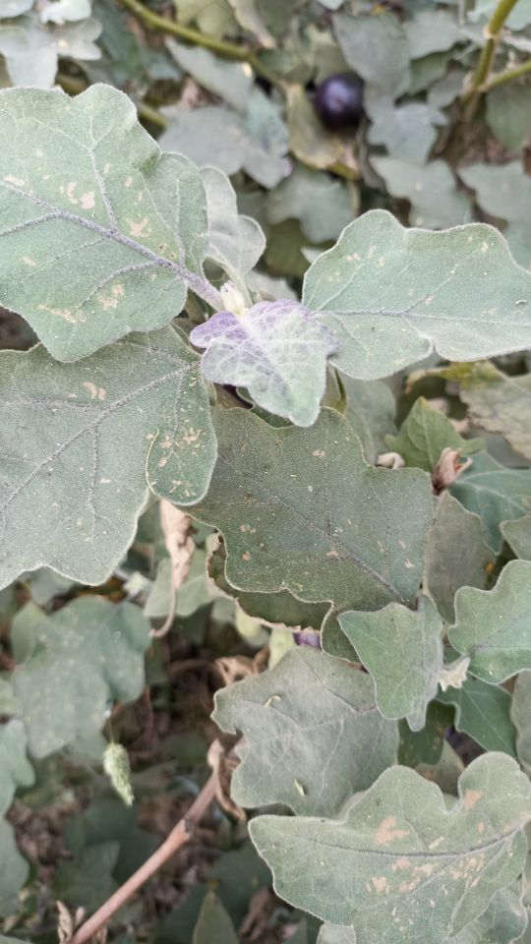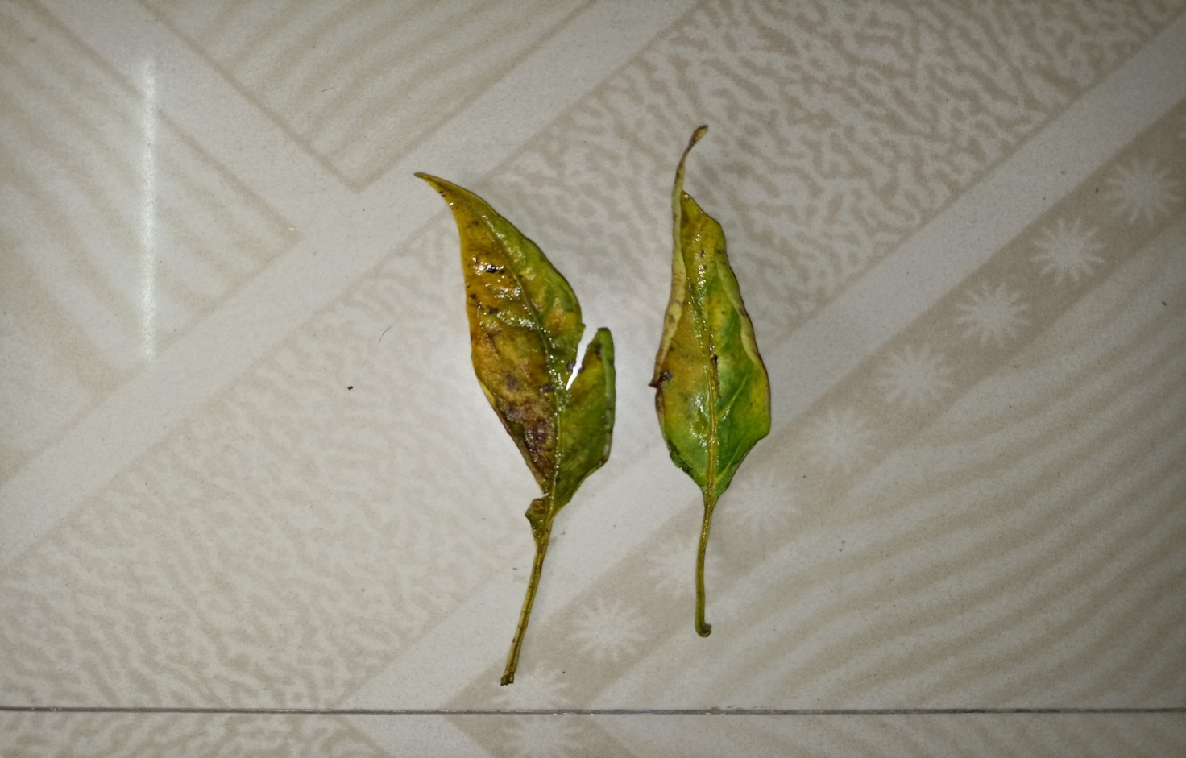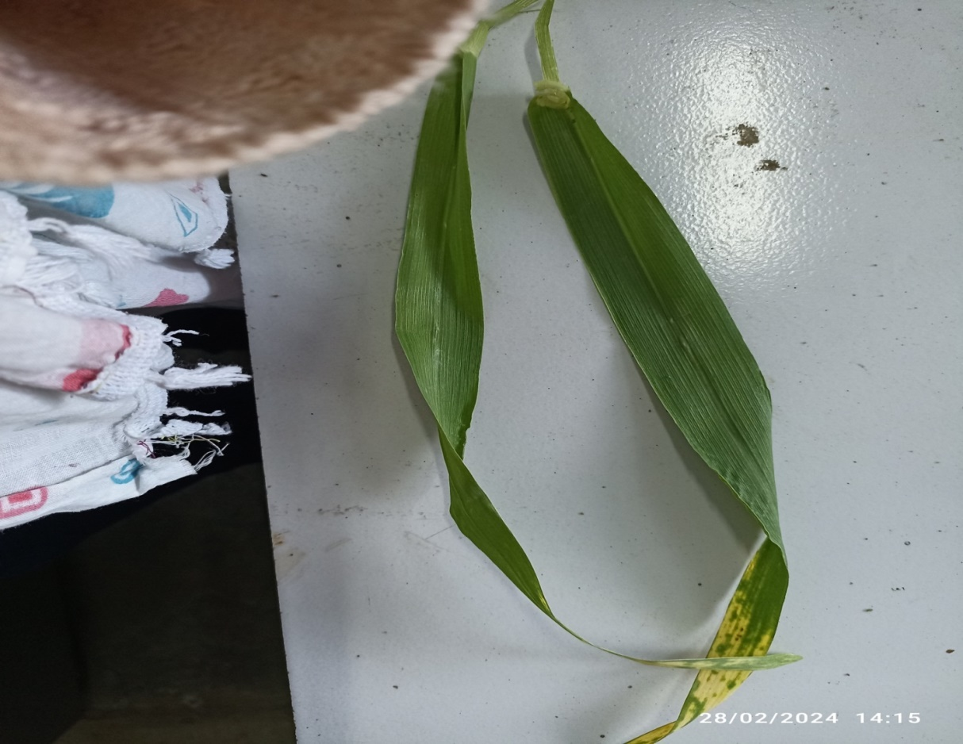
E
D
C
B
A

FIG 5. Photograph of Diseased Rabi Crops: (A) Brinjalleaf feeding (B) Chili leaf curls (C) Potato Late Blight and Potato Beetle (D) Barley Yellow Strip Rust (E) Mustard Alternaria blight.

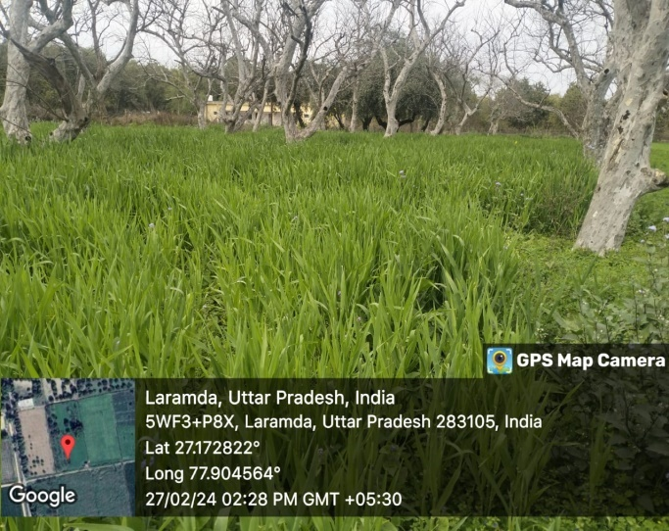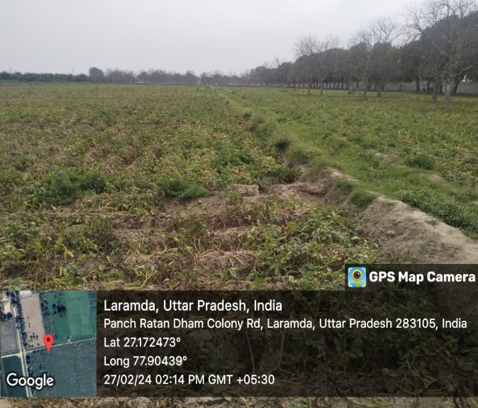
B
A
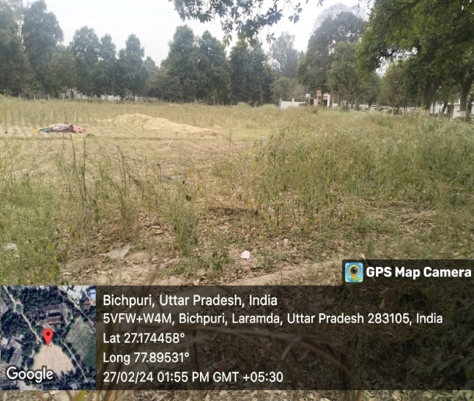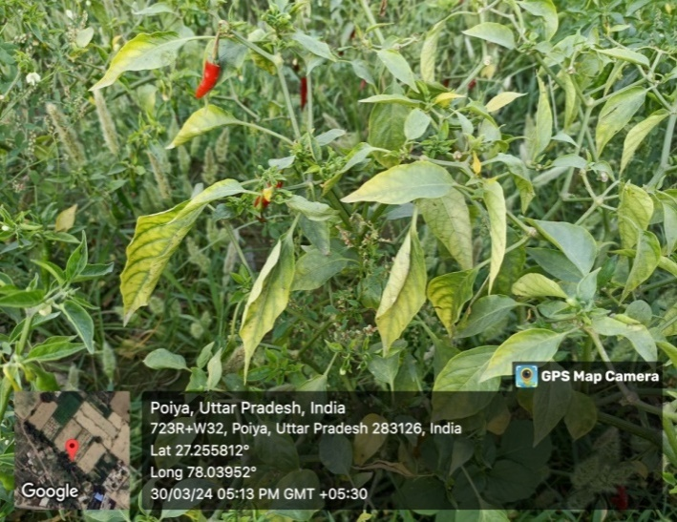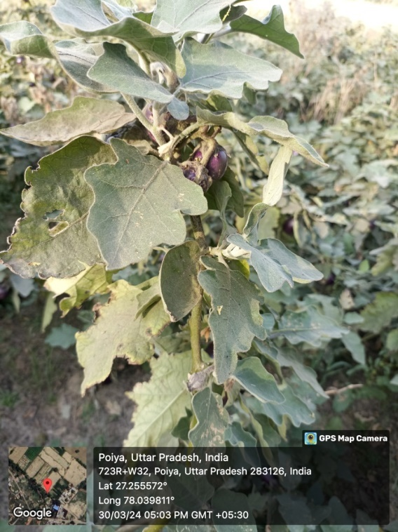
FIG6.Photographs of crop fields with their coordinates: (A)Barley Field(B)Potato Field(C)Mustard Field(D) Chili Field(E)Brinjal Field

E
D
C

In Present Study, Geospatial techniques were used in marking the precise location of diseased crop and in mapping of disease affected area. Food is the basic necessity of life and any country’s growth is dependent on diet safety. With growing masses, every country has to fulfill the requirement of food by increasing crop production but loss in crop production is one of the most important things that limit the amount of harvest production. It has been reported that Plant diseases, insect pests and weeds cause 30 to 40 % damage in production (Md. Arshad Anwer & Garima Singh 2019). Damage may be reduced through usage of geospatial technology. In order to detect insect pest in crop plants we can consider geospatial techniques. These approaches possibly reduce the financial burden on farmers or Producers intended for purchasing pesticides.

- CONCLUSION
This research shows the potential of geospatial techniques to investigate the diseases in rabi crops.The early finding can also be thinkable and it will later assist in the precision application of Pesticides. These techniques together give information about the location, timing and images or maps of the study area. These techniques yield significant results in finding better ways to manage disease and insect pests in crops.

COMPETING INTERESTS DISCLAIMER:
Authors have declared that they have no known competing financial interests OR non-financial interests OR personal relationships that could have appeared to influence the work reported in this paper.

REFERENCES
- Anwer, A., & Singh, G. (2019). Geo-spatial technology for plant disease and insect pest management. Bulletin of Environment, Pharmacology and Life Sciences, 8(12), 01-12.
- Arjun, K. M. (2013). Indian agriculture-status, importance and role in Indian economy. International Journal of Agriculture and Food Science Technology, 4(4), 343-346.
- Chakrabarti, S. K., Sharma, S., & Shah, M. A. (2022). Potato pests and diseases: a global perspective. In Sustainable Management of Potato Pests and Diseases (pp. 1-23). Singapore: Springer Singapore.
- Gangwar, O. P., Bhardwaj, S. C., Singh, G. P., Prasad, P., & Kumar, S. (2018). Barley disease and their management: An Indian perspective. Wheat and Barley Research, 10(3), 138-150.
- Goyal, A. K., & Sandeep Kumar, S. K. (2013). Agricultural production trends and cropping pattern in Uttar Pradesh.International Journal of Agriculture Innovations, 2(2), 2319-1473.
- Gulati, A., Terway, P., & Hussain, S. (2021). Performance of agriculture in Uttar Pradesh. Revitalizing Indian agriculture and boosting farmer incomes, 175-210.
- KadoićBalaško, M., Mikac, K. M., Bažok, R., &Lemic, D. (2020). Modern techniques in Colorado potato beetle (Leptinotarsadecemlineata Say) control and resistance management: history review and future perspectives. Insects, 11(9), 581.
- Khatri, S., Kokane, P., Kumar, V., & Pawar, S. (2022). Prediction of waterlogged zones under heavy rainfall conditions using machine learning and GIS tools: a case study of Mumbai. GeoJournal, 3(22), 10708-10731.
- Kumar, D., Sinha, S. K., & Singh, R. B. (2019). Biological control of Alternaria brassicae (BERK.) Leaf spot disease of Brassica campestris Linn. By antagonist Streptomyces carcinomycicus strain. Biological control, 4(2).
- Lal, M., Arora, R. K., Maheshwari, U., Rawal, S., & Yadav, S. (2016). Impact of late blight occurrence on potato productivity during 2013-14. International Journal of Agriculture and Statistical Sciences, 12(1), 187-192.
- Nageswararao, M. M., Dhekale, B. S., & Mohanty, U. C. (2016). Impact of climate variability on various Rabi crops over Northwest India. Theoretical and applied climatology, 131, 503-521.
- Nageswararao, M. M., Mohanty, U. C., Nair, A., & Ramakrishna, S. S. V. S. (2015). Comparative evaluation of performances of two versions of NCEP climate forecast system in predicting winter precipitation over India. Pure and Applied Geophysics, 173, 2147-2166.
- Naz, A., Khan, R. U., Pathak, D., & Singh, V. P.(2017). A survey on incidence of stem rot of mustard caused by Sclerotiniasclerotiorum (Lib.) de Bary in different districts of Uttar Pradesh and Rajasthan.
- Pradesh, U. (2020). Survey of Wheat Crop for the Prevailing Brow Rust (Puccinia Recodita F. Sp. Tritci Rob. Ex. Desm.) In Different Region Of. Journal Of Plant Development Sciences, 12(2), 119-121.
- Prasad, M., Srivastava, J. N., Dantu, P. K., & Ranjan, R. (2019). Medicinal plants of DEI herbal garden, Dayalbagh: A survey. Journal of Pharmacognosy and Phytochemistry, 8(5), 06-22.
- Raj, A., Singh, M. K., & Prasad, S. (2024). Integrated Pest Management of Potato in India.
- Sahu, P. S., Kumar, A., Husain, H., & Naz, H. (2018). Seasonal incidence of chillithrips, Scirtothrips dorsalis (Hood)(Thripidae: Thysanoptera): A review. Journal of Entomology and Zoology Studies, 6(1), 1738-1740.
- Singh V.P & Khan, R. (2022). Prevalence of Alternaria Blight of Rapeseed- Mustard in Different Districts of Uttar Pradesh. 1140-1144.
- Singh, N. J., Kudrat, M., Jain, K., & Pandey, K. (2011). Cropping pattern of Uttar Pradesh using IRS-P6 (AWiFS) data. International journal of remote sensing, 32(16), 4511-4526.
- Singh, S. K., Dutta, S., & Dharaiya, N. (2016). A study on geospatial technology for detecting and mapping of Solenopsis mealybug (Hemiptera: Pseudococcidae) in cotton crop. Journal of Applied and Natural Science, 8(4), 2175-2181.
- Walker, S., & Kumar, J. (2021). Spatial Distribution and Utility of Pre and Post Monsoon Vegetation in Churu District &Dungargarh Tehsil, Rajasthan India. Traditional Uses, Phytochemistry and Pharmacological Potential, 1, 1-16.
- Walker, S., Kumar, J., Linda, R., & Puran, A. N. (2021). Geospatial Techniques and Their Natural Resources Roles. International Journal of Agriworld, 2(2), 31-36.
- Yadav, B. C., & Kumar, S. (2016). Survey and Identification of Root-Knot Nematodes Associated with Brinjal Crops in Fatehabad, Agra. Current Agriculture Research Journal, 4(1), 114-119.
- Krishi Vigyan Kendra, Agra

