Case report

Nodular lymphangitic syndrome: a case report

Abstract: Nodular lymphangitic syndrome manifests clinically as a series of subcutaneous nodules arranged in a linear fashion, following the course of the lymphatic vessels, and is usually associated with subacute or chronic infections. In this context, sporotrichosis is a frequent cause, this infection is caused by a complex of dimorphic fungi , being Sporothrix schenckii is the most common. These fungi are distributed worldwide; however, they are most prevalent in tropical and subtropical regions of the Americas. They are found mainly in vegetation, decomposing organic matter, and soil. This sapronosis is most commonly transmitted through trauma from objects contaminated by fungal propagules. We describe the case of a 44-year-old male patient with skin phototype V/VI who presented with a dermatosis located on the back of his right hand, characterized by a single ulcer. Multiple erythematous nodules arranged in a linear pattern up to the axillary region were also observed. Based on the clinical, epidemiological, and mycological findings, a diagnosis of sporotrichosis was established. cutaneous lymphangitic . Consequently, treatment with antifungals was initiated, achieving a favorable therapeutic response.
Keywords: Subcutaneous mycoses, tropical mycoses, Sporothrix , itraconazole .

Introduction
lymphangitic syndrome is a clinical presentation characterized by nodular lesions arranged in linear paths along the course of lymphatic vessels, commonly associated with subcutaneous infections. Its most common causes include sporotrichosis , a subcutaneous mycosis caused by the Sporothrix complex. schenckii , which is acquired by traumatic inoculation of contaminated material. This entity represents a diagnostic challenge in endemic regions, where it can be confused with other dermatoses of nodular and lymphangitic evolution , such as nocardiosis , leishmaniasis or atypical mycobacteriosis . We present the case of a patient with ascending nodular lesions in the upper extremity, with subacute evolution and a history of contact with vegetation, whose diagnosis was confirmed by mycological culture. This report seeks to highlight the importance of considering sporotrichosis in the differential diagnosis of nodular lymphangitic syndrome , especially in tropical contexts, and emphasizes the value of clinical- epidemiological -mycological correlation for timely therapeutic intervention.
Clinical case
This is a 44 -year-old male patient , originally from Valencia, Carabobo state, Venezuela. He has no relevant personal or family history and is a florist by occupation. He reports the onset of the current illness in December 2024, characterized by the appearance of an erythematous papule on the back of his right hand, following trauma while handling flowers. The lesion progressively evolved into a crusty plaque and, finally, an ulcer. For this reason, he attended a public health center, where he was prescribed antibiotic therapy for 14 days. Given the persistence and exacerbation of his clinical condition, he decided to consult the dermatology department of the Dr. Henrique Tejera Hospital City in December 2024.

Physical examination revealed skin phototype IV/VI according to the Fitzpatrick scale. A localized dermatosis was observed on the back of the right hand, characterized by a single ulcer measuring 3 × 2 cm in diameter, with wavy edges, a granular base, and scant purulent discharge (Figure 1). In addition, multiple erythematous nodules of varying size (0.5 to 1 cm) were observed, arranged in a linear fashion up to the axillary region, some with a tendency to ulcerate (Figure 2). The lesions were not painful upon movement and were not accompanied by other systemic symptoms.
Paraclinical studies reported: hemoglobin 14.4 g/dl, hematocrit 44%, red blood cells 4.48 M/μl, leukocytes 6300 cells/mm³ (neutrophils 42%, lymphocytes 31%, eosinophils 2%), platelets 282,000/mm³, glycemia 185.6 mg/dl, urea 34.9 mg/dl, creatinine 1.0 mg/dl, SGOT 23.9 IU/L, SGPT 24.1 IU/L. Serologies for HIV and VDRL were negative.
Sporotrichin intradermal smear was performed : 0.1 ml was injected intradermally into the left forearm using heat-killed yeast cells. Forty-eight hours later, a 30 × 35 mm papule was observed (Figure 3).
Direct mycological examination with 20% potassium hydroxide and physiological saline revealed round or oval, basophilic, yeast-like asteroid bodies 3 to 5 µm in diameter, compatible with Sporothrix Mycological culture on Sabouraud agar, incubated at 28°C, showed white, creamy, yeast-like filamentous colonies with a dark brown center, phenotypic characteristics of the pathogenic Sporothrix clade . sp . (Figure 4). The microculture incubated at 28°C showed thin (1 to 3 µm), hyaline, septate and branched hyphae.
Based on the clinical and paraclinical findings, the definitive diagnosis of lymphangitic cutaneous sporotrichosis was established , compatible with Sporothrix. schenckii . Treatment was started with itraconazole 100 mg BID for three months, local hyperthermia, monitoring of SGOT and SGPT, and follow-up by a mycology clinic.
We therefore present a case of rapidly evolving lymphangitic cutaneous sporotrichosis , in which relevant studies were performed that confirmed the presumptive diagnosis.

Discussion
Sporotrichosis , also known as “ rose grower 's disease ” or “rose grower's disease”, is a subacute or chronic fungal infection, first described by Benjamin Schenk in 1898. It is caused by thermodimorphic fungi of the Sporothrix complex , with S. schenckii (62%) and S. globosa (38%) being the most prevalent species in Venezuela. Sporothrix spp . lives in vegetation, organic debris, and soil, which explains its high incidence among agricultural workers and people who work in open environments. It is considered an occupational disease among foresters, horticulturists, gardeners, and agricultural personnel. ^{1,2.}
It is the most common subcutaneous mycosis in Latin America, where environmental conditions (temperatures close to 30°C, soil pH between 3.5 and 9.4, and high humidity) favor its development. Fungi of the S. schenckii complex exhibit dimorphism: in nature, they adopt a mycelial form with infective conidia , while in the host, they transform into yeasts, responsible for chronic infection . ^{4.5.}
Although S. globosa is more common in Asia, Europe and North America, a recent molecular study in Venezuela reported a high frequency of this species (30%), being the second most common after S. schenckii , and the highest recorded in America for this species ^{3,6.}
According to Miranda et al. (2024), in a study conducted at the Dr. Manuel Gea González General Hospital (Mexico City), with 28 patients diagnosed with sporotrichosis , 64.28% were men and 35.71% were women. The most affected age group was 41 to 60 years, with the upper extremity being the most compromised site (60%) and the lymphangitic form being the most prevalent, coinciding with the case presented here. On the other hand, Barreto et al. (2021) identified that S. schenckii predominates in the lymphocutaneous form , while S. globosa is associated with the fixed cutaneous form. These findings are related to host immunity, virulence, and genetic diversity of the strain. ^{5.7.}
Sporotrichosis​ Lymphocutaneous lymphoma accounts for approximately 50% of cases. It occurs after inoculation with the fungus due to minor trauma, with an incubation period of 7 days to 6 months. The initial lesion is papulonodular , erythematous, painless, and prone to ulceration. Subsequently, regional lymph nodes become involved, generating an ascending chain of subcutaneous nodules, forming the classic " sporotrichoid pattern ." It is generally not accompanied by systemic symptoms. ^{4,5,6.}
The treatment of choice is itraconazole, up to 200 mg/day, continued for 2 to 4 weeks after complete resolution of the lesions. Therapy typically lasts between 3 and 6 months. This antifungal works by inhibiting ergosterol synthesis in the fungal cell wall and can be used in both immunocompetent and immunosuppressed patients. ^{7,8} . Local hyperthermia consists of applying warm compresses (42–43°C) for 40–60 minutes daily. S. schenckii is heat-sensitive: its growth slows above 40°C and it dies at 45°C. ^{9,10.}
After two months of treatment with oral itraconazole and local hyperthermia, the ulcer resolved and the nodules reduced in size. Three months later, complete improvement was evident, with residual post-inflammatory hyperpigmentation (Figure 5).
Conclusion
In conclusion, the study of ulcerative lesions follows a meticulous protocol aimed at determining their etiopathogenesis. Furthermore, mycological culture has a sensitivity of 90-94% for the identification of Sporothrix. schenckii . Furthermore, knowledge of epidemiology is essential for suspecting the disease and guiding the diagnostic search. Finally, itraconazole is considered the first-line treatment due to its good tolerability and associated low relapse rate.

(Figure 1) Single ulcer measuring 3cm x 2cm in diameter, with wavy border, granular base and scant purulent discharge
(Figure 2) Multiple erythematous nodules, varying in size from 0.5cm to 1cm, following a linear path, which extends to the axillary region, some with a tendency to ulcerate
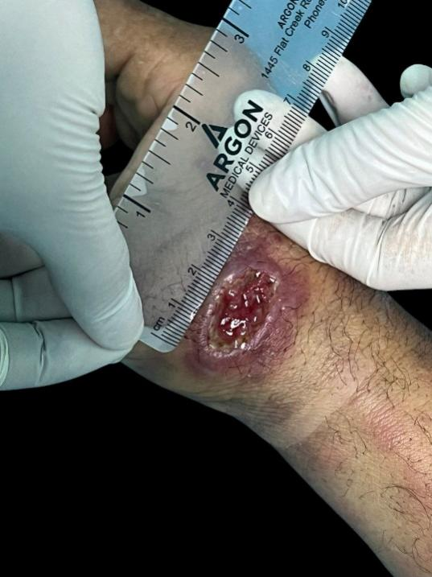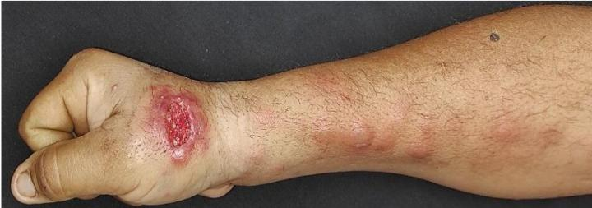

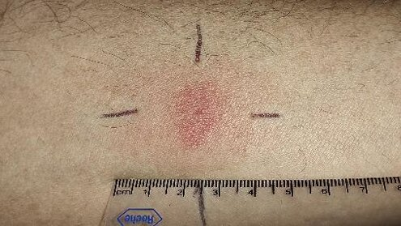

(Figure 3) Intradermal reaction test, 30 x 35 mm papule at 48 hours.

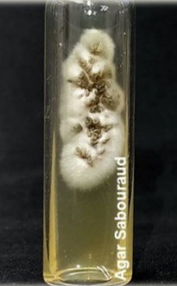
(Figure 4 ) Mycological culture White, creamy, yeast -like filamentous colonies with a center that turns dark brown.

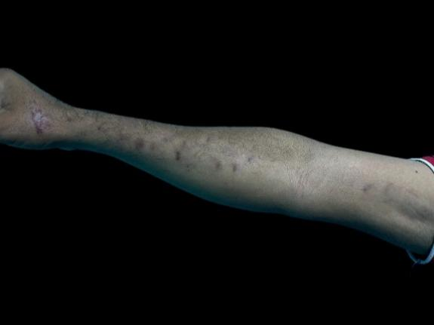

(Figure 5) After three months of treatment, complete improvement was observed with the presence of post-inflammatory hyperpigmentation..

DISCLAIMER (ARTIFICIAL INTELLIGENCE)
ETHICAL APPROVAL
This clinical case was managed in accordance with the ethical principles established in the Declaration of Helsinki. The patient gave written informed consent for the publication of the clinical data and associated images, guaranteeing confidentiality and anonymity. Institutional ethics committee approval was not required because this was a single case report with no experimental intervention.
DATA AVAILABILITY
Clinical images are available in the manuscript and are published with informed consent from the patient.
COMPETING INTERESTS
The authors have declared that there are no competing interests.

References
- Pinto R, † Sandoval K, † Damián E 3, † Arenas R, Fuentes C, Zárate P, Martínez E and Rodríguez C. Relationship of Sporotrichosis and Infected Patients with HIV-AIDS: An Actual Systematic Review . Journal of Fungi 2023, 9, 396. https://doi.org/10.3390/jof9040396 .
- Santiso G, Messina F, Arechavala A, Marín E, et al. Sporotrichosis in Argentina: A clinical and epidemiological analysis. Biomédica 2023;43(Suppl.1):109-19 Sporotrichosis in Argentina doi : https://doi.org/10.7705/biomedica.6886 .
- Miranda J, Vega D, Arenas R. Sporotrichosis . Report of 28 cases studied over 28 years at the Dr. Manuel Gea González General Hospital in Mexico City (1995–2023). DermatologyCMQ2024;22(2):146–150
- Lacovone M, Manteroa M, Caristiaa L, Della Giovannab P, Alfaroc C. Transmitted sporotrichosis by domestic cats : Report of a case Arch Argent Pediatrics 2024 ;122(6 ):e 202310169.
- Picollo M, Epelbaum C, Bustos A, Carnovale S and Rosanova M. Sporotrichosis lymphocutaneous in a pediatric patient, a case report. Rev Chilean Infectol 2021; 38 (6): 811-815.
- Etchecopaz A, Alavaa K, Scarpac M, Duchenec A, Garcia D, Luján M. Feline sporotrichosis due to Sporothrix globosa in it Metropolitan Region from Buenos Aires: a study of case . Argentine Magazine of Microbiology 56 ( 2024 ) 4 -7 . https://doi.org/10.1016/j.ram.2023.07.001 .
- De Flammineis D, Cachutt A, Alvarado P, Cavallera E. UPDATE ON THE EPIDEMIOLOGY OF SPOROTHRICOSIS IN VENEZUELA. Dermatol Venez h Vol.60 h N°2 h 2022.
- Carrasco- Zubera J, Navarrete C, Bonifazc A, Fichb F, Vial- Letelierby V, Berroeta D. Cutaneous involvement in deep mycoses: a literature review. Part 1: subcutaneous mycoses. Actas Dermosiliogr . 2016;107(10):806---815. http://dx.doi.org/10.1016/j.ad.2016.05.017
- Castro E, Pacheco H, Juárez D, Lozano Z. Fixed cutaneous sporotrichosis : case report. Dermatol Pediatrician Lat 2004; 2(1): 59-63. URL: https://sisbib.unmsm.edu.pe/bvrevistas/dpl/v02n01/pdf/a12.pdf
- Silva A, Mena L , Giacamana P, Zapatad S. Sporotrichosis , a reality still present in Chile: a case report. [REV. MED. CLIN. CONDES - 2021; 32(2) 240-245]. URL: https://www.elsevier.es/es-revista-revista-medica-clinica-las-condes-202-pdf-S0716864021000298

