Minireview Article
Preconception care: A crucial aspect of antenatal care

ABSTRACT
Preconception care consists of a range of biomedical, behavioral, and social health measures aimed at women and couples prior to conception. This perspective emphasizes the essential function of preconception care in enhancing maternal, neonatal, and child health by tackling risk factors like family planning, infectious disease prevention, chronic condition management, genetic counseling, and psychosocial wellbeing. By incorporating thorough preconception models into healthcare systems and bolstering these efforts with focused awareness campaigns, professional training, and cross-sector partnerships, it is possible to lessen the incidence of negative pregnancy outcomes and advance health equity. This model stresses the importance of early interventions and community outreach for vulnerable populations, supporting the inclusion of preconception care as a standard part of reproductive health services to promote healthier pregnancies and the long-term well-being of mothers and their children.
Keywords: Preconception care, Family Planning, Genetic counselling, Infant’s Milestone, Interpersonal Violence

INTRODUCTION
What is preconception care?
Preconception care is the provision of biomedical, behavioural and social health interventions to women and couples before conception occurs (Dorney et al., 2022; Peahl & Howell, 2021; Holcomb et al., 2021). It aims at improving their health status, and reducing behaviours and individual and environmental factors that contribute to poor maternal and child health outcomes (O’Shea et al., 2023; Ajefu et al., 2022; Miller et al., 2023). Its ultimate aim is to improve maternal and child health, in both the short and long term (Nishimura et al., 2023; Jeong et al., 2021; Nakshine & Jogdand, 2023). [1]
Reducing maternal, neonatal, and childhood mortality and morbidity worldwide depends heavily on improving the health of adolescent girls and young women (Tschiderer et al., 2022; Nove et al., 2021). [2]
Crucial preconception measures to enhance the health of mothers, newborns, and children

- Family Planning: Family planning reduces the need for abortions and avoids unintended pregnancies. Negative perinatal outcomes, including preterm birth, low birth weight (LBW), small for gestational age (SGA), and perinatal death, are linked to both short and lengthy interpregnancy intervals. Birth spacing may be regarded as an intervention to stop these negative occurrences, particularly in poor nations. [3] Teaching safe and efficient family planning techniques and the use of birth control contraceptive methods can help achieve birth spacing. The time periods during which the previous pregnancy might not have concluded in a live birth are known as the "inter-pregnancy." Maternal and perinatal outcomes are negatively impacted by 60-month gaps between pregnancies. A gap of 18 to 24 months following a live birth was advised by experts. A 24-month pregnancy spacing prescription would align with the ideal nursing period, providing additional nutritional advantages for young children. [2]
- Prevention and management of sexually transmitted infections (STIs): If implemented at reproductive age, effective therapies can stop the transmission of illness. While biological STI interventions can lower the incidence of chlamydia and gonorrhoea, mass treatments and behavioural interventions to raise awareness can considerably lower the incidence of STIs. [3]
- Immunizations and infectious disease prevention: The importance of vaccinations in shielding people and their unborn offspring from avoidable diseases is highlighted by preconception care. It guarantees that people are current on necessary immunizations, like hepatitis B and rubella, which can negatively impact pregnancy. In order to promote a healthy environment for conception and fetal development, preconception care also helps prevent and manage infections that could present hazards during pregnancy. [4]
- Preventing non-communicable disease (NCDs) among infants: Weight, diet, smoking, and alcohol use are among the behavioural risk factors during the preconception period that have been connected to long-term health effects for the offspring, including type 2 diabetes, cardiometabolic illnesses, and neuro-developmental problems. These preconception health behaviours may raise the chance that their children may grow up to have noncommunicable diseases. Additionally, it has been discovered that parental exposure to environmental risk factors such phthalates, air pollution, and pesticides raises the child's chance of congenital malformations, behavioural problems, and cancer. [5] It is known that taking folic acid from three months before to conception to three months following conception lowers the chance of both the initial incidence and recurrence of neural tube defects (NTDs). Pregnancy complications such as LBW, antepartum haemorrhage, and perinatal death have been associated with folic acid insufficiency. In order to lower the chance of an NTD pregnancy, it is advised that all women of reproductive age take 0.4 mg of folic acid daily. The need may increase to at least 600 mcg or possibly more, up to 1000 mcg, during pregnancy. [3]
- Preventing first and repeat pregnancy in adolescence: The likelihood of pregnancy during adolescence is not considerably decreased by sex education programs centered on abstinence. The risk of teen pregnancy was reduced by 41% thanks to comprehensive interventions like the "Children's Aid Society Carrera Program," which was implemented in community centers and offered free STI testing, condoms, medical care, sports and the arts, sex education, educational and vocational support, and more. Community service, personal growth, conditional cash transfers for girls to go back to school, and the use of text messages for reminders and education could all be potential avenues for youth development. Regardless of whether they are conducted in health centers, support groups, or during home visits, interventions to prevent adolescent mothers from becoming pregnant again include parenting skills training and encouraging them to finish their education. [2]
- Advanced maternal age: Everyone agrees that a decrease in fertility increases the risk of triploid illnesses and may make it harder for couples to conceive later in life. Furthermore, parenting practices may have long-term repercussions. Maternal age was found to be strongly associated with an increased likelihood of Caesarean birth. [2]
- Genetic Counselling: Providing information and explanations, discussing potential options, and diagnosing are all part of genetic counselling. Couples looking to get married should have premarital screening for hemoglobinopathies; if the results are positive, additional counselling should be given. The "INTER-CARRIERS" Union should also perform prenatal diagnostics. [2] Individuals or couples can receive genetic counselling to talk about their possibilities for genetic testing and to help them make well-informed family planning decisions. This part of preconception care guarantees that people have the knowledge and assistance they need to recognize and manage any possible genetic concerns. [4]
- Awareness among parents on infant’s milestone: Every parent should know how to raise their children, according to the World Health Organization. Successful and fruitful parent-child interactions can result from parents' understanding of the phases, processes, caring abilities, and child development as well as their competence with childcare techniques. Mothers must be able to apply their understanding of the developmental phases of infants, as they are the primary caregivers. Because of this, evaluating a child's growth requires collaboration, of which the family is a crucial element. By making observations, mothers can evaluate the milestone progress of their infants. A woman can discuss any issues or concerns she may have with the baby's physician. Using developmental screening, pediatricians can also find kids who could be at risk for developmental delays. The developmental stages of infants should be better understood by mothers under the age of twenty-five. Free workshops and courses on child development should be provided to women in health centers, and training and educational programs for unemployed moms should be reinforced. Furthermore, mothers ought to know more about physical development as opposed to merely social growth. [6]
Social Aspect: 1. The child uses crying to get attention
2. The child smiles in response to the smiles of others
3. the child begins to be afraid and surprised by people at the age of 6 months.
4. The child behaves differently with strangers than he behaves with his family at the age of 8 months
5. the child begins to choose favourite toys and people at the age of 12 months

Physical aspect: 1. The child begins toile on his stomach at the age of 4 months
2. The child begins to sit with the forearm at the age of 4 months
3. the child rolls from front to back and in the opposite direction at the age of 4 months
4. the child begins to sit without assistance at the age of 8 months
5. the child begins offevolved crawling on the age of seven months

Cognitive aspect: 1. The child begins to babble at the age of 5 months
2. the kid places gadgets in his mouth to perceive them
3. the kid responds to his call on the age of eight months
4. the child begins to explore things by shaking, hitting and throwing at the age of 10 months
5. The child begins to respond to simple and understandable requests at the age of 12 months

Psychological aspect: 1. Breastfeeding is an effective way to develop the child’s relationship with his mother
2. the kid cries whilst he feels hungry
3. The child will be ready for potty training at the age of 12 months
4. The child begins to try to rely on himself to eat at the age of 12 months

- Screening and managing pre-existing conditions: Finding and treating pre-existing medical issues that could affect the course of a pregnancy is the main goal of preconception care. This involves checking for diseases like infections, diabetes, and high blood pressure. Early detection of these disorders allows for the implementation of suitable management techniques, such as changes in medication, lifestyle, or specialist referrals, to maximize health prior to pregnancy. [4]
- Psychosocial support and mental health considerations: Preconception care recognizes the significance of mental health and psychosocial well-being. It entails screening for mental health issues, promoting stress management, and attending to emotional well-being. In order to assist people in achieving their best possible mental health before to becoming pregnant, preconception care also involves making the proper referrals for counselling or therapy, if necessary. [4]
Addressing Psychosocial stressors:
- Inadequate economic resources
How detectable is the condition?
A health care professional can determine a woman's financial situation by asking a few basic questions, such as whether she is receiving housing help, food stamps, Temporary help to Needy Families (TANF or "welfare"), or medical support. Are her kids getting free breakfasts or lunches at school? Providers must gently inquire if they believe a lady is not getting the financial support she requires. For example, they could ask her if she struggles to pay her regular household expenses or refer her to a social service agency that is equipped to make that determination. Some locations, such community health clinics and WIC and food stamp offices, may also offer on-site assistance with Medicaid and different advantage applications.
Impact of preconception care
It would seem reasonable to assume that a woman is more likely to be healthy after becoming pregnant if her financial situation can be improved prior to becoming pregnant, since higher income can reduce financial stress, increase food security, and improve well-being in other ways.
- Inability to obtain healthcare: Getting the primary care services needed for preconception care might be difficult for women of reproductive age. Usually, this is the outcome of not having insurance. Living in an area with few providers, however, might potentially make access problems worse. It is important to ask each lady about her health insurance coverage and usual source of care. They should be referred to a welfare office, Medicaid outstation facility, or private social service agency if they do not have health insurance in order to determine their eligibility for public insurance. If they don't have a regular care provider, they should find one who will either take their insurance or give care for free or on a sliding fee basis.
- Child abuse, sexual assault, and intimate relationship violence: In their routine care, all healthcare professionals should screen for current interpersonal violence as well as a history of sexual violence, maltreatment of children, and interpersonal violence. The American College of Obstetricians and Gynecologists (ACOG) proposes the following claim and questions: Violence affects a lot of women. Since it affects their health and wellbeing, I ask all of my patients about it.
(i). Have you been struck, slapped, kicked, or in any other case bodily harmed through a person withinside the beyond year (for the reason that I last saw you)? (If so, by whom? How often? What kind of harm?)
(ii). Have you been struck, slapped, kicked, or otherwise physically harmed by someone since you became pregnant? (If so, by whom? How often? What kind of harm?)
(iii). Has somebody forced you to do something sexual that you didn't want to do in the past year? (If so, who?)
(iv). Do you fear anyone, including your partner?

Healthcare providers can assist women who are abused by encouraging them to be safer, such as by making protection plans, and through assisting them to legally and in any other case break away their modern-day abuser. Women who have previously experienced sexual assault, interpersonal violence, or child abuse should seek psychological assistance due to the possibility of repercussions that could impact a pregnancy. A woman should be identified and isolated from her current abuser before becoming pregnant in order to lower the chance of violence during pregnancy. It is especially crucial to identify women who have previously experienced sexual assault, interpersonal violence, or child abuse before to getting pregnant in order to treat any psychological trauma and minimize any potential detrimental effects. In addition to appropriate examination, counseling, and treatment for physical injuries, STDs, unintended pregnancies, and psychological trauma, emergency contraception and empirical antibiotic therapy should be offered in the event of sexual assault. Women should have access to information about local abuse-focused groups so they can receive counseling, legal support, and other services. [7]

IPV is a major public health concern that encompasses physical and sexual assault as well as stalking or psychological aggression (including coercive behaviors) by a current or former intimate partner. Sexual and reproductive coercion are examples of forms of IPV that can influence a woman's decision to become pregnant or not and increase her risk of STIs. IPV-affected pregnant women are more likely to experience postpartum depression, contemplate suicide, and give birth to an underweight or preterm child. [8]

PRECONCEPTION HEALTH PROMOTION

- One strategy that may be applied at any stage of life is preconception health promotion, which involves teaching individuals about the impact of preconception health on the mother, father, child, and later life.

- Preconception Care Integration with Current Healthcare Systems:

- Primary Care: Opportunistic screening and education are the most popular ways to reach the target group during general practice visits. Opportunistic preconception treatment may be able to reach most women of reproductive age, but it primarily depends on the primary care physician's willingness to educate women about preconception and the number of women who visit the practice. [9]

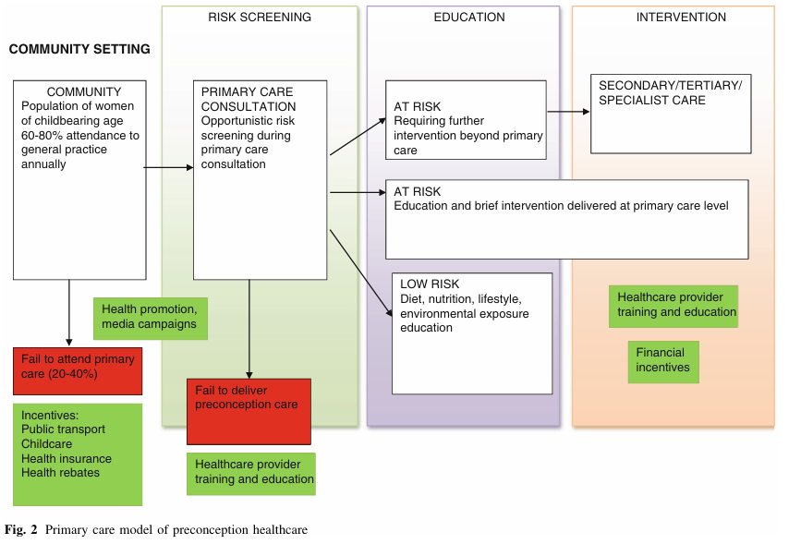
Fig 1: primary care model for preconception care
Source: Shannon, Geordan & Alberg, Corinna & Nacul, Luis & Pashayan, Nora. (2013). Preconception Healthcare Delivery at a Population Level: Construction of Public Health Models of Preconception Care. Maternal and child health journal. 18. 10.1007/s10995-013-1393-8.

- Hospital Based Preconception Care: During a woman's hospital stay, preconception education and risk assessment are part of hospital-based preconception care. Whether or not it is related to reproduction, it can be done opportunistically during any type of hospital stay. Preconception treatment is also provided by the hospital's outpatient clinic. Even though most hospitals do not have clinics specifically for preconception care, there is an opportunity to incorporate preconception care into genitourinary or sexual health clinics as well as chronic illness clinics. For example, diabetes or epilepsy clinics can be used to screen for risk factors, treat the condition as well as feasible, and give women of reproductive age additional preconception care. [9]
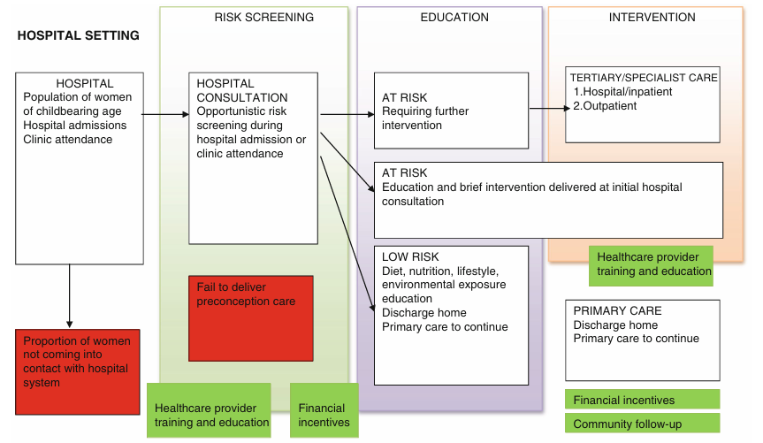

Fig 2: Hospital based model for preconception care
Source: Shannon, Geordan & Alberg, Corinna & Nacul, Luis & Pashayan, Nora. (2013). Preconception Healthcare Delivery at a Population Level: Construction of Public Health Models of Preconception Care. Maternal and child health journal. 18. 10.1007/s10995-013-1393-8.

- Preconception Care Clinics: The creation of dedicated preconception care clinics may help overcome several barriers to opportunistic preconception care models, such as insufficient staff training and scheduling constraints. Because it offers a specific service, it might avoid misunderstandings with several health messages at a single appointment. However, only a small number of highly motivated women who are seeking a pregnancy are likely to visit this clinic due to its nature. The requirement for specialized facilities, staff, and resources as well as an appropriate referral procedure for women who have been identified as high risk are further challenges to this paradigm. [9]
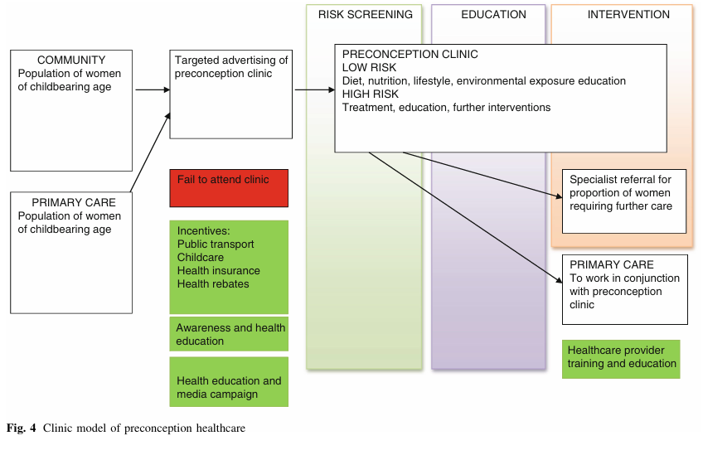
Fig 3: preconception care clinic model for preconception care
Source: Shannon, Geordan & Alberg, Corinna & Nacul, Luis & Pashayan, Nora. (2013). Preconception Healthcare Delivery at a Population Level: Construction of Public Health Models of Preconception Care. Maternal and child health journal. 18. 10.1007/s10995-013-1393-8.

- Inter-Conception Care: It is a form of secondary prevention that takes place when a woman is in the hospital for labor and delivery. Identification of birth outcomes, such as low birthweight, congenital or genetic diseases, medical comorbidities, and health behaviors after the delivery of a first child, may facilitate the identification of factors that may influence a woman's subsequent pregnancies. [9]
- High-Risk Care/Community Outreach: Outreach programs usually target women from low socioeconomic backgrounds, women from minority backgrounds, and women who have previously experienced an unfavorable pregnancy outcome. These women are more likely to experience unfavorable pregnancy outcomes and are more difficult to reach with standard treatment. Preconception and basic healthcare services have historically been less accessible to women who are low-income earners, members of marginalized groups, homeless, unemployed, or uninsured. Community outreach programs target women who have difficulty accessing primary care and provide additional resources to compensate for potentially complex social and health needs. [9]
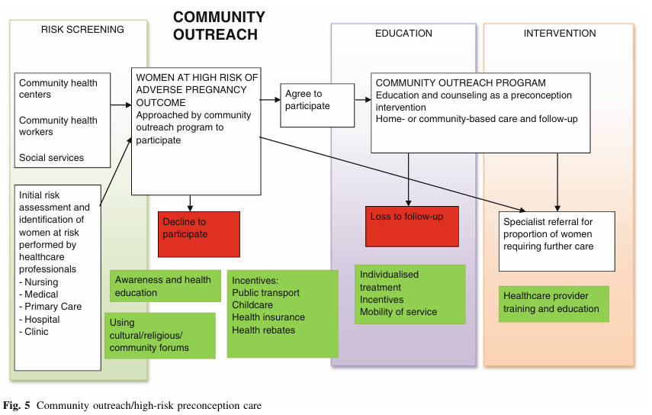
Fig 4: Community care model for preconception care
Source: Shannon, Geordan & Alberg, Corinna & Nacul, Luis & Pashayan, Nora. (2013). Preconception Healthcare Delivery at a Population Level: Construction of Public Health Models of Preconception Care. Maternal and child health journal. 18. 10.1007/s10995-013-1393-8.

- Focused Awareness-Building Campaigns and Interventions : Raising awareness of the need of preconception care is crucial to ensuring its acceptability. Targeted initiatives and campaigns can be developed to educate individuals, couples, and communities about the benefits of preconception care and the resources that are available. These solutions include educational materials, social media campaigns, community outreach programs, and partnerships with local organizations. By giving correct information and emphasizing the impact of preconception care on mother and fetal health outcomes, it is feasible to increase awareness and motivate patients to seek out preconception care services. [4]
- Education and Training for Healthcare Professionals: Improving the knowledge and skills of healthcare professionals is necessary for the successful implementation of preconception care. Raising awareness of preconception care, providing evidence-based recommendations and best practices, and teaching medical professionals how to incorporate preconception care into their everyday practices should be the primary objectives of educational programs. The latest developments in preconception care can be taught to healthcare professionals, and information can be disseminated via conferences, workshops, continuing education courses, and online resources. Giving medical personnel the knowledge and skills they require will enable them to effectively assist patients and deliver preconception care services. [4]
- Collaborations and Partnerships for Comprehensive Preconception Care: Comprehensive preconception care requires cooperation and coordination between all sectors. Legislators, community organizations, public health organizations, and medical professionals must work together to create an atmosphere that is favorable for preconception care. Collaborations may involve sharing resources, expertise, and best practices in addition to developing referral networks and care coordination systems. Collaborations with local organizations may help reach poor populations and address social determinants of health that impact access to preconception care. Active engagement with legislators is necessary to advocate for policies that prioritize and promote preconception care within healthcare systems and allocate resources appropriately. Preconception care can be effectively promoted by using these strategies, which will increase uptake and improve health outcomes for both the individuals and their unborn children. It is critical to integrate current healthcare systems, raise awareness, educate medical professionals, and foster partnerships in order to ensure that preconception care becomes an essential part of standard medical care and reproductive health services. [4]
- Reduce interpersonal violence: One particular technique seeks to disrupt the developmental pathways toward partner violence by reducing early hazards such as chronic stress and unpleasant experiences such as seeing family or community violence, suffering abuse and neglect as a child, or parental substance addiction. Strategies for disrupting these detrimental pathways include early childhood home visiting, preschool enrichment and family engagement programs, parent skill and family interaction programs, and therapy for at-risk adolescents and their families. All of these tactics have been shown to reduce intimate partner violence risk factors. Teaching adolescents safe and healthy relationship skills is another strategy that may help avoid IPV since it focuses social emotional development and healthy relationship approaches to improve areas like communication and conflict resolution skills and emotional control. One successful social emotional learning program is Safe Dates, a school-based effort that promotes healthy relationships and the avoidance of teen dating violence. In addition to preventative programs targeted at children and teens, screening for IPV in health care settings is a way to identify women who are at risk of violence and who need referrals to IPV support services. Health care practitioners can assist patients in accessing services in two ways: either by providing onsite services or by contacting the service to bring the patient in direct contact with a service provider. Clinicians who provide family planning services are in a unique position to identify and treat women who suffer from intimate partner violence because a reproductive/family planning visit is sometimes the only source of primary health care for women in this age range. When resources are available, state health departments can collaborate with academic institutions and mother and child health organizations to develop and implement IPV screening and interventions. [8]
- Using parental motivation to help those who are considering starting a family now or in the future adopt healthy habits : It is a two-pronged strategy that focuses on certain groups that are actively planning pregnancies while also attempting to enhance population health overall. Planned pregnancies are characterized by the parents' deliberate efforts to prepare for or become pregnant (e.g., stopping the use of contraception, discussing pregnancy with a partner, beginning health behavior changes before conception). The amount of time allotted for pregnancy planning can vary widely because it may take some time to change certain health behaviors (like optimizing weight or limiting the use of teratogenic medications) and circumstances (like secure housing), as well as because reproductive partners may not become pregnant immediately once they start trying. Pregnancy intention screening may increase the likelihood that treatments will lead to a change in behavior by enabling more effective targeting of relevant strategies and support. One-on-one therapies that target specific individuals or subpopulations include treating chronic health conditions and encouraging healthy behavior change. In addition to concentrating on adult reproductive partners, which is the first stage of Preconception Action, childhood and adolescence are only now being prioritized in preconception health. Health education that addresses preconception topics in the school curriculum is required to promote awareness from an early age due to the low level of understanding surrounding the concept of safe pregnancy preparation. [5]
- Health policy: People with specific social, economic, and cultural characteristics are disproportionately harmed by the majority of preconception exposures that have a detrimental impact on a mother's and child's health. Therefore, lowering preconception risks will depend on enhancing health equity in the community through structural and policy reforms. Two socioeconomic factors that have been linked to preconception health outcomes are income and race/ethnicity. Furthermore, there are established commercial determinants of health that directly affect exposure to the environment, alcohol and tobacco use, a healthy diet, and other health risks. 1) Individual-level behavior change (e.g., quitting smoking, increasing physical activity); 2) organizational-level determinants (e.g., housing, health care access); and 3) macroenvironmental-level determinants (e.g., infrastructure, fiscal policy, and environmental considerations; e.g., poverty, universal health care, systematic racism, climate change, marketing, supply chains). However, a wide range of factors (domains) are included in the indicators found in the US and the UK, including: health care; family planning and reproductive health; health behaviors; pre-existing physical and mental health conditions; emotional and social support; infections and immunizations; and social determinants of health. [5]

CONCLUSION
By tackling biomedical, behavioral, and social determinants prior to pregnancy, the preconception care model has considerable potential to enhance maternal and child health. By being put into practice, it encourages healthier pregnancies, diminishes negative outcomes, and bolsters the long-term welfare of mothers and their children. Essential strategies comprise the incorporation of preconception care into healthcare systems, awareness-raising, training of healthcare professionals, building partnerships, and focusing on at-risk populations. In sum, the adoption of this model is crucial for effective reproductive planning and for improving health equity among communities.

COMPETING INTERESTS DISCLAIMER:
Authors have declared that they have no known competing financial interests OR non-financial interests OR personal relationships that could have appeared to influence the work reported in this paper.

REFERENCES
- https://www.who.int/docs/default-source/mca-documents/maternal-nb/preconception_care_policy_brief.pdf?sfvrsn=e31b3602_1
- Dean, Sohni V et al. “Preconception care: promoting reproductive planning.” Reproductive health vol. 11 Suppl 3,Suppl 3 (2014): S2. doi:10.1186/1742-4755-11-S3-S2
- Lassi, Zohra S et al. “Essential pre-pregnancy and pregnancy interventions for improved maternal, newborn and child health.” Reproductive health vol. 11 Suppl 1,Suppl 1 (2014): S2. doi:10.1186/1742-4755-11-S1-S2
- Khekade, Harshal et al. “Preconception Care: A Strategic Intervention for the Prevention of Neonatal and Birth Disorders.” Cureus vol. 15,6 e41141. 29 Jun. 2023, doi:10.7759/cureus.41141
- Steel, Amie et al. “Preconception health policy, health promotion, and health services to achieve health in current and future generations: a narrative review.” BMC pregnancy and childbirth vol. 25,1 188. 20 Feb. 2025, doi:10.1186/s12884-025-07176-0
- Shaker, E. (2023). Mothers Knowledge Regarding Infant Development Milestone. Central Asian Journal of Medical and Natural Science, 4(6), 1311-1319. https://doi.org/10.51699/cajmns.v4i6.2229
- Klerman, Lorraine V et al. “The clinical content of preconception care: care of psychosocial stressors.” American journal of obstetrics and gynecology vol. 199,6 Suppl 2 (2008): S362-6. doi:10.1016/j.ajog.2008.08.042
- Morgan, Isabel A et al. “Addressing Intimate Partner Violence to Improve Women's Preconception Health.” Journal of women's health (2002) vol. 27,10 (2018): 1189-1194. doi:10.1089/jwh.2018.7366
- Shannon, Geordan & Alberg, Corinna & Nacul, Luis & Pashayan, Nora. (2013). Preconception Healthcare Delivery at a Population Level: Construction of Public Health Models of Preconception Care. Maternal and child health journal. 18. 10.1007/s10995-013-1393-8.
- Dorney, E., Boyle, J. A., Walker, R., Hammarberg, K., Musgrave, L., Schoenaker, D., ... & Black, K. I. (2022, July). A systematic review of clinical guidelines for preconception care. In Seminars in reproductive medicine (Vol. 40, No. 03/04, pp. 157-169). Thieme Medical Publishers, Inc..
- Peahl, A. F., & Howell, J. D. (2021). The evolution of prenatal care delivery guidelines in the United States. American journal of obstetrics and gynecology, 224(4), 339-347.
- Holcomb, D. S., Pengetnze, Y., Steele, A., Karam, A., Spong, C., & Nelson, D. B. (2021). Geographic barriers to prenatal care access and their consequences. American journal of obstetrics & gynecology MFM, 3(5), 100442.
- O’Shea, T. M., McGrath, M., Aschner, J. L., Lester, B., Santos Jr, H. P., Marsit, C., ... & program collaborators for Environmental influences on Child Health Outcomes Smith PB 16 Newby KL 16 Jacobson LP 17 Parker CB 18. (2023). Environmental influences on child health outcomes: cohorts of individuals born very preterm. Pediatric Research, 93(5), 1161-1176.
- Ajefu, J. B., Singh, N., Ali, S., & Efobi, U. (2022). Women’s inheritance rights and child health outcomes in India. The Journal of development studies, 58(4), 752-767.
- Miller, R. L., Schuh, H., Chandran, A., Aris, I. M., Bendixsen, C., Blossom, J., ... & Samuels-Kalow, M. (2023). Incidence rates of childhood asthma with recurrent exacerbations in the US Environmental influences on Child Health Outcomes (ECHO) program. Journal of Allergy and Clinical Immunology, 152(1), 84-93.
- Nishimura, E., Rahman, M. O., Ota, E., Toyama, N., & Nakamura, Y. (2023). Role of maternal and child health handbook on improving maternal, newborn, and child health outcomes: a systematic review and meta-analysis. Children, 10(3), 435.
- Jeong, J., Pitchik, H. O., & Fink, G. (2021). Short-term, medium-term and long-term effects of early parenting interventions in low-and middle-income countries: a systematic review. BMJ Global Health, 6(3).
- Nakshine, V. S., & Jogdand, S. D. (2023). A comprehensive review of gestational diabetes mellitus: impacts on maternal health, fetal development, childhood outcomes, and long-term treatment strategies. Cureus, 15(10).
- Tschiderer, L., Seekircher, L., Kunutsor, S. K., Peters, S. A., O’Keeffe, L. M., & Willeit, P. (2022). Breastfeeding is associated with a reduced maternal cardiovascular risk: Systematic review and meta‐analysis involving data from 8 studies and 1 192 700 parous women. Journal of the American Heart Association, 11(2), e022746.
- Nove, A., Friberg, I. K., De Bernis, L., McConville, F., Moran, A. C., Najjemba, M., ... & Homer, C. S. (2021). Potential impact of midwives in preventing and reducing maternal and neonatal mortality and stillbirths: a Lives Saved Tool modelling study. The Lancet Global Health, 9(1), e24-e32.

