Preliminary Checklist Study on Marine Algae along the Coast between Tukra and Tolmetha, Libya, III: Rhodophyta

Abstract
A systematic survey of marine red algae was conducted along a 30 km coastal stretch between Tukra and Tolmetha, Libya. Specimens were collected and identified based on detailed morphological and anatomical characteristics. The study documented eleven species, representing ten genera, distributed across three orders—Gigartinales, Cryptonemiales, and Ceramiales—within the class Florideophyceae. Species richness varied among the sampling sites, with observed counts of 9, 9, 6, and 4 species from site 1 to site 5, respectively. Notably, three species—Corallina officinalis, Laurencia obtusa, and Rytiphlaea tinctoria—were consistently present across all five sampling stations. These findings contribute to the baseline knowledge of Rhodophyta diversity in northeastern Libya and provide a foundation for future ecological and biogeographical studies in the region.
Keywords: Marine algae, Rhodophyta, Corallina officinalis, Laurencia obtusa, and Rytiphlaea tinctoria
Introduction
Marine macroalgae represent one of the most ecologically and economically important groups of organisms inhabiting coastal ecosystems worldwide. They contribute significantly to primary production, nutrient cycling, and the stabilization of benthic habitats, while also providing food, shelter, and nursery grounds for diverse marine fauna (Heckwolf et al., 2020; Handayani, 2019; Duffy et al., 2019; Setia et al., 2023; Fulton et al., 2019; Kamal et al., 2023; Jueterbock et al., 2021). Among these macroalgal divisions, the red algae (Rhodophyta) constitute a particularly diverse group, with species known for their varied morphologies, physiological adaptations, and commercial applications ranging from phycocolloids to nutraceuticals (Ismail et al., 2020; Borg et al., 2023; Brawley et al., 2017; Freitas et al., 2021; Kasanah et al., 2022; Carpena et al., 2022; Petroll et al., 2025).
The Mediterranean Sea, situated at the crossroads of the Atlantic and Indo-Pacific marine realms, harbors a rich algal flora shaped by complex biogeographic and ecological influences (Pezzolesi et al., 2019; Sales et al., 2012; Katsaros et al., 2022). However, the distribution and diversity of marine algae along the Libyan coast remain insufficiently documented compared with other Mediterranean countries (Godeh et al., 2022; El-Adl et al., 2022; Ali et al., 2018; Said et al., 2010; El-Adl & Bream, 2016). Although several early surveys and sporadic taxonomic reports exist, comprehensive and systematic studies of Libyan algae are limited, leading to significant gaps in knowledge regarding local species composition and biodiversity patterns (Godeh et al., 2022; El-Adl et al., 2022; Ali et al., 2018; Said et al., 2010; El-Adl & Bream, 2016).
The stretch of coastline between Tukra and Tolmetha offers a range of habitats, from sandy shores and rocky outcrops to sheltered bays. Despite its ecological importance, this area has received minimal phycological attention. Previous studies from the same project have addressed Chlorophyta and Phaeophyceae, and the present contribution focuses on the Rhodophyta. Establishing a reliable checklist of red algal taxa in this region is a critical step toward understanding the structure of the coastal algal flora, providing baseline data for future ecological monitoring, conservation management, and assessment of potential biotechnological resources. This study presents the preliminary checklist of Rhodophyta recorded along the coast between Tukra and Tolmetha. By documenting the occurrence, diversity, and habitat distribution of red algae in this region, this study aims to fill an important regional knowledge gap and contribute to a broader understanding of Mediterranean phycological diversity.
Materials and Methods
Macroalgal samples, both epilithic (attached to rocks) and drift forms, were collected at irregular intervals from five sites—Om al-Hajl, Ardano, Soqba, Zaghrat, and Potraba—spanning approximately 30 km between Tukra and Tolmetha, from July 2017 to December 2019. In situ, samples were rinsed with seawater, placed in plastic bags, and transported to the laboratory, where they were further washed with distilled water to remove salts and debris. The specimens were then air-dried on herbarium sheets using absorbent paper and cloth for pressing and drying. Portions of each sample were preserved in 4% diluted formalin and stored in a freezer for subsequent microscopic analysis. Preliminary identification in the field was based on macroscopic color assessment, followed by detailed morphological and anatomical examination using light microscopy in the laboratory. Taxonomic identification was conducted with reference to established taxonomic literature and regional floristic works, including those by Hauck (1885), Abbott and Hollenberg (1976), Ardissone (1893), Pampanini (1931), Aleem (1993), and Libyan algal flora publications by Nizamuddin (1979, 1981, 1991), Godeh et al. (1992), and Godeh and Said (2008, 2012, 2014) (Nahor et al., 2024; Rindi et al., 2024; García-Seoane et al., 2018).
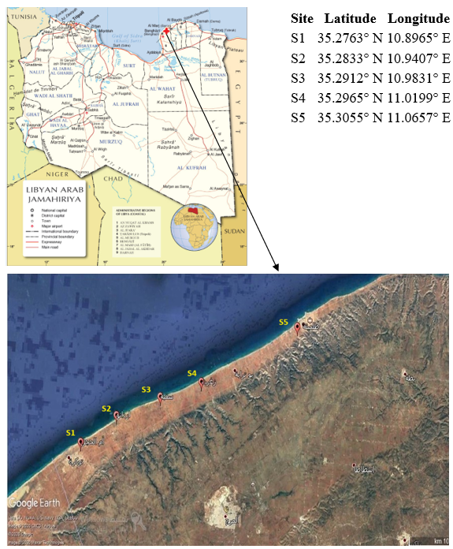
Figure (1): Map of the study area.
Result and discussion
Fritsch (1945) classified the red algae on the basis of thallus organization into a single class, the Rhodophyceae. In contrast, other researchers such as Papenfuss (1966) and Bold & Wynne (1978) divided the red algae into two classes: Bangiophyceae and Florideophyceae. The Bangiophyceae include the more primitive or structurally simple red algae; however, no representatives of this class were recorded in the study area. The Florideophyceae, by contrast, comprise the more structurally complex red algae, ranging from simple filamentous to highly organized forms with foliose structures. This class includes numerous orders. The specimens collected from the study area belong to three orders: Gigartinales, Cryptonemiales, and Ceramiales. These can be distinguished using the following key:
1.(a) Auxiliary cell is part of a diminutive filament and situated between ordinary cells .................................................................................................................. Gigartinales
1.(b) Auxiliary cell not of this type ........................................................................... 2
- (a) Auxiliary cell borne on a specialized filament arising from the supporting cell or adjacent cells ........................................................................ Cryptonemiales
- (b) Auxiliary cell formed directly from the supporting cell after fertilization .................................................................................................................. Ceramiales
Order: Gigartinales
Thalli of this order are of medium to large size and show great variation in form, ranging from crustose and foliose to fleshy or gelatinous, and in some cases, calcareous. A distinguishing feature in several species is the development of the auxiliary cell on an ordinary filament, rather than on a specialized or auxiliary filament. Members of this order typically inhabit intertidal and upper subtidal zones in marine environments worldwide. From this order, only one family was recorded in the study area: Hypneaceae.
Family: Hypneaceae
The thallus is uniaxial and erect, with radial branching composed of cylindrical axes, some of which terminate in hook-like structures. The tetrasporangia are divided cruciately, and auxiliary cells arise from the supporting cells. The life cycle exhibits an isomorphic alternation of generations. In the study area, only a single genus was recorded from this family: Hypnea.
Genus: Hypnea Lamouroux, 1813
The thallus in Hypnea is uniaxial and commonly presents as intertwined masses of cylindrical axes. In certain species, primary branch apices characteristically form curved hooks, often coiling around neighboring algae. Smaller branchlets may develop spines, and attachment occurs via a discoid holdfast. Species of Hypnea are widespread in tropical and warm temperate waters, occurring in both the eastern and western Atlantic, the Indian Ocean, and throughout the Mediterranean Sea. In the present study, only a single species was identified: Hypnea spinella, recorded at the Om al-Hajal and Ardano sites.
Hypnea spinella (C. Agardh) Kützing, 1847
Specimens of this species were collected as drifted accumulations from the sites of Om al-Hajl and Ardano on Feb 2018 and June 2019. Hypnea spinella is characterized by a semi-erect, dark red thallus ranging from 3.3–4.7 cm in length. The thalli form dense tufts covered with spine-like outgrowths (Figure 2A). Creeping branches attach to substrata by several discoid holdfast cells. Branches are numerous, short, irregular, and arranged alternately or oppositely; they are often curved outward with straight apices, and only rarely forked, lacking the typical hooks or tendrils found in some congeners (Figure 2B). Microscopic examination shows that the branchlets resemble spines with sharp angular outlines (Figure 3C). In cross section, the thallus reveals a small, centrally located, round axial cell surrounded by 4–6 periaxial cells, circular to oval in shape (Figure 2 D). Tetrasporangia are located at the apices of determinate branches (Figure 2 E). It is noteworthy that only a single specimen from the collected material, sample from Ardano, summer collection, was found to be in a reproductive stage. In Libya, the distribution of Hypnea spinella appears to be restricted, with records limited to Benghazi (Godeh et al., 2010).
Order:Cryptonemiales
This order is considered one of the largest orders of red algae, containing fifteen families and more than 100 genera. The thallus in this order exhibits various morphological forms and different structures, including gelatinous, fleshy, cartilaginous, and calcareous. One family from this order has been recorded in the study area, which is Corallinaceae. .
Family Corallinaceae
The Corallinaceae family is one of the largest families in this order, with more than thirty genera. It has a flattened, calcified thallus that is usually dichotomously branched. Most of its members are characterized by intercalary meristematic cells and the production of tetraspore reproductive structures (Garbery et al., 1981; Garbery and Veltcamp,1980).
Members of this family live in the waters of temperate seas and oceans, and some are found in cold regions. They are widely distributed in the Mediterranean Sea.
Only two genera from this family have been recorded at the study stations, which are Jania and Corallina, and they can be distinguished using the following key:
1- a. The thallus is a branched, feathery, and opposite branching rock…………………………………………………………………………………. Corallina
1- b. The thallus is a branched, dichotomously branched rock .............................................................................................................................Jania
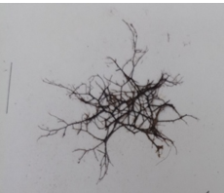A | 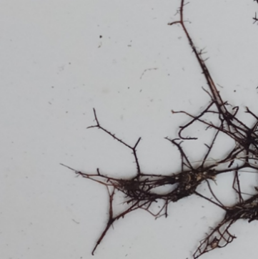  B | 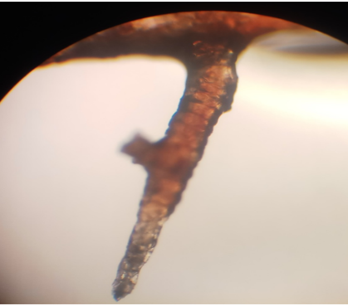C
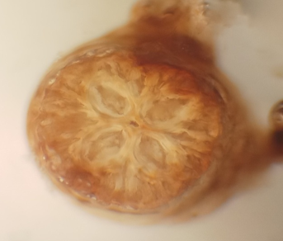  D | 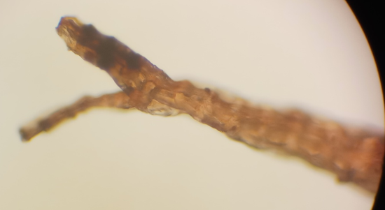  E
Figure 2: (A): Thallus of Hypnea spinella; scale bar = 2 cm. (B) Curved branches with straight apices, rarely forked, lacking hooks. (C): Branchlets resembling spines with sharp angular outlines, observed under light microscopy at 100x magnification. (D): A cross-section of the thallus shows the presence of four oval-shaped peripheral cells surrounded by the axial cell, using a microscope lens with a magnification of 100x. (E): The tetraspore capsules at the tip of the branch 40 x magnification.
CorallinaLinnaeus,1758
The Corallina algae consists of a calcareous thallus due to the deposition of calcium carbonate on the intergeniculum, and it is a filamentous alga with a length ranging between 3-12 cm, branched in a pinnately, and attaches to substrates with a crustose base. The axis and branches appear under the microscope composed of very small cylindrical pieces or flattened or winged or unwinged leaflets depending on the type, and the reproductive structures are singular and lateral, forming at the ends of the branches within axial reproductive cavities (Conceptacle). Usually, each leaflet carries only one reproductive cavity. The Corallina algae are dioecious and reproduce asexually thru the tetraspore produced from the tetrasporic phase, which develops into the male or female gametophytic phase. The reproductive cells form within the cavity, and sexual reproduction results in the formation of the fruiting sporophytic phase, which produces fruiting spores that develop into the tetrasporic phase, completing a haplodiplontic life cycle with three similar phases (Garbery, 1978; Garbery and Veltcamp,1980; Garbery et al.,1981). The genus Corallina was recorded at all study stations, represented by only one species, Corallina officinalis.
Corallina officinalis (1758 Linnaeus)
Samples of this species were collected outside the water at all study sites and also attached to the Cystoseira algae on Oct, Nov, Dec 2017, and Dec 2019. The thallus of this algae is rocky, reaching a length between 3.1 - 5.9 cm, with a reddish-purple color (Figure 3A) Its color changes to white or yellow when dried, and it is branched in a pinnate, opposite manner (Figure 3B) The moss attaches itself using a scaly base from which a compressed cylindrical axis arises, bearing erect leaves that branch slightly at the bottom, while at the top, the branching is dense, simple, or compound in more than one direction (Figure 3C) and the lateral branches are usually separated by gaps that cause the leaflets to be long on the main axis (Figure 3 D) The apex of the main axis is trifurcated (Figure 3E). In addition to the study area, this species was also recorded in Benghazi, Toukra, and Sabratha (Godeh and Said 2008; Godeh et al., 2010; Abuhabil et al., 2019).
Genus: Jania Lamouroux, 1812
Jania consists of a highly calcified thallus for the deposition of calcium carbonate on the fronds, while the connections of these fronds remain uncalcified. It is dichotomously branched, and these branches or fronds are cylindrical in shape. Jania algae are widely distributed in the seas and oceans in the tidal zone and the upper submerged zone, adhering to rocks. These algae reproduce both asexually and sexually with a triphasic, diplohaplontic life cycle similar to that of the Corallina algae. The genus Jania was recorded at only one station in the study, which is Ardano, where only one species from this genus, Jania adhaerens, was recorded.

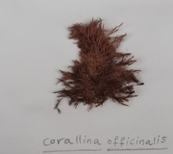A | 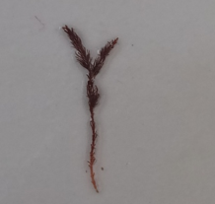B | 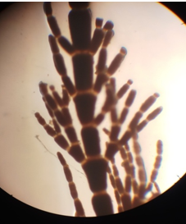C
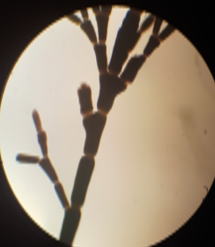  D | 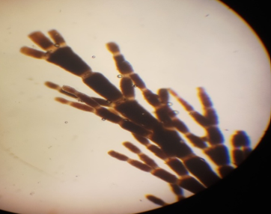  E
Figure 3. (A): The thallus of Corallina officinalis with a 2 cm ruler. (B): Illustrates the opposite pinnate branching. (C): The opposite pinnate branching of the leaflets, which is dense at the top, making it appear as if it branches in multiple directions using a microscope lens with a magnification power of 100X. (D): The lateral branches separated by gaps that cause the leaflets to be elongated along the main axis at100 x. ( E): The apex of the main axis, which appears to be trifurcated at 100 x.
Jania Lamouroux, 1812
The Jania alga consists of a highly calcified thallus for the deposition of calcium carbonate on the fronds, while the connections of these fronds remain uncalcified. It is dichotomously branched, and these branches or fronds are cylindrical in shape. The Jania algae are widely distributed in the seas and oceans in the tidal zone and the upper submerged zone, adhering to rocks. The Jania algae reproduce both asexually and sexually with a triphasic, diplohaplontic life cycle similar to that of the Corallina algae. The genus Jania was recorded at only one station in the study, which is Ardano, where only one species from this genus, Jania adhaerens, was recorded.
Jania adhaerens Lamouroux 1816
Samples of this species were collected only from the Ardano site, attached to algae on Oct 2017, Jun and Sep 2019. The thallus consists of complex interwoven masses (Figure 4A), branched with a slightly wide-angle dichotomous branching (Figure 4 B) Its color is pink in nature, and when dried, it changes color. The thallus length ranges between 3.8 – 5.2 cm and adheres to the substrates via a crusty base. The leaves are short cylindrical, bearing slightly wide branches with sharp tips, and the number of segments in these branches is 3-6 (Figure 4C). The reproductive cavities resemble a vessel and are located near the end of the branches. These cavities bear two protrusions that develop into branches (Figure 4D). All the samples collected and examined from the Ardano site showed the absence of reproductive structures, except for the sample collected on Jun 2019. The presence of this species was also recorded in Sabratha, Benghazi, Tobruk, and Tolmetha (Abuhabil et al. 2019). Godeh and Said 2008, Godeh et al., 2009, 2010.
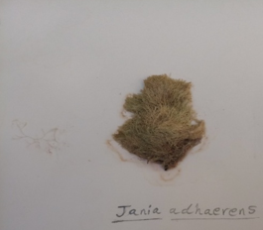 | 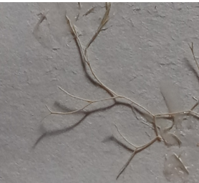
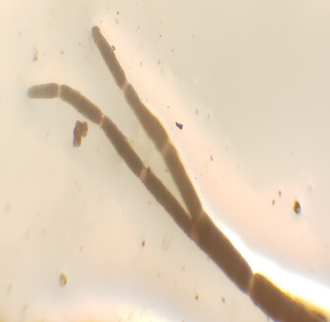 | 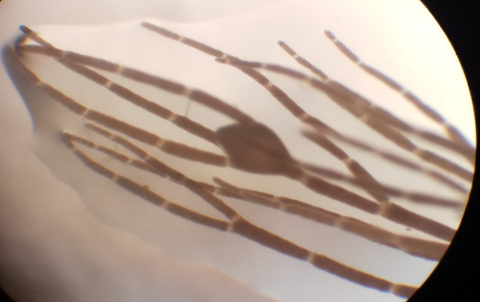
Figure 4: (A) The thallus of Jania adhaerens with a 2 cm ruler. (B) The branched bifurcations with wide angles. (C): The branches composed of 3-6 segments at a magnification of 100x. (D): It shows the reproductive cavities that resemble vessels, and these cavities bear protrusions that develop into branches at100x.
Order: Ceramiales
This order is one of the largest orders of red algae, containing more than 240 genera and more than 1,000 species distributed across four families. The thallus in this order is a branched monopodial axis consisting of one or more layers of unicellular or multinucleated cells and numerous disc-shaped plastids without a stroma centre. Its life cycle is monoecious, with two or three phases. They live in tropical and subtropical seas and oceans on rocks or other plants in tidal zones and submerged areas. Ceramiaceae and Rhodomelaceae can be distinguished from other families in this order using the following key:
1 – a. Monopodial thallus containing nodes, sometimes with a shell and not multiple tubes ……………………………………………………………………Ceramiaceae
1- b. Thallus with multiple tubes........................................................ Rhodomelaceae
Family: Ceramiaceae
The thallus in this family is small, monoecious, and mutually branching, and these branches are normal single-tubular and may or may not have a shell. The spore capsules are quadrangular, occurring either singly or in groups, and the auxiliary cell is formed after fertilization from the supporting cell. Only one genus of this family has been recorded in the study area, Acrothamnion.
Acrothamnion J. Agardh, 1892
This algae is a filamentous red alga that usually lives attached to Posidonia oceanica seagrass or algae in intertidal zones and at depths of up to 40 metres. The sample was collected from only one site, Botraba.
Acrothamnion preissii (Sonder) E.M.Wollaston, 1968)
Only one sample of this species was collected from the Botraba site, attached to algae on Jan 2018. The algae consist of a reddish-pink thallus attached to Cystoseira substrates by rhizoids (Figure 5A). This thallus consists of an axis bearing equal peripheral branches and contains oval-shaped terminal glandular cells located at the ends of the branches (Figure 5B).
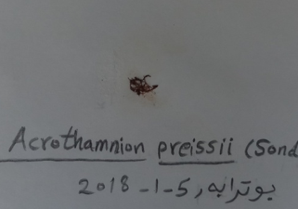 | 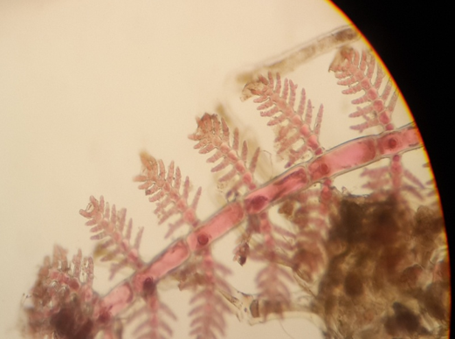
A | B
Figure 5. A: Thallus of Acrothamnion preissii, B: The peripheral branches which bear glandular cells at their tips at a magnification power of 100x.
Family: Rhodomelaceae
This family is characterized by having an erect, branched thallus consisting of several tubes (Polysiphonia) and disc-shaped plastids and quadrangular spore capsules. It is usually found on its own branches and is usually divided into four parts, but sometimes into three. Six genera of this family have been recorded in the study area: Halopitys, Rytiphlaea, Herposiphonia, Polysiphonia, Wrangelia, and Laurencia. They can be distinguished using the following key:
1- a. The main axes and side branches bear simple or compound lateral pairs, and the herbaceous leaves do not turn red when dried .............................................. Halopitys
1- b. The main axes bear lateral branches with reciprocal feathery branching, and the herbaceous leaves turn red when dried....................................................... Rytiphlaea
2 – a. The thallus is creeping, and rhizoids arise from the base of each segment .............. Herposiphonia
2- b. The thallus is erect and creeping, and rhizoids either sever the surrounding cells or remain in open contact with them .................................................... Polysiphonia
3 – a. Thallus filamentous .......................... ............................................ Wrangelia
3- b. Thallus cylindrical or compressed ...............................................Laurencia
Halopitys (Halopitys Kützing Itys 1849)
Halopitys consists of a rough, cylindrical thallus that is dark red in color. The main branches are opposite and simple at the bottom and become increasingly branched at the top, mostly curved or hook-like. The secondary branches are short on the upper side only. This moss is found on rocks in the intertidal zone. The genus Halopitys was recorded at all study stations except Botraba, represented by only one species, Halopitys incurvus .
Halopitys incurvus (Hud) Batters Itys 1902
=Halopitys pinastroides (Gmelin) Kützing =
= Rhodomela pinastroides (Gmelin) C. Agardh
Specimens of this species were collected out of the water from four sites, except for the Potraba site, on Jan and Feb 2018, Mar; Apr; Jun and Dec 2019. The thallus of this moss is erect, ranging in length from 6.2 to 10.1 cm. The thallus consists of one or more axes of unlimited growth that arise from a disc-shaped adhesive cell (Figure 6A). The main axis and lateral branches bear pairs of simple or compound limited branches (Figure 6 B), whose tips are strongly curved (Figure 6 C). When a cross-section of the axis is made, it appears to consist of a central axial cell surrounded by five peripheral cells that are slightly larger than the central axial cell (Figure 6 D). In addition to the study stations, this moss has been recorded in Tokra, Benghazi and Tolmitha.
Rytiphlaea C. Agardh 1817
The name Rytiphlaea refers to the distinctive hook at the end of the thallus. In the past, the moss was used as a source of red dye. There are four spore capsules on the edges of the branches, and the fruit capsule is spherical in shape and sits on the branch. The moss reproduces sexually and asexually through small black spores, which are found on the inner sides of the branches near the edge and arranged in two parallel rows. This algae found live on rocks and in shaded locations in the upper areas of the intertidal zone, and is often found on Jania algae. The genus Rytiphlaea was recorded at all study sites and is represented by a single species,
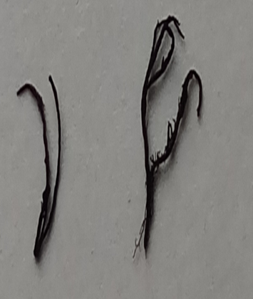 | 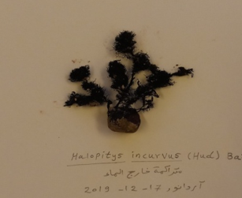
A | B
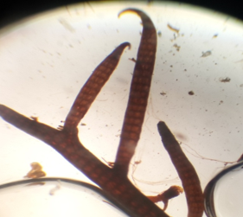 | 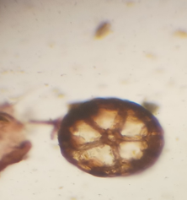
C | D
Figure 6. A: Thallus Halopitys incurvus. B: The main axis and lateral branches bearing pairs of simple or compound opposite limited branches in Halopitys incurvus. C: The strongly curved branches using a microscope at a magnification of 100x. D: The cross-section of the axis of Halopitys incurvus, which consists of a central axial cell surrounded by five peripheral cells at magnification of 100x.
Rytiphlaea tinctoria (Clemente) C. Agardh 1824
=Rytiphlaea semicristata J. Agardh
= Fucus purpureus Turner nom. Illeg
Samples of this algae were collected from all study sites attached to rocks on Oct, Nov 2017, Jan 2018, Mar, Apr, Aug and Dec 2019. The length of the thallus ranges from 3.6 to 8.8 cm, and its color ranges from yellow to dark red, becoming darker towards the top of the axis. This algae is characterized by the leakage of red pigment into the water or onto the leaves of the herbarium when dried. It adheres by means of a disc-shaped adhesive cell, from which one or more upright axes arise (Figure 7A). These axes bear lateral branches with reciprocal feathery branching (Figure 7B). The tips of the lateral branches are strongly curved and hook-like, with small filamentous tufts inside a sac (Figure 7 C &D). When a cross-section of the axis is made, it appears oval in shape, consisting of a central axial cell surrounded by five cells surrounding the center (Figure 7E). In addition to the study sites, this algae has also been recorded in Tripoli, Surman, Sabratha, Sirt, Benghazi, Tokra, Talmitha, and Derna (Godeh et al., 1992; Nizamuddin et al., 1979; Al-Shatwi and Abu-habil 2010; Abu-habil et al. 2019).
Herposiphonia Nageli 1846
Herposiphonia consists of a main axis bearing two types of branches, the first of which is simple and limited in branching in most species, while the second branches are unlimited in branching and arise on the opposite side of the axis, with rhizoids always arising at the end of the central cells. The reproductive organs are found on the limited branches. The genus Herposiphonia has been classified into species based on several characteristics, including the number, shape and length of the limited branches, the location of the quadrangular spore capsules in the thallus, and the shape, size and location of the fruit capsule and the location and arrangement of the male capsules (Masuda and Shimada 2003). This algae usually grows on large mosses, and only one species, Herposiphonia secunda, has been recorded at the Um Al-Hajl station (Table 1).
Herposiphonia secunda (C. Agardh) Ambronn) 1880
=Polysiphonia secunda ( C. Agardh ) Zanardini =
Specimens of this species were collected only from the Om al-Hajl site attached to the genus Cystoseira on Jan 2018 and Dec 2019. The length of the thallus ranges from 0.5 - 1.1 cm and reddish-brown in colour (Figure 8A). The thallus consists of a regularly sectioned tubular creeping axis (composed of segments) from which arise limited branching erect branches with 5-9 segments. At the tips of these branches are terminal filamentous tufts (Figure 8B). The moss adheres to substrates by means of distinct rhizoids arising from the base of each segment (Figure 8C). In addition to the study sites, this moss has also been recorded in Tripoli, Surman, Sabrata, Benghazi and Tokra (Godeh et al., 1992; Nizamuddin et al., 1979; Al-Shatwi and Abu-habil 2010, Abu-Habib et al., 2019). In addition to Libya.
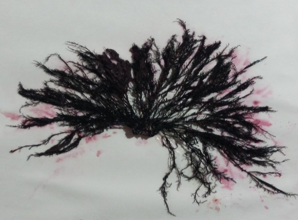 | 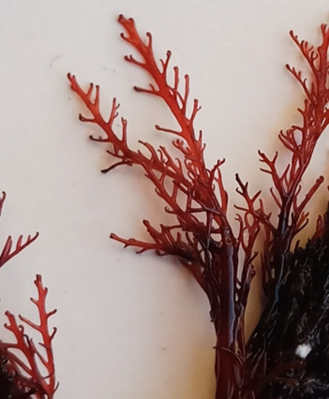
A | B
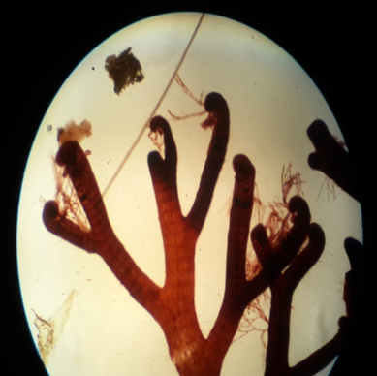 | 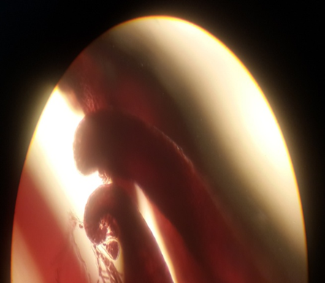
C | D
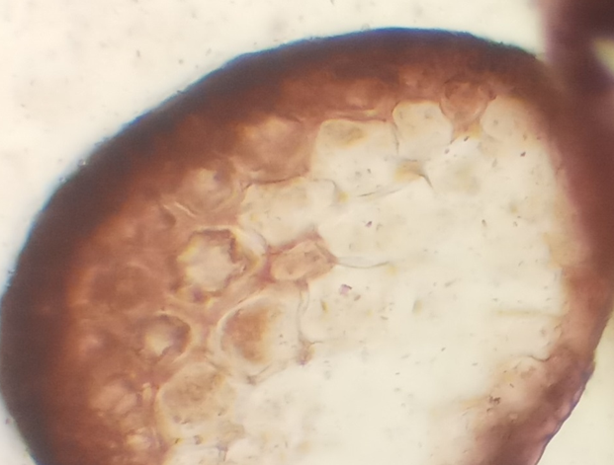
E
Figure 7. A: Thallus of Rytiphlaea tinctoria, 2 cm long. B: Side branches of Rytiphlaea tinctoria with reciprocal feathery branching. C: Strongly curved branch tips resembling hooks at a magnification of 100x. D: Shows the filamentous tufts inside a vesicle on the curved tips of the branches at a magnification power of 100x. E: Shows a cross-section of the axis, revealing its oval shape and central axial cell surrounded by five peripheral cells and a dark-stained shell at a magnification of 100x.

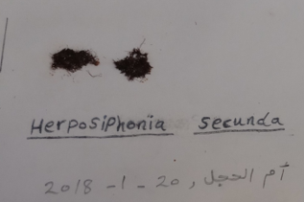 | 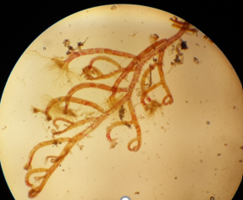
A | B
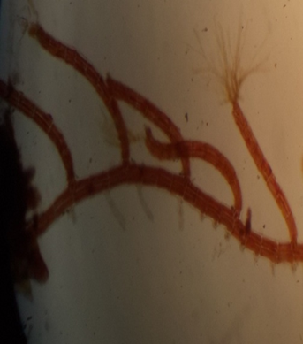
C
Figure 8. A: Thallus of Herposiphonia secunda. B: The creeping axis of Herposiphonia secunda, which bears erect branches consisting of 5-9 segments and terminal filamentous tufts at their tips, at a magnification of 100x. C: The rhizoids that arise from the base of each segment in Herposiphonia secunda at a magnification of 100 x.
Polysiphonia greville 1830
It is a red filamentous alga that is red or reddish-purple in colour. The thallus has multiple axes, and all of its cells are connected by pits, from which it gets its name. The thallus has two types of branches, one short and the other long. The short branches are limited in growth and arise from the main axis. The long branches are lateral, have unlimited growth, originate from the base of the terminal parts, and develop from a basal cell. The algae lives attached to rocks and large marine algae, and has a monoecious triphasic life cycle. This genus is classified into several species based on certain characteristics, including whether the thallus is erect or prostrate, the number of segments in the branches, and the presence or absence of filamentous tufts and rhizoids emerging from the peripheral cells. The quadrangular sporangia are arranged in straight chains on the limited branch. One species of this genus was recorded at the study stations of Om al-Hajl and Ardanou, Polysiphonia nigrescens.
Polysiphonia nigrescens (Hudson) Greville ex Harvey
Samples of this species were collected at the Om al-Hajl and Ardano sites attached to rocks on Jul and Oct 2017, Apr, Jun and Aug 2019. Thallus consists of small tufts covering the surfaces of rocks. It is dark brown in color with a hard texture (Figure 9A). Thallus ranges in length from 2.7 to 6.7 cm and adheres by rhizoids that arise from the basal part of the erect axes, forming short, intertwined creeping axes (Figure 9B). The rhizoids cut through the surrounding cells (Figure 9 C). The erect axes give rise to branches without filamentous tufts (Figure 9 D). When a cross-section of the erect axes is made, it appears that the number of peripheral cells ranges between 14 and 20 (Figure 9 E, F, G, H, and I). The fruit capsule is spherical (Figure 9 J), and the spore capsules are quadrangular and located at the top of the branches in a spiral arrangement (Figure 9 K). This species has been recorded in Libya in the cities of Surman and Sabrata (Al-Shatwi and Abu-Habil 2010, Abu-Habil et al., 2019).
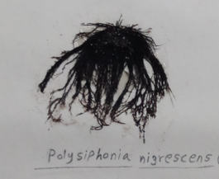 | 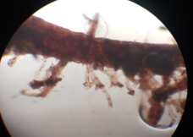 | 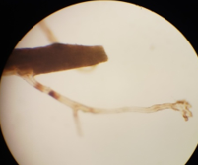
A | B | C
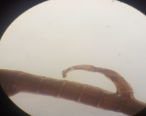 | 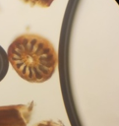 | 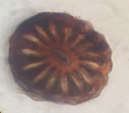
D | E | F
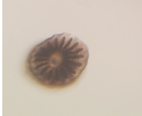 | 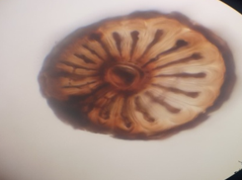 | 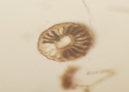
G | H | I
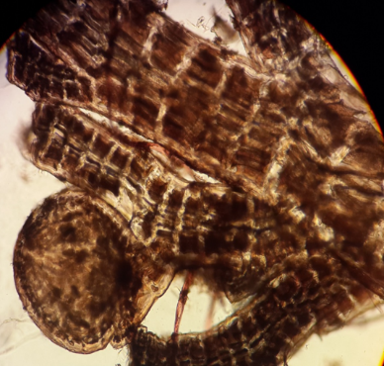 | 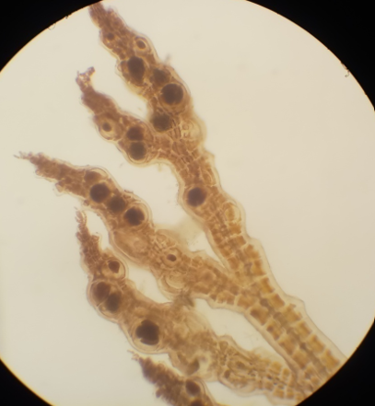
J | K
Figure 9. A: Thallus of Polysiphonia nigrescens. B: The rhizoids that arise from the basal part of the erect axes, forming short, intertwined creeping axes at a magnification of 100x. C: Rhizoids cutting through peripheral cells in the thallus of at a magnification of 100x. D: The upright axis from which branches without filamentous tufts arise at a magnification of 100x. E: A cross-section in the vertical axes, which shows that there are fourteen peripheral cells at a magnification of 100x. F: shows a cross-section of Polysiphonia nigrescens algae in the vertical axis, showing that there are fifteen peripheral cells, at a magnification of 400x. G: A cross-section in the existing axes, showing that there are seventeen peripheral cells at a magnification of 100x. H: shows a cross-section of Polysiphonia nigrescens moss in the vertical axes, which shows that there are eighteen peripheral cells at a magnification of 400x. I: A cross-section in the vertical axes, which shows that there are twenty peripheral cells at 100x. J: The spherical fruit capsule in the thallus of at a magnification of 100x. K: The oval-shaped spore capsules located at the top of the branches at a magnification of 100x.
Wrangelia C. Agardh 1828
Wrangelia algae consists of single-row strands of cells with large central axial cells. This moss attaches itself using rhizoids. The genus Wrangelia is recorded in Om Hajl, Ardanou, Sakba, and Zagrat, and is represented by a single species, Wrangelia penicillate.
Wrangelia penicillata (C. Agardh) C. Agardh
= Wrangelia penicillata var. tenera (C. Agardh) Kützing
Samples of this species were collected in Om al-Hajl, Ardanou, and Saqba, attached to rocks on Oct 2017, Apr, June, Aug, Sep 2019, and accumulated outside the water at the Zagrat site on Dec 2019. The length of the thallus ranges from 3.7 and 5.5 cm. It is thread-like, transparent, and light pink in color (Figure 10A). It is characterized by a single cylindrical axis bearing cylindrical branches curved towards the apex with reciprocal branching (Figure 10 B). The sporangia are spherical and borne on the branches in clusters (Figure 10 C). In addition to the study sites, this moss has also been recorded in Benghazi and Tokra (Godeh and Said 2008 and Godeh et al., 2010).
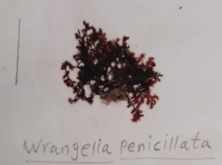 | 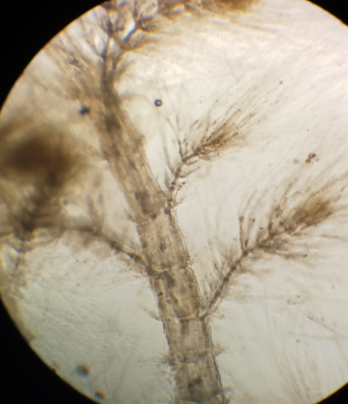  B
A
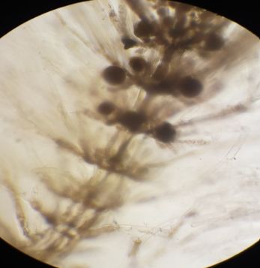
C
Figure 10: A: Thallus of Wrangelia penicillate. B: Cylindrical axis bearing cylindrical branches curved towards the apex with reciprocal branching at a magnification of 100x. C: The branches bearing spherical quadrangular spore capsules in clusters at a magnification of 100x.
Laurencia Lamouroux 1813
This alga has a cylindrical or compressed thallus, lateral branches, and a central tube. Laurencia consists only of the tips of the branches and the surrounding area, which are composed of elongated cells connected by dichotomous trichoblasts. The apical cell is surrounded by a colorless bifurcated filament. Laurencia reproduces asexually through the growth of quadripartite spores produced by the quadripartite spore stage, which gives rise to the arthrosporangium stage, which in turn reproduces sexually, giving rise to the fruiting stage in a monoecious, tripartite life cycle. Only two species have been recorded in some study stations, and they can be distinguished by the following key:
1- a. The thallus has a smooth texture and the branches are arranged oppositely ........................................... ................................................................ Laurencia obtusa
1- b. Thallus with a cartilaginous texture and branches arranged alternately .................................... ................................................................ Laurencia papillosa
Laurencia obtusa (Hudson) Lamouroux 1813)
= Chondria obtusa (Hudson) C. Agardh
= Fucus obtusus Hudson
Samples of this species were collected from all study sites, attached to rocks on Jul, Oct, Nov 2017, Mar, Apr, June, July, August, Sept and Dec 2019. The thallus ranges in length from 4.2 to 6.8 cm and is green, yellow, or red in color with a smooth texture. It quickly loses its color when exposed to light. The thallus consists of small, disc-shaped adhesive cells with irregular vertical axes (Figure 11A). With cylindrical branches and limited ramifications, they are arranged oppositely (Figure 11B). In the cross-section of the upper part of the branches, they appear to consist of 4-6 peripheral cells around the axis cell (Figure 11C). In addition to the study stations, this moss has also been recorded in Tripoli, Sirman, Sabrata, Benghazi, Tokra, Derna, and Sousse (Godeh et al., 1992; Nizamuddin et al., 1979; Al-Shatwi and Abu-habil 2010; Abu-habil et al. 2019).
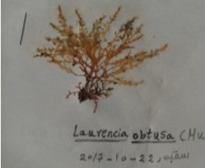 | 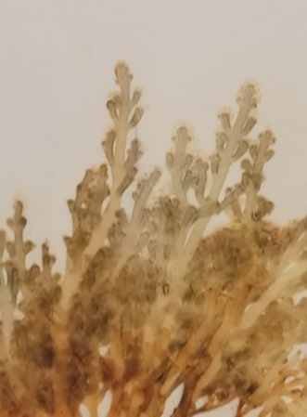
A | B
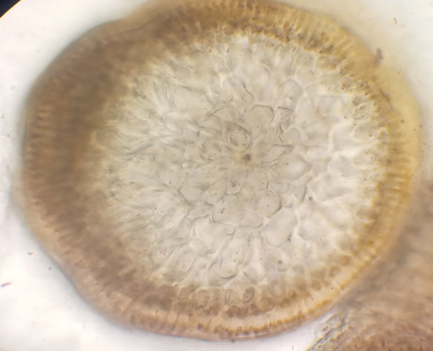
C
Figure 11. A: Thallus of Laurencia obtuse. B: Opposite arrangement of cylindrical branches. C: Cross section of the upper part of a branch showing six peripheral cells with a central cell at a magnification of 100x.
Laurencia papillosa (C. Agardh) Greville 1830
=Plisada perforata (Bory de Saint-Vincent) K.W.Nam
=Chondria papillosa C. Agardh 1822
=Chondrophycus papillosus (C. Agardh) D.J.Garbary and J.T.Harper
Samples of this species were collected from Om Al-Hajl, Ardanou, Saqba and Zagrat on Oct and Nov 2017, Jun, Aug, Sept and Dec 2019. The thallus has a compressed cartilaginous texture and ranges in length from 7.1 to 14.3 cm. It is greenish-brown in color and consists of small, disc-shaped adhesive cells from which upright axes arise (Figure 12. A). These axes bear 2 to 4 branches with thin tips (Figure 12. B, C). These branches are arranged alternately (Figure 12. D) and are very dense in the upper part, with numerous limited cylindrical branches resembling protrusions or projections. When a cross-section of the upper part of the branches is made, the axis cell appears to be cut by two peripheral cells (Figure 13). In a cross section of the thallus, the epidermal cells appear to consist of one or two layers of square-shaped coloured cells arranged vertically (palisade arrangement) in the middle part of the main axis. In the medullary region, there are four or five layers of colourless circular cells (Figure 14). In addition to the study stations, this moss has also been recorded in Tripoli, Sirman, Sabrata, Benghazi, Tokra, Talmitha, and Sousse (Nizamuddin et al., 1979; Godeh et al., 1992; Al-Shatwi and Abu-habil, 2010; Abu-habil et al., 2019).
Conclusion
This checklist establishes a foundation for future taxonomic, ecological, and applied research on Rhodophyta in Libya. Continued monitoring and advanced identification methods, such as molecular barcoding, are recommended to further elucidate species diversity, track environmental changes, and explore the biotechnological potential of local red algae.
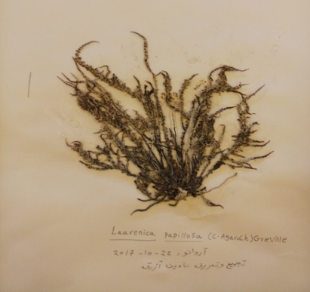 | 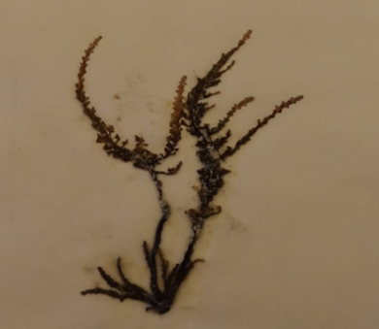 | 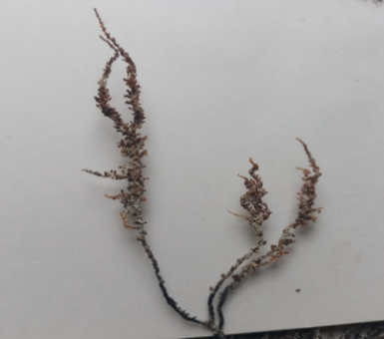
A | B | C
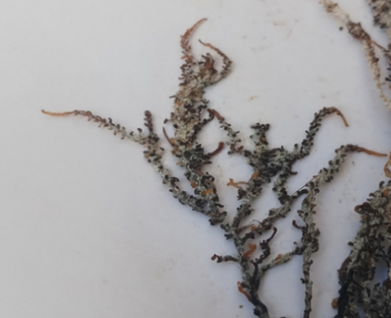 | 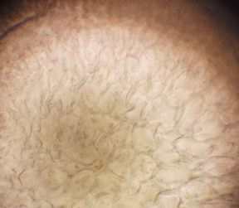 | 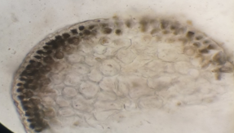
D | E | F
Figure 12. A: Thallus of Laurencia papillosa. B: Axis bearing two branches with thin tips. C: Axis bearing four branches with thin tips. D: The alternately arranged branches. E: A cross-section at the top of the branch, showing the axis cell intersected by two peripheral cells at a magnification of 100x. F: A cross section of the thallus, showing epidermal cells consisting of one or two layers of square-shaped colored cells arranged vertically, and the medullary region consisting of four or five layers of colorless circular cells at a magnification of 100x.
References
Abouhabil, Hana, Al-Shatiwi, Omar, Al-Naas, Amal, Al-Toumi, Omar, Benouba, Ibtisam, and Omar, Zohour. (2019). Inventory and identification of marine algae on the coast of Sabratha on the western coast of Libya. Journal of Applied Sciences, 2: 113-123.
Aleem, A., 1993. The marine algae of the Alexandria, Egypt, 1: 1- 4.
Al-Shatwi, Omar and Abu Habib, Hana. (2010). Seasonal variation in parametric measurements and marine algae at the coast of the Surman area, Al-Jami'i - Mahkama, 28: 221-234.
Ambrogi, A., Marchini, A., Cantone, G., Castelli, A ., Chimenz, C., Cormaci, M., Froglia, C., Furnari, G., Gambi, M., Giaccone, G., Giangrande, A., Gravili, C., Mastrototaro, F., Mazziotti, C., Orsi-Relini, L and Pirain, S., 2010. Alien species along the Italian coasts: an overview Biol. Invas 1-23 .
Ardissone, F., 1893. Note alia Phycologia mediterranea. Rend. R. Ist. Lombarde Sei Lett Ser, 26: 674-690.
Verlaqu, M., 2017. The introduced marine macroflora of Lebanon and its distribution on the Levantine coast, Medit Mar Sci, 138-155.
Bold, H., and Wynne, M., 1978. Inrtoduction to the algae structure and reproduction Prentice Hall of India , New Delhi , p720 .
Borg, M., Krueger‐Hadfield, S., Destombe, C., Collén, J., Lipinska, A., & Coelho, S. (2023). Red macroalgae in the genomic era.. The New phytologist. https://doi.org/10.1111/nph.19211
Carpena, M., García-Pérez, P., García-Oliveira, P., Chamorro, F., Otero, P., Lourenço-Lopes, C., Cao, H., Simal-Gándara, J., & Prieto, M. (2022). Biological properties and potential of compounds extracted from red seaweeds. Phytochemistry Reviews, 1 - 32.
Catra, M., Alongi, G., Serio, D., Cormaci, M., and Furnari, G., 2006 . The benthic algal flora on rocky substrata of the Egadi islands , a marine protected archipelago off the western coast of Sicily ( Italy , Mediterranean sea ) Nova Hedwigia, 82: 489-538 .
Cormaci, M., Lanfranco, E., Borg, J., Buttigieg, S., Furnari, G., Micallef, S., Mifsud , C., Pizzuto, F., Scammacca, B., and Serio, D., 1997. Contribution to the knowledge of Benthic Marine Algae on Rocky Substrata of the Maltese island ( Mediterranean Sea ) Bot . Mar. 40: 203-215.
Freitas, M., Pacheco, D., Cotas, J., Mouga, T., Afonso, C., & Pereira, L. (2021). Red Seaweed Pigments from a Biotechnological Perspective. Phycology.
Fulton, C., Abesamis, R., Berkström, C., Depczynski, M., Graham, N., Holmes, T., Kulbicki, M., Noble, M., Radford, B., Tano, S., Tinkler, P., Wernberg, T., & Wilson, S. (2019). Form and function of tropical macroalgal reefs in the Anthropocene. Functional Ecology.
Garbary, D., 1978. on the phylogentic relationships of the Acrochaetiaceae
Garbary, D., and Veltkamp, C., 1980. Observation on Mesophyllum lichenoides (Corallinaceae,Rhodophyta ) with scanning electron microscope.phycol, 19:49-53.
Garbary, D., Johansen, H and Scagel, R., 1981. Aspects of the morphology, ultrastructure and distribution of the two species of Yamadaea Segawa (Corallinaceae,Rhodophyta ) Jap.J.phycol, 29:7-13.
García-Seoane, R., Fernández, J., Villares, R., & Aboal, J. (2018). Use of macroalgae to biomonitor pollutants in coastal waters: Optimization of the methodology. Ecological Indicators, 84, 710-726.
Glimn-Lacy, J., & Kaufman, P. (1984). Red Algae: Rhodophyta. **, 57-57.
Godeh, M., and Said, A., 2008. Marine algae of Tukra and Tolmeta coasts, Libya.
Godeh, M., Nizamuddin, M., and El-Menifi, F., 1992. Marine algae from eastern coast of Libya (Cyrenaica). Pak. J. Bot., 24(1): 11-21.
Godeh, M., Said, A and El-Menifi, F., 2009. Marine algae of Tobruk and Ain Ghazala Coasts , Libya . J. Sci. Appli , 3 (1): 42- 55.
Godeh, M., Said, A., El-Menifi, F., and Zarmouh, M., 2017. Marine Algae of Sert Coasts, Libya. Sci.Appli, 5(1): 41- 44.
Godeh, M., Said, A., Zarmouh, M and El-Menifi, F., 2010. A list of marine Rhodophyta of Benghazi Coasts, Egypt. J. Exp. Biol. (Bot.), 6 (2): 93 – 97 . Rearrange according to date
Handayani, T. (2019). PERANAN EKOLOGI MAKROALGA BAGI EKOSISTEM LAUT. **, 44, 1-14.
Hauck, F., 1885. Kryptogamen-Flora ( 1st ed ) . New York, London.
Heckwolf, M., Peterson, A., Jänes, H., Horne, P., Künne, J., Liversage, K., Sajeva, M., Reusch, T., & Kotta, J. (2020). From ecosystems to socio-economic benefits: A systematic review of coastal ecosystem services in the Baltic Sea.. The Science of the total environment, 755 Pt 2, 142565. https://doi.org/10.1016/j.scitotenv.2020.142565
Ismail, M., Alotaibi, B., & El-Sheekh, M. (2020). Therapeutic Uses of Red Macroalgae. Molecules, 25. https://doi.org/10.3390/molecules25194411
Jueterbock, A., Minne, A., Cock, J., Coleman, M., Wernberg, T., Scheschonk, L., Rautenberger, R., Zhang, J., & Hu, Z. (2021). Priming of Marine Macrophytes for Enhanced Restoration Success and Food Security in Future Oceans. **, 8. https://doi.org/10.3389/fmars.2021.658485
Kamal, M., Abdel-Raouf, N., Alwutayd, K., AbdElgawad, H., Abdelhameed, M., Hammouda, O., & Elsayed, K. (2023). Seasonal Changes in the Biochemical Composition of Dominant Macroalgal Species along the Egyptian Red Sea Shore. Biology, 12. https://doi.org/10.3390/biology12030411
Kasanah, N., Ulfah, M., Imania, O., Hanifah, A., & Marjan, M. (2022). Rhodophyta as Potential Sources of Photoprotectants, Antiphotoaging Compounds, and Hydrogels for Cosmeceutical Application. Molecules, 27.
Menez, E., and Mathieson, A., 1981. The Marine Algae of Tunisia Smithsonian Contributions to the Marine Sciences, 10: 3- 59
N’Yeurt, A., and Payri, C., 2010. Marine algal flora of French Polynesia III. Rhodophyta, with additions to the Phaeophyceae and Chlorophyta Cryptogamie Bryolo, 31 (1): 3-205.
Nahor, O., Israel, Á., Barger, N., Rubin‐Blum, M., & Luzzatto-Knaan, T. (2024). Epiphytic microbiome associated with intertidal seaweeds in the Mediterranean Sea: comparative analysis of bacterial communities across seaweed phyla. Scientific Reports, 14.
Nizamuddin, M., West, J., & Meñez, E. (1979). A List of Marine Algae from Libya. **, 22, 465 - 476.
Nizamuddin, M.,West, J., and Menez, E., 1979. A List of Marine Algae from Libya . Bot. Mar ,22: 465-476.
Okudan, E., and Aysel,V., 2005. Marine Algae and Seagrasses of Antalya Shore ( Mediterranean, Turkey) J. Black Sea/Mediterranean Environment ,11: 256 – 279.
Pampanini, R., 1931. Prodromo della Flora Cirenaica. Algae, 1-40.
Petroll, R., West, J., Ogden, M., McGinley, O., Craig, R., Coelho, S., & Borg, M. (2025). The expanded Bostrychia moritziana genome unveils evolution in the most diverse and complex order of red algae. Current Biology, 35, 2771-2788.e8.
Rindi, F., Bellanti, G., Annibaldi, A., & Accoroni, S. (2024). Reconstructing Historical Changes in the Macroalgal Vegetation of a Central Mediterranean Coastal Area Based on Herbarium Collections. Diversity.
Setia, T., Fadhillah, H., Wulandari, P., Handayani, S., Sainal, S., Praptiwi, R., & Sugardjito, J. (2023). Biodiversity, community structure and potential uses of seaweeds and seagrass in transition zone of Taka Bonerate Kepulauan Selayar biosphere reserve, Indonesia. IOP Conference Series: Earth and Environmental Science, 1255.
Shabaka, S., 2018. Checklist of seaweeds and seagrass of Egypt (Mediterranean Sea) Egyptian journal of Aquatic research ,44: 203-212.
Tsiamis, K., Taşkın, E., Orfanidis, S., Stavrou, P., Argyrou, M., Panayotidis, P.,Tsioli,T., Cicek, A., Marcou, M and Küppe, F., 2014. Checklist of seaweeds of Cyprus (Mediterranean Sea) Bot. Mar. Sci , 57(3): 153–166.
Verlaqu, M., 2017. The introduced marine macroflora of Lebanon and its distribution on the Levantine coast, Medit Mar Sci, 138-155.
Al-Shatwi and Abu-habil, 2010 not sighted

