Preliminary Checklist Study on Marine Algae along the Coast between Tukra and Tolmetha, Libya, II: Phaeophyta

Abstract
Brown marine macroalgal samples, whether attached to rocks or found drifting outside the water (drift), were collected irregularly from five sites (site1: Om al-Hajl, site2: Ardano, site3: Soqba, site4: Zaghrat and site5: Butraba) which are located between Tukra and Tolmetha and extending about 30 km. 11 species of Phaeophytes were collected from the study area, belonged to 4 genera. All five sampling sites were involved in the presence of four species of Phaeophytes (Cystoseira barbata, Cystoseira cinitophylla, Cystoseira crinita, and Sargassum ramentaceum). These findings highlight the ecological significance and widespread distribution of key Phaeophyta species along this Libyan coastal stretch.
Keywords: Phaeophytes, marine algae, Libyan algae, Cystoseira, Sargassum.
Introduction
Marine algae represent one of the most ecologically and economically important components of coastal ecosystems. They play a central role as primary producers, contribute substantially to nutrient cycling, and provide habitat and nourishment for a wide range of marine organisms (Nelson, 2009; Duffy et al., 2019). Among them, the brown algae (Phaeophyta) are particularly significant due to their abundance in temperate and subtropical waters, their structural contributions to littoral communities, and their diverse applications in food, pharmaceuticals, and industry (Anburaj et al., 2024).
The Mediterranean Sea hosts a rich flora of marine algae, yet the distribution and composition of algal communities remain incompletely documented along many North African coasts (Zingone et al., 2020). In Libya, despite its extensive Mediterranean shoreline, systematic surveys of marine algal diversity are relatively scarce. Previous investigations in selected areas have reported general floristic elements, but more comprehensive and region-focused checklists are needed to advance baseline knowledge and support ecological monitoring.
The coastal stretch between Tukra and Tolmetha in northeastern Libya is an understudied region that harbors a variety of habitats, ranging from rocky substrates to sandy shores, which are likely to support diverse algal assemblages. Preliminary studies have begun to document the occurrence of different algal divisions in this area, providing an essential reference for future taxonomic, ecological, and biogeographical research. The present work is the second installment of a checklist series on marine algae from this region, with a focus on the division Phaeophyta (brown algae). Its primary aim is to provide an updated record of species composition, thereby contributing to a more complete understanding of Libyan marine flora and enhancing the basis for comparative studies across the Mediterranean.
Materials and Methods
Sample collection
Macroalgal samples, whether attached to rocks or found drifting outside the water (drift), were collected irregularly from five sites (site1: Om al-Hajl, site2: Ardano, site3: Soqba, site4: Zaghrat and site5: Butraba) which are located between Tukra and Tolmetha and extending about 30 km (Figure 1), starting in July 2017 until December 2019. The samples were washed on site with seawater, then placed in plastic bags and transported to the laboratory. In the laboratory, they were rinsed with distilled water to remove salts and debris, then air-dried on herbarium sheets using pieces of paper and cloth for pressing and drying. A portion of each sample was preserved in a diluted formalin solution (4%) and stored in the freezer for further microscopic examination.
Macroalgae identification
Macroalgal samples were initially examined in the study area based on their color by the naked eye. Subsequently, the algae were identified and classified through morphological and anatomical studies, as well as by means of light microscopy. The taxonomic identification was performed by refereeing to several key taxonomic sources (Hauck, 1885; Abbott and Hollenberg, 1976) and some the Italian floristic works (Ardissone,1893; Pampanini,1931 and Aleem,1993), and Libyan flora of algae publications (Nizamuddin, 1979, Nizamuddin 1981, 1991; Godeh et al., 1992, Godeh and Said, 2008; Godeh and Said, 2012; Godeh and Said, 2014).

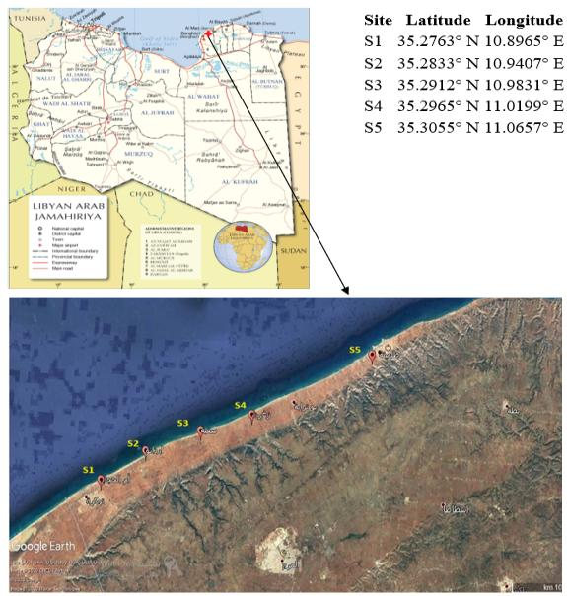
Figure (1): Map of the study area.
Results and discussion
The brown algae are classified into a single class, Phaeophyceae, within which only two orders were recorded in the study area: Dictyotales and Fucales. These two can be distinguished based on the following key:
1.a. Thallus is foliose, lacking air vesicles, with an isomorphic haplodiplontic life cycle →Dictyotales
1. b. Thallus is foliose, containing air vesicles, with a diplontic life cycle → Fucales
Order Dictyotales
Members of this order possess a foliose thallus that may be lobed or branched, usually growing by means of a single apical cell or a row of apical cells. The plastids are disc-shaped and lack pyrenoids (Womersley, 1987). Their life cycle is isomorphic haplodiplontic. This order is represented by a single family, Dictyotaceae.
Family Dictyotaceae
The thallus in this family is fan-shaped, strap-like, or consists of branched and lobed fragments. Growth is apical, accomplished either through a single apical cell or a row of apical cells. Structurally, the thallus is composed of large, unpigmented central cells and a single layer of very small pigmented cortical cells covering both surfaces. From the study stations, only two genera of this family were recorded, distinguished by the followingkey:
1. a. Foliose thallus with a distinct stipe →Dilophus
1. b. Fan-shaped foliose thallus → Padina
Genus Dilophus J. Agardh, 1882
The thallus of Dilophus is differentiated into two parts, a prostrate portion bearing rhizoids and an erect, dichotomously branched foliose portion with a smooth surface (Womersley, 1987). The erect part consists of more than two cell layers, with large, unpigmented central cells surrounded by small, pigmented surface cells. Growth is apical from a single apical cell. Reproduction occurs asexually by means of spores, while sexual reproduction is oogamous. This alga inhabits tropical, subtropical, and temperate seas and oceans, commonly occurring in the lower intertidal zone and the subtidal region. In the study area, Dilophus was recorded from several stations (Om al-Hajl, Ardano, and Butraba), represented only by the species Dilophus fasciola
Dilophus fasciola (Roth) Howe, 1914
= Dictyota fasciola (Roth) J.V. Lamouroux
Samples of this species were collected in an aggregated form outside the water from Ardano site on 29 June 2019, and also attached to sedimentary rocks in clustered groups at Umm Al-Hajal and Butraba site on 19 January 2018. The thallus is yellowish-brown in color, ranging in length from 4.4 to 7.2 cm. It is composed of a stolon from which rhizoids arise, allowing the alga to attach firmly to substrates. The thallus also bears erect, bifurcating blades (Fig.2A). These blades are narrow, strap-like in shape, with an attenuated apex (Fig.2B). The apical portion of the erect axis (blade) is composed of three cell layers (Fig.2C), while the middle portion consists of four layers: two layers of large, colorless medullary cells and one layer of small, pigmented cortical cells on each surface (Fig.2D). The basal portion of the erect blade comprises several layers of colorless medullary cells (Fig.2E).
In surface view, the reproductive structures appear as scattered, single, oval-shaped sporangia (Fig.2F). All specimens collected and examined from the sites (Umm Al-Hajal, Ardano, and Butraba) revealed the presence of reproductive sporangia irregularly distributed across the entire thallus surface. The occurrence of this species has been recorded along several Libyan coasts, including Tripoli, Sirte, Sabratha, Benghazi, Sousa, and Tobruk (Nizamuddin et al., 1979; Godeh and Said, 2008; Godeh et al., 2009, 2010, 2017; Abuhbeil et al., 2019). Within the broader Mediterranean region,
D. fasciola has been reported from Egypt, Tunisia, Algeria, Lebanon, Syria, Italy, Cyprus, Spain, France, Turkey, and Greece (Menez & Mathieson, 1981; Ribera et al., 1992; Moya et al., 1995; Rindi et al., 2002; Okudan & Aysel, 2005; Tsiamis et al., 2013; Tsiamis et al., 2014; Shabaka, 2018).
Genus Padina Adanson, 1763
The alga Padina is characterized by a fan-shaped foliose thallus composed of several concentric layers of large medullary cells surrounded by upper and lower layers of small, pigmented cortical cells. Its color is typically whitish-brown due to deposits of calcium carbonate. Growth in this genus occurs from a marginal row of apical cells, in contrast to Dictyota, where growth is initiated by a single apical cell. Reproductive sporangia are located on the upper portions of the blades, and sometimes on the lower surface. The main diagnostic features used to distinguish species within this genus are: the degree of thallus calcification, the number of cells layers the location and arrangement of reproductive sporangia in relation to hair lines, and the presence or absence of a delicate indusium (a thin membrane surrounding the reproductive sori). Padina species are distributed worldwide in subtropical and tropical seas and oceans, usually occurring in the lower intertidal and subtidal zones. In Libya, the genus was recorded only at Ardano and Soqba stations, represented by a single species: Padina pavonia.

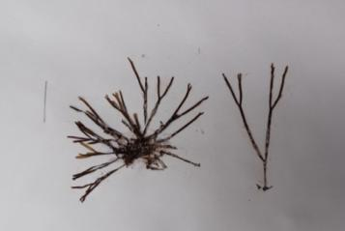A | 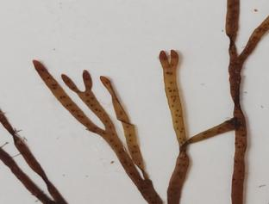B
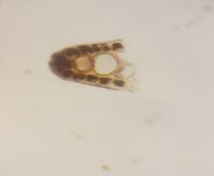  C | 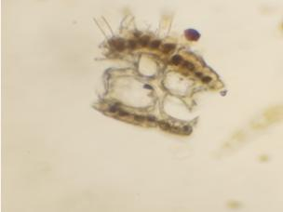D
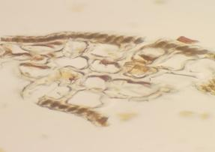  E | 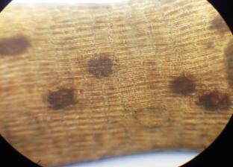  F
Figure 2: A: The thallus of Dilophus fasciola, B: the narrow, tapered leaflets, C: Transverse section of the apical portion of the blade showing three layers of cells, observed under a light microscope at 4 μm magnification. D: Transverse section of the middle portion of the blade consisting of four layers of cells: two layers of large, colorless medullary cells, and one layer of small, pigmented cortical cells on each surface. Observed under a light microscope at 4 μm magnification. E: Transverse section of the basal portion of the blade composed of several layers of large, colorless medullary cells. Observed under a light microscope at 40x magnification. F: Surface view of the blade showing reproductive sporangia scattered singly and oval in shape. Observed under a light microscope at 100x magnification.
Padina pavonia (Linnaeus) Lamouroux, 1816
= Padina pavonica (Linnaeus) Thivy
= Padina mediterranea Bory de Saint-Vincent
Specimens of this species were collected attached to sedimentary rocks from Soqba and Ardano, where individuals were found aggregated above the waterline on Oct 2017 and Jun 2019. The thallus arises from rhizoids bearing a short, erect stipe up to 0.5 cm in length, with the overall thallus measuring 3.2–4 cm. Its color is pale whitish-brown. The stipe supports erect fan-shaped blades that are semicircular, lobed, and wavy at the margins (Fig.3 A). Each fan is calcified due to calcium carbonate deposition, with calcification occurring only on one side of the blades: minimal near the basal portions, moderate in the upper parts. Histologically, the thallus consists of three layers of elongated cells in the basal region of the lobes (Fig.3B). Reproductive sporangia occur on the surface of the blades, arranged along both sides of the hair-line rows, present on both the upper and lower surfaces (Fig.3C). The sporangia are tetrasporic, spherical in shape, and enveloped by a thin indusium (Fig.3D). All specimens collected and studied from Ardano and Soqba stations revealed the presence of reproductive sporangia. The presence of this species has been recorded along the Libyan coast, including Tripoli, Sirte, Sabratha, Surman, Benghazi, Tokra, Ptolemais, Sousa, and Tobruk (Nizamuddin et al., 1979; Godeh and Said, 2008; Godeh et al., 2009, 2010, 2017; Abuhbeil, 2010; Al-Shtawi & Abuhbeil et al., 2019).
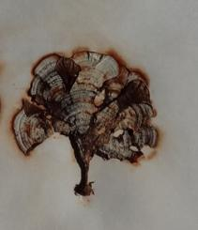  A | 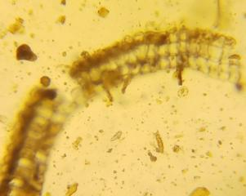  B
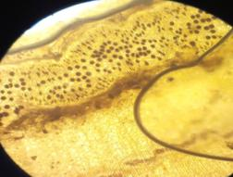C | 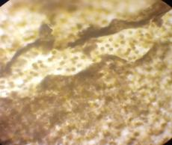  D
Figure 3. A: The thallus of Padina pavonia, B: A cross-sectional view of the basal portion of the thallus, illustrating the presence of three layers of elongated cells, observed using a microscope with a magnification of 100x. C: A surface view of the reproductive structures on the surface of the thallus, specifically located on all sides of the filament lines on both the upper and lower surfaces of these lines in Padina pavonia, observed using a microscope with a magnification of 100x. D: A surface view of the thallus illustrating the quadrate reproductive structures surrounded by a thin membrane (indusium) in Padina pavonia, observed using a microscope with a magnification of 100x.

Order: Fucales
This order encompasses large, branched algae that exhibit either dichotomous or radial branching, contain air sacs, and grow apically via a single cell or a group of cells. In the study area, two families from this order were recorded, distinguishable by the following key:
1.a. Reproductive structures borne on ordinary branches → Cystoseiraceae
1.b. Reproductive structures borne on specialized branches →Sargassaceae
Family: Cystoseiraceae
Members of this family inhabit warm and cold seas and oceans. A distinguishing feature of this family is that reproductive structures are typically located at the tips of ordinary branches rather than on specialized branches. One genus recorded from this family is Cystoseira.
Cystoseira (C. Agardh, 1820)
Cystoseira is a large, perennial, highly branched marine brown alga. The alga consists of a holdfast that anchors it to rocks and gives rise to a main axis that persists throughout its life, typically upright and growing via a three-sided apical cell. Lateral branches bear temporary, smooth cylindrical leaf-like structures or spines, arranged in a pinnate pattern, and sometimes contain scattered stomata within the thallus. The alga is distributed worldwide in both warm and cold seas and oceans, thriving in intertidal and subtidal zones. Cystoseira reproduces both asexually and sexually via oogamy, forming specialized reproductive regions (receptacles) at the ends of ordinary branches, where numerous cavities develop to produce eggs or male gametes, either within the same cavity or in independent cavities. Key characteristics used to classify this genus into species include the presence of one or several stipes emerging from the holdfast, the shape of the branches (cylindrical or leaf-like), the presence or absence of stomata, the release of eggs into the water or their retention on the surface until fertilization, as well as the number of layers and plastids in each cell (Godeh and Said, 2014). Seven species have been recorded from this genus, distinguishable by the following key:
1.a. Thallus formed from a single stipe→ 2
1.b. Thallus formed from multiple stipes → 3
2.a. Stipe long → Cystoseira barbata
2.b. Not long →4
3.a. Branches leaf-like and compressed with distinct stomata (Cryptostomata) → Cystoseira compressa
3.b. Branches cylindrical with indistinct stomata (Cryptostomata) →Cystoseira humilis
4.a. Primary branches with a non-swollen basal part and tips of branches bearing reproductive structures sharp → Cystoseira crinita
4.b. Primary branches with a swollen basal part bearing spines and tips of branches bearing reproductive structures not sharp →Cystoseira cinitophylla
5.a. Primary branches cylindrical, covered with serrated spines, and branches bearing reproductive structures simple or branched →Cystoseira elegans
5.b. Primary branches cylindrical, not covered with serrated spines, and branches bearing reproductive structures swollen with small rounded tips → Cystoseira gerloffii
Cystoseira barbata (Stackhouse) C. Agardh, 1820
= Fucus barbatus L.
Samples of this species were collected as accumulations outside the water at the stations of Om al-Hajal, Suqbah, Zugharat, and Butraba on Nov 2017, Dec 2017, Jan 2018, and Dec 2019. Additional samples were found attached to rocks at the Ardano station on Oct 2017. The thallus consists of a single main axis ranging in length from 19.4 to 40.2 cm (Fig.4 A), attached by means of a small basal discoid holdfast (Fig.4B). From this holdfast arises a single cylindrical stipe that lacks basal swellings (tophules) (Fig.4C). Its apex is very prominent and smooth (Fig.4D). The main stipe bears smooth cylindrical primary branches and slender cylindrical secondary branches with dichotomous ramifications (Fig.4E). Air vesicles are absent. The reproductive structures are borne on normal branches known as receptacles, which are apical, cylindrical to fusiform, and terminate with a sharp spine (Fig.4F). In transverse section, these receptacles display cavities (conceptacles) that contain reproductive organs. The female oogonia are reddish-brown and occur in pairs within the same cavity (Fig.4G). This species has been recorded along the Libyan coast at Tripoli, Surman, Benghazi, Tukra, Tolmetha, Susa, and Derna (Godeh and Said, 2008; Al-Shatwi and Abuhbeil, 2010; Said et al., 2010, 2013).
Cystoseira compressa
(Cystoseira compressa Gerloffi and Nizamuddin, 1975 = Cystoseira fimbriata (Desf.) Bory = Cystoseira abrotanifolia C. Agardh)
Specimens of this species were collected in aggregated form above the waterline from Ardano, Soqba, Zgharta, and Butraba sites on Oct 2017, Jan 2018 and Dec2019. The thallus consists of several stipes ranging between 7.6–12.1 cm in length (Figure 5). It is attached by means of a small discoid holdfast (Figure 5B), from which several stipes arise. These stipes bear smooth, leaf-like primary branches (Figure 5C) and short secondary branches with rounded apices arranged alternately (Figure 5D). The conceptacles are located on the primary and secondary branches, distributed in two rows extending from the base toward the apices (Figure 5E). Air vesicles are found at the tips of the secondary branches (Figure 5F). This species was recorded at all study site except for Om Al-Hajal. It has also been documented in Tripoli, Sabratha, Surman, Benghazi, Tukra, Tolmetha, and Susa (Nizamuddin et al., 1979; Godeh and Said, 2008; Godeh et al., 2010; Al-Shatwi and Abuhbeil, 2010; Abuhbeil et al., 2019).
Cystoseira crinita (Desfontaines) Duby (1830)
Samples of this species were collected from all study sites, accumulating outside the water at the Um al-Hajl, Zagrat and Botraba stations on Dec 2017, Jan 2018, and attached to rocks at the Ardanou and Saqba sites Oct & Nov 2017. The thallus consists of several stems ranging in length from 11.4 and 29.7 cm in length and brown to dark brown in color (Figure 6A). It is attached by an irregular basal disc-shaped adhesive cell from which cylindrical stems arise with prominent tips (Figure 6 B). The stems bear primary branches with spines and branches at the top of a thin, slightly or highly branched cylinder (Figure 6 C). Air sacs are absent, and the reproductive receptacles are borne on general branches called receptacles; these branches are simple, swollen, cylindrical, with spine-like appendages and sharp tips (Figure 6 D). This species has also been recorded in Benghazi, Tripoli, Sabratha, and Surman (Said et al., 2013).
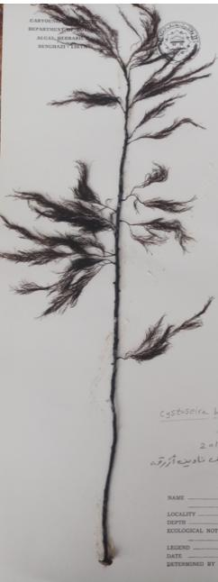A | 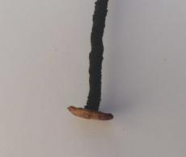B | 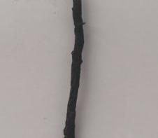C
 | 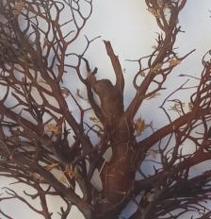D | 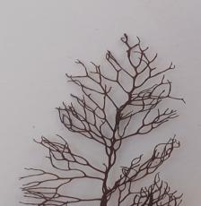E
 | 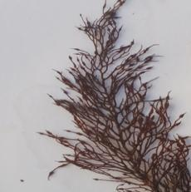F | 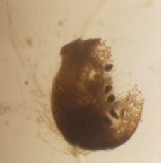G
Figure4: A: The thallus of Cystoseira barbata, B: the small discoid basal holdfast. C: the cylindrical stipe, which lacks a basal swelling (tophules). D: the apex of the stipe, which is markedly prominent and smooth. E: the secondary branches, which are thin, cylindrical, and dichotomously branched in F: the branches bearing reproductive receptacles, which are terminal, cylindrical, spindle-shaped, and simple, with their apices ending in a spine. G: a transverse section of a branch, showing the conceptacles (cavities) that contain the reproductive structures, located within the same cavity.
Cystoseira cinitophylla Ercegovic(1952)
Samples of this species were collected from outside the water at Ardanou, Sakba, Zgharta, and Butraba sites on Jan 2018, Dec 2019. The thallus consists of several stems ranging in length from 14.5 to 30.3 cm and is olive green to yellowish green in color (Figure 7A). It adheres by means of an irregular basal disc-shaped adhesive cell (Figure 7 B), from which simple or branched cylindrical stems ranging in length from 2.3 to 12.6 cm arise. These stems bear spines (Figure 7 C) with prominent spines at their tips (Figure 7 D). The stems bear primary cylindrical branches, the basal part of which is swollen and bears many or few spines close together. The branches range in length from 5.6 to 19.5 cm (Figure 7 E) The secondary branches are cylindrical or simple leaf-like or divided with spine-like appendages (Figure 7 F). The air sacs are absent, and the reproductive capsules are borne on general branches. These branches are cylindrical, swollen at the top, bearing short lateral spines, and their tips are not sharp (Figure 7 G). When a cross-section of these branches is made, the reproductive capsules appear to be located within the same cavity (Figure7 H). This species has also been recorded in Benghazi, Tolmitha and Sussa.
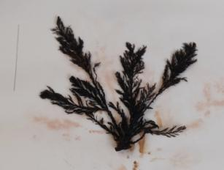A | 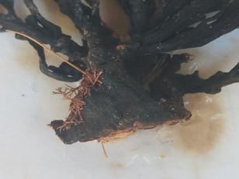B
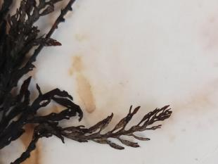  C | 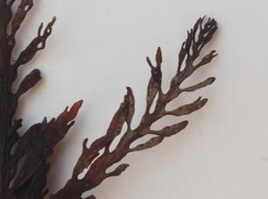D
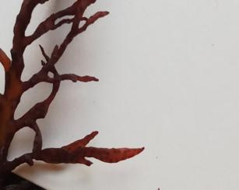  E | 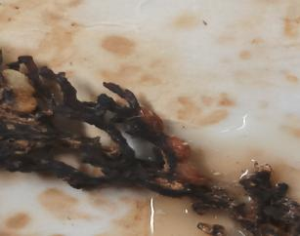F
Figure 5, A: the small discoid holdfast of Cystoseira compressa. B: the smooth, leaf-like primary branches. C: the short secondary branches with rounded apices arranged alternately. D: the conceptacles located on both the primary and secondary branches, arranged in two rows extending from the base toward the apex. E: the air vesicles located at the tips of the secondary branches.

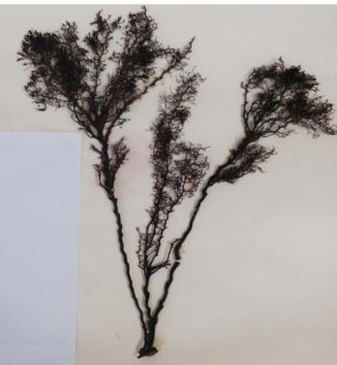  A | 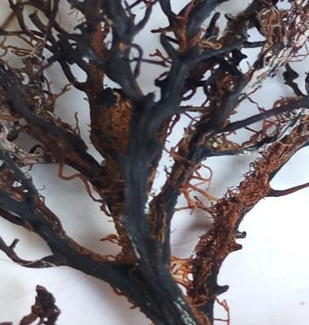B
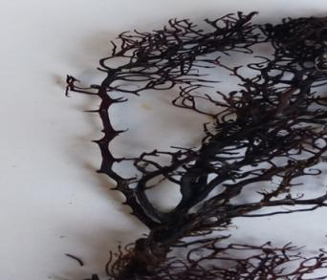C | 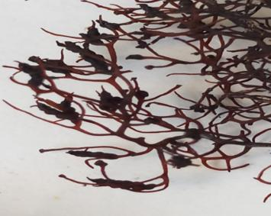D
Figure 6, A: The thallus of Cystoseira crinita , B: the prominent apex of the stems. C: the primary branches bearing spines, D: the cylindrical branches bearing reproductive capsules, which are simple swollen tips with spine-like appendages with sharp tips.

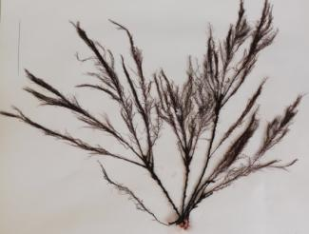  A | 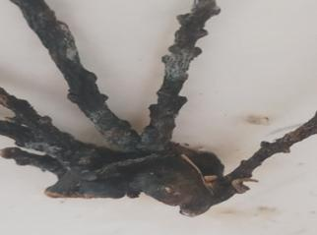  B
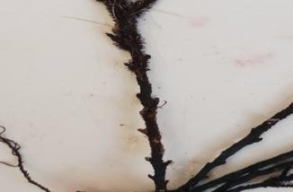C | 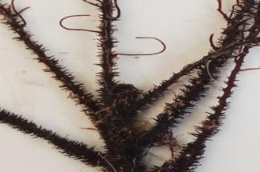  D
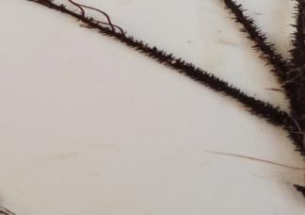E | 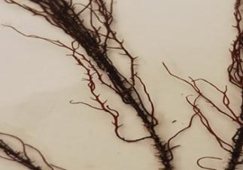F
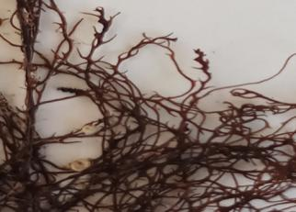G | 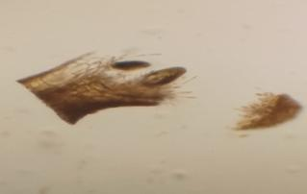H
Figure 7: (A): The thallus of Cystoseira cinitophylla. (B): the adhesive cell, which is a disc-shaped, irregular basal structure in the alga. (C) a simple cylindrical stipe bearing spines. (D): the prominent apex of the stipe, which appears to bear spines. (E): the primary cylindrical branches bearing spines. (F): the secondary cylindrical branches with spine-like outgrowths. (G): the branches bearing reproductive receptacles, which are terminal, swollen, cylindrical structures with short lateral spines and a blunt apex. (H) a cross-section showing branches containing cavities within which both male (antheridia) and female (oogonia) reproductive structures are located.

Cystoseira elegans Sauvageau (1912) .
Specimens of this species were collected as detached accumulations outside the water at the stations of Sakhba and Boutraba on Nov 2017 and Jan 2018. The thallus consists of several stipes ranging in length from 14.8 to 15.7 cm (Figure 8A), and is attached by means of a small, circular disc-shaped adhesive cell (Figure 8B). Cylindrical stipes arise from this basal disc, and along these stipes, a basal swelling known as a tophule is observed (Figure 8C). From these stipes, slender primary cylindrical branches emerge, which are smooth at the base. In the upper region of the thallus, these branches are covered with serrated spines (Figure 8D). Air vesicles are absent. The reproductive receptacles are borne on general branches, which are terminal, cylindrical, either simple or branched, and bear spines (Figure 9E). This species was recorded in Tolmetha and Susa (Said et al., 2010).
Cystoseira humilis Schousboe ex Kützing 1860
= Cystoseira planiramea Schiffner ex Gerloff & Nizamuddin.
Specimens of this species were collected in bulk outside the water at Umm Al Hajel site only on Dec 2017. The thallus consists of several stalks ranging in length from 16.1 to 31.2 cm and is olive-brown in color (Figure 9A). It is attached by a compact disc-shaped basal adhesive cell (Figure 9 B), from which arise rough, cylindrical, upright stalks (with projections) (Figure 9 C), the apex of which is slightly raised and smooth (Figure 9 D). These stalks bear branches, all of which are cylindrical, with the primary branches being smooth and curved (flexuous), giving a pyramidal shape (Figure 9 E). The secondary branches are smooth, arranged radially and branch abundantly (Figure 9 F). The stomata are not clear, the air sacs are absent and the reproductive capsules are borne on general branches called receptacles. These branches are small, simple or branched apical fusiform (Figure 9 G). The presence of this species has also been recorded only in Benghazi (Godeh et al., 2011).
Cystoseira gerloffi (Nizamuddin)
Samples of this species were collected, accumulating outside the water, in Om al-Hajl, Ardano and Zghart on Dec 2017, Jan 2018 and Dec 2019. The thallus consists of several stalks ranging in length from 9.6 to 17.9 cm (Figure 10A) and is attached by a small circular disc-like adhesive cell (Figure 10 B) from which several short stalks arise. Along the length of these stalks there is a basal swelling called (tophules) (Figure 10 C) and from these stalks arise smooth cylindrical primary branches not covered with spines (Figure 10 D). The air sacs are absent and the reproductive capsules are borne on general branches called receptors) and these branches Cylindrical, swollen, with a small rounded tip (Figure 10 E). This species has been recorded in Tolmetha and Sussa (Said et al., 2010).
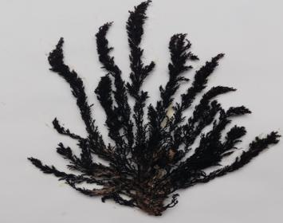 | 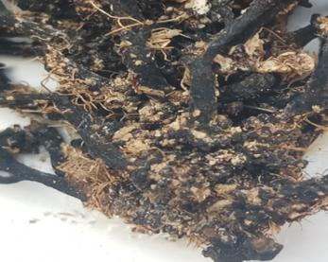
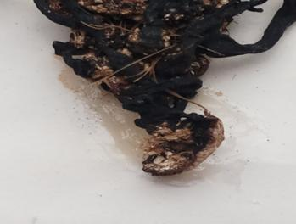 | 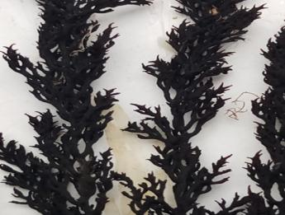
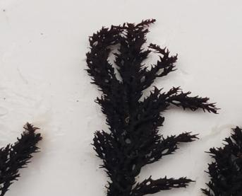
Figure 8(A): The thallus of Cystoseira elegans. (B) shows the small, circular, disc-shaped adhesive cell in the alga. (C) the stipes bearing a basal swelling known as a tophule in Cystoseira elegans. (D) the upper primary cylindrical branches covered with serrated spines. (E) shows the branches bearing reproductive receptacles, which are terminal, cylindrical, either simple or branched, and bear spines.

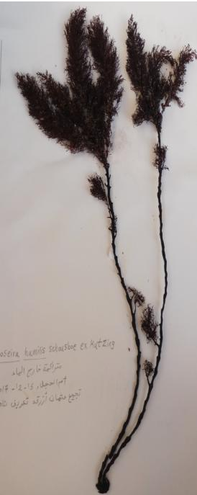  A | 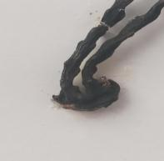  B | 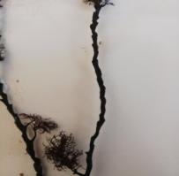C
 | 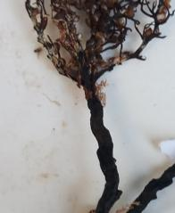D | 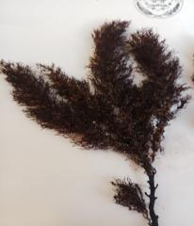E
 | 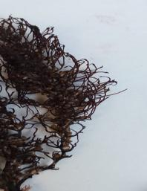F | 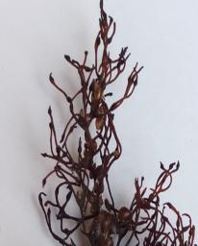G
Figure 9: (A): The thallus of Cystoseira humilis, (B): the compact disc-shaped basal adhesive cell (C): the rough, cylindrical, upright petiole (with projections), (D): the slightly projecting, smooth petiole apex (E): the smooth, curved primary branches, giving a pyramidal shape, (F): the smooth, radially arranged, profusely branched secondary branches, (G): the branches bearing the reproductive capsules, which are small, simple, or branched terminal fusiform.
Family Sargassaceae
Members of the family Sargassaceae are characterized by a uniaxial thallus bearing numerous lateral branches. These branches typically differentiate into structures resembling leaves or air vesicles. The reproductive receptacles are borne on specialized branches. Within this family, only a single genus has been recorded, namely Sargassum.

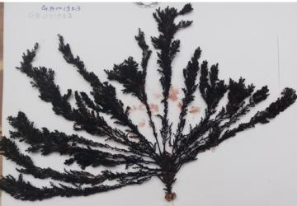 | 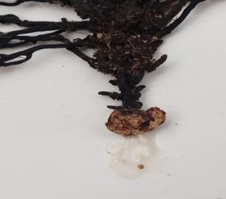
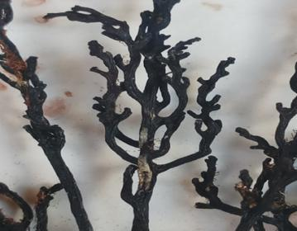 | 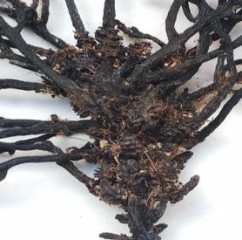
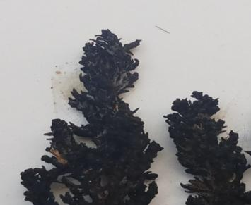
Figure 10: (A): The thallus of Cystoseira gerloffi, (B): the small, circular, disc-shaped adhesive cell (C): the petioles with basal swellings called tophules, (D): the smooth, cylindrical, non-thorny primary branches, (E): the branches bearing the reproductive stomata, which are cylindrical, swollen, apical, bearing thorns, and with a small, rounded apex.
The Alga Sargassum (Sargassum C. Agardh, 1820)
The thallus of Sargassum exhibits a distinctive morphological organization, consisting of a disc-shaped holdfast and a main axis that gives rise to lateral branches. Some of these branches develop into leaf-like structures with smooth, serrated, or undulate margins and possess a prominent midrib. Sargassum is widely distributed in tropical, subtropical, and even temperate to cold seas. It may grow either attached to rocks and other substrates via a permanent discoid holdfast or float freely. In the Atlantic Ocean, floating Sargassum accumulates in large quantities, forming the well-known “Sargasso Sea.” Sargassum reproduces asexually through vegetative fragmentation, whereby detached portions of the thallus give rise to new plants. Sexual reproduction is oogamous. The reproductive receptacles are borne on specialized terminal branches, where surface cavities develop containing filaments that bear either antheridia or oogonia. Fertilization results in the formation of a zygote, which subsequently grows into a new plant, completing a haplodiplontic life cycle.
The classification of Sargassum species is based on several diagnostic features, primarily; presence or absence of leaf-like structures, presence or absence of a midrib, whether leaf-like structures are branched or unbranched, shape and margins of these leaf-like structures, shape of air vesicles, and the position of receptacles (whether pedicellate or sessile). In the present study, the genus Sargassum was recorded at all sampling stations, with two species identified and distinguished by the following key:
1.a. Leaf-like structures petiolate with a distinct midrib → Sargassum hornschuchii
1. b. Leaf-like structures sessile with no distinct midrib → Sargassum ramentaceum
Sargassum hornschuchii C. Agardh (= Sargassum amigdalifolium Bory)
Specimens of this species were collected as accumulated fragments washed ashore from the Ardano and Zugra sites on Jan 2018. The thallus is yellowish-brown to dark brown, with cylindrical stems reaching up to 19.8 cm in length (Figure 11A). These bear primary serrated foliar-like branches ranging from 2.4–4.9 cm in length. The leaf-like structures are lanceolate, long-petiolate, and relatively broad (2.6 mm wide) with a distinct midrib. Their margins are strongly undulate with minute teeth, and the tips are attenuate (not sharply pointed). Stomata are arranged irregularly along the margins, occasionally in pairs (Figure 11B).
The air vesicles are spherical with a smooth apex, attached to the branches by short cylindrical stalks (Figure 11C). This species has also been reported in Tripoli and Tolmeitha (Nizamuddin et al., 1979; Godeh & Said, 2008). Across the Mediterranean region, its distribution includes Algeria, Morocco, Egypt, Tunisia, Italy, Malta, Cyprus, Turkey, Greece, and France (Cormaci et al., 1997; Ribera et al., 1992; Okudan & Aysel, 2005; Catra et al., 2006; Tsiamis et al., 2013, 2014; Shabaka, 2018).
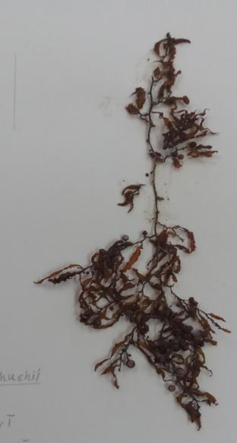  A | 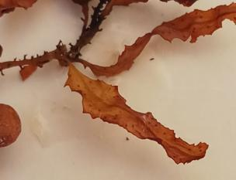B
 | 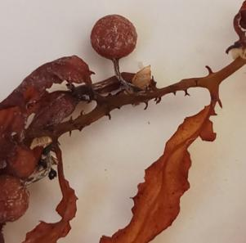C
Figure 11, (A): The thallus of Sargassum hornschuchii, (B): the lanceolate, long-petiolate leaf-like structures which are relatively broad with a distinct midrib. Their margins are strongly undulate, resembling waves, and bear minute teeth. The apices are attenuate (not sharply pointed). Stomata are distributed along the margins in irregular rows, occasionally appearing in pairs, (C): the spherical air vesicles, which have a smooth apex devoid of spines and are attached to the branches by short cylindrical stalks.
Sargassum ramentaceum (Zarmouh & Nizamuddin, 1991)
Specimens of this species were collected as accumulated fragments washed ashore at all sampling sites on Jul & Oct 2017; Jan 2018; Jun and Jul 2019. The thallus measured between 34.6–60 cm in length and consisted of a flattened stipe bearing cylindrical primary branches (Figure 12A). These branches carried sessile, narrow, strap-shaped leaf-like structures ranging from 1.9–4.9 mm in width, with serrated margins and no distinct midrib (Figure 12B). The air vesicles were spherical, smooth at the apex (without apical spines), and supported on compressed stalks bearing spines (Figure 12 C). Receptacles were observed only in a specimen that was collected from Butraba site during summer. These receptacles occurred on specialized terminal branches that were simple or branched, cylindrical, with surface protuberances, and sub-monoecious in form (Figure 12 D). This species has also been recorded in Tripoli, Benghazi, and Derna (Godeh et al., 1992; Said et al., 2013).
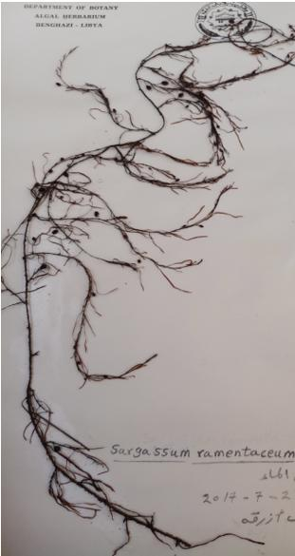  A | 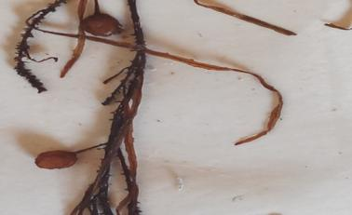  B
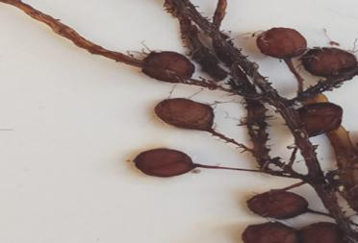
C
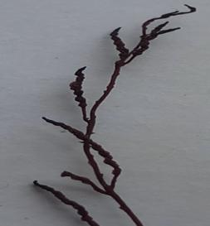
D
Figure 12, (A): The thallus of Sargassum ramentaceum. (B): the sessile, ribbon-like, toothed-edged leaflets with an indistinct midrib. (C): the globular, spineless apical air sacs borne by a compressed spine-bearing stalk. (D): the special branches bearing the reproductive calyces, which are nearly monomorphic.
Conclusion
This preliminary checklist of Phaeophyta (brown algae) recorded along the coast between Tukra and Tolmetha, Libya, provides an important contribution to understanding the marine floristic composition of the region. The documented taxa not only expand the current knowledge of Libyan seaweed biodiversity but also offer a baseline for future comparative and ecological studies. Given the ecological significance of Phaeophyta as primary producers, habitat providers, and bioindicators of environmental change, the findings highlight the need for continued monitoring and more detailed surveys. Future research should emphasize seasonal variability, community structure, and the potential impacts of environmental pressures, such as coastal development and climate change, on these algal populations. Ultimately, this study represents a step toward establishing a more comprehensive assessment of the marine flora along the northeastern Libyan coast and underscores the value of regional marine biodiversity inventories for conservation and sustainable management.
References
Abbott, Is and Holle, G., 1976. Marine Algae of California (1st ed). Stanford , California
Abouhabil, Hana, Al-Shatiwi, Omar, Al-Naas, Amal, Al-Toumi, Omar, Benouba, Ibtisam, and Omar, Zohour. (2019). Inventory and identification of marine algae on the coast of Sabratha on the western coast of Libya. Journal of Applied Sciences, 2: 113-123.
Al-Shatwi, Omar and Abu Habib, Hana. (2010). Seasonal variation in parametric measurements and marine algae at the coast of the Surman area, Al-Jami'i - Mahkama, 28: 221-234.
Anburaj, R., Kathiresan, K., & Prasannakumar, C. (2024). Exploring the depths: A comprehensive review of marine algae. Recent Trends In, 176.
Catra, M., Alongi, G., Serio, D., Cormaci, M., and Furnari, G., 2006 . The benthic algal flora on rocky substrata of the Egadi islands , a marine protected archipelago off the western coast of Sicily ( Italy , Mediterranean sea ) Nova Hedwigia, 82: 489-538 .
Cormaci, M., Lanfranco, E., Borg, J., Buttigieg, S., Furnari, G., Micallef, S., Mifsud , C., Pizzuto, F., Scammacca, B., and Serio, D., 1997. Contribution to the knowledge of Benthic Marine Algae on Rocky Substrata of the Maltese island ( Mediterranean Sea ) Bot . Mar. 40: 203-215.
Duffy, E., Benedetti‐Cecchi, L., Triñanes, J., Muller‐Karger, F., Ambo‐Rappe, R., Boström, C., Buschmann, A., Byrnes, J., Coles, R., Creed, J., Cullen‐Unsworth, L., Diaz-Pulido, G., Duarte, C., Edgar, G., Fortes, M., Goñi, G., Hu, C., Huang, X., Hurd, C., Johnson, C., Konar, B., Krause‐Jensen, D., Krumhansl, K., Macreadie, P., Marsh, H., McKenzie, L., Mieszkowska, N., Miloslavich, P., Montes, E., Nakaoka, M., Norderhaug, K., Norlund, L., Orth, R., Prathep, A., Putman, N., Samper‐Villarreal, J., Serrão, E., Short, F., Pinto, I., Steinberg, P., Stuart‐Smith, R., Unsworth, R., Van Keulen, M., Van Tussenbroek, B., Wang, M., Waycott, M., Weatherdon, L., Wernberg, T., & Yaakub, S. (2019). Toward a Coordinated Global Observing System for Seagrasses and Marine Macroalgae. Frontiers in Marine Science. https://doi.org/10.3389/fmars.2019.00317
Godeh, M., Said, A., El-Menifi, F., and Zarmouh, M., 2017. Marine Algae of Sert Coasts, Libya. Sci.Appli, 5(1): 41- 44.
Godeh, M., Said, A., Zarmouh, M and El-Menifi, F., 2010. A list of marine Rhodophyta of Benghazi Coasts, Egypt. J. Exp. Biol. (Bot.), 6 (2): 93 – 97 .
Godeh, M., Said, A., Zarmouh, M and El-Menifi, F., 2010. Marine Chlorophyta of Benghazi Coasts, Libya .J.Sci.Appli, 4 (1): 7-13 . 204
Godeh, M., Said, A., Zarmouh, M and El-Menifi, F., 2011. Marine Phaeophyceae of Benghazi coasts , Libya. Pure and Appli. Sci, (10):32- 39 .
Hauck, F., 1885. Kryptogamen-Flora ( 1st ed ) . New York, London.
Menez, E., and Mathieson, A., 1981. The Marine Algae of Tunisia Smithsonian Contributions to the Marine Sciences, 10: 3- 59
Nelson, W. (2009). Calcified macroalgae - critical to coastal ecosystems and vulnerable to change: a review. Marine and Freshwater Research, 60, 787-801. https://doi.org/10.1071/mf08335
Nizamuddin, M., 1981. Contribution to the marine algae of Libya Dictyotales. Bibl. Phycol, vol. 54:120 pp ( J. Cramer West Germany ). Vaduz
Nizamuddin, M., 1985. A new species of Cystoseira C. Ag . ( Phaeophyta ) from the eastern Part of Libya. Nova Hedw, 42: 119-122.
Nizamuddin, M., 1991. The green marine algae of Libya .230 pp.Elga.bern. Nizamuddin, M., 1995. Acaespitose tophulose Cystoseira species from Tripoli, Libya Pak. J. Bot, 27(1): 49-54.
Nizamuddin, M., and El-Menifi, F., 1993. A new species of the genus Codium (Chlorophyta- Codiales) from the eastern coast of Libya. Pak. J. Bot, 25(2): 208-214. Nizamuddin, M., and Godeh, M., 1993. Observations on Taonia Atomaria F.Ciliata ( Lamour ) Nizamuddin. pak. J.bot, 25 ( 2 ):199- 207 .
Nizamuddin, M., and Godeh, M ., 1989 . Stypopodium tubruqense (Phaeophyta, Dictyotales ), a new species from the Mediterranean Sea .Willdenowia ,18: 603-608. Nizamuddin, M., and Godeh, M., 1990a. A first record of the genus Cottoniella borgesen ( Ceramiales , Rhodophyta ) from Libya . Pak. J . Bot , 22(1): 24-35. Nizamuddin, M., and Godeh, M., 1990b. Studies on new species of Cottoniella from the coast of Libya . Pak .J. Bot, 22(2): 24-35.
Nizamuddin, M., West, J., & Meñez, E. (1979). A List of Marine Algae from Libya. **, 22, 465 - 476. https://doi.org/10.1515/botm.1979.22.7.465
Okudan, E., and Aysel,V., 2005. Marine Algae and Seagrasses of Antalya Shore ( Mediterranean, Turkey) J. Black Sea/Mediterranean Environment ,11: 256 – 279.
Pampanini, R., 1931. Prodromo della Flora Cirenaica. Algae, 1-40.
Ribera, M., Gomez, A., Gallardo, T., Cormac, M., Furnari, G., and Giaccone, G., 1992. Check-list of mediterranean sea weeds . I. Fucophyceae. Bot. Mar, 35: 109-130.
Rindi, F., Sartoni, G and Cinelli, F., 2002. A floristic account of the benthic marine algae of Tuscany ( Western Mediterranean Sea ) Nova Hedwigia ,74: 201-250.
Said, A., Godeh, M., & El-Menifi, F. (2010). Marine algal survey of Derna, Susa and Tolmeta at Libya Coasts -. **, 11, 1-13. https://doi.org/10.21608/egyjs.2010.114873
Said, A., Godeh, M., and El-Menifi, F., 2010. Marine algae of Derna, Susa and Tolmeta coasts, Libya, Egyptian J. of Phycol, 11: 1- 13.
Said, A., Godeh, M., El-Menifi, F., Zarmouh, M and Bleibilo, A., 2013. Marine brown algae of Benghazi and Tripoli coasts eastern and western Libya, Egypt. J. Exp. Biol. (Bot.), 9(1): 49 – 53.
Shabaka, S., 2018. Checklist of seaweeds and seagrass of Egypt (Mediterranean Sea) Egyptian journal of Aquatic research ,44: 203-212.
Tsiamis, K., Panayotidis, P., Amilli, A and Katsaros, C., 2013. Seaweeds of the Greek coasts. I. Phaeophyceae ,Medit. Mar. Sci, 141-157.
Tsiamis, K., Taşkın, E., Orfanidis, S., Stavrou, P., Argyrou, M., Panayotidis, P.,Tsioli,T., Cicek, A., Marcou, M and Küppe, F., 2014. Checklist of seaweeds of Cyprus (Mediterranean Sea) Bot. Mar. Sci , 57(3): 153–166.
Womersley, H., 1987. The marine benthic flora of southern Australia Part II ( 1st ed ) Adelaide, South Australia.
Zingone, A., Escalera, L., Aligizaki, K., Fernández-Tejedor, M., Ismael, A., Montresor, M., Mozetič, P., Tas, S., & Totti, C. (2020). Toxic marine microalgae and noxious blooms in the Mediterranean Sea: A contribution to the Global HAB Status Report.. Harmful algae, 102, 101843. https://doi.org/10.1016/j.hal.2020.101843

