Original Research Article
Evaluation of Achyranthes Aspera Linn. extract for phytochemical content and invitro antioxidant activity.

ABSTRACT
Aims: The present study aimed to evaluate the phytochemical composition, total phenolic content (TPC), total flavonoid content (TFC), and in vitro antioxidant activity of methanolic leaf and stem extracts of Achyranthes aspera Linn.
Study Design: This study is design as an experimental and laboratory based in vitro methods.
Place and Duration of Study: Department of Biotechnology, Dr. D.Y. Patil ACS College, Pimpri, Pune, India, conducted between July 2024 and March 2025.
Methodology: Achyranthes aspera plant samples were shade-dried, powdered and extracted using methanol. Phytochemical screening was performed for alkaloids, phenolics, flavonoids, tannins, saponins, terpenoids, and steroids. The antioxidant activity of Leaf and stem of A. aspera (Linn.) was assessed with the help of various in vitro antioxidant assay systems as 2,2-Diphenyl-1-picrylhydrazyl (DPPH) scavenging assay, reducing power assay and hydrogen peroxide radical scavenging assay. The total phenolic content was determined using the Folin–Ciocalteu method, while the total flavonoid content was estimated by the aluminum chloride spectrophotometric method.
Results: Phytochemical analysis confirmed the presence of alkaloids, phenolics, flavonoids, tannins, saponins, steroids, and terpenoids in both extracts. The leaf extract exhibited higher TPC (374.93±1.23 mg GAE/g) and TFC (98.12±0.27 mg QE/g) compared to the stem extract (270.23±1.12 mg GAE/g; 93.34±0.21 mg QE/g). Antioxidant assays revealed concentration-dependent activities. The leaf extract demonstrated lower IC₅₀ values in DPPH (316.14±2.95 μg/mL) and H₂O₂ scavenging assays (551.05±8.41 μg/mL) compared to the stem extract (497.32±5.82 μg/mL and 604.06±9.39 μg/mL, respectively), which indicates stronger antioxidant efficacy. Both extracts showed significant ferric reduction activity, with the leaf extract possessing more efficient than the stem extract (P<0.05). This results indicated that the direct correlation among antioxidant potential, total phenolics and flavonoids content.
Conclusion: These findings conclude the traditional use of A. aspera and highlight its potential as a natural source of antioxidants for managing oxidative stress-related disorders. And can surve as alternatives to synthetic drugs. Further research is needed for the identification of active molecules and in vivo validation.
Keywords: Achyranthes aspera, Oxidative stress, Phenolic content, Flavonoid content, Antioxidant

- INTRODUCTION
Reactive oxygen species (ROS), including superoxide anion, hydroxyl radical, and hydrogen peroxide, are consistently produced during normal aerobic metabolism. While they are required in cell signaling and host defense mechanism. Their excessive production results in oxidative stress, causing damage to lipids, proteins, and nucleic acids. This oxidative imbalance is specifically associated with the pathogenesis of chronic and degenerative diseases, including cancer, cardiovascular disorders, neurodegenerative conditions, diabetes, and accelerated aging (Valko et al., 2016; Dichi., 2014).
Antioxidants are either natural or synthetic substances that prevent oxidative chain reactions by neutralizing free radicals, thereby proactively protecting biological systems from oxidative damages. Phenolic compounds and flavonoids, as natural antioxidants, have been of significant interest owing to their redox properties, allowing them to function as hydrogen or electron donors, singlet oxygen quenchers, and metal chelators (Panche et al., 2016; Ullah et al., 2022). Dietary and medicinal plants are rich source of these bioactive compounds are regarded as viable alternatives to synthetic antioxidants, which may present toxic side effects. Medicinal plants are a rich source of structurally varied phenolics and flavonoids that enhance their therapeutic effectiveness. Achyranthes aspera Linn. (family Amaranthaceae), commonly referred to as “Apamarga” or “Prickly Chaff Flower,” is a perennial herb extensively distributed throughout the tropical and subtropical regions of Asia, Africa, and America. The plant has a ritualistic importance in various region of India. The plant has been utilized in traditional medicine for the treatment of inflammatory disorders, respiratory issues, gastrointestinal disturbances, and dermatological conditions. Phytochemical analyses have identified alkaloids, saponins, terpenoids, glycosides, and particularly, phenolic compounds and flavonoids, which are regarded as significant contributors to its pharmacological properties (Sharma et al., 2021; Rashad et al., 2024). The determination of total phenolic content (TPC) and total flavonoid content (TFC) estimates the antioxidant capacity of plant extract. This can help in the establishment of correlations between phytochemical composition and biological activity. Previous research has shown that phenolic- and flavonoid rich A. aspera extracts have free radical scavenging and reducing properties, indicating potential therapeutic applications against oxidative stress-related disorders (Awasthi et al., 2021; Ullah et al., 2022). However, thorough studies of A. aspera's phenolic and flavonoid contents, as well as antioxidant activity, remain limited, and comparative data utilizing standardized assays are uncommon. In this study, total phenolic and flavonoid contents of methanolic exract from leaves and stem of Achyranthes aspera Linn. were thus quantitatively determined, and the its antioxidant potential was assessed using in vitro radical scavenging assays. The results are intended to support A. aspera's ethnomedicinal uses and help with its potential development into therapeutic formulations, as they provide reliable evidence of its function as a natural source of antioxidants.

- MATERIALS AND METHODS
2.1 Chemicals
2,2-diphenyl-1-Picrylhydrazyl (DPPH), Ferric Chloride (FeCl3), Potassium Ferricyanide [K3Fe(CN)6], Folin-Ciocalteu reagent, Gallic acid, Trichloroacetic acid, monobasic Sodium Phosphate, disodium Phosphate, hydrogen peroxide, Tween-20, Ascorbic acid were purchased from Himedia Laboratories Pvt. Ltd. (Bangalore, India). All other chemicals and solvents used were of analytical grade.
2.2 Plant material
The plant material of Achyranthes aspera were collected from local medicinal flora of Pune (Maharashtra) in the month of August to September. The plant was identified and confirmed by the taxonomist. The leaves and stem samples were collected from healthy plants. They were allowed to air dry under shade for few days followed by oven dry at 40℃ for two days. The dried plants material were ground into a fine powder using clean, dry blender and then stored in airtight bottles.
2.3 Preparation of the plant extract
The methanol extract of Achyranthes aspera leaves and stem were prepared by soaking 10g each of the dried powder plant materials in 250 ml of solvent using a shaker continuously for 48 hours. The extracts were then filtered through Whatman filter paper No. 42 (125 mm) to remove all non-extractable matter, including cellular materials and other constitutions that are insoluble in the extraction solvent. After that extracts were concentrated to dryness using a rotary evaporator. The final dried samples were stored in labeled sterile bottles and kept at -20℃. The percentage yields were calculated (Chew et al., 2012).
2.4 Phytochemical Screening of plant extract

Standard techniques were used to conduct phytochemical screening of leaves and stem bark of Achyranthes aspera. The plant extract was screened for the presence of alkaloids, phenolic compound, flavanoids, tannins, saponin, steroids, and terpenoids using the methods as described by Adil et al., (2024)
2.5 Estimation of Total Phenolic Content (TPC)
The total phenolic content of the extracts was determined using the Folin–Ciocalteu colorimetric method as described by Singleton et al.,(1999) with slight modifications. Briefly, 125 μL of extract was mixed with 500 μL distilled water and 125 μL Folin–Ciocalteu reagent. After 6 min of reaction, 1.25 mL of 7% Na₂CO₃ solution and 1 mL of distilled water were added. The mixture was incubated for 90 min at room temperature in the dark, and absorbance was measured at 760 nm. Results were expressed as gallic acid equivalents (mg GAE/100 g DW).
2.6 Estimation of Total flavonoid Content (TFC)
The total flavonoid content of the extracts was estimated using the aluminum chloride (AlCl₃) colorimetric method following Chang et al., (2002). In brief, 0.5 mL of extract was mixed with 1.5 mL methanol, 0.1 mL 10% AlCl₃, 0.1 mL 1 M potassium acetate, and 2.8 mL distilled water. The reaction mixture was incubated at room temperature for 30 min, and absorbance was recorded at 415 nm. Quercetin was used to construct the standard calibration curve, and results were expressed as quercetin equivalents (mg QE/100 g DW).
2.7 Antioxidant activity
2.7.1 DPPH Radical Scavenging assay
The antioxidant activity of the extracts was determined using the DPPH radical scavenging method (Brand-Williams et al., 1995; Blois, 1958) with slight modifications. Briefly, sample solutions (100–1000 μg/mL) were mixed with 0.3 mM DPPH in methanol and incubated in the dark at 37 °C for 30–45 min. Absorbance was recorded at 517 nm, and radical scavenging activity (%) was calculated as:
Scavenging activity (%) = Absorbance of control - Absorbance of sample X 100
Absorbance of control
Ascorbic acid served as the positive control. The IC₅₀ value, defined as the concentration required scavenging 50% of DPPH radicals, was obtained from dose response curves.
2.7.2 Ferric reducing power assay
The reducing power of stem and leaves extracts was determined by mixing various concentrations (200–1000 µg/mL) with phosphate buffer (0.2 M, pH 6.6) and potassium ferricyanide (1%), incubating at 50 °C for 20 min. After addition of 10% trichloroacetic acid and centrifugation, the upper layer was reacted with FeCl₃ (0.1%) and absorbance was measured at 700 nm. Increased absorbance indicates greater reducing power; ascorbic acid was used as standard (Gulçin et al., 2025).
2.7.3 Hydrogen Peroxide (H₂O₂) Scavenging Assay
The H₂O₂ scavenging activity of plant extracts was evaluated following Ruch et al., (1989) with modifications. Leaves and stem extracts (200-1000 µg/mL) were mixed with 1 mL of 50 mM phosphate buffer (pH 7.4) and 0.1 mL of 40 mM H₂O₂. The mixtures were incubated at room temperature for 10–15 min, and absorbance was measured at 230 nm. Controls contained the solvent instead of the extract. Scavenging activity (%) was calculated as:
H₂O₂ radical scavenging activity (%) = A_{c}-A_{s} / A_{c} X 100
Where:
A_{c}​ = Absorbance of the control (without sample)
A_{s}​ = Absorbance in the presence of the sample/extract

2.8 Statistical Analysis
All experimental data were presented as Mean ± SD. The half-maximal inhibitory concentration (IC₅₀) was determined by plotting concentration against percentage inhibition using Prism software. Differences between the test samples and their respective controls were analyzed using One-way ANOVA (n=3), followed by Dunnett’s post-test for multiple comparisons.
- RESULT AND DISCUSSION
The yields of crude extracts were found to be 10.3 % and 7.03 % for leaves and stem respectively. Standard phytochemical tests were used to perform the initial screening of the whole A.aspera plant. Alkaloids, flavonoids, phenolics, saponins, tannins, terpenoids and steroids were all found in the sample. These bioactive compounds, which are known for their pharmacological properties, contribute to the various biological activities of A. aspera.
3.1 Total Phenolic and Flavonoid Content

The Folin–Ciocalteu technique was used to assess the extract's total phenolic content; the results were reported as Gallic Acid Equivalents (GAE). Aluminium chloride colorimetric method was used to determine the total flavonoids contents in plant extracts and expressed in mg Quercetin equivalent (QE)/g dry weight of plant extracts. The results presented in Table 1 indicate a significant statistical difference in both phenolic and flavonoid contents in the methanolic extracts of leaves and stem of A. aspera (Linn.) with P<0.05. The total phenolic content was found to be higher in leaf extract (374.93 mg ±1.23 GAE/g) compared to stem (270.23±1.12 mg GAE/g). Similarly, the flavonoid content was observed to be greater in leaf (98.12± 0.27 mg QE/g) than in stem (93.34±0.21 mg QE/g). These results are consistent with earlier studies on Achyranthes aspera, which have shown significant levels of flavonoids and phenolic compounds in different plant parts. According to a study by Awasthi et al., (2021), methanolic leaf extracts of A. aspera had a total phenolic content of 362.74 ± 10.13 mg/g and a flavonoid content of 96.33 ± 7.67 mg/g. Similarly, Asogwa et al., (2023) showed considerable antioxidant potential in addition to even higher phenolic and flavonoid contents in ethanolic leaf extracts of A. aspera. The extract is high in phenolic and flavonoid components, which support the potential antioxidant activity of samples. Phenolics are known to scavenge free radicals and contribute to cellular defense mechanisms.

Table 1: Total phenolics and flavonoids content of leaf and stem extract of A. aspera
 | TPC(mg GAE/g extract) | TFC(mg QE/g extract)
Leaf Extract | 374.93±1.23 | 98.12±0.27
Stem Extract | 270.23±1.12 | 93.34±0.21
TPC=total phenolic content; TFC=total flavonoid content; GAE= Gallic acid equivalent; QE =Quercetin equivalent

3.2 Antioxidant Activity

3.2.1 DPPH free radical scavenging assay

2,2-diphenyl-2-picryl hydrazyl (DPPH) is a free radical widely used to determine the antioxidant activity of plant extracts. When an antioxidant reacts with DPPH, a persistent free radical, is transformed into diphenyl-picryl hydrazine, which changes color from deep violet to pale yellow. The absorbance of DPPH solution decreases proportionally to the antioxidant content. This free radical scavenging activity is stated as IC₅₀, which is the concentration of antioxidant needed to lower the initial DPPH concentration by 50%. Lower IC₅₀ values indicate a higher antioxidant potential. The results of DPPH free radical scavenging activity of A. aspera methanolic extract of leaf and stem (n=3) are shown in Figure 1 and Table 2. There is a significant increase in the percentage inhibition of DPPH radical due to the scavenging ability of extracts and ascorbic acid. The scavenging effects of leaf and stem extract of A. aspera and ascorbic acid as standard were found to be 90.61±0.09, 70.07±6.05 and 92.36±2.42 at the concentration of 800 μg/ml, respectively. These results indicated that the leaf extracts of A. aspera have a noticeable effect on scavenging free radicals and their activity was found to be increasing with increase in the dose. It was also found that there was no significant difference observed between the extracts P < 0.05. The leaf extract showed 50% inhibition (IC₅₀) at 316.14±2.95 μg/ml and ascorbic acid which was used as a standard antioxidant compound, showed IC₅₀ at 274.48±2.98 μg/ml. Among both the extracts of A.aspera, the leaf extract was found to be the most efficient antioxidant with lower IC₅₀ than that of the stem extract. Thus, when compared with standard antioxidant, the leaf extract of A.aspera showed better radical scavenging activity. (Charles et al., 2010, 2012) have previously reported on the antioxidant capacity of Achyranthes aspera extracts, showing that the plant's high phenolic compound content plays a major role in its ability to scavenge free radicals. Similar to this, (Edwin et al., 2008) demonstrated that A. aspera leaf extracts successfully suppressed oxygen free radicals using DPPH radical scavenging experiments, demonstrating its antioxidant properties. Numerous processes, such as chelation of transition metal ion catalysts, decomposition of peroxides, inhibition of hydrogen extraction, increase in reducing capacity, direct radical scavenging ability, and prevention of chain initiation, have been implicated in the antioxidant effects of plant secondary metabolites (Liu et al., 2013). These processes collectively imply that extracts from A. aspera may be useful therapeutic agents in the treatment of chronic diseases associated with oxidative stress.

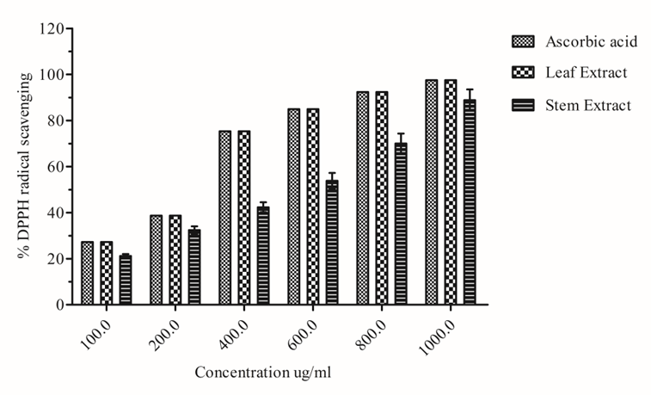
Figure1: DPPH radical scavenging activity (Mean±SD) of leaf and stem extract of A. aspera (n=3).

Table 2: Antioxidant activities showing IC₅₀ values (Mean±SD) of leaf and stem extract of A.aspera.
 | IC₅₀ (µg/ml)
Extracts | DPPH Assay | Hydrogen peroxide radical scavenging assay
Leaf | 316.14±2.95 | 551.05±8.41
Stem | 497.32±5.82 | 604.06±9.39
Ascorbic Acid (Standard) | 274.48±2.98 | 458.96±1.2

3.2.2 Ferric reducing power assay
The reducing power of a compound is an essential measure of its antioxidant potential. Compounds exhibiting reducing power work as electron donors, enabling them to reduce oxidized intermediates produced during lipid peroxidation. In this manner, they function as both primary and secondary antioxidants (Ikeura et al., 2010). The reducing power assay is based on the ability of antioxidants to donate electrons. In this method, the reduction of ferric ions (Fe³⁺) to ferrous ions (Fe²⁺) is detected by the formation of a blue-green colored complex, which shows maximum absorbance at 700 nm. A higher absorbance value indicates stronger reducing power, thereby showing greater antioxidant potential. The reducing power of the leaf and stem extracts, as well as ascorbic acid, increased in a dose-dependent manner (Figure 2), with the maximum activity observed at 1000 μg/ml. Among the extracts, the leaf extract exhibited the highest reducing power (P<0.05) at this concentration. When compared with the positive control (ascorbic acid), the strong reducing activity of the leaf extract highlights its significant antioxidant potential.
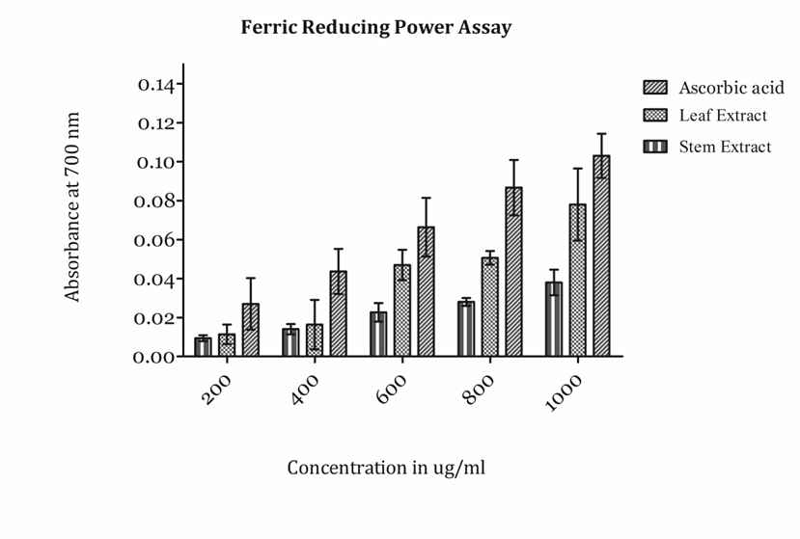
Figure 2: Ferric Reducing power (Mean ± SD) of leaf and stem extracts (n=3) of A.aspera

3.2.3 Hydrogen Peroxide (H₂O₂) Scavenging Assay
The hydrogen peroxide (H₂O₂) scavenging activity of the test sample was evaluated to determine its antioxidant potential. Hydrogen peroxide, although not highly reactive by itself, can generate hydroxyl radicals in the presence of transition metal ions, contributing to oxidative stress in biological systems. Therefore, the ability to neutralize H₂O₂ reflects a compound’s effectiveness in mitigating oxidative damage. In the present study, the methanolic extract of leaf and stem of A. aspera exhibited a concentration-dependent increase in H₂O₂ scavenging activity (Figure 3). The absorbance of H₂O₂ decreased progressively with increasing concentrations of the sample, indicating its ability to decompose hydrogen peroxide into non-toxic products.
The results of the hydrogen peroxide scavenging assay demonstrated a concentration-dependent increase in antioxidant activity of the test sample. The percentage inhibition values ranged from 30% to 75%, with the highest inhibition observed at the maximum concentration tested. Notably, 50% inhibition (IC₅₀) mentioned in Table 2 was achieved within this concentration range, indicating substantial antioxidant efficacy. The consistent increase in scavenging activity suggests that the sample effectively neutralizes hydrogen peroxide, potentially reducing oxidative stress. Recently (Kumar et al., 2024) observed that leaves extract served as a good scavenger of hydrogen peroxide in the concentration range of 200- 1000µg/ml. IC₅₀ was found to be 116.76 µg/ml ethanolic extract of A. Aspera.
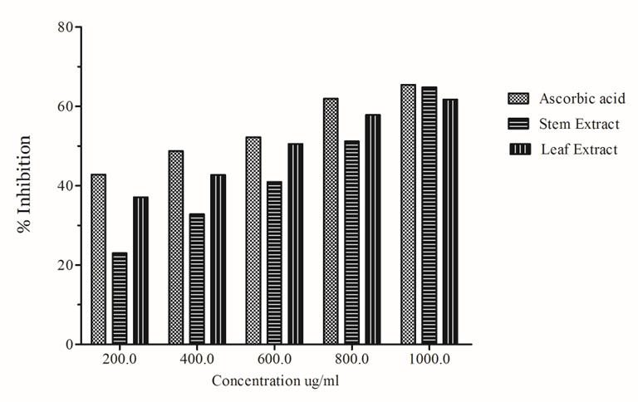
Figure 3: Hydrogen peroxide radical scavenging activity of leaf and stem bark of A.aspera

- CONCLUSION
This study conclude that the leaf and stem extrcat of A.aspera (Linn.) exhibited significant antioxidant potential, as demonstrated through various in vitro assays, including DPPH scavenging, reducing power, and nitric oxide scavenging assays. Among the tested extracts, the leaf extract showed the highest antioxidant activity, followed by the stem extract. This increase in activity may be attributed to its higher content of total phenolics and flavonoids, indicating a direct correlation between antioxidant potential and phytochemicals present in plant. Thus, the leaf extract of A. aspera could serve as a natural source of antioxidants and may be beneficial in the treatment of different free radical related diseases. However, further studies are required to isolate and identify the bioactive constituents using various solvents and extraction methods. Also evaluate the in vivo efficacy of these plant parts in reducing the risk of chronic diseases associated with oxidative stress.

REFERENCES:
Valko, M., Leibfritz, D., Moncol, J., Cronin, M. T., Mazur, M., & Telser, J. Free radicals and antioxidants in normal physiological functions and human disease. The international journal of biochemistry & cell biology, (2007).39(1), 44-84.
Dichi, I., Breganó, J. W., & Cecchini, R. (Eds.). (2014). Role of oxidative stress in chronic diseases. CRC Press.
Panche, A. N., Diwan, A. D., & Chandra, S. R. (2016). Flavonoids: an overview. Journal of nutritional science, 5, e47.
Choe, K., Park, H. Y., Ikram, M., Lee, H. J., Park, T. J., Ullah, R., & Kim, M. O. (2022). Systematic review of the common pathophysiological mechanisms in COVID-19 and neurodegeneration: the role of bioactive compounds and natural antioxidants. Cells, 11(8), 1298.
Sharma A, et al. Phytochemical and pharmacological profile of Achyranthes aspera. J Ethnopharmacol. 2021.
Rashad, M., Adil, M. A., Siddique, M. B., Peerzadah, S., & Saadullah, M. (2024). Antioxidant and Pharmacognostic Evaluation of Achyranthes Aspera: Therapeutic Potential and Analytical Validation of Secondary Metabolites. Advances in Herbal Research, 7(1), 1-14.
Awasthi, H., Shah, P., Kunwor, K., & Kalauni, S. K. (2021). Antioxidant and Antimicrobial Activities of Achyranthes Aspera from Ghodaghodi Lakeside, Kailali, Nepal. Scholars' Journal, 131-148.
Adil, M., Filimban, F. Z., Ambrin, Quddoos, A., Sher, A. A., & Naseer, M. (2024). Phytochemical screening, HPLC analysis, antimicrobial and antioxidant effect of Euphorbia parviflora L.(Euphorbiaceae Juss.). Scientific reports, 14(1), 5627.
Chew, A. L., Jessica, J. J. A., & Sasidharan, S. (2012). Antioxidant and antibacterial activity of different parts of Leucas aspera. Asian pacific journal of tropical biomedicine, 2(3), 176-180.
Singleton VL, Orthofer R, Lamuela-Raventós RM. (1999). Analysis of total phenols and other oxidation substrates and antioxidants by means of Folin–Ciocalteu reagent. Methods in Enzymology. 299: 152–178.
Chang CC, Yang MH, Wen HM, Chern JC. (2002). Estimation of total flavonoid content in propolis by two complementary colorimetric methods. J Food Drug Anal. 10(3): 178–182.
Brand-Williams W, Cuvelier ME, Berset C. (1995). Use of a free radical method to evaluate antioxidant activity. LWT – Food Science and Technology. 28(1): 25–30.
Blois, M. S. (1958). Antioxidant determinations by the use of a stable free radical. Nature, 181(4617), 1199-1200.
Gulçin, İ., & Alwasel, S. H. (2025). Fe³⁺ Reducing Power as the Most Common Assay for Understanding the Biological Functions of Antioxidants. Processes, 13(5), 1296.
Ruch, R.J., Cheng, S.J., Klaunig, J.E. (1989). Carcinogenesis, 10, 1003–1008; Kyada et al., 2023, Antioxidants, 12, 6689595; Chaurasia et al., 2025, J. Pharmacogn. Phytochem., 14(2), 123–130.
Awasthi, H., Shah, P., Kunwor, K., & Kalauni, S. K. (2021). Antioxidant and Antimicrobial Activities of Achyranthes aspera from Ghodaghodi Lakeside, Kailali, Nepal. Scholars’ Journal, 4(1), 131–148. They report TPC ≈ 362.74 ± 10.13 mg/g and TFC ≈ 96.33 ± 7.67 mg/g in methanolic extract.
Asogwa et al. (2023). Evaluation of Anti-obesity and Antioxidant Activities of Ethanolic Extract of Achyranthes aspera Leaves. Journal of Research in Pharmacy. They found even higher phenolic/flavonoid contents in ethanolic leaf extracts.
Charles P. L., Kumar, G., Karthik, L., & Rao, K. V. B. (2010). Antioxidant activity of Achyranthes aspera Linn stem extracts. Pharmacologyonline, 2(2), 228-237.
Charles P. L., Kumar, G., Karthik, L., & Rao, K. B. (2012). Phytochemical composition and in vitro antioxidant activity of Achyranthes aspera Linn.(Amaranthaceae) leaf extracts.
Edwin, S., Jarald, E. E., Deb, L., Jain, A., Kinger, H., Dutt, K. R., & Raj, A. A. (2008). Wound healing and antioxidant activity of Achyranthes aspera. Pharmaceutical biology, 46(12), 824-828.
Liu, J., Jia, L., Kan, J., & Jin, C. H. (2013). In vitro and in vivo antioxidant activity of ethanolic extract of white button mushroom (Agaricus bisporus). Food and chemical toxicology, 51, 310-316.
Ikeura, H., Kobayashi, F., & Hayata, Y. (2010). Attractant and oviposition stimulant of Crataeva religiosa Forst. to Pieris rapae.
Kumar, J., Joriya, A., & Singh, A. (2024). Evalaution of synergistically gastroprotective effects of ethanolic leaves extracts of achyranthes aspera & euphorbia hirta.

