Assessment of Suitable Areas for Physical Development of Residential Zones: A Case Study of the Makran Coastal Strip, Southern Iran

Abstract
The geographical position of the Makran coasts has led this region to face an increasing population and physical development of residential areas in recent years. Considering that the Makran coasts face many natural limitations for the physical development of residential areas, identifying areas suitable for the development of settlements in this region is very important, which is addressed in this research. In this study, the 30-meter SRTM DEM, a 1:100,000 geological map, data related to earthquake epicenters occurring in the region from 1907 to 2024, MODIS and Google Earth images have been used as the main research data. The main research tools were Google Earth Engine, ArcGIS, and TerrSet. In this research, using 10 natural and human parameters, the relative weighting method, and the WLC model, areas suitable for the physical development of residential areas along the Makran coasts were identified. Based on the results, 34.1% of the area is classified as prohibited areas and lacks potential for the development of residential zones, while only 6.9% of the area, which mainly includes the outskirts of the cities of Negour, Chabahar, Konarak, and Jask, is suitable for urban development objectives. Given the obtained results, the Makran coasts face significant limitations for urban development goals, and therefore, special attention should be paid to the natural potentials of this region in the planning of residential area development.
Keywords: Population growth, physical development of settlements, Makran coasts, prohibited areas, WLC method, remote sensing .

1. Introduction
The establishment and emergence of a city are primarily dependent on its geographical conditions and location, as natural features and phenomena have a decisive impact on site selection, sphere of influence, physical development, and urban morphology (Ugenti et al., 2025). Natural phenomena can sometimes act as positive factors and at other times as negative and deterrent factors (Zhu et al., 2023; Mohammadzadeh et al., 2024). In fact, the establishment and growth of cities without consideration of the land’s capabilities and potentials can lead to numerous destructive and harmful effects, resulting in a multiplicative increase in human and financial losses during critical times (Nayyeri et al., 2018; Shi et al., 2023).
In recent years, with the increase in population and urbanization, the trend of expanding residential areas has been increasing (Aarthi et al., 2018; Bharath et al., 2018; Deb et al., 2024; Pireh & Ganjaeian, 2024). This expansion has led to an unplanned movement of population centers towards hazardous areas, which can pose significant risks (Gibson et al., 2016; Fekete, 2022). In fact, the unlimited and unplanned expansion of cities has led to encroachment on the environment and its destruction (Ghosh et al., 2022; Osman & Das, 2023), resulting in many residential areas being exposed to hazards and facing not only billions in financial losses annually but also human casualties (Safari Namivandi et al., 2024).

Different regions are influenced by geological, geomorphological, and hydroclimatic conditions, resulting in varying potentials for urban development, with some areas facing significant limitations (Ganjaeian et al., 2024; Negahban et al., 2025). As previous research has shown, approximately 60 percent of the world population lives in coastal areas (Hosseini & Ashournejad, 2018). The Makran coast in southern Iran faces significant limitations for the development of residential areas due to the influence of natural factors. Due to its geographical position, the Makran coast has high potential for the development of economic activities, trade, tourism, and more, leading to repeated attention towards residential development plans in this area. In fact, the limitation of water resources in many parts of Kerman and Sistan & Baluchestan provinces has prompted numerous proposals for residential development along the Makran coastal strip. However, considering that the Makran coastal strip also has high geomorphological potential for various hazards, including floods and dust storms, assessing the coastal strip and identifying areas suitable for residential development in this region is of great importance, which is addressed in this research.
Various studies have been conducted in relation to the subject. Many of these studies have focused on locating areas suitable for the physical development of residential zones using various zoning and weighting methods (Alberico et al., 2020; Ramadan & Effat, 2021; Fan & Ma, 2024; Fu et al., 2024; Qi et al., 2024; Rahman Shah et al., 2025). Some studies have assessed the natural hazards in urban areas using remote sensing, field methods, and zoning techniques (Lee, 2015; El Jazouli et al., 2019; Negahban et al., 2021; Jiang & Yu, 2022; Pinskwar et al., 2023). Other research has evaluated the trend of physical development in residential areas in relation to hazardous zones using remote sensing methods (Shooshtarian et al., 2018; Negahban et al., 2019; Pérez-Molina et al., 2025). Additionally, some studies have focused on predicting the trend of physical development in residential areas using remote sensing and various modeling methods (Negahban et al., 2019; Salari et al., 2020; Beyene et al., 2023; Kumar et al., 2025).
In line with previous research, the goal of this study is to identify areas suitable for the physical development of residential zones along the Makran coast. This research not only employs zoning methods but also defines prohibited areas, allowing for the obtaining of final results with high accuracy.
2. Study Area
The study area encompasses the coastal counties of Makran in southern Iran. In the Makran coast, there are five counties: Jask, Zarabad, Konarak, Chabahar, and Dashtyari. Jask County is part of Hormozgan Province, while Zarabad, Konarak, Chabahar, and Dashtyari Counties belong to Sistan & Baluchestan Province. The study area is bordered to the south by the Oman Sea, to the west by the Strait of Hormuz, and to the east by Pakistan (Figure 1). The length of the coastline in the study area exceeds 600 km, and the total area of the study region is approximately 26,900 km².
The study area exhibits significant topographical diversity, with an overall increasing elevation trend from south to north. Climatically, due to its location in the subtropical high-pressure region, it has an average annual rainfall of about 100 mm and an average annual temperature of approximately 27 °C. Additionally, considering the climatic and hydro-geomorphologic conditions, this region lacks permanent rivers.

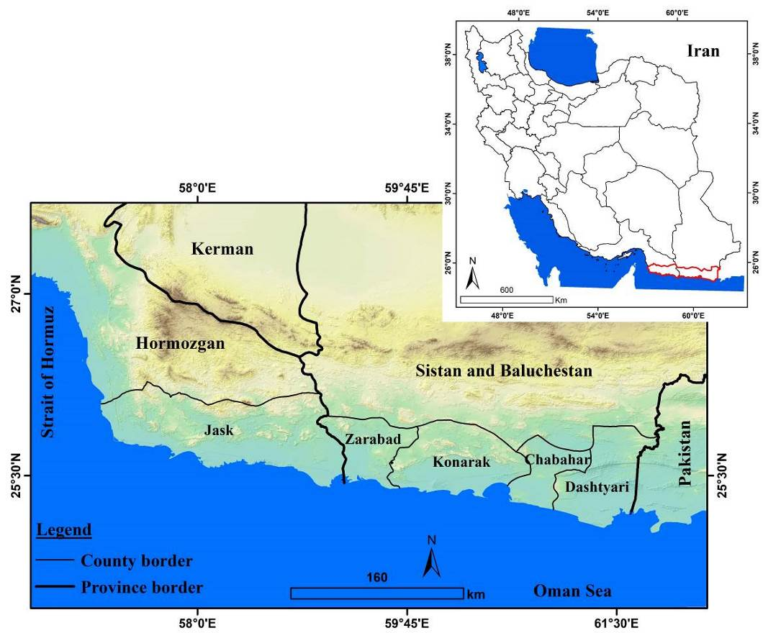
Figure: 1. Location of the Study Area

3. Methodology
In this study, the 30-meter SRTM DEM, a digital geological map layer at a scale of 1:100,000, data regarding the epicenters of earthquakes that occurred in the region from 1907 to 2024 (sourced from the USGS website), MODIS satellite imagery, and Google Earth images were utilized as the primary data sources. The main research tools employed included Google Earth Engine, ArcGIS, and TerrSet. Considering the subject and objectives of the study, the research was conducted in several stages, which are detailed below:
Step 1. Identification of Parameters and Preparation of Data Layers for Each Parameter
In this step, parameters were selected based on library studies and the condition of the area to identify regions suitable for the physical development of residential zones in the study area (Table 1). After selecting the relevant parameters, data layers for each parameter were prepared.
To create the layers related to elevation, slope, and rivers, the 30-meter DEM was utilized. For the preparation of lithology and fault layers, the 1:100,000 geological map of the area was employed. To generate layers concerning urban points, communication lines, and the coastline, Google Earth images were used. Additionally, to create a vegetation cover density map for the region, MODIS satellite imagery, Google Earth Engine, and the NDVI index were utilized.

Table 1: Parameters Used and Methods for Preparing Data Layers
Index | Parameter | Method for Preparing Data Layers
Hydrogeomorphology | Elevation | Prepared based on the 30-meter DEM
Hydrogeomorphology | Slope | Prepared based on the 30-meter DEM
Hydrogeomorphology | Distance from River | Prepared based on the 30-meter DEM
Hydrogeomorphology | Distance from Coastline | Prepared based on Google Earth images
Geology | Lithology | Prepared based on the 1:100,000 geological map
Geology | Distance from Fault | Prepared based on the 1:100,000 geological map
Geology | Distance from Earthquake Epicenters | Obtained from the USGS website
Human Factors | Distance from Urban Points | Prepared based on Google Earth images
Human Factors | Distance from Main Road | Prepared based on Google Earth images
Vegetation Cover | Vegetation Density | Prepared based on MODIS satellite imagery and Google Earth Engine

Step 2. Standardization of Data Layers
After preparing, the layers were standardized to make them evaluable. The standardization of the layers was conducted based on intra-layer weighting and according to the potential they have for the development of residential areas (Table 2).

Table 2: Method of Standardizing Data Layers
Row | Parameter | Method of Standardizing Data Layers
1 | Elevation | Areas with low elevation are given a value close to 1, and areas with high elevation are given a value close to 0.
2 | Slope | Areas with low slope are given a value close to 1, and areas with steep slope are given a value close to 0.
3 | Distance from River | Areas far from the river are given a value close to 1, and areas close to the river are given a value close to 0.
4 | Distance from Coastline | Areas close to the coastline are given a value close to 1, and areas far from the coastline are given a value close to 0.
5 | Lithology | Conglomerate and sandstone: value 0.9  Sandstone and marl: value 0.8  Shale, marl, and sandstone: value 0.7  Limestone and marl: value 0.6  Alluvial materials: value 0.5  Salt flats: value 0.3  Coastal and swamp sediments: value 0.2  Sand dunes: value 0.1
6 | Distance from Fault | Areas far from faults are given a value close to 1, and areas close to faults are given a value close to 0.
7 | Distance from Earthquake Epicenters | Areas far from earthquake epicenters are given a value close to 1, and areas close to epicenters are given a value close to 0.
8 | Distance from Urban Points | Areas close to urban points are given a value close to 1, and areas far from urban points are given a value close to 0.
9 | Distance from Main Road | Areas close to main roads are given a value close to 1, and areas far from main roads are given a value close to 0.
10 | Vegetation Density | Areas with sparse vegetation are given a value close to 1, and areas with dense vegetation are given a value close to 0.

Step 3. Weighting Data Layers
Given that the value and importance of data layers are not the same, in this step, the layers were assigned weights using the weighting method proposed by Ganjaeian et al., 2025. In this method, based on the opinions of experts (5 geomorphology experts), all criteria were compared with each other, and the final weight was determined based on the number of priorities each parameter had relative to other parameters. For example, the lithology parameter is considered the most important among all parameters, thus it received a weight of 1.9 and because it is deemed more important than 9 other parameters, so 0.1 was added to its coefficient. Similarly, the slope parameter has a weight of 1.8, as it is more important than 8 parameters, thus it received a weight of 1.8. According to this method, for each time a parameter is prioritized over other parameters, a coefficient of 0.1 is added to its weight. After weighting the parameters, the derived weight was applied to each layer.

Step 4. Implementation of the WLC Model
In this step, the layer of prohibited areas was first prepared. The prohibited areas layer was developed based on expert opinions and the condition of the region (Table 3). This layer has a value of zero and has been applied to all data layers. Subsequently, the data layers were imported into the TerrSet software, and ultimately, they were combined using the Weighted Linear Combination (WLC) model. This process resulted in the creation of a map showing the areas suitable for the development of residential zones in the study area.
The WLC method is considered one of the most common techniques for multi-criteria evaluation, also known as the additive weighting method or scoring method (Ogato et al., 2020). The basis of this method is the weighted average, where decision-makers assign weights to criteria directly based on their relative importance. Then, by multiplying the relative weight by the value of that criterion, a final weight for that criterion is obtained (Ganjaeian et al., 2021).
After determining the final weights of the options, the option with the highest value will be the most suitable choice for the intended objective. The WLC technique is one of the Multi-Criteria Evaluation (MCE) methods, which is computed according to Eq. (1) (Tabesh et al, 2020., Mostafa et al, 2022):

Eq 1. | min₍w₎ ∑ⱼ₌₁ⁿ Mⱼ ( ∑ᵢ₌₁ᴷ wᵢ xᵢⱼ − yⱼ )²  subject to ∑ᵢ₌₁ᴷ wᵢ = 1, wᵢ ≥ 0 ∀ i

- w=[w₁​,w²​,…,w^{K}​] is the vector of normalized weigh
- x_{ij}​ denotes the value of the i-th criterion at pixel j,
- y_{j} is the reference or target value at pixel j,
- Mj∈{0,1} is the Boolean mask applied to pixel j,
- N is the total number of pixels,
- K is the number of input layers or criteria.
wᵢ are the normalized weights (∑ᵢ wᵢ = 1, wᵢ ≥ 0), xᵢⱼ represents the value of criterion i at pixel j, yⱼ is the reference value at pixel j, and Mⱼ is a Boolean mask indicating inclusion (Mⱼ = 1) or exclusion (Mⱼ = 0) of pixel j in the optimization (Solaimani et al, 2023).

Table 3. Criteria considered for preparing the prohibited areas layer
Row | Parameter | Prohibited Areas
1 | Slope | Areas with a slope greater than 15 degrees
2 | Distance from River | A buffer of 500 m from main rivers
3 | Lithology | Areas with swampy sediments and sand dunes
4 | Distance from Fault | A buffer of 1 km from main faults
10 | Vegetation Density | Areas with NDVI value greater than 0.2

4. Results and Discussion
4.1. Description of the Parameters Used
In this study, in order to identify areas suitable for physical development in the residential areas along the Makran coast, 10 parameters have been utilized, which are described below:
A. Hydro-geomorphological Parameters. The hydro-geomorphological parameters used in this study include elevation, slope, distance from rivers, and distance from the coastline. Elevation is considered one of the effective parameters in environmental planning. High-altitude areas typically have steep slopes, high erosion potential, and frost risk, and the development of residential areas in these regions is very costly. Moreover, the high-altitude regions in the study area are primarily composed of degraded and eroded lands; therefore, they have limited suitability for the physical development of residential areas (Salari et al., 2017). Given the above factors, low-elevation areas have the highest value and high-elevation areas have the lowest value for urban development purposes (Figure 2).
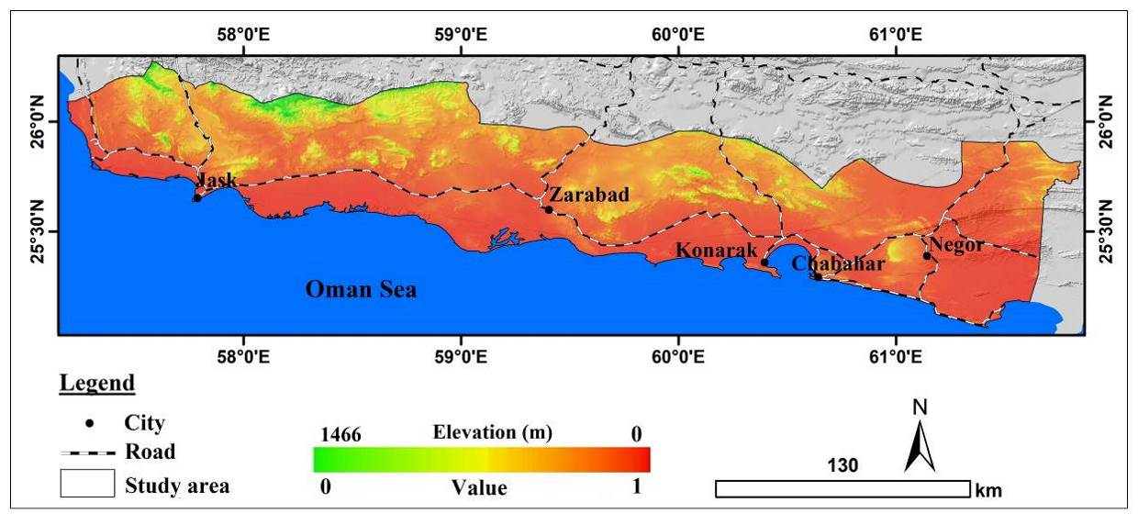
Figure- 2: Standardized Elevation Map

Slope is another crucial parameter for urban physical development. Areas with steep slopes have limited potential for residential development, while regions with slopes between 2 to 10 degrees are considered the most suitable for urban development purposes. Additionally, as slope increases, land prices tend to decrease, but construction costs rise, as building on steep slopes requires more investment, thus increasing overall construction costs (Nayyeri et al., 2017; Shi et al., 2023). Accordingly, low-slope areas have the highest value and high-slope areas have the lowest value for urban development purposes (Figure 3).
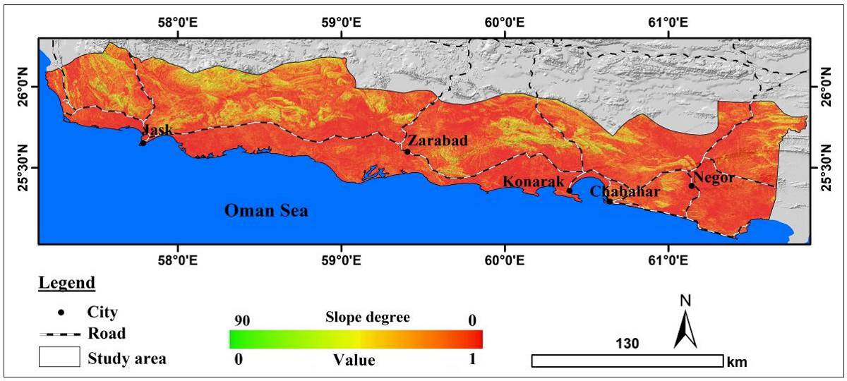
Figure-3: Standardized Slope Map

Rivers also play an important role in urban development objectives. The study area lacks permanent rivers, and due to the sporadic nature of rainfall in the region, areas close to the rivers are at risk of flooding. Considering this, areas far from the region’s rivers have the highest value, while areas close to rivers have the lowest value for urban development purposes (Figure 4).

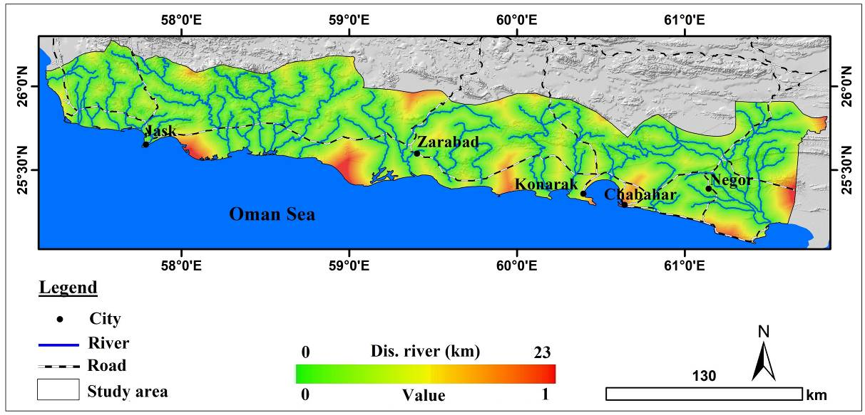
Figure- 4: Standardized Distance from River Map

Furthermore, the distance from coastlines also plays a significant role in urban development planning. Since coastlines are considered population attractors, with about 60% of the world's population living on the coasts (Hosseini & Ashournejad, 2018), and coastal strips have high economic potential, areas close to coastlines have greater potential for the physical development of residential areas (Xu et al., 2025; Su et al., 2025). Accordingly, areas near coastlines have the highest value, while areas far from coastlines have the lowest value for urban development purposes (Figure 5).
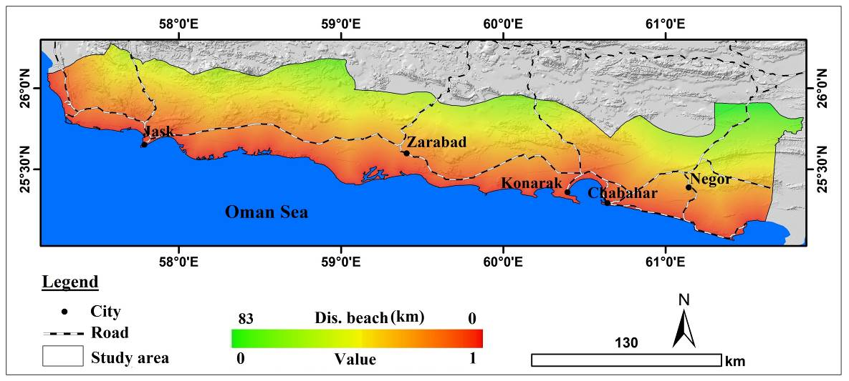
Figure- 5: Standardized Distance from Coastline Map

B. Geological Parameters. Geological parameters are other effective factors in urban planning. The geological parameters relevant to the present study include lithology, distance from faults, and distance from earthquake epicenters. Lithology, as the foundation of cities, plays an important role in urban development goals. Areas with resistant lithology have greater potential for urban development objectives. The assessment of the lithological status of the studied area indicates that a large portion of the area is covered by swamp sediments and sand dunes, which are unsuitable for urban development purposes. Therefore, the studied area has significant limitations regarding lithological conditions (Ganjaeian et al., 2020). Considering the mentioned factors, areas with resistant lithology, such as conglomerates and sandstones, are assigned a value close to 1, while areas with swamp sediments and sand dunes are assigned a value close to 0 (Figure 6).

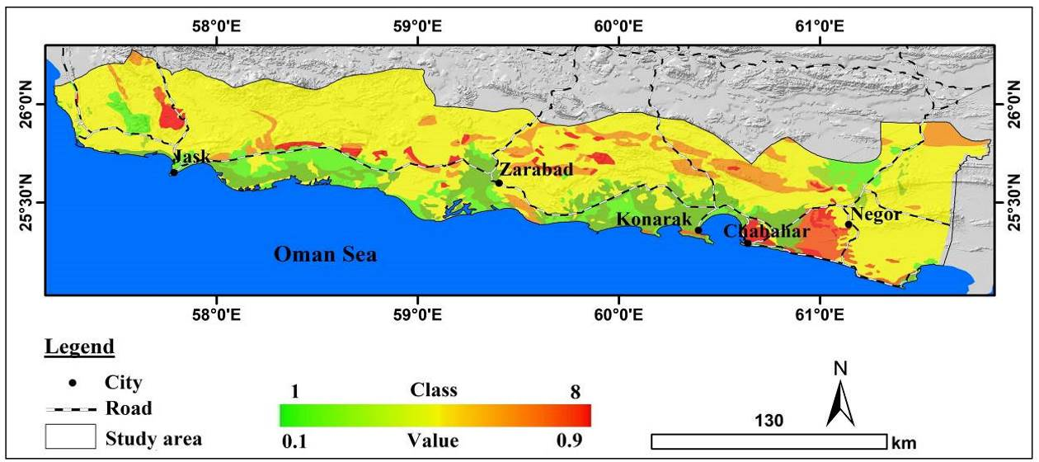
Figure-6: Standardized Lithology Map

Fault lines are another geological parameter that should be considered as a threatening factor (Lei et al., 2022). Areas close to fault lines have lower potential for urban physical development due to their exposure to earthquake hazards. Accordingly, areas far from fault lines are assigned a value close to 1, while areas near fault lines are given a value close to 0 (Figure 7). Earthquake epicenters are also considered as another effective parameter. Areas close to earthquake epicenters have lower values for urban development objectives due to their high seismic potential (Figure 8).

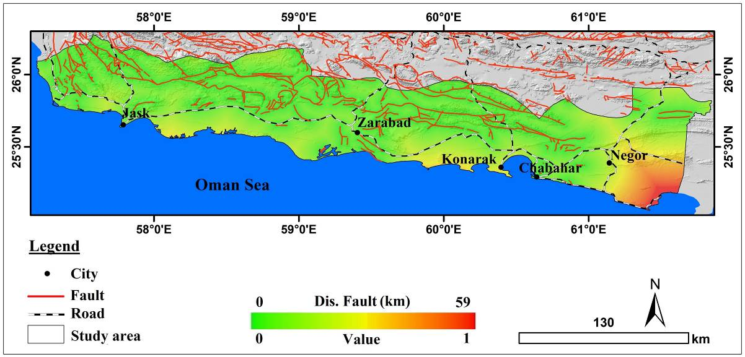
Figure-7: Standardized Distance from Fault Lines Map

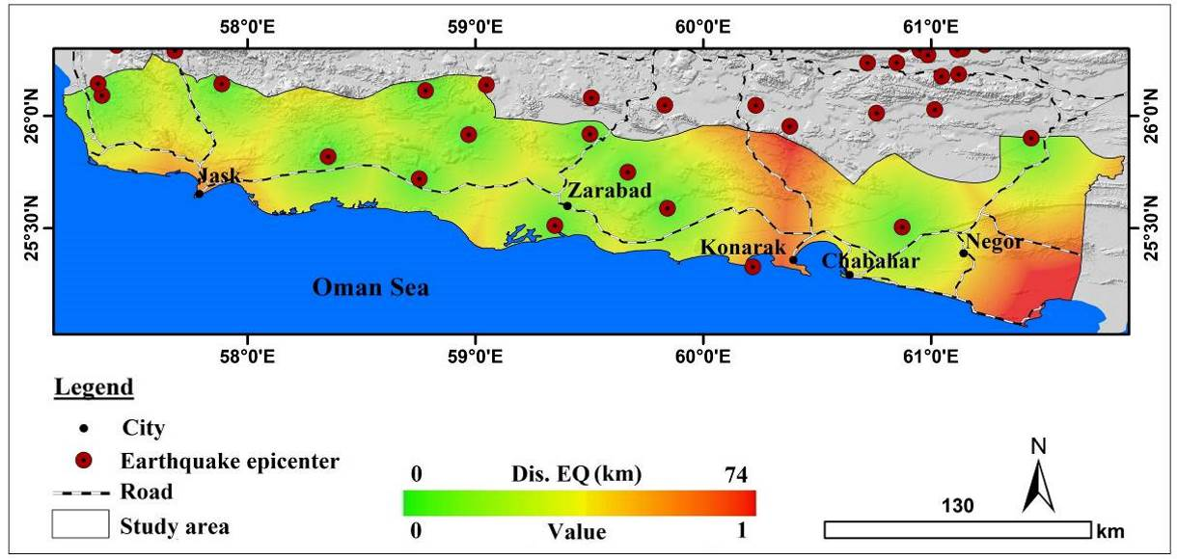
Figure-8: Standardized Distance from Earthquake Epicenters Map

C. Human Parameters. Attention to human parameters in urban planning, especially in identifying areas suitable for urban physical development, is of great importance. In this study, two parameters, distance from urban points and distance from main roads, are used as the most important human parameters. In the process of physical development of residential areas, the distance from the current fabric and area of cities is significant, as it relates to access to the services and facilities of the central city. The best locations for residential development are those areas that, in addition to other conditions, are close to the current city limits or the proper of villages that will join the city. Considering these issues regarding the layer of distance from residential areas, the shorter the distance from residential areas, the more suitable it is for the intended goals (Ganjaeian et al., 2020). In this way, areas close to urban points are assigned a value close to 1, while areas far from urban points are assigned a value close to 0 (Figure 9). Additionally, access to communication routes also plays an important role in urban development goals. Communication routes are significant for urban development objectives due to their ease of access and convenience for construction and infrastructure development (Salari et al., 2017). Therefore, areas close to main roads are assigned a value close to 1, while areas far from main roads are assigned a value close to 0 (Figure 10).

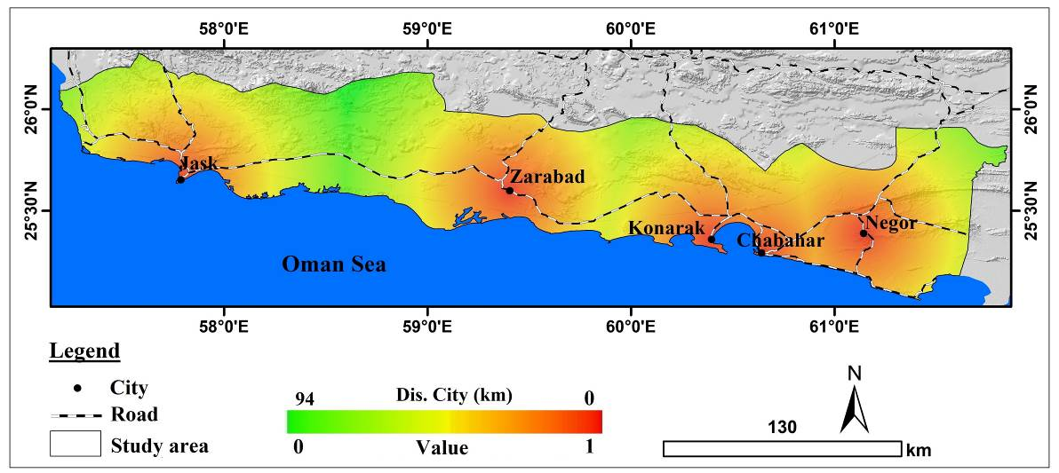
Figure-9: Standardized Distance from Urban Points Map

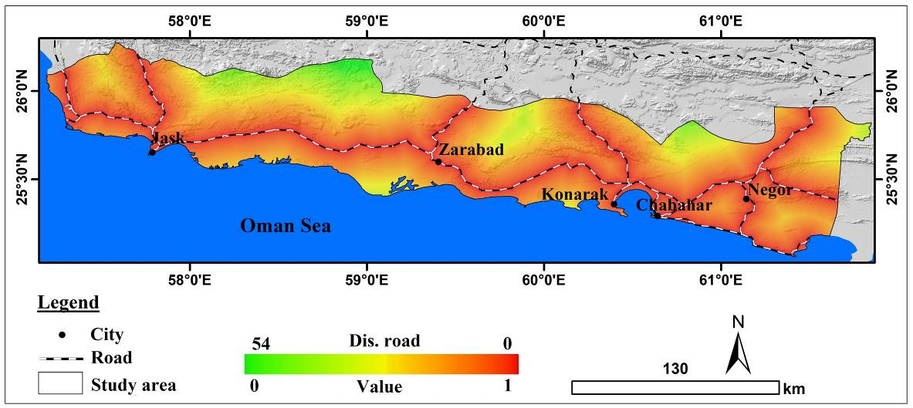
Figure-10: Standardized Distance from Main Roads Map

D. Vegetation Cover. Considering the environmental conditions in various environmental planning is very important (Song et al., 2024). Given that the studied area is part of the dry regions of Iran and has a sensitive and fragile ecosystem, paying attention to its environmental status is therefore crucial (Safari Namivandi et al., 2023). Considering the importance of the subject, this study uses the parameter of vegetation cover density, and using MODIS images, the NDVI index, and Google Earth Engine, a map of vegetation cover density for the area has been prepared. Based on the prepared map, only a small portion of the studied area has dense vegetation cover; therefore, the development of residential areas should be such that it does not harm these regions. So, for the standardization of the vegetation cover density layer, areas with less vegetation cover are assigned a value close to 1, while areas with dense vegetation cover are assigned a value close to 0 (Figure 11).

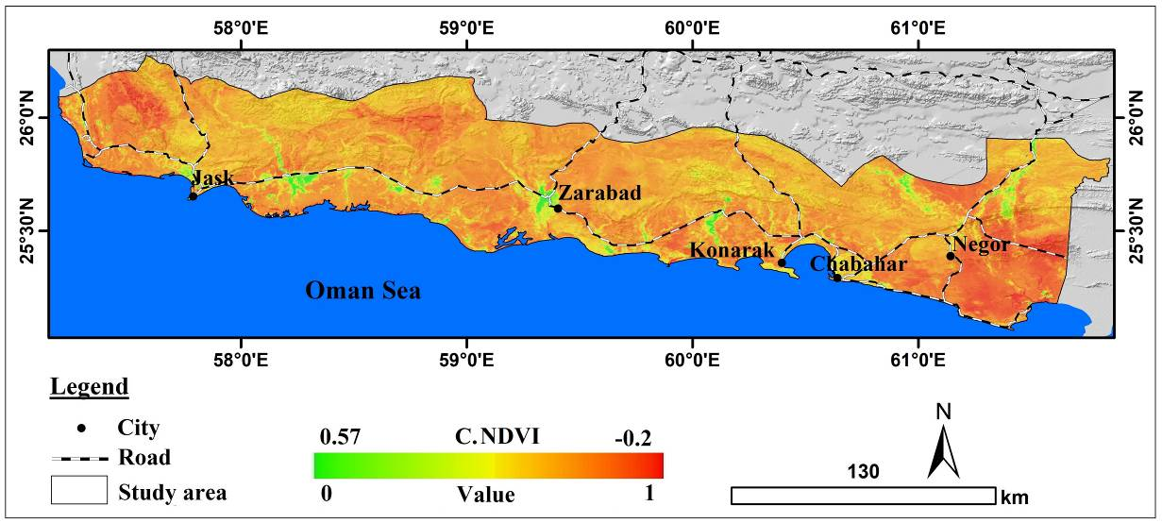
Figure-11: Standardized Vegetation Cover Map of the Area

4.2. Weighting of Dat Layers
Considering that the value and importance of data layers are not the same, in this section, the data layers have been weighted based on expert opinions and using a relative weight coefficient (Table 4). Based on the results, the lithology layer, due to the specific lithological conditions of the area, has the highest value with a weight of 1.9. Following this parameter, the slope and vegetation cover density parameters have the highest values with weights of 1.8 and 1.7, respectively.

Table 4. Weighting of Used Parameters
Overall Weight | Priority Relative to Other Parameters | Parameter | Row
1.1 | Distance from earthquake epicenters | Elevation | 1
1.8 | Elevation, distance from river, distance from coast, distance from fault, distance from earthquake epicenters, distance from urban areas, distance from main roads, vegetation cover density | Slope | 2
1.6 | Elevation, distance from coast, distance from fault, distance from earthquake epicenters, distance from urban areas, distance from main roads | Distance from river | 3
1.3 | Elevation, distance from earthquake epicenters, distance from main roads | Distance from coast | 4
1.9 | Elevation, slope, distance from river, distance from coast, distance from fault, distance from earthquake epicenters, distance from urban areas, distance from main roads, vegetation cover density | Lithology | 5
1.5 | Elevation, distance from coast, distance from earthquake epicenters, distance from urban areas, distance from main roads | Distance from fault | 6
1.0 | - | Distance from earthquake epicenters | 7
1.4 | Elevation, distance from coast, distance from earthquake epicenters, distance from main roads | Distance from urban areas | 8
1.2 | Elevation, distance from earthquake epicenters | Distance from main roads | 9
1.7 | Elevation, distance from river, distance from coast, distance from fault, distance from earthquake epicenters, distance from urban areas, distance from main roads | Vegetation cover density | 10

4.3. Application of Prohibited Areas and Execution of the WLC Model
In this study, after standardizing and weighting the data layers, based on Table 3, the layer of prohibited areas has been prepared (Figure 12). According to the prepared map, a large portion of the study areas lacks potential for the development of residential areas due to having a slope greater than 15 degrees, proximity to main rivers, the lithology of swamp sediments and sand dunes, closeness to active faults, and areas with an NDVI coefficient greater than 0.2.

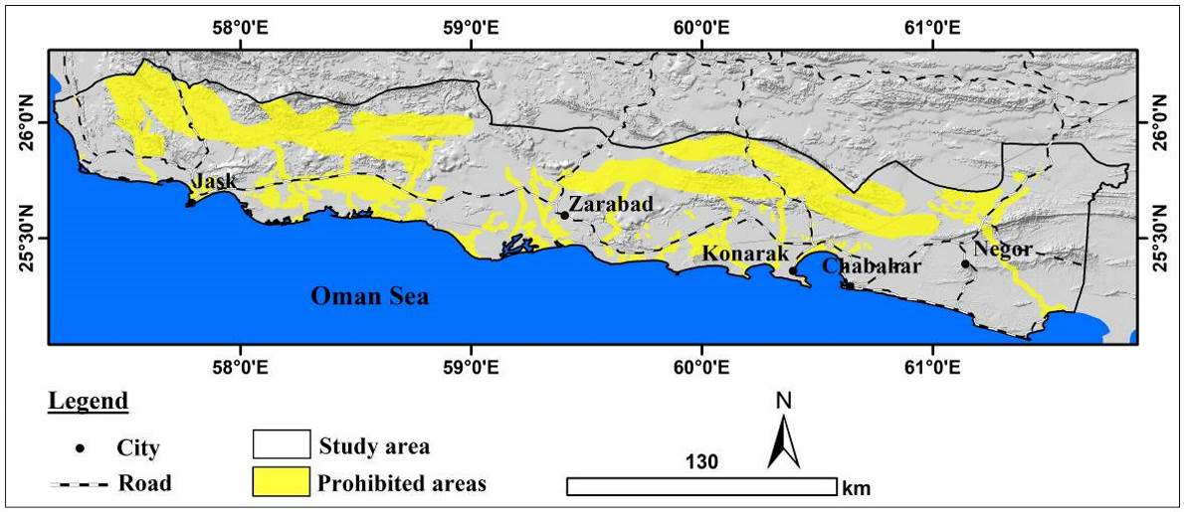
Figure-12: Map of Prohibited Areas

After the application of prohibited areas, the data layers were combined using the WLC model, resulting in the final map of areas suitable for the physical development of residential zones in the studied region (Figure 13). According to the prepared map, the peripheries of the cities of Negour, Chabahar, Konarak, and Jask have a high potential for the physical development of residential areas. In contrast, the central and northern sections of the region have low potential for urban development due to factors such as lithology type, proximity to fault lines, slope, distance from urban points, distance from communication routes, and distance from coastal lines.
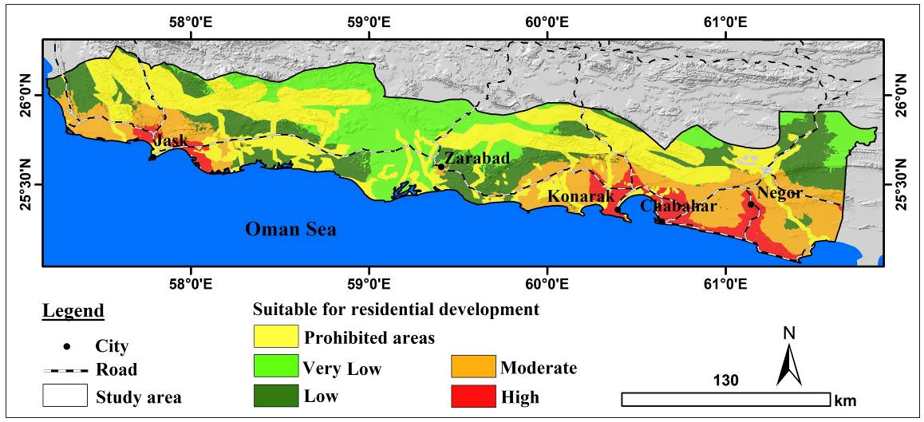
Figure-13: Final Map of Areas Suitable for Physical Development of Residential Zones

Table 5 and Figure 14 show the area and percentage of the classes. According to the results, 9,170 km² of the studied area (equivalent to 34.1% of the total area) are classified as prohibited areas and lack potential for the development of residential zones. Additionally, 10,609 km² (equivalent to 39.4% of the total area) have low to very low potential for urban development. Areas with moderate potential for urban development cover 5,275 km² (equivalent to 19.6% of the total area). Furthermore, 1,848 km² (equivalent to 6.9% of the total area) have high potential for urban development. Based on the results, influenced by geological and hydrogeomorphological conditions, only a small portion of the Makran coastal strip has potential for the physical development of residential areas.

Table 5. Area and Percentage of Classes
Class | Prohibited areas | Very Low | Low | Moderate | High
Area (km²) | 9170 | 5445 | 5164 | 5275 | 1848
Percent | 34.1 | 20.2 | 19.2 | 19.6 | 6.9

Figure-14: Percentage of Area Classes

5. Conclusion
The results of this research indicate that the Makran coasts face significant limitations due to geological and hydro-geomorphological conditions, which has led to the impossibility of developing residential areas in some regions. According to the findings, 9,170 km² of the studied area, equivalent to 34.1% of the total area, are classified as prohibited areas and lack potential for residential development. The results further reveal that only the peripheries of the cities of Negour, Chabahar, Konarak, and Jask possess high potential for the physical development of residential zones. The assessment of the area classes also shows that only 6.9% of the total area has significant potential for urban development, while many parts of the region have low potential due to factors such as lithology type, proximity to fault lines, slope, and distance from urban centers, distance from communication routes, and distance from coastal lines. Overall, the findings of this study demonstrate that the Makran coasts face substantial constraints regarding urban development objectives, and therefore, it is essential to pay special attention to the natural potentials of this region in the planning of residential area development.

Reference
- Aarthi, A. D., & Gnanappazham, L. (2018). Urban growth prediction using neural network coupled agents-based Cellular Automata model for Sriperumbudur Taluk, Tamil Nadu, India. Egyptian Journal of Remote Sensing and Space Science, 21(3), 353-362. https://doi.org/10.1016/j.ejrs.2017.12.004
- Alberico, I., Iavarone, R., & Petrosino, P. (2020). A procedure for the resilience mapping in urban systems exposed to natural hazard: The Ischia Island (southern Italy) test area. International Journal of Disaster Risk Reduction, 50. https://doi.org/10.1016/j.ijdrr.2020.101893
- Beyene, E., & Minal, A.S. (2023). Modeling urban land use dynamics using Markov-chain and cellular automata in Gondar City, Northwest Ethiopia. Chinese Journal of Population, Resources and Environment, 21(2), 111-120. https://doi.org/10.1016/j.cjpre.2023.06.007
- Bharath, H. A., Chandan, M. C., Vinay, S., & Ramachandra, T. V. (2018). Modelling urban dynamics in rapidly urbanising Indian cities. Egyptian Journal of Remote Sensing and Space Science, 21(3), 201–210. https://doi.org/10.1016/j.ejrs.2017.08.002
- Deb, D., Muslem Uddin, M., Mahbub-E-Kibria, A.S., Das, M.K., & Hasan, M. (2024). Coastal vulnerability assessment to multi hazards in the exposed coast of Southeastern Coastal Region of Bangladesh. Regional Studies in Marine Science, 73. https://doi.org/10.1016/j.rsma.2024.103484
- El Jazouli, A., Barakat, A., & Khellouk, R. (2019). GIS-multicriteria evaluation using AHP for landslide susceptibility mapping in oum Er high basin (Morocco). Geoenviromental Disasters, 6 (3), 1-12. https://geoenvironmental-disasters.springeropen.com/articles/10.1186/s40677-019-0119-7
- Fan, Y., & Ma, S. (2024). Integrating fuzzy analytic hierarchy process into ecosystem service-based spatial planning: A case study of the Shenyang metropolitan area, China. Ecological Informatics, 81. https://doi.org/10.1016/j.ecoinf.2024.102625
- Fekete, A. (2022). Peri-urban growth into natural hazard-prone areas: mapping exposure transformation of the built environment in Nairobi and Nyeri, Kenya, from 1948 to today. Natural Hazards. https://doi.org/10.1007/s11069-022-05515-4
- Fu, H., Zhang, T., & Wang, J. (2024). Evaluating suitability of development and construction with of minimum cumulative resistance model for a mountain scenic area in Jinyun Xiandu, China. Ecological Engineering, 202. https://doi.org/10.1016/j.ecoleng.2024.107240
- Ganjaeian, H. (2024). Identification of sinkhole-prone areas using radar images (Case study: Qorveh Plain). Environmental erosion research, 14(2), 87-105. http://dx.doi.org/10.61186/jeer.14.2.6 [In Persian]
- Ganjaeian, H., Rezaei Arefi, M., Peysoozi, T., & Emami, K. (2021). Zonning susceptible areas of landslide using WLC and OWA methods -A case study in Mountain cliff Khan, Iran. Sustainable Earth Trends, 1(2), 35-43. https://doi.org/10.52547/sustainearth.1.2.43
- Ghosh, A., Dey, P., & Ghosh, T. (2022). Integration of RS-GIS with Frequency Ratio, Fuzzy Logic, Logistic Regression and Decision Tree Models for Flood Susceptibility Prediction in Lower Gangetic Plain: A Study on Malda District of West Bengal, India. Journal of the Indian Society of Remote Sensing, 50: 1725-1745. https://doi.org/10.1007/s12524-022-01560-5
- Gibson, T. Pelling, M., Ghosh, A., Matyas, D., Siddiqi, A., Solecki, W., Johnson, L., Kenney, C., Johnston, D., & Du Plessis, R. (2016). Pathways for transformation: disaster risk management to enhance resilience to extreme events. J Extreme Events, 3(1). https://doi.org/10.1142/S2345737616710020
- Hosseini, S. J., & Ashournejad, Q. (2018). Detection of Shifts in the Southeastern Coastline of the Caspian Sea withLandsat MSS, TM and ETM+ Images in 1977, 1987 and 2001, Coastal Zone Management, 21:2. https://doi.org/10.4172/2473-3350.1000457 [In Persian].
- Jiang, W., & Yu, J. (2022). Impact of rainstorm patterns on the urban flood process superimposed by flash floods and urban waterlogging based on a coupled hydrologic–hydraulic model: a case study in a coastal mountainous river basin within southeastern China. Natural Hazards, 112: 301–326. https://doi.org/10.1007/s11069-021-05182
- Kumar, S., Midya, K., Ghosh, S., Kumar, P., & Mishra, V.N. (2025). Land use change analysis and prediction of urban growth using multi-layer perceptron neural network Markov chain model in Faridabad- A data-scarce region of Northwestern India. Physics and Chemistry of the Earth, Parts A/B/C, 138. https://doi.org/10.1016/j.pce.2025.103884
- Lee. M. j. (2015). Analysis on the flood vulnerability in the Seoul and Busan metropolitan area, Korea using spatial database, EGU General Assembly, 17 (1). https://ui.adsabs.harvard.edu/abs/2015EGUGA..17.4667L/abstract
- Lei, X., Ren, J., Xu, X., Qian, R., Zhang, J., & Song, B. (2022). Application of high-power ground-penetrating radar antennas with different frequencies to quickly locate the upper breakpoint of active buried faults in an urban area in the Datong basin (northern China). Journal of Applied Geophysics, 196. https://doi.org/10.1016/j.jappgeo.2021.104515
- Mahmoudzadeh, H., Abedini, A., Aram, F., & Mosavi, A. (2024). Evaluating urban environmental quality using multi criteria decision making. Heliyon, 10(3). https://doi.org/10.1016/j.heliyon.2024.e24921
- Nayyeri, H., Ganjaeian, H., & Amani, K. (2018). Evaluation of Environmental Indicator of Perimeters of the Land Suitability for the Development of the Sarvabad City by Combining Two Models of Network Analysis and Fuzzy Logic. Journal of Urban Social Geography, 5(1), 49-62. https://doi.org/10.22103/JUSG.2018.1961 [In Persian]
- Nayyeri, H., Salari, M., Ganjaeian, H., & Amani, K. (2017). Geomorphological Assessment of Land Suitability for the Physical Expansion of Sanandaj City Applying Restricted Areas. Geographical Urban Planning Research (GUPR), 5(1), 127-145. https://doi.org/10.22059/jurbangeo.2017.63213 [In Persian]
- Negahban, S., Ganjaeian, H., Ebrahimi, A. & Emami, K. (2019). Monitoring and predicting the trend of changes in residential areas using multi-timed images (Case study: Songhor city). Journal of the Earth and Space Physics, 45(2), 343-354. https://doi.org/10.22059/jesphys.2019.275076.1007084 [In Persian]
- Negahban, S., Ganjaeian, H., Ebrahimi, A., & Gheysarian, S.S. (2025). Analysis of the Roles of Environmental Factors in the Occurrence of Floods Using the Google Earth Engine System (Case Study: West of Golestan Province). Geography and Environmental Planning, 35(4), 1-18. https://doi.org/10.22108/gep.2024.142342.1659 [In Persian]
- Negahban, S., Ganjaeiyan, H., Feraydooni Kordestani, M., & Cheshmeh sefidi, Z. (2019). Assessing the physical development of cities and extending to geomorphological prohibited areas Using LCM (Case Study: Sanandaj City). Journal of Natural Environmental Hazards, 8(20), 39-52. https://doi.org/10.22111/jneh.2018.21943.1317 [In Persian]
- Negahban, S., Peysoozi, T., Ganjaeian, H., & Norozi, M. (2021). Identify areas prone to landslide and vertical displacement using Radar images (Case study: Lavasan urban area and urban margin). Journal of Geography and Environmental Hazards, 10(3), 1-18. https://doi.org/10.22067/geoeh.2021.71728.1094 [In Persian]
- Ogato, G.S., Bantider, A., Abebe, K., & Geneletti, D. (2020). Geographic information system (GIS)-Based multicriteria analysis of flooding hazard and risk in Ambo Town and its watershed, West shoa zone, oromia regional State, Ethiopia. Journal of Hydrology: Regional Studies, 27. https://doi.org/10.1016/j.ejrh.2019.100659
- Osman, S.A., & Das, j. (2023). GIS-based flood risk assessment using multi-criteria decision analysis of Shebelle River Basin in southern Somalia. SN Applied Sciences, 5 (134). https://doi.org/10.1007/s42452-023-05360-5
- Pérez-Molina, E., Pujol-Mesalles, R., Aguero-Valverde, J., & Zumbado-Morales, F. (2025). The influence of land use planning and exposure to flooding on urban growth in San José, Costa Rica. Land Use Policy, 118. https://doi.org/10.1016/j.landusepol.2024.107407
- Pinskwar, J., Choryński, A., & Graczyk, D. (2023). Risk of Flash Floods in Urban and Rural Municipalities Triggered by Intense Precipitation in Wielkopolska of Poland. International Journal of Disaster Risk Science, 14: 440–457. https://doi.org/10.1007/s13753-023-00493-y
- Pireh, M., & Ganjaeian, H. (2024). Analysis of landslides occurred in connection with environmental factors (Case study: Sanandaj County). Geography and Human Relationships, 7(3), 262-278. https://doi.org/10.22034/gahr.2025.458065.2135 [In Persian]
- Qi, S., Hu, S., & Cao, S. (2024). Spatial and temporal changes of social vulnerability of cities to natural hazards in Zhejiang province, China. Heliyon, 10(6). https://doi.org/10.1016/j.heliyon.2024.e27120
- Rahman Shah, M.A., Van Dau, Q., & Wang, X. (2025). Social-ecological vulnerability and risk to coastal flooding and erosion in major coastal cities. International Journal of Disaster Risk Reduction, 118. https://doi.org/10.1016/j.ijdrr.2025.105286
- Ramadan, M.S., & Effat, H.A. (2021). Geospatial modeling for a sustainable urban development zoning map using AHP in Ismailia Governorate, Egyp. The Egyptian Journal of Remote Sensing and Space Science, 24 (2), 191-202. https://doi.org/10.1016/j.ejrs.2021.01.003
- Safari Namivandi, M., Ganjaeian, H., Ebrahimi, A., & Ebadinezhad, S. (2023). Evaluation of desertification risk potential using DVI model (Case study: northern regions of Semnan province). Journal of Arid Regions Geographic Studies, 14(53), 17-1. https://doi.org/10.22034/jargs.2023.397791.1032 [In Persian]
- Safari namivandi, M., Ganjaeian, H., Nosrati, M., & Mohammadian, K. (2024). Identification of flooded areas and analysis of factors influencing its occurrence (Case study: Southeast of Sistan and Baluchestan province). Quantitative Geomorphological Research, 13(2), 181-194. https://doi.org/10.22034/gmpj.2024.449586.1494 [In Persian]
- Salari, M., Nayeri, H., Amani, K. & Ganjaiean, H. (2017). Locating Suitable Directions for Kamyaran Urban Development through a Hazardology Approach based on the Application of Geomorphologically Restricted Areas. Environmental Management Hazards, 4(4), 419-436. https://doi.org/10.22059/jhsci.2018.252694.341 [In Persian]
- Salari, M., Nayyeri, H., Ganjaeian, H., & Amani, K. (2020). Assessment and Prediction of the process of expansion of residential areas with Geomorphological Approach and Environmental Management (Case Study: Paveh City). Quantitative Geomorphological Research, 9(1), 86-101. https://doi.org/10.22034/gmpj.2020.109536 [In Persian]
- Shi, K., Liu, G., Zhou, L., Cui, Y., Liu, S., & Wu, Y. (2023). Satellite remote sensing data reveal increased slope climbing of urban land expansion worldwide. Landscape and Urban Planning, 235. https://doi.org/10.1016/j.landurbplan.2023.104755
- Shi, K., Yu, B., Ma, J., Cao, W., & Cui, Y. (2023). Impacts of slope climbing of urban expansion on global sustainable development. The Innovation, 4(6). https://doi.org/10.1016/j.xinn.2023.100529
- Shooshtarian, M.R., Dehghani, M., Margherita, F., Gea, O.C., & Mortezazadeh, S. (2018). Land use change and conversion effects on ground water quality trends: An integration of land change modeler in GIS and a new Ground Water Quality Index developed by fuzzy multi-criteria group decision-making models. Food and Chemical Toxicology, 114, 204-214. https://doi.org/10.1016/j.fct.2018.02.025
- Song, X., Chen, F., Sun, Y., Ma, J., & Yang, Y. (2024). Effects of land utilization transformation on ecosystem services in urban agglomeration on the northern slope of the Tianshan Mountains, China. Ecological Indicators, 162. https://doi.org/10.1016/j.ecolind.2024.112046
- Su, M., Zou, W., Zhao, B., & Fan, W. (2025). The impact of high-speed railways on urban spatial evolution: A case study of China's coastal areas. Applied Geography, 175. https://doi.org/10.1016/j.apgeog.2024.103504
- Ugenti, A., Mevoli, F.A., Lucia, D., Lollino, P., & Fazio, M.N. (2025). Moving beyond single slope quantitative analysis: A 3D slope stability assessment at urban scale. Engineering Geology, 344. https://doi.org/10.1016/j.enggeo.2024.107841
- Xu, J., Chen, J., Zhao, Q., Shi, J., She, S., & Chen, H. (2025). The impact of port-city interaction on urban economic development: An empirical study based on coastal port cities in China, 159. https://doi.org/10.1016/j.cities.2025.105770
- Zhu, C., Fang, C., & Zhang, L. (2023). Analysis of the coupling coordinated development of the Population–Water–Ecology–Economy system in urban agglomerations and obstacle factors discrimination: A case study of the Tianshan North Slope Urban Agglomeration, China. Sustainable Cities and Society, 90. https://doi.org/10.1016/j.scs.2022.104359
- Ganjaeian, H., Rezaei Arefi, M., Peysoozi, T., & Emami, K. (2021). Zonning susceptible areas of landslide using WLC and OWA methods -A case study in Mountain cliff Khan, Iran. Sustainable Earth Trends, 1(2), 35-43. https://doi.org/10.52547/sustainearth.1.2.43
- Mostafa, S., Hatami, N., Espahbodi, K., & Asadi, F. (2022). Fuzzy Analytic Hierarchy Process (FAHP) applied to evaluating the forest management approaches. Journal of Forest Science, 68(7), 1-14. http://dx.doi.org/10.17221/27/2022-JFS
- Solaimani, K., Shokrian, F. & Darvishi, S. (2023). An Assessment of the Integrated Multi-Criteria and New Models Efficiency in Watershed Flood Mapping. Water Resour Manage, 37, 403–425. https://doi.org/10.1007/s11269-022-03380-1
- Tabesh, S., Noori khanyourdi, M., Dousti, M., & Ganjaeian, H. (2020). Presenting the proposed model for the location of sports places using the integrated model of WLC and AHP. Sport Management and Development, 9(1), 2-22. https://doi.org/10.22124/jsmd.2020.4096

