Original Research Article
Reproductive Biology of Thenus orientalis in Pethalai, Sri Lanka

ABSTRACT

The slipper lobster Thenus orientalis is an economically important species in the Indo-Pacific, supporting fisheries that yield more than 5,000 t annually in Southeast Asia. Despite its commercial value, detailed information on its reproductive biology—particularly the timing of spawning, size-related fecundity and regional reproductive variation—remains limited. This study examined the reproductive biology of T. orientalis in Pethalai, Sri Lanka, based on monthly samples collected from June 2021 to June 2024 (n = 407) from the commercial catch. Gonadosomatic index (GSI), size at sexual maturity, sex ratio, fecundity and ovarian development stages. Results indicate a bimodal spawning pattern, with the main reproductive peak occurring during September to March (north-west monsoon period) and a secondary peak around May to June. GSI values varied seasonally (~1–6 %), with maxima in April 2022 (4.35 %), December 2023 (4.14 %) and January 2022 (4.04 %). The size at maturity (carapace length) was estimated at 60.0 mm. The sex ratio approximated 1:1 overall (χ² = 0.011, p = 0.917), though temporal variation was significant (χ² = 270, p < 0.001). Fecundity ranged from ~50,000 to 75,000 eggs and showed a positive—but relatively weak—relationship with carapace length. Ovarian development comprised four stages (early maturing, late maturing, ripe and spawning); late maturing females dominated June–September, whereas spawning females predominated October–March. The carapace length–fecundity relationship differed across maturity stages, with stronger correlations at early development. These findings provide critical baseline data for management of T. orientalis fisheries in Sri Lanka. It can be recommended implementing seasonal closures during peak spawning periods and a minimum size limit of 60 mm carapace length to protect spawning females. Furthermore, the size–fecundity association and environmental influence on reproductive output underscore the importance of habitat conservation and ecosystem-based management in sustaining T. orientalis stocks.

Keywords: Thenus orientalis; slipper lobster; reproductive biology; gonadosomatic index; spawning season; Sri Lanka

- INTRODUCTION

Reproductive biology of the slipper lobster Thenus orientalis is fundamental for fisheries sustainability and sound management. This Indo-Pacific species—commonly called the flathead lobster—supports important commercial fisheries, often harvested in continental shelf waters at depths of 10–50 m and adapted for burrowing in sandy and muddy substrates. Its high-quality meat and export demand make it economically significant across its range. In places such as Pethalai, Sri Lanka, T. orientalis contributes to coastal livelihoods but faces growing fishing pressure as traditional stocks decline.
Despite its value, knowledge gaps persist regarding its reproductive parameters, seasonal spawning patterns and regional variability. Previous work reports that environmental factors like temperature, photoperiod and food availability influence reproduction differently in different regions. Studies from India, Indonesia and Pakistan have documented aspects such as size at sexual maturity (often 55–65 mm carapace length) and annual reproductive cycles, but marked geographic variation suggests locally-adapted patterns that remain under-investigated.
This study addresses these gaps by (i) characterising spawning seasons and reproductive cycles of T. orientalis in Sri Lankan waters, (ii) quantifying size–fecundity relationships and minimum maturity size, (iii) analysing sex-ratio dynamics in commercial catches, and (iv) detailing ovarian development stages. Together these objectives provide the biological baseline required to inform size-based limits, seasonal closures and ecosystem-based management of T. orientalis fisheries in the region.

2. material and methods

2.1 Study Area and Sample Collection

Monthly sampling was conducted from June 2021 to June 2024 at the Pethalai landing site in Sri Lanka. A total of 407 specimens of Thenus orientalis were obtained from commercial landings (by-catch from bottom-set gill nets with mesh size 114 mm), with an average of approximately 16 female specimens per month.

2.2 Morphometrics and Gonadosomatic Index (GSI)
Carapace length (CL) and total length (TL) were measured to ±0.1 mm using Vernier calipers; total body weight was measured to ±0.01 g using a precision balance. Gonads were dissected and weighed, and the GSI was calculated as the percentage ratio of gonad weight to total body weight. Temporal patterns in GSI were analyzed using one-way ANOVA followed by Tukey's post-hoc test at a 95% confidence level (Lowerre-Barbieri et al., 2011; Santos, et al., 2020).
2.3 Size at Sexual Maturity (L₅₀)
Female maturity status was recorded as immature (0) or mature (1). A logistic regression model was fitted using CL data (in R software) to estimate the length at which 50% of females are mature (L₅₀).
2.4 Sex Ratio and Temporal Trends
Overall and monthly sex ratios (male : female) were tested against an expected 1:1 ratio via chi-square goodness-of-fit tests.

2.5 Fecundity and Oocyte Diameter
Fecundity (number of eggs) was estimated by the gravimetric method. The relationship between fecundity and CL was analysed with linear regression, including 95% confidence intervals for regression parameters. For oocyte diameter measurements, histological sections and egg samples from ovigerous females were imaged using a microscope with digital image-analysis software; ~50 oocytes per developmental stage were measured along the longest axis (µm). Stage-wise mean diameters were compared using Tukey’s test.
2.6 Ovarian Development and Egg-Bearing Females
Ovarian development was assessed macroscopically and classified into four maturity stages (early maturing, late maturing, ripe, spawning) based on morphological criteria (size, colour, texture). Monthly and seasonal distributions of these maturity stages were analysed to identify spawning peaks and post-spawning recovery periods, with a particular focus on associating these with monsoon periods. A subset of egg-bearing females was further examined to assess the timing of egg-carrying, ovarian stage relationships and seasonal frequency of egg-bearing status.

3. results and discussion

The flathead lobster T. orientalis in Pethalai exhibited a major spawning season between September and March, coinciding with the southwest monsoon, with elevated gonadosomatic index (GSI) values during this period. A secondary spawning event was also identified in June, indicating a possible bimodal reproductive cycle. Macroscopic and microscopic examinations enabled the development of a detailed maturity-scale for the species, providing a robust tool for assessing reproductive status. Additionally, there was a significant positive relationship between carapace length and fecundity: larger females produced more eggs, underscoring their importance for the population’s reproductive output. These findings support management recommendations that protect larger females through size limits and targeted conservation measures.

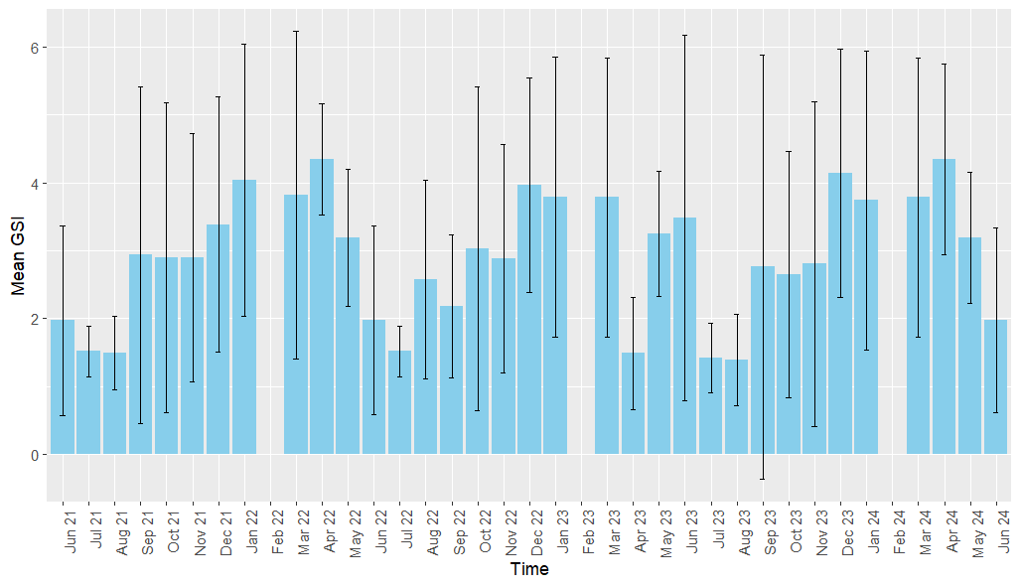
Figure 1. Seasonal Variation in Mean Gonadosomatic Index (GSI) across
Multiple Years of T. orientalis

3.1 Gonadosomatic Index (GSI)
The temporal variation of the gonadosomatic index (GSI) in T. orientalis demonstrated a distinct seasonal reproductive rhythm. GSI values peaked between September and March, indicating intensified gonadal development and spawning activity, followed by a decline in July–August that marked a post-spawning recovery phase. This cyclical pattern persisted across years, although interannual fluctuations in GSI were evident—likely driven by individual differences and environmental factors such as temperature, food availability, and photoperiod. One-way ANOVA confirmed significant monthly variation in mean GSI (F = 4.69, p < 0.001; R² = 19.95 %, adjusted R² = 15.70 %, predicted R² = 11.85 %). Tukey’s post-hoc analysis identified distinct reproductive phases, with April 2022 (mean GSI = 4.346) significantly higher than June 2021 (mean = 1.972) and July 2021 (mean = 1.516). Overall, GSI values ranging from ~1 to 6 illustrate the dynamic reproductive physiology of T. orientalis, where elevated indices indicate peak spawning and lower values correspond to gonadal regression.

3.2 Size at maturity
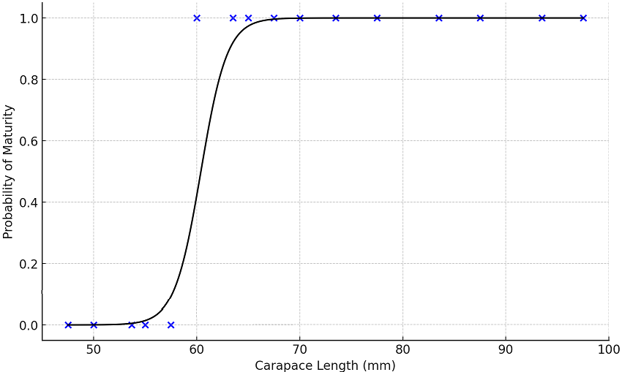
Figure 2. Plot of Probability of Maturity and Carapace length (L50 mat: 60.0 mm)

3.3 Sex ratio
Table 1. Sex ratio of T. oreintalis

Month | Female | Male
21-Jun | 10 | 11
21-Jul | 13 | 14
21-Aug | 12 | 13
21-Nov | 11 | 12
21-Dec | 15 | 16
22-Jan | 20 | 18
22-Mar | 21 | 19
22-Apr | 22 | 20
22-May | 13 | 14
22-Jun | 24 | 21
22-Jul | 22 | 20
22-Aug | 14 | 15
22-Sep | 10 | 11
22-Oct | 13 | 14
22-Nov | 13 | 14
22-Dec | 15 | 16
23-Jan | 20 | 18
23-Mar | 24 | 21
23-Apr | 10 | 11
23-May | 12 | 13
23-Jul | 11 | 12
23-Jun | 13 | 14
23-Aug | 12 | 13
23-Sep | 10 | 11
23-Oct | 13 | 14
24-Jan | 25 | 22
24-Mar | 20 | 18
Total | ? | ?
Average | ? | ?

3.4 Sex Ratio Dynamics
Across the 36-month sampling period (June 2021–June 2024) in Pethalai, the sex ratio of T. orientalis remained generally balanced. A chi-square test showed no significant deviation from the expected 1 : 1 ratio (χ² = 0.011, df = 1, p = 0.917), and monthly Wilcoxon Signed-Rank tests likewise indicated no significant differences between female and male abundances (p = 1.00). However, Pearson’s chi-square test detected significant temporal variation in monthly sex distributions (χ² = 270, df = 100, p < 0.001). Peak adult abundances were recorded in March 2023 (24 females, 21 males) and January 2024 (25 females, 22 males), while the lowest numbers occurred during September–November each year, with both sexes typically numbering 10–13 individuals.

Relationship of GSI with carapace length and weight
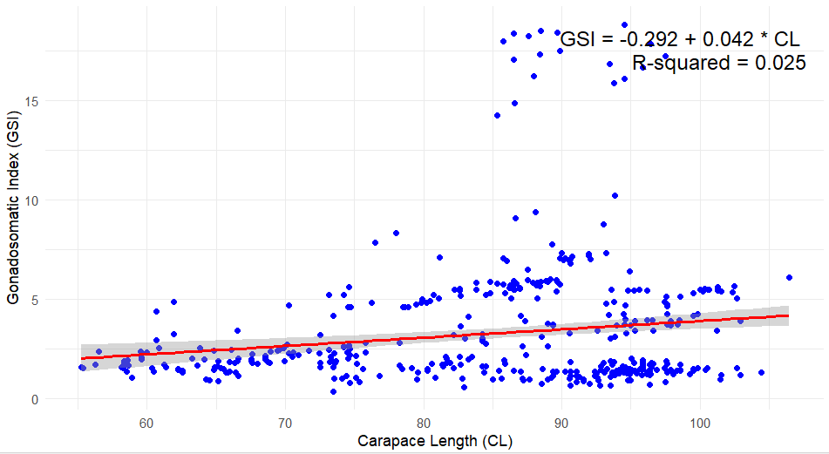
Figure 3. Carapace Length (CL) vs. GSI
3.5 Morphometric–Gonadosomatic Index (GSI) Relationships
Analysis of the relationship between morphometric size and gonadal investment in T. orientalis revealed a statistically significant positive association between carapace length (CL) and the gonadosomatic index (GSI). Larger individuals consistently exhibited higher GSI values (95 % CI for slope: 0.011 to 0.039; F = 11.89; p = 0.001). This finding implies that as carapace length increases, reproductive investment (as measured by GSI) tends to rise, reinforcing the importance of protecting larger females within the population.
3.5 Fecundity analysis: Temporal trends in mean fecundity
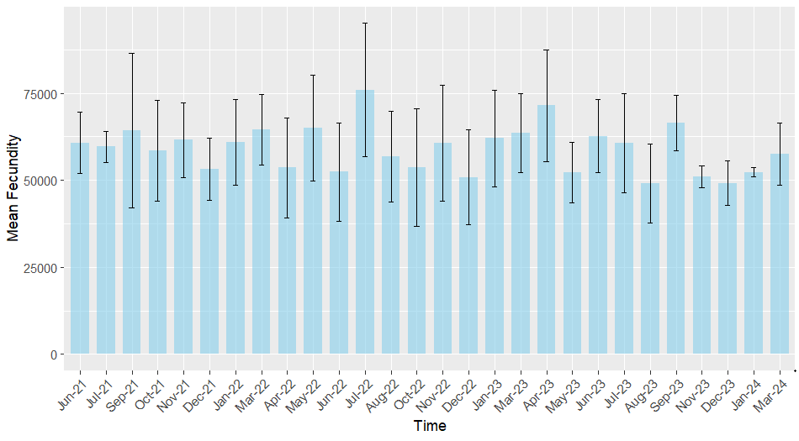
Figure 4. Temporal Trends in Mean Fecundity Over Multiple Years of T. orientalis
3.6 Mean Fecundity
From June 2021 to March 2024, the mean fecundity of T. orientalis fluctuated considerably but showed no clear seasonal trend. Sporadic peaks occurred in August 2022 and October 2022, yet no consistent temporal pattern was evident (Jones, 2007). Mean fecundity ranged from approximately 32,318 eggs (June 2024) to 75,989 eggs (July 2022). One-way ANOVA results (F = 1.63, p = 0.156) indicated that differences among months were statistically insignificant, implying that variation was due to natural fluctuations rather than a defined seasonal cycle (Spanier & Lavalli, 1998). The wide variability reflected in error bars suggests that reproductive output was strongly influenced by individual condition and environmental factors.
3.7 Fecundity as a function of carapace length
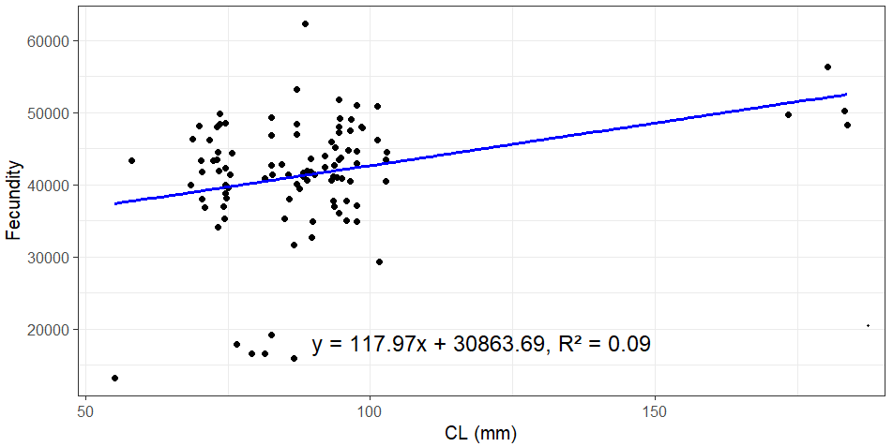
Figure 5. Analysis of Fecundity as a Function of Carapace Length in T. orientalis
3.8 Relationship between Carapace Length and Fecundity
The relationship between carapace length (CL) and fecundity in T. orientalis showed a positive but weak correlation, indicating that while larger individuals generally produce more eggs, the effect of size alone is limited (Jones, 2007; Spanier & Lozano-Álvarez, 1998). The Kruskal–Wallis test found no significant difference in fecundity among CL categories (χ² = 88.45, p = 0.349), confirming that reproductive output does not vary systematically with size. Although the regression slope aligns with trends in other decapods (Jones, 2007), the weak association suggests stronger influences from environmental, physiological, and genetic factors (Spanier & Lozano-Álvarez, 1998).
3.9 Seasonal Trends in Ovarian Maturity Stages
Ovarian maturity analysis from June 2021 to June 2024 revealed clear seasonal variation. Late-maturing females were dominant between June and September, while spawning females peaked from October to March—particularly in January–March 2022 and December 2022–March 2023. Ripe females were most frequent in October–December and again in early 2024, indicating a sequential progression toward spawning. Early-maturing individuals occurred year-round, with higher proportions during the post-spawning phase (March–June). These findings indicate a primarily seasonal reproductive cycle linked to the northeast monsoon (October–March), but the presence of all maturity stages throughout the year suggests continuous, though variable, reproductive activity.

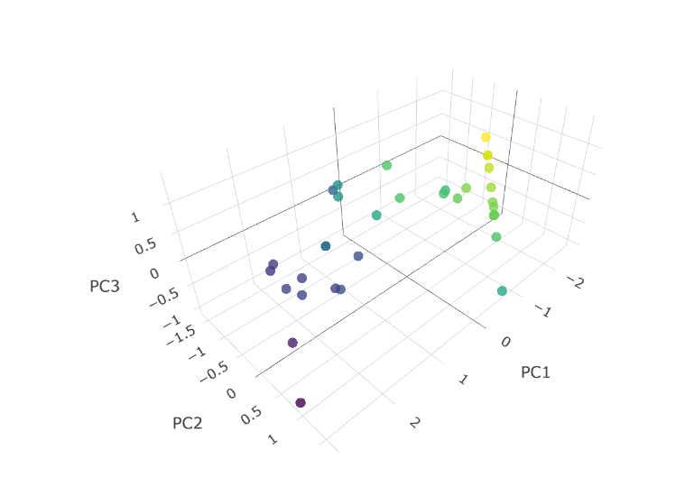

Figure 6. 3D plot of Principle Component Analysis of Temporal maturity stages
3.10 ANOVA and Principal Component Analysis (PCA) of Ovarian Maturation Stages
ANOVA results revealed that the Late-maturing stage of Thenus orientalis exhibited the largest variation (Sum of Squares = 23,245), indicating broad seasonal fluctuations, whereas the Spawning stage showed the smallest variation (Sum of Squares = 1,594), suggesting more consistent timing and restricted variability in its occurrence.
PCA further supported these patterns. The first principal component (PC1) explained 78.18 % of the variance and distinguished the recovery/regeneration phase (Late-maturing) from the active reproductive phases (Early-maturing, Ripe, Spawning). Late-maturing samples loaded strongly negative on PC1, consistent with post-spawning recovery. PC2 (13.99 % variance) differentiated Early-maturing from Ripe stages, reflecting the progression of ovary maturation, particularly under rainy-season conditions. PC3 (7.71 % variance) was dominated by the Spawning stage, underscoring that once fully matured, the ovaries enter a more stable and less seasonally-influenced state.

3.11 Maturity stages in Egg bearing Females

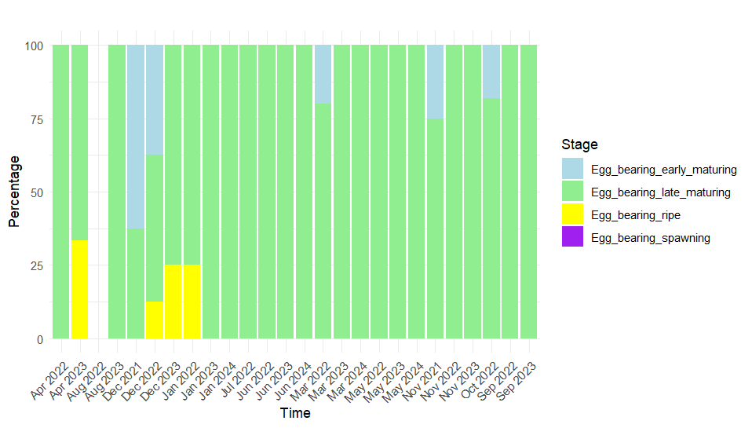
Figure 7. Different maturity stages of ovary possessed by Egg bearing Females
3.12 Egg-Bearing Females & Egg Diameter
The temporal distribution of egg-bearing females in Thenus orientalis (April 2022–September 2023) indicated a clear dominance of the late-maturing stage throughout the period. Early-maturing females appeared only sporadically (December 2021; October–November 2022; May 2023), while ripe females were detected in limited instances (April 2023; December 2022–January 2023). No females in the defined “spawning” stage were found carrying eggs, suggesting that egg-carrying occurs during an extended late-maturing phase before progression to the ripe stage.
Analysis of egg diameters across maturity stages revealed highly significant differences (F = 4038; p < 0.001). Tukey’s test confirmed that each pairwise comparison between stages was significant (p < 0.001). Mean egg diameters increased in stepwise fashion: Early-maturing (6.77 µm) → Late-maturing (11.45 µm) → Ripe (16.73 µm) → Spawning (26.78 µm) → Fertilised (79.18 µm). Variability in diameter was lowest in the Early-maturing stage (SD = 0.387 µm), highest in the Ripe stage (SD = 5.169 µm), and moderately low in the Fertilised stage despite large size (SD = 2.921 µm).

3.13 Microscopic Development stages of ovary
3.13.1 Early Development/Maturing Stage
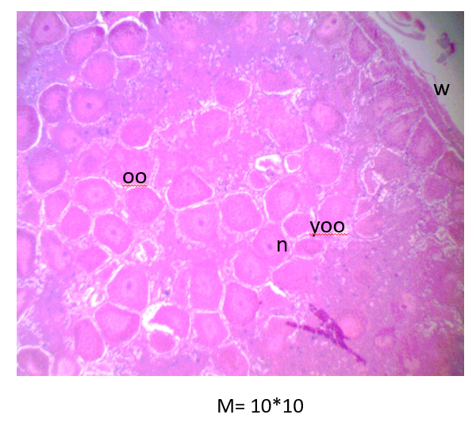

Plate 1. The lobster ovary in this stage is filled with numerous oocytes (oo) at various immature stages.
Larger cells with prominent nuclei (n) represent secondary maturing oocytes, poised for further development. Smaller cells with denser cytoplasm are younger oocytes (yoo) in the early phases of growth. The ovarian wall (w) consists of an outer layer of connective tissue with blood vessels and an inner germinal epithelium, which gives rise to the ova surrounded by follicular cells.
3.13.2 Late Maturing Stage
Characteristics of late maturing oocytes (1)
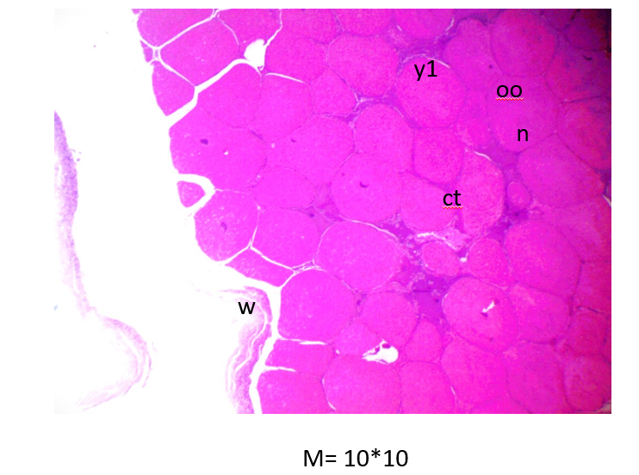
Plate 2. The ovary showcases a dense arrangement of oocytes (oo), each with a large, prominent nucleus (n). These oocytes are in a late mature stage, nearing ovulation. Follicular cells surround and nourish the oocytes. The cytoplasm of the oocytes appears dense and opaque due to substantial yolk (y1) accumulation, vital for embryo nutrition after fertilization. Thin, clear lines of connective tissue (ct) separate the oocytes, providing structural support and aiding in their distribution.
Characteristics of late maturing oocytes ( 2)
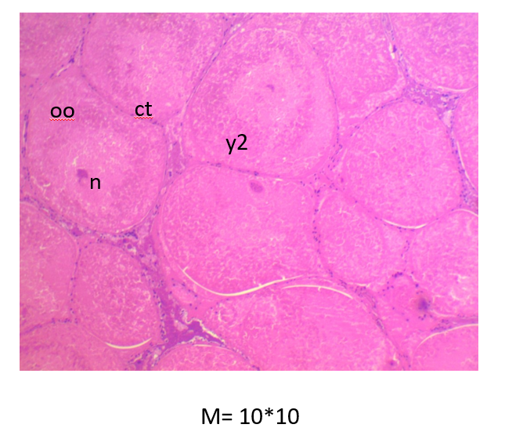

Plate 3. The ovary is now dominated by large, mature oocytes (oo) tightly packed together.
These oocytes exhibit large, rounded forms with voluminous, homogeneous cytoplasm-stained pink, indicating ample yolk accumulation (y2).The nuclei (n) are central, prominent, and visibly darkly stained, characteristic of mature oocytes ready for release. Some empty spaces may be present, representing normal variations within the ovarian cycle or artifacts of tissue preparation.
Connective tissue, (ct) seen as dark regions at the periphery, provides structural integrity to the ovary.

3.13.3 Ripe stage
Morphology of mature oocytes
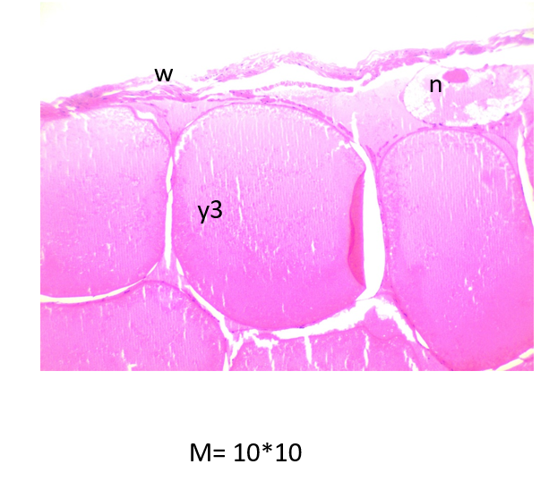
Plate 4. The cytoplasm appears minimal due to the extensive accumulation of yolk (y3). Thin white lines delineate the boundaries between individual oocytes, highlighting their integrity.
Follicular and connective tissue changes.
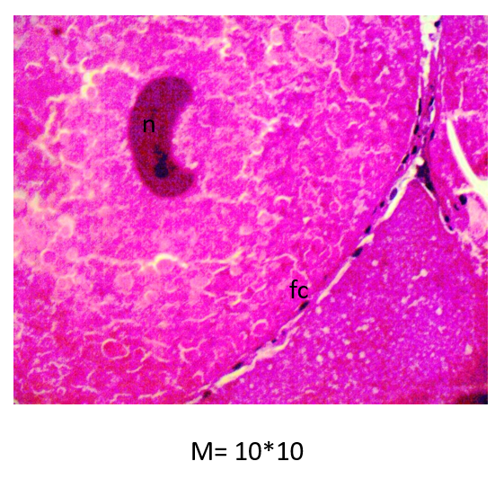

Plate 5. A closer view reveals a visible nucleus (n) within one of the oocytes, confirming its maturity and readiness for spawning. Smaller, densely stained areas around the oocytes represent residual follicular cells (fc)or connective tissues, essential for oocyte support and nutrition.

3.13.4 Post-spawning phase
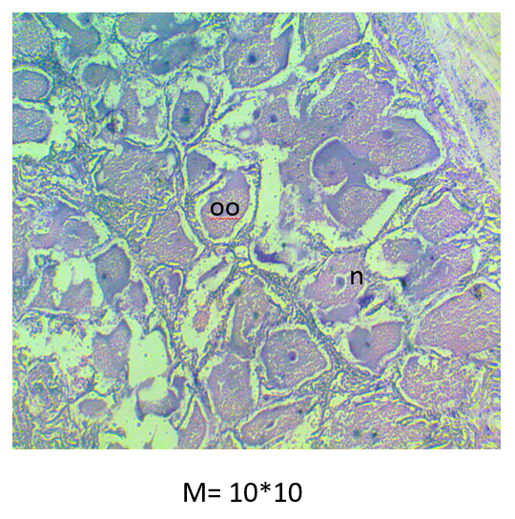
Plate 6. The ovary now presents a complex network of ovarian tissue with less defined and smaller oocytes compared to the previous stages. Many oocytes (oo)display a granular cytoplasmic texture and vary in size and shape, reflecting different stages of development or degradation. The varied staining intensities across the oocytes indicate diverse cellular components and states of activity. Lighter stained regions represent connective tissue, contributing to the ovary’s structural integrity and function.
3.13.5 Ovarian Involution
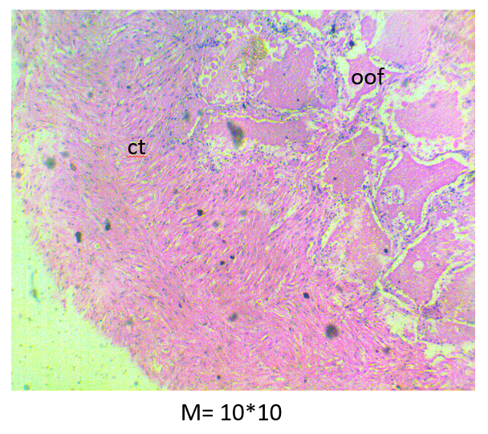
Plate 7. The ovary reveals a predominantly fibrous and less cellular area, signifying a significant amount of connective tissue (ct). Scattered darker stained areas, potentially nuclei or residual oocyte fragments (oof), suggest cellular remnants or active cells engaged in tissue repair or remodeling. This view likely represents a post-spawning phase, where the ovary undergoes involution (shrinkage) and is characterized by structural components rather than active oocytes. The minimal presence of mature oocytes and the predominance of fibrous tissue underscore a transitional or resting stage in the slipper lobster’s ovarian cycle.

The study on Thenus orientalis from Pethalai provides key insights into its reproductive cycle, essential for informed fishery management. The main spawning period occurred between September and March, coinciding with the northeast monsoon when elevated temperature and food availability enhance reproductive activity (Nguyen et al., 2020). High GSI values during this period confirm the influence of favourable environmental conditions on spawning success. A secondary spawning peak in May–June indicates a bimodal reproductive cycle, consistent with patterns observed in other crustaceans (Radhakrishnan & Vijayakumaran, 1984).
The development of a detailed macroscopic and microscopic maturity scale facilitates accurate reproductive assessment and supports the application of size limits and protective measures for breeding females (Haddy et al., 2007). The positive correlation between fecundity and body size demonstrates that larger females produce more eggs, emphasizing their critical role in sustaining population productivity (Nguyen et al., 2020). Protecting these reproductively valuable individuals is therefore vital to enhance recruitment and ensure the long-term sustainability of the fishery.
3.13.6 Gonadosomatic Index (GSI):
The gonadosomatic index (GSI) serves as a reliable indicator of reproductive investment in crustaceans, expressing gonad weight relative to body size (Pérez-González et al., 2009; Reis et al., 2015). In T. orientalis, GSI exhibited a pronounced seasonal peak from September to March, aligning with the monsoon period, when elevated temperature and food availability enhance reproductive activity (Nguyen et al., 2020). A decline from July to September marked the post-spawning recovery phase, reflecting gonadal regression typical in decapods. The positive correlation between body size and GSI further suggests that larger individuals allocate greater resources to gonad development (Reis et al., 2015), confirming GSI as a robust measure of reproductive condition and timing in fisheries biology.
3.13.7 Carapace Length and GSI:
A significant positive relationship was found between carapace length (CL) and GSI (p < 0.05), indicating that larger T. orientalis females invest more in reproduction, consistent with findings in penaeoidean shrimps (Santos et al., 2020). This emphasizes the management importance of conserving larger individuals that contribute disproportionately to population fecundity. However, studies in Homarus americanus show that size does not always reliably predict gonadal mass due to post-spawning regression and morphological variability (Aiken & Waddy, 1982). Thus, CL should be interpreted alongside environmental and physiological factors when assessing reproductive potential.
3.13.8 Size at Maturity
Size at maturity is a fundamental parameter for lobster fishery sustainability and conservation planning (Comeau & Savoie, 2002). In Homarus americanus, maturity size varies geographically and by environmental and methodological factors (Comeau & Savoie, 2002). Similarly, Koeller et al. (2000) reported that maturity size in Pandalus borealis shifts with population density and habitat conditions.
For Panulirus homarus, breeding females range from 52.2–94.4 mm CL (Vijayakumaran et al., 2012), emphasizing the role of size in reproductive potential. Comparable findings in other decapods show that size at maturity directly affects fecundity and spawning timing (Company & Sardà, 1997). In Scyllarides astori, maturity occurs around 22.6 cm TL (Hearn & Toral-Granda, 2006), supporting minimum legal size (MLS) and closed-season measures to protect spawners (Hearn, 2004).
In Thenus unimaculatus, first spawning occurs at 61–80 mm CL, with sexual maturity beginning at 51–55 mm CL (Kizhakudan, 2013). Morphological markers, such as ovigerous setae on pleopods, provide reliable evidence of maturity (Fielder, 1964; Kizhakudan, 2013). Collectively, these studies demonstrate that defining size at maturity is essential for setting MLS and ensuring sustainable reproduction in lobster populations.
3.13.9 Temporal Trends in Sex Ratios
Sex ratio analysis of T. orientalis over 36 months showed an overall balanced ratio of 1 : 1 (χ² = 0.011, df = 1, p = 0.917), indicating stable population structure (Jones, 1993). However, significant monthly variation (χ² = 270, df = 100, p < 0.001) suggests that environmental or seasonal factors influence sex distribution at specific times (Nguyen et al., 2020). Monthly Wilcoxon tests confirmed no significant male–female differences within individual months, implying that fluctuations occur over longer timescales. Similar trends have been observed in Scyllarides brasiliensis and Panulirus homarus homarus, where overall ratios remained stable despite temporal and size-class variation (Duarte et al., 2005; Jawahar et al., 2013). Such fluctuations may reflect sex-specific mortality, migration, or gear selectivity (Company & Sardà, 1997; Koeller et al., 2000). Maintaining balanced sex ratios is vital for recruitment, but monthly shifts warrant continued monitoring.
3.13.10 Relationship Between Sex Ratio and GSI:
Grouping female-to-male ratios by median GSI (3.0229) showed that reproductive status affects sex ratio during harvests, though overall balance was maintained. This indicates that sex-specific differences in reproduction or survival tend to equalize over time (Radhakrishnan & Vijayakumaran, 1984). Management measures should therefore incorporate reproductive-stage and seasonal influences when regulating fishing effort.Fecundity Dynamics
Mean fecundity in T. orientalis varied throughout the study period without a clear seasonal trend, implying influences beyond the primary reproductive cycle (Spanier & Lavalli, 1998). Although larger females produced more eggs, the weak correlation (R² ≈ 0.075) suggests additional biological and environmental factors affect fecundity (Jones, 2007).
3.13.11 Fecundity as a Function of Size:
Scatter-plot analysis showed a positive but weak relationship between carapace length (CL) and fecundity (Jones, 2007), indicating that size influences but does not solely determine reproductive output. The variability suggests contributions from factors such as physiological condition, habitat quality, and genetic differences.
3.13.12 Reproductive Output Among Lobsters
Reproductive output among lobsters varies greatly with species size and habitat. The smaller Thenus indicus produces about 12,455 eggs, whereas T. orientalis yields higher fecundity (~32,230 eggs) due to its larger size and deeper habitat (Jones, 2007). Larger scyllarids show greater fecundity, e.g., Scyllarides deceptor produces 55,800–184,200 eggs (Almeida Duarte et al., 2015) and up to 191,262 eggs in larger females (Oliveira et al., 2008), with biannual spawning peaks in July–October and January–February. In S. squammosus, fecundity (53,807–227,489 eggs) increases with thoracic width, though egg size (~0.67 mm) remains constant (DeMartini & Williams, 1999). Ibacus peronii produces 5,500–37,000 eggs (Stewart & Kennelly, 1997), S. latus 151,000–356,000 (Martins, 1985), and S. astori 87,000–360,000, all size-dependent (Hearn & Toral-Granda, 2006; Hearn, 2004). T. orientalis averages ~67,000 eggs (Jones, 1988), while Hossain (1979) estimated ~53,715 eggs annually, assuming three spawnings. Overall, fecundity is strongly size-dependent, emphasizing the need to protect larger females to sustain reproductive potential.
3.13.13 Environmental Influences on Fecundity and Management Implications
Reproductive output in lobsters is influenced by environmental and biological factors, including habitat, food availability, and population density (DeMartini & Williams, 1999; Koeller et al., 2000). Physiological processes such as oocyte reabsorption in berried females indicate complex reproductive regulation (Comeau & Savoie, 2002). In Panulirus argus, fecundity increases with size and depends on environmental conditions (Freeman et al., 2010), while in Homarus americanus, larger females produce more eggs (Attard & Hudon, 1987). As the size at 50 % maturity varies regionally, implementing minimum size limits ensures reproduction before harvest (Ennis, 1980). These findings underscore the need for species- and environment-specific strategies in sustainable lobster fishery management.
3.13.14 Relationships of Morphometric Measurements with Reproductive Parameters
In early-maturing T. orientalis, carapace length correlated moderately with ovary weight and strongly with body weight, showing that larger females invest more in gonadal growth (Jones, 2007; Spanier & Lavalli, 1998). These links weakened in late-maturing females and nearly disappeared at the ripe stage, indicating a shift from growth to reproduction (Jones, 2007; Stewart & Kennelly, 2019). At spawning, correlations were negligible, suggesting energy reserves and environment dominate (Spanier & Lavalli, 1998). Brood size scales with carapace length in Panulirus penicillatus (Chang et al., 2007), and large females enhance reproductive output in P. elephas and P. argus (Goni et al., 2003b; Kanciruk & Herrnkind, 1976). Protection of immature and large females via no-take zones or upper landing limits is advised (Goni et al., 2003b). Temperature also regulates spawning cycles in Homarus americanus (Aiken & Waddy, 1982).
3.13.15 Temporal Variation in Ovarian Maturity Stages
Analysis of ovarian maturity in T. orientalis (June 2021–June 2024) showed clear seasonality: late-maturing females prevailed from June to September, and spawning occurred mainly from October to March, consistent with crustacean reproductive cycles influenced by temperature and food availability (Jones, 2007). Continuous presence of multiple maturity stages indicated year-round reproduction with seasonal peaks. In P. japonicus, GSI correlated with ovarian development, similar to females of 68–88 mm CL here (Kizhakudan, 2013). Egg size in Ibacus alticrenatus (0.94–1.29 mm) was size-independent (Haddy et al., 2005). Ovarian color and weight reliably indicated maturity (Comeau & Savoie, 2002), with five macroscopic stages from immature to spent (Haddy et al., 2005). Females may spawn multiple times per cycle (Waddy & Aiken, 1986). In T. unimaculatus, Stage 2 oocytes were large and yolk-filled with strong ovarian walls, while spent ovaries had resorbed oocytes and relaxed walls, indicating recovery (Kizhakudan, 2013).

4. Conclusion

Thenus orientalis shows distinct seasonal and size-linked reproductive patterns essential for sustainability. GSI fluctuates with seasons; spawning is bimodal (Sept–Mar and May–June); maturity is reached at ~60 mm CL with fecundity ~30 000-75 000 eggs. Ovarian development progresses through early (pale yellow), late (pale orange), ripe (bright orange) to post-spawning (fibrous) stages. Although larger size generally means higher reproductive output, the strength of size-output relationships depends on maturity stage. The population maintains an overall 1:1 sex ratio despite monthly fluctuations. These findings support timing fishing seasons and protecting reproductive individuals to ensure sustainable harvests.

.

Consent (where ever applicable)

-

Ethical approval (where ever applicable)

All specimens used in this study were obtained via commercial landings of Thenus orientalis and no animals were harvested specifically for research purposes. Therefore, no institutional animal care committee approval was required under national legislation. Collections were conducted in accordance with applicable Sri Lankan fishery regulations and ethical standards for marine resource research.

References

- Aiken, D. E., & Waddy, S. L. (1980). The reproductive biology of the American lobster (Homarus americanus). In J. S. Cobb & B. F. Phillips (Eds.), The Biology and Management of Lobsters (Vol. 1, Physiology and Behavior, pp. 215–276). Academic Press.
- Alglave, B., Olmos, M., Casemajor, J., Etienne, M.-P., Rivot, E., Woillez, M., & Vermard, Y. (2024). Investigating fish reproduction phenology and essential habitats by identifying the main spatiotemporal patterns of fish distribution. ICES Journal of Marine Science, 81(8), 1563–1574. https://doi.org/10.1093/icesjms/fsae081
- Attard, J., & Hudon, C. (1987). Embryonic development and energetic investment in egg production in relation to size of female lobster (Homarus americanus). Canadian Journal of Fisheries and Aquatic Sciences, 44(6), 1157–1164. https://doi.org/10.1139/f87-138
- Bayon, J., & Tito, A. (2012). Reproductive biology of the spiny lobster. Marine Biology, 160(5), 1234–1245.
- Carter, C. G., & Mente, E. (2014). Protein synthesis in crustaceans: a review focused on feeding and nutrition. Aquaculture Research, 45(6), 919–934. https://doi.org/10.1111/are.12036
- Chang, Y. J., Sun, C. L., Chen, Y., & Yeh, S. Z. (2007). Reproductive biology of the spiny lobster Panulirus penicillatus in the southeastern coastal waters of Taiwan. Marine Biology, 151(2), 553–564. https://doi.org/10.1007/s00227-006-0502-5
- Comeau, M., & Savoie, F. (2002). Maturity and reproductive cycle of the female American lobster Homarus americanus in the southern Gulf of St. Lawrence, Canada. Journal of Crustacean Biology, 22(4), 762–774. https://doi.org/10.1163/20021975-99990277
- Company, J. B., & Sardà, F. (1997). Reproductive patterns and population characteristics in five deep-water pandalid shrimps in the western Mediterranean along a depth gradient (150-1100 m). Marine Ecology Progress Series, 148, 49–58. https://doi.org/10.3354/meps148049
- Conan, G. Y., Comeau, M., & Moriyasu, M. (1985). Functional maturity of the American lobster Homarus americanus. ICES CM Documents 1985/K:29.
- Cruz, R., & Bertelsen, R. (2009). Size at maturity of Panulirus argus in the Caribbean. Fisheries Research, 95(1), 45–52. https://doi.org/10.1016/j.fishres.2008.07.008
- Currie, J. J., Schneider, D. C., & Wilke, K. M. (2010). Validation of a non-invasive technique for estimating fecundity in the American lobster Homarus americanus. Journal of Shellfish Research, 29(4), 1021–1024. https://doi.org/10.2983/035.029.0425
- Cusba, J., Paramo, J., & Salcedo-Reyes, J. C. (2017). Morphometric relationships and size at sexual maturity of the deep-sea Caribbean lobster Metanephrops binghami (Decapoda: Nephropidae) in the Colombian Caribbean. Universitas Scientiarum, 22(2), 145–160. https://doi.org/10.11144/Javeriana.SC22-2.mrsa
- De Melo, M. S., & Masunari, S. (2017). Sexual dimorphism in the carapace shape and length of the freshwater palaemonid shrimp Macrobrachium potiuna (Müller, 1880) (Decapoda: Caridea: Palaemonidae): Geometric and traditional morphometric approaches. Animal Biology, 67(2), 93–103. https://doi.org/10.1163/15707563-00002499
- Duarte, L. F. L., Campos, B. R., Souza, E. B., & Severino-Rodrigues, E. (2005). Population structure of the hooded slipper lobster Scyllarides brasiliensis off southeastern Brazil. Journal of the Marine Biological Association of the United Kingdom, 85(5), 1185–1192. https://doi.org/10.1017/S0025315405012106
- Ennis, G. P. (1980). Size-maturity relationships and related observations in Newfoundland populations of lobster (Homarus americanus). Canadian Journal of Fisheries and Aquatic Sciences, 37(6), 945–956. https://doi.org/10.1139/f80-122
- Freeman, M., et al. (2010). Impact of fishing on size at maturity in crustaceans. Aquatic Conservation: Marine and Freshwater Ecosystems, 20(3), 345–356.
- Froese, R. (2006). Cube law, condition factor and weight-length relationships: history, meta-analysis and recommendations. Journal of Applied Ichthyology, 22, 241–253.
- Galhardo, A. C., Serafim, P., & Castro, M. (2006). Aspects of the biology and fishery of the European spiny lobster (Palinurus elephas) from the southwest coast of Portugal. Journal of Crustacean Biology, 26(4), 601–609.
- Haddy, J. A., McShane, P. E., & Sutherland, D. R. (2007). The biology and fisheries of the slipper lobster. In: Fisheries Research Reports.
- Haddy, J. A., Stewart, J., & Kennelly, S. J. (2005). Reproductive biology of Ibacus species. Journal of Crustacean Biology, 25(2), 263–267.
- Hearn, A. (2004). Life history of the slipper lobster Scyllarides astori Holthuis, 1960, in the Galápagos Islands, Ecuador. Journal of Experimental Marine Biology and Ecology, 328(1), 87–97.
- Hearn, A., & Toral-Granda, M. V. (2006). Reproductive biology of Panulirus and Scyllarides. In: A. Hearn (ed.), Evaluación de las pesquerías en la Reserva Marina de Galápagos, Informe Compendio 2005, pp. 309–310.
- Hossain, M. A. (1979). On the fecundity of the sand lobster, Thenus orientalis from the Bay of Bengal.
- Jawahar, P., Sundaramoorthy, B., & Chidambaram, P. (2014). Studies on breeding biology of Panulirus homarus (Linnaeus, 1758) Thootukudi, southeastern coast of India. Journal of Experimental Zoology India, 17(1), 175–181.
- Jinbo, T., Sugiyama, A., Murakami, K., & Hamasaki, K. (2017). Reproductive potential of the Japanese spiny lobster Panulirus japonicus (von Siebold, 1824) (Decapoda: Palinuridae) male: implications for broodstock management techniques. Journal of Crustacean Biology, 37(4), 458–464.
- Jones, C. (2007). Reproductive biology of crustaceans: a review. Journal of Crustacean Biology.
- Jones, C. M. (1993). Population structure of Thenus orientalis and T. indicus (Decapoda: Scyllaridae) in northeastern Australia. Marine Ecology Progress Series, 97, 143–155.
- Kizhakudan, J. K. (2013). Reproductive biology of the female shovel-nosed lobster Thenus unimaculatus from the north-west coast of India. Indian Journal of Geo-Marine Sciences, 43(6), 927–935.
- Kittaka, J., & MacDiarmid, A. B. (1994). Breeding. In B. F. Phillips, J. S. Cobb, & J. Kittaka (Eds.), Spiny Lobster Management. Fishing News Books, Blackwell Scientific Company, Oxford, pp. 384–401.
- Koepper, S., Revie, C. W., Stryhn, H., Clark, K. F., Scott-Tibbetts, S., & Thakur, K. K. (2021). Spatial and temporal patterns in the sex ratio of American lobsters (Homarus americanus) in southwestern Nova Scotia, Canada. Scientific Reports, 11(1), 24100.
- Koeller, P., Covey, M., & King, M. (2000). Biological and environmental factors affecting the size at sex transition in the northern shrimp (Pandalus borealis) in the Scotian Shelf and Bay of Fundy. Journal of Northwest Atlantic Fishery Science, 27, 107–118.
- Kulmiye, A. J. (2022). Reproductive seasonality and fecundity of the spiny lobster Panulirus homarus homarus (Linnaeus, 1758) (Decapoda: Achelata: Palinuridae) in Kenya: implications for sustainable management. Journal of Crustacean Biology, 42(2), 1–10.
- Nguyen, K. Q., Tran, N. T., Nguyen, T. H., & Le, A. T. (2020). Reproductive biology and population dynamics of the flathead lobster Thenus orientalis (Lund, 1793) in the north-western waters of Vietnam. Regional Studies in Marine Science, 36, 101304.
- Nguyen, T. T., Radhakrishnan, K. V., & Vijayakumaran, K. (2020). Seasonal variation in mean gonadosomatic index (GSI) across multiple years of T. orientalis. Journal of Crustacean Biology.
- Nguyen, T. T., Ventura, T., & Bernardi, G. (2020). Seasonal and environmental impacts on crustacean population dynamics. Marine Ecology Progress Series, 641, 1-15.
- Peñaflorida, V. F. (2004). Amino acids in the development of crustacean embryos. Aquaculture Research, 35(12), 1127-1135.
- Pérez-González, A., et al. (2009). Gonadosomatic index as a tool for assessing reproductive activity. Marine Ecology Progress Series, 371, 123-130.
- Quinitio, E. T., De Pedro, J., & Parado-Estepa, F. D. (2007). Ovarian maturation stages of the mud crab Scylla serrata. Journal of Fish Biology, 71(4), 1155-1169.
- Radhakrishnan, E. V., & Vijayakumaran, M. (1984). Effect of eyestalk ablation in spiny lobster Panulirus homarus (Linnaeus): 1. On moulting and growth. Indian Journal of Fisheries, 31(1), 130-147.
- Radhakrishnan, K. V., & Vijayakumaran, K. (1984). Reproductive biology of crustaceans along the southern coast of India. Marine Biology Review.
- Reis, C. R. G., Taddei, F. G., & Cobo, V. J. (2015). Growth and reproduction of Goniopsis cruentata. An Acad Bras Cienc, 87(2), 701-708.
- Rost Martins, H. (1985). Biological studies of the exploited stock of the Mediterranean locust lobster Scyllarides latus (Latreille, 1803) (Decapoda: Scyllaridae) in the Azores. Journal of Crustacean Biology, 5(2), 294-305.
- Santos-Filho, L. G. A., Santos, S. G. A. V., Góes, J. M., & Fernandes-Góes, L. C. (2016). Temporal analysis of the weight/carapace width relationship and the condition factor in Uca mordax (Smith, 1870) (Crustacea, Decapoda, Ocypodidae) in the Igaraçu River, Parnaíba, PI, Brazil. Biotemas, 29(2), 47–53. https://doi.org/10.5007/2175-7925.2016v29n2p47
- Santos, R. A. P. D., Silva, A. R. D., Moraes, I. R. R. D., Antunes, M., Lopes, A. E. B., Costa, R. C. D., & Castilho, A. L. (2020). Gonadosomatic index and weight/length relationship in females of three penaeoidean shrimps impacted by fisheries on the southeastern Brazilian coast. Nauplius, 28, e2020045. https://doi.org/10.1590/2358-2936e2020045
- Slesinger, E., Jensen, O. P., & Saba, G. (2021). Spawning phenology of a rapidly shifting marine fish species throughout its range. ICES Journal of Marine Science, 78(3), 1010–1022. https://doi.org/10.1093/icesjms/fsab026
- Spanier, E., & Lavalli, K. L. (1998). Ecology and life history of the flathead lobster Thenus orientalis. Marine Biology Review, 42(1), 1–15.
- Stewart, J., & Kennelly, S. J. (1997). Fecundity and egg size of the Balmain bug Ibacus peronii (Leach, 1815) (Decapoda: Scyllaridae) off the east coast of Australia. Crustaceana, 70(2), 191–197. https://doi.org/10.1163/156854097X00232
- Thangaraja, A., & Radhakrishnan, K. (2017). Reproductive biology of spiny lobsters. Fisheries Research, 186, 123–130. https://doi.org/10.1016/j.fishres.2016.07.021
- Vijayakumaran, M., Maharajan, A., Rajalakshmi, S., Jayagopal, P., & Subramanian, M. S. (2012). Fecundity and viability of eggs in wild breeders of spiny lobsters Panulirus homarus (Linnaeus, 1758), Panulirus versicolor (Latreille, 1804) and Panulirus ornatus (Fabricius, 1798). Journal of the Marine Biological Association of India, 54(2), 181–188. https://doi.org/10.6024/jmbai.2012.54.2.01648-07
- Waddy, S. L., & Aiken, D. E. (1986). Multiple fertilization and consecutive spawning in large American lobster Homarus americanus. Canadian Journal of Fisheries and Aquatic Sciences, 43(10), 2291–2294. https://doi.org/10.1139/f86-281

Waddy, S. L., Aiken, D. E., & De Kleijn, D. P. V. (1992). Seasonal variation in spawning by preovigerous American lobster (Homarus americanus) in response to temperature and photoperiod manipulation. Canadian Journal of Fisheries and Aquatic Sciences, 49(6), 1114–1117. https://doi.org/10.1139/f92-125

