Original Research Article

Comprehensive Assessment of Fish Availability Across Seasons at Kismayo Landing Sites

ABSTRACT
This study looks at the Comprehensive Assessment of Fish Availability Across Seasons at Kismayo Landing Sites, considering seasonal changes and what they mean for local fishing. we gathered info by watching landings at Kibora Fish Landing Site and Kismayo Fish Market, and by talking to local fishers and market people. We wrote down the Somali, English, and scientific names of fish and shellfish species and noted when they were available during the year. We found that 19 pelagic species, like tunas (Thunnus albacares, Thunnus obesus), mackerels (Scomberomorus guttatus), and wahoo (Acanthocybium solandri), were more common from October to December and February to April. On the other hand, demersal and reef-related species, such as seabream (Acanthopagrus berda) and spinefoot fish (Siganus sutor), as well as shellfish like lobsters (Panulirus spp.) and mangrove crabs (Scylla serrata), were around all year. This gives a reliable source of food and income for coastal communities. Seasonal ups and downs in pelagic fish supply affected how much fishing was done, what gear was used, and how the market worked. These results show that we need fisheries management plans that consider seasonal shifts. This will help protect marine resources for the future while keeping the fishing communities in Kismayo fed and financially stable.
Keywords: Fish Market Trends in Kismayo, Seasonal Variation in Fish Species, Assessing Fish Availability, Identifying Fish Species, and Fisheries Management Practices.

INTRODUCTION
The relationship between environmental conditions and seasonal fluctuations in fish communities surrounding a coastal island was examined. Researchers found 72 fish species from 40 families and 23 orders in the waters of the Seto Inland Sea in Western Japan, demonstrating the region's great biodiversity(Nhat et al., 2024).
The longest seasonal fishing ban in the Mediterranean is in place in Turkey, where industrial fishing is banned every year from April 15 to September 1 (Yıldız et al., 2020). The purpose of this prohibition is to safeguard important spawning times and promote sustainable fisheries management (Yıldız et al., 2020).
Certain fishing grounds consistently exhibit higher productivity for both Norway lobster and European hake. Although landings vary greatly between harbors, only a few consistently account for a significant share of the catch, with the Pomo/Jabuka Pit area emerging as a particularly important site for both species (Russo et al., 2018)
This study provides the first assessment of historical landing patterns for 21 fish taxa and evaluates recent population trends for 27 commercially important fish species in the lower La Plata Basin, Argentina(Scarabotti et al., 2021).
A year-long study at the Chairman Ghat Fish Landing Center in Noakhali assessed both the diversity of fish and shellfish species and the associated marketing channels. Samples collected from the landing site were analyzed at the laboratory of Noakhali Science and Technology University. Over the course of the study, researchers documented 32 fish species, 4 prawn species, and 1 shrimp species across 22 families. The Engraulidae and Palaemonidae families showed the highest species richness, with 4 species each. Among the fish recorded, 24 were classified as not threatened (NO), 3 as critically endangered (CR), and 10 as data deficient (DD) (Chakraborty et al., 2020). The low abundance of certain species highlights a concerning decline in fish biodiversity both locally and nationally. In addition, the study explored general trends in fish marketing within the region(Chakraborty et al., 2020).
In Bangladesh, a study documented 237 fish landing centres and 5,440 markets includes chittagong had the largest number of landing centres, whereas the Dhaka division hosted the highest number of markets the fish distribution network involved 6,219 arotdars, 39,506 paikers, and 122,922 retailers the most landing centers (approximately 84.7%) operate year-round, while the remaining 15.3% function seasonally (Rahman et al., 2013).
The study examined seasonal variations in the distribution of fish species and their conservation status over three seasons—summer, autumn, and winter—from September 2017 to August 2018(Imran et al., 2023). Researchers documented 64 fish species across 25 genera and 24 families, representing 10 different orders. Cypriniformes was the most abundant order, accounting for 42% of all species, while Siluriformes (22%), Perciformes (16%), Channiformes (6%), and Clupeiformes (5%) also contributed notably to species diversity(Imran et al., 2023). Cypriniformes, however, exhibited the highest dominance among the identified species. The study further highlighted that 14 species (18.88%) face conservation concerns, with 6.25% classified as vulnerable, 12.5% as endangered, and 3.12% as critically endangered according to the IUCN Red List (Imran et al., 2023).
India is one of the leading fishing nations in the Indian Ocean, with commercial marine fish landings comprising nearly 1,000 species overfished (Setiadi M Noor, Iin Solihin, Retno Muninggar, 2024).Regular and comprehensive assessments of these stocks are crucial for promoting sustainable fisheries management and responsible harvesting. In this study, 135 stocks from 70 species were evaluated using monthly length-frequency data in the results showed that 91.1% of the assessed stocks maintain a healthy biomass, while some stocks were identified as sustainable and others as overfished (Setiadi M Noor, Iin Solihin, Retno Muninggar, 2024).
Monthly fish landing data were collected from August 2016 to December 2024 from a local fish buyer in Sut Pa Nu Village, situated near the estuary. Over the eight years, researchers recorded 30 fish species across 19 families in the dominant species—Hilsa shad, Pama croaker, and Mango fish—together accounted for 54% of the total annual catch and contributed 76% of the total annual economic value (Yıldız et al., 2020). The study assessed the local ecological knowledge of fishers, gathered through interviews, in relation to detailed data on seasonal differences in fish catch rates (CPUE) throughout the monsoon periods in both the northeast (NE) and southeast (SE) monsoons. Overall, the fishers' perceptions aligned with the catch data, suggesting that the NE monsoon typically yields higher catch rates than the SE monsoon. However, at two landing locations (Nyamisati and Shangani), the fishers' opinions diverged, as they indicated experiencing greater catches during the SE monsoon (Silas et al., 2023).
The typical volume of fish exchanged in Kenya varied according to the seasons when lake fishing is most active, specifically from January to March and from August to October. In contrast, Uganda experienced an inconsistent pattern of fish trade throughout the year, with weekly trade quantities fluctuating based on the average fish prices(Aura et al., 2019). The lower sales margins observed during the EFMIS project highlighted the benefits of sharing information through ICT platforms, which can lead to more efficient and fair fish trade. This assessment of fish market data is valuable for shaping fish trade policies and for the sustainable management of fisheries and ecosystems in rural and peri-urban areas (Aura et al., 2019)
Moreover, this estimation does not consider the landings (number of individuals) overlooked by observers at the study locations, which could be significant (weighted means ranging from 17.3 to 33.9%) (Temple et al., 2019). In summary, the findings clearly indicate that the landings of elasmobranch species from SSF are probably notably underreported in the fisheries statistics for the SWIO region. The extent of underreporting varied by country (Temple et al., 2019).
The results of this research show that demersal species, including scavengers, rabbitfish, snappers, and parrotfish, are the most prevalent in the marine catch, accounting for 50% of the overall landings of marine and coastal fish pelagic species, which encompass mullets, bonito, cavalla jacks, mackerel, kingfish, and sailfish, made up 28%, while the remaining 22% consisted of elasmobranchs, crustaceans, and mollusks. (Aloo, P.A. Munga, C. Kimani, E. Ndegwa, 2014).
This research presents, for the first time, the species variety, population density, and length-weight correlation of groupers within the inshore artisanal fisheries of Kenya. Data were collected from the catches of artisanal fishermen along the southern coast of Kenya from February to July 2007 (Agembe et al., 2010). A total of 37 species from six genera—Aanyperodon, Cephalopholis, Dermatolepis, Epinephelus, Plectropomus, and Variola—were recorded in the fishermen's landings (Agembe et al., 2010)
This research examines the diversity and numbers of fish species at various landing sites in the Upper Benue River Basin located in Taraba State, Nigeria. Fish were collected every month for six months (from February to August 2022) at the Mayo-Renewo and Lau landing sites using different fishing techniques, including traps, gillnets, and hook and line. A total of 6,519 fish specimens representing 26 species across 22 families were documented, with the most prevalent species in Mayo-Renewo being Tilapia galilaeus, Distichodus rostratus, and Alestes macroplepidotus, while Clarias gariepinus, Heterotis niloticus, and Alestes macroplepidotus were the most frequently found in the other location. Lau(David et al., 2025).
The data indicate that a majority of fish reproduce throughout the year in these tropical waters, as we did not observe significant seasonal trends; all locations exhibited a high relative abundance of larvae from demersal spawning fish, suggesting that many species relocate to coastal areas for spawning (Ngisiange et al., 2024). Primary productivity and dissolved oxygen levels, influenced by hydrodynamic conditions, are positively associated with fish larvae productivity in both Kenya and Tanzania (Ngisiange et al., 2024). These results imply that the presence of both resident and transient fish larvae in seagrass meadows is influenced by strong hydrodynamic and tidal processes that move fish larvae across neighboring habitats (Ngisiange et al., 2024).
Seasonal collections were primarily composed of fewer than 10 small estuarine forage species, such as Anchoa mitchilli, Menidia spp., Floridichthys carpio, and Lucania parva, which were found in high numbers throughout the year(Tremain & Adams, 1995). They identified significant seasonal variations in abundance for several rarer or transient species collected from shallow-water habitats, including Brevoortia spp(Tremain & Adams, 1995)., Trachinotus falcatus, Caranx hippos, Cynoscion nebulosus, and Leiostomus xanthurus, as well as species from lagoon-basin habitats like Micropogonias undulatus and Diapterus auratus(Tremain & Adams, 1995). Estimates of species richness and abundance were positively associated with water temperature, peaking during the summer or fall and dipping to their lowest levels in winter. (Tremain & Adams, 1995)
The findings indicated that the most prevalent fish species along the Mogadishu coast were pelagic fish that inhabit the surface and those found at the bottom(Farah, 2023). The primary pelagic species identified included Yellowfin Tuna, Skipjack Tuna, Kawakawa Tuna, mackerels, billfishes, and Mahimahi(Farah, 2023). This category also encompasses fish species found in both inshore and offshore areas, such as certain Jack fish and shark species. Conversely, the leading demersal fish included spine-foot fish, emperors, seabreams, red snappers, parrot fish, surgeons, as well as a few types of snappers and groupers. Therefore, these fish represent the key species observed throughout the Somali coast (Farah, 2023).

Objective
- Identify the fish species available at Kismayo landing sites throughout the year.
- Analyse the seasonal patterns of fish abundance and their implications for local fishing practices.

MATERIALS AND METHODS

Study Design
This study utilizes qualitative data collection methods to gather comprehensive information on fish and shellfish species along the Kismayo landsite and Kismayo Fish Market, focusing on documenting their Somali, English, and scientific names, as well as seasonal availability. Descriptive research design, combining both quantitative and qualitative approaches, is employed to explore "what is" through observational and survey methods (Pereira & Gheisari, 2017).

Date analysis

The collected data will be was systematically analysed to document fish and shellfish species according to their Somali, English, and scientific names, as well as to assess their seasonal availability. The findings will be presented using tables, charts, and seasonal timetables to effectively illustrate observed patterns and trends. Interviews will focus on species names ( Somali, English, and scientific name ), seasonal availability.

Study Locations
In Kismayo, Somalia, the current study will be carried out at two main landing sites:

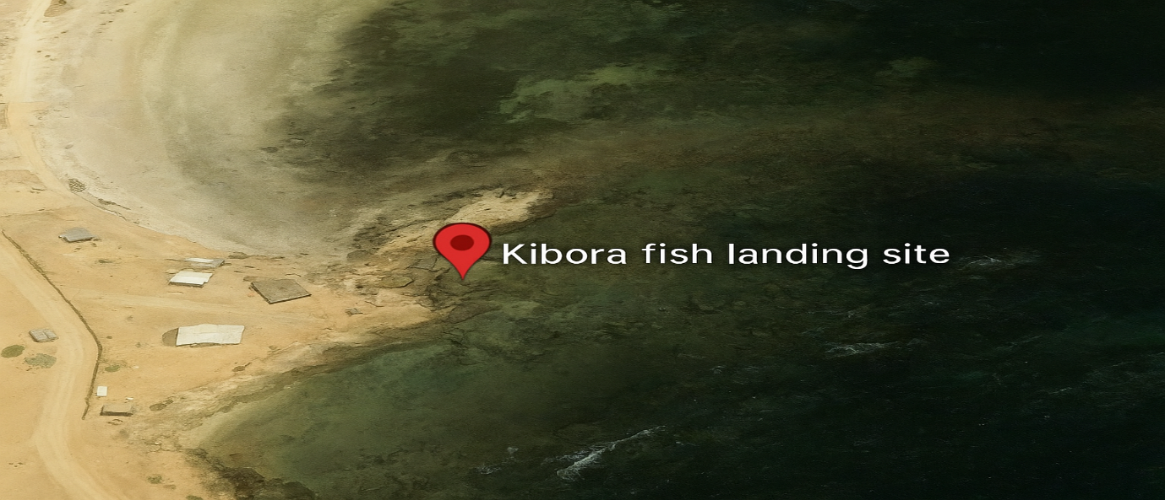

Fig. 1: This graphic depicts the Kibora Fish Landing Site, a crucial location in Kismayo where the research was performed. The location is a significant zone for regional fishing endeavors, and interviews were conducted here as part of the study.

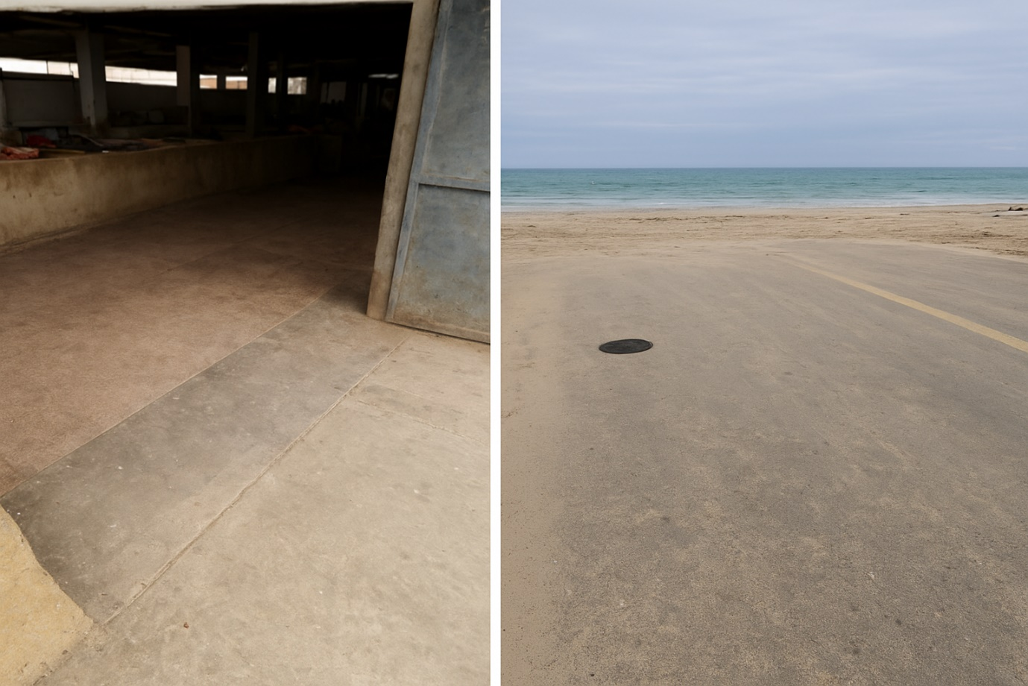

Figure 2: This illustration depicts a segment of the Kismayo Fish Market, a significant site for regional fish commerce. The market functions as a primary hub for the commerce of many fish and shellfish species. Observations and interviews were performed at this location to collect data on species availability, seasonal patterns, and market dynamics.
RESULT AND DISCUSION

RESULT
Table 1: Common Commercial Pelagic Fish Found on the Kismayo landing site
This table enumerates prevalent pelagic fish species located off the Kismayo coast, including their Somali and English nomenclature, scientific classifications, and seasonal availability. These fish are predominantly seasonal, with availability fluctuating from October to early December and again from February to April, contingent upon local environmental conditions and migratory patterns.

Somali Name | English Name | Scientific Name | Availability | Seasonal availability
Dhiigloow | Kawakawa Tuna | Thynnus affine | Seasonal | From October to Early December and from the end of February to April.
Saynab | Spotted mackerel | Scomberomorus guttatus | Seasonal | from October to Early December and from early March to Early June
Yuumbi | Spanish mackerel | Scomberomorus commerson | Seasonal | from October to November and from the end of February to April.
Jeedar | Yellow-fin Tuna | Thunnus albacares | Seasonal | From October to Early December and from the end of February to April.
Sanuuro | Skipjack Tuna | Katsuwonus pelamis | Seasonal | from October to Early December and from the end of February to April.
Gaxash | Jacks | Carangidae | Seasonal | from October to Early December and from the end of February to April.
Jabto | Talang Queenfish | Scomberoides commersonnianus | Seasonal | from October to Early December and from the end of February to April.
Shaamshuutar | Striped Bonito Tuna | Sarda orientalis | Seasonal | from October to Early December and from early February to April.
Booraay | Bullet Tuna | Auxis rochei | Seasonal | from October to Early December and from early February to April.
Daanberi | Billfishes | Xiphidae & Istiophoridae | Seasonal | from October to Early December and from the end of February to April
Dooldool | Ladyfish | Elops machnata |  | From October to Early December and from early February to April.
Fuluus | Mahi-mahi | Coryphaena hippurus | Seasonal | from October to early December and from early February to April.
Yuumbi Baxreed | Wahoo | Acanthocybium solandari | Seasonal | from October to early December and from February to April.
Ilwayn | Bigeye Tuna | Thunnus obesus | Seasonal | from October to early December and from early February to April.
Saynuub | Longtail tuna | Thynnus tonggol | Seasonal | from October to Early December and from early February to April.
Sulsuul | Black marlin | Istiompax indica | Seasonal | from October to early December and from February to April.
Faras | Sailfish | Istiophorus | Seasonal | from October to early December and from early February to April.
Garabdiir | Frigate tuna | Auxis thazard | Seasonal | from October to early December and from early February to April.
Wayanbuura | Swordfish | Xiphias gladius | Seasonal | from October to early December and from early February to April.

Figure 3: The figure summarizes the prevalent commercial pelagic fish species located around the Kismayo Coast. It indicates that these fish species are accessible from October to November and again from February to April, with a total of 19 species..

Table 2: Common Commercial reef-associated or demersal Fish Found in the Kismayo landing site.
This category encompasses reef-associated and demersal fish species that are present year-round along the Kismayo coast. These species are essential to the coastal ecology and are perpetually present year-round.
Somali Name | English Name | Scientific Name | Availability
Saanfiid | Spinefoot Fish | Siganus sutor | Year-round
Tartabo | Seabream | Acanthopagrus berda | Year-round
Dhuubaani | Emperors | Lethrinidae | Year-round
Jeerjeer | Slit-eye Shark | Loxodon macrorhinus | Year-round
Gaduudow | Snappers | Lutjanidae | Year-round
Madaxgoys | Parrotfishes | Scaridae | Year-round
Kaxan | Surgeons | Acanthuridae | Year-round
Qashir weyne | Groupers | Epinephilinae | Year-round

Table 3 :Common Commercial shellfish Found in the Kismayo landing site
This table enumerates the prevalent shellfish species located along the Kismayo coast, all of which are accessible throughout the year. These species are essential to the local marine ecosystem and sustain the region's commercial fishing endeavors.
Somali name | English name | Scientific name | Availability
Carsaanyo/ Abu maqas | Mangrove craps | Scylla serranta | Year-round
Aar-goosato | Painted lobster | Panulirus versicolor | Year-round
Aar-goosato | Ornate Tropical Rock Lobster | Panulirus ornatus | Year-round
Aar-goosato | Flathead Slipper Lobster | Thenus orientalis | Year-round
Sanaani | Cuttlefish | Sepia officinalis | Year-round

The pie chart 1: details the makeup of common commercial species at the Kismayo landing site. Pelagic fish, like tuna, mackerel, and billfishes, are the largest group. Then come reef and demersal fish, such as groupers and snappers, while shellfish, like crabs, lobsters, shrimps, and cuttlefish, are the smallest group there.

DISCUSSION

Discussion on Fish and Shellfish Availability at Kismayo Landing Sites
The Mogadishu coast is home to both pelagic species that occupy the top and those that dwell at the bottom. The principal pelagic species identified were Yellowfin Tuna, Skipjack Tuna, Kawakawa Tuna, mackerels, billfishes, and Mahimahi. This category includes fish species inhabiting both inshore and offshore regions, such as specific Jack fish and shark species. In contrast, the predominant demersal fish comprised spine-foot fish, emperors, seabreams, red snappers, parrot fish, surgeons, along with other varieties of snappers and groupers. Consequently, these fish signify the principal species identified throughout the Somali coast (Farah, 2023). Pelagic Fish Species in Kismayo. The species, comprising Tunas (Thunnus affinis, Thunnus albacares), Mackerels (Scomberomorus guttatus), and Wahoo (Acanthocybium solandri), are seasonal, occurring from October to early December and from February to April. Their migratory habits are influenced by environmental conditions, and their prevalence during certain times bolsters both commercial and subsistence fishing. This research in the Upper Benue River Basin, Nigeria, recorded 6,519 fish specimens from 26 species across 22 families over a duration of six months. Mayo-Renewo contained species such as Tilapia galilaeus, whereas Lau included species including Clarias gariepinus (David et al., 2025). Reef-Associated and Demersal Fish Species such as Spinefoot Fish (Siganus sutor), Seabream (Acanthopagrus berda), and Snappers (Lutjanidae) are present throughout the year. These species inhabit the ocean floor or adjacent to coral reefs, and their persistent presence guarantees a reliable supply of fish for local markets. Species of Shellfish Shellfish include Mangrove Crabs (Scylla serranta), Lobsters (Panulirus versicolor), and Cuttlefish (Sepia officinalis) are accessible throughout the year.

Analysis of Seasonal Patterns of Fish Abundance and Their Implications for Local Fishing Practices
Fish populations in coastal areas exhibit seasonal variations affected by environmental factors including temperature, currents, and food supply. Seasonal fluctuations significantly impact local fishing practices, influencing both the species of fish accessible and the scheduling of fishing activities.
.Seasonal Fluctuations in Ichthyologic Species
Pelagic Fish (e.g., Tunas, Mackerels, Wahoo): These species demonstrate seasonal availability, peaking in abundance from October to early December and again from February to April. Their movement is affected by environmental factors, including water temperature and prey availability, resulting in peak catches throughout these months.
Implications: Local fishing communities must modify their habits to coincide with these peak seasons, concentrating fishing efforts during periods of abundance. This may result in heightened fishing activity during these months, culminating in enhanced yields and potentially elevated costs due to the abundance of desirable species.
Reef-Associated and Demersal Fish (e.g., Spinefoot Fish, Seabream, Snappers) are accessible throughout the year and are typically less affected by migratory behaviors. They inhabit areas adjacent to coral reefs or the ocean floor, providing a reliable source of catch year-round.
Implications: Year-round species offer local fishermen a consistent and dependable source of income, diminishing reliance on seasonal fish. These species provide reliable fishing activities, crucial for sustaining a continuous supply in local markets.
.Effects on Regional Fishing Methods
Fishing Techniques: Seasonal variations frequently determine the selection of fishing equipment and methodologies. Fishermen may employ trawlers, longlines, or purse seines for pelagic fish during peak migration periods. Gillnets or traps are predominantly employed for demersal species. The gear employed may affect the species captured, necessitating adjustments in fishing methods according to seasonal availability.
Frequency and Intensity of Fishing: During seasonal peaks, fishing activities escalate due to the heightened availability of pelagic fish. Fishermen may extend their working hours or augment the frequency of their voyages to capitalize on the increased yields. Conversely, during the off-seasons for certain species, fishing may diminish or shift towards other fish kinds, such as reef-associated species, which are accessible throughout the year.
Market and Economic Implications: Seasonal surpluses might induce variations in fish prices. When pelagic fish are plentiful, their prices may decrease owing to oversaturation. Conversely, during the off-season, prices for these species may soar, advantageous to fishermen who possess storage or preservation techniques. Perennial species, such as reef fish and shellfish, might contribute to price stabilization throughout the year.

CONCLUSION
This study highlights the fluctuating seasonal patterns of fish availability at Kismayo landing sites and their vital importance in indigenous fishing practices. The cyclical prevalence of pelagic fish affects fishing intensity, but the continuous availability of demersal species and shellfish ensures a reliable source of revenue and food security for local residents. An awareness of seasonal changes is essential for formulating sustainable fishing tactics, safeguarding fish populations while satisfying market demands. Efficient management and response to these periodic cycles can improve the sustainability of local fisheries, guaranteeing long-term ecological and economic advantages for the region.

CONSENT
All study participants gave their written consent to participate. The journal editors can review a copy of the consent form if needed.

ETHICAL APPROVAL
This study received approval from the Ethical Review Committee, and all methods adhered to the Declaration of Helsinki guidelines.

REFERENCE
Agembe, S., Mlewa, C. M., & Kaunda-Arara, B. (2010). Catch Composition, Abundance, and Length-Weight Relationships of Groupers (Pisces: Serranidae) from Inshore Waters of Kenya. Western Indian Ocean J. Mar. Sci, 9(1), 91–102. http://www.redlist.org
Aloo, P.A. Munga, C. Kimani, E. Ndegwa, S. (2014). A Study of the Status and Potential of the Marine Fisheries Resources in Kenya. International Journal of Marine Science, 4(January 2014), 219–226. https://doi.org/10.5376/ijms.2014.04.0063
Aura, C. M., Nyamweya, C. S., Njiru, J. M., Odoli, C., Musa, S., Ogari, Z., Abila, R., Okeyo, R., & Oketch, R. (2019). Using fish landing sites and markets information towards quantification of the blue economy to enhance fisheries management. Fisheries Management and Ecology, 26(2), 141–152. https://doi.org/10.1111/fme.12334
Chakraborty, S., Saha, D., Dey, S. C., & Yasmin, R. (2020). Monitoring of Fish and Shellfish Biodiversity and Marketing Channels in Fish Landing Centre, Noakhali, Bangladesh. Current Journal of Applied Science and Technology, 39(43), 11–27. https://doi.org/10.9734/cjast/2020/v39i4331136
David, D. L., Godwin, C. O., Garkida, D. M., & Emmanuel, A. (2025). I k a i l a l. 3(1), 225–249.
Farah, L. I. (2023). Analysis of the Most Common Commercial Fish Species Found in Mogadishu Fen ve Ziraat Bilimleri Bildiri Kitabı 2. December 2020.
Imran, M. F., Habib, A. S., & Hossain, M. N. (2023). Seasonal variation and fish assemblage at Hakaluki Haor, Moulvibazar, Bangladesh. International Journal of Fisheries and Aquatic Studies, 11(3), 17–27. https://doi.org/10.22271/fish.2023.v11.i3a.2803
Ngisiange, N., Tarimo, B., Daudi, L., Mwangi, S., Malesa, F., George, R., Kyewalyanga, M. S., Gullström, M., Osore, M., Mwaluma, J., & Winder, M. (2024). Seasonal fish larvae abundance and composition in seagrass habitats of coastal East Africa. Scientific Reports, 14(1), 1–14. https://doi.org/10.1038/s41598-024-62012-3
Nhat, N. H., Saito, M., Hamada, M., & Onodera, S. I. (2024). Evaluation of the Effects of Environmental Factors on Seasonal Variations in Fish Diversity on a Coastal Island in Western Japan. Environments - MDPI, 11(3). https://doi.org/10.3390/environments11030060
Rahman, M., Khatun, S., Hossain, M. B., Hassan, M. N., & Nowsad, A. K. M. (2013). Present scenario of landing and distribution of fish in Bangladesh. Pakistan Journal of Biological Sciences, 16(22), 1488–1495. https://doi.org/10.3923/pjbs.2013.1488.1495
Russo, T., Morello, E. B., Parisi, A., Scarcella, G., Angelini, S., Labanchi, L., Martinelli, M., D’Andrea, L., Santojanni, A., Arneri, E., & Cataudella, S. (2018). A model combining landings and VMS data to estimate landings by fishing ground and harbor. Fisheries Research, 199(October), 218–230. https://doi.org/10.1016/j.fishres.2017.11.002
Scarabotti, P. A., Lucifora, L. O., Espínola, L. A., Rabuffetti, A. P., Liotta, J., Mantinian, J. E., Roux, J. P., Silva, N., Balboni, L., Vargas, F., Demonte, L. D., & Sánchez, S. (2021). Long-term trends of fishery landings and target fish populations in the lower La Plata basin. Neotropical Ichthyology, 19(3), 1–31. https://doi.org/10.1590/1982-0224-2021-0013
Setiadi M Noor, Iin Solihin, Retno Muninggar. (2024). Facility Performance Evaluation at Fish Landing Port (PPI) Binuangeun Banten, Indonesia: What strategies can be applied? Dandao Xuebao/Journal of Ballistics, 36(1), 24–36. https://doi.org/10.52783/dxjb.v36.134
Silas, M. O., Semba, M. L., Mgeleka, S. S., Van Well, L., Linderholm, H. W., & Gullström, M. (2023). Using fishers’ local ecological knowledge for management of small-scale fisheries in data-poor regions: Comparing seasonal interview and field observation records in East Africa. Fisheries Research, 264(August). https://doi.org/10.1016/j.fishres.2023.106721
Temple, A. J., Wambiji, N., Poonian, C. N. S., Jiddawi, N., Stead, S. M., Kiszka, J. J., & Berggren, P. (2019). Marine megafauna catch in the southwestern Indian Ocean small-scale fisheries from landings data. Biological Conservation, 230(December 2018), 113–121. https://doi.org/10.1016/j.biocon.2018.12.024
Tremain, D. M., & Adams, D. H. (1995). Seasonal Variations in Species Diversity, Abundance, and Composition of Fish Communities in the Northern Indian River Lagoon, Florida. Bulletin of’ Marine Science, 57(1), 171–192.
Yıldız, T., Ulman, A., & Demirel, N. (2020). A comparison of market landings during fish spawning seasons to better understand the effectiveness of the temporal fishery closure in Turkey. Ocean and Coastal Management, 198(April). https://doi.org/10.1016/j.ocecoaman.2020.105353

