Review Article
Mapping the Landscape of Research on Consumer Altruism: A Bibliometric Analysis of Trends and Future Research Directions

ABSTRACT
Consumer altruism has gained prominence with the rise of ethical consumption, corporate social responsibility and sustainability driven markets. This bibliometric analysis maps its intellectual structure, key trends and influential works using data from the Scopus database. Techniques such as co-citation analysis, co-authorship analysis and co-occurrence word analysis are applied using VOSviewer and Biblioshiny software. Findings reveal an uneven research trajectory and highlights the most prolific authors, institutions and journals, as well as the evolution of core themes. By offering insights into the field’s development, this study serves as a foundational reference for scholars seeking to advance knowledge in this domain.
Keywords: Consumer altruism, Ethical consumerism, Consumer behaviour, Sustainable development, Bibliometric analysis, Corporate social responsibility (CSR)
- INTRODUCTION
Consumer altruism refers to the selfless concern consumers exhibit in their purchasing decisions, prioritizing benefits for others, society or the environment over personal gain. Various scholars have explored this concept from psychological, economic and marketing perspectives. According to Batson (1991), altruism is a motivational state with the ultimate goal of increasing another’s welfare, a principle that extends to consumer behavior when individuals choose ethical or prosocial consumption. Becker (1976) defines altruism in economic terms as behaviour that increases another person’s utility at a personal cost. In consumer research, Moosmayer et al. (2019) describe consumer altruism as voluntary acts where individuals purchase, donate or support ethical products and causes without expecting direct personal benefits.
With the increasing emphasis on sustainability, ethical consumerism and corporate social responsibility (CSR), consumer altruism has become a burgeoning area of research in consumer behavior. Scholars have explored its key drivers such as moral identity (Aquino & Reed, 2002), social influence (Fehr & Fischbacher, 2003) and sustainability concerns (White, Habib & Hardisty, 2019). However, despite the growing body of literature, a comprehensive analysis of its development, major contributors and prevailing thematic trends remains limited.
This study aims to provide insights about the current intellectual landscape of consumer altruism by analyzing the bibliometric structure of key elements in this area. It examines the most influential authors, countries as well as the social structure or collaborative networks, and the thematic or cognitive structure of the field. The scope of this study includes bibliometric analysis of publications on consumer altruism, utilizing data from the Scopus database.
1.1 RESEARCH QUESTIONS
- What are the publication trends and academic impact of research on consumer altruism?
- Which publications on consumer altruism are the most influential?
- What social and collaborative relationships exist among researchers studying consumer altruism?
- What is the intellectual and thematic structure of consumer altruism research within the field of consumer behavior?
Addressing these questions will answer some important questions like-what factors are of interest, how and when they are related and who, where and when they apply while also ensuring novelty of the topic and adding value to existing perspectives. To answer these questions a Bibliometric analysis is conducted through techniques of performance analysis and science mapping using Biblioshiny and VOSviewer software.
The contribution of this study is threefold. Firstly, the findings reveal the research pattern on consumer altruism over a period of more than four decades. Secondly, it offers a comprehensive overview of the network between themes. Thirdly, the study outlines some suggestions for future research which will help researchers to identify future issues and opportunities for further exploration in the field.
- METHODOLOGY
The data for the study was collected from the Scopus database using the search string “(Consumer OR Customer) AND (Altruis*)”. This search was performed on “Title, Abstract, keywords”. No specific starting or ending year was set, so the search included all articles published up to 2025, covering the period from 1981 (when the first article was published in Scopus database) to 2025. Searches were conducted on February 2, 2025, to capture the maximum number of publications and gain a comprehensive view of the research landscape. Initially, 1501 documents were retrieved. After screening, 1011 documents were retained, in the subject area of Business, Management and Accounting (708) and Economics, Econometrics and Finance (303). Further,…………………………………………………………………….
Documents other than articles and book chapters published in language other than English in source apart from journal were deleted. 16 articles in Press were also removed from the database. Next, 7 articles published in 2025 were deleted manually as they were not a true representation of the complete year. So finally, 698 documents published in various journals were considered in the study for analysis. Figure 1 represents the flow diagram of the search strategy used in the study.
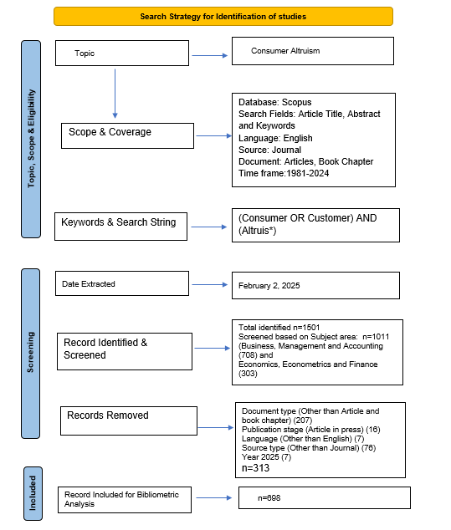
Figure 1: Flow diagram of the search strategy (Source: Adapted from Zakaria et al., 2021)
The study employs two main techniques of bibliometric analysis i.e. Performance analysis and Science mapping. The first examines the contributions of key research constituents in the field where as the second explores the relationship among these constituents. Publication trends, most productive Authors, number of articles, active years in research are included in performance analysis. Science mapping on the other hand includes Citation analysis, to identify the most influential publications; Co-authorship analysis, to explore the social structure of the field; and Keyword co-occurrence analysis or co-word analysis, to identify the main thematic clusters related to consumer altruism.
2.1 OVERVIEW OF DATASET USED
Table 1 summarizes the statistics of the dataset used in the study for bibliometric analysis.
Table 1: Overview of Dataset Used
Description | Results
MAIN INFORMATION ABOUT DATA
Timespan | 1981:2024
Sources (Journals) | 313
Documents | 698
Annual Growth Rate % | 10.56
Document Average Age | 7.86
Average citations per doc | 43.09
References | 41689
DOCUMENT CONTENTS
Keywords Plus (ID) | 895
Author's Keywords (DE) | 2251
AUTHORS
Authors | 1666
Authors of single-authored docs | 106
AUTHORS COLLABORATION
Single-authored docs | 112
Co-Authors per Doc | 2.72
International co-authorships % | 25.36
DOCUMENT TYPES
Article | 679
Review | 19

Source: Compiled using Biblioshiny
- ANALYSIS AND RESULTS
VOSviewer and Biblioshiny have been used to analyze the dataset sourced from the Scopus database.
3.1 PUBLICATION TRENDS
3.1.1 ANNUAL SCIENTIFIC PRODUCTION
Figure 2 shows the publication trends in the field of consumer altruism from 1981 to 2024. The results present a slow and uneven increase in the field of consumer altruism. The first publication in the Scopus database on this topic was reported in the year 1981. The study covers over 40 years, but notably the growth has been picking momentum since 2019 as more than 50 articles each year are published since then. This slow and uneven growth may be due to a lack of global awareness or economic constraints that make research in the area less feasible.
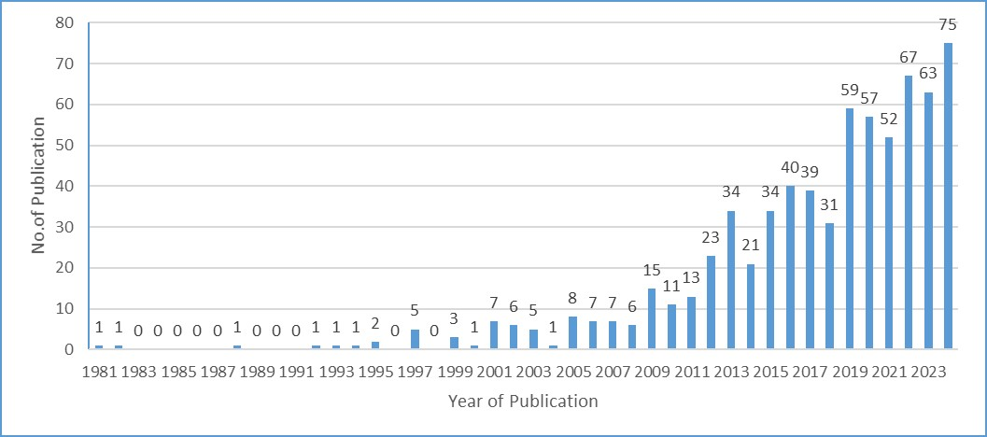

Figure 2: Annual Scientific Production (Source: Compiled using Biblioshiny)
3.1.2 MOST PRODUCTIVE AUTHORS
In the present study the most productive authors in the area of consumer altruism and consumer behavior are identified based on their publication history, citation count and H- index. This suggests the significant intellectual core of the research field by highlighting the most influential authors.
Table 2 is a compilation of the 10 most productive authors with their affiliations to help researchers seeking collaborations. KIM S., the most prolific author in the dataset has published 8 documents. KIM S. is highly impactful in terms of research contributions and high index factor indicating high influence and engagement in their field. Ahmed N. (Pakistan) is emerging with a rapid research pace. Sustained contributors like Irene Gil Saura (Spain) and Michael Lynn (USA) maintained a long-term engagement by having active research in this field. Most authors have a perfect ratio of 1.00, meaning each of their articles has, on average, enough citations to contribute to their H-index.

Table 2: Most Productive Authors, Number of Articles, Active Years in Research and H-index

Authors | Affiliation | Country | Active Years of research on the topic | No. of Articles on the topic | H- Index based on this dataset | Ratio  (H-Index/Articles)
Seeun Kim, Ph. D. | Department of Consumer and Design Sciences, Auburn University,Auburn, Alabama, USA | USA | 2014-202 | 8 | 7 | 0.875
Naveed Ahmed, Ph.D. | Department of Management Sciences, Virtual University of Pakistan, Lahore, Pakistan | Pakistan | 2023-202 | 5 | 5 | 1.0
Jayson Lusk, Ph.D. | Department of Agricultural Economics, Oklahoma State University, USA | USA | 2007-201 | 5 | 5 | 1.0
Michael Lynn, Ph.D. | School of Hotel Administration, Cornell University, Ithaca, New York, USA | USA | 2015-202 | 5 | 5 | 1.0
Wang Yong, Ph.D. | School of Management Science and Engineering, Shandong University of Finance and Economics, Jinah, Shandong, China | China | 2020-202 | 5 | 5 | 1.0
Irene Gil Saura, Ph.D. | University of Valencia, Spain | Spain | 2013-202 | 4 | 4 | 1.0
Yunhi Kim, Ph.D. | Department of Tourism Management, College of Business Administration, Dang-A University, Busan South Korea (current affiliation may vary) | South Korea | 2014-202 | 4 | 4 | 1.0
Sushant Kumar, Ph.D. | Department of Physics at Kent State University, USA | USA | 2018-202 | 4 | 4 | 1.0
Jihad Mohammed, Ph.D. | International Business School, Universiti Teknologi Malaysia, Kuala Lumpur | Malaysia | 2016-202 | 4 | 4 | 1.0
Source: Compiled using Biblioshiny

3.1.3 PRODUCTIVITY OF THE AUTHORS BASED ON LOTKA’S LAW:
Figure 3 states the relationship between the percentage of authors contributing to the field and number of documents. The Lotka’s Law states that a small percentage of authors contribute the majority of publications, while most authors publish only a few papers. The sharp decline at the beginning suggests that a large proportion (above 75%) of authors have written only one document, reinforcing Lotka’s principle of inverse square law. The present study agrees that a small group of highly productive authors hold significant influence in the field, shaping academic discourse. Since few individuals published extensively, there is a space for emerging researchers to contribute and establish themselves.
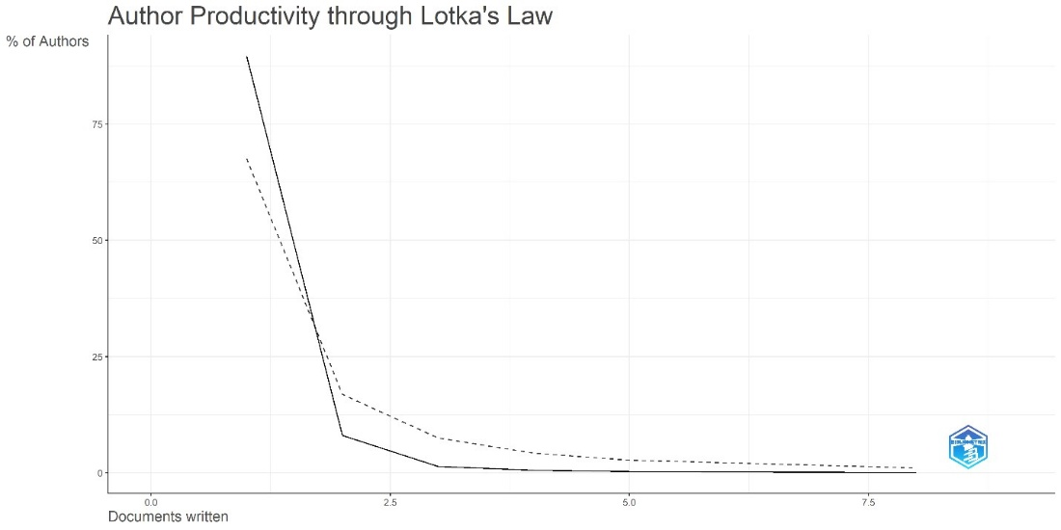

Figure 3: Author’s Productivity Through Lotka’s Law (Source: Compiled using Biblioshiny)
3.2 MOST INFLUENTIAL ARTICLES BASED ON CITATIONS
Identification of the most influential articles based on global citations is helpful for researchers to study and refer to reliable, foundational and widely used articles in the field which can be useful in further research.
3.2.1 TOP 10 MOST GLOBAL CITED ARTICLES
Table 3 enlists and classifies the top 10 most cited articles in the field of Consumer Altruism. The focus theme of these articles are Consumer Altruism, Consumer Behaviour, Sustainability, Environmental Concern, CSR, Green Marketing and Psychographics. All the top 10 papers are quantitative in nature and most of the articles have single-country authors.

Table 3: Top 10 Most Global Cited Articles

S.No | Authors | Countries of Authors | Title | Keywords | Year of Publication | Total Citation | Type of Research | Journal Details | Summary of the Study
1 | Pam Scholder Ellen, Deborah J. Webb, and Lois A. Mohr | Georgia | Building Corporate Associations: Consumer Attributions for Corporate Socially Responsible Programs | corporate social responsibility; corporate associations; motives; altruism; cause marketing; corporate reputation; commitment; congruency | 2006 | 1079 | Quantitative | Journal of the Academy of Marketing Science (Vol. 34, Issue 2, pp. 147-157),  Publisher -Springer | Consumer Perception towards a company’s motives for undertaking CSR activities influences and enhances a company’s image and consumer behaviour.
2 | Robert D. Straughan and James A. Roberts | USA | Environmental Segmentation Alternatives: A Look at Green Consumer Behavior in the New Millennium, | Green marketing, Consumer behaviour, Ecology, Psychographics | 1999 | 956 | Quantitative | Journal of Consumer Marketing  Publisher - Emerald | Explores evolving consumer behaviourof environmentally conscious consumers among college graduates. It suggests that psychographic factors like perceived consumer effectiveness and altruism are effective measures in profiling green consumers compared to other demographic aspects.
3 | Rifon, N. J., Choi, S. M., Trimble, C. S., & Li, H. | USA | Congruence Effect in Sponsorship: The Mediating Role of Sponsor Credibility and Consumer Attributions of Sponsor Motive |  | 2004 | 739 | Quantitative | Journal of Advertising  Publisher - Routledge | A good fit between the sponsor and event influences positive consumer perception and leads to altruistic attributions and enhanced credibility.
4 | Onwezen, M. C., Antonides, G., & Bartels, J. | The Netherlands | The Norm Activation Model: An exploration of the functions of anticipated pride and guilt in pro-environmental behaviour | Emotion sustainable Consumer Attitudes & Behavior General Environmental Economics Norms Self-regulation | 2013 | 691 | Quantitative | Journal of Economic Psychology  Publisher - Elsevier | Anticipated emotions like pride and guilt significantly mediate and influence environmentally friendly actions and behaviours.
5 | Lee, J.-S., Hsu, L.-T. (Jane), Han, H., & Kim, Y. | Hong Kong  USA  South Korea | Understanding how consumers view green hotels: how a hotel's green image can influence behavioural intentions | cognitive image; affective image; overall image; behavioural intentions; green hotels | 2010 | 671 | Quantitative | Journal of Sustainable Tourism  Publisher – Taylor & Francis | An eco-friendly image on guests of a hotel has a positive impact and leads to revisits, recommendations and premium chargers. Suggest focus on both cognitive and affective component in shaping the consumers’ perception.
6 | White, K., & Peloza, J. | Canada  USA | Self-Benefit Versus Other-Benefit Marketing Appeals: Their Effectiveness in Generating Charitable Support | charity, self-benefit, other-benefit, altruism, egoism, public self-image, norms | 2009 | 435 | Quantitative | Journal of Marketing  Publisher- Sage | Tailored messages enhance the effectiveness of donations. Self-Benefit marketing appeals are more private while others benefit marketing appeals are more effective in public settings.
7 | Akehurst, G., Afonso, C., & Martins Gonçalves, H. | UK  Portugal | Re-examining green purchase behaviour and the green consumer profile: new evidences | Green marketing, green consumer profile, green consumer behaviour, Ecological consciousness, Green purchase intention, Green purchase behaviour, Demographics, Psychographics | 2012 | 401 | Quantitative | Management Decision  Publisher - Emerald | Psychographic variables like perceived consumer effectiveness and altruism are more significant than demographic variables in predicting ecologically conscious behaviour (ECCB). A strong ECCB positively correlates with higher green purchase intentions and behaviour.
8 | Davies, J., Foxall, G. R., & Pallister, J. | UK | Beyond the Intention–Behaviour Mythology | attitude–behaviour relationship • consumer choice • multi-attribute theories • recycling | 2002 | 398 |  | Marketing Theory  Publisher - Sage | Proposes an integrated model for recycling. The study critiques traditional models linking intentions directly to behaviour. They propose an integrated model of recycling that incorporates cognitive, affective, situational factors suggesting that intentions alone insufficiently predict actual recycling behaviour.
9 | Barbarossa, C., & De Pelsmacker, P. | Italy  Belgium | Positive and Negative Antecedents of Purchasing Eco-friendly Products: A Comparison Between Green and Non-green Consumers | Eco-friendly products consumption Environment Self-identity Moral Obligation Intention– behavior gap Spillover effect Structural equation modeling Multi-group analysis | 2014 | 314 | Quantitative | Journal of Business Ethics  Publisher -Springer | Positive altruistic motivations like environmental concerns, green self-identity, and moral obligations are the key drivers of eco-friendly product purchases.
10 | Cook, A.., Kerr, G.., & Moore, K. | New Zealand | Attitudes and intentions towards purchasing GM food. | Consumer attitudes; Consumer behaviour; Intention | 2002 | 313 | Quantitative | Journal of Economic Psychology  Publisher - Elsevier | Self-identity, attitude, subjective norm, and perceived behavioural control significantly determine factors influencing consumer intentions to purchase Genetically Modified Food.

Source: Compiled using Biblioshiny

3.2.2 MOST CITED REFERENCES IN THE DATABASE
Figure 4 highlights the top 10 most local cited references in the database considered in the study. These references represent the most studied and cited articles by researchers in this database, highlighting them as foundational studies undertaken in this field. Fornell C. (1981) leads with 55 local citations, emphasizing its critical role in structural equation modelling (SEM) and measuring latent variables in consumer satisfaction analysis. Ajzen I. (1991) with 39 citations introduces the Theory of Planned Behaviour and states attitudes, subjective norms, and perceived behavioural control to an underlying foundation of beliefs about the behaviour. Schwartz (1977) with 29 citations explores normative influences on altruism, emphasizing social and personal norm in prosocial behaviour. Schwartz (1992) with 25 citations advances value theory, identifying universal human values across cultures, their structure, and impact on behaviour. His work highlights the role of values in guiding consumer choices, decision-making, and societal functioning. Bagozzi R.P. (1988) and Anderson J.C. (1988) with each over 20 citations reinforce the role of psychometric and behavioural research methodologies in measuring social behaviour. The presence of Hennig -Thurau T. (2004) with 23 citations reflects the growing interest in Customer Relationship Management (CRM) and measuring consumer opinion through electronic word-of-mouth(eWOM). Notably, Ellen P.S. (2006) with 20 citations also suggests a strong connection between corporate social responsibility (CSR) and consumer behaviour. This also is the most globally cited article.
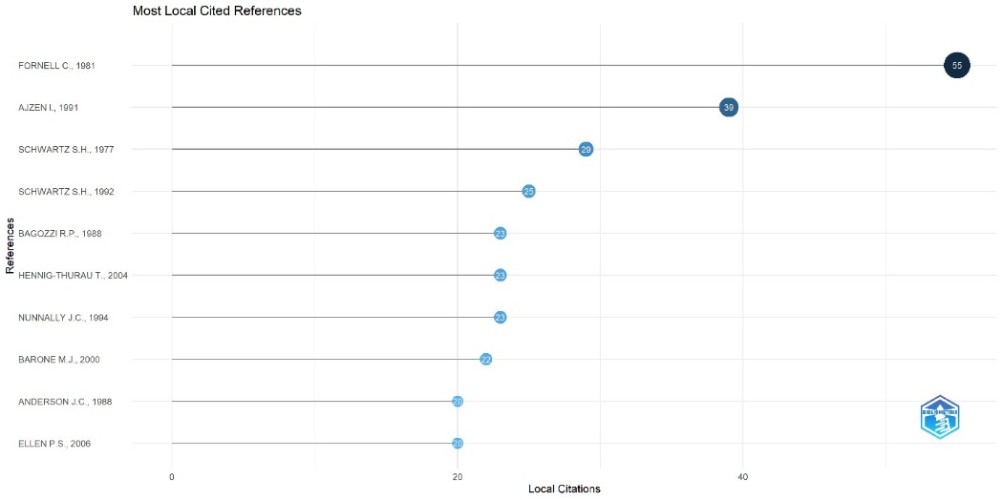
Figure 4: Most Local Cited References (Source: Compiled using Biblioshiny)
5.2.3 MOST PRODUCTIVE JOURNALS
Understanding most productive journals can help researchers to identify sources of most impactful and latest studies in the field. These can be used by them to search the trend related to their research area or identify journal to publish their work.
Table 4: Most Productive Journals related to consumer altruism
Sources | Publisher | Impact Factor* | No. of Articles
Journal Of Business Research | ScienceDirect | 10.5 | 30
Journal Of Cleaner Production | Elsevier | 9.8 | 20
European Journal Of Marketing | Emerald Publishing | 3.7 | 19
Journal of Retailing and Consumer Services | ScienceDirect | 11.0 | 19
International Journal of Consumer Studies | Wiley-Blackwell | 8.6 | 16
Journal of Business Ethics | Springer | 5.9 | 16
Asia Pacific Journal of Marketing and Logistics | Emerald Publication | 3.9 | 13
Psychology and Marketing | Wiley | 8.9 | 11
International Journal of Hospitality Management | ScienceDirect | 10.0 | 10
Journal Of Consumer Marketing | Emerald Publishing | 2.7 | 10
Source: Compiled using Biblioshiny
*Impact Factors are based on 2023 Journal Citation Reports (Clarivate Analytics, 2024)
3.3 COLLABORATIVE PATTERN BETWEEN PROMINENT AUTHORS
Collaborative pattern among prominent authors aims to explore how researchers have worked in collaboration for making scholarly contributions to the field. For exploring the collaborative pattern in the domain of consumer altruism, co-authorship analysis and country co-authorship analysis is performed.
3.3.1 CO-AUTHORSHIP ANALYSIS
Co-authorship analysis is a quantitative method that explores the collaborative pattern between the authors based on number of mutual documents. Figure 5 shows network visualization map of co-authorship analysis in the domain of consumerism altruism. In co-authorship analysis for the authors who have worked in the field of consumerism altruism, a total of 1719 authors have been found contributing scholarly articles. On setting a threshold of authors who have contributed at least 2 papers having at least 2 citations, it is found that out of 1719 only 139 authors qualify the threshold criteria. Further in co-authorship analysis, strength of co-authorship links was evaluated and results of the same are shown in the table 5. Following the specified thresholds, 5 authors are found to have maximum link strength in the context of collaborative work in the field. Ahmad, Naved (Ahmad & et al., 2024, 2023) have the highest total link strength of 9 followed by Ahmad, Aqueel (Ahmad & et al., 2024, 2023) having total link strength of 6, then it is Han, heesup (Han & et al., 2024, 2023) with a link strength of 4 followed by Siddique, Irfan (Siddique & et al., 2024, 2023) with total link strength of 4 and at last is Samad, Sarminah (Samad & et al., 2024, 2023) with link strength of 3. Among all the authors working in this field, only 5 authors are found to have connections at the selected threshold indicating a huge gap for collaborative work in the field of consumer altruism. Analyzing their work reveals a strong focus on the relationship between CSR, consumer advocacy and brand advocacy, with consumer altruism as an influencing factor. Also, it is found that they have done collaborative work keeping their focus on the hospitality sector only.
TABLE 5: CO-AUTHORSHIP ANALYSIS (SOURCE: COMPILED USING VOSVIEWER)
Author | Documents | Citations | Total link strength
Ahmad, Naveed | 5 | 86 | 9
Ahmad, Aqeel | 3 | 53 | 6
Han, Heesup | 3 | 709 | 4
Samad, Sarminah | 3 | 239 | 3
Siddique, Irfan | 2 | 35 | 4
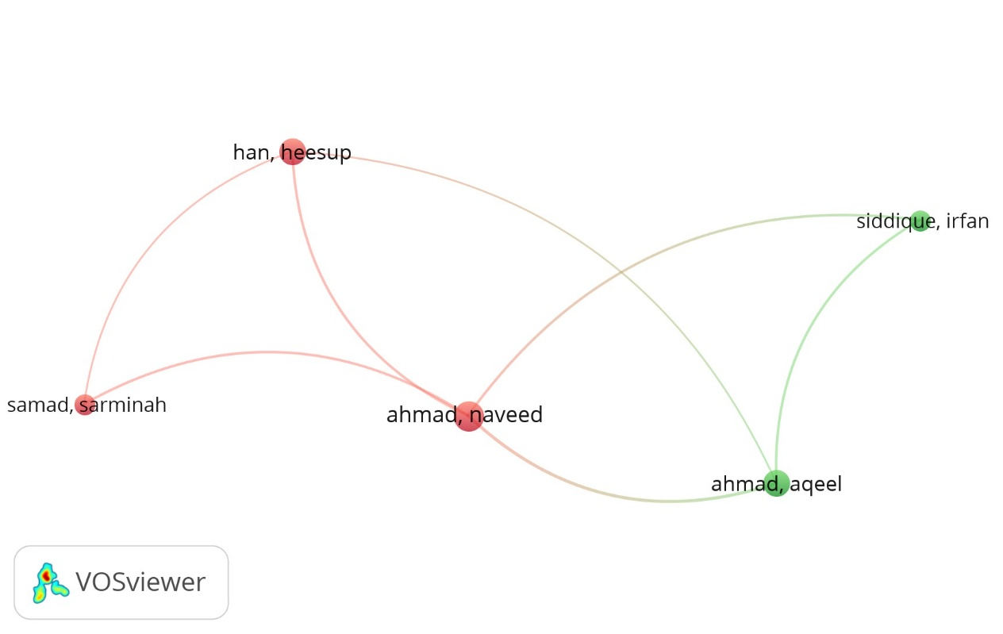
Figure 5: Network Visualization map of Co- Authorship (Source: Compiled using VOSviewer)
3.3.2 MOST PRODUCTIVE COUNTRIES & COUNTRY CO-AUTHORSHIP ANALYSIS
Since 1981, both developed and developing countries have made contributions to the research in the field. USA followed by China and the United Kingdom are the leading countries' contributing articles in the area of consumer altruism. USA leads with 205 articles, followed by China with 68 documents and the United Kingdom with 67 documents. Even though the United Kingdom has slightly lesser documents than China but global link strength of the United Kingdom is far more than China. With reference to country wise citation scores, USA is a leading country with a total citation score of 11678 followed by United Kingdom with a total citation of 4061 and China with 2210 total citation score. With reference to average of citation per document, South Korea and Canada are found to have a higher average of citation per document compared to other countries. This can be attributed to the growing awareness about the importance of consumer altruism among these countries. Table 6 provides a list of 10 most productive countries.

TABLE 6: MOST PRODUCTIVE COUNTRIES
Rank | Country | Documents | Citations | Average Citation /Document | Total link strength
1. | United states | 205 | 11678 | 56.96 | 77
2. | China | 68 | 2210 | 32.50 | 38
3. | United Kingdom | 67 | 4061 | 60.61 | 63
4. | India | 48 | 1796 | 37.41 | 25
5. | Australia | 42 | 1317 | 31.35 | 30
6. | Spain | 41 | 1159 | 28.26 | 19
7. | France | 39 | 1254 | 32.153 | 38
8. | Germany | 33 | 1322 | 40.06 | 14
9. | South Korea | 29 | 1976 | 68.13 | 23
10. | Canada | 27 | 1743 | 64.55 | 21
Source: Compiled using VOSviewer
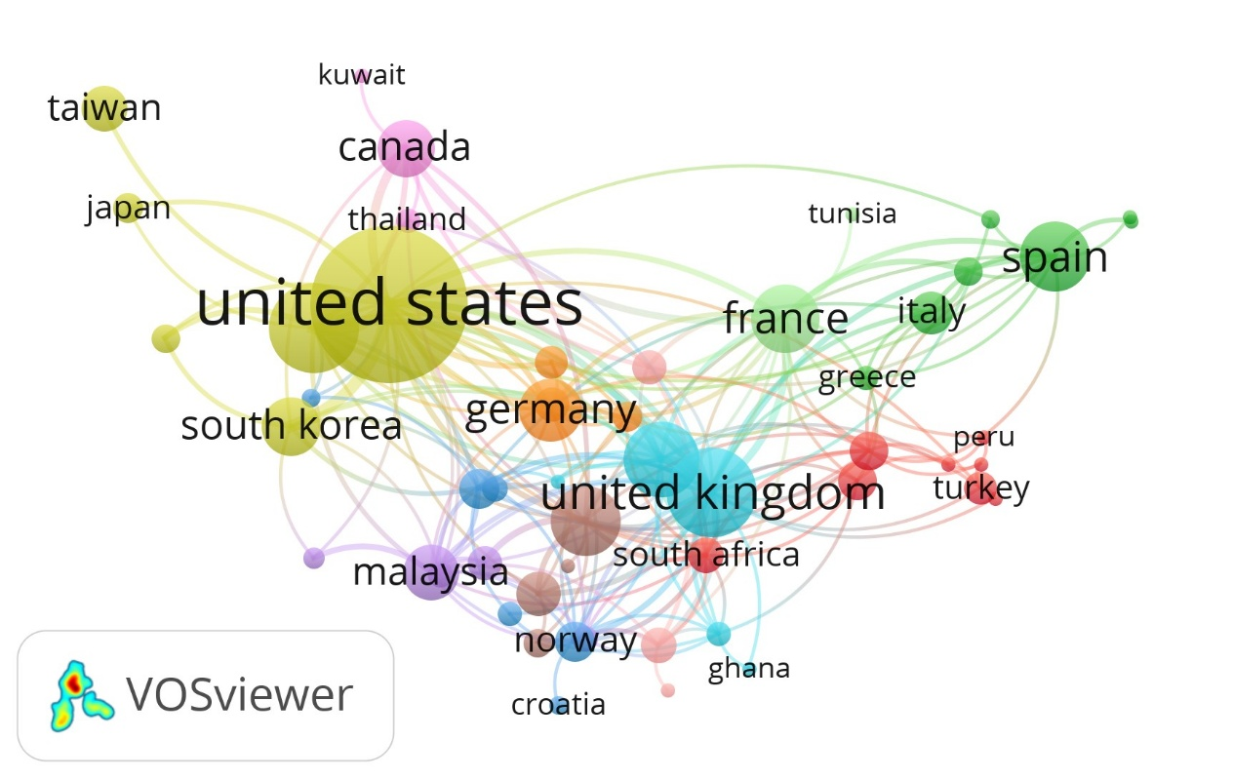

Figure 6: Network Visualization Map of Country Co-authorship (Source: Compiled using VOSviewer)
Country co-authorship analysis is done to find clusters of countries where collaborative research work has been done in context of consumer altruism. For this purpose, a threshold of countries with at least two documents cited at least two times is used in VOSviewer. A total of 56 out of 76 countries are found to meet the threshold criteria. While exploring country co-authorship linkage, out of 56 qualified countries, authors from 53 countries only are found to have such linkage which are grouped in 11 clusters as shown in the figure 6. In the figure, nodes represent the country and lines represent the linkage between the countries. The clustering of countries indicates that consumer altruism is a globally researched topic from different perspectives like corporate social responsibility, influence of social and regional factors.
3.3.3 KEYWORD ANALYSIS
Keyword analysis is performed to create word cloud and to find the clusters of co-occurring keywords among articles in the dataset.
WORD CLOUD
A word cloud is a visual depiction of keywords extracted from source dataset based on their occurrence frequency. The greater the frequency of occurrence of a keyword in the source dataset, the larger is the size of the keyword in the word cloud. In this study keyword “altruism” is the most used keyword followed by “consumption behavior”. The primary 10 keywords and their frequency of occurrence in studies related to consumer altruism are shown in table 7. Figure 7 represents the word cloud of keywords.
TABLE 7: PROMINENT KEYWORDS
Terms | Frequency
Altruism | 61
Consumption Behavior | 48
Human | 13
Sustainable Development | 13
Article | 12
Consumer Behavior | 12
Marketing | 12
Sales | 12
Sustainability | 12
Willingness to pay | 12
Source: Compiled using Biblioshiny
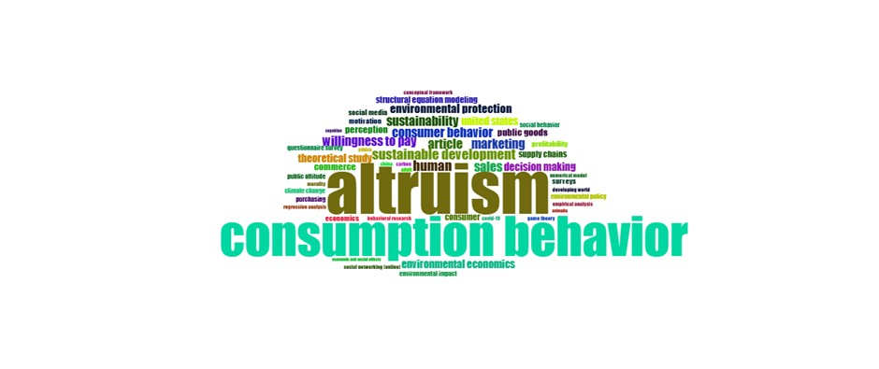
Figure 7: Word cloud (Source: Compiled using Biblioshiny)
KEYWORD CO-OCCURRENCE ANALYSIS
Keyword co-occurrence analysis is a technique of extracting most prominent keywords based on their repeated occurrence in an entire set of source publications. It involves finding the most prominent co-occurring keywords and strength of linkage between co-occurring keywords. For extracting most significant co-occurring keywords within the source publications, the minimum number of keyword co-occurrence is taken to be 10. On the threshold of 10, out of 2886 keywords, only 36 keywords met the threshold criterion and are grouped into 5 clusters shown in figure 8. Figure 8 shows a network visualization map of co-occurring keywords. In the figure each node represents a co-occurring keyword extracted from title and abstract of source publications. The size of the node in figure represents the quantum of co-occurrences of the keywords. Lines connecting two nodes represent the linkage between the keywords. The details of clusters of co-occurring keywords as visible in network visualization map of keyword co-occurrence is as follows-
Cluster 1 (Red) in the figure contains the following 10 keywords - Consumption behavior, ethical consumption, ethics, green consumption, green marketing, marketing, sustainability, sustainable consumption, theoretical study, Theory of Planned Behaviour. Publications with these keywords focused on alignment of consumer behavior with ethical and sustainable consumption practices.
Cluster 2 (green) is found to have following 7 keywords- Article, consumer, consumer behavior, human, motivation, organic food, social media. Articles featuring these keywords focused on consumer behavior and purchase motivation for organic food, with emphasis on role of social media.
Cluster 3 (blue) consists of 7 items namely Altruism, cause-related marketing, corporate social responsibility, covid-19, innovation, purchase intention, trust. The keywords of this cluster indicates that studies with these keywords examined how CSR and cause related marketing efforts framed consumer trust, altruistic perception and purchase intention during COVID-19.
Cluster 4 (yellow) has 6 items i.e.- Consumer behavior, decision making, environmental protection, sales, SEM, sustainable development. Studies with these keywords focused on linkage between consumer decision making, sustainable development and environmental protection. Also these studies are quantitative in nature with Structural Equation Modelling as a common method of analysis.
Cluster 5 (purple) contains 6 items namely Altruistic value, environmental concern, perception, social responsibility, values, willingness to pay. Studies with these keywords have focused on intersection of consumers' altruistic values, environmental concern, purchase of socially responsible products and willingness to pay for such products.
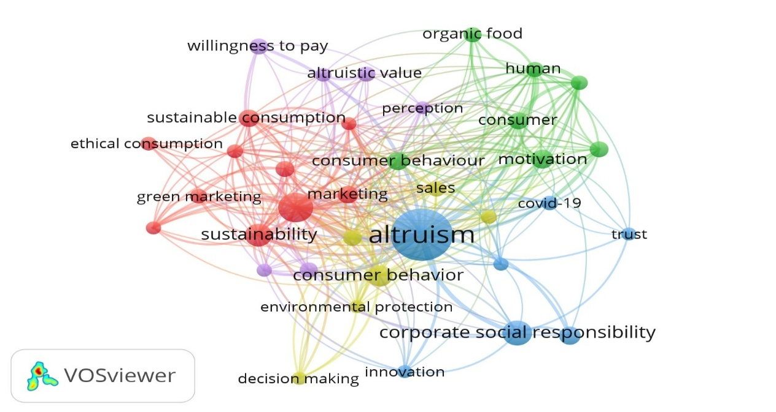
Figure 8: Network Visualization Map of Keyword co-occurrence (Source: Compiled using VOSviewer)
3.3.4 CO-CITATION ANALYSIS
Co-citation analysis involves evaluation of researchers’ work that are cited together in the source publication. Figure 9 represents the network visualization map of co-cited authors. Table 8 provides details of clusters of co-cited author’s work, with their centrality, closeness and PageRank measures.
Cluster 1 (red) contains work of thirteen co-cited authors. In this cluster, publication of Eleen, P. S. (2006) is found to have the highest betweenness centrality score, indicating its pivotal role in connecting various publications. Cluster 2 (blue) includes co-cited work of fifteen authors. Among these Fornell, C. (1981) has the highest betweenness score of 566.755 followed by Fishbein, M. (1975) with a betweenness score of 149.252. Cluster 3 (green) is the largest cluster containing co-cited work of nineteen authors. Publication of Ajzen, I. (1991) in this cluster has the highest betweenness score of 161.638 followed by Schwartz, S. H. (1977) with a betweenness score of 133.536. Cluster 4 is the smallest, comprising co-cited work of two authors.
Ajzen, I. has extensively worked in the field of Theory of Planned Behaviour, often in collaboration with Fishbein, M. while Schwartz, S. H. has worked on Normative Influence on Altruism. Fornell’s work focuses on Structural Equation Modelling while Fishbein (1975) research contributes to Theory of Reasoned Action. High value of betweenness score of Fornell and Ajzen suggests that their work acts as a linking bridge for many other research works. Closeness centrality of both these authors is also comparatively high which confirms their deep integration into the network ensuring rapid dissemination of their ideas among the clusters. From this it is concluded that the working field of these influential authors are common grounds for working in the domain of consumer altruism.
Fornell C. (1981) emerged as the most influential author based on PageRank (0.058), indicating a strong citation impact. Schwartz S.H. (1977) and Ajzen I. (1991) also ranked highly, suggesting a foundational role in the field.

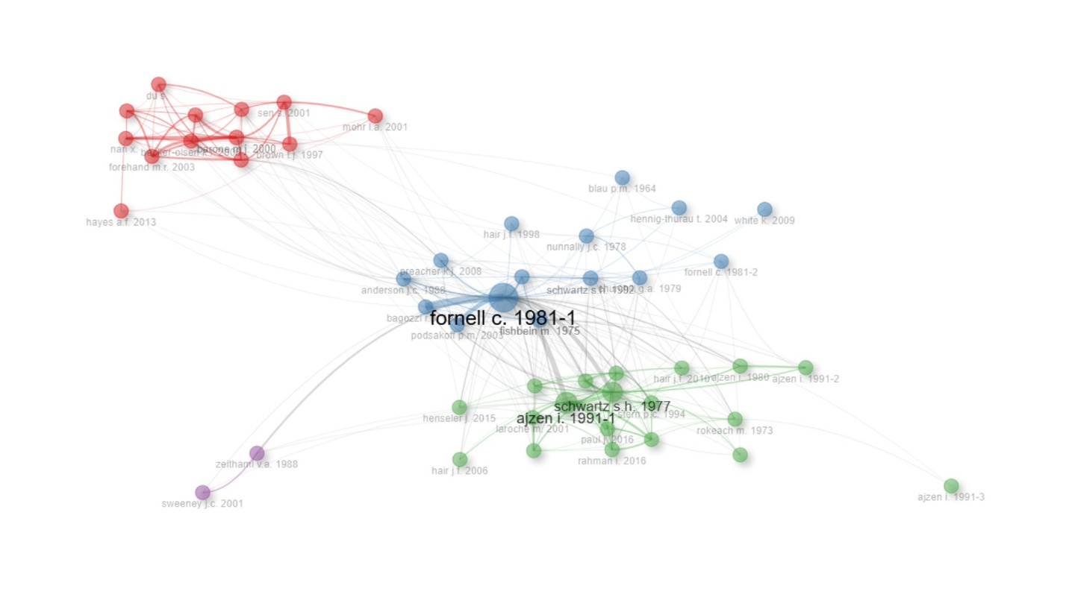
Figure 9: Network Visualization Map of Co-citation Analysis (Source: Compiled using Biblioshiny)
TABLE 8: CLUSTERS BASED ON CO-CITATION ANALYSIS
Cluster & Node | Betweenness | Closeness | PageRank
Cluster 1 (Red)
Barone M.J. 2000 | 5.395 | 0.008 | 0.032
Ellen P.S. 2006 | 24.303 | 0.009 | 0.029
Sen S. 2001 | 3.622 | 0.007 | 0.025
Nan X. | 3.23 | 0.008 | 0.024
Yoon Y. | 0.344 | 0.006 | 0.019
Hayes A.F. 2013 | 3.747 | 0.008 | 0.007
Becker-Olsen K.L. 2006 | 6.067 | 0.007 | 0.029
Brown T.J. 1997 | 18.408 | 0.008 | 0.022
Du S. | 0 | 0.003 | 0.017
Ellen P.S. 2000 | 2.41 | 0.008 | 0.022
Forehand M.R. 2003 | 6.569 | 0.008 | 0.023
Du S. 2007 | 7.013 | 0.007 | 0.017
Mohr L.A. 2001 | 2.706 | 0.008 | 0.011
Cluster 2 (Green)
Fornell C. 1981-1 | 566.755 | 0.012 | 0.058
Fishbein M. 1975 | 149.252 | 0.009 | 0.023
Schwartz S.H. 1992 | 71.851 | 0.009 | 0.025
Bagozzi R.P. 1988 | 3.827 | 0.007 | 0.02
Hennig-Thurau T. 2004 | 0 | 0.007 | 0.01
Nunnally J.C. 1994 | 47.002 | 0.008 | 0.022
Anderson J.C. 1988 | 88.47 | 0.008 | 0.022
Nunnally J.C. 1978 | 19.169 | 0.008 | 0.015
Podsakoff P.M. 2003 | 13.875 | 0.008 | 0.021
Blau P.M. 1964 | 1.044 | 0.007 | 0.008
Preacher K.J. 2008 | 35.193 | 0.008 | 0.017
White K. 2009 | 0 | 0.003 | 0.006
Fornell C. 1981-2 | 6.241 | 0.007 | 0.009
Hair J.F. 1998 | 0.121 | 0.007 | 0.008
Churchill G.A. 1979 | 2.533 | 0.008 | 0.014
Cluster 3 (Blue)
Ajzen I. 1991-1 | 161.638 | 0.01 | 0.045
Schwartz S.H. 1977 | 133.536 | 0.01 | 0.05
Ajzen I. 1980 | 38.13 | 0.009 | 0.014
Laroche M. 2001 | 23.622 | 0.009 | 0.023
Ajzen I. 1991-2 | 6.002 | 0.008 | 0.012
Hair J.F. 2010 | 20.796 | 0.009 | 0.019
Rokeach M. 1973 | 4.153 | 0.007 | 0.018
Stern P.C. 1993 | 32.642 | 0.009 | 0.031
Stern P.C. 1994 | 35.232 | 0.009 | 0.031
Steg L. 2005 | 46.806 | 0.01 | 0.028
Straughan R.D. 1999 | 6.018 | 0.009 | 0.017
Ajzen I. 1991-3 | 0 | 0.007 | 0.005
Henseler J. 2015 | 10.686 | 0.008 | 0.01
Paul J. 2016 | 0 | 0.008 | 0.028
Stern P.C. 2000-1 | 20.534 | 0.009 | 0.022
Yadav R. 2016 | 5.234 | 0.009 | 0.009
Rahman I. 2016 | 0 | 0.008 | 0.026
Stern P.C. 2000-2 | 0.727 | 0.008 | 0.028
Hair J.F. 2006 | 5.353 | 0.009 | 0.007
Cluster 4 (Purple)
Sweeney J.C. 2001 | 0 | 0.009 | 0.011
Zeithaml V.A. 1988 | 4.743 | 0.009 | 0.012
Source: Compiled using Biblioshiny
3.4 PROGRESSION OF THEMES
To show the conceptual structure of research on consumer altruism, a thematic map was built based on the co-occurrence of the author’s keywords using Biblioshiny. Figure 10 represents the thematic map. This map categorizes themes based on relevance (centrality) and development (density), offering insights into their significance and progression.
Motor themes (Core Drivers): There are two clusters in this quadrant. Cluster1 has topics like altruism, consumption behaviour and marketing and Cluster 2 has topics such as human, article and consumer that are highly relevant and well-developed, shaping research and business strategies.
Niche themes (Specialized areas): Themes like Supply chain, profitability and carbon are well developed but less central, requiring integration into broader discussions in context of consumer altruism.
Basis themes (Foundational concepts): Sustainable development, consumer behavior and sales are relevant but need further research to strengthen their theoretical foundation.
Emerging or declining themes: Topics like food consumption, food market, developing world and competition are undergoing change and need continuous monitoring to determine their evolving significance in context of consumer altruism.
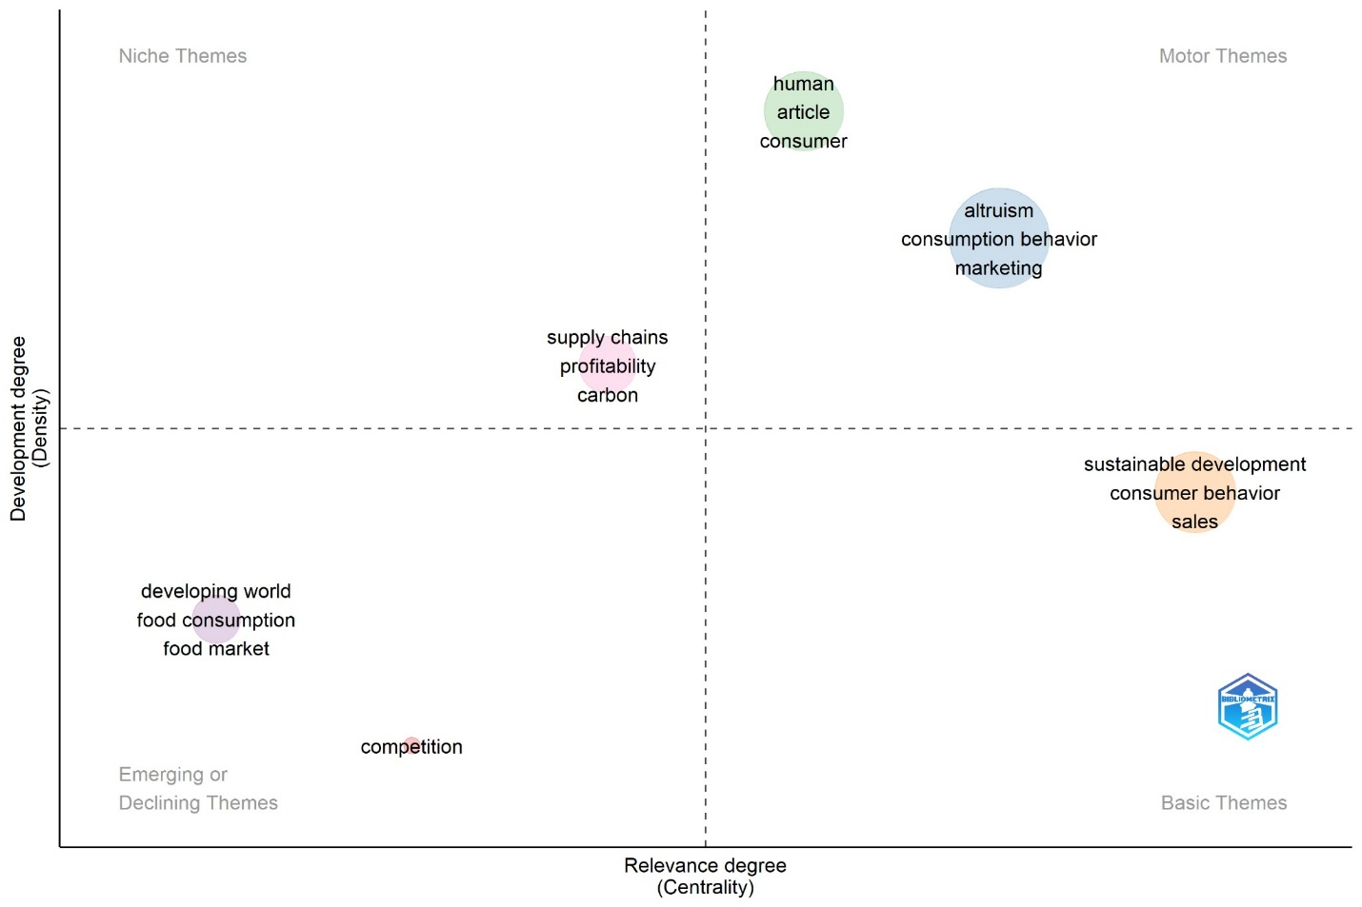
Figure 10: Thematic Map (Source: Compiled using Biblioshiny)
- DISCUSSION AND CONCLUSION
The bibliometric analysis developed from various perspectives within this study provides comprehensive and relevant insights that allow the identification of fundamental characteristics and systemization of the body of knowledge of this important research field on consumer altruism. Based on the results of the bibliometric analysis, the most popular themes, trends and directions for future research were discussed, confirming that the research field of consumer altruism is vital and of increasing interest to both academia and business.
This bibliometric study offers a holistic visual image of the intellectual structure of knowledge related to consumer altruism, providing a comprehensive assessment of the literature related to this subject. The study has taken articles from 1981, when the first article on consumer altruism was recorded in the Scopus Database. Since then, a total of 698 papers in the area of Business Management and Finance have been published. The data clearly states a dearth of literature in this field, which is still less discussed by researchers as isolating altruism behaviour in consumer behaviour is challenging. Data shows that 56 countries have contributed in this pool and most of the articles are single country authored. USA leads the publication count with 205 articles followed by China with 68 articles. The publication trends are slow and uneven up till 2019. The leading global authors in the domain of consumer altruism are from diverse fields making the importance of consumer altruism evident in different sectors. Since few individuals published extensively, there is space for emerging researchers to contribute and establish themselves. Most of the leading articles are by authors of a single country, highlighting low inter-country co-authorship and collaborations and also providing space for collaborations and associations between authors, institutions and countries. Word cloud and keyword co-occurrence analysis reveals the fact that future researchers desirous to contribute significantly in the field of consumer altruism must explore the publications focusing on corporate social responsibility, ethical and sustainable consumption practices, environmental protection, willingness to pay for socially responsible products. Based on insights from most cited references and co-citation analysis, it is concluded that future researchers must refer seminal work done by Ajzen I., Fornell, C., Fishbein, M., Schwartz S.H., Eleen, P. S., Bagozzi R.P. and Anderson J.C. for advancing scholarly contributions in the domain of consumer altruism. The thematic map provides a strategic overview of the conceptual landscape, highlighting areas of strength, emerging interests and gaps that require further exploration. By leveraging motor themes, refining foundational concepts and integrating niche insights, meaningful advancements can be made in consumer behavior, sustainability and marketing.
- LIMITATIONS OF THE STUDY AND FUTURE WORK DIRECTIONS
Like any research, this study is not without limitations. First limitation lies in the fact that only one database (Scopus) has been considered with main focus on subject areas of Business Management and Economics and Finance, as a result, relevant insights from other disciplines may have been overlooked. Secondly, books, conference papers and reviews were excluded, even though they could contribute valuable perspectives.
Based on the findings of this bibliometrics analysis, several key directions for future research in domain of consumer altruism have emerged. Future research could integrate insights from Psychology, Behavioural Economics and Sociology to develop a more holistic understanding of this topic. Investigating the impact of cultural differences on altruistic consumer behaviour can provide deeper insights into differences or similarities in global consumption patterns. Examining the intersection of altruism, sustainability and ethical consumption can help identify how businesses can encourage responsible consumer behaviour. Developing standardized frameworks and methodologies to assess Consumer Altruism across different countries, sectors and demographics could enhance comparability and reliability in research findings. Thus, investigating how businesses can effectively communicate and market altruistic values to consumers while maintaining authenticity and avoiding ethical misrepresentation could be an area to work in future.
Conclusion
Conflict of Interest:
The authors declare that they have no conflict of interest associated with this paper.

COMPETING INTERESTS DISCLAIMER:
Authors have declared that they have no known competing financial interests OR non-financial interests OR personal relationships that could have appeared to influence the work reported in this paper.
REFERENCES
Ahmad, N., Ahmad, A., & Siddique, I. (2023). Responsible tourism and hospitality: The intersection of altruistic values, human emotions, and corporate social responsibility. Administrative Sciences, 13(4), 105. https://doi.org/10.3390/admsci13040105
Ahmad, N., Ahmad, A., & Siddique, I. (2024). Beyond self‐interest: how altruistic values and human emotions drive brand advocacy in hospitality consumers through corporate social responsibility. Corporate Social Responsibility and Environmental Management, 31(3), 2439-2453. https://doi.org/10.1002/csr.2701
Ahmad, N., Ahmad, A., Lewandowska, A., & Han, H. (2024). From screen to service: How corporate social responsibility messages on social media shape hotel consumer advocacy. Journal of Hospitality Marketing & Management, 33(3), 384-413. https://doi.org/10.1080/19368623.2023.2271448
Ahmad, N., Samad, S., & Han, H. (2023). Travel and tourism marketing in the age of the conscious tourists: A study on CSR and tourist brand advocacy. Journal of Travel & Tourism Marketing, 40(7), 551-567. https://doi.org/10.1080/10548408.2023.2276433
Ahmad, N., Samad, S., & Mahmood, S. (2024). Sustainable pathways: The intersection of CSR, hospitality and the United Nations’ sustainable development goals. Current Issues in Tourism, 1-20. https://doi.org/10.1080/13683500.2024.2313047
Ajzen, I. (1991). The theory of planned behavior. Organizational Behavior and Human Decision Processes, 50(2), 179–211. https://doi.org/10.1016/0749-5978(91)90020-T
Ajzen, I., & Fishbein, M. (1975). A Bayesian analysis of attribution processes. Psychological bulletin, 82(2), 261. https://doi.org/10.1037/h0076477
Akehurst, G., Afonso, C., & Gonçalves, H. M. (2012). Re-examining green purchase behaviour and the green consumer profile: New evidences. Management Decision, 50(5), 972–988. https://doi.org/10.1108/00251741211227726
Anderson, J. C. (1988). Structural equation modeling in practice: A review and recommended two-step approach. Psychological Bulletin, 103(3), 411–423. https://doi.org/10.1037/0033-2909.103.3.411
Aquino, K., & Reed, A. (2002). The self-importance of moral identity. Journal of Personality and Social Psychology, 83(6), 1423–1440. https://doi.org/10.1037/0022-3514.83.6.1423
Aria, M., & Cuccurullo, C. (2017). bibliometrix: An R-tool for comprehensive science mapping analysis. Journal of Informetrics, 11(4), 959-975. https://doi.org/10.1016/j.joi.2017.08.007
Bagozzi, R. P. (1988). The rebirth of attitude research in marketing. Journal of the Market Research Society, 30(2), 163–195.
Barbarossa, C., & De Pelsmacker, P. (2014). Positive and negative antecedents of purchasing eco-friendly products: A comparison between green and non-green consumers. Journal of Business Ethics, 134(2), 229–247. https://doi.org/10.1007/s10551-014-2425-z
Batson, C. D. (1991). The altruism question: Toward a social-psychological answer. Erlbaum.
Becker, G. S. (1976). The economic approach to human behavior. University of Chicago Press.
Cook, A. J., Kerr, G. N., & Moore, K. (2002). Attitudes and intentions towards purchasing GM food. Journal of Economic Psychology, 23(5), 557–572. https://doi.org/10.1016/S0167-4870(02)00117-4
Davies, J., Foxall, G. R., & Pallister, J. (2002). Beyond the intention–behaviour mythology: An integrated model of recycling. Marketing Theory, 2(1), 29–113. https://doi.org/10.1177/1470593102002001645
Ellen, P. S., Webb, D. J., & Mohr, L. A. (2006). Building corporate associations: Consumer attributions for corporate socially responsible programs. Journal of the Academy of Marketing Science, 34(2), 147–157. https://doi.org/10.1177/0092070305284976
Fehr, E., & Fischbacher, U. (2003). The nature of human altruism. Nature, 425(6960), 785-791. https://doi.org/10.1038/nature02043
Fornell, C. (1981). Structural equation models with unobservable variables and measurement error: Algebra and statistics. Journal of Marketing Research, 18(3), 382–388. https://doi.org/10.2307/3150980
Hennig-Thurau, T., Gwinner, K. P., Walsh, G., & Gremler, D. D. (2004). Electronic word-of-mouth via consumer-opinion platforms: What motivates consumers to articulate themselves on the internet? Journal of Interactive Marketing, 18(1), 38–52. https://doi.org/10.1002/dir.10073
Jin-Soo Lee , Li-Tzang (Jane) Hsu , Heesup Han & Yunhi Kim (2010): Understanding how consumers view green hotels: how a hotel's green image can influence behavioural intentions, Journal of Sustainable Tourism, 18:7, 901-914. https://doi.org/10.1080/09669581003777747
Moosmayer, D. C., Dale, L., Schleer, C., & Mühlbacher, H. (2019). International consumer altruism: Conceptualization, measurement, and cross-national differences. International Marketing Review, 36(5), 640-664. https://doi.org/10.1108/IMR-12-2018-0363
Nora J. Rifon , Sejung Marina Choi , Carrie S. Trimble & Hairong Li (2004). Congruence Effects in Sponsorship: The Mediating Role of Sponsor Credibility and Consumer Attributions of Sponsor Motive, Journal of Advertising, 33:1, 30-42. https://doi.org/10.1080/00913367.2004.10639151
Onwezen, M. C., Antonides, G., & Bartels, J. (2013). The Norm Activation Model: An exploration of the functions of anticipated pride and guilt in pro-environmental behaviour. Journal of Economic Psychology, 39, 141–153. https://doi.org/10.1016/j.joep.2013.07.005
Robert D. Straughan, James A. Roberts, (1999) "Environmental segmentation alternatives: a look at green consumer behavior in the new millennium", Journal of Consumer Marketing, 16 (6), 558-575. https://doi.org/10.1108/07363769910297506
Schwartz, S. H. (1977). Normative influences on altruism. Advances in Experimental Social Psychology, 10, 221–279. https://doi.org/10.1016/S0065-2601(08)60358-5
Schwartz, S. H. (1992). Universals in the content and structure of values: Theoretical advances and empirical tests in 20 countries. Advances in Experimental Social Psychology, 25, 1–65. https://doi.org/10.1016/S0065-2601(08)60281-6
White, K., & Peloza, J. (2009). Self-Benefit Versus Other-Benefit Marketing Appeals: Their Effectiveness in Generating Charitable Support. Journal of Marketing, 73(4), 109–124. https://doi.org/10.1509/jmkg.73.4.109
White, K., Habib, R., & Hardisty, D. J. (2019). How to SHIFT consumer behaviors to be more sustainable: A literature review and guiding framework. Journal of Marketing, 83(3), 22-49. https://doi.org/10.1177/002224291982564
Zakaria, R., Ahmi, A., Ahmad, A. H., & Othman, Z. (2020). Worldwide melatonin research: a bibliometric analysis of the published literature between 2015 and 2019. Chronobiology International, 38(1), 27–37. https://doi.org/10.1080/07420528.2020.1838534

Loktas Law

Prisma format/Metheod

