Minireview Article
The Communication and Innovation of Chinese Calligraphy Art in the Digital Era

__________________________________________________________________________________________

Abstract: Chinese calligraphy art is an important carrier of Chinese culture; its communication mode and innovation mode in the digital environment are gradually becoming the focus of scholars' attention. To explore the influence of digital technology in the process of inheritance and development of calligraphy art, this study takes the literature review method as the main research method to sort out research achievements at home and abroad in digital calligraphy and summarize its current situation of dissemination, channels of dissemination, and advantages and disadvantages of technical application. Research results show that the integration of digital technology provides new ideas and ways to inherit the art. It can not only open up new audience groups and channels for dissemination, but also enhance cultural identity and international influence. There are also practical problems, such as uneven quality of resources, of traditional spirit, and copyright protection, in the process of digital communication. The development of digital calligraphy reflects the process of integration and innovation of traditional art and digital technology. It provides a new direction for the sustainable inheritance and innovation of calligraphy art. This research provides a theoretical basis for people to understand the dissemination mechanism and development trend of Chinese calligraphy art in the digital age, and has positive significance in promoting the creative development and innovative development of China's excellent traditional culture.

Keywords: Digital Era; Calligraphy Art; Cultural Communication; Digital Technology; Innovative Development

___________________________________________________________________________
1. Introduction

The digital age takes information technology as core, digital technology as support, emerging technology such as the Internet, big data, and artificial intelligence as engine, driving social revolution and change. In this process, the inheritance and development of traditional art have new opportunities and challenges. Digital technology not only provides more convenient means to transmit traditional art, breaks through the limitation of time and space, and actively adapts traditional art actively adapt to communication laws and aesthetic pursuits of the digital age, to realize digital transformation and maintain the charm of art. Chinese calligraphy is profound and long-standing. It reflects the aesthetic spirit and cultural pursuit of the Chinese nation, and accumulates rich historical connotation in the process of inheritance(Hongming, 2024; Xiaoli & Shenglong, 2024). With the continuous development of digital technology, calligraphy art and digital media are integrating and innovating, and a new field of "digital calligraphy" has emerged. Digital calligraphy reproduces the process of writing by simulating the physical properties of brush, ink color, and paper, expanding the form of creation and dissemination of calligraphy(Yang, 2022; Zhang J., 2019). This integration promotes the innovative expression of calligraphy art, providing a new space for its inheritance and popularization. However, digital transformation has also brought about new problems. How to achieve technological innovation while retaining the core spirit of calligraphy has become a core issue of concern in the academic circle.

At present, certain progress has been made in the research of digital calligraphy, but the research perspectives are still rather scattered. From the perspective of art theory, some scholars adopt semiotics methods to analyze the strokes and structures in digital calligraphy and reveal its deep meanings (Zhao, 2015). However, this research method mainly focuses on the internal logic of artistic symbols, and it is difficult to fully present the actual communication path and audience feedback of calligraphy. Other studies have focused on specific applications such as digital display and online education platforms(Li, 2024), but have not fully compared the differences and effectiveness of various types of calligraphy dissemination channels. Furthermore, research on international communication is still relatively insufficient, especially in a cross-cultural context. How digital calligraphy can achieve effective dissemination and cultural resonance remains an issue that has not been fully explored by the academic community(Yu & Zhou, 2020). With the popularization of technical means, problems such as uneven quality of network resources and strong technical dependence have gradually emerged (Xu, 2024; Zhang L., 2025).However, there is no review study on the communication and innovation of calligraphy art in the digital age.

This study takes the combination and analysis of related literature at home and abroad as the basis, and explores the role and influence of digital technology in the dissemination and innovation of calligraphy art in depth. This study takes the current situation of dissemination of digital calligraphy, the two-way communication path of digital calligraphy, and the advantages and disadvantages of technical application as research focus, and explores its value and challenges in expanding audience, enhancing cultural identity, and promoting international communication. Through systematic review and inductive analysis, this article provides a new perspective for the application of digital calligraphy in education and artistic practice, and offers theoretical references and practical inspirations for the inheritance and innovation of calligraphy art in the digital age. After the background discussion, this paper expounds the research methods, presents the research results, and finally conducts a comprehensive discussion and summary.

2. Research Methodology

This study adopted the unique "Literature Review Synthesis Process" developed by Masiran et al(2020)(Ibrahim & Mustafa Kamal, 2018). This process is based on an independent literature review typology. The selected literature is summarized and sorted out in the early conception stage of the research, thereby constructing the background theoretical environment of the research(Rousseau et al., 2008; Templier & Paré, 2015). The Ibrahim(2011 & 2020) Research Question (RQ) structure classification technique was used to determine the topic, which was used to identify three different RQ structures - "WHO", "WHAT", and "HOW" - to formulate the main research question. Researchers searched for relevant literature on the topic through Google Scholar and China National Knowledge Infrastructure (CNKI), with keywords including "Digital Calligraphy", "Digital Dissemination of Calligraphy", "Innovation in Calligraphy Art", etc. The selected literature was strictly screened based on its relevance to themes such as "digital communication", "Technology application", and "Artistic innovation".For each document or full text carried on a thorough analysis, to identify the core idea, theoretical contribution, and the deficiency of the existing research. Based on the thematic synthesis and cross-comparison, the contents of literature are summarized from three perspectives as follows: (1) The Current Situation of Digital Calligraphy Transmission; (2) Two-way Communication Paths in the Digital Age; (3) Advantages and Limitations of Digital Technology Application. This integrated, comprehensive analysis will make it clearer that digital technology and traditional art are constantly changing in an interactive relationship, and then explore how digitalization promotes the transmission, innovation, and inheritance of Chinese calligraphy in the contemporary context.

3. Results

In this section, the current situation of digital calligraphy communication is discussed, and then the two-way communication paths in the digital age are explored. Finally, the advantages and limitations of digital technology applications are analyzed.

3.1 The current status of digital calligraphy communication

Digital calligraphy is an art form that simulates the creative process and results of traditional calligraphy through modern digital technology, achieving the reproduction and innovation of calligraphy in a virtual environment, which reflects the deep integration of digital technology and traditional culture(Y. Wang, 2024). It is not only a combination of technology and art, but also an important symbol of the transformation of the way calligraphy is disseminated. As an innovative form, the emergence of digital calligraphy has opened up a new path for the inheritance and development of calligraphy art.

The research on digital calligraphy can be traced back to the 1980s. In 1986, Wang et al. from Jilin University proposed the computer Chinese calligraphy system CCC. In the same year, Strassmann from the Massachusetts Institute of Technology proposed the first virtual brush model. After that, different models appear constantly, which promote the early development of digital calligraphy(Zhang J., 2019). With the arrival of the 21st century, digital tools such as drawing software and digitizers are widely used in the field of calligraphy. The brushstroke can be simply simulated, and the process of creation is more flexible and expressive. This work not only retains the beauty of traditional calligraphy but also absorbs the various expressions of digital technology. The use of software such as Photoshop also enriches the way of showing color, texture, and background of work (Li, 2024). Make calligraphy creation more characteristic of The Times in terms of aesthetic expression. In terms of the range of transmission, digital calligraphy expands its audience range by using Internet technology(Zhao, 2015) . The rise of online teaching and short-video platforms has provided learners with more convenient paths. The subjects of dissemination are showing a diversified trend, covering professional calligraphers, scholars, students, enthusiasts, and the general public(Huang & Wang, 2023). Especially on short-video platforms, calligraphy teaching content has attracted a large number of young users' attention. Through video explanations and interactive teaching, the popularity and learning efficiency of calligraphy have been effectively enhanced (Guo, 2024). This "online + fragmented" form of dissemination makes calligraphy education more in line with the learning habits of the younger generation. In terms of dissemination channels, diversified dissemination approaches have injected new vitality into the art of calligraphy. Social media, virtual exhibitions, and online education platforms have broken through the time and space limitations of traditional displays, enhancing the visibility and influence of calligraphy works (Li, 2024). For instance, in the China Pavilion of the Shanghai World Expo, the "Along the River During the Qingming Festival" was displayed through multimedia, providing an immersive experience for the audience with animation, projection, and touch screen technology, and offering new ideas for calligraphy exhibitions(Wang Y. & Wang, 2016) . Auxiliary technology, such as laser scanning, makes the learning process of calligraphy simpler and easier, and calligraphy is gradually spreading from the professional circle to the general public. Henan Satellite TV uses creative dance in calligraphy content, and "Ink Dance Mid-Autumn Festival Post" achieves extensive transmission through Weibo topic# The Beauty of Chinese Calligraphy # (Huang & Wang, 2023). Virtual exhibition rebuilds classic calligraphy works through 3D modeling and enhances the effect of transmission (Zhang J., 2019).

The emergence of online education websites also promotes the popularization of calligraphy education. For example, the Living Calligraphy Copybook APP uses game mechanism design and a realistic brush and ink effect to reduce the learning difficulty(Wang Y. & Wang, 2016). Coursera, Udemy, and other international online education websites provide a variety of calligraphy courses, and students can learn at their own pace independently. Virtual classrooms can improve the interaction between teachers and students through real-time demonstration and homework feedback(Li, 2024). It can effectively improve the degree of students' immersion and continuity of learning. In general, the overall development of digital calligraphy has shown multi-dimensional expansion in terms of dissemination scope, disseminators and disseminators, and dissemination channels. With the assistance of digital technology, it constantly stimulates the contemporary expressive power of calligraphy art and provides more powerful impetus for the transmission and innovation of calligraphy.

3.2 Bidirectional communication channels in the digital age

In the digital age, the dissemination path of Chinese calligraphy art gives equal weight to the localization and inheritance in the east and the expansion to the west, and promotes the innovation, development, and value transmission of calligraphy art in a larger cultural space.

In terms of local dissemination, digital technology has provided convenient means and diverse paths for the inheritance of calligraphy. The rise of online education platforms and virtual practice environments enables learners to practice and communicate calligraphy anytime and anywhere(L. Wang, 2023). Calligraphy art is the carrier of the aesthetic connotation, philosophical thought, and humanistic temperament of the Chinese nation and an important part of national culture. When creating, calligraphers pursue a natural realm. For instance, Wang Xizhi's "Preface to the Poems Composed at the Orchid Pavilion" features smooth and elegant brushstrokes, embossing the idea of "following the way of nature"(Feng, 2024). Through multimedia technology, calligraphy works have broken through the limitations of time and space, achieving a more vivid presentation and dissemination(Lu, 2024) . A large number of high-quality calligraphy teaching videos have emerged on social media platforms such as Bilibili, forming a new digital calligraphy education base. This has effectively enhanced the popularity and interest of calligraphy learning, and strengthened the sense of identity and cultural confidence of young people towards China's fine traditional culture(Zhu & Lu, 2024) (see Figure 1).
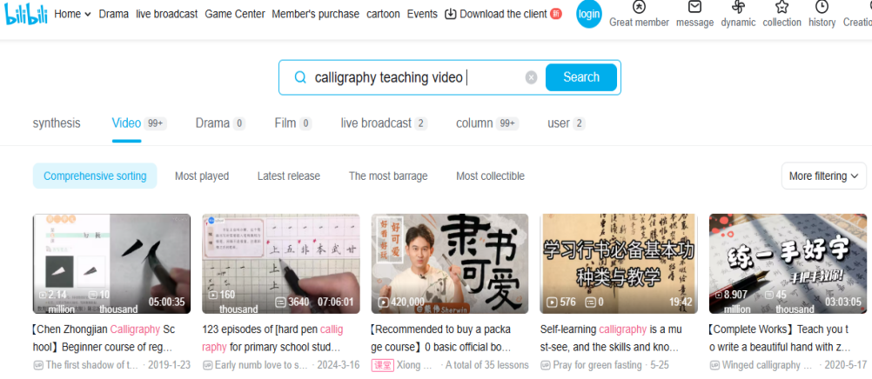
Figure 1： bilibili calligraphy teaching video
In terms of international communication, the application of digital technology has broken through geographical limitations, providing new possibilities for the "going global" of calligraphy art. Through online courses, digital works exhibitions, and virtual teaching environments, overseas learners can more conveniently access and learn calligraphy(Tian, 2024). The holding of international calligraphy exhibitions, special lectures, workshops, and on-site creation activities has enhanced the interactivity of cultural exchanges and also increased the international visibility of Chinese calligraphy. The International Calligraphy Symposium invited scholars from more than ten countries to discuss dissemination strategies and artistic value of calligraphy together and conduct in-depth academic discussion (Xue, 2025). In addition, the international layout of calligraphy education is gradually expanded. Calligraphy courses are taught in foreign countries, calligraphers are dispatched to teach, and student exchanges are conducted with foreign universities. For example, in the calligraphy education cooperation between the Confucius Institute and a foreign university, calligraphy courses gradually enter the international education system, which injects continuous impetus into the global layout of calligraphy (see figure 2).Social media uses social networking sites as a communication platform, builds an interactive space for calligraphy artists and people all over the world, increases the exposure of calligraphy works, and promotes the exchange of calligraphy culture across cultures (Tian, 2024).
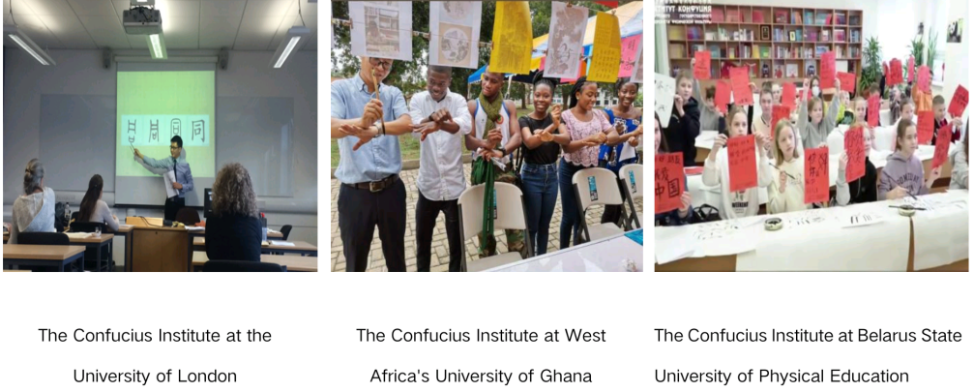
Figure 2: Confucius Institutes in each country
Calligraphy, as an important spiritual symbol of Chinese civilization, is playing an increasingly prominent role in international cultural exchanges. Through forms such as international calligraphy exhibitions and online cooperation projects, understanding and respect among different cultures have been continuously deepened, and the global influence of calligraphy art has also been enhanced accordingly(S. Zhang & Li, 2024) . Under the background of the Belt and Road Initiative, calligraphy has become an important carrier of cultural exchange, not only conveying Chinese culture and values, but also promoting emotional resonance and cultural mutual learning among people of all countries(Pan & Yi, 2024) . For instance, the interactive video work "Traces of Ink" has enhanced the immersion and participation of overseas audiences through touch experience and intelligent detection functions, stimulating their interest in learning calligraphy (Si & Wu, 2023). Figure 3 illustrates the two-way dissemination path of calligraphy in the digital age .
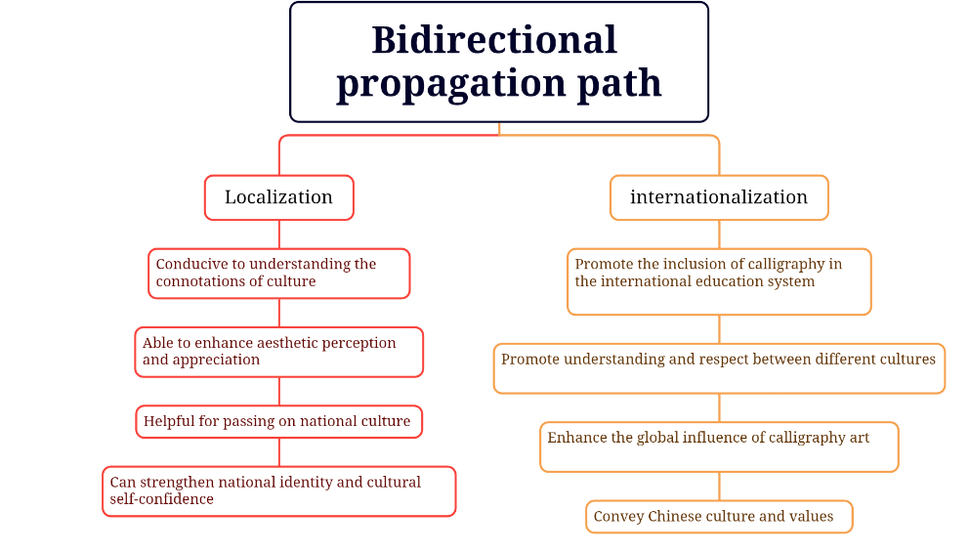
Figure 3: Bidirectional propagation path

However, there are still some prominent problems in the international dissemination of Chinese calligraphy. Some of the dissemination content overly emphasizes the one-way output of traditional concepts and techniques, lacking effective dialogue and interaction with audiences from different cultural backgrounds. In non-Chinese cultural circles, due to the audience's lack of understanding of the structure of Chinese characters and cultural context, it is difficult for them to deeply comprehend the textual connotations and formal logic of calligraphy works, thus leading to the phenomenon of "cultural blindness"(Yu & Zhou, 2020).

3.3 The advantages and limitations of digital technology applications

In the digital age, the dissemination and innovation of calligraphy art have significantly benefited from the convenience and interactivity of digital technology. Online courses and digital publications, and other platforms have broken through the limitations of time and space, enabling learners to access, study, and appreciate calligraphy works anytime and anywhere (He Z., 2024; Zhang L., 2025). The emergence of calligraphy websites and virtual exhibition halls realizes the real-time information sharing all over the world, expands the calligraphy dissemination range, and allows more people to understand and experience calligraphy(Gao, 2018; Zhang F., 2018), as shown in Figure 4. In addition, the extensive application of electronic writing pads, calligraphy software, and other digital tools not only expands the calligraphy creation space, enhances the freedom and initiative of calligraphy creation, but also makes the calligraphy creation process more convenient and efficient through real-time display and editing(Song, 2023), as shown in Figure 5. The popularization of these digital tools makes calligraphy gradually moving calligraphy from traditional manual creation to intelligent, visual, and interactive creation.

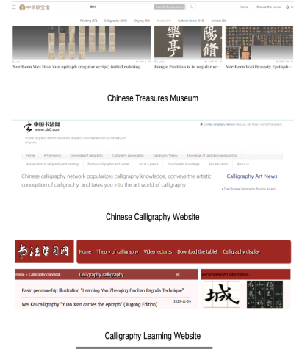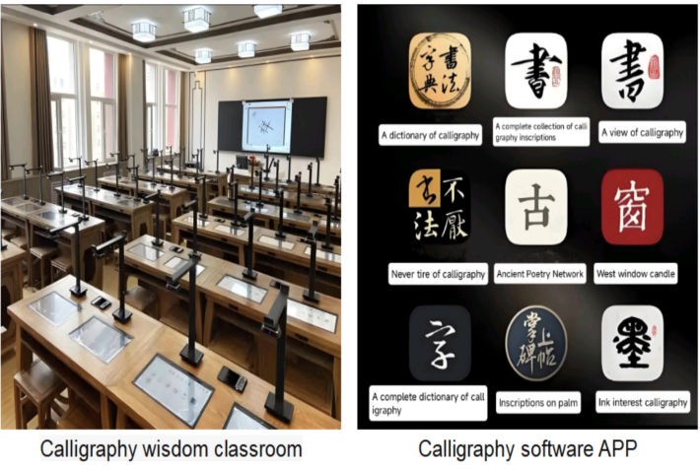
Figure 4: Calligraphy Website Figure 5: Digitization tools

Moreover, the interactivity and innovation of digital technology are also growing. The audience can communicate with the artist in real time through social media and online communities, which greatly improves the participation(Xu, 2024). By using VR and AR technology, calligraphy works can be transformed into a three-dimensional display, greatly enriching the expression of calligraphy works (He M., 2020; Si & Wu, 2023). For example, in the "Chinese Calligraphy Conference", the calligraphy works were transformed into a three-dimensional display by using AR and VR technology, giving the audience an immersive viewing experience (Diao, 2024), as shown in Figure 6.This trend of integrating traditional calligraphy art with technology allows the traditional calligraphy art to gain more dissemination and attraction in the new media environment.

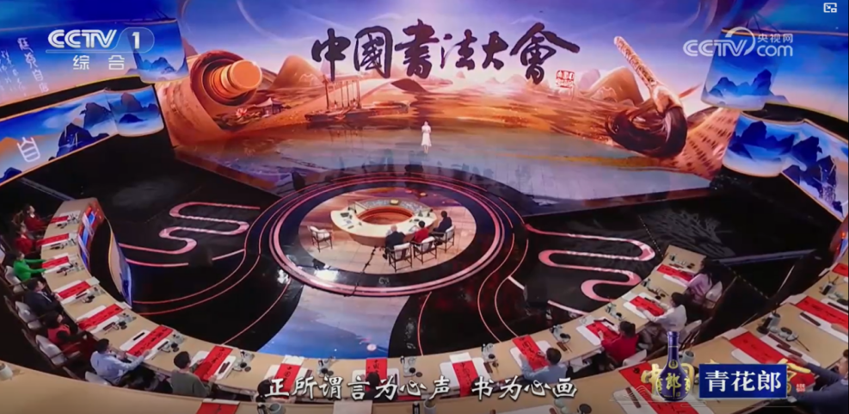
Figure 6: Chinese Calligraphy Conference
However, the application of digital technology has also brought multiple challenges. Firstly, the calligraphy resources on online platforms vary in quality, and the authenticity of the information is hard to guarantee, which can easily mislead learners(Xu, 2024) . Secondly, the unlimited modification and replication functions of digital calligraphy have weakened the artistic spirit and uniqueness of traditional calligraphy, which is "completed in one go"(Hou, 2023). The digital dissemination of calligraphy art is highly dependent on technology and equipment. Once a malfunction occurs, it will directly affect the display and dissemination of the works(Guo, 2024). Furthermore, over-reliance on digital means may also weaken the practical experience and skill inheritance of calligraphy, gradually distancing creators and audiences from the true charm of handcrafted works(Zhang L., 2025). At the visual level, the display form of digital devices makes it difficult to reproduce the texture and charm of real calligraphy works in terms of texture and atmosphere, weakening the perceptual experience of the audience (Chen, 2024). A more prominent issue is the copyright risk. Digital dissemination has made illegal copying and distribution easier, seriously infringing upon the intellectual property rights of artists (He Z., 2024). Overall, while digital technology is promoting the dissemination and innovation of calligraphy art, it also poses new challenges to its traditional spirit, aesthetic characteristics, and copyright protection. How to maintain the authenticity and unique value of calligraphy art while taking advantage of digital benefits is an important issue that calligraphy urgently needs to consider and address in the digital age (see Figure 7).
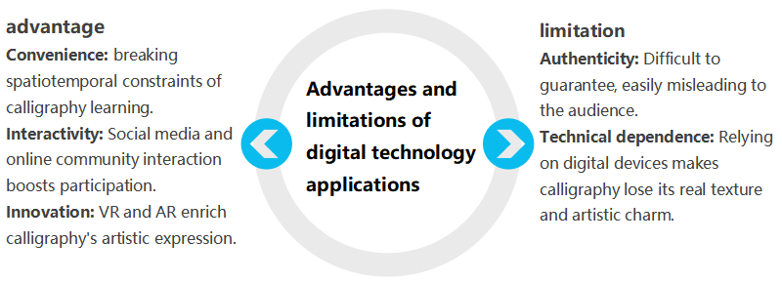
Figure 7：Advantages and limitations of digital technology applications

4 Discussion

The current situation of digital calligraphy dissemination shows that the integration of digital technology and traditional culture provides a new path for the inheritance and development of calligraphy art. Since the emergence of computerized Chinese calligraphy systems and virtual brush models in the 1980s, digital calligraphy has gradually developed. After entering the 21st century, the popularization of digital tools has made calligraphy creation more flexible and diverse, retaining the traditional charm while integrating digital innovation. Internet technology has broadened the dissemination scope of calligraphy. Online teaching and short-video platforms have lowered the learning threshold, attracting a large number of young users and enhancing the popularity and learning efficiency of calligraphy. This shows that digital technology brought new ideas for the inheritance of calligraphy art and made calligraphy art regain its vitality in modern society. In the digital age, the popularization of Chinese calligraphy art presents a balance between local inheritance and going global. Digital technology brought convenient means for the local inheritance of calligraphy, which strengthened the sense of identity and confidence of the young group in calligraphy towards traditional culture. While popularizing calligraphy in other parts of the world, digital technology broke through geographical restrictions and opened up a new way for calligraphy to "go global". Overseas students can conveniently receive online courses, and calligraphy teachers can display calligraphy through digital display and a virtual teaching environment. The international calligraphy exhibition, special lectures, and calligraphy courses also enhanced the interaction of cultural exchanges and improved the international influence of calligraphy art. In addition, social media also enlarged the exposure of calligraphy works and promoted cross-cultural communication and exchange. The expansion of these channels not only enhanced the influence of calligraphy art but also promoted understanding and respect for different cultures. However, digital technology brought challenges as well. The quality of calligraphy resources on online platforms was uneven, which would mislead learners. The unlimited modification and replication functions of digital calligraphy weakened the uniqueness of traditional calligraphy. The digital dissemination of calligraphy art was highly dependent on technology and equipment. If there were technical malfunctions or problems with equipment, it would affect the display and dissemination of works. In addition, the excessive dependence on digital technology may make people neglect the manual skills and practical experience of traditional calligraphy and weaken the inheritance of calligraphy techniques. Moreover, the display form of digital devices weakened the texture and charm of real calligraphy works and weakened the audience's perceptual experience. What is more serious is that the digital dissemination of calligraphy works brought about copyright issues. Illegal copying and dissemination were very convenient and seriously damaged the legal rights and interests of artists. These results showed the reformation and value extension of the calligraphy dissemination model caused by digital technology. Digital platforms not only became new display Spaces for traditional art, but also brought a great impact on aesthetic experience and cultural education. The rise of digital calligraphy reflected the regeneration mechanism of traditional art in the digital age, that is, the "re-contextualization" of culture through digital technology. This shows that digital calligraphy is not traditional art, but a new kind of medium form with functions of dissemination and education.

Although this article conducts a comprehensive exploration of the dissemination and innovation of Chinese calligraphy art in the digital age, there are still limitations. This article is mainly review-based on existing literature and lacks empirical research, thus failing to directly reflect the practical application effect of digital technology in the dissemination of calligraphy. The research data mainly come from Chinese literature, and the analysis of the international communication effect is relatively insufficient. In the future, the research scope can be further expanded, and the analysis of international cases can be added. Future research can be expanded and deepened in the following aspects. First of all, more empirical research needs to be carried out. Through methods such as questionnaires and experimental studies, the actual effect of digital technology on the dissemination of calligraphy should be directly evaluated. Secondly, emerging technologies such as artificial intelligence and virtual reality can be combined to study their potential in digital calligraphy creation and education, providing theoretical support for the intelligent development of calligraphy. In addition, it is also necessary to further analyze international cases, study the dissemination strategies and effectiveness of calligraphy art in different cultural backgrounds, and put forward more targeted suggestions for the international dissemination of calligraphy art. Through the expansion of these research directions, a more comprehensive understanding of the dissemination and innovation of Chinese calligraphy art in the digital age can be achieved, providing more powerful support for the inheritance and development of calligraphy art.

This study, by analyzing the current application situation of digital technology in calligraphy art dissemination and innovation process, explores the promotion effect of digital technology on calligraphy audience expansion, learning effect enhancement, and cultural identity consolidation. At the same time, the research results explore the relationship among "technology - culture - education" in the process of digitalization, laying the theoretical foundation for the next stage of research to establish a more systematic digital art dissemination framework. In addition, the research sorted out and discussed the two-way dissemination path of calligraphy art dissemination in the digital age and the advantages and disadvantages of applying digital technology, providing a reference for further exploration of the inheritance and development of calligraphy art in the digital age. The conceptual framework is presented in Figure 8.

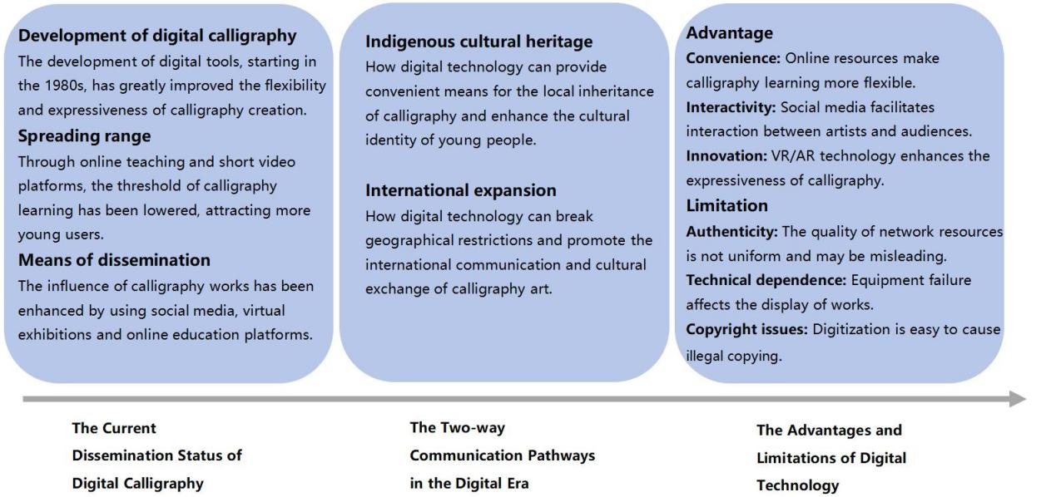

Figure 8：Conceptual Framework

5 Conclusion

With the arrival of the digital age, this new wave brought new vitality to the inheritance and innovation of Chinese calligraphy art. Based on the review of related researches, it can be found that digital technology has changed the way of calligraphy art dissemination, expanded the space of calligraphy expression, realized the learning and communication of calligraphy through multiple ways such as online education, social media and virtual exhibition, improved the participation degree and sense of identity of the masses; And realized the exchange of Chinese calligraphy culture and the international influence of calligraphy through digital communication at the international level. At the same time, some problems worth attention have also appeared in the process of digitalization. The uneven quality of online resources, the increasing dependence on technology, and the increased difficulty of copyright protection have affected the authenticity and uniqueness of calligraphy art to a certain extent. Relying on technology may reduce the handcrafted quality and aesthetic experience of calligraphy creation, and even blur the traditional spirit. How to use digital technology rationally and retain the inherent characteristics of calligraphy art is a problem that needs to be solved in future development. Digital technology realizes the new development opportunities of calligraphy art, and also brings new challenges. In future research, it is hoped that we can further combine practical experience and empirical data to discuss calligraphy teaching and dissemination, audience experience, international comparison, and other issues deeply, to explore the sustainable development road of traditional art in the digital age, so that calligraphy art can create and present more works based on inheritance.

COMPETING INTERESTS DISCLAIMER:
Authors have declared that they have no known competing financial interests OR non-financial interests OR personal relationships that could have appeared to influence the work reported in this paper.

References

Chen W. (2024). The integration strategy of art media and traditional culture in the digital age. New Legends, 25, 25–27.
Diao Y. (2024). Research on the innovative dissemination of classic works of calligraphy in the “Chinese Calligraphy Conference”. Western Literature and Art Studies, 6, 119–124.
Feng M. (2024). The cultural connotation and modern inheritance of calligraphy art. China National Exhibition, 19, 103–105.
Gao H. (2018). A Probe into the Communication of Calligraphy Art in the New Media Age. Chinese Calligraphy, 10, 168–169.
Guo, Q. (2024). The Spread and Challenges of Traditional Calligraphy in the Digital Media Era. The Four Treasures of Chinese Study, 7, 44–45.
He M. (2020). The spread and development of calligraphy in the era of digital media. Wen Yuan, 2, 441–442. https://doi.org/10.12252/j.issn.2096-627X.2020.02.2
He Z. (2024). Digital Publishing Promotes the Dissemination and Safeguarding of Intangible Cultural Heritage: A Case Study of Traditional Chinese Calligraphy. Culture Journal, 9, 14–17.
Hongming, Z. (2024). Construction of International Communication of Chinese Calligraphy Culture in the Digital Age Selecting and the Selection of the Pathways. Academic Journal of Humanities & Social Sciences, 7(7), 259–264. https://doi.org/10.25236/AJHSS.2024.070740
Hou Y. (2023). Innovation and inheritance of calligraphy art in the context of the digital age. Calligraphy Appreciation and Critique Calligraphy Education, 2, 49–51.
Huang Y., & Wang Y. (2023). Research on the communication of calligraphy art in the new media era. JinGu Creative Literature, 31, 98–100. https://doi.org/10.20024/j.cnki.CN42-1911/I.2023.31.031
Ibrahim, R., & Mustafa Kamal, R. (2018). Templates for Thinking. Unpublished Literary. Copyright MYIPO LY2018002437.
Li Z. (2024). The digital transformation of the art of calligraphy. Calligraphy newspaper, 1–5.
Lu Z. (2024). The dissemination and development of calligraphy art in the context of convergence media. New Horizon, 6, 49–51.
Pan S., & Yi W. (2024). Under the background of the Belt and Road Initiative, the construction and dissemination of calligraphy art in China is a research on the media. Media Forum, 7(5), 89–91.
Rousseau, D. M., Manning, J., & Denyer, D. (2008). 11 Evidence in Management and Organizational Science: Assembling the Field’s Full Weight of Scientific Knowledge Through Syntheses. Academy of Management Annals, 2(1), 475–515. https://doi.org/10.5465/19416520802211651
Si Z., & Wu Y. (2023). Research on the Innovation of Chinese Calligraphy External Communication Practice: A Case Study of Interactive Video Empathy Design. Beijing Culture Creativity, S2, 67–76.
Song D. (2023). Research and Practice of Adaptability of Calligraphy in the Digital Age. Art Evaluation, 61–66.
Templier, M., & Paré, G. (2015). A framework for guiding and evaluating literature reviews. Communications of the Association for Information Systems, 37(1), 6.
Tian Y. (2024). The International Diffusion of Calligraphy: Multiple Perspectives from Sinological Studies to the Global Art Market. Art Evaluation, 19, 43–48.
Wang, L. (2023). The art of calligraphy in the digital age. Huazhang, 11, 12–14.
Wang, Y. (2024). A Preliminary Study on Digital Calligraphy: A Comparison between Digital Calligraphy and Traditional Calligraphy. https://kns.cnki.net/reader/flowpdf?invoice=Tkd2M7Cg0vmw9lhx0bVfdbsITzf4eHdM%2FeVem7rFreF8GVoHKl7waEjgcP4faMWlpjYLWp2E67vm%2BatQuG5QCQZR6S6zW2EvAZhXK3DgBejbFDkoKI%2F7h7TVfScuas7BjyjDIdu3QOde%2FKbMVQizb%2FGkaNMP1eRPtYnfrgowhK0%3D&platform=NZKPT&product=CMFD&filename=1024698268.nh&tablename=cmfdtemp&type=DISSERTATION&scope=trial&dflag=pdf&pages=&language=CHS&trial=&nonce=703C4C9BF0D34051B62B31B1B04C250C&cflag=pdf
Wang Y., & Wang F. (2016). New ideas for the dissemination of calligraphy art in the context of new media. Art Science and Technology, 29(12), 118.
Xiaoli, M., & Shenglong, M. (2024). INTEGRATION OF ART AND TECHNOLOGY: INNOVATIVE DEVELOPMENT OF CALLIGRAPHY IN THE ERA OF BIG DATA. EPRA International Journal of Multidisciplinary Research (IJMR), 9(11), 2455–3662. https://doi.org/10.36713/epra19169
Xu, Y. (2024). The dissemination of the art of calligraphy in the context of “Internet +.” Tomorrow’s Style, 19, 49–51.
Xue J. (2025). The value and inheritance of traditional Chinese calligraphy in the contemporary art system. China National Exhibition, 1, 115–117.
Yang, W. (2022). Development and Application of Calligraphy Culture Communication Platform Based on Web Technology. EIMT 2022, 113–121. https://doi.org/10.2991/978-94-6463-012-1_13
Yu H., & Zhou J. (2020). The path and strategy of the international dissemination of Chinese calligraphy. People’s Tribune, 07, 120–122.
Zhang F. (2018). The current situation of the dissemination of calligraphy art in online media. chuanbo yu banQuan, 7, 130-131+134. https://doi.org/10.16852/j.cnki.45-1390/g2.2018.07.054
Zhang J. (2019). A survey of digital calligraphy. SCIENTIA SINICA Informationis, 49(2), 143–158. https://doi.org/10.1360/N112018-00202
Zhang L. (2025). Opportunities, Challenges and Strategies for Writing Cultural Inheritance in the Digital Age. Xinchu culture, 03, 58–61. https://doi.org/10.20133/j.cnki.CN42-1932/G1.2025.03.015
Zhang, S., & Li, Z. (2024). Research on the external communication strategy of Chinese calligraphy. Journalism Lover, 10, 65–67. https://doi.org/10.16017/j.cnki.xwahz.2024.10.034
Zhao L. (2015). The Contemporary Dissemination of Chinese Calligraphy and Its Strategies. Sichuan Drama, 10, 51–53.
Zhu Z., & Lu H. (2024). Research on the path of improving calligraphy literacy in the digital era. Art Education Research, 7, 78–82. https://doi.org/10.3969/j.issn.1674-9286.2024.07.030.

