DEVELOPMENT AND VALIDATION OF A FLUTTER-BASED ANDROID APPLICATION FOR NEAR REAL-TIME REFERENCE EVAPOTRANSPIRATION ESTIMATION USING THE FAO-56 PENMAN–MONTEITH MODEL IN NIGERIA

Abstract
The developed app aims to enhance water management practices and promote sustainable agriculture in Nigeria and globally. This study focuses on the development of an Android application utilising the FAO-56 Penman-Monteith (FAO-56 PM) model to estimate near real-time daily reference evapotranspiration (ET_{o}), particularly tailored for Nigerian farmers. The background underscores the critical role of ET_{o} in managing water resources for agriculture, especially in water-scarce regions like Nigeria. Challenges in ET_{o} estimation, including complex mathematical computations and data collection, are identified. The study proposes the use of mobile applications to simplify ET_{o} estimation, leveraging the Flutter SDK for cross-platform development. The methodology outlines data collection from the location-specific climate data retrieved from the OpenWeatherMap API, including temperature, humidity, wind speed, and solar radiation. Algorithm implementation of the FAO-56 PM model, and application development using Flutter and Dart. Testing and validation procedures ensure the accuracy and reliability of the application. Results indicate a strong positive correlation between ET_{o} estimations from the developed app and those generated using NASA parameters, albeit with discrepancies attributed to temporal variations. The conclusion highlights the app's potential benefits for Nigerian farmers and recommends further analysis, data collection, and user education for continuous improvement.

Keywords: Reference evapotranspiration; Flutter; FAO-56 Penman–Monteith; Mobile application; Irrigation scheduling

1.0 Introduction
There are an estimated 1,400 million cubic kilometres of water in the world; however, just 0.003% of this massive amount is considered a source of freshwater that may be used for industry, agriculture, drinking and sanitation. But part of this water flows into distant rivers during seasonal floods, making it not all easily accessible. Given that an astounding 70% of freshwater resources in Nigeria are used for farming, the lack of readily available freshwater poses a serious and urgent threat to the country's agriculture (Siebert et al., 2013). Up to 95% of the water extracted in some developing nations is used for irrigation, which is crucial for both the year-round availability of food and agricultural production (Siebert et al., 2013). Uncontrolled water consumption has the potential to degrade the water available (Silva et al., 2016).

According to Allen et al. (2011), Lima et al. (2013), Djman et al. (2016), and others, evapotranspiration (ET) is a crucial metric for scientific research on climate and hydrology as well as for managing agricultural water resources, which includes irrigation planning and performance. The concept of reference evapotranspiration (𝐸𝑇_{𝑜}) was devised to study the evaporative demand of the atmosphere independent of the type of crop, crop growth, or management practices. Since water is easily available at the ET_{o} surface, soil factors do not influence ET. It is possible to tie ET from different surfaces to a reference by connecting ET to a particular surface. It eliminates the requirement to provide an individual ET level for every crop and development stage. Since they use the same reference surface for ET, ET_{o} values observed or computed at various times of the year are similar. The only variables influencing ET_{o} are those related to the climate. Consequently, ET_{o} is a climatic parameter that may be computed with meteorological data. Instead of accounting for crop characteristics or soil conditions, ET_{o} represents the atmosphere's evaporating power at a certain location and time of year.

Over the last 50 years, a variety of empirical techniques have been developed to estimate ET from various meteorological factors. According to several international studies, the FAO-56 Penman-Monteith (FAO-56 PM) model is the most accurate for a variety of meteorological circumstances (Allen et al., 1998). Among the countries of the world, Brazil (Camargo and Camargo, 2000), the USA (Irmak et al., 2003), and Greece (Xystrakis and Matzarakis, 2011) are among the regions where the FAO-56 PM model has been tested. It is recommended to compute ET_{o} only using the FAO-56 PM approach. The approach has been selected because it is physically based, approximates grass ET_{o} at the location under examination, and clearly accounts for both physiological and aerodynamic features. Furthermore, techniques for estimating absent climate variables have been developed.

Meteorological data may be used to determine crop ET by directly merging the crop resistance, albedo, and air resistance variables in the PM approach. Due to the existing lack of knowledge regarding different crops, the PM approach is used to determine the standard ET_{o}. Crop coefficients (Kc), which are ratios of ETc and ET_{o} that are experimentally measured, are used to connect ETc to ET_{o}. Under identical climatic conditions, crop evapotranspiration varies from ET_{o} because of variations in leaf design, stomatal properties, aerodynamic qualities, and even albedo. Due to variations in the crop's qualities over its growth season, a given crop's Kc fluctuates from planting to harvest (Allen and Pereira, 1998).

In contrast to previous research, which predominantly focused on traditional methodologies and platform-specific development frameworks, this study represents a pioneering effort in the adoption of cross-platform development frameworks like Flutter and Dart. Notably, this is the first instance where a cross-platform approach has been utilised in the development of mobile applications dedicated to estimating evapotranspiration. These advancements not only emphasise reference evapotranspiration but also offer dynamic application design, marking a significant milestone in the evolution of ET_{o} estimation applications within the literature.

2.0 Literature Review

2.1 Overview of Reference Evapotranspiration and Its Significance
Reference evapotranspiration (ET_{o}) plays a pivotal role in understanding crop water utilisation, optimising irrigation schedules, and ensuring sustainable water resource management practices, especially in the context of global warming and climate change challenges (Pandey and Pandey, 2020). The FAO Penman-Monteith model (FAO-56 PM), introduced by Allen et al. (1998), stands as the globally accepted standard for ET_{o} computation. However, the precision of ET_{o} estimation depends on various meteorological factors and equations, including temperature (T), relative humidity (Rh), net radiation (Rn), solar radiation (Rs), vapour pressure (Vp), wind speed (Vw), and the psychrometric coefficient. Notably, the measurement of Rn, Rs, and Vp requires specialised instruments, posing challenges in locations with limited meteorological data availability.

2.2 Addressing Challenges in ET_{o} Estimation
While the FAO-56 PM method is widely used, it presents challenges such as potential inaccuracies in radiation measurements and sensitivity to input parameters (Antonopoulos and Antonopoulos, 2017). Moreover, complexities in obtaining wind speed data, particularly in regions with limited data availability, further complicate ET_{o} estimation. To mitigate these challenges, researchers have explored alternative methods such as the Priestley-Taylor and Hargreaves methods. Recent advancements have also witnessed the integration of machine learning techniques, including artificial neural networks (ANNs), aimed at enhancing ET_{o} estimation accuracy (Zhang et al., 2021). However, ensuring the robust performance of ANNs remains a concern, necessitating standardisation and normalisation techniques.

Additionally, other machine learning models such as support vector machines (SVMs), decision trees, and random forests have been applied in ET_{o} estimation with promising results (Tausif et al., 2023). These models leverage historical meteorological data to predict ET_{o} values, offering potential improvements in accuracy and reliability.

2.3 Mobile Applications in Evapotranspiration Estimation
Mobile applications have emerged as valuable tools for simplifying ET_{o} estimation, providing accessibility and user-friendliness (Francisco et al., 2018). Notable examples include EvapoCalc, which integrates established models such as the Blaney-Criddle and Hargreaves-Samani methods(Francisco et al., 2018). These applications aim to democratize ET_{o} estimation, empowering users with practical tools for sustainable use of water (Pavlo, 2022). Furthermore, the adoption of Flutter SDK for Android app development will revolutionise ET_{o} estimation applications, offering cross-platform compatibility and dynamic user interface (UI) design.

2.4 Flutter SDK for Android app development
With Google's meticulously designed Flutter open-source framework, developers can create aesthetically beautiful native apps for a variety of platforms, including desktop, mobile, web, and embedded devices. Enabled by a single codebase, Flutter runs smoothly on top of the Dart programming language, which is another one of Google's inventions. Its dynamic hot reload functionality, which lets developers see how code changes are reflected in the application in real time without requiring a restart, is one of its best features. This feature sets Flutter apart as a priceless tool for agile development processes and quick prototyping.

2.5 Rationale for Opting for Flutter in Android App Development
Simplifying development across platforms: Flutter streamlines the development process by enabling code to be written and deployed on platforms, like desktop, web, iOS and Android. This approach eliminates the need to maintain codebases for each platform, ultimately saving time and resources. Instant updates with hot reload: The hot reload feature allows developers to see changes in their code reflected in the application without the hassle of restarting. This capability boosts productivity by enabling iterations in both design and code.
User-friendly interface design: With a selection of widgets, Flutter facilitates the creation of appealing and user-friendly interfaces. These widgets ensure a good user experience across platforms by adhering to Material Design standards for Android and Cupertino guidelines for iOS. Enhanced app performance: Flutter’s compilation of apps into native code results in performance levels comparable to those achieved with Java or Kotlin development. This optimisation enhances app performance by delivering efficient functionality.

3.0 Methodology

3.1 Data Collection
The initial phase of the methodology involved acquiring the requisite climate data inputs for the FAO-56 PM model. This encompassed air temperature, humidity, wind speed, and solar radiation.
The data collection process consisted of the following steps:
Exploration of data sources: Data were obtained from "openweathermap.org," a free weather data provider.
User location: To provide location-specific climate data, the geolocator package in the Flutter SDK was utilised to obtain the user's current geographic coordinates (latitude and longitude). This location information was then seamlessly integrated with the “OWM API” to retrieve near-realtime climate data for the user's location.
Data retrieval and preprocessing: Gridded climate datasets were extracted and preprocessed to obtain the required variables in a format compatible with the FAO-56 PM equation.

3.2 Algorithm Implementation
Subsequent to data collection, the FAO-56 PM model was implemented algorithmically to estimate the rate of daily ET_{o}. The implementation process involved the following steps:
Coding of the FAO-56 PM model: The mathematical formulation of the FAO-56 PM model, as per the guidelines provided by the FAO, was translated into executable code using the Dart programming language.
Simplification of ancillary equations: Ancillary equations, such as those for slope, vapour pressure and saturation vapour pressure, were simplified to enhance coding efficiency while maintaining accuracy.
Development of modular functions: Modular functions were developed to encapsulate specific calculations within the FAO-56 PM model, promoting code readability and reusability.
The following formula (Eq. (1)) (Allen et al., 1998) describes the FAO-56 PM model of daily ET_{o} estimation:
900
ET_{o} = 0.408∆(𝑅^{𝑛}−𝐺)+ 𝛾𝑇+273𝑢²(𝑒^{𝛼}−𝑒^{𝑑}) (3.1)
∆+ 𝛾(1+0.34𝑢2)
where ET_{o} is the daily reference evapotranspiration (mm d⁻¹), Δ is the slope of the saturation vapor pressure curve at air temperature (kPa °C⁻¹), Rn is the net radiation (MJ m⁻² d⁻¹), u₂ is the mean wind speed at 2m above soil surface (ms⁻¹), T is the mean air temperature (°C), G is the soil heat flux density at the soil surface (MJ m⁻² d⁻¹), e_{α} is the saturation vapour pressure (kPa), e_{d} is the actual vapour pressure (kPa), γ is the psychrometric constant (kPa °C⁻¹).
The slope of the vapour pressure curve, saturation vapour pressure and actual vapour pressure are calculated according to Equations (3.2) - (3.6).

17.27𝑇𝑚𝑒𝑎𝑛
4098[0.6108𝑒𝑥𝑝( )]
∆ = (𝑇𝑚𝑒𝑎𝑛+237𝑇𝑚𝑒𝑎𝑛.3)2+237.3 (3.2)
𝑒𝛼 = 𝑒𝑇𝑚𝑎𝑥+2 𝑒𝑇𝑚𝑖𝑛 (3.3)
17.27𝑇𝑚𝑎𝑥
𝑒𝑇𝑚𝑎𝑥 = 0.6108exp [𝑇𝑚𝑎𝑥+237.3] (3.4)
17.27𝑇𝑚𝑖𝑛
𝑒𝑇𝑚𝑖𝑛 = 0.6108exp [𝑇𝑚𝑖𝑛+237.3] (3.5)
𝑅𝐻𝑚𝑒𝑎𝑛 (3.6)
𝑒𝑑 = 𝑒𝑇𝑚𝑎𝑥[ 100 ]

3.3 Application Development
With the algorithm in place, the Android application was developed using the Flutter framework and Dart programming language. The development process encompassed the following key steps:
- Frontend interface design: The user interface (UI) was designed to provide an intuitive user experience, with no input requirements and clear presentation of results.
- Backend logic implementation: Backend logic was implemented to handle data processing, invoke the FAO-56 PM equation algorithm, and generate estimates of daily ET_{o} based on generated values from the endpoint.
- Location integration: The geolocator package was integrated into the application's codebase to request and handle the user's location permissions. The obtained geographic coordinates were then seamlessly incorporated into the API calls to OpenWeatherMap, enabling the retrieval of location-specific climate data.
- Version control and repository management: Version control and repository management: Version control was managed using online repositories such as GitHub, facilitating collaboration and tracking changes throughout the development process.
The codes for the study can be found at https://github.com/alausaJNR/EVAPOTRANSPIRATION_LATEST, and the corresponding screenshots are available in Figures (1) – (8).

3.4 Testing and Validation
To ensure the accuracy and reliability of the application, rigorous testing and validation procedures were conducted. This phase involved:
Performance comparison: The performance of the application was benchmarked against existing tools such as the FAO ET_{o} Calculator, with iterative model refinements made based on testing outcomes.
The application's UI was designed with a clean and intuitive layout, allowing users to easily access and view the estimated daily evapotranspiration rate based on their location and the retrieved climate data.
Validation against measured data: Application estimations of daily evapotranspiration were compared against measured data from NASA Prediction of Worldwide Energy Resources (NASA POWER) through the use of correlation analysis.

3.4.1 Comparison of meteorological parameters
Mean temperature (Tmean): The mean temperature comparison between the developed app and NASA parameters for the period between April 4th and April 14th, 2024, at a specific geographical location with latitude 7.39 and longitude 3.89, reveals discrepancies arising from differences in data collection methods. Table 1 presents the mean temperature values obtained from both sources. The table highlights variations in temperature readings over the specified time frame.
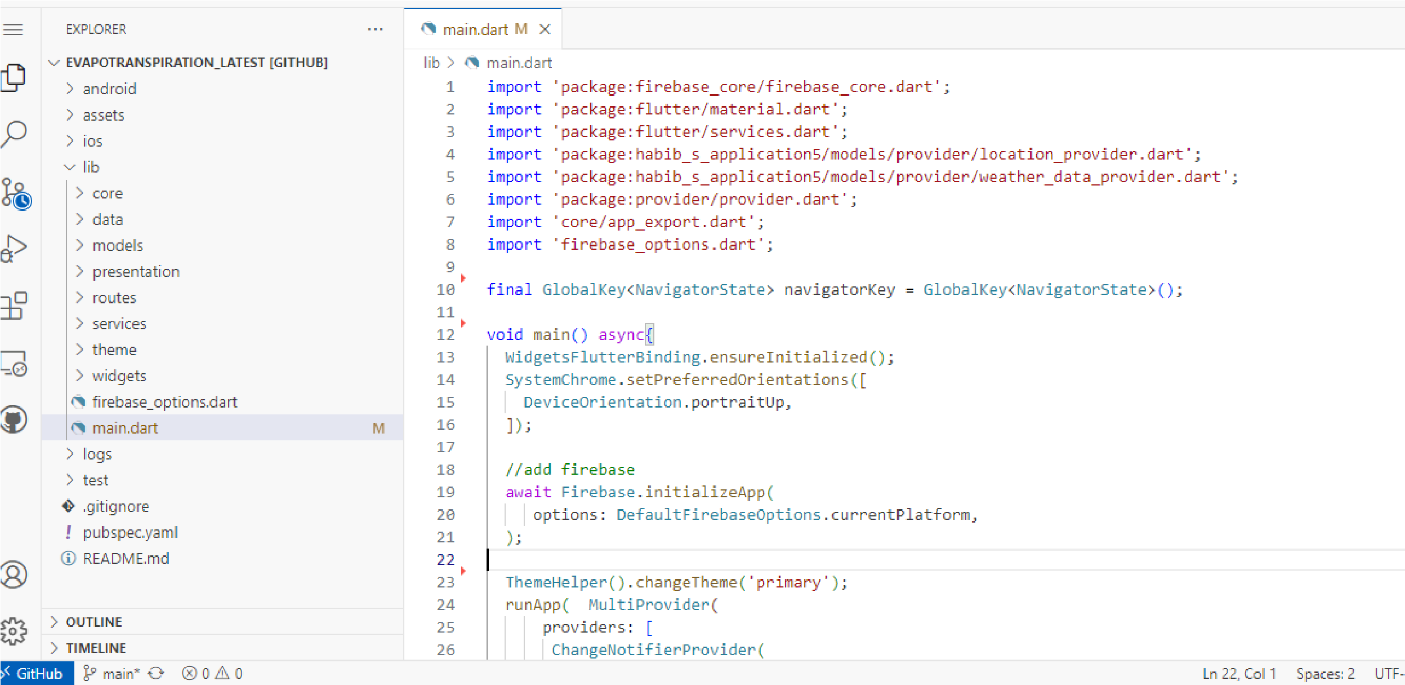
Relative humidity (RH): The comparison of relative humidity values obtained from the developed app and NASA parameters during the specified period and location is depicted in Table.2. Differences in humidity readings are observed due to variations in data collection intervals and averaging methods.

Figure 1: Flutter app setup with Firebase integration and provider state management

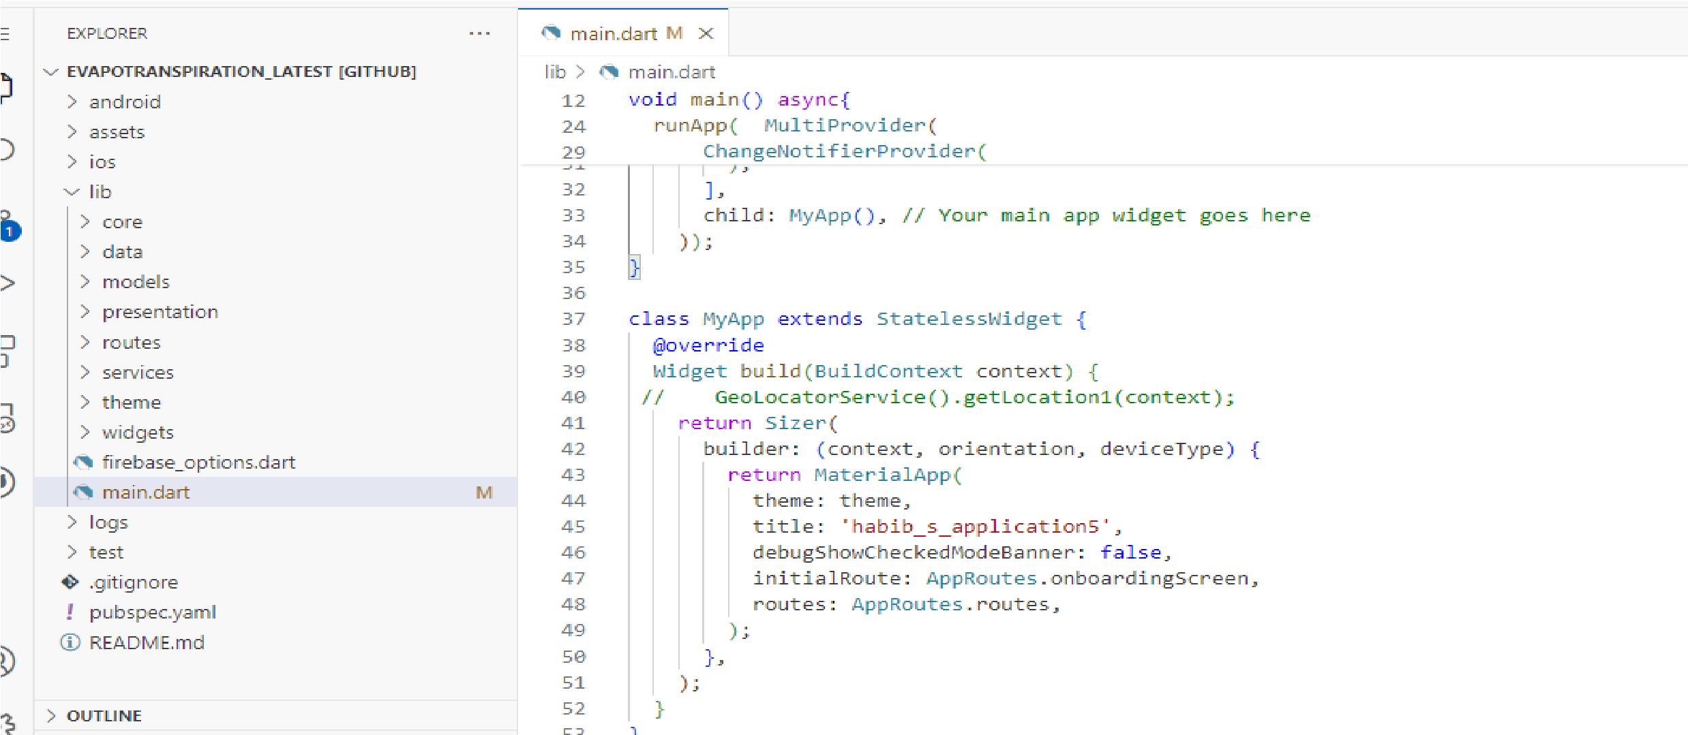
Figure.2: Flutter app setup with Firebase integration and provider state management.
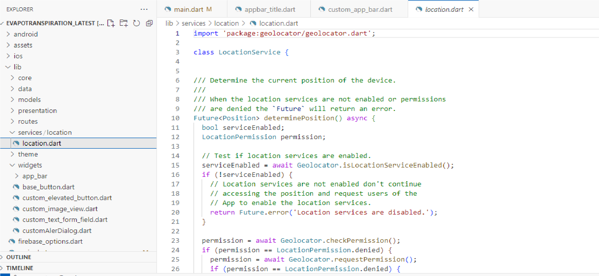
Figure 3.: Location service class for determining device position

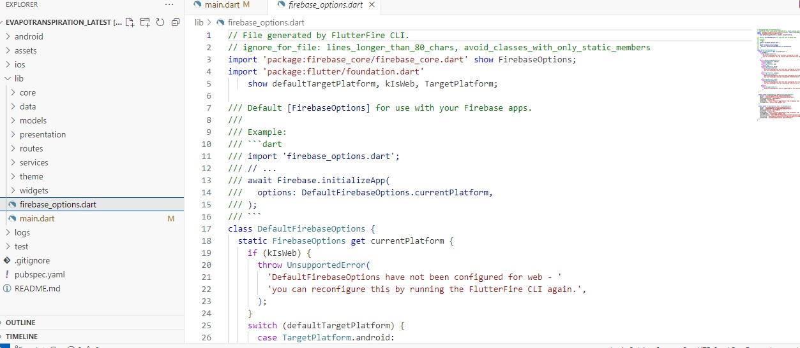
Figure 4: Firebase configuration for the Flutter app
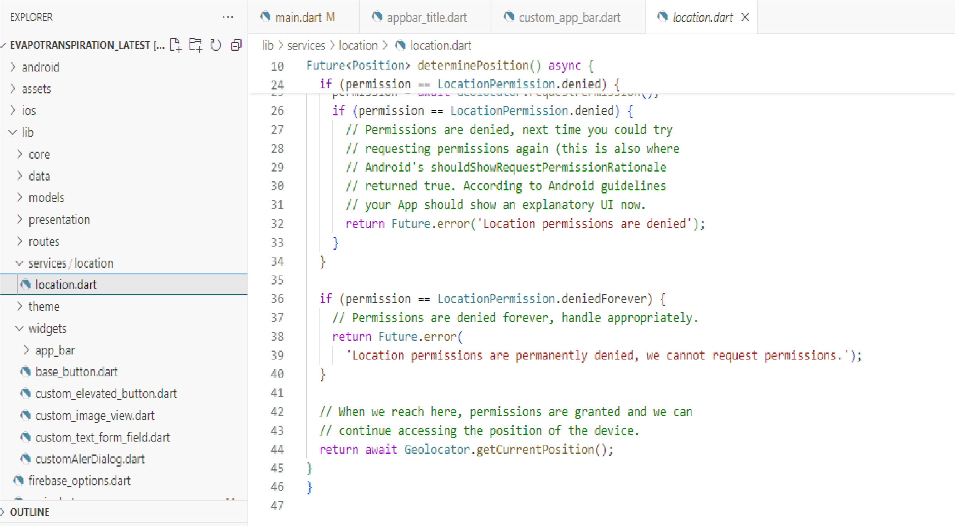
Figure 5: Approutes class definition for navigation in the application
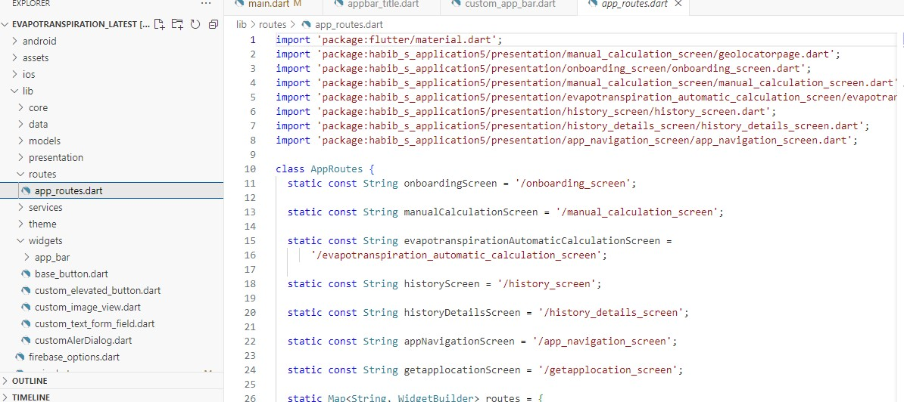
Figure 6: Weatherservice class for fetching weather data from OWM API

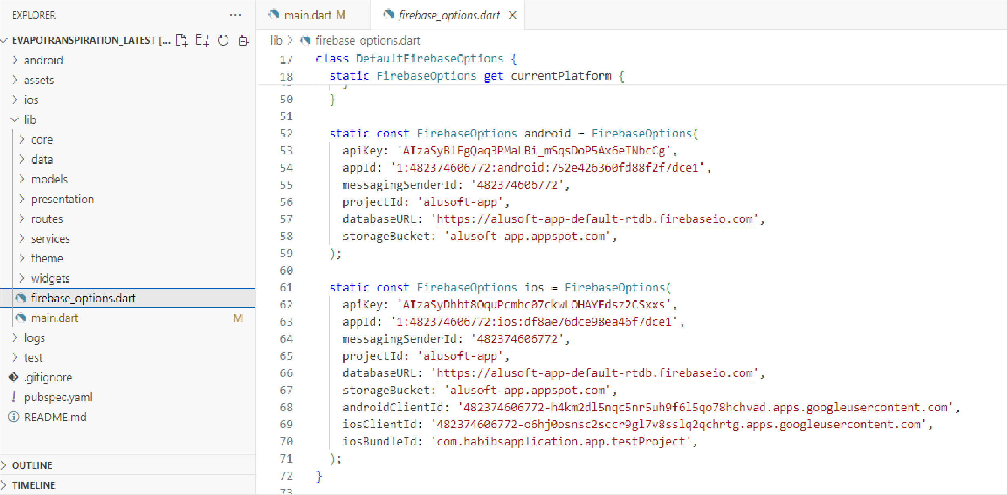
Figure 7: Appbarleadingimage widget for custom appbar leading icon
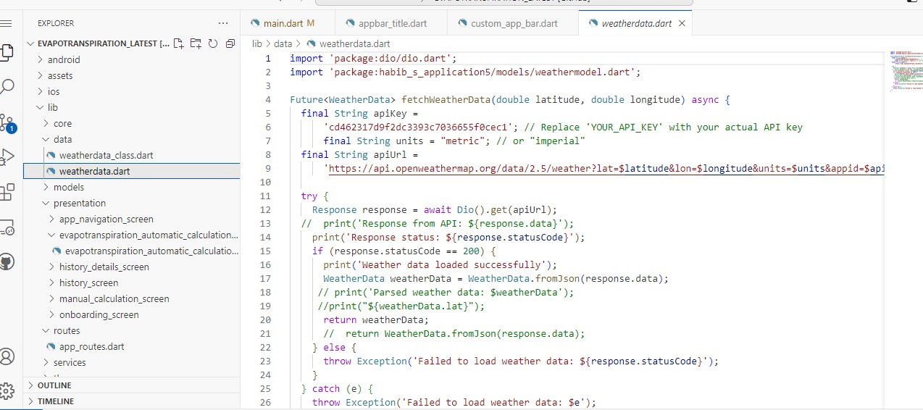
Figure 8: Appbar title widget for custom appbar title
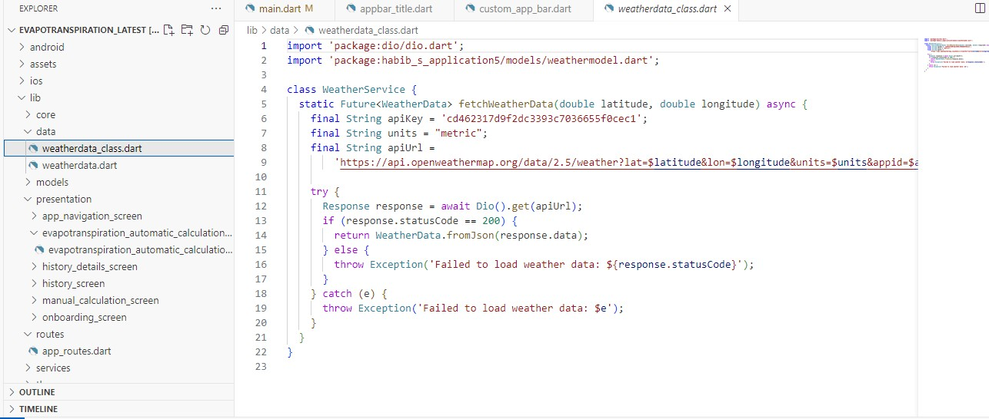
Figure 9: Appbartrailingimage widget for custom appbartailing icon.

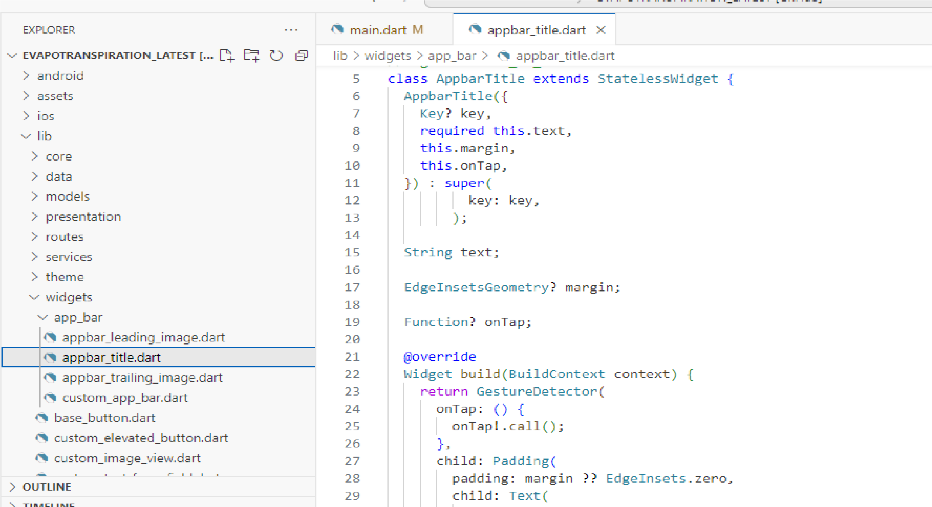
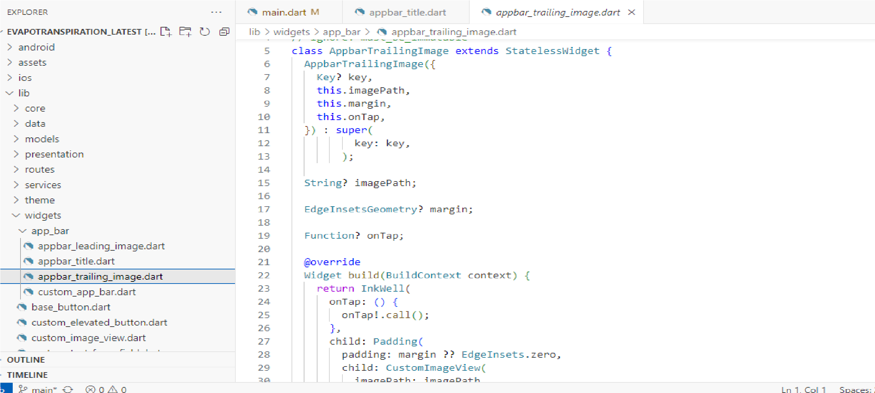

Figure 10: Evapotranspiration automatic calculation screen UI Layout

Figure 11: Evapotranspiration automatic calculation screen UI Layout Mean wind speed (MWS)

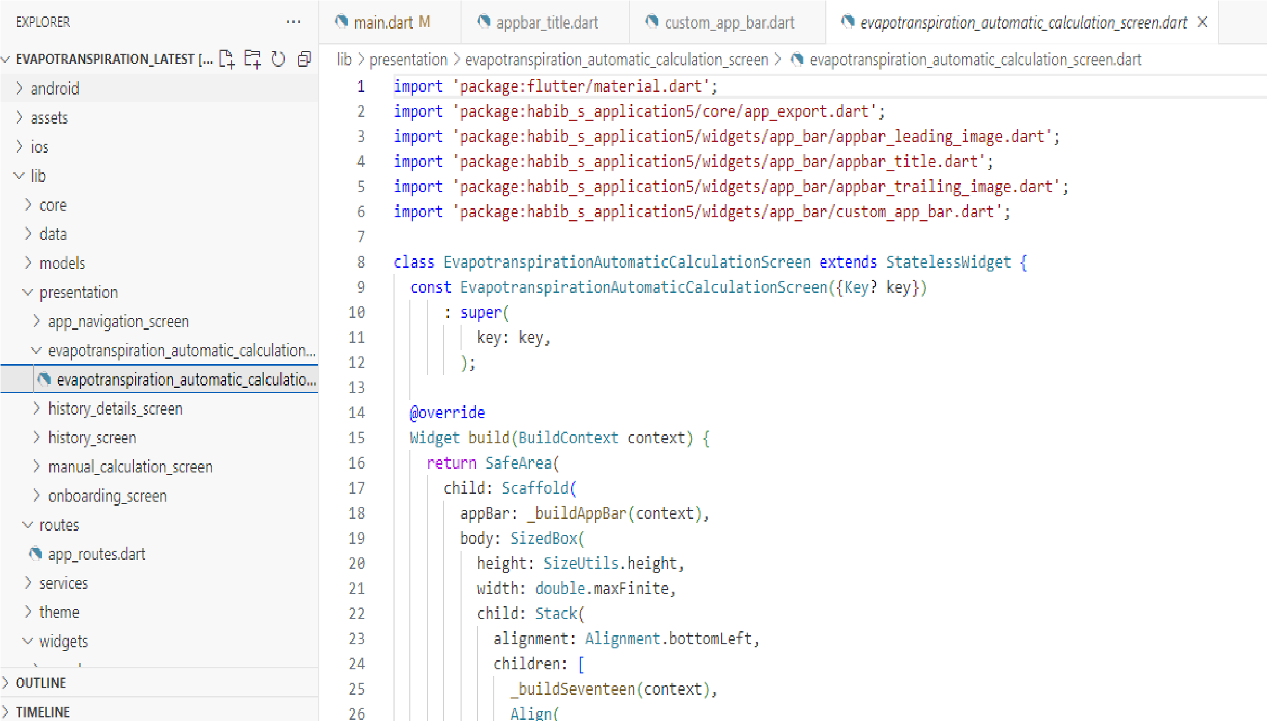
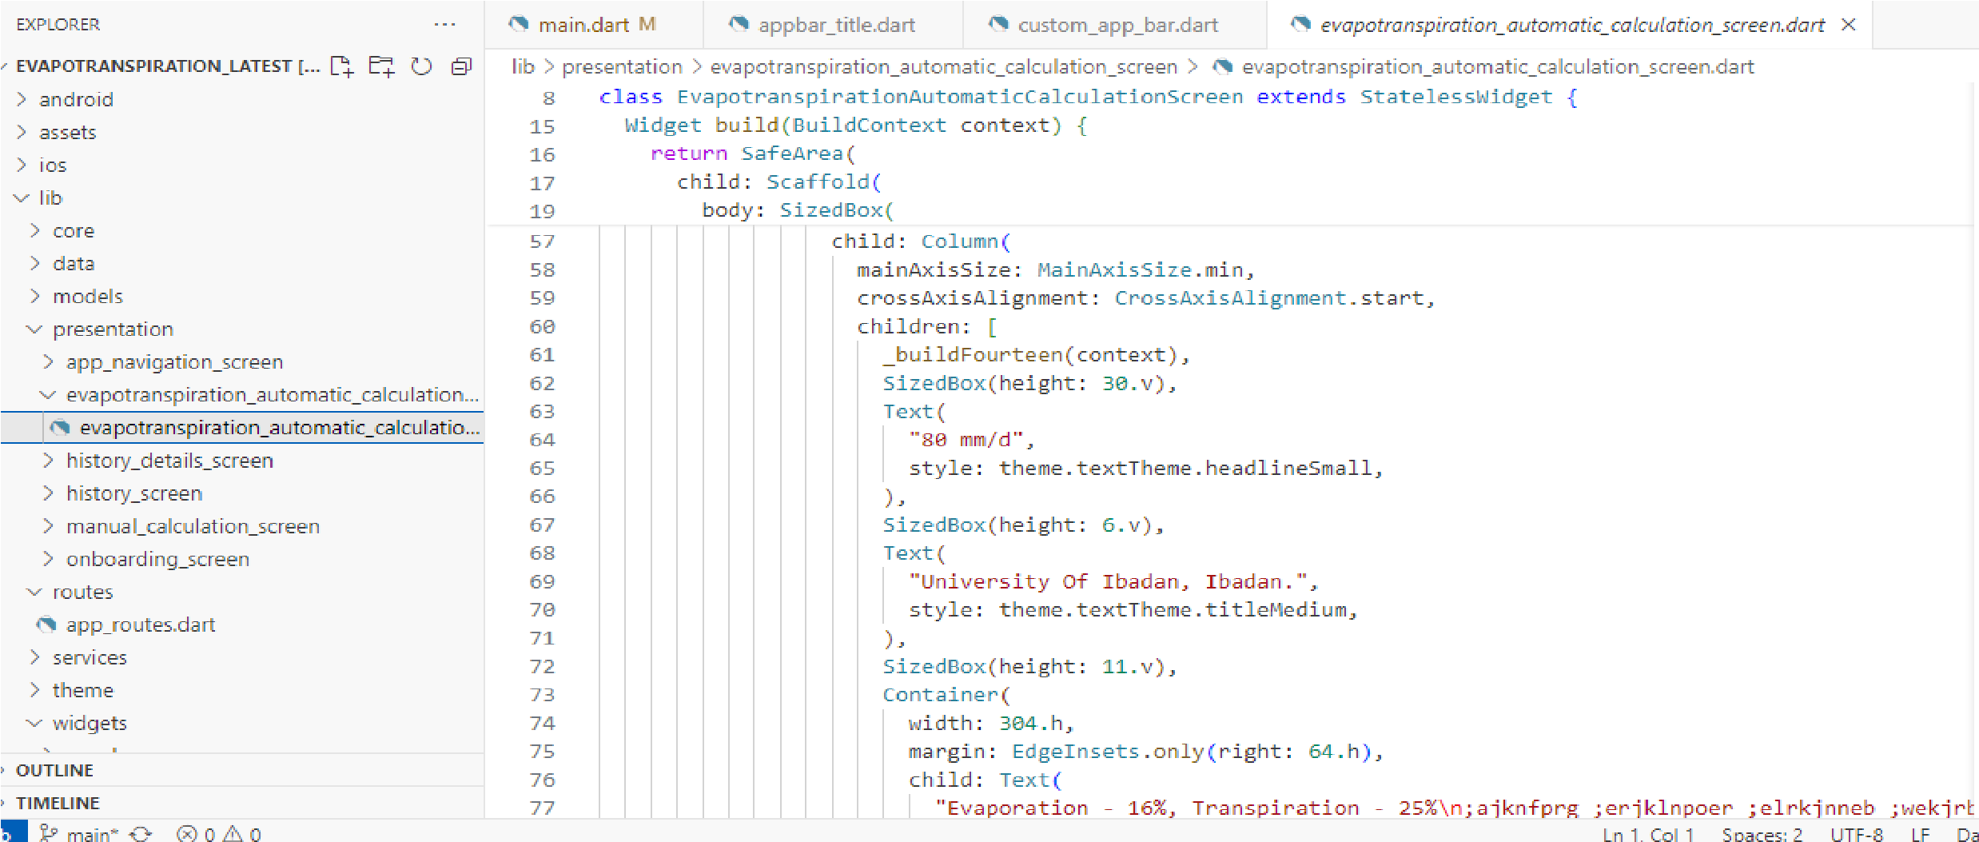
Fig 12 : Flutter Evapotranspiration Calculation Screen Code

MWS comparison between the developed app and NASA parameters for the specified period and location is presented in Table.3. Variations in MWS measurements are attributed to differences in data collection time intervals and averaging techniques. Table 4. provides a detailed overview of wind speed comparisons.

Fig 13 : Evapotranspiration Screen UI Implementation (Flutter Dart)
Reference Evapotranspiration (ET_{o}): Table 4 illustrates the comparison of ET_{o} values obtained from the developed app and NASA parameters over the specified time frame. The discrepancy in ET_{o} values arises from the app’s data collection over a 5-hour period compared to NASA’s 24-hour averaging method.

3.4.2 Correlation analysis
Pearson's correlation coefficients (r) were calculated to assess the linear relationships between the
ETo values and various meteorological parameters obtained from the developed app and the NASA parameters. The correlation coefficients are summarised in Table 5.

Table 1: Mean temperature comparison between the developed app and NASA parameters
S/N | Date | NASA Tmean (°C) | App Tmean (°C)
1 | 04/04/2024 | 31.1 | 33.95
2 | 05/04/2024 | 31.62 | 34.21
3 | 06/04/2024 | 30.01 | 32.14
4 | 07/04/2024 | 31.13 | 34.61
5 | 08/04/2024 | 30.09 | 33.71
6 | 09/04/2024 | 31.78 | 33.55
7 | 10/04/2024 | 32.26 | 33.17
8 | 11/04/2024 | 30.92 | 32.33
9 | 12/04/2024 | 30.97 | 32.18
10 | 13/04/2024 | 31.23 | 32.79
11 | 14/04/2024 | 32.74 | 34.21
Table.2: | Relative Humidity comparison between | ween the developed app | and NASA parameters
S/N | Date | NASA RH (%) App RH (%)
1 | 04/04/2024 | 83.75 80.17
2 | 05/04/2024 | 84.19 81.74
3 | 06/04/2024 | 88.06 75.22
4 | 07/04/2024 | 83.75 76.32
5 | 08/04/2024 | 86.06 81.21
6 | 09/04/2024 | 81.12 75.35
7 | 10/04/2024 | 81.06 76.54
8 | 11/04/2024 | 82.62 78.91
9 | 12/04/2024 | 82.44 80.11
10 | 13/04/2024 | 83.56 75.67
11 | 14/04/2024 | 76.88 69.23

Table 3: Mean wind speed comparison between the developed app and NASA parameters
S/N | Date | NASA MWS (m/s) | App MWS (m/s)
1 | 04/04/2024 | 3.02 | 2.7
2 | 05/04/2024 | 3.31 | 3.43
3 | 06/04/2024 | 3.12 | 2.3
4 | 07/04/2024 | 2.62 | 2.57
5 | 08/04/2024 | 2.84 | 2.79
6 | 09/04/2024 | 2.62 | 2.75
7 | 10/04/2024 | 2.7 | 2.13
8 | 11/04/2024 | 2.62 | 2.5
9 | 12/04/2024 | 3.2 | 3.6
10 | 13/04/2024 | 3.57 | 3.4
11 | 14/04/2024 | 2.03 | 1.9
Table.4: | ET_{o} comparison between the developed app and NASA parameters
S/N | Date | NASA ET_{o} (mm/day) | App ET_{o} (mm/day)
1 | 04/04/2024 | 2.21 | 2.26
2 | 05/04/2024 | 2.17 | 2.3
3 | 06/04/2024 | 2.17 | 2.19
4 | 07/04/2024 | 2.15 | 2.2
5 | 08/04/2024 | 2.26 | 2.27
6 | 09/04/2024 | 2.15 | 2.17
7 | 10/04/2024 | 2.50 | 2.88
8 | 11/04/2024 | 2.23 | 2.22
9 | 12/04/2024 | 2.51 | 2.24
10 | 13/04/2024 | 2.78 | 2.8
11 | 14/04/2024 | 2.20 | 2.18

Table.5: Pearson's correlation coefficients
Parameter | Correlation coefficient
Mean temperature | 0.42
Relative humidity | 0.57
Wind speed  Reference evapotranspiration | 0.79  0.80

4.0 Results and Discussion
This chapter presents the results of comparing reference evapotranspiration (ETo) values obtained from the developed app with those calculated using NASA parameters via an ordinary calculator. The analyses aimed to evaluate the agreement and correlation between the two sets of ETo values, as well as the relationships between ET_{o} and other meteorological parameters.

4.1 Comparison of Meteorological Parameters
Mean temperature (Tmean): The mean temperature comparison between the developed app and NASA parameters for the period between April 4th and April 14th, 2024, at a specific geographical location with latitude 7.3885162 and longitude 3.8866652, reveals discrepancies arising from differences in data collection methods. Table 6 presents the mean temperature values obtained from both sources. The table highlights variations in temperature readings over the specified time frame.
Relative humidity (RH): The comparison of relative humidity values obtained from the developed app and NASA parameters during the specified period and location is depicted in Table 7. Differences in humidity readings are observed due to variations in data collection intervals and averaging methods.
Mean wind speed (MWS): MWS comparison between the developed app and NASA parameters for the specified period and location is presented in Table 8. Variations in MWS measurements are attributed to differences in data collection time intervals and averaging techniques. Table 8 provides a detailed overview of wind speed comparisons.
Reference Evapotranspiration (ET_{o}): Table 9 illustrates the comparison of ET_{o} values obtained from the developed app and NASA parameters over the specified time frame. The discrepancy in ET_{o} values arises from the app’s data collection over a 5-hour period compared to NASA’s 24-hour averaging method.

Table 6: Mean temperature comparison between the developed app and NASA parameters
S/N | Date | NASA Tmean (°C) | App Tmean (°C)
1 | 04/04/2024 | 31.1 | 33.95
2 | 05/04/2024 | 31.62 | 34.21
3 | 06/04/2024 | 30.01 | 32.14
4 | 07/04/2024 | 31.13 | 34.61
5 | 08/04/2024 | 30.09 | 33.71
6 | 09/04/2024 | 31.78 | 33.55
7 | 10/04/2024 | 32.26 | 33.17
8 | 11/04/2024 | 30.92 | 32.33
9 | 12/04/2024 | 30.97 | 32.18
10 | 13/04/2024 | 31.23 | 32.79
11 | 14/04/2024 | 32.74 | 34.21
Table 7: | Relative Humidity comparison bet | ween the developed app | and NASA parameters
S/N | Date | NASA RH (%) App RH (%)
1 | 04/04/2024 | 83.75 80.17
2 | 05/04/2024 | 84.19 81.74
3 | 06/04/2024 | 88.06 75.22
4 | 07/04/2024 | 83.75 76.32
5 | 08/04/2024 | 86.06 81.21
6 | 09/04/2024 | 81.12 75.35
7 | 10/04/2024 | 81.06 76.54
8 | 11/04/2024 | 82.62 78.91
9 | 12/04/2024 | 82.44 80.11
10 | 13/04/2024 | 83.56 75.67
11 | 14/04/2024 | 76.88 69.23

Table 8: Mean wind speed comparison between the developed app and NASA parameters
S/N | Date | NASA MWS (m/s) | App MWS (m/s)
1 | 04/04/2024 | 3.02 | 2.7
2 | 05/04/2024 | 3.31 | 3.43
3 | 06/04/2024 | 3.12 | 2.3
4 | 07/04/2024 | 2.62 | 2.57
5 | 08/04/2024 | 2.84 | 2.79
6 | 09/04/2024 | 2.62 | 2.75
7 | 10/04/2024 | 2.7 | 2.13
8 | 11/04/2024 | 2.62 | 2.5
9 | 12/04/2024 | 3.2 | 3.6
10 | 13/04/2024 | 3.57 | 3.4
11 | 14/04/2024 | 2.03 | 1.9
Table 9: | ET_{o} comparison between the developed app and NASA parameters
S/N | Date | NASA ET_{o} (mm/day) | App ET_{o} (mm/day)
1 | 04/04/2024 | 2.21 | 2.26
2 | 05/04/2024 | 2.17 | 2.3
3 | 06/04/2024 | 2.17 | 2.19
4 | 07/04/2024 | 2.15 | 2.2
5 | 08/04/2024 | 2.26 | 2.27
6 | 09/04/2024 | 2.15 | 2.17
7 | 10/04/2024 | 2.50 | 2.88
8 | 11/04/2024 | 2.23 | 2.22
9 | 12/04/2024 | 2.51 | 2.24
10 | 13/04/2024 | 2.78 | 2.8
11 | 14/04/2024 | 2.20 | 2.18

Table 10: Pearson's correlation coefficients
Parameter | Correlation coefficient
Mean temperature | 0.42
Relative humidity | 0.57
Wind speed  Reference evapotranspiration | 0.79  0.80

4.2 Correlation Analysis
Pearson's correlation coefficients (r) were calculated to assess the linear relationships between the
ETo values and various meteorological parameters obtained from the developed app and the NASA parameters. The correlation coefficients are summarized in Table 5.

4.3 Regression Analysis (R-squared)
The regression analysis on mean temperature yielded an 𝑅² value of 0.17, while relative humidity resulted in 0.33. Mean wind speed exhibited a notably higher R-squared value of 0.63, and ET_{o} showed the highest value at 0.64. These results are visually represented in Figures (14) – (17), respectively.

4.4 APP UI Screenshot
The user interface (UI) of the developed app is depicted in Figures (5) – (11). This screenshot provides a visual representation of the app's layout and design, showcasing its user-friendly features and functionalities. The app UI includes interactive elements such as buttons, input fields, and graphical displays to facilitate easy navigation and data interpretation for users. Detailed information about the app's functionality and usage instructions can be found within the app itself.

4.5 Discussion
The strong positive correlation (0.80) between the ET_{o} values obtained from the developed app and those calculated using NASA parameters suggests good overall agreement. However, discrepancies observed in the scatter plot indicate differences, attributed to varying time periods and averaging methods. The varying strengths of correlations for meteorological parameters suggest differing susceptibilities to diurnal variations or other factors, leading to greater differences between sources.
The regression analysis conducted on various meteorological parameters, including mean temperature, relative humidity, mean wind speed, and ET_{o}, yielded distinct coefficients of determination (R-squared) indicative of the degree to which each parameter could explain the variability observed between the developed app's data and NASA parameters. For mean temperature, the R-squared value was found to be 0.1749. This relatively low value suggests that only approximately 17.49% of the variability in mean temperature readings from the developed app can be accounted for by the NASA parameters. The discrepancy in readings may be attributed to the differing time intervals during which the data were collected. The app's readings were taken over a period of five hours within 11 days, whereas NASA's data represents a comprehensive 24-hour average for the same duration.

Similarly, the R-squared value for relative humidity was calculated at 0.3258. While indicating a moderate level of explanatory power, this value implies that approximately 32.58% of the variation in relative humidity readings from the developed app can be explained by the corresponding NASA parameters. Again, the discrepancy in data collection methods, with the app's readings being limited to a shorter time span compared to NASA's comprehensive 24-hour averages, likely contributes to the observed differences.

In contrast, the R-squared value for mean wind speed was notably higher at 0.6255, suggesting that approximately 62.55% of the variability in wind speed readings from the developed app can be elucidated by the NASA parameters. Despite the discrepancy in data collection timeframes, the strong correlation indicates a relatively robust agreement between the two datasets for this particular meteorological parameter. Notably, the highest R-squared value was observed for ET_{o}, calculated at 0.641. This indicates that approximately 64.1% of the variation in ETo values obtained from the developed app can be explained by the corresponding NASA parameters. Despite the differences in data collection methods, including the shorter time intervals used by the app compared to NASA's full-day averages, the relatively strong correlation underscores the encouraging agreement between the two datasets for estimating evapotranspiration.

R² = 0.1749
32
32.5
33
33.5
34
34.5
35
29.5
30
30.5
31
31.5
32
32.5
33
App Tmean
NASA Tmean
PLOT OF APP. Tmean AGAINST NASA Tmean
Figure 14: Scatter plot of Tmean values from the app against NASA parameters.

R² = 0.3258
68
70
72
74
76
78
80
82
84
76
78
80
82
84
86
88
90
APP RH
NASA RH
PLOT OF APP. RH AGAINST NASA RH
Figure 15: Scatter plot of RH values from the app against NASA parameters.

R² = 0.6255
0
0.5
1
1.5
2
2.5
3
3.5
4
0
0.5
1
1.5
2
2.5
3
3.5
4
APP MWS
NASA MWS
PLOT OF APP. MWS AGAINST NASA MWS
Figure 16: Scatter plot of MWS values from the app against NASA parameters.

R² = 0.641
2
2.1
2.2
2.3
2.4
2.5
2.6
2.7
2.8
2.9
3
2.00
2.10
2.20
2.30
2.40
2.50
2.60
2.70
2.80
2.90
App
ET
o
NASA
ET
o
PLOT OF APP.
ET
o
AGAINST NASA
ET
o
Figure 17: Scatter plot of ET_{o} values from the app against NASA parameters.


Figure 18: The application icon


Fig 18a: first screen


Figure 19: The application's second screen


Fig 19a: third screen displaying the user’s location

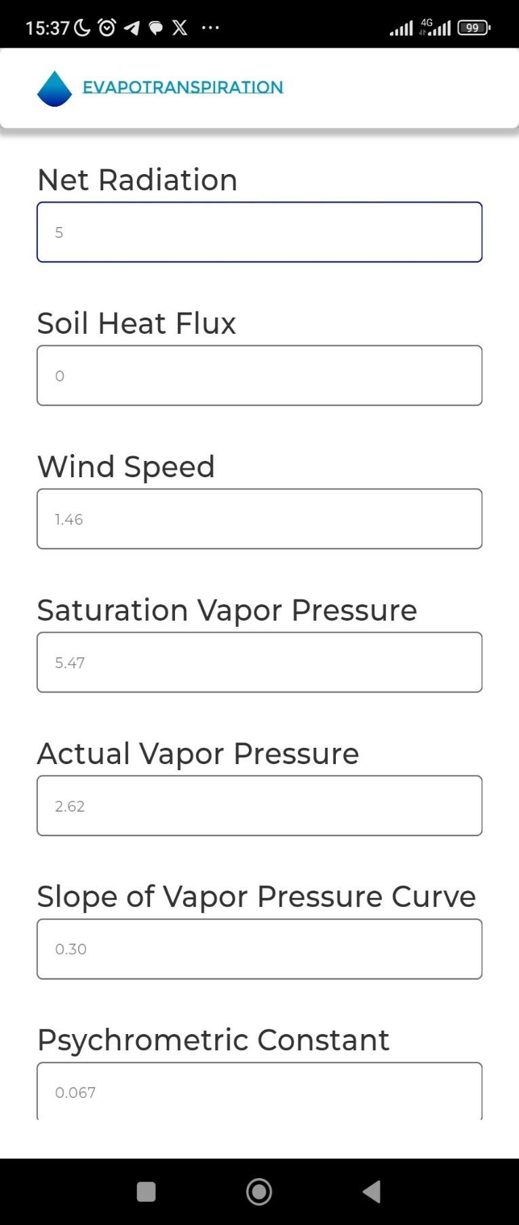
Figure 20: The application's fourth screen displaying climate data
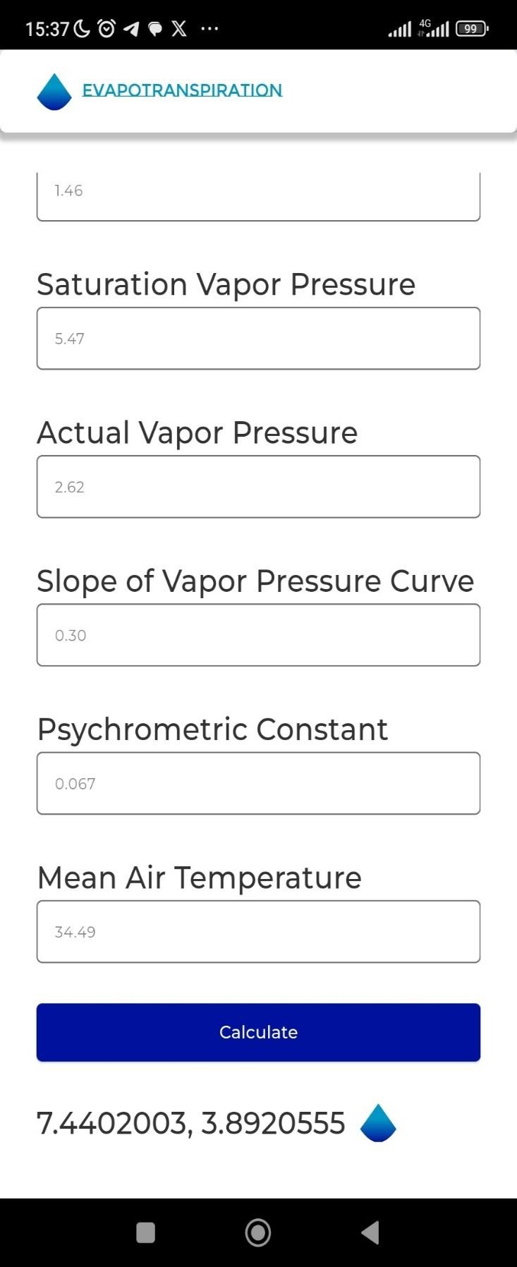
Fig 20a: fourth screen displaying climate data after scrolling
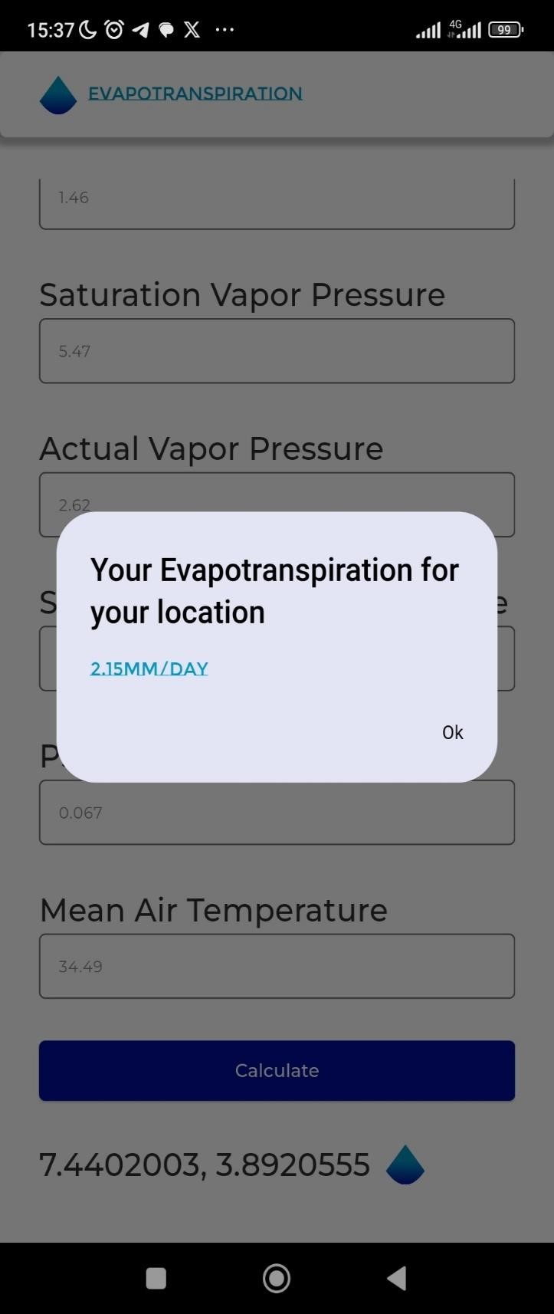
Figure 21: The application screen displaying the estimated near-real-time ET_{o} result

Conclusion
The project aimed to develop an Android app using the FAO-56 PM model to compute ETo, benefiting Nigerian farmers for irrigation scheduling and water resource management. A strong positive correlation (0.80) between ETo estimations from NASA parameters and the app was observed. However, discrepancies indicate the need for more validation and consideration of temporal variations in meteorological parameters.
References
Allen, R. G., & Pereira, L. S. (1998). Crop evapotranspiration: Guidelines for computing crop water requirements (FAO Irrigation and Drainage Paper 56). Food and Agriculture Organisation of the United Nations. https://www.researchgate.net/publication/290988983
Allen, R. G., Pereira, L. S., Howell, T. A., & Jensen, M. E. (2011). Evapotranspiration information reporting: II. Recommended documentation. Agricultural Water Management, 98(6), 921–929. https://doi.org/10.1016/j.agwat.2010.12.016
Antonopoulos, V. Z., & Antonopoulos, A. V. (2017). Daily reference evapotranspiration estimates by artificial neural networks technique and empirical equations using limited input climate variables. Computers and Electronics in Agriculture, 132, 86–96. https://doi.org/10.1016/j.compag.2016.11.010
Azhar, A. H., & Perera, B. J. C. (2011). Evaluation of reference evapotranspiration estimation methods under southeast Australian conditions. Journal of Irrigation and Drainage Engineering, 137(5), 268–279. https://doi.org/10.1061/(ASCE)IR.1943-4774.0000297
Camargo, A. P., & Camargo, M. B. P. (2000). One century of evapotranspiration in Brazil. Revista Brasileira de Agrometeorologia, 8(1), 111–122.
Cunha, A. C., Filho, L. R. A. G., Tanaka, A. A., Goes, B. C., & Putti, F. F. (2021). Influence of the estimated global solar radiation on the reference evapotranspiration obtained through the Penman–Monteith FAO-56 method. Agricultural Water Management, 243, 106491. https://doi.org/10.1016/j.agwat.2020.106491
Francisco, D., Rodrigues, B., Barbosa de Albuquerque Moura, G., Lima Montenegro, G. M. S., Rodrigues, S. M. N., Maciel de Oliveira, M., Villar, A. C., Gusmão, L. C. D., & Araújo, S. M. (2018). EvapoCalc: An Android application to estimate evapotranspiration by different methods. EPiC Series in Engineering, 3, 198–205. https://play.google.com/store/apps/details?id=com.thunkable.android.diogo_borbar.Eva
Hargreaves, G. H. (1989). Accuracy of estimated reference crop evapotranspiration. Journal of Irrigation and Drainage Engineering, 115(6), 1000–1007. https://doi.org/10.1061/(ASCE)0733-9437(1989)115:6(1000)
Jabloun, M., & Sahli, A. (2008). Evaluation of FAO-56 methodology for estimating reference evapotranspiration using limited climatic data: Application to Tunisia. Agricultural Water Management, 95(6), 707–715. https://doi.org/10.1016/j.agwat.2008.01.009
Lykhovyd, P. (2022). Comparing reference evapotranspiration calculated in the ETo Calculator (Ukraine) mobile app with that estimated by the standard FAO-based approach. AgriEngineering, 4(3), 747–757. https://doi.org/10.3390/agriengineering4030046
Maldonado, W., Valeriano, T. T. B., & de Souza Rolim, G. (2019). EVAPO: A smartphone application to estimate potential evapotranspiration using cloud gridded meteorological data from the NASA-POWER system. Computers and Electronics in Agriculture, 156, 374–384. https://doi.org/10.1016/j.compag.2018.10.032
Mecikalski, J. R., Shoemaker, W. B., Wu, Q., Holmes, M. A., Paech, S. J., & Sumner, D. M. (2018). High-resolution GOES insolation–evapotranspiration data set for water resource management in Florida: 1995–2015. Journal of Irrigation and Drainage Engineering, 144(9), 04018033. https://doi.org/10.1061/(ASCE)IR.1943-4774.0001312
Migliaccio, K. W., Morgan, K. T., Vellidis, G., Zotarelli, L., Fraisse, C., Zurweller, B. A., Andreis, J. H., Crane, J. H., & Rowland, D. L. (2016). Smartphone apps for irrigation scheduling. Transactions of the ASABE, 59(1), 291–301. https://doi.org/10.13031/trans.59.11158
Pandey, P. K., & Pandey, V. (2020). Development of reference evapotranspiration equations using an artificial intelligence-based function discovery method under the humid climate of Northeast India. Computers and Electronics in Agriculture, 179, 105838. https://doi.org/10.1016/j.compag.2020.105838
Rajavel, M., Guhan, V., Vakeswaran, V., Bhuvaneswari, K., Gowtham, R., & Priyanka, S. (2022). Estimation of reference evapotranspiration in Bhavanisagar block of Tamil Nadu using FAO ETo Calculator. International Journal of Plant & Soil Science, 34(18), 352–359. https://doi.org/10.9734/ijpss/2022/v34i1831172
Thorp, K. R. (2022). pyfao56: FAO-56 evapotranspiration in Python. SoftwareX, 19, 101208. https://doi.org/10.1016/j.softx.2022.101208
Xiang, K., Li, Y., Horton, R., & Feng, H. (2020). Similarity and difference of potential evapotranspiration and reference crop evapotranspiration – A review. Agricultural Water Management, 232, 106043. https://doi.org/10.1016/j.agwat.2020.106043

