Journal Name: | Asian Journal of Biotechnology and Bioresource Technology
Manuscript Number: | Ms_AJB2T_147906
Title of the Manuscript: | Optimization of Cellulase Production by Daldinia concentrica through Variation of Incubation Time and Lignocellulosic Substrate under Solid-State Fermentation
Type of the Article

PART 1: Comments
 | Reviewer’s comment  Artificial Intelligence (AI) generated or assisted review comments are strictly prohibited during peer review. | Author’s Feedback (It is mandatory that authors should write his/her feedback here)
Please write a few sentences regarding the importance of this manuscript for the scientific community. A minimum of 3-4 sentences may be required for this part. | Such research is of great practical importance with dual outputs: on the one hand, it has an environmental dimension in terms of preventing the accumulation of plant waste, and on the other hand, it recycles this waste and utilizes it to obtain important materials through green biotechnology methods. It is a prime example of green chemistry, therefore the research is original.
Is the title of the article suitable?  (If not please suggest an alternative title) | The title is suitable. It includes the most important point highlighted in the research is the optimization of cellulase production and its applications on different substrates.
Is the abstract of the article comprehensive? Do you suggest the addition (or deletion) of some points in this section? Please write your suggestions here. | The abstract is comprehensive, it includes the most important results.
Is the manuscript scientifically, correct? Please write here. | The researcher followed a high scientific methodology for this type of research and relied on comprehensive references to cover the methods of work and to ensure that his results are comparable with similar research.
Are the references sufficient and recent? If you have  suggestions of additional references, please mention them in the review form. | The references are sufficient and recent.

Is the language/English quality of the article suitable for scholarly communications? | The language is simple and understandable, and the researcher used relevant terminology.
Optional/General comments | - I completely agree with the researcher and understand his choice of different substrates such as sugarcane bagasse, rice husks, and eucalyptus sawdust because it serves the purpose of his research. As was later shown in the discussion of the results, the purpose of the selections is not solely for their potential as abundant sources of cellulose, however, for other considerations such as chemical composition, physical state, crystallinity, mineral content, and others that play a crucial role in the research process. The researcher should have focused more on those factors that facilitated, or rather guided, the research results.  For example:  - Rice husks contain B-complex vitamins, including thiamine, riboflavin, niacin, and other vitamins like A, C, D, E, and K. They are also a source of minerals like calcium, magnesium, iron, potassium, sodium, zinc, and phosphorus.  - The Crystallinity: These images illustrate for example the crystalline structure of cellulose in Rice husks  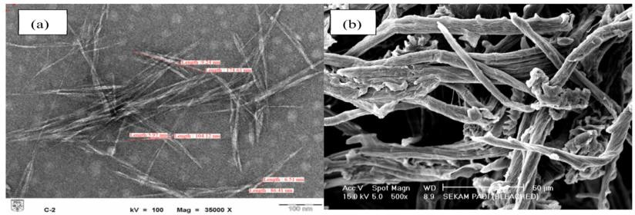  This is what the researcher stated in the discussion: (Quote from the researcher's discussion): By contrast, rice husks, with higher silica and crystalline cellulose content, yielded the highest FPase but lower exoglucanase than eucalyptus, suggesting that substrate crystallinity and mineral content can differentially influence the relative activity profile of cellulase components.  Result: The researcher should have supported his argument with what is known in the references to explain his results more clearly. This process can be applied to other substrates.  - To make the research methodology more comprehensive, the researcher had to mention the other importance of these substrates as an important source of vitamins and other substances that must be extracted and utilized before delving into the utilization of the cellulose content.  - The text of the research paper contains this symbol R^2 = 0.9925, but the correct one is R² I believe it's a difference in settings because the submitted file is a Word document.  - DNS reagent Methods and the Potential interferences: Other compounds with active carbonyl groups can interfere with the assay. For example, furfural and 5-HMF can lead to an overestimation of reducing sugars. Nevertheless, this method is important and widely used despite  the existence of more accurate alternative methods such as enzymatic assays or HPLC.

PART 2:

 | Reviewer’s comment | Author’s Feedback (It is mandatory that authors should write his/her feedback here)
Are there ethical issues in this manuscript? | (If yes, Kindly please write down the ethical issues here in details)

Reviewer details:
Kamal Fared Almokhalelati, Syria

