Economic Viability and Market Potential of Cannabis Cultivation in Malawi: An Empirical Analysis of Smallholder Farmer Perspectives

Abstract
Malawi’s agricultural economy, historically dependent on tobacco, faces structural vulnerability as global demand declines, necessitating urgent diversification. The legalization of industrial and medicinal cannabis in 2020 provides a transformative opportunity for rural livelihoods, yet empirical evidence on its economic feasibility remains limited. This study quantitatively evaluates the economic and market dynamics of smallholder cannabis cultivation in Malawi. A cross-sectional survey of 60 licensed farmers was conducted across five major agricultural districts—Blantyre, Lilongwe, Zomba, Rumphi, and Mzimba. Descriptive statistics were applied to characterize production systems, cost–benefit analysis assessed profitability, one-way Analysis of Variance (ANOVA) tested cost differentials, and Chi-square (χ2\chi^2χ2) tests examined relationships among categorical variables. The mean production cost per grower was MWK 203,443.72 (± SD 18,188.95). ANOVA revealed no significant variation across region, cultivar, or experience level, indicating uniform production input structures. Sativa was the dominant strain (80%), while 60% of farmers experienced income increases. However, χ2\chi^2χ2 tests showed income change was independent of cultivation experience and water management, highlighting structural rather than individual determinants of profitability. Regulatory costs (56.7%) and restricted market access (65%) emerged as key constraints. The study concludes that cannabis is economically viable but requires inclusive policies, financial access, and streamlined regulations to achieve sustainable and equitable sectoral growth.
Keywords: Cannabis cultivation, Economic viability, Agricultural diversification, Smallholder farmers, Malawi, Agribusiness.

1. Introduction
The Malawian economy is intrinsically linked to its agricultural sector, which accounts for approximately 30% of its Gross Domestic Product (GDP) (Malawi Government, 2020) and over 80% of its export earnings. For decades, this sector has been dominated by tobacco, a crop that has shaped the nation's political and economic landscape (Chitete et al., 2025), However, this mono-crop dependency has evolved into a significant source of economic vulnerability. A confluence of global factors, including declining international demand, the implementation of stringent anti-smoking regulations under the WHO Framework Convention on Tobacco Control, and growing public health concerns, has led to a steady erosion of tobacco's profitability (Tambala, 2022). This paradigm shift threatens the livelihoods of millions of smallholder farmers and necessitates a strategic and urgent transition towards alternative, high-value crops to diversify the agricultural base and ensure long-term economic resilience.
In this context, the legalization of industrial and medicinal cannabis cultivation via the Cannabis Regulation Act (2020) represents a landmark policy shift for Malawi. This legislation signaled a deliberate move to harness the economic potential of a crop historically grown illicitly, known for the famed "Malawi Gold" Sativa strain (McCool, 2020; SGOW, 2023; Wikipedia, 2025). The Act established a legal framework for licensing, quality control, and export, positioning Malawi to enter the burgeoning global cannabis market, which was valued at over $37 billion and continues to expand (Wise et al., 2024). Malawi possesses a strong comparative advantage for cannabis production, including favorable agro-climatic conditions, ample arable land, and a skilled, underutilized agricultural labor force (Hanusová et al., 2022).
Despite this clear potential, the transition is fraught with uncertainty, particularly for the smallholder farmers who are the intended beneficiaries of agricultural diversification policies. The economic viability of legal cannabis cultivation at the smallholder level remains poorly understood. There is a significant knowledge gap concerning the empirical realities of production costs, yield potentials, market access, and overall profitability compared to established cash crops. Furthermore, the high costs of licensing and compliance under the new regulatory framework may create insurmountable barriers to entry, risking the exclusion of smallholders and the capture of the industry by well-capitalized elites (Chinsinga, 2011).
This study seeks to bridge this critical gap by providing a robust empirical analysis of the economic viability and market potential of cannabis cultivation from the perspective of smallholder farmers in Malawi. We investigate the structural challenges and opportunities inherent in this nascent sector. Specifically, this research aims to:
- Analyze the production costs, yields, and profitability of cannabis cultivation among smallholder farmers in major agricultural districts of Malawi.
- Evaluate the domestic and international market dynamics, including marketing pathways, price determinants, and challenges in market access.
- Assess the socioeconomic impact of cannabis cultivation on farmer livelihoods and income diversification.
To achieve these objectives, we test two central null hypotheses:
- H₀¹: The economic inputs (production costs) of cannabis cultivation do not significantly differ based on farm-level characteristics such as geographical location, cannabis cultivar, or farmer experience.
- H₀²: The economic outcomes (farmer income changes) are statistically independent of farm management practices (e.g., water management) and farmer experience.
By testing these hypotheses, this research aims to disentangle the factors driving profitability in this new sector. The findings are intended to provide evidence-based recommendations to guide policymakers, development practitioners, and investors in fostering a cannabis industry in Malawi that is not only profitable but also sustainable and inclusive.

2. Literature Review
2.1 The Agricultural Economy of Malawi and the Decline of Tobacco
Agriculture has long been the backbone of Malawi’s economy, serving as the main source of livelihood and foreign exchange (Blebea et al., 2021). Historically, the sector has been dominated by a few crops—maize for subsistence and tobacco, tea, and sugar for export. Tobacco once contributed over 60% of total export revenue (Kateta, 2019; Wikipedia, 2025).This deep reliance has exposed Malawi to external shocks. The global anti-smoking movement and stricter import regulations have triggered a structural decline in demand and price, undermining long-term viability (Tambala, 2022). The resulting economic pressure has created an urgent need for diversification toward sustainable alternatives.
2.2 The Global and African Shift Towards Legal Cannabis
Global perceptions of cannabis have shifted dramatically. Scientific evidence supporting its therapeutic applications has fueled widespread decriminalization and legalization for medicinal and industrial purposes (Rodin et al., 2025). This evolution has created a multi-billion-dollar global market. In Africa, countries such as Lesotho, Zimbabwe, and Ghana have formalized their cannabis sectors to capture this opportunity (Wise et al., 2024). This regional trend offers Malawi a model to leverage its agricultural capacity and compete in global markets.
2.3 The Legal Framework for Cannabis in Malawi
Before 2020, cannabis cultivation—mainly of the potent Sativa strain “Malawi Gold” was illicit, though economically significant at about 0.2% of GDP (McCool, 2020; SGOW, 2023; Wikipedia, 2025). The Cannabis Regulation Act (2020) decriminalized the cultivation of industrial hemp (low-THC) and medicinal cannabis (high-THC) under a strict licensing regime. It established the Cannabis Regulatory Authority (CRA) to oversee licensing and quality control .(Bandawe, 2022). However, high entry costs, including a US$10,000 annual license for medicinal cannabis, remain prohibitive for smallholders (Brian, 2022; Malawi, 2020). This structure risks concentrating the industry among elites and foreign investors, limiting equitable access.
2.4 Economic Potential and Market Dynamics
Projections for Malawi’s cannabis industry are optimistic. The CRA estimates potential revenues of up to US$200 million annually, possibly surpassing tobacco (Masina, 2024; Pensulo, 2024). Industrial hemp supports multiple sectors textiles, biofuels, paper, and construction—while medicinal cannabis targets high-value pharmaceutical markets (Ding et al., 2024; Salami et al., 2020). However, realizing this potential requires meeting stringent international standards, strengthening value chains, and improving logistics and infrastructure (Wise et al., 2024). Lessons from the groundnut sector’s aflatoxin challenges underscore the importance of compliance to maintain global competitiveness.
2.5 Socioeconomic Impacts and the Smallholder Context
For smallholders, legal cannabis offers prospects for income diversification and rural revitalization (Falcone, 2019). It could create employment, enhance livelihoods, and stabilize household incomes (Veerabadhran et al., 2021). However, barriers persist: limited finance for high input costs, scarce certified seeds, gaps in agronomic knowledge, and heavy regulatory burdens (Spano et al., 2021). The crop’s success as a development tool will depend on inclusive policies that integrate smallholders, promote access to resources, and ensure equitable benefit sharing.
3. Methodology
3.1 Research Design
A quantitative, cross-sectional survey design was employed to capture a static snapshot of the economic, agronomic, and market conditions faced by smallholder cannabis farmers during a single cultivation season. This design was selected for its efficiency in collecting data from a geographically dispersed population at a single point in time, enabling a comprehensive analysis of the sector's current state. The survey approach was complemented by qualitative questions to capture farmer perceptions and experiences.
3.2 Study Area
The study was conducted across five purposively selected districts: Blantyre, Lilongwe, Mzuzu, Zomba, and Rumphi. These districts were chosen because they are major agricultural regions in Malawi, represent diverse agro-ecological zones (from the southern highlands to the central plains and northern plateau), and have a significant concentration of farmers who have begun participating in the legal cannabis sector. This geographical spread enhances the external validity of the findings.
Figure 1. Map of Study Area in Malawi
3.3 Sampling Strategy and Sample Size
The study population comprised smallholder farmers actively engaged in the legal cultivation of cannabis. A purposive sampling technique was used to identify and select a sample of N=60 farmers. This non-probability sampling method was deemed appropriate for this exploratory study as it ensured that all respondents had direct, relevant experience with the production and marketing of cannabis under the 2020 legal framework. The sample was balanced to capture gender dynamics, consisting of n=35 male (58.3%) and n=25 female (41.7%) farmers.
3.4 Data Collection Instrument and Procedure
Primary data were collected through in-person, structured interviews conducted by trained enumerators. The survey questionnaire was designed to be comprehensive, divided into five sections:
- Demographics and Farm Profile: Age, gender, farm location, and farm size.
- Production Practices: Years of cultivation, farm type (smallholder/commercial), cannabis variety (Sativa, Indica, Hybrid), other crops grown, inputs used (seeds, fertilizer, pesticides), and water management methods (rain-fed, irrigation).
- Market and Income: Methods of selling produce, average price per kilogram, factors influencing market price, and challenges in accessing markets.
- Challenges and Opportunities: Major challenges in cultivation (finance, seeds, technical knowledge), income changes since starting cultivation, and perceived growth potential of the industry.
- Policy and Support: Awareness and perceived effectiveness of the Cannabis Regulation Act, and support needed to improve profitability.
3.5 Data Analysis Plan
All collected data were coded, entered into a database, and analyzed using SPSS (Version 25). The analytical process involved several stages:
Descriptive Statistics: Frequencies, percentages, means, and standard deviations (SD) were calculated to summarize all variables. This provided a comprehensive overview of the demographic profile, production costs, yield categories, and market characteristics.
Cost-Benefit Analysis: The economic viability was assessed by comparing the mean production cost per grower (MWK 203,443.72) with the reported farm-gate prices and income changes.
One-Way Analysis of Variance (ANOVA): To test hypothesis H₀¹, ANOVA was used to compare the mean production costs across the different levels of four independent categorical variables:
Table 1. Summary of Key Variables Used in the Study
Variable | Categories
Location | Blantyre, Lilongwe, Mzuzu, Rumphi, Zomba
Cannabis Type | Indica, Sativa, Hybrid
Years of Cultivation | < 1 year, 1–3 years, 3–5 years, > 5 years
Yield Category | < 500 kg, 500–1,000 kg, 1,000–2,000 kg, > 2,000 kg

- Chi-Square (χ²) Test of Independence: To test hypothesis H₀², this test was used to examine the association between pairs of categorical variables. The primary tests conducted were:
Table 2. Summary of Key Categorical Relationships Examined Using Chi-square (χ²) Tests
Cross-Tabulated Variables | Purpose of Analysis
Water Management × Income Change | To determine whether the method of irrigation (rain-fed, irrigation, or combined) was associated with changes in farmer income.
Years of Cultivation × Income Change | To assess whether more experienced farmers reported different levels of income change after adopting cannabis cultivation.
Gender × Location | To identify any gender-based patterns in the geographical distribution of cannabis farmers across districts.
For all inferential tests, the alpha level for statistical significance was set at p < 0.05.
3.6 Ethical Considerations
The research protocol adhered to strict ethical standards. All participants were informed of the study's objectives and assured that their participation was voluntary and that they could withdraw at any time. Informed consent was obtained prior to each interview. To ensure confidentiality and anonymity, no personally identifiable information was collected, and all data were aggregated for analysis.
4. Results
This section presents the empirical findings from the survey of 60 smallholder cannabis farmers. The results are organized thematically, covering demographic profiles, production systems, economic performance, market dynamics, and the outcomes of the inferential statistical analyses.
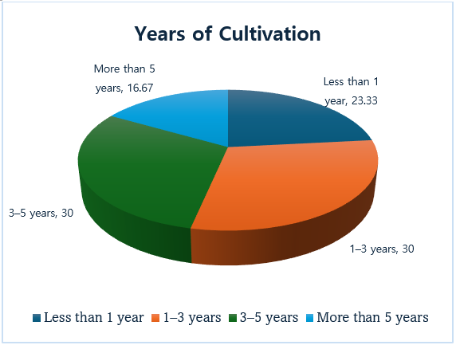
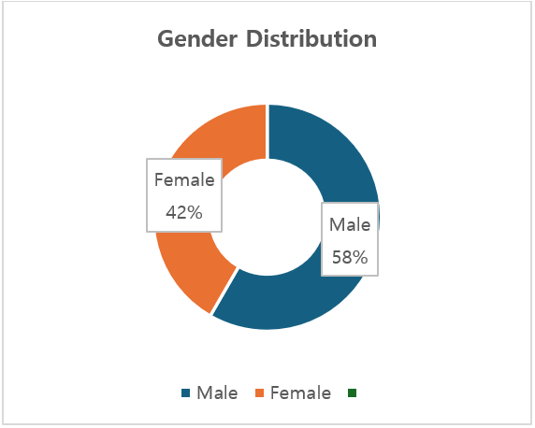
4.1 Demographic and Farm Profile
The demographic composition of the cannabis farmers revealed a group of middle-aged, experienced agriculturalists. The mean age of respondents was 41.78 years (SD = 5.67), with a range from 28 to 55 years. The sample comprised 58.3% male and 41.7% female farmers. Geographically, the farms were distributed across Blantyre (30.0%), Mzuzu (21.7%), Zomba (20.0%), Rumphi (16.7%), and Lilongwe (11.7%). In terms of experience with legal cannabis cultivation, the sample was fairly evenly split between new and moderately experienced growers: 23.3% had been cultivating for less than one year, 30.0% for 1-3 years, 30.0% for 3-5 years, and 16.7% for more than five years. The demographic profile of the farmers is summarized in Figure 2.

Figure 2: Demographic and Experience Profile of Surveyed Farmers.
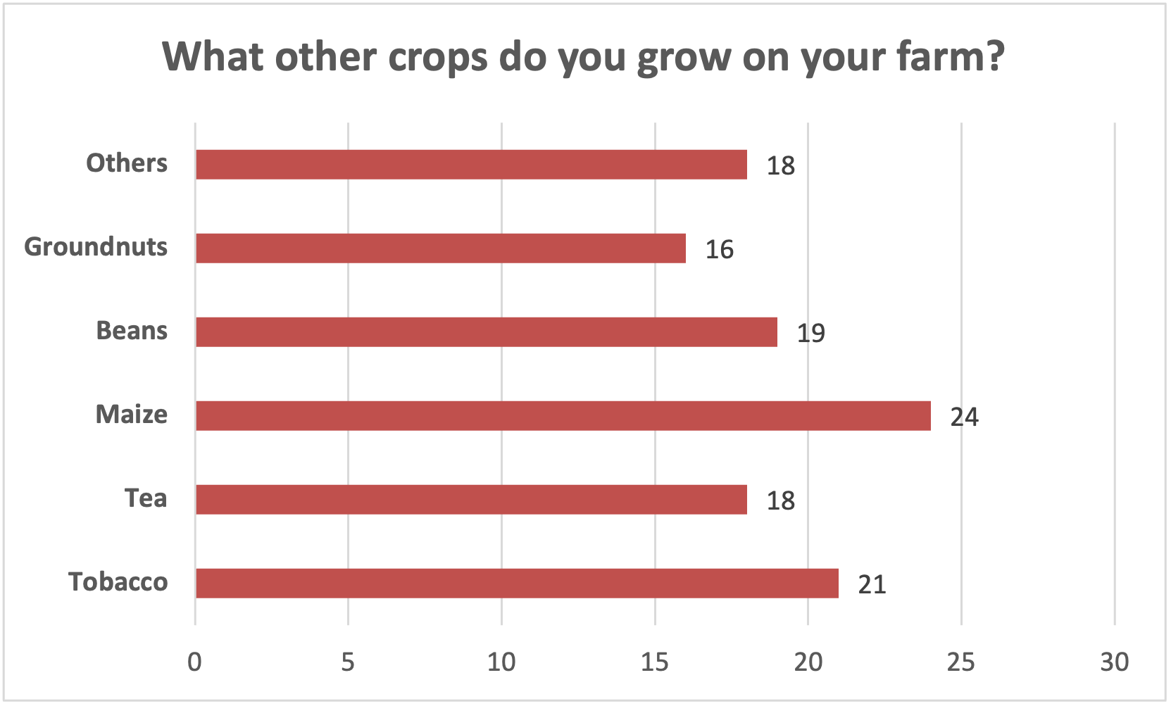
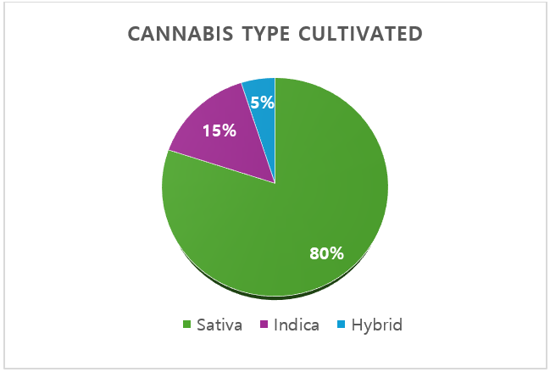
4.2 Agronomic Practices and Production Systems
The data indicate that cannabis is being integrated into existing diversified farming systems. Farmers reported also growing maize (40.0%), tobacco (35.0%), tea (30.0%), beans (31.7%), and ground nuts (26.7%). The choice of cannabis cultivar was overwhelmingly dominated by Sativa (80.0%), followed by Indica (15.0%) and Hybrid varieties (5.0%), reflecting a clear market orientation towards the internationally recognized Sativa strain. Production was capital-intensive, with high utilization of key inputs. The most frequently used inputs were irrigation equipment (66.7%), pesticides and herbicides (66.7%), fertilizers (63.3%), and seeds (61.7%). Water management practices were varied: 45.0% of growers relied on rain-fed systems, 21.7% used irrigation alone, and 33.3% used a combination of both.

Figure 3: Agronomic Profile of Cannabis Cultivation
4.3 Economic Analysis: Costs, Yields, and Revenues
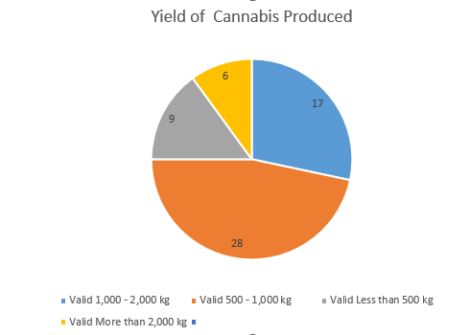
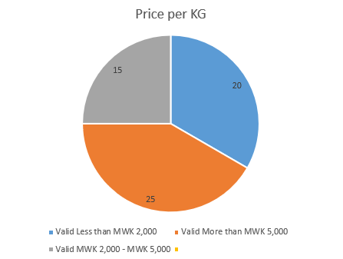
Production and Irrigation Costs: The mean production cost per grower was calculated to be MWK 203,443.72 (SD = 18,188.95), with a range from MWK 172,819 to MWK 249,173. Irrigation costs showed considerable diversity: 36.7% spent less than MWK 50,000, while another 36.7% spent more than MWK 100,000. Yields: The most common yield category was 500–1,000 kg (46.7% of farmers). This was followed by 1,000–2,000 kg (28.3%), less than 500 kg (15.0%), and more than 2,000 kg (10.0%), indicating moderate productivity levels across the sample. Prices and Revenues: Farm-gate prices for cannabis were highly variable. A plurality of farmers (41.7%) earned more than MWK 5,000 per kg. However, a significant portion (33.3%) earned less than MWK 2,000 per kg, with the remaining 25.0% falling in the MWK 2,000–5,000 range. Key determinants of price were identified as product quality (80.0%), market access (75.0%), supply and demand dynamics (70.0%), and government regulations (70.0%). Productivity levels were moderate across the sample (Figure 4A), but farm-gate prices were highly variable, highlighting significant market volatility (Figure 4B).
A
B

Figure 4: Economic Profile of Production and Revenue
4.4 Livelihood Impacts and Farmer Perceptions
Income Changes: The introduction of cannabis cultivation had a positive impact on income for a majority of respondents. A combined 60.0% experienced either a moderate increase (28.3%) or a significant increase (31.7%) in their household income. In contrast, 16.7% reported no change, and 23.3% reported a decrease. For many, cannabis became a substantial income source, with 30.0% of growers deriving 40-60% of their total farm income from the crop, and 23.3% deriving more than 60%. he introduction of cannabis cultivation had a significant impact on income, with a majority of respondents reporting positive changes, although a notable minority experienced a decrease (Figure 5).

Figure 5: Reported Changes in Household Income
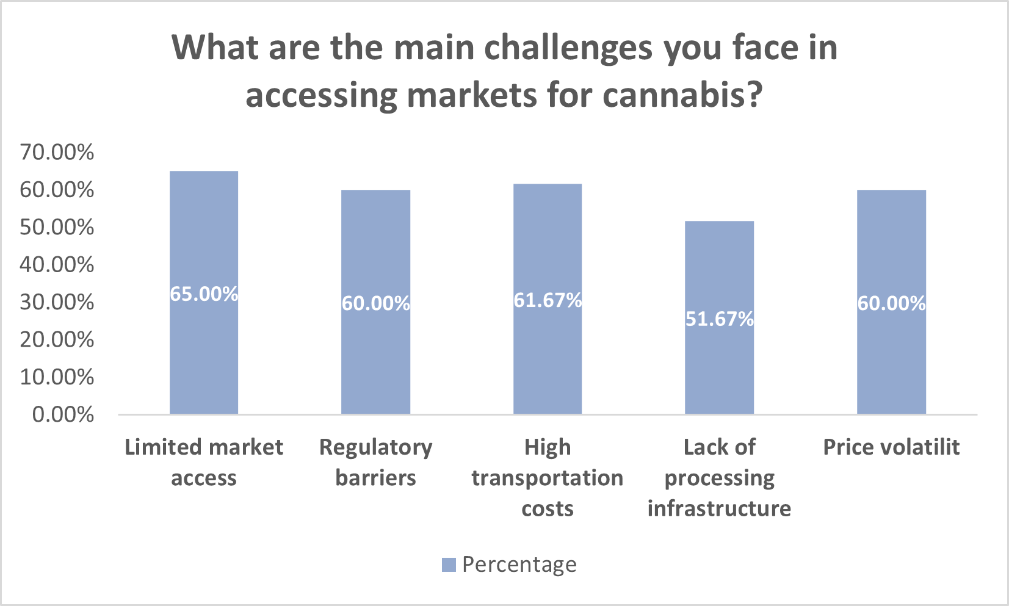
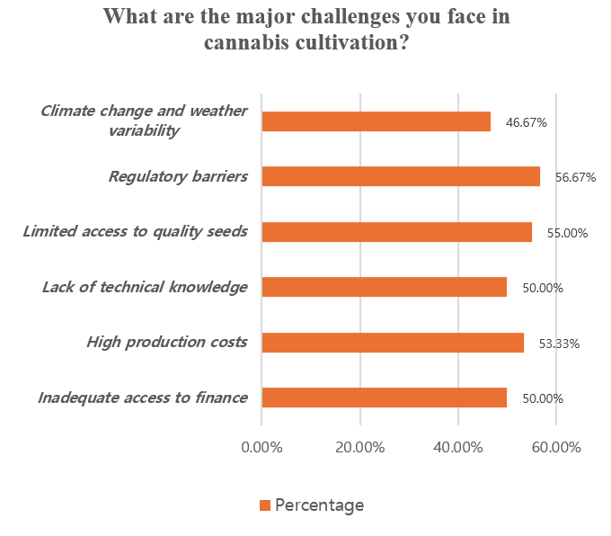
Awareness and Support Needs: Just over half of the farmers (51.7%) were aware of the existing cannabis regulations. Perceptions of the regulations' effectiveness were mixed. To improve profitability, farmers overwhelmingly prioritized the need for policy reforms (58.3%), followed by better infrastructure (55.0%), training (51.7%), improved market access (45.0%), and financial support (40.0%). Farmers identified a range of significant obstacles, with market-related and regulatory issues being the most prominent challenges (Figure 6).
Figure 6: Primary Challenges Faced by Smallholder Cannabis Farmers

4.5 Inferential Statistical Findings
The results of the inferential tests provided critical insights into the structural nature of the cannabis sector.
ANOVA Results: As detailed in Table 3, the one-way ANOVA tests failed to find any statistically significant differences in the mean production costs across all tested groups. The p-values for location (p=0.531), cannabis type (p=0.491), years of cultivation (p=0.919), and yield category (p=0.398) were all well above the alpha level of 0.05. This robustly supports the null hypothesis (H₀¹) that production costs are largely standardized and not significantly influenced by these farm-level variables.
Chi-Square Results: The Chi-square tests of independence also yielded non-significant results, supporting the second null hypothesis (H₀²). There was no statistically significant association between a farmer's income change and their chosen water management method (χ²(6, N=60) = 4.57, p=0.600) or their years of cultivation experience (χ²(9, N=60) = 4.92, p=0.841). This indicates that income outcomes are statistically independent of these specific characteristics and practices.
Table 3. Summary of ANOVA and Chi-Square Tests on Production Costs and Farmer Characteristics.
Test / Variable | Grouping Categories (N) | Test Statistic (F/χ²) | df | p-value | Interpretation
ANOVA: Production Cost by Location | Blantyre(18), Lilongwe(7), Mzuzu(13), Rumphi(10), Zomba(12) | F = 0.80 | (4, 55) | .531 | No significant difference across districts
ANOVA: Production Cost by Cannabis Type | Indica(9), Sativa(48), Hybrid(3) | F = 0.72 | (2, 57) | .491 | No significant difference across types
ANOVA: Production Cost by Years of Cultivation | <1yr(14), 1-3yrs(18), 3-5yrs(18), >5yrs(10) | F = 0.17 | (3, 56) | .919 | No significant difference across experience
ANOVA: Production Cost by Yield Category | <500kg(9), 500-1k kg(28), 1k-2k kg(17), >2k kg(6) | F = 1.00 | (3, 56) | .398 | No significant difference across yield levels
Chi-Square: Gender × Location | Male(35), Female(25) across five districts | χ² = 3.02 | 4 | .554 | Gender not associated with location
Chi-Square: Gender × Water Management | Irrigation(13), Rain-fed(27), Combination(20) | χ² = 2.29 | 2 | .318 | Gender not associated with water practices
Chi-Square: Water Management × Income Change | Decrease(14), Moderate/Significant Increase(36), No Change(10) | χ² = 4.57 | 6 | .600 | No significant relationship
Chi-Square: Years of Cultivation × Income Change | <1yr(14), 1-3yrs(18), 3-5yrs(18), >5yrs(10) | χ² = 4.92 | 9 | .841 | No significant relationship

5. Discussion
The empirical findings of this study provide a nuanced and data-driven perspective on the state of Malawi's emerging smallholder cannabis sector. The results highlight a critical duality: while cannabis cultivation presents a significant and viable economic opportunity, its potential is currently constrained by formidable systemic barriers. Statistical analyses, in particular, allow us to deconstruct the primary drivers of profitability, revealing that success is less a function of individual farmer skill or location and more a product of the broader market and regulatory environment.
5.1 The Primacy of Systemic Factors over Farm-Level Variables
The most compelling finding of this research is the consistent non-significance of farm-level variables in determining economic outcomes. Our first null hypothesis (H₀¹)—that production costs do not differ significantly by location, cultivar, or experience—was strongly supported by the ANOVA results. This uniformity in costs suggests a standardized input market where structural factors, such as the national price of certified seeds, fertilizers, and equipment, are the dominant cost drivers. It implies that individual farmers, regardless of their location or experience, face a similar, high financial barrier to entry. This finding aligns with literature that points to the capital-intensive nature of cannabis production and the challenges smallholders face in accessing affordable finance (Kaselema & Mtima, 2025).
Similarly, the failure to reject our second null hypothesis (H₀²) that income changes are independent of management practices and experience is highly instructive. The Chi-square tests demonstrate that there is no statistical evidence that more experienced farmers or those using specific irrigation techniques are more likely to achieve positive income outcomes. This counterintuitive finding suggests that agronomic proficiency alone is insufficient to guarantee profitability. Instead, it points to the overwhelming influence of external factors. Profitability appears to be primarily dictated by a farmer's ability to navigate a fragmented and volatile market, secure access to reliable buyers, and negotiate favorable prices factors largely outside their direct control. This reinforces the idea that market structure and policy are the ultimate arbiters of success in this sector (Chinsinga, 2011).
5.2 Market Fragmentation, Price Volatility, and the Smallholder Dilemma
The study's results paint a clear picture of a fragmented and immature market. Farmers employ a multi-channel selling strategy (direct to buyers, processors, exporters) not as a sign of sophisticated market integration but as a risk mitigation tactic in an environment lacking a structured, centralized value chain. This fragmentation directly contributes to the extreme price volatility observed, where some farmers achieve premium prices while a third receive prices below sustainable levels. This situation is symptomatic of markets with high information asymmetry, weak infrastructure, and limited collective bargaining power for producers longstanding challenges in Malawi's agricultural sector (Chitete et al., 2025). While the dominance of the Sativa cultivar (80%) indicates that farmers are responsive to international market signals, their ability to profit from this is undermined by these structural market weaknesses.
5.3 Cannabis as a Viable but Conditional Livelihood Alternative
Despite these challenges, the study confirms that cannabis cultivation is a viable livelihood alternative for a majority of the farmers surveyed. The finding that 60% of respondents reported moderate to significant income increases provides strong evidence of the crop's potential to replace declining tobacco revenues. For nearly a quarter of the sample, cannabis now constitutes over 60% of their farm income, marking a significant shift in livelihood strategies. However, the fact that 23.3% experienced an income decrease serves as a critical reminder that profitability is not guaranteed. This group of farmers is likely those who have been unable to overcome the high input costs, secure market access, or have been victims of price volatility. Their experience underscores the conditional nature of success in the current environment.
5.4 Regulatory Barriers as a Central Constraint
The prominence of "regulatory barriers" as the most cited cultivation challenge (56.7%) is a direct indictment of the current implementation of the Cannabis Regulation Act (2020). While the Act was a necessary step, its high licensing fees and complex compliance procedures are perceived by farmers as a primary constraint. This validates concerns raised in the literature about the risk of elite capture and the marginalization of smallholders (Brian, 2022; Malawi, 2020). For the sector to be truly inclusive, the regulatory framework must be reformed to be more accessible and affordable for the small-scale producers it is meant to empower.
5.5 Limitations of the Study
This study, while providing valuable foundational data, is subject to certain limitations. The sample size of N=60, while sufficient for the statistical tests conducted, is relatively small and may limit the generalizability of the findings to the entire population of cannabis farmers in Malawi. The purposive sampling method, though necessary for this exploratory phase, may introduce selection bias. Furthermore, the cross-sectional design provides a snapshot in time and does not capture the dynamic evolution of profitability and market structures across multiple seasons.
6. Conclusion and Policy Implications
6.1 Conclusion
This study provides robust empirical evidence that cannabis cultivation is a viable and economically significant diversification strategy for smallholder farmers in Malawi. It offers a clear pathway to reduce dependence on the declining tobacco sector and has already resulted in substantial income gains for a majority of early adopters. However, the sector's sustainability and inclusivity are severely hampered by systemic, structural barriers. Our statistical analyses demonstrate that profitability is not primarily determined by farm-level factors like experience, location, or agronomic practices. Instead, it is governed by external conditions: a fragmented market structure, high input costs, volatile pricing, and a burdensome regulatory framework. To unlock the full potential of cannabis as a tool for broad-based rural development, these systemic issues must be addressed.
6.2 Policy Implications
Based on the empirical findings, the following policy implications are recommended to foster an equitable and competitive cannabis sector in Malawi:
- Reform Regulatory and Licensing Frameworks for Inclusivity: Given that regulatory barriers were the most cited challenge, the Cannabis Regulatory Authority (CRA) should review and reform its licensing procedures. The introduction of a tiered licensing system with significantly lower fees for individual smallholders and cooperatives, and progressive rates for large commercial enterprises is critical to prevent elite capture and ensure equitable access.
- Develop Market Infrastructure and Structured Value Chains: To combat price volatility and fragmented markets, public and private investment is needed in critical infrastructure. This includes establishing regional processing hubs, certified storage facilities, and transparent commodity exchanges or auction systems. Such infrastructure would reduce post-harvest losses, improve product quality, and enhance the bargaining power of smallholders.
- Facilitate Access to Finance and Quality Inputs: The high production costs are a major barrier. The government, in partnership with financial institutions, should create tailored credit products for cannabis farmers. Subsidies on certified seeds and water-efficient irrigation technologies could lower the capital intensity of production and broaden participation.
- Strengthen Extension Services and Capacity Building: While experience alone was not a determinant of profitability, specialized knowledge is crucial. Extension services must be scaled up to provide training in Good Agricultural Practices (GAPs) for cannabis, international quality standards, post-harvest handling, and financial literacy. This will enable farmers to meet the demands of high-value medicinal and export markets.
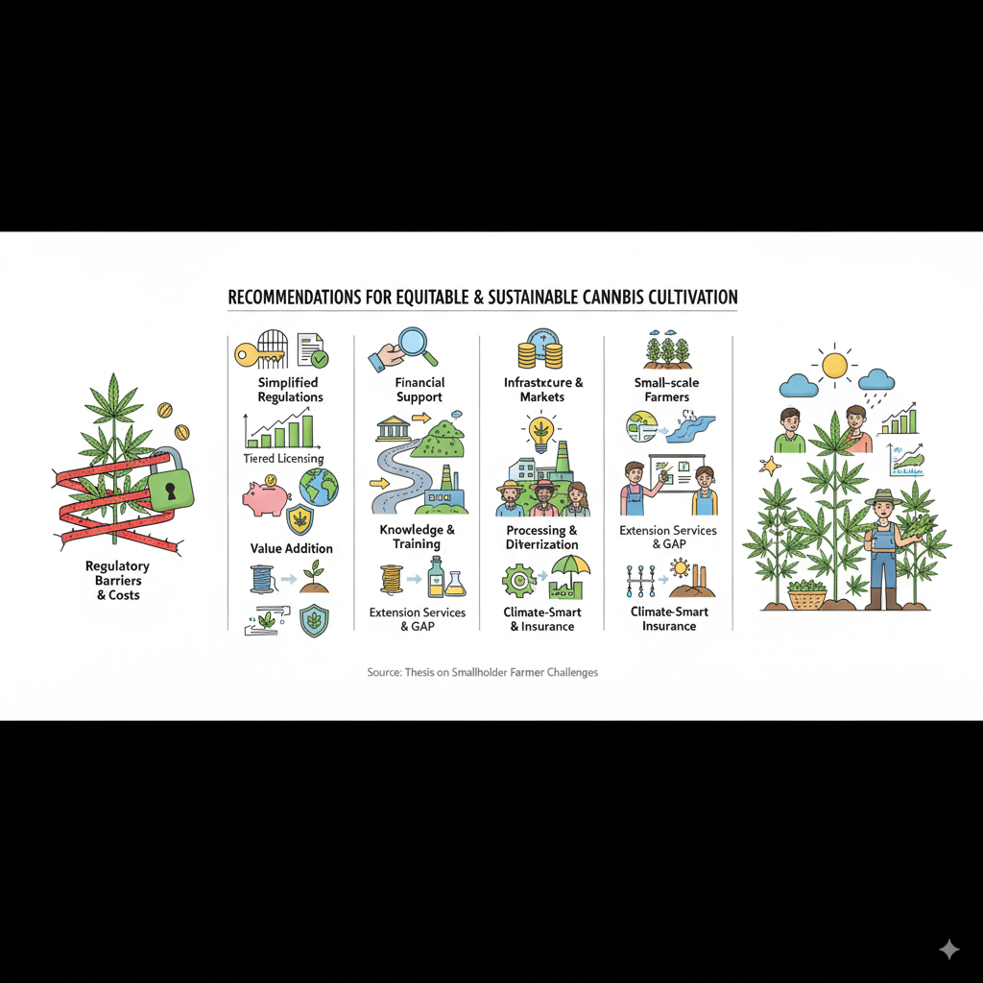
- Promote Value Addition and Industrial Linkages: To maximize national economic benefit, policy should incentivize local value addition beyond the export of raw cannabis. This includes offering tax incentives and grants for investment in facilities for processing hemp fiber, seed oil, and medicinal extracts, thereby creating jobs and capturing more value within Malawi.
Figure 7: A Conceptual Framework for a Sustainable Smallholder Cannabis Sector in Malawi
By implementing these evidence-based policies, Malawi can transition its cannabis sector from a high-potential but high-risk venture into a stable and inclusive engine of agricultural growth.

DISCLAIMER (ARTIFICIAL INTELLIGENCE)
The author(s) hereby declare that no generative artificial intelligence technologies, including but not limited to large language models (e.g., ChatGPT, Copilot, or similar systems), and text-to-image generation tools were used in the writing, editing, or preparation of this manuscript.

References
Bandawe, G. (2022). Medical cannabis and cannabidiol: A new harvest for Malawi. Malawi medical journal : the journal of Medical Association of Malawi, 34(2), 138-142. https://doi.org/10.4314/mmj.v34i2.10
Blebea, N. M., Rambu, D., Costache, T., & Negreș, S. (2021). Very Fast RP–UHPLC–PDA Method for Identification and Quantification of the Cannabinoids from Hemp Oil. Applied Sciences, 11(20), 9414. https://doi.org/10.3390/app11209414
Brian, P. K. (2022). Legalising Recreational Cannabis Sativa as forex cash cow for Malawi– Focussing on what buyer wants. https://mpra.ub.uni-muenchen.de/114352/7/MPRA_paper_114352.pdf
Chinsinga, B. (2011). Agro-dealers, Subsidies and Rural Market Development in Malawi: A Political Economy Enquiry. https://hdl.handle.net/20.500.12413/2256
Chitete, M. M. N., Mgomezulu, W. R., Bwanaisa, M., Damazio, C., Kaunda, R. T., & Dzanja, J. (2025). A Systematic Review of the Performance of Agricultural Marketing in Malawi. Journal of Asian and African Studies, 60(5), 2829-2846. https://doi.org/10.1177/00219096231224679
Ding, Z., Hamann, K. T., & Grundmann, P. (2024). Enhancing circular bioeconomy in Europe: Sustainable valorization of residual grassland biomass for emerging bio-based value chains. Sustainable Production and Consumption, 45, 265-280. https://doi.org/10.1016/j.spc.2024.01.008
Falcone, P. M. (2019). Tourism-Based Circular Economy in Salento (South Italy): A SWOT-ANP Analysis. Social Sciences, 8(7), 216. https://doi.org/10.3390/socsci8070216
Hanusová, H., Juřenová, K., Hurajová, E., Vaverková, M., & Winkler, J. (2022). Vegetation structure of bio-belts as agro-environmentally-climatic measures to support biodiversity on arable land: A case study. AIMS Agriculture and Food, 7, 883-896. https://doi.org/10.3934/agrfood.2022054
Kaselema, K., & Mtima, C. (2025). Assessing the Relationship between Access to Agricultural Extension Services and Maize Yield among Smallholder Farmers in Malawi. N/A, 26.
Kateta, M. (2019). Malawi losing millions of export earnings from untapped ‘Malawi Gold’. Equal Times. https://www.equaltimes.org/malawi-losing-millions-of-export?lang=en
Malawi, G. o. (2020). Cannabis Regulation (Fees) Regulations, . (95). Retrieved from https://malawilii.org/akn/mw/act/gn/2020/95/eng@2020-11-20
Malawi Government. (2020). Cannabis Regulation Act, . Retrieved from https://malawilii.org/akn/mw/act/2020/6/eng@2020-05-08
Masina, L. (2024). Malawi Parliament to Debate Cannabis Farming. https://www.voanews.com/a/malawi-parliament-to-debate-cannabis-farming/7538900.html
McCool, A. (2020). Malawi legalises cannabis amid hopes of fresh economic growth. Guardian News & Media Limited. https://www.theguardian.com/global-development/2020/feb/28/malawi-legalises-cannabis-amid-hopes-of-fresh-economic-growth
Pensulo, C. (2024). Malawi: Legalising cannabis will boost economy as country’s tobacco farms dwindle. In.
Rodin, D., Maizels, Y., & Koman, I. (2025). Medical Cannabis Library: development of a curated database for research articles on cannabis therapeutic activity. Journal of Cannabis Research, 7(1). https://doi.org/10.1186/s42238-025-00295-7
Salami, S. A., Martinelli, F., Giovino, A., Bachari, A., Arad, N., & Mantri, N. (2020). It Is Our Turn to Get Cannabis High: Put Cannabinoids in Food and Health Baskets. Molecules, 25(18), 4036. https://doi.org/10.3390/molecules25184036
SGOW. (2023). MALAWI AFRICA’s hidden giant. https://sacgow.com/wp-content/uploads/2023/11/An-Investors-Guide-to-Cannabis-in-Malawi.pdf
Spano, M., Di Matteo, G., Ingallina, C., Botta, B., Quaglio, D., Ghirga, F., Balducci, S., Cammarone, S., Campiglia, E., Giusti, A. M., Vinci, G., Rapa, M., Ciano, S., Mannina, L., & Sobolev, A. P. (2021). A Multimethodological Characterization of Cannabis sativa L. Inflorescences from Seven Dioecious Cultivars Grown in Italy: The Effect of Different Harvesting Stages. Molecules, 26(10), 2912. https://doi.org/10.3390/molecules26102912
Tambala, H. (2022). Examining the Experiences of Smallholder farmers in Malawi towards Farm Input Subsidies OpenUCT. http://hdl.handle.net/11427/37344
Veerabadhran, M., Natesan, S., MubarakAli, D., Xu, S., & Yang, F. (2021). Using different cultivation strategies and methods for the production of microalgal biomass as a raw material for the generation of bioproducts. Chemosphere, 285, 131436. https://doi.org/10.1016/j.chemosphere.2021.131436
Wikipedia. (2025). Cannabis in Malawi. In.
Wise, K., Selby-Pham, J., Chai, X., Simovich, T., Gupta, S., & Gill, H. (2024). Fertiliser supplementation with a biostimulant complex of fish hydrolysate, Aloe vera extract, and kelp alters cannabis root architecture to enhance nutrient uptake. Scientia Horticulturae, 323, 112483. https://doi.org/10.1016/j.scienta.2023.112483

