Policy Article

Rice Post-Harvest Value Addition Agricultural Extension Training Model for Smallholder Farmers and Extension Agents in the Southern Region of Sierra Leone

Abstract
A study was conducted to develop an agricultural training model for smallholder farmers and extension agents (farming actors) in rice post-harvest value addition in the Southern region of Sierra Leone. The study sought to identify the training needs and competencies of the farming actors in rice post-harvest value addition with a vision to identify their required training contents. A multi-stage random sampling technique was employed to select 400 smallholder farmers from 157,114 households by the use of Yamane's formula. A census of 50 extension agents operating in the region was also done. The training model development was aided by undertaking a training needs assessment. The model is largely a synthesis of the study objectives of the rice post-harvest value addition study. The assessment revealed that farming actors have limited resources, low-value addition competencies, imperfect market situation, inadequate extension services, low profit margin, low livelihood, peasant farming, and low motivation for extension agents. The study further reveals low competency levels for the farming actors. The key expressed training needs of the farming actors include milling, packaging and marketing, and storage of rice whilst the majority preferred group training methods in rice post-harvest value addition. For effective training, the study further shows that training support such as subject matter specialists, input suppliers, service providers, and infrastructure, among others, are to be provided. The study also provided a dynamic extension model as an alternative option to the generic type since farming situations are constantly changing. This dynamic model ensures that as the context issues change, there is a need for the farming actors to respond to those changes. It is therefore recommended that regular needs assessment and monitoring of training actors must be done for full utilisation of the proposed model.

Keywords: Competencies, Extension agents, Rice post-harvest value addition, Smallholder farmers, Training model, Training needs

Introduction
The construction and coordination of the training programme at the local level in an effort to accomplish the specific objectives of a training are illustrated by an extension training model (Caillouet, Harder, Bunch, Roberts & Radunovich 2022). In order to undertake an appropriate analysis of the contents that need to be taught, the beneficiary, organisation, the training needs assessment is the first stage in any training development efforts (Salas, Tannenbaum, Kraiger, & Smith-Jentsch, 2012). According to these authors, the desired objectives of this stage include expected learning outcomes, recommendations for the design and delivery of training, suggestions for evaluating training, and knowledge of the organisational elements that may help or hinder training effectiveness. In order to improve performance and prepare for future advantageous changes, training consequently has a favourable impact on the conduct and working abilities of the trainees (Jehanzeb & Bashir, 2013). As a result, training develops fundamental knowledge of the subject. This information is essential, according to Bukchin and Kerret (2020), since farmers' adoption of technologies and, as a result, their level of expertise or competence in a particular technology, may be impacted by their context or surroundings. This is crucial for the adoption of better agricultural product production and processing technologies since the backdrop of the study acts as the main engine for the expansion of agriculture in low-income nations (Mihretie, Misganaw, & Siyum Muluneh, 2022). Also, training support is a must for the sustainability of any training initiative. Thus, "training support" refers to any tangible or practical aid required to facilitate training and its implementation for the development of knowledge and skills (Issahaku, 2014).

It is obvious that the creation of a suitable context-specific training model depends on an accurate evaluation of the training needs and the provision of training assistance (See Figure 1). These are covered in the sections that follow. It is obvious that an awareness of the target group's context and the knowledge gap that needs to be filled is necessary for a successful training needs assessment. This knowledge is crucial since farmers' environments might affect how they accept new technologies and, in turn, their degree of expertise with such technologies (Bukchin & Kerret, 2020). The low level of resources available to smallholder farmers and extension agents, the low level of post-harvest value addition undertaken by farmers, the unfavourable market environment, the high extension agent-to-farmer ratio, the low profit margin realised by farmers in farming, the low livelihood status of smallholder farmers and extension agents, the peasantry nature of the smallholder farmers, and the demotivated extension agents are all factors in this context (Figure 2).

According to the findings of the rice post-harvest value addition study in the said study area, smallholder rice farmers lack access to important resources for rice post-harvest value addition. These include human resources, specialised equipment for parboiling, dehusking, and grading, as well as financial resources, packing, and branding resources. The majority of farmers cannot access or afford these resources even where they are available. Therefore, smallholder farmers in the study area add little value to their products. Smallholder farmers usually scored a (composite mean=1.45) in the study area in rice post-harvest value addition, indicating that smallholder farmers only added value to a very small extent. Smallholder farmers who use certain technologies engage in value addition to a considerable amount via timely harvesting, sun drying paddy on tarpaulin/plastic sheets or concrete floors, milling, and parboiling paddy. Farmers performed very modestly among the other value-adding tasks, such as using a moisture metre to determine the moisture level of the paddy, using a de-stoner and threshing paddy with a machine.

The study also demonstrates that, even though most smallholder farmers sell their rice after harvest, very few do so in milled form. Farmers at both local and regional marketplaces "Lummur" virtually never meet these requirements because of the various rice qualities that clients choose. As a result, the fact that farmers do not adhere to the necessary value addition standards, buyers demonstrate imperfection in the market situation. Due to this flaw in the market, sellers typically offer rice at mediocre or low pricing rates. The difficulties farmers faced in marketing their rice, including fluctuating market circumstances, transportation, low yields, scarce storage space, and low prices, have made the issue worse.

The results also demonstrate that during the stages of rice post-harvest value addition, farmers have limited access to extension information. This is inextricably linked to the low farmer-to-extension agent ratio in the study areas, which prohibits farmers from effectively adopting and using post-harvest value addition technologies for rice. The majority of the farmers make little to no profit because of the low degree of value addition and the high overall cost of all the production elements (land, labour, and capital). The aforementioned difficulties smallholder farmers face lead to a very low level of their livelihood status. The majority of smallholder farmers are impoverished and have low social standing in their communities, hence the best way to define them is as peasant farmers, according to the overall findings. The privilege of family ownership over lands is one of the farmers' distinctively peasant traits. This is because the family owns the majority of the land, has varying production patterns, subordinate to various social sectors both inside and outside of their communities, and has variable degrees of market system integration. According to the research findings, the conceptual framework below may be utilised to teach farming actors very explicitly.
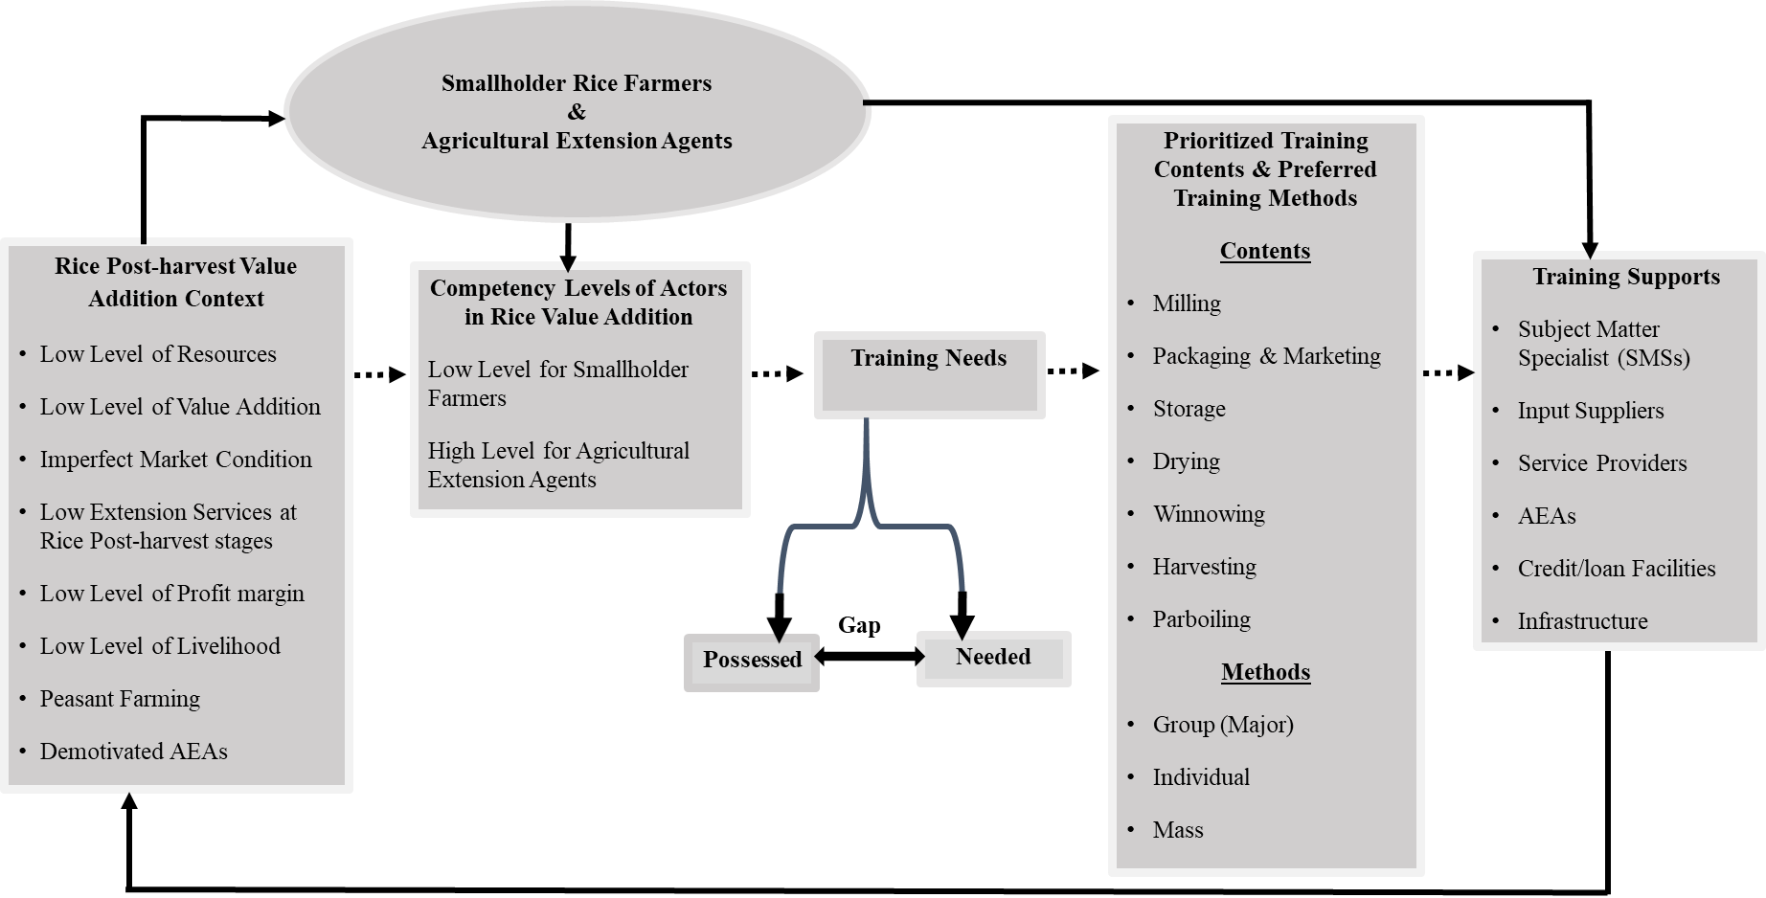
Figure 1: Proposed Extension Training Model for Rice Post-harvest Value Addition in Southern Region, Sierra Leone
Source: Author’s construct, Kamanda (2021)
Assessment of the rice post-harvest value addition resources for extension agents reveal that the majority of the resources were insufficient. Human resources, equipment, and supplies for adding value to rice, services and buildings are some of these resources. The primary human resources were those involved in value addition, subject matter specialists, post-harvest value addition service providers, and input suppliers. Also included in the list of material resources are monetary/financial resources, mobility for extension agents, processing and storage facilities, computers and accessories, and infrastructure including (venues, offices), audio-visual aids, prints and non-print materials.

Most extension agents acknowledged that they worked with smallholder farmers throughout the whole rice production period. A little over half of the agents offer extension services monthly basis, and the majority of them employ the group method to teach. Due to a lack of the aforementioned essential extension service delivery resources at the rice post-harvest level, extension agents tend to be least motivated, which often prevents them from doing their extension activities successfully and efficiently. Conspicuous markers of the public extension agents' demotivation in the research areas include their poor financial remuneration and low self-esteem. According to the findings of the study, both extension agents and smallholder farmers have low competence in adding value to rice after harvest. For the farmers, other than panicle selection to harvest rice with a knife, packing paddy on heaps, and using baskets to transport paddy by farmers themselves, are where require high competency. However, they (farmers) lack competence in the use of a moisture metre to regulate the amount of moisture in the paddy, using a combine harvester to harvest the paddy, and utilising a power tiller.

Contextual concerns may be a factor in the causes of these findings. Farmers will be prevented from learning and using new technology, for instance, due to a lack of resources, especially monetary resources. Additionally, the low rice prices that buyers are willing to pay will substantially deter farmers from implementing value-addition techniques. Additionally, less effective extension services, particularly at the post-harvest stages for rice, along with the typical low profit margin perceived by the majority of farmers, would together limit their eagerness for accepting these post-harvest value addition technologies. According to Jewitt and Raman (2017), more recent research are focusing on the shortcomings that prevent appropriate knowledge transfer from scientists or experimental stations to farmers in order to provide successful extension services.

Public extension agents have historically played a crucial role in the dissemination and acceptance of technical advancements. They make substantial profits from farming and are more inclined than smallholder farmers to adopt new technologies. According to research conducted in Tunisia by Dhraief et al. (2018), bigger farmers that make significant income from their farming operations are more inclined to use technology than small farmers. However, it could be too expensive to actively teach each and every farmer to increase their knowledge and comprehension of new technologies, hence encouraging their acceptance and broader distribution. This is particularly true in many low-income countries where small-scale farms are the main mode of agricultural production and are distributed geographically. Information dissemination to these regions is more expensive due to the typically poor infrastructure quality in these locations. Finally, because of their poor financial situation, the farmers may not be able to invest in the value-addition processing machinery necessary for their participation in peasant farming.
The findings also demonstrate that farmers and extension agents both possess moderate competence. The harvesting of paddy by using a knife to select panicle, heaping paddy on tarpaulin, using the coned heap style to pack paddy and usage of a number of other technologies are all tasks that the extension agents are highly competent in. However, extension agents also have low levels of competence in a number of other areas, including using a power tiller to transport paddy, drying wet paddy before it is threshed, using a specialised container for parboiling, and more. The context issues may once again have an impact on the reasons for the findings. In contrast, despite having few resources, subject matter specialists, input suppliers, and adequate infrastructure, extension agents nonetheless possess a high degree of competency in rice post-harvest value addition technologies. This is unquestionably due to the fact that extension agents have access to at least a trustworthy source of rice post-harvest market data as a result of their formal education. According to this study, this training is reflected in the regular extension services that are provided to farmers during the general agronomic stages of rice growing. As a result, the extension agents' levels of competence rise. However, the poor livelihood status of extension agents is a result of their level of demotivation due to inadequate compensation packages, which would eventually have the tendency to hamper their competencies to successfully help farmers realise value addition.

Training Contents and Preferred Methods
Following a thorough assessment of the smallholder farmers' training needs and the environment in which they operate, the next task of the researcher was to identify the training contents and delivery methods that would best support farmers' learning and the adoption of new practices. The Borich Needs Assessment Model (Umar, Man, Nawi, Latif, & Samah, 2017) was used to identify the crucial training needs of farmers and extension agents in rice post-harvest value addition. This can be done by using the findings of the study. It is also possible to identify the appropriate preferred training technologies for both farmers and extension agents.

Packaging and marketing, milling, drying, winnowing, harvesting, transportation, storing, parboiling, threshing, and heaping are the prioritised (ranked) technologies that should be taken into account while developing training for smallholder rice post-harvest value addition farmers. It is interesting to note that most farmers preferred group training methods across the board for the technology they used.

There are many specific tasks involved in packaging and marketing technologies, but the three most crucial ones in terms of training needs are labelling for the identification of rice types and quality, weighing paddy to determine selling weight, and packing rice at 8.0-13.0% moisture content. For these locations, the majority of the farmers preferred using group training methods. The most important areas for training in milling are the use of machines for dehusking or hulling rice, removing unfilled grains, and grading broken and unbroken rice (separator). The main training topics for smallholder farmers should cover the use of a moisture metre to test for moisture content, mechanical drier for paddy, oscillators and aspirators for mechanical winnowing. The instruction of smallholder farmers also included harvesting paddy. To be more precise, desired core training topics for smallholder farmers include the usage of a combine harvester, moisture metre, and planting calendar to establish the paddy harvesting date. Smallholder farmers favour training in the use of a power tiller to transport paddy after it has been harvested from the field.

Smallholder farmers prefer training in three areas: limiting grain moisture content at or below 14.0% w.b., storing paddy in sacks or jute bags, and cleaning the storehouse three weeks before the arrival of freshly harvested paddy. Despite the fact that smallholder farmers did not prioritise paddy threshing as a training need, they still favour using a threshing machine and threshing paddy with feet on tarpaulin as their primary training topics. Last but not least, smallholder farmers need training in packing their paddy in a coned heap form and stacking it on tarpaulins after harvest.

Table 1: Smallholder farmer’s training contents and preferred training methods
Rank | Technology | Priority Areas | Method (%)
Rank | Technology | Priority Areas | Group | Individual | Mass
1 | Packaging & Marketing | Labels/tags for identification of rice types and quality  Weighing paddy on a scale to determine selling weight  Packing rice at 8.0-13.0% moisture content, etc. | 79.3  84.8  77.0 | 14.5  14.2  15.3 | 6.2  1.0  7.7
2 | Milling | Rice separator to grade broken rice  Machine to remove unfilled grains  Dehusking or dehulling machine to dehusk rice, etc. | 91.0  88.5  83.0 | 9.0  10.5  13.8 | 0.0  1.0  3.2
3 | Drying | Moisture meter to test for moisture content  Use of mechanical dryer to dry paddy | 89.5  69.5 | 9.5  30.0 | 1.0  0.5
4 | Winnowing | Use of oscillating sieves and aspirators (mechanical winnower) | 78.0 | 21.8 | 0.2
5 | Harvesting | Harvesting paddy with a combine harvester  Use of moisture meter to determine moisture content in paddy  Use of planting calendar to determine harvesting date | 77.0  71.8  51.8 | 10.2  24.4  22.2 | 12.8  3.8  26.0
6 | Transporting | Use of power tiller to transport paddy  Use of baskets to transport paddy by humans  Use of bags to transport paddy by humans | 48.5  59.5  57.8 | 46.3  25.5  27.5 | 5.2  15.0  14.7
7 | Storage | Keeping moisture content of grains at or below 14.0%.w.b.  Sacks or jute bags to store rice  Cleaning storehouse three weeks before the arrival of fresh harvest etc. | 86.8  85.5  72.8 | 6.2  8.0  17.5 | 7.0  6.5  9.7
8 | Parboiling | Use of a specialized parboiling container  Removal of unfilled/empty grains  Use of rice separator/net to sieve broken grains from paddy | 78.0  86.8  82.0 | 16.8  10.2  17.3 | 5.2  3.0  0.7
9 | Threshing | Use of threshing machine  Threshing paddy with feet on tarpaulin | 81.0  82.0 | 18.5  16.5 | 0.5  1.5
10 | Heaping | Heaping paddy on tarpaulin  Use of coned heap style to pack paddy | 82.5  91.0 | 14.0  8.2 | 3.5  0.8
Source: Field Data, Kamanda (2021)
Table 2 presents lists of the rice post-harvest value addition technologies that are prioritised and for which extension agents need training. In order of priority to the extension agents, the technologies include milling, packing, and marketing, parboiling, harvesting, transporting, drying, and storing, as well as heaping and threshing. The above-mentioned rice post-harvest value addition technology areas that require training are needed by extension agents for the specific training areas, also known as the training contents. For instance, training in the usage of a de-stoner to remove stones or pebbles from rice, a machine to remove unfilled grains, and a mechanical miller to mill paddy are all necessary for extension agents to work in the milling sector.

Similar to this, for the majority of the training contents in rice post-harvest value addition technologies, extension agents prefer group methods followed by individual methods. However, there are certain locations where extension agents choose to be trained by group methods, followed by a mass method, such as weighing paddy on a scale, soaking paddy for about 18 hours in the water, using a planting calendar to determine the planting date, and a few others. The highly prioritised (ranked) technologies listed in Table 2 are milling, packing and marketing, parboiling, harvesting, transportation, drying, storing, piling, and threshing. These technologies should also be taken into account when designing training for extension agents working with rice post-harvest farmers. Although various specific activities are needed for the milling paddy which is a high priority training need of extension agents in rice post-harvest value addition (Table 2), there are three crucial training areas that the extension agents choose. These include using a de-stoner to remove pebbles and stones from rice, a machine to remove empty grains, and a mechanical miller to mill paddy. Extension agents especially need training in using laminated and zippered bags to package rice, marking or tagging rice packets for tracing and identifying varieties of rice and quality, and marketing after packaging and marketing.

Additionally, parboiling is the third most important training need for extension agents. The use of a rice separator/net to filter broken grains, the use of specialised parboiling containers, and soaking paddy in warm water before drying are some specific paddy parboiling technologies in which extension agents require training. Extension agents will require extensive training in the operation of a combine harvester, a moisture metre to gauge the moisture content in the paddy, and the use of a planting calendar to estimate when to harvest paddy. They also call for the installation of a mechanical drier, a moisture metre to gauge the amount of moisture in the paddy, and concrete or drying floors to speed up the drying process. Extension agents must get training in rice barn usage, maintaining grains' moisture content at or below 14.0% w.b., and cleaning storage facilities prior to the arrival of new harvests.

The extension agents have the greatest need for training in the usage of coned heap style to pack paddy after harvest and heaping for no longer than a day before threshing, which are among the least priority training needs. Last but not least, the extension agents require thorough training in the use of a threshing machine as well as the use of feet to thresh paddy on concrete or drying floors.

Table 2: Agricultural extension agents’ training contents and preferred training methods
Rank | Technology | Priority Areas | Method (%)
Rank | Technology | Priority Areas | Group | Individual | Mass
1 | Milling | Use of de-stoner to remove stones/pebbles from rice  Use of a machine to remove unfilled grains  Use of mechanical miller to mill paddy | 88.0  88.0  90.0 | 12.0  12.0  10.0 | 0.0  0.0  0.0
2 | Packaging & Marketing | Use of laminated and zipped bags to package rice  Use labels/tags for traceability/identification of rice types and quality  Weighing paddy on a weighing scale to determine selling weight | 90.0  90.0  98.0 | 8.0  10.0  0.0 | 2.0  0.0  2.0
3 | Parboiling | Use of rice separator/net to sieve broken grains from paddy  Use of a specialized parboiling container  Soaking paddy for about 18 hours in warm water. | 92.0  94.0  96.0 | 6.0  6.0  2.0 | 2.0  0.0  2.0
4 | Harvesting | Harvesting paddy with a combine harvester  Use of moisture meter to determine moisture content in paddy  Use of planting calendar to determine harvesting date | 90.0  90.0  86.0 | 8.0  10.0  4.0 | 2.0  0.0  10.0
5 | Transporting | Use of power tiller to transport paddy  Use of bags to transport paddy by humans  Use of baskets to transport paddy by humans | 92.0  86.0  88.0 | 8.0  8.0  6.0 | 0.0  6.0  6.0
6 | Drying | Use of mechanical dryer to dry paddy  Use of moisture meter to test for moisture content in the paddy  Use of concrete/drying floor to dry paddy | 92.0  88.0  90.0 | 8.0  12.0  2.0 | 0.0  0.0  8.0
7 | Storage | Keeping moisture content of grains at or below 14.0%.w.b  Use of rice barns  Cleaning storehouse three weeks before the arrival of fresh harvest | 92.0  92.0  90.0 | 8.0  2.0  2.0 | 0.0  6.0  8.0
8 | Heaping | Use of coned heap style to pack paddy  Heaping paddy on tarpaulin  Heaping harvested paddy for not more than a day | 88.0  94.0  88.0 | 8.0  6.0  10.0 | 4.0  0.0  2.0
9 | Threshing | Use of threshing machine  Threshing paddy with feet on concrete/dying floor | 90.0  86.0 | 10.0  10.0 | 0.0  4.0
Source: Field Data, Kamanda (2021)

Training Support
According to Issahaku (2014), training support refers to the practical or material assistance that is made accessible to help training and its application to gain information and skills for a certain goal. After successfully acquiring information and skills through training, it is expected that a support system would be in place to make it easier for the knowledge and skills to be put into practice (Rodriguez & Walters, 2017). The study makes clear that a number of resources and circumstances are required for smallholder farmers and extension agents in Sierra Leone to get effective and efficient training in rice post-harvest value addition.

The study has identified the need for sufficient extension agents, rice post-harvest value addition input suppliers, rice post-harvest value addition service providers, infrastructure (buildings), and credit/loan facilities for farmers as essential training support for the farming actors (Figure 2). Extension agents are essential resources for teaching smallholder farmers in rice post-harvest value addition; without them, training cannot be carried out (FAO, 2020). Based on the findings of this training needs assessment study, the extension agents will design and execute the training materials through suitable training techniques for the farmers. Without enough training support, it would be hard to give smallholder farmers in rice growing regions appropriate training in rice post-harvest value addition technologies.

The lack of input suppliers and service providers for rice post-harvest value addition will also make training impractical and unsustainable. As a result, these farming actors play a crucial role during the whole training process. Infrastructure, such as meeting rooms, workshop spaces, and conference rooms, is crucial for organising a successful training course for farmers. Importantly, the use of support services, particularly credits, and loans, can be a crucial component in maintaining the results of any training endeavour (Rodriguez & Walters, 2017). Therefore, for farmers to continue doing what they have been taught, they require financial support in the form of either loans (which must be repaid) or subsidies (which are not). The government can implement policies to support a debt recovery plan, such as penalties or collateral requirements for loan defaulters. In addition to enough subject matter specialists (SMS), rice post-harvest value addition input suppliers, rice post-harvest value addition service providers, credits, and infrastructure (buildings), the study further identified the need for training support for extension agents. Similar to the previous training supports, all of them are essential needs that are crucial to the implementation of a programme for extension agents' training. The training of extension agents cannot be particularly effective without any of these. Every extension training programme in rice post-harvest value addition must, in fact, be preceded by a thorough analysis to determine the extension agents' top requirements, as shown in Table 2 above. The delivery of financial resources to allow extension agents to assess the training programme or repeat what they will be taught is a remarkable support service for the long-term implementation of training efforts.

Dynamic Extension Training Model for Improving Rice Post-Harvest Value Addition in Sierra Leone
The technology, environment, and farmer needs are all fast evolving as African agriculture modernises. Therefore, it is crucial to view the proposed extension training model as a dynamic model that depends on two key processes: 1) continuous generation of prioritised knowledge (technology) in rice post-harvest value addition through an interaction between extension agents and farmers, taking into consideration field context; and 2) transfer of new rice post-harvest value addition technologies by extension agents to farmers, drawing on good support services and use of suitable extension training methods (Figure 2).
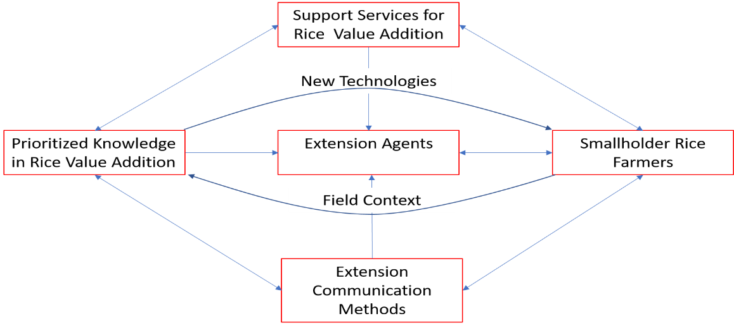
Figure 2: Dynamic extension model for improving Rice Post-harvest in Sierra Leone
Source: Author’s construct, Kamanda (2021)

This suggested framework is based on an ongoing evaluation of the farming actors and their context issues as they change. The framework suggests that interactions between smallholder rice farmers and extension agents will be ongoing such that the farmers may learn new skills to enhance rice post-harvest value addition while the extension agents can better grasp the context and requirements of farmers. The new dynamic model proposes that extension agents continually assess their extension training techniques with farmers to discover the most appropriate approaches for certain rice post-harvest value addition technologies in order to ensure efficacy, despite the fact that farmers often prefer group methods of extension. The training support required to guarantee that training is successfully delivered and the information is implemented in the right way is a crucial component of the model. The responsibility for securing adequate training for both extension agents and farmers rests with the public extension service, which must mobilise the necessary resources (both human and material) either independently or in collaboration with the private sector. For them to embrace and utilise the post-harvest value addition technologies for rice, farmers must also mobilise the resources that are required. Thus, when farmers feel the need for change (necessity is the mother of invention), they (farmers) may implement the adoption process of post-harvest addition technologies for rice. If farmers want to increase their ability to make a living from farming in our technologically advanced world, they must adopt a fresh perspective on farming challenges. This implies that farmers should view farming as a dynamic business that requires modification for the anticipated yields and results. Through the training of the farmers, which will improve their business orientation and desire to build successful farmer-based organisations (FBOs) in local communities for cooperation, such understanding of the dynamic character of farming will be achieved. Working in collaboration can occasionally make it simple to contact donors, thereby supplanting the difficulty in obtaining governmental funding.

Conclusion
The extension training model for smallholder farmers and extension agents was created from the analysis of the study on rice post-harvest value addition in the Southern Region of Sierra Leone. Additionally, it offered a context-specific training approach that the Sierra Leonean extension system could use to improve the capacity of extension agents and smallholder farmers in Southern Sierra Leone and even beyond to add value to rice after harvest. The article concluded by presenting a dynamic extension training approach that can help to continually increase the ability of extension agents and smallholder farmers in Sierra Leone at rice post-harvest value addition.

References
Bukchin, S., & Kerret, D. (2020). Character strengths and sustainable technology adoption by smallholder farmers. Heliyon, 6(8), e04694. https://doi.org/10.1016/j.heliyon.2020.e04694
Caillouet, O., Harder, A., Bunch, J. C., Roberts, T. G., & Radunovich, H. (2022). An Exploration of the Transformational Factors Affecting the Performance of Intercollegiate Extension Programs. North American Colleges and Teachers of Agriculture, 103-112.
Dhraief, M. Z., Bedhiaf-Romdhania, S., Dhehibib, B., Oueslati-Zlaouia, M., Jebali, O., & Ben Youssef, S. (2018). Factors Affecting the Adoption of Innovative Technologies by Livestock Farmers in Arid Area of Tunisia. FARA Research Report, 3(5), 23. https://www.researchgate.net/publication/327971458
FAO (2020). Social protection and COVID-19 response in rural areas.
Issahaku, A. (2014). Perceived Competencies of Agriculture Extension Workers in Extension Services Delivery in Northern Region of Ghana , Perspective from Literature. Developing Country Studies, 4(15), 107–115.
Jehanzeb, K., & Bashir, N. A. (2013). Training and development program and its benefits to employee and organization: A conceptual study. European Journal of business and management, 5(2).https://w ww.re search gate.n et/pub licatio n/274 704136.
Jewitt, S., & Raman, S. (2017). Energy poverty, institutional reform and challenges of sustainable development: The case of India. Progress in Development Studies, 17(2), 173-185.
Mihretie, A. A., Misganaw, G. S., & Siyum Muluneh, N. (2022). Adoption Status and Perception of Farmers on Improved Tef Technology Packages: Evidence from East Gojjam Zone, Ethiopia. Advances in Agriculture, 2022. Article ID 6121071 | https://doi.org/10.1155/2022/6121071.
Rodriguez, J., & Walters, K. (2017). The Importance of Training and Development in Employee Performance and Evaluation. International Journal Peer Reviewed Journal Refereed Journal Indexed Journal UGC Approved Journal Impact Factor, 3(10), 206–212. https://www.researchgate.net/publication/332537797%0Awww.wwjmrd.com
Salas, E., Tannenbaum, S. I., Kraiger, K., & Smith-Jentsch, K. A. (2012). The Science of Training and Development in Organizations: What Matters in Practice. Psychological Science in the Public Interest, Supplement, 13(2), 74–101. https://doi.org/10.1177/1529100612436661
Umar, S., Man, N., Nawi, N. M., Latif, I. A., & Samah, B. A. (2017). Core competency requirements among extension workers in peninsular Malaysia: Use of Borich’s needs assessment model. Evaluation and Program Planning, 62, 9–14. https://doi.org/10.1016/j.evalprogplan.2017.02.001

