Original Research Article

ASSESSMENT OF CROP WATER PRODUCTIVITY AND EFFICIENCY OF PADDY SYSTEMS: A COMPARISON BETWEEN ALTERNATE WETTING AND DRYING AND CONVENTIONAL FLOODING METHODS

ABSTRACT
Water scarcity is still among the major challenges facing rice production as the gap between available water supply and water demand is increasing in many parts of the world, limiting future expansion of irrigation. Crop water productivity for rice was evaluated using the alternate wetting and drying (AWD) and continuous flooding irrigation (CF) methods to come up with the best method with higher productivity (WP) and water use efficiency (WUE). An experiment was carried out at Hembeti irrigation scheme, Morogoro region in Tanzania to investigate WP and WUE of paddy systems comparing the AWD and CF methods. The experiment was done in 2 seasons starting from July to September 2023 and from September to November 2023 using a rice variety locally known as SARO MALOLO (cross of YY and Super) with 90 day-duration from nursery to harvest. Two treatments namely, AWD and CF were arranged in a randomized complete block design with 3 replications to form 6 experimental plots each with 1m² area separated by a 1 m buffer zone to prevent lateral movement of water. Plant spacing used was 20cm x 20cm forming 25 plants per square meter (1 seedling per hill). Several growth variables were monitored and data collected on daily and weekly basis. The growth parameters monitored were plant height, canopy cover, number of tillers and productive tillers, number of panicles and grain number. Findings show that WP was 4.05kgm⁻³ for AWD plots and 1.21kgm⁻³ for CF. It also shows that AWD achieved 75% of WUE compared to 41% in CF. This indicates that AWD performed much better compared to CF in terms of water use and yield. The results also showed that there was no significance difference in the number of productive tillers and panicles for both treatments at p=0.05, but with slight variation (significance difference) between the seasons and between the replicates. Results also showed significance difference in the amount of water applied and consumed for both treatments at p=0.05, where AWD managed to save 65.8% of irrigation water meaning AWD is the best method for regions with water scarcity as it can maintain or improve yield but with an advantage of less water input.

Keywords: water productivity; water-use efficiency; water scarcity; water application; water consumption; irrigation technique

1.0 INTRODUCTION
According to recent estimates for food and agricultural production, the world population is projected to reach 9.6 billion by 2050 (Tripathi et al.,2019) with 135.2 million of those people living in Tanzania (Mwakisisile and Mushi, 2019). The growing population will lead to a significant increase in the demand for food. Concurrently, water demand from non-agricultural sectors will continue to rise in both developed and developing countries (Ali and Talukder, 2008). Consequently, it is widely anticipated that the agricultural sector will have to expand its use of water for irrigation to meet the rising food demand exacerbating the competition for water resources in many regions. As a response, there is an increasing emphasis on improving water productivity in agriculture, with significant public and private investments being made towards this objective (Scheierling et al.,2014).

Water productivity is defined as the ratio of agricultural output to the amount of water applied (Ali and Talukder, 2008). It is also calculated based on the amount of water directly consumed by the crop through evaporation and transpiration from irrigation water or rainfall. The need for enhancing water productivity is particularly critical in situations where water is limited and there is a necessity for fully utilizing of other agricultural inputs, such as fertilizers, high-quality seeds, tillage and land preparation, as well as labor, energy, and machinery (Sharma et al., 2015). Improved irrigation management methods, such as field water management, deficit irrigation, and strategies to enhance productivity, have been identified as highly effective techniques (Rajwade et al., 2018; Mirzaei et al., 2019; Fadul et al., 2020).

Rice, recognized as one of the most extensively cultivated crops worldwide, holds a central position in the diets of approximately half of the global population, constituting roughly 80% of their food intake (Djaman et al., 2020; Pourgholam-Amiji et al., 2020). Its adaptability to diverse ecological conditions has led to its cultivation in roughly 113 countries (FAOSTAT, 2016). Given its nutritional and economic significance, rice occupies more than 146.5 million hectares of agricultural land across the globe (Gill et al., 2014; Murumkar et al., 2014; Lampayan et al., 2015). However, the adverse effects of climate change and water scarcity exert a considerable influence on rice production (Pan et al., 2017).
In Tanzania, rice plays a major role as a staple food and a vital component of the agricultural sector. According to the Food and Agriculture Organization (FAO), Tanzania's rice production reached approximately 2.2 million metric tons in 2020, positioning the country as one of the leading rice producers in Sub-Saharan Africa. The area dedicated to rice cultivation in Tanzania has consistently expanded, reaching about 1.1 million hectares in recent years (FAO, 2021). Nevertheless, the average rice yield in Tanzania remains relatively low, standing at approximately 2 tons per hectare, in contrast to the global average of 4 tons per hectare (World Bank, 2020).

The sustainability of irrigated rice systems in Sub-Saharan Africa and Tanzania confronts significant threats arising from water scarcity, which is further amplified by climate change, droughts, urbanization, and industrialization. These factors deplete water reserves and restrict the availability of irrigation water (Bouman & Tuong, 2001; Yan et al., 2015; Pourgholam-Amiji et al., 2020). Consequently, it becomes imperative to adopt water-efficient techniques capable of decreasing water usage in agriculture while concurrently sustaining or elevating yields to cater to expanding populations (Carrijo et al., 2017; Brar et al., 2018). One highly effective technique is periodic or alternate irrigation.
The Conventional continuous flooding (CF) system, which operates under anaerobic conditions, facilitates optimal supply of water, nutrients, and weed management. However, this method demands significantly greater water input compared to other cereal crops (Datta et al., 2017). Its low efficiency leads to excessive water consumption, necessitating the implementation of management practices that conserve water and boost water productivity (WP) in rice cultivation. Alternate irrigation or water stress management stands as one such strategy (Carracelas et al., 2019).
Rezaei & Nahvi (2007) demonstrated that alternate irrigation reduces water consumption and enhances water use efficiency in rice, making it a viable approach to manage irrigation during droughts and water scarcity. Originating in Madagascar in the early 1980s (Bhuiyan, 1992), this method is widely regarded as an effective means to improve WP, reduce water usage, and sustain or augment yields at minimal cost without the reliance on costly equipment (Bouman & Tuong, 2001).The Alternate Wetting and Drying (AWD) technique, which was introduced by the International Rice Research Institute (IRRI), is widely promoted as a solution to address water scarcity in rice cultivation (Belder et al., 2004; Azamathulla et al., 2008; Datta et al., 2017; Yang et al., 2017; López-López et al., 2018). AWD involves intermittently flooding rice fields, with cycles of saturation and unsaturation, applying 2–5 cm of water at intervals of 2–7 days, depending on soil type and weather conditions, until visible cracks appear on the soil surface (Tuong & Bouman, 2003).
Efforts to enhance water productivity involve optimizing the use of water in agricultural practices to produce more food with less water. This approach is particularly crucial in regions where water is scarce. Improving water productivity requires a holistic strategy that encompasses the efficient use of other agricultural inputs, such as fertilizers, high-quality seeds, and advanced tillage and land formation techniques. Additionally, optimizing labor, energy, and machinery usage plays a vital role in achieving higher water productivity (Sharma et al., 2015).
Public and private investments are increasingly being directed towards research, technology, and infrastructure aimed at improving water productivity. Innovative irrigation techniques, such as drip and sprinkler systems, soil moisture monitoring, and the development of drought-resistant crop varieties, are some of the advancements being pursued. These efforts aim not only to sustain agricultural productivity but also to ensure food security in the face of growing populations and limited water resources.

Rice cultivation is a vital component of global food security, providing a staple food source for a significant portion of the world's population (Nyamai et al.,2012). However, the cultivation of rice requires substantial amounts of water, making it highly water-intensive. As water scarcity becomes an increasingly critical global issue, there is a growing need to enhance water productivity in rice production systems (Pascual and Wang, 2016) as it is a useful indicator for quantifying the effect of irrigation scheduling decisions with regard to water management (Ali and Talukder, 2008). This necessitates the exploration of innovative irrigation methods to optimize water usage while maintaining or improving crop yields.

One such irrigation technique that has gained attention in recent years is the Alternate wetting and drying (AWD) method. Unlike Conventional continuous flooding (CF), AWD involves periodically drying the rice field between irrigations. This intermittent irrigation approach aims to reduce water usage while still providing sufficient moisture for the rice plants' growth and development (Biswas et al.,2021). In the CF system, water is administered on a regular basis to keep ponding at a set depth (for example, 5 cm) throughout the growing season. Through seepage, deep percolation, and excessive unproductive evaporation, more than 50% of irrigation water is lost under the CF (Materu et al.,2018)

Comparisons between AWD and CF methods were conducted to assess the crop water productivity and efficiency and its implications for sustainable agriculture; where several key growth variables were considered; these included amounts of applied water, consumed water, crop canopy cover, crop height, number of tillers per hill, number of productive tillers, number of panicles, number of grains per panicle and the yield.

2.0 METHODOLOGY
2.1 Description of the Study Area
The study was conducted at the Hembeti-Dihombo traditional irrigation scheme, which was established in 2001 through the initiatives of farmers inspired by the successful paddy production of the neighbouring Mkindo irrigation scheme. It is located in the Hembeti ward encompassing the two beneficial villages, Hembeti and Dihombo, in the Mvomero district of Morogoro region, between latitudes 6° 16’ 6.8’’S and 6° 16’ 51.95” S and longitudes 37° 31’ 29. 7’’E and 37° 32’ 4.19’’E along the Turiani - Morogoro road and 35 km from the Mvomero district headquarters (Figure 1). The primary source of irrigation water for the scheme is the perennial Dizingwi River, which has a minimum discharge of approximately 3 m³/s.
Although the proposed Hembeti-Dihombo scheme has 2,000 ha of potential irrigable land, the scheme currently irrigates only 223 hectares. However, once its irrigation structures are fully developed, the plan is to irrigate over 1,000 hectares (Mvomero 2021). The Mvomero district, where the irrigation scheme is located, is characterized by sandy loam soil and predominantly grassland vegetation. Annual rainfall is distributed in two rainy seasons with the long rains occurring between March and May, and the short rains between October and December, representing a bimodal rainfall regime (Figure 2). The average maximum and minimum temperatures for the area are 29.7°C and 24.4°C in December and July respectively while the average humidity is 69.7%. The main crops grown are rice, maize, sorghum and sunflower.
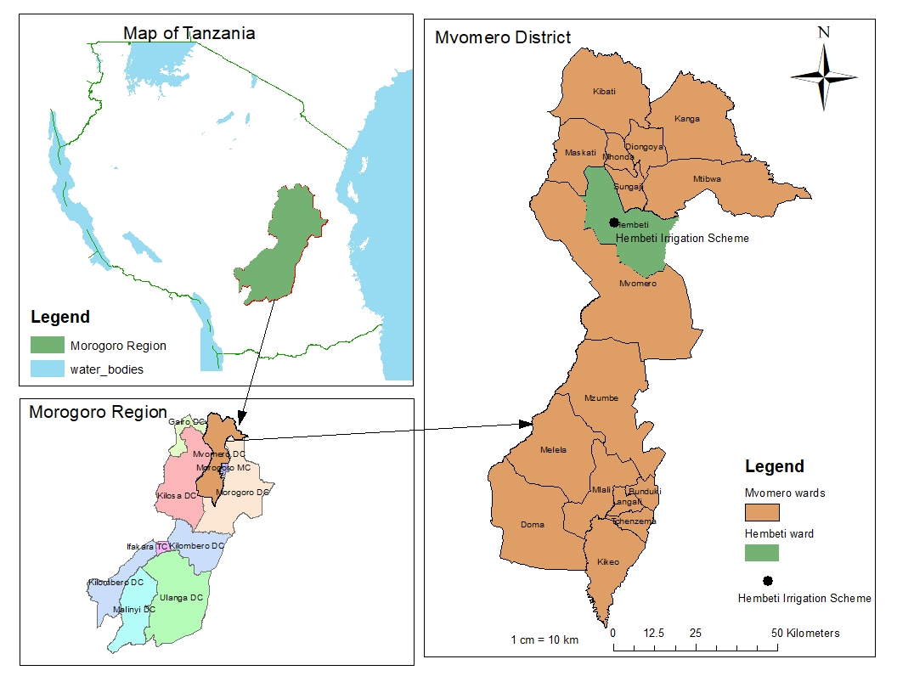
Figure 1: Map of Morogoro region showing Hembeti-Dihombo Irrigation scheme where the study was conducted

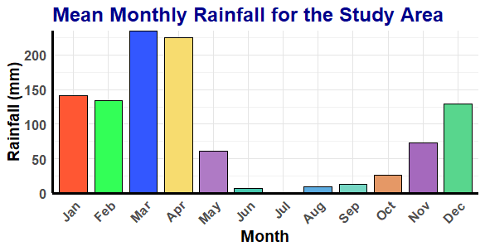
Figure 2: Mean monthly rainfall for the study area

2.2 Experimental design
A randomized complete block design was utilized for setting up and developing the field experiment at the Hembeti-Dihombo irrigation scheme. The size of each plot was set to 1 m² (1 m x 1 m), and the two treatments were assigned to the plots randomly. The plots had a 1 m buffer zone separating them to prevent lateral movement of water between the plots as shown in Figure 3. The same variety of rice (SARO malolo, a cross of YY and Super) was transplanted in all plots at the same grid spacing of 20 cm x 20 cm resulting in 25 rice plants per square meter. The growth variables monitored were crop height, canopy cover, number of tilers per hill, number of productive tillers per hill, panicles per hill, grains per panicle, and yield. The amount of water applied and consumed were also monitored.
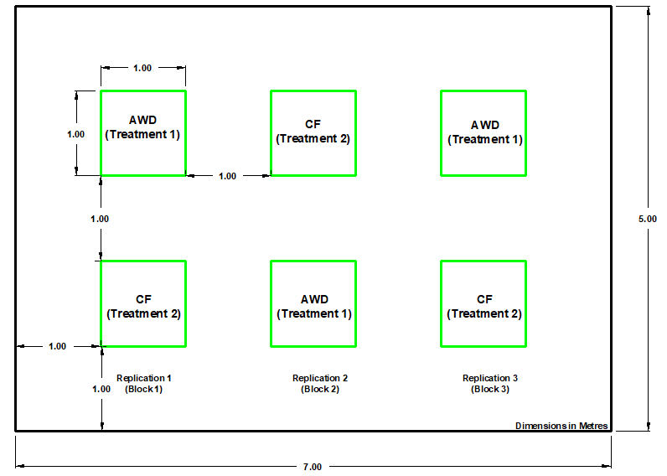
Figure 3: Layout plan of the experimental plots

Table 1: Treatment details on the experimental plots
Treatment | Water application regime | Transplanting age (days) | Seedling per hill | Spacing (cm)
T1 | AWD | 17 | 1 | 20 x 20
T2 | CF | 17 | 1 | 20 x 20

2.3 Field establishment
The experiment was conducted over two seasons within a span of five months. The two seasons overlapped by one month: the first season ran from July to September 2023, while the second season took place from September to November 2023, following the scheme's farming schedule

2.3.1 Nursery and Experimental plots
The sunken experimental plots were established in two areas of the same field, ensuring that both areas had identical physical and chemical soil properties. Two raised seedbeds were prepared for nursery establishment: one in June for season 1 and the other in August for season 2. Rice seeds were broadcast on each bed and left for 17 days to germinate and develop into seedlings before transplanting. One seedling per hill (17 days old) was transplanted in a square pattern of 20 cm by 20 cm on 1m² sunken experimental plots.

2.3.2 Fertilizer and Insecticide application
Fertilizer and pesticide applications were carried out to ensure proper growth. DAP was applied during transplanting, and UREA (46% N) was applied as split application on the 14th and 50th days after transplanting (DAT) both at a rate of 100 kg/ha (Mbaga, 2015). Additionally, lambda-cyhalothrin 50 g/L, an insecticide, was applied at a rate of 5 mL per 2.5 litres of water every week

2.3.3 Irrigation water management
The irrigation water ponding depth for the CF system was maintained at 30 mm from transplanting until a few days before harvesting (Nyamai et al., 2012). Excess water was drained through channels to prevent overflow. In the AWD system, water was applied following an irrigation schedule designed based on crop water requirements, field application efficiency, and the minimum allowable depletion of soil moisture.

2.4 Data collection procedure
2.4.1 Soil sampling and analysis
Soil data were collected following analysis by the TARI Mlingano Central Soils Laboratory. A total of 12 soil samples were taken from the Hembeti irrigation scheme, consisting of 6 core samples and 6 composite soil samples. These samples were analysed for soil water retention characteristics (pF determination), bulk density, and standard fertility assessment for the composite samples.

2.4.2 Climate data
The 20-year climate data for the study area was collected from the nearest meteorological station, TARI Ilonga, to estimate crop evapotranspiration (ET_{C)} using the CLIMWAT/CROPWAT model. The collected data included maximum and minimum temperatures, humidity, wind speed, sunshine duration, and rainfall, all recorded on a monthly basis.

2.4.3 Water application
- For AWD, the amount of water applied was determined by considering the crop water requirements, field application efficiency, and allowable soil moisture depletion. The crop water requirement data for rice was estimated using the CLIMWAT/CROPWAT model, which incorporated climate, soil, and crop data to calculate the net depth of water application (ET_{c}). The field application efficiency for surface irrigation was set at 60%, and the minimum allowable moisture depletion was 50%. The gross irrigation application depth was calculated by dividing ET_{c} (mm/day) by the field application efficiency.

The gross volume of water (length x width x gross depth) was calculated for a plot by considering the flow discharge (m³/s) and the time (s) taken. Discharge was determined by multiplying the current flow velocity (m/s) by the flume’s cross-sectional area (m²). The current flow velocity was measured using the float method, which involved placing a small piece of leaf on the flowing water in the channel. A stopwatch was started when the leaf began to move, and the distance it travelled (m) was recorded. The current flow velocity was then calculated as the distance travelled by the leaf (m) divided by the time (s).

A tensiometer was utilized to determine the optimal timing for irrigation. For sandy loam soils, the type of soil at the experimental site, the moisture at field capacity corresponded to approximately 11 centibars, while irrigation was initiated at tensiometer readings of 40-50 centibars.

- For CF, water was applied and maintained at a ponding depth of 30 mm from transplanting until a few days before harvesting (Nyamai et al.,2012).

The percentage water saved was calculated using the formula:

$$Water saved \left(\%\right)=\frac{(Water applied in CF Plot - Water applied in AWD Plot)}{(Water applied in CF Plot)}x100\% (1)$$
(Chapagain and Riseman, 2010)

2.4.4 Water consumed by a crop
The amount of water consumed by rice was estimated by a CLIMWAT/CROPWAT model. Soil, climate, and crop data was fed into the model to give daily estimates of net depth of water application (crop evapotranspiration) (Kihupi, 2008).

2.4.5 Crop height
The height of rice plants was measured using a ruler or measuring tape, from ground level to the tip of the tallest leaf (FAO, 2004).

2.4.6 Crop canopy cover
The percentage of ground covered by the vertical projection of the outermost perimeter of the natural spread of rice plants (FAO, 2020) was measured biweekly using a mobile app called Canopy Cover Free. This app features sliders for adjusting parameters to ensure accurate canopy identification, such as the leaf green-red ratio, leaf green-blue ratio, and G minimum (Yu et al., 2020). It also provides the latitude and longitude of the area.

2.4.7 Tillers per hill
During the growing season, the number of tillers on each hill was recorded for both treatments. Data were collected from the experimental plots, where a random sample of five hills from each plot was selected for observation and marked with a slender stick inserted into the soil during the early stages of plant development. To gather data for the study, tillers were manually counted weekly throughout the growing season. At the crop maturity stage, the number of productive tillers per hill was also counted (Reuben et al., 2016).

2.4.8 Panicles per hill
At crop maturity, the number of panicles per hill was counted using the five randomly selected hills. The total number of panicles from each hill was summed and averaged to estimate the average number of panicles per hill.

2.4.9 Grains per panicle
One of the factors influencing rice yield is the number of grains per panicle. As the quantity of grains per panicle increases, the yield of rice also rises. To assess this, the number of grains per panicle at crop maturity was recorded from the five randomly selected hills. The grain count from each panicle was totalled, and the results were averaged before being entered onto a recording sheet for analysis (Reuben et al., 2016).

2.4.10 Crop yield
During harvesting, rice panicles were cut from the tillers, and the rice seeds were separated from the straws. The seeds were weighed using a measuring balance and recorded on a data recording sheet as fresh weight. The fresh weight grains were then sun-dried for three consecutive days. After this period, the dry grains were weighed, and the data recorded for analysis. Rice grain yield estimation was conducted at the end of each cropping season using the following formula:

$$Yield in 1 hectare area=Yield of 1 plant x Number of plants or productive tillers (2)$$

Where $Yield of 1 plant=Grain weight x Number of grains per plant (3)$

$Number of plants=\frac{1 ha area in m^{2}}{plant spacing area in m^{2}}$ (4)

2.5 Data analysis
An analysis of variance (ANOVA) was conducted using R version 4.3.2 to assess the variations between rice crops irrigated with AWD and CF treatments. The variables examined included plant height, crop canopy cover, total number of tillers, productive tillers, and water application. Mean separation was performed using Tukey's Honestly Significant Difference (HSD) test at the 0.05 significance level. The results for the variables were illustrated using bar graphs to analyse trends and differences.

3.0 RESULTS AND DISCUSSION
3.1 Physical and chemical properties of soil at the study area
3.1.1 Soil physical properties
The bulk density values for all the samples (A1, A2, A3, C1, C2, C3) taken from the experimental plots A1, A2, A3, C1, C2, and C3 respectively range from 1.04 to 1.21 g/cc, which is generally acceptable as it indicates good porosity and aeration, which are beneficial for rice cultivation (Figure 4). Lower bulk density indicates a relatively loose soil structure, which allows rice roots to penetrate more easily. Variation in bulk density could be due to natural variations in soil properties, differences in land management practices, and environmental influences. The porosity percentages among the samples varied slightly from 39.2% to 43.2% (Figure 4). These values are reasonable for rice cultivation, as they suggest the presence of adequate pore spaces for air and water movement. The total available water (T.A.W) on a volume basis varies from 11.9% to 12.5%, the corresponding T.A.W values in mm water/m soil range from 119 to 125. This suggests a moderate to high availability of water across all samples, though differences in porosity and bulk density slightly affect the amount of available water (Figure 4) that the soil can hold, which is crucial for rice plants during periods of limited rainfall. Rice grows well in soils with low salinity level, good water retention capacity such as those with a high percentage of clay or organic matter, are often better suited for rice production. The soil texture for all samples had an average composition of 52.3% sand, 29.3% silt and 18% clay which falls under sandy loam soil texture which is acceptable for rice cultivation (Table 2). Overall, the soil analysis results indicated that the samples had reasonable characteristics for rice cultivation.

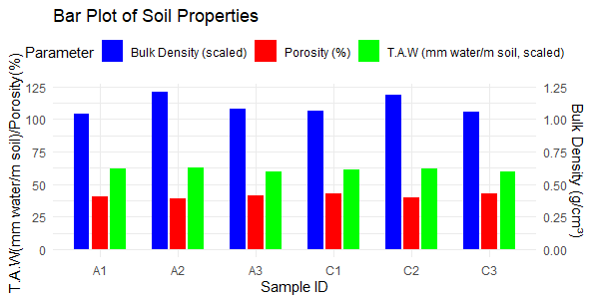
Figure 4: Bulk density, Porosity and Total available moisture/water for soil samples A1, A2, A3, C1, C2, C3.

3.1.2 Soil chemical properties
3.1.2.1 Soil pH
Rice prefers slightly acidic to neutral soils for optimal growth. The pH values in the samples ranged from 5.3 to 6.3 (Table 2). Msanya et al. (2001) and Landon (2014) reported that medium acidic soil has a pH ranging from 5.5 to 7.0 and Pawar et al. (2009) rated a soil pH of between 5.3 and 6.5 as moderately/slightly acidic and therefore suitable for rice cultivation.

3.1.2.2 Electrical Conductivity
Electrical conductivity (EC) serves as an indicator of soil salinity. Generally, lower EC values correspond to lower soil salinity, and vice versa (Che Othaman et al., 2020). High salinity can negatively impact rice growth. The EC values for all samples analysed were relatively low, ranging from 0.01 to 0.06 mS/cm (Table 2). This finding aligns with the laboratory manuals of Pawar et al. (2009), Maral (2010), which indicate that an electrical conductivity range of 0 to 10 mS/cm is optimal for soil supporting rice cultivation.

3.1.2.3 Total Nitrogen and Organic Carbon
Organic Carbon (OC) is a measure of the organic matter content in the soil, while Total Nitrogen (TN) indicates the amount of nitrogen present. Nitrogen is essential for rice growth and is often supplied through the breakdown of organic matter. According to Table 2, sample A1 had the highest TN content at 0.12%, whereas sample C2 had the lowest at 0.02%. Msanya et al. (2001) and Landon (2014) categorized TN levels of less than 0.1% as very low. This low TN content may be attributed to nutrient leaching due to irrigation or uptake by plants. Therefore, it has been recommended to use nitrogen-rich fertilizers to enhance productivity (Gowele, 2021). Pawar et al. (2009) classified OC content greater than 1.0% as very high and less than 0.2% as very low. Samples analysed showed OC content ranging between 1.02% and 1.38%, which is favourable for rice production. Additionally, the residue from rice plants contributes significantly to OC levels, as this biomass is typically incorporated into the soil when preparing for the next planting season.

3.1.2.4 C:N Ratio
The Carbon-to-Nitrogen ratio (C:N) is a crucial factor influencing the decomposition rate of organic matter, as it represents the balance of carbon and nitrogen in the soil. A higher C:N ratio indicates a greater abundance of carbon-rich organic matter relative to nitrogen-rich compounds. According to Rajani (2019), the C:N ratio in arable (cultivated) soils typically ranges from 8:1 to 15:1. In the soil samples analysed, the C:N ratios ranged from 8:1 to 12:1 (Table 2), suggesting a smaller disparity between carbon and nitrogen quantities in the soil organic matter, which is conducive to plant growth.

3.1.2.5 Na, K, P-Bray1, Ca, Mg
These elements represent the soil's nutrient content. They are important for plant growth and play crucial roles in various biochemical processes in the soil. Adequate nutrient levels are necessary for rice growth. The nutrient levels in the samples appeared to be appropriate for rice cultivation, though slight variations were observed among the samples (Table 2). The Na levels in all samples (0.11-0.14 meq/100g) are low, which is generally positive for rice cultivation. Excessive sodium can lead to soil salinity issues, negatively affecting rice growth. According to Singh et al., (2019), Na levels under 1 meq/100g are considered safe for rice production, suggesting that Na concentrations in these samples are well within acceptable limits. Potassium levels range from 0.15 to 0.27 meq/100g across samples. The critical level of K for rice is around 0.2 meq/100g or higher in soils, which means that most of the samples meet or exceed this level. Only sample C3 is slightly lower but still within the manageable range. Adequate K is essential for proper growth, grain filling, and resistance to pests. P-Bray 1 values range from 6.8 to 9.6 mg/kg, which are appropriate for rice cultivation. Phosphorus is crucial for root development and early growth stages. According to Dobermann and Fairhurst (2000), P levels in rice paddies should ideally be between 5-10 mg/kg, aligning with the values in these samples. Calcium levels range between 0.35 to 0.76 meq/100g. Adequate Ca is necessary for cell wall integrity and proper root development. A Ca level above 0.3 meq/100g is generally considered sufficient for rice cultivation, meaning all the samples fall within or above the recommended range. Magnesium levels in the samples vary between 1.7 to 3.12 meq/100g, which is appropriate since Mg plays an important role in photosynthesis and enzyme activation. Fageria (2014) suggests that Mg levels above 0.2 meq/100g are needed for rice, so all samples have adequate Mg levels for optimal rice production.

3.1.2.6 Calcium-to-Magnesium Ratio (Ca/Mg)
The calcium-to-magnesium ratio in the soil is essential for maintaining proper soil structure and facilitating nutrient uptake by plants. This balance is vital for soil fertility. According to Maral (2010), calcium and magnesium are among the key parameters used for assessing soil efficiency. Specifically, calcium levels below 2.38 meq/100g (1.19 mmol/100g) are classified as very low, while magnesium levels between 2.68 and 8 meq/100g (1.34 - 4.0 mmol/100g) are considered medium. Table 2 indicates that the concentration of calcium ions in the samples ranged from 0.35 to 0.76 meq/100g, which is significantly lower than the magnesium ions concentration of between 1.7 and 3.12 meq/100g. This results in a calcium to magnesium ratio of 0.2:1. Consequently, the soil in the study area is identified as calcium deficient. A study conducted by Alva and Edwards (1996) found that calcium-deficient soils often result in poor root elongation, limiting the ability of plants to absorb water and nutrients effectively. It is therefore recommended to apply fertilizers rich in calcium to restore the ratio to at least 3:1 (Ca/Mg). However, there is very little research evidence to support any effect, either positive or negative, of the soil Ca/Mg ratio on crop production and yield. But since Mg works closely with Ca, it is important to have an appropriate ratio of both minerals in order for them to be effective. A good rule of thumb is a 2:1 Ca/Mg ratio. (Magdoff, F., et al., 2009)

3.1.2.7 CEC
Cation Exchange Capacity (CEC) refers to the soil's capability to retain and supply cations (positively charged ions) such as potassium, calcium, and magnesium for plant uptake (Saha, 2022). Higher CEC values indicate better nutrient retention capacity. In this study, the CEC values for all samples ranged from 4.2 to 6.2 meq/100g. However, Saha (2022), in his revised paper on cation exchange capacity and base saturation, reported CEC values for sandy loam soil between 5 and 10 meq/100g. This suggests that the soil in the study area has good potential for retaining and supplying nutrients to rice plants (Table 2).

3.1.2.8 Base Saturation
The base saturation percentage indicates the proportion of exchangeable bases to the total CEC, representing the percentage of CEC occupied by base cations, including calcium, magnesium, potassium, and sodium (Horneck et al., 2019). The base saturation (BS) values for the samples ranged from 55% to 74% (Table 2), with corresponding soil pH levels between 5.3 and 6.3, indicating low acidity, which is favourable for rice production (NARO, 2010).

Table 2: Soil analysis results for six different samples at Hembeti-Dihombo irrigation scheme
SAMPLE ID. | SAND | SILT | CLAY | pH | pH | EC | TN | OC | C:N | Na | K | P-Bray 1 | Ca | Mg | Ca/Mg | CEC | BS
 | % | % | % | water | Kcl | mScm | % | % |  | (meq/100g) | (meq/100g) | (mg/kg) | (meq/100g) | (meq/100g) |  | (meq/100g) | %
A1 | 56 | 28 | 16 | 5.9 | 5.2 | 0.06 | 0.12 | 1.26 | 11 | 0.12 | 0.20 | 9.6 | 0.48 | 2.07 | 0.2 | 4.20 | 68
A2 | 40 | 32 | 28 | 5.6 | 4.8 | 0.03 | 0.11 | 1.02 | 9 | 0.13 | 0.26 | 7.8 | 0.66 | 3.12 | 0.2 | 5.60 | 74
A3 | 54 | 30 | 16 | 6.3 | 5.6 | 0.04 | 0.16 | 1.28 | 8 | 0.11 | 0.21 | 8.2 | 0.49 | 2.35 | 0.2 | 4.80 | 66
C1 | 56 | 32 | 12 | 6.1 | 5.3 | 0.04 | 0.14 | 1.08 | 8 | 0.14 | 0.22 | 9.4 | 0.76 | 2.94 | 0.3 | 6.20 | 65
C2 | 54 | 26 | 18 | 5.8 | 5.1 | 0.02 | 0.18 | 1.38 | 8 | 0.12 | 0.27 | 8.6 | 0.62 | 2.64 | 0.2 | 5.40 | 68
C3 | 54 | 28 | 18 | 5.3 | 4.4 | 0.01 | 0.11 | 1.36 | 12 | 0.12 | 0.15 | 6.8 | 0.35 | 1.70 | 0.2 | 4.20 | 55

3.2 Water applied Vs Water consumed
The average amount of water applied in two seasons was 375mm and 1,098.5mm for AWD and CF plots respectively, while the average amount of water consumed by rice was 281.8mm and 449.95mm for AWD and CF plots respectively (Table 3). There is significance difference in the amount of water applied between AWD and CF treatments at p=0.05 meaning the amount of water applied in CF was extremely larger than that in AWD. Sandy loam texture might have caused depletion of too much water through infiltration and percolation leading to frequent refill of water to maintain a ponding depth of 30mm (CF) throughout the cropping season. Intermittent application of water was probably a reason for low amount of water applied to plots with AWD treatment; where it saved 65.8% of water compared to CF treatment. According to Majeed et al. (2017), most studies reported irrigation water save from 20% to 70% by AWD technique with no significant change in yield.

Table 3: Total water applied and consumed in AWD and CF treatments
Treatment | Water applied (mm) | Water consumed (mm)
AWD-S1 | 340 | 229.8
CF-S1 | 1,088 | 444
AWD-S2 | 410 | 333.8
CF-S2 | 1,109 | 455.9
^{S1=Season 1, S2=Season 2}
3.3 Crop height
The analysis of variance (ANOVA) was carried out to check for significance difference in rice plant height for the two treatments (AWD and CF). The results show that there was no significance difference in the plant heights between AWD and CF treatments for both seasons and between replicates (p = 0.05). The heights in all plots increased simultaneously with time to flowering stage, and no more height increment was encountered to maturity stage (Figure 5a, b). The average maximum height was 125.6cm and 126.2cm for AWD and CF respectively. The similarity in height might be due to the fact that the specific rice variety used in the experiment might possess genetic traits that make it resilient to water stress, flooding stress and poor soil aeration; and therefore, capable of maintaining its growth under both AWD and CF conditions. (Panda et al.,2021, Panda and Barik, 2020)

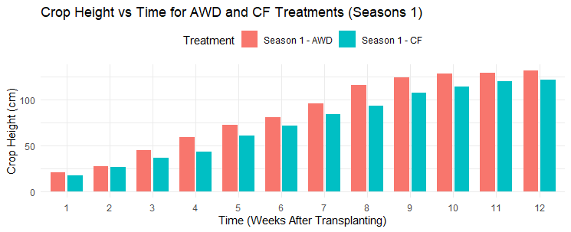
Figure 5 (a): Variation of rice plant height with time for AWD and CF plots during season 1

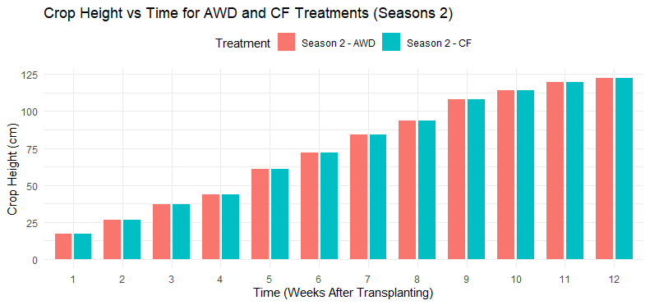
Figure 5 (b): Variation of rice plant height with time for AWD and CF plots during season 2

3.4 Total number of tillers per hill Vs productive tillers per hill
Tillering for both seasons started a week after transplanting (between 7 DAT and 10DAT) for both AWD and CF plots, and continued multiplying as days went on up to maturity (Figure 6). The total number of tillers and productive tillers per hill was estimated during the rice maturation stage of growth (Table 4). The average total number of tillers per hill for AWD and CF plots was respectively 22 and 21 for season 1 and 19 and 20 for season 2. It was also observed that there were 10.2 and 9.5 productive tillers per hill for AWD and CF plots respectively for season 1 and 10.1 and 8.2 for season 2. The results showed that, at least half of the tillers in the AWD and CF treatments were productive; there were only slight variation in the number of productive tillers between the treatments. According to Reuben et al., (2016); unproductive tillers might be formed due to late tillering of some tillers during rice growth stages. The findings also indicate that there was no significance difference between the AWD and CF treatments in the number of tillers per rice hill in both seasons (p = 0.05)

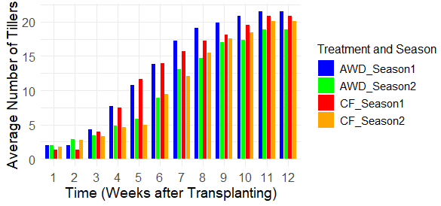
Figure 6: Tillering of rice plant for AWD and CF treated plots against time

Table 4: Number of tillers Vs productive tillers of rice plant for AWD and CF treated plots
 | (AWD)-S1 | (CF)-S1 | (AWD)-S2 | (CF)-S2
Average number of tillers per hill | 22 | 21 | 19 | 20
Average number of productive tillers per hill | 10.2 | 9.5 | 10.1 | 8.2
^{S1=Season 1, S2=Season 2}
3.5 Crop canopy cover
Results shows Canopy Cover (CC) ranged from 7.2% to 97% for AWD and CF plots respectively for season 1; and from 7% to 93.9% for season 2 (Figure 7a, b). The mean values of CC for both seasons were 94.9% and 94.6% for AWD and CF respectively. There was no significance difference at p > 0.05 in CC mean for the treatments and between replicates. There was only a slight difference in CC, one for AWD treatment appeared to be a little bit larger than that in CF treatment. The correlation coefficient for CC and the plant height is 0.992 and 0.991 for AWD and CF treatments respectively; indicating strong positive correlations that, within each treatment (AWD or CF), there is a close relationship between canopy cover and plant height. As one of these variables increases, the other tends to increase proportionally (Table 5). The increase in plant height gave rise to an increase in leaves’ length upward and sideways thereby contributing to an increase in canopy (Yu et al., 2020).

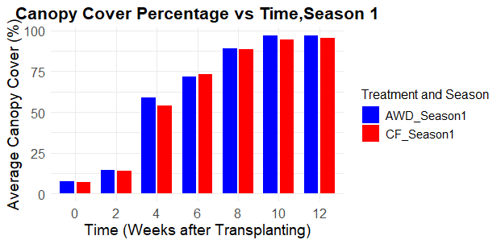

Figure 7a: Variation of Canopy cover (%) for AWD and CF treated plots in season 1

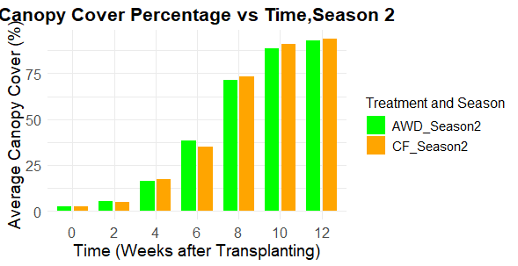
Figure 7b: Variation of Canopy cover (%) for AWD and CF treated plots in season 2

Table 5: Correlation between Canopy cover and Plant height for AWD and CF treatments
 | Canopy Cover – AWD | Plant height - AWD | Canopy Cover  – CF | Plant height  - CF
Canopy Cover – AWD | 1
Plant height – AWD | 0.992 | 1
Canopy Cover – CF | 0.999 | 0.991 | 1
Plant height – CF | 0.991 | 0.999 | 0.991 | 1

3.6 Number of panicles per hill
The average number of panicles per hill was 10 for plots under AWD and 9 for those under CF (Table 6). The results indicate that the difference in the number of panicles between the two treatments was not statistically significant at the 0.05 level, suggesting only a slight variation in panicle count. Reuben et al., (2016) obtained an estimated 20 number of panicles under AWD which is twice the count for this research. This may be attributed to the rice variety used and the presence of unproductive tillers in each hill, which may have resulted from late tillering (Reuben et al., 2016), as well as the variety's capacity to cope with stress, particularly in CF conditions. (Mallareddy et al., 2023)

Table 6: Average number of panicles per hill for AWD and CF treatments
Treatment | Blocks
Treatment | 1 | 2 | 3
AWD-S1  CF-S1  AWD-S2  CF-S2 | 9.64  10.96  9.2  8.36 | 10.32  10.16  9.96  8.96 | 10.72  7.52  11.2  7.24
^{S1=Season 1, S2=Season 2}

3.7 Number of grains per panicle
There was no significant difference (p > 0.05) in the number of grains per panicle between the AWD and CF treatments. This finding suggests that rice transplanted under both treatments performs similarly in terms of the number of grains per panicle. Specifically, the number of grains per panicle in the AWD plots ranged from 214 to 239, while in the CF plots, it ranged from 208 to 235. As shown in Table 7; the average number of grains per panicle was 219 for AWD-S1, 217 for CF-S1, 222 for AWD-S2, and 219 for CF-S2. Thus, the overall average number of grains per panicle for both seasons was 220 for the AWD plots and 218 for the CF plots. Reuben et al., (2016) obtained an average number of 136.6 grains per panicle under AWD for plant spacing of 20cm x 20cm. The difference might be due to varieties used and agronomic practises during cultivation

Table 7: Average number of grains per panicle for AWD and CF treatments
Treatment | Average number of grains per panicle
AWD-S1 | 219
CF-S1 | 217
AWD-S2 | 222
CF-S2 | 219
^{S1=Season 1, S2=Season 2}

3.8 Yield
The average fresh yield weight for both seasons were 1.65 kg/m² (16,529.57 kg/ha) and 1.45 kg/m² (14,469.84 kg/ha) for the AWD and CF treated plots respectively while the dry yield weight was 1.52 kg/m² (15,184.15 kg/ha) and 1.33 kg/m² (13,292.07 kg/ha) respectively (Table 8). The moisture content for freshly harvested rice and the dried one were 21% and 14% respectively. The analysis of variance showed no significance difference (p > 0.05) but slight variation in yield between treatments, which may be attributed to minor variation in the number of productive tillers, panicles and grains among plots.

Table 8: Fresh and dry yield weight for AWD and CF treatments
Treatment | Fresh weight (kg/ha) | Dry weight (kg/ha)
AWD-S1 | 17,633.20 | 16,197.96
CF-S1 | 16,460.74 | 15,120.91
AWD-S2 | 15,425.93 | 14,170.33
CF-S2 | 12,478.95 | 11,463.22
^{S1=Season 1, S2=Season 2}
3.9 Water productivity and efficiency
AWD irrigation technique outperformed CF in terms of water productivity as it gave 5.38kg of yield in 1 m³ of water consumed compared to 2.95kg of yield in 1 m³ of water consumed in CF; that is, water productivity of paddy using AWD is 1.2 times that for CF (Table 9). AWD supplied less amount of water with a little bit higher yield compared to CF. Water productivity in terms of kg of yield per m³ of water applied (Ali and Talukder, 2008) gave 4.05kg/m³ and 1.21kg/m³ for AWD and CF, respectively. This agrees with Nyamai et al., (2012) who obtained 1.54 kg/m³ for AWD compared with 0.81 kg/m³ of CF; the differences might be due to rice variety used, number of productive tillers, inefficient fertilizer use, improper weed control and poor management of pests and diseases.

Water use efficiency for AWD treated plots was 75%, that is, it reduced water usage by 25% whereas for CF treated plots the efficiency was 41% (Table 9); implying an efficient supply of water through AWD technique that saved 65.8% of water as it allowed some days of dryness before re-wetting. Uphoff et al., (2009) conducted field experiments in several Asian countries and reported that AWD reduced water use by 15-30% while maintaining similar or higher rice yields compared to CF. For the case of CF, water was continuously supplied to maintain the set ponding depth throughout the season causing high water loss.

Table 9: Water productivity and efficiency according to irrigation technique
Irrigation technique | Water productivity (Yield-kg/Water consumed-m⁻³) | Water productivity (Yield-kg/Water applied-m⁻³) | Water use efficiency | Irrigation water saving
CF | 2.95 | 1.21 | 41% | -
AWD | 5.38 | 4.05 | 75% | 65.8%

4.0 CONCLUSION
Water scarcity and sustainable agricultural practices are crucial challenges facing the global community. In the context of rice production, which accounts for a significant share of global water consumption, optimizing water productivity has become essential. Results on yield, water application and usage revealed the importance of AWD as an irrigation method that maintains or improves crop yield with less water input compared to CF. AWD saved 65.8% of water which could be used for other purposes to improve water use efficiency rather than being wasted through CF. Farmers at Hembeti irrigation scheme should be encouraged to adopt AWD practice for their crops to minimize water scarcity problems. They should as well be encouraged to apply good agronomic practice such as tillage, weeding, fertilization, insecticide application etc that had contributed much on the yield and water productivity. Government and policymakers should consider integrating AWD practices into agricultural policies and incentives. This can encourage farmers to adopt water-efficient techniques and contribute to overall water conservation efforts. Rehabilitation of poor water distribution infrastructure for Hembeti Irrigation scheme should also be considered to avoid water conflict among farmers during the dry spell season.

REFERENCES:

- Tripathi, D., Mishra, R., Maurya, K., Singh, R., Douglas W. Wilson, D., (2019): Chapter 1 - Estimates for World Population and Global Food Availability for Global Health. Science direct (https://doi.org/10.1016/B978-0-12-813148-0.00001-3)

- Mwakisisile, A and Mushi, A (2019); Mathematical Model for Tanzania Population Growth – AJOL. (https://www.ajol.info/index.php/tjs/article/view/191174)

- Ali, M.H., M.S.U. Talukder,2008; Increasing water productivity in crop production - A synthesis. Elsevier
- Scheierling, S., Treguer, D., Booker, J., Decker, E.,2014; How to Assess Agricultural Water Productivity? Looking for Water in the Agricultural Productivity and Efficiency Literature. World Bank Policy Research Working Paper No. 6982, 44 Pages - SSRN (https://papers.ssrn.com/sol3/papers.cfm?abstract_id=2475069)
- Sharma, B., Molden, D., Cook, S., & Bell, R. (2015). Efforts to enhance water productivity. Agricultural Water Management, 161, 125-134. doi:10.1016/j.agwat.2015.07.019

- Rajwade, Y. A., Patel, J. S., & Shukla, M. K. (2018). Water management strategies to enhance agricultural productivity. Journal of Irrigation Science, 36(4), 551-564. https://doi.org/10.1007/s00271-018-0585-9

- Mirzaei, M., Arshad, M., & Taghizadeh, M. (2019). Deficit irrigation strategies for sustainable water use and improving agricultural productivity. Agricultural Water Management, 212, 283-297. https://doi.org/10.1016/j.agwat.2018.07.011

- Fadul, A. A., Mekonen, T., & Abera, G. (2020). Field water management practices for optimizing water use efficiency. International Journal of Agronomy, 2020, Article 6574851. https://doi.org/10.1155/2020/6574851

- Djaman, K., Mel, V. C., Ndiaye, M. K., El-Namaky, R., Koudahe, K., Diop, A. B., ... & Irmak, S. (2020). Rice yield and water use efficiency as affected by irrigation regimes and cultivar in the Senegal River Valley. Journal of Agricultural Science, 12(3), 88-103. doi:10.5539/jas.v12n3p88

- Pourgholam-Amiji, N., Shariatmadari, H., Karimi, A., & Aghaalikhani, M. (2020). Evaluation of nitrogen use efficiency and agronomic nitrogen efficiency of rice cultivars under different nitrogen levels. Agronomy Journal, 112(4), 3175-3184. doi:10.1002/agj2.20225

- FAOSTAT. (2016). Food and Agriculture Organization of the United Nations. Retrieved from http://www.fao.org/faostat/en/#data/QC

- Gill, G., Kumar, A., & Singh, J. P. (2014). Constraints in adoption of recommended rice cultivation practices. Journal of Agricultural Science, 6(4), 45-52. doi:10.5539/jas.v6n4p45

- Murumkar, A. R., Raskar, S. K., & Tumbare, A. D. (2014). Productivity and economics of rice as influenced by integrated nutrient management. International Journal of Agricultural Sciences, 10(1), 157-160.

- Lampayan, R. M., Rejesus, R. M., Singleton, G. R., & Bouman, B. A. M. (2015). Adoption and economics of alternate wetting and drying water management for irrigated lowland rice. Field Crops Research, 170, 95-108. doi: 10.1016/j.fcr.2014.10.013

- Pan, Z., Ma, Y., Xu, D., Zeng, Y., & Zhang, J. (2017). Climate change impacts on agronomic traits of rice and adaptation strategies in Southern China. Field Crops Research, 214, 119-125. doi: 10.1016/j.fcr.2017.09.010
- Food and Agriculture Organization (FAO). (2021). Rice Market Monitor. Rome: FAO. Retrieved from FAO Rice Market Monitor.
- World Bank. (2020). World Development Indicators. Washington, DC: World Bank. Retrieved from World Development Indicators.
- Bouman, B. A. M., & Tuong, T. P. (2001). Field water management to save water and increase its productivity in irrigated lowland rice. Agricultural Water Management, 49(1), 11–30.

- Yan, J., Cui, Y., & Yang, Z. (2015). Influences of climate change on water use and water consumption of rice in China: A case study of Jiangsu Province. Agricultural Water Management, 152, 233-241.

- Pourgholam-Amiji, N., Palizban, A., & Rahnama, A. (2020). Assessment of climate change impacts on water resources and irrigation in arid regions using SWAT model: A case study of Jiroft Plain, Iran. Agricultural Water Management, 231, 106010.

- Carrijo, D. R., Lundy, M. E., & Linquist, B. A. (2017). Rice yields and water use under alternate wetting and drying irrigation: A meta-analysis. Field Crops Research, 203, 173-180.

- Brar, S. K., Sangeet, P., & Garg, M. (2018). Performance of rice under different methods of irrigation and nitrogen levels in Punjab. Journal of the Indian Society of Soil Science, 66(1), 98-104.

- Datta, A., Gogoi, N., & Saikia, B. (2017). Rice-based cropping systems in the Brahmaputra Valley of Assam: Constraints and opportunities. Indian Journal of Agronomy, 62(3), 183–188.

- Carracelas, G., Navas, M. L., Alcaraz, M. V., & Ronco, A. E. (2019). Assessing the environmental risk of glyphosate in Argentina: A probabilistic approach. Environmental Toxicology and Chemistry, 38(2), 359–369.

- Rezaei, N., & Nahvi, M. (2007). The effects of alternate wetting and drying irrigation on the water use and yield of rice. Journal of Agricultural Science and Technology, 9(1), 15–24.

- Bhuiyan, S. I. (1992). Water management in relation to crop production: Case study on rice. Outlook on Agriculture, 21(4), 293–299.

- Belder, P., Bouman, B. A. M., Spiertz, J. H. J., & Peng, S. (2004). Water use and water productivity of irrigated rice in Asia: A review. Agricultural Water Management, 65(1), 67–88.

- Azamathulla, H. M., Wu, F.-C., Lee, J. H., & Haque, M. A. (2008). Comparative analysis of fuzzy logic and genetic algorithm-based decision-making systems for fish habitat suitability. Ecological Modelling, 215(1–3), 174–181.

- Yang, J., Liu, K., Wang, Z., Du, Y., & Zhang, J. (2017). Alternative wetting and drying irrigation for rice in the sub-humid region of China. Field Crops Research, 213, 136–147.

- López-López, A., Stagnari, F., & Ramazzotti, S. (2018). Water productivity in Mediterranean drylands: A methodological approach. Agricultural Water Management, 204, 185–192.

- Tuong, T. P., & Bouman, B. A. M. (2003). Rice production in water-scarce environments. In J. W. Kijne, R. Barker, & D. Molden (Eds.), Water Productivity in Agriculture: Limits and Opportunities for Improvement (pp. 53–67). CABI.

- Sharma, B., Molden, D., & Cook, S.,2015. Water use efficiency in agriculture: measurement, current situation and trends. Managing Water and Fertilizer for Sustainable Agricultural Intensification, 39–64.
- Nyamai, M., Mati, B., Home, P., Odongo, B., Wanjogu, R., Thuranira, E., 2012. Improving land and water productivity in basin rice cultivation in Kenya through system of rice intensification (SRI) – CIGR journal.

- Pascual, V. and Wang, Y., 2016. Impact of water management on rice varieties, yield and water productivity under SRI in southern Taiwan – MDPI

- Biswas, A., Mailapalli, D.R., Raghuwanshi, N.S. (2021); Consumptive water footprints, water use efficiencies and productivities of rice under alternate wetting and drying for Kharagpur, West Bengal, India – Water supply

- Materu, T., Shukla, S., Sishodia, R., Tarimo, A., and Tumbo, D., 2018; Water Use and Rice Productivity for Irrigation Management Alternatives in Tanzania – WATER doi:10.3390/w10081018

- Mvomero District Irrigation Development Team (DIDT) 2021; Engineering design report for improvement of Hembeti -Dihombo traditional irrigation scheme, Mvomero district council.

- Mbaga, H. R. (2015). Response of rice to nitrogen and phosphorus applied to the dominant soil type at the Dakawa irrigation scheme, Morogoro, Tanzania. Dissertation for Award of MSc Degree at Sokoine University of Agriculture, Morogoro, Tanzania. 122pp.

- Chapagain, T. and Riseman, A. (2010): Achieving More with Less Water: Alternate Wet and Dry Irrigation (AWDI) as an Alternative to the Conventional Water Management Practices in Rice Farming. Agriculture Science. P5

- Kihupi, N.I, 2008; Crop water requirements teaching manual. Sokoine University of Agriculture, pp100

- FAO (Food and Agriculture Organization of the United Nations). (2004). "Rice Crop Manager: Information for Site-Specific Nutrient Management." (http://www.fao.org/3/y5785e/y5785e00.htm), accessed on 21st July 2023

- FAO (Food and Agriculture Organization of the United Nations) 2020. Global forestry resources assessment; terms and definitions. FRA 2020(https://www.fao.org/3/I8661EN/i8661en.pdf). Accessed on 21st July 2023

- Yu, Z., Ustin, S. L., Zhang, Z., Liu, H., Zhang, X., Meng, X., Cui, Y. & Guan, H. (2020). Estimation of a new canopy structure parameter for rice using smartphone photography. Sensors, 20(14), 4011. (https://doi.org/10.3390/s20144011) (https://www.mdpi.com/1424-8220/20/14/4011) Accessed on 8th August 2023.

- Reuben, P., Katambara, Z., Kahimba, F., Mahoo, H., Mbungu, W., Mhenga, F., Nyarubamba, A., Maugo, M. (2016); Influence of Transplanting Age on Paddy Yield under the System of Rice Intensification. Agricultural sciences.

- Msanya, B. M., Kimaro, D. N., Kileo, E. P., Kimbi, G. G. and Mwango, S. B. (2001). Land suitability evaluation for the production of food crops and extensive grazing: a case study of Wami Plains in Morogoro Rural District, Tanzania. Soils and Land Resources of Morogoro Rural and Urban Districts, Volume 1. Department of Soil Science, Faculty of Agriculture, Sokoine University of Agriculture Morogoro Tanzania. 73pp.
- Landon, J. R. (2014). Booker Tropical Soil Manual. A hand book for soil survey and agricultural land evaluation in the tropics and subtropics. Longman Scientific and Technical Publishers, Essex. 474pp.

- Pawar, D., Randhe, D., Shaikh, M., Korde, A., Shinde, K., Yadav, M., Chavan, A., Sapkale, V. (2009); Laboratory testing procedure for Soil & Water sample analysis. Water Resources Department, Directorate of Irrigation Research & Development, Pune. 18pp (https://www.researchgate.net/profile/Arvind_Singh56/post/How_we_can_determine_the_N_P_K_Ca_Na_and_Mg_content_of_soil_sample_for_Pisum_species_growing_areas/attachment/59d641dd79197b807799dbed/AS%3A436663110377472%401481120006055/download/2.pdf) Accessed on 30th July 2023.

- Che Othaman, N., Md Isa, M., Ismail, R., Ahmad, M., Hui, C. (2020); Factors that affect soil electrical conductivity (EC) based system for smart farming application. AIP (https://doi.org/10.1063/1.5142147) Accessed on 28th July 2023.

- Maral, N. (2010); Soil and Water analysis techniques for agricultural production. Dissertation for Award of MSc Degree in Chemistry at Middle East Technical University, Ankara, Turkey.123pp. (https://etd.lib.metu.edu.tr/upload/12611829/index.pdf) Accessed on 30th July 2023

- Gowele, G.E,2021; Silicon uptake by rice plant under the System of rice intensification and Continuous flooding in Mkindo irrigation scheme, Morogoro, Tanzania. Thesis for award of MSc Degree at Sokoine University of Agriculture, Morogoro, Tanzania. 37pp.

- Rajani, A (2019): Chapter 4: Soil organic matter. Book. ResearchGate. DOI:10.13140/RG.2.2.19679.00167(https://www.researchgate.net/publication/335835145_CHAPTER_4_SOIL_ORGANIC_MATTER) Accessed on 1st August 2023.

- Singh, S. K., & Mishra, S. K. (2019). Soil Salinity: Causes, Effects, and Management. Springer.

- Dobermann, A., & Fairhurst, T. H. (2000). Rice: Nutrient Disorders & Nutrient Management. IRRI.

- Fageria, N. K. (2014). Nutrient Management for Improving Rice (Oryza sativa L.) Productivity. Advances in Agronomy.

- Alva, A. K., & Edwards, D. G. (1996). Effects of calcium deficiency on nutrient uptake and root elongation in maize. Plant and Soil, 184(2), 243-249.

- Magdoff, F., & van Es, H. (2009). Building Soils for Better Crops (3rd ed.). Sustainable Agriculture Research and Education (SARE) Program.

- Saha, U. (2022); Cation exchange capacity and base saturation; A revised paper. UGA cooperative extension circular 1040.University of Georgia. (https://extension.uga.edu/publications). Accessed on 28th July 2023

- Horneck, D., Sullivan, D., Owen, J., and Hart, J. (2019): Soil Test Interpretation Guide. Review paper. (https://extension.oregonstate.edu/sites/default/files/catalog/auto/EC1478.pdf) Accessed on 31st July 2023.
- National Agricultural Research Organisation (2010); Rice cultivation handbook. JICA. 26pp (https://www.jica.go.jp/activities/issues/agricul/approach/ku57pq00002m21du-att/handbook_01.pdf) Accessed on 31st July 2023

- Majeed, A., Saleem, M., Jalil, S., Abbas, S., Hayat, A. (2017): Water Saving Rice Production Using Alternate Wetting and Drying Technique in Rice Based Cropping System in Sindh, Pakistan. Science, Technology and Development. DOI: 10.3923/std.2017.30.35

- Panda, D., Mishra, S., and Behera, P. (2021): Drought Tolerance in Rice: Focus on Recent Mechanisms and Approaches. Rice Science. Volume 28, Issue 2, March 2021, Pages 119-132.https://doi.org/10.1016/j.rsci.2021.01.002 (https://www.sciencedirect.com/science/article/pii/S1672630821000032) Accessed on 7th August 2023

- Panda, D. and Barik, J. (2020): Flooding Tolerance in Rice: Focus on Mechanisms and Approaches. Rice Science. Volume 28, Issue 1, January 2021, Pages 43-57. https://doi.org/10.1016/j.rsci.2020.11.006 (https://www.sciencedirect.com/science/article/pii/S1672630820301074) Accessed on 7thAugust 2023.

- Mallareddy, M.; Thirumalaikumar, R.; Balasubramanian, P.; Naseeruddin, R.; Nithya, N.; Mariadoss, A.; Eazhilkrishna, N.; Choudhary, A.K.; Deiveegan, M.; Subramanian, E.; et al., (2023): Maximizing Water Use Efficiency in Rice Farming: A Comprehensive Review of Innovative Irrigation Management Technologies. Water 2023, 15, 1802. https://doi.org/10.3390/w15101802

- Uphoff, N., et al. (2009). "Alternatives to conventional water management in rice cultivation." Agronomy for Sustainable Development, 29(4), 435-454.

