Stabilization of Soil of Hilly Region Using Fly Ash with Various Additives

Abstract
In Civil Engineering construction activities, the soil is stabilized using stabilizers such as stone dust, rice husk ash, fly ash, lime, cockle shell, sisal fiber, coir fiber, cement, etc. In this study, the Well-Graded Silty Sand (SW-SM) soil is stabilized with Fly Ash (FA), Fly Ash with Cement (FAC) combinations, and Fly Ash with Coir Fiber (FACF) combinations. A series of laboratory tests, namely Sieve analysis, Atterberg Limits test, Pycnometer test, Standard Proctor tests, and soaked California Bearing Ratio (CBRs), was conducted on natural soil. The various percentages of Fly Ash (5%, 10%, 15%, and 20%), Cement (2%, 4%, 6%, and 8%), and Coir Fiber (0.5%, 1%, 1.5%, and 2%) by dry weight of soil were used. The CBR test investigated the effectiveness of these additives on soil. The maximum value of CBR_{s} was 25.683% for Soil+10% Fly Ash, 85.376% for Soil+20% Fly Ash+8% Cement, and 18.067% for Soil+5% Fly Ash+0.5% Coir Fiber. The variation of CBR_{s} of soil while treated with FAC combinations reveals that CBR_{s} increase continuously with increments in the percentage of FAC content. The study shows the effective utilization of waste products to stabilize soil.
Keywords: -Soil Stabilization, Fly Ash, Cement, Coir Fiber, Soaked CBR
- Introduction
The soil is anisotropic, biologically active, non-homogeneous, and porous material developed by the rocks' weathering and appearing on the top layer of the earth's surface. Geologic cycles are responsible for soil formation on the earth's surface. In the geotechnical field, sometimes the soil is also called geomaterial. It is the foundation or backbone for any structure built over it and provides structural support. Silty sand soil has been naturally dissipated in the streams and rivers by natural erosion and artificial activities like construction (Amrullah and Sharma, 2020). With modernization, increased urbanization and civilization occur, so the demand for land use for better living and transportation rises continuously. The number of houses, high-rise buildings, commercial buildings, railways, tunnels, highways, earth dams, barrages, and constructed levees will increase due to high demand. So, the construction sites are less available with suitable geotechnical conditions, which has led to the need to use these sites for construction activities. Engineers and researchers have faced problems such as instability, erosion, bearing failure, liquefaction, large total, differential settlements, etc. The adjustment of the soil is the modification of the engineering properties by compound and physical methods to improve the designing properties of the soil (Mir, 2015). Hence, it is necessary to stabilize the unstable soil to avoid such failure. For this reason, the properties of problematic soil are improved by the stabilization of soil, and the engineering properties of the soil are enhanced by mixing additives having cementitious characteristics (Makusa, 2012). The properties of the subgrade soil of the railway were effectively treated with fly ash, lime, cement, and pozzolanic materials (Rosa et al., 2002).Soil stabilization takes place using various approaches such as chemical, physical, and polymer treatment, which increase the stability of soil and improve its engineering properties. The mixture of bottom ash and fly ash is effectively used for the construction of highway embankments and stabilization (Kim et al., 2005). The effect of fly ash and cement on subgrade soil was identified, and the microstructure of the stabilized soil samples was changed by various percentages of fly ash and cement (Rai et al., 2021).
Fly ash is industrial waste developed through coal burning into fuel for power or electricity generation (Dungca and Galupino, 2017).The colors of fly ash vary from grey to blackish grey depending on the combustion process and type of coal. It has also dielectric properties (Dhadse et al., 2008). The total calcium varies between 1% and 12%, as calcium sulfate, hydroxide, and glassy components, with silica and alumina in class F fly ash (Abmaruzzaman, 2010).The reaction mechanism between soil and fly ash can be explained in the sequence: dissolution, gelation/precipitation, and hardening/crystallization (Duxson et al. 2007).Natural fibers such as coir fiber, sisal, jute, cotton, etc, are widely used to improve soil properties, and this is a cost-effective method for soil reinforcement. Coir fiber is utilized as an inoperative material for stabilization due to its long spikes and spiral fibers (Anggraini, 2016). Coir fiber is known for being a stable, simple fiber used in stabilization (Hejazi et al., 2012). Cellulose gives stiffness, strength, and stability to the coir fiber. Higher lignin content improves the quality and performance of stabilized soil, pavement subgrade, and landfill liner (Babu and Vasudevan,2008). The performance of silty sand subgrade reinforced with fly ash and fibers (coir and synthetic) showed that 0.75% coir fiber and 1% synthetic fiber are optimum in fly ash mixed soil. It is thus recommended for reinforcement (Chauhan et al., 2008). The flexible pavement subbase was improved using fly ash and natural coconut coir fiber, and the results reveal that 0.2% of coconut coir fiber is optimum as fiber reinforcement beyond 0.2% coir fiber, there is no significant improvement in the geotechnical properties of soil (Venkateswararao et al., 2023).
The present study aims to determine the suitability of Fly Ash (FA), Fly Ash with Cement (FAC) combinations, and Fly Ash with Coir Fiber (FACF) combinations as soil stabilizing agents for unstable soil. The laboratory investigations were performed to determine the geotechnical properties of natural soil, fly ash stabilized soil, FAC combinations stabilized soil, and FACF combinations stabilized soil. The effect of fly ash with various additives on soil on compaction and the soaked CBR value was determined to improve the load-bearing capacity.
- Materials and Methods
  - Soil
The soil was collected from Govind Ballabh Pant Institute of Engineering and Technology (GBPIET), Ghurdauri, in Pauri Garhwal district of Uttarakhand state, India. The study area is about 5230 km^{2,} and the altitudinal expansion is about 1650 m from the mean sea level. The latitude is about29° 45’ to 30°15’ N, and the longitude is about 78° 24’ to 79° 23’ E. Fig. 1 shows the map of the study area. Before collecting the soil sample, the topmost layer of the soil was removed with the help of a spade up to 50 cm from the ground surface. Fig. 2 shows the collected soil sample. The soil was air-dried, and before performing the series of laboratory tests on the soil to determine the geotechnical properties, it should be oven-dried at 105℃ to 110℃ temperature for 24 hours. Fig. 3 shows an oven-dried Soil Sample.
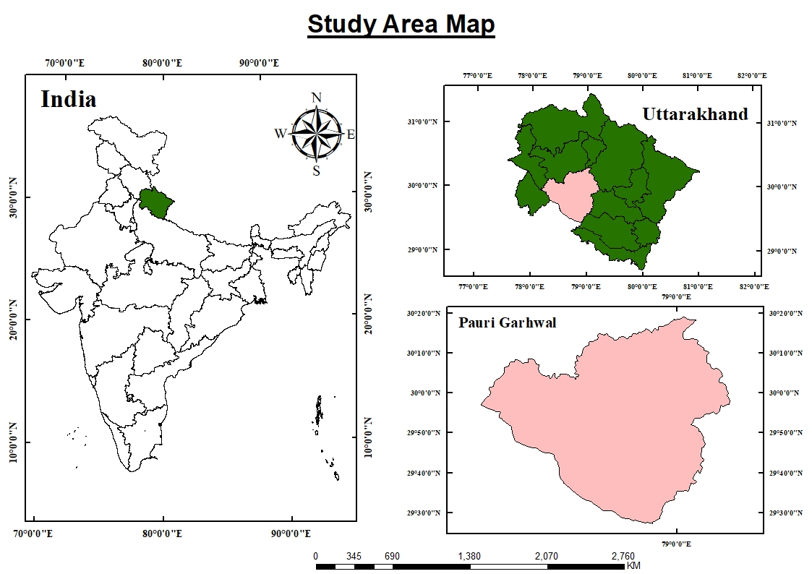
Fig. 1 Map of the Study Area
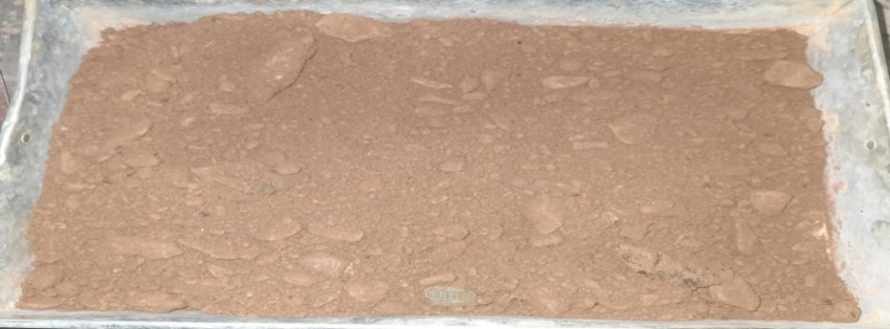
Fig. 2 Collected Soil Sample
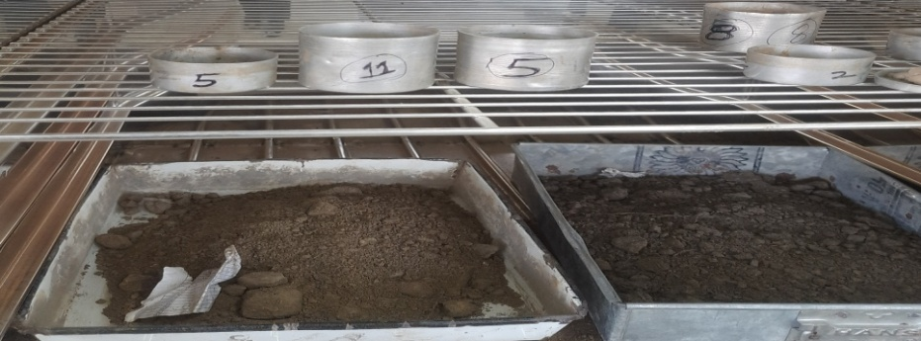
Fig. 3 Oven-Dried Soil Sample
  - Fly Ash
The class F fly ash was collected from Gandhi Logistic Lucknow in Uttar Pradesh state, India. Fig. 4 (a) shows the sample of class F fly ash. The specific gravity of class F fly ash was 2.49.
  - Cement
The cement was used as Ordinary Portland Cement (OPC) of 43 grade collected from the local market of Pauri Garhwal district located in Uttarakhand state, India. Fig. 4 (b) shows the sample of cement.
  - Coir Fiber
The coir fiber was collected from a locally available source. The length and average diameter of the coir fibers are 2 cm and 0.305 mm. Fig. 4 (c) shows the sample of coir fiber. The aspect ratio of coir fiber was 65.57. The diameter and length of coconut coir fibers are essential in soil reinforcement. Fig. 4 (d) shows the cutting of coir fiber.
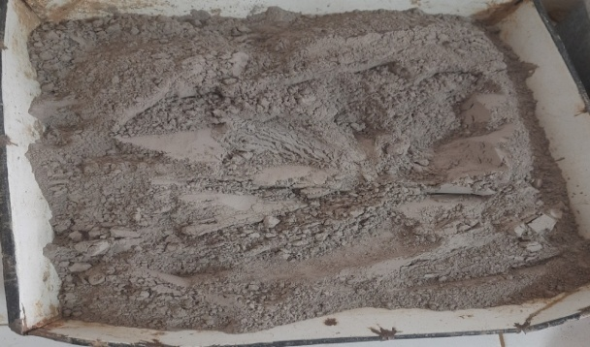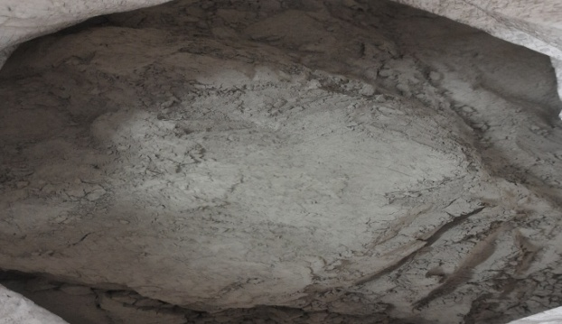
(a) Class F Fly Ash (b) Cement
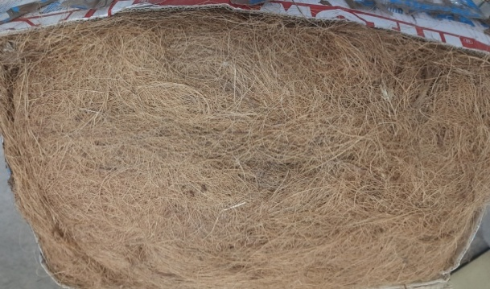
(c) Coir Fiber (d) Cutting of Coir Fiber
Fig. 4 Materials used in the study (a) Class F Fly Ash, (b) Cement, (c) Coir Fiber, and (d) Cutting of Coir Fiber
  - Methodology
Fly ash, cement, and coir fibers are the additives used to stabilize the soil. The soil was mixed with different percentages of class F fly ash, cement, and coir fiber in the study to enhance the soaked California Bearing Ratio (CBR_{s}). The methodology used in the present study is in two phases: laboratory tests on natural soil and laboratory tests on soil mixed with additives. In this research work, the various percentages of fly ash (5%, 10%, 15%, and 20%), cement (2%, 4%, 6%, and 8%), and coir fiber (0.5%, 1%, 1.5%, and 2%) by the dry weight of the soil were used. Fig. 5 shows the testing on natural soil and soil mixed with different additives.

Fig. 5 Testing on natural soil and soil mixed with additives
  - Laboratory Experiments
    - Particle Size Distribution Analysis
The soil sample consists of particles of various sizes in varying quantities. The size of particles and their distribution in the soil influence the engineering properties of soil. The different particle sizes and their distribution can be determined by using a mechanical approach. Grain size distribution of coarser particles (gravel and sand) can be determined by sieving the soil sample through a set of sieves according to IS: 2720 (Part IV) -1985. The particle size was analyzed using sieve analysis to plot the particle size distribution curve and to obtain the various proportions of gravel, sand, and silt in the collected soil sample. Fig. 6 shows the sieves set used in the size of particle distribution analysis of the soil sample.
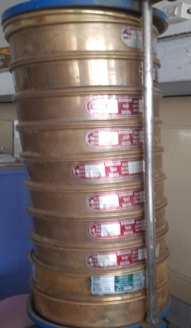
Fig. 6 Set of Sieves
    - Atterberg Limits
The Atterberg limits (liquid and plastic limits) of soil were determined concerning IS 2720 (Part V)-1985.
      - Liquid Limit
The liquid limit can be defined as the minimum moisture content at which soil tends to flow with negligible shear strength. The graph between the number of blows and water content on a semi-log graph is plotted. From the flow curve, the water content obtained corresponding to 25 blows is the liquid limit of soil. Fig. 7 shows the Casagrande apparatus.
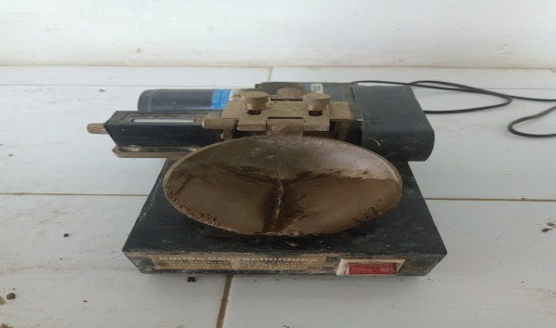
Fig. 7 Casagrande Apparatus
      - Plastic Limit
The plastic limit of the soil is the water content at which the soil begins to crumble when rolled into a thread of approximately 3 mm in diameter.
    - Pycnometer Test
The pycnometer method is used to estimate the specific gravity of the soil sample for both coarse-grained and fine-grained soils. This test is conducted according to IS: 2720 (Part III/Section I) – 1980.Fig. 8 shows the Pycnometer bottle.
The specific gravity can be determined as:
Specific Gravity$\left(Gs\right)=\frac{W_{2}-W_{1}}{{(W}_{2}-W_{1})-(W_{3}-W_{4})}$ (1)
Where, W₁ = weight of empty pycnometer, W₂ = weight of pycnometer + oven dried soil, W₃ = weight of pycnometer + oven dried soil + water, and W₄ = weight of pycnometer + water
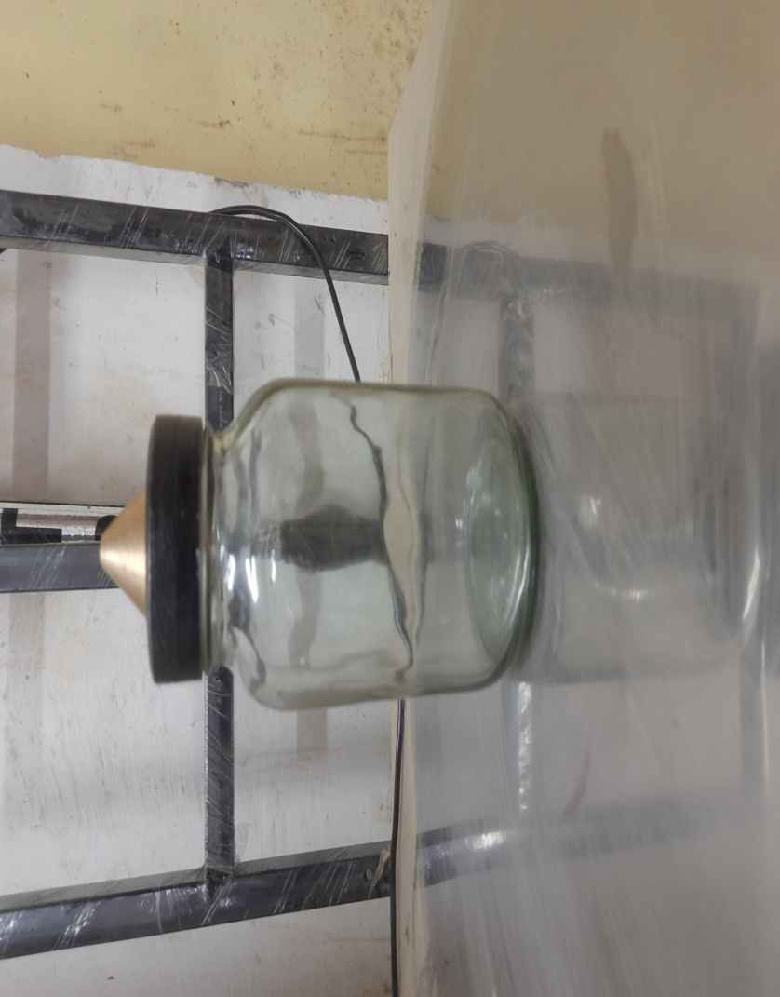
Fig. 8 Pycnometer Bottle
    - Standard Proctor Test
This test aims to determine the relationship between optimum water content and dry density of soil using the “Standard Proctor Test” (light compaction). The test is followed as explained in the Indian Standard Code (IS: 2720 Part VII-1980), which was adopted to determine the parameter. Then, plot a curve between the tested soil specimen's water content and dry density. The plotted curve shows the maximum dry density (MDD) and optimum moisture content (OMC), as shown in Fig. 9, which shows the Standard Proctor test assembly.
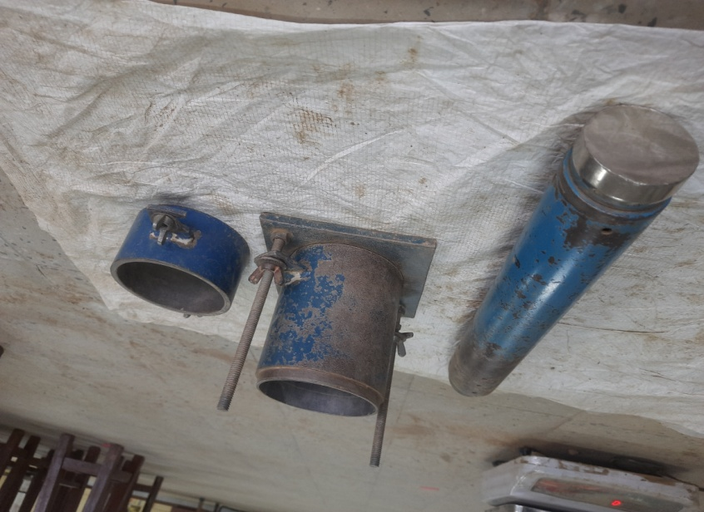
Fig. 9 Standard Proctor Test Assembly
    - California Bearing Ratio Test (CBR)
The objective of the test is to determine the CBR of a soil sample in the laboratory in a soaked condition. The test is performed per Indian Standard (IS: 2720 Part XVI-1987). After 4 days of soaking, fix the mold in the machine and record the values for soaked CBR. The load and penetration curve is plotted to find out the CBR Values. Fig. 10 (a) CBR testing machine and Fig. 10 (b) show a soaked CBR soil specimen.
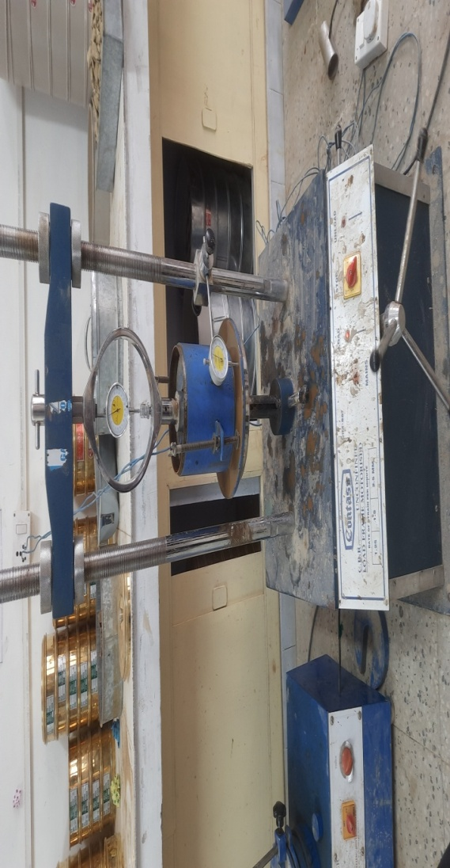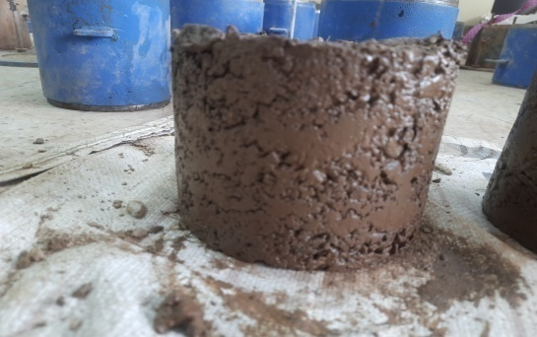
(a) (b)
Fig. 10 (a) CBR Testing Machine (b) Soaked CBR Soil Specimen
- Results and Discussion
  - Geotechnical Properties of the Natural Soil
The results are plotted between sieve size (mm) and percentage finer (%). From the laboratory experiment, 15% of particles were retained on a 4.75 mm IS sieve. A 75-micron sieve passes only 6% particles, less than 10%, so the sedimentation analysis does not apply to the study. The coefficient of uniformity (C_{u}) and curvature (C_{c}) of the natural soil are 22.4 and 1.49. According to IS 1498: 1970, the soil is well graded, as Cu is more significant than six, and Cc lies between 1 and 3. The fines lie between 5% and 12%. Therefore, a dual symbol should be used, as shown in Table 1. The Atterberg limits lie below the A-line in the plasticity chart, and the soil is non-plastic; the soil is classified as well-graded silty sand (SW-SM). The specific gravity of silty sand lies between 2.67 to 2.7. The standard proctor test is performed because only 15% of particles are retained on a 4.75 mm IS sieve, less than 20%.From Fig. 11 (c), the MDD of soil is observed as 1.795 gm/cm³ at 9.214% water content. From the figure, it is observed that dry density tends to decrease beyond 9.214% water content. So, the OMC of natural soil is 9.214%. From Fig. 11 (d), the CBR value of the soil specimen in the soaked condition is observed as 4.605%. This is significantly less for heavy construction activities.
Table 1 Geotechnical Properties of Natural Soil
S. No. | Parameters | Results
1. | Grain Size Distribution  Gravel Size Fraction (%)  Sand Size Fraction (%)  Silt Size Fraction (%) | 40%  54%  6%
2. | Specific Gravity | 2.68
3. | Atterberg Limits  Liquid Limit (%)  Plastic Limit (%)  Plasticity Index (%) | 31.625%  NP  NP
4. | Soil type as per IS: 1498-1970 | SW-SM
5. | Maximum Dry Density, MDD (gm/cm³) | 1.795 gm/cm³
6. | Optimum Moisture Content, OMC (%) | 9.214%
7. | Soaked California Bearing Ratio, CBR_{s} (%) | 4.605%

(a) (b)

(c) (d)
Fig. 11Test Results of Natural Soil (a) Grain Size Distribution Curve of Natural Soil, (b) Flow Curve of Soil, (c) Compaction Characteristics of Natural Soil, (d) Load Penetration Curve of Soaked Soil Sample
  - Variation in Geotechnical Properties of Soil Treated with Fly Ash (FA)
The soil is treated with various percentages of Fly Ash (5%, 10%, 15%, and 20%) by the dry weight of the soil. A series of laboratory tests namely the Standard Proctor test and CBR_{s} test are performed to determine the variation in geotechnical properties of treated soil.
Table 2 OMC and MDD Values of Soil with Various Percentages of Fly Ash
S. No. | Mix | OMC (%) | MDD (gm/cm³)
1. | Soil+5% Fly Ash | 15.053 | 1.839
2. | Soil+10% Fly Ash | 16.937 | 1.821
3. | Soil+15% Fly Ash | 19.486 | 1.750
4. | Soil+20% Fly Ash | 16.781 | 1.762

The MDD at corresponding OMC of the treated soil with various percentages of fly ash were evaluated and presented in Table 2. From Fig. 12 it is observed that the relationship is affected by the addition of FA content and it varies with the various percentage of fly ash. It is observed that OMC increases with increasing the FA content by up to 15%. Among all the treated soil samples, the maximum value of OMC attained by the mix of Soil+15% Fly Ash is 19.486%. For the comparative study of soil treated with various percentages of FA, the variations of MDD are also represented. Among all the treated samples, the maximum value of MDD attained by the mixture of Soil+5% Fly Ash is 1.839gm/cm³.
It is also observed that with a further increase in the FA content up to 15%, there is a decrease in MDD and an increase in OMC. The mixing of a small percentage of Fly Ash (5% Fly Ash content) may result in the decrease of repulsive forces of soil particles. So the resistance to the compaction of soil-mixed FA is reduced and compacted to greater densities. Further, the addition of FA content (10% and 15%) may increase the repulsive forces of soil particles, so it results in to increase in the resistance to compaction effort and hence the density of the soil treated with fly ash decreasing with increasing moisture content. With the addition of 20% Fly Ash content to the soil, the dry density increases and moisture content decreases. The above discussion in the variation of MDD and OMC values with the varying percentages of FA can suggest the utilization of an optimum percentage of FA to achieve a higher value of MDD and a lower value of OMC for any particular soil.

(a) (b)

(c) (d)

(e)

(f) (g)
Fig. 12 Compaction Characteristics for (a) Soil +5% Fly Ash, (b) Soil +10% Fly Ash, (c) Soil +15% Fly Ash, (d) Soil +20% Fly Ash, (e) Soil with Various Percentages of Fly Ash, (f) OMC with Percentage of Fly Ash, (g) MDD with Percentage of Fly Ash
It can be defined as comparing all the observations from the experimental results that OMC increased from 9.214% to 19.486%. The MDD increased from 1.795 gm/cm³ to 1.839gm/cm³.
Table 3 CBR_{s} Values of Soil with Various Percentages of Fly Ash
S. No. | Mix | CBR_{s} (%)
1. | Soil+5% Fly Ash | 24.089
2. | Soil+10% Fly Ash | 25.683
3. | Soil+15% Fly Ash | 16.295
4. | Soil+20% Fly Ash | 10.451
For the comparative study of treated soil with various percentages of FA, the variations of CBR_{s} values are represented in Fig. 13. The load-penetration relationship is affected by the addition of FA content and it varies with the percentage of FA content respectively. The CBR_{s} value increases with increasing the content of FA up to 10% and then decreases. It has been observed that the CBR_{s} values of soil comparatively increase from 4.605% to 25.683% with the addition of FA content shown in Table 3. Among all the treated soil samples, the maximum value of CBR_{s} attained by the mix of Soil+10% Fly Ash is 25.683%. With the addition of FA content to the SW-SM soil results in a more rigid behavior of the soil mix and hence from the experiments it is noticed that for the same penetration level, the loads are high as the percentage of FA content mixed to the soil.

(a) (b)

(c) (d)

(e)
Fig. 13 Load Penetration Curve for (a) Soil +5% Fly Ash, (b) Soil +10% Fly Ash, (c) Soil +15% Fly Ash, (d) Soil +20% Fly Ash, (e) Soil with Various Percentages of Fly Ash
For the FA-treated soil samples, the CBR_{s} drastically increase with increasing FA content because of the pozzolanic and cementitious reaction of additives in the soil. And beyond 10% Fly Ash addition to the soil, the CBR_{s} of treated soil decrease.
  - Variation in Geotechnical Properties of Soil Treated with Fly Ash and Cement (FAC) Combinations
The soil is treated with various percentages of Fly Ash (5%, 10%, 15%, and 20%) and Cement (2%, 4%, 6%, and 8%) combinations by the dry weight of the soil. A series of laboratory tests namely the Standard Proctor test and CBR_{s} test are performed to determine the variation in geotechnical properties of treated soil.
Table 4OMC and MDD Values of Soil with Various Percentages of FAC
S. No. | Mix | OMC (%) | MDD (gm/cm³)
1. | Soil+5% Fly Ash+2% Cement | 15.845 | 1.851
2. | Soil+10% Fly Ash+4% Cement | 18.111 | 1.779
3. | Soil+15% Fly Ash+6% Cement | 19.082 | 1.725
4. | Soil+20% Fly Ash+8% Cement | 18.775 | 1.719

For the comparative study of treated soil with different percentages of FA and Cement, the variations of MDD at respective OMC are represented in Fig. 14. It is observed that the relationship is affected by the addition of FAC content and it varies with the percentage of FAC. The OMC increases with increasing the FAC content up to 15% Fly Ash+6% Cement. Among all the treated soil samples, the maximum value of OMC attained by the mix of Soil+15% Fly Ash+6% Cement is 19.082%. For the comparative study of soil treated with various percentages of FA and Cement content, the variations of MDD are also represented.
Among all the treated samples, the maximum value of MDD attained by the mixture of Soil+5% Fly Ash+2% Cement is 1.851gm/cm³shown in Table 4. It is also observed that with a further increase in the FAC content, there is a decrease in MDD. The mixing of a small percentage of FAC content (5% FA+2% Cement) may result in the decrease of repulsive forces of soil particles. So, the resistance to the compaction of mixed soil FAC content is reduced and compacted to greater densities. Further, the addition of FAC content (10% FA+4% cement, 15% FA+6% cement, and 20% FA+8% cement) may increase the repulsive forces of soil particles, so it results in to increase the resistance to compaction effort and hence the density of the soil treated with FAC content decreases. The above discussion in the variation of OMC and MDD values with the varying percentages of FAC content can suggest the utilization of an optimum percentage of FAC combinations to achieve a higher value of MDD and a lower value of OMC for any particular soil.

(a) (b)

(c) (d)

(e)

(f) (g)
Fig. 14 Compaction Characteristics for (a) Soil +5% FA+2% Cement, (b) Soil +10% FA+4% Cement, (c) Soil +15% FA+6% Cement, (d) Soil +20% FA+8% Cement, (e) Soil with Various Percentages of FAC, (f) OMC with Percentage of FAC, (g) MDD with Percentage of FAC
It can be defined as by comparing all the observations from the experimental results that OMC increased from 9.214% to 19.082%. The MDD increased from 1.795 gm/cm³ to 1.851gm/cm³.
Table 5 CBR_{s} Values of Soil with Various Percentages of Fly Ash and Cement
S. No. | Mix | CBR (%)
1. | Soil+5% Fly Ash+2% Cement | 44.105
2. | Soil+10% Fly Ash+4% Cement | 59.69
3. | Soil+15% Fly Ash+6% Cement | 64.121
4. | Soil+20% Fly Ash+8% Cement | 85.376
From Table 5, it is observed that the CBR_{s} value increases with increasing the content of FAC combinations. The CBR_{s} values of soil comparatively increase from 4.605% to 85.376% with the addition of FAC content. Among all the treated soil samples, the maximum value of CBR_{s} attained by the mix of Soil+20% Fly Ash+8% Cement is 85.376% shown in Fig. 15. By the addition of FAC content to the SW-SM soil results in more rigid behavior of the soil mix and hence from the experiments it is observed that for the same penetration level, the required loads are high as the percentage of FAC content increases. The above discussion in the variation of CBR_{s} values with the varying percentages of FAC content can suggest the utilization of an optimum percentage of FAC combinations to achieve a higher value of CBR_{s} for any particular soil.

(a) (b)

(c) (d)

(e)
Fig. 15 Load Penetration Curve for (a) Soil +5% FA+2% Cement, (b) Soil +10% FA+4% Cement, (c) Soil +15% FA+6% Cement, (d) Soil +20% FA+8% Cement, (e) Soil with Various Percentages of FAC
  - Variation in Geotechnical Properties of Soil Treated with Fly Ash and Coir Fiber (FACF) Combinations
The soil is treated with various percentages of Fly Ash (5%, 10%, 15%, and 20%) and Coir Fiber (0.5%, 1%, 1.5%, and 2%) by the dry weight of the soil. A series of laboratory tests namely the Standard Proctor test and CBR_{s} test are performed to determine the variation in geotechnical properties of treated soil.
Table 6OMC and MDD Values of Soil with Various Percentages of Fly Ash and Coir Fiber
S. No. | Mix | OMC (%) | MDD (gm/cm³)
1. | Soil+5% Fly Ash+0.5% Coir Fiber | 12.556 | 1.848
2. | Soil+10% Fly Ash+1% Coir Fiber | 15.486 | 1.728
3. | Soil+15% Fly Ash+1.5% Coir Fiber | 20.059 | 1.726
4. | Soil+20% Fly Ash+2% Coir Fiber | 17.918 | 1.658
For the comparative study of treated soil with various percentages of FACF combinations, the variations of MDD at respective OMC are represented in Fig. 16. From the figure, it is observed that the relationship is affected by the addition of FACF content. The OMC increases with increasing the FACF content up to 15% Fly Ash+1.5% Coir Fiber. Among all the treated soil samples, the maximum value of OMC attained by the mix of Soil+15% Fly Ash+1.5% Coir Fiber is 20.059%. The comparative study of soil treated with various percentages of FACF content, the variations of MDD are also represented shown in Table 6.
Among all the treated samples, the maximum value of MDD attained by the mixture of Soil+5% Fly Ash+0.5% Coir Fiber is 1.848gm/cm³. It is also observed that with a further increase in the FACF content, there is a decrease in MDD. The mixing of the small percentage of FACF content (5% Fly Ash +0.5% Coir Fiber) may result in the decrease of repulsive forces of soil particles. So, the resistance to the compaction of soil-mixed FACF is reduced and compacted to greater densities. Further, the addition of FACF content (10% Fly Ash+1% Coir Fiber, 15% Fly Ash+1.5% Coir Fiber, and 20% Fly Ash+2% Coir Fiber) may increase the repulsive forces of soil particles, so it results in to increase in the resistance to compaction effort and hence the density of the soil treated with FACF content decreases. The above discussion in the variation of OMC and MDD values with the varying percentages of FACF content can suggest the utilization of an optimum percentage of FACF to achieve a higher value of MDD and a lower value of OMC for any particular soil.

(a) (b)

(c) (d)

(e)

(f) (g)
Fig. 16 Compaction Characteristics for (a) Soil +5% FA+0.5% Coir Fiber, (b) Soil +10% FA+1% Coir Fiber, (c) Soil +15% FA+1.5% Coir Fiber, (d) Soil +20% FA+2% Coir Fiber, (e) Soil with Various Percentages of FACF, (f) OMC with Percentage of FACF, (g) MDD with Percentage of FACF
It can be defined by comparing all the observations from the experimental results that OMC increased from 9.214% to 20.059%. MDD increased from 1.795 gm/cm³ to 1.848gm/cm³.
Table 7 CBR_{s} Values of Soil with Various Percentages of Fly Ash and Coir Fiber
S. No. | Mix | CBR_{s} (%)
1. | Soil+5% Fly Ash+0.5% Coir Fiber | 18.067
2. | Soil+10% Fly Ash+1% Coir Fiber | 12.576
3. | Soil+15% Fly Ash+1.5% Coir Fiber | 10.627
4. | Soil+20% Fly Ash+2% Coir Fiber | 7.794

(a) (b)

(c) (d)

(e)
Fig. 17 Load Penetration Curve for (a) Soil +5% FA+0.5% Coir Fiber, (b) Soil +10% FA+1% Coir Fiber, (c) Soil +15% FA+1.5% Coir Fiber, (d) Soil +20% FA+2% Coir Fiber, (e) Soil with Various Percentages of FACF
For the comparative study of treated soil with various percentages of FACF content, the variations of CBR_{s} values are represented in Fig. 17. From the figure, the load-penetration relationship is affected with the addition of FACF content and it varies with the percentage of FACF respectively. The CBR_{s} values of soil comparatively increase from 4.605% to 18.067% with the addition of FACF content. Among all the treated soil samples, the maximum value of CBR_{s} attained by the mix of Soil+5% Fly Ash+0.5% Coir Fiber is 18.067% shown in Table 7. With the addition of FACF content to the SW-SM soil results in a more rigid behavior of the soil mix and hence from the experiments it is noticed that for the same penetration level, the loads are high as the percentage of FACF content. The above discussion in the variation of CBR_{s} values with the varying percentages of FACF content can suggest the utilization of an optimum percentage of FACF combinations for reinforcement to achieve a higher value of CBR_{s} for any particular soil.
- Conclusions
The research highlighted the stabilization of the SW-SM soil with fly ash, FAC combinations, and FACF combinations. The effect of the different additives on the index and geotechnical properties of the SW-SM soil were studied. From the study the following conclusions can be obtained:
- From the results, it was found that with the increase in the percentage of the FA (up to 15% Fly Ash), FAC combination (15% Fly Ash+ 6% Cement), and FACF combination (15% Fly Ash + 1.5% Coir Fiber) the OMC of the soil also increases. This is because Fly Ash, Cement, and Coir Fiber dry the soil by chemical reaction and when it is added to the soil it consumes the moisture.
- The MDD of the natural soil was 1.795gm/cm³.The MDD of soil increases with the addition of 5% Fly Ash, 5% Fly Ash+2% Cement, and 5% Fly Ash +0.5% Coir Fiber.
- CBR_{s} of the natural soil was 4.605%. The optimum value of FA (10% Fly Ash), and FACF combination (5% Fly Ash+0.5% Coir Fiber) were found for CBR_{s}.
- The variation of CBR_{s} with the percentage of FAC combinations reveals that CBR_{s} drastically increase continuously with the increase in the percentage of FAC content.
References
- Abmaruzzaman, M. 2010. A review on the utilization of fly ash. Prog. Energy Combust. Sci.36(3),327–363.
- Amrullah, A. R. Z., Sharma, N. 2020. Experimental investigation on utilization of silty sand, lime, and gypsum to improve mechanical properties of fly ash. Materials Today: Proceedings. https://doi.org/10.1016/j.matpr.2020.09.761
- Anggraini, V. 2016. Potential of Coir Fibres as Soil Reinforcement. Pertanika J. Scholarly Res. Rev., 2(1): 95-106.
- Babu, S., and Vasudevan, K. 2008. Strength and stiffness response of coir fiber-reinforced tropical soil. J. of Materials in Civil Engineering, ASCE, vol. 20(9), pp. 571–577
- Chauhan, M. S., Mittal, S., Mohanty, B. 2008. Performance evaluation of silty sand subgrade reinforced with fly ash and fibre. Geotext Geomembranes, 26(5):429–35. https://doi.org/10.1016/j. geotexmem.2008.02.001
- Dhadse, S., Kumari, P. and Bhagia, L.J., 2008. Fly Ash Characterization, Utilization and Government Initiatives in India A Review. Journal of Scientific and Industrial Research, Vol. 67, January 2008.
- Dungca, J. R., & Galupino, J. G. 2017. Artificial neural network permeability modeling of soil blended with fly ash. International Journal of GEOMATE.
- Duxson, P., Fernandes-Jiménez, A., Provis, J. L., Luckey, G. C., Palomo, A., and Van Deventer, J. S. J. 2007. Geopolymer technology: The current state of the art. J. Mater. Sci., 42(9): 2917–2933.
- Hejazi, S. M., Sheikhzadeh, M., Abtahi, S. M., Zadhoush, A. 2012. A simple review of soil reinforcement by using natural and synthetic fibers. Const. Build. Mater., 30: 100–116.
- IS: 1478-1970, Indian Standard for Classification and Identification of Soil for General Engineering Purpose, A publication of Bureau of Indian Standard, Manak Bhawan, 9 Bahadur Shah Zafar Marg, New Delhi.
- IS: 2720 (Part 16)- 1987, Indian Standard for Laboratory Determination of CBR, A Publication of Bureau of Indian Standard, Manak Bhawan, 9 Bahadur Shah Zafar Marg, New Delhi.
- IS: 2720 (Part 3/Sec-I)- 1980, Indian Standard for Determination of Specific Gravity, A Publication of Bureau of Indian Standard, Manak Bhawan, 9 Bahadur Shah Zafar Marg, New Delhi.
- IS: 2720 (part 4)- 1985, Indian Standard for Grain Size Distribution, A Publication of Bureau of Indian Standard, Manak Bhawan, 9 Bahadur Shah Zafar Marg, New Delhi.
- IS: 2720 (Part 5)- 1985, Indian Standard for Determination of Liquid and Plastic Limit, A Publication of Bureau of Indian Standard, Manak Bhawan, 9 Bahadur Shah Zafar Marg, New Delhi.
- IS: 2720 (Part 7)- 1980, Indian Standard for Determination of Water Content – Dry Density using Light Compaction, A publication of Bureau of Indian Standard, Manak Bhawan, 9 Bahadur Shah Zafar Marg, New Delhi.
- Kim, B., Prezzi, M. and Salgado, R. 2005. Geotechnical Properties of Fly and Bottom Ash Mixtures for Use in Highway Embankments. Journal of Geotechnical and Geo-Environmental Engineering, 131(7), 914-924.
- Makusa, G. 2012. Soil stabilization methods and materials (In engineering practice). Lulea University of Technology, Sweden.
- Mir, B. A. 2015. Soil studies on the effect of fly and lime mechanical properties of expansive clay. 13.
- Rai, P., Qiu, W., Pei, H., Chen, J., Ai, X., Liu, Y., Ahmad, M., Wu, Y. Z. 2021. Effect of Fly Ash and Cement on the Engineering Characteristic of Stabilized Subgrade Soil: An Experimental Study. Geofluids, 1–11. https://doi.org/10.1155/2021/ 1368194.
- Rosa, Santoni, L., Tingle, J. S., Webster, S. L. 2002. Stabilization of Silty Sand with Non- traditional Additives. Transportation Research Record: Journal of the Transportation Re-search Board, Volume: 1787 (1): 61-70.
- Venkateswararao, T., Jeevitesh, S., Kumar, N. 2023. Amelioration of flexible pavement subbases using fly ash and natural fibres. Materialstoday proceedings. https://doi.org/10.1016/j.matpr.2023.04.063.

